 |  | E  TG/84/4 Corr. 2 Rev. 2  ORIGINAL: English  DATE: 2011-10-20 + 2013-01-25  + 2017-04-05 + 2018-09-20  + 2021-10-26
INTERNATIONAL UNION FOR THE PROTECTION OF NEW VARIETIES OF PLANTS
GENEVA

 | JAPANESE PLUM  UPOV Code: PRUNU_SAL  Prunus salicina Lindl. | *

GUIDELINES

FOR THE CONDUCT OF TESTS

FOR DISTINCTNESS, UNIFORMITY AND STABILITY

Alternative Names:*

Botanical name | English | French | German | Spanish
Prunus salicina Lindl. | Japanese plum | Prunier Japonais | Ostasiatische Pflaume | Ciruelo Japonés

The purpose of these guidelines (“Test Guidelines”) is to elaborate the principles contained in the General Introduction (document TG/1/3), and its associated TGP documents, into detailed practical guidance for the harmonized examination of distinctness, uniformity and stability (DUS) and, in particular, to identify appropriate characteristics for the examination of DUS and production of harmonized variety descriptions.

ASSOCIATED DOCUMENTS

These Test Guidelines should be read in conjunction with the General Introduction and its associated TGP documents.

TABLE OF CONTENTS PAGE

1. Subject of these Test Guidelines 3
2. Material Required 3
3. Method of Examination 3
3.1 Number of Growing Cycles 3
3.2 Testing Place 3
3.3 Conditions for Conducting the Examination 4
3.4 Test Design 4
3.5 Additional Tests 4
4. Assessment of Distinctness, Uniformity and Stability 4
4.1 Distinctness 4
4.2 Uniformity 5
4.3 Stability 5
5. Grouping of Varieties and Organization of the Growing Trial 6
6. Introduction to the Table of Characteristics 6
6.1 Categories of Characteristics 6
6.2 States of Expression and Corresponding Notes 7
6.3 Types of Expression 7
6.4 Example Varieties 7
6.5 Legend 8
7. Table of Characteristics/Tableau des caractères/Merkmalstabelle/Tabla de caracteres 9
8. Explanations on the Table of Characteristics 25
8.1 Explanations covering several characteristics 25
8.2 Explanations for individual characteristics 25
9. Literature 37
10. Technical Questionnaire 38

Subject of these Test Guidelines
These Test Guidelines apply to all varieties of Prunus salicina Lindl.. For the examination of hybrids involving Prunus salicina Lindl., guidance is provided in document TGP/13 “Guidance for new types and species”.

Material Required
2.1 The competent authorities decide on the quantity and quality of the plant material required for testing the variety and when and where it is to be delivered. Applicants submitting material from a State other than that in which the testing takes place must ensure that all customs formalities and phytosanitary requirements are complied with.

2.2 The material is to be supplied in the form of budsticks, dormant shoots or one-year-old trees grafted on a rootstock selected by the testing authority.

2.3 The minimum quantity of plant material, to be supplied by the applicant, should be:

- 5 budsticks with sufficient buds to propagate 5 trees (to be sent at budding time); or
- 5 dormant shoots for grafting, sufficient to propagate 5 trees (to be sent at grafting time); or
- 5 one-year-old trees grafted on a rootstock selected by the testing authority.

2.4 The plant material supplied should be visibly healthy, not lacking in vigor, nor affected by any important pest or disease.

2.5 The plant material should not have undergone any treatment which would affect the expression of the characteristics of the variety, unless the competent authorities allow or request such treatment. If it has been treated, full details of the treatment must be given.

Method of Examination

3.1 Number of Growing Cycles
3.1.1 The minimum duration of tests should normally be two independent growing cycles. In particular, it is essential that the trees produce a satisfactory crop of fruit in each of the two growing cycles.

3.1.2 The growing cycle is considered to be the duration of a single growing season, beginning with bud burst (flowering and/or vegetative), flowering and fruit harvest and concluding when the following dormant period ends with the swelling of new season buds.

3.2 Testing Place
Tests are normally conducted at one place. In the case of tests conducted at more than one place, guidance is provided in TGP/9 “Examining Distinctness”.

3.3 Conditions for Conducting the Examination
The tests should be carried out under conditions ensuring satisfactory growth for the expression of the relevant characteristics of the variety and for the conduct of the examination. Trees should only be pruned in the year of planting to ensure good branch formation.

3.4 Test Design
3.4.1 Each test should be designed to result in a total of at least 5 trees.

3.4.2 The design of the tests should be such that plants or parts of plants may be removed for measurement or counting without prejudice to the observations which must be made up to the end of the growing cycle.

3.5 Additional Tests
Additional tests, for examining relevant characteristics, may be established.

Assessment of Distinctness, Uniformity and Stability

4.1 Distinctness

4.1.1 General Recommendations
It is of particular importance for users of these Test Guidelines to consult the General Introduction prior to making decisions regarding distinctness. However, the following points are provided for elaboration or emphasis in these Test Guidelines.

4.1.2 Consistent Differences
The differences observed between varieties may be so clear that more than one growing cycle is not necessary. In addition, in some circumstances, the influence of the environment is not such that more than a single growing cycle is required to provide assurance that the differences observed between varieties are sufficiently consistent. One means of ensuring that a difference in a characteristic, observed in a growing trial, is sufficiently consistent is to examine the characteristic in at least two independent growing cycles.

4.1.3 Clear Differences
Determining whether a difference between two varieties is clear depends on many factors, and should consider, in particular, the type of expression of the characteristic being examined, i.e. whether it is expressed in a qualitative, quantitative, or pseudo-qualitative manner. Therefore, it is important that users of these Test Guidelines are familiar with the recommendations contained in the General Introduction prior to making decisions regarding distinctness.

4.1.4 Number of Plants / Parts of Plants to be Examined
Unless otherwise indicated, for the purposes of distinctness, all observations on single plants should be made on 5 plants or parts taken from each of 5 plants and any other observations made on all plants in the test, disregarding any off-type plants. In the case of observations of parts taken from single plants, the number of parts to be taken from each of the plants should be 2.

4.1.5 Method of Observation
The recommended method of observing the characteristic for the purposes of distinctness is indicated by the following key in the second column of the Table of Characteristics (see document TGP/9 “Examining Distinctness”, Section 4 “Observation of characteristics”):

MG: single measurement of a group of plants or parts of plants
MS: measurement of a number of individual plants or parts of plants
VG: visual assessment by a single observation of a group of plants or parts of plants
VS: visual assessment by observation of individual plants or parts of plants

Type of observation: visual (V) or measurement (M)

“Visual” observation (V) is an observation made on the basis of the expert’s judgment. For the purposes of this document, “visual” observation refers to the sensory observations of the experts and, therefore, also includes smell, taste and touch. Visual observation includes observations where the expert uses reference points (e.g. diagrams, example varieties, side-by-side comparison) or non-linear charts (e.g. color charts). Measurement (M) is an objective observation against a calibrated, linear scale e.g. using a ruler, weighing scales, colorimeter, dates, counts, etc.

Type of record: for a group of plants (G) or for single, individual plants (S)

For the purposes of distinctness, observations may be recorded as a single record for a group of plants or parts of plants (G), or may be recorded as records for a number of single, individual plants or parts of plants (S). In most cases, “G” provides a single record per variety and it is not possible or necessary to apply statistical methods in a plant-by-plant analysis for the assessment of distinctness.

In cases where more than one method of observing the characteristic is indicated in the Table of Characteristics (e.g. VG/MG), guidance on selecting an appropriate method is provided in document TGP/9, Section 4.2.

4.2 Uniformity
4.2.1 It is of particular importance for users of these Test Guidelines to consult the General Introduction prior to making decisions regarding uniformity. However, the following points are provided for elaboration or emphasis in these Test Guidelines:

4.2.2 For the assessment of uniformity, a population standard of 1% and an acceptance probability of at least 95% should be applied. In the case of a sample size of 5 plants, no off-types are allowed.

4.3 Stability
4.3.1 In practice, it is not usual to perform tests of stability that produce results as certain as those of the testing of distinctness and uniformity. However, experience has demonstrated that, for many types of variety, when a variety has been shown to be uniform, it can also be considered to be stable.

4.3.2 Where appropriate, or in cases of doubt, stability may be further examined by testing a new plant stock to ensure that it exhibits the same characteristics as those shown by the initial material supplied.

Grouping of Varieties and Organization of the Growing Trial
5.1 The selection of varieties of common knowledge to be grown in the trial with the candidate varieties and the way in which these varieties are divided into groups to facilitate the assessment of distinctness are aided by the use of grouping characteristics.

5.2 Grouping characteristics are those in which the documented states of expression, even where produced at different locations, can be used, either individually or in combination with other such characteristics: (a) to select varieties of common knowledge that can be excluded from the growing trial used for examination of distinctness; and (b) to organize the growing trial so that similar varieties are grouped together.

5.3 The following have been agreed as useful grouping characteristics:

- Fruit: size (characteristic 29)
- Fruit: ground color of skin (characteristic 40)
- Fruit: over color of skin (characteristic 42)
- Fruit: color of flesh (characteristic 46)
- Time of beginning of flowering (characteristic 60)
- Time of beginning of fruit ripening (characteristic 61)

Guidance for the use of grouping characteristics, in the process of examining distinctness, is provided through the General Introduction and document TGP/9 “Examining Distinctness”.

Introduction to the Table of Characteristics

6.1 Categories of Characteristics
6.1.1 Standard Test Guidelines Characteristics

Standard Test Guidelines characteristics are those which are approved by UPOV for examination of DUS and from which members of the Union can select those suitable for their particular circumstances.

6.1.2 Asterisked Characteristics

Asterisked characteristics (denoted by *) are those included in the Test Guidelines which are important for the international harmonization of variety descriptions and should always be examined for DUS and included in the variety description by all members of the Union, except when the state of expression of a preceding characteristic or regional environmental conditions render this inappropriate.

6.2 States of Expression and Corresponding Notes
6.2.1 States of expression are given for each characteristic to define the characteristic and to harmonize descriptions. Each state of expression is allocated a corresponding numerical note for ease of recording of data and for the production and exchange of the description.

6.2.2 In the case of qualitative and pseudo-qualitative characteristics (see Chapter 6.3), all relevant states of expression are presented in the characteristic. However, in the case of quantitative characteristics with 5 or more states, an abbreviated scale may be used to minimize the size of the Table of Characteristics. For example, in the case of a quantitative characteristic with 9 states, the presentation of states of expression in the Test Guidelines may be abbreviated as follows:

State | Note
small | 3
medium | 5
large | 7

However, it should be noted that all of the following 9 states of expression exist to describe varieties and should be used as appropriate:

State | Note
very small | 1
very small to small | 2
small | 3
small to medium | 4
medium | 5
medium to large | 6
large | 7
large to very large | 8
very large | 9

6.2.3 Further explanation of the presentation of states of expression and notes is provided in document TGP/7 “Development of Test Guidelines”.

6.3 Types of Expression
An explanation of the types of expression of characteristics (qualitative, quantitative and pseudo-qualitative) is provided in the General Introduction.

6.4 Example Varieties
Where appropriate, example varieties are provided to clarify the states of expression of each characteristic.

6.5 Legend
(*) Asterisked characteristic – see Chapter 6.1.2

QL Qualitative characteristic – see Chapter 6.3
QN Quantitative characteristic – see Chapter 6.3
PQ Pseudo-qualitative characteristic – see Chapter 6.3

MG, MS, VG, VS – see Chapter 4.1.5

(a)-(c) See Explanations on the Table of Characteristics in Chapter 8.1

(+) See Explanations on the Table of Characteristics in Chapter 8.2

Table of Characteristics/Tableau des caractères/Merkmalstabelle/Tabla de caracteres
 |  | English | français | deutsch | español | Example Varieties  Exemples  Beispielssorten  Variedades ejemplo | Note/  Nota
1 | VG | Tree: type of bearing | Arbre : type de fructification | Baum: Fruchtansatz | Árbol: tipo de fructificación
PQ |  | on spurs only | sur spurs seulement | nur an Kurztrieben | únicamente en espolones | Gaviota | 1
 |  | on spurs and long shoots | sur spurs et rameaux longs | an Kurztrieben und Langtrieben | en espolones y tallos largos | Angeleno, Shiro | 2
 |  | on long shoots only | sur rameaux longs seulement | nur an Langtrieben | únicamente en tallos largos |  | 3
2  (+) | VG | Tree: vigor | Arbre : vigueur | Baum: Wuchsstärke | Árbol: vigor
QN |  | weak | faible | gering | débil | Black Gold, Satsuma | 3
 |  | medium | moyenne | mittel | medio | Autumn Giant, Suplumeleven | 5
 |  | strong | forte | stark | fuerte | Robusto, Royal Diamond, Taiyou | 7
3  (*) | VG | Tree: habit | Arbre : port | Baum: Wuchsform | Árbol: porte
PQ |  | upright | dressé | aufrecht | erecto | Formosa, Freedom, Taiyou | 1
 |  | semi-upright | demi-dressé | halbaufrecht | semierecto | Laroda | 2
 |  | spreading | étalé | breitwüchsig | extendido | Ozark Premier, Shiro | 3
 |  | drooping | retombant | überhängend | colgante | Weeping Santa Rosa | 4
4  (+) | VG | One-year-old shoot: color | Rameau d’un an : couleur | Einjähriger Trieb: Farbe | Rama de un año: color
PQ |  | greyish brown | brun grisâtre | graubraun | marrón grisáceo | Taiyou | 1
 |  | yellow brown | marron jaune | gelbgrün | marrón amarillento | Sordum | 2
 |  | brown | brun | braun | marrón | Methley | 3
 |  | reddish brown | brun rougeâtre | rötlichbraun | marrón rojizo | Combination | 4
5 | VG | Spur: length | Spur : longueur | Kurztrieb: Länge | Espolón: longitud
QN |  | short | courte | kurz | corto | Laroda, Sordum | 3
 |  | medium | moyenne | mittel | medio | Frontier | 5
 |  | long | longue | lang | largo | October Purple | 7
6  (+) | VG | Vegetative bud: size | Bourgeon : taille | Vegetative Knospe: Größe | Yema de madera: tamaño
QN | (a) | small | petit | klein | pequeña | Harry Pickstone | 1
 |  | medium | moyen | mittel | mediana | Black Gold,  Great Yellow | 2
 |  | large | grand | groß | grande |  | 3
7  (+) | VG | Vegetative bud: shape of apex | Bourgeon : forme du sommet | Vegetative Knospe: Form der Spitze | Yema de madera: forma del ápice
PQ | (a) | acute | aigue | spitz | agudo | Eldorado | 1
 |  | obtuse | obtuse | stumpf | obtuso | Songold | 2
 |  | rounded | arrondie | abgerundet | redondeado | Satsuma | 3
8  (+) | VG | One-year-old shoot: position of vegetative bud in relation to shoot | Rameau d’un an : position du bourgeon par rapport au rameau | Einjähriger Trieb: Stellung der vegetativen Knospe im Vergleich zum Trieb | Rama de un año: posición de la yema de madera en relación con la rama
QN | (a) | adpressed | appliquée | anliegend | alineada | Queen Ann | 1
 |  | slightly held out | légèrement divergente | leicht abstehend | ligeramente divergente | Satsuma | 2
 |  | markedly held out | fortement divergente | deutlich abstehend | fuertemente divergente | Songold | 3
9  (*) | MS/VG | Leaf blade: length | Limbe : longueur | Blattspreite: Länge | Limbo: longitud
QN | (a) | short | courte | kurz | corto | Honey Rosa | 3
 |  | medium | moyen | mittel | medio | Taiyou | 5
 |  | long | longue | lang | largo | Ozark Premier, Sordum | 7
10  (*) | MS/ VG | Leaf blade: width | Limbe : largeur | Blattspreite: Breite | Limbo: anchura
QN | (a) | narrow | étroite | schmal | estrecho | Beauty | 3
 |  | medium | moyenne | mittel | mediano | Sordum, Suplumeleven | 5
 |  | broad | large | breit | ancho | Combination | 7
11 (*) | MS/ VG | Leaf blade: length/width ratio | Limbe : rapport longueur/largeur | Blattspreite: Verhältnis Länge/Breite | Limbo: relación entre la longitud y la anchura
QN | (a) | slightly elongated | légèrement allongé | leicht langgezogen | ligeramente alargada | Casselman | 1
 |  | moderately elongated | modérément allongé | mäßig langgezogen | moderadamente alargada | Pioneer | 2
 |  | very elongated | très allongé | stark langgezogen | muy alargada | Eclipse | 3
12 (*) (+) | VG | Leaf blade: shape | Limbe : forme | Blattspreite: Form | Limbo: forma
QN | (a) | ovate | ovale | eiförmig | oval |  | 1
 |  | elliptic | elliptique | elliptisch | elíptico | Black Gold, October Purple, Syokou, Taiyou | 2
 |  | obovate | obovale | verkehrt eiförmig | ovoidal | Kanro, Kelsey | 3
13  (*) | VG | Leaf blade: color of upper side | Limbe : couleur de la face supérieure | Blattspreite: Farbe der Oberseite | Limbo: color del haz
PQ | (a) | light green | vert clair | hellgrün | verde claro | Flaming Delicious, Taiyou | 1
 |  | medium green | vert moyen | mittelgrün | verde medio | Abundance, Laroda | 2
 |  | dark green | vert foncé | dunkelgrün | verde oscuro | Gaviota, Shiro | 3
 |  | Reddish purple | pourpre rougeâtre | rötlichpurpurn | púrpura rojizo | Hollywood | 4
14(*) (+) | VG | Leaf blade: angle of apex (excluding tip) | Limbe : angle de l’apex (pointe exclue) | Blattspreite: Winkel des Scheitels (ohne Spitze) | Limbo: ángulo del ápice (sin punta)
QN | (a) | acute | aigu | spitz | agudo | Ozark Premier, Taiyou | 1
 |  | right angled | droit | rechtwinklig | en ángulo recto | Satsuma | 2
 |  | obtuse | obtus | stumpf | obtuso | Methley | 3
15 | VG | Leaf: glossiness of upper side | Feuille : brillance sur la face supérieure | Blatt: Glanz der Oberseite | Hoja: brillo del haz
QN | (a) | weak | faible | gering | débil | Ozark Premier, Taiyou | 1
 |  | medium | moyenne | mittel | medio | Frontier, Shiro | 2
 |  | strong | forte | stark | fuerte | Nubiana | 3
16 | VG | Leaf blade: density of pubescence of lower side | Limbe : densité de la pilosité sur la face inférieure | Blattspreite: Dichte der Behaarung der Unterseite | Limbo: pubescencia del envés
QN | (a) | sparse | sparse | locker | laxa | Angeleno, Redheart, Taiyou | 1
 |  | medium | moyenne | mittel | media | Queen Ann, Shiro | 2
 |  | dense | dense | dicht | densa | Obilnaja | 3
17  (*)  (+) | VG | Leaf blade: incisions of margin | Limbe : découpures du bord | Blattspreite: Randeinschnitte | Limbo: incisiones del borde
PQ | (a) | crenate | crénelées | gekerbt | crenadas | Gaviota, Harry Pickstone | 1
 |  | bi-crenate | bicrénelées | doppelt gekerbt | bicrenadas | Golden Kiss, Pioneer | 2
 |  | serrate | en scie | gesägt | serradas | Dapple Dandy | 3
 |  | bi-serrate | en scie double | doppelt gesägt | biserradas |  | 4
18 (*) | MS/ VG | Petiole: length | Pétiole : longueur | Blattstiel: Länge | Pecíolo: longitud
QN | (a) | short | courte | kurz | corto | Kelsey | 3
 |  | medium | moyenne | mittel | mediano | Frontier | 5
 |  | long | longue | lang | largo | Combination | 7
19 | VG | Leaf: position of nectaries | Feuille : position des nectaires | Blatt: Stellung der Nektarien | Hoja: posición de nectarios
QN | (a) | predominantly on base of leaf blade | essentiellement à la base du limbe | vorwiegend an der Basis der Blattspreite | principalmente en la base del limbo | Methley | 1
 |  | equally on base of leaf blade and on petiole | autant à la base du limbe que sur le pétiole | gleichermaßen an der Basis der Blattspreite und am Blattstiel | tanto en la base del limbo como en el pecíolo | Nubiana | 2
 |  | predominantly on petiole | essentiellement sur le pétiole | vorwiegend am Blattstiel | principalmente en el pecíolo | Queen Ann | 3
20 (*)  (+) | MS/ VG | Pedicel: length | Pédoncule : longueur | Blütenstiel: Länge | Pedicelo: longitud
QN | (b) | short | courte | kurz | corto | Methley | 3
 |  | medium | moyenne | mittel | medio | Queen Ann, Shiro | 5
 |  | long | longue | lang | largo | Red Ace, Taiyou | 7
21 | MS/VG | Flower: diameter | Fleur : diamètre | Blüte: Durchmesser | Flor: diámetro
QN | (b) | small | petit | klein | pequeño | Black Gold, Nubiana | 3
 |  | medium | moyen | mittel | medio | October Purple, Shiro, Taiyou | 5
 |  | large | grand | groß | grande | Kiyou, Methley, Ozark Premier | 7
22  (+) | VG | Flower: arrangement of petals | Fleur : disposition des pétales | Blüte: Anordnung der Blütenblätter | Flor: disposición de los pétalos
QN | (b) | free | disjointes | freistehend | libres | Laroda | 1
 |  | touching | tangentes | sich berührend | en contacto | Harry Pickstone, Shiro | 2
 |  | overlapping | chevauchantes | überlappend | solapados | Beauty | 3
23  (*)  (+) | VG | Sepal: shape | Sépale : forme | Kelchblatt: Form | Sépalo: forma
PQ | (b) | triangular | triangulaire | dreieckig | triangular | Mariposa | 1
 |  | medium ovate | ovale moyenne | mittel eiförmig | oval medio | Harry Pickstone | 2
 |  | broad ovate | ovale large | breit eiförmig | oval ancho | George Wilson | 3
 |  | narrow elliptic | elliptique étroite | schmal elliptisch | elíptico estrecho | Laroda | 4
 |  | medium elliptic | elliptique moyenne | mittel elliptisch | elíptico medio | Nubiana | 5
24  (*) | MS/  VG | Petal: length | Pétale : longueur | Blütenblatt: Länge | Pétalo: longitud
QN | (b) | short | courte | kurz | corto | Laroda, Shigyoku | 3
 |  | medium | moyenne | mittel | medio | Santa Rosa | 5
 |  | long | longue | lang | largo | Burbank | 7
25  (*) (+) | VG | Petal: shape | Pétale : forme | Blütenblatt: Form | Pétalo: forma
PQ | (b) | elliptic | elliptique | elliptisch | elíptico | Red Ace, Taiyou | 1
 |  | circular | circulaire | kreisförmig | circular | Shiro, Wickson | 2
 |  | oblate | oblongue | breitrund | achatado | Wright’s Early | 3
 |  | obovate | obovale | verkehrt eiförmig | ovoidal | Mammoth Cardinal | 4
26 | VG | Petal: undulation of margin | Pétale : ondulation du bord | Blütenblatt: Randwellung | Pétalo: ondulación del margen
QN | (b) | weak | faible | gering | débil | Redheart, Shiro, Taiyou | 1
 |  | medium | moyenne | mittel | media | Queen Ann | 2
 |  | strong | forte | stark | fuerte | Lady Red, Morettini 355, Showtime | 3
27  (*) | VG | Stigma: position in relation to anthers | Stigmate : position par rapport aux anthères | Narbe: Stellung im Vergleich zu den Antheren | Estigma: posición en relación con las anteras
QN | (b) | below | au-dessous | unterhalb | por debajo | Mariposa | 1
 |  | same level | au même niveau | auf gleicher Höhe | al mismo nivel | Methley | 2
 |  | above | au-dessus | oberhalb | por encima | Mammoth Cardinal | 3
28 | MS | Fruit: length of stalk | Fruit : longueur du pédoncule | Frucht: Länge des Stiels | Fruto: longitud del pedúnculo
QN |  | short | courte | kurz | corto | Yonemomo | 3
 |  | medium | moyenne | mittel | medio | Sordum | 5
 |  | long | longue | lang | largo | Hollywood | 7
29  (*)  (+) | VG | Fruit: size | Fruit : taille | Frucht: Größe | Fruto: tamaño
QN | (c) | very small | très petite | sehr klein | muy pequeño | Methley | 1
 |  | small | petite | klein | pequeño | Allo, Eldorado | 3
 |  | medium | moyenne | mittel | medio | Shiro | 5
 |  | large | grosse | groß | grande | Angeleno, Taiyou | 7
 |  | very large | très grosse | sehr groß | muy grande | Songold | 9
30  (*)  (+) | MS | Fruit: height | Fruit : hauteur | Frucht: Höhe | Fruto: altura
QN | (c ) | short | courte | kurz | corto | Eclipse | 3
 |  | medium | moyenne | mittel | mediano | Harry Pickstone | 5
 |  | tall | haute | hoch | alto | Valentine | 7
31  (*)  (+) | MS | Fruit: width | Fruit : largeur | Frucht: Breite | Fruto: anchura
QN | (c) | narrow | étroite | schmal | estrecho | Amber Jewel | 3
 |  | medium | moyenne | mittel | medio | Casselman | 5
 |  | broad | large | breit | ancho | Simka | 7
32 (*)  (+) | VG | Fruit: shape in lateral view | Fruit : forme en vue latérale | Frucht: Form in Seitenansicht | Fruto: forma en vista lateral
PQ | (c) | oblong | oblongue | rechteckig | oblongo | Reubennel | 1
 |  | elliptic | elliptique | elliptisch | elíptico | Ozark Premier, Taiyou | 2
 |  | circular | circulaire | kreisförmig | circular | Red Beauty, Shiro | 3
 |  | oblate | aplatie | breitrund | achatado | Friar | 4
 |  | cordate | cordiforme | herzförmig | cordiforme | Morettini 355 | 5
 |  | obovate | obovale | verkehrt eiförmig | ovoidal |  | 6
 |  | obcordate | obcordiforme | verkehrt herzförmig | obcordiforme | Santa Rosa | 7
33  (+) | VG | Fruit: symmetry | Fruit : symétrie | Frucht: Symmetrie | Fruto: simetría
QN | (c) | symmetric or slightly asymmetric | symétrique ou légèrement dissymétrique | symmetrisch oder leicht asymmetrisch | simétrico o ligeramente asimétrico | Laroda, Shiro | 1
 |  | moderately asymmetric | modérément dissymétrique | mäßig asymmetrisch | moderadamente asimétrico | Friar, Harry Pickstone | 2
 |  | strongly asymmetric | fortement dissymétrique | stark asymmetrisch | muy asimétrico | Ozark Premier | 3
34  (*)  (+) | VG | Fruit: shape of base | Fruit : forme de la base | Frucht: Form der Basis | Fruto: forma de la base
PQ | (c) | pointed | pointue | spitz | puntiaguda | Morettini 355, Taiyou | 1
 |  | truncate | tronquée | gerade | truncada | Black Gold, Green Sun | 2
 |  | depressed | déprimée | eingesenkt | hendida | Calita, Durado, Gabora | 3
35  (+) | VG | Fruit: shape of apex | Fruit : forme de l’apex | Frucht: Form der Spitze | Fruto: forma del ápice
PQ | (c) | pointed | pointue | spitz | puntiaguda | Golden Plumza | 1
 |  | rounded | arrondie | abgerundet | redondeada | Shiro | 2
 |  | truncate | tronquée | gerade | truncada | Angeleno | 3
 |  | depressed | déprimée | eingesenkt | hendida | Friar, Tereda | 4
36  (*) | MS/VG | Fruit: depth of stalk cavity | Fruit : profondeur de la cavité du pédoncule | Frucht: Tiefe der Stielhöhle | Fruto: profundidad de la cavidad peduncular
QN | (c) | shallow | peu profonde | flach | poco profunda | Taiyou | 1
 |  | medium | moyenne | mittel | media | Angeleno, Nubiana | 2
 |  | deep | profonde | tief | profunda | Black Gold, Laroda | 3
37  (*)  (+) | VG/MS | Fruit: width of stalk cavity | Fruit : largeur de la cavité du pédoncule | Frucht: Breite der Stielhöhle | Fruto: anchura de la cavidad peduncular
QN | (c) | narrow | étroite | schmal | estrecha | Koike Sumomo | 1
 |  | medium | moyenne | mittel | media | Beni Ryozhen | 2
 |  | broad | large | breit | ancha | Finroza | 3
38  (*)  (+) | VG | Fruit: depth of suture | Fruit : profondeur de la suture | Frucht: Tiefe der Naht | Fruto: profundidad de la sutura
QN | (c) | absent or very shallow | absente ou très peu profonde | fehlend oder sehr flach | ausente o muy poco profunda | Sunrise | 1
 |  | shallow | peu profonde | flach | poco profunda | Taiyou | 2
 |  | medium | moyenne | mittel | media | Sordum | 3
 |  | deep | profonde | tief | profunda | Akihime | 4
39  (*)  (+) | VG | Fruit: bloom of skin | Fruit : pruine de l’épiderme | Frucht: Bereifung der Schale | Fruto: pruina de la epidermis
QN | (c) | absent or very weak | absente ou très faible | fehlend oder sehr gering | ausente o muy débil |  | 1
 |  | weak | faible | gering | débil | Red June | 3
 |  | medium | moyenne | mittel | media | Ooishi Nakate | 5
 |  | strong | forte | stark | fuerte | Sordum | 7
 |  | very strong | très forte | sehr stark | muy fuerte |  | 9
40  (*) (+) | VG | Fruit: ground color of skin | Fruit : couleur de fond de l’épiderme | Frucht: Grundfarbe der Schale | Fruto: color de fondo de la epidermis
PQ | (c) | not visible | non visible | nicht sichtbar | no visible | Angeleno | 1
 |  | green | vert | grün | verde | Gaviota, Santa Rosa | 2
 |  | yellowish green | vert jaunâtre | gelblichgrün | verde amarillento | Songold, Taiyou | 3
 |  | yellow | jaune | gelb | amarillo | Shiro | 4
41  (*) (+) | VG | Fruit: relative area of over color | Fruit : proportion de lavis | Frucht: relative Fläche der Deckfarbe | Fruto: proporción del color superficial de la epidermis
QN | (c) | absent or very small | absente ou très petite | fehlend oder sehr klein | ausente o muy pequeña | Green Sun, Shiro | 1
 |  | small | petite | klein | pequeña | Bragialla | 3
 |  | medium | moyenne | mittel | mediana | Fortune | 5
 |  | large | large | groß | grande | Taiyou | 7
 |  | very large or whole surface | très large ou sur toute la surface | sehr groß oder ganzflächig | muy grande o totalidad de la superficie | Friar, Suplumeleven | 9
42  (*) (+) | VG | Fruit: over color of skin | Fruit : lavis | Frucht: Deckfarbe der Schale | Fruto: color superficial de la epidermis
PQ | (c) | none | aucun | keine | ninguno | Golden Japan | 1
 |  | orange yellow | jaune orangé | orangegelb | amarillo anaranjado | Formosa | 2
 |  | medium red | rouge moyen | mittelrot | rojo medio | Red Beauty | 3
 |  | dark red | rouge foncé | dunkelrot | rojo oscuro | Starking Delicious, Taiyou | 4
 |  | purple | pourpre | purpurn | púrpura | Karari, Morettini 355 | 5
 |  | dark blue | bleu foncé | dunkelblau | azul oscuro | Laroda | 6
 |  | black | noir | schwarz | negro | Angeleno | 7
43  (*)  (+) | VG | Fruit: pattern of over color | Fruit : distribution du lavis | Frucht: Verteilung der Deckfarbe | Fruto: distribución del color superficial
PQ | (c) | flecks only | tâches seulement | nur Flecken | sólo manchas | Tiger | 1
 |  | mottled | marbrée | gepunktet | jaspeado | Omega | 2
 |  | solid flush only | en plages continues seulement | nur ganzflächig | de manera puramente uniforme | Friar, Taiyou | 3
44  (*) | VG | Fruit: number of lenticels | Fruit : nombre de lenticelle | Frucht: Anzahl der Lentizellen | Fruto: número de lenticelas
QN | (c) | few | petit | gering | bajo | ARC PR 3 | 3
 |  | medium | moyen | mittel | medio | Sunrise | 5
 |  | many | grand | groß | alto | Polar Eclipse | 7
45  (*) | VG | Fruit: size of lenticels | Fruit : taille des lenticelles | Frucht: Größe der Lentizellen | Fruto: tamaño de las lenticelas
QN | (c) | small | petites | klein | pequeñas | Sunset | 1
 |  | medium | moyennes | mittel | medianas | Extreme | 2
 |  | large | grandes | groß | grandes | Southern Belle | 3
46  (*) | VG | Fruit: color of flesh | Fruit : couleur de la chair | Frucht: Farbe des Fleisches | Fruto: color de la pulpa
PQ | (c) | whitish | blanchâtre | weißlich | blanquecino | Taiyou | 1
 |  | green | verte | grün | verde | Reina Claudia | 2
 |  | yellowish green | vert jaunâtre | gelblichgrün | verde amarillento | Shiro | 3
 |  | yellow | jaune | gelb | amarillo | Angeleno, Golden Japan, Reubennel | 4
 |  | orange | orange | orange | naranja | Black Amber, Sun Gold | 5
 |  | medium red | rouge moyen | mittelrot | rojo medio | Satsuma, Sordum | 6
 |  | dark red | rouge foncé | dunkelrot | rojo oscuro | Beauty, Hawera, Karari, Stark Delicious | 7
 |  | purplish | pourpre | purpurn | purpúreo | Sangue di Drago | 8
47  (+) | MS | Fruit: firmness | Fruit : fermeté | Frucht: Festigkeit | Fruto: firmeza
QN | (c) | soft | molle | weich | blando | Shiro | 3
 |  | medium | moyenne | mittel | medio | Frontier | 5
 |  | firm | ferme | fest | firme | Laroda, Taiyou | 7
48  (+) | MG | Fruit: juiciness | Fruit : jutosité | Frucht: Saftigkeit | Fruto: jugosidad
QN | (c) | low | faible | gering | baja | Autumn Giant, Laroda | 1
 |  | medium | moyenne | mittel | media | Gaviota, Ozark Premier | 2
 |  | high | forte | hoch | alta | Reubennel, Shiro, Santa Rosa | 3
49  (+) | MG | Fruit: acidity | Fruit : acidité | Frucht: Säure | Fruto: acidez
QN | (c) | low | faible | gering | baja | Angeleno, Durado | 1
 |  | medium | moyenne | mittel | media | Green Sun, Shiro, Taiyou | 2
 |  | high | élevée | hoch | alta | Carmen, Obilnaja | 3
50  (+) | MG | Fruit: sweetness | Fruit : goût sucré | Frucht: Süße | Fruto: dulzura
QN | (c) | low | faible | gering | baja | Durado, Obilnaja, Shiro | 1
 |  | medium | moyen | mittel | media | Angeleno | 2
 |  | high | élevé | hoch | alta | Black Gold, Laroda, Taiyou | 3
51  (*) | VG | Fruit: adherence of stone to flesh | Fruit : adhérence du noyau à la chair | Frucht: Anhaften des Steins am Fleisch | Fruto: adhesión del hueso a la pulpa
QN | (c) | non-adherent | non-adhérent | nicht anhaftend | no adherente | Fortune | 1
 |  | semi-adherent | semi-adhérent | zum Teil anhaftend | semiadherente | Nubiana, Taiyou | 2
 |  | adherent | adhérent | völlig anhaftend | adherente | Shiro, Sungold | 3
52  (+) | VG | Fruit: amount of fiber | Fruit : quantité de fibres | Frucht: Menge der Fasern | Fruto: cantidad de fibra
QN |  | low | faible | gering | poca |  | 1
 |  | medium | moyenne | mittel | media |  | 2
 |  | high | grande | hoch | mucha |  | 3
53  (*) | VG | Stone: size | Noyau : taille | Stein: Größe | Hueso: tamaño
QN | (c) | small | petite | klein | pequeño | Angeleno, Eldorado | 3
 |  | medium | moyenne | mittel | mediano | Taiyou, Wickson | 5
 |  | large | grande | groß | grande | Freedom | 7
54.  (*) (+) | VG | Stone: shape in lateral view | Noyau : forme en vue latérale | Stein: Form in Seitenansicht | Hueso: forma en vista lateral
PQ | (c) | narrow elliptic | elliptique étroite | schmal elliptisch | elíptico estrecho | Eldorado | 1
 |  | medium elliptic | elliptique moyenne | mittel elliptisch | elíptico medio | Santa Rosa, Taiyou | 2
 |  | circular | circulaire | kreisförmig | circular | Angeleno, Kelsey | 3
 |  | broad ovate | ovale large | breit eiförmig | oval ancho |  | 4
55.  (*)  (+) | VG | Stone: shape in ventral view | Noyau : forme en vue ventrale | Stein: Form in Bauchansicht | Hueso: forma en vista ventral
PQ | (c) | narrow elliptic | elliptique étroite | schmal elliptisch | elíptico estrecho | Kelsey | 1
 |  | medium elliptic | elliptique moyenne | mittel elliptisch | elíptico medio | Santa Rosa, Taiyou | 2
 |  | broad elliptic | elliptique large | breit elliptisch | elíptico ancho | Eldorado | 3
56.  (*) | VG | Stone: shape in basal view | Noyau : forme en vue basale | Stein: Form in Basisansicht | Hueso: forma desde la base
PQ | (c) | narrow elliptic | elliptique étroite | schmal elliptisch | elíptico estrecho | Shiro, Songold | 1
 |  | medium elliptic | elliptique moyenne | mittel elliptisch | elíptico medio | Bragialla | 2
 |  | broad elliptic | elliptique large | breit elliptisch | elíptico ancho | Black Gold, Frontier | 3
57. | VG | Stone: symmetry in lateral view | Noyau : symétrie en vue latérale | Stein: Symmetrie in Seitenansicht | Hueso: simetría en vista lateral
QN | (c) | symmetric or slightly asymmetric | symétrique ou légèrement dissymétrique | symmetrisch oder leicht asymmetrisch | simétrico o ligeramente asimétrico | Angeleno, Frontier | 1
 |  | moderately asymmetric | modérément dissymétrique | mäßig asymmetrisch | moderadamente asimétrico | Shiro | 2
 |  | strongly asymmetric | fortement dissymétrique | stark asymmetrisch | muy asimétrico |  | 3
58. | VG | Stone: texture of lateral surfaces | Noyau : texture des surfaces latérales | Stein: Struktur der seitlichen Oberflächen | Hueso: textura de las superficies laterales
PQ | (c) | fine grained | à grains fins | feinkörnig | de grano fino | Eldorado | 1
 |  | granular | granulaire | körnig | granular | Nubiana | 2
 |  | rough | rugueuse | rauh | rugosa | Laroda, Songold | 3
 |  | hammered | martelée | gehämmert | martillada | Harry Pickstone | 4
59.  (+) | VG | Stone: width of stalk-end | Noyau : largeur de l’attache pédonculaire | Stein: Breite des Stielansatzes | Hueso: anchura de la punta del pedúnculo
QN | (c) | narrow | étroit | schmal | estrecha | Frontier | 1
 |  | medium | moyen | mittel | media | Harry Pickstone | 2
 |  | broad | large | breit | ancha | Angeleno, Lady Red | 3
60.  (*)  (+) | MG | Time of beginning of flowering | Époque de début de floraison | Zeitpunkt des Blühbeginns | Época del comienzo de la floración
QN |  | very early | très précoce | sehr früh | muy temprana | Durado, Karari,  Red Beauty | 1
 |  | early | précoce | früh | temprana | Fortune, Mariposa, Taiyou | 3
 |  | medium | moyenne | mittel | media | Green Sun, Nubiana | 5
 |  | late | tardive | spät | tardía | Gaviota, Shiro | 7
 |  | very late | très tardive | sehr spät | muy tardía | Angeleno, Simka | 9
61.  (*)  (+) | MG | Time of beginning of fruit ripening | Époque du début de la maturité des fruits | Zeitpunkt des Beginns der Fruchtreife | Época de inicio de la madurez del fruto
QN |  | very early | très précoce | sehr früh | muy temprana | Beauty, Durado, Red Noble | 1
 |  | early | précoce | früh | temprana | Mariposa, Shiro | 3
 |  | medium | moyenne | mittel | media | Black Gold, Gaviota | 5
 |  | late | tardive | spät | tardía | Angeleno, Nubiana, Taiyou | 7
 |  | very late | très tardive | sehr spät | muy tardía | Akihime,  Autumn Giant, Golden King, | 9

Explanations on the Table of Characteristics

8.1 Explanations covering several characteristics
Characteristics containing the following key in the second column of the Table of Characteristics should be examined as indicated below:

(a) All observations on the bud, the leaf and the shoot should be made at the central third of the shoot. The observations on the leaf should be made on mature leaves from current season’s shoots.

(b) All observations on the flower should be made at the time of full flowering.

(c) All observations on the fruit should be made at full maturity for consumption.

8.2 Explanations for individual characteristics

Ad. 2: Tree: vigor

The vigor of the tree is observed as the overall abundance of vegetative growth.

Ad. 4: One-year-old shoot: color

To be observed on the sunny side after removal of cuticle

Ad. 6: Vegetative bud: size

To be observed on one-year-old shoots before the opening up of the bud.

Ad. 7: Vegetative bud: shape of apex

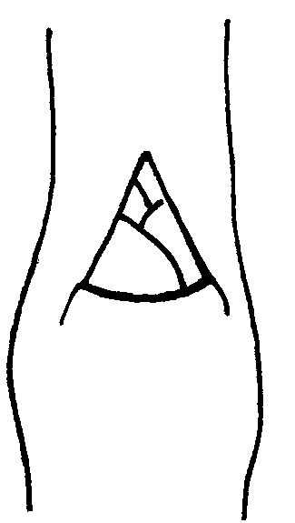 | 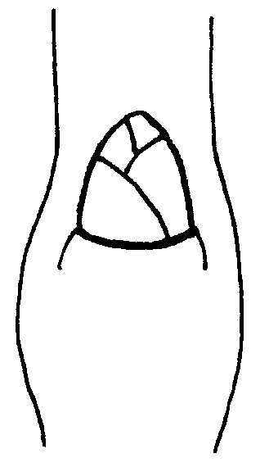 | 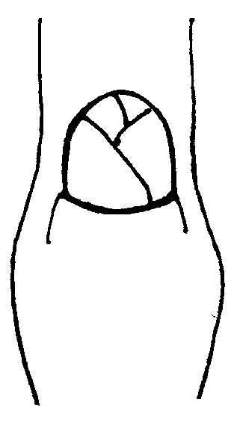
1 | 2 | 3
acute | obtuse | rounded

Ad. 8: One-year-old shoot: position of vegetative bud in relation to shoot

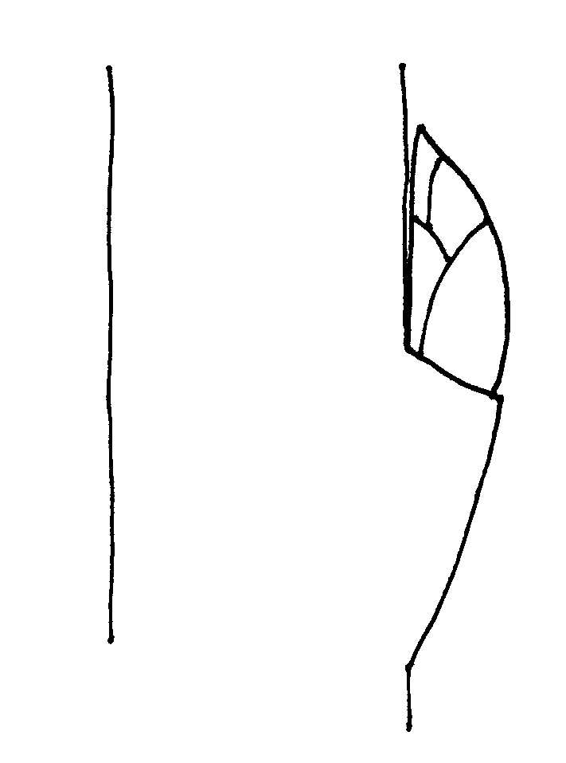 | 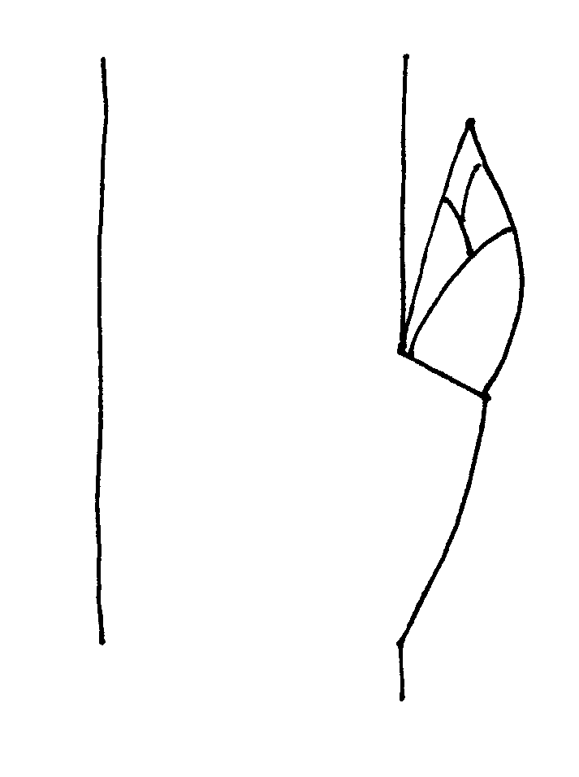 | 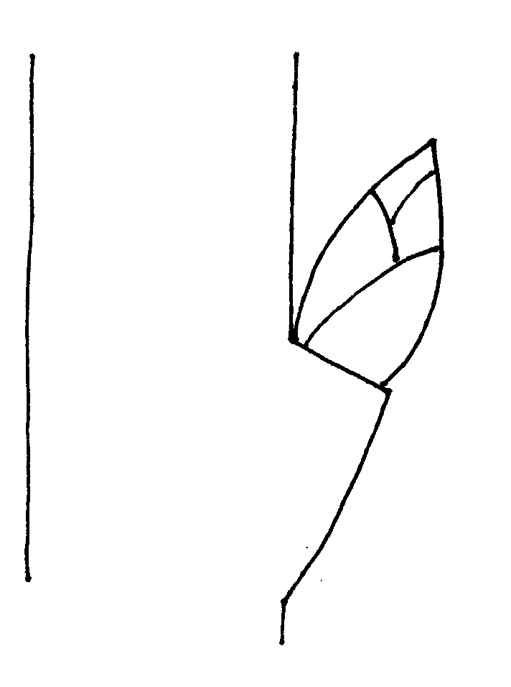
1 | 2 | 3
adpressed | slightly held out | markedly held out

Ad. 12: Leaf blade: shape

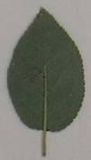 | 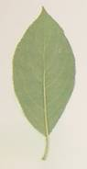 | 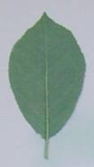
1 | 2 | 3
ovate | elliptic | obovate

Ad. 14: Leaf blade: angle of apex (excluding tip)

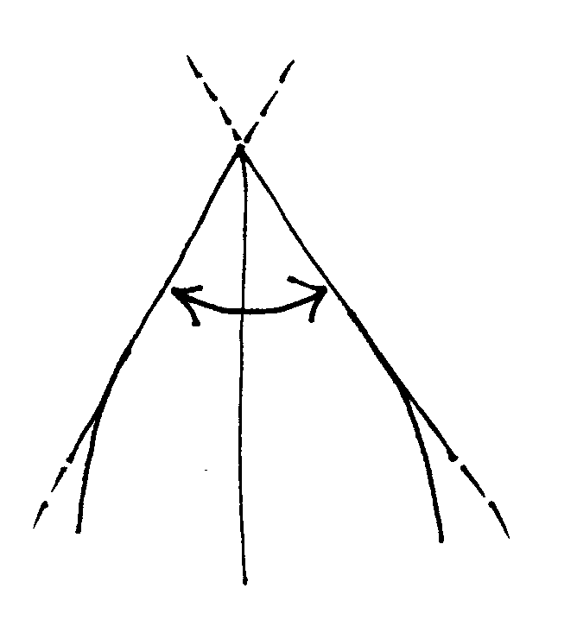 | 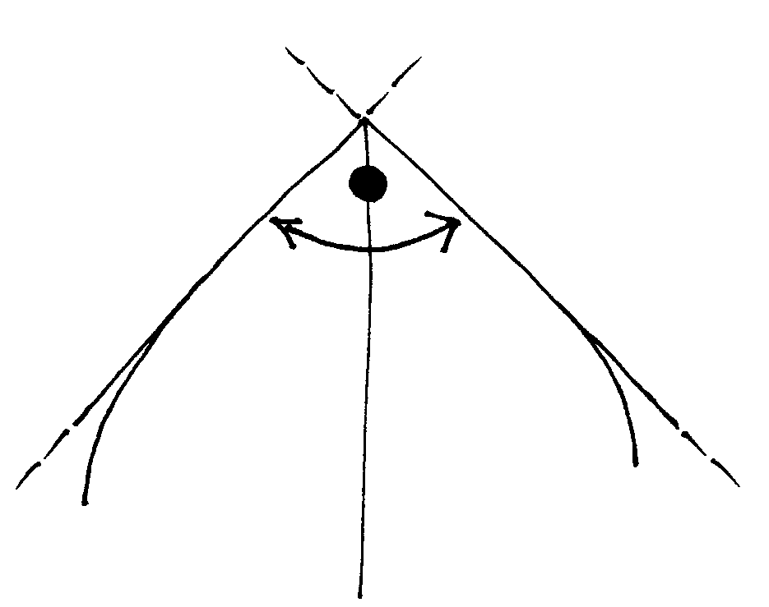 | 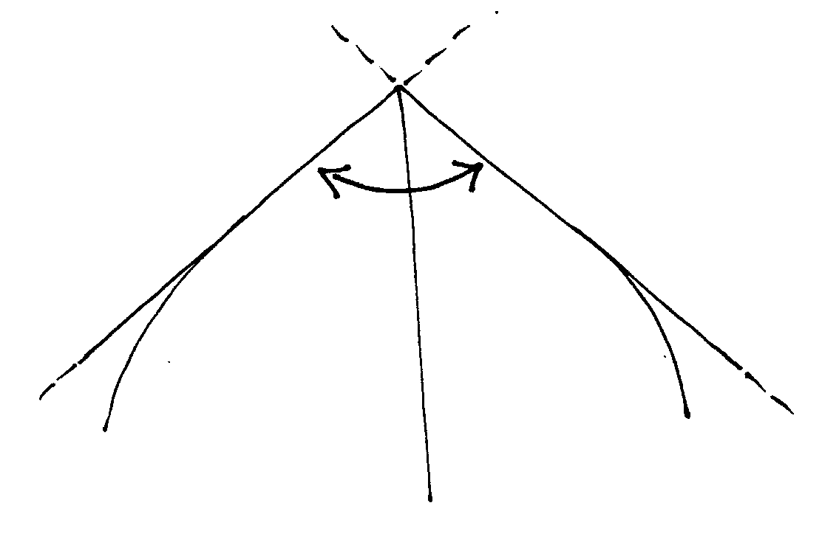
1 | 2 | 3
acute | right angled | obtuse

Ad. 17: Leaf blade: incisions of margin

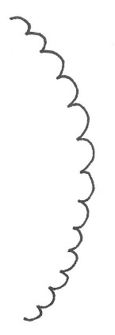 | 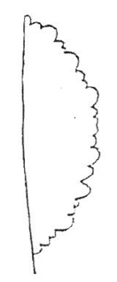 | 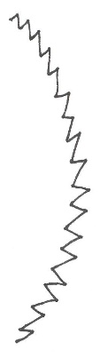
1 | 2 | 3 | 4
crenate | bi-crenate | serrate | bi-serrate

Ad. 20: Pedicel: length

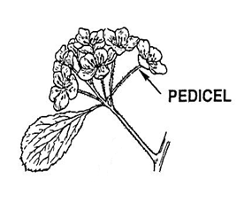

Ad. 22: Flower: arrangement of petals

To be observed solely on flowers which have five petals.

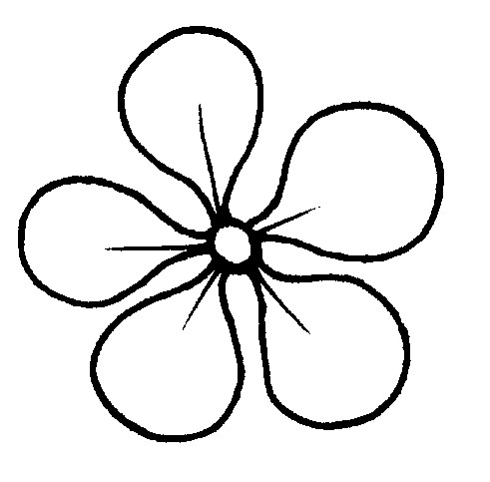 | 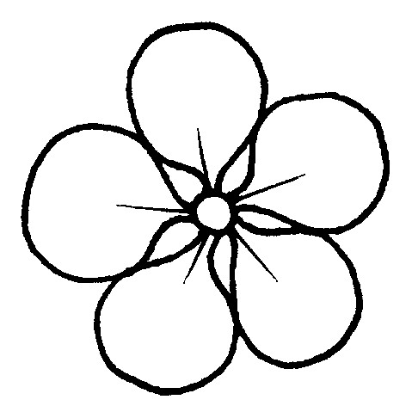 | 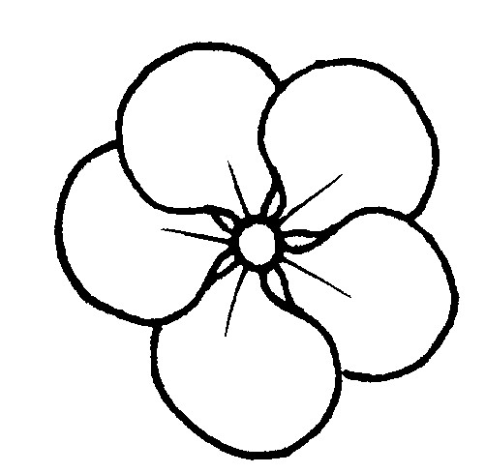
1 | 2 | 3
free | touching | overlapping

Ad. 23: Sepal: shape

 |  | ← broadest part →
 |  | (below middle) | at middle | (above middle)

broad (compressed)←width (ratio length/width) → narrow (elongated)
 |  |  |  | 4
 |  |  |  | narrow elliptic
 |  | (angular)  1 | (rounded)  2 | 5
 |  | triangular | medium ovate | medium elliptic
 |  |  | 3
 |  |  | broad ovate

Ad. 25: Petal: shape

 |  | ← broadest part →
 |  | at middle | (above middle)

broad (compressed) ← width (ratio length/width) → narrow (elongated) |  | 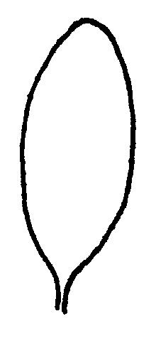
 |  | 1
 |  | elliptic
 |  |  | 
 |  | 2 | 4
 |  | circular | obovate
 |  | 
 |  | 3
 |  | oblate

Ad. 29: Fruit: size

To be observed on the area of the lateral section of the fruit.

Ad. 30: Fruit: height

Height to be observed from ventral view.

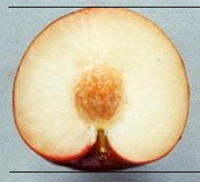

Ad. 31: Fruit: width

Width to be observed from ventral view.

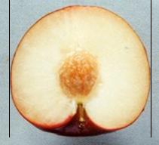

Ad. 32: Fruit: shape in lateral view

 | ← broadest part →
 | (below middle) | at middle | (above middle)
broad (compressed) ← width (ratio length/width → narrow
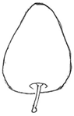 | 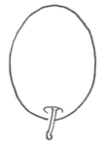
5 | 2
cordate | elliptic
 | 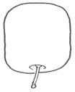 | 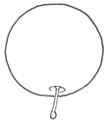 | 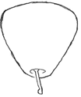 | 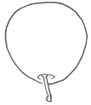
 | 1 | 3 | 7 | 6
 | oblong | circular | obcordate | obovate
 | 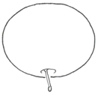
 | 4
 | oblate

Ad. 33: Fruit: symmetry

Symmetry to be observed from ventral view, along suture.

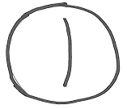 | 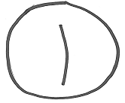 | 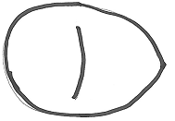
1 | 2 | 3
symmetric or slightly asymmetric | moderately asymmetric | strongly asymmetric

Ad. 34: Fruit: shape of base

1 | 2 | 3
pointed | truncate | depressed

Ad. 35: Fruit: shape of apex

1 | 2 | 3 | 4
pointed | rounded | truncate | depressed

Ad. 37: Fruit: width of stalk cavity

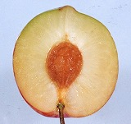 | 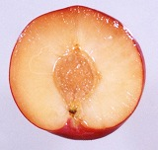 | 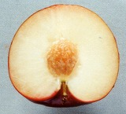
1 | 2 | 3
narrow | medium | broad

Ad. 38: Fruit: depth of suture

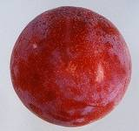 | 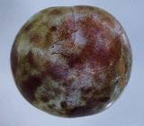 | 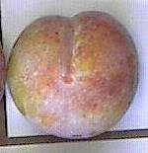
2 | 3 | 4
shallow | medium | deep

Ad. 39: Fruit: bloom of skin

The bloom is the waxy layer that can be removed by rubbing

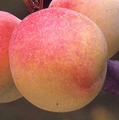 | 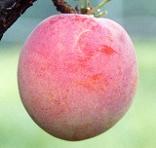 | 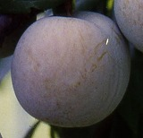
3 | 5 | 7
weak | medium | strong

Ad. 40: Fruit: ground color of skin
Ad. 41: Fruit: relative area of over color
Ad. 42: Fruit: over color of skin

To be observed without the bloom. The ground color is the first color to appear chronologically during the development of the skin and upon which other colors will develop in time in the form of spots, a macule, or a color flush or blush. It is not always necessarily the largest area of the fruit. The over color is the second color developing over time over the ground color. The coloration does not necessarily cover the smallest area of the fruit and consists of a pattern such as a flush or flecking.

Ad. 43: Fruit: pattern of over color

The over color is the second color developing over time over the ground color. The coloration does not necessarily cover the smallest area of the fruit and consists of a pattern such as a flush or flecking.

Ad. 47: Fruit: firmness

To be observed at eating ripeness with a penetrometer (see Ad. 61)

Ad. 48: Fruit: juiciness

The characteristic is observed as the juice content expressed as the percentage of total fruit weight obtained by pressing fruit.

Ad. 49: Fruit: acidity

Calculation of total titratable acidity of a juice sample. The equation is the following:
Ac (g/l) = ( V1 * N * me) / V
V = sample volume in ml
V1 = NaOH volume in ml
N = normality of NaOH
me = equivalent weight of malic acid (67)

Ad. 50: Fruit: sweetness

Calculation of total soluble solids measured using a refractometer. The measured unit is the degree Brix (º Brix). One degree Brix corresponds to 1 gram of sucrose in 100 grams of solution.

Ad. 52: Fruit: amount of fiber

To be observed at eating ripeness. The fruit should be cut in half longitudinally and a visual observation made to see if there are visible fibers in the flesh. The sliced fruit should then be eaten to assess further the amount of fiber.

Ad. 54: Stone: shape in lateral view

← broadest part →
Broad (compressed) width (ratio length/width) narrow (elongated)
(below middle) | at middle |  | (above middle)
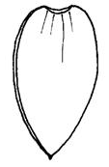
1
narrow elliptic
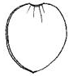 |  | 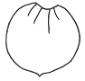
2 |  | 3
medium elliptic |  | circular
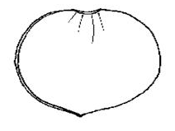
4
broad ovate

Ad. 55: Stone: shape in ventral view

1 | 2 | 3
narrow elliptic | medium elliptic | broad elliptic

Ad. 59: Stone: width of stalk-end

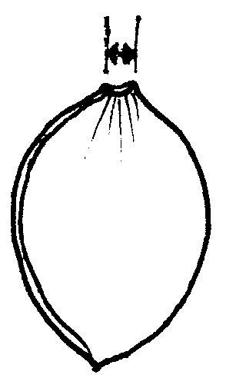 | 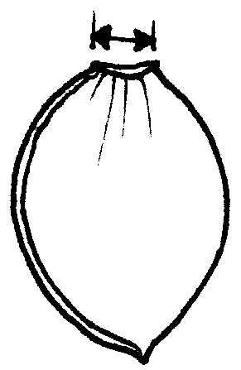 | 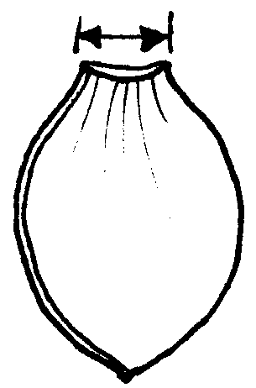
1 | 2 | 3
narrow | medium | broad

Ad. 60: Time of beginning of flowering

The time of beginning of flowering is when all trees have 10% open flowers.

Ad. 61: Time of beginning of fruit ripening

The time of fruit ripening should be considered as the time of eating ripeness, when the fruit is most easily removed from the tree.

Literature

No specific literature.

Technical Questionnaire
TECHNICAL QUESTIONNAIRE |  | Page {x} of {y} | Reference Number:
 |  |  | Application date:
 |  |  | (not to be filled in by the applicant)
TECHNICAL QUESTIONNAIRE
to be completed in connection with an application for plant breeders’ rights

1. Subject of the Technical Questionnaire
1.1 Botanical name | Prunus salicina Lindl.
1.2 Common name | Japanese plum
2. Applicant
Name
Address
Telephone No.
Fax No.
E-mail address
Breeder (if different from applicant)
3. Proposed denomination and breeder’s reference
Proposed denomination
(if available)

Breeder’s reference
#4. Information on the breeding scheme and propagation of the variety

4.1 Breeding scheme

Variety resulting from:

4.1.1 Crossing

(a) controlled cross [ ]
(please state parent varieties)

(…………………..……………..…) x (……………..…………………..…)
female parent male parent

(b) partially known cross [ ]
(please state known parent variety(ies))

(…………………..……………..…) x (……………..…………………..…)
female parent male parent

(c) unknown cross [ ]

4.1.2 Mutation [ ]
(please state parent variety)

4.1.3 Discovery and development [ ]
(please state where and when discovered and how developed)

4.1.4 Other [ ]
(please provide details)

4.2 Method of propagating the variety

4.2.1 Vegetative propagation

(a) cuttings [ ]

(b) in vitro propagation [ ]

(c) other (state method) [ ]

4.2.2 Other [ ]
(please provide details)

TECHNICAL QUESTIONNAIRE |  |  | Page {x} of {y} |  | Reference Number:
5. Characteristics of the variety to be indicated (the number in brackets refers to the corresponding characteristic in Test Guidelines; please mark the note which best corresponds).

 | Characteristics |  |  |  |  | Example Varieties |  | Note
5.1  (2) | Tree: vigor
 | weak |  |  |  |  |  |  | 1[ ]
 | very weak to weak |  |  |  |  |  |  | 2[ ]
 | weak |  |  |  |  | Black Gold, Satsuma |  | 3[ ]
 | weak to medium |  |  |  |  |  |  | 4[ ]
 | medium |  |  |  |  | Autumn Giant, Suplumeleven |  | 5[ ]
 | medium to strong |  |  |  |  |  |  | 6[ ]
 | strong |  |  |  |  | Robusto, Royal Diamond, Taiyou |  | 7[ ]
 | strong to very strong |  |  |  |  |  |  | 8[ ]
 | very strong |  |  |  |  |  |  | 9[ ]
5.2  (5) | Spur: length
 | very short |  |  |  |  |  |  | 1[ ]
 | very short to short |  |  |  |  |  |  | 2[ ]
 | short |  |  |  |  | Laroda, Sordum |  | 3[ ]
 | short to medium |  |  |  |  |  |  | 4[ ]
 | medium |  |  |  |  | Frontier |  | 5[ ]
 | medium to long |  |  |  |  |  |  | 6[ ]
 | long |  |  |  |  | October Purple |  | 7[ ]
 | long to very long |  |  |  |  |  |  | 8[ ]
 | very long |  |  |  |  |  |  | 9[ ]
 | Characteristics |  |  |  |  | Example Varieties |  | Note
5.3  (12) | Leaf blade: shape
 | ovate |  |  |  |  |  |  | 1[ ]
 | elliptic |  |  |  |  | Black Gold, October Purple, Syokou, Taiyou |  | 2[ ]
 | obovate |  |  |  |  | Kanro, Kelsey |  | 3[ ]
5.4  (14) | Leaf blade: angle of apex (excluding tip)
 | acute |  |  |  |  | Ozark Premier, Taiyou |  | 1[ ]
 | right angled |  |  |  |  | Satsuma |  | 2[ ]
 | obtuse |  |  |  |  | Methley |  | 3[ ]
5.5  (20) | Pedicel: length
 | very short |  |  |  |  |  |  | 1[ ]
 | very short to short |  |  |  |  |  |  | 2[ ]
 | short |  |  |  |  | Methley |  | 3[ ]
 | short to medium |  |  |  |  |  |  | 4[ ]
 | medium |  |  |  |  | Queen Ann, Shiro |  | 5[ ]
 | medium to long |  |  |  |  |  |  | 6[ ]
 | long |  |  |  |  | Red Ace, Taiyou |  | 7[ ]
 | long to very long |  |  |  |  |  |  | 8[ ]
 | very long |  |  |  |  |  |  | 9[ ]
 | Characteristics |  |  |  |  | Example Varieties |  | Note
5.6  (21) | Flower: diameter
 | very small |  |  |  |  |  |  | 1[ ]
 | very small to small |  |  |  |  |  |  | 2[ ]
 | small |  |  |  |  | Black Gold, Nubiana |  | 3[ ]
 | small to medium |  |  |  |  |  |  | 4[ ]
 | medium |  |  |  |  | October Purple, Shiro, Taiyou |  | 5[ ]
 | medium to large |  |  |  |  |  |  | 6[ ]
 | large |  |  |  |  | Kiyou, Methley,  Ozark Premier |  | 7[ ]
 | large to very large |  |  |  |  |  |  | 8[ ]
 | very large |  |  |  |  |  |  | 9[ ]
5.7  (29) | Fruit: size
 | very small |  |  |  |  | Methley |  | 1[ ]
 | very small to small |  |  |  |  |  |  | 2[ ]
 | small |  |  |  |  | Allo, Eldorado |  | 3[ ]
 | small to medium |  |  |  |  |  |  | 4[ ]
 | medium |  |  |  |  | Shiro |  | 5[ ]
 | medium to large |  |  |  |  |  |  | 6[ ]
 | large |  |  |  |  | Angeleno, Taiyou |  | 7[ ]
 | large to very large |  |  |  |  |  |  | 8[ ]
 | very large |  |  |  |  | Songold |  | 9[ ]
 | Characteristics |  |  |  |  | Example Varieties |  | Note
5.8  (32) | Fruit: shape in lateral view
 | oblong |  |  |  |  | Reubennel |  | 1[ ]
 | elliptic |  |  |  |  | Ozark Premier, Taiyou |  | 2[ ]
 | circular |  |  |  |  | Red Beauty, Shiro |  | 3[ ]
 | oblate |  |  |  |  | Friar |  | 4[ ]
 | cordate |  |  |  |  | Morettini 355 |  | 5[ ]
 | obovate |  |  |  |  |  |  | 6[ ]
 | obcordate |  |  |  |  | Santa Rosa |  | 7[ ]
5.9  (40) | Fruit: ground color of skin
 | not visible |  |  |  |  | Angeleno |  | 1[ ]
 | green |  |  |  |  | Gaviota, Santa Rosa |  | 2[ ]
 | yellowish-green |  |  |  |  | Songold, Taiyou |  | 3[ ]
 | yellow |  |  |  |  | Shiro |  | 4[ ]
5.10  (42) | Fruit: over color of skin
 | none |  |  |  |  | Golden Japan |  | 1[ ]
 | orange yellow |  |  |  |  | Formosa |  | 2[ ]
 | medium red |  |  |  |  | Red Beauty |  | 3[ ]
 | dark red |  |  |  |  | Starking Delicious, Taiyou |  | 4[ ]
 | purple |  |  |  |  | Karari, Morettini 355 |  | 5[ ]
 | dark blue |  |  |  |  | Laroda |  | 6[ ]
 | black |  |  |  |  | Angeleno |  | 7[ ]
 | Characteristics |  |  |  |  | Example Varieties |  | Note
5.11  (46) | Fruit: color of flesh
 | whitish |  |  |  |  | Taiyou |  | 1[ ]
 | green |  |  |  |  | Reina Claudia |  | 2[ ]
 | yellowish green |  |  |  |  | Shiro |  | 3[ ]
 | yellow |  |  |  |  | Angeleno, Golden Japan, Reubennel |  | 4[ ]
 | orange |  |  |  |  | Black Amber, Sun Gold |  | 5[ ]
 | medium red |  |  |  |  | Satsuma, Sordum |  | 6[ ]
 | dark red |  |  |  |  | Beauty, Hawera, Karari, Stark Delicious |  | 7[ ]
 | purplish |  |  |  |  | Sangue di Drago |  | 8[ ]
5.12  (51) | Fruit: adherence of stone to flesh
 | non-adherent |  |  |  |  | Fortune |  | 1[ ]
 | semi-adherent |  |  |  |  | Nubiana, Taiyou |  | 2[ ]
 | adherent |  |  |  |  | Shiro, Sungold |  | 3[ ]
5.13  (53) | Stone: size
 | very small |  |  |  |  |  |  | 1[ ]
 | very small to small |  |  |  |  |  |  | 2[ ]
 | small |  |  |  |  | Angeleno, Eldorado |  | 3[ ]
 | small to medium |  |  |  |  |  |  | 4[ ]
 | medium |  |  |  |  | Taiyou, Wickson |  | 5[ ]
 | medium to large |  |  |  |  |  |  | 6[ ]
 | large |  |  |  |  | Freedom |  | 7[ ]
 | large to very large |  |  |  |  |  |  | 8[ ]
 | very large |  |  |  |  |  |  | 9[ ]
 | Characteristics |  |  |  |  | Example Varieties |  | Note
5.14 (60) | Time of beginning of flowering
 | very early |  |  |  |  | Durado, Karari, Red Beauty |  | 1[ ]
 | very early to early |  |  |  |  |  |  | 2[ ]
 | early |  |  |  |  | Fortune, Mariposa, Taiyou |  | 3[ ]
 | early to medium |  |  |  |  |  |  | 4[ ]
 | medium |  |  |  |  | Green Sun, Nubiana |  | 5[ ]
 | medium to late |  |  |  |  |  |  | 6[ ]
 | late |  |  |  |  | Gaviota, Shiro |  | 7[ ]
 | late to very late |  |  |  |  |  |  | 8[ ]
 | very late |  |  |  |  | Angeleno, Simka |  | 9[ ]
5.15 (61) | Time of beginning of fruit ripening
 | very early |  |  |  |  | Beauty, Durado, Red Noble |  | 1[ ]
 | very early to early |  |  |  |  |  |  | 2[ ]
 | early |  |  |  |  | Mariposa, Shiro |  | 3[ ]
 | early to medium |  |  |  |  |  |  | 4[ ]
 | medium |  |  |  |  | Black Gold, Gaviota |  | 5[ ]
 | medium to late |  |  |  |  |  |  | 6[ ]
 | late |  |  |  |  | Angeleno, Nubiana, Taiyou |  | 7[ ]
 | late to very late |  |  |  |  |  |  | 8[ ]
 | very late |  |  |  |  | Akihime, Autumn Giant, Golden King |  | 9[ ]
6. Similar varieties and differences from these varieties

Please use the following table and box for comments to provide information on how your candidate variety differs from the variety (or varieties) which, to the best of your knowledge, is (or are) most similar. This information may help the examination authority to conduct its examination of distinctness in a more efficient way.

Denomination(s) of variety(ies) similar to your candidate variety |  | Characteristic(s) in which your candidate variety differs from the similar variety(ies) |  | Describe the expression of the characteristic(s) for the similar variety(ies) |  |  | Describe the expression of the characteristic(s) for your candidate variety
Angeleno |  | Fruit: ground color of skin |  | Not visible |  |  | Green
Comments:

#7. Additional information which may help in the examination of the variety

7.1 In addition to the information provided in sections 5 and 6, are there any additional characteristics which may help to distinguish the variety?

Yes [ ] No [ ]

(If yes, please provide details)

7.2 Are there any special conditions for growing the variety or conducting the examination?

Yes [ ] No [ ]

(If yes, please provide details)

7.3 Other information

A representative color image of the variety should accompany the Technical Questionnaire.

8. Authorization for release

(a) Does the variety require prior authorization for release under legislation concerning the protection of the environment, human and animal health?

Yes [ ] No [ ]

(b) Has such authorization been obtained?

Yes [ ] No [ ]

If the answer to (b) is yes, please attach a copy of the authorization.

9. Information on plant material to be examined or submitted for examination.

9.1 The expression of a characteristic or several characteristics of a variety may be affected by factors, such as pests and disease, chemical treatment (e.g. growth retardants or pesticides), effects of tissue culture, different rootstocks, scions taken from different growth phases of a tree, etc.

9.2 The plant material should not have undergone any treatment which would affect the expression of the characteristics of the variety, unless the competent authorities allow or request such treatment. If the plant material has undergone such treatment, full details of the treatment must be given. In this respect, please indicate below, to the best of your knowledge, if the plant material to be examined has been subjected to:

(a) Microorganisms (e.g. virus, bacteria, phytoplasma) Yes [ ] No [ ]

(b) Chemical treatment (e.g. growth retardant, pesticide) Yes [ ] No [ ]

(c) Tissue culture Yes [ ] No [ ]

(d) Other factors Yes [ ] No [ ]

Please provide details for where you have indicated “yes”.

……………………………………………………………

9.3 Has the plant material to be examined been tested for the presence of virus or other pathogens?

Yes [ ]
(please provide details as specified by the Authority)

No [ ]

10. I hereby declare that, to the best of my knowledge, the information provided in this form is correct:

Applicant’s name

Signature Date

[End of document]

* These names were correct at the time of the introduction of these Test Guidelines but may be revised or updated. [Readers are advised to consult the UPOV Code, which can be found on the UPOV Website (www.upov.int), for the latest information.]
## Authorities may allow certain of this information to be provided in a confidential section of the Technical Questionnaire.
# #Authorities may allow certain of this information to be provided in a confidential section of the Technical Questionnaire.

