 |  | E  TG/82/4

INTERNATIONAL UNION FOR THE PROTECTION  OF NEW VARIETIES OF PLANTS | UNION INTERNATIONALE POUR LA PROTECTION  DES OBTENTIONS VÉGÉTALES | INTERNATIONALER VERBAND ZUM SCHUTZ VON PFLANZEN-ZÜCHTUNGEN | UNIÓN INTERNACIONAL PARA LA PROTECCIÓN  DE LAS OBTENCIONES VEGETALES

GUIDELINES

FOR THE CONDUCT OF TESTS

FOR DISTINCTNESS, UNIFORMITY AND STABILITY

CELERY, STALK CELERY
Apium graveolens L. var. dulce (Mill.) Pers.
CUTTING CELERY, LEAF CELERY, SMALLAGE
Apium graveolens L. var. secalinum Alef.

GENEVA
2002

Copies of this document are available on request at the price of 10 Swiss francs each, including surface mail, from the Office of UPOV, 34, chemin des Colombettes, P.O. Box 18, 1211 Geneva 20, Switzerland

This document or parts of it may be reproduced, translated and published without obtaining the specific consent of UPOV, provided that the source is acknowledged.

* * * * * * *
E
TG/82/4
ORIGINAL: English
DATE: 2002-04-17

INTERNATIONAL UNION FOR THE PROTECTION  OF NEW VARIETIES OF PLANTS | UNION INTERNATIONALE POUR LA PROTECTION  DES OBTENTIONS VÉGÉTALES | INTERNATIONALER VERBAND ZUM SCHUTZ VON PFLANZEN-ZÜCHTUNGEN | UNIÓN INTERNACIONAL PARA LA PROTECCIÓN  DE LAS OBTENCIONES VEGETALES

GUIDELINES

FOR THE CONDUCT OF TESTS

FOR DISTINCTNESS, UNIFORMITY AND STABILITY

CELERY, STALK, CELERY
Apium graveolens L. var. dulce (Mill.) Pers.
CUTTING CELERY, LEAF CELERY, SMALLAGE
Apium graveolens L. var. secalinum Alef.

These Guidelines should be read in conjunction with document TG/1/2, which contains explanatory notes on the general principles on which the Guidelines have been established.

TABLE OF CONTENTS PAGE

I. Subject of these Guidelines 3

II. Material Required 3

III. Conduct of Tests 3

IV. Methods and Observations 3

V. Grouping of Varieties 4

VI. Characteristics and Symbols 4

VII. Table of Characteristics 5

VIII. Explanations on the Table of Characteristics 10

IX. Literature 13

X. Technical Questionnaire 14

I. Subject of these Guidelines

These Guidelines apply to all varieties of Apium graveolens L. var. dulce (Mill.) Pers. (Celery/Stalk Celery) and Apium graveolens L. var. secalinum Alef. (Cutting Celery, Leaf Celery, Smallage).

II. Material Required

1. The competent authorities decide when, where and in what quantity and quality the seed required for testing the variety is to be delivered. Applicants submitting material from a State other than that in which the testing takes place must ensure that all customs formalities are complied with. As a minimum, for each year of the test the following quantity of seed is recommended:

6 g.

2. The seed should meet the minimum requirements for germination, species and analytical purity, health and moisture content, specified by the competent authority. In cases where the seed is to be stored, the germination capacity should be as high as possible and should be stated by the applicant

3. The plant material must not have undergone any treatment unless the competent authorities allow or request such treatment. If it has been treated, full details of the treatment must be given.

III. Conduct of Tests

1. The minimum duration of tests should normally be two independent growing cycles.

2. The tests should normally be conducted at one place. If any important characteristics of the variety cannot be seen at that place, the variety may be tested at an additional place.

3. The tests should be carried out under conditions ensuring satisfactory growth for the expression of the relevant characteristics of the variety and for the conduct of the examination. The size of the plots should be such that plants or parts of plants may be removed for measurement and counting without prejudice to the observations which must be made up to the end of the growing period. Each test should be designed to result in a total of at least 60 plants, which should be divided between two or more replicates. Separate plots for observation and for measuring can only be used if they have been subject to similar environmental conditions.

4. Additional tests for special purposes may be established.

IV. Methods and Observations

1. Unless otherwise indicated, all observations determined by measurement, weighing or counting should be made on 30 plants or parts taken from each of 30 plants.

2. The assessment of uniformity for cross-pollinated varieties should be according to the recommendations in the General Introduction. The assessment of uniformity for hybrid varieties depends on the type of hybrid and should be according to the recommendations in the General Introduction.

3. The petioles of plants grown should not be covered with additional soil (“earthed up”).

4. All observations on the plant and the leaf should be made on fully developed plants before harvest maturity.

V. Grouping of Varieties

1. The collection of varieties to be grown should be divided into groups to facilitate the assessment of distinctness. Characteristics which are suitable for grouping purposes are those which are known from experience not to vary, or to vary only slightly, within a variety. Their various states of expression should be fairly evenly distributed throughout the collection.

2. It is recommended that the competent authorities use the following characteristics for grouping varieties:

- Petiole: anthocyanin coloration (characteristic 14);
- Petiole: self-blanching (characteristic 20).

VI. Characteristics and Symbols

1. To assess distinctness, uniformity and stability, the characteristics and their states as given in the Table of Characteristics should be used.

2. Notes (numbers), for the purposes of electronic data processing, are given opposite the states of expression for each characteristic.

3. Legend:

(*) Characteristics that should be used on all varieties in every growing period over which the examinations are made and always be included in the variety descriptions, except when the state of expression of a preceding characteristic or regional environmental conditions render this impossible.

(+) See Explanations on the Table of Characteristics in Chapter VIII.

VII. Table of Characteristics/Tableau des caractères/Merkmalstabelle/Tabla de caracteres

 | English | français | deutsch | español | Example Varieties  Exemples  Beispielssorten  Variedades ejemplo | Note/  Nota
1.  (*) | Plant: height | Plante: hauteur | Pflanze: Höhe | Planta: altura
 | very short | très basse | sehr niedrig | muy baja | Afina | 1
 | short | basse | niedrig | baja | Claudius | 3
 | medium | moyenne | mittel | media | Green Sleeves | 5
 | tall | haute | hoch | alta | Martine | 7
 | very tall | très haute | sehr hoch | muy alta | Giant Red | 9
2. | Plant: number of lateral shoots | Plante: nombre de tiges latérales | Pflanze: Anzahl Seitentriebe | Planta: número de tallos laterales
 | absent of very few | nul ou très petit | fehlend oder  sehr gering | ausente o muy bajo | Ideal | 1
 | few | petit | gering | bajo | Summit | 3
 | medium | moyen | mittel | medio | Groene Pascal | 5
 | many | grand | groß | alto | Del Valdarno | 7
3.  (*) | Foliage: attitude | Feuillage: port | Laub: Haltung | Follaje: porte
 | erect | dressé | aufrecht | erecto | Autumn Gold | 1
 | erect to semi-erect | dressé à demi-dressé | aufrecht bis halbaufrecht | erecto a semierecto | Green Sleeves | 2
 | semi-erect | demi-dressé | halbaufrecht | semierecto | Shamrock | 3
 | semi-erect to horizontal | demi-dressé à horizontal | halbaufrecht bis waagerecht | semierecto a horizontal | Amsterdam Donkergroene | 4
 | horizontal | horizontal | waagerecht | horizontal | Martine | 5
4. | Foliage: number of leaves | Feuillage: nombre de feuilles | Laub: Anzahl Blätter | Follaje: número de hojas
 | few | petit | gering | bajo | Gigante di Romagna | 3
 | medium | moyen | mittel | medio | Green Sleeves | 5
 | many | grand | groß | alto | Ideal | 7
5.  (*) | Foliage: intensity of green color (excluding petioles) | Feuillage: intensité de la couleur verte (à l’exclusion des pétioles) | Laub: Intensität der Grünfärbung  (ohne Blattstiele) | Follaje: intensidad del color verde (excluidos los pecíolos)
 | very light | très claire | sehr hell | muy claro | Ivory Tower | 1
 | light | claire | hell | claro | Victoria | 3
 | medium | moyenne | mittel | medio | Multipak | 5
 | dark | foncée | dunkel | oscuro | Mammoth White; Giant Red | 7
6. | Foliage: glossiness | Feuillage: brillance | Laub: Glanz | Follaje: brillo
 | weak | faible | gering | débil | Ramon | 3
 | medium | moyenne | mittel | medio | Lino | 5
 | strong | forte | stark | fuerte | Golden Spartan | 7
7. | Foliage: blistering | Feuillage: cloqûre | Laub: Blasigkeit | Follaje: abullonado
 | absent or very weak | nulle ou très faible | fehlend oder  sehr gering | ausente o muy débil | Amsterdam Donkergroene | 1
 | weak | faible | gering | débil | Florida 683; Giant Red | 3
 | medium | moyenne | mittel | medio | Lino | 5
 | strong | forte | stark | fuerte | Groene Pascal | 7
8.  (*) (+) | Leaf: length (including petiole) | Feuille: longueur (pétiole compris) | Blatt: Länge (einschließlich Blattstiel) | Hoja: longitud (incluido el pecíolo)
 | short | courte | kurz | corta | Golden Spartan | 3
 | medium | moyenne | mittel | media | Celebrity | 5
 | long | longue | lang | larga | Martine | 7
9.  (+) | Leaf: distance between 1st and 2nd leaflet pairs | Feuille: distance entre la 1re et la 2e paire de folioles | Blatt: Abstand zwischen 1. und 2. Blattfiederpaar | Hoja: distancia entre el 1º y 2º par de folíolos
 | short | courte | kurz | corta | Claudius, Early Spring | 3
 | medium | moyenne | mittel | media | Greensleeves, Octavius | 5
 | long | longue | lang | larga | Florida 683, Groene Pascal | 7
10.  (*)  (+) | Leaf: size of the terminal leaflet | Feuille: taille de la foliole terminale | Blatt: Größe des Endfiederblattes | Hoja: tamaño del folíolo terminal
 | small | petite | klein | pequeño | Giant Red, Stardust | 3
 | medium | moyenne | mittel | medio | Shamrock | 5
 | large | grande | groß | grande | Early Spring | 7
11.  (*)  (+) | Leaflet: shape of tips on margin | Foliole: forme des pointes du bord | Blattfieder: Form der Spitzen des Randes | Folíolo: forma de las puntas del borde
 | acute | pointues | zugespitzt | agudas | Trinova, Bolivar | 1
 | rounded | arrondies | abgerundet | redondeadas | D’Elne | 2
12.  (+) | Leaflet: density of margin incisions | Foliole: densité des incisions du bord | Blattfieder: Dichte der Randeinschnitte | Folíolo: densidad de las incisiones del borde
 | sparse | lâche | locker | laxa | Multipak | 3
 | medium | moyenne | mittel | media | Del Valdarno | 5
 | dense | dense | dicht | densa | Golden Spartan | 7
13.  (*)  (+) | Leaflet: spacing of lobes | Foliole: espacement entre les lobes | Blattfieder: Abstand zwischen den Lappen | Folíolo: espaciado entre los lóbulos
 | not touching | ne se touchent pas | sich nicht berührend | sin tocarse | Golden Spartan, Uta | 1
 | touching | se touchent | sich berührend | tocándose | Early Spring, Victoria | 2
 | overlapping | se chevauchent | überlappend | solapados | Claudius | 3
14.  (*) | Petiole: anthocyanin coloration | Pétiole: pigmentation anthocyanique | Blattstiel: Anthocyanfärbung | Pecíolo: pigmentación antociánica
 | absent | absente | fehlend | ausente | Golden Spartan | 1
 | present | présente | vorhanden | presente | Giant Red | 9
15. | Petiole: intensity of anthocyanin coloration | Pétiole: intensité de la pigmentation anthocyanique | Blattstiel:  Intensität der Anthocyanfärbung | Pecíolo: intensidad de la pigmentación antociánica
 | weak | faible | gering | débil | Giant Pink | 3
 | medium | moyenne | mittel | media | Ideal | 5
 | strong | forte | stark | fuerte | Giant Red | 7
16.  (*)  (+) | Petiole: length | Pétiole: longueur | Blattstiel: Länge | Pecíolo: longitud
 | short | court | kurz | corto | Oscar | 3
 | medium | moyen | mittel | medio | Groene Pascal | 5
 | long | long | lang | largo | Giant Red | 7
17.  (+) | Petiole: width | Pétiole: largeur | Blattstiel: Breite | Pecíolo: anchura
 | narrow | étroit | schmal | estrecho | Ideal | 3
 | medium | moyen | mittel | medio | Green Sleeves | 5
 | broad | large | breit | ancho | Top Seller | 7
18. | Petiole: prominence of ribs | Pétiole: relief des côtes | Blattstiel: Ausprägung der Rippen | Pecíolo: prominencia de las costillas
 | absent or very weak | nul ou très faible | fehlend oder sehr gering | ausente o muy débil | Plein blanc Lepage | 1
 | weak | faible | gering | débil | Golden Self-Blanching | 3
 | medium | moyen | mittel | medio | Victoria | 5
 | strong | fort | stark | fuerte | Claudius | 7
19.  (+) | Petiole: profile of inner side in cross section | Pétiole: profil de la face interne en section transversale | Blattstiel: Profil der Innenseite im Querschnitt | Pecíolo: perfil de la cara interna en sección transversal
 | straight | droit | gerade | recta | D’Elne | 1
 | slightly concave | légèrement concave | leicht konkav | ligeramente cóncava | Groene Pascal | 2
 | strongly concave | fortement concave | stark konkav | fuertemente cóncava | Green Sleeves | 3
20.  (*) | Petiole: self-blanching | Pétiole: blanchiment naturel | Blattstiel: Selbstbleichung | Pecíolo: autoblanqueo
 | absent | absent | fehlend | ausente | Groene Pascal | 1
 | present | présent | vorhanden | presente | Autumn Gold | 9
21. | Only non self-blanching varieties: Petiole: intensity of green color | Seulement les variétés n’ayant pas un blanchiment naturel: Pétiole: intensité de la couleur verte | Nur nicht-selbstbleichende Sorten: Blattstiel: Intensität der Grünfärbung | Sólo variedades que no son de autoblanqueo: Pecíolo: intensidad del color verde
 | light | claire | hell | claro | Autumn Gold | 3
 | medium | moyenne | mittel | medio | Green Sleeves | 5
 | dark | foncée | dunkel | oscuro | Giant Red | 7

VIII. Explanations on the Table of Characteristics

Ad. 8, 9, 10, 16, 17

10  Leaf: length (including petiole) (8) | 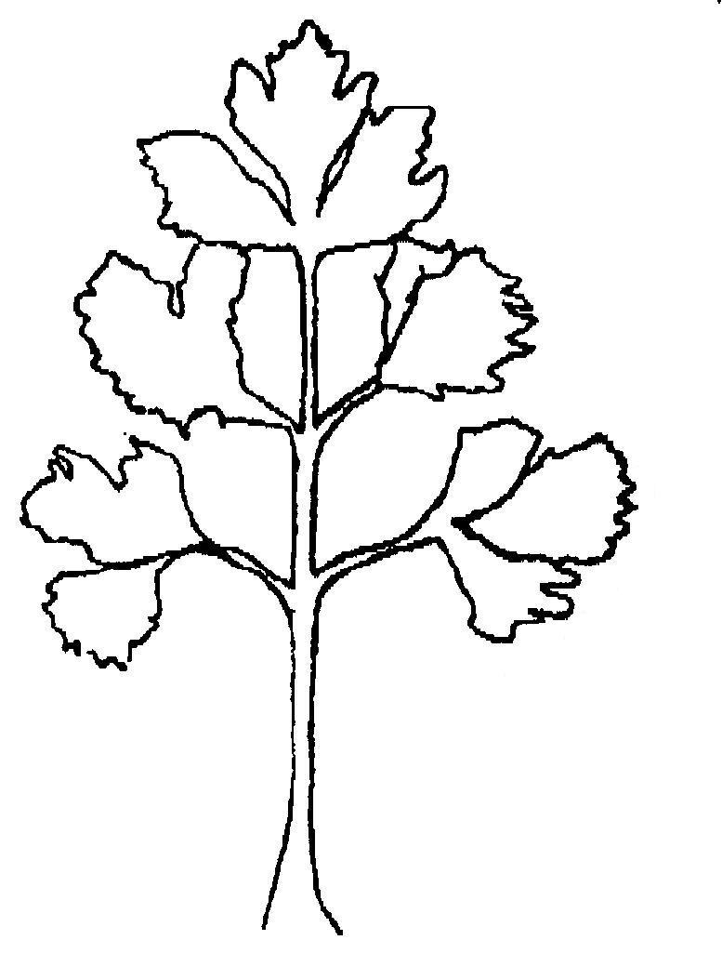
8

Leaf: distance between
1st and 2nd pair of
leaflets (9)

9
16

Leaf: size of the terminal leaflet (10)
170

Petiole: length (16)
width (17)

Ad. 11: Leaflet: shape of tips on margin
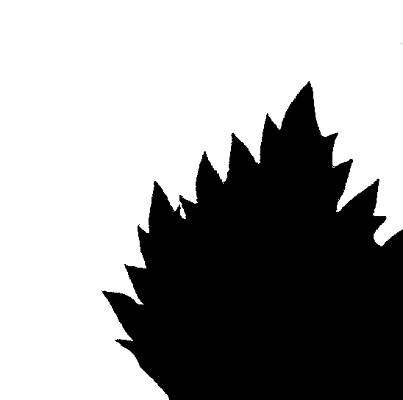
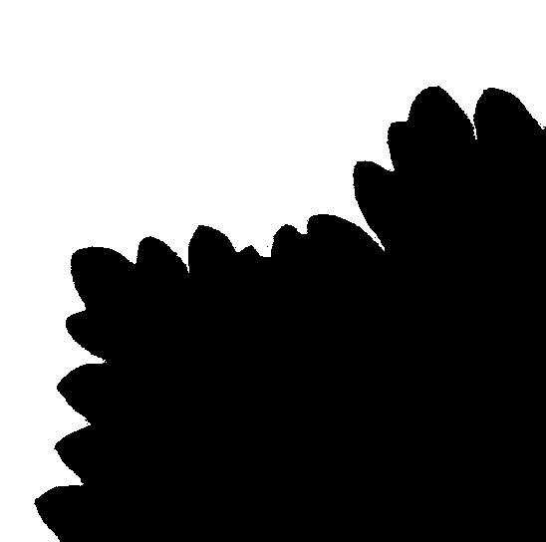

1 | 2
acute | rounded

Ad. 12: Leaflet: density of margin incisions

    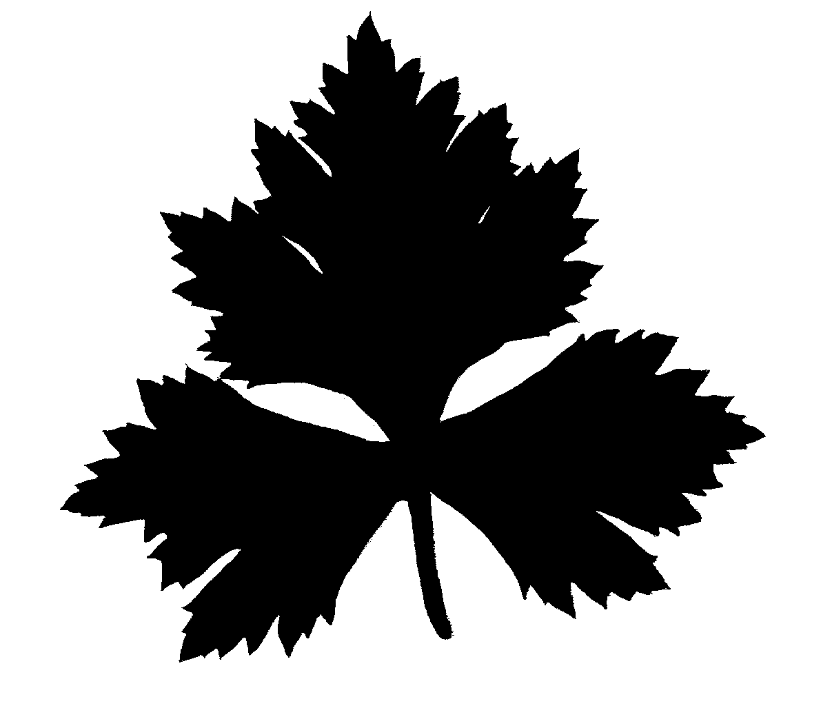  3 | 5 | 7
sparse | medium | dense

Ad. 13: Leaflet: spacing of lobes





1 | 2 | 3
not touching | touching | overlapping

Ad. 19: Petiole: profile of inner side in cross section

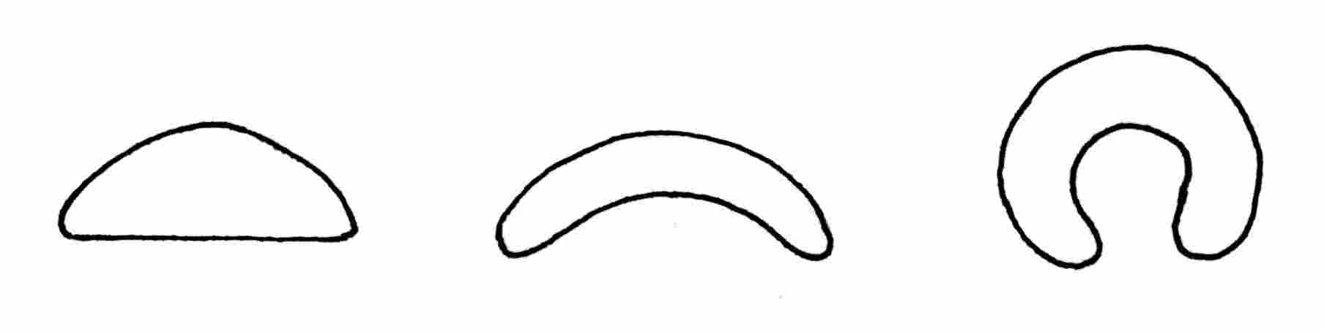

1 2 3
straight slightly concave strongly concave

IX. Literature

Becker-Dillingen, 3 (1956): Sellerie in: Handbuch des gesamten Gemüsebaues, 6. Auflage, Paul Parey Verlag, Berlin – Hamburg, 592-613.

Benoit, F., Kinet, J.M., Ceustermans, N. (1978): Induction, suppression or prevention of vernalisation in self-blanching celery (Apium graveolens var. dulce). Agricultura. 26, 163-182.

Davis, R.M., Raid, R.N. (Eds) (2002): Compendium of Umbelliferous Crop Diseases. The American Phytopathological Society. St. Paul, Minnesota. ISBN: 0-89054-287-2

Kampe, K.; Basse, H.; Glaschke, B., Schreiber, F. (1956): Sellerie in: Gemüsesorten, II. Teil (Kohl-, Blatt- und Wurzelgemüse), 1. Auflage, Paul Parey Verlag, Berlin – Hamburg, 115-119.

Quiros, C.F. (1993): Celery – Apium graveolens L. In Kalloo, G. and Bergh, B.O. (eds) Genetic Improvement of Vegetable Crops. Pergamon Press, Oxford. 523-534.

Ramin, A.A., Atherton, J.G. (1991): Manipulation of bolting and flowering in Celery (Apium graveolens var. dulce). 1. Effects of chilling during germination and seed development. Journal of Horticultural Science. 66 (4) 435-441.

Ramin, A.A., Atherton, J.G. (1991): Manipulation of bolting and flowering in Celery (Apium graveolens var. dulce). III. Effects of photoperiod and irradiance. Journal of Horticultural Science. 69 (5) 861-868.

Rubatksky, V.E., Quiros, C.F., Simon, P.W. (1999): Carrots and related vegetable Umbelliferae. Crop Production Science in Horticulture Series; 10. CABI Publishing. Wallingford & New York. ISBN 0 85199 1297.
X. Technical Questionnaire

 |  |  |  |  |  | Reference Number
 |  |  |  |  |  | (not to be filled in by the applicant)
TECHNICAL QUESTIONNAIRE
to be completed in connection with an application for plant breeders’ rights

1. Species Apium graveolens L. var. dulce (Mill.) Pers.

CELERY, STALK CELERY

Apium graveolens L. var. secalinum Alef.

Cutting Celery, Leaf Celery, Smallage

2. Applicant (Name and address)

3. Proposed denomination or breeder’s reference

4. Information on origin, maintenance and reproduction of the variety

4.1 Method of maintenance and reproduction

(a) hybrid [ ]

(b) open-pollinated [ ]

(c) other (please, indicate) [ ]

4.2 Other information

5. Characteristics of the variety to be given (the number in brackets refers to the corresponding characteristics in the Test Guidelines; please mark the state of expression which best corresponds).

 | Characteristics |  |  |  | Example Varieties |  |  | Note
5.1  (1) | Plant: height
 | very short |  |  |  | Afina |  |  | 1 [ ]
 | short |  |  |  | Claudius |  |  | 3 [ ]
 | medium |  |  |  | Green Sleeves |  |  | 5 [ ]
 | tall |  |  |  | Martine |  |  | 7 [ ]
 | very tall |  |  |  | Giant Red |  |  | 9 [ ]
5.2  (3) | Foliage: attitude
 | erect |  |  |  | Autumn Gold |  |  | 1 [ ]
 | erect to semi-erect |  |  |  | Green Sleeves |  |  | 2 [ ]
 | semi-erect |  |  |  | Shamrock |  |  | 3 [ ]
 | semi-erect to horizontal |  |  |  | Amsterdam Donkergroene |  |  | 4 [ ]
 | horizontal |  |  |  | Martine |  |  | 5 [ ]
5.3  (10) | Leaf blade: size of the terminal leaflet
 | small |  |  |  | Giant Red, Stardust |  |  | 3 [ ]
 | medium |  |  |  | Shamrock |  |  | 5 [ ]
 | large |  |  |  | Early Spring |  |  | 7 [ ]
 | Characteristics |  |  |  | Example Varieties |  |  | Note
5.4  (11) | Leaflet: shape of tips on margin
 | acute |  |  |  | Trinova, Bolivar |  |  | 1 [ ]
 | rounded |  |  |  | D’Elne |  |  | 2 [ ]
5.5  (13) | Leaflet: spacing of lobes
 | not touching |  |  |  | Golden Spartan, Uta |  |  | 1 [ ]
 | touching |  |  |  | Early Spring, Victoria |  |  | 2 [ ]
 | overlapping |  |  |  | Claudius |  |  | 3 [ ]
5.6  (14) | Petiole: anthocyanin coloration
 | absent |  |  |  | Golden Spartan |  |  | 1 [ ]
 | present |  |  |  | Giant Red |  |  | 9 [ ]
5.7  (20) | Petiole: self-blanching
 | absent |  |  |  | Groene Pascal |  |  | 1 [ ]
 | present |  |  |  | Autumn Gold |  |  | 9 [ ]
5.8  (21) | Only non self-blanching varieties: Petiole: intensity of green color
 | light |  |  |  | Autumn Gold |  |  | 3 [ ]
 | medium |  |  |  | Green Sleeves |  |  | 5 [ ]
 | dark |  |  |  | Giant Red |  |  | 7 [ ]
6. Similar varieties and differences from these varieties

Denomination of similar variety |  | Characteristic in which the similar variety is different ^{o)} |  | State of expression of similar variety |  |  | State of expression of candidate variety
^{o)} In the case of identical states of expressions of both varieties, please indicate the size of the difference.

7. Additional information which may help to distinguish the variety

7.1 Resistance to pests and diseases

  - Special conditions for the examination of the variety

7.3 Intended main use

(a) leaves (cuttings) [ ]

(b) petioles [ ]

7.4 Other information

A representative photocopy of one or more terminal leaflets in original size of the variety should be included in the Technical Questionnaire.

8. Authorization for release

- Does the variety require prior authorization for release under legislation concerning the protection of the environment, human and animal health?

Yes [ ] No [ ]

- Has such authorization been obtained?

Yes [ ] No [ ]

If the answer to that question is yes, please attach a copy of such an authorization.

[End of document]

