 |  | E  TG/75/7 Rev.  ORIGINAL: English  DATE: 2006-04-05 + 2023-10-24
INTERNATIONAL UNION FOR THE PROTECTION OF NEW VARIETIES OF PLANTS
GENEVA

 | CORNSALAD  UPOV Code: VLRNL_LOC  VLRNL_ERI  Valerianella locusta L.  & Valerianella eriocarpa Desv. | *

GUIDELINES

FOR THE CONDUCT OF TESTS

FOR DISTINCTNESS, UNIFORMITY AND STABILITY

Alternative Names:*
Botanical name | English | French | German | Spanish
Valerianella locusta L. | Cornsalad, Lambs’ Lettuce | Mâche | Feldsalat, Rapunzel, Rapünzchen | Hierba de los canónigos, Lechuga de campo
Valerianella eriocarpa Desv.

The purpose of these guidelines (“Test Guidelines”) is to elaborate the principles contained in the General Introduction (document TG/1/3), and its associated TGP documents, into detailed practical guidance for the harmonized examination of distinctness, uniformity and stability (DUS) and, in particular, to identify appropriate characteristics for the examination of DUS and production of harmonized variety descriptions.

ASSOCIATED DOCUMENTS

These Test Guidelines should be read in conjunction with the General Introduction and its associated TGP documents.

TABLE OF CONTENTS PAGE

1. Subject of these Test Guidelines 3
2. Material Required 3
3. Method of Examination 3
3.1 Number of Growing Cycles 3
3.2 Testing Place 3
3.3 Conditions for Conducting the Examination 3
3.4 Test Design 4
3.5 Number of Plants / Parts of Plants to be Examined 4
3.6 Additional Tests 4
4. Assessment of Distinctness, Uniformity and Stability 4
4.1 Distinctness 4
4.2 Uniformity 5
4.3 Stability 5
5. Grouping of Varieties and Organization of the Growing Trial 5
6. Introduction to the Table of Characteristics 6
6.1 Categories of Characteristics 6
6.2 States of Expression and Corresponding Notes 6
6.3 Types of Expression 6
6.4 Example Varieties 6
6.5 Legend 6
7. Table of Characteristics/Tableau des caractères/Merkmalstabelle/Tabla de caracteres 7
8. Explanations on the Table of Characteristics 12
9. Literature 15
10. Technical Questionnaire 16

Subject of these Test Guidelines
These Test Guidelines apply to all varieties of Valerianella locusta L. and Valerianella eriocarpa Desv.

Material Required
2.1 The competent authorities decide on the quantity and quality of the plant material required for testing the variety and when and where it is to be delivered. Applicants submitting material from a State other than that in which the testing takes place must ensure that all customs formalities and phytosanitary requirements are complied with.

2.2 The material is to be supplied in the form of seed.

2.3 The minimum quantity of plant material, to be supplied by the applicant, should be:

20 grams or 20,000 seeds.

The seed should meet the minimum requirements for germination, species and analytical purity, health and moisture content, specified by the competent authority. In cases where the seed is to be stored, the germination capacity should be as high as possible and should, be stated by the applicant.

2.4 The plant material supplied should be visibly healthy, not lacking in vigor, nor affected by any important pest or disease.

2.5 The plant material should not have undergone any treatment which would affect the expression of the characteristics of the variety, unless the competent authorities allow or request such treatment. If it has been treated, full details of the treatment must be given.

Method of Examination

3.1 Number of Growing Cycles
The minimum duration of tests should normally be two independent growing cycles.

3.2 Testing Place
Tests are normally conducted at one place. In the case of tests conducted at more than one place, guidance is provided in TGP/9 “Examining Distinctness”.

3.3 Conditions for Conducting the Examination
3.3.1 The tests should be carried out under conditions ensuring satisfactory growth for the expression of the relevant characteristics of the variety and for the conduct of the examination.

3.3.2 The recommended method of observing the characteristic is indicated by the following key in the second column of the Table of Characteristics:

MG: single measurement of a group of plants or parts of plants
MS: measurement of a number of individual plants or parts of plants
VG: visual assessment by a single observation of a group of plants or parts of plants
VS: visual assessment by observation of individual plants or parts of plants

3.4 Test Design
3.4.1 Each test should be designed to result in a total of at least 60 plants, which should be divided between two or more replicates.

3.4.2 The design of the tests should be such that plants or parts of plants may be removed for measurement or counting without prejudice to the observations which must be made up to the end of the growing cycle.

3.5 Number of Plants / Parts of Plants to be Examined
Unless otherwise indicated, all observations should be made on 20 plants or parts taken from each of 20 plants.

3.6 Additional Tests
Additional tests, for examining relevant characteristics, may be established.

Assessment of Distinctness, Uniformity and Stability

4.1 Distinctness

4.1.1 General Recommendations

It is of particular importance for users of these Test Guidelines to consult the General Introduction prior to making decisions regarding distinctness. However, the following points are provided for elaboration or emphasis in these Test Guidelines.

4.1.2 Consistent Differences

The differences observed between varieties may be so clear that more than one growing cycle is not necessary. In addition, in some circumstances, the influence of the environment is not such that more than a single growing cycle is required to provide assurance that the differences observed between varieties are sufficiently consistent. One means of ensuring that a difference in a characteristic, observed in a growing trial, is sufficiently consistent is to examine the characteristic in at least two independent growing cycles.

4.1.3 Clear Differences

Determining whether a difference between two varieties is clear depends on many factors, and should consider, in particular, the type of expression of the characteristic being examined, i.e. whether it is expressed in a qualitative, quantitative, or pseudo-qualitative manner. Therefore, it is important that users of these Test Guidelines are familiar with the recommendations contained in the General Introduction prior to making decisions regarding distinctness.

4.2 Uniformity
4.2.1 It is of particular importance for users of these Test Guidelines to consult the General Introduction prior to making decisions regarding uniformity. However, the following points are provided for elaboration or emphasis in these Test Guidelines:

4.2.2 For the assessment of uniformity, a population standard of 1 % and an acceptance probability of at least 95 % should be applied. In the case of a sample size of 60 plants, 2 off-types are allowed.

4.3 Stability
4.3.1 In practice, it is not usual to perform tests of stability that produce results as certain as those of the testing of distinctness and uniformity. However, experience has demonstrated that, for many types of variety, when a variety has been shown to be uniform, it can also be considered to be stable.

4.3.2 Where appropriate, or in cases of doubt, stability may be tested, either by growing a further generation, or by testing a new seed stock to ensure that it exhibits the same characteristics as those shown by the previous material supplied.

Grouping of Varieties and Organization of the Growing Trial
5.1 The selection of varieties of common knowledge to be grown in the trial with the candidate varieties and the way in which these varieties are divided into groups to facilitate the assessment of distinctness are aided by the use of grouping characteristics.

5.2 Grouping characteristics are those in which the documented states of expression, even where produced at different locations, can be used, either individually or in combination with other such characteristics: (a) to select varieties of common knowledge that can be excluded from the growing trial used for examination of distinctness; and (b) to organize the growing trial so that similar varieties are grouped together.

5.3 The following have been agreed as useful grouping characteristics:

(a) Leaf: length (characteristic 3)
(b) Leaf: profile of apical part in longitudinal section (characteristic 9)
(c) Seed: size (characteristic 19)
(d) Seed: collar (characteristic 20)

5.4 Guidance for the use of grouping characteristics, in the process of examining distinctness, is provided through the General Introduction.

Introduction to the Table of Characteristics

6.1 Categories of Characteristics
6.1.1 Standard Test Guidelines Characteristics

Standard Test Guidelines characteristics are those which are approved by UPOV for examination of DUS and from which members of the Union can select those suitable for their particular circumstances.

6.1.2 Asterisked Characteristics

Asterisked characteristics (denoted by *) are those included in the Test Guidelines which are important for the international harmonization of variety descriptions and should always be examined for DUS and included in the variety description by all members of the Union, except when the state of expression of a preceding characteristic or regional environmental conditions render this inappropriate.

6.2 States of Expression and Corresponding Notes
States of expression are given for each characteristic to define the characteristic and to harmonize descriptions. Each state of expression is allocated a corresponding numerical note for ease of recording of data and for the production and exchange of the description.

6.3 Types of Expression
An explanation of the types of expression of characteristics (qualitative, quantitative and pseudo-qualitative) is provided in the General Introduction.

6.4 Example Varieties
Where appropriate, example varieties are provided to clarify the states of expression of each characteristic.

6.5 Legend
(*) Asterisked characteristic – see Chapter 6.1.2

QL: Qualitative characteristic – see Chapter 6.3
QN: Quantitative characteristic – see Chapter 6.3
PQ: Pseudo-qualitative characteristic – see Chapter 6.3

MG, MS, VG, VS: See Chapter 3.3.2

(+) See Explanations on the Table of Characteristics in Chapter 8

Table of Characteristics/Tableau des caractères/Merkmalstabelle/Tabla de caracteres
 |  | English | français | deutsch | Español | Example Varieties/  Exemples/  Beispielssorten/  Variedades ejemplo | Note/  Nota
1.  (*) |  | Plant: attitude | Plante: port | Pflanze: Haltung | Planta: porte
QN | VG | erect | dressé | aufrecht | erecto | Elan | 1
 |  | semi-erect | demi-dressé | halbaufrecht | semierecto | Verte de Louviers | 3
 |  | horizontal | horizontal | waagerecht | horizontal | Valgros | 5
2.  (*) |  | Plant: diameter | Plante: diamètre | Pflanze: Durchmesser | Planta: diámetro
QN | VG | very small | très petit | sehr klein | muy pequeño |  | 1
 |  | small | petit | klein | pequeño | Coquille de Louviers | 3
 |  | medium | moyen | mittel | medio | Verte de Louviers | 5
 |  | large | grand | groß | grande | Verte de Cambrai | 7
 |  | very large | très grand | sehr groß | muy grande | A grosse graine | 9
3.  (*) |  | Leaf: length | Feuille: longueur | Blatt: Länge | Hoja: longitud
 |  | very short | très courte | sehr kurz | muy corta |  | 1
 |  | very short to short | très courte à courte | sehr kurz bis kurz | muy corta a corta |  | 2
QN | MS | short | courte | kurz | corta | Coquille de Louviers | 3
 |  | short to medium | courte à moyenne | kurz bis mittel | corta a media | Verte de Cambrai | 4
 |  | medium | moyenne | mittel | media | Verte à coeur plein 2 | 5
 |  | medium to long | moyenne à longue | mittel bis lang | media a larga | Arpege | 6
 |  | long | longue | lang | larga | Agathe | 7
 |  | long to very long | longue à très longue | lang bis sehr lange | larga a muy larga | A grosse graine | 8
 |  | very long | très longue | sehr lang | muy larga | Ljubljanski | 9
4.  (*) |  | Leaf: width | Feuille: largeur | Blatt: Breite | Hoja: anchura
QN | MS | narrow | étroite | schmal | estrecha | Verte d’Etampes | 3
 |  | medium | moyenne | mittel | media | A grosse graine, Verte de Cambrai | 5
 |  | broad | large | breit | ancha | Palace, Rodion | 7
5. |  | Leaf: ratio length/width | Feuille: rapport longueur/largeur | Blatt: Verhältnis Länge/Breite | Hoja: relación longitud/ anchura
QN | MS | small | petit | klein | pequeña |  | 3
 |  | medium | moyen | mittel | media |  | 5
 |  | large | grand | groß | grande |  | 7
6.  (*) (+) |  | Leaf: shape | Feuille: forme | Blatt: Form | Hoja: forma
PQ | VG | elliptic | elliptique | elliptisch | elíptica | Verte de Louviers | 1
 |  | broad spatulate | spatulée large | breit spatelförmig | espatulada ancha | Verte à coeur plein 2 | 2
 |  | narrow spatulate | spatulée étroite | schmal spatelförmig | espatulada estrecha | A grosse graine | 3
7. |  | Leaf: glossiness | Feuille: brillance | Blatt: Glanz | Hoja: brillo
QN | VG | weak | faible | gering | débil | D’Italie à feuille de laitue | 3
 |  | medium | moyenne | mittel | medio | Verte maraîchère | 5
 |  | strong | forte | stark | fuerte | Verte de Louviers | 7
8. |  | Leaf: profile in cross-section | Feuille: profil en section transversale | Blatt: Profil im Querschnitt | Hoja: perfil en sección transversal
QN | VG | concave | concave | konkav | cóncavo |  | 1
 |  | flat | droit | eben | plano | Coquille de Louviers | 2
 |  | convex | convexe | konvex | convexo | Verte à coeur plein 2 | 3
9.  (*)  (+) |  | Leaf: profile of apical part in  longitudinal section | Feuille: profil de la partie apicale en section longitudinale | Blatt: Profil des apikalen Teiles im Längsschnitt | Hoja: perfil de la zona apical en sección longitudinal
QN | VG | concave | concave | konkav | cóncavo | Coquille de Louviers | 1
 |  | flat | droit | eben | plano | Gala,  Verte à coeur plein 2 | 2
 |  | convex | convexe | konvex | convexo | Verte d’Etampes | 3
10. |  | Leaf: torsion | Feuille: torsion | Blatt: Drehung | Hoja: torsión
QN | VG | absent or very weak | nulle ou très faible | fehlend oder sehr gering | ausente o muy débil |  | 1
 |  | weak | faible | gering | débil | Dante | 3
 |  | medium | moyenne | mittel | media | A grosse graine | 5
 |  | strong | forte | stark | fuerte | Topaze | 7
11.  (*) |  | Leaf: intensity of green color | Feuille: intensité de la couleur verte | Blatt: Intensität der Grünfärbung | Hoja: intensidad del color verde
QN | VG | light | claire | hell | claro | Verte maraîchère | 3
 |  | medium | moyenne | mittel | medio | Verte de Rouen | 5
 |  | dark | foncée | dunkel | oscuro | Verte à coeur plein 2 | 7
12. |  | Leaf: dentation (outer leaves) | Feuille: denti-  culation (feuilles externes) | Blatt: Zähnung (äußere Blätter) | Hoja: dentado (hojas externas)
QL | VG | absent | absente | fehlend | ausente | A grosse graine, Coquille de Louviers | 1
 |  | present | présente | vorhanden | presente | Saphir, Sapiana | 9
13. |  | Leaf: thickness | Feuille: épaisseur | Blatt: Dicke | Hoja: espesor
QN | VG | thin | mince | dünn | delgado | Valgros | 3
 |  | medium | moyen | mittel | medio |  | 5
 |  | thick | épais | dick | grueso | Verte d’Etampes | 7
14.  (*) |  | Leaf: prominence of veins | Feuille: importance de la nervation | Blatt: Hervortreten der Aderung | Hoja: prominencia del nervio
QN | VG | weak | faible | gering | débil | Verte de Louviers | 3
 |  | medium | moyenne | mittel | media | Progres | 5
 |  | strong | forte | stark | fuerte | Toendra, Vit | 7
15. |  | Leaf: blistering | Feuille: cloqûre | Blatt: Blasigkeit | Hoja: abullonado
QN | VG | absent or very weak | nulle ou très faible | fehlend oder sehr gering | ausente o muy débil | A grosse graine, Baron | 1
 |  | weak | faible | gering | débil |  | 3
 |  | medium | moyenne | mittel | media | D’Italie à feuille de laitue, Saphir | 5
 |  | strong | forte | stark | fuerte | Progres | 7
 |  | very strong | très forte | sehr stark | muy fuerte |  | 9
16. |  | Time of beginning of bolting (10% of plants) | Époque de début de montaison (10% des plantes) | Zeitpunkt des Schoßbeginns  (10 % der Pflanzen) | Fecha del comienzo de salida de flor (10% de las plantas)
QN | MG | very early | très précoce | sehr früh | muy precoz | Valgros | 1
 |  | early | précoce | früh | precoz | Verte à coeur plein 2 | 3
 |  | medium | moyenne | mittel | media | Verte d’Etampes | 5
 |  | late | tardive | spät | tardía | Baikal | 7
17. |  | Flower stem: fasciation | Tige: fasciation | Blütenstiel: Verbänderung | Tallo: fasciación
QL | VG | absent | absente | fehlend | ausente | A grosse graine, Coquille de Louviers | 1
 |  | present | présente | vorhanden | presente | Jobra, Jovis | 9
18. |  | Flower stem: anthocyanin coloration | Tige: pigmentation anthocyanique | Blütenstiel: Anthocyanfärbung | Tallo: pigmentación antociánica
QN | VG | weak | faible | gering | débil | A grosse graine | 3
 |  | medium | moyenne | mittel | media | Valvert | 5
 |  | strong | forte | stark | fuerte | Pustade | 7
19.  (*) |  | Seed: size | Graine: grosseur | Samen: Größe | Semilla: tamaño
QN | VG | small | petite | klein | pequeña | D’Italie à feuille de laitue, Deutscher | 3
 |  | medium | moyenne | mittel | mediana | Vit | 5
 |  | large | grosse | groß | grande | A grosse graine | 7
20.  (*) (+) |  | Seed: collar | Graine: collerette | Samen: Kragen | Semilla: collar
QL | VG | absent | absente | fehlend | ausente | Deutscher | 1
 |  | present | présente | vorhanden | presente | D’Italie à feuille de laitue | 9
21.  (+)  QL | VG | Resistance to downy mildew (Peronospora valerianella) | Résistance au mildiou (Peronospora valerianella) | Resistenz gegen Falschen Mehltau (Peronospora valerianella) | Resistencia al mildiu  (Peronospora valerianella)
21.1 |  | Strain 1 | Souche 1 | Pathotyp 1 | Cepa Ls 1
 |  | absent | absente | fehlend | ausente |  | 1
 |  | present | présente | vorhanden | presente |  | 9
21.2 |  | Strain 2 | Souche 2 | Pathotyp 2 | Cepa Ls 2
 |  | absent | absente | fehlend | ausente |  | 1
 |  | present | présente | vorhanden | presente |  | 9

Explanations on the Table of Characteristics

Ad. 6: Leaf: shape
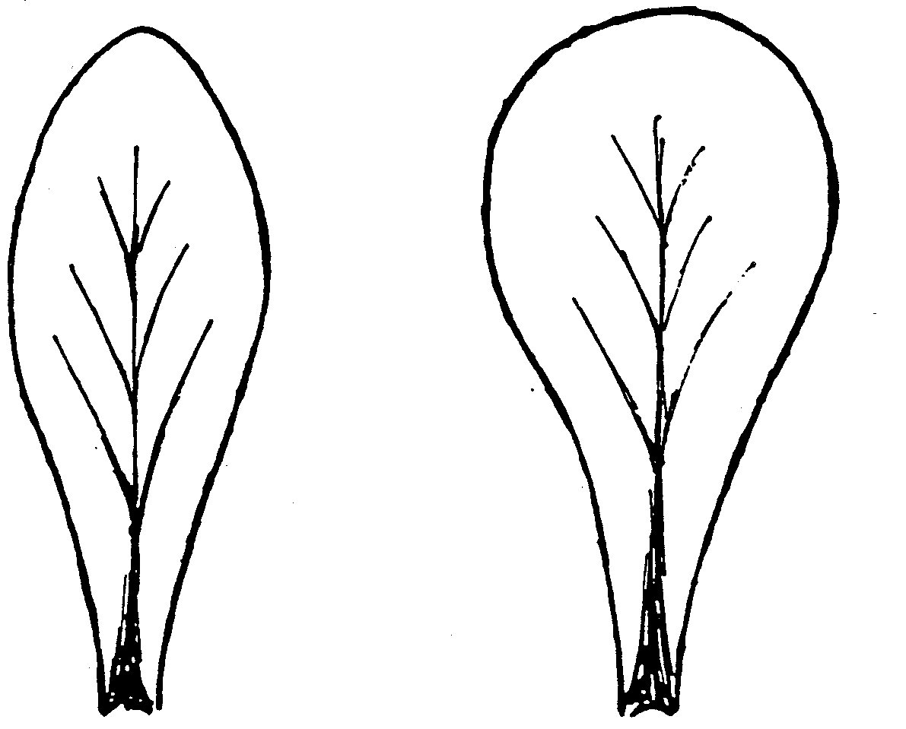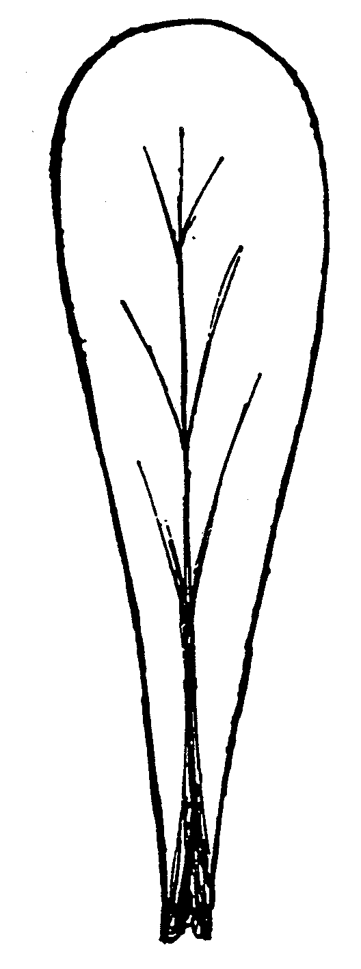
1 | 2 | 3
elliptic | broad spatulate | narrow spatulate

Ad. 9: Leaf: profile of apical part in longitudinal section


1 |  | 2 |  | 3
concave | flat |  | convex

Ad. 20: Seed: collar
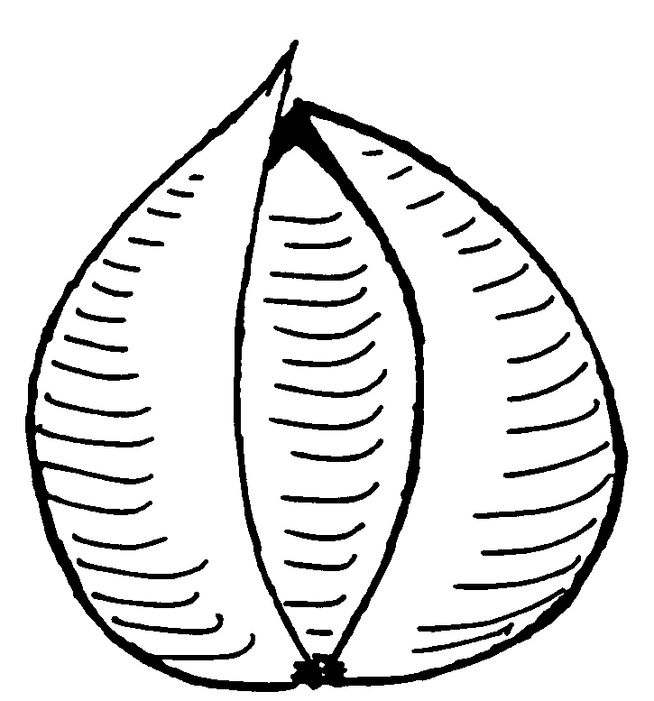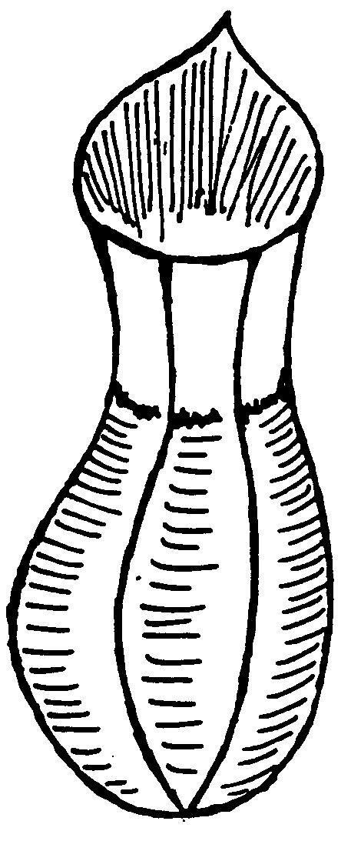

1 |  | 9
absent |  | present

Ad. 21: Resistance to downy mildew (Peronospora valerianella)

Strain(s) used: Races 1, 2

Maintenance of strains:

Nature of medium: Conservation of strains in the form of oospores associated with naturally contaminated seeds.

Particular conditions: Storage of batches of contaminated seeds in waterproof sachets at 4ºC, on different varieties.

Comments: Since mildew spores are fragile, medium-term conservation (a few months) on contaminated leaves kept in a freezer
(-20ºC) is particularly delicate.

Production of inoculum: At the beginning of the test period, inoculum is produced from naturally contaminated seeds (sanitary analysis). Broadcast sowing, about 200-250 seeds per box. Germination and development of plant germs in a cold tunnel, 10 to 15ºC.

From the time of appearance of the first leaf, the boxes are placed in a plastic cage or are covered with a plastic lid
(mini-glasshouse), in order to generate moisture on the plants.

10 to 12 days after sowing, the first symptoms appear on the plants produced from the infected seeds. The cotyledons and leaves have a rolled aspect. The sick leaves are recovered in order to multiply the inoculum or for an infection. The spores are collected on a recent sporulation (night time). They are suspended in a small amount of permuted water, with 20 tween added (1 drop per 100 ml) and filtered on stamens. The concentration in spores is adjusted to 10⁵ spores/ml. The inoculum is kept on a bed of ice.

Sowing: Sowing in plugs (5 x 5 cm), at a rate of 2 to 3 seeds per plug, in order to conserve only one seed per plug.

Conduct of the test:

Plant stage: First leaf stage

Number of plants studied: 40 plants per variety and 10 plants of a control variety.

Cultivation conditions: 10 to 15ºC before inoculation / 8 to 15ºC after inoculation: the difference in temperature is important.

Implantation: Cold glasshouse prior to inoculation / cold tunnel (anti-freeze) after inoculation.

Inoculation: Spraying of a suspension of spores at 10⁵ spores/ml, using an ECOSPRAY type sprayer, then the plants are covered for 48 hours in a plastic cage.

Duration of the test: Sowing-inoculation: approximately 10-12 days
Inoculation-reading: 12-15 days.

Test reading: Beginning of sporulation on sensitive plants approximately 12 days after the inoculation.

Test reliability:

Differential hosts to be used:

Hosts | Pathotype 1  (Cambrai) | Pathotype 2  (Gala)
Cambrai | S | R
Verella | R | S
Gala | R | S

S = Sensitive, R = Resistant

Literature
Fascicule du CTPS - Novembre 1995: Tests de résistance aux maladies, Plantes potagères.

Technical Questionnaire
TECHNICAL QUESTIONNAIRE |  |  |  | Page {x} of {y} |  | Reference Number:
 |  |  |  |  |  | Application date:
 |  |  |  |  |  | (not to be filled in by the applicant)
TECHNICAL QUESTIONNAIRE
to be completed in connection with an application for plant breeders’ rights

1. Subject of the Technical Questionnaire (please indicate the relevant species)
1.1.1 Botanical name |  |  | Valerianella locusta L..
1.1.2 Common name |  |  | Cornsalad, Lambs’ Lettuce |  |  |  |  |  | [ ]
1.2.1 Botanical name |  |  | Valerianella eriocarpa Desv.
1.2.2 Common name |  |  |  |  |  |  |  |  | [ ]
2. Applicant
Name
Address
Telephone No.
Fax No.
E-mail address
Breeder (if different from applicant)
3. Proposed denomination and breeder’s reference
Proposed denomination
(if available)

Breeder’s reference
#4. Information on the breeding scheme and propagation of the variety

4.1 Breeding scheme

Variety resulting from:

4.1.1 Crossing

(a) controlled cross [ ]
(please state parent varieties)

(b) partially known cross [ ]
(please state known parent variety(ies))

(c) unknown cross [ ]

4.1.2 Mutation [ ]
(please state parent variety)

4.1.3 Discovery and development [ ]
(please state where and when discovered
and how developed)

4.1.4 Other [ ]
(please provide details)

4.2 Method of propagating the variety

(a) Self-pollination [ ]

(b) Other [ ]
(please provide details)

5. Characteristics of the variety to be indicated (the number in brackets refers to the corresponding characteristic in Test Guidelines; please mark the note which best corresponds).

 | Characteristics |  |  |  |  |  | Example Varieties |  |  | Note
5.1  (3) | Leaf: length
 | very short |  |  |  |  |  |  |  |  | 1[ ]
 | very short to short |  |  |  |  |  |  |  |  | 2[ ]
 | short |  |  |  |  |  | Coquille de Louviers |  |  | 3[ ]
 | short to medium |  |  |  |  |  | Verte de Cambrai |  |  | 4[ ]
 | medium |  |  |  |  |  | Verte à coeur plein 2 |  |  | 5[ ]
 | medium to long |  |  |  |  |  | Arpege |  |  | 6[ ]
 | long |  |  |  |  |  | Agathe |  |  | 7[ ]
 | long to very long |  |  |  |  |  | A grosse graine |  |  | 8[ ]
 | very long |  |  |  |  |  | Ljubljanski |  |  | 9[ ]
5.2  (9) | Leaf: profile of apical part in longitudinal section
 | concave |  |  |  |  |  | Coquille de Louviers |  |  | 1[ ]
 | flat |  |  |  |  |  | Gala, Verte à coeur plein 2 |  |  | 2[ ]
 | convex |  |  |  |  |  | Verte d’Etampes |  |  | 3[ ]
5.3  (11) | Leaf: intensity of green color
 | very light |  |  |  |  |  |  |  |  | 1[ ]
 | very light to light |  |  |  |  |  |  |  |  | 2[ ]
 | light |  |  |  |  |  | Verte maraîchère |  |  | 3[ ]
 | light to medium |  |  |  |  |  |  |  |  | 4[ ]
 | medium |  |  |  |  |  | Verte de Rouen |  |  | 5[ ]
 | medium to dark |  |  |  |  |  |  |  |  | 6[ ]
 | dark |  |  |  |  |  | Verte à coeur plein 2 |  |  | 7[ ]
 | dark to very dark |  |  |  |  |  |  |  |  | 8[ ]
 | very dark |  |  |  |  |  |  |  |  | 9[ ]
 | Characteristics |  |  |  |  |  | Example Varieties |  |  | Note
5.4  (19) | Seed: size
 | very small |  |  |  |  |  |  |  |  | 1[ ]
 | very small to small |  |  |  |  |  |  |  |  | 2[ ]
 | small |  |  |  |  |  | D’Italie à feuille de laitue, Deutscher |  |  | 3[ ]
 | small to medium |  |  |  |  |  |  |  |  | 4[ ]
 | medium |  |  |  |  |  | Vit |  |  | 5[ ]
 | medium to large |  |  |  |  |  |  |  |  | 6[ ]
 | large |  |  |  |  |  | A grosse graine |  |  | 7[ ]
 | large to very large |  |  |  |  |  |  |  |  | 8[ ]
 | very large |  |  |  |  |  |  |  |  | 9[ ]
5.5  (20) | Seed: collar
 | absent |  |  |  |  |  | Deutscher |  |  | 1[ ]
 | present |  |  |  |  |  | D’Italie à feuille de laitue |  |  | 9[ ]
6. Similar varieties and differences from these varieties

Please use the following table and box for comments to provide information on how your candidate variety differs from the variety (or varieties) which, to the best of your knowledge, is (or are) most similar. This information may help the examination authority to conduct its examination of distinctness in a more efficient way.

Denomination(s) of variety(ies) similar to your candidate variety |  | Characteristic(s) in which your candidate variety differs from the similar variety(ies) |  |  | Describe the expression of the characteristic(s) for the similar variety(ies) |  |  | Describe the expression of the characteristic(s) for your candidate variety
Rodion |  | Leaf: width |  |  | broad |  |  | medium
Comments:

#7. Additional information which may help in the examination of the variety

7.1 In addition to the information provided in sections 5 and 6, are there any additional characteristics which may help to distinguish the variety?

Yes [ ] No [ ]

(If yes, please provide details)

7.2 Are there any special conditions for growing the variety or conducting the examination?

Yes [ ] No [ ]

(If yes, please provide details)

7.3 Other information

8. Authorization for release

(a) Does the variety require prior authorization for release under legislation concerning the protection of the environment, human and animal health?

Yes [ ] No [ ]

(b) Has such authorization been obtained?

Yes [ ] No [ ]

If the answer to (b) is yes, please attach a copy of the authorization.

9. Information on plant material to be examined or submitted for examination.

9.1 The expression of a characteristic or several characteristics of a variety may be affected by factors, such as pests and disease, chemical treatment (e.g. growth retardants or pesticides), effects of tissue culture, different rootstocks, scions taken from different growth phases of a tree, etc.

9.2 The plant material should not have undergone any treatment which would affect the expression of the characteristics of the variety, unless the competent authorities allow or request such treatment. If the plant material has undergone such treatment, full details of the treatment must be given. In this respect, please indicate below, to the best of your knowledge, if the plant material to be examined has been subjected to:

(a) Microorganisms (e.g. virus, bacteria, phytoplasma) Yes [ ] No [ ]

(b) Chemical treatment (e.g. growth retardant, pesticide) Yes [ ] No [ ]

(c) Tissue culture Yes [ ] No [ ]

(d) Other factors Yes [ ] No [ ]

Please provide details for where you have indicated “yes”.

……………………………………………………………

10. I hereby declare that, to the best of my knowledge, the information provided in this form is correct:

Applicant’s name

Signature Date

[End of document]

* These names were correct at the time of the introduction of these Test Guidelines but may be revised or updated. [Readers are advised to consult the UPOV Code, which can be found on the UPOV Website (www.upov.int), for the latest information.]
# Authorities may allow certain of this information to be provided in a confidential section of the Technical Questionnaire.
# Authorities may allow certain of this information to be provided in a confidential section of the Technical Questionnaire.

