 |  | E  TG/74/4 Corr.

INTERNATIONAL UNION FOR THE PROTECTION  OF NEW VARIETIES OF PLANTS | UNION INTERNATIONALE POUR LA PROTECTION  DES OBTENTIONS VÉGÉTALES | INTERNATIONALER VERBAND ZUM SCHUTZ VON PFLANZEN-ZÜCHTUNGEN | UNIÓN INTERNACIONAL PARA LA PROTECCIÓN  DE LAS OBTENCIONES VEGETALES

GUIDELINES

FOR THE CONDUCT OF TESTS

FOR DISTINCTNESS, UNIFORMITY AND STABILITY

CELERIAC

(Apium graveolens L. var. rapaceum (Mill.) Gaud.)

GENEVA
2002, 2006*

* The Technical Committee, during its session in April 2006, revised characteristic 6 of Chapter VII of the Test Guidelines for Celeriac. TG/74/4 Corr. replaces document TG/74/4.

Copies of this document are available on request at the price of 10 Swiss francs each, including surface mail, from the Office of UPOV, 34, chemin des Colombettes, P.O. Box 18, 1211 Geneva 20, Switzerland

This document or parts of it may be reproduced, translated and published without obtaining the specific consent of UPOV, provided that the source is acknowledged.

* * * * * * *
E
TG/74/4 Corr.
ORIGINAL: English
DATE : 2002-04-17 + 2006-04-05*

INTERNATIONAL UNION FOR THE PROTECTION  OF NEW VARIETIES OF PLANTS | UNION INTERNATIONALE POUR LA PROTECTION  DES OBTENTIONS VÉGÉTALES | INTERNATIONALER VERBAND ZUM SCHUTZ VON PFLANZEN-ZÜCHTUNGEN | UNIÓN INTERNACIONAL PARA LA PROTECCIÓN  DE LAS OBTENCIONES VEGETALES

GUIDELINES

FOR THE CONDUCT OF TESTS

FOR DISTINCTNESS, UNIFORMITY AND STABILITY

CELERIAC

(Apium graveolens L. var. rapaceum (Mill.) Gaud.)

These Guidelines should be read in conjunction with document TG/1/2, which contains explanatory notes on the general principles on which the Guidelines have been established.

* The Technical Committee, during its session in April 2006, revised characteristic 6 of Chapter VII of the Test Guidelines for Celeriac. TG/74/4 Corr. replaces document TG/74/4.

TABLE OF CONTENTS PAGE

I. Subject of these Guidelines 3

II. Material Required 3

III. Conduct of Tests 3

IV. Methods and Observations 3

V. Grouping of Varieties 4

VI. Characteristics and Symbols 4

VII. Table of Characteristics 5

VIII. Explanations on the Table of Characteristics 12

IX. Literature 17

X. Technical Questionnaire 18

I. Subject of these Guidelines

These Guidelines apply to all varieties of Apium graveolens L. var. rapaceum (Mill.) Gaud.

II. Material Required

1. The competent authorities decide when, where and in what quantity and quality the seed required for testing the variety is to be delivered. Applicants submitting material from a State other than that in which the testing takes place must make sure that all customs formalities are complied with. As a minimum, for each year of the test the following quantity of seed is recommended:

4 grams.

The seed should meet the minimum requirements for germination, species and analytical purity, health and moisture content, specified by the competent authority. In cases where the seed is to be stored, the germination capacity should be as high as possible and should be stated by the applicant.

2. The plant material must not have undergone any treatment unless the competent authorities allow or request such treatment. If it has been treated, full details of the treatment must be given.

III. Conduct of Tests

1. The minimum duration of tests should normally be two independent growing cycles.

2. The tests should normally be conducted at one place. If any important characteristics of the variety cannot be seen at that place, the variety may be tested at an additional place.

3. The tests should be carried out under conditions ensuring satisfactory growth for the expression of the relevant characteristics of the variety and for the conduct of the examination. The size of the plots should be such that plants or parts of plants may be removed for measurement and counting without prejudice to the observations which must be made up to the end of the growing cycle. Each test should be designed to result in a total of, at least 60 plants, which should be divided between two or more replicates. Separate plots for observation and for measuring should only be used if they have been subject to similar environmental conditions.

4. Additional tests for special purposes may be established.

IV. Methods and Observations

- Unless otherwise indicated, all observations determined by measurement, weighing or counting should be made on 40 plants or parts taken from each of 40 plants.

2. The assessment of uniformity for cross-pollinated varieties should be according to the recommendations in the General Introduction. The assessment of uniformity for hybrid varieties depends on the type of hybrid and should be according to the recommendations in the General Introduction.

- All observations on the plant and the leaf should be made on fully developed plants before harvest maturity. All observations on the leaf should be made on leaves in the middle of the rosette of leaves.

- All observations on the tuber should be made at harvest maturity.

V. Grouping of Varieties

1. The collection of varieties to be grown should be divided into groups to facilitate the assessment of distinctness. Characteristics which are suitable for grouping purposes are those which are known from experience not to vary, or to vary only slightly, within a variety. Their various states of expression should be fairly evenly distributed throughout the collection.

2. It is recommended that the competent authorities use the following characteristic for grouping varieties:

  - Petiole: anthocyanin coloration (characteristic 12)

VI. Characteristics and Symbols

1. To assess distinctness, uniformity and stability, the characteristics and their states as given in the Table of Characteristics should be used.

2. Notes (numbers), for the purposes of electronic data processing, are given opposite the states of expression for each characteristic.

3. Legend:

(*) Characteristics that should be used on all varieties in every growing cycle over which the examinations are made and always be included in the variety descriptions, except when the state of expression of a preceding characteristic or regional environmental conditions render this impossible.

(+) See Explanations on the Table of Characteristics in Chapter VIII.

VII. Table of Characteristics/Tableau des Caractères/Merkmalstabelle/Tabla de Caracteres

 | English | français | deutsch | español | Example Varieties  Exemples  Beispielssorten  Variedades ejemplo | Note/  Nota
1.  (*) | Plant: height | Plante: hauteur | Pflanze: Höhe | Planta: altura
 | short | basse | niedrig | baja | Ofir | 3
 | medium | moyenne | mittel | media | Ibis, Monarch | 5
 | tall | haute | hoch | alta | Bergers weisse Kugel, Boule de Marbre, Mars | 7
2.  (*)  (+) | Foliage: attitude | Feuillage: port | Laub: Haltung | Follaje: porte
 | erect | dressé | aufrecht | erecto | Mars | 1
 | erect to semi-erect | dressé à demi-dressé | aufrecht bis halbaufrecht | erecto a semierecto | Bergers weisse Kugel, Monarch | 2
 | semi-erect | demi-dressé | halbaufrecht | semierecto | Anita, Ibis | 3
 | semi-erect to horizontal | demi-dressé à horizontal | halbaufrecht bis waagerecht | semierecto a  horizontal | Ofir | 4
 | horizontal | horizontal | waagerecht | horizontal | Ilona | 5
3. | Foliage: number of leaves | Feuillage: nombre de feuilles | Laub: Anzahl Blätter | Follaje: número de hojas
 | few | petit | gering | bajo |  | 3
 | medium | moyen | mittel | medio | Ibis, Prinz | 5
 | many | grand | groß | alto | Mars | 7
4.  (+) | Foliage: diameter of petiole insertion on tuber | Feuillage: diamètre de l’insertion du pétiole sur le tubercule | Laub: Durchmesser des Blattstiel-ansatzes an der Knolle | Follaje: diámetro de la inserción del pecíolo en el tubérculo
 | small | petit | klein | pequeño |  | 3
 | medium | moyen | mittel | medio |  | 5
 | large | grand | groß | grande |  | 7
5. | Foliage: green coloration of inner leaves | Feuillage: couleur verte des feuilles internes | Laub: Grünfärbung der inneren Blätter | Follaje: color verde de las hojas interiores
 | light | claire | hell | claro | Ortho | 3
 | medium | moyenne | mittel | medio | Bergers weisse Kugel, Cesar, Prinz | 5
 | dark | foncée | dunkel | oscuro | President | 7
6. | Foliage: green coloration of fully developed leaves | Feuillage: couleur verte des feuilles pleinement développées | Laub: Grünfärbung der ausgewachsenen Blätter | Follaje: color verde de las hojas completamente desarrolladas
 | light | claire | hell | claro | Ibis | 3
 | medium | moyenne | mittel | medio |  | 5
 | dark | foncée | dunkel | oscuro | Bergers weisse Kugel, Mars, Monarch, Prinz | 7
7.  (*) | Leaf: length (including petiole) | Feuille: longueur (pétiole compris) | Blatt: Länge  (einschließlich Blattstiel) | Hoja: longitud (incluido el pecíolo)
 | short | courte | kurz | corta | Ofir, Ortho | 3
 | medium | moyenne | mittel | media | Anita | 5
 | long | longue | lang | larga | Bergers weisse Kugel | 7
8.  (+) | Leaf blade: length | Limbe: longueur | Blattspreite: Länge | Limbo: longitud
 | short | court | kurz | corto | Ortho | 3
 | medium | moyen | mittel | medio | Anita, Cesar, President | 5
 | long | long | lang | largo | Bergers weisse Kugel | 7
9.  (+) | Leaf blade: distance between 1st and 2nd leaflet pairs | Limbe: distance entre la 1ère et la 2e paire de folioles | Blattspreite: Abstand zwischen 1. und 2. Blattfiederpaar | Limbo: distancia entre el 1er y el 2º par de folíolos
 | short | courte | kurz | corta |  | 3
 | medium | moyenne | mittel | media | Monarch, President, Prinz | 5
 | long | longue | lang | larga | Bergers weisse Kugel | 7
10.  (+) | Petiole: length | Pétiole: longueur | Blattstiel: Länge | Pecíolo: longitud
 | short | court | kurz | corto | Prinz | 3
 | medium | moyen | mittel | medio | Cesar, Diamant | 5
 | long | long | lang | largo | Bergers weisse Kugel, Hochdahler Markt | 7
11.  (+) | Petiole: width | Pétiole: largeur | Blattstiel: Breite | Pecíolo: anchura
 | narrow | étroit | schmal | estrecho |  | 3
 | medium | moyen | mittel | medio | Cesar, Prinz | 5
 | broad | large | breit | ancho | Bergers weisse Kugel | 7
12.  (*) | Petiole: anthocyanin coloration | Pétiole: pigmentation anthocyanique | Blattstiel: Anthocyanfärbung | Pecíolo: pigmentación antociánica
 | absent | absente | fehlend | ausente | Mars, Neve | 1
 | present | présente | vorhanden | presente | Bergers weisse Kugel, Geant Danois, Hochdahler Markt | 9
13.  (*)  (+) | Leaf blade: size of terminal leaflet | Limbe: taille de la foliole terminale | Blattspreite: Größe der Endfieder | Limbo: tamaño del folíolo superior
 | small | petite | klein | pequeño | Ortho | 3
 | medium | moyenne | mittel | medio | Ibis, Kojak | 5
 | large | grande | groß | grande |  | 7
14.  (+) | Leaflet: shape of tips of margin | Foliole: forme des pointes du bord | Blattfieder: Form der Spitzen des Randes | Folíolo: forma de las puntas del borde
 | pointed | pointues | zugespitzt | puntiaguda | Dolvi, Ibis | 1
 | intermediate | intermédiaires | intermediär | intermedia | Monarch, President, Prinz | 2
 | rounded | arrondies | abgerundet | redondeada | Radiant | 3
15.  (+) | Leaflet: density of margin incisions | Foliole: densité des incisions du bord | Blattfieder: Dichte der Randeinschnitte | Folíolo: densidad de las incisiones del borde
 | sparse | lâche | locker | laxa | Cesar, Hans, Rex | 3
 | medium | moyenne | mittel | media | Ibis, Prinz | 5
 | dense | dense | dicht | densa | Diamant, Kojak | 7
16.  (*)  (+) | Leaflet: spacing of lobes | Foliole: espacement entre les lobes | Blattfieder: Abstand zwischen den Lappen | Folíolo: espaciado entre los lóbulos
 | not touching | ne se touchent pas | sich nicht berührend | sin tocarse | Cascade | 1
 | touching | se touchent | sich berührend | tocándose | Monarch | 2
 | overlapping | se chevauchent | überlappend | solapados | Kojak | 3
17.  (*) | Tuber: size | Tubercule: taille | Knolle: Größe | Tubérculo: tamaño
 | small | petit | klein | pequeño | Ofir | 3
 | medium | moyen | mittel | medio | Anita, Bergers weisse Kugel, Des Maraichers | 5
 | large | grand | groß | grande | Ibis, Neve | 7
18.  (+) | Tuber: protrusion | Tubercule: protubérance | Knolle: Wulstbildung | Tubérculo: protuberancia
 | absent or very weak | nulle ou très faible | fehlend oder sehr gering | ausente o muy débil |  | 1
 | weak | faible | gering | débil | Ortho | 3
 | medium | moyenne | mittel | media | Bergers weisse Kugel, Monarch, President | 5
 | strong | forte | stark | fuerte | Anita, Boule de Marbre, Dolvi | 7
 | very strong | très forte | sehr stark | muy fuerte |  | 9
19.  (*) | Tuber: main color of skin | Tubercule: couleur principale de l’épiderme | Knolle: Hauptfarbe der Haut | Tubérculo: color principal de la epidermis
 | whitish | blanchâtre | weißlich | blanquecino | Mars, Monarch, Neve | 1
 | brown | brune | braun | marrón | Anita, Bergers weisse Kugel, Des Maraichers | 2
20. | Varieties with tubers with brown main color only: Tuber: intensity of main color of skin | Seulement les variétés dont la couleur principale du tubercule est brune: Tubercule: intensité de la couleur principale de l’épiderme | Nur Sorten mit brauner Hauptfarbe der Knolle: Knolle: Intensität der Hauptfarbe der Haut | Sólo para variedades con tubérculos de color principal marrón: Tubérculo: intensidad del color principal de la epidermis
 | light | claire | hell | claro | Anita | 3
 | medium | moyenne | mittel | medio | Ortho | 5
 | dark | foncée | dunkel | oscuro | Balder | 7
21.  (*) (+) | Tuber: insertion of roots | Tubercule: insertion des racines | Knolle: Wurzelansatz | Tubérculo: inserción de raíces
 | low | basse | tief | baja | Cesar, Ortho | 3
 | medium | moyenne | mittel | media | Hochdahler Markt, Monarch | 5
 | high | haute | hoch | alta |  | 7
22. | Tuber: number of roots | Tubercule: quantité de racines | Knolle: Anzahl Wurzeln | Tubérculo: cantidad de raíces
 | few | petite | gering | pequeña | Cesar, Ortho | 3
 | medium | moyenne | mittel | media | Bergers weisse Kugel, Brilliant, Monarch | 5
 | many | grande | groß | grande |  | 7
23. | Tuber: thickness of roots | Tubercule: épaisseur des racines | Knolle: Wurzeldicke | Tubérculo: grosor de las raíces
 | thin | minces | dünn | delgadas | Cesar, Ortho | 3
 | medium | moyennes | mittel | medias | Bergers weisse Kugel, Diamant, Monarch | 5
 | thick | épaisses | dick | gruesas | Hochdahler Markt | 7
24  (*)  (+) | Tuber: shape in longitudinal section | Tubercule: forme en coupe longitudinale | Knolle: Form im Längsschnitt | Tubérculo: forma en sección longitudinal
 | broad elliptic | elliptique large | breit elliptisch | elíptico ancho | Kojak | 1
 | round | rond | rund | redondo | Monarch | 2
 | transverse broad elliptic | elliptique transversal large | quer breit elliptisch | elíptico transversal ancho | Anita, Bergers weisse Kugel | 3
 | truncate conical | conique tronqué | stumpf kegelförmig | de cono truncado | Dolvi | 4
 | flattened truncated conical | conique tronqué aplati | flach stumpf kegelförmig | de cono truncado aplanado | Alabaster 3 | 5
25.  (*) | Tuber: color of flesh | Tubercule: couleur de la chair | Knolle: Fleischfarbe | Tubérculo: color de la pulpa
 | white | blanche | weiß | blanco | Diamant, Monarch | 1
 | ivory | ivoire | elfenbein | marfil | Hochdahler Markt, Ofir | 2
26. | Tuber: inner cavity | Tubercule: cavité intérieure | Knolle: Innerer Hohlraum | Tubérculo: cavidad interior
 | small | petite | klein | pequeña |  | 3
 | medium | moyenne | mittel | media | Mars | 5
 | large | grande | groß | grande | Ortho | 7
27. | Tuber: sponginess | Tubercule: spongiosité | Knolle: Schwammigkeit | Tubérculo: esponjosidad
 | weak | faible | gering | débil | Monarch, Prinz | 3
 | medium | moyenne | mittel | media | Bergers weisse Kugel, Cesar | 5
 | strong | forte | stark | fuerte | Ortho | 7
28.  (+) | Tuber: internal rust spot of flesh | Tubercule: présence de taches brunes dans la chair | Knolle: Eisenfleckigkeit des Fleisches | Tubérculo: presencia de manchas marrones en la pulpa
 | weak | faible | gering | débil | Brilliant, Monarch | 3
 | medium | moyenne | mittel | media | Bergers weisse Kugel, Mars | 5
 | strong | forte | stark | fuerte | Ortho | 7

VIII. Explanations on the Table of Characteristics

Ad. 2: Foliage: attitude
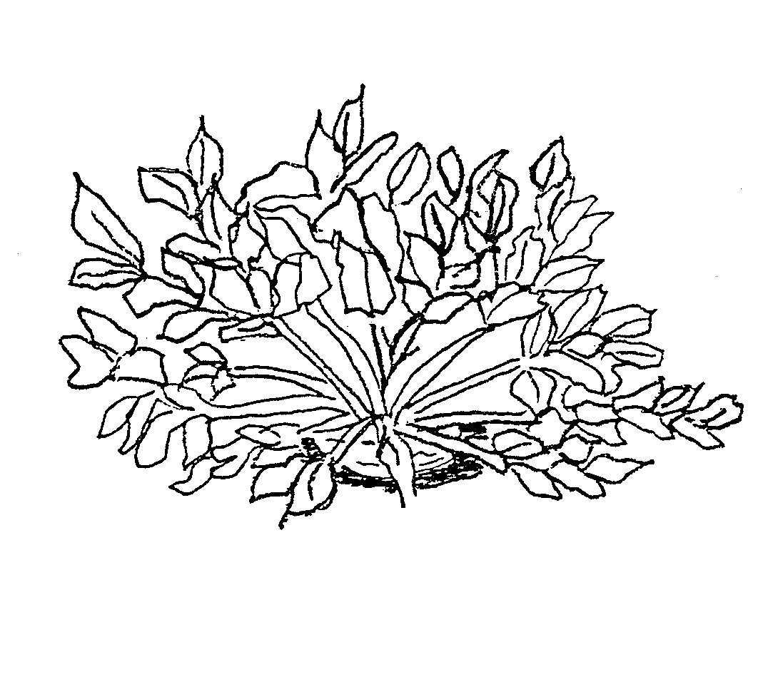
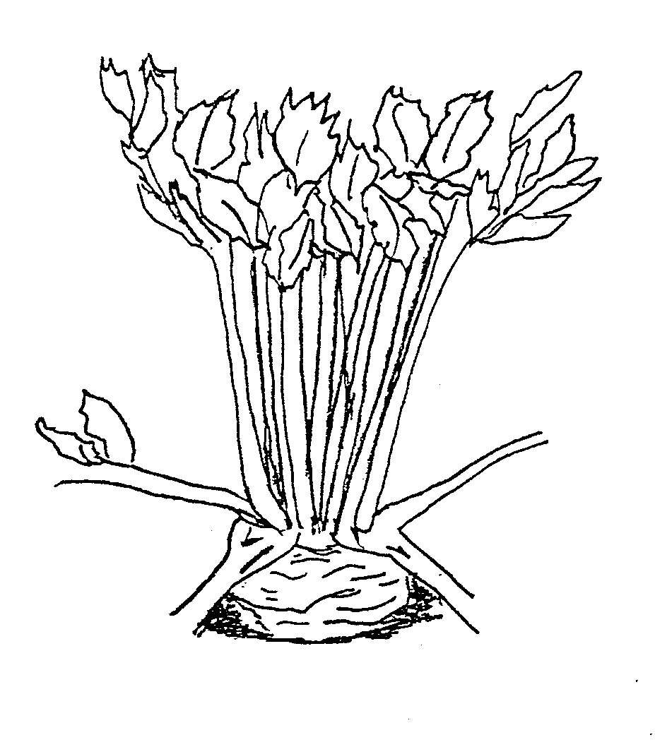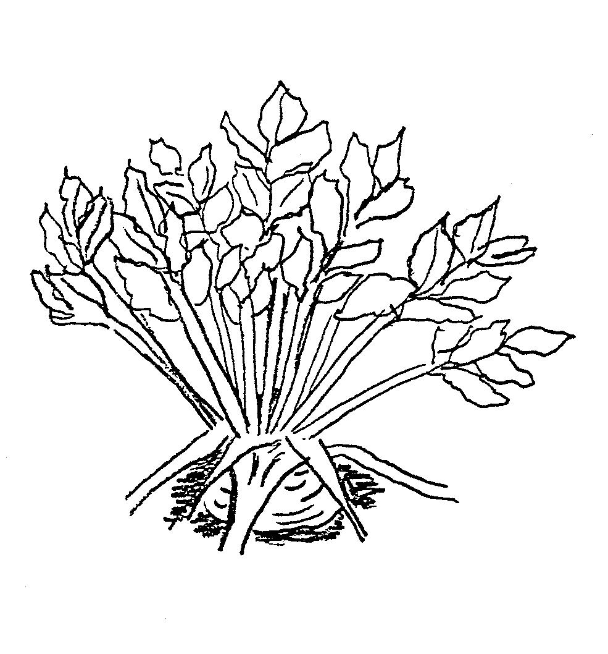

1 | 3 | 5
erect | semi-erect | horizontal

Ad. 4: Foliage: diameter of petiole insertion on tuber

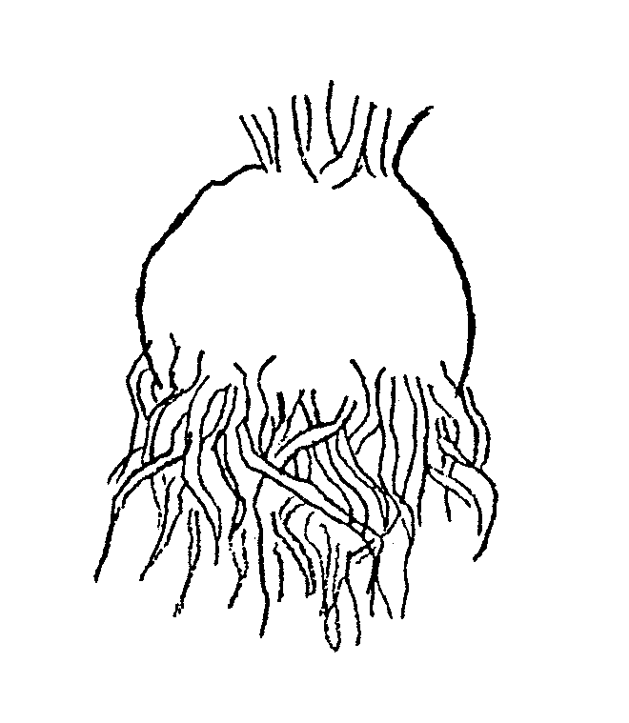

Ad. 8, 9, 10, 11, 13

Leaf blade: length(8)  13 | 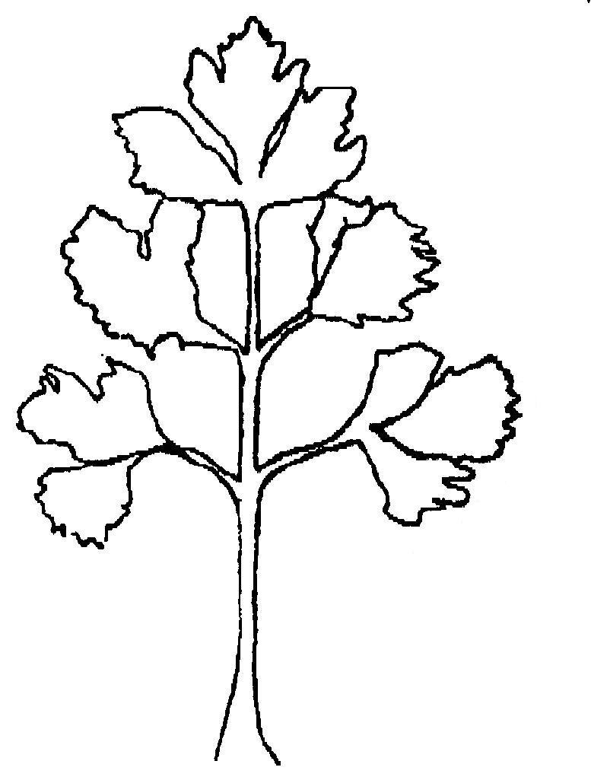
8
Leaf blade: distance between
1st and 2nd pair of
leaflets (9)

11
9
Petiole: length (10)
width (11)

10
Leaf: size of the terminal leaflet (13)


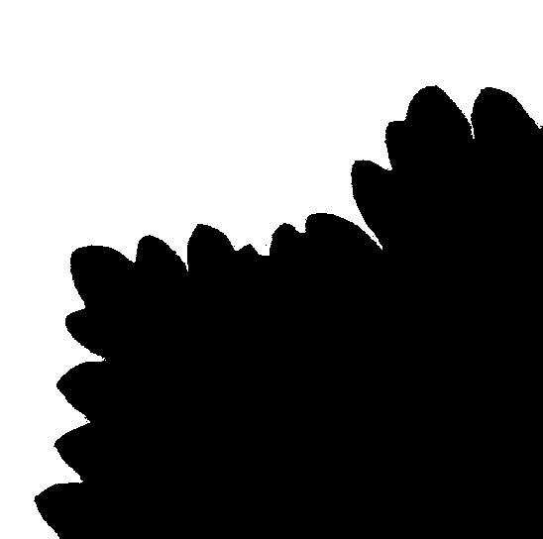
Ad. 14: Leaflet: shape of tips of margin
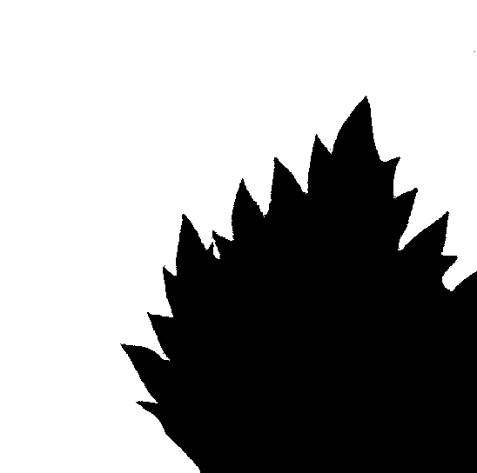

1 | 2 | 3
pointed | intermediate | rounded

Ad. 15: Leaflet: density of margin incisions

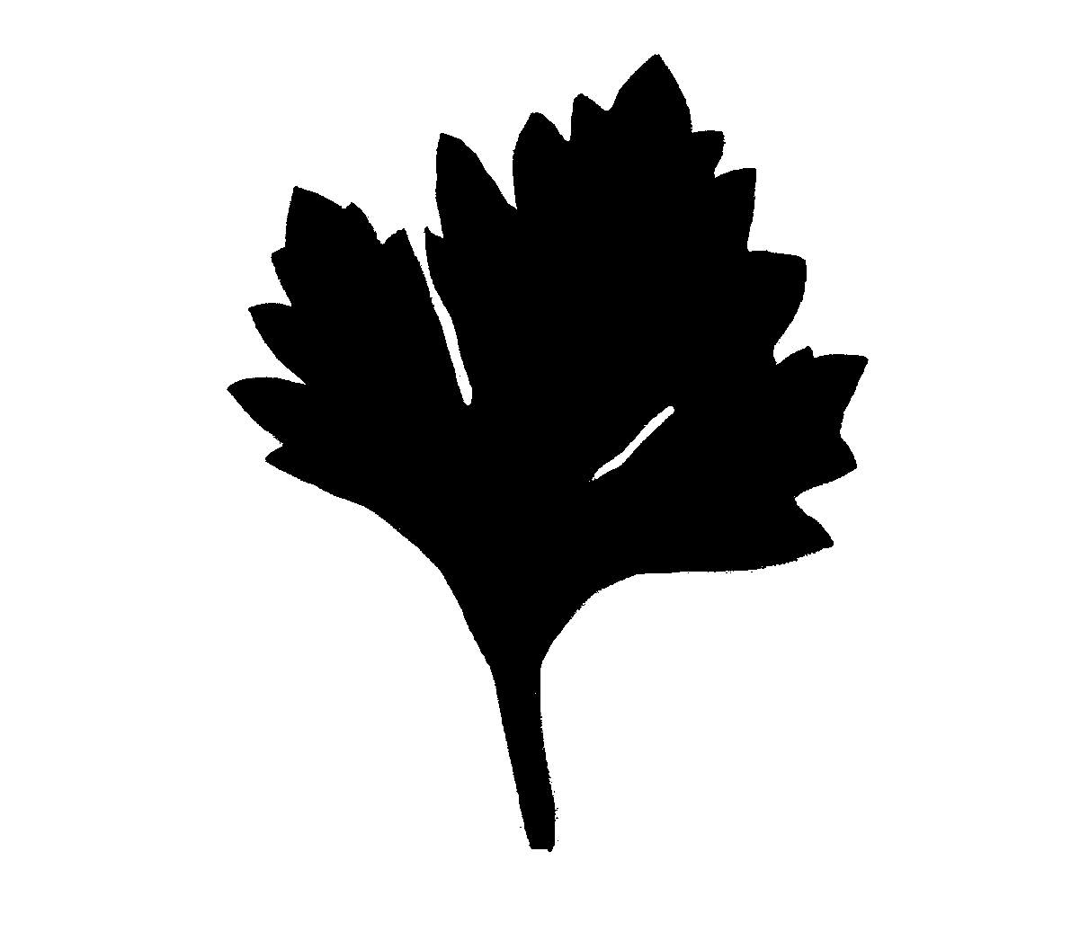

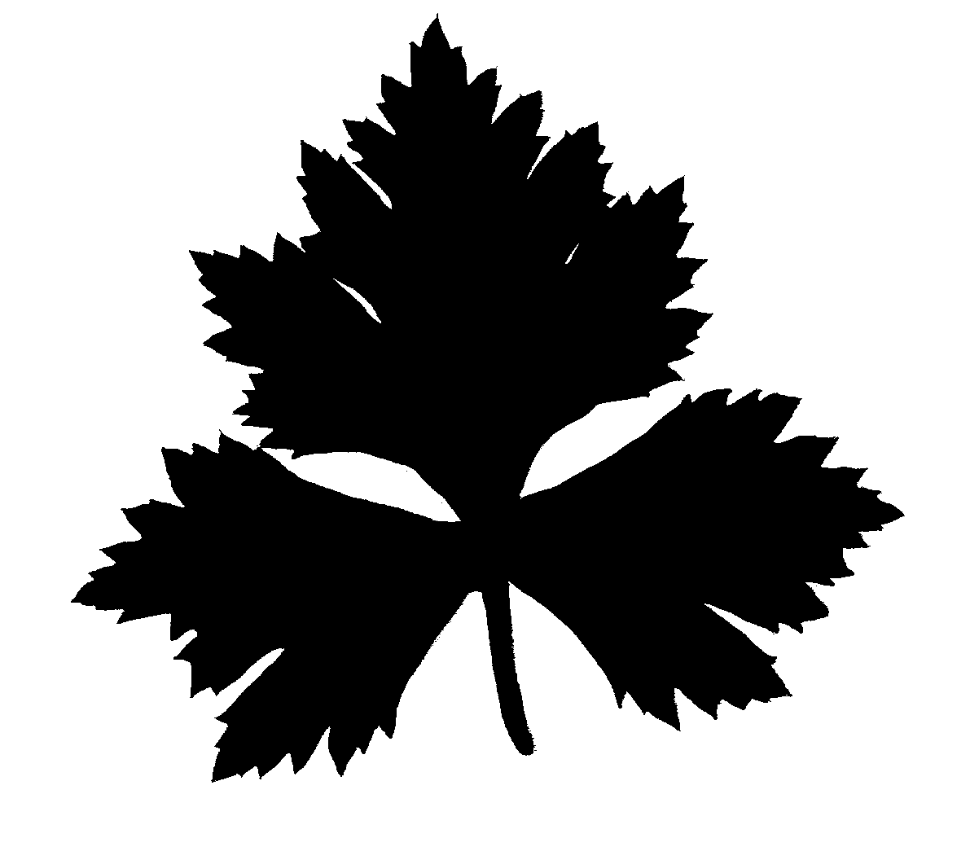
3 | 5 | 7
sparse | medium | dense

Ad. 16: Leaflet: spacing of lobes

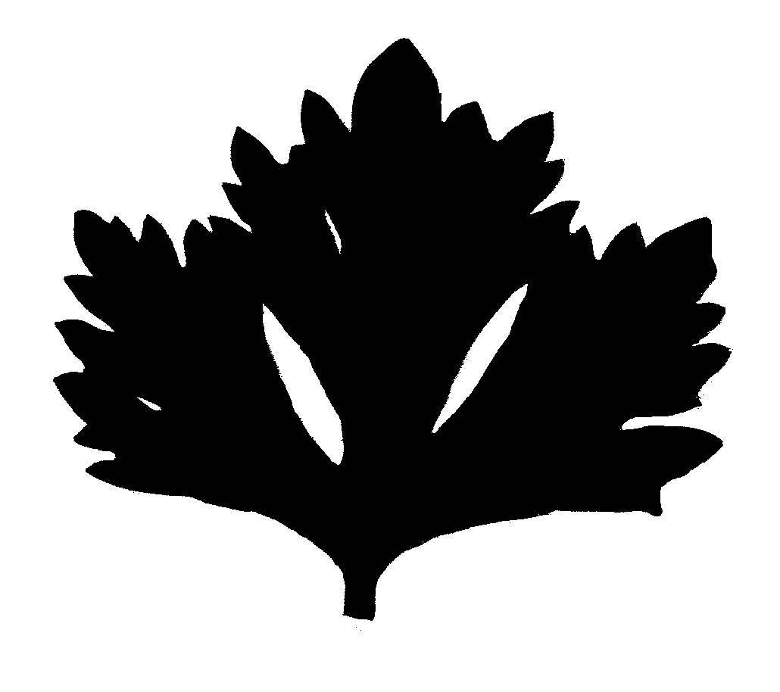


1 | 2 | 3
not touching | touching | overlapping

Ad. 18: Tuber: protrusion

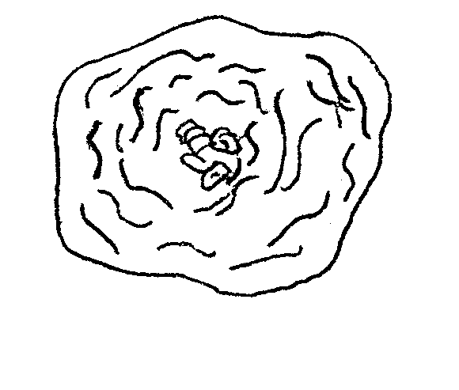
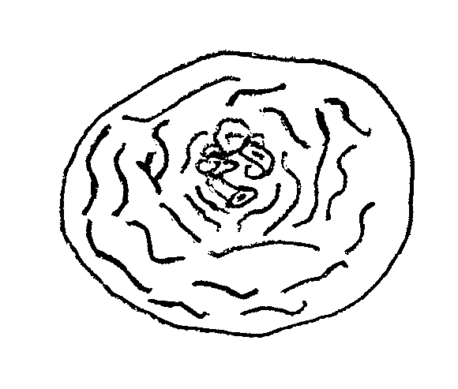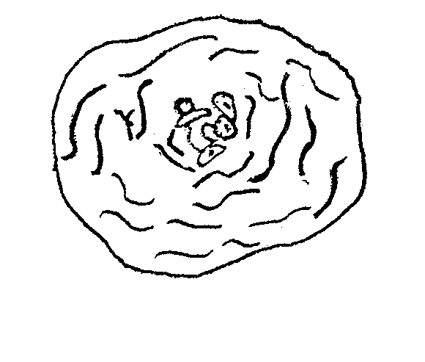

3 | 5 | 7
weak | medium | strong

Protrusions are raised/heightened insertion points of the main roots, which result in a more irregular shape, when viewed from above, as their intensity increases.

Ad. 21: Tuber: insertion of roots

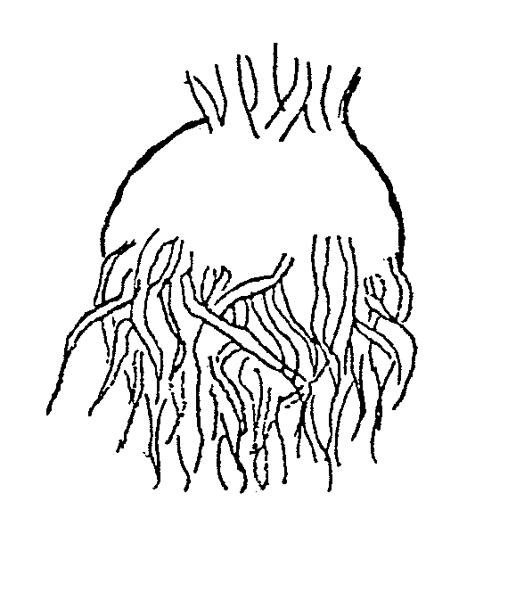
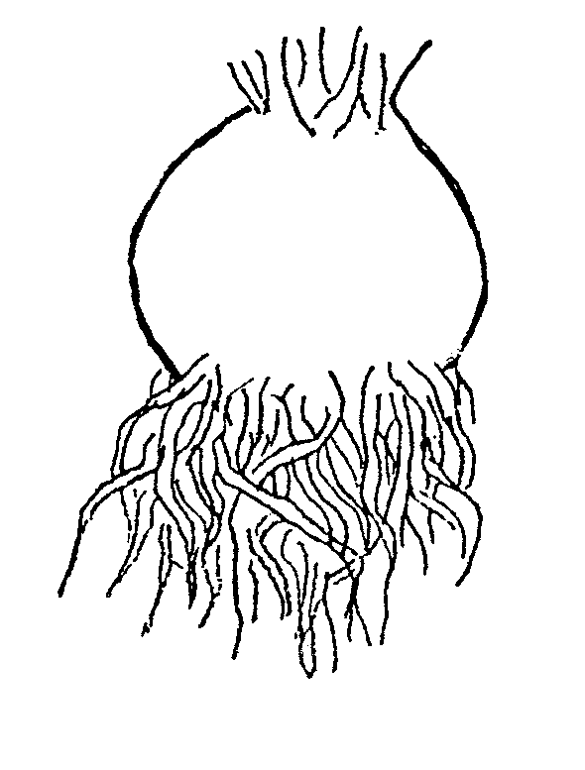

3 | 5 | 7
low | medium | high

Ad. 24: Tuber: shape in longitudinal section
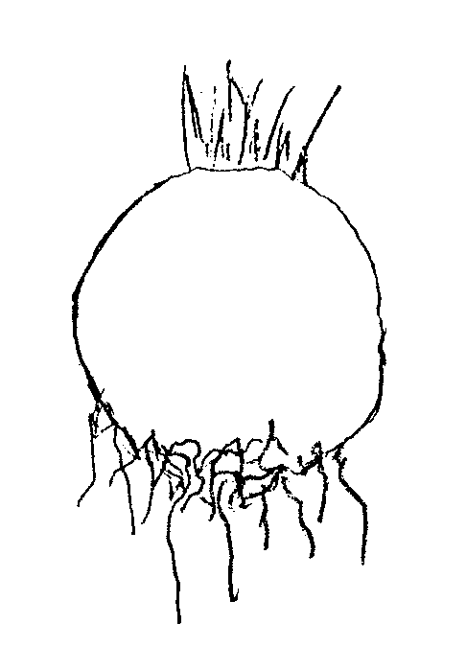
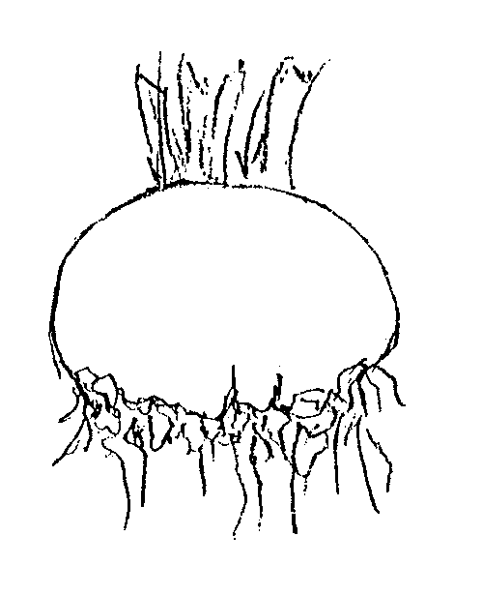
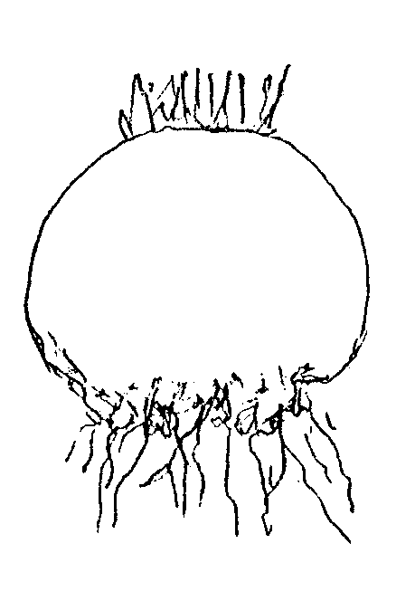

1 | 2 | 3
broad elliptic | round | transverse broad elliptic

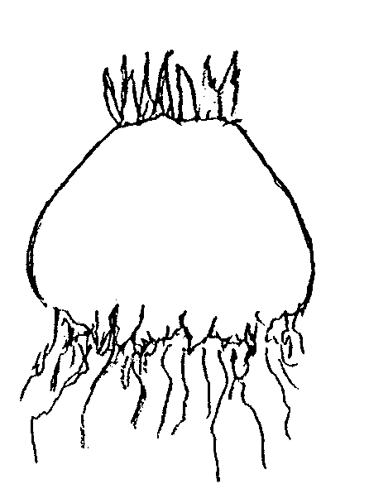

4 | 5
truncate conical | flattened truncated conical

Ad. 28: Tuber: internal rust spot of flesh

The flesh should be assessed for internal rust spots, one hour after cutting the tuber in longitudinal section.
IX. Literature

BECKER, G. (1962): Knollensellerie in: Handbuch der Pflanzenzüchtung, Band VI, 2. Auflage, Parey Verlag, Berlin – Hamburg, 104-130.

BECKER-DILLINGEN, 3. (1956): Sellerie in: Handbuch des gesamten Gemüsebaues, 6. Auflage, Parey Verlag, Berlin – Hamburg, 592-613.

HAHN, P. und SCHMITT, U. (1951): Knollensellerie in: Kohl- und Wurzelgemüse, Arten- und Sortenkunde, Band 2, 1. Auflage, Deutscher Bauernverlag, Berlin, 246-255.

KAMPE, K.; BASSE, H.; GLASCHKE, B. und SCHREIBER, F. (1956): Sellerie in: Gemüsesorten, II. Teil (Kohl-, Blatt- und Wurzelgemüse), 1. Auflage, Parey Verlag, Berlin – Hamburg, 115-119.

VOGEL, G. (1996): Sellerie in: Handbuch des speziellen Gemüsebaus. Ulmer Verlag, Stuttgart, 975-990.

WIEBE, H.-J. (1989): Vernalisation von wichtigen Gemüsearten – Ein Überblick. Gartenbauwissenschaft 54 (3), Ulmer Verlag, Stuttgart, 97-104.

WIEBE, H.-J.(1998): Blütenbildung von Knollensellerie (Apium graveolens L. var. rapaceum). I. Vernalisation und Devernalisation. Gartenbauwissenschaft 63 (4), Ulmer Verlag, Stuttgart, 171-177.

X. Technical Questionnaire

Reference Number
(not to be filled in by the applicant)
TECHNICAL QUESTIONNAIRE
to be completed in connection with an application for plant breeders’ rights

1. Species Apium graveolens L. var. rapaceum (Mill.) Gaud.

CELERIAC

2. Applicant (Name and address)

3. Proposed denomination or breeder’s reference

4. Information on origin, maintenance and reproduction of the variety

4.1 Method of maintenance and reproduction

(i) hybrid [ ]

(ii) open-pollinated variety [ ]

(iii) others (please indicate) [ ]

4.2 Other information

5. Characteristics of the variety to be given (the number in brackets refers to the corresponding characteristics in the Test Guidelines; please mark the state of expression which best corresponds)

 | Characteristics | Example Varieties | Note
5.1  (1) | Plant: height
 | short | Ofir | 3 [ ]
 | medium | Ibis, Monarch | 5 [ ]
 | tall | Bergers weisse Kugel, Boule de Marbre, Mars | 7 [ ]
5.2  (2) | Foliage: attitude
 | erect | Mars | 1 [ ]
 | erect to semi-erect | Bergers weisse Kugel, Monarch | 2 [ ]
 | semi-erect | Anita, Ibis | 3 [ ]
 | semi-erect to horizontal | Ofir | 4 [ ]
 | horizontal | Ilona | 5 [ ]
5.3  (12) | Petiole: anthocyanin coloration
 | absent | Mars, Neve | 1 [ ]
 | present | Bergers weisse Kugel, Geant Danois, Hochdahler Markt | 9 [ ]
5.4  (13) | Leaf blade: size of terminal leaflet
 | small | Ortho | 3 [ ]
 | medium | Ibis, Kojak | 5 [ ]
 | large |  | 7 [ ]
5.5  (14) | Leaflet: shape of tips of margin
 | pointed | Dolvi, Ibis | 1 [ ]
 | intermediate | Monarch, President, Prinz | 2 [ ]
 | rounded | Radiant | 3 [ ]

 | Characteristics | Example Varieties | Note
5.6  (16) | Leaflet: spacing of lobes
 | not touching | Cascade | 1 [ ]
 | touching | Monarch | 2 [ ]
 | overlapping | Kojak | 3 [ ]
5.7  (17) | Tuber: size
 | small | Ofir | 3 [ ]
 | medium | Anita, Bergers weisse Kugel, Des Maraichers | 5 [ ]
 | large | Ibis, Neve | 7 [ ]
5.8  (19) | Tuber: main color of skin
 | whitish | Mars, Monarch, Neve | 1 [ ]
 | brown | Anita, Bergers weisse Kugel, Des Maraichers | 2 [ ]
5.9  (21) | Tuber: insertion of roots
 | low | Cesar, Ortho | 3 [ ]
 | medium | Hochdahler Markt, Monarch | 5 [ ]
 | high |  | 7 [ ]
5.10  (24) | Tuber: shape in longitudinal section
 | broad elliptic | Kojak | 1 [ ]
 | round | Monarch | 2 [ ]
 | transverse broad elliptic | Anita, Bergers weisse Kugel | 3 [ ]
 | truncate conical | Dolvi | 4 [ ]
 | flattened truncated conical | Alabaster 3 | 5 [ ]
5.11  (25) | Tuber: color of flesh
 | white | Diamant, Monarch | 1 [ ]
 | ivory | Hochdahler Markt, Ofir | 2 [ ]

6. Similar varieties and differences between these varieties

Denomination of similar variety | Characteristic in which the similar variety is different ^{o)} | State of expression of similar variety | State of expression of candidate variety
______________
^{o)} In the case of identical states of expressions of both varieties, please indicate the size of the difference.

7. Additional information which may help to distinguish the variety

7.1 Resistance to pests and diseases

  - Special conditions for the examination of the variety

7.3 Other information

A representative photocopy of one or more terminal leaflets of the variety in original size may be included in the Technical Questionnaire.

8. Authorization for release

- Does the variety require prior authorization for release under legislation concerning the protection of the environment, human and animal health?

Yes [ ] No [ ]

- Has such authorization been obtained?

Yes [ ] No [ ]

If the answer to that question is yes, please attach a copy of such an authorization.

[End of document]

