 |  | E  TG/73/7 Corr.  ORIGINAL: English  DATE: 2006-04-05 + 2017-10-17
INTERNATIONAL UNION FOR THE PROTECTION OF NEW VARIETIES OF PLANTS
GENEVA

 | BLACKBERRY  UPOV Codes: RUBUS_EUB  RUBUS_IEU  Rubus subg. Rubus | *

GUIDELINES

FOR THE CONDUCT OF TESTS

FOR DISTINCTNESS, UNIFORMITY AND STABILITY

Alternative Names:*
Botanical name | English | French | German | Spanish
Rubus subgenus Rubus | Blackberry, Loganberry, Boysenberry | Ronce fruitière | Brombeere | Zarzamora

The purpose of these guidelines (“Test Guidelines”) is to elaborate the principles contained in the General Introduction (document TG/1/3), and its associated TGP documents, into detailed practical guidance for the harmonized examination of distinctness, uniformity and stability (DUS) and, in particular, to identify appropriate characteristics for the examination of DUS and production of harmonized variety descriptions.

ASSOCIATED DOCUMENTS
These Test Guidelines should be read in conjunction with the General Introduction and its associated TGP documents.

Other associated UPOV documents: TG/43: Test Guidelines for Raspberry
TABLE OF CONTENTS PAGE

1. Subject of these Test Guidelines 3
2. Material Required 3
3. Method of Examination 3
3.1 Number of Growing Cycles 3
3.2 Testing Place 4
3.3 Conditions for Conducting the Examination 4
3.4 Test Design 4
3.5 Number of Plants / Parts of Plants to be Examined 4
3.6 Additional Tests 4
4. Assessment of Distinctness, Uniformity and Stability 4
4.1 Distinctness 4
4.1.1 General Recommendations 4
4.1.2 Consistent Differences 4
4.1.3 Clear Differences 5
4.2 Uniformity 5
4.3 Stability 5
5. Grouping of Varieties and Organization of the Growing Trial 5
6. Introduction to the Table of Characteristics 6
6.1 Categories of Characteristics 6
6.1.1 Standard Test Guidelines Characteristics 6
6.1.2 Asterisked Characteristics 6
6.2 States of Expression and Corresponding Notes 6
6.3 Types of Expression 6
6.4 Example Varieties 6
6.5 Legend 6
7. Table of Characteristics/Tableau des caractères/Merkmalstabelle/Tabla de caracteres 7
8. Explanations on the Table of Characteristics 18
8.1 Explanations covering several characteristics 18
8.2 Explanations for individual characteristics 18
9. Literature 24
10. Technical Questionnaire 25

Subject of these Test Guidelines
1.1 These Test Guidelines apply to all varieties of Rubus subgenus Rubus of the family Rosaceae and their hybrids as far as they are morphologically similar.

1.2 In the case of hybrids between species within the genus Rubus L., the Test Guidelines to be used should be those for which the overall appearance of fruit is most suited. However, if the variety cannot be clearly distinguished from all varieties covered by other Test Guidelines, those other Test Guidelines should also be used to examine the variety. In particular the Test Guidelines for Raspberry (TG/43) should be taken into consideration.

1.3 In the case of hybrids between species within the genus Rubus L., even where the variety is clearly distinguishable from all other varieties covered by other Test Guidelines, it may still be necessary to use additional characteristics to examine the variety. In these circumstances the characteristics from the Test Guidelines covering the parent species may be particularly useful.

1.4 For all blackberry varieties, their hybrids and closely related varieties, the berry does not detach completely from the plug, whereas for all raspberry varieties and their related types, the berry does completely detach from the plug. These Test Guidelines are suited for varieties which do not completely detach from the plug.

Material Required
2.1 The competent authorities decide on the quantity and quality of the plant material required for testing the variety and when and where it is to be delivered. Applicants submitting material from a State other than that in which the testing takes place must ensure that all customs formalities and phytosanitary requirements are complied with.

2.2 The material is to be supplied in the form of one-year-old plants propagated from stem or leaf cuttings.

2.3 The minimum quantity of plant material, to be supplied by the applicant, should be:

5 plants.

2.4 The plant material supplied should be visibly healthy, not lacking in vigor, nor affected by any important pest or disease.

2.5 The plant material should not have undergone any treatment which would affect the expression of the characteristics of the variety, unless the competent authorities allow or request such treatment. If it has been treated, full details of the treatment must be given.

Method of Examination

3.1 Number of Growing Cycles
The minimum duration of tests should normally be two independent growing cycles.

3.2 Testing Place
Tests are normally conducted at one place. In the case of tests conducted at more than one place, guidance is provided in TGP/9 “Examining Distinctness”.

3.3 Conditions for Conducting the Examination
The tests should be carried out under conditions ensuring satisfactory growth for the expression of the relevant characteristics of the variety and for the conduct of the examination. In particular, it is essential that the plants produce a satisfactory crop of fruit in each of the two growing cycles.

3.4 Test Design
3.4.1 Each test should be designed to result in a total of at least 5 plants.

3.4.2 The design of the tests should be such that plants or parts of plants may be removed for measurement or counting without prejudice to the observations which must be made up to the end of the growing cycle.

3.5 Number of Plants / Parts of Plants to be Examined
Unless otherwise indicated, all observations should be made on 5 plants or parts taken from each of 5 plants. In the case of parts of plants, the number to be taken from each of the plants should be 3.

3.6 Additional Tests
Additional tests, for examining relevant characteristics, may be established.

Assessment of Distinctness, Uniformity and Stability

4.1 Distinctness

4.1.1 General Recommendations
It is of particular importance for users of these Test Guidelines to consult the General Introduction prior to making decisions regarding distinctness. However, the following points are provided for elaboration or emphasis in these Test Guidelines.

4.1.2 Consistent Differences
The differences observed between varieties may be so clear that more than one growing cycle is not necessary. In addition, in some circumstances, the influence of the environment is not such that more than a single growing cycle is required to provide assurance that the differences observed between varieties are sufficiently consistent. One means of ensuring that a difference in a characteristic, observed in a growing trial, is sufficiently consistent is to examine the characteristic in at least two independent growing cycles.

4.1.3 Clear Differences
Determining whether a difference between two varieties is clear depends on many factors, and should consider, in particular, the type of expression of the characteristic being examined, i.e. whether it is expressed in a qualitative, quantitative, or pseudo-qualitative manner. Therefore, it is important that users of these Test Guidelines are familiar with the recommendations contained in the General Introduction prior to making decisions regarding distinctness.

4.2 Uniformity
4.2.1 It is of particular importance for users of these Test Guidelines to consult the General Introduction prior to making decisions regarding uniformity. However, the following points are provided for elaboration or emphasis in these Test Guidelines:

4.2.2 For the assessment of uniformity, a population standard of 1% and an acceptance probability of at least 95% should be applied. In the case of a sample size of 5 plants, no off-type is allowed.

4.3 Stability
4.3.1 In practice, it is not usual to perform tests of stability that produce results as certain as those of the testing of distinctness and uniformity. However, experience has demonstrated that, for many types of variety, when a variety has been shown to be uniform, it can also be considered to be stable.

4.3.2 Where appropriate, or in cases of doubt, stability may be tested, either by growing a further generation, or by testing a new plant stock to ensure that it exhibits the same characteristics as those shown by the previous material supplied.

Grouping of Varieties and Organization of the Growing Trial
5.1 The selection of varieties of common knowledge to be grown in the trial with the candidate varieties and the way in which these varieties are divided into groups to facilitate the assessment of distinctness are aided by the use of grouping characteristics.

5.2 Grouping characteristics are those in which the documented states of expression, even where produced at different locations, can be used, either individually or in combination with other such characteristics: (a) to select varieties of common knowledge that can be excluded from the growing trial used for examination of distinctness; and (b) to organize the growing trial so that similar varieties are grouped together.

5.3 The following have been agreed as useful grouping characteristics:

- Plant: growth habit (characteristic 1);
- Dormant cane: spines (characteristic 9);
- Leaf: predominant number of leaflets (characteristic 24);
- Leaf: type (characteristic 25);
- Time of beginning of flowering on previous year’s cane (characteristic 41);
- Time of beginning of fruit ripening on previous year’s cane (characteristic 43).

5.4 Guidance for the use of grouping characteristics, in the process of examining distinctness, is provided through the General Introduction.

Introduction to the Table of Characteristics

6.1 Categories of Characteristics

6.1.1 Standard Test Guidelines Characteristics
Standard Test Guidelines characteristics are those which are approved by UPOV for examination of DUS and from which members of the Union can select those suitable for their particular circumstances.

6.1.2 Asterisked Characteristics
Asterisked characteristics (denoted by *) are those included in the Test Guidelines which are important for the international harmonization of variety descriptions and should always be examined for DUS and included in the variety description by all members of the Union, except when the state of expression of a preceding characteristic or regional environmental conditions render this inappropriate.

6.2 States of Expression and Corresponding Notes
States of expression are given for each characteristic to define the characteristic and to harmonize descriptions. Each state of expression is allocated a corresponding numerical note for ease of recording of data and for the production and exchange of the description.

6.3 Types of Expression
An explanation of the types of expression of characteristics (qualitative, quantitative and pseudo-qualitative) is provided in the General Introduction.

6.4 Example Varieties
Where appropriate, example varieties are provided to clarify the states of expression of each characteristic.

6.5 Legend
(*) Asterisked characteristic – see Chapter 6.1.2
QL: Qualitative characteristic – see Chapter 6.3
QN: Quantitative characteristic – see Chapter 6.3
PQ: Pseudo-qualitative characteristic – see Chapter 6.3
(a)-(d) See Explanations on the Table of Characteristics in Chapter 8.1
(+) See Explanations on the Table of Characteristics in Chapter 8.2

Table of Characteristics/Tableau des caractères/Merkmalstabelle/Tabla de caracteres
 |  | English | français | deutsch | español | Example Varieties/  Exemples/  Beispielssorten/  Variedades ejemplo | Note/  Nota
1.  (*)  (+) |  | Plant: growth habit | Plante: port | Pflanze: Wuchsform | Planta: porte
PQ | (a) | upright | dressé | aufrecht | erecto | Wilson’s Early, Arapaho | 1
 |  | upright to semi-upright | dressé à demi-dressé | aufrecht bis halbaufrecht | erecto a semierecto | Kiowa | 2
 |  | semi-upright | demi-dressé | halbaufrecht | semierecto | Jersey Black | 3
 |  | semi-upright to spreading | demi-dressé à étalé | halbaufrecht bis breitwüchsig | semierecto a rastrero | Tayberry | 4
 |  | spreading | étalé | breitwüchsig | rastrero | Himalaya, Aurora | 5
2. |  | Plant: number of new canes | Plante: nombre de jeunes cannes | Pflanze: Anzahl neuer Ruten | Planta: número de ramas nuevas
QN | (a) | very few | très petit | sehr gering | muy bajo | Himalaya | 1
 |  | few | petit | gering | bajo | Thornfree | 3
 |  | medium | moyen | mittel | medio | Jersey Black | 5
 |  | many | grand | groß | alto | Philadelphia | 7
3. |  | Dormant cane: length | Canne dormante: longueur | Winterrute: Länge | Rama latente: longitud
QN | (a) | short | courte | kurz | corta | Philadelphia | 3
 |  | medium | moyenne | mittel | media | Jersey Black | 5
 |  | long | longue | lang | larga | Tayberry | 7
 |  | very long | très longue | sehr lang | muy larga | Ranui, Marahau | 9
4. |  | Dormant cane: diameter (in central third) | Canne dormante: diamètre (au tiers moyen) | Winterrute: Durchmesser (im mittleren Drittel) | Rama latente: diámetro (en el tercio central)
QN | (a) | very small | très petit | sehr klein | muy pequeño | Aurora | 1
 |  | small | petit | klein | pequeño | Philadelphia | 3
 |  | medium | moyen | mittel | medio | Tayberry | 5
 |  | large | grand | groß | grande | Himalaya | 7
 |  | very large | très grand | sehr groß | muy grande | Jersey Black | 9
5.  (*) |  | Dormant cane: anthocyanin coloration | Canne dormante: pigmentation anthocyanique | Winterrute: Anthocyanfärbung | Rama latente: pigmentación antociánica
QN | (a) | absent or very weak | nulle ou très faible | fehlend oder sehr gering | ausente o muy débil | Taylor’s Prolific | 1
 |  | weak | faible | gering | débil | Black Satin | 3
 |  | medium | moyenne | mittel | media | Alfred | 5
 |  | strong | forte | stark | fuerte | Wilson’s Early | 7
6. |  | Dormant cane: number of branches | Canne dormante: nombre de ramifications | Winterrute: Anzahl Seitentriebe | Rama latente: número de ramas
QN | (a) | few | petit | gering | bajo | Himalaya | 3
 |  | medium | moyen | mittel | medio | Jersey Black | 5
 |  | many | grand | groß | alto | Kittatinny | 7
7. |  | Dormant cane: predominant distribution of branches | Canne dormante: répartition prédominante des ramifications | Winterrute: vorwiegende Verteilung der Seitentriebe | Rama latente: distribución predominante de las ramas
PQ | (a) | only on upper third | sur le tiers supérieur | nur am oberen Drittel | sólo en el tercio superior | Mammoth | 1
 |  | only on upper half | sur la moitié supérieure | nur an der oberen Hälfte | sólo en la primera mitad | Taylor’s Prolific | 2
 |  | over whole length | sur toute la longueur | auf der gesamten Länge | en toda la longitud | Himalaya | 3
8.  (*)  (+) |  | Dormant cane: cross section | Canne dormante: section transversale | Winterrute: Querschnitt | Rama latente: sección transversal
PQ | (a) | rounded | arrondie | abgerundet | redondeada | Sunberry | 1
 |  | rounded to angular | arrondie à anguleuse | abgerundet bis winklig | redondeada a angular | Douglas | 2
 |  | angular | anguleuse | winklig | angular | Wilson’s Early | 3
 |  | angular to grooved | anguleuse à cannelée | winklig bis gerieft | angular a acanalada | Kiowa | 4
 |  | grooved | cannelée | gerieft | acanalada | Mammoth | 5
9.  (*) |  | Dormant cane: spines | Canne dormante: épines | Winterrute: Stacheln | Rama latente: espinas
QL | (a) | absent | absentes | fehlend | ausentes | Loch Ness | 1
 |  | present | présentes | vorhanden | presentes | Himalaya | 9
10. |  | Dormant cane: number of spines | Canne dormante: nombre d’épines | Winterrute: Anzahl Stacheln | Rama latente: número de espinas
QN | (a) | very few | très petit | sehr gering | muy bajo | Philadelphia | 1
 |  | few | petit | gering | bajo | Wilson’s Early | 3
 |  | medium | moyen | mittel | medio | Himalaya | 5
 |  | many | grand | groß | alto | Bedford Giant | 7
 |  | very many | très grand | sehr groß | muy alto | Sunberry | 9
11.  (*) |  | Spine: size | Épine: taille | Stachel: Größe | Espina: tamaño
QN | (a) | small | petite | klein | pequeño | Sunberry | 3
 |  | medium | moyenne | mittel | medio | Bedford Giant | 5
 |  | large | grande | groß | grande | Himalaya | 7
 |  | very large | très grande | sehr groß | muy grande | Jersey Black | 9
12.  (+) |  | Spine: attitude of apex in relation to cane | Épine: orientation de la pointe par rapport à la canne | Stachel: Stellung der Spitze im Verhältnis zur Rute | Espina: postura del ápice en relación con la rama
QN | (a) | upwards | vers le haut | aufwärts | hacia arriba | Kittatinny | 1
 |  | outwards | horizontal | abstehend | hacia afuera | Jersey Black | 2
 |  | downwards | vers le bas | abwärts | hacia abajo | Mammoth | 3
13. |  | Young shoot: anthocyanin coloration (during rapid growth) | Jeune pousse: pigmentation anthocyanique (pendant la croissance rapide) | Junger Trieb: Anthocyanfärbung (während des schnellen Wachstums) | Brote joven: pigmentación antociánica (durante el crecimiento rápido)
QN | (b) | absent or very weak | nulle ou très faible | fehlend oder sehr gering | ausente o muy débil | Philadelphia | 1
 |  | weak | faible | gering | débil | Black Satin | 3
 |  | medium | moyenne | mittel | media | Bedford Giant | 5
 |  | strong | forte | stark | fuerte | Tayberry | 7
14. |  | Young shoot: intensity of green color | Jeune pousse: intensité de la couleur verte | Junger Trieb: Intensität der Grünfärbung | Brote joven: intensidad del color verde
QN | (b) | light | claire | hell | claro | Philadelphia | 3
 |  | medium | moyenne | mittel | medio | Ashton Cross | 5
 |  | dark | foncée | dunkel | oscuro | Thornless Evergreen | 7
15.  (+) |  | Young shoot: number of glandular hairs | Jeune pousse: nombre de poils glandulaires | Junger Trieb: Anzahl der Drüsenhaare | Brote joven: densidad de la pilosidad glandular
QN | (b) | absent or few | nul ou faible | fehlend oder gering | ausente o baja | Silvan | 1
 |  | medium | moyen | mittel | media | Navaho | 2
 |  | many | grand | groß | alta | Karaka Black | 3
16. |  | Terminal leaflet: length | Foliole terminale: longueur | Endfieder: Länge | Folíolo superior: longitud
QN | (c) | short | courte | kurz | corta | Ashton Cross | 3
 |  | medium | moyenne | mittel | media | Loch Ness | 5
 |  | long | longue | lang | larga | Taylor’s Prolific | 7
17. |  | Terminal leaflet: width | Foliole terminale: largeur | Endfieder: Breite | Folíolo superior: anchura
QN | (c) | narrow | étroite | schmal | estrecha | Alfred | 3
 |  | medium | moyenne | mittel | media | Navaho | 5
 |  | broad | large | breit | ancha | Douglas | 7
18.  (+) |  | Terminal leaflet: lobing | Foliole terminale: découpure | Endfieder: Lappung | Folíolo superior: lobulado
QL | (c) | absent | absente | fehlend | ausente | Wilson’s Early | 1
 |  | present | présente | vorhanden | presente | Thornless Evergreen | 9
19. |  | Terminal leaflet: shape in cross-section | Foliole terminale: forme en section transversale | Endfieder: Form im Querschnitt | Folíolo superior: forma en sección transversal
QL | (c) | u-shaped | en forme de U | u-förmig | en forma de U | Bedford Giant | 1
 |  | v-shaped | en forme de V | v-förmig | en forma de V | Mammoth | 2
20. |  | Terminal leaflet: undulation of margin | Foliole terminale: ondulation du bord | Endfieder: Wellung des Randes | Folíolo superior: ondulación del borde
QN | (c) | absent or very weak | absente ou très faible | fehlend oder sehr gering | ausente o muy débil | Hull Thornless | 1
 |  | weak | faible | gering | débil | Loch Ness, Thornfree | 2
 |  | strong | forte | stark | fuerte | Navaho | 3
21. |  | Terminal leaflet: blistering between veins | Foliole terminale: cloqûre entre les nervures | Endfieder: Blasigkeit zwischen den Nebenadern | Folíolo superior: abullonado entre las venas
QN | (c) | very weak | très faible | sehr gering | muy débil | Himalaya | 1
 |  | weak | faible | gering | débil | Jersey Black | 3
 |  | medium | moyenne | mittel | medio | Thornfree | 5
 |  | strong | forte | stark | fuerte | Philadelphia | 7
 |  | very strong | très forte | sehr stark | muy fuerte | Tayberry | 9
22.  (+) |  | Leaflet: type of incision of margin | Foliole: type d’incision du bord | Fiederblatt: Typ des Randeinschnitts | Folíolo: tipo de incisión del margen
QL | (c) | serrate | dentée | gesägt | serrada | Himalaya | 1
 |  | bi-serrate | bi-dentée | doppelt gesägt | biserrada | Thornless Evergreen | 2
23. |  | Leaflet: depth of incisions | Foliole: profondeur des incisions | Fiederblatt: Tiefe der Randeinschnitte | Folíolo: profundidad de las incisiones
QN | (c) | shallow | peu profondes | flach | poco profunda | Philadelphia | 3
 |  | medium | moyennes | mittel | media | Himalaya | 5
 |  | deep | profondes | tief | profunda | Loch Ness | 7
 |  | very deep | très profondes | sehr tief | muy profunda | Thornless Evergreen | 9
24.  (*) |  | Leaf: predominant number of leaflets | Feuille: nombre prédominant de folioles | Blatt: vorwiegende Anzahl Fiederblätter | Hoja: número predominante de folíolos
PQ | (c) | three | trois | drei | tres | Marionberry | 1
 |  | five | cinq | fünf | cinco | Himalaya, Jumbo | 2
 |  | seven | sept | sieben | siete | Karaka Black | 3
25.  (*)  (+) |  | Leaf: type | Feuille: type | Blatt: Typ | Hoja: tipo
QL | (c) | odd-pinnate | imparipenné | unpaarig gefiedert | imparipinnada | Philadelphia | 1
 |  | intermediate | intermédiaire | intermediär | intermedia | Karaka Black | 2
 |  | palmate | palmé | fingerförmig gefiedert | palmada | Thornless Evergreen | 3
26. |  | Leaf: intensity of green color of upper side | Feuille: intensité de la couleur verte de la face supérieure | Blatt: Intensität der Grünfärbung der Oberseite | Hoja: intensidad del color verde del haz
QN | (c) | light | claire | hell | claro | Philadelphia | 3
 |  | medium | moyenne | mittel | medio | Kittatinny | 5
 |  | dark | foncée | dunkel | oscuro | Thornless Evergreen | 7
27. |  | Leaf: glossiness of upper side | Feuille: brillance de la face supérieure | Blatt: Glanz der Oberseite | Hoja: brillo del haz
QN | (c) | weak | faible | gering | débil | Thornless Evergreen | 3
 |  | medium | moyenne | mittel | medio | Mammoth | 5
 |  | strong | forte | stark | fuerte | Kittatinny | 7
28. |  | Petiole: size of stipules | Pétiole: taille des stipules | Blattstiel: Größe der Nebenblätter | Peciolo: tamaño de las estípulas
QN | (c) | small | petits | klein | pequeño | Wilson’s Early | 3
 |  | medium | moyens | mittel | medio | Thornless Hull | 5
 |  | large | grands | groß | grande | Loch Ness | 7
29. |  | Flower: diameter | Fleur: diamètre | Blüte: Durchmesser | Flor: diámetro
QN |  | very small | très petit | sehr klein | muy pequeño | Dyke | 1
 |  | small | petit | klein | pequeño | Tayberry | 3
 |  | medium | moyen | mittel | medio | Thornfree | 5
 |  | large | grand | groß | grande | Himalaya | 7
 |  | very large | très grand | sehr groß | muy grande | Silvan, Marionberry | 9
30. |  | Flower: color of petal | Fleur: couleur du pétale | Blüte: Farbe des Blütenblatts | Flor: color del pétalo
PQ |  | white | blanc | weiß | blanco | Philadelphia | 1
 |  | white with violet tinge | blanc teinté de violet | weiß mit violettem Anflug | blanco con trazas de violeta | Black Satin | 2
 |  | pinkish | rosâtre | blaßrosa | rosáceo | Dirksen Thornless, Theodor Reimers | 3
31. |  | Fruiting lateral: length | Rameau fructifère: longueur | Fruchttrieb: Länge | Fructificación lateral: longitud
QN |  | short | court | kurz | corta | Mammoth | 3
 |  | medium | moyen | mittel | media | Jersey Black | 5
 |  | long | long | lang | larga | Thornless Evergreen | 7
 |  | very long | très long | sehr lang | muy larga | Tayberry | 9
32. |  | Fruit: length | Fruit: longueur | Frucht: Länge | Fruto: longitud
QN | (d) | short | court | kurz | corta | Himalaya | 3
 |  | medium | moyen | mittel | media | Taylor’s Prolific | 5
 |  | long | long | lang | larga |  | 7
 |  | very long | très long | sehr lang | muy larga | Tayberry | 9
33. |  | Fruit: width | Fruit: largeur | Frucht: Breite | Fruto: anchura
QN | (d) | narrow | étroit | schmal | estrecha | Tayberry | 3
 |  | medium | moyen | mittel | media | Loch Ness | 5
 |  | broad | large | breit | ancha |  | 7
 |  | very broad | très large | sehr breit | muy ancha | Douglas | 9
34. |  | Fruit: ratio length/width | Fruit: rapport longueur/largeur | Frucht: Verhältnis Länge/Breite | Fruto: relación longitud/anchura
QN | (d) | small | petit | klein | pequeña | Himalaya | 3
 |  | medium | moyen | mittel | media | Taylor’s Prolific | 5
 |  | large | grand | groß | grande | Tayberry | 7
 |  | very large | très grand | sehr groß | muy grande | Karaka Black | 9
35. |  | Fruit: number of drupelets | Fruit: nombre de fructules | Frucht: Anzahl der Einzelsteinfrüchte | Fruto: número de drupas
QN | (d) | few | petit | wenig | bajo | Marionberry | 3
 |  | medium | moyen | mittel | medio | Himalaya | 5
 |  | many | grand | viele | alto | Tayberry | 7
 |  | very many | très grand | sehr viele | muy alto | Karaka Black | 9
36. |  | Fruit: size of drupelet | Fruit: taille du fructule | Frucht: Größe der Einzelsteinfrucht | Fruto: tamaño de la drupa
QN | (d) | very small | très petit | sehr klein | muy pequeño | Waldo, Siskiyou | 1
 |  | small | petit | klein | pequeño | Wilson’s Early, Siskiypu | 3
 |  | medium | moyen | mittel | medio | Navaho | 5
 |  | large | grand | groß | grande | Douglas | 7
37.  (*)  (+) |  | Fruit: shape in longitudinal section | Fruit: forme en section longitudinale | Frucht: Form im Längsschnitt | Fruto: forma en sección longitudinal
PQ | (d) | circular | circulaire | rund | circular | Himalaya | 1
 |  | elliptic | elliptique | elliptisch | elíptica | Taylor’s Prolific | 2
 |  | narrow ovate | ovale étroit | schmal eiförmig | oval estrecha |  | 3
 |  | medium ovate | ovale moyen | mittel eiförmig | oval media | Wilson’s Early | 4
 |  | long conical | conique long | lang konisch | cónica alargada | Tayberry | 5
 |  | oblong | oblong | länglich | oblonga | Karaka Black | 6
38. |  | Fruit: color | Fruit: couleur | Frucht: Farbe | Fruto: color
PQ | (d) | red | rouge | rot | rojo | Sunberry | 1
 |  | reddish purple | pourpre rougeâtre | rötlichpurpurn | púrpura rojizo | Tayberry | 2
 |  | reddish black | noir rougeâtre | rötlichschwarz | negro rojizo | Alfred | 3
 |  | bluish black | noir bleuâtre | bläulichschwarz | negro azulado | Himalaya | 4
 |  | black | noir | schwarz | negro | Black Satin | 5
39. |  | Time of leaf bud burst | Époque du débourrement foliaire | Zeitpunkt des Öffnens der Blattknospe | Época de brotación de la yema foliar
QN |  | very early | très précoce | sehr früh | muy temprana | Ranui | 1
 |  | early | précoce | früh | temprana | Wilson’s Early | 3
 |  | medium | moyenne | mittel | media | Black Satin | 5
 |  | late | tardive | spät | tardía | Jumbo | 7
40.  (*) |  | Fruiting on current year’s cane | Fruitification sur la canne de l’année en cours | Fruchtentwicklung an der diesjährigen Rute | Fructificacicón en la rama del año en curso
QL |  | absent | absente | fehlend | ausente | Navaho | 1
 |  | present | présente | vorhanden | presente | Taylor’s Prolific | 9
41.  (*)  (+) |  | Time of beginning of flowering on previous year’s cane | Époque du début de la floraison sur la canne de l’année précédente | Zeitpunkt des Blühbeginns an der Vorjahresrute | Época de comienzo de la floración en la rama del año anterior
QN |  | very early | très précoce | sehr früh | muy temprana | Wilson’s Early | 1
 |  | early | précoce | früh | temprana | Taylor’s Prolific | 3
 |  | medium | moyenne | mittel | media | Himalaya | 5
 |  | late | tardive | spät | tardía | Thornfree | 7
 |  | very late | très tardive | sehr spät | muy tardía | Thornless Evergreen | 9
42.  (+) |  | Only varieties which fruit on current year's cane: Time of beginning of flowering on current year’s cane | Seulement variétés qui donnent des fruits sur la canne de l'année en cours: Époque du début de la floraison sur la canne de l’année en cours | Nur Sorten die Früchte an der diesjährigen Rute tragen: Zeitpunkt des Blühbeginns an der diesjährigen Rute | Sóló variedades que dan fruitos en la rama del año en curso: Época de comienzo de la floración en la rama del año en curso
QN |  | very early | très précoce | sehr früh | muy temprana |  | 1
 |  | early | précoce | früh | temprana |  | 3
 |  | medium | moyenne | mittel | media |  | 5
 |  | late | tardive | spät | tardía |  | 7
 |  | very late | très tardive | sehr spät | muy tardía |  | 9
43.  (*)  (+) |  | Time of beginning of fruit ripening on previous year's cane | Époque du début de maturité des fruits sur la canne de l’année précédente | Zeitpunkt des Beginns der Fruchtreife an der vorjährigen Rute | Época de comienzo de madurez del fruto en la rama del año anterior
QN |  | very early | très précoce | sehr früh | muy temprana | Loch Tay, Ranui | 1
 |  | early | précoce | früh | temprana | Taylor’s Prolific, Karaka Black, Sunberry | 3
 |  | medium | moyenne | mittel | media | Himalaya, Marionberry | 5
 |  | late | tardive | spät | tardía | Thornfree | 7
 |  | very late | très tardive | sehr spät | muy tardía | Thornless Evergreen | 9
44.  (+) |  | Only varieties which fruit on current year's cane: Time of beginning of fruit ripening on current year's cane | Seulement variétés qui donnent des fruits sur la canne de l'année en cours: Époque du début de maturité des fruits sur la canne de l’année en cours | Nur Sorten die Früchte an der diesjährigen Rute tragen: Zeitpunkt des Beginns der Fruchtreife an der diesjährigen Rute | Sóló variedades que dan fruitos en la rama del año en curso: Época de comienzo de madurez del fruto en la rama del año en curso
QN |  | very early | très précoce | sehr früh | muy temprana |  | 1
 |  | early | précoce | früh | temprana |  | 3
 |  | medium | moyenne | mittel | media |  | 5
 |  | late | tardive | spät | tardía |  | 7
 |  | very late | très tardive | sehr spät | muy tardía |  | 9

Explanations on the Table of Characteristics

8.1 Explanations covering several characteristics
Characteristics containing the following key in the second column of the Table of Characteristics should be examined as indicated below:

(a) Observations on the plant and the dormant cane which should be made during winter dormancy.

(b) Observations on the young shoot which should be made during rapid growth and before flowering.

(c) Observations on the new cane and the leaf which should be made during flowering.

(d) Observations on the fruit which should be made on fruits collected during the second, third and/or fourth picking.

8.2 Explanations for individual characteristics
Ad. 1: Plant: growth habit

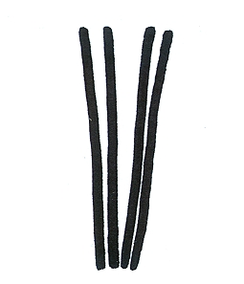 | 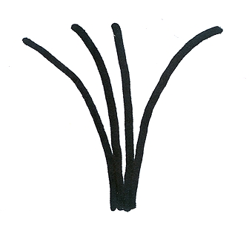 |  | 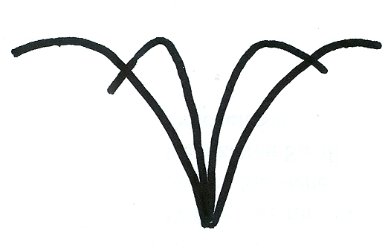
1 | 2 |  | 3
upright | upright to semi-upright |  | semi-upright
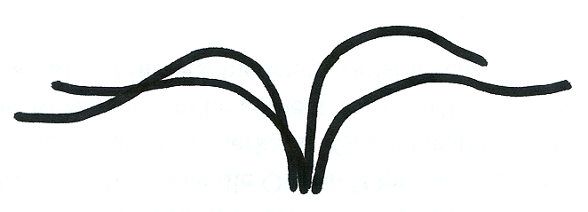 |  | 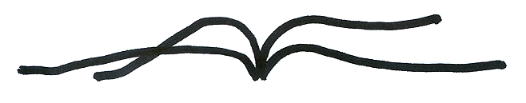
4 |  | 5
semi-upright to spreading |  | spreading

Ad. 8: Dormant cane: cross section

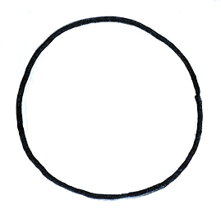 |  | 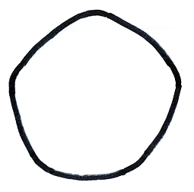 |  | 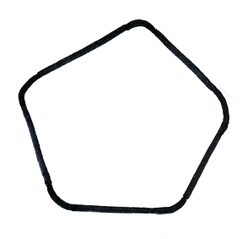
1 |  | 2 |  | 3
rounded |  | rounded to angular |  | angular
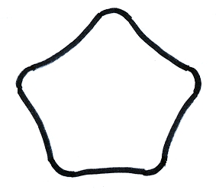 | 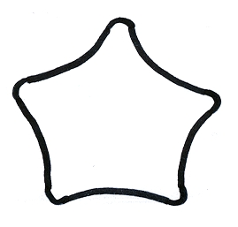
4 | 5
angular to grooved | grooved

Ad. 12: Spine: attitude of apex in relation to cane

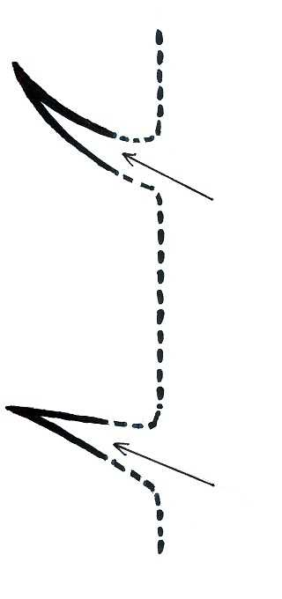 | 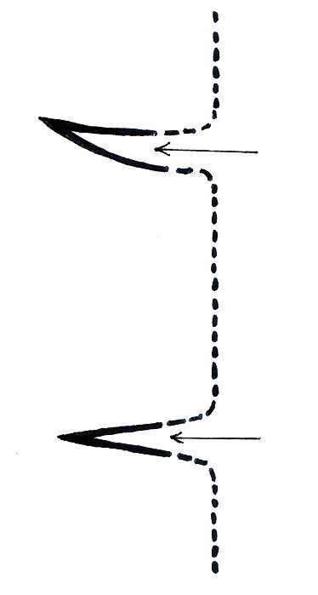 | 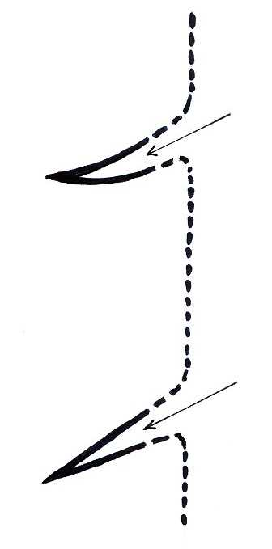
1 | 2 | 3
upwards | outwards | downwards

Ad. 15: Young shoot: number of glandular hairs

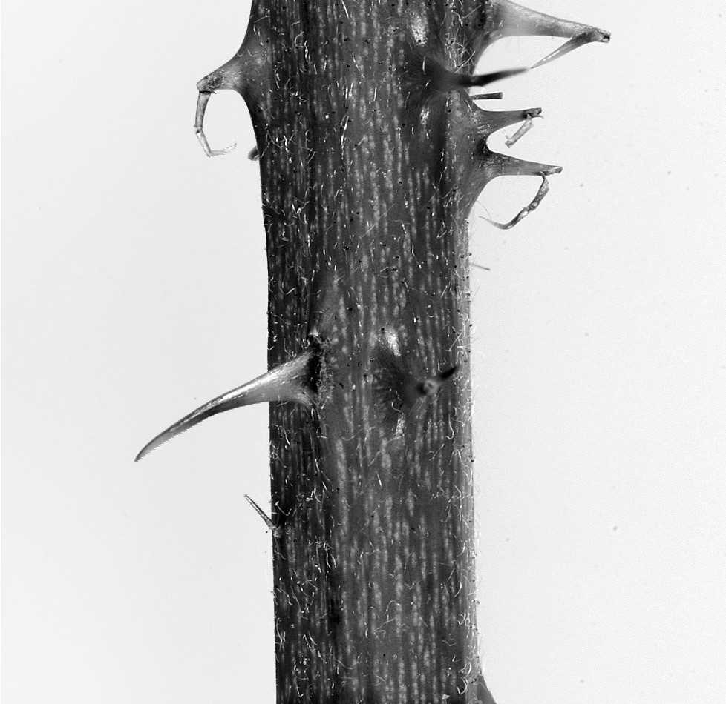 | 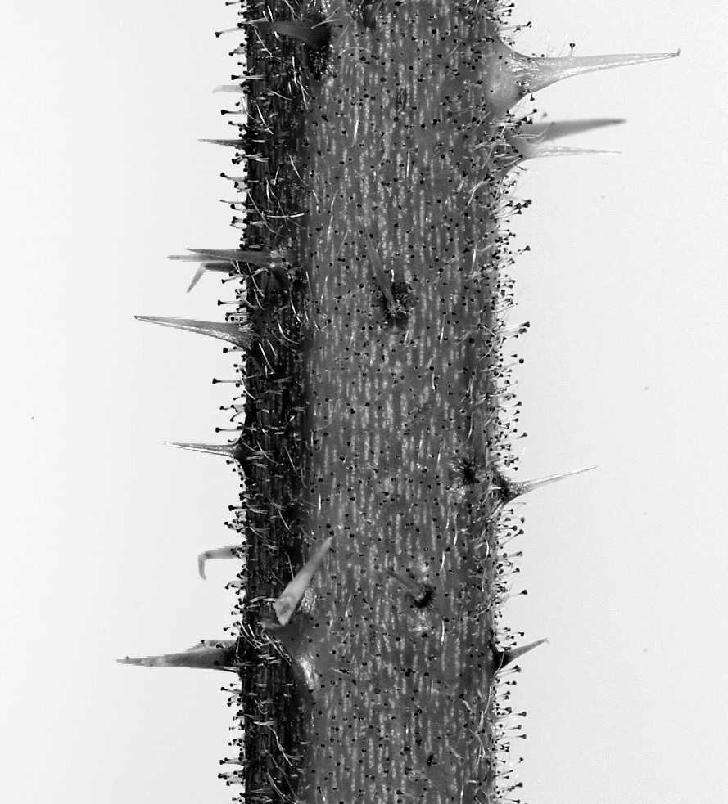
1 | 3
absent or few | many
Ad. 18: Terminal leaflet: lobing

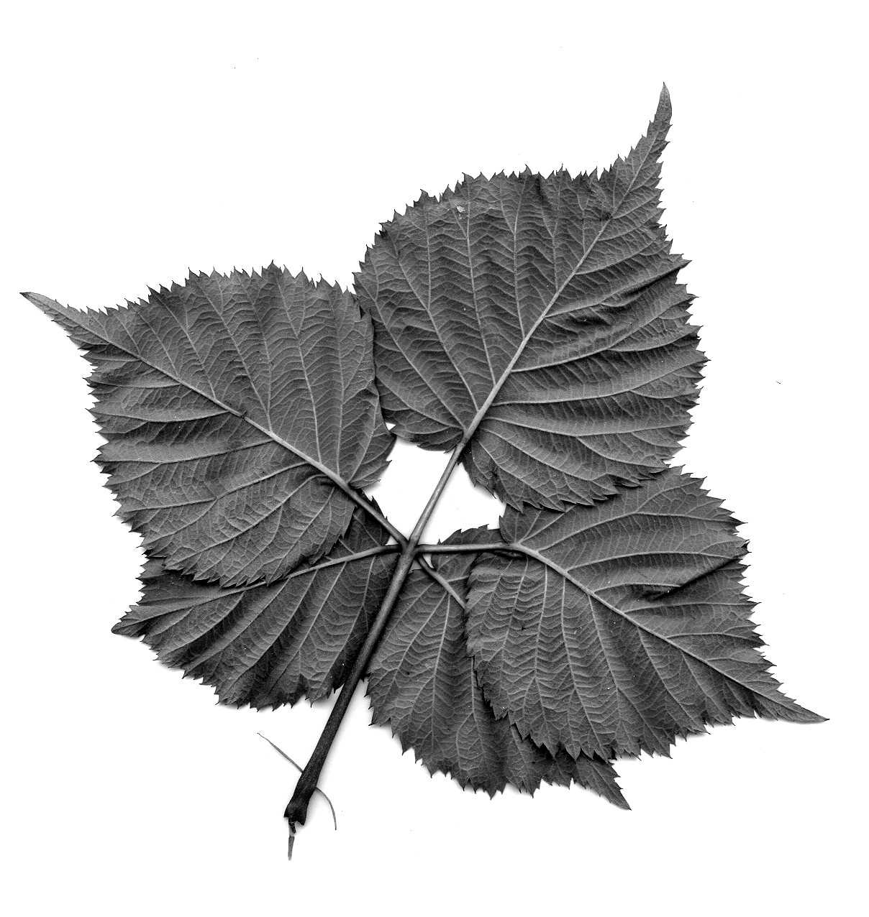 | 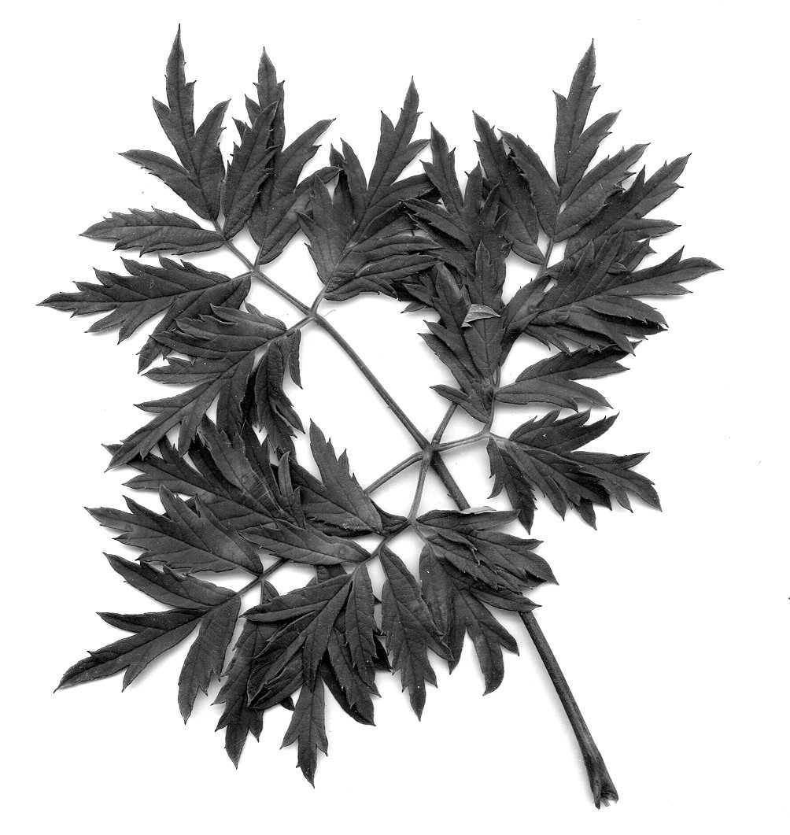
1 | 9
absent | present

Ad. 22: Leaflet: type of incision of margin

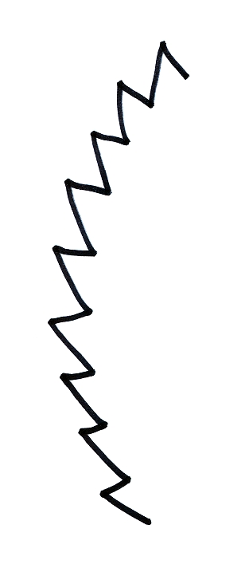 | 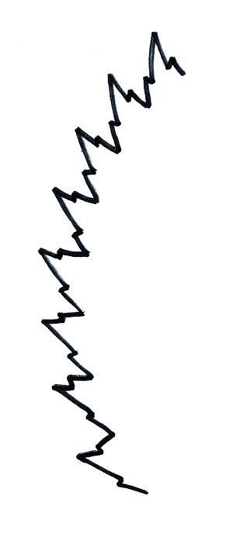
1 | 2
serrate | bi-serrate

Ad. 25: Leaf: type

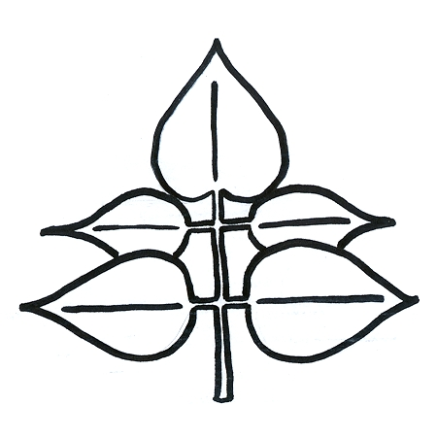 | 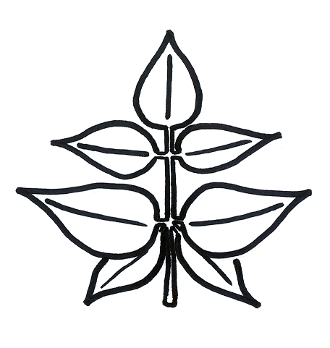 | 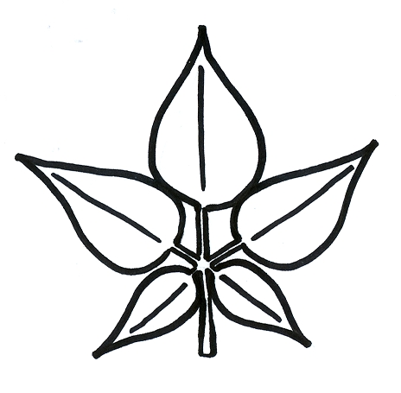
1 | 2 | 3
odd-pinnate | intermediate | palmate

Ad. 37: Fruit: shape in longitudinal section

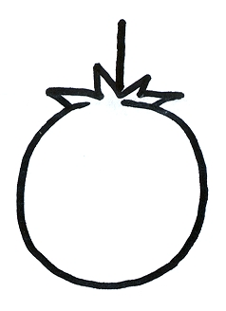 | 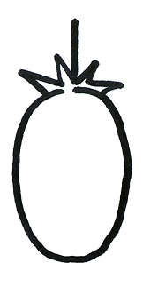 | 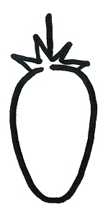
1 | 2 | 3
circular | elliptic | narrow ovate
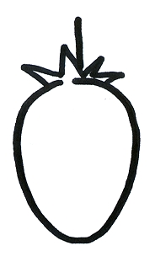 | 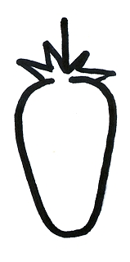 | 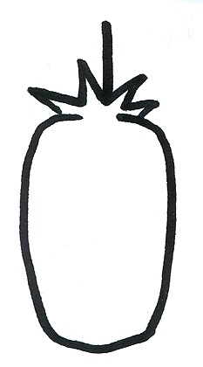
4 | 5 | 6
medium ovate | long conical | oblong

Ad. 41: Time of beginning of flowering on previous year’s cane
Ad. 42: Only varieties which fruit on current year's cane: Time of beginning of flowering on current year’s cane

The time of beginning of flowering is reached when 10% of the flower buds are open.

Ad. 43: Time of beginning of fruit ripening on previous year’s cane
Ad. 44: Only varieties which fruit on current year's cane: Time of beginning of fruit ripening on current year's cane

The time of beginning of fruit ripening is when the fruit is most easily removed from the plant.

Literature
Bordeianu, T.; Constantinescu, N.; Stefan, N., 1968: Pomologia, Vol.. VII. Editura Academiei Republicii Socialiste Romania, Bukarest, Romania.

Bundessortenamt, 1995: Beschreibende Sortenliste Beerenobst – Erdbeere, Himbeere, Brombeere, Stachelbeere. Landbuch Verlagsgesellschaft, Hannover, Germany.

Hedrick, U.P., 1925: The small fruits of New York, State of New York – Department of Farms and Markets, Thirty-third Annual Report, Part II. Albany, J.B. Lyon Company.

Jennings, D.L. 1988: Raspberries and Blackberries: Their breeding, diseases and growth, Academic Press. London, United Kingdom.

Sorge, P., 1984: Beerenobstsorten. Verlag J. Neumann-Neudamm, Melsungen, Germany.

Technical Questionnaire
TECHNICAL QUESTIONNAIRE |  |  |  | Page {x} of {y} |  | Reference Number:
 |  |  |  |  |  | Application date:
 |  |  |  |  |  | (not to be filled in by the applicant)
TECHNICAL QUESTIONNAIRE
to be completed in connection with an application for plant breeders’ rights

1. Subject of the Technical Questionnaire
1.1.1 Botanical Name |  |  | Rubus subgenus Rubus |  |  |  |  |  | [ ]
1.1.2 Common Name |  |  | Blackberry
1.2 Hybrid |  |  |  |  |  |  |  |  | [ ]
(please specify)

2. Applicant
Name
Address
Telephone No.
Fax No.
E-mail address
Breeder (if different from applicant)
3. Proposed denomination and breeder’s reference
Proposed denomination
(if available)

Breeder’s reference
#4. Information on the breeding scheme and propagation of the variety

4.1 Breeding scheme

Variety resulting from:

4.1.1 Crossing

(a) controlled cross [ ]
(please state parent varieties)
(b) partially known cross [ ]
(please state known parent variety(ies))
(c) unknown cross [ ]

4.1.2 Mutation [ ]
(please state parent variety)

4.1.3 Discovery and development [ ]
(please state where and when discovered
and how developed)

4.1.4 Other [ ]
(please provide details)

4.2 Method of propagating the variety

4.2.1 Vegetative propagation

(a) cuttings [ ]
(b) other (state method) [ ]

4.2.2 Other [ ]
(please provide details)

5. Characteristics of the variety to be indicated (the number in brackets refers to the corresponding characteristic in Test Guidelines; please mark the note which best corresponds).
 | Characteristics |  |  |  |  |  | Example Varieties |  |  | Note
5.1  (1) | Plant: growth habit
 | upright |  |  |  |  |  | Wilson’s Early, Arapaho |  |  | 1[ ]
 | upright to semi-upright |  |  |  |  |  | Kiowa |  |  | 2[ ]
 | semi-upright |  |  |  |  |  | Jersey Black |  |  | 3[ ]
 | semi-upright to spreading |  |  |  |  |  | Tayberry |  |  | 4[ ]
 | spreading |  |  |  |  |  | Himalaya, Aurora |  |  | 5[ ]
5.2  (9) | Dormant cane: spines
 | absent |  |  |  |  |  | Loch Ness |  |  | 1[ ]
 | present |  |  |  |  |  | Himalaya |  |  | 9[ ]
5.3  (24) | Leaf: predominant number of leaflets
 | three |  |  |  |  |  | Marionberry |  |  | 1[ ]
 | five |  |  |  |  |  | Himalaya, Jumbo |  |  | 2[ ]
 | seven |  |  |  |  |  | Karaka Black |  |  | 3[ ]
5.4  (25) | Leaf: type
 | odd-pinnate |  |  |  |  |  | Philadelphia |  |  | 1[ ]
 | intermediate |  |  |  |  |  | Karaka Black |  |  | 2[ ]
 | palmate |  |  |  |  |  | Thornless Evergreen |  |  | 3[ ]
5.5  (40) | Fruiting on current year’s cane
 | absent |  |  |  |  |  | Navaho |  |  | 1[ ]
 | present |  |  |  |  |  | Taylor’s Prolific |  |  | 9[ ]
 | Characteristics |  |  |  |  |  | Example Varieties |  |  | Note
5.6  (41) | Time of beginning of flowering on previous year’s cane
 | very early |  |  |  |  |  | Wilson’s Early |  |  | 1[ ]
 | early |  |  |  |  |  | Taylor’s Prolific |  |  | 3[ ]
 | medium |  |  |  |  |  | Himalaya |  |  | 5[ ]
 | late |  |  |  |  |  | Thornfree |  |  | 7[ ]
 | very late |  |  |  |  |  | Thornless Evergreen |  |  | 9[ ]
5.7  (43) | Time of beginning of fruit ripening on previous year's cane
 | very early |  |  |  |  |  | Loch Tay, Ranui |  |  | 1[ ]
 | early |  |  |  |  |  | Taylor’s Prolific, Karaka Black, Sunberry |  |  | 3[ ]
 | medium |  |  |  |  |  | Himalaya, Marionberry |  |  | 5[ ]
 | late |  |  |  |  |  | Thornfree |  |  | 7[ ]
 | very late |  |  |  |  |  | Thornless Evergreen |  |  | 9[ ]
6. Similar varieties and differences from these varieties
Please use the following table and box for comments to provide information on how your candidate variety differs from the variety (or varieties) which, to the best of your knowledge, is (or are) most similar. This information may help the examination authority to conduct its examination of distinctness in a more efficient way.
Denomination(s) of variety(ies) similar to your candidate variety |  | Characteristic(s) in which your candidate variety differs from the similar variety(ies) |  |  | Describe the expression of the characteristic(s) for the similar variety(ies) |  |  | Describe the expression of the characteristic(s) for your candidate variety
Example |  | Fruit: size of drupelet |  |  | small |  |  | medium
Comments:

#7. Additional information which may help in the examination of the variety

7.1 In addition to the information provided in sections 5 and 6, are there any additional characteristics which may help to distinguish the variety?

Yes [ ] No [ ]
(If yes, please provide details)

7.2 Are there any special conditions for growing the variety or conducting the examination?

Yes [ ] No [ ]
(If yes, please provide details)

7.3 Other information

A representative color photograph of the variety should accompany the Technical Questionnaire.

8. Authorization for release

(a) Does the variety require prior authorization for release under legislation concerning the protection of the environment, human and animal health?

Yes [ ] No [ ]

(b) Has such authorization been obtained?

Yes [ ] No [ ]

If the answer to (b) is yes, please attach a copy of the authorization.

9. Information on plant material to be examined or submitted for examination.

9.1 The expression of a characteristic or several characteristics of a variety may be affected by factors, such as pests and disease, chemical treatment (e.g. growth retardants or pesticides), effects of tissue culture, different rootstocks, scions taken from different growth phases of a tree, etc.

9.2 The plant material should not have undergone any treatment which would affect the expression of the characteristics of the variety, unless the competent authorities allow or request such treatment. If the plant material has undergone such treatment, full details of the treatment must be given. In this respect, please indicate below, to the best of your knowledge, if the plant material to be examined has been subjected to:

(a) Microorganisms (e.g. virus, bacteria, phytoplasma) Yes [ ] No [ ]

(b) Chemical treatment (e.g. growth retardant, pesticide) Yes [ ] No [ ]

(c) Tissue culture Yes [ ] No [ ]

(d) Other factors Yes [ ] No [ ]

Please provide details for where you have indicated “yes”.

10. I hereby declare that, to the best of my knowledge, the information provided in this form is correct:

Applicant’s name

Signature Date

[End of document]

* These names were correct at the time of the introduction of these Test Guidelines but may be revised or updated. [Readers are advised to consult the UPOV Code, which can be found on the UPOV Website (www.upov.int), for the latest information.]
# Authorities may allow certain of this information to be provided in a confidential section of the Technical Questionnaire.
# Authorities may allow certain of this information to be provided in a confidential section of the Technical Questionnaire.

