 |  | E  TG/72/6  ORIGINAL: English  DATE: 2006-04-05
INTERNATIONAL UNION FOR THE PROTECTION OF NEW VARIETIES OF PLANTS
GENEVA

 | WILLOW  UPOV Code: SALIX  Salix L. | *

GUIDELINES

FOR THE CONDUCT OF TESTS

FOR DISTINCTNESS, UNIFORMITY AND STABILITY

Alternative Names:*

Botanical name | English | French | German | Spanish
Salix L. | Willow | Saule | Weide | Sauce

The purpose of these guidelines (“Test Guidelines”) is to elaborate the principles contained in the General Introduction (document TG/1/3), and its associated TGP documents, into detailed practical guidance for the harmonized examination of distinctness, uniformity and stability (DUS) and, in particular, to identify appropriate characteristics for the examination of DUS and production of harmonized variety descriptions.

ASSOCIATED DOCUMENTS

These Test Guidelines should be read in conjunction with the General Introduction and its associated TGP documents.

TABLE OF CONTENTS PAGE

1. Subject of these TEST Guidelines 3
2. Material Required 3
3. Method of Examination 3
3.1 Duration of Tests 3
3.2 Testing Place 3
3.3 Conditions for Conducting the Examination 3
3.4 Test Design 3
3.5 Number of Plants / Parts of Plants to be Examined 4
4. Assessment of Distinctness, Uniformity and Stability 4
4.1 Distinctness 4
4.2 Uniformity 4
4.3 Stability 5
5. Grouping of Varieties and Organization of the Growing Trial 5
6. Introduction to the Table of Characteristics 5
6.1 Categories of Characteristics 5
6.2 States of Expression and Corresponding Notes 6
6.3 Types of Expression 6
6.4 Example Varieties 6
6.5 Legend 6
7. Table of Characteristics 7
8. Explanations on the Table of Characteristics 15
8.1 Explanations covering several characteristics 15
8.2 Explanations for individual characteristics 15
9. Literature 17
10. Technical Questionnaire 18

Subject of these Test Guidelines
These Test Guidelines apply to all varieties of Salix L. of the family Salicaceae.

Material Required
2.1 The competent authorities decide on the quantity and quality of the plant material required for testing the variety and when and where it is to be delivered. Applicants submitting material from a State other than that in which the testing takes place must ensure that all customs formalities and phytosanitary requirements are complied with.

2.2 The material is to be supplied in the form of hardwood cuttings with a diameter of at least 1 cm and a length of 20 cm, or well rooted one-year-old plants. Hardwood cuttings should be taken from one-year-old main shoots from stools.

2.3 The minimum quantity of plant material, to be supplied by the applicant, should be:

30 hardwood cuttings or 15 plants.

2.4 The plant material supplied should be visibly healthy, not lacking in vigor, nor affected by any important pest or disease.

2.5 The plant material should not have undergone any treatment which would affect the expression of the characteristics of the variety, unless the competent authorities allow or request such treatment. If it has been treated, full details of the treatment must be given.

Method of Examination

3.1 Number of growing cycles
The minimum duration of tests should normally be two independent growing cycles.

3.2 Testing Place
Tests are normally conducted at one place. In the case of tests conducted at more than one place, guidance is provided in TGP/9 “Examining Distinctness”.

3.3 Conditions for Conducting the Examination
The tests should be carried out under conditions ensuring satisfactory growth for the expression of the relevant characteristics of the variety and for the conduct of the examination.

3.4 Test Design
3.4.1 Each test should be designed to result in a total of at least 10 plants.

3.4.2 The design of the tests should be such that plants or parts of plants may be removed for measurement or counting without prejudice to the observations which must be made up to the end of the growing cycle.

3.5 Number of Plants / Parts of Plants to be Examined
Unless otherwise indicated, all observations should be made on 10 plants or parts taken from each of 10 plants.

3.6 Additional Tests

Additional tests, for examining relevant characteristics, may be established.

Assessment of Distinctness, Uniformity and Stability

4.1 Distinctness

4.1.1 General Recommendations

It is of particular importance for users of these Test Guidelines to consult the General Introduction prior to making decisions regarding distinctness. However, the following points are provided for elaboration or emphasis in these Test Guidelines.

4.1.2 Consistent Differences

The differences observed between varieties may be so clear that more than one growing cycle is not necessary. In addition, in some circumstances, the influence of the environment is not such that more than a single growing cycle is required to provide assurance that the differences observed between varieties are sufficiently consistent. One means of ensuring that a difference in a characteristic, observed in a growing trial, is sufficiently consistent is to examine the characteristic in at least two independent growing cycles.

4.1.3 Clear Differences

Determining whether a difference between two varieties is clear depends on many factors, and should consider, in particular, the type of expression of the characteristic being examined, i.e. whether it is expressed in a qualitative, quantitative, or pseudo-qualitative manner. Therefore, it is important that users of these Test Guidelines are familiar with the recommendations contained in the General Introduction prior to making decisions regarding distinctness.

4.2 Uniformity
4.2.1 It is of particular importance for users of these Test Guidelines to consult the General Introduction prior to making decisions regarding uniformity. However, the following points are provided for elaboration or emphasis in these Test Guidelines:

4.2.2 For the assessment of uniformity a population standard of 1% and an acceptance probability of at least 95% should be applied. In the case of a sample size of 10 plants, 1 off-type is allowed.

4.3 Stability
4.3.1 In practice, it is not usual to perform tests of stability that produce results as certain as those of the testing of distinctness and uniformity. However, experience has demonstrated that, for many types of variety, when a variety has been shown to be uniform, it can also be considered to be stable.

4.3.2 Where appropriate, or in cases of doubt, stability may be tested, either by growing a further generation, or by testing a new plant stock to ensure that it exhibits the same characteristics as those shown by the previous material supplied.

Grouping of Varieties and Organization of the Growing Trial
5.1 The selection of varieties of common knowledge to be grown in the trial with the candidate varieties and the way in which these varieties are divided into groups to facilitate the assessment of distinctness are aided by the use of grouping characteristics.

5.2 Grouping characteristics are those in which the documented states of expression, even where produced at different locations, can be used, either individually or in combination with other such characteristics: (a) to select varieties of common knowledge that can be excluded from the growing trial used for examination of distinctness; and (b) to organize the growing trial so that similar varieties are grouped together.

5.3 The following have been agreed as useful grouping characteristics:

(a) Plant: sex (characteristic 1)

5.4 Guidance for the use of grouping characteristics, in the process of examining distinctness, is provided through the General Introduction.

Introduction to the Table of Characteristics

6.1 Categories of Characteristics
6.1.1 Standard Test Guidelines Characteristics

Standard Test Guidelines characteristics are those which are approved by UPOV for examination of DUS and from which members of the Union can select those suitable for their particular circumstances.

6.1.2 Asterisked Characteristics

Asterisked characteristics (denoted by *) are those included in the Test Guidelines which are important for the international harmonization of variety descriptions and should always be examined for DUS and included in the variety description by all members of the Union, except when the state of expression of a preceding characteristic or regional environmental conditions render this inappropriate.

6.2 States of Expression and Corresponding Notes
States of expression are given for each characteristic to define the characteristic and to harmonize descriptions. Each state of expression is allocated a corresponding numerical note for ease of recording of data and for the production and exchange of the description.

6.3 Types of Expression
An explanation of the types of expression of characteristics (qualitative, quantitative and pseudo-qualitative) is provided in the General Introduction.

6.4 Example Varieties
Where appropriate, example varieties are provided to clarify the states of expression of each characteristic.

6.5 Legend
(*) Asterisked characteristic – see Section 6.1.2

QL Qualitative characteristic – see Section 6.3
QN Quantitative characteristic – see Section 6.3
PQ Pseudo-Qualitative characteristic – see Section 6.3

(a)-(d) See Explanations on the Table of Characteristics in Chapter 8.1

(+) See Explanations on the Table of Characteristics in Chapter 8.2

Table of Characteristics/Tableau des caractères/Merkmalstabelle/Tabla de caracteres
 |  | English | français | deutsch | español | Example Varieties  Exemples  Beispielssorten  Variedades ejemplo | Note/  Nota
1.  (*) | (a) | Plant: sex | Plante: sexe | Pflanze: Geschlecht | Planta: sexo
QL |  | dioecious female | dioïque femelle | zweihäusig weiblich | dioico femenino | Tora | 1
 |  | dioecious male | dioïque mâle | zweihäusig männlich | dioico masculino | Björn | 2
 |  | monoecious unisexual | monoïque unisexuée | einhäusig eingeschlechtlich | monoico unisexual |  | 3
 |  | monoecious hermaphrodite | monoïque hermaphrodite | einhäusig zwittrig | monoico hermafrodita |  | 4
2.  (*) | (a) | Plant: spring foliation | Plante: débourrement | Pflanze: Frühjahrsaustrieb | Planta: foliación en primavera
QN |  | very early | très précoce | sehr früh | muy temprana | I - 3 – 58 | 1
 |  | early | précoce | früh | temprana | Godesberg | 3
 |  | medium | moyen | mittel | media | Metz | 5
 |  | late | tardif | spät | tardía | F - 65 - 02 | 7
 |  | very late | très tardif | sehr spät | muy tardía | Mangahn | 9
3.  (*) | (b) | Main shoot: attitude | Pousse principale: port | Haupttrieb: Haltung | Rama principal: postura
PQ |  | straight | droit | gerade | recto | Bredevoort | 1
 |  | slightly curved | légèrement flexueux | schwach gebogen | ligeramente curvado | I - 3 - 58 | 2
 |  | moderately curved | modérément flexueux | mäßig gebogen | moderamente curvado | Mittlerer Inn V | 3
 |  | strongly curved | fortement flexueux | stark gebogen | fuertement curvado | 75/64 (S. fragilis L.) | 4
 |  | tortuous | tortueux | gewunden | tortuoso | Tortuosa | 5
4. | (b)  (c) | Main shoot: color in middle third (sunny side) | Pousse principale: couleur au tiers moyen (face ensoleillée) | Haupttrieb: Farbe im mittleren Drittel (Sonnenseite) | Rama principal: color en el tercio medio (parte soleada)
PQ |  | yellow | jaune | gelb | amarillo |  | 1
 |  | orange | orange | orange | naranja | Gelbe Dotterweide | 2
 |  | grey | gris | grau | gris |  | 3
 |  | grey green | gris vert | graugrün | verde gris |  | 4
 |  | light green | vert clair | hellgrün | verde claro | Graupa 34 | 5
 |  | medium green | vert moyen | mittelgrün | verde medio | 259/64 (S. x smithiana Willd.) | 6
 |  | brown green | brun vert | braungrün | marrón verdoso | I – 3 – 58 | 7
 |  | grey brown | brun gris | graubraun | marrón grisáceo |  | 8
 |  | red brown | brun rouge | rotbraun | marrón rojizo | Altenstadt 4 | 9
 |  | brown | brun | braun | marrón | Straubinger Baumweide II | 10
5. | (b)  (c) | Main shoot: hairiness | Pousse principale: pilosité | Haupttrieb: Behaarung | Rama principal: vellosidad
QN |  | absent or very weak | nulle ou très faible | fehlend oder sehr gering | ausente o muy débil | Tordis | 1
 |  | weak | faible | gering | débil |  | 3
 |  | medium | moyenne | mittel | media |  | 5
 |  | strong | forte | stark | fuerte | Osk | 7
 |  | very strong | très forte | sehr stark | muy fuerte |  | 9
6.  (+) | (b) | Main shoot: protrusion of lenticels | Pousse principale: protubérance des lenticelles | Haupttrieb: Hervorstehen der Lentizellen | Rama principal: protuberancia de lenticelas
QN |  | absent or very weak | nulle ou très faible | fehlend oder sehr gering | ausente o muy débil |  | 1
 |  | weak | faible | gering | débil | Olaf | 3
 |  | medium | moyenne | mittel | media |  | 5
 |  | strong | forte | stark | grande | Sherwood | 7
 |  | very strong | très forte | sehr stark | muy fuerte |  | 9
7. | (b)  (c) | Main shoot: color of leaf bud | Pousse principale: couleur du bourgeon à feuilles | Haupttrieb: Farbe der Blattknospe | Rama principal: color de la yema foliar
PQ |  | light green | vert clair | hellgrün | verde claro |  | 1
 |  | medium green | vert moyen | mittelgrün | verde medio |  | 2
 |  | greenish brown | brun verdâtre | grünlichbraun | marrón verdoso | Gustaf | 3
 |  | brown | brun | braun | marrón | Björn, Orm | 4
 |  | reddish brown | brun rougeâtre | rötlichbraun | marrón rojizo | Stott 10 | 5
8. | (b)  (c) | Main shoot: hairiness of leaf bud | Pousse principale: pilosité du bourgeon à feuilles | Haupttrieb: Behaarung der Blattknospe | Rama principal: vellosidad de la yema foliar
QN |  | absent or very weak | nulle ou très faible | fehlend oder sehr gering | ausente o muy débil | Armando | 1
 |  | weak | faible | gering | débil | Sherwood | 3
 |  | medium | moyenne | mittel | media | Nils | 5
 |  | strong | forte | stark | fuerte | Stott 10 | 7
 |  | very strong | très forte | sehr stark | muy fuerte | Osk | 9
9.  (*) | (b) | Main shoot: number of branches longer than 5 cm | Pousse principale: nombre de rameaux de plus de 5 cm de long | Haupttrieb: Anzahl der Zweige, die länger als 5 cm sind | Rama principal: número de ramas de longitud superior a 5 cm
QN |  | absent or very few | nul ou très petit | fehlend oder sehr gering | ausente o muy bajo | Altenstadt 4 | 1
 |  | few | petit | gering | bajo | Mittlerer Inn III | 3
 |  | medium | moyen | mittel | medio | Bredevoort | 5
 |  | many | grand | groß | alto | Belders | 7
 |  | very many | très grand | sehr groß | muy alto | I - 3 - 58 | 9
10.  (*) | (b) | Branch: angle between first 5 cm of branch and main shoot in middle third of main shoot | Rameau: angle entre les 5 premiers centimètres du rameau et la pousse principale au tiers moyen de la pousse principale | Zweig: Winkel zwischen den ersten 5 cm des Zweiges und dem Haupttrieb im mittleren Drittel des Haupttriebes | Rama: ángulo entre los primeros 5 cm de la rama y la rama principal en el tercio medio de la rama principal
QN |  | very small | très petit | sehr klein | muy pequeño |  | 1
 |  | small | petit | klein | pequeño | Resolution | 3
 |  | medium | moyen | mittel | medio | Karin | 5
 |  | large | grand | groß | grande | Doris | 7
 |  | very large | très grand | sehr groß | muy grande |  | 9
11.  (*) | (b) | Branch: attitude | Rameau: port | Zweig: Haltung | Rama: postura
PQ |  | curved up | incurvé vers le haut | aufwärts gebogen | curvada hacia arriba | Orm | 1
 |  | straight | droit | gerade | recta | Olaf | 2
 |  | drooping | retombant | überhängend | colgante | Pendula | 3
 |  | first curved down, then curved up | incurvé vers le bas, puis vers le haut | erst abwärts, dann aufwärts gebogen | curvada primero hacia abajo y luego hacia arriba |  | 4
12. | (b) | Branch: color (sunny side) | Rameau: couleur (face ensoleillée) | Zweig: Farbe (Sonnenseite) | Rama: color (parte soleada)
PQ |  | yellow green | vert jaune | gelbgrün | verde amarillento |  | 1
 |  | grey green | gris vert | graugrün | verde-gris | Unn | 2
 |  | green | vert | grün | verde |  | 3
 |  | grey brown | brun gris | graubraun | marrón grisáceo | Stott 10 | 4
 |  | red brown | brun rouge | rotbraun | marrón rojizo | Boberg | 5
 |  | brown | brun | braun | marrón | Karin | 6
13.  (*) | (d) | Leaf blade: length of midrib | Limbe: longueur de la nervure principale | Blattspreite: Länge der Mittelrippe | Limbo: longitud del nervio central
QN |  | very short | très courte | sehr kurz | muy pequeño | Armando | 1
 |  | short | courte | kurz | pequeño | Vidi | 3
 |  | medium | moyenne | mittel | medio | Doris | 5
 |  | long | longue | lang | grande | A. Parfitt | 7
 |  | very long | très longue | sehr lang | muy grande |  | 9
14.  (*) | (d) | Leaf blade: width | Limbe: largeur | Blattspreite: Breite | Limbo: anchura
QN |  | very narrow | très étroit | sehr schmal | muy estrecho | Armando | 1
 |  | narrow | étroit | schmal | estrecho | Karin | 3
 |  | medium | moyen | mittel | medio | A. Parfitt | 5
 |  | broad | large | breit | ancho | Vidi | 7
 |  | very broad | très large | sehr breit | muy ancho |  | 9
15. | (d) | Leaf blade: position of maximum width | Limbe: position de la largeur maximale | Blattspreite: Position der maximalen Breite | Limbo: posición de la anchura máxima
QN |  | below middle | en dessous du milieu | unterhalb der Mitte | debajo de la mitad | Karin | 1
 |  | approximately at middle | à peu près au milieu | etwa in der Mitte | aproximadamente en la mitad | Vidi | 2
 |  | above middle | au-dessus du milieu | oberhalb der Mitte | encima de la mitad | Pendula | 3
16.  (*)  (+) | (d) | Leaf blade: shape of base | Limbe: forme de la base | Blattspreite: Form der Basis | Limbo: forma de la base
PQ |  | acuminate | acuminée | zugespitzt | acuminada |  | 1
 |  | acute | aiguë | spitz | aguda | Prinzeninsel Plön | 2
 |  | rounded | arrondie | abgerundet | redondeada | Super White | 3
 |  | obtuse | obtuse | rundlich keilförmig | obtusa |  | 4
 |  | truncate | tronquée | gerade | truncada |  | 5
 |  | cordate | cordiforme | herzförmig | cordiforme | SHS | 6
17. | (d) | Leaf blade: color of upper side | Limbe: couleur de la face supérieure | Blattspreite: Farbe der Oberseite | Limbo: color del haz
PQ |  | yellow green | vert jaune | gelbgrün | verde amarillento | Gold Leaf | 1
 |  | light green | vert clair | hellgrün | verde claro |  | 2
 |  | medium green | vert moyen | mittelgrün | verde medio | Flamingo, Hild | 3
 |  | dark green | vert foncé | dunkelgrün | verde oscuro |  | 4
 |  | grey green | gris vert | graugrün | verde-gris |  | 5
 |  | blue green | bleu vert | blaugrün | verde azulado |  | 6
 |  | red green | vert rouge | rotgrün | verde rojizo |  | 7
18. | (d) | Leaf blade: hairiness of upper side | Limbe: pilosité de la face supérieure | Blattspreite: Behaarung der Oberseite | Limbo: vellosidad del haz
QN |  | absent or very weak | nulle ou très faible | fehlend oder sehr gering | ausente o muy débil | Flamingo | 1
 |  | weak | faible | gering | débil | Aud | 3
 |  | medium | moyenne | mittel | media | Hild | 5
 |  | strong | forte | stark | fuerte |  | 7
 |  | very strong | très forte | sehr stark | muy fuerte |  | 9
19. | (d) | Leaf blade: hairiness of lower side | Limbe: pilosité de la face inférieure | Blattspreite: Behaarung der Unterseite | Limbo: vellosidad del envés
QN |  | absent or very weak | nulle ou très faible | fehlend oder sehr gering | ausente o muy débil |  | 1
 |  | weak | faible | gering | débil | Flamingo | 3
 |  | medium | moyenne | mittel | media |  | 5
 |  | strong | forte | stark | fuerte |  | 7
 |  | very strong | très forte | sehr stark | muy fuerte | Ivar, Sherwood | 9
20.  (*) | (d) | Petiole: length | Pétiole: longueur | Blattstiel: Länge | Pecíolo: longitud
QN |  | very short | très court | sehr kurz | muy corto |  | 1
 |  | short | court | kurz | corto | F-65-02 | 3
 |  | medium | moyen | mittel | medio | Garonne 47 | 5
 |  | long | long | lang | largo | 259/64 (S. x smithiana Willd.) | 7
 |  | very long | très long | sehr lang | muy largo |  | 9
21. | (d) | Petiole: color of upper side | Pétiole: couleur de la face supérieure | Blattstiel: Farbe der Oberseite | Pecíolo: color del haz
PQ |  | yellow green | vert jaune | gelbgrün | verde amarillento |  | 1
 |  | green | vert | grün | verde |  | 2
 |  | red green | vert rouge | rotgrün | verde rojizo |  | 3
 |  | violet green | vert violet | violettgrün | verde violeta | F-65-02, Garonne 47 | 4
22. | (d) | Stipule: length | Stipule: longueur | Nebenblatt: Länge | Estípula: longitud
QN |  | very short | très court | sehr kurz | muy corta |  | 1
 |  | short | court | kurz | corta | 259/64 (S. x smithiana Willd.) | 3
 |  | medium | moyen | mittel | media | Super White | 5
 |  | long | long | lang | larga | Mangahn | 7
 |  | very long | très long | sehr lang | muy larga | Jodis | 9
23.  (+) | (d) | Stipule: type | Stipule: type | Nebenblatt: Typ | Estípula: tipo
PQ |  | type 1 | type 1 | Typ 1 | tipo 1 |  | 1
 |  | type 2 | type 2 | Typ 2 | tipo 2 |  | 2
 |  | type 3 | type 3 | Typ 3 | tipo 3 |  | 3

Explanations on the Table of Characteristics

8.1 Explanations covering several characteristics
Characteristics containing the following key in the second column of the Table of Characteristics should be examined as indicated below:

(a) Observations on the plant sex and spring foliation should be made at beginning of growth after winter dormancy.

(b) All observations on the main shoot and the branches should be made in autumn.

(c) Hairiness and color of the main shoot and the leaf bud should be observed at 20 cm from the tip of the main shoot.

(d) All observations on the leaf should be made in the middle of the growing period on leaves of the middle third of the main shoot.

8.2 Explanations for individual characteristics
Ad. 6: Main shoot: protrusion of lenticel

To be observed in the middle third of the main shoot.

Ad. 16: Leaf blade: shape of base

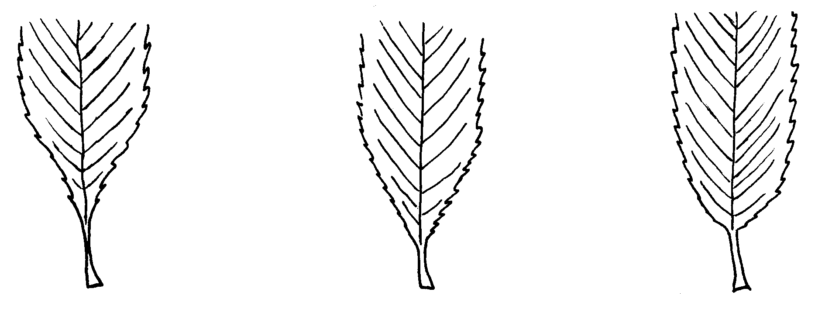
1 | 2 | 3
acuminate | acute | rounded

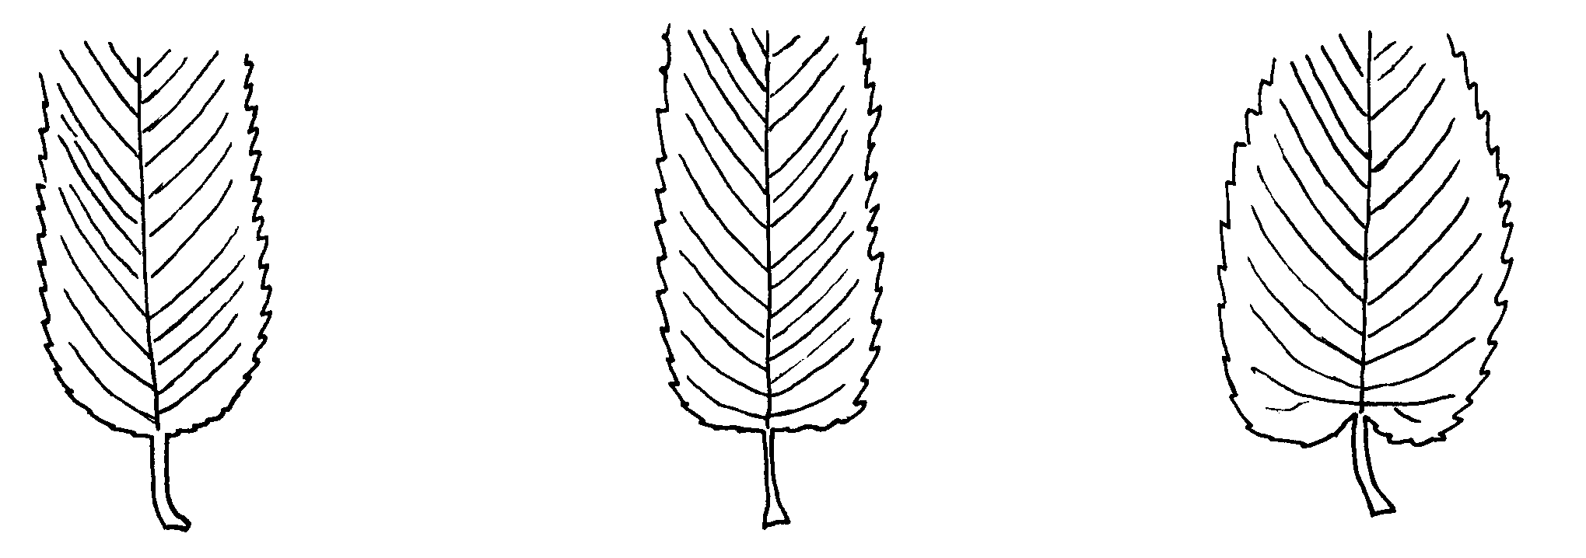

4 | 5 | 6
obtuse | truncate | cordate

Ad. 23: Stipule: type

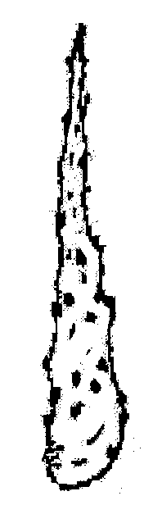 | 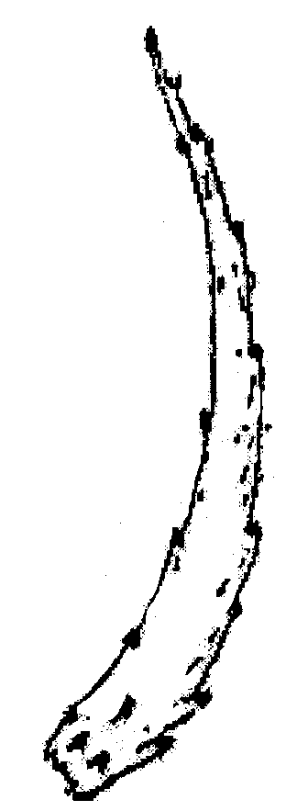 | 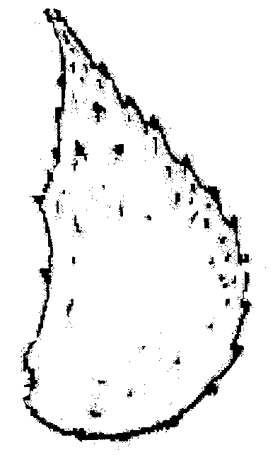
type 1 | type 2 | type 3

Literature
Newsholme, Christopher: Willows, the genus Salix, London, B. T. Batsford Ltd., Great Britain, 1992

Schiechtl, H. M.: Weiden in der Praxis, Patzer Verlag, Hannover, 1992

Technical Questionnaire
TECHNICAL QUESTIONNAIRE |  |  |  | Page {x} of {y} |  |  | Reference Number:
 |  |  |  |  |  |  | Application date:
 |  |  |  |  |  |  | (not to be filled in by the applicant)
TECHNICAL QUESTIONNAIRE
to be completed in connection with an application for plant breeders’ rights
1. Subject of the Technical Questionnaire
1.1 Botanical Name |  |  | Salix L.
1.2 Common Name |  |  | Willow
1.3 Species
(please complete)
2. Applicant
Name
Address
Telephone No.
Fax No.
E-mail address
Breeder (if different from applicant)
3. Proposed denomination and breeder’s reference
Proposed denomination
(if available)

Breeder’s reference
4. Information on the breeding scheme and propagation of the variety

4.1 Breeding Scheme

Variety resulting from:

4.1.1 Crossing

(a) controlled cross [ ]
(please state parent varieties)
(b) partially known cross [ ]
(please state known parent variety(ies))
(c) unknown cross [ ]

4.1.2 Mutation [ ]
(please state parent variety)

4.1.3 Discovery and development [ ]
(please state where and when discovered and
how developed)

4.1.4 Other [ ]
(please provide details)

4.2 Method of propagating the variety

(a) cuttings [ ]

(b) in vitro propagation [ ]

(c) other (state method) [ ]

5. Characteristics of the variety to be indicated (the number in brackets refers to the corresponding characteristic in Test Guidelines; please mark the note which best corresponds).

 | Characteristics |  |  |  |  | Example Varieties |  |  |  | Note
5.1  (1) | Plant: sex
 | dioecious female |  |  |  |  | Tora |  |  |  | 1[ ]
 | dioecious male |  |  |  |  | Björn |  |  |  | 2[ ]
 | monoecious unisexual |  |  |  |  |  |  |  |  | 3[ ]
 | monoecious hermaphrodite |  |  |  |  |  |  |  |  | 4[ ]
5.2  (2) | Plant: spring foliation
 | very early |  |  |  |  | I - 3 - 58 |  |  |  | 1[ ]
 | early |  |  |  |  | Godesberg |  |  |  | 3[ ]
 | medium |  |  |  |  | Metz |  |  |  | 5[ ]
 | late |  |  |  |  | F - 65 - 02 |  |  |  | 7[ ]
 | very late |  |  |  |  | Mangahn |  |  |  | 9[ ]
6. Similar varieties and differences from these varieties

Please use the following table and box for comments to provide information on how your candidate variety differs from the variety (or varieties) which, to the best of your knowledge, is (or are) most similar. This information may help the examination authority to conduct its examination of distinctness in a more efficient way.

Denomination(s) of variety(ies) similar to your candidate variety |  | Characteristic(s) in which your candidate variety differs from the similar variety(ies) |  |  | Describe the expression of the characteristic(s) for the similar variety(ies) |  |  | Describe the expression of the characteristic(s) for your candidate variety
Example |  | Plant: spring foliation |  |  | medium |  |  | early
Comments:

#7. Additional information which may help in the examination of the variety

7.1 In addition to the information provided in sections 5 and 6, are there any additional characteristics which may help to distinguish the variety?

Yes [ ] No [ ]

(If yes, please provide details)

7.2 Are there any special conditions for growing the variety or conducting the examination?

Yes [ ] No [ ]

(If yes, please provide details)

7.3 Main use

(a) ornamental plant [ ]
(b) biomass production [ ]

7.4 Other information

A representative color photograph of the variety should accompany the Technical Questionnaire.

8. Authorization for release

(a) Does the variety require prior authorization for release under legislation concerning the protection of the environment, human and animal health?

Yes [ ] No [ ]

(b) Has such authorization been obtained?

Yes [ ] No [ ]

If the answer to (b) is yes, please attach a copy of the authorization.

9. Information on plant material to be examined or submitted for examination.

9.1 The expression of a characteristic or several characteristics of a variety may be affected by factors, such as pests and disease, chemical treatment (e.g. growth retardants or pesticides), effects of tissue culture, different rootstocks, scions taken from different growth phases of a tree, etc.

9.2 The plant material should not have undergone any treatment which would affect the expression of the characteristics of the variety, unless the competent authorities allow or request such treatment. If the plant material has undergone such treatment, full details of the treatment must be given. In this respect, please indicate below, to the best of your knowledge, if the plant material to be examined has been subjected to:

(a) Microorganisms (e.g. virus, bacteria, phytoplasma) Yes [ ] No [ ]

(b) Chemical treatment (e.g. growth retardant, pesticide) Yes [ ] No [ ]

(c) Tissue culture Yes [ ] No [ ]

(d) Other factors Yes [ ] No [ ]

Please provide details for where you have indicated “yes”.

……………………………………………………………

10. I hereby declare that, to the best of my knowledge, the information provided in this form is correct:

Applicant’s name

Signature Date

[End of document]

* These names were correct at the time of the introduction of these Test Guidelines but may be revised or updated. [Readers are advised to consult the UPOV Code, which can be found on the UPOV Website (www.upov.int), for the latest information.]
# Authorities may allow certain of this information to be provided in a confidential section of the Technical Questionnaire.

