 |  | E  TG/66/4  ORIGINAL: English  DATE: 2004-03-31
INTERNATIONAL UNION FOR THE PROTECTION OF NEW VARIETIES OF PLANTS
GENEVA

White Lupin *
(Lupinus albus L.),
NARROW LEAF LUPIN/*
Blue Lupin
(Lupinus angustifolius L.) and
Yellow Lupin *
(Lupinus luteus L.).

GUIDELINES

FOR THE CONDUCT OF TESTS

FOR DISTINCTNESS, UNIFORMITY AND STABILITY

Alternative Names:*

 | Latin |  | English |  | French |  | German |  | Spanish
Lupinus albus L. |  | White Lupin |  | Lupin blanc |  | Weiße Lupine |  | Altramuz blanco
Lupinus angustifolius L. |  | Narrow Leaf Lupin/Blue Lupin |  | Lupin bleu |  | Blaue Lupine/ Schmalblättrige Lupine |  | Altramuz azul
Lupinus luteus L. |  | Yellow Lupin |  | Lupin jaune |  | Gelbe Lupine |  | Altramuz amarillo

ASSOCIATED DOCUMENTS

These guidelines should be read in conjunction with document TG/1/3, “General Introduction to the Examination of Distinctness, Uniformity and Stability and the Development of Harmonized Descriptions of New Varieties of Plants” (hereinafter referred to as the “General Introduction”) and its associated “TGP” documents.

TABLE OF CONTENTS PAGE

1. Subject of these Test Guidelines 3
2. Material Required 3
3. Method of Examination 3
3.1 Duration of Tests 3
3.2 Testing Place 3
3.3 Conditions for Conducting the Examination 3
3.4 Test Design 4
3.5 Number of Plants / Parts of Plants to be Examined 4
3.6 Additional Tests 4
4. Assessment of Distinctness, Uniformity and Stability 4
4.1 Distinctness 4
4.2 Uniformity 5
4.3 Stability 5
5. Grouping of Varieties and Organization of the Growing Trial 5
6. Introduction to the Table of Characteristics 6
6.1 Categories of Characteristics 6
6.2 States of Expression and Corresponding Notes 6
6.3 Types of Expression 6
6.4 Example Varieties 6
6.5 Legend 6
7. Table of Characteristics/Tableau des caractères/Merkmalstabelle/Tabla de caracteres 8
8. Explanations on the Table of Characteristics 15
9. Literature 19
10. Technical Questionnaire 20

Subject of these Test Guidelines
These Test Guidelines apply to all varieties of Lupinus albus L., Lupinus angustifolius L. and Lupinus luteus L.

Material Required
2.1 The competent authorities decide on the quantity and quality of the plant material required for testing the variety and when and where it is to be delivered. Applicants submitting material from a State other than that in which the testing takes place must ensure that all customs formalities and phytosanitary requirements are complied with.

2.2 The material is to be supplied in the form of seed.

2.3 The minimum quantity of plant material, to be supplied by the applicant, should be:

2,5 kg

2.4 The seed should meet the minimum requirements for germination, species and analytical purity, health and moisture content, specified by the competent authority. In cases where the seed is to be stored, the germination capacity should be as high as possible and should be stated by the applicant.

2.5 The plant material supplied should be visibly healthy, not lacking in vigor, nor affected by any important pest or disease.

2.6 The plant material should not have undergone any treatment which would affect the expression of the characteristics of the variety, unless the competent authorities allow or request such treatment. If it has been treated, full details of the treatment must be given.

Method of Examination

3.1 Duration of Tests
The minimum duration of tests should normally be two independent growing cycles.

3.2 Testing Place
The tests should normally be conducted at one place. If any characteristics of the variety, which are relevant for the examination of DUS, cannot be observed at that place, the variety may be tested at an additional place.

3.3 Conditions for Conducting the Examination
The tests should be carried out under conditions ensuring satisfactory growth for the expression of the relevant characteristics of the variety and for the conduct of the examination.

3.3.1 Type of observation

The recommended method of observing the characteristic is indicated by the following key in the second column of the Table of Characteristics:

MG: single measurement of a group of plants or parts of plants
MS: measurement of a number of individual plants or parts of plants
VG: visual assessment by a single observation of a group of plants or parts of plants
VS: visual assessment by observation of individual plants or parts of plants
C: special test

3.4 Test Design
3.4.1 Each test should be designed to result in a total of at least 200 plants, which should be divided between two or more replicates.

3.4.2 The design of the tests should be such that plants or parts of plants may be removed for measurement or counting without prejudice to the observations which must be made up to the end of the growing cycle.

3.5 Number of Plants / Parts of Plants to be Examined
Unless otherwise indicated, all observations on single plants should be made on 30 plants or parts taken from each of 30 plants.

3.6 Additional Tests
Additional tests, for examining relevant characteristics, may be established.

Assessment of Distinctness, Uniformity and Stability

4.1 Distinctness

4.1.1 General Recommendations

It is of particular importance for users of these Test Guidelines to consult the General Introduction prior to making decisions regarding distinctness. However, the following points are provided for elaboration or emphasis in these Test Guidelines.

4.1.2 Consistent Differences

The minimum duration of tests recommended in Section 3.1 reflects, in general, the need to ensure that any differences in a characteristic are sufficiently consistent.

4.1.3 Clear Differences

Determining whether a difference between two varieties is clear depends on many factors, and should consider, in particular, the type of expression of the characteristic being examined, i.e. whether it is expressed in a qualitative, quantitative, or pseudo-qualitative manner. Therefore, it is important that users of these Test Guidelines are familiar with the recommendations contained in the General Introduction prior to making decisions regarding distinctness.

4.2 Uniformity
4.2.1 It is of particular importance for users of these Test Guidelines to consult the General Introduction prior to making decisions regarding uniformity. However, the following points are provided for elaboration or emphasis in these Test Guidelines:

4.2.2 For the assessment of uniformity, a population standard of 1% and an acceptance probability of at least 95% should be applied. In the case of a sample size of 200 plants, 5 off-types are allowed.

4.3 Stability
4.3.1 In practice, it is not usual to perform tests of stability that produce results as certain as those of the testing of distinctness and uniformity. However, experience has demonstrated that, for many types of variety, when a variety has been shown to be uniform, it can also be considered to be stable.

4.3.2 Where appropriate, or in cases of doubt, stability may be tested, either by growing a further generation, or by testing a new seed stock to ensure that it exhibits the same characteristics as those shown by the previous material supplied.

Grouping of Varieties and Organization of the Growing Trial
5.1 The selection of varieties of common knowledge to be grown in the trial with the candidate varieties and the way in which these varieties are divided into groups to facilitate the assessment of distinctness is aided by the use of grouping characteristics.

5.2 Grouping characteristics are those in which the documented states of expression, even where produced at different locations, can be used, either individually or in combination with other such characteristics: (a) to select varieties of common knowledge that can be excluded from the growing trial used for examination of distinctness; and (b) to organize the growing trial so that similar varieties are grouped together.

5.3 The following have been agreed as useful grouping characteristics:

(a) Grain: bitter principle (characteristic 1)
(b) Flower: color of wings (characteristic 9)
(c) Plant: growth type (characteristic 11)

5.4 Guidance for the use of grouping characteristics, in the process of examining distinctness, is provided through the General Introduction.

Introduction to the Table of Characteristics

6.1 Categories of Characteristics

6.1.1 Standard Test Guidelines Characteristics
Standard Test Guidelines characteristics are those which are approved by UPOV for examination of DUS and from which members of the Union can select those suitable for their particular circumstances.

6.1.2 Asterisked Characteristics
Asterisked characteristics (denoted by *) are those included in the Test Guidelines which are important for the international harmonization of variety descriptions and should always be examined for DUS and included in the variety description by all members of the Union, except when the state of expression of a preceding characteristic or regional environmental conditions render this inappropriate.

6.2 States of Expression and Corresponding Notes
States of expression are given for each characteristic to define the characteristic and to harmonize descriptions. Each state of expression is allocated a corresponding numerical note for ease of recording of data and for the production and exchange of the description.

6.3 Types of Expression
An explanation of the types of expression of characteristics (qualitative, quantitative and pseudo-qualitative) is provided in the General Introduction.

6.4 Example Varieties
6.4.1 Where appropriate, example varieties are provided to clarify the states of expression of each characteristic.

6.4.2 Species of example varieties:

Lal: Lupinus albus
Lan: Lupinus angustifolius
Llu: Lupinus luteus

6.5 Legend
(*) Asterisked characteristic – see Section 6.1.2
QL Qualitative characteristic – see Section 6.3
QN Quantitative characteristic – see Section 6.3
PQ Pseudo-qualitative characteristic – see Section 6.3

MG Single measurement of a group of plants or parts of plants – see Section 3.3.1
MS Measurement of a number of individual plants or parts of plants – see Section 3.3.1
VG Visual assessment by a single observation of a group of plants or parts of plants – see Section 3.3.1
VS Visual assessment by observation of individual plants or parts of plants – see Section 3.3.1
C: special test – see Section 3.3.1

(a) See Explanations on the Table of Characteristics in Chapter 8, Section 8.1
(+) See Explanations on the Table of Characteristics in Chapter 8, Section 8.2

Table of Characteristics/Tableau des caractères/Merkmalstabelle/Tabla de caracteres
 |  | English | français | deutsch | español | Example Varieties  Exemples  Beispielssorten  Variedades ejemplo | Note/  Nota
1.  (*)  (+) | C  VG | Grain: bitter principle | Semence: amertume | Samen: Bitterstoff | Semilla: amargor
QL |  | absent | absente | fehlend | ausente | Nelly (Lal),  Bordako (Lan),  Borselfa (Llu) | 1
 |  | present | présente | vorhanden | presente | Feli (Lal),  Azuro (Lan),  Trebisa (Llu) | 9
2.  (+) | VG | Plant: height at vegetative stage | Plante: hauteur au stade végétatif | Pflanze: Höhe im vegetativen Stadium | Planta: altura en estado vegetativo
QN |  | short | courte | niedrig | baja |  | 3
 |  | medium | moyenne | mittel | media | Minori (Lal),  Azuro (Lan),  Borselfa (Llu) | 5
 |  | tall | haute | hoch | alta | Evita (Lal) | 7
3.  (*) | VG | Leaf: intensity of green color prior to bud emergence | Feuille: intensité de la couleur verte avant l’émergence du bourgeon | Blatt: Intensität der Grünfärbung vor dem Erscheinen der Knospen | Hoja: intensidad del color verde antes de la emergencia de la yema
QN |  | light | claire | hell | claro | Rubine (Lan) | 3
 |  | medium | moyenne | mittel | medio | Nelly (Lal),  Bordako (Lan),  Juno (Llu) | 5
 |  | dark | foncée | dunkel | oscuro | Sonet (Lan) | 7
4.  (*) | VG | Stem: anthocyanin coloration prior to bud emergence | Tige: pigmentation anthocyanique avant l’émergence du bourgeon | Stengel: Anthocyanfärbung vor dem Erscheinen der Knospen | Tallo: pigmentación antociánica antes de la emergencia de la yema
QN |  | absent or very weak | absente ou très faible | fehlend oder sehr gering | ausente o muy débil | Minori (Lal),  Bolivio (Lan) | 1
 |  | weak | faible | gering | débil | Juno (Llu) | 3
 |  | medium | moyenne | mittel | media | Nelly (Lal),  Boltensia (Lan) | 5
 |  | strong | forte | stark | fuerte | Sonet (Lan) | 7
5.  (*)  (+) | VS  VG | Time of flowering | Époque de  floraison | Zeitpunkt der Blüte | Época de la floración
QN |  | early | précoce | früh | temprana | Nelly (Lal),  Markiz (Llu) | 3
 |  | medium | moyenne | mittel | media | Bordako (Lan),  Juno (Llu) | 5
 |  | late | tardive | spät | tardía | Boruta (Lan),  Bornal (Llu) | 7
6.  (*) | MG | Plant: height at beginning of flowering | Plante: hauteur au début de la floraison | Pflanze: Höhe bei Blühbeginn | Planta: altura al comienzo de la floración
QN |  | short | basse | niedrig | baja |  | 3
 |  | medium | moyenne | mittel | media | Nelly (Lal),  Bolivio (Lan),  Juno (Llu) | 5
 |  | tall | haute | hoch | alta | Rubine (Lan) | 7
7.  (*)  (+) | MS | Central leaflet: length | Foliole médiane: longueur | Mittlere Blattfieder: Länge | Folíolo central: longitud
QN |  | short | courte | kurz | corto | Bolivio (Lan) | 3
 |  | medium | moyenne | mittel | medio | Minori (Lal),  Bordako (Lan),  Juno (Llu) | 5
 |  | long | longue | lang | largo | Nelly (Lal),  Sonet (Lan),  Teo (Llu) | 7
8.  (+) | MS | Central leaflet: width | Foliole médiane: largeur | Mittlere Blattfieder: Breite | Folíolo central: anchura
QN |  | narrow | étroite | schmal | estrecho | Bolivio (Lan) | 3
 |  | medium | moyenne | mittel | medio | Minori (Lal),  Borweta (Lan),  Juno (Llu) | 5
 |  | broad | large | breit | ancho | Nelly (Lal),  Markiz (Llu) | 7
9.  (*)  (+) | VG | Flower: color of wings | Fleur: couleur des ailes | Blüte: Farbe der Flügel | Flor: color de las alas
PQ |  | white | blanche | weiß | blanco | Minori (Lal) | 1
 |  | bluish white | blanc bleuâtre | bläulichweiß | blanco azulado | Nelly (Lal) | 2
 |  | blue | bleue | blau | azul | Azuro (Lan) | 3
 |  | violet | violette | violett | violeta | Bordako (Lan) | 4
 |  | pink | rose | rosa | rosa | Rubine (Lan) | 5
 |  | light yellow | jaune clair | hellgelb | amarillo claro | Teo (Llu) | 6
 |  | dark yellow | jaune foncé | dunkelgelb | amarillo oscuro | Juno (Llu) | 7
10.  (*)  (+) | VG | Flower: color of tip of carina | Flower: couleur de l’extrémité de la carène | Blüte: Farbe der Schiffchenspitze | Flor: color de la punta de la quilla
QL |  | yellow | jaune | gelb | amarillo | Minori (Lal),  Bordako (Lan) | 1
 |  | blue black | noir-bleu | blauschwarz | negro azulado | Nelly (Lal),  Azuro (Lan),  Juno (Llu) | 2
11.  (*)  (+) | VG | Plant: growth type | Plante: type de croissance | Pflanze: Wuchstyp | Planta: hábito de crecimiento
QL |  | determinate | déterminé | determiniert | determinado | Borweta (Lan), Borselfa (Llu) | 1
 |  | indeterminate | indéterminé | nicht determiniert | indeterminado | Nelly (Lal),  Azuro (Lan),  Juno (Llu) | 2
12.  (+) | VG | Time of green ripening | Époque de maturité en vert | Zeitpunkt der Grünreife | Época de madurez verde
QN |  | early | précoce | früh | temprana | Borweta (Lan) | 3
 |  | medium | moyenne | mittel | media | Bardo (Lal),  Bora (Lan),  Borena (Llu) | 5
 |  | late | tardive | spät | tardía | Nelly (Lal),  Azuro (Lan) | 7
13.  (+) | MG | Plant: height of insertion of first inflorescence at green ripening (from ground level to insertion of first inflorescence) | Plante: hauteur de l’insertion de la première inflorescence au stade de la maturité en vert (du niveau du sol à l’insertion de la première inflorescence) | Pflanze: Ansatzhöhe des ersten Blütenstands bei Grünreife (vom Boden bis zum Ansatz des ersten Blütenstands) | Planta: altura de inserción de la primera inflorescencia en madurez verde (a partir del suelo hasta la inserción de la primera inflorescencia)
QN |  | very low | très faible | sehr niedrig | muy baja | Borweta (Lan) | 1
 |  | low | faible | niedrig | baja | Nelly (Lal),  Borselfa (Llu) | 3
 |  | medium | moyenne | mittel | media | Boruta (Lan),  Borsaja (Llu) | 5
 |  | high | forte | hoch | alta | Bordako (Lan),  Bornal (Llu) | 7
14.  (*)  (+) | MG | Plant: height at green ripening | Plante: hauteur au stade de la maturité en vert | Pflanze: Höhe bei Grünreife | Planta: altura en madurez verde
QN |  | short | basse | niedrig | baja | Bardo (Lal),  Borweta (Lan),  Borselfa (Llu) | 3
 |  | medium | moyenne | mittel | media | Nelly (Lal),  Rubine (Lan),  Borsaja (Llu) | 5
 |  | tall | haute | hoch | alta | Bordako (Lan),  Trebisa (Llu) | 7
15.  (+) | MS | Pod: length | Gousse: longueur | Hülse: Länge | Vaina: longitud
QN |  | short | courte | kurz | corta | Borweta (Lan) | 3
 |  | medium | moyenne | mittel | media | Minori (Lal),  Borlana (Lan),  Juno (Llu) | 5
 |  | long | longue | lang | larga | Nelly (Lal),  Bolivio (Lan) | 7
16.  (+) | VG | Time of ripening | Époque de maturité | Zeitpunkt der Vollreife | Época de la madurez
QN |  | early | précoce | früh | temprana | Bardo (Lal),  Borweta (Lan) | 3
 |  | medium | moyenne | mittel | media | Nelly (Lal),  Bora (Lan),  Borena (Llu) | 5
 |  | late | tardive | spät | tardía | Azuro (Lan) | 7
17.  (*)  (+) | VS  (a) | Grain: ornamentation | Graine: ornementations | Samen: Ornamentierung | Semilla: ornamentación
QL |  | absent | absentes | fehlend | ausente | Nelly (Lal),  Bordako (Lan),  Teo (Llu) | 1
 |  | present | présentes | vorhanden | presente | Azuro (Lan),  Juno (Llu) | 9
18.  (+) | VS  (a) | Grain: color of ornamentation | Graine: couleur des ornementations | Samen: Farbe der Ornamentierung | Semilla: color de la ornamentación
PQ |  | beige | beige | beige | beige | Borlu (Lan) | 1
 |  | brown | brune | braun | marrón | Bolivio (Lan) | 2
 |  | grey | grise | grau | gris |  | 3
 |  | black | noire | schwarz | negro | Juno (Llu) | 4
 |  | multicolored | multicolore | mehrfarbig | multicolor | Azuro (Lan) | 5
19.  (+) | VS  (a) | Grain: distribution of ornamentation | Graine: distribution des ornementations | Samen: Verteilung der Ornamentierung | Semilla: distribución de la ornamentación
QL |  | total | complète | gesamt | completa | Azuro (Lan) | 1
 |  | total except eyebrow | complète avec auréole | gesamt außer Sichel | completa excepto en la aureola | Borena (Llu) | 2
 |  | dorsal | dorsale | dorsal | dorsal | Markiz (Llu) | 3
 |  | ventral | ventrale | ventral | ventral |  | 4
 |  | eyebrow only | auréole seulement | nur Sichel | aureola solamente |  | 5
20.  (+) | VS  (a) | Excluding varieties with eyebrow only: Grain: density of ornamentation | A l’exclusion des variétés avec auréole seulement: Graine: densité des ornamentations | Außer Sorten mit nur Sichel: Samen: Dichte der Ornamentierung | Excluyendo las variedades con aureola solamente: Semilla: densidad de la ornamentación
QN |  | sparse | lâche | locker | laxa | Boruta (Lan) | 3
 |  | medium | moyenne | mittel | media | Bolivio (Lan),  Juno (Llu) | 5
 |  | dense | dense | dicht | densa | Sonet (Lan),  Borena (Llu) | 7
 |  | very dense | très dense | sehr dicht | muy densa | Rubine (Lan),  Trebisa (Llu) | 9
21. | MG  (a) | Grain: 100 seed weight | Graine: poids de  100 grains | Samen: Gewicht von 100 Samen | Semilla: peso de 100 semillas
QN |  | low | petit | niedrig | pequeño | Bardo (Lal),  Borweta (Lan) | 3
 |  | medium | moyen | mittel | medio | Nelly (Lal),  Bordako (Lan),  Juno (Llu) | 5
 |  | high | grand | hoch | grande | Bolivio (Lan) | 7

Explanations on the Table of Characteristics
8.1 Explanations covering several characteristics

Characteristics containing the following key in the second column of the Table of Characteristics should be examined as indicated below:

- Grain: All observations on the grain should be made on grain of fully mature pods harvested from the plots.

8.2 Explanations for individual characteristics

Ad. 1: Grain: bitter principle

The bitter principle should be assessed on the seed submitted by the applicant. The Grain-Cut-Method according to v. Sengbusch (1942), Ivanov and Smirnova (1932) and Eggebrecht (1949) is applicable as the testing method to Lupinus albus, Lupinus angustifolius and Lupinus luteus. The dry or swollen grains are cut transversely. The grain halves are placed on a sieve, dipped in an iodine solution for 10 seconds and then rinsed with water for 5 seconds. The cut surfaces of bitter grains discolor to brown but those of non-bitter grains remain yellow.

For the preparation of the iodine solution 14g potassium iodate are dissolved in as little water as possible, then 10g iodine is added and should be made up to 100cm³ with water. The solution must be left for one week before it can be used. Storage should be in brown bottles. This main solution is diluted between 1 to 3 and 1 to 5 before being used.

Ad. 2: Plant: height at vegetative stage

To be observed on the whole trial just before bud emergence of the earliest variety.

Ad. 5: Time of flowering

A plant is considered to begin to flower when 3 flowers of the inflorescence on the main shoot have opened. If observations are made on individual plants, the mean date for the plot should be calculated. If observations are made on a group of plants, the date of flowering is when the flower buds on the main shoot of about 50% of the plants in the plot have begun to open.

Ads. 7, 8: Central leaflet: length and width

All observations on the leaf should be made at the time of full flowering.
Indeterminate type: on the central leaflet of the leaf just below the uppermost branch bearing flower.

Determinate type: on the central leaflet of the uppermost leaf of the main stem.
Ads. 9, 10: Flower: color of wings (9) and color of tip of carina (10)

All observations on the flower should be made at the time of full flowering. Observations should be made on the middle of the inflorescence on flowers at the stage of pollen release.

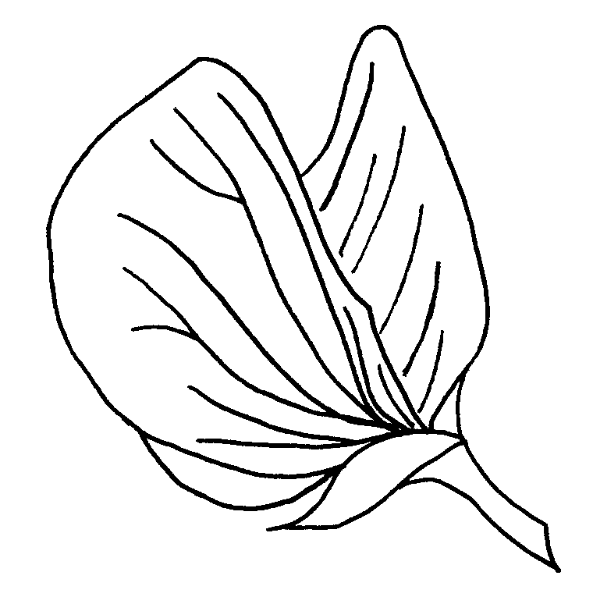
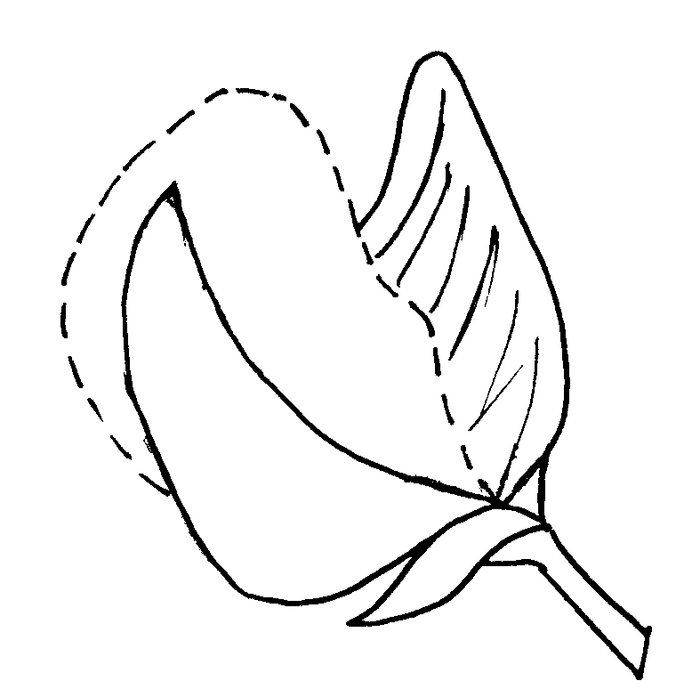
wing
tip of carina
carina

Ad. 11: Plant: growth type

Determinate:

Spring Type: Lateral branches develop at the base of the main stem. Height of lateral branches is lower than height of main stem. Development of flowers and pods from axillary buds along the whole branches.

Winter Type: Lateral branches develop from axillary buds of the highest main stem leaves with further branching of primary branches. The lateral primary branches grow higher than the main stem, etc. After production of 2 or 3 levels of branches, all vegetative buds turn into flowers and the vegetative development is definitely stopped.

Indeterminate: Lateral branches develop along the main stem with further branching. The secondary lateral branches grow higher than the primary lateral branches, etc. Flowers develop in compact inflorescences at top of branches. The expression is the same in spring type and winter type.

Ads. 12, 13 and 14: Time of green ripening (12), Plant: height of insertion of first inflorescence at green ripening (13) and height at green ripening (14)

At green ripening, the grains in the pods of the main shoot have reached full size and can be dented with the thumbnail.

Ad. 15: Pod: length

All observations should be made on pods at green maturity, in the middle third of the main inflorescence.

Ad. 16: Time of ripening

The time of ripening is when the grains in the pods of the main shoot can no longer be dented with the thumb nail.

Ads. 17 and 18: Grain: ornamentation (17) and color of ornamentation (18)

Ornamentation means well-defined dots different from the ground color. They should be assessed at full maturity of the grain.

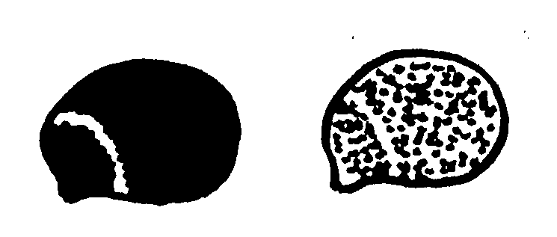Ad. 19: Grain: distribution of ornamentation
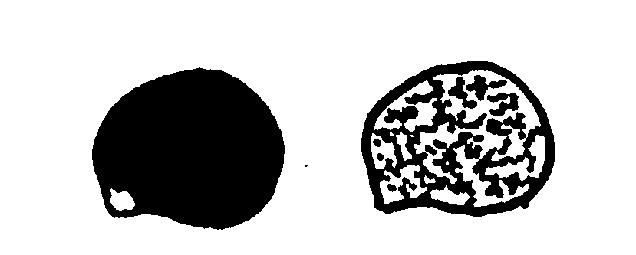1 | 2
total | total except eyebrow

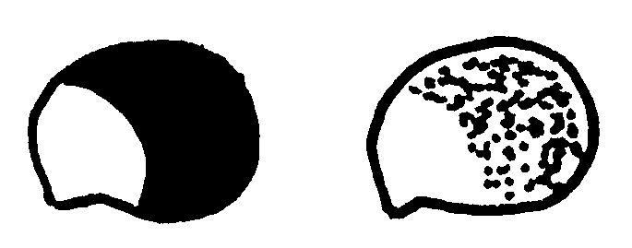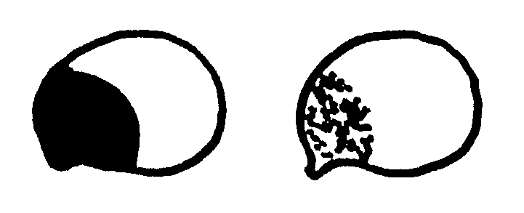
3 | 4
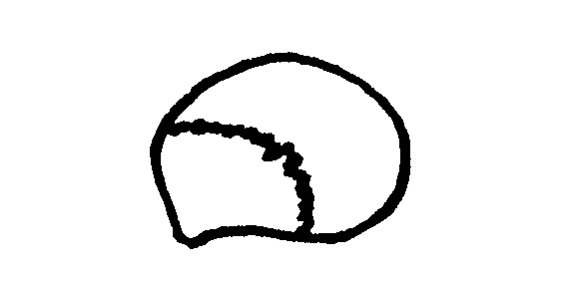dorsal | ventral

5
eyebrow only

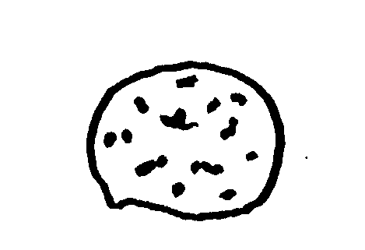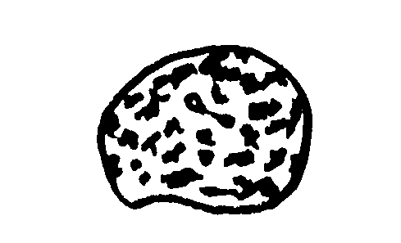Ad. 20: Excluding varieties with eyebrow only: Grain: density of ornamentation

3 | 5
sparse | medium

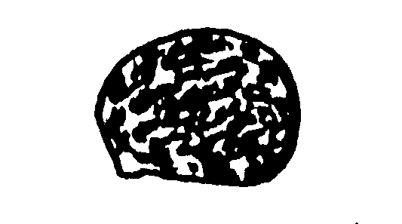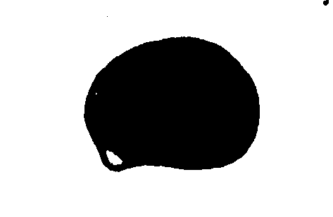
7 | 9
dense | very dense

Literature

Dracup, M. and Thomson, B.: Narrow-leafed lupins with restricted branching. Annals of Botany 85: 29-35, 2000

Eggebrecht, H.: Methodenbuch Band V. Die Untersuchung von Saatgut, Radebeul und Berlin. 1949

IBPGR Secretariat: Lupin Descriptor, Rome 1981

Julier, B.: Etude génétique et physiologique de l’architecture déterminée chez le Lupin blanc d’hiver. Conséquences agronomiques et en sélection. Thése. 1994

Juliwe, B., Huyghe, C., Papineau, J., Billot, C. and Deroo, C.: Genetic and environmental variation in architecture and yield components in determinate white lupin (Lupinus albus L.). Euphytica 81: 171-179, 1995

Technical Questionnaire
TECHNICAL QUESTIONNAIRE |  |  |  |  | Page {x} of {y} |  | Reference Number:
 |  |  |  |  |  |  | Application date:
 |  |  |  |  |  |  | (not to be filled in by the applicant)
TECHNICAL QUESTIONNAIRE
to be completed in connection with an application for plant breeders’ rights

1. Subject of the Technical Questionnaire
1.1.1 Latin Name |  |  |  | Lupinus albus L.
1.1.2 Common Name |  |  |  | White Lupin |  |  |  |  | [ ]
1.2.1 Latin Name |  |  |  | Lupinus angustifolius L.
1.2.2 Common Name |  |  |  | Narrow Leaf Lupin/Blue Lupin |  |  |  |  | [ ]
1.3.1 Latin Name |  |  |  | Lupinus luteus L.
1.3.2 Common Name |  |  |  | Yellow Lupin |  |  |  |  | [ ]
2. Applicant
Name
Address
Telephone No.
Fax No.
E-mail address
Breeder (if different from applicant)
3. Proposed denomination and breeder’s reference
Proposed denomination
(if available)

Breeder’s reference
4. Information on the breeding scheme and propagation of the variety

4.1 Breeding scheme

Variety resulting from:

4.1.1 Crossing

(a) controlled cross [ ]
(please state parent varieties)
(b) partially known cross [ ]
(please state known parent variety(ies))
(c) totally unknown cross [ ]

4.1.2 Discovery and development [ ]
(please state where and when discovered
and how developed)

………………………………………………………………………….

………………………………………………………………………….

4.1.3 Other [ ]
(please provide details)

……………………………………………………………………………

……………………………………………………………………………

4.2 Method of propagating the variety

5. Characteristics of the variety to be indicated (the number in brackets refers to the corresponding characteristic in Test Guidelines; please mark the note which best corresponds).

 | Characteristics |  |  |  |  |  |  | Example Varieties |  |  |  | Note
5.1  (1) | Grain: bitter principle
 | absent |  |  |  |  |  |  | Nelly (Lal),  Bordako (Lan),  Borselfa (Llu) |  |  |  | 1[ ]
 | present |  |  |  |  |  |  | Feli (Lal),  Azuro (Lan),  Trebisa (Llu) |  |  |  | 9[ ]
5.2  (4) | Stem: anthocyanin coloration prior to bud emergence
 | absent or very weak |  |  |  |  |  |  | Minori (Lal),  Bolivio (Lan) |  |  |  | 1[ ]
 | weak |  |  |  |  |  |  | Juno (Llu) |  |  |  | 3[ ]
 | medium |  |  |  |  |  |  | Nelly (Lal),  Boltensia (Lan) |  |  |  | 5[ ]
 | strong |  |  |  |  |  |  | Sonet (Lan) |  |  |  | 7[ ]
5.3  (5) | Time of flowering (quote date of flowering of variety as well as of two well-known comparable varieties)
…………………………………………………………………….

……………………………………………………………………..

5.4  (9) | Flower: color of wings
 | white |  |  |  |  |  |  | Minori (Lal) |  |  |  | 1[ ]
 | bluish white |  |  |  |  |  |  | Nelly (Lal) |  |  |  | 2[ ]
 | blue |  |  |  |  |  |  | Azuro (Lan) |  |  |  | 3[ ]
 | violet |  |  |  |  |  |  | Bordako (Lan) |  |  |  | 4[ ]
 | pink |  |  |  |  |  |  | Rubine (Lan) |  |  |  | 5[ ]
 | light yellow |  |  |  |  |  |  | Teo (Llu) |  |  |  | 6[ ]
 | dark yellow |  |  |  |  |  |  | Juno (Llu) |  |  |  | 7[ ]
 | Characteristics |  |  |  |  |  |  | Example Varieties |  |  |  | Note
5.5  (11) | Plant: growth type
 | determinate |  |  |  |  |  |  | Borweta (Lan),  Borselfa (Llu) |  |  |  | 1[ ]
 | indeterminate |  |  |  |  |  |  | Nelly (Lal),  Azuro (Lan),  Juno (Llu) |  |  |  | 2[ ]
6. Similar varieties and differences from these varieties

Please use the table, and space provided for comments, below to provide information on how your candidate variety differs from the variety (or varieties) which, to the best of your knowledge, is (or are) most similar. This information may help the examination authority to conduct its examination of distinctness in a more efficient way.

Denomination(s) of variety(ies) similar to your candidate variety |  | Characteristic(s) in which your candidate variety differs from the similar variety(ies) |  |  |  | Describe the expression of the characteristic(s) for the similar variety(ies) |  |  |  | Describe the expression of the characteristic(s) for your candidate variety
Comments:

7. Additional information which may help in the examination of the variety

7.1 In addition to the information provided in sections 5 and 6, are there any additional characteristics which may help to distinguish the variety?

Yes [ ] No [ ]

(If yes, please provide details)

7.2 Special conditions for the examination of the variety

7.2.1 Group

Spring type ……………………………[ ]

Winter type ……………………………[ ]

7.2.2 Are there any special conditions for growing the variety or conducting the examination?

Yes [ ] No [ ]

7.2.3 If yes, please give details:

…………………………………………………………………………………………

7.3 Other information

A representative color photograph of the variety should accompany the Technical Questionnaire.

8. Authorization for release

(a) Does the variety require prior authorization for release under legislation concerning the protection of the environment, human and animal health?

Yes [ ] No [ ]

(b) Has such authorization been obtained?

Yes [ ] No [ ]

If the answer to (b) is yes, please attach a copy of the authorization.

9. Information on plant material to be examined.

9.1 The expression of a characteristic or several characteristics of a variety may be affected by factors, such as pests and disease, chemical treatment (e.g. growth retardants or pesticides), effects of tissue culture, different rootstocks, scions taken from different growth phases of a tree, etc.

9.2 The plant material should not have undergone any treatment which would affect the expression of the characteristics of the variety, unless the competent authorities allow or request such treatment. If the plant material has undergone such treatment, full details of the treatment must be given. In this respect, please indicate below, to the best of your knowledge, if the plant material to be examined has been subjected to:

(a) Microorganisms (e.g. virus, bacteria, phytoplasma) Yes [ ] No [ ]

(b) Chemical treatment (e.g. growth retardant or pesticide) Yes [ ] No [ ]

(c) Tissue culture Yes [ ] No [ ]

(d) Other factors Yes [ ] No [ ]

Please provide details of where you have indicated “yes”.

…………………………………………………………………………………………

………………………………………………………………………………………….

………………………………………………………………………………………….

10. I hereby declare that, to the best of my knowledge, the information provided in this form is correct:

Applicant’s name

Signature Date

[End of document]

* These names were correct at the time of the introduction of these Test Guidelines but may be revised or updated. [Readers are advised to consult the UPOV Code, which can be found on the UPOV Website (www.upov.int), for the latest information.]

