 |  | E  TG/59/7  ORIGINAL: English  DATE: 2010-03-24
INTERNATIONAL UNION FOR THE PROTECTION OF NEW VARIETIES OF PLANTS
GENEVA

 | LILY  UPOV Code: LILIU  Lilium L. | *

GUIDELINES

FOR THE CONDUCT OF TESTS

FOR DISTINCTNESS, UNIFORMITY AND STABILITY

Alternative Names:*

Botanical name | English | French | German | Spanish
Lilium L. | Lily | Lys | Lilie | Lily, azucena, lirio

The purpose of these guidelines (“Test Guidelines”) is to elaborate the principles contained in the General Introduction (document TG/1/3), and its associated TGP documents, into detailed practical guidance for the harmonized examination of distinctness, uniformity and stability (DUS) and, in particular, to identify appropriate characteristics for the examination of DUS and production of harmonized variety descriptions.

ASSOCIATED DOCUMENTS

These Test Guidelines should be read in conjunction with the General Introduction and its associated TGP documents.

TABLE OF CONTENTS PAGE

1. Subject of these Test Guidelines 3
2. Material Required 3
3. Method of Examination 3
3.1 Number of Growing Cycles 3
3.2 Testing Place 3
3.3 Conditions for Conducting the Examination 3
3.4 Test Design 4
3.5 Number of Plants / Parts of Plants to be Examined 4
3.6 Additional Tests 4
4. Assessment of Distinctness, Uniformity and Stability 4
4.1 Distinctness 4
4.2 Uniformity 5
4.3 Stability 5
5. Grouping of Varieties and Organization of the Growing Trial 5
6. Introduction to the Table of Characteristics 6
6.1 Categories of Characteristics 6
6.2 States of Expression and Corresponding Notes 6
6.3 Types of Expression 6
6.4 Example Varieties 6
6.5 Legend 7
7. Table of Characteristics/Tableau des caractères/Merkmalstabelle/Tabla de caracteres 8
8. Explanations on the Table of Characteristics 20
8.1 Explanations covering several characteristics 20
8.2 Explanations for individual characteristics 20
9. Literature 27
10. Technical Questionnaire 28

Subject of these Test Guidelines
These Test Guidelines apply to all varieties of Lilium L.

Material Required
2.1 The competent authorities decide on the quantity and quality of the plant material required for testing the variety and when and where it is to be delivered. Applicants submitting material from a State other than that in which the testing takes place must ensure that all customs formalities and phytosanitary requirements are complied with.

2.2 In the case of vegetatively propagated varieties, the material is to be supplied in the form of bulbs of sufficient size to show full flowering in the first year (hybrids with an Oriental parent: circumference of 16-18 cm; all other types circumference of 14-16 cm). The bulbs should have only one vegetation point. In the case of seed-propagated varieties, the seed should have a germination capacity of at least 50%.

2.3 The minimum quantity of plant material, to be supplied by the applicant, should be:

vegetatively propagated varieties: 20 bulbs
seed-propagated varieties: 300 seeds.

2.4 The plant material supplied should be visibly healthy, not lacking in vigor, nor affected by any important pest or disease.

2.5 The plant material should not have undergone any treatment which would affect the expression of the characteristics of the variety, unless the competent authorities allow or request such treatment. If it has been treated, full details of the treatment must be given.

Method of Examination

3.1 Number of Growing Cycles
The minimum duration of tests should normally be a single growing cycle.

3.2 Testing Place
Tests are normally conducted at one place. In the case of tests conducted at more than one place, guidance is provided in TGP/9 “Examining Distinctness”.

3.3 Conditions for Conducting the Examination
3.3.1 The tests should be carried out under conditions ensuring satisfactory growth for the expression of the relevant characteristics of the variety and for the conduct of the examination.

3.3.2 Unless otherwise indicated, all observations should be made at the time of anther dehiscence of the first flower.

3.3.3 Because daylight varies, color determinations made against a color chart should be made either in a suitable cabinet providing artificial daylight or in the middle of the day in a room without direct sunlight. The spectral distribution of the illuminant for artificial daylight should conform with the CIE Standard of Preferred Daylight D 6500 and should fall within the tolerances set out in the British Standard 950, Part I. These determinations should be made with the plant part placed against a white background.

3.4 Test Design
3.4.1 Each test should be designed to result in a total of at least 20 plants for vegetatively propagated varieties and 50 plants for seed-propagated varieties.

3.4.2 The design of the tests should be such that plants or parts of plants may be removed for measurement or counting without prejudice to the observations which must be made up to the end of the growing cycle.

3.5 Number of Plants / Parts of Plants to be Examined
3.5.1 Vegetatively propagated varieties: unless otherwise indicated, all observations on single plants should be made on 10 plants or parts taken from each of 10 plants and any other observations made on all plants in the test.

3.5.2 Seed-propagated varieties: unless otherwise indicated, all observations on single plants should be made on 30 plants or parts taken from each of 30 plants and any other observations made on all plants in the test.

3.6 Additional Tests
Additional tests, for examining relevant characteristics, may be established.

Assessment of Distinctness, Uniformity and Stability

4.1 Distinctness

4.1.1 General Recommendations

It is of particular importance for users of these Test Guidelines to consult the General Introduction prior to making decisions regarding distinctness. However, the following points are provided for elaboration or emphasis in these Test Guidelines.

4.1.2 Consistent Differences

The differences observed between varieties may be so clear that more than one growing cycle is not necessary. In addition, in some circumstances, the influence of the environment is not such that more than a single growing cycle is required to provide assurance that the differences observed between varieties are sufficiently consistent. One means of ensuring that a difference in a characteristic, observed in a growing trial, is sufficiently consistent is to examine the characteristic in at least two independent growing cycles.

4.1.3 Clear Differences

Determining whether a difference between two varieties is clear depends on many factors, and should consider, in particular, the type of expression of the characteristic being examined, i.e. whether it is expressed in a qualitative, quantitative, or pseudo-qualitative manner. Therefore, it is important that users of these Test Guidelines are familiar with the recommendations contained in the General Introduction prior to making decisions regarding distinctness.

4.2 Uniformity
4.2.1 It is of particular importance for users of these Test Guidelines to consult the General Introduction prior to making decisions regarding uniformity. However, the following points are provided for elaboration or emphasis in these Test Guidelines:

4.2.2 For the assessment of uniformity of vegetatively propagated varieties, a population standard of 1% and an acceptance probability of at least 95% should be applied. In the case of a sample size of 20 plants, 1 off-type is allowed.

4.2.3 The assessment of uniformity for seed-propagated varieties should be according to the recommendations for cross-pollinated varieties in the General Introduction.

4.3 Stability
4.3.1 In practice, it is not usual to perform tests of stability that produce results as certain as those of the testing of distinctness and uniformity. However, experience has demonstrated that, for many types of variety, when a variety has been shown to be uniform, it can also be considered to be stable.

4.3.2 Where appropriate, or in cases of doubt, stability may be tested, either by growing a further generation, or by testing a new seed or plant stock to ensure that it exhibits the same characteristics as those shown by the previous material supplied.

Grouping of Varieties and Organization of the Growing Trial
5.1 The selection of varieties of common knowledge to be grown in the trial with the candidate varieties and the way in which these varieties are divided into groups to facilitate the assessment of distinctness are aided by the use of grouping characteristics.

5.2 Grouping characteristics are those in which the documented states of expression, even where produced at different locations, can be used, either individually or in combination with other such characteristics: (a) to select varieties of common knowledge that can be excluded from the growing trial used for examination of distinctness; and (b) to organize the growing trial so that similar varieties are grouped together.

5.3 The following have been agreed as useful grouping characteristics:

(a) Flower: attitude of perianth (excluding pedicel) (characteristic 15)
(b) Flower: shape of perianth (excluding pedicel) (characteristic 16)
(c) Flower: fragrance (characteristic 17)
(d) Tepal: main color of central part (characteristic 24)
(e) Tepal: number of papillae and/or spots (characteristic 31)
(f) Tepal: color of papillae and/or spots (characteristic 33)
(g) Time of flowering (characteristic 40)

5.4 Guidance for the use of grouping characteristics, in the process of examining distinctness, is provided through the General Introduction.

Introduction to the Table of Characteristics

6.1 Categories of Characteristics
6.1.1 Standard Test Guidelines Characteristics

Standard Test Guidelines characteristics are those which are approved by UPOV for examination of DUS and from which members of the Union can select those suitable for their particular circumstances.

6.1.2 Asterisked Characteristics

Asterisked characteristics (denoted by *) are those included in the Test Guidelines which are important for the international harmonization of variety descriptions and should always be examined for DUS and included in the variety description by all members of the Union, except when the state of expression of a preceding characteristic or regional environmental conditions render this inappropriate.

6.2 States of Expression and Corresponding Notes
States of expression are given for each characteristic to define the characteristic and to harmonize descriptions. Each state of expression is allocated a corresponding numerical note for ease of recording of data and for the production and exchange of the description.

6.3 Types of Expression
An explanation of the types of expression of characteristics (qualitative, quantitative and pseudo-qualitative) is provided in the General Introduction.

6.4 Example Varieties
Where appropriate, example varieties are provided to clarify the states of expression of each characteristic.

6.5 Legend
(*) Asterisked characteristic – see Chapter 6.1.2

QL: Qualitative characteristic – see Chapter 6.3
QN: Quantitative characteristic – see Chapter 6.3
PQ: Pseudo-qualitative characteristic – see Chapter 6.3

(a)-(d) See Explanations on the Table of Characteristics in Chapter 8.1
(+) See Explanations on the Table of Characteristics in Chapter 8.2

Table of Characteristics/Tableau des caractères/Merkmalstabelle/Tabla de caracteres
 |  | English | français | deutsch | español | Example Varieties/  Exemples/  Beispielssorten/  Variedades ejemplo | Note/  Nota
1.  (*)  (+) |  | Plant: height | Plante : hauteur | Pflanze: Höhe | Planta: altura
QN |  | short | courte | niedrig | baja | Orange Pixie | 3
 |  | medium | moyenne | mittel | media | Casablanca | 5
 |  | tall | haute | hoch | alta | Golden Tycoon | 7
2.  (*) |  | Stem: anthocyanin coloration | Tige : pigmentation anthocyanique | Trieb: Anthocyanfärbung | Tallo: pigmentación antociánica
QN | (a) | absent or weak | absente ou faible | fehlend oder gering | ausente o débil | Casablanca, White Europe, Zanlophator | 1
 |  | medium | moyenne | mittel | media |  | 2
 |  | strong | forte | stark | fuerte | Conception, Tresor | 3
3. |  | Stem: number of leaves | Tige : nombre de feuilles | Trieb: Anzahl Blätter | Tallo: número de hojas
QN | (a) | few | petit | gering | bajo |  | 3
 |  | medium | moyen | mittel | medio |  | 5
 |  | many | grand | groß | alto |  | 7
4.  (*)  (+) |  | Leaf: arrangement | Feuilles : disposition | Blatt: Anordnung | Hoja: disposición
QL |  | alternate | alternées | wechselständig | alternada | Casablanca | 1
 |  | decussate | opposées | gekreuzt | decusada | Aristo, Vedea | 2
 |  | whorled | verticillées | quirlig | en verticilos | Kurumayuri | 3
5. |  | Leaf: length | Feuille : longueur | Blatt: Länge | Hoja: longitud
QN | (a) | short | courte | kurz | corta | Denia, Peach Dwarf | 3
 |  | medium | moyenne | mittel | media | Lorina, Mero Star, Vedea | 5
 |  | long | longue | lang | larga | White Europe, Zanlophator | 7
6.  (+) |  | Leaf: width | Feuille : largeur | Blatt: Breite | Hoja: anchura
QN | (a) | narrow | étroite | schmal | estrecha | Pink Pixie | 3
 |  | medium | moyenne | mittel | media | Golden Tycoon, White Europe | 5
 |  | broad | large | breit | ancha | Acapulco, Helvetia | 7
7.  (*) |  | Leaf: variegation | Feuille : panachure | Blatt: Panaschierung | Hoja: variegación
QL | (a) | absent | absente | fehlend | ausente | Acapulco | 1
 |  | present | présente | vorhanden | presente | Chotaro | 9
8. |  | Leaf: glossiness of upper side | Feuille : lustre de la face supérieure | Blatt: Glanz der Oberseite | Hoja: brillo del haz
QN | (a) | absent or very weak | nul ou très faible | fehlend oder sehr gering | ausente o muy débil |  | 1
 |  | weak | faible | gering | débil | Acapulco, Vedea | 3
 |  | medium | moyen | mittel | medio | White Elegance | 5
 |  | strong | fort | stark | fuerte | Golden Tycoon | 7
 |  | very strong | très fort | sehr stark | muy fuerte |  | 9
9.  (+) |  | Leaf: cross section | Feuille : section transversale | Blatt: Querschnitt | Hoja: sección transversal
QL | (a) | flat | droite | flach | plana | Vedea | 1
 |  | V-shaped | en forme de v | V-förmig | en forma de V | Da Vinci | 2
10.  (+) |  | Flower bud: main color | Bouton : couleur principale | Blütenknospe: Hauptfarbe | Botón floral: color principal
PQ |  | white | blanc | weiß | blanco |  | 1
 |  | green | vert | grün | verde |  | 2
 |  | yellow green | vert-jaune | gelbgrün | verde amarillento |  | 3
 |  | yellow | jaune | gelb | amarillo |  | 4
 |  | orange | orange | orange | anaranjado |  | 5
 |  | orange pink | orange-rose | orangerosa | rosa anaranjado |  | 6
 |  | pink | rose | rosa | rosa |  | 7
 |  | red | rouge | rot | rojo |  | 8
 |  | purple red | rouge-pourpre | purpurrot | rojo purpúreo |  | 9
 |  | purple | pourpre | purpurn | púrpura |  | 10
 |  | purple brown | brun-pourpre | purpurbraun | marrón purpúreo |  | 11
11.  (*)  (+) |  | Inflorescence: type of branching | Inflorescence : type de ramification | Blütenstand: Art der Verzweigung | Inflorescencia: tipo de ramificación
QL |  | only racemose | seulement en racème | nur traubenartig | sólo racimosa | Helvetia, Vedea | 1
 |  | umbellate and racemose | en ombelle et en racème | doldenartig und traubenartig | umbelada y racimosa | Pavia | 2
12. |  | Inflorescence: number of flowers | Inflorescence : nombre de fleurs | Blütenstand: Anzahl Blüten | Inflorescencia: número de flores
QN |  | very few | très petit | sehr gering | muy pocas |  | 11
 |  | few | petit | gering | pocas | Brindisi, Zanlophator | 3
 |  | medium | moyen | mittel | medio | Golden Tycoon, Siberia | 5
 |  | many | grand | groß | muchas | Monte Negro | 7
13. |  | Inflorescence: pubescence | Inflorescence : pilosité | Blütenstand: Behaarung | Inflorescencia: pubescencia
QN |  | absent or very weak | absente ou très faible | fehlend oder sehr gering | ausente o muy débil | Val di Sole, White Europe | 1
 |  | weak | faible | gering | débil | Helvetia, Vedea | 3
 |  | medium | moyenne | mittel | media | Ceb Crimson | 5
 |  | strong | forte | stark | fuerte | Tiny Scyline | 7
 |  | very strong | très forte | sehr stark | muy fuerte |  | 9
14.  (+) |  | Flower: type | Fleur : type | Blüte: Typ | Flor: tipo
QN |  | single | simple | einfach | simple | Golden Tycoon | 1
 |  | semi double | semi-double | halbgefüllt | semidoble |  | 2
 |  | double | double | gefüllt | doble | Little Kiss | 3
15.  (*)  (+) |  | Flower: attitude of perianth (excluding pedicel) | Fleur : port du périanthe (sans le pédoncule) | Blüte: Haltung der Blütenhülle (ohne Blütenstiel) | Flor: porte del perianto (excluido el pedicelo)
QN |  | erect | dressé | aufrecht | erecto | Tresor | 1
 |  | erect to horizontal | dressé à horizontal | aufrecht bis waagerecht | erecto a horizontal | Siberia, Stargazer | 2
 |  | horizontal (outward facing) | horizontal (orientation perpendiculaire) | waagerecht (nach außen gerichtet) | horizontal (orientado hacia el exterior) | Casablanca, White Heaven | 3
 |  | drooping | retombant | hängend | colgante | Galloway | 4
16.  (*)  (+) |  | Flower: shape of perianth (excluding pedicel) | Fleur : forme du périanthe (sans le pédoncule) | Blüte: Form der Blütenhülle (ohne Blütenstiel) | Flor: forma del perianto (excluido el pedicelo)
PQ |  | trumpet | en trompette | trompetenförmig | en corneta | White Elegance | 1
 |  | bowl | en coupe | schüsselförmig | cratiforme | Siberia | 2
 |  | flat | plat | flach | plano | Sugar Jewel | 3
 |  | recurved | recourbé | zurückgebogen | recurvado | Belletti | 4
17.  (*) |  | Flower: fragrance | Fleur: parfum | Blüte: Duft | Flor: fragancia
QN |  | absent or weak | absent ou faible | fehlend oder gering | ausente o débil | Nemo | 1
 |  | medium | moyen | mittel | media | Jetaime | 2
 |  | strong | fort | stark | fuerte | Saltarello | 3
18. |  | Tepal: length | Tépale: longueur | Perigonblatt: Länge | Tépalo: longitud
QN | (b) | short | court | kurz | corta | Tresor, Val di Sole | 3
 |  | medium | moyen | mittel | media | Casablanca, Siberia | 5
 |  | long | long | lang | larga | White Elegance, Zanlophator | 7
19. |  | Tepal: width | Tépale: largeur | Perigonblatt: Breite | Tépalo: anchura
QN | (b) | narrow | étroit | schmal | estrecha | Helvetia | 3
 |  | medium | moyen | mittel | media | Siberia, White Europe, White Lace | 5
 |  | broad | large | breit | ancha | Zanlophator | 7
20. |  | Tepal: ribbing | Tépale : côtes | Perigonblatt: Rippung | Tépalo: acostillado
QN | (d) | absent or weak | absentes ou faibles | fehlend oder gering | ausente o débil |  | 1
 |  | medium | moyennes | mittel | medio |  | 2
 |  | strong | fortes | stark | fuerte |  | 3
21.  (+) |  | Tepal: undulation of margin | Tépale : ondulation du bord | Perigonblatt: Randwellung | Tépalo: ondulación del borde
QN | (b) | absent or very weak | absente ou très faible | fehlend oder sehr gering | ausente o muy débil |  | 1
 |  | weak | faible | gering | débil |  | 3
 |  | medium | moyenne | mittel | media |  | 5
 |  | strong | forte | stark | fuerte | Vedea | 7
 |  | very strong | très forte | sehr stark | muy fuerte |  | 9
22.  (+) |  | Tepal: type of undulation of margin | Tépale : type de l’ondulation du bord | Perigonblatt: Art der Randwellung | Tépalo: tipo de ondulación del borde
PQ | (b) | fine only | seulement fine | nur fein | sólo fina | Vedea | 1
 |  | fine and coarse | fine et grossière | fein und grob | fina y gruesa |  | 2
 |  | coarse only | seulement grossière | nur grob | sólo gruesa | Casablanca | 3
23.  (*) |  | Tepal: degree of recurving | Tépale : degré de recourbure | Perigonblatt: Stärke der Biegung | Tépalo: grado de curvatura
QN | (b) | weak | faible | gering | débil |  | 3
 |  | medium | moyen | mittel | medio | Vedea | 5
 |  | strong | fort | stark | fuerte | Casablanca | 7
24.  (*)  (+) |  | Tepal: main color of central part | Tépale : couleur principale de la partie centrale | Perigonblatt: Hauptfarbe des mittleren Teils | Tépalo: color principal de la parte central
PQ | (c) | RHS Colour Chart (indicate reference number) | Code RHS des couleurs (indiquer le numéro de référence) | RHS-Farbkarte (Nummer angeben) | Carta de colores RHS (indíquese el número de referencia)
25.  (*)  (+) |  | Tepal: main color of basal part | Tépale : couleur principale de la partie basale | Perigonblatt: Hauptfarbe des basalen Teils | Tépalo: color principal de la parte basal
PQ | (c) | RHS Colour Chart (indicate reference number) | Code RHS des couleurs (indiquer le numéro de référence) | RHS-Farbkarte (Nummer angeben) | Carta de colores RHS (indíquese el número de referencia)
26.  (*)  (+) |  | Tepal: color of zone bordering on nectar furrow | Tépale : couleur de la zone bordant le sillon nectarifaire | Perigonblatt: Farbe der an die Nektarfurche angrenzenden Zone | Tépalo: color de la zona que bordea el surco nectarial
PQ | (c) | white | blanc | weiß | blanco | Vedea | 1
 |  | green | vert | grün | verde | Brindisi | 2
 |  | yellow green | vert-jaune | gelbgrün | verde amarillento | Val di Sole | 3
 |  | yellow | jaune | gelb | amarillo | Pavia | 4
 |  | orange | orange | orange | anaranjado | Tresor | 5
 |  | orange pink | rose-orange | orangerosa | rosa anaranjado | Olina | 6
 |  | pink | rose | rosa | rosa | Vedea | 7
 |  | red | rouge | rot | rojo | Mero Star | 8
 |  | purple red | rouge-pourpre | purpurrot | rojo purpúreo | Cilagon | 9
 |  | purple | pourpre | purpurn | púrpura | Take Five | 10
 |  | purple brown | brun-pourpre | purpurbraun | marrón purpúreo | Tiny Padhye | 11
27.  (*)  (+) |  | Tepal: main color of distal part | Tépale : couleur principale de la partie distale | Perigonblatt: Hauptfarbe des distalen Teils | Tépalo: color principal de la parte distal
PQ | (c) | RHS Colour Chart (indicate reference number) | Code RHS des couleurs (indiquer le numéro de référence) | RHS-Farbkarte (Nummer angeben) | Carta de colores RHS (indíquese el número de referencia)
28.  (*)  (+) |  | Tepal: main color of marginal zone | Tépale : couleur principale de la zone marginale | Perigonblatt: Hauptfarbe der Randzone | Tépalo: color principal de la zona marginal
PQ | (c) | RHS Colour Chart (indicate reference number) | Code RHS des couleurs (indiquer le numéro de référence) | RHS-Farbkarte (Nummer angeben) | Carta de colores RHS (indíquese el número de referencia)
29.  (+) |  | Tepal: main color of outer side of inner tepal | Tépale : couleur principale de la face externe du tépale interne | Perigonblatt: Hauptfarbe der Außenseite des inneren Perigonblattes | Tépalo: color principal de la parte exterior del tépalo interno
PQ | (c) | RHS Colour Chart (indicate reference number) | Code RHS des couleurs (indiquer le numéro de référence) | RHS-Farbkarte (Nummer angeben) | Carta de colores RHS (indíquese el número de referencia)
30.  (+) |  | Tepal: color of nectar furrow | Tépale : couleur du sillon nectarifaire | Perigonblatt: Farbe der Nektarfurche | Tépalo: color del surco nectarial
PQ |  | white | blanc | weiß | blanco | Imperia, Pyramid | 1
 |  | green | vert | grün | verde | Helvetia, Vede | 2
 |  | yellow green | vert-jaune | gelbgrün | verde amarillento | Double Surprise | 3
 |  | yellow | jaune | gelb | amarillo | Mero Star | 4
 |  | orange | orange | orange | anaranjado | Tresor | 5
 |  | orange pink | rose-orange | orangerosa | rosa anaranjado |  | 6
 |  | pink | rose | rosa | rosa | Minerva, Vermeer | 7
 |  | red | rouge | rot | rojo |  | 8
 |  | purple red | rouge-pourpre | purpurrot | rojo purpúreo |  | 9
 |  | purple | pourpre | purpurn | púrpura |  | 10
 |  | purple brown | brun-pourpre | purpurbraun | marrón purpúreo |  | 11
31.  (*)  (+) |  | Tepal: number of papillae and/or spots | Tépale : nombre de papilles ou de taches | Perigonblatt: Anzahl Papillen und/oder Flecken | Tépalo: número de papilas y/o puntos
QN | (d) | absent or very few | nul ou très petit | fehlend oder sehr gering | ausentes o muy pocos | Siberia, White Europe | 1
 |  | few | petit | gering | pocos | Vedea, Vermeer | 3
 |  | medium | moyen | mittel | medio | Purple Rain, Stargazer | 5
 |  | many | grand | groß | muchos | Pink Mystery | 7
32.  (*)  (+) |  | Tepal: size of area with papillae and/or spots | Tépale : taille de la surface avec papilles et/ou taches | Perigonblatt: Größe der Zone mit Papillen und/oder Flecken | Tépalo: tamaño de la superficie que presenta papilas y/o puntos
QN | (d) | absent or very small | nulle ou très petite | fehlend oder sehr klein | ausente o muy pequeña |  | 1
 |  | small | petite | klein | pequeña | Pink Supreme | 3
 |  | medium | moyenne | mittel | media | Minerva, Vedea | 5
 |  | large | grande | groß | grande | Purple Rain | 7
33.  (*)  (+) |  | Tepal: color of papillae and/or spots | Tépale : couleur des papilles ou des taches | Perigonblatt: Farbe der Papillen und/oder Flecken | Tépalo: color de las papilas y/o los puntos
PQ | (d) | white | blanches | weiß | blanco | Siberia | 1
 |  | yellow | jaunes | gelb | amarillo | Conca d’Or | 2
 |  | brown yellow | jaunes-brunes | braungelb | amarillo amarronado | Windsor | 3
 |  | brown | brunes | braun | marrón | Fenice | 4
 |  | red brown | rouges-brunes | rotbraun | marrón rojizo | Pirandello | 5
 |  | pink | roses | rosa | rosa | Camaiore | 6
 |  | red | rouges | rot | rojo | Nippon | 7
 |  | purple red | rouges-pourpres | purpurrot | rojo purpúreo | Dizzy | 8
34. |  | Stamen: length | Étamine : longueur | Staubgefäß: Länge | Estambre: longitud
QN |  | short | courte | kurz | corta | Fangio | 3
 |  | medium | moyenne | mittel | media | Mero Star | 5
 |  | long | longue | lang | larga | Casablanca | 7
35.  (*)  (+) |  | Stamen: main color of filament | Étamine : couleur principale du filet | Staubgefäß: Hauptfarbe des Staubfadens | Estambre: color principal del filamento
PQ |  | white | blanc | weiß | blanco | Verdi, Zanlophator | 1
 |  | green | vert | grün | verde | Casablanca, White Europe | 2
 |  | yellow green | vert-jaune | gelbgrün | verde amarillento | Yelloween | 3
 |  | yellow | jaune | gelb | amarillo | Golden Tycoon | 4
 |  | orange | orange | orange | anaranjado | Tresor | 5
 |  | orange pink | rose-orange | orangerosa | rosa anaranjado | Olina | 6
 |  | pink | rose | rosa | rosa | Vermeer | 7
 |  | red | rouge | rot | rojo | Marianne Timmer | 8
 |  | purple red | rouge-pourpre | purpurrot | rojo purpúreo | Red Alert | 9
 |  | purple | pourpre | purpurn | púrpura | Tamburo | 10
 |  | purple brown | brun-pourpre | purpurbraun | marrón purpúreo | Original Love | 11
36.  (*) |  | Stamen: color of anther | Étamine : couleur des anthères | Staubfaden: Farbe der Anthere | Estambre: color de la antera
PQ |  | orange yellow | orange-jaune | orangegelb | amarillo anaranjado | Premium Blond | 1
 |  | orange brown | brun-orange | orangebraun | marrón anaranjado | Landini | 2
 |  | reddish brown | rouge-brun | rötlichbraun | marrón rojizo | Paradero | 3
 |  | brown | brunes | braun | marrón | Etosha | 4
 |  | purple | pourpres | purpurn | púrpura | Mero Star | 5
 |  | purple red | rouge-pourpre | purpurrot | rojo purpúreo | Bacardi | 6
37. |  | Pollen: color | Pollen : couleur | Pollen: Farbe | Polen: color
PQ |  | light yellow | jaune clair | hellgelb | amarillo claro |  | 1
 |  | medium yellow | jaune moyen | mittelgelb | amarillo medio |  | 2
 |  | orange | orange | orange | anaranjado | Pink Supreme | 3
 |  | light brown | brun clair | hellbraun | marrón claro |  | 4
 |  | medium brown | brun moyen | mittelbraun | marrón medio | Zanlophator | 5
 |  | orange brown | brun-orange | orangebraun | marrón anaranjado | Casablanca, Sorbonne | 6
 |  | red brown | brun-rouge | rotbraun | marrón rojizo | Brindisi | 7
 |  | dark brown | brun foncé | dunkelbraun | marrón oscuro | Fangio | 8
38.  (*) |  | Style: main color | Style : couleur principale | Griffel: Hauptfarbe | Estilo: color principal
PQ |  | white | blanc | weiß | blanco | Litouwen | 1
 |  | green | vert | grün | verde | Casablanca, White Europe | 2
 |  | yellow green | vert-jaune | gelbgrün | verde amarillento | Pink Supreme | 3
 |  | yellow | jaune | gelb | amarillo | Golden Tycoon | 4
 |  | orange | orange | orange | anaranjado | Brindisi | 5
 |  | orange pink | rose-orange | orangerosa | rosa anaranjado | Amateras | 6
 |  | pink | rose | rosa | rosa | Arbatex | 7
 |  | red | rouge | rot | rojo | Marianne Timmer | 8
 |  | purple red | rouge-pourpre | purpurrot | rojo purpúreo | Red Alert | 9
 |  | purple | pourpre | purpurn | púrpura | Landini | 10
 |  | purple brown | brun-pourpre | purpurbraun | marrón purpúreo | Orfeo | 11
39. |  | Stigma: color | Stigmate : couleur | Narbe: Farbe | Estigma: color
PQ |  | grey | gris | grau | gris | d'Oleron | 1
 |  | grey green | gris-vert | graugrün | verde grisáceo |  | 2
 |  | green | vert | grün | verde | White Europe | 3
 |  | yellow | jaune | gelb | amarillo |  | 4
 |  | orange | orange | orange | anaranjado |  | 5
 |  | purple red | rouge-pourpre | purpurrot | rojo purpúreo | Casablanca | 6
 |  | purple | pourpre | purpurn | púrpura |  | 7
 |  | dark purple | pourpre foncé | dunkelpurpurn | púrpura oscuro |  | 8
 |  | brown | brun | braun | marrón |  | 9
40.  (*)  (+) |  | Time of flowering | Époque de floraison | Blühzeitpunkt | Época de floración
QN |  | very early | très précoce | sehr früh | muy temprana |  | 1
 |  | early | précoce | früh | temprana |  | 3
 |  | medium | moyenne | mittel | media | Bonsoir, Vedea | 5
 |  | late | tardive | spät | tardía | Acapulco | 7
 |  | very late | très tardive | sehr spät | muy tardía | Mero Star, Rousseau | 9

Explanations on the Table of Characteristics

8.1 Explanations covering several characteristics
(a) To be examined on middle third of the stem.
(b) Observations should be made on outer tepals.
(c) Observations on color should be made on the inner side of the inner tepal, excluding papillae, spots and nectar furrow.
(d) Observations on papillae and/or spots and ribbing should be made on the inner side of the inner tepal.

8.2 Explanations for individual characteristics
Ad. 1: Plant height

To be observed from the soil level to the top of the inflorescence.

Ad. 4: Leaf: arrangement

 | EMBED PBrush 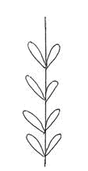 | 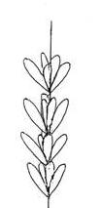
1 | 2 | 3
alternate | decussate | whorled

Ad. 6: Leaf: width

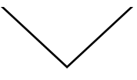 | < width >

The width of V-shaped leaves should be observed when held flat

Ad. 9: Leaf: cross section

1 | 2
flat | V-shaped

Ad. 10: Flower bud: main color

The main color is the color with the largest surface area. The main color should be observed just before the opening of the flower.

Ad. 11: Inflorescence: type of branching

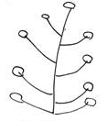 | 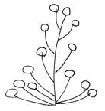
1 | 2
only racemose | umbellate and racemose

In the case of varieties with umbellate and racemose branching (note 2), the first (lowest) branches are umbellate and the upper (higher) branches are racemose.

Ad. 14: Flower type

1≤6 tepals should be described as single
7≤11 tepals should be classified as semi-double
≥12 tepals should be described as double

Ad. 15: Flower: attitude of perianth (excluding pedicel)

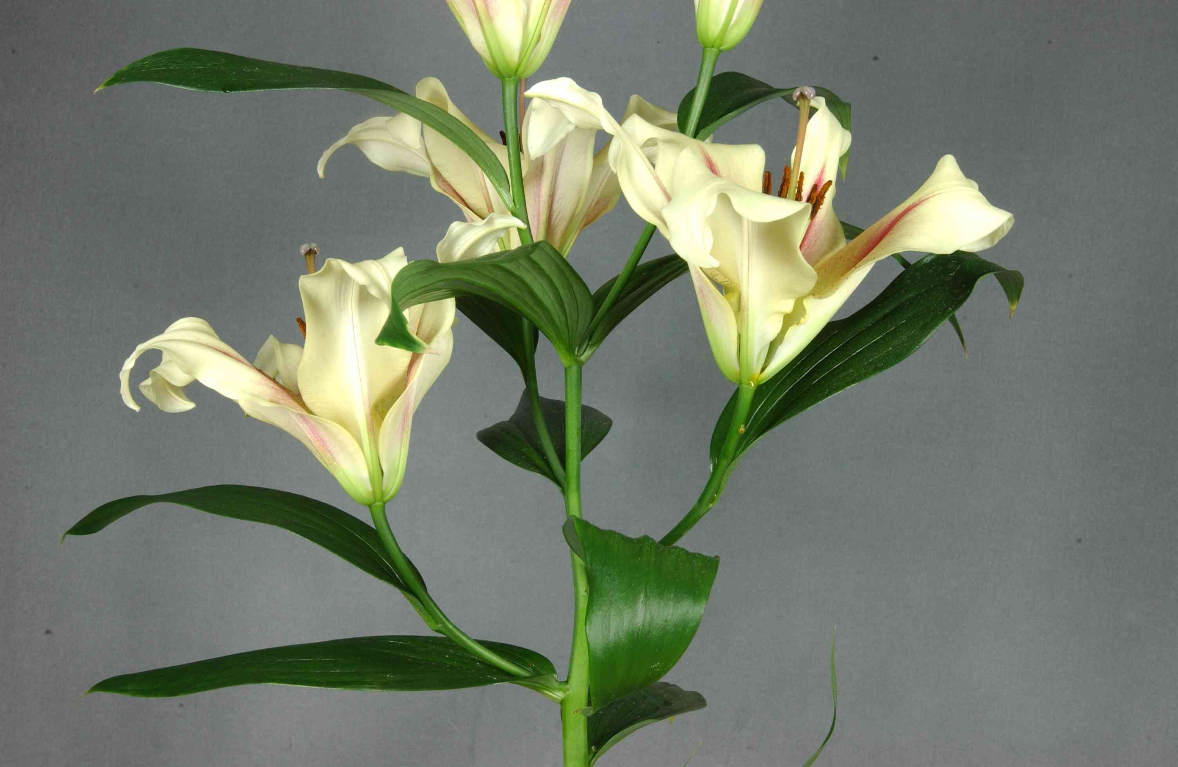 | 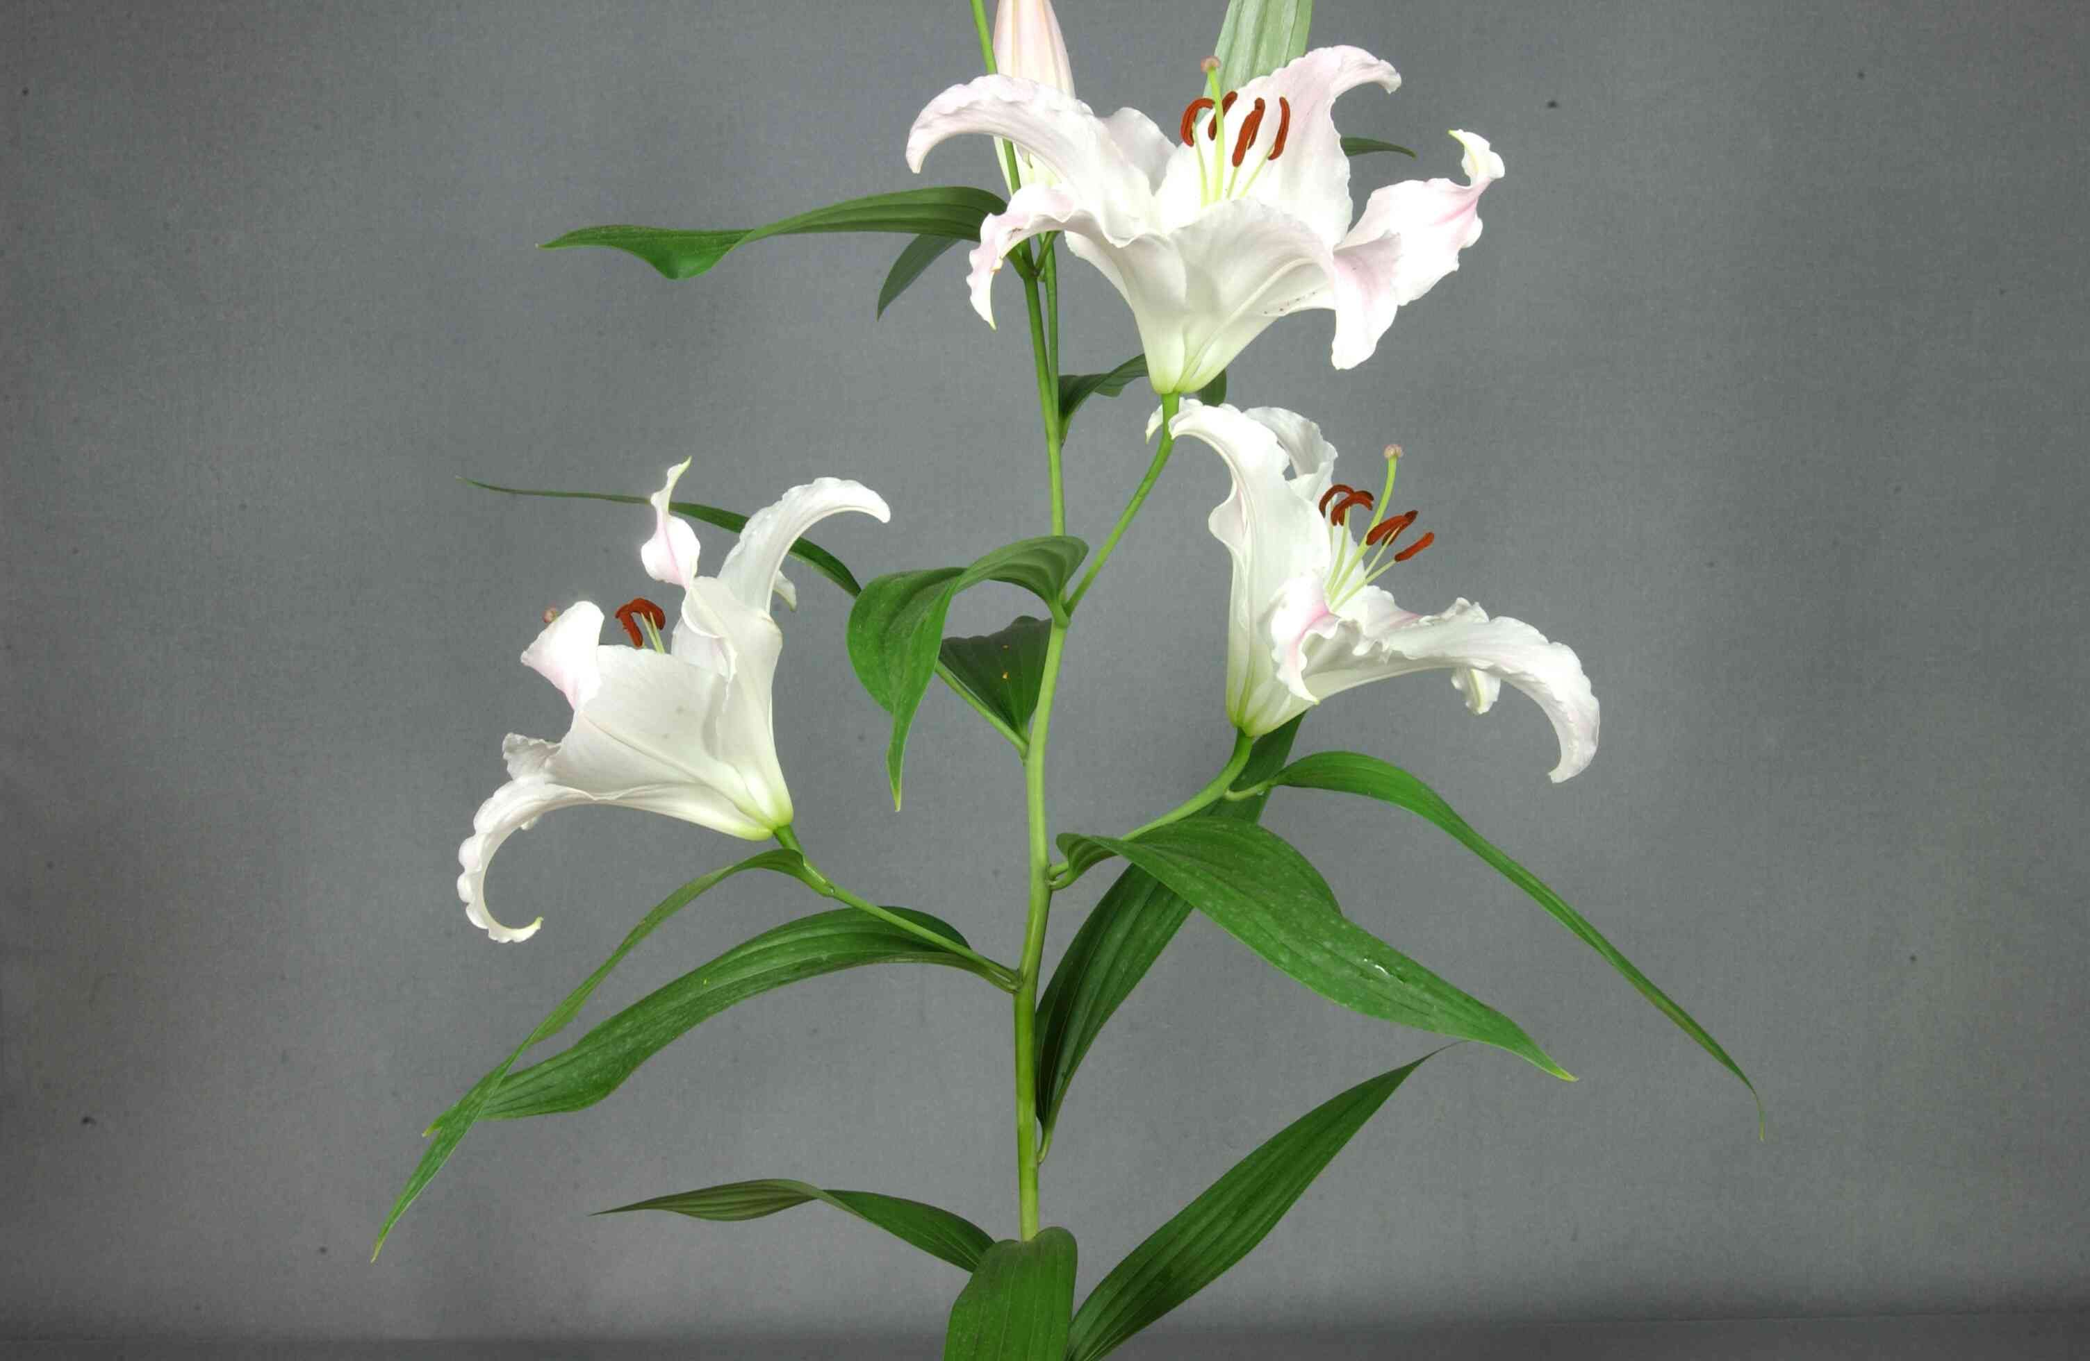
1 | 2
erect | erect to horizontal
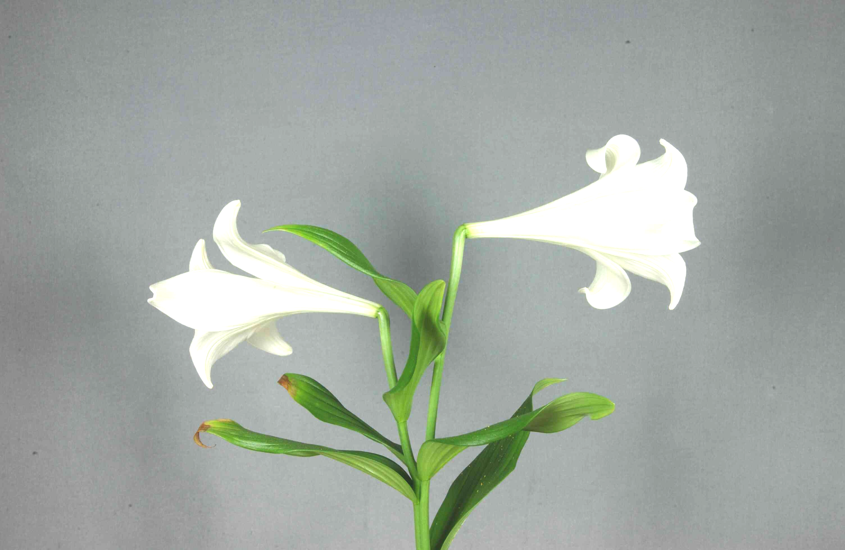 | 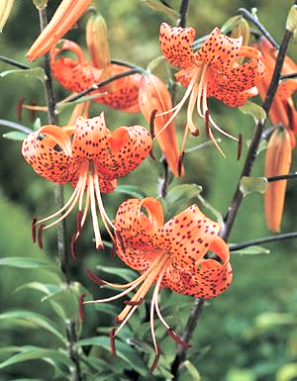
3 | 4
horizontal (outward facing) | drooping

Ad. 16: Flower: shape of perianth (excluding pedicel)

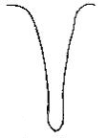 | 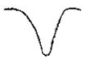
1 | 2 | 3 | 4
trumpet | bowl | flat | recurved

Ad. 21: Tepal: undulation of margin

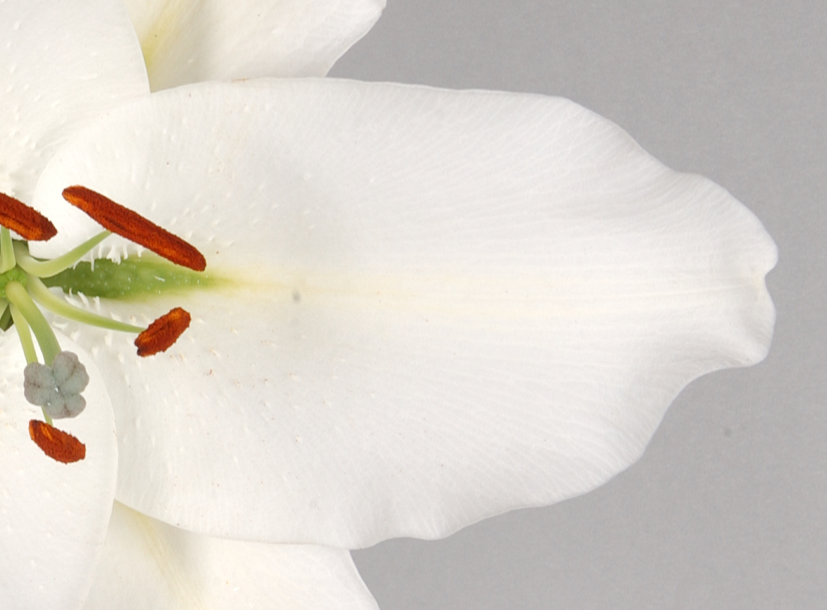 | 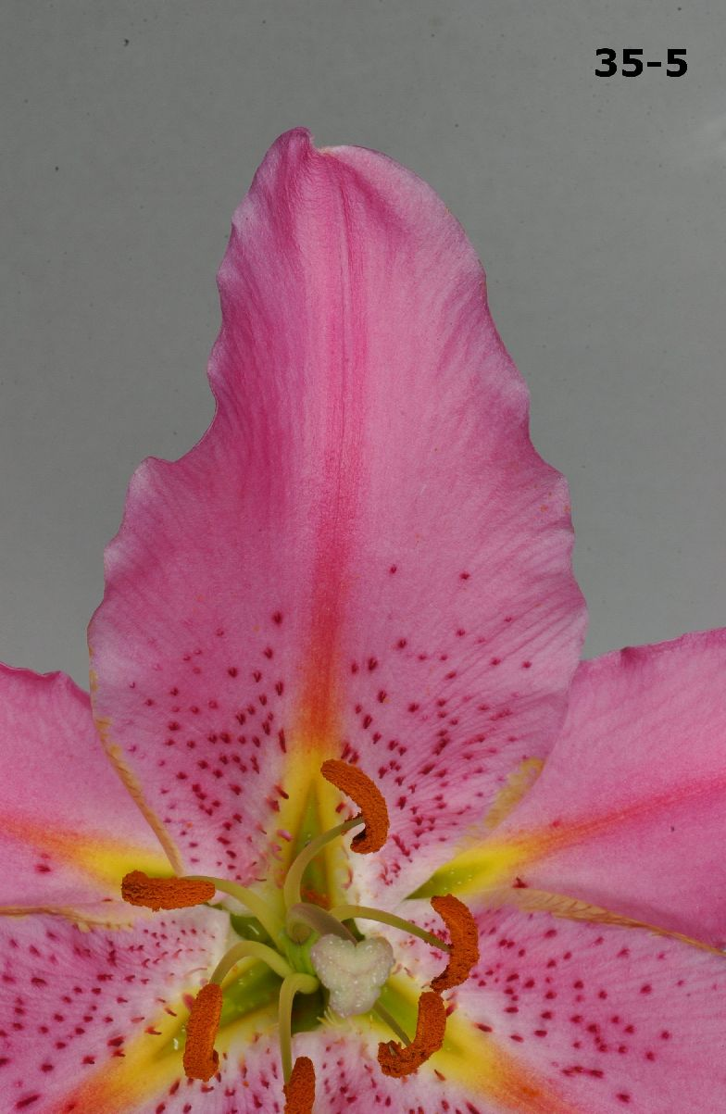 | 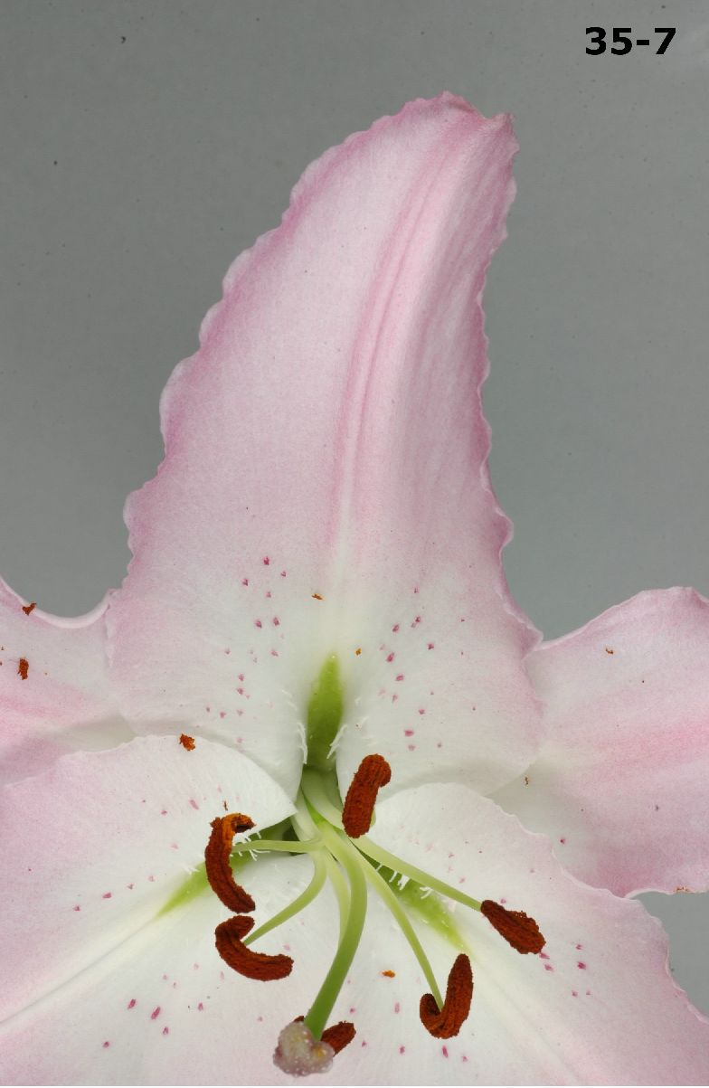
3 | 5 | 7
weak | medium | strong

Ad. 22: Tepal: type of undulation of margin

 |  | 
1 | 2 | 3
fine only | fine and coarse | coarse only

Ad. 24: Tepal: main color of central part
Ad. 25: Tepal: main color of basal part
Ad. 26: Tepal: color of zone bordering on nectar furrow
Ad. 27: Tepal: main color of distal part
Ad. 28: Tepal: main color of marginal zone
Ad. 29: Tepal: main color of outer side of inner tepal
Ad. 30: Tepal: color of nectar furrow

The main color of a part or zone is the color with the largest surface area on the part or zone concerned.

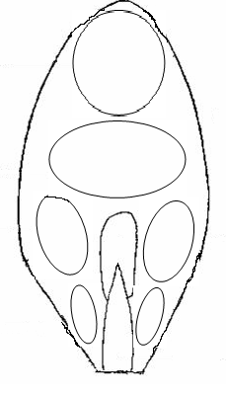
Ad. 30: nectar furrow
Ad. 27: distal part
Ad. 24: centre
Ad. 28: marginal zone
Ad. 25: basal part

Ad. 26: bordering zone on nectar furrow
Ad. 31: Tepal: number of papillae and/or spots
Ad. 32: Tepal: size of area with papillae and/or spots
Ad. 33: Tepal: color of papillae and/or spots

Papillae: pimpled, with small, rounded, soft to firm, unequal bumps

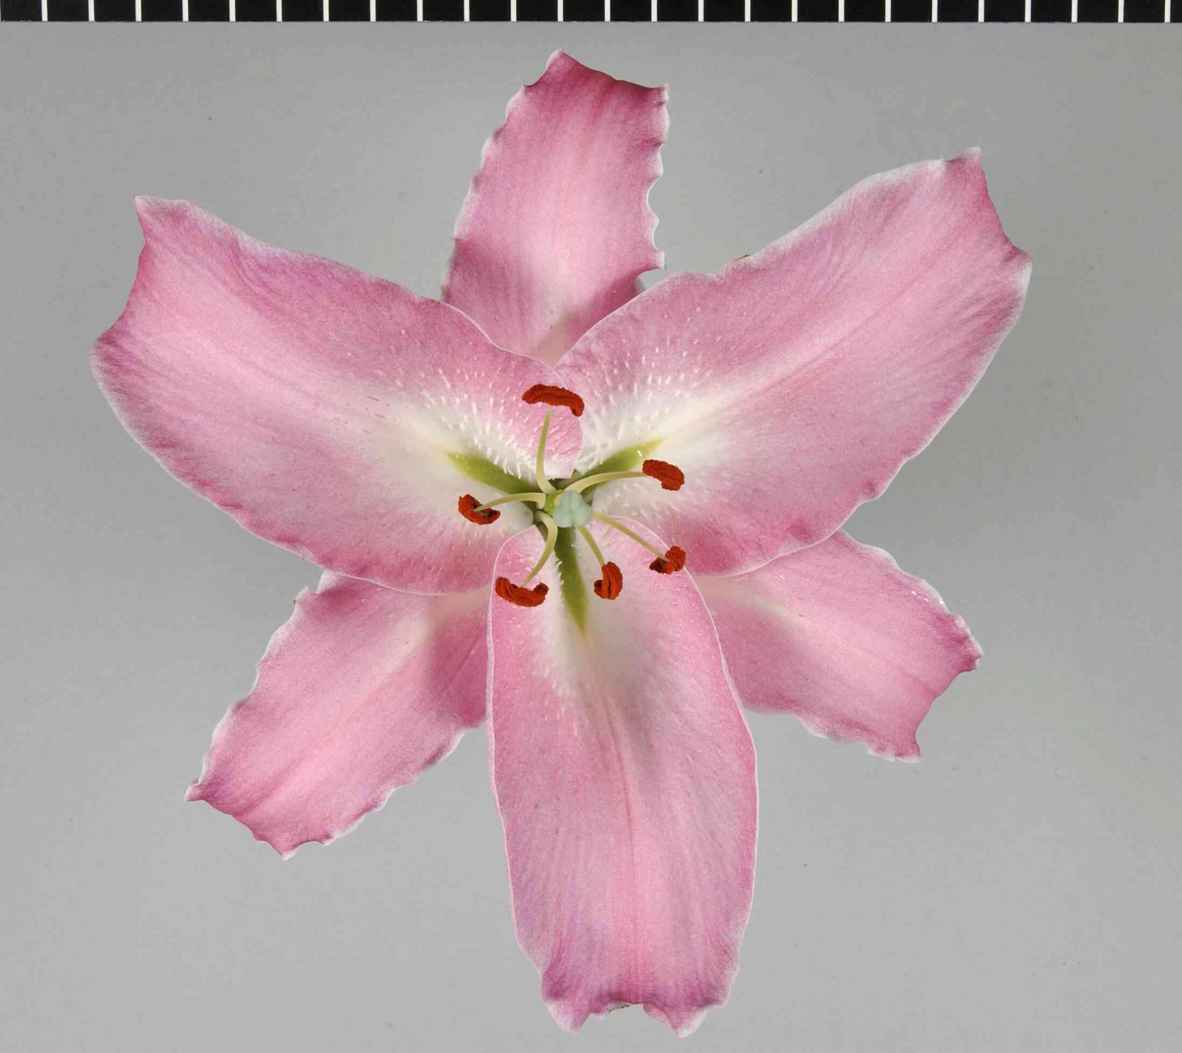
Spots: small areas of another color than the background color

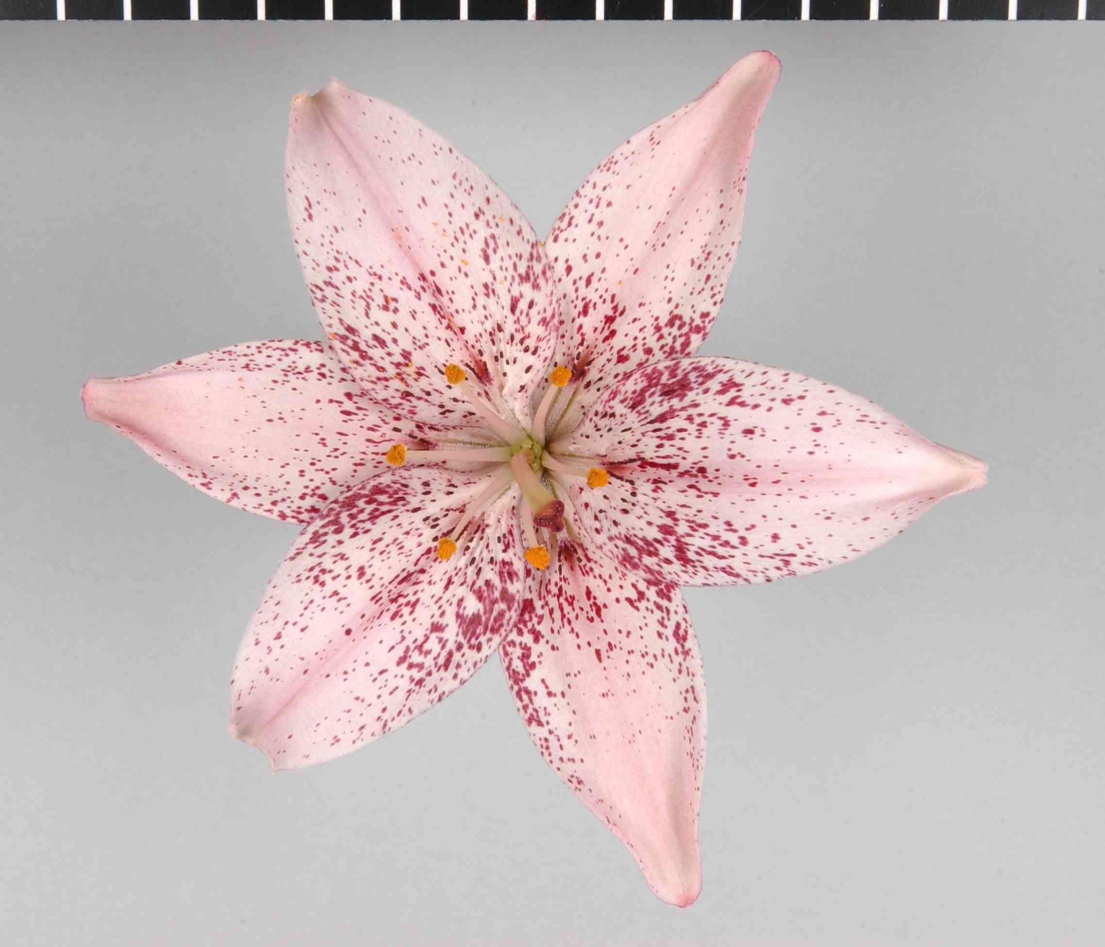

Ad. 35: Stamen: main color of filament

The main color is the color with the largest surface area.

Ad. 40: Time of flowering

The time of flowering is when 50% of the plants have at least one open flower.

Literature
Tsukamoto, Y., 1991: The Grand Dictionary of Horticulture. Volume 5, The Shogakukan Ltd., Tokyo, JP, pp.198 to 211.

Kunishige, M., 1993: Lily: Breeding and Cultivation. The Seibundo-Shinkou Ltd., Tokyo, JP.

Shimizu, M., 1987: The Lilies of Japan: Species and Hybrid. The Seibundo-Shinkou Ltd., Tokyo, JP.

Tukamoto, Y., 1978: The Color Dictionary of Horticulture. The Hoiku Ltd., Tokyo, JP, pp. 93 to 125.

Leslie, A.C., 1982: The International Lily Register. RHS, London, GB, and yearly supplements [First (1983) to Twentieth (2002)].

Victoria Matthews: The International Lily Register and Checklist 2007, RHS, London, GB.

Feldmaier, C., McRae, J., 1982: Lilien. Eugen Ulmer, Stuttgart, DE.

10. Technical Questionnaire
TECHNICAL QUESTIONNAIRE |  |  |  | Page {x} of {y} |  | Reference Number:
 |  |  |  |  |  | Application date:
 |  |  |  |  |  | (not to be filled in by the applicant)
TECHNICAL QUESTIONNAIRE
to be completed in connection with an application for plant breeders’ rights

1. Subject of the Technical Questionnaire
1.1 Botanical name |  |  | Lilium L.
1.2 Common name |  |  | Lily
2. Applicant
Name
Address
Telephone No.
Fax No.
E-mail address
Breeder (if different from applicant)
3. Proposed denomination and breeder’s reference
Proposed denomination
(if available)

Breeder’s reference
#4. Information on the breeding scheme and propagation of the variety

4.1 Breeding scheme

Variety resulting from:

4.1.1 Crossing

(a) controlled cross [ ]
(please state parent varieties)
(b) partially known cross [ ]
(please state known parent variety(ies))
(c) unknown cross [ ]

4.1.2 Mutation [ ]
(please state parent variety)

4.1.3 Discovery and development [ ]
(please state where and when discovered
and how developed)

4.1.4 Other [ ]
(please provide details)

4.2 Method of propagating the variety

4.2.1 Vegetative propagation

(a) scales [ ]
(b) in vitro propagation [ ]
(c) other (state method) [ ]

4.2.2 Seed [ ]

4.2.3 Other [ ]
(please provide details)

5. Characteristics of the variety to be indicated (the number in brackets refers to the corresponding characteristic in Test Guidelines; please mark the note which best corresponds).

 | Characteristics |  |  |  |  | Example Varieties |  |  | Note
5.1  (15) | Flower: attitude of perianth (excluding pedicel)
 | erect |  |  |  |  | Tresor |  |  | 1[ ]
 | erect to horizontal |  |  |  |  | Siberia, Stargazer |  |  | 2[ ]
 | horizontal (outward facing) |  |  |  |  | Casablanca, White Heaven |  |  | 3[ ]
 | drooping |  |  |  |  | Galloway |  |  | 4[ ]
5.2  (16) | Flower: shape of perianth (excluding pedicel)
 | trumpet |  |  |  |  | White Elegance |  |  | 1[ ]
 | bowl |  |  |  |  | Siberia |  |  | 2[ ]
 | flat |  |  |  |  | Sugar Jewel |  |  | 3[ ]
 | recurved |  |  |  |  | Belletti |  |  | 4[ ]
5.3  (17) | Flower: fragrance
 | absent or weak |  |  |  |  | Nemo |  |  | 1[ ]
 | medium |  |  |  |  | Jetaime |  |  | 2[ ]
 | strong |  |  |  |  | Saltarello |  |  | 3[ ]
5.4  (24) | Tepal: main color of central part
 | RHS Colour Chart (indicate reference number)
5.5  (31) | Tepal: number of papillae and/or spots
 | absent or very few |  |  |  |  | Siberia, White Europe |  |  | 1[ ]
 | few |  |  |  |  | Vedea, Vermeer |  |  | 3[ ]
 | medium |  |  |  |  | Purple Rain, Stargazer |  |  | 5[ ]
 | many |  |  |  |  | Pink Mystery |  |  | 7[ ]
 | Characteristics |  |  |  |  | Example Varieties |  |  | Note
5.6  (33) | Tepal: color of papillae and/or spots
 | white |  |  |  |  | Siberia |  |  | 1[ ]
 | yellow |  |  |  |  | Conca d’Or |  |  | 2[ ]
 | brown yellow |  |  |  |  | Windsor |  |  | 3[ ]
 | brown |  |  |  |  | Fenice |  |  | 4[ ]
 | red brown |  |  |  |  | Pirandello |  |  | 5[ ]
 | pink |  |  |  |  | Camaiore |  |  | 6[ ]
 | red |  |  |  |  | Nippon |  |  | 7[ ]
 | purple red |  |  |  |  | Dizzy |  |  | 8[ ]
5.7  (40) | Time of flowering
 | very early |  |  |  |  |  |  |  | 1[ ]
 | early |  |  |  |  |  |  |  | 3[ ]
 | medium |  |  |  |  | Bonsoir, Vedea |  |  | 5[ ]
 | late |  |  |  |  | Acapulco |  |  | 7[ ]
 | very later |  |  |  |  | Mero Star, Rousseau |  |  | 9[ ]
6. Similar varieties and differences from these varieties

Please use the following table and box for comments to provide information on how your candidate variety differs from the variety (or varieties) which, to the best of your knowledge, is (or are) most similar. This information may help the examination authority to conduct its examination of distinctness in a more efficient way.

Denomination(s) of variety(ies) similar to your candidate variety |  | Characteristic(s) in which your candidate variety differs from the similar variety(ies) |  |  | Describe the expression of the characteristic(s) for the similar variety(ies) |  | Describe the expression of the characteristic(s) for your candidate variety
Example |  | Flower bud: main color |  |  | yellow |  | orange
Comments:

#7. Additional information which may help in the examination of the variety

7.1 In addition to the information provided in sections 5 and 6, are there any additional characteristics which may help to distinguish the variety?

Yes [ ] No [ ]

(If yes, please provide details)

7.2 Are there any special conditions for growing the variety or conducting the examination?

Yes [ ] No [ ]

(If yes, please provide details)

7.3 Other information

7.3.1 Main use

(a) garden plant [ ]
(b) pot plant [ ]
(c) cut-flower [ ]
(d) other [ ]
(please provide details)

7.3.2 A representative color photograph of the variety should accompany the Technical Questionnaire.

8. Authorization for release

(a) Does the variety require prior authorization for release under legislation concerning the protection of the environment, human and animal health?

Yes [ ] No [ ]

(b) Has such authorization been obtained?

Yes [ ] No [ ]

If the answer to (b) is yes, please attach a copy of the authorization.

9. Information on plant material to be examined or submitted for examination.

9.1 The expression of a characteristic or several characteristics of a variety may be affected by factors, such as pests and disease, chemical treatment (e.g. growth retardants or pesticides), effects of tissue culture, different rootstocks, scions taken from different growth phases of a tree, etc.

9.2 The plant material should not have undergone any treatment which would affect the expression of the characteristics of the variety, unless the competent authorities allow or request such treatment. If the plant material has undergone such treatment, full details of the treatment must be given. In this respect, please indicate below, to the best of your knowledge, if the plant material to be examined has been subjected to:

(a) Microorganisms (e.g. virus, bacteria, phytoplasma) Yes [ ] No [ ]

(b) Chemical treatment (e.g. growth retardant, pesticide) Yes [ ] No [ ]

(c) Tissue culture Yes [ ] No [ ]

(d) Other factors Yes [ ] No [ ]

Please provide details for where you have indicated “yes”.

……………………………………………………………

10. I hereby declare that, to the best of my knowledge, the information provided in this form is correct:

Applicant’s name

Signature Date

[End of document]

* These names were correct at the time of the introduction of these Test Guidelines but may be revised or updated. [Readers are advised to consult the UPOV Code, which can be found on the UPOV Website (www.upov.int), for the latest information.]
# Authorities may allow certain of this information to be provided in a confidential section of the Technical Questionnaire.
# Authorities may allow certain of this information to be provided in a confidential section of the Technical Questionnaire.

