 |  | E  TG/57/7  ORIGINAL: English  DATE: 2011-10-20
INTERNATIONAL UNION FOR THE PROTECTION OF NEW VARIETIES OF PLANTS
GENEVA

 | FLAX, LINSEED  UPOV Code: LINUM_USI  Linum usitatissimum L. | *

GUIDELINES

FOR THE CONDUCT OF TESTS

FOR DISTINCTNESS, UNIFORMITY AND STABILITY

Alternative Names:*

Botanical name | English | French | German | Spanish
Linum usitatissimum L. | Flax, Linseed | Lin | Lein, Flachs | Lino

The purpose of these guidelines (“Test Guidelines”) is to elaborate the principles contained in the General Introduction (document TG/1/3), and its associated TGP documents, into detailed practical guidance for the harmonized examination of distinctness, uniformity and stability (DUS) and, in particular, to identify appropriate characteristics for the examination of DUS and production of harmonized variety descriptions.

ASSOCIATED DOCUMENTS

These Test Guidelines should be read in conjunction with the General Introduction and its associated TGP documents.
TABLE OF CONTENTS PAGE

1. Subject of these Test Guidelines 3
2. Material Required 3
3. Method of Examination 3
3.1 Number of Growing Cycles 3
3.2 Testing Place 3
3.3 Conditions for Conducting the Examination 3
3.4 Test Design 4
3.5 Additional Tests 4
4. Assessment of Distinctness, Uniformity and Stability 4
4.1 Distinctness 4
4.2 Uniformity 5
4.3 Stability 6
5. Grouping of Varieties and Organization of the Growing Trial 6
6. Introduction to the Table of Characteristics 6
6.1 Categories of Characteristics 6
6.2 States of Expression and Corresponding Notes 7
6.3 Types of Expression 7
6.4 Example Varieties 7
6.5 Legend 8
7. Table of Characteristics/Tableau des caractères/Merkmalstabelle/Tabla de caracteres 9
8. Explanations on the Table of Characteristics 17
8.1 Explanation covering several characteristics 17
8.2 Explanations for individual characteristics 17
8.3 Growth stages of Linum usitatissimum L. adapted to the BBCH (Meier U., 1997) scale applicable to individual plant 21
9. Literature 22
10. Technical Questionnaire 23

Subject of these Test Guidelines
These Test Guidelines apply to all varieties of Linum usitatissinum L..

Material Required
2.1 The competent authorities decide on the quantity and quality of the plant material required for testing the variety and when and where it is to be delivered. Applicants submitting material from a State other than that in which the testing takes place must ensure that all customs formalities and phytosanitary requirements are complied with.

2.2 The material is to be supplied in the form of seed.

2.3 The minimum quantity of plant material, to be supplied by the applicant, should be

1 kg

The seed should meet the minimum requirements for germination, species and analytical purity, health and moisture content, specified by the competent authority. In cases where the seed is to be stored, the germination capacity should be as high as possible and should, be stated by the applicant.

2.4 The plant material supplied should be visibly healthy, not lacking in vigor, nor affected by any important pest or disease.

2.5 The plant material should not have undergone any treatment which would affect the expression of the characteristics of the variety, unless the competent authorities allow or request such treatment. If it has been treated, full details of the treatment must be given.

Method of Examination

3.1 Number of Growing Cycles
The minimum duration of tests should normally be two independent growing cycles.

3.2 Testing Place
Tests are normally conducted at one place. In the case of tests conducted at more than one place, guidance is provided in TGP/9 “Examining Distinctness”.

3.3 Conditions for Conducting the Examination
3.3.1 The tests should be carried out under conditions ensuring satisfactory growth for the expression of the relevant characteristics of the variety and for the conduct of the examination.

3.3.2 The optimum stage of development for the assessment of each characteristic is indicated by a number in the second column of the Table of Characteristics. The stages of development denoted by each number are described in Chapter 8.

3.4 Test Design
3.4.1 Each test should be designed to result in a total of at least 1,000 plants, which should be divided between at least two replicates.

3.4.2 The design of the tests should be such that plants or parts of plants may be removed for measurement or counting without prejudice to the observations which must be made up to the end of the growing cycle.

3.5 Additional Tests
Additional tests, for examining relevant characteristics, may be established.

Assessment of Distinctness, Uniformity and Stability

4.1 Distinctness
4.1.1 General Recommendations

It is of particular importance for users of these Test Guidelines to consult the General Introduction prior to making decisions regarding distinctness. However, the following points are provided for elaboration or emphasis in these Test Guidelines.

4.1.2 Consistent Differences

The differences observed between varieties may be so clear that more than one growing cycle is not necessary. In addition, in some circumstances, the influence of the environment is not such that more than a single growing cycle is required to provide assurance that the differences observed between varieties are sufficiently consistent. One means of ensuring that a difference in a characteristic, observed in a growing trial, is sufficiently consistent is to examine the characteristic in at least two independent growing cycles.

    - Clear Differences

Determining whether a difference between two varieties is clear depends on many factors, and should consider, in particular, the type of expression of the characteristic being examined, i.e. whether it is expressed in a qualitative, quantitative, or pseudo-qualitative manner. Therefore, it is important that users of these Test Guidelines are familiar with the recommendations contained in the General Introduction prior to making decisions regarding distinctness.

4.1.4 Number of Plants / Parts of Plants to be Examined
Unless otherwise indicated, for the purposes of distinctness, all observations on single plants should be made on 40 plants or parts taken from each of 40 plants and any other observations made on all plants in the test, disregarding any off-type plants.

4.1.5 Method of Observation
The recommended method of observing the characteristic for the purposes of distinctness is indicated by the following key in the second column of the Table of Characteristics (see document TGP/9 “Examining Distinctness”, Section 4 “Observation of characteristics”):

MG: single measurement of a group of plants or parts of plants
MS: measurement of a number of individual plants or parts of plants
VG: visual assessment by a single observation of a group of plants or parts of plants
VS: visual assessment by observation of individual plants or parts of plants

Type of observation: visual (V) or measurement (M)

“Visual” observation (V) is an observation made on the basis of the expert’s judgment. For the purposes of this document, “visual” observation refers to the sensory observations of the experts and, therefore, also includes smell, taste and touch. Visual observation includes observations where the expert uses reference points (e.g. diagrams, example varieties, side-by-side comparison) or non-linear charts (e.g. color charts). Measurement (M) is an objective observation against a calibrated, linear scale e.g. using a ruler, weighing scales, colorimeter, dates, counts, etc.

Type of record: for a group of plants (G) or for single, individual plants (S)

For the purposes of distinctness, observations may be recorded as a single record for a group of plants or parts of plants (G), or may be recorded as records for a number of single, individual plants or parts of plants (S). In most cases, “G” provides a single record per variety and it is not possible or necessary to apply statistical methods in a plant-by-plant analysis for the assessment of distinctness.

In cases where more than one method of observing the characteristic is indicated in the Table of Characteristics (e.g. VG/MG), guidance on selecting an appropriate method is provided in document TGP/9, Section 4.2.

4.2 Uniformity
4.2.1 It is of particular importance for users of these Test Guidelines to consult the General Introduction prior to making decisions regarding uniformity. However, the following points are provided for elaboration or emphasis in these Test Guidelines:

4.2.2 For the assessment of uniformity, a population standard of 1% and an acceptance probability of at least 95% should be applied. In the case of a sample size of 1,000 plants, 15 off-types are allowed.

4.2.3 For characteristic “Corolla: color” (characteristic 4), a population standard of 0.1% and an acceptance probability of at least 95% should be applied. In the case of a sample size of 1,000 plants, 3 off-types are allowed.

4.3 Stability
4.3.1 In practice, it is not usual to perform tests of stability that produce results as certain as those of the testing of distinctness and uniformity. However, experience has demonstrated that, for many types of variety, when a variety has been shown to be uniform, it can also be considered to be stable.

4.3.2 Where appropriate, or in cases of doubt, stability may be further examined by testing a new seed stock to ensure that it exhibits the same characteristics as those shown by the initial material supplied.

Grouping of Varieties and Organization of the Growing Trial
5.1 The selection of varieties of common knowledge to be grown in the trial with the candidate varieties and the way in which these varieties are divided into groups to facilitate the assessment of distinctness are aided by the use of grouping characteristics.

5.2 Grouping characteristics are those in which the documented states of expression, even where produced at different locations, can be used, either individually or in combination with other such characteristics: (a) to select varieties of common knowledge that can be excluded from the growing trial used for examination of distinctness; and (b) to organize the growing trial so that similar varieties are grouped together.

5.3 The following have been agreed as useful grouping characteristics:

(a) Corolla: color (characteristic 4)
(b) Boll: ciliation of false septa (characteristic 16)
(c) Stem: length from cotyledon scar to first branch (characteristic 20)
(d) Seed: color (characteristic 23)

5.4 Guidance for the use of grouping characteristics, in the process of examining distinctness, is provided through the General Introduction and document TGP/9 “Examining Distinctness.

Introduction to the Table of Characteristics

6.1 Categories of Characteristics
6.1.1 Standard Test Guidelines Characteristics

Standard Test Guidelines characteristics are those which are approved by UPOV for examination of DUS and from which members of the Union can select those suitable for their particular circumstances.

6.1.2 Asterisked Characteristics

Asterisked characteristics (denoted by *) are those included in the Test Guidelines which are important for the international harmonization of variety descriptions and should always be examined for DUS and included in the variety description by all members of the Union, except when the state of expression of a preceding characteristic or regional environmental conditions render this inappropriate.

6.2 States of Expression and Corresponding Notes
6.2.1 States of expression are given for each characteristic to define the characteristic and to harmonize descriptions. Each state of expression is allocated a corresponding numerical note for ease of recording of data and for the production and exchange of the description.

6.2.2 In the case of qualitative and pseudo-qualitative characteristics (see Chapter 6.3), all relevant states of expression are presented in the characteristic. However, in the case of quantitative characteristics with 5 or more states, an abbreviated scale may be used to minimize the size of the Table of Characteristics. For example, in the case of a quantitative characteristic with 9 states, the presentation of states of expression in the Test Guidelines may be abbreviated as follows:

State | Note
small | 3
medium | 5
large | 7

However, it should be noted that all of the following 9 states of expression exist to describe varieties and should be used as appropriate:

State | Note
very small | 1
very small to small | 2
small | 3
small to medium | 4
medium | 5
medium to large | 6
large | 7
large to very large | 8
very large | 9

6.2.3 Further explanation of the presentation of states of expression and notes is provided in document TGP/7 “Development of Test Guidelines”.

6.3 Types of Expression
An explanation of the types of expression of characteristics (qualitative, quantitative and pseudo-qualitative) is provided in the General Introduction.

6.4 Example Varieties
6.4.1 Where appropriate, example varieties are provided to clarify the states of expression of each characteristic.

6.4.2 Type of example varieties:
(F) Fiber variety
(O) Oil variety

6.5 Legend
(*) Asterisked characteristic – see Chapter 6.1.2

QL: Qualitative characteristic – see Chapter 6.3
QN: Quantitative characteristic – see Chapter 6.3
PQ: Pseudo-qualitative characteristic – see Chapter 6.3

MG, MS, VG, VS: see Chapter 4.1.5

(a)-(d): See Explanations on the Table of Characteristics in Chapter 8.1

(+) See Explanations on the Table of Characteristics in Chapter 8.2

55-99 See Chapter 3.3.2 and Explanations on the Table of Characteristics in Chapter 8.3

(F): Fiber variety: see Chapter 6.4.2
(O): Oil variety: see Chapter 6.4.2

Table of Characteristics/Tableau des caractères/Merkmalstabelle/Tabla de caracteres
 |  | English | français | deutsch | español | Example Varieties/  Exemples/  Beispielssorten/  Variedades ejemplo | Note/  Nota
1.  (+) | VG | Petal: color of crown at bud stage | Pétale : couleur de la couronne au stade bouton | Blütenblatt: Farbe der Krone im Knospenstadium | Pétalo: color de la corona en la fase de botón
PQ | 55-61 | white | blanche | weiß | blanco | Belinka (F), Laser (O) | 1
 |  | pink | rose | rosa | rosa | Hella (O) | 2
 |  | blue violet | bleu-violet | blauviolett | azul violeta | Violin (F), Oural (O) | 3
 |  | violet | violette | violett | violeta | Lorea (F), Banquise (O) | 4
2.  (*)  (+) | MG | Time of beginning of flowering | Époque de début de floraison | Zeitpunkt des Blühbeginns | Época de inicio de la floración
QN |  | very early | très précoce | sehr früh | muy temprana | Comtess (O) | 1
 |  | early | précoce | früh | temprana | Eole (O) | 3
 |  | medium | moyenne | mittel | media | Agatha (F), Juliet (O) | 5
 |  | late | tardive | spät | tardía | Aretha (F), Aries (O) | 7
 |  | very late | très tardive | sehr spät | muy tardía | Drakkar (F), Bilton (O) | 9
3.  (+) | VG  61-65 | Corolla : arrangement of petals | Corolle : disposition des pétales | Krone: Anordnung der Blütenblätter | Corola: disposición de los pétalos
QN | (a) | free | disjoints | freistehend | separados | Caesar augutus (F), Altess (O) | 1
 |  | intermediate | intermédiaires | intermediär | en contacto | Andréa (F), Oural (O) | 2
 |  | overlapping | chevauchants | überlappend | solapados | Electra (F), Valoal (O) | 3
4.  (*) | VG  61-65 | Corolla : color | Corolle : couleur | Krone: Farbe | Corola: color
PQ | (a) | white | blanche | weiß | blanco | Belinka (F), Laser (O) | 1
 |  | light pink | rose clair | hellrosa | rosa claro | Zhong Ya Ma No.3 (F) | 2
 |  | medium pink | rose moyen | mittelrosa | rosa medio | Petra (O) | 3
 |  | red violet | rouge-violet | rotviolett | rojo violeta |  | 4
 |  | violet | violette | violett | violeta | Violin (F), Hungarian Gold (O) | 5
 |  | blue violet | bleu-violet | blauviolett | azul violeta | Hermes (F), Niagara (O) | 6
 |  | medium blue | bleu moyen | mittelblau | azul medio | Escalina (F), Alaska (O) | 7
 |  | light blue | bleu clair | hellblau | azul claro | Melina (F), Barbara (O) | 8
5.  (+) | MS/VG  61-65 | Flower: size of corolla | Fleur : taille de la corolle | Blüte: Größe der Krone | Flor: tamaño de la corola
QN | (a) | small | petite | klein | pequeña | Eden (F), Laser (O) | 3
 |  | medium | moyenne | mittel | media | Escalina (F),  Ingot (O) | 5
 |  | large | grande | groß | grande | Juliet (O) | 7
6.  (+) | VG  61-65 | Excluding varieties with corolla color : white : Flower : shape of corolla heart | À l’exception des variétés avec corolle de couleur : blanche : Fleur : forme du cœur de la corolle | Ohne Sorten mit Farbe der Krone: weiß: Blüte: Form des Kroneninneren | Excluídas las variedades con color de la corola: blanco: Flor: forma del corazón de la corola
QN | (a) | circular | orbiculaire | kreisförmig | circular | Barbara (O) | 1
 |  | circular to pentagonal | orbiculaire à pentagonal | kreisförmig bis fünfeckig | circular a pentagonal | Agatha (F), Eole (O) | 2
 |  | pentagonal | pentagonal | fünfeckig | pentagonal | Hermes (F),  Baikal (O) | 3
7.  (+) | MS  61-65 | Petal: length | Pétale : longueur | Blütenblatt: Länge | Pétalo: longitud
QN | (a) | very short | très court | sehr kurz | muy corto | Lorea (F) | 1
 | (b) | short | court | kurz | corto | Diane (F) | 3
 |  | medium | moyen | mittel | medio | Electra (F) | 5
 |  | long | long | lang | largo | Escalina (F) | 7
 |  | very long | très long | sehr lang | muy largo |  | 9
8.  (+) | MS  61-65 | Petal: width | Pétale : largeur | Blütenblatt: Breite | Pétalo: anchura
QN | (a) | very narrow | très étroit | sehr schmal | muy estrecho | Lorea (F) | 1
 | (b) | narrow | étroit | schmal | estrecho | Diane (F) | 3
 |  | medium | moyen | mittel | medio | Agatha (F) | 5
 |  | broad | large | breit | ancho | Ariane (F) | 7
 |  | very broad | très large | sehr breit | muy ancho | Violin (F) | 9
9. | MS  61-65 | Petal: ratio length/width | Pétale : rapport longueur/largeur | Blütenblatt: Verhältnis Länge/Breite | Pétalo: relación longitud/anchura
QN | (a) | very compressed | très comprimé | stark zusammengedrückt | muy comprimida | Violin (F) | 1
 | (b) | moderately compressed | modérément comprimé | mäßig zusammengedrückt | moderadamente comprimida | Venica (F) | 3
 |  | medium | moyen | mittel | media | Alizee (F) | 5
 |  | moderately elongated | modérément allongé | mäßig langgezogen | moderadamente alargada | Electra (F) | 7
 |  | very elongated | très allongé | stark langgezogen | muy alargada | Hermes (F) | 9
10. | VG  61-65 | Stamen: color of distal part of filament | Étamine : couleur de la partie distale du filet | Staubblatt: Farbe des distalen Teils des Staubfadens | Estamen: color de la parte distal del filamento
QL | (a) | white | blanche | weiß | blanco | Selena (F), Valoal(O) | 1
 |  | blue | bleue | blau | azul | Artemida (F), Aries (O) | 2
11. | VG  61-65 | Stamen: color of basal part of filament | Étamine : couleur de la base du filet | Staubblatt: Farbe des basalen Teils des Staubfadens | Estamen: color de la parte basal del filamento
QL | (a) | white | blanche | weiß | blanco | Artemida (F), Valoal(O) | 1
 |  | blue | bleue | blau | azul | Selena (F), Aries (O) | 2
12.  (*) | VG  61-65 | Anther: color | Anthère : couleur | Staubbeutel: Farbe | Antera: color
PQ | (a) | yellowish | jaunâtre | gelblich | amarillento | Laser (O) | 1
 |  | pinkish | saumonée | zartrosa | rosáceo | Aardvark (O) | 2
 |  | greyish | grisâtre | gräulich | grisáceo | Diane (F) | 3
 |  | bluish | bleuâtre | bläulich | azulado | Escalina (F), Barbara (O) | 4
13.  (*) | VG  61-65 | Style: color | Style : couleur | Griffel: Farbe | Estilo: color
PQ | (a) | white | blanc | weiß | blanco | Belinka (F),  Abacus (O) | 1
 |  | white with a yellow dot at base | blanc avec un point jaune à la base | weiß mit gelbem Punkt an der Basis | blanco con un punto amarillo en la base | Laura (F) | 2
 |  | yellow | jaune | gelb | amarillo |  | 3
 |  | white with a blue dot at base | blanc avec un point bleu à la base | weiß mit blauem Punkt an der Basis | blanco con un punto azul en la base | Melina (F),  Banquise (O) | 4
 |  | blue | bleu | blau | azul | Violin (F),  Hivernal (O) | 5
14.  (+) | MG  65-69 | Plant: height | Plante : hauteur | Pflanze: Höhe | Planta: altura
QN |  | very short | très basse | sehr niedrig | muy corta | Comtess (O) | 1
 |  | short | basse | kurz | corta | Germini (O) | 3
 |  | medium | moyenne | mittel | media | Violin (F), Aries (O) | 5
 |  | tall | haute | hoch | larga | Andréa (F) | 7
 |  | very tall | très haute | sehr hoch | muy larga | Drakkar (F) | 9
15.  (*) | VG  89-99 | Boll: size | Capsule : taille | Kapsel: Größe | Cápsula: tamaño
QN |  | very small | très petite | sehr klein | muy pequeña | Jitka (F),  Mac Gregor (O) | 1
 |  | small | petite | klein | pequeña | Melina (F);  Hivernal (O) | 2
 |  | medium | moyenne | mittel | media | Agatha (F),  Kaolin (O) | 3
 |  | large | grande | groß | grande | Barbara (O) | 4
 |  | very large | très grande | sehr groß | muy grande | Biltstar (O) | 5
16.  (*)  (+) | VG  99 | Boll: ciliation of false septa | Capsule : ciliation des fausses cloisons | Kapsel: Bewimperung der Kapselscheide | Cápsula: ciliación de las falsas membranas
QL |  | absent | absente | fehlend | ausente | Violin (F),  Hivernal (O) | 1
 |  | present | présente | vorhanden | presente | Heljä (F), Barbara (O) | 9
17.  (+) | MS  99 | Boll: length | Capsule : longueur | Kapsel: Länge | Cápsula: longitud
QN | (b) | very short | très courte | sehr kurz | muy corta | Drakkar (F) | 1
 | (c) | short | courte | kurz | corta | Hermes (F) | 3
 |  | medium | moyenne | mittel | media | Escalina (F) | 5
 |  | long | longue | lang | larga | Violin (F) | 7
 |  | very long | très longue | sehr lang | muy larga | Eden (F) | 9
18.  (+) | MS  99 | Boll: width | Capsule : largeur | Kapsel: Breite | Cápsula: anchura
QN | (b) | very narrow | très étroite | sehr schmal | muy estrecha |  | 1
 | (c) | narrow | étroite | schmal | estrecha | Electra (F) | 3
 |  | medium | moyenne | mittel | media | Hermes (F) | 5
 |  | broad | large | breit | ancha | Agatha (F) | 7
 |  | very broad | très large | sehr breit | muy ancha |  | 9
19. | MS  99 | Boll: ratio length/width | Capsule : rapport longueur/largeur | Kapsel: Verhältnis Länge/Breite | Cápsula: relación longitud/anchura
QN | (b) | very compressed | très comprimé | stark zusammengedrückt | muy comprimida | Drakkar (F) | 1
 | (c) | moderately compressed | modérément comprimé | mäßig zusammengedrückt | moderadamente comprimida | Diane (F) | 3
 |  | medium | moyen | mittel | media | Ilona (F) | 5
 |  | moderately elongated | modérément allongé | mäßig langgezogen | moderadamente alargada | Agatha (F) | 7
 |  | very elongated | très allongé | stark langgezogen | muy alargada | Violin (F) | 9
20.  (*)  (+) | MS  99 | Stem: length from cotyledon scar to first branch | Tige : longueur entre la cicatrice du cotylédon et la première ramification | Stengel: Länge von Keimblattnarbe zu erstem Zweig | Tallo: longitud desde la cicatriz del cotiledón hasta la primera rama
QN |  | very short | très courte | sehr kurz | muy corta | Abacus (O) | 1
 |  | short | courte | kurz | corta | Eole (O) | 3
 |  | medium | moyenne | mittel | media | Mac Gregor (O) | 5
 |  | long | longue | lang | larga | Agatha (F) | 7
 |  | very long | très longue | sehr lang | muy larga | Drakkar (F) | 9
21.  (+) | MS  99 | Stem: length from cotyledon scar to top boll | Tige : longueur entre la cicatrice du cotylédon et le sommet de la capsule | Stengel: Länge von Keimblattnarbe zu oberster Kapsel | Tallo: longitud desde la cicatriz del cotiledón hasta la cápsula superior
QN |  | very short | très courte | sehr kurz | muy corta | Banquise (O) | 1
 |  | short | courte | kurz | corta | Barbara (O) | 3
 |  | medium | moyenne | mittel | media | Bilton (O) | 5
 |  | long | longue | lang | larga | Escalina (F) | 7
 |  | very long | très longue | sehr lang | muy larga | Drakkar (F) | 9
22. (*) | MG  99 | 1000 seed weight | Poids de 1000 graines | 1000-Korngewicht | Peso de 1000 semillas
QN |  | very low | très petit | sehr gering | muy pequeño | Ariane(F), Ingot (O) | 1
 |  | low | petit | gering | pequeño | Alizee (F),  Banquise (O) | 3
 |  | medium | moyen | mittel | medio | Barbara (O) | 5
 |  | high | grand | hoch | grande | Astral (O) | 7
 |  | very high | très grand | sehr hoch | muy grande | Master (O) | 9
23.  (*) | VG  99 | Seed: color | Graine : couleur | Korn: Farbe | Semilla: color
QL |  | white | blanche | weiß | blanco | Zhang Bei white linseed (O) | 1
 |  | yellow | jaune | gelb | amarillo | Aardvark (O) | 2
 |  | brown | brune | braun | marrón | Escalina (F), Barbara (O) | 3
24. | MS  99 | Seed: length | Graine : longueur | Korn: Länge | Semilla: longitud
QN | (b) | very short | très courte | sehr kurz | muy corta | Delphine (F) | 1
 | (d) | short | courte | kurz | corta | Marylin (F) | 2
 |  | medium | moyenne | mittel | media | Rosalin (F) | 3
 |  | long | longue | lang | larga | Alizee (F) | 4
 |  | very long | très longue | sehr lang | muy larga | Escalina (F) | 5
25. | MS  99 | Seed : width | Graine : largeur | Korn: Breite | Semilla: anchura
QN | (b) | very narrow | très étroite | sehr schmal | muy estrecha | Sofie (F) | 1
 | (d) | narrow | étroite | schmal | estrecha | Electra (F) | 2
 |  | medium | moyenne | mittel | media | Marylin (F) | 3
 |  | broad | large | breit | ancha | Escalina (F) | 4
 |  | very broad | très large | sehr breit | muy ancha | Viking (F) | 5
26. | MS  99 | Seed: ratio length/width | Graine : rapport longueur/largeur | Korn: Verhältnis Länge/Breite | Semilla: relación longitud/anchura
QN | (b) | very compressed | très comprimé | stark zusammengedrückt | muy comprimida | Josephine (F) | 1
 | (d) | moderately compressed | modérément comprimé | mäßig zusammengedrückt | moderadamente comprimida | Marylin (F) | 2
 |  | medium | moyen | mittel | media | Hermes (F) | 3
 |  | moderately elongated | modérément allongé | mäßig langgezogen | moderadamente alargada | Escalina (F) | 4
 |  | very elongated | très allongé | stark langgezogen | muy alargada | Sofie (F) | 5

Explanations on the Table of Characteristics

8.1 Explanation covering several characteristics
Characteristics containing the following key in the second column of the Table of Characteristics should be examined as indicated below:

(a) To be observed on fresh fully opened flowers
1 = Absent
1= absent

(b) To be observed for long and medium type varieties with brown seed color only. The observation is not useful for short type varieties and for varieties with yellow seed color.

Varieties are classified in short type varieties (Note 1-4), medium type varieties (Note 5) and long type varieties (Note 6-9) based on characteristic 20 (Stem: length from cotyledon scar to first branch).

(c) Should be observed on the top boll

(d) Should be observed on single seed taken from top boll. Seeds should be extracted by hand. Seed width and seed length are measured on the same sample of 20 seeds.

8.2 Explanations for individual characteristics
Ad. 1: Petal: color of crown at bud stage

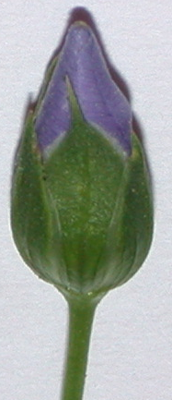
color of crown at bud stage

Ad. 2: Time of beginning of flowering

Time of flowering is reached when the first flower is open in 10% of plants.

Ad. 3: Corolla: arrangement of petals

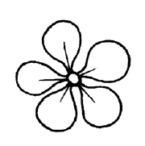 | 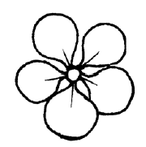 | 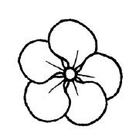
1 | 2 | 3
free | intermediate | overlapping

Ad. 5: Flower: size of corolla

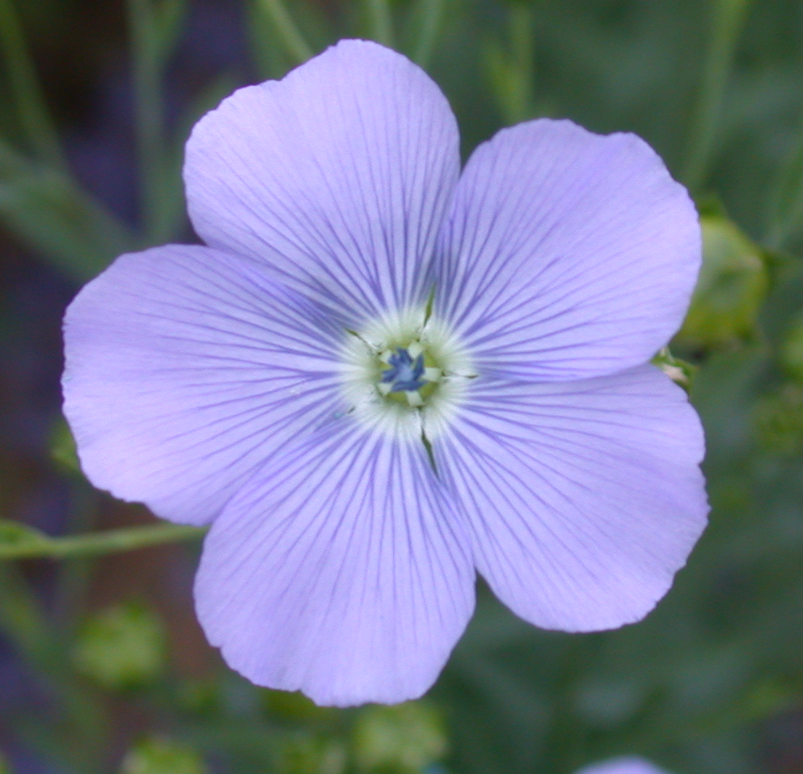

The size is the diameter of the corolla observed in the natural position (not with corolla held flat).

Ad. 6: Excluding varieties with corolla color: white: Flower: shape of corolla heart

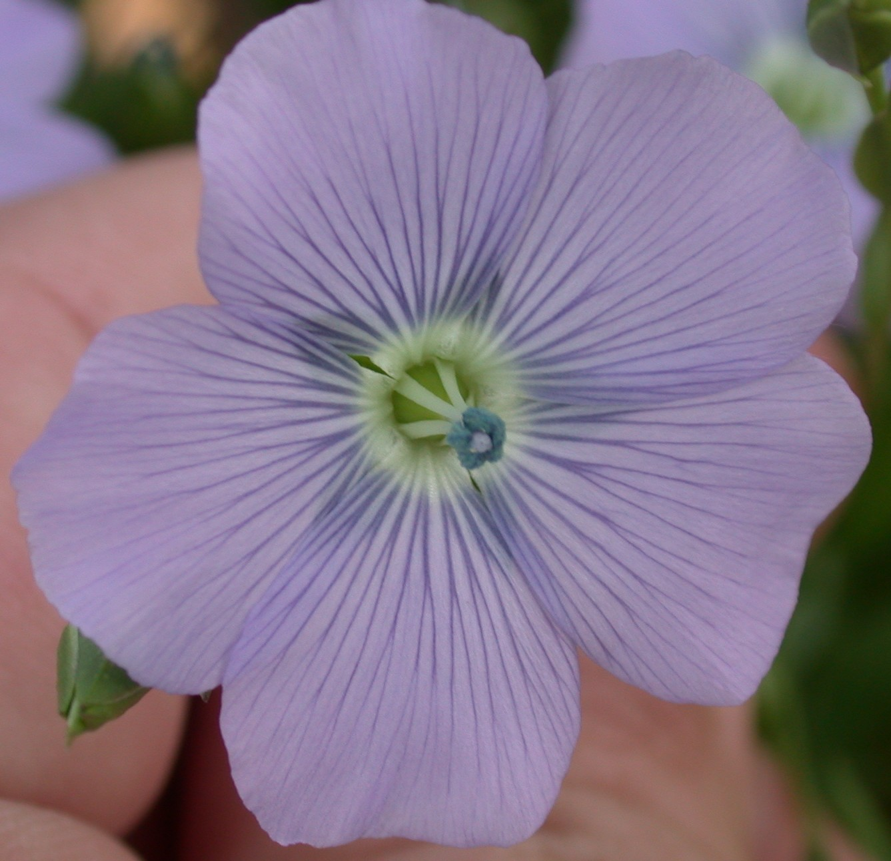 | 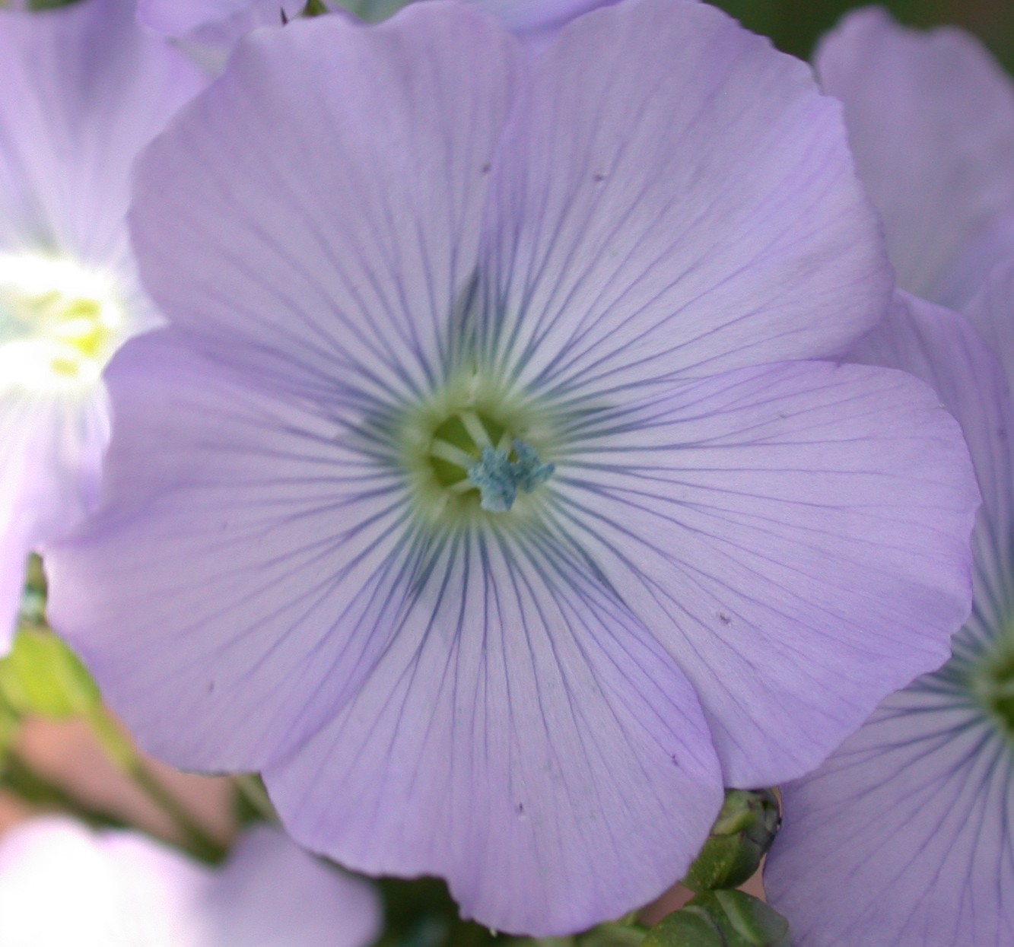 | 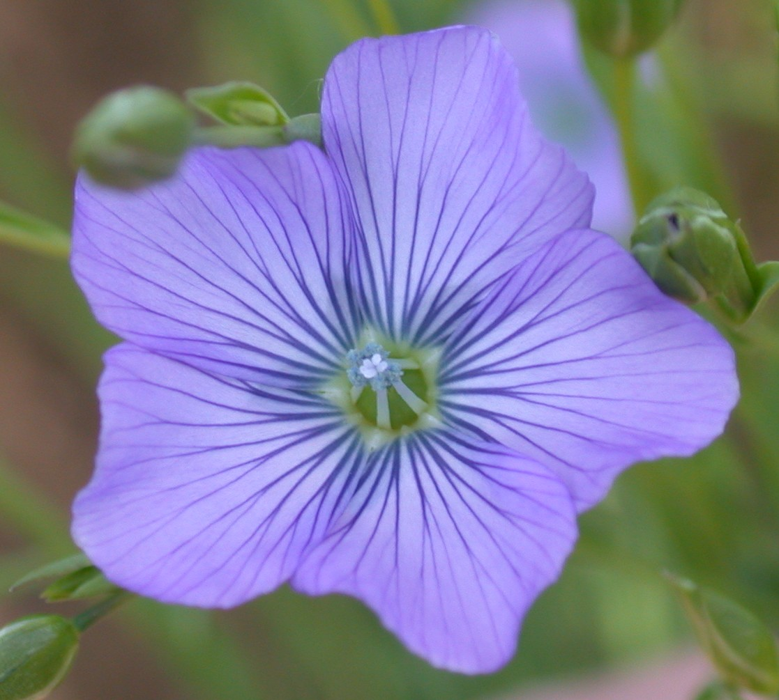
1 | 2 | 3
circular | circular to pentagonal | pentagonal

Ad. 7: Petal: length
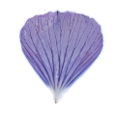
Ad. 8: Petal: width
Petal lentgh
Petal width

Ad. 14: Plant: height

Should be measured on the plot including lateral branches (at time of flowering) (see Ad. 21).

Ad. 16: Boll: ciliation of false septa

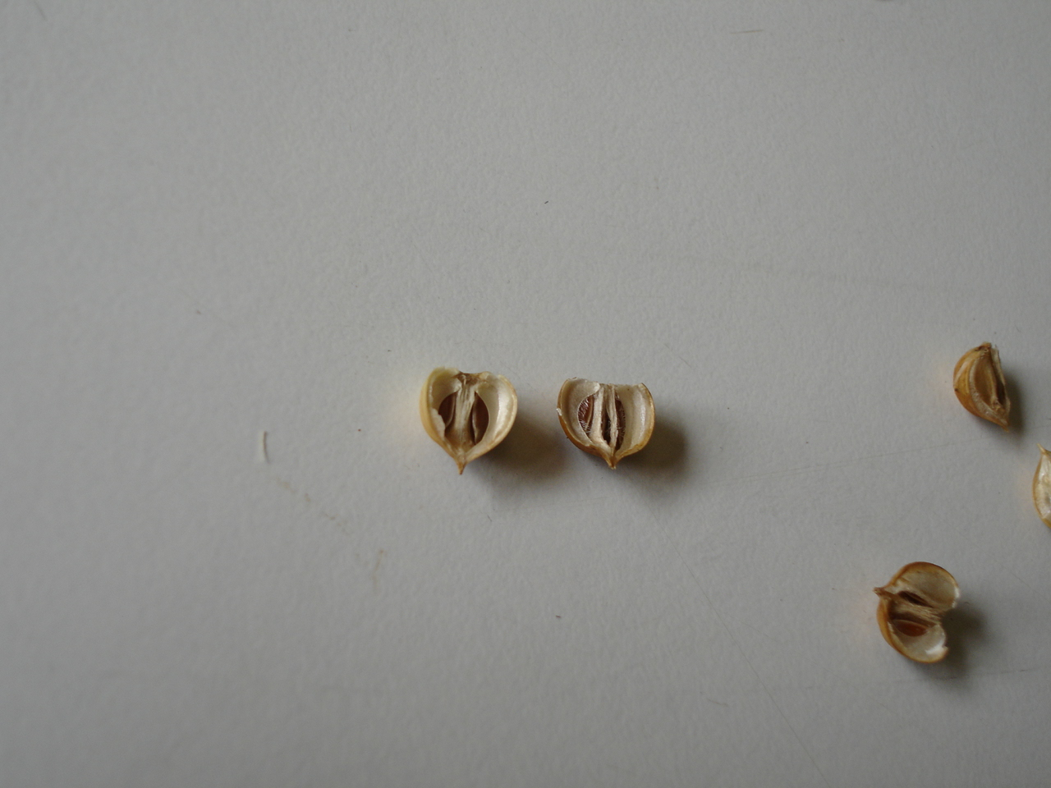
ciliation of false septa
1 | 9
absent | present

Ad. 17: Boll: length
Ad. 18: Boll: width

Boll
length
Boll width

Ad. 20: Stem: length from cotyledon scar to first branch
Ad. 21: Stem: length from cotyledon scar to top boll

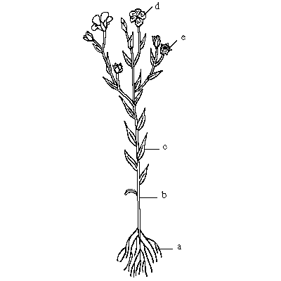
Characteristics should be observed on the main stem.
Stem: length from cotyledon scar to first branch
(characteristic 20)
Stem: length from cotyledon scar to top boll (characteristic 21)
Plant: height (characteristic 14)
cotyledon scar

8.3 Growth stages of Linum usitatissimum L. adapted to the BBCH (Meier U., 1997) scale applicable to individual plant
Stage 0 Germination
- Dry seed
- Beginning of seed imbibition
- Radicle (root) emerged from seed
- Emergence, Coleoptiles breaks through soil surface

Stage 1 Leaf development (main shoot)
- First true leaf unfolded
- Two true leaves unfolded
- Five true leaves unfolded
.. Stages continuous till stage 19

Stage 5 Inflorescence emergence (main shoot)/heading
- Flower buds visible
- First individual flowers visible (still closed)
- First flower petals visible

Stage 6 Flowering (main shoot)
- First flowers open (sporadically)
- Beginning of flowering: 10% of flowers open
65 Full flowering: 50% of flowers open
- End of flowering: fruit set visible

Stage 7 Development of bolls
71 10% of bolls have reached final size
75 50% of bolls have reached final size
79 Nearly all bolls have reached final size

Stage 8 Ripening or maturity of fruit and seed
81 Beginning of ripening or boll colouration
85 Sepals and bolls yellow coloured
89 Fully ripe, boll and seed show fully ripe colour

Stage 9 Senescence
99 Harvested plants and/or seeds

Literature
Anonyme, 1969: Le lin au service des hommes, sa vie, ses techniques, son histoire. Editions J-B Baillière et Fils. Paris, FR.

Anselme, CI, 1956: Les variétés de lin, leurs principales maladies cryptogamiques. INRA, (Institut National de la Recherche Agronomique). Paris, FR.

Keefe, P.D., 1999: Measurement of linseed (Linum usitatissimum L.) seed characters distinctness, uniformity and stability testing using image analysis, Plant Varieties and Seeds, Cambridge, GB.

Marshall, G., Editor, 1988: “Flax: Breeding and utilisation” Proceedings of the EEC Flax Workshop held in Brussels, Belgium, May 4-5 1998, sponsored by the Commission of the European Communities, Directorate-General for agriculture, Kluwer Academic Publishers, BE.

Meier U., 1997: Growth stages of mono- and dicotyledonous plants: BBCH-Monograph. Wien Federal Biological Research Center for Agriculture and Forestry, Blackwell Wissenschafts-Verlag, Berlin, DE.

Plonka, F., 1956: Les variétés de lin. INRA (Institut National de la Recherche Agronomique). Paris, FR.

Technical Questionnaire
TECHNICAL QUESTIONNAIRE |  |  | Page {x} of {y} | Reference Number:
 |  |  |  | Application date:
 |  |  |  | (not to be filled in by the applicant)
TECHNICAL QUESTIONNAIRE
to be completed in connection with an application for plant breeders’ rights

1. Subject of the Technical Questionnaire
1.1 Botanical name |  | Linum usitatissinum L.
1.2 Common name |  | Flax, Linseed
2. Applicant
Name
Address
Telephone No.
Fax No.
E-mail address
Breeder (if different from applicant)
3. Proposed denomination and breeder’s reference
Proposed denomination
(if available)

Breeder’s reference
#4. Information on the breeding scheme and propagation of the variety

  - Breeding scheme

Variety resulting from:
4.1.1 Crossing

(a) controlled cross [ ]
(please state parent varieties)

(…………………..……………..…) x (……………..…………………..…)
female parent male parent

(b) partially known cross [ ]
(please state known parent variety(ies))

(…………………..……………..…) x (……………..…………………..…)
female parent male parent

(c) unknown cross [ ]

4.1.2 Mutation [ ]
(please state parent variety)

4.1.3 Discovery and development [ ]
(please state where and when discovered
and how developed)

4.1.4 Other [ ]
(please provide details)

4.2 Method of propagating the variety

4.2.1 Seed-propagated varieties

(a) Self-pollination [ ]

(b) Cross-pollination
(i) population [ ]
(ii) synthetic variety [ ]

(c) Hybrid [ ]

(d) Other [ ]
(please provide details)

4.2.2 Other [ ]
(please provide details)

5. Characteristics of the variety to be indicated (the number in brackets refers to the corresponding characteristic in Test Guidelines; please mark the note which best corresponds).

 | Characteristics |  |  |  | Example Varieties |  | Note
5.1  (4) | Corolla : color
 | white |  |  |  | Belinka (F), Laser (O) |  | 1[ ]
 | light pink |  |  |  | Zhong Ya Ma No. 3 (F) |  | 2[ ]
 | medium pink |  |  |  | Petra (O) |  | 3[ ]
 | red violet |  |  |  |  |  | 4[ ]
 | violet |  |  |  | Violin (F),  Hungarian Gold (O) |  | 5[ ]
 | blue violet |  |  |  | Hermes (F), Niagara (O) |  | 6[ ]
 | medium blue |  |  |  | Escalina (F), Alaska (O) |  | 7[ ]
 | light blue |  |  |  | Melina (F), Barbara (O) |  | 8[ ]
5.2  (16) | Boll: ciliation of false septa
 | absent |  |  |  | Violin (F), Hivernal (O) |  | 1[ ]
 | present |  |  |  | Heljä (F), Barbara (O) |  | 9[ ]
5.3  (20) | Stem: length from cotyledon scar to first branch
 | very short |  |  |  | Abacus (F) |  | 1[ ]
 | very short to short |  |  |  |  |  | 2[ ]
 | short |  |  |  | Eole (O) |  | 3[ ]
 | short to medium |  |  |  |  |  | 4[ ]
 | medium |  |  |  | Mac Gregor (O) |  | 5[ ]
 | medium to long |  |  |  |  |  | 6[ ]
 | long |  |  |  | Agatha (F) |  | 7[ ]
 | long to very long |  |  |  |  |  | 8[ ]
 | very long |  |  |  | Drakkar (F) |  | 9[ ]
 | Characteristics |  |  |  | Example Varieties |  | Note
5.4  (23) | Seed: color
 | white |  |  |  | Zhang Bei white linseed (O) |  | 1[ ]
 | yellow |  |  |  | Aardvark (O) |  | 2[ ]
 | brown |  |  |  | Escalina (F), Barbara (O) |  | 3[ ]

TECHNICAL QUESTIONNAIRE |  | Page {x} of {y} |  | Reference Number:
6. Similar varieties and differences from these varieties

Please use the following table and box for comments to provide information on how your candidate variety differs from the variety (or varieties) which, to the best of your knowledge, is (or are) most similar. This information may help the examination authority to conduct its examination of distinctness in a more efficient way.

Denomination(s) of variety(ies) similar to your candidate variety | Characteristic(s) in  which your candidate  variety differs from the  similar variety(ies) |  | Describe the expression  of the characteristic(s)  for the similar  variety(ies) |  | Describe the  expression of the  characteristic(s) for  your candidate variety
Example | Plant: natural height |  | tall |  | very tall
Comments:

#7. Additional information which may help in the examination of the variety

7.1 In addition to the information provided in sections 5 and 6, are there any additional characteristics which may help to distinguish the variety?

Yes [ ] No [ ]

(If yes, please provide details)

7.2 Are there any special conditions for growing the variety or conducting the examination?

Yes [ ] No [ ]

(If yes, please provide details)

7.3 Other information

7.3.1 Main use

(a) Fibre [ ]
(b) Oil [ ]
(c) Fibre and Oil [ ]
(please provide details)

7.3.2 Time of sowing

(a) winter [ ]
(b) spring [ ]

8. Authorization for release

(a) Does the variety require prior authorization for release under legislation concerning the protection of the environment, human and animal health?

Yes [ ] No [ ]

(b) Has such authorization been obtained?

Yes [ ] No [ ]

If the answer to (b) is yes, please attach a copy of the authorization.

9. Information on plant material to be examined or submitted for examination.

9.1 The expression of a characteristic or several characteristics of a variety may be affected by factors, such as pests and disease, chemical treatment (e.g. growth retardants or pesticides), effects of tissue culture, different rootstocks, scions taken from different growth phases of a tree, etc.

9.2 The plant material should not have undergone any treatment which would affect the expression of the characteristics of the variety, unless the competent authorities allow or request such treatment. If the plant material has undergone such treatment, full details of the treatment must be given. In this respect, please indicate below, to the best of your knowledge, if the plant material to be examined has been subjected to:

(a) Microorganisms (e.g. virus, bacteria, phytoplasma) Yes [ ] No [ ]

(b) Chemical treatment (e.g. growth retardant, pesticide) Yes [ ] No [ ]

(c) Tissue culture Yes [ ] No [ ]

(d) Other factors Yes [ ] No [ ]

Please provide details for where you have indicated “yes”.

……………………………………………………………

10. I hereby declare that, to the best of my knowledge, the information provided in this form is correct:

Applicant’s name

Signature Date

[End of document]

* These names were correct at the time of the introduction of these Test Guidelines but may be revised or updated. [Readers are advised to consult the UPOV Code, which can be found on the UPOV Website (www.upov.int), for the latest information.]
# Authorities may allow certain of this information to be provided in a confidential section of the Technical Questionnaire.
# Authorities may allow certain of this information to be provided in a confidential section of the Technical Questionnaire.

