 |  | E  TG/56/4 Corr. Rev.  ORIGINAL: English  DATE: 2011-10-20 + 2017-10-17  + 2019-06-14
INTERNATIONAL UNION FOR THE PROTECTION OF NEW VARIETIES OF PLANTS
GENEVA

 | ALMOND  UPOV Code: PRUNU_DUL  Prunus dulcis (Mill.) D.A.Webb | *

GUIDELINES

FOR THE CONDUCT OF TESTS

FOR DISTINCTNESS, UNIFORMITY AND STABILITY

Alternative Names:*

Botanical name | English | French | German | Spanish
Prunus dulcis (Mill.) D.A.Webb  Prunus amygdalus (L.) | Almond | Amandier | Mandel | Almendro

The purpose of these guidelines (“Test Guidelines”) is to elaborate the principles contained in the General Introduction (document TG/1/3), and its associated TGP documents, into detailed practical guidance for the harmonized examination of distinctness, uniformity and stability (DUS) and, in particular, to identify appropriate characteristics for the examination of DUS and production of harmonized variety descriptions.

ASSOCIATED DOCUMENTS

These Test Guidelines should be read in conjunction with the General Introduction and its associated TGP documents.
TABLE OF CONTENTS PAGE

1. Subject of these Test Guidelines 3
2. Material Required 3
3. Method of Examination 3
3.1 Number of Growing Cycles 3
3.2 Testing Place 3
3.3 Conditions for Conducting the Examination 4
3.4 Test Design 4
3.5 Additional Tests 4
4. Assessment of Distinctness, Uniformity and Stability 4
4.1 Distinctness 4
4.2 Uniformity 5
4.3 Stability 6
5. Grouping of Varieties and Organization of the Growing Trial 6
6. Introduction to the Table of Characteristics 6
6.1 Categories of Characteristics 6
6.2 States of Expression and Corresponding Notes 7
6.3 Types of Expression 7
6.4 Example Varieties 7
6.5 Legend 8
7. Table of Characteristics/Tableau des caractères/Merkmalstabelle/Tabla de caracteres 9
8. Explanations on the Table of Characteristics 19
8.1 Explanations covering several characteristics 19
8.2 Explanations for individual characteristics 19
9. Literature 23
10. Technical Questionnaire 24

Subject of these Test Guidelines
These Test Guidelines apply to all varieties of Prunus dulcis (Mill.) D.A. Webb.

Material Required
2.1 The competent authorities decide on the quantity and quality of the plant material required for testing the variety and when and where it is to be delivered. Applicants submitting material from a State other than that in which the testing takes place must ensure that all customs formalities and phytosanitary requirements are complied with.

2.2 The material is to be supplied in the form of budsticks.

  - The minimum quantity of plant material, to be supplied by the applicant, should be:

- 5 budsticks with sufficient buds to propagate 5 trees (to be sent at budding time) or
- 5 dormant shoots for grafting, sufficient to propagate 5 trees ( to be sent at grafting time); or
- 5 one-year-old trees grafted on a rootstock selected by the testing authority.

2.4 The plant material supplied should be visibly healthy, not lacking in vigor, nor affected by any important pest or disease.

2.5 The plant material should not have undergone any treatment which would affect the expression of the characteristics of the variety, unless the competent authorities allow or request such treatment. If it has been treated, full details of the treatment must be given.

Method of Examination

3.1 Number of Growing Cycles
3.1.1 The minimum duration of tests should normally be two independent growing cycles. In particular, it is essential that the plants produce a satisfactory crop of fruit in each of the two growing cycles.

3.1.2 The growing cycle is considered to be the duration of a single growing season, beginning with bud burst (flowering and/or vegetative), flowering and fruit harvest and concluding when the following dormant period ends with the swelling of new seasons buds.

3.2 Testing Place
Tests are normally conducted at one place. In the case of tests conducted at more than one place, guidance is provided in TGP/9 “Examining Distinctness”.

3.3 Conditions for Conducting the Examination
The tests should be carried out under conditions ensuring satisfactory growth for the expression of the relevant characteristics of the variety and for the conduct of the examination.

3.4 Test Design
3.4.1 Each test should be designed to result in a total of at least 5 plants.

3.4.2 The design of the tests should be such that plants or parts of plants may be removed for measurement or counting without prejudice to the observations which must be made up to the end of the growing cycle.

3.5 Additional Tests
Additional tests, for examining relevant characteristics, may be established.

Assessment of Distinctness, Uniformity and Stability

4.1 Distinctness
4.1.1 General Recommendations

It is of particular importance for users of these Test Guidelines to consult the General Introduction prior to making decisions regarding distinctness. However, the following points are provided for elaboration or emphasis in these Test Guidelines.

4.1.2 Consistent Differences

The differences observed between varieties may be so clear that more than one growing cycle is not necessary. In addition, in some circumstances, the influence of the environment is not such that more than a single growing cycle is required to provide assurance that the differences observed between varieties are sufficiently consistent. One means of ensuring that a difference in a characteristic, observed in a growing trial, is sufficiently consistent is to examine the characteristic in at least two independent growing cycles.

4.1.3 Clear Differences

Determining whether a difference between two varieties is clear depends on many factors, and should consider, in particular, the type of expression of the characteristic being examined, i.e. whether it is expressed in a qualitative, quantitative, or pseudo-qualitative manner. Therefore, it is important that users of these Test Guidelines are familiar with the recommendations contained in the General Introduction prior to making decisions regarding distinctness.

    - Number of Plants / Parts of Plants to be Examined

Unless otherwise indicated, for the purposes of distinctness, all observations on single plants should be made on 5 plants or parts taken from each of 5 plants and any other observations made on all plants in the test, disregarding any off-type plants. In the case of observations of parts taken from single plants, the number of parts to be taken from each of the plants should be 2.

4.1.5 Method of Observation

The recommended method of observing the characteristic is indicated by the following key in the second column of the Table of Characteristics (see document TGP/9 “Examining Distinctness”, Section 4 “Observation of characteristics”:

MG: single measurement of a group of plants or parts of plants
MS: measurement of a number of individual plants or parts of plants
VG: visual assessment by a single observation of a group of plants or parts of plants
VS: visual assessment by observation of individual plants or parts of plants

Type of observation: visual (V) or measurement (M)

“Visual” observation (V) is an observation made on the basis of the expert’s judgment. For the purposes of this document, “visual” observation refers to the sensory observations of the experts and, therefore, also includes smell, taste and touch. Visual observation includes observations where the expert uses reference points (e.g. diagrams, example varieties, side-by-side comparison) or non-linear charts (e.g. color charts). Measurement (M) is an objective observation against a calibrated, linear scale e.g. using a ruler, weighing scales, colorimeter, dates, counts, etc.

Type of record: for a group of plants (G) or for single, individual plants (S)

For the purposes of distinctness, observations may be recorded as a single record for a group of plants or parts of plants (G), or may be recorded as records for a number of single, individual plants or parts of plants (S). In most cases, “G” provides a single record per variety and it is not possible or necessary to apply statistical methods in a plant-by-plant analysis for the assessment of distinctness.

In cases where more than one method of observing the characteristic is indicated in the Table of Characteristics (e.g. VG/MG), guidance on selecting an appropriate method is provided in document TGP/9, Section 4.2.

Uniformity
4.2.1 It is of particular importance for users of these Test Guidelines to consult the General Introduction prior to making decisions regarding uniformity. However, the following points are provided for elaboration or emphasis in these Test Guidelines:

4.2.2 For the assessment of uniformity, a population standard of 1% and an acceptance probability of at least 95 % should be applied. In the case of a sample size of 5 plants, no off-types are allowed.

4.3 Stability
4.3.1 In practice, it is not usual to perform tests of stability that produce results as certain as those of the testing of distinctness and uniformity. However, experience has demonstrated that, for many types of variety, when a variety has been shown to be uniform, it can also be considered to be stable.

4.3.2 Where appropriate, or in cases of doubt, stability may be further examined by testing a new plant stock to ensure that it exhibits the same characteristics as those shown by the initial material supplied.

Grouping of Varieties and Organization of the Growing Trial
5.1 The selection of varieties of common knowledge to be grown in the trial with the candidate varieties and the way in which these varieties are divided into groups to facilitate the assessment of distinctness are aided by the use of grouping characteristics.

5.2 Grouping characteristics are those in which the documented states of expression, even where produced at different locations, can be used, either individually or in combination with other such characteristics: (a) to select varieties of common knowledge that can be excluded from the growing trial used for examination of distinctness; and (b) to organize the growing trial so that similar varieties are grouped together.

5.3 The following have been agreed as useful grouping characteristics:

(a) Tree: distribution of flower buds (characteristic 8)
(b) Fruit: size (characteristic 27)
(c) Stone: resistance to cracking (characteristic 37)
(d) Time of beginning of flowering (characteristic 43)
(e) Time of harvest (characteristic 44)

5.4 Guidance for the use of grouping characteristics, in the process of examining distinctness, is provided through the General Introduction.

Introduction to the Table of Characteristics

6.1 Categories of Characteristics
6.1.1 Standard Test Guidelines Characteristics

Standard Test Guidelines characteristics are those which are approved by UPOV for examination of DUS and from which members of the Union can select those suitable for their particular circumstances.

6.1.2 Asterisked Characteristics

Asterisked characteristics (denoted by *) are those included in the Test Guidelines which are important for the international harmonization of variety descriptions and should always be examined for DUS and included in the variety description by all members of the Union, except when the state of expression of a preceding characteristic or regional environmental conditions render this inappropriate.

6.2 States of Expression and Corresponding Notes
6.2.1 States of expression are given for each characteristic to define the characteristic and to harmonize descriptions. Each state of expression is allocated a corresponding numerical note for ease of recording of data and for the production and exchange of the description.
6.2.2 In the case of qualitative and pseudo-qualitative characteristics (see Chapter 6.3), all relevant states of expression are presented in the characteristic. However, in the case of quantitative characteristics with 5 or more states, an abbreviated scale may be used to minimize the size of the Table of Characteristics. For example, in the case of a quantitative characteristic with 9 states, the presentation of states of expression in the Test Guidelines may be abbreviated as follows:

State | Note
small | 3
medium | 5
large | 7

However, it should be noted that all of the following 9 states of expression exist to describe varieties and should be used as appropriate:

State | Note
very small | 1
very small to small | 2
small | 3
small to medium | 4
medium | 5
medium to large | 6
large | 7
large to very large | 8
very large | 9

6.2.3 Further explanation of the presentation of states of expression and notes is provided in document TGP/7 “Development of Test Guidelines”.

6.3 Types of Expression
An explanation of the types of expression of characteristics (qualitative, quantitative and pseudo-qualitative) is provided in the General Introduction.

6.4 Example Varieties
Where appropriate, example varieties are provided to clarify the states of expression of each characteristic.

6.5 Legend
(*) Asterisked characteristic – see Chapter 6.1.2

QL Qualitative characteristic – see Chapter 6.3
QN Quantitative characteristic – see Chapter 6.3
PQ Pseudo-qualitative characteristic – see Chapter 6.3

MG, MS, VG, VS – see Chapter 4.1.5

(a)-(d) See Explanations on the Table of Characteristics in Chapter 8.1
(+) See Explanations on the Table of Characteristics in Chapter 8.2

Table of Characteristics/Tableau des caractères/Merkmalstabelle/Tabla de caracteres
 |  | English | français | deutsch | español | Example Varieties  Exemples  Beispielssorten  Variedades ejemplo | Note/  Nota
1.  (*)  (+) | VG | Tree: vigor | Arbre : vigueur | Baum: Wuchsstärke | Árbol: vigor
QN |  | weak | faible | gering | débil | Marcona, Tuono,  Umm al-Fahm | 3
 |  | medium | moyenne | mittel | mediano | Nonpareil | 5
 |  | strong | forte | stark | fuerte | Barte, Flour en bas, Peerless | 7
2.  (*)  (+) | VG | Tree: habit | Arbre : port | Baum: Wuchsform | Árbol: porte
PQ |  | upright | dressé | aufrecht | erguido | Fournat de Brezenaud | 1
 |  | upright to spreading | dressé à divergent | aufrecht bis breitwüchsig | erguido a extendido | Ferragnes | 2
 |  | spreading | divergent | breitwüchsig | extendido | Nec Plus Ultra | 3
 |  | drooping | retombant | überhängend | colgante | Primorskii,  Umm al-Fahm | 4
3.  (*) | VG | Tree: texture of bark | Arbre : texture de l’écorce | Baum: Beschaffenheit der Rinde | Árbol: textura de la corteza
QN |  | smooth | lisse | glatt | lisa | Barte, Volcani 5 | 1
 |  | moderately cracked | peu craquelée | mäßig rissig | moderadamente agrietada |  | 2
 |  | strongly cracked | très craquelée | stark rissig | fuertemente agrietada | Ferragnes | 3
4. | VG | One-year-old shoot: thickness | Rameau d’un an : épaisseur | Einjähriger Trieb: Dicke | Rama de un año: grosor
QN |  | thin | fin | dünn | delgada | Ai | 3
 |  | medium | moyen | mittel | mediana | Nonpareil | 5
 |  | thick | épais | dick | gruesa | Primorski, Texas | 7
5. (*)  (+) | VG | One-year-old shoot: anthocyanin coloration | Rameau d’un an : pigmentation anthocyanique | Einjähriger Trieb: Anthocyanfärbung | Rama de un año: pigmentación antociánica
QN | (a) | absent or very weak | absente ou très faible | fehlend oder sehr gering | ausente o muy débil |  | 1
 |  | weak | faible | gering | débil | Desmayo Largueta | 3
 |  | medium | moyenne | mittel | mediana | Barte, Nonpareil | 5
 |  | strong | forte | stark | fuerte | Ferragnes, Marcona, Texas | 7
6. (*)  (+) | VG | Shoot: feathering | Rameau : anticipés | Trieb: Seitentriebbildung | Rama: brotes laterales
QN |  | absent or very weak | absents ou très peu nombreux | fehlend oder sehr gering | ausentes o muy débiles | Barte | 1
 |  | weak | peu nombreux | gering | débiles | Texas | 2
 |  | medium | moyennement nombreux | mittel | medianos | Desmayo Larguerta | 3
 |  | strong | nombreux | stark | fuertes | Marcona | 4
 |  | very strong | très nombreux | sehr stark | muy fuertes | Ai | 5
7. | VG | Tree: density of foliage | Arbre : densité du feuillage | Baum: Dichte des Laubs | Árbol: densidad del follaje
QN |  | sparse | faible | locker | ralo | Fournat de Brezenaud | 3
 |  | medium | moyenne | mittel | mediano | Nonpareil | 5
 |  | dense | forte | dicht | denso | Peerless | 7
8. (*) | VG | Tree: distribution of flower buds | Arbre : répartition des boutons floraux | Baum: Verteilung der Blütenknospen | Árbol: distribución de  las yemas florales
QN |  | predominantly on spurs | le plus souvent sur bouquets de mai | vorwiegend an Kurztrieben | predominantemente en espolones | Cristomorto | 1
 |  | equally on spurs and one year old shoots | autant sur bouquets de mai que sur rameaux d’un an | gleichermaßen an Kurztrieben und an einjährigen Trieben | en espolones y en ramas de un año por igual | Ferragnes | 2
 |  | predominantly on one year old shoots | le plus souvent sur rameaux d’un an | vorwiegend an einjährigen Trieben | principalmente en ramas de un año | Nonpareil | 3
9. (*) | MS/MG | Leaf blade: length | Limbe : longueur | Blattspreite: Länge | Limbo: longitud
QN | (a) | short | court | kurz | corto | Ai | 3
 |  | medium | moyen | mittel | mediano | Primorskii | 5
 |  | long | long | lang | largo | Barte | 7
10. (*) | MS/MG | Leaf blade: width | Limbe : largeur | Blattspreite: Breite | Limbo: anchura
QN | (a) | narrow | étroit | schmal | estrecho | Ai | 3
 |  | medium | moyen | mittel | mediano | Nec Plus Ultra | 5
 |  | broad | large | breit | ancho | Barte | 7
11. (*) | MS | Leaf : ratio length/width | Feuille : rapport longueur/largeur | Blatt: Verhältnis Länge/Breite | Hoja: relación longitud/anchura
QN | (a) | slightly elongated | légèrement allongé | leicht langgezogen | ligeramente alargado | Volcani 5 | 3
 |  | moderately elongated | modérément allongé | mäßig langgezogen | moderadamente alargado | Nec Plus Ultra, Texas | 5
 |  | very elongated | très allongé | stark langgezogen | muy alargado | Nonpareil | 7
12. (*) | VG | Leaf blade: intensity of green color | Limbe : intensité de la couleur verte | Blattspreite: Intensität der Grünfärbung | Limbo: intensidad del color verde
QN | (a) | light | claire | hell | claro | Barte | 3
 |  | medium | moyenne | mittel | mediano | Nonpareil | 5
 |  | dark | foncée | dunkel | oscuro | Texas | 7
13. (*)  (+) | VG | Leaf blade: incisions of margin | Limbe : type d’incisions du bord | Blattspreite: Randeinschnitte | Limbo: incisiones del borde
QL | (a) | serrate | dentelé | gesägt | serrado |  | 1
 |  | crenate | crénelé | gekerbt | crenado | Texas | 2
14. (*) | MS/  VG | Petiole: length | Pétiole : longueur | Stiel: Länge | Peciolo: longitud
QN | (a) | short | court | kurz | corto | Ferragnes | 3
 |  | medium | moyen | mittel | mediano | Primorskii | 5
 |  | long | long | lang | largo | Peerless | 7
15. (*)  (+) | VG | Flower bud: shape | Bouton floral : forme | Blütenknospe: Form | Botón floral: forma
PQ | (a) | triangular | triangulaire | dreieckig | triangular | Ai | 1
 |  | ovate | ovale | eiförmig | oval | Desmayo Largueta | 2
 |  | circular | circulaire | kreisförmig | circular | Cristomorto | 3
16. (*)  (+) | VG | Flower bud: color of tip of petals | Bouton floral : couleurs de l’extrémité des pétales | Blütenknospe: Farbe der Spitze der Kronblätter | Botón floral: color de la punta de los pétalos
PQ | (a) | white | blanche | weiß | blanco | Ardechoise | 1
 |  | pink | rose | rosa | rosa | Barte, Marcona | 2
 |  | red | rouge | rot | rojo | Ai, Trell | 3
17. (*) | VG | Flower bud: color of sepals | Bouton floral : couleur des sépales | Blütenknospe: Farbe der Kelchblätter | Botón floral: color de los sépalos
PQ | (a) | green | vert | grün | verde | Cristomorto | 1
 |  | brown | brun | braun | marrón | Tuono | 2
 |  | red | rouge | rot | rojo | Desmayo Largueta | 3
18. | VG | Flower bud: pubescence of sepals | Bouton floral : pilosité des sépales | Blütenknospe: Behaarung der Kelchblätter | Botón floral: pubescencia de los sépalos
QN | (a) | absent or very weak | absente ou très faible | fehlend oder sehr gering | ausente o muy débil | Marcona | 1
 |  | weak | faible | gering | débil | Ardechoise | 2
 |  | medium | moyenne | mittel | mediana | Barte | 3
 |  | strong | forte | stark | fuerte |  | 4
 |  | very strong | très forte | sehr stark | muy fuerte |  | 5
19. (*). | MS/  VG | Flower: diameter | Fleur : diamètre | Blüte: Durchmesser | Flor: diámetro
QN | (b) | small | petit | klein | pequeña | Umm al-Fahm | 3
 |  | medium | moyen | mittel | mediana | Peerless | 5
 |  | large | grand | groß | grande | Nec Plus Ultra | 7
20. (*)  (+) | VG | Petal: shape | Pétale : forme | Blütenblatt: Form | Pétalo: forma
PQ | (b) | narrow elliptic | elliptique étroite | schmal elliptisch | elíptica estrecha | Volcani 5 | 1
 |  | medium elliptic | elliptique moyenne | mittel elliptisch | elíptica mediana | Butte | 2
 |  | circular | circulaire | kreisförmig | circular | Texas Mission | 3
 |  | rhombic | rhombique | rautenförmig | rómbica | Umm al-Fahm | 4
21. (*) | VG | Petal: color of inner side | Pétale : couleur de la face interne | Blütenblatt: Farbe der Innenseite | Pétalo: color de la cara interna
PQ | (b) | white | blanche | weiß | blanco | Barte | 1
 |  | light pink | rose clair | hellrosa | rosa claro | Ai | 2
 |  | medium pink | rose moyen | mittelrosa | rosa mediano | Marcona | 3
 |  | dark pink | rose foncé | dunkelrosa | rosa oscuro | Trell | 4
22. | VG | Petal: undulation of margin | Pétale : ondulation du bord | Blütenblatt: Randwellung | Pétalo: ondulación del borde
QN | (b) | absent or very weak | absente ou très faible | fehlend oder sehr gering | ausente o muy débil | Carmel | 1
 |  | weak | faible | gering | débil | Butte | 2
 |  | medium | moyenne | mittel | mediana | Nec Plus Ultra | 3
 |  | strong | forte | stark | fuerte | Texas Mission | 4
 |  | very strong | très forte | sehr stark | muy fuerte |  | 5
23. | VG | Flower: number of stamens | Fleur : nombre d’étamines | Blüte: Anzahl der Staubgefäße | Flor: número de estambres
QN |  | few | faible | gering | bajo | Cristomorto | 1
 |  | medium | moyen | mittel | mediano | Ai | 2
 |  | many | élevé | hoch | alto | Barte | 3
24. (*) | VG | Stamen: anthocyanin coloration of filament | Étamine : pigmentation anthocyanique du filament | Staubgefäß: Anthcyanfärbung der Fäden | Estambre: pigmentación antociánica del filamento
QN | (b) | absent or weak | absente ou faible | fehlend oder gering | ausente o débil | Price | 1
 |  | moderate | moyenne | mäßig | moderada | Nonpareil | 2
 |  | strong | forte | stark | fuerte | Texan Mission | 3
25. (*) | VG | Stigma: position in relation to anthers | Stigmate : position par rapport aux anthères | Narbe: Stellung im Vergleich zu den Antheren | Estigma: posición en relación con las anteras
QN | (b) | below | en dessous | unterhalb | por debajo | Drake | 1
 |  | same level | au même niveau | auf gleicher Höhe | al mismo nivel | Nec Plus Ultra | 2
 |  | above | au-dessus | oberhalb | por encima | Desmayo Largueta | 3
26. | VG | Stigma: size | Stigmate : taille | Narbe: Größe | Estigma: tamaño
QN | (b) | small | petit | klein | pequeño | Desmayo Largueta | 1
 |  | medium | moyen | mittel | mediano |  | 2
 |  | large | grand | groß | grande | Ai | 3
27. (*) | VG | Fruit: size | Fruit : taille | Frucht: Größe | Fruto: tamaño
QN | (c) | very small | très petit | sehr klein | muy pequeño |  | 1
 |  | small | petit | klein | pequeño | Texas | 3
 |  | medium | moyen | mittel | mediano | Nonpareil | 5
 |  | large | grand | groß | grande | Ardechoise | 7
 |  | very large | très grand | sehr groß | muy grande | Barte | 9
28. (*)  (+) | VG | Fruit: shape (in lateral view) | Fruit : forme (en vue latérale) | Frucht: Form (in Seitenansicht) | Fruto: forma (en vista lateral)
PQ | (c) | ovate | ovale | eiförmig | ovado | Marcona | 1
 |  | elliptic | elliptique | elliptisch | elíptico | Ai | 2
 |  | circular | circulaire | kreisförmig | circular | Nec Plus Ultra | 3
 |  | obovate | obovale | verkehrt eiförmig | obovado | Ardechoise | 4
29.  (*)  (+) | VG | Fruit: shape of apex | Fruit : forme du sommet | Frucht: Form der Spitze | Fruto: forma del ápice
PQ | (c) | acute | aigu | spitz | agudo | Carmel | 1
 |  | obtuse | obtus | stumpf | obtuso | Price | 2
 |  | rounded | arrondi | abgerundet | redondeado | Texas Mission | 3
30. (*) | VG | Fruit: pubescence | Fruit : pilosité | Frucht: Behaarung | Fruto: pubescencia
QN | (c) | sparse | faible | locker | escasa |  | 1
 |  | medium | moyenne | mittel | mediana | Desmayo Largueta | 2
 |  | dense | forte | dicht | densa | Ferraduel | 3
31. (*) | MS/  VG | Stone: length | Noyau : longueur | Stein: Länge | Hueso: longitud
QN | (d) | short | court | kurz | corto | Texas Mission | 3
 |  | medium | moyen | mittel | mediano | Nec Plus Ultra | 5
 |  | long | long | lang | largo | Peerless | 7
32. (*) | MS/  VG | Stone: width (in lateral view) | Noyau : largeur (en vue latérale) | Stein: Breite (in Seitenansicht) | Hueso: anchura (en vista lateral)
QN | (d) | narrow | étroit | schmal | estrecho | Price | 3
 |  | medium | moyen | mittel | mediano | Nec Plus Ultra | 5
 |  | broad | large | breit | ancho | Peerless | 7
33. (*) | MS/  VG | Stone: ratio length/width in lateral view | Noyau : rapport longueur/largeur en vue latérale | Stein: Verhältnis Länge/Breite in Seitenansicht | Hueso: relación longitud/anchura en vista lateral
QN | (d) | compressed | comprimé | zusammengedrückt | comprimido |  | 1
 |  | medium | moyen | mittel | mediano |  | 2
 |  | elongated | allongé | langgezogen | alargado |  | 3
34. (*)  (+) | VG | Stone: shape (in lateral view) | Noyau : forme (en vue latérale) | Stein: Form (in Seitenansicht) | Hueso: forma (en vista lateral)
PQ | (d) | ovate | ovale | eiförmig | ovado | Marcona, Montrone | 1
 |  | elliptic | elliptique | elliptisch | elíptica | Catuccia | 2
 |  | circular | circulaire | kreisförmig | circular | Nonpareil | 3
 |  | obovate | obovale | verkehrt eiförmig | obovado | Nec Plus Ultra | 4
35.  (+) | VG | Stone: shape of apex | Noyau : forme du sommet | Stein: Form der Spitze | Hueso: forma del ápice
PQ | (d) | acute | aigu | spitz | agudo |  | 1
 |  | obtuse | obtus | stumpf | obtuso |  | 2
 |  | rounded | arrondi | abgerundet | redondeado |  | 3
36. (*) | VG | Stone: thickness of endocarp | Noyau : épaisseur de l’endocarpe | Stein: Dicke des Endokarps | Hueso: grosor del endocarpio
QN | (d) | thin | fin | dünn | delgado | Nonpareil | 1
 |  | medium | moyen | mittel | mediano | Ferragnes | 2
 |  | thick | épais | dick | grueso | Barte | 3
37. (*)  (+) | VG | Stone: resistance to cracking | Noyau : résistance à la fissuration | Stein: Härte beim Knacken | Hueso: resistencia a la quebradura
QN | (d) | absent or very weak | absente ou très faible | fehlend oder sehr gering | ausente o muy débil | Nonpareil | 1
 |  | weak | faible | gering | débil | Princess | 2
 |  | medium | moyenne | mittel | mediana | Texas | 3
 |  | strong | forte | stark | fuerte | Desmayo Largueta | 4
 |  | very strong | très forte | sehr stark | muy fuerte | Barte | 5
38. (*)  (+) | VG | Stone: keel development | Noyau : développement de la carène | Stein: Ausprägung des Kiels | Hueso: desarrollo de la quilla
QN | (d) | weak | faible | gering | débil | Marcona, Peerless | 3
 |  | medium | moyen | mittel | mediano | Nec Plus Ultra | 5
 |  | strong | fort | stark | fuerte | Nonpareil | 7
39. (*) | VG | Kernel: size | Amande : taille | Kern: Größe | Almendra: tamaño
QN |  | very small | très petite | sehr klein | muy pequeña | Kapareil | 1
 |  | small | petite | klein | pequeña | Texas | 3
 |  | medium | moyenne | mittel | mediana | Nonpareil | 5
 |  | large | grande | groß | grande | Ferragnes | 7
 |  | very large | très grande | sehr groß | muy grande | Barte | 9
40. (*)  (+) | VG | Kernel: intensity of brown color | Amande : intensité de la couleur brune | Kern: Intensität der Braunfärbung | Almendra: intensidad del color marrón
QN |  | light | claire | hell | claro | Nonpareil | 1
 |  | medium | moyenne | mittel | mediano |  | 2
 |  | dark | foncée | dunkel | oscuro |  | 3
41. (*) |  | Kernel: rugosity of surface | Amande : rugosité de la surface | Kern: Rauheit der Oberfläche | Almendra: rugosidad de la superficie
QN |  | weak | faible | gering | débil | Texas Mission | 1
 |  | medium | moyenne | mittel | mediana | Umm al-Fahm | 3
 |  | strong | forte | stark | fuerte | Carmel | 5
42. (*) | VG | Time of leaf bud burst in relation to beginning of flowering | Époque du débourrement foliaire par rapport à l’époque du début de floraison | Zeitpunkt des Blattkonspenaufbruchs im Vergleich zum Blühbeginn | Época de comienzo de la apertura de la yema foliar en relación con el comienzo de la floración
QN |  | earlier | plus précoce | früher | más temprana | Cavaliera | 1
 |  | same | identique | gleichzeitig | la misma | Ferragnes | 2
 |  | later | plus tardive | später | más tardía | Texas | 3
43. (*)  (+) | MG | Time of beginning of flowering | Époque du début de floraison | Zeitpunkt des Blühbeginns | Epoca de comienzo de la floración
QN |  | very early | très précoce | sehr früh | muy temprana | Cavaliera, Zahaf | 1
 |  | very early to early | très précoce à  précoce | sehr früh bis früh | muy temprana a temprana | Avola,  Desmayo Largueta, Rameira | 2
 |  | early | précoce | früh | temprana | Chellaston, Princesse | 3
 |  | early to medium | précoce à moyenne | früh bis mittel | temprana a mediana | Bartre, Marcona,  Nec Plus Ultra | 4
 |  | medium | moyenne | mittel | mediana | Cristomorto, Miagkoskorlupij, Nonpareil, Peerless | 5
 |  | medium to late | moyenne à tardive | mittel bis spät | mediana a tardía | Ferragnès, Guara, Primorskij | 6
 |  | late | tardive | spät | tardía | Felisia, Steliette | 7
 |  | late to very late | tardive à très tardive | spät bis sehr spät | tardía a muy tardía | Vialfas | 8
 |  | very late | très tardive | sehr spät | muy tardía | Diamar, Penta | 9
44. (*)  (+) | VG | Time of harvest | Époque de maturité | Zeitpunkt der Ernte | Época de la cosecha
QN |  | very early | très précoce | sehr früh | muy temprana | Cavaliera,  Umm al-Fahm | 1
 |  | early | précoce | früh | temprana | Nec Plus Ultra | 3
 |  | medium | moyenne | mittel | mediana | Ferragnes | 5
 |  | late | tardive | spät | tardía | Marcona | 7
 |  | very late | très tardive | sehr spät | muy tardía | Texas | 9

Explanations on the Table of Characteristics

8.1 Explanations covering several characteristics
Characteristics containing the following key in the second column of the Table of Characteristics should be examined as indicated below:

(a) Observations should be made at the central third of the shoot. The observations on the leaves should be made on mature leaves from current season’s shoots.

(b) Observations should be made at the time of full flowering.

(c) Observations should be made approximately 3 months after full flowering.

(d) Observations should be made after splitting or cracking of the flesh of the fruit.

8.2 Explanations for individual characteristics
Ad. 1: Tree: vigor

The tree vigor should be considered as the overall abundance of vegetative growth.

Ad. 2: Tree: habit

1 | 2 | 3 | 4
upright | upright to spreading | spreading | drooping

Ad. 5: One-year-old shoot: anthocyanin coloration

The anthocyanin coloration should be observed on the sunny side of the one-year-old shoot.

Ad. 6: Shoot: feathering

“Feathering” is the presence of secondary shoots on current year’s shoots.

Ad. 13: Leaf blade: incisions of margin

1 | 2
serrate | crenate

Ad. 15: Flower bud: shape

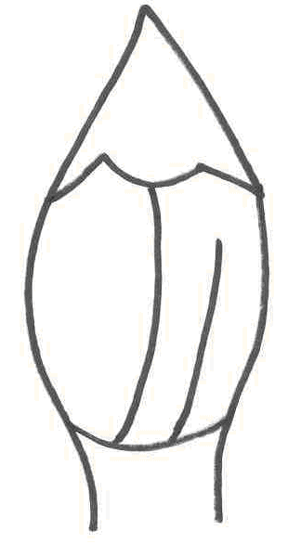 | 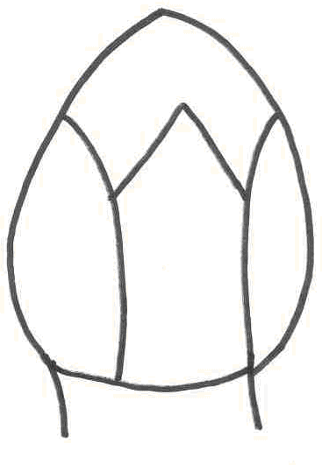 | 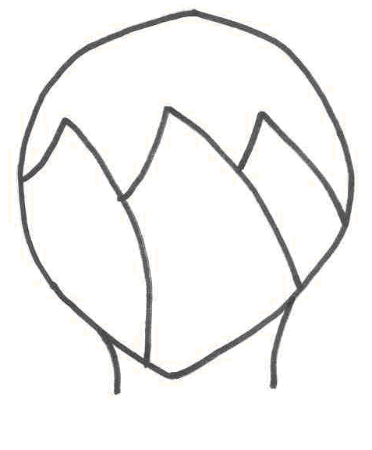
1 | 2 | 3
triangular | ovate | circular

Ad. 16: Flower bud: color of tip of petals

The color of the tip of the petals should be observed just before opening.

Ad. 20: Petal: shape

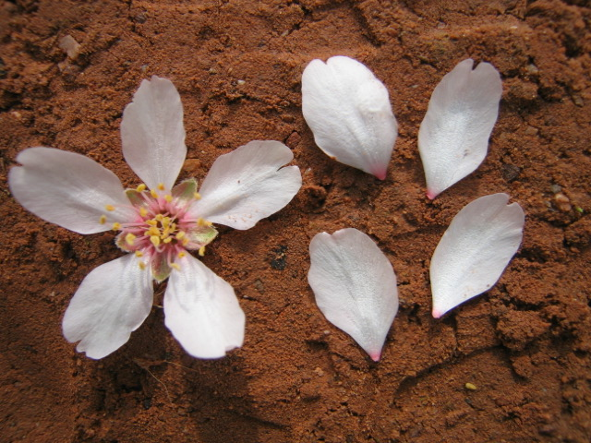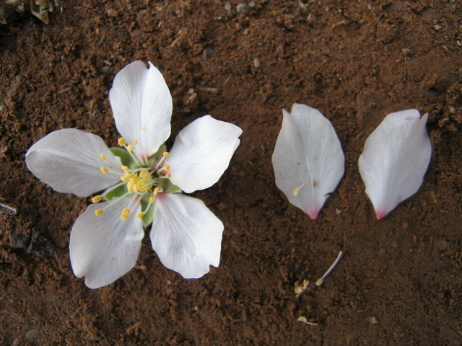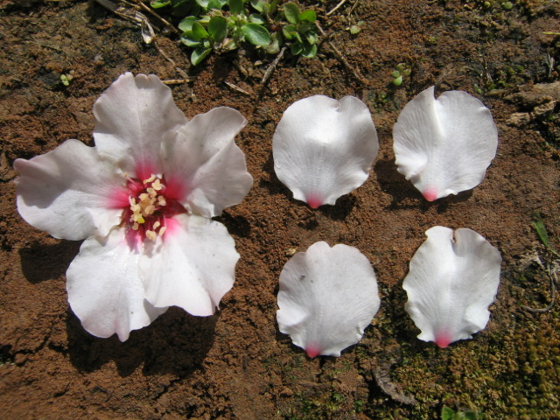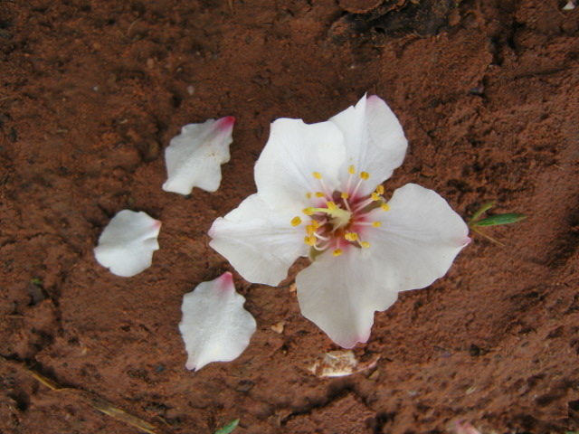

1 | 2 | 3 | 4
narrow elliptic | medium elliptic | circular | rhombic
Ad. 28: Fruit: shape (in lateral view)
Ad. 34: Stone: shape (in lateral view)

 |  | ← position of broadest part →
 |  | below middle | at middle | above middle

broad (compressed) ←length/width ratio→ narrow (elongated) narroweeleleelonelongated(elongated) |  | 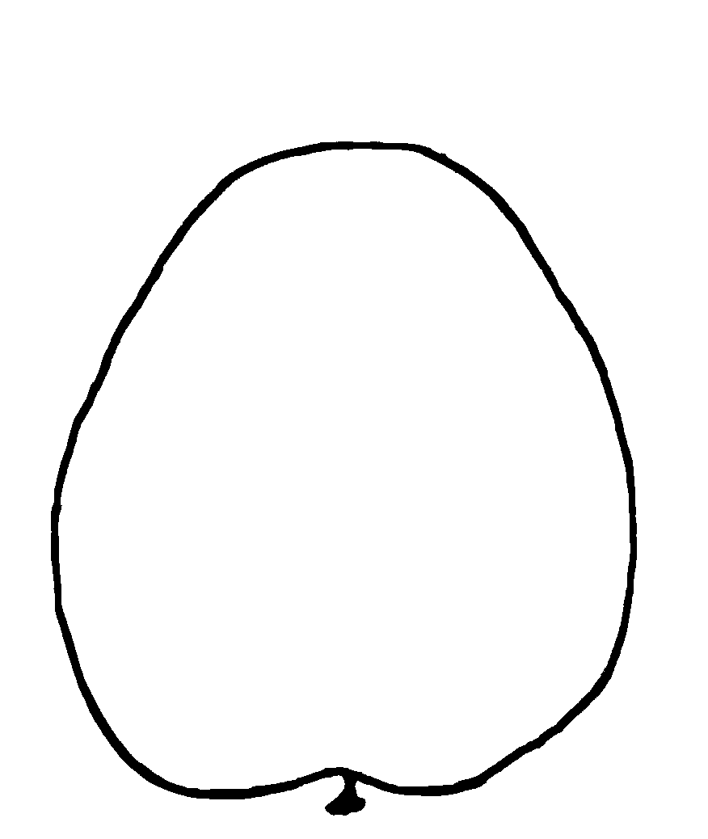 | 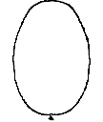  2  elliptic | 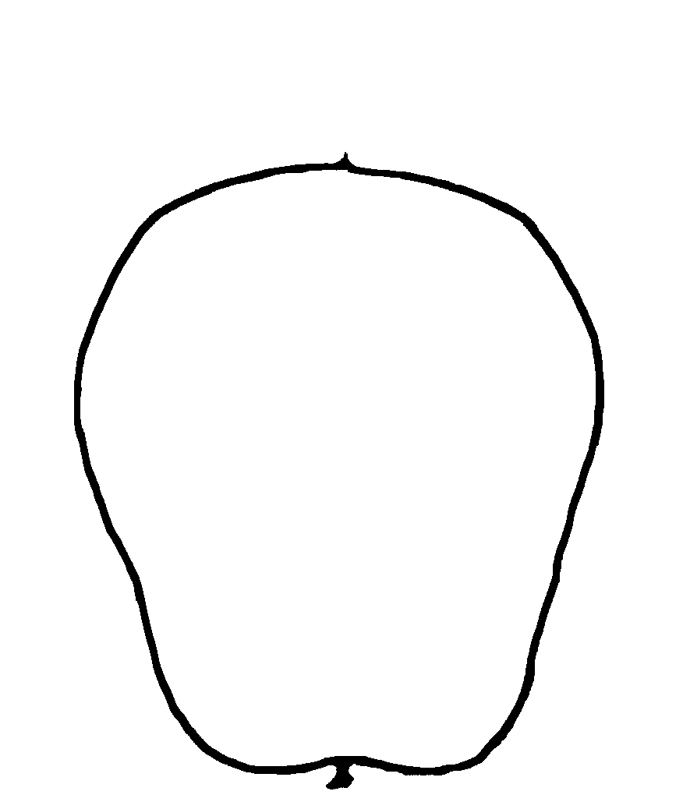
 |  |  | 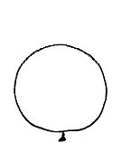
 |  | 1 | 3 | 4
 |  | ovate | circular | obovate

Ad. 29: Fruit: shape of apex

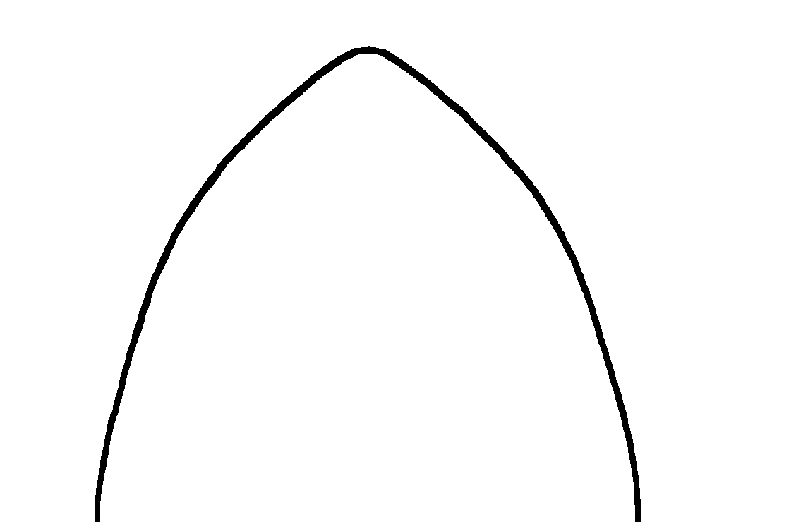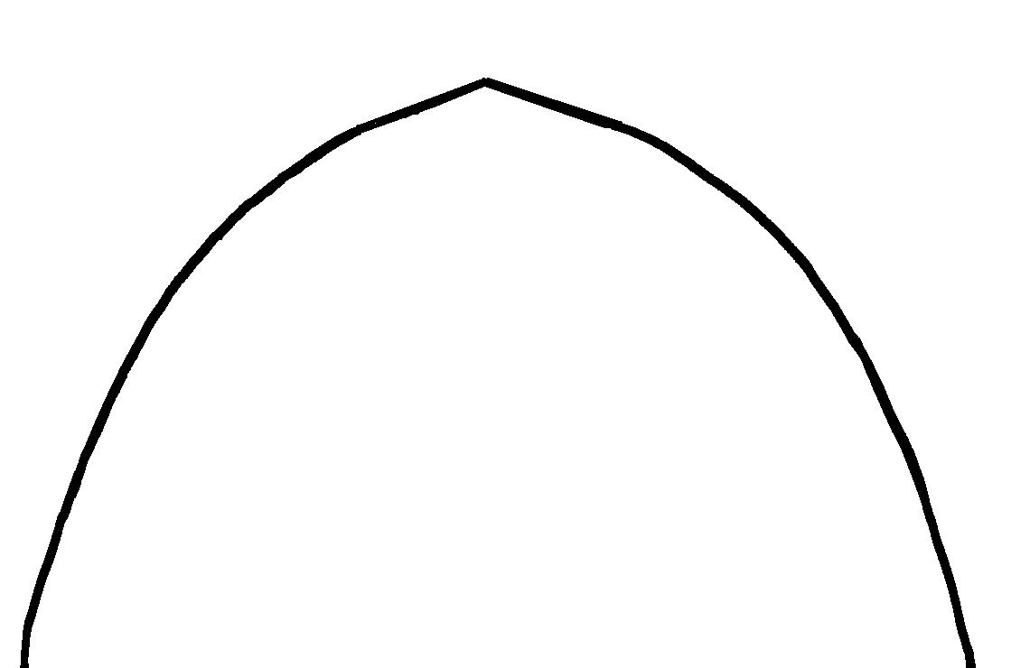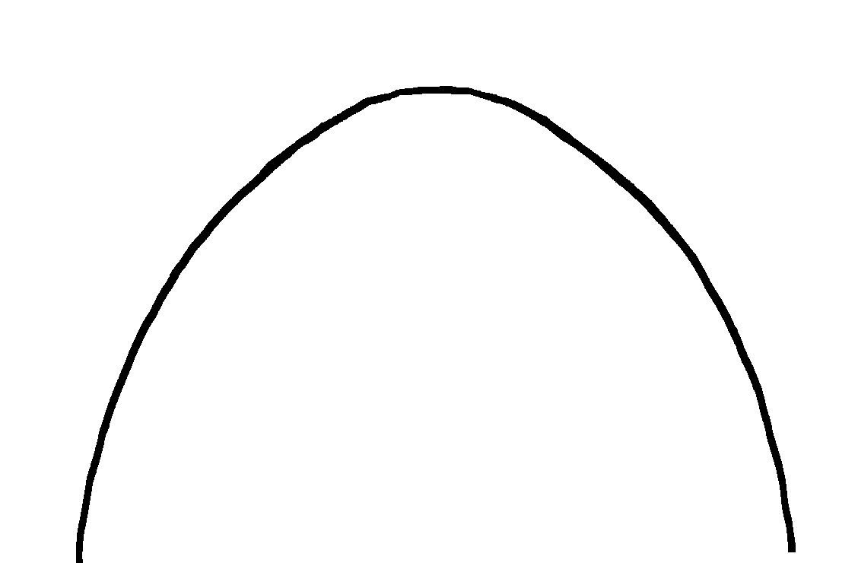

1 | 2 | 3
acute | obtuse | rounded

Ad. 35: Stone: shape of apex

1 | 2 | 3
acute | obtuse | rounded

Ad. 37: Stone: resistance to cracking

The characteristic is observed as the ease with which the stone can be broken by hand.

Ad. 38: Stone: keel development

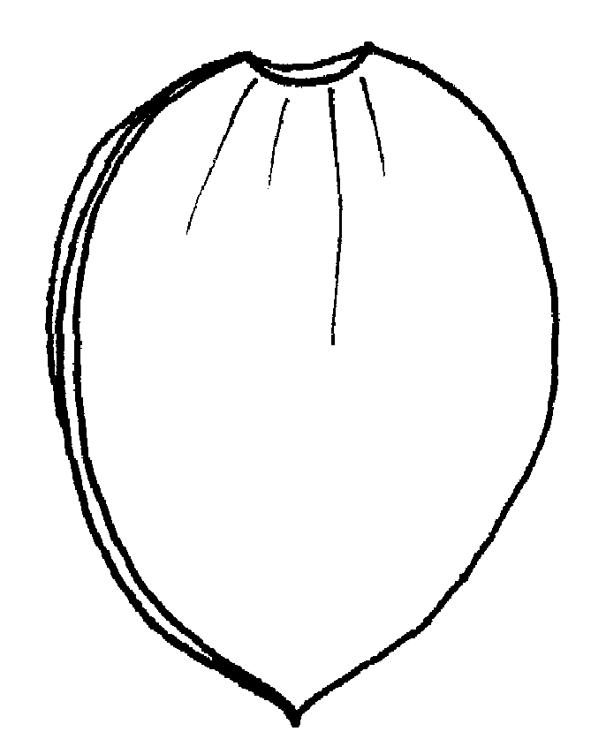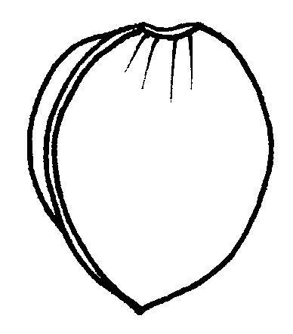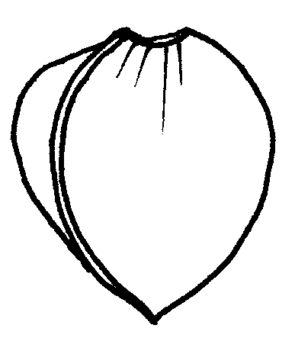

3 | 5 | 7
weak | medium | strong

Ad. 40: Kernel: intensity of brown color

The color of the kernel should be observed on freshly opened stones.

Ad. 43: Time of beginning of flowering

The beginning of flowering is when 10% of flowers have fully opened.

Ad. 44: Time of harvest

The time of harvest is when 50% of the fruits on the tree split.

Literature

Alonso Segura J.M., Socias i Company, R., Kodad O., 2017: Late-blooming in almond: A controversial objective. Scientia Horticulturae 224: pp. 61 to 67

Asai W.K., Micke W.C., Kester D.E., Rough D., 1996: The Evaluation and Selection of Current Varieties (Chapter 8.) In: Almond production manual (Micke, W.C. Ed.). Division of Agriculture and Natural Resources, University of California. Oakland, US, pp. 52 to 60

Dicenta, F., Sánchez-Pérez, R., Batlle, I., Martínez-Gómez, P. 2017: 7 Late-blooming Cultivar Development. in: Socias i Company, R., Gradziel T. M. (Eds.), Almonds. Botany, Production and Uses. CABI, US, pp.168 to 187

Wirthensohn, M., Iannamico, L., 2017: 4 Almond in the Southern Hemisphere. in: Socias i Company, R., Gradziel T. M. (Eds.), Almonds. Botany, Production and Uses. CABI, US, pp. 87 to 110

Technical Questionnaire
TECHNICAL QUESTIONNAIRE |  |  |  | Page {x} of {y} |  | Reference Number:
 |  |  |  |  |  | Application date:
 |  |  |  |  |  | (not to be filled in by the applicant)
TECHNICAL QUESTIONNAIRE
to be completed in connection with an application for plant breeders’ rights

1. Subject of the Technical Questionnaire
1.1 Botanical name |  |  | Prunus dulcis (Mill) D.A. Webb (synonym: Prunus amygdalus (L.))
1.2 Common name
2. Applicant
Name
Address
Telephone No.
Fax No.
E-mail address
Breeder (if different from applicant)
3. Proposed denomination and breeder’s reference
Proposed denomination
(if available)
Breeder’s reference
#4. Information on the breeding scheme and propagation of the variety

4.1 Breeding scheme

Variety resulting from:

4.1.1 Crossing

(a) controlled cross [ ]
(please state parent varieties)

(…………………..……………..…) x (……………..…………………..…)
female parent male parent

(b) partially known cross [ ]
(please state known parent variety(ies))

(…………………..……………..…) x (……………..…………………..…)
female parent male parent

(c) unknown cross [ ]

4.1.2 Mutation [ ]
(please state parent variety)

4.1.3 Discovery and development [ ]
(please state where and when discovered and how developed)

4.1.4 Other [ ]
(please provide details)

4.2 Method of propagating the variety

4.2.1 Vegetative propagation

(a) cuttings [ ]

(b) in vitro propagation [ ]

(c) other (state method) [ ]

4.2.2 Other [ ]
(please provide details)

5. Characteristics of the variety to be indicated (the number in brackets refers to the corresponding characteristic in Test Guidelines; please mark the note which best corresponds).
 | Characteristics |  |  |  |  |  | Example Varieties |  |  | Note
5.1  (8) | Tree: distribution of flower buds
 | predominantly on spurs |  |  |  |  |  | Cristomorto |  |  | 1[ ]
 | equally on spurs and one year old shoots |  |  |  |  |  | Ferragnes |  |  | 2[ ]
 | predominantly on one year old shoots |  |  |  |  |  | Nonpareil |  |  | 3[ ]
5.2  (27) | Fruit: size
 | very small |  |  |  |  |  |  |  |  | 1[ ]
 | very small to small |  |  |  |  |  |  |  |  | 2[ ]
 | small |  |  |  |  |  | Texas |  |  | 3[ ]
 | small to medium |  |  |  |  |  |  |  |  | 4[ ]
 | medium |  |  |  |  |  | Nonpareil |  |  | 5[ ]
 | medium to large |  |  |  |  |  |  |  |  | 6[ ]
 | large |  |  |  |  |  | Ardechoise |  |  | 7[ ]
 | large to very large |  |  |  |  |  |  |  |  | 8[ ]
 | very large |  |  |  |  |  | Barte |  |  | 9[ ]
5.3  (37) | Stone: resistance to cracking
 | absent or very weak |  |  |  |  |  | Nonpareil |  |  | 1[ ]
 | weak |  |  |  |  |  | Princess |  |  | 2[ ]
 | medium |  |  |  |  |  | Texas |  |  | 3[ ]
 | strong |  |  |  |  |  | Desmayo Largueta |  |  | 4[ ]
 | very strong |  |  |  |  |  | Barte |  |  | 5[ ]
 | Characteristics |  |  |  |  |  | Example Varieties |  |  | Note
5.4  (43) | Time of beginning of flowering
 | very early |  |  |  |  |  | Cavaliera, Zahaf |  |  | 1[ ]
 | very early to early |  |  |  |  |  | Avola,  Desmayo Largueta, Rameira |  |  | 2[ ]
 | early |  |  |  |  |  | Chellaston, Princesse |  |  | 3[ ]
 | early to medium |  |  |  |  |  | Bartre, Marcona,  Nec Plus Ultra |  |  | 4[ ]
 | medium |  |  |  |  |  | Cristomorto, Miagkoskorlupij, Nonpareil, Peerless |  |  | 5[ ]
 | medium to late |  |  |  |  |  | Ferragnès, Guara, Primorskij |  |  | 6[ ]
 | late |  |  |  |  |  | Felisia, Steliette |  |  | 7[ ]
 | late to very late |  |  |  |  |  | Vialfas |  |  | 8[ ]
 | very late |  |  |  |  |  | Diamar, Penta |  |  | 9[ ]
5.5  (44) | Time of harvest
 | very early |  |  |  |  |  | Cavaliera,  Umm al-Fahm |  |  | 1[ ]
 | very early to early |  |  |  |  |  |  |  |  | 2[ ]
 | early |  |  |  |  |  | Nec Plus Ultra |  |  | 3[ ]
 | early to medium |  |  |  |  |  |  |  |  | 4[ ]
 | medium |  |  |  |  |  | Ferragnes |  |  | 5[ ]
 | medium to late |  |  |  |  |  |  |  |  | 6[ ]
 | late |  |  |  |  |  | Marcona |  |  | 7[ ]
 | late to very late |  |  |  |  |  |  |  |  | 8[ ]
 | very late |  |  |  |  |  | Texas |  |  | 9[ ]
6. Similar varieties and differences from these varieties

Please use the following table and box for comments to provide information on how your candidate variety differs from the variety (or varieties) which, to the best of your knowledge, is (or are) most similar. This information may help the examination authority to conduct its examination of distinctness in a more efficient way.

Denomination(s) of variety(ies) similar to your candidate variety |  | Characteristic(s) in which your candidate variety differs from the similar variety(ies) |  |  | Describe the expression of the characteristic(s) for the similar variety(ies) |  |  | Describe the expression of the characteristic(s) for your candidate variety
Example |  | Fruit color |  |  | orange red |  |  | orange
Comments:

#7. Additional information which may help in the examination of the variety

7.1 In addition to the information provided in sections 5 and 6, are there any additional characteristics which may help to distinguish the variety?

Yes [ ] No [ ]

(If yes, please provide details)

7.2 Are there any special conditions for growing the variety or conducting the examination?

Yes [ ] No [ ]

(If yes, please provide details)

7.3 Other information

A representative color image of the variety should accompany the Technical Questionnaire.

8. Authorization for release

(a) Does the variety require prior authorization for release under legislation concerning the protection of the environment, human and animal health?

Yes [ ] No [ ]

(b) Has such authorization been obtained?

Yes [ ] No [ ]

If the answer to (b) is yes, please attach a copy of the authorization.

9. Information on plant material to be examined or submitted for examination.

9.1 The expression of a characteristic or several characteristics of a variety may be affected by factors, such as pests and disease, chemical treatment (e.g. growth retardants or pesticides), effects of tissue culture, different rootstocks, scions taken from different growth phases of a tree, etc.

9.2 The plant material should not have undergone any treatment which would affect the expression of the characteristics of the variety, unless the competent authorities allow or request such treatment. If the plant material has undergone such treatment, full details of the treatment must be given. In this respect, please indicate below, to the best of your knowledge, if the plant material to be examined has been subjected to:

(a) Microorganisms (e.g. virus, bacteria, phytoplasma) Yes [ ] No [ ]

(b) Chemical treatment (e.g. growth retardant, pesticide) Yes [ ] No [ ]

(c) Tissue culture Yes [ ] No [ ]

(d) Other factors Yes [ ] No [ ]

Please provide details for where you have indicated “yes”.

……………………………………………………………

9.3 Has the plant material to be examined been tested for the presence of virus or other pathogens?

Yes [ ]
(please provide details as specified by the Authority)

No [ ]

10. I hereby declare that, to the best of my knowledge, the information provided in this form is correct:

Applicant’s name

Signature Date

[End of document]

* These names were correct at the time of the introduction of these Test Guidelines but may be revised or updated. [Readers are advised to consult the UPOV Code, which can be found on the UPOV Website (www.upov.int), for the latest information.]
# Authorities may allow certain of this information to be provided in a confidential section of the Technical Questionnaire.
# Authorities may allow certain of this information to be provided in a confidential section of the Technical Questionnaire.

