 |  | E  TG/53/7 Rev. 2  ORIGINAL: English  DATE: 2010-03-24 + 2014-04-09  + 2021-10-26
INTERNATIONAL UNION FOR THE PROTECTION OF NEW VARIETIES OF PLANTS
GENEVA

 | PEACH  UPOV Code: PRUNU_PER  Prunus persica (L.) Batsch | *

GUIDELINES

FOR THE CONDUCT OF TESTS

FOR DISTINCTNESS, UNIFORMITY AND STABILITY

Alternative Names:*

Botanical name | English | French | German | Spanish
Prunus persica (L.) Batsch,  Persica vulgaris Mill.,  Prunus L. subg. Persica | Peach | Pêcher | Pfirsich | Duraznero,  Melocotonero

The purpose of these guidelines (“Test Guidelines”) is to elaborate the principles contained in the General Introduction (document TG/1/3), and its associated TGP documents, into detailed practical guidance for the harmonized examination of distinctness, uniformity and stability (DUS) and, in particular, to identify appropriate characteristics for the examination of DUS and production of harmonized variety descriptions.

ASSOCIATED DOCUMENTS

These Test Guidelines should be read in conjunction with the General Introduction, its associated TGP documents and the Test Guidelines for Prunus Rootstocks, document TG/187.
TABLE OF CONTENTS PAGE

1. Subject of these Test Guidelines 3
2. Material Required 3
3. Method of Examination 3
3.1 Number of Growing Cycles 3
3.2 Testing Place 3
3.3 Conditions for Conducting the Examination 3
3.4 Test Design 4
3.5 Number of Plants / Parts of Plants to be Examined 4
3.6 Additional Tests 4
4. Assessment of Distinctness, Uniformity and Stability 4
4.1 Distinctness 4
4.2 Uniformity 5
4.3 Stability 5
5. Grouping of Varieties and Organization of the Growing Trial 6
6. Introduction to the Table of Characteristics 7
6.1 Categories of Characteristics 7
6.2 States of Expression and Corresponding Notes 7
6.3 Types of Expression 7
6.4 Example Varieties 7
6.5 Legend 8
7. Table of Characteristics/Tableau des caractères/Merkmalstabelle/Tabla de caracteres 9
8. Explanations on the Table of Characteristics 27
8.1 Explanations covering several characteristics 27
8.2 Explanations for individual characteristics 27
9. Literature 40
10. Technical Questionnaire 42

Subject of these Test Guidelines
These Test Guidelines apply to all varieties of peach (including nectarine) of the species Prunus persica (L.) Batsch. For the examination of hybrids involving Prunus persica (L.) Batsch, guidance is provided in document TGP/13 “Guidance for New Types and Species”.

Material Required
2.1 The competent authorities decide on the quantity and quality of the plant material required for testing the variety and when and where it is to be delivered. Applicants submitting material from a State other than that in which the testing takes place must ensure that all customs formalities and phytosanitary requirements are complied with.

2.2 The material is to be supplied in the form of grafted trees, on a peach rootstock to be selected by the competent authorities.

2.3 The minimum quantity of plant material, to be supplied by the applicant, should be:

3 grafted trees.

2.4 The plant material supplied should be visibly healthy, not lacking in vigor, nor affected by any important pest or disease.

2.5 The plant material should not have undergone any treatment which would affect the expression of the characteristics of the variety, unless the competent authorities allow or request such treatment. If it has been treated, full details of the treatment must be given.

Method of Examination

3.1 Number of Growing Cycles
The minimum duration of tests should normally be two independent growing cycles. In particular, it is essential that the trees produce a satisfactory crop of fruit in each of the two growing cycles.

3.2 Testing Place
Tests are normally conducted at one place. In the case of tests conducted at more than one place, guidance is provided in TGP/9 “Examining Distinctness”.

3.3 Conditions for Conducting the Examination
3.3.1 The tests should be carried out under conditions ensuring satisfactory growth for the expression of the relevant characteristics of the variety and for the conduct of the examination.
3.3.2 Because daylight varies, color determinations made against a color chart should be made either in a suitable cabinet providing artificial daylight or in the middle of the day in a room without direct sunlight. The spectral distribution of the illuminant for artificial daylight should conform with the CIE Standard of Preferred Daylight D 6500 and should fall within the tolerances set out in the British Standard 950, Part I. These determinations should be made with the plant part placed against a white background.

3.4 Test Design
3.4.1 Each test should be designed to result in a total of at least 3 trees.

3.4.2 The design of the tests should be such that plants or parts of plants may be removed for measurement or counting without prejudice to the observations which must be made up to the end of the growing cycle.

3.5 Number of Plants / Parts of Plants to be Examined
Unless otherwise indicated, all observations should be made on 3 plants or parts taken from each of 3 plants. In the case of parts of plants, the number to be taken from each of the plants should be at least 5.

3.6 Additional Tests
Additional tests, for examining relevant characteristics, may be established.

Assessment of Distinctness, Uniformity and Stability

4.1 Distinctness

4.1.1 General Recommendations

It is of particular importance for users of these Test Guidelines to consult the General Introduction prior to making decisions regarding distinctness. However, the following points are provided for elaboration or emphasis in these Test Guidelines.

4.1.2 Consistent Differences

The differences observed between varieties may be so clear that more than one growing cycle is not necessary. In addition, in some circumstances, the influence of the environment is not such that more than a single growing cycle is required to provide assurance that the differences observed between varieties are sufficiently consistent. One means of ensuring that a difference in a characteristic, observed in a growing trial, is sufficiently consistent is to examine the characteristic in at least two independent growing cycles.

4.1.3 Clear Differences

Determining whether a difference between two varieties is clear depends on many factors, and should consider, in particular, the type of expression of the characteristic being examined, i.e. whether it is expressed in a qualitative, quantitative, or pseudo-qualitative manner. Therefore, it is important that users of these Test Guidelines are familiar with the recommendations contained in the General Introduction prior to making decisions regarding distinctness.

4.1.4 Method of Observation

The recommended method of observing the characteristic for the purposes of distinctness is indicated by the following key in the second column of the Table of Characteristics (see document TGP/9 “Examining Distinctness”, Section 4 “Observation of characteristics”):

MG: single measurement of a group of plants or parts of plants
MS: measurement of a number of individual plants or parts of plants
VG: visual assessment by a single observation of a group of plants or parts of plants
VS: visual assessment by observation of individual plants or parts of plants

Type of observation: visual (V) or measurement (M)

“Visual” observation (V) is an observation made on the basis of the expert’s judgment. For the purposes of this document, “visual” observation refers to the sensory observations of the experts and, therefore, also includes smell, taste and touch. Visual observation includes observations where the expert uses reference points (e.g. diagrams, example varieties, side-by-side comparison) or non-linear charts (e.g. color charts). Measurement (M) is an objective observation against a calibrated, linear scale e.g. using a ruler, weighing scales, colorimeter, dates, counts, etc.

Type of record: for a group of plants (G) or for single, individual plants (S)

For the purposes of distinctness, observations may be recorded as a single record for a group of plants or parts of plants (G), or may be recorded as records for a number of single, individual plants or parts of plants (S). In most cases, “G” provides a single record per variety and it is not possible or necessary to apply statistical methods in a plant-by-plant analysis for the assessment of distinctness.”

In cases where more than one method of observing the characteristic is indicated in the Table of Characteristics (e.g. VG/MG), guidance on selecting an appropriate method is provided in document TGP/9, Section 4.2.”

4.2 Uniformity
4.2.1 It is of particular importance for users of these Test Guidelines to consult the General Introduction prior to making decisions regarding uniformity. However, the following points are provided for elaboration or emphasis in these Test Guidelines:

4.2.2 For the assessment of uniformity, a population standard of 1% and an acceptance probability of at least 95% should be applied. In the case of a sample size of 3 plants, no off-types are allowed.

4.3 Stability
4.3.1 In practice, it is not usual to perform tests of stability that produce results as certain as those of the testing of distinctness and uniformity. However, experience has demonstrated that, for many types of variety, when a variety has been shown to be uniform, it can also be considered to be stable.

4.3.2 Where appropriate, or in cases of doubt, stability may be tested, either by growing a further generation, or by testing a new plant stock to ensure that it exhibits the same characteristics as those shown by the previous material supplied.

Grouping of Varieties and Organization of the Growing Trial
5.1 The selection of varieties of common knowledge to be grown in the trial with the candidate varieties and the way in which these varieties are divided into groups to facilitate the assessment of distinctness are aided by the use of grouping characteristics.

5.2 Grouping characteristics are those in which the documented states of expression, even where produced at different locations, can be used, either individually or in combination with other such characteristics: (a) to select varieties of common knowledge that can be excluded from the growing trial used for examination of distinctness; and (b) to organize the growing trial so that similar varieties are grouped together.

  - The following have been agreed as useful grouping characteristics:

- Tree: size (characteristic 1)
- Flower: type (characteristic 9)
- Leaf blade: red mid-vein on the lower side (characteristic 28)
- Petiole: nectaries (characteristic 30)
- Petiole: shape of nectaries (characteristic 31)
- Fruit: shape (in ventral view) (characteristic 33)
- Fruit: pubescence of skin (characteristic 44)
- Fruit: carotenoid coloration of flesh (characteristic 51)
- Fruit: acidity (characteristic 60) with the following groups:
- low
- medium
- high
- Fruit: flesh type (TQ characteristic), with the following groups:
- melting
- non-melting
- stony hard
- Time of beginning of flowering (characteristic 69)
(l) Time of maturity (characteristic 70)

5.4 Guidance for the use of grouping characteristics, in the process of examining distinctness, is provided through the General Introduction.

Introduction to the Table of Characteristics

6.1 Categories of Characteristics
6.1.1 Standard Test Guidelines Characteristics

Standard Test Guidelines characteristics are those which are approved by UPOV for examination of DUS and from which members of the Union can select those suitable for their particular circumstances.

6.1.2 Asterisked Characteristics

Asterisked characteristics (denoted by *) are those included in the Test Guidelines which are important for the international harmonization of variety descriptions and should always be examined for DUS and included in the variety description by all members of the Union, except when the state of expression of a preceding characteristic or regional environmental conditions render this inappropriate.

6.2 States of Expression and Corresponding Notes
States of expression are given for each characteristic to define the characteristic and to harmonize descriptions. Each state of expression is allocated a corresponding numerical note for ease of recording of data and for the production and exchange of the description.

6.3 Types of Expression
An explanation of the types of expression of characteristics (qualitative, quantitative and pseudo-qualitative) is provided in the General Introduction.

6.4 Example Varieties
Where appropriate, example varieties are provided to clarify the states of expression of each characteristic.

6.5 Legend
(*) Asterisked characteristic – see Chapter 6.1.2

QL Qualitative characteristic – see Chapter 6.3
QN Quantitative characteristic – see Chapter 6.3
PQ Pseudo-qualitative characteristic – see Chapter 6.3

MG, MS, VG, VS – see Chapter 4.1.4

(a)-(g) See Explanations on the Table of Characteristics in Chapter 8.1
(+) See Explanations on the Table of Characteristics in Chapter 8.2

Table of Characteristics/Tableau des caractères/Merkmalstabelle/Tabla de caracteres
 |  | English |  | français | deutsch | español | Example Varieties/  Exemples/  Beispielssorten/  Variedades ejemplos | Note/  Nota
1.  (*) | VG | Tree: size |  | Arbre : taille | Baum: Größe | Árbol: tamaño
QN | (a) | very small |  | très petit | sehr klein | muy pequeño | Bonanza, Bonfire, Pix Zee, Zaino | 1
 |  | small |  | petit | klein | pequeño | Richaven | 3
 |  | medium |  | moyen | mittel | mediano | Robin | 5
 |  | large |  | grand | groß | grande | Redhaven | 7
 |  | very large |  | très grand | sehr groß | muy grande | Champion | 9
2.  (+) | VG | Tree: vigor |  | Arbre : vigueur | Baum: Wuchsstärke | Árbol: vigor
QN |  | weak |  | faible | gering | débil | J. H. Hale | 3
 |  | medium |  | moyenne | mittel | medio | Robin | 5
 |  | strong |  | forte | stark | fuerte | Springtime | 7
3.  (*)  (+) | VG | Tree: habit |  | Arbre : port | Baum: Wuchsform | Árbol: porte
QN | (a) | fastigiate |  | fastigié | sehr aufrecht | fastigiado | Nectarose, Pillar | 1
 |  | upright |  | dressé | aufrecht | erecto | Fairhaven, Redwing | 2
 |  | upright to spreading |  | dressé à étalé | aufrecht bis breitwüchsig | erecto a extendido | Albertina, Elegant Lady, Mercil | 3
 |  | spreading |  | étalé | breitwüchsig | extendido | Charles Roux | 4
 |  | drooping |  | retombant | überhängend | colgante | Biancopendulo | 5
4. | VG | Flowering shoot: thickness |  | Rameau mixte : grosseur | Blütentrieb: Dicke | Rama floral: grosor
QN | (a) | thin |  | fin | dünn | delgada | Mayred | 3
 |  | medium |  | moyen | mittel | media | Redhaven | 5
 |  | thick |  | gros | dick | gruesa | Flavorcrest, Lizzie | 7
5. | VG | Flowering shoot: length of internodes |  | Rameau mixte : longueur des entrenœuds | Blütentrieb: Länge der Internodien | Rama floral: longitud de los intranudos
QN | (a) | very short |  | très courts | sehr kurz | muy cortos | Bonanza, Bonfire, Pix Zee, Zaino | 1
 | (d) | short |  | courts | kurz | cortos | June Gold, Merrill Sundance | 3
 |  | medium |  | moyens | mittel | medianos | Redhaven | 5
 |  | long |  | longs | lang | largos | Fairhaven | 7
 |  | very long |  | très longs | sehr lang | muy largos | Flacara | 9
6.  (*) | VG | Flowering shoot: presence of anthocyanin coloration |  | Rameau mixte : présence de la pigmentation anthocyanique | Blütentrieb: Vorhandensein von Anthocyanfärbung | Rama floral: presencia de pigmentación antociánica
QL | (d) | absent |  | absente | fehlend | ausente | De flor doble blanca | 1
 |  | present |  | présente | vorhanden | presente | Robin | 9
7.  (+) | VG | Flowering shoot: intensity of anthocyanin coloration |  | Rameau mixte : intensité de la pigmentation anthocyanique | Blütentrieb: Intensität der Anthocyanfärbung | Rama floral: intensidad de la pigmentación antociánica
QN | (d) | very weak |  | très faible | sehr gering | muy débil | Biancopendulo,  De flor doble blanca | 1
 |  | weak |  | faible | gering | débil | Springtime | 3
 |  | medium |  | moyenne | mittel | media | Fuzalode | 5
 |  | strong |  | forte | stark | fuerte | Robin, Sanguine Chanas | 7
8.  (+) | VG | Flowering shoot: density of flower buds |  | Rameau mixte : densité des boutons floraux | Blütentrieb: Dichte der Blütenknospen | Rama floral: densidad de los botones florales
QN | (a) | very sparse |  | très peu dense | sehr locker | muy laxa | Monline | 1
 | (d) | sparse |  | peu dense | locker | laxa | Mercil, Zaitabo | 3
 |  | medium |  | moyenne | mittel | media | Craucail, Flacara, Michelini, Rich Lady | 5
 |  | dense |  | dense | dicht | densa | Momée | 7
 |  | very dense |  | très dense | sehr dicht | muy densa | Armking, Harco | 9
9.  (*)  (+) | VG | Flower: type |  | Fleur : type | Blüte: Typ | Flor: tipo
QL | (d) | campanulate |  | campanulée | glockenförmig | acampanada | Dida, Springtime | 1
 | (e) | rosette |  | rosacée | rosettenförmig | roseta | Robin, Vesuvio | 2
10.  (*)  (+) | VG | Corolla: main color (inner side) |  | Corolle : couleur principale (face interne) | Blütenkrone: vorwiegende Farbe (Innenseite) | Corola: color principal (cara interna)
PQ | (d) | white |  | blanc | weiß | blanco | Biancopendulo, De flor doble blanca | 1
 | (e) | very light pink |  | rose très pale | sehr hellrosa | rosa muy claro | Cardinal | 2
 |  | light pink |  | rose pale | hellrosa | rosa claro | Michelini | 3
 |  | medium pink |  | rose moyen | mittelrosa | rosa medio | Alexia, Fuzalode | 4
 |  | dark pink |  | rose foncé | dunkelrosa | rosa oscuro | Flacara, Vivian | 5
 |  | violet pink |  | rose violacé | violettrosa | rosa violáceo | Candor | 6
 |  | red |  | rouge | rot | rojo | Red Flower Peach | 7
11.  (*) (+) | VG | Petal: shape |  | Pétale : forme | Blütenblatt: Form | Pétalo: forma
PQ | (d) | narrow ovate |  | ovale étroit | schmal eiförmig | oval estrecho |  | 1
 | (e) | medium ovate |  | ovale moyen | mittel eiförmig | oval medio |  | 2
 |  | narrow elliptic |  | elliptique étroit | schmal elliptisch | elíptico estrecho |  | 3
 |  | medium elliptic |  | elliptique moyen | mittel elliptisch | elíptico medio |  | 4
 |  | circular |  | rond | rund | circular |  | 5
12.  (+) | VG/MS | Only varieties with flower type: campanulate: Petal: width |  | Seulement pour les variétés à fleurs campanulées : Pétale : largeur | Nur Sorten mit glockenförmigem Blütentyp: Blütenblatt: Breite | Sólo variedades con tipo de flor: acampanada: Pétalo: anchura
QN | (d) | very narrow |  | très étroit | sehr schmal | muy estrecho |  | 1
 | (e) | narrow |  | étroit | schmal | estrecho | Meydicte | 2
 |  | medium |  | moyen | mittel | medio | Bradgust | 3
 |  | broad |  | large | breit | ancho | Monnail | 4
 |  | very broad |  | très large | sehr breit | muy ancho |  | 5
13.  (*)  (+) | VG/MS | Only varieties with flower type: rosette: Petal: width |  | Seulement pour les variétés à fleurs en rosette : Pétale : largeur | Nur Sorten mit rosettenförmigem Blütentyp: Blütenblatt: Breite | Sólo variedades con tipo de flor: roseta: Pétalo: anchura
QN | (d) | very narrow |  | très étroit | sehr schmal | muy estrecho | Triumph | 1
 | (e) | narrow |  | étroit | schmal | estrecho | Shasta | 2
 |  | medium |  | moyen | mittel | medio | Robin | 3
 |  | broad |  | large | breit | ancho | Michelini | 4
 |  | very broad |  | très large | sehr breit | muy ancho | Veteran | 5
14.  (*)  (+) | VG | Flower: number of petals |  | Fleur : nombre de pétales | Blütenblätter: Anzahl | Flor: número de pétalos
QL | (d) | five |  | cinq | fünf | cinco | Redhaven | 1
 | (e) | more than five |  | plus de cinq | mehr als fünf | más de cinco | Red Flower Peach, Royal Glo | 2
15.  (+) | VG | Stamen: position compared to petals |  | Étamines : position par rapport aux pétales | Staubgefäße: Stellung im Verhältnis zu den Blütenblättern | Estambre: posición relativa a los pétalos
QN | (d) | below |  | au-dessous | unterhalb | por debajo | Loring | 1
 | (e) | same level |  | même niveau | gleiche Höhe | mismo nivel | Robin, Springtime | 2
 |  | above |  | au-dessus | oberhalb | por encima | Redhaven | 3
16.  (*)  (+) | VG | Stigma: position compared to anthers |  | Stigmate : position par rapport aux anthères | Narbe: Stellung im Verhältnis zu den Antheren | Estigma: posición relativa a las anteras
QN | (d) | below |  | au-dessous | unterhalb | por debajo | Vivian | 1
 | (e) | same level |  | au même niveau | auf gleicher Höhe | en el mismo nivel | Crimson Gold | 2
 |  | above |  | au-dessus | oberhalb | por encima | Fuzalode | 3
17.  (*) | VG | Anthers: pollen |  | Anthères : pollen | Antheren: Pollen | Anteras: polen
QL | (d) | absent |  | absent | fehlend | ausente | J. H. Hale | 1
 | (e) | present |  | présent | vorhanden | presente | Redhaven | 9
18.  (*) | VG | Ovary: pubescence |  | Ovaire : pubescence | Fruchtknoten: Behaarung | Ovario: pubescencia
QL |  | absent |  | absente | fehlend | ausente | Fuzalode | 1
 |  | present |  | présente | vorhanden | presente | Redhaven | 9
19.  (+) | VG | Stipule: length |  | Stipule : longueur | Nebenblatt: Länge | Estípula: longitud
QN | (d) | short |  | court | kurz | corta | Redhaven | 3
 | (e) | medium |  | moyen | mittel | media | Robin | 5
 |  | long |  | long | lang | larga | Dixired | 7
20.  (*)  (+) | VG/MS | Leaf blade: length |  | Limbe : longueur | Blattspreite: Länge | Limbo: longitud
QN | (b) | short |  | court | kurz | corto | Jeronimo | 3
 |  | medium |  | moyen | mittel | medio | Fairhaven | 5
 |  | long |  | long | lang | largo | Southland | 7
21.  (*)  (+) | VG/MS | Leaf blade: width |  | Limbe : largeur | Blattspreite: Breite | Limbo: anchura
QN | (b) | narrow |  | étroit | schmal | estrecho | Redhaven | 3
 |  | medium |  | moyen | mittel | medio | Robin | 5
 |  | broad |  | large | breit | ancho | Dixired | 7
22.  (*)  (+) | VG/MS | Leaf blade: ratio length/width |  | Limbe : rapport longueur/largeur | Blattspreite: Verhältnis Länge/Breite | Limbo: relación longitud/anchura
QN | (b) | low |  | petit | klein | pequeña | Mountaingold | 3
 |  | medium |  | moyen | mittel | media | Early Sungrand | 5
 |  | high |  | grand | groß | grande | Springtime, Vivian | 7
23.  (+) | VG | Leaf blade: shape in cross section |  | Limbe : forme en section transversale | Blattspreite : Form im Querschnitt | Limbo: forma en sección transversal
QL | (b) | concave |  | concave | konkav | cóncavo | Merrill Gemfree | 1
 |  | flat |  | droite | eben | plano | Mayred | 2
24.  (+) | VG | Leaf blade: margin |  | Limbe : bord | Blattspreite: Rand | Limbo: borde
PQ | (b) | crenate |  | crénelé | gekerbt | crenado | Crimson Glo | 1
 |  | shallow serrate |  | denté peu profond | flach gesägt | poco serrado | Fiesta Red | 2
 |  | deep serrate |  | profondément denté | tief gesägt | muy serrado | Bailey | 3
25.  (+) | VG | Leaf blade: angle at base |  | Limbe : angle à la base | Blattspreite: Winkel an der Basis | Limbo: ángulo en la base
QN | (b) | acute |  | aigu | spitz | agudo | Springtime | 1
 |  | right angle |  | à angle droit | rechtwinklig | ángulo recto | Redhaven | 2
 |  | obtuse |  | obtus | stumpf | obtuso | Merrill Franciscan | 3
26. | VG | Leaf blade: angle at apex |  | Limbe : angle au sommet | Blattspreite: Winkel an der Spitze | Limbo: ángulo en el ápice
QN | (b) | small |  | petit | klein | pequeño | Red June | 3
 |  | medium |  | moyen | mittel | medio | Earlired | 5
 |  | large |  | grand | groß | grande | Merrill Franciscan | 7
27. | VG | Leaf blade: color |  | Limbe : couleur | Blattspreite: Farbe | Limbo: color
PQ | (b) | greenish yellow |  | jaune verdâtre | grünlichgelb | amarillo verdoso | Redhaven | 1
 |  | light green |  | vert clair | hellgrün | verde claro | Silver Fire | 2
 |  | medium green |  | vert moyen | mittelgrün | verde medio | Robin | 3
 |  | dark green |  | vert foncé | dunkelgrün | verde oscuro | Fiesta Red | 4
 |  | purplish red |  | rouge pourpre | purpurrot | rojo purpúreo | Garnem, Goldcrest, Rubira | 5
28.  (*)  (+) | VG | Leaf blade: red mid-vein on the lower side |  | Limbe : Nervure principale rouge face inférieure | Blattspreite: rote Hauptader auf der Unterseite | Limbo: nervio central rojo en el envés
QL | (b) | absent |  | absente | fehlend | ausente | Redhaven | 1
 |  | present |  | présente | vorhanden | presente | Sanguine Chanas | 9
29.  (+) | VG/MS | Petiole: length |  | Pétiole : longueur | Blattstiel: Länge | Peciolo: longitud
QN |  | short |  | court | kurz | corto | Redhaven | 3
 |  | medium |  | moyen | mittel | medio | Genadix 7 | 5
 |  | long |  | long | lang | largo | Andross | 7
30.  (*)  (+) | VG | Petiole: nectaries |  | Pétiole : nectaires | Blattstiel: Nektarien | Peciolo: nectarios
QL | (c) | absent |  | absente | fehlend | ausente | Crimson Glo, Tejon | 1
 |  | present |  | présente | vorhanden | presente | Redhaven | 9
31.  (*)  (+) | VG | Petiole: shape of nectaries |  | Pétiole : forme des nectaires | Blattstiel: Form der Nektarien | Peciolo: forma de los nectarios
QL | (c) | round |  | circulaires | rund | circulares | Springtime | 1
 |  | reniform |  | réniformes | nierenförmig | reniformes | Redhaven | 2
32.  (*) | VG | Fruit: size |  | Fruit : taille | Frucht: Größe | Fruto: tamaño
QN | (f) | very small |  | très petit | sehr klein | muy pequeño | Nectarine-Cerise | 1
 |  | small |  | petit | klein | pequeño | Minastar, Springtime | 3
 |  | medium |  | moyen | mittel | mediano | Momée, Springlady, Sunhaven | 5
 |  | large |  | grand | groß | grande | Loring, Zaifer, Zaitabo | 7
 |  | very large |  | très grand | sehr groß | muy grande | Comanche, Maillarbig | 9
33.  (*)  (+) | VG | Fruit: shape (in ventral view) |  | Fruit : forme (vue ventrale) | Frucht: Form (in Bauchansicht) | Fruto: forma (en vista ventral)
PQ | (f) | broad oblate |  | aplati large | breit abgeflacht | achatado ancho | Alex, Bailou, UFO3 |  | 1
 |  | medium oblate |  | moyennement aplati | mittel abgeflacht | achatado medio | Herastrau, Robin |  | 2
 |  | circular |  | rond | rund | circular | Redwing |  | 3
 |  | broad elliptic |  | elliptique large | breit elliptisch | elíptico ancho | Cavalier |  | 4
 |  | medium elliptic |  | moyennement elliptique | mittel elliptisch | elíptico medio | Elberta |  | 5
34.  (+) | VG | Fruit: mucron tip at pistil end |  | Fruit : mucron à l’extrémité du pistil | Frucht: aufgesetzte Spitze am Kelchende | Fruto: punta del mucrón en el extremo del pistilo
QL | (f) | absent |  | absent | fehlend | ausente | Robin |  | 1
 |  | present |  | présent | vorhanden | presente | Jerseyland, Springtime |  | 9
35.  (+) | VG | Fruit: shape of pistil end (excluding mucron tip) |  | Fruit : forme de l’extrémité pistillaire (mucron exclu) | Frucht: Form des Kelchendes (außer aufgesetzte Spitze) | Fruto: forma del extremo del pistilo (la punta del mucrón excluida)
QN |  | prominently pointed |  | nettement pointue | deutlich zugespitzt | destacadamente puntiagudo | Jerseyland |  | 1
 |  | weakly pointed |  | faiblement pointue | schwach zugespitzt | débilmente puntiagudo | Springtime |  | 2
 |  | flat |  | plate | flach | plano | Redhaven |  | 3
 |  | weakly depressed |  | faiblement déprimée | schwach eingesenkt | débilmente hundido | Robin |  | 4
 |  | strongly depressed |  | fortement déprimée | stark eingesenkt | muy hundido | Bailou, UFO3 |  | 5
36.  (+) | VG | Fruit: symmetry (viewed from pistil end) |  | Fruit : symétrie (vue de l’extrémité pistillaire) | Frucht: Symmetrie (vom Kelchende aus gesehen) | Fruto: simetría (vista desde el extremo del pistilo)
QN | (f) | symmetric |  | symétrique | symmetrisch | simétrico | Redhaven |  | 1
 |  | moderately asymmetric |  | modérément asymétrique | etwas asymmetrisch | moderadamente asimétrico | Brittney Lane,  Jim Dandy |  | 2
 |  | strongly asymmetric |  | fortement asymétrique | stark asymmetrisch | muy asimétrico | Precocissima Morettini |  | 3
37. | VG | Fruit: prominence of suture |  | Fruit : proéminence de la suture | Frucht: Ausprägung der Naht | Fruto: prominencia de la sutura
QN | (f) | weak |  | faible | gering | débil | Redhaven |  | 3
 |  | medium |  | moyenne | mittel | media | Amsden, May Flower, Précoce de Hale |  | 5
 |  | strong |  | forte | stark | fuerte | Precocissima Morettini |  | 7
38. | VG/MS | Fruit: depth of stalk cavity |  | Fruit : profondeur de la cavité pédicellaire | Frucht: Tiefe der Stielhöhe | Fruto: profundidad de la cavidad peduncular
QN | (f) | shallow |  | peu profonde | flach | poco profunda | Robin |  | 3
 |  | medium |  | moyenne | mittel | media | Triumph |  | 5
 |  | deep |  | profonde | tief | profunda | Southland |  | 7
39. | VG/MS | Fruit: width of stalk cavity |  | Fruit : largeur de la cavité pédicellaire | Frucht: Breite der Stielhöhe | Fruto: anchura de la cavidad peduncular
QN | (f) | narrow |  | étroite | schmal | estrecha | Redhaven |  | 3
 |  | medium |  | moyenne | mittel | media | Maygrand |  | 5
 |  | broad |  | large | breit | ancha | Robin |  | 7
40.  (*)  (+) | VG | Fruit: ground color of skin |  | Fruit : couleur de fond de l’épiderme | Frucht: Grundfarbe der Haut | Fruto: color de fondo de la piel
PQ | (f) | not visible |  | non visible | nicht sichtbar | no visible | Fiesta Red |  | 1
 |  | green |  | verte | grün | verde | Ruberrina |  | 2
 |  | cream green |  | vert crème | cremegrün | verde crema | Carman |  | 3
 |  | greenish white |  | blanc verdâtre | grünlichweiß | blanco verdoso | Morton |  | 4
 |  | cream white |  | blanc crème | cremeweiß | blanco crema | Antonia, Michelini |  | 5
 |  | cream |  | crème | cremefarben | crema | Amsden |  | 6
 |  | pink white |  | blanc rosé | rosaweiß | blanco rosado | Précoce de Hale |  | 7
 |  | greenish yellow |  | jaune verdâtre | grünlichgelb | amarillo verdoso | Veteran |  | 8
 |  | cream yellow |  | jaune crème | cremegelb | amarillo crema | Fuzalode |  | 9
 |  | yellow |  | jaune | gelb | amarillo | Sudanell |  | 10
 |  | orange yellow |  | jaune orange | orangegelb | amarillo anaranjado | Redtop, Victoria |  | 11
41.  (*)  (+) | VG | Fruit: relative area of over color of skin |  | Fruit : extension relative de la couleur du lavis | Frucht: Anteil der Deckfarbe der Haut | Fruto: extensión relativa del color de superficie de la piel
QN | (f) | absent or very small |  | absent ou très petit | fehlend oder sehr klein | ausente o muy pequeña | Ghiaccio 1, Veteran, Zholty |  | 1
 |  | small |  | petit | klein | pequeña | Amsden |  | 3
 |  | medium |  | moyen | mittel | mediana | Redhaven |  | 5
 |  | large |  | grand | groß | grande | Redtop |  | 7
 |  | very large |  | très grand | sehr groß | muy grande | Rich Lady, Zaitabo |  | 9
42. | VG | Fruit: hue of over color of skin |  | Fruit : teinte de la couleur du lavis de l’épiderme | Frucht: Ton der Deckfarbe der Haut | Fruto: tono del color de superficie de la piel
PQ | (f) | orange red |  | rouge orangé | orangerot | rojo anaranjado | Velvet |  | 1
 |  | pink |  | rosé | rosa | rosa | Genard |  | 2
 |  | pink red |  | rouge rosé | rosarot | rojo rosado | Fuzalode |  | 3
 |  | light red |  | rouge clair | hellrot | rojo claro | Redtop |  | 4
 |  | medium red |  | rouge moyen | mittelrot | rojo medio | Red Diamond |  | 5
 |  | dark red |  | rouge foncé | dunkelrot | rojo oscuro | Redwing |  | 6
 |  | blackish red |  | rouge vineux | schwärzlichrot | rojo negruzco | Monec, Monid |  | 7
43.  (+) | VG | Fruit: pattern of over color of skin |  | Fruit : répartition de la couleur du lavis de l’épiderme | Frucht: Muster der Deckfarbe der Haut | Fruto: distribución del color de superficie de la piel
PQ | (f) | solid flush |  | en plages continues | ganzflächig | de manera puramente uniforme | Zaitabo |  | 1
 |  | mottled |  | moucheté | punktiert | jaspeado | Merrill Sundance |  | 2
 |  | striped |  | en stries | gestreift | estriado | Velvet |  | 3
 |  | marbled |  | marbré | marmoriert | marmóreo | Genadix 7 |  | 4
44.  (*) | VG | Fruit: pubescence of skin |  | Fruit : pubescence de l’épiderme | Frucht: Behaarung der Haut | Fruto: pubescencia de la piel
QL | (f) | absent |  | absente | fehlend | ausente | Daisy, Fantasia, Monco, Zaitabo |  | 1
 |  | present |  | présente | vorhanden | presente | Merspri, Moncav, Rich May |  | 9
45.  (*) | VG | Fruit: density of pubescence of skin |  | Fruit : densité de la pilosité de l’épiderme | Frucht: Dichte der Behaarung der Haut | Fruto: densidad de la pubescencia de la piel
QN | (f) | very sparse |  | très faible | sehr gering | muy baja | Merrill Gemfree |  | 1
 |  | sparse |  | faible | gering | baja | Suncrest |  | 3
 |  | medium |  | moyenne | mittel | media | Dixired |  | 5
 |  | dense |  | forte | stark | densa | Erlyvee, Veteran |  | 7
 |  | very dense |  | très forte | sehr stark | muy densa | Arp Beauty, Triumph |  | 9
46. | VG | Only varieties with fruit pubescence: absent: Fruit: glossiness |  | Seulement les variétés sans pilosité : Fruit : brillance | Nur Sorten mit Fruchtbehaarung : fehlend: Frucht: Glanz | Sólo variedades con pubescencia en el fruto: ausente: Fruto: brillo
QN | (f) | absent or weak |  | absente ou faible | fehlend oder schwach | ausente o débil |  |  | 1
 |  | medium |  | moyenne | mittel | medio |  |  | 2
 |  | strong |  | forte | stark | fuerte |  |  | 3
47.  (+) | VG | Only varieties with fruit pubescence: absent: Fruit: conspicuousness of lenticels |  | Seulement les variétés sans pilosité : Fruit : netteté des lenticelles | Nur Sorten mit Fruchtbehaarung : fehlend: Frucht: Ausprägung der Lentizellen | Sólo variedades con pubescencia en el fruto: ausente: Fruto: visibilidad de las lenticelas
QN | (f) | weak |  | faible | schwach | débil | Flavortop |  | 1
 |  | medium |  | moyenne | mittel | media | Ruby Diamond |  | 2
 |  | strong |  | forte | stark | fuerte | Zairegem |  | 3
48. | VG | Fruit: thickness of skin |  | Fruit : épaisseur de l’épiderme | Frucht: Dicke der Haut | Fruto: grosor de la piel
QN | (f) | thin |  | faible | dünn | fina | Fuzalode |  | 1
 |  | medium |  | moyenne | mittel | media | Mme Girerd |  | 2
 |  | thick |  | forte | dick | gruesa | Carman |  | 3
49. | VG | Fruit: adherence of skin to flesh |  | Fruit : adhérence de l’épiderme à la chair | Frucht: Haften der Haut am Fleisch | Fruto: adherencia de la piel a la pulpa
QN | (f) | very weak |  | très faible | sehr gering | muy débil | Mme Girerd |  | 1
 |  | weak |  | faible | gering | débil | Redhaven |  | 3
 |  | medium |  | moyenne | mittel | media | Early Sungrand |  | 5
 |  | strong |  | forte | stark | fuerte | Babygold 5 |  | 7
 |  | very strong |  | très forte | sehr stark | muy fuerte | Vivian |  | 9
50.  (*) | MS | Fruit: firmness of flesh |  | Fruit : fermeté de la chair | Frucht: Festigkeit des Fleisches | Fruto: firmeza de la pulpa
QN | (f) | very soft |  | très molle | sehr weich | muy blanda | Amsden, Morettini n°1, Springtime |  | 1
 |  | soft |  | molle | weich | blanda | Fairhaven |  | 3
 |  | medium |  | moyenne | mittel | media | Flavorcrest, Redtop |  | 5
 |  | firm |  | ferme | fest | firme | Honey Blaze, Zaitabo |  | 7
 |  | very firm |  | très ferme | sehr fest | muy firme | Babygold 6, Ghiaccio 2 |  | 9
51.  (*) | VG | Fruit: carotenoid coloration of flesh |  | Fruit : couleur des caroténoïdes de la chair | Frucht: Karotenoidfärbung des Fleisches | Fruto: pigmentación de los carotenoides de la pulpa
PQ | (f) | greenish white |  | blanc verdâtre | grünlichweiß | blanco verdoso | Charles Roux |  | 1
 |  | white |  | blanche | weiß | blanco | Caldesi 2000, Springtime |  | 2
 |  | cream white |  | blanc crème | cremeweiß | blanco crema | Michelini |  | 3
 |  | light yellow |  | jaune clair | hellgelb | amarillo claro | Armking, Spring Gold |  | 4
 |  | yellow |  | jaune | gelb | amarillo | Early Sungrand |  | 5
 |  | orange yellow |  | jaune orange | orangegelb | amarillo anaranjado | Lovell,  Merrill Franciscan |  | 6
 |  | orange |  | orange | orange | naranja | Sungold |  | 7
52.  (*) | VG | Fruit: anthocyanin coloration of flesh next to skin |  | Fruit : pigmentation anthocyanique sous-épidermique | Frucht: Anthocyanfärbung direkt unter der Haut | Fruto: pigmentación antociánica de la pulpa pegada a la piel
QL | (f) | absent |  | absente | fehlend | ausente | Springfire |  | 1
 |  | present |  | présente | vorhanden | presente | Sanguine Vineuse |  | 9
53.  (*)  (+) | VG | Fruit: intensity of anthocyanin coloration of flesh next to skin |  | Fruit : intensité de la pigmentation anthocyanique sous-épidermique | Frucht: Intensität der Anthocyanfärbung direkt unter der Haut | Fruto: intensidad de la pigmentación antociánica de la pulpa pegada a la piel
QN | (f) | weak |  | faible | schwach | débil | Daisy, Dolores, Monco |  | 1
 |  | medium |  | moyenne | mittel | media | Rich May, Zairegem, Merrill Franciscan |  | 2
 |  | strong |  | forte | stark | fuerte | Monalu, Monof,  Sanguine Chanas, Sanguine Vineuse |  | 3
54.  (*) | VG | Fruit: anthocyanin coloration of flesh in central part of flesh |  | Fruit : pigmentation anthocyanique de la partie centrale de la chair | Frucht: Anthocyanfärbung des Fleisches im mittleren Teil des Fruchtfleisches | Fruto: pigmentación antociánica de la parte central de la pulpa
QL | (f) | absent |  | absente | fehlend | ausente | Springfire |  | 1
 |  | present |  | présente | vorhanden | presente | Monof |  | 9
55.  (*)  (+) | VG | Fruit: intensity of anthocyanin coloration of flesh in central part of flesh |  | Fruit : intensité de la pigmentation anthocyanique de la partie centrale de la chair | Frucht: Intensität der Anthocyanfärbung des Fleisches im mittleren Teil des Fruchtfleisches | Fruto: intensidad de la pigmentación antociánica de la parte central de la pulpa
QN | (f) | weak |  | faible | schwach | débil | Robin |  | 1
 |  | medium |  | moyenne | mittel | media | Dolores, Monco, Suncrest |  | 2
 |  | strong |  | forte | stark | fuerte | Monof, Zairegem |  | 3
56.  (*) | VG | Fruit: anthocyanin coloration of flesh around stone |  | Fruit : pigmentation anthocyanique de la chair autour du noyau | Frucht: Anthocyanfärbung im Bereich des Steines | Fruto: pigmentación antociánica de la pulpa alrededor del hueso
QL | (f) | absent |  | absente | fehlend | ausente | Springfire |  | 1
 |  | present |  | présente | vorhanden | presente | Summer Lady |  | 9
57.  (*)  (+) | VG | Fruit: intensity of anthocyanin coloration of flesh around stone |  | Fruit : intensity de la pigmentation anthocyanique de la chair autour du noyau | Frucht: Intensität der Anthocyanfärbung im Bereich des Steines | Fruto: intensidad de la pigmentación antociánica de la pulpa alrededor del hueso
QN | (f) | weak |  | faible | schwach | débil | Andross, Ghiaccio 1 |  | 1
 |  | medium |  | moyenne | mittel | media | Ryans Sun |  | 2
 |  | strong |  | forte | stark | fuerte | Summer Lady, Zaipeo |  | 3
58.  (+) | VG | Fruit: flesh fiber |  | Fruit : chair fibreuse | Frucht: Fleischfasern | Fruto: pulpa fibrosa
QN | (f) | absent or weak |  | absente ou faible | fehlend oder schwach | ausente o débil | Redhaven |  | 1
 |  | medium |  | moyenne | mittel | media |  |  | 2
 |  | strong |  | forte | stark | fuerte | Sunhigh |  | 3
59.  (+) | MG | Fruit: sweetness |  | Fruit : goût sucré | Frucht: Süße | Fruto: dulzor
QN | (f) | low |  | faible | gering | bajo | Alexandra, Armking, Merrill Gemfree | 1
 |  | medium |  | moyen | mittel | medio | Dixired, Redhaven | 2
 |  | high |  | fort | stark | alto | Maillardoux, Philp | 3
60.  (*)  (+) | MG |  | Fruit: acidity | Fruit : acidité | Frucht: Säure | Fruto: acidez
QN | (f) |  | very low | très faible | sehr gering | muy baja | Monam, Moncav, Monna, Redwing, Zaibomi, Zaidaso | 1
 |  |  | low | faible | gering | baja | Maillarboom, Monnude, Zaifave, Zaifuro, Zairesu, Zaitabo | 2
 |  |  | medium | moyenne | mittel | media | Mercil, Monprime, Ryans Sun | 3
 |  |  | high | forte | stark | alta | Craucail, Kraprim, Nectaross, Orion, Rich May, Zailice, Zainara | 4
 |  |  | very high | très forte | sehr stark | muy alta | Armking, Bracid, Maycrest, Red Robin, Savana Red, Star Bright, Zaibri, Zaitop | 5
61.  (*)  (+) | MG |  | Stone: size in relation to fruit | Noyau : taille par rapport à celle du fruit | Stein: Größe im Verhältnis zur Frucht | Hueso: tamaño con respecto al fruto
QN | (g) |  | small | petit | klein | pequeño | Alex, Robin | 3
 |  |  | medium | moyen | mittel | mediano | Redhaven | 5
 |  |  | large | gros | groß | grande | Somervee | 7
62.  (*)  (+) | VG |  | Stone: shape  (in lateral view) | Noyau : forme  (vue latérale) | Stein: Form  (in Seitenansicht) | Hueso: forma (en vista lateral)
PQ | (g) |  | oblate | aplati | abgeflacht | plano | Alex, Bailou, UFO 3 | 1
 |  |  | circular | rond | rund | circular | Robin | 2
 |  |  | elliptic | elliptique | elliptisch | elíptico | Loring | 3
 |  |  | obovate | obovoide | verkehrt eiförmig | oboval | Rubidoux | 4
63. | VG | Stone: anthocyanin coloration |  | Noyau : pigmentation anthocyanique | Stein: Anthocyanfärbung | Hueso: pigmentación antociánica
QN | (g) | absent or very weak |  | absente ou très faible | fehlend oder sehr schwach | ausente o muy débil | Oom Sarel | 1
 |  | weak |  | faible | schwach | débil | Alpine | 3
 |  | medium |  | moyenne | mittel | media | Jim Dandy | 5
 |  | strong |  | forte | stark | fuerte | Margaret’s Pride | 7
 |  | very strong |  | très forte | sehr stark | muy fuerte | Arctic Red | 9
64.  (+) | VG |  | Stone: intensity of brown color | Noyau : intensité de la couleur brune | Stein: Intensität der Braunfärbung | Hueso: intensidad del color marrón
QN | (g) |  | light | claire | hell | claro | Robin | 3
 |  |  | medium | moyenne | mittel | medio | Alexia, Amalia, Victoria | 5
 |  |  | dark | foncée | dunkel | oscuro | Vivian | 7
65.  (+) | VG |  | Stone: relief of surface | Noyau : relief de la surface | Stein: Aussehen der Oberfläche | Hueso: relieve de la superficie
PQ | (g) |  | only pits | uniquement cavités | nur Gruben | únicamente hoyos |  | 1
 |  |  | predominantly pits | le plus souvent cavités | vorherrschend Gruben | predominio de hoyos |  | 2
 |  |  | equally pits and grooves | à la fois cavités et sillons | gleichmäßig Gruben und Furchen | igualdad de hoyos y surcos |  | 3
 |  |  | predominantly grooves | le plus souvent sillons | vorherrschend Furchen | predominio de surcos |  | 4
 |  |  | only grooves | uniquement sillons | nur Furchen | únicamente surcos |  | 5
66.  (*) | VG | Stone: adherence to flesh |  | Noyau : adhérence a la chair | Stein: Anhaften am Fleisch | Hueso: adherencia a la pulpa
QL | (g) | absent |  | absente | fehlend | ausente | Fairhaven, Fuzalode | 1
 |  | present |  | présente | vorhanden | presente | Sweet Gold, Vivian | 9
67. | VG | Stone: degree of adherence to flesh |  | Noyau : degré d’adhérence a la chair | Stein: Stärke des Anhaftens am Fleisch | Hueso: grado de adherencia a la pulpa
QN | (g) | weak |  | faible | gering | débil | Dixired | 3
 |  | medium |  | moyenne | mittel | media | Springcrest | 5
 |  | strong |  | forte | stark | fuerte | Vivian | 7
68.  (+) | MG | Time of beginning of leaf bud burst |  | Époque de début de débourrement foliaire | Zeitpunkt des Aufbrechens der vegetativen Knospe | Época de comienzo de la brotación de la yema foliar
QN |  | very early |  | très précoce | sehr früh | muy temprana | Sunred | 1
 |  | early |  | précoce | früh | temprana | Springtime | 3
 |  | medium |  | moyenne | mittel | media | Redhaven | 5
 |  | late |  | tardive | spät | tardía | Genadix 7 | 7
 |  | very late |  | très tardive | sehr spät | muy tardía | Reine des Vergers | 9
69.  (*)  (+) | MG | Time of beginning of flowering |  | Époque de début de floraison | Zeitpunkt des Blüh-beginns | Época de comienzo de la floración
QN |  | very early |  | très précoce | sehr früh | muy temprana | Zaibop, Zaitolio | 1
 |  | early |  | précoce | früh | temprana | Rich Lady, Springtime | 3
 |  | medium |  | moyenne | mittel | media | Monnude, Zaitabo | 5
 |  | late |  | tardive | spät | tardía | Maillarflat, Maillarlau | 7
 |  | very late |  | très tardive | sehr spät | muy tardía | Summerqueen | 9
70.  (*)  (+) | MG | Time of maturity |  | Époque de maturité | Zeitpunkt der Reife | Época de madurez
QN |  | very early |  | très précoce | sehr früh | muy temprana | Rich May,  Springtime, Zaibaro | 1
 |  | very early to early |  | très précoce à précoce | sehr früh bis früh | de muy temprana a temprana | Zainoar, Zaitani | 2
 |  | early |  | précoce | früh | temprana | Antonia, Redwing,  Rich Lady, Robin | 3
 |  | early to medium |  | précoce à moyenne | früh bis mittel | de temprana a media | Craucail, Diamond Princess | 4
 |  | medium |  | moyenne | mittel | media | Fairhaven, Fantasia, Summer Bright, Zee Lady | 5
 |  | medium to late |  | moyenne à tardive | mittel bis spät | de media a tardía | Maillarbig,  Savana Red, Zaimor | 6
 |  | late |  | tardive | spät | tardía | Fairlane, Flacara,  Veteran, Western Red, Zailati, Zairova | 7
 |  | late to very late |  | tardive à très tardive | spät bis sehr spät | de tardía a muy tardía | Andgold, Tardibelle | 8
 |  | very late |  | très tardive | sehr spät | muy tardía | Rubidoux | 9
 |  | extremely late |  | extrêmement tardive | extrem spät | extremadamente tardía | Calante, Jesca | 10

Explanations on the Table of Characteristics

8.1 Explanations covering several characteristics
Characteristics containing the following key in the second column of the Table of Characteristics should be examined as indicated below :

- Observations should be made during winter dormancy.

(b) Observations on the leaf should be made on fully developed leaves in the central third of a current season shoot.

(c) Observations on the nectaries (glands) should be made on leaves as soon as they are fully developed.

(d) Observations on the flowering shoot and the flower should be made in the central third of the shoot.

(e) Observations on the flower should be made on fully opened flowers at the beginning of anther dehiscence.

(f) Observations on the fruit should be made on fruit that are mature for consumption (see Ad. 70).

(g) Observations on the stone should be made on the dry stone after removal of the flesh.

8.2 Explanations for individual characteristics
Ad. 2: Tree: vigor

The vigor of the tree should be considered as the overall abundance of vegetative growth, during the growing period.

Ad. 3: Tree habit
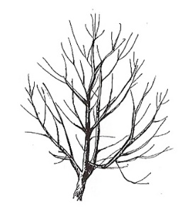
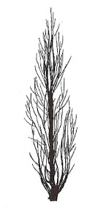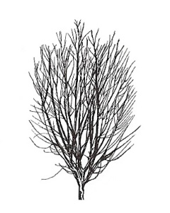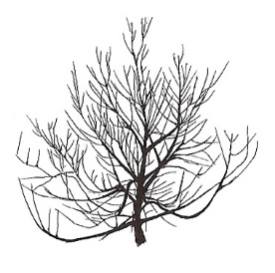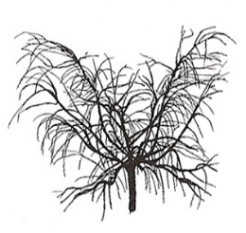
1 | 2 | 3 | 4 | 5
fastigiate | upright | upright to spreading | spreading | drooping

Ad. 7: Flowering shoot : intensity of anthocyanin coloration

The intensity of anthocyanin coloration should be observed on the shaded side of the shoot.

Ad. 8: Flowering shoot: density of flower buds

The density of flower buds is determined along the length of the current year’s shoot.

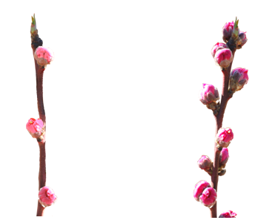
3 | 7
sparse | dense

Ad. 9: Flower: type

‘Campanulate’ (bell-shaped) is also referred to as ‘non showy’ : these types have small petals and stamens often higher than the petals.

‘Rosette’ (rose-shaped) is also referred to as ‘showy’ : these types have large petals.

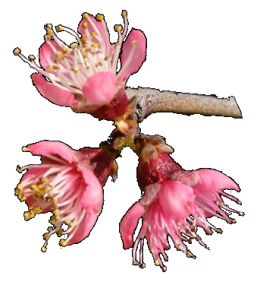 | 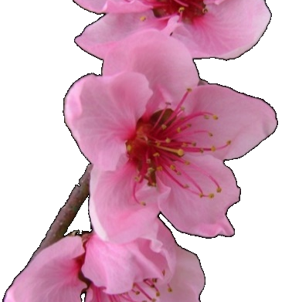
1 | 2
campanulate  (non showy) | rosette  (showy)

Ad. 10: Corolla: main color (inner side)

The main color is the color with the largest surface area.

Ad. 11: Petal: shape

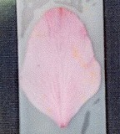 | 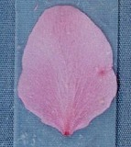
1 | 2
narrow ovate | medium ovate

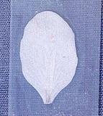 | 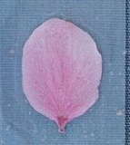 | 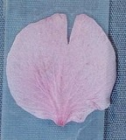
3 | 4 | 5
narrow elliptic | medium elliptic | circular

Ad. 12: Only varieties with flower type: campanulate: Petal: width
Ad. 13: Only varieties with flower type: rosette: Petal: width

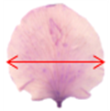

Ad. 14: Flower: number of petals

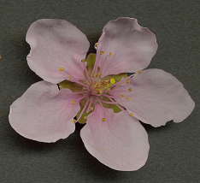 | 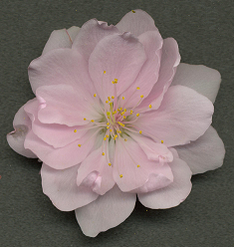 | 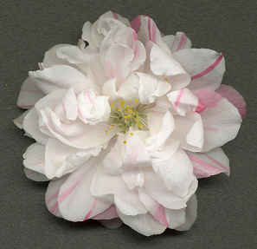
1 | 2
five | more than five

Varieties with note 1 may have occasional flowers with more than 5 petals and varieties with note 2 may have occasional flowers with five petals.

Ad. 15: Stamen: position compared to petals

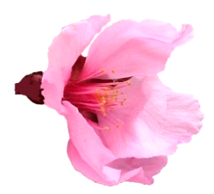 | 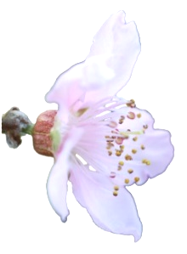 | 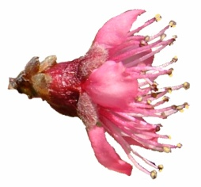
1 | 2 | 3
below | same level | above

Ad. 16: Stigma: position compared to anthers

To be observed on 5 flowers per tree.

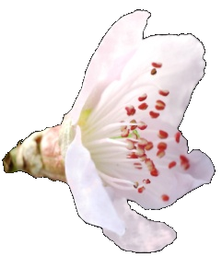 | 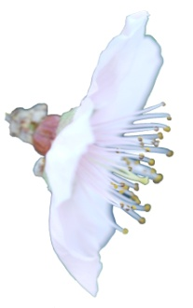 | 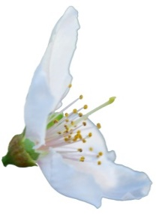
1 | 2 | 3
below | same level | above

Ad. 19: Stipule: length

The length of stipule should be observed on a fully expanded leaf on a young shoot. The characteristic should be observed on 5 stipules per tree.

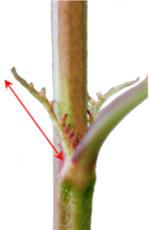 | 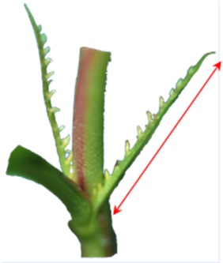
5 | 7
medium | long

Ad. 20: Leaf blade: length Ad. 21: Leaf blade: width

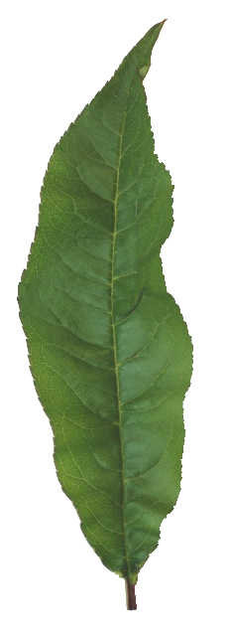 | 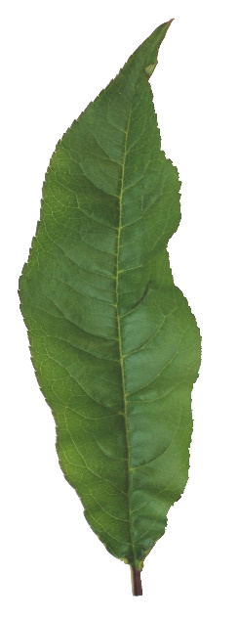

Ad. 22: Leaf blade: ratio length/width

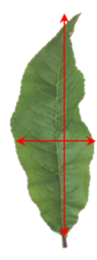 | 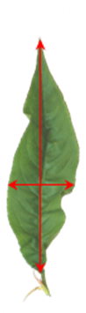 | 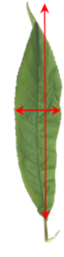
3 | 5 | 7
low | medium | high

Ad. 23: Leaf blade: shape in cross section

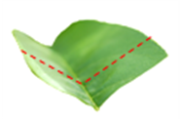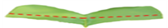
concave flat

Ad. 24: Leaf blade: margin

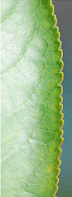 | 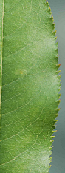 | 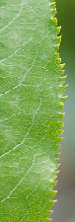
1 | 2 | 3
crenate | shallow serrate | deep serrate

Ad. 25: Leaf blade: angle at base Ad. 26: Leaf blade: angle at apex

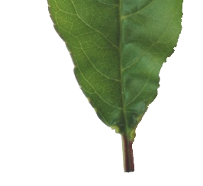 | 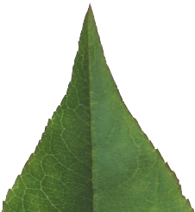

Ad. 28: Leaf blade: red mid-vein on the lower side

To be observed during the period of new leaf growth.

Ad. 29: Petiole: length

To be evaluated on 5 leaves per tree.

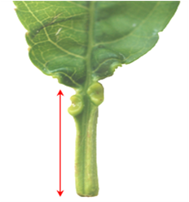

Ad. 30: Petiole: nectaries

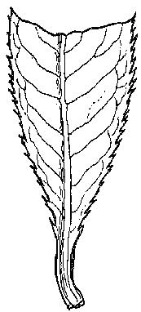 | 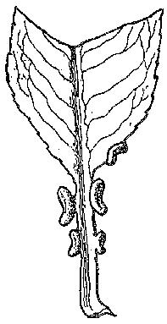 | 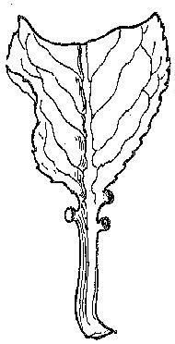
1 | 9
absent | present

Ad. 31: Petiole: shape of nectaries

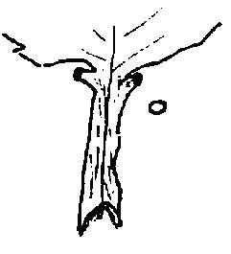 | 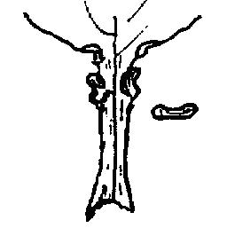
1 | 2
round | reniform

Ad. 33: Fruit: shape (in ventral view)

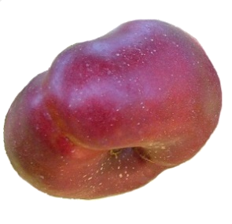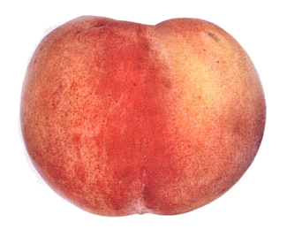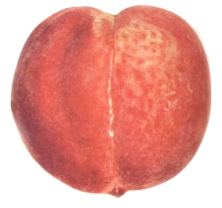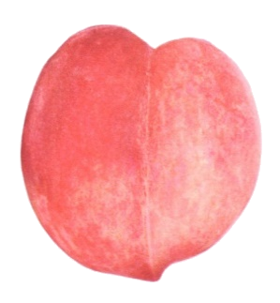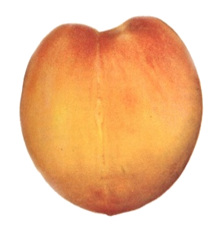
1 | 2 | 3 | 4 | 5
broad oblate | medium oblate | circular | broad elliptic | medium elliptic

Ad. 34: Fruit: mucron tip at pistil end

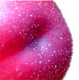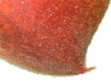

1 | 9
absent | present

Ad. 35: Fruit: shape of pistil end (excluding mucron tip)

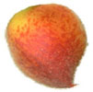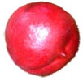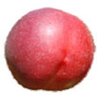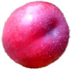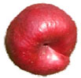

1 | 2 | 3 | 4 | 5
prominently pointed | weakly pointed | flat | weakly depressed | strongly depressed

Ad. 36: Fruit: symmetry (viewed from pistil end)

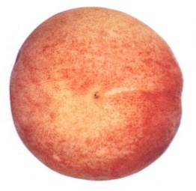 | 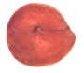
1 | 3
symmetric | strongly asymmetric

Ad. 40: Fruit: ground color of skin

The ground color is the first color to appear chronologically during the development of the skin and upon which the over color will develop in time. It is not always necessarily the largest area of the skin.

Ad. 41: Fruit: relative area of over color of skin

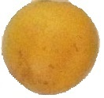 | 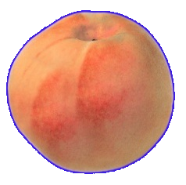 | 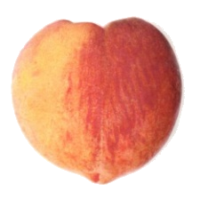 | 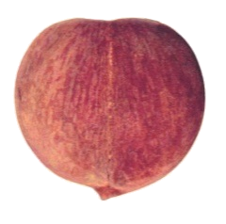
1 | 3 | 5 | 7
absent or very small | small | medium | large

Ad. 43: Fruit: pattern of over color of skin

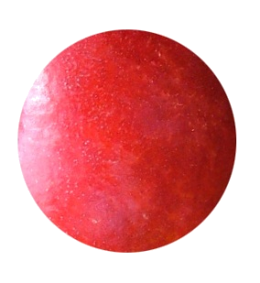 | 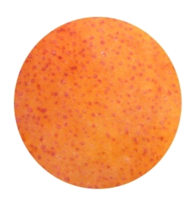 | 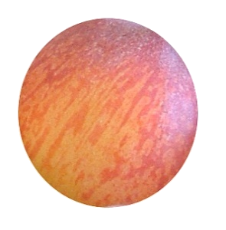 | 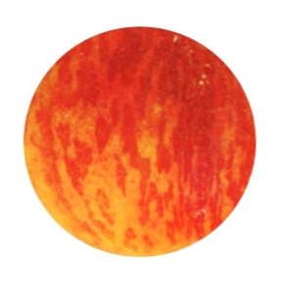
1 | 2 | 3 | 4
solid flush | mottled | striped | marbled

Ad. 47: Only varieties with fruit pubescence: absent: Fruit: conspicuousness of lenticels

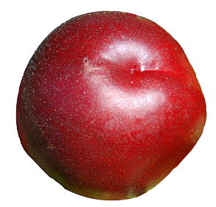 | 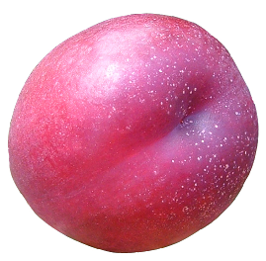 | 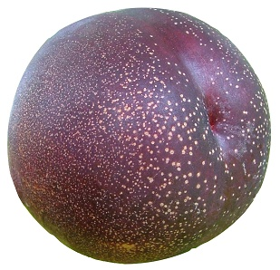
1 | 2 | 3
weak | medium | strong

The conspicuousness of lenticels is determined by the size and the color contrast.

Ad. 53: Fruit: intensity of anthocyanin coloration of flesh next to skin

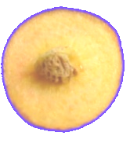 | 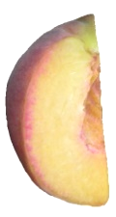 | 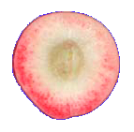
1 | 2 | 3
weak | medium | strong

Ad. 55: Fruit: intensity of anthocyanin coloration of flesh in central part of flesh

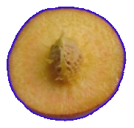 | 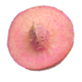 | 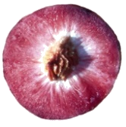
1 | 2 | 3
weak | medium | strong

Ad. 57: Fruit: intensity of anthocyanin coloration of flesh around stone

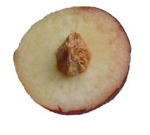 | 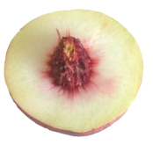 | 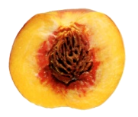
1 | 2 | 3
weak | medium | strong

Ad. 58: Fruit: flesh fiber

The flesh fiber is evaluated by biting into the flesh to determine the amount of fiber.

Ad. 59: Fruit: sweetness

The sweetness of the fruit should be observed in degrees Brix.

Ad. 60: Fruit: acidity

The acidity of the fruit should be observed as the titrable acidity in meq 100/ml.

Ad. 61: Stone: size in relation to fruit

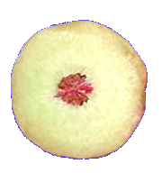 | 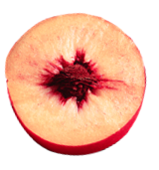 | 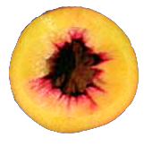
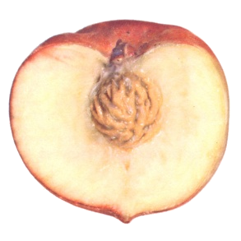 | 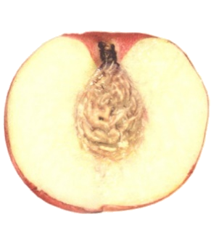 | 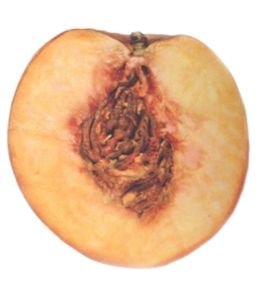
3 | 5 | 7
small | medium | large

Ad. 62: Stone: shape (in lateral view)
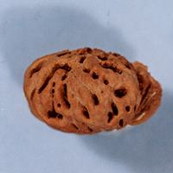 | 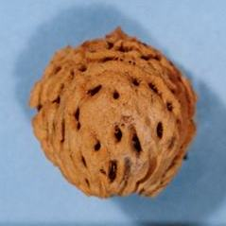 | 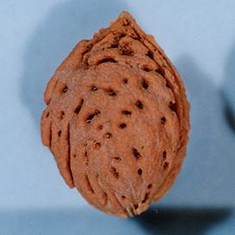 | 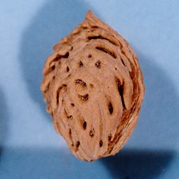
1 | 2 | 3 | 4
oblate | circular | elliptic | obovate

Ad. 64: Stone: intensity of brown color

To be observed on fresh stones.

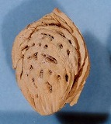 | 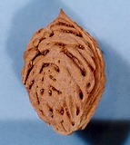 | 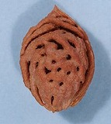
3 | 5 | 7
light | medium | dark

Ad. 65: Stone: relief of surface

 |  | 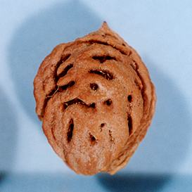 | 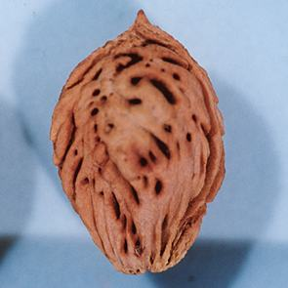
pits |  | grooves | pits and grooves

Ad. 68: Time of beginning of leaf bud burst

The time of the beginning of leaf bud burst should be observed as the appearance of first leaves on all trees.

Ad. 69: Time of beginning of flowering

The time of beginning of flowering is when all trees have 10% open flowers.

Ad. 70: Time of maturity

The time of maturity is when the overall appearance, firmness and taste indicate that the fruit is ready for consumption.

9. Literature
Bellini E., Scaramuzzi, F., 1975: Pesco. Enciclopedia agraria italiana VIII, Roma, IT.

Bellini, E., 1981: Il pesco. Cultivar. R.E.D.A., Roma, IT, pp. 9-90.

Bellini, E., Scaramuzzi, F. 1976: Monografia delle principali cultivar di pesco. Vol. II., C.N.R., Firenze, IT, 564 pp.

Blaha, J., 1966: Broskovone, merunky, mandlone (peach, apricot, almond). Ceskoslovenska Akademie VED, Praha, Czechoslovakia, 438 pp.

Brozik, S., Termesztett gyumolcsfajtaink 2. Csonthejastermesuek. Oszibarack (Fruit varieties 2., stone fruits peach)," Mezogazdasagi Kiado, Budapest, HU, 64 pp.

Caillavet, H., 1975: Variétés de pêchers. Maison de l'agriculture, Perpignan, 213 pp.

Caillavet, H., Souty, J., 1950: Monographie des principales variétés de pêcher. Société Bordelaise d'Imprimerie, Bordeaux, FR, 416 pp.

Chaparro J.X., Werner D.J., Whetten R.W. and D.M. O'Malley, 1995 : Inheritance, genetic interaction and biochemical characterization of anthocyanin phenotypes in peach. J. Hered., 86: 32-38.

Childers, N.F., 1975: The peach, varieties, culture etc. 1 Tome.

CTIFL, 2002: Les variétés de pêches et de nectarines. Ed. CTIFL, Paris, FR, 223 p.

CTIFL, 1994: Pêche, les variétés et leur conduite. Ed. CTIFL, Paris, FR, 306 p.

Fideghelli, C., Bassi, D., Bellini, E., Monastra, F., 1980: Schede per il registro varietale dei fruttiferi 2 – pesco. M.A.F.-S.O.I., Roma, IT, 104 pp.

Fideghelli, C., Monastra, F., Faedi, W., Rosati, P., 1977: Monografia di cultivar di nettarine. Ministero Agricoltura e Foreste, Roma, IT, 88 pp.

Hu D. and R. Scorza, 2009: Analysis of the ‘A72’ peach tree Growth Habit and its inheritance in progeny obtained from crosses of ‘A72’ with columnar peach trees. J. Amer. Sc. Hort. Sci. 134(2):236-243.

Hugard, J., Saunier, R., 1965: Monographie des principales variétés de pêcher. Période d'études 1950-1962, Institut national de la recherche agronomique (INRA), Paris, FR, 276 pp.

IRTA, 2002: Melocotonero, las variedades de más interés. Ed. IRTA, Barcelona, ESP, 287 p.

Ivascu, Antonia, 2003: Peach varieties catalog (catalogul soiurilor de pierfic), ed. Medro Ro, 110 p.

Layne D.R. and D. Bassi, 2008: The peach : Botany, production and uses. Ed. By Desmond R. Layne and Daniele Bassi. ISBN 978 1 84593 386 9. CABI, 30 nov. 2008 - 615 pages.

Leroy, A., 1867: Dictionnaire de pomologie. 2 Tomes
Loreti, F., Fiorino, P., 1972: Monografia delle principali cultivar di nettarine. C.N.R., Pisa, IT, 340 pp.

Monet, R., 1983: Le pêcher. Génétique et physiologie. Ed. Masson, Paris, France

Monet R., Bastard Y. en Gibault B., 1988: Etude génétique du caractère « port pleureur » chez le pêcher. Agronomie, 8(2): 127-132.

Monet R. Guye A. and N. Dachary, 1996: Peach Mendelian genetics: a short review and new results. Agronomie, 16: 321-329.

Morettini, A., Baldini, E., Scaramuzzi, F., Bargioni, G., Pisani, P.L., 1972: Monografia delle principali cultivar di pesco. C.N.R., Firenze, IT, 636 pp.

Morettini, A., et al., 1967: Monografia delle principali cultivar di pesco. Consiglio nazionale delle Ricerche. Centro miglioramento piante da frutto e da orto, Firenze, IT, 633 pp.

Okayama-ken, 1978: The report on the characterization and classification of peach varieties. Okayama-ken (By consignment of the MAFF), JP, 267 pp.

Sajer O., Scorza R., Dardick C., Zhenbentyayeva T., 2012: Development of sequence-tagged site markers linked to the pillar growth type in peach (Prunus persica). Abbott A.G. and R. Horn, Plant Breeding, doi:10.1111/j.1439-0523.2011.01912.x

Sansavini, S., Bargioni, G., Basso, M., Fideghelli, C. et al., 1974: Pesche da industria. Ministero Agricoltura e Foreste, Bologna, IT, 136 pp.

Saunier, R., 1979: Variétés de pêchers, nectarines et poires. 1 Tome, Publication CTIFL, rue Bergère, Paris, FR

Scorza R., Lightner G.W. and A. Liverani, 1989: The pillar peach tree and growth habit analysis of compact x pillar progeny. J. Am. Soc. Hortic. Sci., 114: 991-995.

Seronie-Vivien, A., 1984: Etude morphologique et physiologique de différents types écologiques de pêchers et une de leur utilisation comme porte-greffe. DEA-INRA-Bordeaux, FR

Takashi Haji, Hideaki Yaegaki, Masami Yamaguchi, 2001: Department of Breeding, National Institute of Fruit Science: Changes in Ethylene Production and Flesh Firmness of Melting, Nonmelting and Stony hard in Peaches after Harvest: J. Japan. Soc. Hort. Sci 70(4): 458-459.

Takashi Haji, Hideaki Yaegaki, Masami Yamaguchi, 2005: Department of Breeding, National Institute of Fruit Science: Inheritance and expression of fruit texture melting, non-melting and stony hard in peach. Scientia Horticulture 105. 241-248.

Timon, B., 1976: Oszibarack (peach). Mezogazdasagi Kiado, Budapest, HU, 424 pp.

Werner R.W. Creller M.A. and J.X. Chaparro, 2005: Inheritance of the blood-flesh trait in peach. Hortscience, 33(7): 1243-1246.

Werner R.W. and Chaparro J.X., 2005: Genetic interactions between pillar and weeping peach genotypes. Hortscience 40(1): 18-20.

10. Technical Questionnaire
TECHNICAL QUESTIONNAIRE |  |  |  | Page {x} of {y} |  | Reference Number:
 |  |  |  |  |  | Application date:
 |  |  |  |  |  | (not to be filled in by the applicant)
TECHNICAL QUESTIONNAIRE
to be completed in connection with an application for plant breeders’ rights

1. Subject of the Technical Questionnaire
1.1.1 Botanical name |  |  | Prunus persica (L.) Batsch var. persica
1.1.2 Common name |  |  | Peach |  |  |  |  | […]
1.2.1 Botanical name |  |  | Prunus persica (L.) Batsch var. nucipersica (Suckow) C. K. Schneid.
1.2.2 Common name |  |  | Nectarine |  |  |  |  | […]
2. Applicant
Name
Address
Telephone No.
Fax No.
E-mail address
Breeder (if different from applicant)
3. Proposed denomination and breeder’s reference
Proposed denomination
(if available)
Breeder’s reference
#4. Information on the breeding scheme and propagation of the variety

4.1 Breeding scheme

Variety resulting from:

4.1.1 Crossing

(a) controlled cross [ ]
(please state parent varieties)
(b) partially known cross [ ]
(please state known parent variety(ies))
(c) unknown cross [ ]

4.1.2 Mutation [ ]
(please state parent variety)

4.1.3 Discovery and development [ ]
(please state where and when discovered
and how developed)

4.1.4 Other [ ]
(please provide details)

4.2 Method of propagating the variety

4.2.1 Vegetative propagation

(a) budding or grafting [ ]

(b) in vitro propagation [ ]

(c) other (state method) [ ]

4.2.2 Other [ ]
(please provide details)

5. Characteristics of the variety to be indicated (the number in brackets refers to the corresponding characteristic in Test Guidelines; please mark the note which best corresponds).

 | Characteristics |  |  |  |  | Example Varieties |  |  | Note
5.1  (1) | Tree: size
 | very small |  |  |  |  | Bonanza, Bonfire, Pix Zee, Zaino |  |  | 1[ ]
 | very small to small |  |  |  |  |  |  |  | 2[ ]
 | small |  |  |  |  | Richaven |  |  | 3[ ]
 | small to medium |  |  |  |  |  |  |  | 4[ ]
 | medium |  |  |  |  | Robin |  |  | 5[ ]
 | medium to large |  |  |  |  |  |  |  | 6[ ]
 | large |  |  |  |  | Redhaven |  |  | 7[ ]
 | large to very large |  |  |  |  |  |  |  | 8[ ]
 | very large |  |  |  |  | Champion |  |  | 9[ ]
5.2  (2) | Tree: vigor
 | very weak |  |  |  |  |  |  |  | 1[ ]
 | very weak to weak |  |  |  |  |  |  |  | 2[ ]
 | weak |  |  |  |  | J. H. Hale |  |  | 3[ ]
 | weak to medium |  |  |  |  |  |  |  | 4[ ]
 | medium |  |  |  |  | Robin |  |  | 5[ ]
 | medium to strong |  |  |  |  |  |  |  | 6[ ]
 | strong |  |  |  |  | Springtime |  |  | 7[ ]
 | strong to very strong |  |  |  |  |  |  |  | 8[ ]
 | very strong |  |  |  |  |  |  |  | 9[ ]
 | Characteristics |  |  |  |  | Example Varieties |  |  | Note
5.3  (3) | Tree: habit
 | fastigiate |  |  |  |  | Nectarose, Pillar |  |  | 1[ ]
 | upright |  |  |  |  | Fairhaven, Redwing |  |  | 2[ ]
 | upright to spreading |  |  |  |  | Albertina, Elegant Lady, Mercil |  |  | 3[ ]
 | spreading |  |  |  |  | Charles Roux |  |  | 4[ ]
 | drooping |  |  |  |  | Biancopendulo |  |  | 5[ ]
5.4  (9) | Flower: type
 | campanulate |  |  |  |  | Dida, Springtime |  |  | 1[ ]
 | rosette |  |  |  |  | Robin, Vesuvio |  |  | 2[ ]
5.5  (12) | Only varieties with flower type: campanulate: Petal: width
 | very narrow |  |  |  |  |  |  |  | 1[ ]
 | narrow |  |  |  |  | Meydicte |  |  | 2[ ]
 | medium |  |  |  |  | Bradgust |  |  | 3[ ]
 | broad |  |  |  |  | Monnail |  |  | 4[ ]
 | very broad |  |  |  |  |  |  |  | 5[ ]
5.6  (13) | Only varieties with flower type: rosette: Petal: width
 | very narrow |  |  |  |  | Triumph |  |  | 1[ ]
 | narrow |  |  |  |  | Shasta |  |  | 2[ ]
 | medium |  |  |  |  | Robin |  |  | 3[ ]
 | broad |  |  |  |  | Michelini |  |  | 4[ ]
 | very broad |  |  |  |  | Veteran |  |  | 5[ ]
5.7  (17) | Anthers: pollen
 | absent |  |  |  |  | J. H. Hale |  |  | 1[ ]
 | present |  |  |  |  | Redhaven |  |  | 9[ ]
 | Characteristics |  |  |  |  | Example Varieties |  |  | Note
5.8  (20) | Leaf blade: length
 | very short |  |  |  |  |  |  |  | 1[ ]
 | very short to short |  |  |  |  |  |  |  | 2[ ]
 | short |  |  |  |  | Jeronimo |  |  | 3[ ]
 | short to medium |  |  |  |  |  |  |  | 4[ ]
 | medium |  |  |  |  | Fairhaven |  |  | 5[ ]
 | medium to long |  |  |  |  |  |  |  | 6[ ]
 | long |  |  |  |  | Southland |  |  | 7[ ]
 | long to very long |  |  |  |  |  |  |  | 8[ ]
 | very long |  |  |  |  |  |  |  | 9[ ]
5.9  (28) | Leaf blade: red mid-vein on the lower side
 | absent |  |  |  |  | Redhaven |  |  | 1[ ]
 | present |  |  |  |  | Sanguine Chanas |  |  | 9[ ]
5.10  (30) | Petiole: nectaries
 | absent |  |  |  |  | Crimson Glo, Tejon |  |  | 1[ ]
 | present |  |  |  |  | Redhaven |  |  | 9[ ]
5.11  (31) | Petiole: shape of nectaries
 | round |  |  |  |  | Springtime |  |  | 1[ ]
 | reniform |  |  |  |  | Redhaven |  |  | 2[ ]
 | Characteristics |  |  |  |  | Example Varieties |  |  | Note
5.12  (32) | Fruit: size
 | very small |  |  |  |  | Nectarine-Cerise |  |  | 1[ ]
 | very small to small |  |  |  |  |  |  |  | 2[ ]
 | small |  |  |  |  | Minastar, Springtime |  |  | 3[ ]
 | small to medium |  |  |  |  |  |  |  | 4[ ]
 | medium |  |  |  |  | Momée, Springlady, Sunhaven |  |  | 5[ ]
 | medium to large |  |  |  |  |  |  |  | 6[ ]
 | large |  |  |  |  | Loring, Zaifer, Zaitabo |  |  | 7[ ]
 | large to very large |  |  |  |  |  |  |  | 8[ ]
 | very large |  |  |  |  | Comanche, Maillarbig |  |  | 9[ ]
5.13  (33) | Fruit: shape (in ventral view)
 | broad oblate |  |  |  |  | Alex, Bailou, UFO3 |  |  | 1[ ]
 | medium oblate |  |  |  |  | Herastrau, Robin |  |  | 2[ ]
 | circular |  |  |  |  | Redwing |  |  | 3[ ]
 | broad elliptic |  |  |  |  | Cavalier |  |  | 4[ ]
 | medium elliptic |  |  |  |  | Elberta |  |  | 5[ ]
 | Characteristics |  |  |  |  | Example Varieties |  |  | Note
5.14  (40) | Fruit: ground color of skin
 | not visible |  |  |  |  | Fiesta Red |  |  | 1[ ]
 | green |  |  |  |  | Ruberrina |  |  | 2[ ]
 | cream green |  |  |  |  | Carman |  |  | 3[ ]
 | greenish white |  |  |  |  | Morton |  |  | 4[ ]
 | cream white |  |  |  |  | Antonia, Michelini |  |  | 5[ ]
 | cream |  |  |  |  | Amsden |  |  | 6[ ]
 | pink white |  |  |  |  | Précoce de Hale |  |  | 7[ ]
 | greenish yellow |  |  |  |  | Veteran |  |  | 8[ ]
 | cream yellow |  |  |  |  | Fuzalode |  |  | 9[ ]
 | yellow |  |  |  |  | Sudanell |  |  | 10[ ]
 | orange yellow |  |  |  |  | Redtop, Victoria |  |  | 11[ ]
5.15  (44) | Fruit: pubescence of skin
 | absent |  |  |  |  | Daisy, Fantasia, Monco, Zaitabo |  |  | 1[ ]
 | present |  |  |  |  | Merspri, Moncav, Rich May |  |  | 9[ ]
5.16  (49) | Fruit: adherence of skin to flesh
 | very weak |  |  |  |  | Mme Girerd |  |  | 1[ ]
 | very weak to weak |  |  |  |  |  |  |  | 2[ ]
 | weak |  |  |  |  | Redhaven |  |  | 3[ ]
 | weak to medium |  |  |  |  |  |  |  | 4[ ]
 | medium |  |  |  |  | Early Sungrand |  |  | 5[ ]
 | medium to strong |  |  |  |  |  |  |  | 6[ ]
 | strong |  |  |  |  | Babygold 5 |  |  | 7[ ]
 | strong to very strong |  |  |  |  |  |  |  | 8[ ]
 | very strong |  |  |  |  | Vivian |  |  | 9[ ]
 | Characteristics |  |  |  |  | Example Varieties |  |  | Note
5.17  (50) | Fruit: firmness of flesh
 | very soft |  |  |  |  | Amsden, Morettini n°1, Springtime |  |  | 1[ ]
 | very soft to soft |  |  |  |  |  |  |  | 2[ ]
 | soft |  |  |  |  | Fairhaven |  |  | 3[ ]
 | soft to medium |  |  |  |  |  |  |  | 4[ ]
 | medium |  |  |  |  | Flavorcrest, Redtop |  |  | 5[ ]
 | medium to firm |  |  |  |  |  |  |  | 6[ ]
 | firm |  |  |  |  | Honey Blaze, Zaitabo |  |  | 7[ ]
 | firm to very firm |  |  |  |  |  |  |  | 8[ ]
 | very firm |  |  |  |  | Babygold 6, Ghiaccio 2 |  |  | 9[ ]
5.18  (51) | Fruit: carotenoid coloration of flesh
 | greenish white |  |  |  |  | Charles Roux |  |  | 1[ ]
 | white |  |  |  |  | Caldesi 2000, Springtime |  |  | 2[ ]
 | cream white |  |  |  |  | Michelini |  |  | 3[ ]
 | light yellow |  |  |  |  | Armking, Spring Gold |  |  | 4[ ]
 | yellow |  |  |  |  | Early Sungrand |  |  | 5[ ]
 | orange yellow |  |  |  |  | Lovell, Merrill Franciscan |  |  | 6[ ]
 | orange |  |  |  |  | Sungold |  |  | 7[ ]
5.19  (58) | Fruit: flesh fiber
 | absent or weak |  |  |  |  | Redhaven |  |  | 1[ ]
 | medium |  |  |  |  |  |  |  | 2[ ]
 | strong |  |  |  |  | Sunhigh |  |  | 3[ ]
 | Characteristics |  |  |  |  | Example Varieties |  |  | Note
5.20  (60) | Fruit: acidity
 | very low |  |  |  |  | Monam, Moncav, Monna, Redwing, Zaibomi, Zaidaso |  |  | 1[ ]
 | low |  |  |  |  | Maillarboom, Monnude, Zaifave, Zaifuro, Zairesu, Zaitabo |  |  | 2[ ]
 | medium |  |  |  |  | Mercil, Monprime, Ryans Sun |  |  | 3[ ]
 | high |  |  |  |  | Craucail, Kraprim, Nectaross, Orion, Rich May, Zailice, Zainara |  |  | 4[ ]
 | very high |  |  |  |  | Armking, Bracid, Maycrest, Red Robin, Savana Red, Star Bright, Zaibri, Zaitop |  |  | 5[ ]
5.21  (61) | Stone: size in relation to fruit
 | very small |  |  |  |  |  |  |  | 1[ ]
 | very small to small |  |  |  |  |  |  |  | 2[ ]
 | small |  |  |  |  | Alex, Robin |  |  | 3[ ]
 | small to medium |  |  |  |  |  |  |  | 4[ ]
 | medium |  |  |  |  | Redhaven |  |  | 5[ ]
 | medium to large |  |  |  |  |  |  |  | 6[ ]
 | large |  |  |  |  | Somervee |  |  | 7[ ]
 | large to very large |  |  |  |  |  |  |  | 8[ ]
 | very large |  |  |  |  |  |  |  | 9[ ]
5.22  (66) | Stone: adherence to flesh
 | absent |  |  |  |  | Fairhaven, Fuzalode |  |  | 1[ ]
 | present |  |  |  |  | Sweet Gold, Vivian |  |  | 9[ ]
 | Characteristics |  |  |  |  | Example Varieties |  |  | Note
5.23  (68) | Time of beginning of leaf bud burst
 | very early |  |  |  |  | Sunred |  |  | 1[ ]
 | very early to early |  |  |  |  |  |  |  | 2[ ]
 | early |  |  |  |  | Springtime |  |  | 3[ ]
 | early to medium |  |  |  |  |  |  |  | 4[ ]
 | medium |  |  |  |  | Redhaven |  |  | 5[ ]
 | medium to late |  |  |  |  |  |  |  | 6[ ]
 | late |  |  |  |  | Genadix 7 |  |  | 7[ ]
 | late to very late |  |  |  |  |  |  |  | 8[ ]
 | very late |  |  |  |  | Reine des Vergers |  |  | 9[ ]
5.24  (69) | Time of beginning of flowering
 | very early |  |  |  |  | Zaibop, Zaitolio |  |  | 1[ ]
 | very early to early |  |  |  |  |  |  |  | 2[ ]
 | early |  |  |  |  | Rich Lady, Springtime |  |  | 3[ ]
 | early to medium |  |  |  |  |  |  |  | 4[ ]
 | medium |  |  |  |  | Monnude, Zaitabo |  |  | 5[ ]
 | medium to late |  |  |  |  |  |  |  | 6[ ]
 | late |  |  |  |  | Maillarflat, Maillarlau |  |  | 7[ ]
 | late to very late |  |  |  |  |  |  |  | 8[ ]
 | very late |  |  |  |  | Summerqueen |  |  | 9[ ]
 | Characteristics |  |  |  |  | Example Varieties |  |  | Note
5.25  (70) | Time of maturity
 | very early |  |  |  |  | Rich May, Springtime, Zaibaro |  |  | 1[ ]
 | very early to early |  |  |  |  | Zainoar, Zaitani |  |  | 2[ ]
 | early |  |  |  |  | Antonia, Redwing, Rich Lady, Robin |  |  | 3[ ]
 | early to medium |  |  |  |  | Craucail, Diamond Princess |  |  | 4[ ]
 | medium |  |  |  |  | Fairhaven, Fantasia, Summer Bright, Zee Lady |  |  | 5[ ]
 | medium to late |  |  |  |  | Maillarbig, Savana red, Zaimor |  |  | 6[ ]
 | late |  |  |  |  | Fairlane, Flacara, Veteran,  Western Red, Zailati, Zairova |  |  | 7[ ]
 | late to very late |  |  |  |  | Andgold, Tardibelle |  |  | 8[ ]
 | very late |  |  |  |  | Rubidoux |  |  | 9[ ]
 | extremely late |  |  |  |  | Calante, Jesca |  |  | 10[ ]
6. Similar varieties and differences from these varieties

Please use the following table and box for comments to provide information on how your candidate variety differs from the variety (or varieties) which, to the best of your knowledge, is (or are) most similar. This information may help the examination authority to conduct its examination of distinctness in a more efficient way.

Denomination(s) of variety(ies) similar to your candidate variety |  | Characteristic(s) in which your candidate variety differs from the similar variety(ies) |  |  | Describe the expression of the characteristic(s) for the similar variety(ies) |  | Describe the expression of the characteristic(s) for your candidate variety
Example |  | Corolla: main color (inner side) |  |  | white |  | very light pink
Comments:

#7. Additional information which may help in the examination of the variety

7.1 In addition to the information provided in sections 5 and 6, are there any additional characteristics which may help to distinguish the variety?

Yes [ ] No [ ]

(If yes, please provide details)

7.2 Are there any special conditions for growing the variety or conducting the examination?

Yes [ ] No [ ]

(If yes, please provide details)
7.3 Other information

7.3.1 A representative color photograph of the variety should accompany the Technical Questionnaire.

7.3.2 Pollinator

Good pollinators are the following varieties

..........................................................................

7.3.3 Explanations for the characteristic “Fruit: flesh type”

Fruits with melting flesh correspond to fruits used for fresh consumption.
Fruits with non-melting flesh correspond to fruits used for canning. The flesh is harder and elastic (clingstones/pavies).

The table below illustrates the principle in greater detail
type | activity |  |  | explanation | candiate variety  (please indicate)
type | ethylene | polygalacturonase |  | explanation | candiate variety  (please indicate)
type | ethylene | endo-type | exo-type | explanation | candiate variety  (please indicate)
melting | present | present | present | Activity both ethylene and polygalacturonase exists in the flesh. Therefore flesh begins melting quickly after harvest. | [ ]
non-melting | present | present | absent | Activity of exo-type polygalacturonase is absent in the flesh. Therefore melting speed of flesh is very slow. | [ ]
stony hard | absent | absent | absent | Activity both ethylene and polygalacturonase are absent in the flesh. Therefore flesh does not begin to melt.  Ex. varieties: Odoroki, Yumyeong | [ ]

8. Authorization for release

(a) Does the variety require prior authorization for release under legislation concerning the protection of the environment, human and animal health?

Yes [ ] No [ ]

(b) Has such authorization been obtained?

Yes [ ] No [ ]

If the answer to (b) is yes, please attach a copy of the authorization.

9. Information on plant material to be examined or submitted for examination.

9.1 The expression of a characteristic or several characteristics of a variety may be affected by factors, such as pests and disease, chemical treatment (e.g. growth retardants or pesticides), effects of tissue culture, different rootstocks, scions taken from different growth phases of a tree, etc.

9.2 The plant material should not have undergone any treatment which would affect the expression of the characteristics of the variety, unless the competent authorities allow or request such treatment. If the plant material has undergone such treatment, full details of the treatment must be given. In this respect, please indicate below, to the best of your knowledge, if the plant material to be examined has been subjected to:

(a) Microorganisms (e.g. virus, bacteria, phytoplasma) Yes [ ] No [ ]

(b) Chemical treatment (e.g. growth retardant, pesticide) Yes [ ] No [ ]

(c) Tissue culture Yes [ ] No [ ]

(d) Other factors Yes [ ] No [ ]

Please provide details for where you have indicated “yes”.
……………………………………………………………
9.3 Virus status

The variety is
(i) virus free [ ]
(indicate viruses)
...................................................................
(ii) virus tested [ ]
(indicate against which virus)
...................................................................
(iii) The virus status is unknown [ ]

10. I hereby declare that, to the best of my knowledge, the information provided in this form is correct:

Applicant’s name

Signature Date

[End of document]

* These names were correct at the time of the introduction of these Test Guidelines but may be revised or updated. [Readers are advised to consult the UPOV Code, which can be found on the UPOV Website (www.upov.int), for the latest information.]
## Authorities may allow certain of this information to be provided in a confidential section of the Technical Questionnaire.
## Authorities may allow certain of this information to be provided in a confidential section of the Technical Questionnaire.

