 |  | E  TG/52/6  ORIGINAL: English  DATE: 2011-10-20
INTERNATIONAL UNION FOR THE PROTECTION OF NEW VARIETIES OF PLANTS
GENEVA

 | RED CURRANT, WHITE CURRANT  UPOV Code: RIBES_RUB  Ribes rubrum L. | *

GUIDELINES

FOR THE CONDUCT OF TESTS

FOR DISTINCTNESS, UNIFORMITY AND STABILITY

Alternative Names:*

Botanical name | English | French | German | Spanish
Ribes rubrum L.;  Ribes sylvestre (Lam.) Mert. et W.Koch;  Ribes vulgare Lam.;  Ribes sativum (Rchb.) Syme | Red Currant,  White currant | groseillier commun,  groseillier rouge | Rote Johannisbeere, Weiße Johannisbeere | grosellero común, grosellero rojo

The purpose of these guidelines (“Test Guidelines”) is to elaborate the principles contained in the General Introduction (document TG/1/3), and its associated TGP documents, into detailed practical guidance for the harmonized examination of distinctness, uniformity and stability (DUS) and, in particular, to identify appropriate characteristics for the examination of DUS and production of harmonized variety descriptions.

ASSOCIATED DOCUMENTS

These Test Guidelines should be read in conjunction with the General Introduction and its associated TGP documents.

TABLE OF CONTENTS PAGE

1. Subject of these Test Guidelines 3
2. Material Required 3
3. Method of Examination 3
3.1 Number of Growing Cycles 3
3.2 Testing Place 3
3.3 Conditions for Conducting the Examination 4
3.4 Test Design 4
3.5 Additional Tests 4
4. Assessment of Distinctness, Uniformity and Stability 4
4.1 Distinctness 4
4.2 Uniformity 5
4.3 Stability 6
5. Grouping of Varieties and Organization of the Growing Trial 6
6. Introduction to the Table of Characteristics 6
6.1 Categories of Characteristics 6
6.2 States of Expression and Corresponding Notes 7
6.3 Types of Expression 7
6.4 Example Varieties 7
6.5 Legend 8
7. Table of Characteristics/Tableau des caractères/Merkmalstabelle/Tabla de caracteres 9
8. Explanations on the Table of Characteristics 18
8.1 Explanations covering several characteristics 18
8.2 Explanations for individual characteristics 18
8.3 Synonyms of the example varieties 22
9. Literature 23
10. Technical Questionnaire 24

Subject of these Test Guidelines
These Test Guidelines apply to all varieties of Ribes rubrum L.

Material Required
2.1 The competent authorities decide on the quantity and quality of the plant material required for testing the variety and when and where it is to be delivered. Applicants submitting material from a State other than that in which the testing takes place must ensure that all customs formalities and phytosanitary requirements are complied with.

2.2 The material is to be supplied in the form of plants on their own roots.

2.3 The minimum quantity of plant material, to be supplied by the applicant, should be:

5 plants (on own roots).

2.4 The plant material supplied should be visibly healthy, not lacking in vigor, nor affected by any important pest or disease.

2.5 The plant material should not have undergone any treatment which would affect the expression of the characteristics of the variety, unless the competent authorities allow or request such treatment. If it has been treated, full details of the treatment must be given.

Method of Examination

3.1 Number of Growing Cycles
3.1.1 The minimum duration of tests should normally be two independent growing cycles. In particular, it is essential that the plants produce a satisfactory crop of fruit in each of the two growing cycles.

3.1.2 The growing cycle is considered to be the duration of a single growing season, beginning with bud burst (flowering and/or vegetative), flowering and fruit harvest and concluding when the following dormant period ends with the swelling of new season buds.

3.2 Testing Place
Tests are normally conducted at one place. In the case of tests conducted at more than one place, guidance is provided in TGP/9 “Examining Distinctness”.

3.3 Conditions for Conducting the Examination
3.3.1 The tests should be carried out under conditions ensuring satisfactory growth for the expression of the relevant characteristics of the variety and for the conduct of the examination.

3.3.2 In order to enable the assessment of growth habit characteristics, the plants should be grown as bushes.

3.4 Test Design
Each test should be designed to result in a total of at least 5 plants.

3.5 Additional Tests
Additional tests, for examining relevant characteristics, may be established.

Assessment of Distinctness, Uniformity and Stability

4.1 Distinctness

4.1.1 General Recommendations

It is of particular importance for users of these Test Guidelines to consult the General Introduction prior to making decisions regarding distinctness. However, the following points are provided for elaboration or emphasis in these Test Guidelines.

4.1.2 Consistent Differences

The differences observed between varieties may be so clear that more than one growing cycle is not necessary. In addition, in some circumstances, the influence of the environment is not such that more than a single growing cycle is required to provide assurance that the differences observed between varieties are sufficiently consistent. One means of ensuring that a difference in a characteristic, observed in a growing trial, is sufficiently consistent is to examine the characteristic in at least two independent growing cycles.

4.1.3 Clear Differences

Determining whether a difference between two varieties is clear depends on many factors, and should consider, in particular, the type of expression of the characteristic being examined, i.e. whether it is expressed in a qualitative, quantitative, or pseudo-qualitative manner. Therefore, it is important that users of these Test Guidelines are familiar with the recommendations contained in the General Introduction prior to making decisions regarding distinctness.

4.1.4 Number of Plants / Parts of Plants to be Examined
Unless otherwise indicated, for the purposes of distinctness, all observations on single plants should be made on 5 plants or parts taken from each of 5 plants and any other observations made on all plants in the test, disregarding any off-type plants.

4.1.5 Method of Observation
The recommended method of observing the characteristic for the purposes of distinctness is indicated by the following key in the second column of the Table of Characteristics (see document TGP/9 “Examining Distinctness”, Section 4 “Observation of characteristics”):

MG: single measurement of a group of plants or parts of plants
MS: measurement of a number of individual plants or parts of plants
VG: visual assessment by a single observation of a group of plants or parts of plants
VS: visual assessment by observation of individual plants or parts of plants

Type of observation: visual (V) or measurement (M)

“Visual” observation (V) is an observation made on the basis of the expert’s judgment. For the purposes of this document, “visual” observation refers to the sensory observations of the experts and, therefore, also includes smell, taste and touch. Visual observation includes observations where the expert uses reference points (e.g. diagrams, example varieties, side-by-side comparison) or non-linear charts (e.g. color charts). Measurement (M) is an objective observation against a calibrated, linear scale e.g. using a ruler, weighing scales, colorimeter, dates, counts, etc.

Type of record: for a group of plants (G) or for single, individual plants (S)

For the purposes of distinctness, observations may be recorded as a single record for a group of plants or parts of plants (G), or may be recorded as records for a number of single, individual plants or parts of plants (S). In most cases, “G” provides a single record per variety and it is not possible or necessary to apply statistical methods in a plant-by-plant analysis for the assessment of distinctness.

In cases where more than one method of observing the characteristic is indicated in the Table of Characteristics (e.g. VG/MG), guidance on selecting an appropriate method is provided in document TGP/9, Section 4.2.

4.2 Uniformity
4.2.1 It is of particular importance for users of these Test Guidelines to consult the General Introduction prior to making decisions regarding uniformity. However, the following points are provided for elaboration or emphasis in these Test Guidelines:

4.2.2 For the assessment of uniformity, a population standard of 1% and an acceptance probability of at least 95% should be applied. In the case of a sample size of 5 plants, no off-types are allowed.

4.3 Stability
4.3.1 In practice, it is not usual to perform tests of stability that produce results as certain as those of the testing of distinctness and uniformity. However, experience has demonstrated that, for many types of variety, when a variety has been shown to be uniform, it can also be considered to be stable.

4.3.2 Where appropriate, or in cases of doubt, stability may be further examined by testing a new plant stock to ensure that it exhibits the same characteristics as those shown by the initial material supplied.

Grouping of Varieties and Organization of the Growing Trial
5.1 The selection of varieties of common knowledge to be grown in the trial with the candidate varieties and the way in which these varieties are divided into groups to facilitate the assessment of distinctness are aided by the use of grouping characteristics.

5.2 Grouping characteristics are those in which the documented states of expression, even where produced at different locations, can be used, either individually or in combination with other such characteristics: (a) to select varieties of common knowledge that can be excluded from the growing trial used for examination of distinctness; and (b) to organize the growing trial so that similar varieties are grouped together.

5.3 The following have been agreed as useful grouping characteristics:

(a) Fruit truss: length excluding stalk (characteristic 22)
(b) Berry: size (characteristic 25)
(c) Berry: color (characteristic 27)
(d) Time of beginning of fruit ripening (characteristic 30)

5.4 Guidance for the use of grouping characteristics, in the process of examining distinctness, is provided through the General Introduction and document TGP/9 “Examining Distinctness”.

Introduction to the Table of Characteristics

6.1 Categories of Characteristics
6.1.1 Standard Test Guidelines Characteristics

Standard Test Guidelines characteristics are those which are approved by UPOV for examination of DUS and from which members of the Union can select those suitable for their particular circumstances.

6.1.2 Asterisked Characteristics

Asterisked characteristics (denoted by *) are those included in the Test Guidelines which are important for the international harmonization of variety descriptions and should always be examined for DUS and included in the variety description by all members of the Union, except when the state of expression of a preceding characteristic or regional environmental conditions render this inappropriate.

6.2 States of Expression and Corresponding Notes
6.2.1 States of expression are given for each characteristic to define the characteristic and to harmonize descriptions. Each state of expression is allocated a corresponding numerical note for ease of recording of data and for the production and exchange of the description.

6.2.2 In the case of qualitative and pseudo-qualitative characteristics (see Chapter 6.3), all relevant states of expression are presented in the characteristic. However, in the case of quantitative characteristics with 5 or more states, an abbreviated scale may be used to minimize the size of the Table of Characteristics. For example, in the case of a quantitative characteristic with 9 states, the presentation of states of expression in the Test Guidelines may be abbreviated as follows:

State | Note
small | 3
medium | 5
large | 7

However, it should be noted that all of the following 9 states of expression exist to describe varieties and should be used as appropriate:

State | Note
very small | 1
very small to small | 2
small | 3
small to medium | 4
medium | 5
medium to large | 6
large | 7
large to very large | 8
very large | 9

6.2.3 Further explanation of the presentation of states of expression and notes is provided in document TGP/7 “Development of Test Guidelines”.

6.3 Types of Expression
An explanation of the types of expression of characteristics (qualitative, quantitative and pseudo-qualitative) is provided in the General Introduction.

6.4 Example Varieties
Where appropriate, example varieties are provided to clarify the states of expression of each characteristic.

6.5 Legend
(*) Asterisked characteristic – see Chapter 6.1.2

QL: Qualitative characteristic – see Chapter 6.3
QN: Quantitative characteristic – see Chapter 6.3
PQ: Pseudo-qualitative characteristic – see Chapter 6.3

MG, MS, VG, VS – see Chapter 4.1.5

(a)-(e) See Explanations on the Table of Characteristics in Chapter 8.1
(+) See Explanations on the Table of Characteristics in Chapter 8.2

Table of Characteristics/Tableau des caractères/Merkmalstabelle/Tabla de caracteres
 |  | English | français | deutsch | español | Example Varieties/  Exemples/  Beispielssorten/  Variedades ejemplo | Note/  Nota
1  (*)  (+) | VG | Plant: vigor | Plante : vigueur | Pflanze: Wuchsstärke | Planta: vigor
QN | (a) | weak | faible | gering | débil | Pink Dutch | 3
 |  | medium | moyenne | mittel | medio | Maarse’s Prominent, Mulka, Rovada | 5
 |  | strong | forte | stark | fuerte | Jonkheer van Tets, Rote Vierländer,  Ruby Castle | 7
2  (*) | VG | Plant: density of shoots | Plante : densité des rameaux | Pflanze: Dichte der Triebe | Planta: densidad de las ramas
QN | (a) | sparse | faible | locker | laxa | Heros, Krenever, Losan | 3
 |  | medium | moyenne | mittel | media | Rondom,  Rote Vierländer, Rovada | 5
 |  | dense | élevée | dicht | densa | Mulka,  Red Dutch,  Rote Versailles, Tatran | 7
3  (*)  (+) | VG | Plant: habit | Plante : port | Pflanze: Wuchsform | Planta: porte
QN | (a) | upright | dressé | aufrecht | erguido | Bad Gasteiner,  Bar le Duc | 1
 |  | semi-upright | demi-dressé | halbaufrecht | semierecto | Rondom | 2
 |  | spreading | étalé | breitwüchsig | rastrero | Heros,  Jonkheer van Tets, Losan | 3
4  (*) | VG | Plant: number of basal shoots | Plante : nombre de rameaux à la base | Pflanze: Anzahl Basistriebe | Planta: número de ramas basales
QN | (a) | few | petit | gering | bajo | Heros, Krenever, Rolan | 3
 |  | medium | moyen | mittel | medio | Red Dutch,  Rote Vierländer | 5
 |  | many | grand | groß | alto | Detvan, Mulka | 7
5  (*)  (+) | VG | Bud: position in relation to shoot | Bourgeon : position par rapport au rameau | Knospe: Stellung im Verhältnis zum Trieb | Yema: posición en relación con la rama
QN | (b) | adpressed or slightly held out | appliqué ou légèrement décollé | anliegend oder leicht abstehend | alineada o ligeramente divergente | Jonkheer van Tets, Natalia, Witan | 1
 |  | moderately held out | modérément décollé | mäßig abstehend | moderadamente divergente | Heinemanns Rote Spätlese | 2
 |  | strongly held out | fortement décollé | stark abstehend | fuertemente divergente | Traubenwunder, Tydeman’s Seedling | 3
6  (*) | VG | Bud: length | Bourgeon : longueur | Knospe: Länge | Yema: longitud
QN | (b) | short | court | kurz | corta | Kimere, London Market, Rovada | 3
 |  | medium | moyen | mittel | media |  | 5
 |  | long | long | lang | larga | Augustus | 7
7  (*)  (+) | VG | Bud: shape of apex | Bourgeon : forme du sommet | Knospe: Form der Spitze | Yema: forma del ápice
QN | (b) | narrow acute | aigu étroit | schmal spitz | agudo estrecho |  | 1
 |  | broad acute | aigu large | breit spitz | agudo ancho |  | 2
 |  | rounded | arrondi | abgerundet | redondeado |  | 3
8 | VG | Bud: anthocyanin coloration | Bourgeon : pigmentation anthocyanique | Knospe: Anthocyanfärbung | Yema: pigmentación antociánica
QN | (b) | absent or very weak | nulle ou très faible | fehlend oder sehr gering | ausente o muy débil |  | 1
 |  | weak | faible | gering | débil |  | 3
 |  | medium | moyenne | mittel | media |  | 5
 |  | strong | forte | stark | fuerte |  | 7
9  (*)  (+) | VG | Bud: bloom | Bourgeon : pruine | Knospe: Bereifung | Yema: pruína
QN | (b) | weak | faible | gering | débil | Cascade, Frauendorfi | 1
 |  | medium | moyenne | mittel | media | Jonkheer van Tets, Palants Sämling,  Red Dutch | 3
 |  | strong | forte | stark | fuerte | Augustus, Detvan, Houghton Castle, Rovada | 5
10  (*)  (+) | VG | Young shoot: anthocyanin coloration | Jeune rameau : pigmentation anthocyanique | Junger Trieb: Anthocyanfärbung | Rama joven: pigmentación antociánica
QN |  | absent or very weak | nulle ou très faible | fehlend oder sehr gering | ausente o muy débil | Maarse’s Prominent | 1
 |  | weak | faible | gering | débil | Augustus,  Houghton Castle, Roodneus | 2
 |  | medium | moyenne | mittel | media | Präkanda | 3
 |  | strong | forte | stark | fuerte | Hochrote Frühe | 4
 |  | very strong | très forte | sehr stark | muy fuerte |  | 5
11  (*) | VG | Young leaf: intensity of green color | Jeune feuille : intensité de la couleur verte | Junges Blatt: Intensität der Grünfärbung | Hoja joven: intensidad del color verde
QN |  | light | faible | hell | clara | Maarse’s Prominent, Roodneus | 3
 |  | medium | moyenne | mittel | media | Cascade | 5
 |  | dark | foncée | dunkel | oscura | Red Lake | 7
12  (*) | VG/MS | Leaf blade: length | Limbe : longueur | Blattspreite: Länge | Limbo: longitud
QN | (c) | short | court | kurz | corto | Red Lake | 3
 |  | medium | moyen | mittel | medio |  | 5
 |  | long | long | lang | largo | Rosetta, Traubenwunder | 7
13  (*) | VG/MS | Leaf blade: width | Limbe : largeur | Blattspreite: Breite | Limbo: anchura
QN | (c) | narrow | étroit | schmal | estrecho | Rosetta | 3
 |  | medium | moyen | mittel | medio |  | 5
 |  | broad | large | breit | ancho | Frauendorfi | 7
14  (*)  (+) | VG/MS | Leaf blade: ratio length/width | Limbe: rapport longueur/ largeur | Blattspreite: Verhältnis Länge/Breite | Limbo: relación longitud/anchura
QN | (c) | moderately compressed | modérément comprimé | mäßig zusammengedrückt | moderadamente comprimido | Cascade,  Witte van Huisman | 3
 |  | medium | moyen | mittel | medio | Augustus, Detvan | 5
 |  | moderately elongated | modérément allongé | mäßig langgezogen | moderadamente alargado | Trent | 7
15  (*) | VG | Leaf: intensity of green color of upper side | Feuille : intensité de la couleur verte de la face supérieure | Blatt: Intensität der Grünfärbung der Oberseite | Hoja: intensidad del color verde del haz
QN | (c) | light | légère | hell | clara | Imperial Blanche | 1
 |  | medium | moyenne | mittel | media | Jonkheer van Tets, Laxton’s No.1 | 3
 |  | dark | foncée | dunkel | oscura | Augustus,  Red Dutch | 5
16  (*)  (+) | VG | Petiole: thickness | Pétiole : épaisseur | Blattstiel: Dicke | Pecíolo: grosor
QN | (c) | thin | mince | dünn | delgado | Hosszufurtu,  Kordes Rotes Wunder | 1
 |  | medium | moyen | mittel | medio | Witte Hollander | 3
 |  | thick | épais | dick | grueso | Detvan,  Imperial Blanche | 5
17  (*)  (+) | VG | Inflorescence: number of flowers | Inflorescence : nombre de fleurs | Blütenstand: Anzahl Blüten | Inflorescencia: número de flores
QN | (d) | few | petit | gering | bajo | Primus, Traubenwunder, Victoria | 3
 |  | medium | moyen | mittel | medio | Heros,  Jonkheer van Tets | 5
 |  | many | grand | groß | alto | Detvan,  Heinemanns Rote Spätlese, Rovada | 7
18  (*) | VG | Inflorescence: anthocyanin coloration of rachis | Inflorescence : pigmentation anthocyanique du rachis | Blütenstand: Anthocyanfärbung der Spindel | Inflorescencia: pigmentación antociánica del raquis
QN | (d) | absent or very weak | nulle ou très faible | fehlend oder sehr gering | ausente o muy débil | Devínska Vel’koplodná, Heros | 1
 |  | weak | faible | gering | débil | Frauendorfi,  Laxton’s No.1 | 3
 |  | medium | moyenne | mittel | media | Rondom | 5
 |  | strong | forte | stark | fuerte | Argos Piros, Heinemanns Rote | 7
 |  | very strong | très forte | sehr stark | muy fuerte |  | 9
19  (*) | VG | Flower: size | Fleur : taille | Blüte: Größe | Flor: tamaño
QN | (d) | small | petite | klein | pequeña | Maarse’s Prominent | 3
 |  | medium | moyenne | mittel | media | Cascade, Rotet, Rovada | 5
 |  | large | grande | groß | grande | Loppersummer,  Red Lake | 7
20  (*)  (+) | VG | Flower: curvature of calyx | Fleur : courbure du calice | Blüte: Biegung des Kelchs | Flor: curvatura del cáliz
QN | (d) | very weak | très faible | sehr gering | muy débil | Devínska Vel’koplodná, Heros | 1
 |  | weak | faible | gering | débil | Houghton Castle, Jonkheer van Tets | 2
 |  | moderate | modérée | mäßig | moderada | Frauendorfi, Mulka, Rote Vierländer | 3
 |  | strong | forte | stark | fuerte | Red Dutch | 4
 |  | very strong | très forte | sehr stark | muy fuerte |  | 5
21  (*) | VG | Flower: anthocyanin coloration of calyx | Fleur : pigmentation anthocyanique du calice | Blüte: Anthocyanfärbung des Kelches | Flor: pigmentación antociánica del cáliz
QN | (d) | absent or very weak | nulle ou très faible | fehlend oder sehr gering | ausente o muy débil | Chenonceau,  Devínska Vel’koplodná, Heros | 1
 |  | weak | faible | gering | débil | Jonkheer van Tets, Minnesota 69,  Rote Vierländer | 3
 |  | medium | moyenne | mittel | media | Detvan, Mulka, Roodneus | 5
 |  | strong | forte | stark | fuerte | Bad Gasteiner,  Red Dutch | 7
 |  | very strong | très forte | sehr stark | muy fuerte |  | 9
22 (*)  (+) | VG/MS | Fruit truss: length excluding stalk | Grappe : longueur, pédoncule exclu | Traube: Länge ohne Stiel | Racimo de frutos: longitud excluyendo el pedúnculo
QN | (e) | very short | très courte | sehr kurz | muy corto |  | 1
 |  | short | courte | kurz | corto | Imperial Blanche | 3
 |  | medium | moyenne | mittel | medio | Rondom | 5
 |  | long | longue | lang | largo | Blanka,  Jonkheer van Tets | 7
 |  | very long | très longue | sehr lang | muy largo | Detvan | 9
23  (*) | VG/MS | Fruit truss: length of stalk | Grappe : longueur du pédoncule | Traube: Länge des Stiels | Racimo de frutos: longitud del pedúnculo
QN | (e) | short | court | kurz | corto |  | 3
 |  | medium | moyen | mittel | medio | Versailles Blanche | 5
 |  | long | long | lang | largo | Augustus, Redpoll, Roodneus | 7
24  (*) | VG | Fruit truss: density of berries | Grappe : densité des baies | Traube: Dichte der Beeren | Racimo de frutos: densidad de bayas
QN | (e) | sparse | faible | locker | laxa | Devínska Vel’koplodná, | 3
 |  | medium | moyenne | mittel | media | Rogwood, Traubenwunder | 5
 |  | dense | élevée | dicht | densa | Kimere,  Kordes Rotes Wunder, Rosetta | 7
25  (*) | VG | Berry: size | Baie : taille | Beere: Größe | Baya: tamaño
QN | (e) | very small | très petite | sehr klein | muy pequeña | Devínska Vel’koplodná, Mulka | 1
 |  | small | petite | klein | pequeña | Hougthon Castle, Laxton’s Perfection | 3
 |  | medium | moyenne | mittel | media | Augustus,  Laxton’s No.1,  Rote Vierländer | 5
 |  | large | grande | groß | grande | Heros,  Jonkheer van Tets | 7
 |  | very large | très grande | sehr groß | muy grande | Cascade | 9
26  (*)  (+) | VG | Berry: shape | Baie : forme | Beere: Form | Baya: forma
PQ | (e) | oblate | aplatie | breitrund | achatada | Laxton’s No.1, Zitavia | 1
 |  | circular | circulaire | kreisförmig | circular | Mulka | 2
 |  | pyriform | pyriforme | birnenförmig | piriforme | Rote Vierländer,  Witte Hollander | 3
27  (*) | VG | Berry: color | Baie : couleur | Beere: Farbe | Baya: color
PQ | (e) | white | blanche | weiß | blanco | Bar le Duc, Blanka, Versailles Blanche, Witte Hollander,  Witte Parel, Zitavia | 1
 |  | pink | rose | rosa | rosa | Hossfurtu,  Rosa Hollander,  Rosa Sport | 2
 |  | light red | rouge clair | hellrot | rojo claro | Präkanda | 3
 |  | medium red | rouge moyen | mittelrot | rojo medio | Jonkheer van Tets, Rondom, Rotet, Victoria | 4
 |  | dark red | rouge foncé | dunkelrot | rojo oscuro | Jobes 88,  Laxton’s Perfection, Mulka, Roodneus, Stanza | 5
28  (*)  (+) | MG | Time of bud burst | Époque de débourrement | Zeitpunkt des Knospenaufbruchs | Época de apertura de yemas
QN |  | early | précoce | früh | temprana | Detvan, Rondom | 3
 |  | medium | moyenne | mittel | medio | Rote Vierländer | 5
 |  | late | tardive | spät | tardía | Frauendorfi, Kaukasische,  Laxton’s Perfection | 7
29  (*)  (+) | MG | Time of beginning of flowering | Époque du début de la floraison | Zeitpunkt des Blühbeginns | Época de inicio de la floración
QN |  | very early | très précoce | sehr früh | muy temprana | Hosszufurtu, Turnier | 1
 |  | early | précoce | früh | temprana | Heros,  Jonkheer van Tets | 3
 |  | medium | moyenne | mittel | media | Losan, Rote Vierländer | 5
 |  | late | tardive | spät | tardía | Red Dutch, Rondom, Victoria | 7
 |  | very late | très tardive | sehr spät | muy tardía | Mulka | 9
30  (*)  (+) | MG | Time of beginning of fruit ripening | Époque du début de maturité des fruits | Zeitpunkt des Beginns der Fruchtreife | Época de inicio de la maduración del fruto
QN |  | very early | très précoce | sehr früh | muy temprana | Jonkheer Van Tets | 1
 |  | early | précoce | früh | temprana | Heros, Red Lake | 3
 |  | medium | moyenne | mittel | media | Detvan, Mulka | 5
 |  | late | tardive | spät | tardía | Blanka, Krenever,  Red Dutch | 7
 |  | very late | très tardive | sehr spät | muy tardía | Heinemanns Rote Spätlese, Tatran | 9

Explanations on the Table of Characteristics

8.1 Explanations covering several characteristics
Characteristics containing the following key in the second column of the Table of Characteristics should be examined as indicated below:

(a) Observations should be made on unpruned bushes in the dormant season.
(b) Observations should be made when the buds begin to swell.
(c) Observations should be made on fully developed leaves at fruit maturity on the upper third of typical one-year-old shoots.
(d) Observations should be made at the time of full flowering.
(e) Observations should be made at the time of beginning of fruit ripening
(see Ad. 30)

8.2 Explanations for individual characteristics
Ad. 1: Plant: vigor

The vigor of the plant should be considered as the overall abundance of vegetative growth.

Ad. 3: Plant: habit
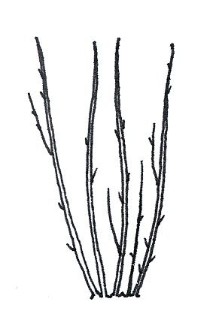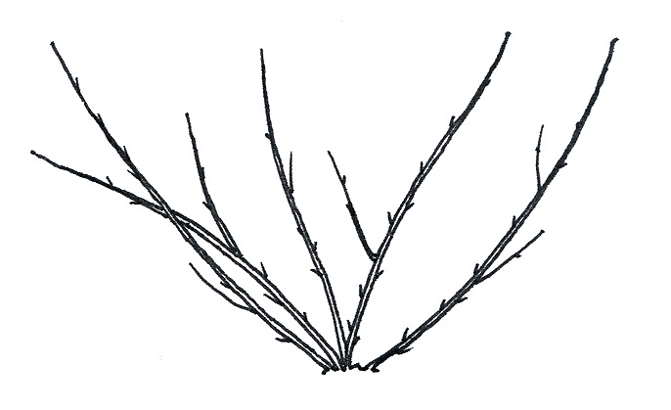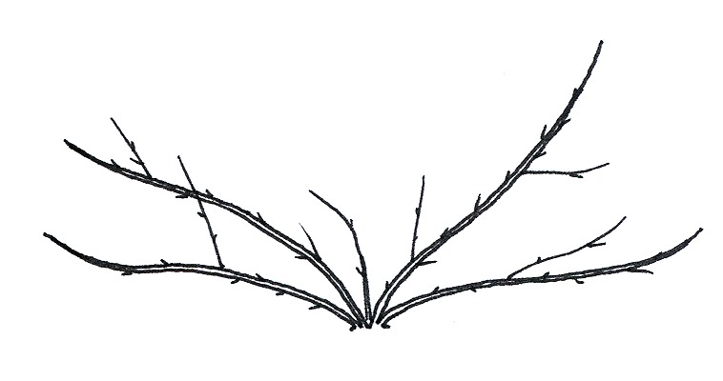
1 | 2 | 3
upright | semi-upright | spreading

Ad. 5: Bud: position in relation to shoot

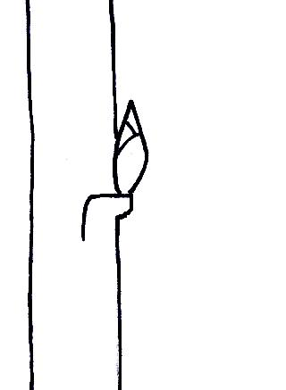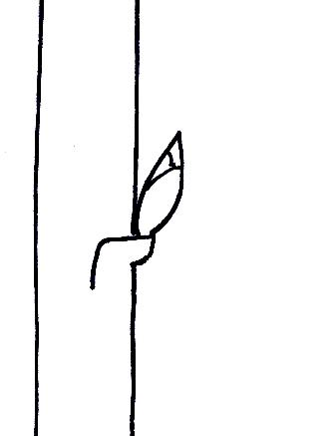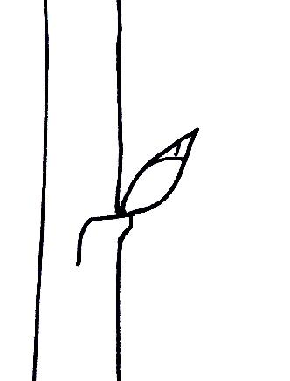
1 | 2 | 3
adpressed or slightly held out | moderately held out | strongly held out

Ad. 7: Bud: shape of apex:
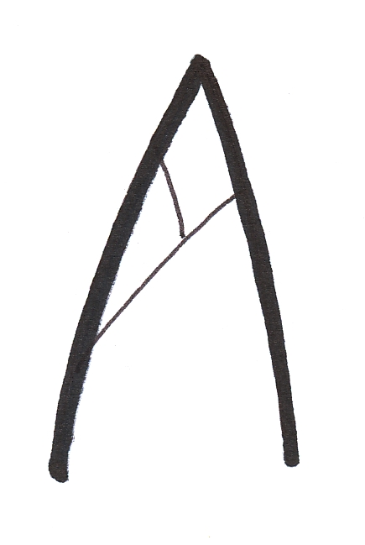 | 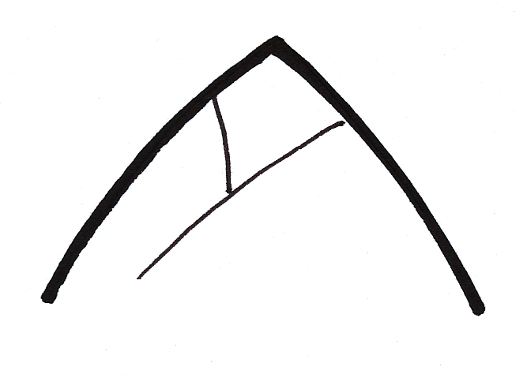 | 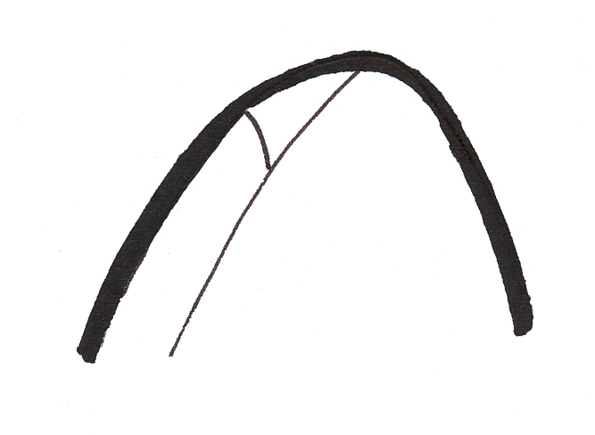
1 | 2 | 3
narrow acute | broad acute | rounded

Ad. 9: Bud: bloom

Bloom is the waxy layer on the scales that can be removed by rubbing.

Ad. 10: Young shoot: anthocyanin coloration

The anthocyanin coloration should be observed on the leaf and shoot at the stage of rapid growth.

Ad. 14: Leaf blade: ratio length/width
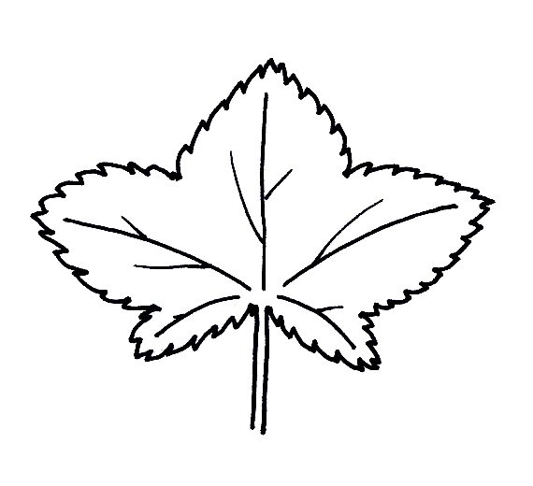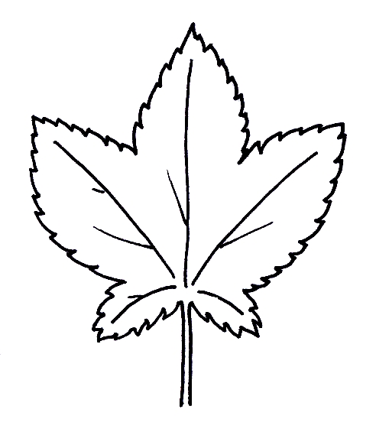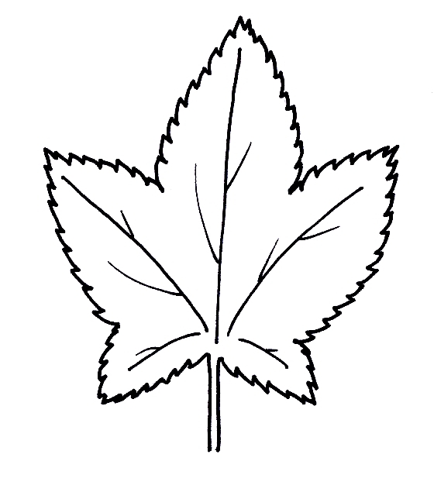

3 | 5 | 7
moderately compressed | medium | moderately elongated

Ad. 16: Petiole: thickness

The thickness should be observed in the middle part of the petiole.

Ad. 17: Inflorescence: number of flowers

The number of flowers should be observed as the total number of flowers, irrespective of whether they are open, or not.

Ad. 20: Flower: curvature of calyx

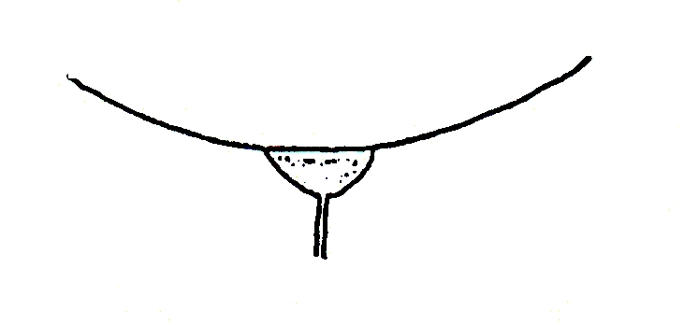 | 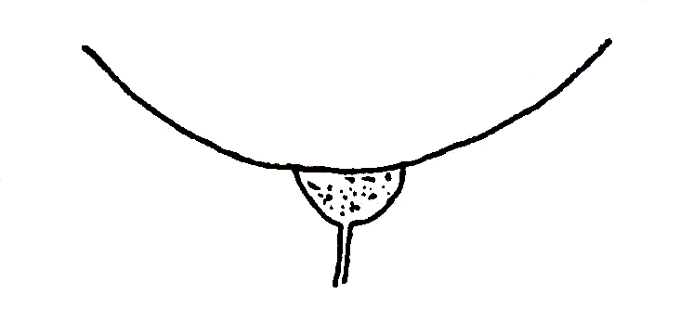 | 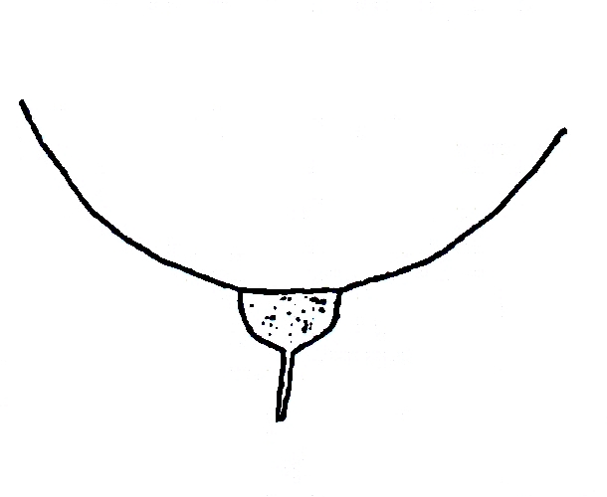 | 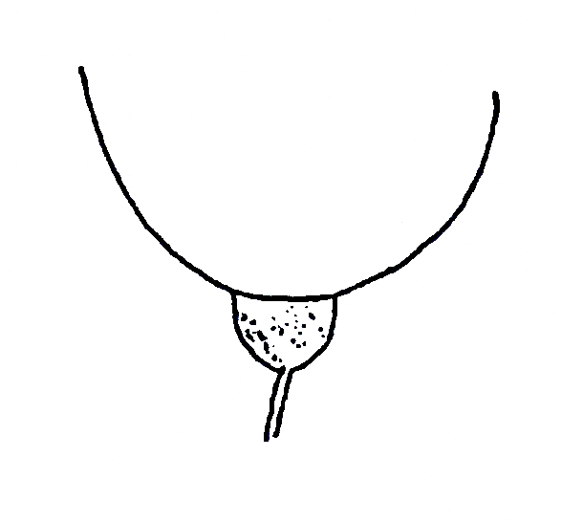 | 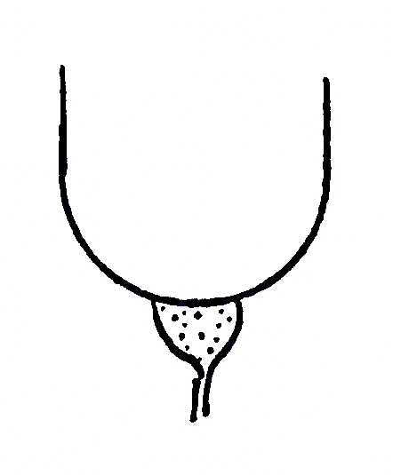
1 | 2 | 3 | 4 | 5
very weak | weak | moderate | strong | very strong

Ad. 22: Fruit truss: length excluding stalk

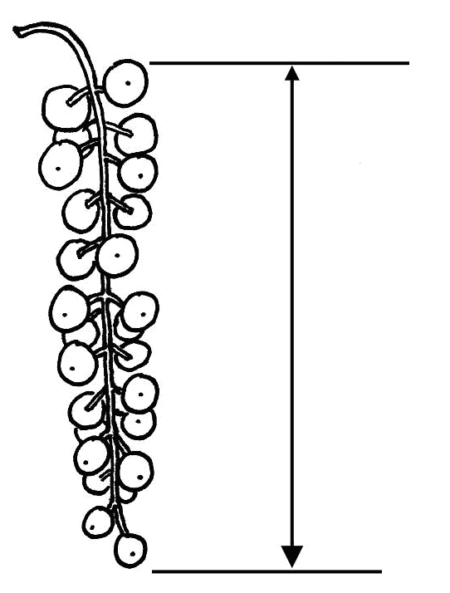

Ad. 26: Berry: shape

 |  | ← broadest part →
 |  | (below middle) | at middle
broad (compressed) ← width (ratio length/width) → narrow (elongated)
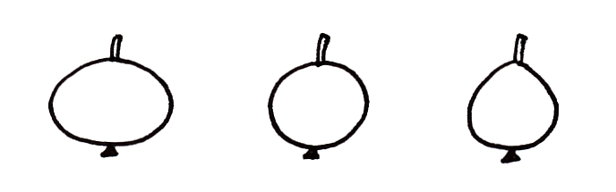
3
pyriform

2
circular
1
oblate

Ad. 28: Time of bud burst

The time of bud burst is when 10% of the buds are burst.

Ad. 29: Time of beginning of flowering

The time of beginning of flowering is when 10% of the flowers are open.

Ad. 30: Time of beginning of fruit ripening

The time of beginning of fruit ripening is when the fruit starts to be easily removed from the plant.

8.3 Synonyms of the example varieties
Example varieties | Synonym(s)
Imperial Blanche | Imperial White, Weiße Kaiserliche
Red Dutch | Roder Hollande, Rote Holländische
Rote Vierländer | Earliest of Fourlands, Erstling aus Vierlanden
Stanza | St. Anna-Beere
Versailles Blanche | Weiße Versailler
Witte Hollander | Weiße Holländische, White Dutch
Witte Parel | White Pearl

Literature
Keipert, K., 1981: Beerenobst. Ulmer Verlag. Stuttgart, DE, 349 pp.

Hoffman, M.H.A., 2005: List of names of woody plants. Praktijkonderzoek Plant & Omgeving BV. Boskoop, NL, 871 pp.

Technical Questionnaire
TECHNICAL QUESTIONNAIRE |  |  |  | Page {x} of {y} |  | Reference Number:
 |  |  |  |  |  | Application date:
 |  |  |  |  |  | (not to be filled in by the applicant)
TECHNICAL QUESTIONNAIRE
to be completed in connection with an application for plant breeders’ rights

1. Subject of the Technical Questionnaire
1.1 Botanical name |  |  | Ribes rubrum L.; Ribes sylvestre (Lam.) Mert. et W.Koch;  Ribes vulgare Lam.; Ribes sativum (Rchb.) Syme
1.2 Common name |  |  | Red and White Currant
2. Applicant
Name
Address
Telephone No.
Fax No.
E-mail address
Breeder (if different from applicant)
3. Proposed denomination and breeder’s reference
Proposed denomination
(if available)

Breeder’s reference
#4. Information on the breeding scheme and propagation of the variety

4.1 Breeding scheme

Variety resulting from:

4.1.1 Crossing

(a) controlled cross [ ]
(please state parent varieties)

(…………………..……………..…) x (……………..…………………..…)
female parent male parent

(b) partially known cross [ ]
(please state known parent variety(ies))

(…………………..……………..…) x (……………..…………………..…)
female parent male parent

(c) unknown cross [ ]

4.1.2 Mutation [ ]
(please state parent variety)

4.1.3 Discovery and development [ ]
(please state where and when discovered and how developed)

4.1.4 Other [ ]
(please provide details)

4.2 Method of propagating the variety

4.2.1 Vegetative propagation

(a) cuttings [ ]

(b) in vitro propagation [ ]

(c) other (state method) [ ]

4.2.2 Seed [ ]

4.2.3 Other [ ]

(please provide details)

5. Characteristics of the variety to be indicated (the number in brackets refers to the corresponding characteristic in Test Guidelines; please mark the note which best corresponds).
 | Characteristics |  |  |  |  |  | Example Varieties |  |  | Note
5.1  (22) | Fruit truss: length excluding stalk
 | very short |  |  |  |  |  |  |  |  | 1 [ ]
 | very short to short |  |  |  |  |  |  |  |  | 2 [ ]
 | short |  |  |  |  |  | Imperial Blanche |  |  | 3 [ ]
 | short to medium |  |  |  |  |  |  |  |  | 4 [ ]
 | medium |  |  |  |  |  | Rondom |  |  | 5 [ ]
 | medium to long |  |  |  |  |  |  |  |  | 6 [ ]
 | long |  |  |  |  |  | Blanka, Jonkheer van Tets |  |  | 7[ ]
 | long to very long |  |  |  |  |  |  |  |  | 8[ ]
 | very long |  |  |  |  |  | Detvan |  |  | 9[ ]
5.2  (25) | Berry: size
 | very small |  |  |  |  |  | Devínska Vel’koplodná, Mulka |  |  | 1 [ ]
 | very small to small |  |  |  |  |  |  |  |  | 2 [ ]
 | small |  |  |  |  |  | Hougthon Castle,  Laxton’s Perfection |  |  | 3 [ ]
 | small to medium |  |  |  |  |  |  |  |  | 4 [ ]
 | medium |  |  |  |  |  | Augustus, Laxton’s No.1,  Rote Vierländer |  |  | 5 [ ]
 | medium to large |  |  |  |  |  |  |  |  | 6 [ ]
 | large |  |  |  |  |  | Heros, Jonkheer van Tets |  |  | 7[ ]
 | large to very large |  |  |  |  |  |  |  |  | 8[ ]
 | very large |  |  |  |  |  | Cascade |  |  | 9[ ]
 | Characteristics |  |  |  |  |  | Example Varieties |  |  | Note
5.3  (27) | Berry: color
 | white |  |  |  |  |  | Bar le Duc, Blanka, Versailles Blanche, Witte Hollander,  Witte Parel, Zitavia |  |  | 1
 | pink |  |  |  |  |  | Hossfurtu, Rosa Hollander,  Rosa Sport |  |  | 2
 | light red |  |  |  |  |  | Präkanda |  |  | 3
 | medium red |  |  |  |  |  | Jonkheer van Tets, Rondom, Rotet, Victoria |  |  | 4
 | dark red |  |  |  |  |  | Jobes 88, Laxton’s Perfection, Mulka, Roodneus, Stanza |  |  | 5
5.4  (30) | Time of beginning of fruit ripening
 | very early |  |  |  |  |  | Jonkheer van Tets |  |  | 1[ ]
 | very early to early |  |  |  |  |  |  |  |  | 2[ ]
 | early |  |  |  |  |  | Heros, Red Lake |  |  | 3[ ]
 | early to medium |  |  |  |  |  |  |  |  | 4[ ]
 | medium |  |  |  |  |  | Detvan, Mulka |  |  | 5[ ]
 | medium to late |  |  |  |  |  |  |  |  | 6[ ]
 | late |  |  |  |  |  | Blanka, Krenever, Red Dutch |  |  | 7[ ]
 | late to very late |  |  |  |  |  |  |  |  | 8[ ]
 | very late |  |  |  |  |  | Heinemanns Rote Spätlese, Tatran |  |  | 9[ ]
6. Similar varieties and differences from these varieties
Please use the following table and box for comments to provide information on how your candidate variety differs from the variety (or varieties) which, to the best of your knowledge, is (or are) most similar. This information may help the examination authority to conduct its examination of distinctness in a more efficient way.

Denomination(s) of variety(ies) similar to your candidate variety |  | Characteristic(s) in which your candidate variety differs from the similar variety(ies) |  |  | Describe the expression of the characteristic(s) for the similar variety(ies) |  |  | Describe the expression of the characteristic(s) for your candidate variety
Example |  | Fruit: color |  |  | pink |  |  | medium red
Comments:

#7. Additional information which may help in the examination of the variety

7.1 In addition to the information provided in sections 5 and 6, are there any additional characteristics which may help to distinguish the variety?

Yes [ ] No [ ]

(If yes, please provide details)

7.2 Are there any special conditions for growing the variety or conducting the examination?

Yes [ ] No [ ]

(If yes, please provide details)

7.3 Other information

A representative color image of the variety should accompany the Technical Questionnaire.

8. Authorization for release

(a) Does the variety require prior authorization for release under legislation concerning the protection of the environment, human and animal health?

Yes [ ] No [ ]

(b) Has such authorization been obtained?

Yes [ ] No [ ]

If the answer to (b) is yes, please attach a copy of the authorization.

9. Information on plant material to be examined or submitted for examination.

9.1 The expression of a characteristic or several characteristics of a variety may be affected by factors, such as pests and disease, chemical treatment (e.g. growth retardants or pesticides), effects of tissue culture, different rootstocks, scions taken from different growth phases of a tree, etc.

9.2 The plant material should not have undergone any treatment which would affect the expression of the characteristics of the variety, unless the competent authorities allow or request such treatment. If the plant material has undergone such treatment, full details of the treatment must be given. In this respect, please indicate below, to the best of your knowledge, if the plant material to be examined has been subjected to:

(a) Microorganisms (e.g. virus, bacteria, phytoplasma) Yes [ ] No [ ]

(b) Chemical treatment (e.g. growth retardant, pesticide) Yes [ ] No [ ]

(c) Tissue culture Yes [ ] No [ ]

(d) Other factors Yes [ ] No [ ]

Please provide details for where you have indicated “yes”.

……………………………………………………………

9.3 Has the plant material to be examined been tested for the presence of virus or other pathogens?

Yes [ ]
(please provide details as specified by the Authority)

No [ ]

10. I hereby declare that, to the best of my knowledge, the information provided in this form is correct:

Applicant’s name

Signature Date

[End of document]

* These names were correct at the time of the introduction of these Test Guidelines but may be revised or updated. [Readers are advised to consult the UPOV Code, which can be found on the UPOV Website (www.upov.int), for the latest information.]
# Authorities may allow certain of this information to be provided in a confidential section of the Technical Questionnaire.
# Authorities may allow certain of this information to be provided in a confidential section of the Technical Questionnaire.

