 |  | E  TG/50/9  ORIGINAL: English  DATE: 2008-04-09
INTERNATIONAL UNION FOR THE PROTECTION OF NEW VARIETIES OF PLANTS
GENEVA

 | GRAPEVINE  UPOV code: VITIS  Vitis L. | *

GUIDELINES

FOR THE CONDUCT OF TESTS

FOR DISTINCTNESS, UNIFORMITY AND STABILITY

Alternative Names:*

Botanical name | English | French | German | Spanish
Vitis L. | Grapevine | Vigne | Rebe | Vid

The purpose of these guidelines (“Test Guidelines”) is to elaborate the principles contained in the General Introduction (document TG/1/3), and its associated TGP documents, into detailed practical guidance for the harmonized examination of distinctness, uniformity and stability (DUS) and, in particular, to identify appropriate characteristics for the examination of DUS and production of harmonized variety descriptions.

ASSOCIATED DOCUMENTS

These Test Guidelines should be read in conjunction with the General Introduction and its associated TGP documents.
TABLE OF CONTENTS PAGE

1. Subject of these Test Guidelines 3
2. Material Required 3
3. Method of Examination 3
3.1 Number of Growing Cycles 3
3.2 Testing Place 3
3.3 Conditions for Conducting the Examination 4
3.4 Test Design 4
3.5 Number of Plants / Parts of Plants to be Examined 4
3.6 Additional Tests 4
4. Assessment of Distinctness, Uniformity and Stability 4
4.1 Distinctness 4
4.2 Uniformity 5
4.3 Stability 5
5. Grouping of Varieties and Organization of the Growing Trial 5
6. Introduction to the Table of Characteristics 6
6.1 Categories of Characteristics 6
6.2 States of Expression and Corresponding Notes 6
6.3 Types of Expression 6
6.4 Example Varieties 7
6.5 Legend 7
7. Table of Characteristics/Tableau des caractères/Merkmalstabelle/Tabla de caracteres 8
8. Explanations on the Table of Characteristics 25
8.1 Explanations covering several characteristics 25
8.2 Explanations for individual characteristics 25
8.3 Encoding and Description of the Phenological Stages of Grapevine According to the Extended BBCH Scale ¹ 37
8.4 Synonyms and skin color of berry for example varieties 38
9. Literature 41
10. Technical Questionnaire 43

Subject of these Test Guidelines
These Test Guidelines apply to all varieties of Vitis L.

Material Required
2.1 The competent authorities decide on the quantity and quality of the plant material required for testing the variety and when and where it is to be delivered. Applicants submitting material from a State other than that in which the testing takes place must ensure that all customs formalities and phytosanitary requirements are complied with.

2.2 The material is to be supplied in the form of

(a) plants on their own roots;
(b) rooted grafts with scions grafted on a rootstock to be specified by the competent authority;
(c) top graft cuttings to produce grafted plants; or
(d) cuttings to produce plants on their own roots.

2.3 The minimum quantity of plant material, to be supplied by the applicant, should be:

5 plants,

or budwood or cuttings sufficient to produce 5 plants.

In the case of a variety with roots sensitive to Phylloxera vastatrix the competent authority can require scions grafted on a specific rootstock variety not being sensitive to that pest. The competent authority can accept the submission of propagating material sufficient to produce 10 rooted grafts or 10 plants on their own roots.

2.4 The plant material supplied should be visibly healthy, not lacking in vigor, nor affected by any important pest or disease.

2.5 The plant material should not have undergone any treatment which would affect the expression of the characteristics of the variety, unless the competent authorities allow or request such treatment. If it has been treated, full details of the treatment must be given.

Method of Examination

3.1 Number of Growing Cycles
The minimum duration of tests should normally be two independent growing cycles.

3.2 Testing Place
Tests are normally conducted at one place. In the case of tests conducted at more than one place, guidance is provided in TGP/9 “Examining Distinctness”.

3.3 Conditions for Conducting the Examination
3.3.1 The tests should be carried out under conditions ensuring satisfactory growth for the expression of the relevant characteristics of the variety and for the conduct of the examination. In particular, it is essential that the plants produce a satisfactory crop of fruit in each of the two growing cycles.

3.3.2 The optimum stage of development for the assessment of each characteristic is indicated by a number in the second column of the Table of Characteristics. The stages of development denoted by each number are described in Chapter 8.3.

3.3.3 The recommended method of observing the characteristic is indicated by the following key in the second column of the Table of Characteristics:

MG: single measurement of a group of plants or parts of plants
VG: visual assessment by a single observation of a group of plants or parts of plants

3.4 Test Design
3.4.1 Each test should be designed to result in a total of at least 5 plants.

3.4.2 The design of the tests should be such that plants or parts of plants may be removed for measurement or counting without prejudice to the observations which must be made up to the end of the growing cycle.

3.5 Number of Plants / Parts of Plants to be Examined
Unless otherwise indicated, all observations should be made on 5 plants or parts taken from each of 5 plants.

3.6 Additional Tests
Additional tests, for examining relevant characteristics, may be established.

Assessment of Distinctness, Uniformity and Stability

4.1 Distinctness

4.1.1 General Recommendations

It is of particular importance for users of these Test Guidelines to consult the General Introduction prior to making decisions regarding distinctness. However, the following points are provided for elaboration or emphasis in these Test Guidelines.

4.1.2 Consistent Differences

The differences observed between varieties may be so clear that more than one growing cycle is not necessary. In addition, in some circumstances, the influence of the environment is not such that more than a single growing cycle is required to provide assurance that the differences observed between varieties are sufficiently consistent. One means of ensuring that a difference in a characteristic, observed in a growing trial, is sufficiently consistent is to examine the characteristic in at least two independent growing cycles.

4.1.3 Clear Differences

Determining whether a difference between two varieties is clear depends on many factors, and should consider, in particular, the type of expression of the characteristic being examined, i.e. whether it is expressed in a qualitative, quantitative, or pseudo-qualitative manner. Therefore, it is important that users of these Test Guidelines are familiar with the recommendations contained in the General Introduction prior to making decisions regarding distinctness.

4.2 Uniformity
4.2.1 It is of particular importance for users of these Test Guidelines to consult the General Introduction prior to making decisions regarding uniformity. However, the following points are provided for elaboration or emphasis in these Test Guidelines:

4.2.2 For the assessment of uniformity, a population standard of 1% and an acceptance probability of at least 95% should be applied. In the case of a sample size of 5 plants, no off-types are allowed.

4.3 Stability
4.3.1 In practice, it is not usual to perform tests of stability that produce results as certain as those of the testing of distinctness and uniformity. However, experience has demonstrated that, for many types of variety, when a variety has been shown to be uniform, it can also be considered to be stable.

4.3.2 Where appropriate, or in cases of doubt, stability may be tested, either by growing a further generation, or by testing a new plant stock to ensure that it exhibits the same characteristics as those shown by the previous material supplied.

Grouping of Varieties and Organization of the Growing Trial
5.1 The selection of varieties of common knowledge to be grown in the trial with the candidate varieties and the way in which these varieties are divided into groups to facilitate the assessment of distinctness are aided by the use of grouping characteristics.

5.2 Grouping characteristics are those in which the documented states of expression, even where produced at different locations, can be used, either individually or in combination with other such characteristics: (a) to select varieties of common knowledge that can be excluded from the growing trial used for examination of distinctness; and (b) to organize the growing trial so that similar varieties are grouped together.

5.3 The following have been agreed as useful grouping characteristics:

- Young shoot: openness of tip (characteristic 2)
- Young leaf: color of upper side of blade (characteristic 6)
- Young leaf: prostrate hairs between main veins on lower side of blade (characteristic 7)
- Flower: sexual organs (characteristic 16)
- Mature leaf: number of lobes (characteristic 20)
- Time of beginning of berry ripening (characteristic 31)
- Berry: shape (characteristic 36)
- Berry: color of skin (without bloom) (characteristic 37)
- Berry: anthocyanin coloration of flesh (characteristic 40)
- Berry: particular flavor (characteristic 42)
- Berry: formation of seeds (characteristic 43)

5.4 Guidance for the use of grouping characteristics, in the process of examining distinctness, is provided through the General Introduction.

Introduction to the Table of Characteristics

6.1 Categories of Characteristics
6.1.1 Standard Test Guidelines Characteristics

Standard Test Guidelines characteristics are those which are approved by UPOV for examination of DUS and from which members of the Union can select those suitable for their particular circumstances.

6.1.2 Asterisked Characteristics

Asterisked characteristics (denoted by *) are those included in the Test Guidelines which are important for the international harmonization of variety descriptions and should always be examined for DUS and included in the variety description by all members of the Union, except when the state of expression of a preceding characteristic or regional environmental conditions render this inappropriate.

6.2 States of Expression and Corresponding Notes
States of expression are given for each characteristic to define the characteristic and to harmonize descriptions. Each state of expression is allocated a corresponding numerical note for ease of recording of data and for the production and exchange of the description.

6.3 Types of Expression
An explanation of the types of expression of characteristics (qualitative, quantitative and pseudo-qualitative) is provided in the General Introduction.

6.4 Example Varieties
Where appropriate, example varieties are provided to clarify the states of expression of each characteristic.
For the example varieties – other than rootstocks – the color of the berry of the example varieties is indicated in the table in Chapter 8.4, following the standardized code used within the European Union for the classification of vine varieties: B = white, G = grey, N = black, Rg = red, Rs = rose. That table also provides synonyms of certain example varieties.

6.5 Legend
(*) Asterisked characteristic – see Chapter 6.1.2

QL: Qualitative characteristic – see Chapter 6.3
QN: Quantitative characteristic – see Chapter 6.3
PQ: Pseudo-qualitative characteristic – see Chapter 6.3

MG, VG: see Chapter 3.3.2

(a)-(b) See Explanations on the Table of Characteristics in Chapter 8.1

(+) See Explanations on the Table of Characteristics in Chapter 8.2

07-00 See Explanations on the Table of Characteristics in Chapter 8.3

In the second column of the Table of Characteristics for each characteristic are indicated the code numbers of the International Organization of Vine and Wine (O.I.V.)
(O-...) and International Plant Genetic Resources Institute (IPGRI) (I-...) of the corresponding characteristic in their Descriptor lists for grapevine varieties and Vitis species, drawn up jointly by the O.I.V. (International Office of the Grapevine and Wine, 18, rue d’Aguesseau, 75008 Paris, France), IPGRI, (Bioversity International, Via dei Tre Denarie 472/a 00057 Maccarese (Fiumicino) Rome, Italy) and UPOV, in order to avoid risks of mistakes and errors resulting from the multiplicity and heterogeneity of existing lists of distinctive characteristics.

O-... code number of O.I.V.

I-... code number of IPGRI

Table of Characteristics/Tableau des caractères/Merkmalstabelle/Tabla de caracteres
 |  |  | English |  | français |  | Deutsch |  | español |  | Example Varieties/  Exemples/  Beispielssorten/  Variedades ejemplo |  |  | Note/  Nota
1.  (*)  (+) | 07-09  O-301  I-7.1.1  MG |  | Time of bud burst |  | Époque de débourrement |  | Zeitpunkt des Knospenaufbruchs |  | Época de desborre
QN |  |  | very early |  | très précoce |  | sehr früh |  | muy temprana |  | Nero |  |  | 1
 |  |  | early |  | précoce |  | früh |  | temprana |  | Chardonnay |  |  | 3
 |  |  | medium |  | moyenne |  | mittel |  | media |  | Cabernet Sauvignon |  |  | 5
 |  |  | late |  | tardive |  | spät |  | tardía |  | Mourvèdre |  |  | 7
 |  |  | very late |  | très tardive |  | sehr spät |  | muy tardía |  | Airen |  |  | 9
2.  (*)  (+) | 53-69  O-001  I-6.1.1  VG |  | Young shoot: openness of tip |  | Jeune rameau: ouverture de l’extrémité |  | Junger Trieb: Öffnung der Triebspitze |  | Pámpano: apertura de la punta
QN |  |  | closed |  | fermée |  | geschlossen |  | cerrada |  | Riparia Gloire de Montpellier |  |  | 1
 |  |  | slightly open |  | légèrement ouverte |  | leicht offen |  | ligeramente abierto |  | 3309 Couderc |  |  | 2
 |  |  | half open |  | demi-ouverte |  | halb offen |  | semi abierta |  | Kober 5 BB |  |  | 3
 |  |  | wide open |  | largement ouverte |  | weit offen |  | muy abierta |  | Cina |  |  | 4
 |  |  | fully open |  | complètement  ouverte |  | vollständig offen |  | completamente abierta |  | Pinot noir, Riesling |  |  | 5
3.  (*)  (+) | 53-69  O-004  I-6.1.3  VG |  | Young shoot: prostrate hairs  on tip |  | Jeune rameau: poils couchés de l’extrémité |  | Junger Trieb: Wollbehaarung an der Triebspitze |  | Pámpano: pelos postrados en la punta
QN |  |  | absent or very sparse |  | absents ou très épars |  | fehlend oder sehr locker |  | ausentes o muy escasos |  |  | 3309 Couderc |  | 1
 |  |  | sparse |  | épars |  | locker |  | escasos |  |  | Chasselas blanc |  | 3
 |  |  | medium |  | moyens |  | mittel |  | medios |  |  | Pinot noir |  | 5
 |  |  | dense |  | denses |  | dicht |  | densos |  |  | Lipovina |  | 7
 |  |  | very dense |  | très denses |  | sehr dicht |  | muy densos |  |  | Meunier |  | 9
4.  (*)  (+) | 53-69  O-003  I-6.1.2  VG |  | Young shoot: anthocyanin coloration of prostrate hairs on tip |  | Jeune rameau: pigmentation anthocyanique des poils couchés de l’extrémité |  | Junger Trieb: Anthocyanfärbung der Woll-behaarung an der Triebspitze |  | Pámpano: pigmentación antociánica de los pelos postrados en la punta
QN |  |  | absent or very weak |  | nulle ou très faible |  | fehlend oder sehr gering |  | ausente o muy débil |  |  | Furmint |  | 1
 |  |  | weak |  | faible |  | gering |  | débil |  |  | Riesling |  | 3
 |  |  | medium |  | moyenne |  | mittel |  | media |  |  | Barbera |  | 5
 |  |  | strong |  | forte |  | stark |  | fuerte |  |  | Cabernet Sauvignon |  | 7
 |  |  | very strong |  | très forte |  | sehr stark |  | muy fuerte |  |  | Cina |  | 9
5.  (+) | 53-69  O-005  I-6.1.4  VG |  | Young shoot:  erect hairs on tip |  | Jeune rameau:  poils dressés de l’extrémité |  | Junger Trieb: Borstenbehaarung an der Triebspitze |  | Pámpano:  pelos erectos en la punta
QN |  |  | absent or very sparse |  | absents ou très épars |  | fehlend oder sehr locker |  | ausentes o muy escasos |  |  | Rupestris du Lot |  | 1
 |  |  | sparse |  | épars |  | locker |  | escasos |  |  | 3309 Couderc |  | 3
 |  |  | medium |  | moyens |  | mittel |  | medios |  |  | 3306 Couderc |  | 5
 |  |  | dense |  | denses |  | dicht |  | densos |  |  | Riparia Gloire de Montpellier |  | 7
 |  |  | very dense |  | très denses |  | sehr dicht |  | muy densos |  |  |  |  | 9
6.  (*)  (+) | 53-69  O-051  I-6.1.16  VG |  | Young leaf: color of upper side of blade |  | Jeune feuille:  couleur de la face supérieure du limbe |  | Junges Blatt: Farbe der Oberseite der Spreite |  | Hoja joven:  color del haz del limbo
PQ |  |  | yellow green |  | verte jaune |  | gelbgrün |  | verde amarillento |  |  | Furmint |  | 1
 |  |  | green |  | vert |  | grün |  | verde |  |  | Silvaner |  | 2
 |  |  | green with anthocyanin spots |  | vert à plages anthocyaniques |  | grün mit Anthocyanflecken |  | verde con zonas antociánicas |  |  | Riesling |  | 3
 |  |  | light copper red |  | rouge cuivré clair |  | hellkupferrot |  | rojo-cobrizo claro |  |  | Kober 5 BB |  | 4
 |  |  | dark copper red |  | rouge cuivré foncé |  | dunkelkupferrot |  | rojo-cobrizo oscuro |  |  | Chasselas blanc |  | 5
 |  |  | wine red |  | rouge vineux |  | weinrot |  | rojo vino |  |  | Deckrot |  | 6
7.  (*)  (+) | 53-69  O-053  I-6.1.17  VG |  | Young leaf: prostrate hairs between main veins on lower side of blade |  | Jeune feuille: poils couchés entre les nervures principales de la face inférieure du limbe |  | Junges Blatt:  Wollbehaarung zwischen den Hauptadern auf der Unterseite der Spreite |  | Hoja joven: pelos postrados entre las nervaduras principales del envés del limbo
QN |  |  | absent or very sparse |  | absents ou très épars |  | fehlend oder sehr locker |  | ausentes o muy escasos |  |  | Rupestris du Lot |  | 1
 |  |  | sparse |  | épars |  | locker |  | escasos |  |  | Muscat à petits grain blancs |  | 3
 |  |  | medium |  | moyens |  | mittel |  | medios |  |  | Merlot, Riesling |  | 5
 |  |  | dense |  | denses |  | dicht |  | densos |  |  | Clairette |  | 7
 |  |  | very dense |  | très denses |  | sehr dicht |  | muy densos |  |  | Meunier |  | 9
8.  (+) | 53-69  O-056  I.6.1.20  VG |  | Young leaf:  erect hairs on main veins on lower side of blade |  | Jeune feuille:  poils dressés sur  les nervures principales de la face inférieure du limbe |  | Junges Blatt:  Borstenbehaarung auf den Haupt-adern auf der Unterseite der Spreite |  | Hoja joven:  pelos erectos sobre las nervaduras principales del envés del limbo
QN |  |  | absent or very sparse |  | absents ou très épars |  | fehlend oder sehr locker |  | ausentes o muy escasos |  |  | Rupestris du Lot |  | 1
 |  |  | sparse |  | épars |  | locker |  | escasos |  |  | 3309 Couderc |  | 3
 |  |  | medium |  | moyens |  | mittel |  | medios |  |  | Kober 125 AA |  | 5
 |  |  | dense |  | denses |  | dicht |  | densos |  |  | Teleki 8 B |  | 7
 |  |  | very dense |  | très denses |  | sehr dicht |  | muy densos |  |  | Riparia Scribner |  | 9
9.  (+) | 60-69  O-006  I-6.1.5  VG |  | Shoot: attitude (before tying) |  | Rameau: port (avant palissage) |  | Trieb: Haltung (vor dem Heften) |  | Sarmiento: porte (antes de ser entutorado)
QN |  |  | erect |  | érigé |  | aufrecht |  | erecto |  |  | Garnacha tinta |  | 1
 |  |  | semi-erect |  | demi-érigé |  | halb aufrecht |  | semierecto |  |  | Muscat Ottonel |  | 3
 |  |  | horizontal |  | horizontal |  | waagerecht |  | horizontal |  |  | Barbera |  | 5
 |  |  | semi-drooping |  | demi-retombant |  | halb hängend |  | semi-rastrero |  |  | Aramon noir |  | 7
 |  |  | drooping |  | retombant |  | hängend |  | rastrero |  |  | Albillo Real |  | 9
10.  (+) | 60-69  O-007  I-6.1.6  VG |  | Shoot: color of dorsal side of internodes |  | Rameau: couleur de la face dorsale de l’entre-nœud |  | Trieb: Farbe der Rückenseite der Internodien |  | Sarmiento: color de la cara dorsal del entrenudo
QN | (a) |  | green |  | verte |  | grün |  | verde |  |  | Sauvignon |  | 1
 |  |  | green and red |  | verte et rouge |  | grün und rot |  | verde y rojo |  |  | Carignan |  | 2
 |  |  | red |  | rouge |  | rot |  | rojo |  |  | Riesling |  | 3
11.  (*)  (+) | 60-69  O-008  I-6.1.7  VG |  | Shoot: color of ventral side of internodes |  | Rameau: couleur de la face ventrale de l’entre-nœud |  | Trieb: Farbe der Bauchseite der Internodien |  | Sarmiento: color de la cara ventral del entrenudo
QN | (a) |  | green |  | verte |  | grün |  | verde |  |  | Sauvignon |  | 1
 |  |  | green and red |  | verte et rouge |  | grün und rot |  | verde y rojo |  |  | Carignan |  | 2
 |  |  | red |  | rouge |  | rot |  | rojo |  |  | Mourvedre |  | 3
12.  (+) | 60-69  O-009  I-6.1.8  VG |  | Shoot: color of dorsal side of nodes |  | Rameau: couleur de la face dorsale du nœud |  | Trieb: Farbe der Rückenseite der Nodien |  | Sarmiento: color de la cara dorsal del nudo
QN | (a) |  | green |  | verte |  | grün |  | verde |  |  | Sauvignon |  | 1
 |  |  | green and red |  | verte et rouge |  | grün und rot |  | verde y rojo |  |  | Barbera |  | 2
 |  |  | red |  | rouge |  | rot |  | rojo |  |  | Kober 5 BB |  | 3
13.  (+) | 60-69  O-010  I-6.1.9  VG |  | Shoot: color of ventral side of nodes |  | Rameau: couleur de la face ventrale du nœud |  | Trieb: Farbe der Bauchseite der Nodien |  | Sarmiento: color de la cara ventral del nudo
QN | (a) |  | green |  | verte |  | grün |  | verde |  |  | 3309 Couderc |  | 1
 |  |  | green and red |  | verte et rouge |  | grün und rot |  | verde y rojo |  |  | Börner |  | 2
 |  |  | red |  | rouge |  | rot |  | rojo |  |  | Kober 5 BB |  | 3
14. | 60-69  O-012  I-6.1.11  VG |  | Shoot: erect hairs on internodes |  | Rameau: poils dressés sur les entre-nœuds |  | Trieb: Borstenbehaarung auf den Internodien |  | Sarmiento: pelos erectos sobre los entrenudos
QN | (a) |  | absent or very sparse |  | absents ou très épars |  | fehlend oder sehr locker |  | ausentes o muy escasos |  |  | 3309 Couderc |  | 1
 |  |  | sparse |  | épars |  | locker |  | escasos |  |  | 161-49 Couderc |  | 3
 |  |  | medium |  | moyens |  | mittel |  | medios |  |  | Teleki 8 B |  | 5
 |  |  | dense |  | denses |  | dicht |  | densos |  |  | Kober 125 AA,  Riparia Scribner |  | 7
 |  |  | very dense |  | très denses |  | sehr dicht |  | muy densos |  |  | Cina |  | 9
15. | 60-73  O-017  I-6.1.15  VG |  | Shoot: length of tendrils |  | Rameau: longueur des vrilles |  | Trieb: Länge der Ranken |  | Sarmiento: longitud del zarcillos
QN | (a) |  | very short |  | très courtes |  | sehr kurz |  | muy cortos |  |  | Rupestris du Lot |  | 1
 |  |  | short |  | courtes |  | kurz |  | cortos |  |  | Aramon noir |  | 3
 |  |  | medium |  | moyennes |  | mittel |  | medios |  |  | Pinot noir |  | 5
 |  |  | long |  | longues |  | lang |  | largos |  |  | Chasselas blanc |  | 7
 |  |  | very long |  | très longues |  | sehr lang |  | muy largos |  |  | Emperor |  | 9
16.  (*)  (+) | 61-68  O-151  I-6.2.1  VG |  | Flower:  sexual organs |  | Fleur:  organes sexuels |  | Blüte:  Geschlechtsorgane |  | Flor:  órganos sexuales
QL |  |  | fully developed stamens and no gynoecium |  | étamines complè-tement développées et pas de gynécée |  | vollentwickelte Staubblätter und kein Stempel |  | estambres comple-tamente desarrolla-dos y gineceo ausente |  |  | Rupestris du Lot |  | 1
 |  |  | fully developed stamens and reduced gynoecium |  | étamines com-plètement déve-loppées et un gynécée réduit |  | vollentwickelte Staubblätter und reduzierter Stempel |  | estambres comple-tamente desarrolla-dos y gineceo reducido |  |  | 3309 Couderc |  | 2
 |  |  | fully developed stamens and fully developed gynoecium |  | étamines com-plètement déve-loppées et un gynécée complète-ment développé |  | vollentwickelte Staubblätter und vollentwickelter Stempel |  | estambres y gineceo completamente desarrollados |  |  | Chasselas blanc |  | 3
 |  |  | reflexed stamens and fully developed gynoecium |  | étamines réfléchies et un gynécée complètement développé |  | zurückgebogene Staubblätter und vollentwickelter Stempel |  | estambres reflejos y gineceo completamente desarrollado |  |  | Kober 5 BB, Ohanes |  | 4
17.  (*) | 75-81  O-065  I-6.1.21  VG |  | Mature leaf: size of blade |  | Feuille adulte: taille du limbe |  | Ausgewachsenes Blatt: Größe der Spreite |  | Hoja madura: tamaño del limbo
QN | (b) |  | very small |  | très petit |  | sehr klein |  | muy pequeño |  |  | Paulsen 1103 |  | 1
 |  |  | small |  | petit |  | klein |  | pequeño |  |  | Gamay |  | 3
 |  |  | medium |  | moyen |  | mittel |  | medio |  |  | Cabernet Sauvignon |  | 5
 |  |  | large |  | grand |  | groß |  | grande |  |  | Carignan |  | 7
 |  |  | very large |  | très grand |  | sehr groß |  | muy grande |  |  | Bobal, Emperor |  | 9
18.  (*)  (+) | 75-81  O-067  I-6.1.22  VG |  | Mature leaf:  shape of blade |  | Feuille adulte: forme du limbe |  | Ausgewachsenes Blatt: Form der Spreite |  | Hoja madura: forma del limbo
PQ | (b) |  | cordate |  | cordiforme |  | herzförmig |  | cordiforme |  |  | Petit Verdot |  | 1
 |  |  | wedge-shaped |  | cunéiforme |  | keilförmig |  | cuneiforme |  |  | Riparia Gloire de Montpellier |  | 2
 |  |  | pentagonal |  | pentagonale |  | fünfeckig |  | pentagonal |  |  | Chasselas blanc |  | 3
 |  |  | circular |  | orbiculaire |  | kreisförmig |  | orbicular |  |  | Clairette |  | 4
 |  |  | kidney-shaped |  | réniforme |  | nierenförmig |  | reniforme |  |  | Rupestris du Lot |  | 5
19. | 75-81  O-075  I-6.1.26  VG |  | Mature leaf:  blistering of upper side of blade |  | Feuille adulte: cloqûre de la face supérieure du limbe |  | Ausgewachsenes Blatt: Blasigkeit der Oberseite der Spreite |  | Hoja madura: abullonado del haz
QN | (b) |  | absent or very weak |  | nulle ou très faible |  | fehlend oder sehr gering |  | nulo o muy débil |  |  | Rupestris du Lot |  | 1
 |  |  | weak |  | faible |  | gering |  | débil |  |  | Chasselas blanc |  | 3
 |  |  | medium |  | moyenne |  | mittel |  | medio |  |  | Semillon |  | 5
 |  |  | strong |  | forte |  | stark |  | fuerte |  |  | Merlot |  | 7
 |  |  | very strong |  | très forte |  | sehr stark |  | muy fuerte |  |  | Brancellao |  | 9
20.  (*)  (+) | 75-81  O-068  I-6.1.23  VG |  | Mature leaf: number of lobes |  | Feuille adulte: nombre de lobes |  | Ausgewachsenes Blatt: Anzahl Lappen |  | Hoja madura:  número de lóbulos
QN | (b) |  | one |  | un |  | einer |  | uno |  |  | Rupestris du Lot |  | 1
 |  |  | three |  | trois |  | drei |  | tres |  |  | Chenin blanc |  | 2
 |  |  | five |  | cinq |  | fünf |  | cinco |  |  | Chasselas blanc |  | 3
 |  |  | seven |  | sept |  | sieben |  | siete |  |  | Vermentino |  | 4
 |  |  | more than seven |  | plus de sept |  | mehr als sieben |  | más de siete |  |  | Hebron |  | 5
21.  (+) | 75-81  O- –  I-6.1.34  VG |  | Mature leaf:  depth of upper lateral sinuses |  | Feuille adulte: profondeur des sinus latéraux supérieurs |  | Ausgewachsenes Blatt: Tiefe der oberen Seiten-buchten |  | Hoja madura:  profundidad de los senos laterales superiores
QN | (b) |  | absent or very shallow |  | nulle ou très superficiels |  | fehlend oder sehr flach |  | ausentes o muy superficiales |  |  | Melon |  | 1
 |  |  | shallow |  | superficiels |  | flach |  | superficiales |  |  | Gamay |  | 3
 |  |  | medium |  | moyens |  | mittel |  | medios |  |  | Merlot |  | 5
 |  |  | deep |  | profonds |  | tief |  | profundos |  |  | Chasan |  | 7
 |  |  | very deep |  | très profonds |  | sehr tief |  | muy profundos |  |  | Chasselas Cioutat |  | 9
22.  (+) | 75-81  O-082  I-6.1.33  VG |  | Only varieties with lobed leaves: Mature leaf: arrangement of lobes of upper lateral sinuses |  | Seulement variétés avec feuilles lobulées: Feuille adulte: arrangement des lobes des sinus latéraux supérieurs |  | Nur Sorten mit gelappten Blättern: Ausgewachsenes Blatt: Anordnung der Lappen der oberen Seitenbuchten |  | Solo variedades de hojas lobuladas: Hoja adulta: disposición de los lóbulos de los senos laterales superiores
QN | (b) |  | open |  | ouverts |  | offen |  | abiertos |  |  | Folle Blanche |  | 1
 |  |  | closed |  | fermés |  | geschlossen |  | cerrados |  |  | Chasselas blanc |  | 2
 |  |  | slightly overlapped |  | légèrement chevauchants |  | leicht überlappt |  | ligeramente superpuestos |  |  | Cabernet Sauvignon |  | 3
 |  |  | strongly overlapped |  | très chevauchants |  | weit überlappt |  | muy superpuestos |  |  | Clairette |  | 4
23.  (*)  (+) | 75-81  O-079  I-6.1.30  VG |  | Mature leaf: arrangement of lobes of petiole sinus |  | Feuille adulte: arrangement des lobes du sinus pétiolaire |  | Ausgewachsenes Blatt: Anordnung der Lappen der Stielbucht |  | Hoja madura: postura de los lóbulos en el seno peciolar
QN | (b) |  | very wide open |  | très largement  ouverts |  | sehr weit offen |  | muy ampliamente abierta |  |  | Rupestris du Lot |  | 1
 |  |  | wide open |  | très ouverts |  | weit offen |  | ampliamente abierta |  |  | Riparia Gloire de Montpellier |  | 2
 |  |  | half open |  | demi-ouverts |  | halb offen |  | abierta a mitad |  |  | Aramon noir |  | 3
 |  |  | slightly open |  | peu ouverts |  | leicht offen |  | ligeramente abierta |  |  | Sauvignon |  | 4
 |  |  | closed |  | fermés |  | geschlossen |  | cerrada |  |  | Chasselas blanc |  | 5
 |  |  | slightly overlapped |  | légèrement chevauchants |  | leicht überlappt |  | ligeramente superpuesta |  |  | Aubun |  | 6
 |  |  | half overlapped |  | demi-chevauchants |  | halb überlappt |  | semisuperpuesta |  |  | Riesling |  | 7
 |  |  | strongly overlapped |  | très chevauchants |  | weit überlappt |  | fuertemente superpuesta |  |  | Clairette |  | 8
 |  |  | very strongly overlapped |  | très fortement chevauchants |  | sehr weit überlappt |  | muy fuertemente superpuesta |  |  | Domina |  | 9
24.  (*)  (+) | 75-81  O- –  I-6.1.28  VG |  | Mature leaf:  length of teeth |  | Feuille adulte: longueur des dents |  | Ausgewachsenes Blatt: Länge der Zähne |  | Hoja madura: longitud de los dientes
QN | (b) |  | short |  | courtes |  | kurz |  | cortos |  |  | Pinot noir |  | 3
 |  |  | medium |  | moyennes |  | mittel |  | medios |  |  | Merlot |  | 5
 |  |  | long |  | longues |  | lang |  | largos |  |  | Carignan |  | 7
25.  (*)  (+) | 75-81  O-078  I-6.1.29  VG |  | Mature leaf:  ratio length/width of teeth |  | Feuille adulte: rapport longueur/ largeur des dents |  | Ausgewachsenes Blatt: Verhältnis Länge/Breite der Zähne |  | Hoja madura: relación longitud/ anchura de los dientes
QN | (b) |  | very small |  | très petit |  | sehr klein |  | muy pequeña |  |  | 157-11 Couderc |  | 1
 |  |  | small |  | petit |  | klein |  | pequeña |  |  | Silvaner |  | 3
 |  |  | medium |  | moyen |  | mittel |  | media |  |  | Chasselas blanc |  | 5
 |  |  | large |  | grand |  | groß |  | grande |  |  | Muscat of Alexandria |  | 7
 |  |  | very large |  | très grand |  | sehr groß |  | muy grande |  |  | Sangiovese |  | 9
26.  (*)  (+) | 75-81  O-076  I-6.1.27  VG |  | Mature leaf: shape of teeth |  | Feuille adulte: forme des dents |  | Ausgewachsenes Blatt: Form der Zähne |  | Hoja madura: forma de los dientes
PQ | (b) |  | both sides concave |  | à côtés concaves |  | beiderseits konkav |  | ambos lados  cóncavos |  |  |  |  | 1
 |  |  | both sides straight |  | à côtés rectilignes |  | beiderseits  geradlinig |  | ambos lados  rectilíneos |  |  | Muscat à petits grain blancs |  | 2
 |  |  | both sides convex |  | à côtés convexes |  | beiderseits konvex |  | ambos lados  convexos |  |  | Chenin blanc |  | 3
 |  |  | one side concave,  one side convex |  | un côté concave,  un côté convexe |  | eine Seite konkav, eine Seite konvex |  | un lado cóncavo,  un lado convexo |  |  | Aspiran |  | 4
 |  |  | mixture of both sides straight and both sides convex |  | mélange de deux côtés rectilignes et deux côtés convexes |  | Mischung aus beiderseits geradlinig und beiderseits konvex |  | mezcla de ambos lados rectilíneos y ambos lados convexos |  |  | Cabernet franc |  | 5
27.  (*)  (+) | 75-81  O- –  I-6.1.24  VG |  | Mature leaf: proportion of main veins on upper side of blade with  anthocyanin  coloration |  | Feuille adulte: proportion des nervures princi-pales de la face supérieure du limbe avec pigmentation  anthocyanique |  | Ausgewachsenes Blatt: Anteil der Hauptadern auf der Oberseite der Spreite mit Anthocyanfärbung |  | Hoja madura: proporción de nervaduras principales del haz con pigmentación antociánica
QN | (b) |  | absent or very low |  | nulle ou très faible |  | fehlend oder sehr gering |  | ausente o muy baja |  |  | Garnacha tinta |  | 1
 |  |  | low |  | faible |  | gering |  | baja |  |  | Muscat of Alexandria |  | 3
 |  |  | medium |  | moyenne |  | mittel |  | media |  |  | Dornfelder |  | 5
 |  |  | high |  | élevée |  | hoch |  | elevada |  |  | Deckrot |  | 7
 |  |  | very high |  | très élevée |  | sehr hoch |  | muy elevada |  |  | Cabernet Mitos |  | 9
28.  (*) | 75-81  O-084  I-6.1.35  VG |  | Mature leaf: prostrate hairs between main veins on lower side of blade |  | Feuille adulte:  poils couchés entre les nervures princi-pales de la face inférieure du limbe |  | Ausgewachsenes Blatt: Wollbehaarung zwischen den Hauptadern auf der Unterseite der Spreite |  | Hoja madura:  pelos postrados entre las nervaduras principales del envés
QN | (b) |  | absent or very sparse |  | absents ou très épars |  | fehlend oder sehr locker |  | ausentes o muy escasos |  |  | Chasselas blanc |  | 1
 |  |  | sparse |  | épars |  | locker |  | escasos |  |  | Gamay |  | 3
 |  |  | medium |  | moyens |  | mittel |  | medios |  |  | Cabernet Sauvignon |  | 5
 |  |  | dense |  | denses |  | dicht |  | densos |  |  | Clairette |  | 7
 |  |  | very dense |  | très denses |  | sehr dicht |  | muy densos |  |  | Isabella |  | 9
29.  (*) | 75-81  O-087  I-6.1.38  VG |  | Mature leaf: erect hairs on main veins on lower side of blade |  | Feuille adulte: poils dressés des ner-vures principales de la face inférieure du limbe |  | Ausgewachsenes Blatt: Borstenbehaarung der Hauptadern auf der Unterseite der Spreite |  | Hoja madura:  pelos erectos sobre las nervaduras principales del envés
QN | (b) |  | absent or very sparse |  | absents ou très épars |  | fehlend oder sehr locker |  | nulos o muy escasos |  |  | Rupestris du Lot |  | 1
 |  |  | sparse |  | épars |  | locker |  | escasos |  |  | Perle de Csaba |  | 3
 |  |  | medium |  | moyens |  | mittel |  | media |  |  | Muscat Ottonel |  | 5
 |  |  | dense |  | denses |  | dicht |  | densos |  |  | Kober 125 AA |  | 7
 |  |  | very dense |  | très denses |  | sehr dicht |  | muy densos |  |  | Börner |  | 9
30.  (+) | 75-81  O-093  I-6.1.40  VG |  | Mature leaf: length of petiole compared to length of middle vein |  | Feuille adulte: longueur du pétiole par rapport à la longueur de la nervure médiane |  | Ausgewachsenes Blatt: Länge des Stieles im Ver-gleich zur Länge der Mittelader |  | Hoja madura: lon-gitud del pecíolo en relación a la longitud de la nervadura central
QN | (b) |  | much shorter |  | plus court |  | viel kürzer |  | más corta |  |  |  |  | 1
 |  |  | moderately shorter |  | modérément plus court |  | mäßig kürzer |  | moderadamente corta |  |  | Riparia Gloire de Montpellier |  | 2
 |  |  | equal |  | égal |  | gleich |  | igual |  |  | Garnacha tinta |  | 3
 |  |  | moderately longer |  | modérément plus long |  | mäßig länger |  | moderadamente larga |  |  | Cardinal Rg |  | 4
 |  |  | much longer |  | plus long |  | viel länger |  | más larga |  |  |  |  | 5
31.  (*)  (+) | 81  O-303  I-7.1.4  MG |  | Time of beginning of berry ripening |  | Époque de début de véraison |  | Zeitpunkt des Beginns der Beerenreife |  | Época del comienzo del envero
QN |  |  | very early |  | très précoce |  | sehr früh |  | muy temprana |  |  | Perle de Csaba |  | 1
 |  |  | early |  | précoce |  | früh |  | temprana |  |  | Pinot noir |  | 3
 |  |  | medium |  | moyenne |  | mittel |  | media |  |  | Riesling |  | 5
 |  |  | late |  | tardive |  | spät |  | tardía |  |  | Carignan |  | 7
 |  |  | very late |  | très tardive |  | sehr spät |  | muy tardía |  |  | Olivette noire |  | 9
32.  (*) | 89  O- –  I-6.2.2  VG |  | Bunch: size (peduncle excluded) |  | Grappe: taille (pédoncule exclu) |  | Traube: Größe (ohne Stiel) |  | Racimo: tamaño (pedúnculo excluido)
QN |  |  | very small |  | très petite |  | sehr klein |  | muy pequeño |  |  | Kober 5 BB |  | 1
 |  |  | small |  | petite |  | klein |  | pequeño |  |  | Riesling |  | 3
 |  |  | medium |  | moyenne |  | mittel |  | medio |  |  | Chasselas blanc |  | 5
 |  |  | large |  | grosse |  | groß |  | grande |  |  | Trebbiano Toscano |  | 7
 |  |  | very large |  | très grosse |  | sehr groß |  | muy grande |  |  | Nehelescol |  | 9
33.  (*)  (+) | 89  O-204  I-6.2.3  VG |  | Bunch: density |  | Grappe: densité |  | Traube: Dichte |  | Racimo: densidad
QN |  |  | very lax |  | très lâche |  | sehr locker |  | muy suelto |  |  | Uva rara |  | 1
 |  |  | lax |  | lâche |  | locker |  | suelto |  |  | Cardinal |  | 3
 |  |  | medium |  | moyenne |  | mittel |  | medio |  |  | Chasselas blanc |  | 5
 |  |  | dense |  | compacte |  | dicht |  | compacto |  |  | Sauvignon |  | 7
 |  |  | very dense |  | très compacte |  | sehr dicht |  | muy compacto |  |  | Meunier |  | 9
34.  (*)  (+) | 89  O-206  I-6.2.4  VG |  | Bunch: length of peduncle of primary bunch |  | Grappe: longueur du pédoncule de la grappe principale |  | Traube: Länge des Stieles der Haupttraube |  | Racimo: longitud del pedúnculo del racimo principal
QN |  |  | very short |  | très court |  | sehr kurz |  | muy corto |  |  | Silvaner |  | 1
 |  |  | short |  | court |  | kurz |  | corto |  |  | Gewürztraminer |  | 3
 |  |  | medium |  | moyen |  | mittel |  | medio |  |  | Marsanne |  | 5
 |  |  | long |  | long |  | lang |  | largo |  |  | Alphonse Lavallée |  | 7
 |  |  | very long |  | très long |  | sehr lang |  | muy largo |  |  | Freisa |  | 9
35.  (*) | 89  O- –  I-6.2.5  VG |  | Berry: size |  | Baie: grosseur |  | Beere: Größe |  | Baya: tamaño
QN |  |  | very small |  | très petite |  | sehr klein |  | muy pequeña |  |  | Corinthe noir |  | 1
 |  |  | small |  | petite |  | klein |  | pequeña |  |  | Riesling |  | 3
 |  |  | medium |  | moyenne |  | mittel |  | media |  |  | Blauer Portugieser |  | 5
 |  |  | large |  | grosse |  | groß |  | grande |  |  | Muscat of Alexandria |  | 7
 |  |  | very large |  | très grosse |  | sehr groß |  | muy grande |  |  | Alphonse Lavallée |  | 9
36.  (*)  (+) | 89  O-223  I-6.2.6  VG |  | Berry: shape |  | Baie: forme |  | Beere: Form |  | Baya: forma
PQ |  |  | obloid |  | obloïde |  | abgeflacht kugelförmig |  | globosa achatada |  |  | Tompa |  | 1
 |  |  | globose |  | globuleuse |  | kugelförmig |  | globosa |  |  | Chasselas blanc |  | 2
 |  |  | broad ellipsoid |  | elliptique large |  | breit ellipsoid |  | elipsoide ancha |  |  | Müller Thurgau |  | 3
 |  |  | narrow ellipsoid |  | elliptique étroite |  | schmal ellipsoid |  | elipsoide estrecha |  |  | Olivette noire |  | 4
 |  |  | cylindrical |  | cylindrique |  | zylindrisch |  | cilíndrica |  |  | Kahlili belyi |  | 5
 |  |  | obtuse ovoid |  | troncovoïde |  | abgestumpft eiförmig |  | ovoide obtusa |  |  | Ahmeur bou Ahmeur |  | 6
 |  |  | ovoid |  | ovoïde |  | eiförmig |  | ovoide |  |  | Bicane |  | 7
 |  |  | obovoid |  | obovoïde |  | verkehrt eiförmig |  | obovoide |  |  |  |  | 8
 |  |  | horn-shaped |  | en corne |  | hornförmig |  | forma de cuerno |  |  | Santa Paula |  | 9
 |  |  | finger-shaped |  | digitiforme |  | fingerförmig |  | forma de dedo |  |  | Black finger |  | 10
37.  (*) | 89  O-225  I-6.2.8  VG |  | Berry: color of skin (without bloom) |  | Baie: couleur de l’épiderme (sans pruine) |  | Beere: Farbe der Haut (ohne Bereifung) |  | Baya: color de la epidermis (sin pruina)
PQ |  |  | green |  | vert |  | grün |  | verde |  |  | King Husainy |  | 1
 |  |  | yellow green |  | vert jaune |  | gelbgrün |  | verde amarillento |  |  | Chasselas blanc |  | 2
 |  |  | yellow |  | jaune |  | gelb |  | amarillo |  |  | Palatina |  | 3
 |  |  | yellow rose |  | jaune rosé |  | gelbrosa |  | rosa amarillento |  |  | Moscatel grano menudo rojo |  | 4
 |  |  | rose |  | rose |  | rosa |  | rosa |  |  | Chasselas rose |  | 5
 |  |  | red |  | rouge |  | rot |  | rojo |  |  | Molinera gorda |  | 6
 |  |  | grey red |  | rouge gris |  | graurot |  | rojo grisáceo |  |  | Pinot gris |  | 7
 |  |  | dark red violet |  | rouge foncé violet |  | dunkelrotviolett |  | violeta rojizo oscuro |  |  | Cardinal |  | 8
 |  |  | blue black |  | noir bleu |  | blauschwarz |  | negro azulado |  |  | Pinot noir |  | 9
38. | 89  O-240  I-6.2.13  VG |  | Berry: ease of detachment from pedicel |  | Baie: facilité de séparation du pédicelle |  | Beere: Trennbarkeit vom Stielchen |  | Baya: Facilidad de separación del pedicelo
QN |  |  | difficult |  | difficile |  | schwierig |  | difícil |  |  | Carignan |  | 1
 |  |  | moderately easy |  | modérément facile |  | mäßig leicht |  | moderadamente fácil |  |  | Silvaner |  | 2
 |  |  | very easy |  | très facile |  | sehr leicht |  | muy fácil |  |  | Isabella |  | 3
39. | 89  O-228  I-7.1.6  VG |  | Berry: thickness of skin |  | Baie: épaisseur de la peau |  | Beere: Dicke der Haut |  | Baya: grosor de la piel
QN |  |  | thin |  | mince |  | dünn |  | delgada |  |  | Chasselas blanc |  | 1
 |  |  | medium |  | moyenne |  | mittel |  | media |  |  | Carignan |  | 2
 |  |  | thick |  | épaisse |  | dick |  | gruesa |  |  | Servant |  | 3
40.  (*) | 89  O-231  I-6.2.9  VG |  | Berry: anthocyanin coloration of flesh |  | Baie: pigmentation anthocyanique de la pulpe |  | Beere:  Anthocyanfärbung des Fruchtfleisches |  | Baya: pigmentación antociánica de la pulpa
QN |  |  | absent or very weak |  | nulle ou très faible |  | fehlend oder sehr gering |  | ausente o muy débil |  |  | Pinot noir |  | 1
 |  |  | weak |  | faible |  | gering |  | débil |  |  | Gamay de Bouze |  | 3
 |  |  | medium |  | moyenne |  | mittel |  | media |  |  | Gamay de Chaudenay |  | 5
 |  |  | strong |  | forte |  | stark |  | fuerte |  |  | Alicante Bouschet |  | 7
 |  |  | very strong |  | très forte |  | sehr stark |  | muy fuerte |  |  | Deckrot |  | 9
41. | 89  O-235  I-6.2.11  VG |  | Berry: firmness of flesh |  | Baie: fermeté de la pulpe |  | Beere: Festigkeit des Fruchtfleisches |  | Baya: firmeza de la pulpa
QN |  |  | soft or slightly firm |  | molle ou légèrement ferme |  | weich oder leicht fest |  | blanda o ligeramente firme |  |  | Pinot noir |  | 1
 |  |  | moderately firm |  | modérément ferme |  | mäßig fest |  | moderadamente firme |  |  | Italia |  | 2
 |  |  | very firm |  | très ferme |  | sehr fest |  | muy firme |  |  | Sugraone, Sultanina |  | 3
42.  (*) | 89  O-236  I-6.2.12  VG |  | Berry: particular flavor |  | Baie: particularité de la saveur |  | Beere: besonderer Geschmack |  | Baya: sabor particular
PQ |  |  | none |  | aucune |  | keiner |  | ninguno |  |  | Auxerrois |  | 1
 |  |  | muscat |  | goût muscaté |  | Muskatgeschmack |  | sabor a moscatel |  |  | Muscat of Alexandria |  | 2
 |  |  | foxy |  | goût foxé |  | Foxgeschmack |  | sabor avulpinado |  |  | Isabella |  | 3
 |  |  | herbaceous |  | goût herbacé |  | krautiger Geschmack |  | sabor herbáceo |  |  | Cabernet Sauvignon |  | 4
 |  |  | other than muscat, foxy or herbaceous |  | autre goût que muscaté, foxé ou herbacé |  | anderer Geschmack als Muskat-, Fox- oder krautiger Geschmack |  | otro sabor aparte de moscatel, avulpinado o herbáceo |  |  | Chardonnay, Merlot, Pinot noir, Riesling |  | 5
43.  (*)  (+) | 89  O-241  I-6.2.7  VG |  | Berry: formation of seeds |  | Baie: formation de pépins |  | Beere: Ausbildung von Samen |  | Baya: formación de pepitas
QL |  |  | none |  | aucune |  | keine |  | ninguna |  |  | Corinthe noir |  | 1
 |  |  | rudimentary |  | rudimentaire |  | rudimentär |  | rudimentaria |  |  | Sultanina |  | 2
 |  |  | complete |  | complète |  | vollständig |  | bien formada |  |  | Riesling |  | 3
44. |  | 91-00  O-103  I-6.1.42  VG |  | Woody shoot:  main color |  | Sarment:  couleur principale |  | Rebholz:  Hauptfarbe |  | Sarmiento leñoso: color principal
PQ |  |  |  | yellowish brown |  | brun jaunâtre |  | gelblichbraun |  | marrón amarillento |  |  | Garnacha tinta |  | 1
 |  |  |  | orange brown |  | brun orangé |  | orangebraun |  | marrón anaranjado |  |  | Malvar, Portugieser |  | 2
 |  |  |  | dark brown |  | brun foncé |  | dunkelbraun |  | marrón oscuro |  |  | Chasselas blanc |  | 3
 |  |  |  | reddish brown |  | brun rougeâtre |  | rötlichbraun |  | marrón rojizo |  |  | 3309 Couderc |  | 4
 |  |  |  | violet |  | violacé |  | violett |  | violáceo |  |  | Aestivalis Jäger |  | 5

Explanations on the Table of Characteristics

8.1 Explanations covering several characteristics
Characteristics containing the following key in the second column of the Table of Characteristics should be examined as indicated below:

- Shoot: Observations on the shoot which should be made in the middle third of shoot.

- Mature leaf: Observations on the mature leaf which should be made on leaves in the middle third of the shoot just above the raceme.

Explanations for individual characteristics
Ad. 1: Time of bud burst

The time of bud burst is when 50% of the plants are at the bud burst stage. A plant is at bud burst stage when 50% of the buds are at least at growth stage 07.

Pruning can influence the time of bud burst, therefore, all material should undergo the same pruning management.

Ad. 2 to 5: Young shoot: tip (part in squares to be observed)

Young shoot: openness of tip (2):
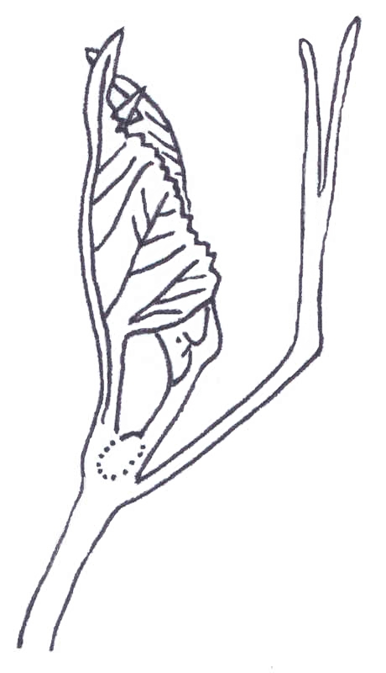  A  A  A | 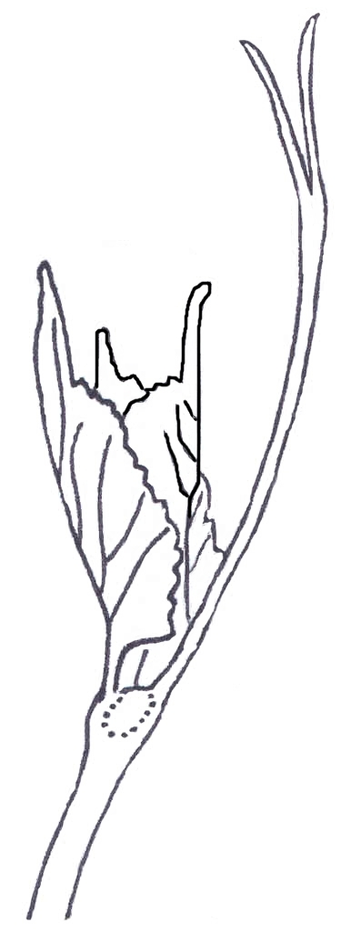 | 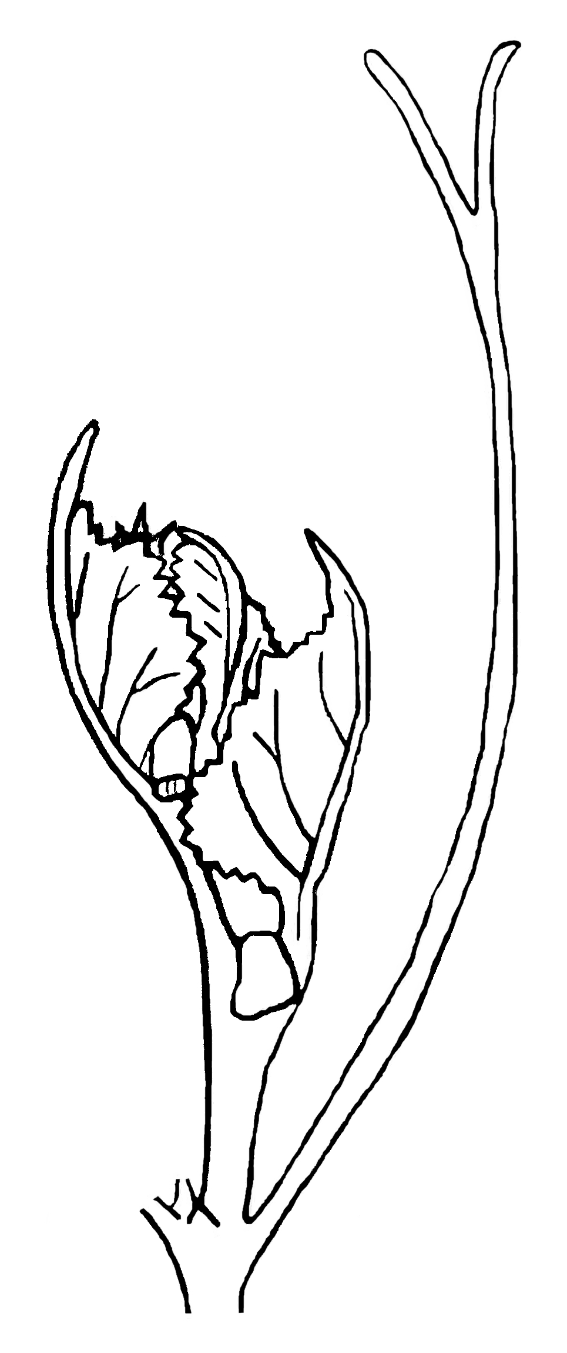
1 | 2 | 3
closed | slightly open | half open

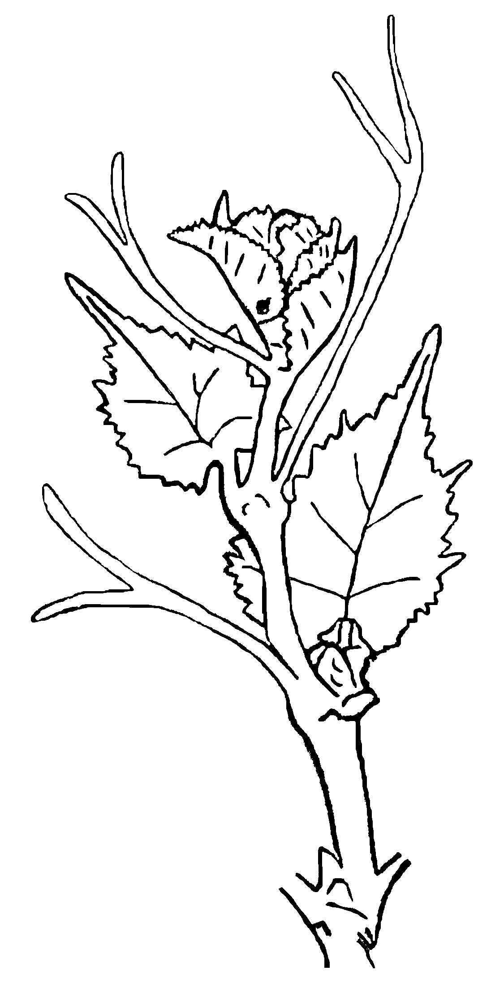  A  A | 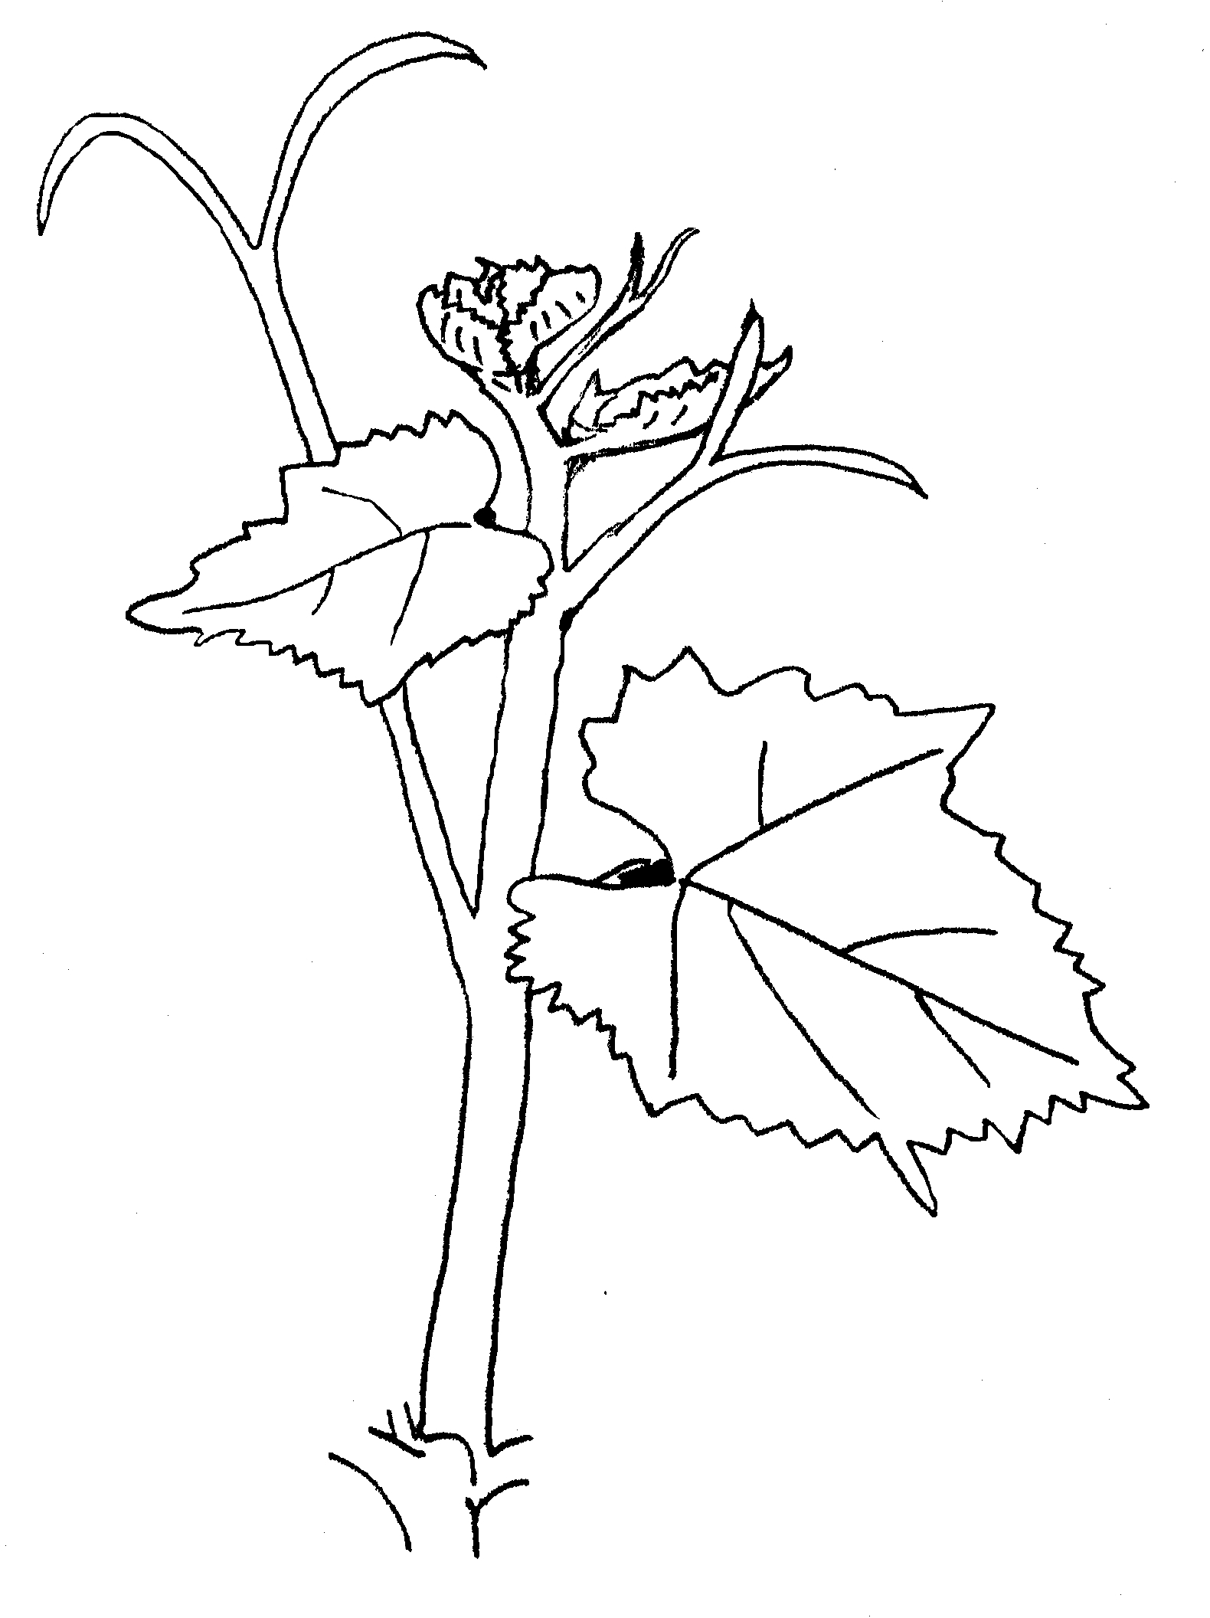
4 | 5
wide open | fully open

The openness of tip results from the attitude of the young leaves. The leaves indicated with ‘A’ have about the same physiological age. Openness of tip is correlated with elongation of the shoot tip.

Ad. 3: Young shoot: prostrate hairs on tip
Ad. 4: Young shoot: anthocyanin coloration of prostrate hairs on tip
Ad. 5: Young shoot: erect hairs on tip

Wide open or fully open tips (characteristic 2) to be observed with inclusion of first 2 distal unfolded leaves. Leaves of closed, slightly open or half open tips to be unfolded to enable observations on corresponding part of tip.

Ad. 6: Young leaf: color of upper side of blade

Observation on first 2 distal unfolded leaves in case of closed, slightly open or half open tips (characteristic 2). Observation on first 4 distal unfolded leaves in case of wide open or fully open tips.
The states green with anthocyanin spots (3); light copper red (4); dark copper red (5); and wine red (6) correspond to an increasing amount of anthocyanin coloration.

Ad. 7: Young leaf: prostrate hairs between main veins on lower side of blade
Ad. 8: Young leaf: erect hairs on main veins on lower side of blade

Observation on second distal unfolded leaf in case of closed, slightly open or half open tips (characteristic 2). Observation on fourth distal unfolded leaf in case of wide open or fully open tips.

Ad. 9: Shoot: attitude (before tying)

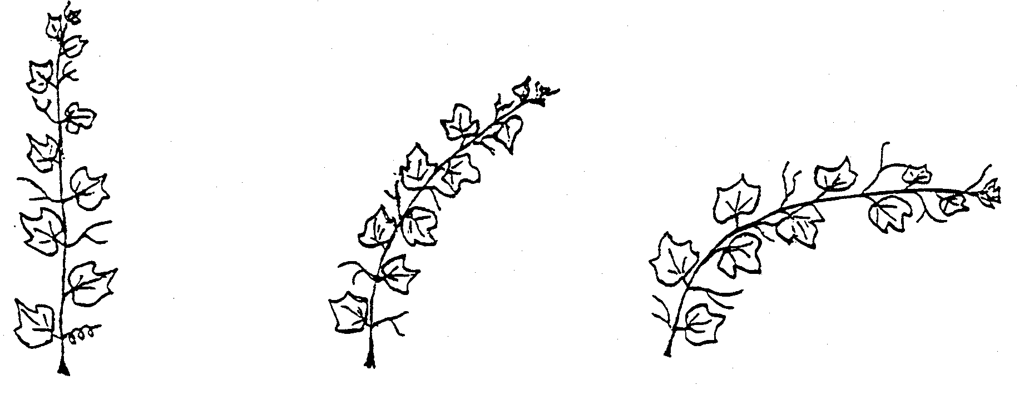
1 | 3 | 5
erect | semi-erect | horizontal
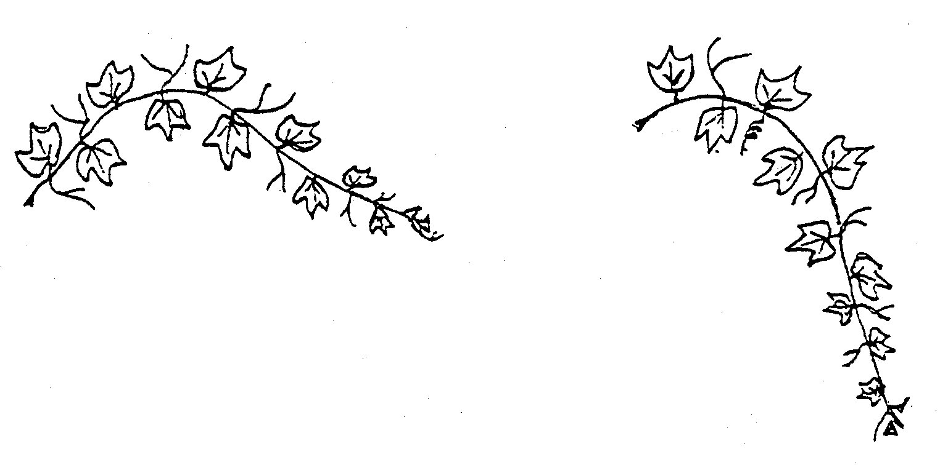
7 | 9
semi-drooping | drooping

Observation of this characteristic is difficult in windy locations where the shoots have to be tied early.

Ad. 10: Shoot: color of dorsal side of internodes
Ad. 11: Shoot: color of ventral side of internodes
Ad. 12: Shoot: color of dorsal side of nodes
Ad. 13: Shoot: color of ventral side of nodes

Cross section of shoot

dorsal side
(exposed to direct sunlight)
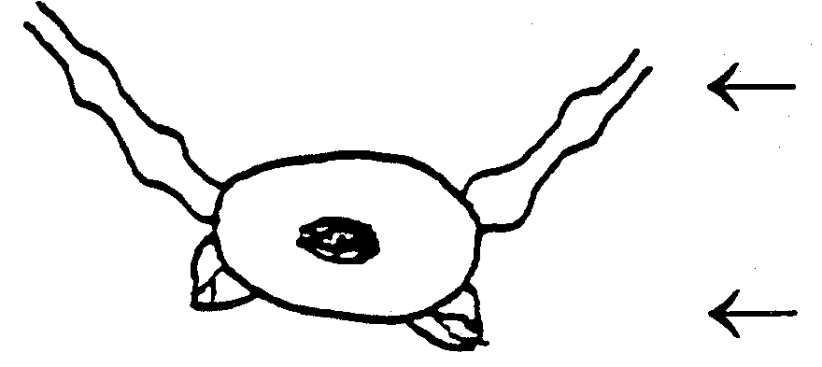 | axillary shoot  winter bud
ventral side
(not exposed to direct sunlight)

The states: green (1); green and red (2); and red (3) correspond to the proportion of anthocyanin coloration: absent or low (1); medium (2); and high (3).

Ad. 16: Flower: sexual organs

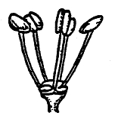 | 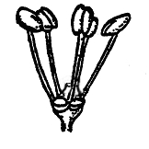
1 | 2
fully developed stamens  and no gynoecium | fully developed stamens  and reduced gynoecium

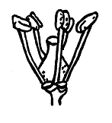 | 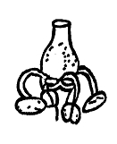
3 | 4
fully developed stamens  and fully developed gynoecium | reflexed stamens  and fully developed gynoecium

Ad. 18: Mature leaf: shape of blade

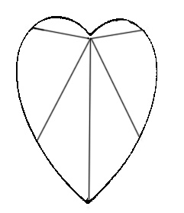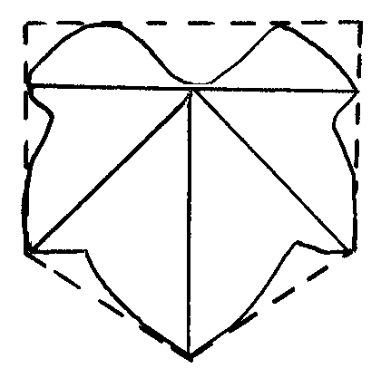

(rounded lateral outline) | (forms a pentagon with parallel sides)
1 | 2
cordate | wedge-shaped

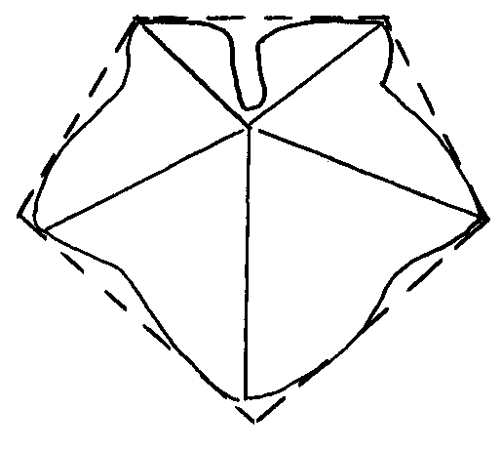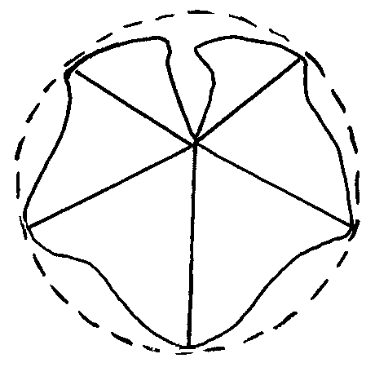

(forms a pentagon with broadest part towards the base) | (forms a pentagon with broadest part towards the apex)
3 | 4
pentagonal | circular

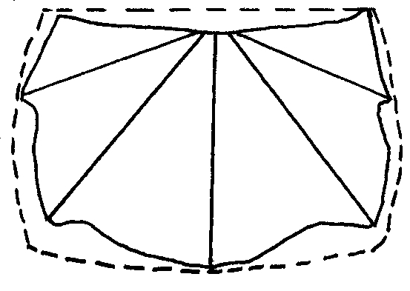

(broader than long)
5
kidney-shaped

Ad. 20: Mature leaf: number of lobes

A lobe is that part of the leaf which lies between two leaf sinuses. A leaf sinus results from a clear interruption of teeth on the leaf margin. A leaf showing no lateral sinus is considered to consist of one lobe.

Within the same plant leaves with different number of lobes can appear. The predominant number of lobes has to be observed.

Ad. 21: Mature leaf: depth of upper lateral sinuses
Ad. 22: Only varieties with lobed leaves: Mature leaf: arrangement of lobes of upper lateral sinuses

A sinus results from a clear interruption of teeth on the leaf margin. The upper lateral sinuses are situated between the middle vein and the next lateral main vein.

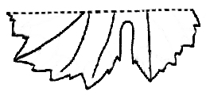 | 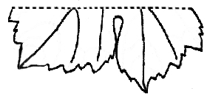
1 | 2
open | closed

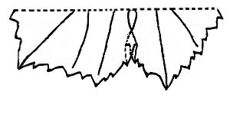 | 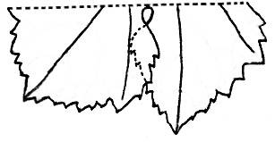
3 | 4
slightly overlapped | strongly overlapped

Ad. 23: Mature leaf: arrangement of lobes of petiole sinus

Leaves must be flattened for notation.

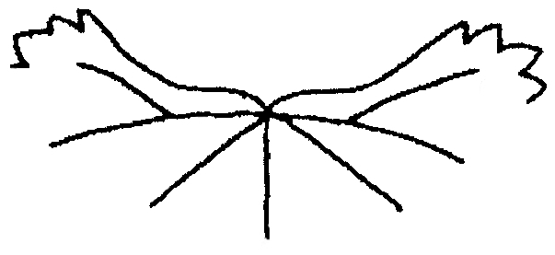 | 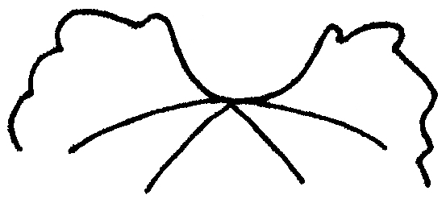 | 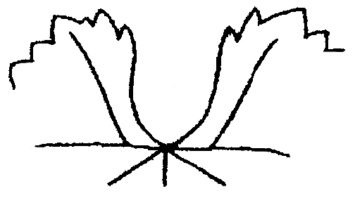
1 | 2 | 3
very wide open | wide open | half open

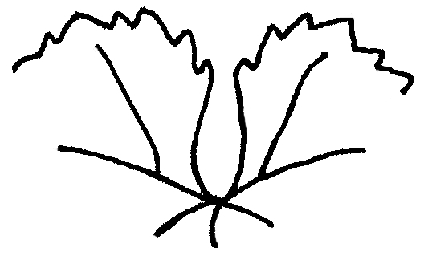 | 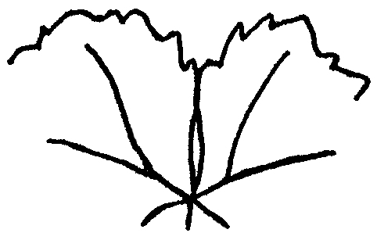 | 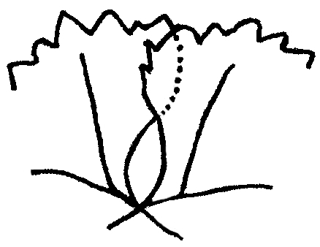
4 | 5 | 6
slightly open | closed | slightly overlapped

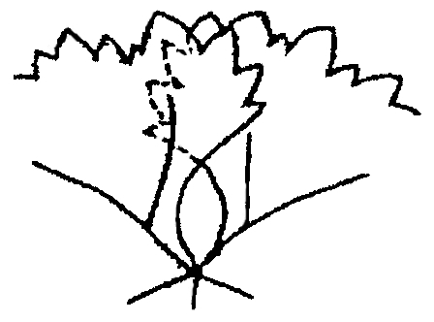 | 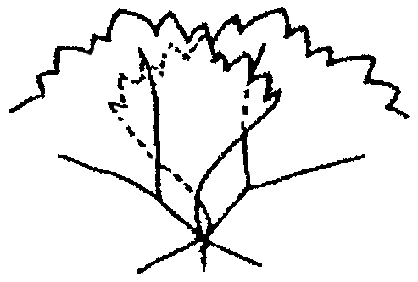 | 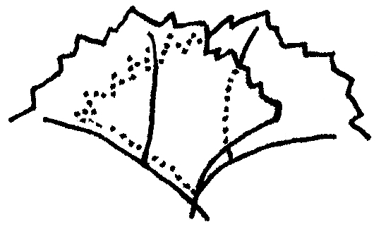
7 | 8 | 9
half overlapped | strongly overlapped | very strongly overlapped

Ad. 24: Mature leaf: length of teeth
Ad. 25: Mature leaf: ratio length/width of teeth
Ad. 26: Mature leaf: shape of teeth

All observations should be made between lateral main veins on the teeth of secondary veins.

Ad. 26: Mature leaf: shape of teeth

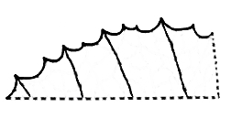 | 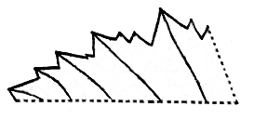
1 | 2
both sides concave | both sides straight

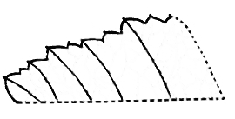 | 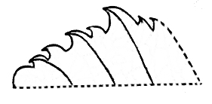
3 | 4
both sides convex | one side concave, one side convex

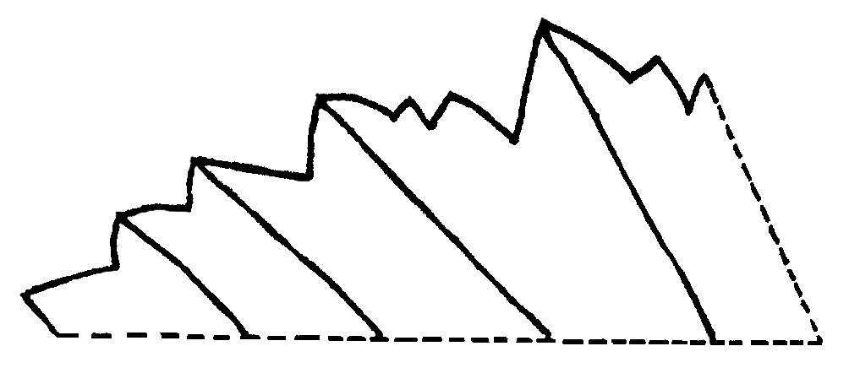
5
mixture of both sides straight and both sides convex

Ad. 27: Mature leaf: proportion of main veins on upper side of blade with anthocyanin coloration

The characteristic should be observed as the proportion of the total length of main veins with anthocyanin coloration. Interruptions in the anthocyanin coloration should not be included in that proportion.

Ad. 30: Mature leaf: length of petiole compared to length of middle vein

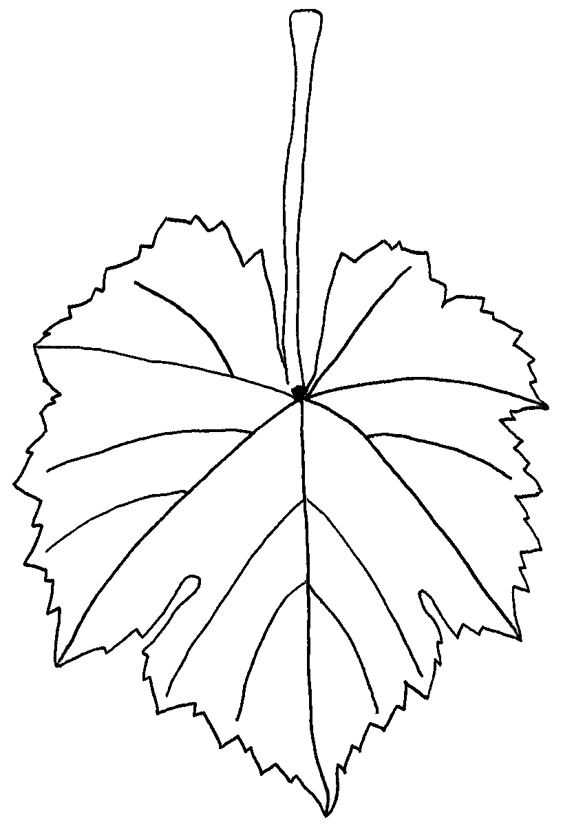  a  b | a = length of petiole  b = length of middle vein

Ad. 31: Time of beginning of berry ripening

To be observed when about 50% of the berries on 50% of the plants start to become soft. Berries will be deformed when lightly pressed between fingers.

Ad. 33: Bunch: density

1 = berries in grouped formation, many visible pedicels
3 = single berries, some pedicels visible
5 = densely distributed berries, pedicels not visible, berries movable
7 = berries not readily movable
9 = berries pressed out of shape.
Ad. 34: Bunch: length of peduncle of primary bunch

The distance from insertion point of peduncle on shoot to 1st ramification of primary bunch should be measured. Above the 1st ramification there is a knot like thickening on the peduncle from which a secondary bunch or a tendril may arise which should not be confused with the 1st ramification.

length of peduncle | 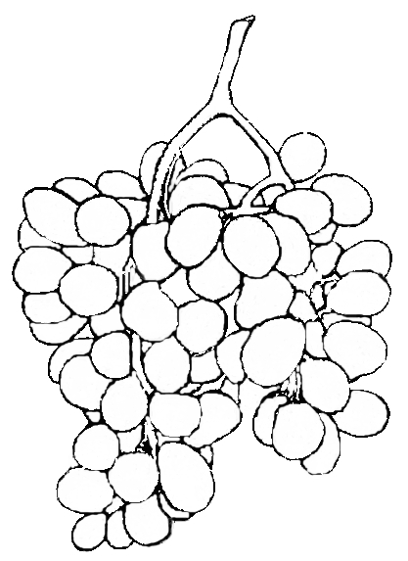 | knot of the bunch peduncle
primary bunch |  | secondary bunch

Ad. 36: Berry: shape

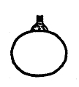 | 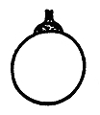 | 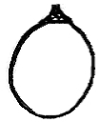
1 | 2 | 3
obloid | globose | broad ellipsoid

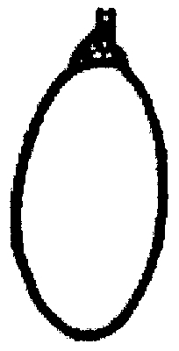 | 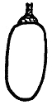 | 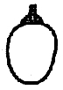
4 | 5 | 6
narrow ellipsoid | cylindrical | obtuse ovoid

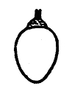 | 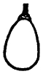 | 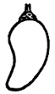 | 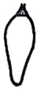
7 | 8 | 9 | 10
ovoid | obovoid | horn-shaped | finger-shaped

Ad. 43: Berry: formation of seeds

1 = no formation of seeds (parthenocarpic, type Corinthe)
2 = seeds with soft seed coat, embryo or endosperm not completely developed
(stenospermocarpic, type Sultanina)
3 = seeds fully developed

Encoding and Description of the Phenological Stages of Grapevine According to the Extended BBCH Scale
BBCH-Code | Description
Principal growth stage 0 | Sprouting/Bud development
00 | Dormancy: winter buds pointed to rounded, light or dark brown according to cultivar; bud scales more or less closed according to cultivar
01 | Beginning of bud swelling: buds begin to expand inside the bud scales
03 | End of bud swelling: buds swollen, but not green
05 | “Wool stage”: brown wool clearly visible
07 | Beginning of bud burst: green shoot tips just visible
09 | Bud burst: green shoot tips clearly visible
Principal growth stage 1 | Leaf development
11 | First leaf unfolded and spread away from shoot
12 | 2nd leaves unfolded
13 | 3rd leaves unfolded
1- | Stages continuous till …
19 | 9 or more leaves unfolded
Principal growth stage 5 | Inflorescence emerge
53 | Inflorescences clearly visible
55 | Inflorescences swelling, flowers closely pressed together
57 | Inflorescences fully developed, flowers separating
Principal growth stage 6 | Flowering
60 | First flowerhoods detached from the receptacle
61 | Beginning of flowering: 10% of flowerhoods fallen
62 | 20% of flowerhoods fallen
63 | Early flowering: 30% of flowerhoods fallen
64 | 40% of flowerhoods fallen
65 | Full flowering: 50% of flowerhoods fallen
66 | 60% of flowerhoods fallen
67 | 70% of flowerhoods fallen
68 | 80% of flowerhood fallen
69 | End of flowering
Principal growth stage 7 | Development of fruits
71 | Fruit set: young fruits begin to swell, remains of flowers lost
73 | Berries groat-sized, bunches begin to hang
75 | Berries pea-sized, bunches hang
77 | Berries beginning to touch
79 | Majority of berries touching
Principal growth stage 8 | Ripening of berries
81 | Beginning of ripening: berries begin to develop variety-specific color
83 | Berries developing color
85 | Softening of berries
89 | Berries ripe for harvest
Principal growth stage 9 | Senescence
91 | After harvest; end of wood maturation
92 | Beginning of leaf discolouration
93 | Beginning of leaf-fall
95 | 50% of leaves fallen
97 | End of leaf-fall
99 | Harvested product

8.4 Synonyms and skin color of berry for example varieties
Example Varieties | Skin color of berry * | Synonyms
Ahmeur bou Ahmeur | Rs
Airen | B
Albillo Real | B
Alicante Bouschet | N | Garnacha Tintorera
Alphonse Lavallée | N | Ribier
Aramon noir | N
Aspiran | N
Aubun | N
Auxerrois | B
Barbera | N
Bicane | B
Black finger | N
Blauer Portugieser | N | Portugais bleu, Modry Portugal
Bobal | N
Brancellao | N
Cabernet Franc | N
Cabernet Mitos | N
Cabernet Sauvignon | N
Cardinal | Rg
Carignan | N | Cariñena, Mazuela
Chardonnay | B
Chasan | B
Chasselas blanc | B | Weisser Gutedel
Chasselas Cioutat | B
Chasselas rose | Rs | Roter Gutedel
Chenin blanc | B
Clairette | B
Corinthe noir | N | Black Corinth, Corinto nero, Korinthiaki,  Corinto negro
Deckrot | N
Domina | N
Dornfelder | N
Emperor | Rg
Folle blanche | B
Freisa | N
Furmint | B
Gamay | N
Gamay de Bouze | N
Gamay de Chaudenay | N
Garnacha tinta | N | Grenache noir
Gewürztraminer | Rs | Roter Traminer, Traminer aromatico,  Tramin cervený
Hebron | B
Isabella | N
Italia | B
Kahlili belyi | B
King Husainy | B | Jade seedless
Lipovina | B | Harslevelu
Malvar | B
Marsanne | B
Melon | B
Merlot | N
Meunier | N | Müllerrebe, Pinot meunier
Molinera gorda | Rg
Moscatel de grano menudo rojo | Rs
Mourvedre | N
Müller Thurgau | B | Rivaner
Muscat à petits grains blancs | B | Gelber Muskateller, Moscatel de grano menudo, Moschato aspro, Muscat blanc
Muscat of Alexandria | B | Hanepoot, Zibibbo, Moscatel de Alejandría, Moscatel de Málaga, Moscatel romano
Muscat Ottonel | B
Nehelescol | B
Nero | N
Ohanes | B
Olivette noir | N
Palatina | B
Perle de Csaba | B | Csaba gyöngye
Petit Verdot | N
Pinot gris | G | Grauburgunder, Pinot grigio, Ruländer
Pinot noir | N | Blauer Spätburgunder, Pinot nero, Rulandské sedé
Portugieser | N
Riesling | B | Riesling renano, Rheinriesling, Weisser Riesling,  Ryzlink rýnský
Sangiovese | N
Santa Paula | B
Sauvignon | B
Semillon | B
Servant | B
Silvaner | B
Sugraone | B | Superior Seedless
Sultanina | B | Thompson Seedless, Sultanine B
Tompa | B
Trebiano Toscano | B
Uva rara | N
Vermentino | B

* The color of the berry is indicated according to the standardized code used within the European
Union for the classification of vine varieties:

B = white
G = grey
N = black
Rg = red
Rs = rose

Literature
Ambrosi, H. et al., 1994: Farbatlas Rebsorten. Verlag Eugen Ulmer, Stuttgart, DE.

Borrego Polanco, J. et al., 1990: Descripciones ampelográficas nacionales. Servicio de Investigación Agraria de la Comunidad de Madrid, Madrid, ES.

Bundessortenamt (editor), 2000: Beschreibende Sortenliste Reben. Landbuch-Verlag, Hannover, DE.

Cabello, F. et al., 2003: La colección de variedades de vid de El Encín. Instituto Madrileño de Investigación Agraria y Alimentaria, Madrid, ES.

Catalogue des variétés et des clones cultivés en France, 2ème édition, Institut Français de la Vigne et du Vin INRA-Montpellier SupAgro-VINIFLHOR, 2007

Chomé, P. et al., 2003: Variedades de vid. Registro de variedades comerciales. Centro de publicaciones del Ministerio de Agricultura, Pesca y Alimentación, Madrid, ES.

CTPS – Ministère de l’Agriculture de la Pêche et de l’Alimentation, 199: Catalogue des variétés et clones de vigne cultivés en France. ENTAV (editor), Le Grau du Roi, FR.

Galet, P., 1988: Cépages et vignobles de France, tome 1: Les vignes américaines. 2e édition, imprimerie Charles Dehan, Montpellier, FR.

Galet, P., 1990: Cépages et vignobles de France, tome 2: L’ampélographie française. 2e édition, imprimerie Charles Dehan, Montpellier, FR.

Garcia de Luján, A. et al. 2004: Catálogo de variedades y clones de vid de Andalucía. Junta de Andalucía, Consejería de Agricultura y Pesca, Sevilla, ES.

Goethe, H., 1887: Handbuch der Ampelographie. 2. Auflage, Verlag Paul Parey, Berlin, DE.

IRZ Geilweilerhof, 2007: Vitis. International Variety Catalogue (VIVC), http://www.vivc.bafz.de/index.php

IPGRI, 1997: Descriptors for Grapevine (Vitis spp.). International Plant Genetic Resources Institute, Via delle Sette Chiese142, 00145 Rome, IT, p. 62.

Lawrence, Eleanor, 1994: Henderson’s Dictionary of Biological Terms. 10th edition, Longman Scientific and Technical.

Lorenz, D.H. et al., 1994: Phänologische Entwicklungsstadien der Weinrebe (Vitis vinifera L. ssp. vinifera). Codierung und Beschreibung nach der erweiterten BBCH-Skala. Vitic. Enol. Sci. 49 (2), pp. 66-70.

Meier, U., 1997: Growth stages of mono- and dicotyledonous plants. BBCH-Monograph, Blackwell Science, Berlin, Vienna, a.o., 622 pp.

Moog, H., 1957: Einführung in die Rebsortenkunde. Verlag Eugen Ulmer, Stuttgart, DE.

OIV, 2007: Descriptor List for Grapevine Varieties and Vitis Species. Office International de la Vigne et du Vin, 18, rue d’Aguesseau, 75008 Paris, FR.

Ortiz Marcide, J.M., et al., 1999: Identificación molecular de Germoplasma de Vid. Instituto Madrileño de Investigación Agraria y Alimentaria, Jornadas de Agronomía, Madrid, ES.

Stern, William T., 1995: Botanical Latin. 4th edition, David and Charles Publishers.

Viala, P. et al., 1901-1910: Ampélographie. Tome 1-7, Editeurs Masson et Cie, Paris, FR.

Technical Questionnaire
TECHNICAL QUESTIONNAIRE |  |  |  | Page {x} of {y} |  | Reference Number:
 |  |  |  |  |  | Application date:
 |  |  |  |  |  | (not to be filled in by the applicant)
TECHNICAL QUESTIONNAIRE
to be completed in connection with an application for plant breeders’ rights

1. Subject of the Technical Questionnaire
1.1 Botanical name |  |  | Vitis L.
Please specify species: ......................................................................................
1.2 Common name |  |  | Grapevine
2. Applicant
Name
Address
Telephone No.
Fax No.
E-mail address
Breeder (if different from applicant)
3. Proposed denomination and breeder’s reference
Proposed denomination
(if available)

Breeder’s reference
#4. Information on the breeding scheme and propagation of the variety

4.1 Breeding scheme

Variety resulting from:

4.1.1 Crossing

(a) controlled cross [ ]
(please state parent varieties)
.................................................................................

(b) partially known cross [ ]
(please state known parent variety(ies))
.................................................................................

(c) unknown cross [ ]

4.1.2 Mutation [ ]
(please state parent variety)
...........................................................................................

4.1.3 Discovery and development [ ]
(please state where and when discovered
and how developed)
...........................................................................................

4.1.4 Other [ ]
(please provide details)
...........................................................................................

4.2 Method of propagating the variety

(a) cuttings [ ]

(b) in vitro propagation [ ]

(c) other (state method) [ ]
.................................................................................

5. Characteristics of the variety to be indicated (the number in brackets refers to the corresponding characteristic in Test Guidelines; please mark the note which best corresponds).

 | Characteristics |  |  |  |  |  |  | Example Varieties |  |  | Note
5.1  (2) | Young shoot: openness of tip
 | closed |  |  |  |  |  |  | Riparia Gloire de Montpellier |  |  | 1[ ]
 | slightly open |  |  |  |  |  |  | 3309 Couderc |  |  | 2[ ]
 | half open |  |  |  |  |  |  | Kober 5 BB |  |  | 3[ ]
 | wide open |  |  |  |  |  |  | Cina |  |  | 4[ ]
 | fully open |  |  |  |  |  |  | Pinot noir, Riesling |  |  | 5[ ]
5.2  (6) | Young leaf: color of upper side of blade
 | yellow green |  |  |  |  |  |  | Furmint |  |  | 1[ ]
 | green |  |  |  |  |  |  | Silvaner |  |  | 2[ ]
 | green with anthocyanin spots |  |  |  |  |  |  | Riesling |  |  | 3[ ]
 | light copper red |  |  |  |  |  |  | Kober 5 BB |  |  | 4[ ]
 | dark copper red |  |  |  |  |  |  | Chasselas blanc |  |  | 5[ ]
 | wine red |  |  |  |  |  |  | Deckrot |  |  | 6[ ]
5.3  (7) | Young leaf: prostrate hairs between main veins on lower side of blade
 | absent or very sparse |  |  |  |  |  |  | Rupestris du Lot |  |  | 1[ ]
 | sparse |  |  |  |  |  |  | Muscat à petits grain blancs |  |  | 3[ ]
 | medium |  |  |  |  |  |  | Merlot, Riesling |  |  | 5[ ]
 | dense |  |  |  |  |  |  | Clairette |  |  | 7[ ]
 | very dense |  |  |  |  |  |  | Meunier |  |  | 9[ ]
 | Characteristics |  |  |  |  |  |  | Example Varieties |  |  | Note
5.4  (16) | Flower: sexual organs
 | fully developed stamens and no gynoecium |  |  |  |  |  | Rupestris du Lot |  |  |  | 1[ ]
 | fully developed stamens and reduced gynoecium |  |  |  |  |  | 3309 Couderc |  |  |  | 2[ ]
 | fully developed stamens and fully developed gynoecium |  |  |  |  |  | Chasselas blanc |  |  |  | 3[ ]
 | reflexed stamens and fully developed gynoecium |  |  |  |  |  | Kober 5 BB, Ohanes |  |  |  | 4[ ]
5.5  (20) | Mature leaf: number of lobes
 | one |  |  |  |  |  | Rupestris du Lot |  |  |  | 1[ ]
 | three |  |  |  |  |  | Chenin blanc |  |  |  | 2[ ]
 | five |  |  |  |  |  | Chasselas blanc |  |  |  | 3[ ]
 | seven |  |  |  |  |  | Vermentino |  |  |  | 4[ ]
 | more than seven |  |  |  |  |  | Hebron |  |  |  | 5[ ]
5.6  (31) | Time of beginning of berry ripening
 | very early |  |  |  |  |  | Perle de Csaba |  |  |  | 1[ ]
 | early |  |  |  |  |  | Pinot noir |  |  |  | 3[ ]
 | medium |  |  |  |  |  | Riesling |  |  |  | 5[ ]
 | late |  |  |  |  |  | Carignan |  |  |  | 7[ ]
 | very late |  |  |  |  |  | Olivette noire |  |  |  | 9[ ]
 | Characteristics |  |  |  |  |  |  | Example Varieties |  |  | Note
5.7  (36) | Berry: shape
 | obloid |  |  |  |  |  |  | Tompa |  |  | 1[ ]
 | globose |  |  |  |  |  | Chasselas blanc |  |  |  | 2[ ]
 | broad ellipsoid |  |  |  |  |  | Müller Thurgau |  |  |  | 3[ ]
 | narrow ellipsoid |  |  |  |  |  | Olivette noire |  |  |  | 4[ ]
 | cylindrical |  |  |  |  |  | Kahlili belyi |  |  |  | 5[ ]
 | obtuse ovoid |  |  |  |  |  | Ahmeur bou Ahmeur |  |  |  | 6[ ]
 | ovoid |  |  |  |  |  | Bicane |  |  |  | 7[ ]
 | obovoid |  |  |  |  |  |  |  |  |  | 8[ ]
 | horn-shaped |  |  |  |  |  | Santa Paula |  |  |  | 9[ ]
 | finger-shaped |  |  |  |  |  | Black finger |  |  |  | 10[ ]
5.8  (37) | Berry: color of skin (without bloom)
 | green |  |  |  |  |  | King Husainy |  |  |  | 1[ ]
 | yellow green |  |  |  |  |  |  | Chasselas blanc |  |  | 2[ ]
 | yellow |  |  |  |  |  | Palatina |  |  |  | 3[ ]
 | yellow rose |  |  |  |  |  | Moscatel de grano menudo rojo |  |  |  | 4[ ]
 | rose |  |  |  |  |  | Chasselas rose |  |  |  | 5[ ]
 | red |  |  |  |  |  | Molinera gorda |  |  |  | 6[ ]
 | grey red |  |  |  |  |  | Pinot gris |  |  |  | 7[ ]
 | dark red violet |  |  |  |  |  | Cardinal |  |  |  | 8[ ]
 | blue black |  |  |  |  |  | Pinot noir |  |  |  | 9[ ]
 | Characteristics |  |  |  |  |  |  | Example Varieties |  |  | Note
5.9  (40) | Berry: anthocyanin coloration of flesh
 | absent or very weak |  |  |  |  |  | Pinot noir |  |  |  | 1[ ]
 | weak |  |  |  |  |  | Gamay de Bouze |  |  |  | 3[ ]
 | medium |  |  |  |  |  | Gamay de Chaudenay |  |  |  | 5[ ]
 | strong |  |  |  |  |  | Alicante Bouschet |  |  |  | 7[ ]
 | very strong |  |  |  |  |  | Deckrot |  |  |  | 9[ ]
5.10  (42) | Berry: particular flavor
 | none |  |  |  |  |  | Auxerrois |  |  |  | 1[ ]
 | muscat |  |  |  |  |  | Muscat of Alexandria |  |  |  | 2[ ]
 | foxy |  |  |  |  |  | Isabella |  |  |  | 3[ ]
 | herbaceous |  |  |  |  |  | Cabernet Sauvignon |  |  |  | 4[ ]
 | other than muscat, foxy or herbaceous |  |  |  |  |  | Chardonnay, Merlot, Pinot noir, Riesling |  |  |  | 5[ ]
5.11  (43) | Berry: formation of seeds
 | none |  |  |  |  |  |  | Corinthe noir |  |  | 1[ ]
 | rudimentary |  |  |  |  |  |  | Sultanina |  |  | 2[ ]
 | complete |  |  |  |  |  | Riesling |  |  |  | 3[ ]
6. Similar varieties and differences from these varieties

Please use the following table and box for comments to provide information on how your candidate variety differs from the variety (or varieties) which, to the best of your knowledge, is (or are) most similar. This information may help the examination authority to conduct its examination of distinctness in a more efficient way.

Denomination(s) of variety(ies) similar to your candidate variety |  | Characteristic(s) in which your candidate variety differs from the similar variety(ies) |  |  | Describe the expression of the characteristic(s) for the similar variety(ies) |  |  |  | Describe the expression of the characteristic(s) for your candidate variety
Example |  | Berry: shape |  |  | globose |  |  |  | broad ellipsoid
Comments:

#7. Additional information which may help in the examination of the variety

7.1 In addition to the information provided in sections 5 and 6, are there any additional characteristics which may help to distinguish the variety?

Yes [ ] No [ ]
..................................................................................................
(If yes, please provide details)

7.2 Are there any special conditions for growing the variety or conducting the examination?

Yes [ ] No [ ]
..................................................................................................
(If yes, please provide details)

7.3 Other information

7.3.1 Fungicide treatment is necessary against the following diseases:

yes no sometimes unknown

(a) Peronospora (Plasmopara) [ ] [ ] [ ] [ ]
(b) Oidium [ ] [ ] [ ] [ ]
(c) Botrytis [ ] [ ] [ ] [ ]

7.3.2 Main use of variety

(a) Wine grape [ ]
(b) Table grape [ ]
(c) Rootstock [ ]
(d) Ornamental [ ]
(e) Other (specify) [ ]

7.3.3 A representative color photograph of the variety should accompany the Technical Questionnaire.

8. Authorization for release

(a) Does the variety require prior authorization for release under legislation concerning the protection of the environment, human and animal health?

Yes [ ] No [ ]

(b) Has such authorization been obtained?

Yes [ ] No [ ]

If the answer to (b) is yes, please attach a copy of the authorization.

9. Information on plant material to be examined or submitted for examination.

9.1 The expression of a characteristic or several characteristics of a variety may be affected by factors, such as pests and disease, chemical treatment (e.g. growth retardants or pesticides), effects of tissue culture, different rootstocks, scions taken from different growth phases of a tree, etc.

9.2 The plant material should not have undergone any treatment which would affect the expression of the characteristics of the variety, unless the competent authorities allow or request such treatment. If the plant material has undergone such treatment, full details of the treatment must be given. In this respect, please indicate below, to the best of your knowledge, if the plant material to be examined has been subjected to:

(a) Microorganisms (e.g. virus, bacteria, phytoplasma) Yes [ ] No [ ]

(b) Chemical treatment (e.g. growth retardant, pesticide) Yes [ ] No [ ]

(c) Tissue culture Yes [ ] No [ ]

(d) Other factors Yes [ ] No [ ]

Please provide details for where you have indicated “yes”.

……………………………………………………………

9.3 Has the plant material to be examined been tested for the presence of virus or other pathogens?

Yes [ ]
....................................................................................
(please provide details)

No [ ]

10. I hereby declare that, to the best of my knowledge, the information provided in this form is correct:

Applicant’s name

Signature Date

[End of document]

* These names were correct at the time of the introduction of these Test Guidelines but may be revised or updated. [Readers are advised to consult the UPOV Code, which can be found on the UPOV Website (www.upov.int), for the latest information.]
IPGRI now operates under the name “Bioversity International”.
? The code has been jointly developed by Biologische Bundesanstalt für Land- und Forstwirtschaft (BB), Bundessortenamt (BSA) and Industrieverband Agrar (IVA) in cooperation with Staatliche Lehr- und Forschungsanstalt für Landwirtschaft, Wein und Gartenbau (SLFA), Section Plant Pathology, Neustadt/Weinstraße. Published in Lorenz et al., 1994, and in Meier, 1997 (see Literature).
# Authorities may allow certain of this information to be provided in a confidential section of the Technical Questionnaire.
# Authorities may allow certain of this information to be provided in a confidential section of the Technical Questionnaire.

