 |  | E  TG/49/8 Rev.  ORIGINAL: English  DATE: 2007-03-28 + 2015-03-25  + 2023-10-24
INTERNATIONAL UNION FOR THE PROTECTION OF NEW VARIETIES OF PLANTS
GENEVA

 | CARROT  UPOV Code: DAUCU_CAR  Daucus carota L. | *

GUIDELINES

FOR THE CONDUCT OF TESTS

FOR DISTINCTNESS, UNIFORMITY AND STABILITY

Alternative Names:*

Botanical name | English | French | German | Spanish
Daucus carota L. | Carrot | Carotte | Möhre | Zanahoria

The purpose of these guidelines (“Test Guidelines”) is to elaborate the principles contained in the General Introduction (document TG/1/3), and its associated TGP documents, into detailed practical guidance for the harmonized examination of distinctness, uniformity and stability (DUS) and, in particular, to identify appropriate characteristics for the examination of DUS and production of harmonized variety descriptions.

ASSOCIATED DOCUMENTS

These Test Guidelines should be read in conjunction with the General Introduction and its associated TGP documents.
TABLE OF CONTENTS PAGE

1. Subject of these Test Guidelines 3
2. Material Required 3
3. Method of Examination 3
3.1 Duration of Tests 3
3.2 Testing Place 3
3.3 Conditions for Conducting the Examination 3
3.4 Test Design 4
3.5 Number of Plants / Parts of Plants to be Examined 4
3.6 Additional Tests 4
4. Assessment of Distinctness, Uniformity and Stability 4
4.1 Distinctness 4
4.2 Uniformity 5
4.3 Stability 5
5. Grouping of Varieties and Organization of the Growing Trial 6
6. Introduction to the Table of Characteristics 6
6.1 Categories of Characteristics 6
6.2 States of Expression and Corresponding Notes 6
6.3 Types of Expression 7
6.4 Example Varieties 7
6.5 Legend 7
7. Table of Characteristics/Tableau des caractères/Merkmalstabelle/Tabla de caracteres 8
8. Explanations on the Table of Characteristics 19
8.1 Explanations for covering several characteristics 19
8.2 Explanations for individual characteristics 19
9. Literature 23
10. Technical Questionnaire 24

Subject of these Test Guidelines
These Test Guidelines apply to all varieties of Daucus carota L.

Material Required
2.1 The competent authorities decide on the quantity and quality of the plant material required for testing the variety and when and where it is to be delivered. Applicants submitting material from a State other than that in which the testing takes place must ensure that all customs formalities and phytosanitary requirements are complied with.

2.2 The material is to be supplied in the form of seed.

2.3 The minimum quantity of plant material, to be supplied by the applicant, should be:

50 g or 50,000 seeds.

2.4 The seed should meet the minimum requirements for germination, species and analytical purity, health and moisture content, specified by the competent authority.

2.5 The plant material supplied should be visibly healthy, not lacking in vigor, nor affected by any important pest or disease.

2.6 The plant material should not have undergone any treatment which would affect the expression of the characteristics of the variety, unless the competent authorities allow or request such treatment. If it has been treated, full details of the treatment must be given.

Method of Examination

3.1 Duration of Tests
The minimum duration of tests should normally be two independent growing cycles.

3.2 Testing Place
Tests are normally conducted at one place. In the case of tests conducted at more than one place, guidance is provided in TGP/9 “Examining Distinctness”.

3.3 Conditions for Conducting the Examination
3.3.1 The tests should be carried out under conditions ensuring satisfactory growth for the expression of the relevant characteristics of the variety and for the conduct of the examination.

3.3.2 The recommended method of observing the characteristic is indicated by the following key in the second column of the Table of Characteristics:

MG: single measurement of a group of plants or parts of plants
MS: measurement of a number of individual plants or parts of plants
VG: visual assessment by a single observation of a group of plants or parts of plants
VS: visual assessment by observation of individual plants or parts of plants

3.4 Test Design
3.4.1 Each test should be designed to result in a total of at least 400 plants, which should be divided between two or more replicates.

3.4.2 The design of the tests should be such that plants or parts of plants may be removed for measurement or counting without prejudice to the observations which must be made up to the end of the growing cycle.

3.5 Number of Plants / Parts of Plants to be Examined
Unless otherwise indicated, all observations should be made on 40 plants or parts taken from each of 40 plants and any other observations made on all plants in the test.

3.6 Additional Tests
Additional tests, for examining relevant characteristics, may be established.

Assessment of Distinctness, Uniformity and Stability

4.1 Distinctness

4.1.1 General Recommendations

It is of particular importance for users of these Test Guidelines to consult the General Introduction prior to making decisions regarding distinctness. However, the following points are provided for elaboration or emphasis in these Test Guidelines.

4.1.2 Consistent Differences

The differences observed between varieties may be so clear that more than one growing cycle is not necessary. In addition, in some circumstances, the influence of the environment is not such that more than a single growing cycle is required to provide assurance that the differences observed between varieties are sufficiently consistent. One means of ensuring that a difference in a characteristic, observed in a growing trial, is sufficiently consistent is to examine the characteristic in at least two independent growing cycles.

4.1.3 Clear Differences

Determining whether a difference between two varieties is clear depends on many factors, and should consider, in particular, the type of expression of the characteristic being examined, i.e. whether it is expressed in a qualitative, quantitative, or pseudo-qualitative manner. Therefore, it is important that users of these Test Guidelines are familiar with the recommendations contained in the General Introduction prior to making decisions regarding distinctness.

4.2 Uniformity
4.2.1 It is of particular importance for users of these Test Guidelines to consult the General Introduction prior to making decisions regarding uniformity. However, the following points are provided for elaboration or emphasis in these Test Guidelines:

4.2.2 Cross-pollinated varieties

The assessment of uniformity for cross-pollinated varieties should be according to the recommendations for cross-pollinated varieties in the General Introduction. For the characteristics external color of root (characteristic 13) and color of core of root (characteristic 19), a population standard of 2% and an acceptance probability of 95% should be applied. In the case of a sample size of 200 plants, 7 off-types are allowed.

4.2.3 Single cross hybrids and inbred lines

For the assessment of uniformity of single cross hybrids and inbred lines, a population standard of 2% and an acceptance probability of at least 95% should be applied. In the case of a sample size of 400 plants, 13 off-types are allowed.

4.2.4 Hybrids

The assessment of uniformity for hybrid varieties depends on the type of hybrid and should be according to the recommendations for hybrid varieties in the General Introduction. In the case of single cross hybrids, the uniformity standards are set out in Section 4.2.3.

4.3 Stability
4.3.1 In practice, it is not usual to perform tests of stability that produce results as certain as those of the testing of distinctness and uniformity. However, experience has demonstrated that, for many types of variety, when a variety has been shown to be uniform, it can also be considered to be stable.

4.3.2 Where appropriate, or in cases of doubt, stability may be tested, either by growing a further generation, or by testing a new seed stock to ensure that it exhibits the same characteristics as those shown by the previous material supplied.

4.3.3 Where appropriate, or in cases of doubt, the stability of a hybrid variety may, in addition to an examination of the hybrid variety itself, also be assessed by examination of the uniformity and stability of its parent lines.

Grouping of Varieties and Organization of the Growing Trial
5.1 The selection of varieties of common knowledge to be grown in the trial with the candidate varieties and the way in which these varieties are divided into groups to facilitate the assessment of distinctness are aided by the use of grouping characteristics.

5.2 Grouping characteristics are those in which the documented states of expression, even where produced at different locations, can be used, either individually or in combination with other such characteristics: (a) to select varieties of common knowledge that can be excluded from the growing trial used for examination of distinctness; and (b) to organize the growing trial so that similar varieties are grouped together.

5.3 The following have been agreed as useful grouping characteristics:

(a) Leaf: length (including petiole) (characteristic 3)
(b) Root: length (characteristic 7)
(c) Root: width (characteristic 8)
(d) Root: shape in longitudinal section (characteristic 10)
(e) Root: tip (when fully developed) (characteristic 13)
(f) Root: external color (characteristic 14)
(g) Plants: proportion of male sterile plants (characteristic 31)
(h) Plant: type of male sterility (characteristic 32).

5.4 Guidance for the use of grouping characteristics, in the process of examining distinctness, is provided through the General Introduction.

Introduction to the Table of Characteristics

6.1 Categories of Characteristics
6.1.1 Standard Test Guidelines Characteristics

Standard Test Guidelines characteristics are those which are approved by UPOV for examination of DUS and from which members of the Union can select those suitable for their particular circumstances.

6.1.2 Asterisked Characteristics

Asterisked characteristics (denoted by *) are those included in the Test Guidelines which are important for the international harmonization of variety descriptions and should always be examined for DUS and included in the variety description by all members of the Union, except when the state of expression of a preceding characteristic or regional environmental conditions render this inappropriate.

6.2 States of Expression and Corresponding Notes
States of expression are given for each characteristic to define the characteristic and to harmonize descriptions. Each state of expression is allocated a corresponding numerical note for ease of recording of data and for the production and exchange of the description.

6.3 Types of Expression
An explanation of the types of expression of characteristics (qualitative, quantitative and pseudo-qualitative) is provided in the General Introduction.

6.4 Example Varieties
Where appropriate, example varieties are provided to clarify the states of expression of each characteristic.

6.5 Legend
(*) Asterisked characteristic – see Chapter 6.1.2

QL: Qualitative characteristic – see Chapter 6.3
QN: Quantitative characteristic – see Chapter 6.3
PQ: Pseudo-qualitative characteristic – see Chapter 6.3

MG, MS, VG, VS: See Chapter 3.3.2

(a)-(c) See Explanations on the Table of Characteristics in Chapter 8.1

(+) See Explanations on the Table of Characteristics in Chapter 8.2

Table of Characteristics/Tableau des caractères/Merkmalstabelle/Tabla de caracteres
 |  | English | français | Deutsch | español | Example Varieties/  Exemples/  Beispielssorten/  Variedades ejemplo | Note/  Nota
1.  (+) | VG | Foliage: width of crown | Feuillage: largeur de la couronne | Laub: Breite des Blattansatzes | Follaje: anchura del cuello
QN | (a) | narrow | étroite | schmal | estrecho | Amsterdam 2 | 3
 |  | medium | moyenne | mittel | medio | Nantaise améliorée 2, Rothild | 5
 |  | broad | large | breit | ancho | Chantenay à cœur rouge 2 | 7
2. | VG | Leaf: attitude | Feuille: port | Blatt: Stellung | Hoja: porte
QN | (a) | erect | dressé | aufrecht | erecto | Touchon | 1
 |  | semi-erect | demi-dressé | halbaufrecht | semierecto | Nantaise améliorée 2 | 3
 |  | prostrate | étalé | liegend | postrado |  | 5
3.  (*) | VG/  MS | Leaf: length (including petiole) | Feuille: longueur (pétiole compris) | Blatt: Länge (einschließlich Stiel) | Hoja: longitud (incluido el peciolo)
QN | (a) | very short | très courte | sehr kurz | muy corta | Mokum, Mignon | 1
 |  | short | courte | kurz | corta | Amsterdam 2, Amsterdam 3 | 3
 |  | medium | moyenne | mittel | media | Juwarot,  Nantaise améliorée 2 | 5
 |  | long | longue | lang | larga | Chantenay, Chantenay à cœur rouge 2 | 7
 |  | very long | très longue | sehr lang | muy large | De Colmar à cœur rouge 2, Rothild | 9
4.  (*) | VG | Leaf: division | Feuille: division | Blatt: Fiederung | Hoja: división
QN | (a) | fine | fine | fein | fina | Amsterdam 2, Amsterdam 3 | 3
 |  | medium | moyenne | mittel | mediana | Nantaise améliorée 2, Nantaise améliorée 3 | 5
 |  | coarse | grossière | grob | grosera | Hytop | 7
5.  (*) | VG | Leaf: intensity of green color | Feuille: intensité de la couleur verte | Blatt: Intensität der Grünfärbung | Hoja: intensidad del color verde
QN | (a) | light | claire | hell | claro | Adelaide, Leonor | 3
 |  | medium | moyenne | mittel | medio | Amsterdam 2, Amsterdam 3 | 5
 |  | dark | foncée | dunkel | oscuro | Rothild | 7
6.  (*) | VG | Leaf: anthocyanin coloration of petiole | Feuille: pigmentation anthocyanique du pétiole | Blatt: Anthocyan- färbung des Blattstiels | Hoja: pigmentación antociánica del pecíolo
QL | (a) | absent | absente | fehlend | ausente | Amsterdam 2 | 1
 |  | present | présente | vorhanden | presente | Tarenco | 9
7.  (*) | VG/  MS | Root: length | Racine: longueur | Rübe: Länge | Raíz: longitud
QN | (b) | very short | très courte | sehr kurz | muy corta | Parijse Markt 2,  Parijse Markt 3 | 1
 |  | short | courte | kurz | corta | Chantenay | 3
 |  | medium | moyenne | mittel | media | Nantaise améliorée 2, Nantaise améliorée 3 | 5
 |  | long | longue | lang | larga | Berlikumer 2, Berlikumer 3 | 7
 |  | very long | très longue | sehr lang | muy large | Lange Stompe Winter | 9
8.  (*) | VG/  MS | Root: width | Racine: largeur | Rübe: Breite | Raíz: anchura
QN | (b) | narrow | étroite | schmal | estrecha | Amsterdam 2, Amsterdam 3 | 3
 |  | medium | moyenne | mittel | media | Nantaise améliorée 2, Nantaise améliorée 3 | 5
 |  | broad | large | breit | ancha | De Colmar à cœur rouge 2,  Parijse Markt 2,  Parijse Markt 3 | 7
9.  (*) | VG/  MS | Root: ratio length/ width | Racine: rapport longueur/largeur | Rübe: Verhältnis Länge/Breite | Raíz: relación longitud/anchura
QN | (b) | very small | très petit | sehr klein | muy pequeña | Parijse Markt 2,  Parijse Markt 3, Parmex | 1
 |  | small | petit | klein | pequeña | Courte améliorée à forcer | 3
 |  | medium | moyen | mittel | media | Chantenay | 5
 |  | large | grand | groß | grande | Nantaise améliorée 2, Nantaise améliorée 3 | 7
 |  | very large | très grand | sehr groß | muy grande | Amsterdam 2 | 9
10.  (*)  (+) | VG | Root: shape in longitudinal section | Racine: forme en section longi-tudinale | Rübe: Form im Längsschnitt | Raíz: forma en sección longitudinal
PQ | (b) | circular | arrondie | kreisförmig | circular | Parijse Markt 2,  Parijse Markt 3 | 1
 |  | obovate | obovale | verkehrt eiförmig | oboval |  | 2
 |  | medium obtriangular | obtriangulaire moyen | mittel verkehrt dreieckig | obtriangular medio | Chantenay, De Colmar à cœur rouge 2 | 3
 |  | narrow obtriangular | obtriangulaire étroite | schmal verkehrt dreieckig | obtriángular estrecha | Imperator, De Colmar à cœur rouge 3 | 4
 |  | narrow obtriangular to narrow oblong | obtriangulaire étroite à rectangulaire  étroite | schmal verkehrt dreieckig bis schmal rechteckig | obtriángular estrecha a oblonga estrecha | Maestro | 5
 |  | narrow oblong | rectangulaire  étroite | schmal rechteckig | oblonga estrecha | Amsterdam 2, Berlikumer 2, Berlikumer 3,  Nantaise améliorée 5, Touchon | 6
11.  (+) | MS/  VG | Varieties scoring between 4 and 6  for characteristic 10 only: Root: tendency to conical shape | Variétés notées entre 4 et 6 pour le caractère 10 uniquement : Racine : tendance à avoir une forme conique | Sorten mit Benotung zwischen 4 und 6 nur für Merk-mal 10: Rübe: Neigung zu konischer Form | Únicamente las variedades con una nota entre 4 y 6 en el carácter 10: Raíz: tendencia a una forma cónica
QN | (b) | very weak | très faible | sehr gering | muy ligera |  | 1
 |  | weak | faible | gering | ligera | Amsterdam 2 | 3
 |  | medium | moyenne | mittel | media | Nantaise améliorée 2, Nantaise améliorée 3 | 5
 |  | strong | forte | stark | fuerte | Giganta | 7
 |  | very strong | très forte | sehr stark | muy fuerte |  | 9
12.  (*)  (+) | VG | Root: shape of shoulder | Racine: forme de l'épaulement | Rübe: Form des Kopfes | Raíz: forma del hombro
PQ | (b) | flat | plat | flach | plana | De Colmar à cœur rouge 2 | 1
 |  | flat to rounded | plat à arrondi | flach bis abgerundet | plana a redondeada | Parijse Markt 2 | 2
 |  | rounded | arrondi | abgerundet | redondeada |  | 3
 |  | rounded to conical | arrondi à conique | abgerundet bis kegelförmig | redondeada a cónica |  | 4
 |  | conical | conique | kegelförmig | cónica | Touchon | 5
13.  (*) | VG | Root: tip (when fully developed) | Racine: extrémité  (à plein développement) | Rübe: Ende (bei voller Entwicklung) | Raíz: punta (en pleno desarrollo)
QN | (b) | blunt | arrondie | stumpf | romo | Berlikumer 3 | 1
 |  | slightly pointed | légèrement pointue | leicht spitz | ligeramente puntiagudo | Mello Yello | 2
 |  | strongly pointed | fortement pointue | sehr spitz | muy puntiagudo | Allred, Orbit | 3
14.  (*) | VG | Root: external color | Racine: couleur externe | Rübe: äußere Farbe | Raíz: color externo
PQ | (b) | white | blanche | weiß | blanco | White Satin | 1
 |  | yellow | jaune | gelb | amarillo | Mello Yello | 2
 |  | orange | orange | orange | naranja | Bingo, Tancar, Goliath, Karotan, Pinocchio | 3
 |  | pinkish red | rouge rosâtre | rosarot | rojo rosado | Nutri-red | 4
 |  | red | rouge | rot | rojo | Pulsor | 5
 |  | purple | pourpre | purpurn | púrpura | Purple Haze | 6
15. | VG | Excluding varieties with white external root color: Root: intensity of external color | À l’exclusion des variétés à racine de couleur externe blanche : Racine : intensité de la couleur externe | Ohne Sorten mit weißer äußerer Farbe der Rübe: Rübe: Intensität der äußeren Farbe | Excluidas las variedades con color externo de la raíz blanco: Raíz: intensidad del color externo
QN | (b) | light | claire | hell | claro | Bingo. Mello Yello, Tancar | 3
 |  | medium | moyenne | mittel | medio | Goliath, Nutri-red | 5
 |  | dark | foncée | dunkel | oscuro | Karotan, Pinocchio, Purple Haze | 7
16. | VG | Root: anthocyanin coloration of skin of shoulder | Racine: pigmentation anthocyanique de la peau du collet | Rübe: Antho-cyanfärbung der Haut des Kopfes | Raíz: pigmentación antociánica de la epidermis del hombro
QL | (b) | absent | absente | fehlend | ausente | Trevor | 1
 |  | present | présente | vorhanden | presente | Touchon | 9
17.  (+) | VG | Root: extent of green color of skin of shoulder | Racine: extension de la coloration verte de la peau du collet | Rübe: Ausdehnung der Grünfärbung der Haut des Kopfes | Raíz: extensión del color verde de la epidermis del hombro
QN | (b) | absent or very small | nulle ou très petite | fehlend oder sehr gering | ausente o muy pequeño | Karotan | 1
 |  | small | petite | gering | pequeño | Scarla | 3
 |  | medium | moyenne | mittel | medio | De Colmar à cœur rouge 2 | 5
 |  | large | grande | groß | grande | Touchon | 7
 |  | very large | très grande | sehr groß | muy grande | Lange Stompe Winter | 9
18. | VG | Root: ridging of surface | Racine: annelure de la surface | Rübe: Ringelung der Oberfläche | Raíz: anillado de la superficie
QN | (b) | absent or very weak | absente ou très faible | fehlend oder sehr gering | ausente o muy débil | Favor, Sytan | 1
 |  | weak | faible | gering | débil | Major | 3
 |  | medium | moyenne | mittel | medio | Chantenay | 5
 |  | strong | forte | stark | fuerte | De Colmar à cœur rouge 2 | 7
 |  | very strong | très forte | sehr stark | muy fuerte |  | 9
19.  (*) | VG | Root: diameter of core relative to total diameter | Racine: diamètre du cœur par rapport au diamètre total | Rübe: Durch- messer des Herzens im Verhältnis zum gesamten Durch- messer | Raíz: diámetro del corazón en relación con el diámetro total
QN | (b) | very small | très petit | sehr klein | muy pequeño | Amsterdam 2, Amsterdam 3, Tourino | 1
 |  | small | petit | klein | pequeño | Nantaise améliorée 2, Nantaise améliorée 3 | 3
 |  | medium | moyen | mittel | medio | Berlikumer 2, Berlikumer 3 | 5
 |  | large | grand | groß | grande | De Colmar à cœur rouge 2 | 7
 |  | very large | très grand | sehr groß | muy grande | Giganta | 9
20.  (*) | VG | Root: color of core | Racine: couleur du cœur | Rübe: Farbe des Herzens | Raíz: color del corazón
PQ | (b) | white | blanc | weiß | blanco | White Satin | 1
 |  | yellow | jaune | gelb | amarillo | Jaune de Lobberich, Pariser Markt | 2
 |  | orange | orange | orange | naranja | Nantaise améliorée 2, Nantaise améliorée 3 | 3
 |  | pinkish red | rouge rosâtre | rosarot | rojo rosado |  | 4
 |  | red | rouge | rot | rojo | Nutri-red | 5
 |  | purple | pourpre | purpurn | púrpura | Afghan purple,  Black Deshi | 6
21. | VG | Excluding varieties with white core: Root: intensity of color of core | À l’exclusion des variétés à cœur blanc : Racine : intensité de la couleur du cœur | Ohne Sorten mit weißem Herzen: Rübe: Intensität der Farbe des Herzens | Excluidas las variedades con corazón blanco: Raíz: intensidad del color del corazón
QN | (b) | light | claire | hell | claro |  | 3
 |  | medium | moyenne | mittel | medio |  | 5
 |  | dark | foncée | dunkel | oscuro |  | 7
22.  (*) | VG | Root: color of cortex | Racine: couleur du cortex | Rübe: Farbe der Rinde | Raíz: color de la corteza
PQ | (b) | white | blanc | weiß | blanco | White Satin | 1
 |  | yellow | jaune | gelb | amarillo | Mellow Yello | 2
 |  | orange | orange | orange | naranja | Allred, Carlo | 3
 |  | pinkish red | rouge rosâtre | rosarot | rojo rosado |  | 4
 |  | red | rouge | rot | rojo | Nutri-red | 5
 |  | purple | pourpre | purpurn | púrpura | Afghan purple,  Black Deshi | 6
23. | VG | Excluding varieties with white cortex: Root: intensity of color of cortex | À l’exclusion des variétés à cortex blanc : Racine : intensité de la couleur du cortex | Ohne Sorten mit weißer Rinde: Rübe: Intensität der Farbe der Rinde | Excluidas las variedades con corteza blanca: Raíz: intensidad del color de la corteza
QN | (b) | light | claire | hell | claro |  | 3
 |  | medium | moyenne | mittel | medio |  | 5
 |  | dark | foncée | dunkel | oscuro |  | 7
24. | VG | Root: color of core compared to color of cortex | Racine: couleur du cœur par rapport à la couleur du cortex | Rübe: Farbe des Herzens im Verhältnis zur Rinde | Raíz: color del corazón en relación con la corteza
QN | (b) | lighter | plus claire | heller | más claro |  | 1
 |  | same | même couleur | gleichfarbig | mismo color |  | 2
 |  | darker | plus foncée | dunkler | más oscuro |  | 3
25.  (*) | VG | Root: extent of green coloration of interior (in longitudinal section) | Racine: extension de la coloration verte à l’intérieur (en section longitudinale) | Rübe: Ausdehnung der Grünfärbung im Inneren (im Längsschnitt) | Raíz: extensión del color verde del interior (en sección longitudinal)
QN | (b) | absent or very small | nulle ou très petite | fehlend oder sehr klein | ausente o muy pequeña | Major | 1
 |  | small | petite | klein | pequeño | Meaux | 3
 |  | medium | moyenne | mittel | medio | Chantenay à cœur rouge 2, De Colmar à cœur rouge 3 | 5
 |  | large | grande | groß | grande | Touchon | 7
 |  | very large | très grande | sehr groß | muy grande | Muscade | 9
26. | VG | Root: protrusion above soil | Racine: partie hors terre | Rübe: Sitz über dem Boden | Raíz: parte fuera del suelo
QN | (b) | absent or very small | nulle ou très petite | fehlend oder sehr flach | ausente o muy pequeño | Karotan,  Parijse Markt 3 | 1
 |  | small | petite | flach | pequeño | Amsterdam 2, Amsterdam 3,  Nantaise améliorée 2, Nantaise améliorée 3 | 3
 |  | medium | moyenne | mittel | medio | Tancar, Toudo | 5
 |  | large | grande | groß | grande | Lange Stompe Winter, Touchon | 7
 |  | very large | très grande | sehr groß | muy grande | Blanche à collet vert hors terre | 9
27.  (+) | MS | Varieties with blunt tip only: Root: time of development of rounded tip | Variétés avec extrémité arrondie seulement: Racine: époque de boutage | Nur Sorten mit stumpfem Ende: Rübe: Zeitpunkt der Bildung eines runden Endes | Solo variedades con extremo romo: Raíz: época de desarrollo del extremo redondeado
QN |  | early | précoce | früh | temprana | Touchon | 3
 |  | medium | moyenne | mittel | media | Nantaise améliorée 2, Nantaise améliorée 3, Tiana | 5
 |  | late | tardive | spät | tardía | Bureau,  Nantaise améliorée 7, Tancar | 7
28.  (+) | MS | Root: time of coloration of tip in longitudinal section | Racine: époque de coloration de l'extrémité en section longitudinale | Rübe: Zeitpunkt der Färbung der Spitze im Längsschnitt | Raíz: época de coloración del extremo en sección longitudinal
QN |  | very early | très précoce | sehr früh | muy temprana | Parijse Markt 3 | 1
 |  | early | précoce | früh | temprana | Amsterdam 2, Amsterdam 3 | 3
 |  | medium | moyenne | mittel | media | Nantaise améliorée 2, Nantaise améliorée 3 | 5
 |  | late | tardive | spät | tardía | De Colmar à cœur rouge 2, Touchon | 7
 |  | very late | très tardive | sehr spät | muy tardía | Goliath | 9
29. | VG | Plant: tendency to bolting | Plante: tendance à la montaison | Pflanze: Neigung zum Schossen | Planta: tendencia a la subida a flor
QN |  | weak | faible | gering | débil | Molene, Tancar | 3
 |  | medium | moyenne | mittel | media | Nantaise améliorée 2, Nantaise améliorée 3 | 5
 |  | strong | forte | stark | fuerte | Muscade, Touchon | 7
30. | VG | Plant: height of primary umbel at time of its flowering | Plante: hauteur de l’ombelle primaire à l’époque de sa floraison | Pflanze: Höhe der ersten Dolde zum Zeitpunkt seiner Blüte | Planta: altura de la umbela primaria en la época de floración
QN | (c) | short | basse | niedrig | baja |  | 3
 |  | medium | moyenne | mittel | media |  | 5
 |  | tall | haute | hoch | alta |  | 7
31.  (*)  (+) | VS | Plants: proportion of male sterile plants | Plantes: proportion de plantes mâles stériles | Pflanzen: Anteil männlich steriler Pflanzen | Plantas: proporción de plantas androestériles
QN | (c) | absent or very low | nulle ou très faible | fehlend oder sehr gering | ausente o muy baja | Nantaise améliorée 2, Touchon | 1
 |  | intermediate | intermédiaire | mittel | intermedio |  | 2
 |  | high | forte | hoch | alta | Nanco, Tino | 3
32.  (*)  (+) | VS | Plant: type of male sterility | Plante: type de stérilité mâle | Pflanze: Typ der männlichen Sterilität | Planta: tipo de androestérilidad
QL | (c) | brown anther | anthères brunes | braune Antheren | antera marrón | Nanco | 1
 |  | petaloid anther | anthères pétaloïdes | petaloide Antheren | antera petaloide | Tino | 2

Explanations on the Table of Characteristics

8.1 Explanations for covering several characteristics
Characteristics containing the following key in the second column of the Table of Characteristics should be examined as indicated below:

(a) Foliage and leaf: Observations on the foliage and the leaf should be made at the time of full development of the foliage.

(b) Root: Observations on the root should be made when the root is fully developed.

(c) Observations should be made when the plant is flowering during the second growing cycle.

8.2 Explanations for individual characteristics
Ad. 1: Foliage: width of crown

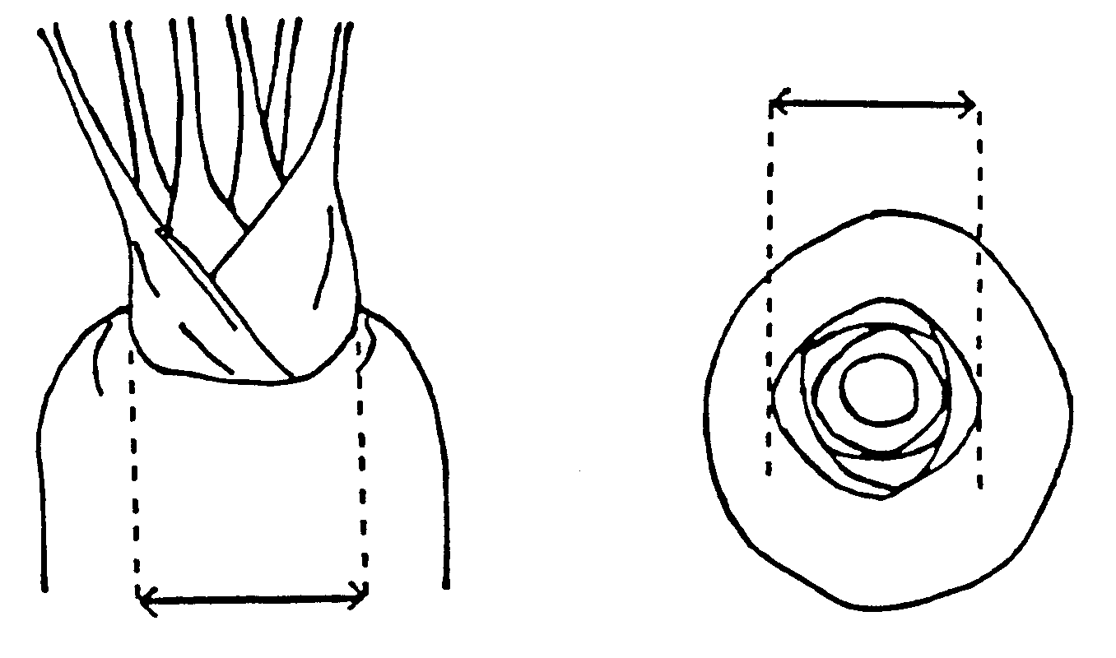
lateral | vertical

Ad. 10: Root: shape in longitudinal section

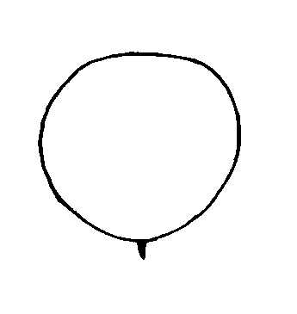 | 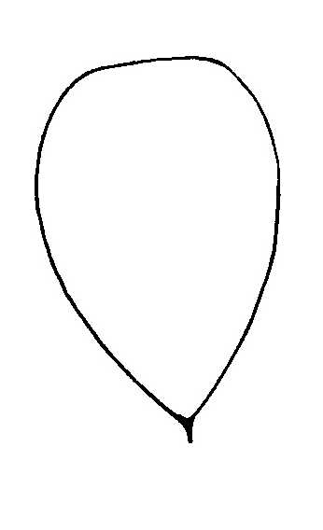 | 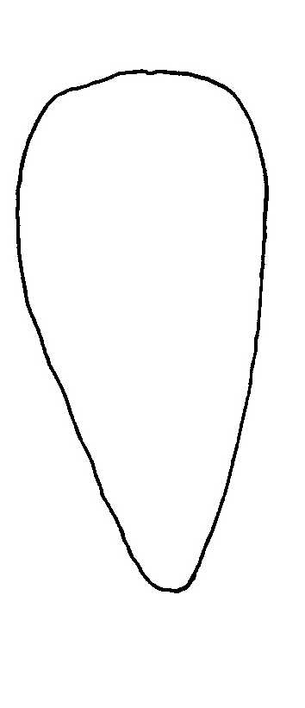
1 | 2 | 3
circular | obovate | medium obtriangular

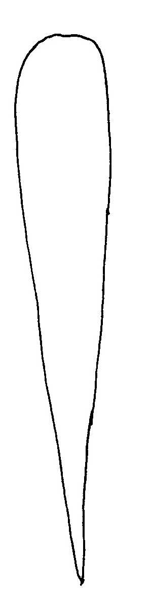 | 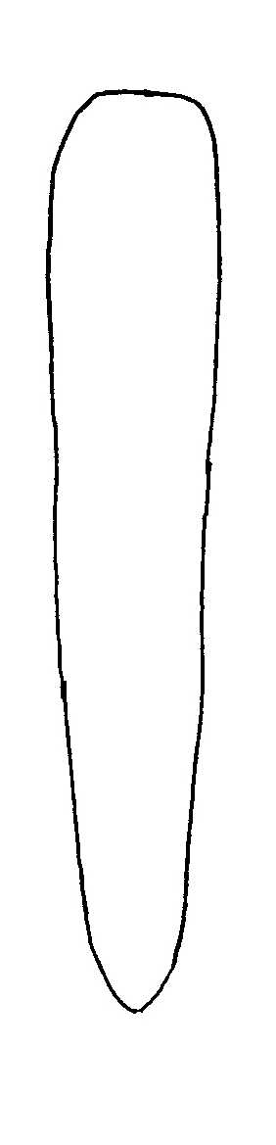 | 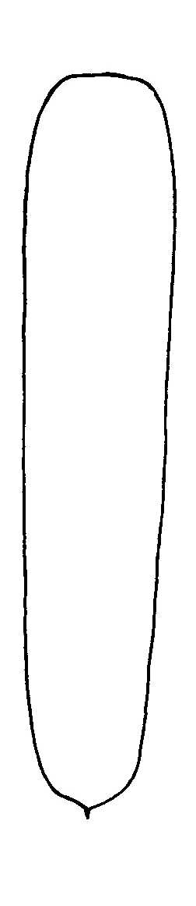
4 | 5 | 6
narrow obtriangular | narrow obtriangular to narrow oblong | narrow oblong

Ad. 11: Varieties scoring between 4 and 6 for characteristic 10 only: Root: tendency to conical shape

The characteristic can be observed either visually or by using a formula. The density of carrot roots is relatively constant and, therefore, it is possible to use the following formula to determine the tendency to conical shape:

shape coefficient = weight/(length x (3.14 x diameter²/4)

length: as for characteristic 7
diameter: as for characteristic 8

The formula above is the formula for calculating the density of a cylinder: therefore, assuming that the density of carrot roots is constant (i.e. 1), a high shape coefficient (close to 1) indicates roots with a cylindrical shape and a low shape coefficient indicates that the roots are tapered.

Ad. 12: Root: shape of shoulder

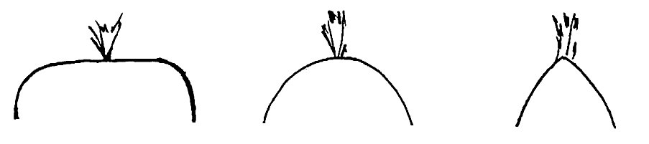
1 | 3 | 5
flat | rounded | conical

Ad. 17: Root: extent of green color of skin of shoulder

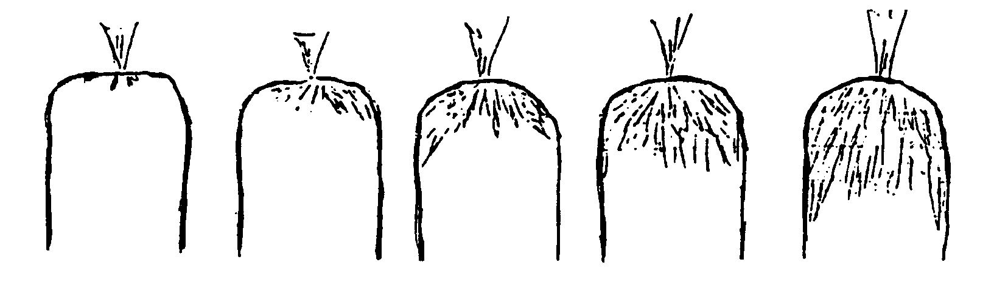

1 | 3 | 5 | 7 | 9
absent  or very small | small | medium | large | very large

Ad. 27: Varieties with blunt tip only: Root: time of development of rounded tip
Ad. 28: Root: time of coloration of tip in longitudinal section

The earliness of carrot varieties can be judged according to two criteria, characteristic 27, time of development of “rounded tip” for the varieties with a blunt tip at maturity and characteristic 28, time of coloration of the tip in longitudinal section.

Three weeks before the normal maturity date of the varieties (where the variety ‘Touchon’ has a blunt tip): pull up of part of the test roots in order to judge the shape of the tip, characteristic 27 (early: blunt tip: variety ‘Touchon’; medium: intermediate tip: varieties ‘Tiana’, ‘Nantaise améliorée 2’, ‘Nantaise améliorée 3’; late: pointed tip: varieties ‘Bureau’, ‘Tancar’, ‘Nantaise améliorée 7’).

Following longitudinal cutting of the roots: examination of the coloration of the tip, characteristic 28 (early: colored tip: varieties ‘Amsterdam 2’, ‘Amsterdam 3’, late: whitish tip: varieties ‘De Colmar à coeur rouge 2’, ‘Touchon’).

A good example of the difference in earliness according to the two characteristics is the variety ‘Touchon’, which is early for characteristic 27 and late for characteristic 28.

Ad. 31: Plants: proportion of male sterile plants
Ad. 32: Plant: type of male sterility

Type of male sterility:

Brown anther type: rudimentary brown anthers;
Petaloid anther type: anthers transformed into petals with different shapes (e.g. bract-like, spoon-like)

Literature
No specific literature.

Technical Questionnaire
TECHNICAL QUESTIONNAIRE |  |  |  | Page {x} of {y} |  | Reference Number:
 |  |  |  |  |  | Application date:
 |  |  |  |  |  | (not to be filled in by the applicant)
TECHNICAL QUESTIONNAIRE
to be completed in connection with an application for plant breeders’ rights

In the case of hybrid varieties which are the subject of an application for plant breeders’ rights, and where the parent lines are to be submitted as a part of the examination of the hybrid variety, this Technical Questionnaire should be completed for each of the parent lines, in addition to being completed for the hybrid variety.

1. Subject of the Technical Questionnaire
1.1 Botanical Name |  |  | Daucus carota L.
1.2 Common Name |  |  | Carrot
2. Applicant
Name
Address
Telephone No.
Fax No.
E-mail address
Breeder (if different from applicant)
3. Proposed denomination and breeder’s reference
Proposed denomination
(if available)

Breeder’s reference
#4. Information on the breeding scheme and propagation of the variety

4.1 Breeding scheme

Variety resulting from:

4.1.1 Crossing

(a) controlled cross [ ]
(please state parent varieties)
(b) partially known cross [ ]
(please state known parent variety(ies))
(c) unknown cross [ ]

4.1.2 Mutation [ ]
(please state parent variety)

4.1.3 Discovery and development [ ]
(please state where and when discovered
and how developed)

4.1.4 Other [ ]
(please provide details)

4.2 Method of propagating the variety

4.2.1 Seed-propagated varieties

(a) Self-pollination [ ]
(b) Cross-pollination
(i) population [ ]
(ii) synthetic variety [ ]
(c) Hybrid [ ]
(d) Other [ ]
(please provide details)

4.2.2 Other [ ]
(please provide details)

5. Characteristics of the variety to be indicated (the number in brackets refers to the corresponding characteristic in Test Guidelines; please mark the note which best corresponds).

 | Characteristics |  |  |  |  |  | Example Varieties |  |  | Note
5.1  (3) | Leaf: length (including petiole)
 | very short |  |  |  |  |  | Mokum, Mignon |  |  | 1[ ]
 | very short to short |  |  |  |  |  |  |  |  | 2[ ]
 | short |  |  |  |  |  | Amsterdam 2, Amsterdam 3 |  |  | 3[ ]
 | short to medium |  |  |  |  |  |  |  |  | 4[ ]
 | medium |  |  |  |  |  | Juwarot,  Nantaise améliorée 2 |  |  | 5[ ]
 | medium to long |  |  |  |  |  |  |  |  | 6[ ]
 | long |  |  |  |  |  | Chantenay,  Chantenay à cœur rouge 2 |  |  | 7[ ]
 | long to very long |  |  |  |  |  |  |  |  | 8[ ]
 | very long |  |  |  |  |  | De Colmar à cœur rouge 2, Rothild |  |  | 9[ ]
5.2  (5) | Leaf: intensity of green color
 | very light |  |  |  |  |  |  |  |  | 1[ ]
 | very light to light |  |  |  |  |  |  |  |  | 2[ ]
 | light |  |  |  |  |  | Adelaide, Leonor |  |  | 3[ ]
 | light to medium |  |  |  |  |  |  |  |  | 4[ ]
 | medium |  |  |  |  |  | Amsterdam 2, Amsterdam 3 |  |  | 5[ ]
 | medium to dark |  |  |  |  |  |  |  |  | 6[ ]
 | dark |  |  |  |  |  | Rothild |  |  | 7[ ]
 | dark to very dark |  |  |  |  |  |  |  |  | 8[ ]
 | very dark |  |  |  |  |  |  |  |  | 9[ ]
 | Characteristics |  |  |  |  |  | Example Varieties |  |  | Note
5.3  (6) | Leaf: anthocyanin coloration of petiole
 | absent |  |  |  |  |  | Amsterdam 2 |  |  | 1[ ]
 | present |  |  |  |  |  | Tarenco |  |  | 9[ ]
5.4  (7) | Root: length
 | very short |  |  |  |  |  | Parijse Markt 2,  Parijse Markt 3 |  |  | 1[ ]
 | very short to short |  |  |  |  |  |  |  |  | 2[ ]
 | short |  |  |  |  |  | Chantenay |  |  | 3[ ]
 | short to medium |  |  |  |  |  |  |  |  | 4[ ]
 | medium |  |  |  |  |  | Nantaise améliorée 2, Nantaise améliorée 3 |  |  | 5[ ]
 | medium to long |  |  |  |  |  |  |  |  | 6[ ]
 | long |  |  |  |  |  | Berlikumer 2, Berlikumer 3 |  |  | 7[ ]
 | long to very long |  |  |  |  |  |  |  |  | 8[ ]
 | very long |  |  |  |  |  | Lange Stompe Winter |  |  | 9[ ]
5.5  (8) | Root: width
 | very narrow |  |  |  |  |  |  |  |  | 1[ ]
 | very narrow to narrow |  |  |  |  |  |  |  |  | 2[ ]
 | narrow |  |  |  |  |  | Amsterdam 2, Amsterdam 3 |  |  | 3[ ]
 | narrow to medium |  |  |  |  |  |  |  |  | 4[ ]
 | medium |  |  |  |  |  | Nantaise améliorée 2,  Nantaise améliorée 3 |  |  | 5[ ]
 | medium to broad |  |  |  |  |  |  |  |  | 6[ ]
 | broad |  |  |  |  |  | De Colmar à cœur rouge 2, Parijse Markt 2,  Parijse Markt 3 |  |  | 7[ ]
 | broad to very broad |  |  |  |  |  |  |  |  | 8[ ]
 | very broad |  |  |  |  |  |  |  |  | 9[ ]
 | Characteristics |  |  |  |  |  | Example Varieties |  |  | Note
5.6  (9) | Root: ratio length/ width
 | very small |  |  |  |  |  | Parijse Markt 2,  Parijse Markt 3, Parmex |  |  | 1[ ]
 | very small to small |  |  |  |  |  |  |  |  | 2[ ]
 | small |  |  |  |  |  | Courte améliorée à forcer |  |  | 3[ ]
 | small to medium |  |  |  |  |  |  |  |  | 4[ ]
 | medium |  |  |  |  |  | Chantenay |  |  | 5[ ]
 | medium to large |  |  |  |  |  |  |  |  | 6[ ]
 | large |  |  |  |  |  | Nantaise améliorée 2, Nantaise améliorée 3 |  |  | 7[ ]
 | large to very large |  |  |  |  |  |  |  |  | 8[ ]
 | very large |  |  |  |  |  | Amsterdam 2 |  |  | 9[ ]
5.7  (10) | Root: shape in longitudinal section
 | circular |  |  |  |  |  | Parijse Markt 2,  Parijse Markt 3 |  |  | 1[ ]
 | obovate |  |  |  |  |  |  |  |  | 2[ ]
 | medium obtriangular |  |  |  |  |  | Chantenay,  De Colmar à cœur rouge 2 |  |  | 3[ ]
 | narrow obtriangular |  |  |  |  |  | Imperator,  De Colmar à cœur rouge 3 |  |  | 4[ ]
 | narrow obtriangular to narrow oblong |  |  |  |  |  | Maestro |  |  | 5[ ]
 | narrow oblong |  |  |  |  |  | Amsterdam 2, Berlikumer 2, Berlikumer 3,  Nantaise améliorée 5, Touchon |  |  | 6[ ]
5.8  (12) | Root: shape of shoulder
 | flat |  |  |  |  |  | De Colmar à cœur rouge 2 |  |  | 1[ ]
 | flat to rounded |  |  |  |  |  | Parijse Markt 2 |  |  | 2[ ]
 | rounded |  |  |  |  |  |  |  |  | 3[ ]
 | rounded to conical |  |  |  |  |  |  |  |  | 4[ ]
 | conical |  |  |  |  |  | Touchon |  |  | 5[ ]
 | Characteristics |  |  |  |  |  | Example Varieties |  |  | Note
5.9  (13) | Root: tip (when fully developed)
 | blunt |  |  |  |  |  | Berlikumer 3 |  |  | 1[ ]
 | slightly pointed |  |  |  |  |  | Mello Yello |  |  | 2[ ]
 | strongly pointed |  |  |  |  |  | Allred, Orbit |  |  | 3[ ]
5.10  (14) | Root: external color
 | white |  |  |  |  |  | White Satin |  |  | 1[ ]
 | yellow |  |  |  |  |  | Mello Yello |  |  | 2[ ]
 | orange |  |  |  |  |  | Bingo, Goliath, Karotan, Pinocchio, Tancar |  |  | 3[ ]
 | pinkish red |  |  |  |  |  | Nutri-red |  |  | 4[ ]
 | red |  |  |  |  |  | Pulsor |  |  | 5[ ]
 | purple |  |  |  |  |  | Purple Haze |  |  | 6[ ]
5.11  (15) | Excluding varieties with white external root color: Root: intensity of external color
 | very light |  |  |  |  |  |  |  |  | 1[ ]
 | very light to light |  |  |  |  |  |  |  |  | 2[ ]
 | light |  |  |  |  |  | Bingo, Mello Yello, Tancar |  |  | 3[ ]
 | light to medium |  |  |  |  |  |  |  |  | 4[ ]
 | medium |  |  |  |  |  | Goliath, Nutri-red |  |  | 5[ ]
 | medium to dark |  |  |  |  |  |  |  |  | 6[ ]
 | dark |  |  |  |  |  | Karotan, Pinocchio,  Purple Haze |  |  | 7[ ]
 | dark to very dark |  |  |  |  |  |  |  |  | 8[ ]
 | very dark |  |  |  |  |  |  |  |  | 9[ ]
5.12  (16) | Root: anthocyanin coloration of skin of shoulder
 | absent |  |  |  |  |  | Trevor |  |  | 1[ ]
 | present |  |  |  |  |  | Touchon |  |  | 9[ ]
 | Characteristics |  |  |  |  |  | Example Varieties |  |  | Note
5.13  (19) | Root: diameter of core relative to total diameter
 | very small |  |  |  |  |  | Amsterdam 2, Amsterdam 3, Tourino |  |  | 1[ ]
 | very small to small |  |  |  |  |  |  |  |  | 2[ ]
 | small |  |  |  |  |  | Nantaise améliorée 2, Nantaise améliorée 3 |  |  | 3[ ]
 | small to medium |  |  |  |  |  |  |  |  | 4[ ]
 | medium |  |  |  |  |  | Berlikumer 2, Berlikumer 3 |  |  | 5[ ]
 | medium to large |  |  |  |  |  |  |  |  | 6[ ]
 | large |  |  |  |  |  | De Colmar à cœur rouge 2 |  |  | 7[ ]
 | large to very large |  |  |  |  |  |  |  |  | 8[ ]
 | very large |  |  |  |  |  | Giganta |  |  | 9[ ]
5.14  (20) | Root: color of core
 | white |  |  |  |  |  | White Satin |  |  | 1[ ]
 | yellow |  |  |  |  |  | Jaune de Lobberich,  Pariser Markt |  |  | 2[ ]
 | orange |  |  |  |  |  | Nantaise améliorée 2,  Nantaise améliorée 3 |  |  | 3[ ]
 | pinkish red |  |  |  |  |  |  |  |  | 4[ ]
 | red |  |  |  |  |  | Nutri-red |  |  | 5[ ]
 | purple |  |  |  |  |  | Afghan purple, Black Deshi |  |  | 6[ ]
5.15  (22) | Root: color of cortex
 | white |  |  |  |  |  | White Satin |  |  | 1[ ]
 | yellow |  |  |  |  |  | Mellow Yello |  |  | 2[ ]
 | orange |  |  |  |  |  | Allred, Carlo |  |  | 3[ ]
 | pinkish red |  |  |  |  |  |  |  |  | 4[ ]
 | red |  |  |  |  |  | Nutri-red |  |  | 5[ ]
 | purple |  |  |  |  |  | Afghan purple, Black Deshi |  |  | 6[ ]
 | Characteristics |  |  |  |  |  | Example Varieties |  |  | Note
5.16  (27) | Varieties with blunt tip only: Root: time of development of rounded tip
 | very early |  |  |  |  |  |  |  |  | 1[ ]
 | very early to early |  |  |  |  |  |  |  |  | 2[ ]
 | early |  |  |  |  |  | Touchon |  |  | 3[ ]
 | early to medium |  |  |  |  |  |  |  |  | 4[ ]
 | medium |  |  |  |  |  | Nantaise améliorée 2,  Nantaise améliorée 3, Tiana |  |  | 5[ ]
 | medium to late |  |  |  |  |  |  |  |  | 6[ ]
 | late |  |  |  |  |  | Bureau,  Nantaise améliorée 7, Tancar |  |  | 7[ ]
 | late to very late |  |  |  |  |  |  |  |  | 8[ ]
 | very late |  |  |  |  |  |  |  |  | 9[ ]
5.17  (28) | Root: time of coloration of tip in longitudinal section
 | very early |  |  |  |  |  | Parijse Markt 3 |  |  | 1[ ]
 | very early to early |  |  |  |  |  |  |  |  | 2[ ]
 | early |  |  |  |  |  | Amsterdam 2, Amsterdam 3 |  |  | 3[ ]
 | early to medium |  |  |  |  |  |  |  |  | 4[ ]
 | medium |  |  |  |  |  | Nantaise améliorée 2, Nantaise améliorée 3 |  |  | 5[ ]
 | medium to late |  |  |  |  |  |  |  |  | 6[ ]
 | late |  |  |  |  |  | De Colmar à cœur rouge 2, Touchon |  |  | 7[ ]
 | late to very late |  |  |  |  |  |  |  |  | 8[ ]
 | very late |  |  |  |  |  | Goliath |  |  | 9[ ]
 | Characteristics |  |  |  |  |  | Example Varieties |  |  | Note
5.18  (29) | Plant: tendency to bolting
 | very weak |  |  |  |  |  |  |  |  | 1[ ]
 | very weak to weak |  |  |  |  |  |  |  |  | 2[ ]
 | weak |  |  |  |  |  | Molene, Tancar |  |  | 3[ ]
 | weak to medium |  |  |  |  |  |  |  |  | 4[ ]
 | medium |  |  |  |  |  | Nantaise améliorée 2, Nantaise améliorée 3 |  |  | 5[ ]
 | medium to strong |  |  |  |  |  |  |  |  | 6[ ]
 | strong |  |  |  |  |  | Muscade, Touchon |  |  | 7[ ]
 | strong to very strong |  |  |  |  |  |  |  |  | 8[ ]
 | very strong |  |  |  |  |  |  |  |  | 9[ ]
5.19  (31) | Plants: proportion of male sterile plants
 | absent or very low |  |  |  |  |  | Nantaise améliorée 2, Touchon |  |  | 1[ ]
 | intermediate |  |  |  |  |  |  |  |  | 2[ ]
 | high |  |  |  |  |  | Nanco, Tino |  |  | 3[ ]
5.20  (32) | Plant: type of male sterility
 | brown anther |  |  |  |  |  | Nanco |  |  | 1[ ]
 | petaloid anther |  |  |  |  |  | Tino |  |  | 2[ ]
6. Similar varieties and differences from these varieties

Please use the table, and space provided for comments, below to provide information on how your candidate variety differs from the variety (or varieties) which, to the best of your knowledge, is (or are) most similar. This information may help the examination authority to conduct its examination of distinctness in a more efficient way.

Denomination(s) of variety(ies) similar to your candidate variety |  | Characteristic(s) in which your candidate variety differs from the similar variety(ies) |  |  | Describe the expression of the characteristic(s) for the similar variety(ies) |  |  | Describe the expression of the characteristic(s) for your candidate variety
Example |  | Root: external color |  |  | orange |  |  | pinkish red
Comments:

#7. Additional information which may help in the examination of the variety

7.1 In addition to the information provided in sections 5 and 6, are there any additional characteristics which may help to distinguish the variety?

Yes [ ] No [ ]

(If yes, please provide details)

7.2 Special conditions for the examination of the variety

7.2.1 Are there any special conditions for growing the variety or conducting the examination?

Yes [ ] No [ ]

7.2.2 If yes, please give details:

7.3 Other information

8. Authorization for release

(a) Does the variety require prior authorization for release under legislation concerning the protection of the environment, human and animal health?

Yes [ ] No [ ]

(b) Has such authorization been obtained?

Yes [ ] No [ ]

If the answer to (b) is yes, please attach a copy of the authorization.

9. Information on plant material to be examined or submitted for examination

9.1 The expression of a characteristic or several characteristics of a variety may be affected by factors, such as pests and disease, chemical treatment (e.g. growth retardants or pesticides), effects of tissue culture, different rootstocks, scions taken from different growth phases of a tree, etc.

9.2 The plant material should not have undergone any treatment which would affect the expression of the characteristics of the variety, unless the competent authorities allow or request such treatment. If the plant material has undergone such treatment, full details of the treatment must be given. In this respect, please indicate below, to the best of your knowledge, if the plant material to be examined has been subjected to:

(a) Microorganisms (e.g. virus, bacteria, phytoplasma) Yes [ ] No [ ]

(b) Chemical treatment (e.g. growth retardant, pesticide) Yes [ ] No [ ]

(c) Tissue culture Yes [ ] No [ ]

(d) Other factors Yes [ ] No [ ]

Please provide details for where you have indicated “yes”.

……………………………………………………………

10. I hereby declare that, to the best of my knowledge, the information provided in this form is correct:

Applicant’s name

Signature Date

[End of document]

* These names were correct at the time of the introduction of these Test Guidelines but may be revised or updated. [Readers are advised to consult the UPOV Code, which can be found on the UPOV Website (www.upov.int), for the latest information.]
# Authorities may allow certain of this information to be provided in a confidential section of the Technical Questionnaire.
# Authorities may allow certain of this information to be provided in a confidential section of the Technical Questionnaire.

