 |  | E  TG/44/11 Rev. 3  ORIGINAL: English  DATE: 2011-10-20 + 2013-03-20  + 2018-10-30 + 2019-10-29
INTERNATIONAL UNION FOR THE PROTECTION OF NEW VARIETIES OF PLANTS
GENEVA

 | TOMATO  UPOV Code: SOLAN_LYC  Solanum lycopersicum L. | *

GUIDELINES

FOR THE CONDUCT OF TESTS

FOR DISTINCTNESS, UNIFORMITY AND STABILITY

Alternative Names:*

Botanical name | English | French | German | Spanish
Solanum lycopersicum L.,  Lycopersicon esculentum Mill.,  Lycopersicon lycopersicum (L.) Karsten ex Farw. | Tomato | Tomate | Tomate | Tomate

The purpose of these guidelines (“Test Guidelines”) is to elaborate the principles contained in the General Introduction (document TG/1/3), and its associated TGP documents, into detailed practical guidance for the harmonized examination of distinctness, uniformity and stability (DUS) and, in particular, to identify appropriate characteristics for the examination of DUS and production of harmonized variety descriptions.

ASSOCIATED DOCUMENTS

These Test Guidelines should be read in conjunction with the General Introduction and its associated TGP documents.
TABLE OF CONTENTS PAGE

1. Subject of these Test Guidelines 3
2. Material Required 3
3. Method of Examination 3
3.1 Number of Growing Cycles 3
3.2 Testing Place 3
3.3 Conditions for Conducting the Examination 4
3.4 Test Design 4
3.5 Additional Tests 4
4. Assessment of Distinctness, Uniformity and Stability 4
4.1 Distinctness 4
4.2 Uniformity 5
4.3 Stability 6
5. Grouping of Varieties and Organization of the Growing Trial 6
6. Introduction to the Table of Characteristics 7
6.1 Categories of Characteristics 7
6.2 States of Expression and Corresponding Notes 7
6.3 Types of Expression 8
6.4 Example Varieties 8
6.5 Legend 8
7. Table of Characteristics/Tableau des caractères/Merkmalstabelle/Tabla de caracteres 9
8. Explanations on the Table of Characteristics 27
8.1 Explanations covering several characteristics 27
8.2 Explanations for individual characteristics 27
9. Literature 64
10. Technical Questionnaire 66

Subject of these Test Guidelines
These Test Guidelines apply to all varieties of Solanum lycopersicum L..

Material Required
2.1 The competent authorities decide on the quantity and quality of the plant material required for testing the variety and when and where it is to be delivered. Applicants submitting material from a State other than that in which the testing takes place must ensure that all customs formalities and phytosanitary requirements are complied with.

2.2 The material is to be supplied in the form of seed or plants.

2.3 The minimum quantity of plant material, to be supplied by the applicant, should be:

- seed propagated varieties: 10g or 2,500 seeds
- vegetatively propagated varieties: 25 plants plus the number required for disease resistance tests

In the case of seed, the seed should meet the minimum requirements for germination, species and analytical purity, health and moisture content, specified by the competent authority. For disease resistance testing, additional plant material may be requested.

2.4 The plant material supplied should be visibly healthy, not lacking in vigor, nor affected by any important pest or disease.

2.5 The plant material should not have undergone any treatment which would affect the expression of the characteristics of the variety, unless the competent authorities allow or request such treatment. If it has been treated, full details of the treatment must be given.

Method of Examination

3.1 Number of Growing Cycles
The minimum duration of tests should normally be two independent growing cycles.

3.2 Testing Place
Tests are normally conducted at one place. In the case of tests conducted at more than one place, guidance is provided in TGP/9 “Examining Distinctness”.

3.3 Conditions for Conducting the Examination
The tests should be carried out under conditions ensuring satisfactory growth for the expression of the relevant characteristics of the variety and for the conduct of the examination. On non-staked plants, the time of flowering (characteristic 43) cannot be easily observed due to the branching of the plant.

3.4 Test Design
3.4.1 Each test should be designed to result in a total of at least 20 plants, which should be divided between at least two replicates.

3.4.2 When resistance characteristics are used for assessing distinctness, uniformity and stability, records must be taken under conditions of controlled infection and, unless otherwise specified, on at least 20 plants.

3.4.3 The design of the tests should be such that plants or parts of plants may be removed for measurement or counting without prejudice to the observations which must be made up to the end of the growing cycle.

3.5 Additional Tests
Additional tests, for examining relevant characteristics, may be established.

Assessment of Distinctness, Uniformity and Stability

4.1 Distinctness
4.1.1 General Recommendations
It is of particular importance for users of these Test Guidelines to consult the General Introduction prior to making decisions regarding distinctness. However, the following points are provided for elaboration or emphasis in these Test Guidelines.

4.1.2 Consistent Differences
The differences observed between varieties may be so clear that more than one growing cycle is not necessary. In addition, in some circumstances, the influence of the environment is not such that more than a single growing cycle is required to provide assurance that the differences observed between varieties are sufficiently consistent. One means of ensuring that a difference in a characteristic, observed in a growing trial, is sufficiently consistent is to examine the characteristic in at least two independent growing cycles.

4.1.3 Clear Differences
Determining whether a difference between two varieties is clear depends on many factors, and should consider, in particular, the type of expression of the characteristic being examined, i.e. whether it is expressed in a qualitative, quantitative, or pseudo-qualitative manner. Therefore, it is important that users of these Test Guidelines are familiar with the recommendations contained in the General Introduction prior to making decisions regarding distinctness.

4.1.4 Number of Plants / Parts of Plants to be Examined
Unless otherwise indicated, for the purposes of distinctness, all observations on single plants should be made on 10 plants or parts taken from each of 10 plants and any other observations made on all plants in the test, disregarding any off-type plants.

4.1.5 Method of Observation
The recommended method of observing the characteristic for the purposes of distinctness is indicated by the following key in the second column of the Table of Characteristics (see document TGP/9 “Examining Distinctness”, Section 4 “Observation of characteristics”):

MG: single measurement of a group of plants or parts of plants
MS: measurement of a number of individual plants or parts of plants
VG: visual assessment by a single observation of a group of plants or parts of plants
VS: visual assessment by observation of individual plants or parts of plants

Type of observation: visual (V) or measurement (M)

“Visual” observation (V) is an observation made on the basis of the expert’s judgment. For the purposes of this document, “visual” observation refers to the sensory observations of the experts and, therefore, also includes smell, taste and touch. Visual observation includes observations where the expert uses reference points (e.g. diagrams, example varieties, side-by-side comparison) or non-linear charts (e.g. color charts). Measurement (M) is an objective observation against a calibrated, linear scale e.g. using a ruler, weighing scales, colorimeter, dates, counts, etc.

Type of record: for a group of plants (G) or for single, individual plants (S)

For the purposes of distinctness, observations may be recorded as a single record for a group of plants or parts of plants (G), or may be recorded as records for a number of single, individual plants or parts of plants (S). In most cases, “G” provides a single record per variety and it is not possible or necessary to apply statistical methods in a plant-by-plant analysis for the assessment of distinctness.

In cases where more than one method of observing the characteristic is indicated in the Table of Characteristics (e.g. VG/MG), guidance on selecting an appropriate method is provided in document TGP/9, Section 4.2.

4.2 Uniformity
4.2.1 It is of particular importance for users of these Test Guidelines to consult the General Introduction prior to making decisions regarding uniformity. However, the following points are provided for elaboration or emphasis in these Test Guidelines:

4.2.2 For the assessment of uniformity, a population standard of 1% and an acceptance probability of at least 95% should be applied. In the case of a sample size of 20 plants, 1 off-type is allowed.

4.3 Stability
4.3.1 In practice, it is not usual to perform tests of stability that produce results as certain as those of the testing of distinctness and uniformity. However, experience has demonstrated that, for many types of variety, when a variety has been shown to be uniform, it can also be considered to be stable.
4.3.2 Where appropriate, or in cases of doubt, stability may be further examined by testing a new seed or plant stock to ensure that it exhibits the same characteristics as those shown by the initial material supplied.

Grouping of Varieties and Organization of the Growing Trial
5.1 The selection of varieties of common knowledge to be grown in the trial with the candidate varieties and the way in which these varieties are divided into groups to facilitate the assessment of distinctness are aided by the use of grouping characteristics.

5.2 Grouping characteristics are those in which the documented states of expression, even where produced at different locations, can be used, either individually or in combination with other such characteristics: (a) to select varieties of common knowledge that can be excluded from the growing trial used for examination of distinctness; and (b) to organize the growing trial so that similar varieties are grouped together.

5.3 The following have been agreed as useful grouping characteristics:

- Plant: growth type (characteristic 2)
- Leaf: type of blade (characteristic 10)
- Peduncle: abscission layer (characteristic 19)
- Fruit: green shoulder (before maturity) (characteristic 21)
- Fruit: size (characteristic 26)
- Fruit: shape in longitudinal section (characteristic 28)
- Fruit: number of locules (characteristic 36)
- Fruit: color (at maturity) (characteristic 37)
- Resistance to Meloidogyne incognita (Mi) (characteristic 46)
- Resistance to Verticillium sp. (Va and Vd) – Race 0 (characteristic 47)
- Resistance to Fusarium oxysporum f. sp. lycopersici (Fol) – Race 0EU/1US (characteristic 48.1)
- Resistance to Fusarium oxysporum f. sp. lycopersici (Fol) – Race 1EU/2US (characteristic 48.2 )
- Resistance to Tomato mosaic virus (ToMV) – Strain 0 (characteristic 51.1)
- Resistance to Tomato spotted wilt virus (TSWV) - Race 0 (characteristic 58)

Guidance for the use of grouping characteristics, in the process of examining distinctness, is provided through the General Introduction and document TGP/9 “Examining Distinctness”.

Introduction to the Table of Characteristics

6.1 Categories of Characteristics
6.1.1 Standard Test Guidelines Characteristics

Standard Test Guidelines characteristics are those which are approved by UPOV for examination of DUS and from which members of the Union can select those suitable for their particular circumstances.

6.1.2 Asterisked Characteristics

Asterisked characteristics (denoted by *) are those included in the Test Guidelines which are important for the international harmonization of variety descriptions and should always be examined for DUS and included in the variety description by all members of the Union, except when the state of expression of a preceding characteristic or regional environmental conditions render this inappropriate.

6.2 States of Expression and Corresponding Notes
6.2.1 States of expression are given for each characteristic to define the characteristic and to harmonize descriptions. Each state of expression is allocated a corresponding numerical note for ease of recording of data and for the production and exchange of the description.

6.2.2 In the case of qualitative and pseudo-qualitative characteristics (see Chapter 6.3), all relevant states of expression are presented in the characteristic. However, in the case of quantitative characteristics with 5 or more states, an abbreviated scale may be used to minimize the size of the Table of Characteristics. For example, in the case of a quantitative characteristic with 9 states, the presentation of states of expression in the Test Guidelines may be abbreviated as follows:

State | Note
small | 3
medium | 5
large | 7

However, it should be noted that all of the following 9 states of expression exist to describe varieties and should be used as appropriate:

State | Note
very small | 1
very small to small | 2
small | 3
small to medium | 4
medium | 5
medium to large | 6
large | 7
large to very large | 8
very large | 9

6.2.3 Further explanation of the presentation of states of expression and notes is provided in document TGP/7 “Development of Test Guidelines”.

6.3 Types of Expression
An explanation of the types of expression of characteristics (qualitative, quantitative and pseudo-qualitative) is provided in the General Introduction.

6.4 Example Varieties
Where appropriate, example varieties are provided to clarify the states of expression of each characteristic.

6.5 Legend
(*) Asterisked characteristic – see Chapter 6.1.2

QL Qualitative characteristic – see Chapter 6.3
QN Quantitative characteristic – see Chapter 6.3
PQ Pseudo-qualitative characteristic – see Chapter 6.3

MG, MS, VG, VS – see Chapter 4.1.5

(a)-(c) See Explanations on the Table of Characteristics in Chapter 8.1

(+) See Explanations on the Table of Characteristics in Chapter 8.2

Table of Characteristics/Tableau des caractères/Merkmalstabelle/Tabla de caracteres
 |  | English | français | deutsch | español | Example Varieties  Exemples  Beispielssorten  Variedades ejemplo | Note/  Nota
1.  (+) | VG | Seed-propagated varieties only: Seedling: anthocyanin coloration of hypocotyl | Variétés reproduites par voie sexuée seulement : Plantule : pigmentation anthocyanique de l’hypocotyle | Nur samenvermehrte Sorten: Sämling: Anthocyanfärbung des Hypocotyls | Sólo variedades de reproducción sexuada: Plántula: pigmentación antociánica del hipocótilo
QL |  | absent | absente | fehlend | ausente | Colt, Heinz 8104, Mogeor, Momorvert, VTM215 | 1
 |  | present | présente | vorhanden | presente | DG-039,  Montfavet H 63.4 | 9
2.  (*)  (+) | VG | Plant: growth type | Plante : type de croissance | Pflanze: Wuchstyp | Planta: hábito de crecimiento
QL |  | determinate | déterminée | begrenzt wachsend | determinado | Campbell 1327, Prisca | 1
 |  | indeterminate | indéterminée | unbegrenzt wachsend | indeterminado | Marmande VR, Saint-Pierre, San Marzano 2 | 2
3. | VG/MS | Only varieties with plant growth type determinate: Plant: number of inflorescences on main stem (side shoots to be removed) | Seulement variétés à type de croissance déterminée : Plante : nombre d’inflorescences sur la tige principale (bourgeons axillaires à éliminer) | Nur begrenzt wachsende Sorten: Pflanze: Anzahl Blütenstände am Haupttrieb (Seitentriebe sind zu entfernen) | Sólo variedades con tipo de crecimiento determinado: Planta: número de inflorescencias en el tallo principal (eliminar ramas axilares)
QN |  | few | petit | gering | bajo | Campbell 1327 | 3
 |  | medium | moyen | mittel | medio | Montfavet H 63.4 | 5
 |  | many | grand | groß | alto | Prisca | 7
4.  (+) | VG | Stem: anthocyanin coloration | Tige : pigmentation anthocyanique | Stengel: Anthocyanfärbung | Tallo: pigmentación antociánica
QN | (a) | absent or very weak | absente ou très faible | fehlend oder sehr gering | ausente o muy débil | Mogeor, Momorvert, | 1
 |  | weak | faible | gering | débil | Montfavet H 63.5 | 3
 |  | medium | moyenne | mittel | media | Rondello | 5
 |  | strong | forte | stark | fuerte | Grinta, Nemato | 7
 |  | very strong | très forte | sehr stark | muy fuerte |  | 9
5.  (+) | VG/MS | Only varieties with plant growth type indeterminate: Stem: length of internode | Seulement les variétés à type de croissance indéterminé : Tige : longueur de l’entre-nœud | Nur unbegrenzt wachsende Sorten: Stengel: Internodienlänge | Sólo variedades con tipo de crecimiento indeterminado: Tallo: longitud del entrenudo
QN | (a) | short | court | kurz | corta | Dombito, Manific, Paso, Trend | 3
 |  | medium | moyen | mittel | media | Montfavet H 63.5 | 5
 |  | long | long | lang | larga | Berdy, Calimero | 7
6. (+) | VG/MS | Only varieties with plant growth type indeterminate: Plant: height | Seulement les variétés à type de croissance indéterminée : Plante : hauteur | Nur unbegrenzt wachsende Sorten: Pflanze: Höhe | Sólo variedades con tipo de crecimiento indeterminado: Planta: altura
QN |  | very short | très basse | sehr niedrig | muy corta | Cherry Belle | 1
 |  | short | basse | niedrig | corta | Carson, Despina | 3
 |  | medium | moyenne | mittel | media | Brooklyn, Buffalo, Vision | 5
 |  | long | haute | hoch | larga | Classy, Clarence, Climberly, Massada | 7
 |  | very long | très haute | sehr hoch | muy larga | Daydream, Minired | 9
7.  (*) (+) | VG | Leaf: attitude | Feuille : port | Blatt: Haltung | Hoja: porte
QN | (a) | erect | dressé | aufgerichtet | erecto |  | 1
 |  | semi-erect | demi-dressé | halbaufrecht | semierecto | Allround, Drakar, Vitador | 3
 |  | horizontal | horizontal | waagerecht | horizontal | Aromata, Triton | 5
 |  | semi-drooping | demi-retombant | halbüberhängend | semicolgante | Montfavet H 63.5 | 7
 |  | drooping | retombant | überhängend | colgante | Multolino, Naram, Tibet | 9
8. | VG/MS | Leaf: length | Feuille : longueur | Blatt: Länge | Hoja: longitud
QN | (a) | short | courte | kurz | corta | Nelson, Red Robin, Tiny Tim | 3
 |  | medium | moyenne | mittel | media | Lorena | 5
 |  | long | longue | lang | larga | Montfavet H 63.5 | 7
9. | VG/MS | Leaf: width | Feuille : largeur | Blatt: Breite | Hoja: anchura
QN | (a) | narrow | étroite | schmal | estrecha | Marmande VR, Red Robin, Tiny Tim | 3
 |  | medium | moyenne | mittel | media |  | 5
 |  | broad | large | breit | ancha | Saint-Pierre | 7
10.  (*) (+) | VG | Leaf: type of blade | Feuille : type de limbe | Blatt: Typ der Blattspreite | Hoja: división del limbo
QL | (a) | pinnate | penné | gefiedert | pinnada | Mikado, Pilot, Red Jacket | 1
 |  | bipinnate | bipenné | doppelt gefiedert | bipinnada | Lukullus, Saint-Pierre | 2
11.  (+) | VG | Leaf: size of leaflets | Feuille : taille des folioles | Blatt: Größe der Blattfiedern | Hoja: tamaño de los folíolos
QN | (a) | very small | très petites | sehr klein | muy pequeños | Minitom | 1
 |  | small | petites | klein | pequeños | Tiny Tim | 3
 |  | medium | moyennes | mittel | medios | Marmande VR, Royesta | 5
 |  | large | grandes | groß | grandes | Daniela, Hynema | 7
 |  | very large | très grandes | sehr groß | muy grandes | Dombo | 9
12. | VG | Leaf: intensity of green color | Feuille : intensité de la couleur verte | Blatt: Intensität der Grünfärbung | Hoja: intensidad del color verde
QN | (a) | light | claire | hell | clara | Macero II, Poncette, Rossol | 3
 |  | medium | moyenne | mittel | media | Lucy | 5
 |  | dark | foncée | dunkel | oscura | Allround, Daniela, Lorena, Red Robin | 7
13.  (+) | VG | Leaf: glossiness | Feuille : brillance | Blatt: Glanz | Hoja: brillo
QN | (a) | weak | faible | gering | débil | Daniela | 3
 |  | medium | moyenne | mittel | medio | Marmande VR | 5
 |  | strong | forte | stark | fuerte | Guindilla | 7
14.  (+) | VG | Leaf: blistering | Feuille : cloqûre | Blatt: Blasigkeit | Hoja: abullonado
QN | (a) | weak | faible | gering | débil | Daniela | 3
 |  | medium | moyenne | mittel | medio | Marmande VR | 5
 |  | strong | forte | stark | fuerte | Delfine, Tiny Tim | 7
15.  (+) | VG | Leaf: attitude of petiole of leaflet in relation to main axis | Feuille : port du pétiole par rapport à l’axe central | Blatt: Stellung des Blattstiels im Verhältnis zur Hauptachse | Hoja: porte del pecíolo de los folíolos en relación con el eje principal
QN | (a) | semi-erect | demi-dressé | halbaufrecht | semierecto | Blizzard, Marmande VR | 3
 |  | horizontal | horizontal | waagerecht | horizontal | Sonatine | 5
 |  | semi-drooping | demi-retombant | halbüberhängend | semicolgante | Montfavet H63.5 | 7
16.  (+) | VG/MS | Inflorescence: type | Inflorescence : type | Blütenstand: Typ | Inflorescencia: tipo
QN |  | mainly uniparous | principalement unipare | überwiegend unverzweigt | principalmente unípara | Dynamo | 1
 |  | equally uniparous and multiparous | autant unipare que multipare | intermediär | intermedia | Harzfeuer | 2
 |  | mainly multiparous | principalement multipare | überwiegend verzweigt | principalmente multípara | Marmande VR | 3
17.  (*) | VG | Flower: color | Fleur : couleur | Blüte: Farbe | Flor: color
QL |  | yellow | jaune | gelb | amarillo | Exota, MarmandeVR | 1
 |  | orange | orange | orange | anaranjado | Orama, Pericherry | 2
18.  (+) | VG | Flower: pubescence of style | Fleur : pilosité du style | Blüte: Behaarung des Griffels | Flor: pubescencia del estilo
QL |  | absent | absente | fehlend | ausente | Campbell 1327 | 1
 |  | present | présente | vorhanden | presente | Saint Pierre | 9
19.  (*)  (+) | VG | Peduncle: abscission layer | Pédoncule : assise d’abscission | Blütenstiel: Bruchstelle | Pedúnculo: capa de abscisión
QL |  | absent | absente | fehlend | ausente | Aledo, Bandera, Count, Lerica | 1
 |  | present | présente | vorhanden | presente | Montfavet H 63.5, Roma | 9
20.  (*)  (+) | VG/MS | Only varieties with peduncle abscission layer present: Pedicel: length | Seulement les variétés avec assise d’abscission : Pédicelle : longueur | Nur Sorten mit Blütenstiel: Bruchstellen vorhanden: Blütenstandstiel: Länge | Sólo para variedades con abscisión: Pedicelo: longitud
QN |  | short | court | kurz | corta | Cerise, Ferline, Montfavet H 63.18, Rossol | 3
 |  | medium | moyen | mittel | media | Dario, Primosol | 5
 |  | long | long | lang | larga | Erlidor, Ramy, Ranco | 7
21.  (*) (+) | VG | Fruit: green shoulder (before maturity) | Fruit : collet vert  (avant maturité) | Frucht: grüne Schulter (vor der Reife) | Fruto: hombro verde (antes de madurez)
QL | (b) | absent | absent | fehlend | ausente | Felicia, Rio Grande, Trust | 1
 |  | present | présent | vorhanden | presente | Daniela, Montfavet H 63.5 | 9
22.  (+) | VG | Fruit: extent of green shoulder (before maturity) | Fruit : extension du collet vert (avant maturité) | Frucht: Größe der grünen Schulter (vor der Reife) | Fruto: tamaño del hombro verde (antes de madurez)
QN | (b) | very small | très petit | sehr klein | muy pequeño | Daniela | 1
 |  | small | petit | klein | pequeño | Ballet, Cristy, Firestone, Siluet | 3
 |  | medium | moyen | mittel | medio | Erlidor, Foxy, Montfavet H 63.5 | 5
 |  | large | grand | groß | grande | Cobra, Delisa, Epona, Manific | 7
23.  (+) | VG | Fruit: intensity of green color of shoulder (before maturity) | Fruit : intensité de la couleur verte du collet  (avant maturité) | Frucht: Intensität der Grünfärbung der Schulter (vor der Reife) | Fruto: intensidad del color verde del hombro (antes de madurez)
QN | (b) | light | claire | hell | clara | Ballet, Daniela, Juboline | 3
 |  | medium | moyenne | mittel | media | Montfavet H 63.5, Siluet | 5
 |  | dark | foncée | dunkel | oscura | Ayala, Erlidor, Xenon | 7
24.  (*) (+) | VG | Fruit: intensity of green color excluding shoulder (before maturity) | Fruit : intensité de la couleur verte à l’exclusion du collet (avant maturité) | Frucht: Intensität der Grünfärbung ohne Schulter (vor der Reife) | Fruto: intensidad del color verde excepto el hombro (antes de madurez)
QN | (b) | very light | très claire | sehr hell | muy clara | Clarée | 1
 |  | light | claire | hell | clara | Capello, Daniela, Duranto, Durinta, Trust | 3
 |  | medium | moyenne | mittel | media | Marmande, Rody | 5
 |  | dark | foncée | dunkel | oscura | Ayala, Centella, Tatiana, Uragano | 7
 |  | very dark | très foncée | sehr dunkel | muy oscura | Verdi | 9
25.  (+) | VG | Fruit: green stripes (before maturity) | Fruit : stries vertes (avant maturité) | Frucht: grüne Flammung (vor der Reife) | Fruto: rayas verdes (antes de madurez)
QL | (b) | absent | absentes | fehlend | ausente | Daniela | 1
 |  | present | présentes | vorhanden | presente | Green Zebra, Tigerella | 9
26.  (*) | VG | Fruit: size | Fruit : taille | Frucht: Größe | Fruto: tamaño
QN | (c) | very small | très petit | sehr klein | muy pequeño | Cerise, Sweet 100 | 1
 |  | small | petit | klein | pequeño | Early Mech, Europeel, Roma | 3
 |  | medium | moyen | mittel | medio | Alphamech, Diego | 5
 |  | large | grand | groß | grande | Carmello, Ringo | 7
 |  | very large | très grand | sehr groß | muy grande | Erlidor, Lydia, Muril | 9
27.  (*) | VG/MS | Fruit: ratio length/diameter | Fruit : rapport longueur/diamètre | Frucht: Verhältnis Länge/Durchmesser | Fruto: relación longitud/diámetro
QN | (c) | very compressed | très comprimé | stark zusammengedrückt | muy comprimida | Campbell 28, Marmande VR | 1
 |  | moderately compressed | modérément comprimé | mäßig zusammengedrückt | moderadamente comprimida | Alicia | 3
 |  | medium | moyen | mittel | media | Early Mech, Peto Gro | 5
 |  | moderately elongated | modérément allongé | mäßig langgezogen | moderadamente alargada | Rimone, Rio Grande | 7
 |  | very elongated | très allongé | stark langgezogen | muy alargada | Elko, Macero II | 9
28.  (*)  (+) | VG | Fruit: shape in longitudinal section | Fruit : forme en section longitudinale | Frucht: Form im Längsschnitt | Fruto: forma en sección longitudinal
PQ | (c) | flattened | nettement aplatie | abgeflacht | aplanada | Campbell 28, Marmande VR | 1
 |  | oblate | aplatie | breitrund | achatada | Montfavet H 63.4, Montfavet H 63.5 | 2
 |  | circular | ronde | kreisförmig | circular | Cerise, Moneymaker | 3
 |  | oblong | oblongue | rechteckig | oblonga | Early Mech, Peto Gro | 4
 |  | cylindric | cylindrique | zylindrisch | cilíndrica | Hypeel 244, Macero II, San Marzano 2 | 5
 |  | elliptic | elliptique | elliptisch | elíptica | Alcaria, Castone | 6
 |  | cordate | cordiforme | herzförmig | cordada | Valenciano | 7
 |  | ovate | ovale | eiförmig | oval | Dualrow, Soto | 8
 |  | obovate | obovale | verkehrt eiförmig | oboval | Duquesa,  Estelle Rimone,  Rio Grande | 9
 |  | pyriform | pyriforme | birnenförmig | piriforme | Europeel | 10
 |  | obcordate | obcordiforme | verkehrt herzförmig | obcordada | Cuore del Ponente, Magno | 11
29.  (*) (+) | VG | Fruit: ribbing at peduncle end | Fruit : côtes au niveau de l’attache pédonculaire | Frucht: Rippung am Stielende | Fruto: acostillado en la zona peduncular
QN | (c) | absent or very weak | absentes ou très faibles | fehlend oder sehr gering | ausente o muy débil | Calimero, Cerise | 1
 |  | weak | faibles | gering | débil | Early Mech, Hypeel 244, Melody, Peto Gro, Rio Grande | 3
 |  | medium | moyennes | mittel | medio | Montfavet H 63.4, Montfavet H 63.5 | 5
 |  | strong | fortes | stark | fuerte | Campbell 1327, Carmello, Count | 7
 |  | very strong | très fortes | sehr stark | muy fuerte | Costeluto Fiorentino, Ingrid, Marmande VR | 9
30.  (+) | VG | Fruit: depression at peduncle end | Fruit : dépression à l’attache pédonculaire | Frucht: Einsenkung am Stielende | Fruto: depresión en la zona peduncular
QN | (c) | absent or very weak | absente ou très faible | fehlend oder sehr gering | ausente o muy débil | Europeel, Heinz 1706, Rossol, Sweet Baby | 1
 |  | weak | faible | gering | débil | Futuria, Melody | 3
 |  | medium | moyenne | mittel | media | Carmello, Count, Fandango, Saint-Pierre | 5
 |  | strong | forte | stark | fuerte | Ballon Rouge, Marmande VR | 7
31.  (+) | VG/MS | Fruit: size of peduncle scar | Fruit : taille de la cicatrice pédonculaire | Frucht: Größe des Stielansatzes | Fruto: tamaño de la cicatriz peduncular
QN | (c) | very small | très petite | sehr klein | muy pequeña | Cerise, Heinz 1706,  Sweet Baby | 1
 |  | small | petite | klein | pequeña | Early Mech,  Peto Gro, Rio Grande | 3
 |  | medium | moyenne | mittel | media | Montfavet H 63 4,  Montfavet H 63 5 | 5
 |  | large | grande | groß | grande | Apla,  Campbell 1327, Carmello, Fandango,  Flora Dade | 7
 |  | very large | très grande | sehr groß | muy grande | Marmande VR | 9
32.  (+) | VG/MS | Fruit: size of blossom scar | Fruit : taille de la cicatrice pistillaire | Frucht: Größe des Blütenansatzes | Fruto: tamaño de la cicatriz pistilar
QN | (c) | very small | très petite | sehr klein | muy pequeña | Cerise, Early Mech, Europeel, Heinz 1706, Peto Gro, Rio Grande | 1
 |  | small | petite | klein | pequeña | Montfavet H 63.4, Montfavet H 63.5 | 3
 |  | medium | moyenne | mittel | media | Alphamech, Apla, Carmello, Floradade | 5
 |  | large | grande | groß | grande | Campbell 1327, Count, Marmande VR, Saint-Pierre | 7
 |  | very large | très grande | sehr groß | muy grande | Rozova Magia | 9
33.  (+) | VG | Fruit: shape at blossom end | Fruit : forme au sommet | Frucht: Form am Blütenende | Fruto: forma del extremo distal
QN | (c) | indented | déprimée | eingesenkt | hundida | Marmande VR, Super Mech | 1
 |  | indented to flat | déprimée à aplatie | eingesenkt bis flach | hundida a plana |  | 2
 |  | flat | aplatie | flach | plana | Montfavet H 63.4, Montfavet H 63.5 | 3
 |  | flat to pointed | aplatie à pointue | flach bis spitz | plana a puntiaguda | Cal J, Early Mech, Peto Gro | 4
 |  | pointed | pointue | spitz | puntiaguda | Europeel,  Heinz 1706,  Hypeel 244,  Roma VF | 5
34.  (+) | VG/MS | Fruit: diameter of core in cross section in relation to total diameter | Fruit : diamètre du cœur en coupe transversale par rapport au diamètre total | Frucht: Herzdurchmesser im Querschnitt im Verhältnis zum Gesamtdurchmesser | Fruto: diámetro del corazón en corte transversal en relación con el diámetro total
QN | (c) | very small | très petite | sehr klein | muy pequeño | Cerise | 1
 |  | small | petite | klein | pequeño | Early Mech, Europeel, Heinz 1706, Peto Gro, Rio Grande, Rossol | 3
 |  | medium | moyenne | mittel | medio | Montfavet H 63.4, Montfavet H 63.5 | 5
 |  | large | grande | groß | grande | Apla, Campbell 1327, Carmello, Count, Fandango, Floradade | 7
 |  | very large | très grande | sehr groß | muy grande | Marmande VR, Valenciano | 9
35.  (+) | VG | Fruit: thickness of pericarp | Fruit : épaisseur du péricarpe | Frucht: Dicke des Perikarps | Fruto: espesor del pericarpio
QN | (c) | very thin | très mince | sehr dünn | muy delgado | Cerise | 1
 |  | thin | mince | dünn | delgado | Marmande VR | 3
 |  | medium | moyen | mittel | medio | Carmello, Europeel, Floradade, Heinz 1706, Montfavet H 63.5 | 5
 |  | thick | épais | dick | grueso | Cal J, Daniela, Ferline, Peto Gro, Rio Grande | 7
 |  | very thick | très épais | sehr dick | muy grueso | Myriade, Rondex | 9
36.  (*)  (+) | VG/MS | Fruit: number of locules | Fruit : nombre de loges | Frucht: Anzahl Kammern | Fruto: número de lóculos
QN | (c) | only two | seulement deux | nur zwei | sólo dos | Early Mech, Europeel, San Marzano, | 1
 |  | two and three | deux et trois | zwei und drei | dos y tres | Alphamech, Futuria | 2
 |  | three and four | trois et quatre | drei und vier | tres y cuatro | Montfavet H 63.5 | 3
 |  | four, five or six | quatre, cinq ou six | vier, fünf oder sechs | cuatro, cinco o seis | Raïssa, Tradiro | 4
 |  | more than six | plus de six | mehr als sechs | más de seis | Marmande VR | 5
37.  (*) (+) | VG | Fruit: color (at maturity) | Fruit : couleur (à maturité) | Frucht: Farbe (bei Reife) | Fruto: color (en la madurez)
PQ | (c) | cream | crème | cremefarben | crema | Jazon, White Mirabell | 1
 |  | yellow | jaune | gelb | amarillo | Goldene Königin, Yellow Pear | 2
 |  | orange | orange | orange | anaranjado | Sungold | 3
 |  | pink | rose | rosa | rosa | Aichi First | 4
 |  | red | rouge | rot | rojo | Daniela, Ferline, Montfavet H 63.5 | 5
 |  | brown | brunâtre | braun | marronáceo | Ozyrys | 6
 |  | green | vert | grün | verde | Green Grape, Green Zebra | 7
38.  (*) (+) | VG | Fruit: color of flesh  (at maturity) | Fruit : couleur de la chair (à maturité) | Frucht: Fleischfarbe (bei Reife) | Fruto: color de la pulpa (en la madurez)
PQ | (c) | cream | crème | cremefarben | crema | Jazon | 1
 |  | yellow | jaune | gelb | amarillo | Jubilée | 2
 |  | orange | orange | orange | anaranjado | Sungold | 3
 |  | pink | rose | rosa | rosa | Regina | 4
 |  | red | rouge | rot | rojo | Ferline, Saint-Pierre | 5
 |  | brown | brunâtre | braun | marrón | Ozyrys | 6
 |  | green | verte | grün | verde | Green Grape,  Green Zebra | 7
39. | VG | Fruit: glossiness of skin | Fruit : brillance de la peau | Frucht: Glanz der Schale | Fruto: brillo de la epidermis
QN | (c) | weak | faible | gering | débil | Josefina | 1
 |  | medium | moyenne | mittel | medio | Roncardo | 2
 |  | strong | forte | stark | fuerte | Mecano | 3
40.  (+) | VG | Fruit: color of epidermis | Fruit : couleur de l’épiderme | Frucht: Farbe der Epidermis | Fruto: color de la epidermis
QL | (c) | colorless | incolore | farblos | incoloro | Fruits,  House Momotaro | 1
 |  | yellow | jaune | gelb | amarillo | Black Cherry, Daniela, Kurikoma | 2
41.  (*)  (+) | VG | Fruit: firmness | Fruit : fermeté | Frucht: Festigkeit | Fruto: firmeza
QN | (c) | very soft | très mou | sehr weich | muy blando | Marmande VR | 1
 |  | soft | mou | weich | blando | Trend | 3
 |  | medium | moyen | mittel | medio | Cristina | 5
 |  | firm | ferme | fest | firme | Fernova, Konsul, Tradiro | 7
 |  | very firm | très ferme | sehr fest | muy firme | Daniela, Karat, Lolek | 9
42.  (+) | VG | Fruit: shelf-life | Fruit : durée de conservation | Frucht: Haltbarkeit | Fruto: vida de anaquel
QN |  | very short | très courte | sehr kurz | muy corta | Marmande VR | 1
 |  | short | courte | kurz | corta | Rambo | 3
 |  | medium | moyenne | mittel | media | Durinta | 5
 |  | long | longue | lang | larga | Daniela | 7
 |  | very long | très longue | sehr lang | muy larga | Ernesto | 9
43.  (+) | MS | Time of flowering | Époque de floraison | Zeitpunkt der Blüte | Época de floración
QN |  | early | précoce | früh | precoz | Feria, Primabel | 3
 |  | medium | moyenne | mittel | media | Montfavet H 63.5, Prisca | 5
 |  | late | tardive | spät | tardía | Manific, Saint-Pierre | 7
44.  (*) (+) | MG | Time of maturity | Époque de maturité | Zeitpunkt der Reife | Época de madurez
QN |  | very early | très précoce | sehr früh | muy precoz | Dolcevita, Sungold, Sweet Baby | 1
 |  | early | précoce | früh | precoz | Bianca, Rossol, Shiren | 3
 |  | medium | moyenne | mittel | media | Gourmet, UC 82B | 5
 |  | late | tardive | spät | tardía | Arletta, Durinta | 7
 |  | very late | très tardive | sehr spät | muy tardía | Daniela | 9
45.  (+) | VG | Sensitivity to silvering | Sensibilité à l’argenture | Empfindlichkeit für Silberblattbildung | Sensibilidad al plateado
QL |  | insensitive | insensible | fehlend | insensible | Marathon, Quest, Sano, Tradiro | 1
 |  | sensitive | sensible | vorhanden | sensible | Belliro, Paradiso, Sonatine | 9
46.  (*)  (+) | VG | Resistance to Meloidogyne incognita (Mi) | Résistance à Meloidogyne incognita (Mi) | Resistenz gegen Meloidogyne incognita (Mi) | Resistencia a Meloidogyne incognita (Mi)
QN |  | susceptible | sensible | anfällig | sensible | Casaque Rouge | 1
 |  | moderately resistant | modérément résistante | mäßig resistent | moderadamente resistente | Campeon, Madyta, Vinchy | 2
 |  | highly resistant | fortement résistante | stark resistent | muy resistente | Anabel, Anahu | 3
47.  (*)  (+) | VG | Resistance to Verticillium sp.  (Va and Vd)  – Race 0 | Résistance à Verticillium sp.  (Va et Vd)  – Pathotype 0 | Resistenz gegen Verticillium sp.  (Va und Vd)  – Pathotyp 0 | Resistencia a Verticillium sp.  (Va y Vd)  – Raza 0
QL |  | absent | absente | fehlend | ausente | Anabel, Marmande verte | 1
 |  | present | présente | vorhanden | presente | Daniela, Marmande VR | 9
48.  (+) | VG | Resistance to  Fusarium oxysporum f. sp. lycopersici (Fol) | Résistance à Fusarium oxysporum f. sp. lycopersici (Fol) | Resistenz gegen Fusarium oxysporum f. sp. lycopersici (Fol) | Resistencia a  Fusarium oxysporum f. sp. lycopersici (Fol)
48.1  (*) | VG | – Race 0EU/1US | – Race 0EU/1US | – Pathotyp 0EU/1US | – Raza 0EU/1US
QL |  | absent | absente | fehlend | ausente | Marmande verte | 1
 |  | present | présente | vorhanden | presente | Anabel, Marporum, Marsol | 9
48.2  (*) | VG | – Race 1EU/2US | – Race 1EU/2US | – Pathotyp 1EU/2US | – Raza 1EU/2US
QL |  | absent | absente | fehlend | ausente | Marmande verte | 1
 |  | present | présente | vorhanden | presente | Motelle, Walter | 9
48.3 | VG | – Race 2EU/3US | – Race 2EU/3US | – Pathotyp 2EU/3US | – Raza 2EU/3US
QL |  | absent | absente | fehlend | ausente | Marmande verte, Motelle | 1
 |  | present | présente | vorhanden | presente | Alliance, Florida, Ivanhoé, Tributes | 9
49.  (+) | VG | Resistance to  Fusarium oxysporum f. sp. radicis-lycopersici (Forl) | Résistance à Fusarium oxysporum f. sp. radicis-lycopersici (Forl) | Resistenz gegen Fusarium oxysporum f. sp. radicis-lycopersici (Forl) | Resistencia a  Fusarium oxysporum f. sp. radicis-lycopersici  (Forl)
QL |  | absent | absente | fehlend | ausente | Motelle | 1
 |  | present | présente | vorhanden | presente | Momor | 9
50.  (+) | VG | Resistance to Fulvia fulva (Ff) (ex Cladosporium fulvum) | Résistance à Fulvia fulva (Ff) (ex Cladosporium fulvum) | Resistenz gegen Fulvia fulva (Ff) (ex Cladosporium fulvum) | Resistencia a Fulvia fulva (Ff) (ex Cladosporium fulvum)
50.1 | VG | – Race 0 | – Pathotype 0 | – Pathotyp 0 | – Raza 0
QL |  | absent | absente | fehlend | ausente | Monalbo | 1
 |  | present | présente | vorhanden | presente | Angela, Estrella, Sonatine, Sonato, Vemone | 9
50.2 | VG | – Group A | – Groupe A | – Gruppe A | – Grupo A
QL |  | absent | absente | fehlend | ausente | Monalbo | 1
 |  | present | présente | vorhanden | presente | Angela, Estrella, Sonatine, Sonato | 9
50.3 | VG | – Group B | – Groupe B | – Gruppe B | – Grupo B
QL |  | absent | absente | fehlend | ausente | Monalbo | 1
 |  | present | présente | vorhanden | presente | Angela, Estrella, Sonatine, Sonato, Vemone | 9
50.4 | VG | – Group C | – Groupe C | – Gruppe C | – Grupo C
QL |  | absent | absente | fehlend | ausente | Monalbo | 1
 |  | present | présente | vorhanden | presente | Angela, Estrella, Sonatine | 9
50.5 | VG | – Group D | – Groupe D | – Gruppe D | – Grupo D
QL |  | absent | absente | fehlend | ausente | Monalbo | 1
 |  | present | présente | vorhanden | presente | Estrella, Sonatine, Vemone | 9
50.6 | VG | – Group E | – Groupe E | – Gruppe E | – Grupo E
QL |  | absent | absente | fehlend | ausente | Monalbo | 1
 |  | present | présente | vorhanden | presente | Jadviga, Rhianna, Sonatine | 9
51.  (+) | VG | Resistance to Tomato mosaic virus (ToMV) | Résistance au virus de la mosaïque de la tomate (ToMV) | Resistenz gegen das Tomatenmosaik-  virus (ToMV) | Resistencia al virus del mosaico del tomate (ToMV)
51.1 | VG | – Strain 0 | – Souche 0 | – Pathotyp 0 | – Cepa 0
QL |  | absent | absente | fehlend | ausente | Monalbo, Moneymaker | 1
 |  | present | présente | vorhanden | presente | Mobaci, Mocimor, Momor, Moperou | 9
51.2 | VG | – Strain 1 | – Souche 1 | – Pathotyp 1 | – Cepa 1
QL |  | absent | absente | fehlend | ausente | Monalbo, Moneymaker | 1
 |  | present | présente | vorhanden | presente | Mocimor, Momor, Moperou | 9
51.3 | VG | – Strain 2 | – Souche 2 | – Pathotyp 2 | – Cepa 2
QL |  | absent | absente | fehlend | ausente | Monalbo, Moneymaker, Moperou | 1
 |  | present | présente | vorhanden | presente | Mobaci, Mocimor, Momor | 9
52.  (+) | VG | Resistance to Phytophthora infestans (Pi) | Résistance à Phytophthora infestans (Pi) | Resistenz gegen Phytophthora infestans (Pi) | Resistencia a Phytophthora infestans (Pi)
QL |  | absent | absente | fehlend | ausente | Heinz 1706,  Saint Pierre | 1
 |  | present | présente | vorhanden | presente | Fline, Heline, Pieraline, Pyros | 9
53.  (+) | VG | Resistance to Pyrenochaeta lycopersici (Pl) | Résistance à Pyrenochaeta lycopersici (Pl) | Resistenz gegen Pyrenochaeta lycopersici (Pl) | Resistencia a Pyrenochaeta lycopersici (Pl)
QL |  | absent | absente | fehlend | ausente | Marmande verte | 1
 |  | present | présente | vorhanden | presente | Garance | 9
54.  (+) | VG | Resistance to Stemphylium spp. (Ss) | Résistance à Stemphylium spp. (Ss) | Resistenz gegen Stemphylium spp. (Ss) | Resistencia a Stemphylium spp. (Ss)
QL |  | absent | absente | fehlend | ausente | Monalbo | 1
 |  | present | présente | vorhanden | presente | Motelle | 9
55.  (+) | VG | Resistance to Pseudomonas syringae pv. tomato (Pst) | Résistance à Pseudomonas syringae pv. tomato (Pst) | Resistenz gegen Pseudomonas syringae pv. tomato (Pst) | Resistencia a Pseudomonas syringae pv. tomato (Pst)
QL |  | absent | absente | fehlend | ausente | Monalbo | 1
 |  | present | présente | vorhanden | presente | Ontario 7710 | 9
56.  (+) | VG | Resistance to  Ralstonia solanacearum (Rs)  – Race 1 | Résistance à  Ralstonia solanacearum (Rs)  – Pathotype 1 | Resistenz gegen Ralstonia solanacearum (Rs)  – Pathotyp 1 | Resistencia a  Ralstonia solanacearum (Rs)  – Raza 1
QL |  | absent | absente | fehlend | ausente | Floradel | 1
 |  | present | présente | vorhanden | presente | Caraïbo | 9
57.  (+) | VG | Resistance to Tomato yellow leaf curl virus (TYLCV) | Résistance au virus des feuilles jaunes en cuillère de la tomate (TYLCV) | Resistenz gegen gelbes Tomatenblatt-rollvirus (TYLCV) | Resistencia al virus del rizado amarillo de la hoja del tomate (TYLCV)
QL |  | absent | absente | fehlend | ausente | Marmande, Moneymaker | 1
 |  | present | présente | vorhanden | presente | Anastasia, Mohawk, TY 20 | 9
58.  (+) | VG | Resistance to Tomato spotted wilt virus (TSWV)  - Race 0 | Résistance au virus de la tache bronzée de la tomate (TSWV)  – Pathotype 0 | Resistenz gegen das Tomatenbronzenfleckenvirus (TSWV)  - Pathotyp 0 | Resistencia al virus del bronceado del tomate (TSWV)  – Raza 0
QL |  | absent | absente | fehlend | ausente | Moneymaker,  Montfavet H 63.5, Mountain Magic | 1
 |  | present | présente | vorhanden | presente | Bodar, Montealto | 9
59.  (+) | VG | Resistance to  Leveillula taurica (Lt) | Résistance à Leveillula taurica (Lt) | Resistenz gegen  Leveillula taurica (Lt) | Resistencia a  Leveillula taurica (Lt)
QL |  | absent | absente | fehlend | ausente | Montfavet H 63.5 | 1
 |  | present | présente | vorhanden | presente | Atlanta | 9
60.  (+) | VG | Resistance to  Oidium neolycopersici (On) (ex Oidium lycopersicum (Ol)) | Résistance à  Oidium neolycopersici (On) (ex Oidium lycopersicum (Ol)) | Resistenz gegen Oidium neolycopersici (On) (ex Oidium lycopersicum (Ol)) | Resistencia a  Oidium neolycopersici (On) (ex Oidium lycopersicum (Ol))
QL |  | absent | absente | fehlend | ausente | Montfavet H 63.5 | 1
 |  | present | présente | vorhanden | presente | Romiro | 9
61.  (+) | VG | Resistance to Tomato torrado virus (ToTV) | Résistance au virus tomato torrado (ToTV) | Resistenz gegen Tomato Torrado Virus (ToTV) | Resistencia al  virus del torrado del tomate (ToTV)
QL |  | absent | absente | fehlend | ausente | Daniela | 1
 |  | present | présente | vorhanden | presente | Matias | 9

Explanations on the Table of Characteristics

8.1 Explanations covering several characteristics
Characteristics containing the following key in the second column of the Table of Characteristics should be examined as indicated below:

- In the case of indeterminate varieties, observations on the plant, stem and leaf should be done after a fruit set on at least five trusses and before ripening of the second truss. In the case of determinate varieties, all observations on the plant and leaves should be done after a fruit set on the second truss. Observations should be done before deterioration of the leaves.
- Observations should be made on the plant before maturity (see Ad. 44).
- Observations should be made on fruits at maturity (see Ad. 44) from the second or higher truss, avoiding first and last mature fruit on the truss.

8.2 Explanations for individual characteristics
Ad. 1: Seed–propagated varieties only: Seedling: anthocyanin coloration of hypocotyl

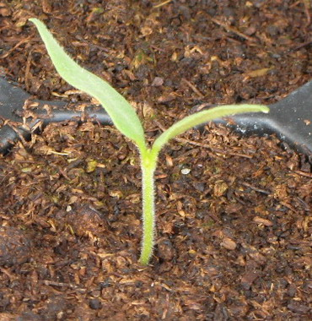 | 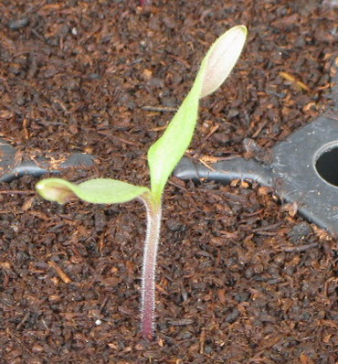
1 | 9
absent | present

Ad. 2: Plant: growth type

Determinate (1):

This type produces a fix number of trusses on each stem. The number of trusses is different among varieties (Note: can be influenced by agro climatic conditions). In this type, the number of leaves or internodes between inflorescence is irregular within a plant and varies from one to three. The stem ends with an inflorescence and no lateral shoots are produced.

This type also includes some so-called “semi-determinate” varieties which do not have consistently three leaves or internodes between inflorescences, and show semi-determinate growth, for example, with the termination of the stem with the 9th inflorescence (e.g. ‘Prisca’ type) or higher than the 20th inflorescence (e.g. Early Pack type).

Indeterminate (2):

In this type, as a rule, three leaves or internodes are observed between inflorescences. After every group of three leaves, the plant produces three buds: the terminal bud is transformed into an inflorescence and one of the two lateral buds starts the prolongation of stem. Plants of this type grow with the continuous repetition of this growth pattern.

It should be noted that sometimes only two leaves or internodes might be observed between inflorescences in some parts of plants in a certain group of indeterminate variety types (e.g. varieties originating from ‘Daniela’). These varieties nevertheless are indeterminate.

This type includes ‘Marmande’ and ‘Costoluto Fiorentino’ types which might be considered to be categorized into an intermediate class between indeterminate and determinate, but they always have three leaves or internodes between inflorescences. They should therefore be categorized into the indeterminate type.

Ad. 4. Stem: anthocyanin coloration

Most of the varieties are classed 1 to 5. Expression of anthocyanin is influenced by day temperature. Under greenhouse conditions, the variation is rather low.

Ad. 5: Only varieties with plant growth type indeterminate: Stem: length of internode

The length of the internode should be observed/measured at one time for the whole trial, e.g after a fruit set on approximately 5 nodes. The total length of the stem should be observed/measured between the 1st and 4th trusses. When this observation/measure is divided by the number of internodes in between, an indication of the length of the internode is given.

Ad. 6: Only varieties with growth type indeterminate: Plant: height

The height of the plant should be measured at one time for the whole trial, e.g. 60 days after planting, or after a fruit set on approximately 5 nodes, or when the first variety in the trial has reached the wire in the green house or the top of the stake.

Ad. 7: Leaf: attitude

The attitude of the middle third part of the leaves in respect to the main stem should be observed. The line in the picture indicates the angle between the stem and leaf (middle third of petiole).

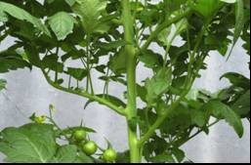 | 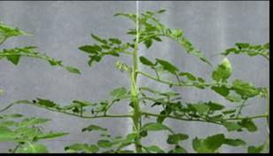
3 | 5
semi-erect | horizontal

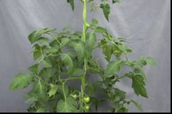 | 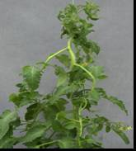
7 | 9
semi-drooping | drooping

Ad. 10: Leaf: type of blade

Pinnate leaf: primary leaflets do not bear secondary leaflets
Bipinnate leaf: primary leaflets again are pinnate, so they bear secondary leaflets

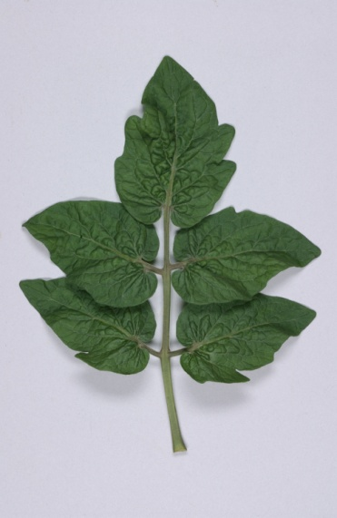 | 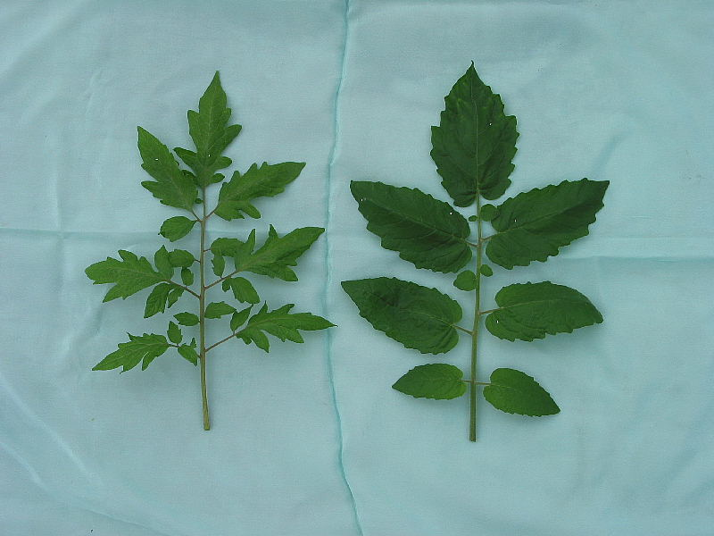
1 | 2
pinnate | bipinnate

Ad. 11: Leaf: size of leaflets

The size of leaflet should be observed in the middle of the leaf.

Ad. 13: Leaf: glossiness

The glossiness of the leaf should be observed in the middle of the plant.
Ad. 14: Leaf: blistering

Caution is required for confusion between blistering and creasing.

Blistering is the difference in height of the surface of the leaf between the veins. Creasing is independent form the veins. The blistering should be observed in the middle third of the plant.

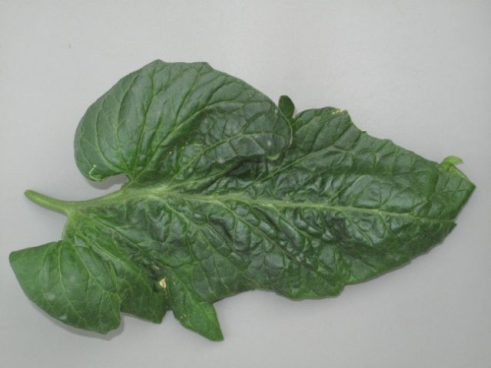 | 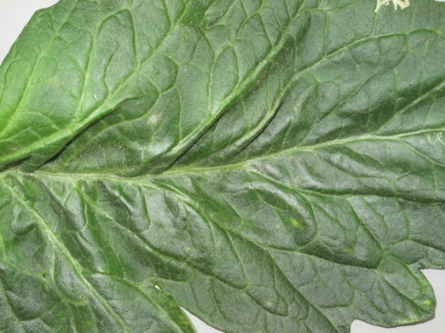
blistering | creasing

Ad. 15: Leaf: attitude of petiole of leaflet in relation to main axis

leaflet
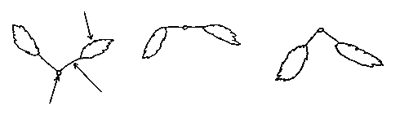
petiole
main axis
3 | 5 | 7
semi-erect | horizontal | semi-drooping

The attitude should be observed in the middle third of the plant.
Ad. 16: Inflorescence: type

The number of uniparous and multiparous trusses on the second and third truss of 10 plants should be counted. When the ratio of uniparous to multiparous is 40-60 percent, the expression of the characteristic should correspond to note “2”.

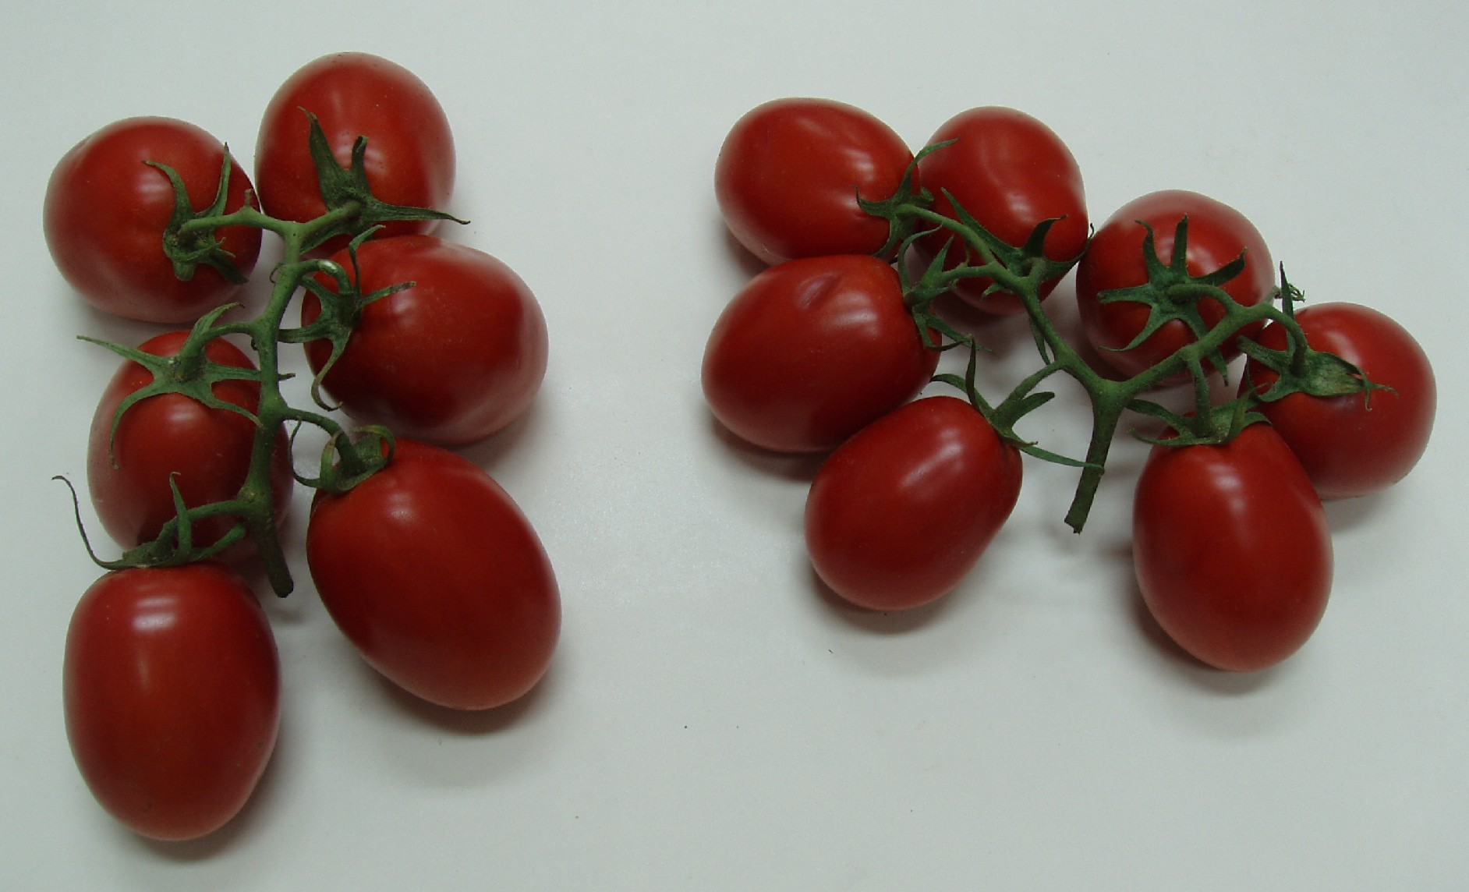
uniparous | multiparous (biparous)

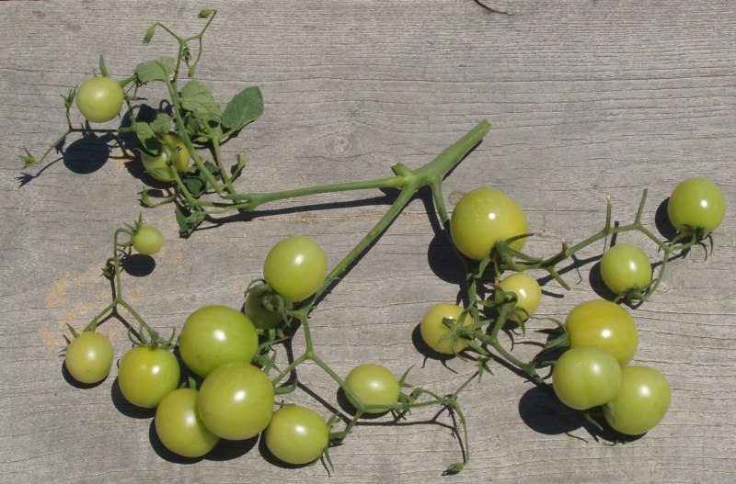
multiparous (triparous)

Ad. 18: Flower: pubescence of style

Some varieties with pubescence of style “present” may have only rare and small hairs at the base of the style
Ad. 19: Peduncle: abscission layer

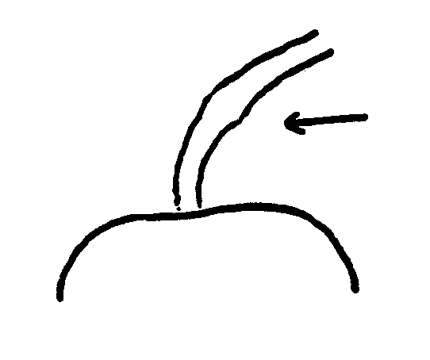 | 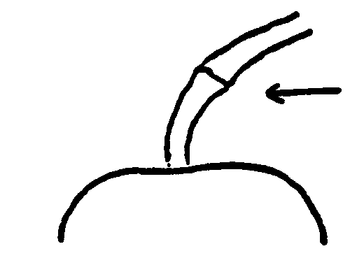
1 | 9
absent | present

Varieties which have only a collar instead of an abscission layer are heterozygous for the gene which controls the presence of the joint. These varieties are considered jointless and the abscission layer is considered absent.

Ad. 20: Only varieties with peduncle abscission layer present: Pedicel: length
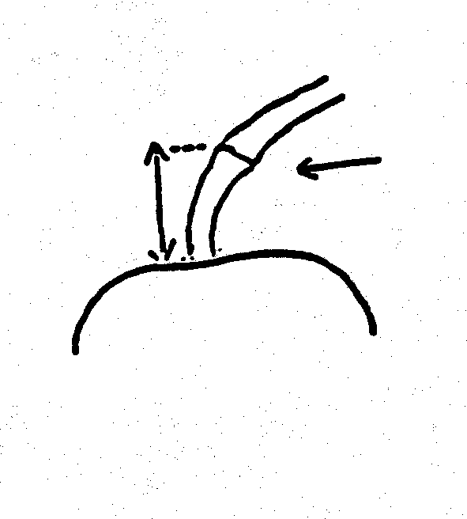
abscission layer
Ad. 21: Fruit: green shoulder (before maturity)

The gene for green shoulder might not be clearly expressed in some conditions, which is why it is important to have the example variety ‘Daniela’ to observe the expression of these characteristics.

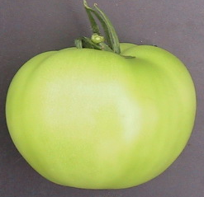 | 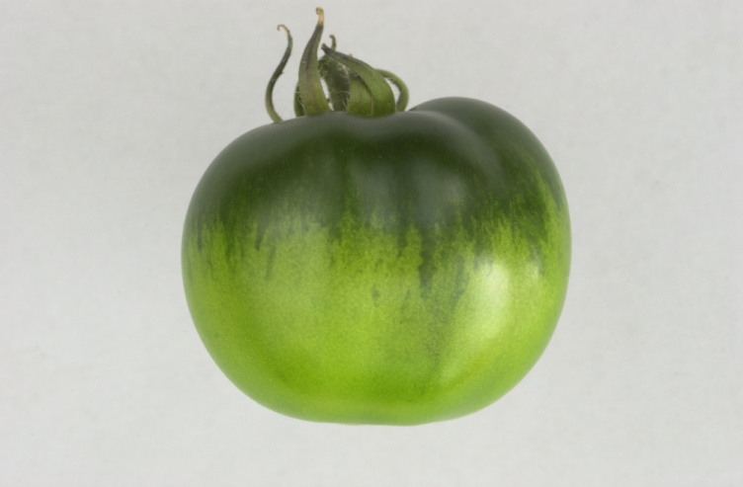
1 | 9
absent | present
Ad. 22: Fruit: extent of green shoulder (before maturity)

The gene for green shoulder might not be clearly expressed in some conditions, which is why it is important to have the example variety ‘Daniela’ to observe the expression of these characteristics.

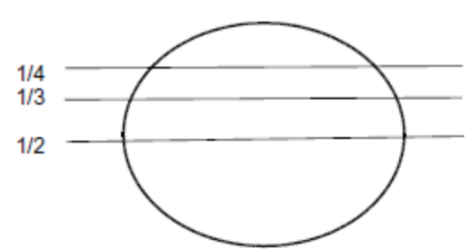 | 3: small (1/4)
 | 5: medium (1/3)
 | 7: large (1/2)

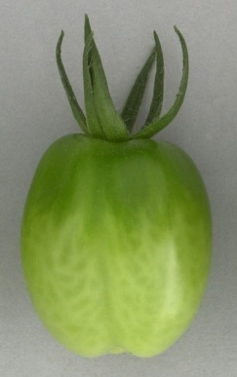  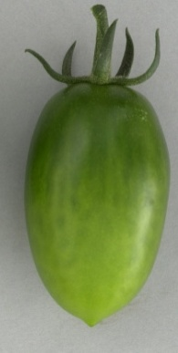  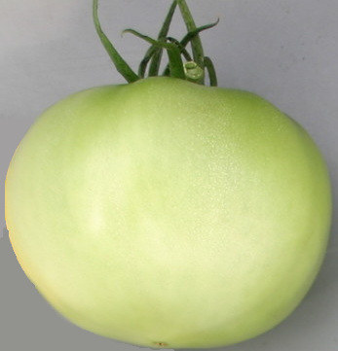 | 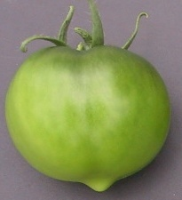
1 | 3 | 5 | 7
very small | small | medium | large

Ad. 23: Fruit: intensity of green color of shoulder (before maturity)
Ad. 24: Fruit: intensity of green color excluding shoulder (before maturity)

Intensity of green color of shoulder and intensity of green color excluding shoulder have to be observed on the same scale. This means that the note for intensity of green color of shoulder should be higher than the note for intensity of green color excluding shoulder, or in exceptional cases the same if the difference in intensity is very small. The gene for green shoulder might not be clearly expressed in some conditions, which is why it is important to have the example variety ‘Daniela’ to observe the expression of these characteristics.

Ad. 25: Fruit: green stripes (before maturity)

The green stripes should be observed before maturity, excluding the green shoulder.

 | 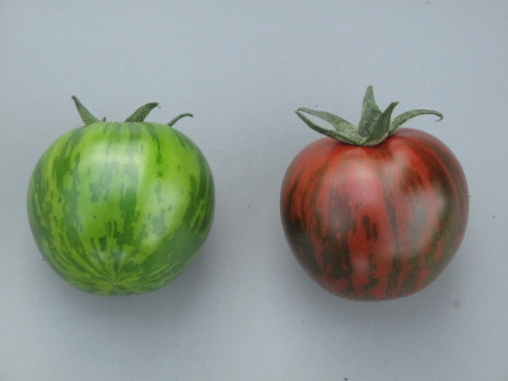
1 | 9
absent | present

Ad. 28: Fruit: shape in longitudinal section

 |  | ← broadest part →
 |  | (below middle) | at middle | (above middle)

broad (compressed) ← width (ratio length/width) → narrow (elongated) |  | 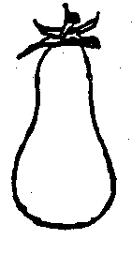 | 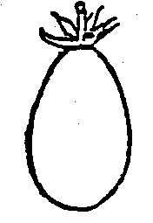 | 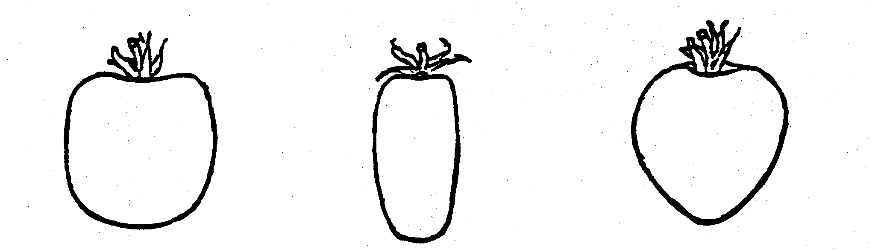 | 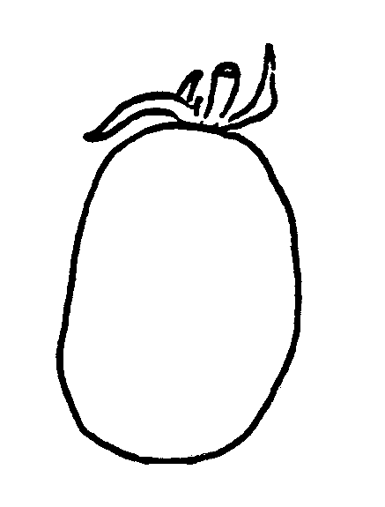 | 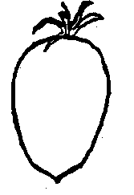
 |  | 10 | 8 | (parallel)  5 | (rounded)  6 | 9 | 7
 |  | pyriform | ovate | cylindric | elliptic | obovate | cordate
 |  | 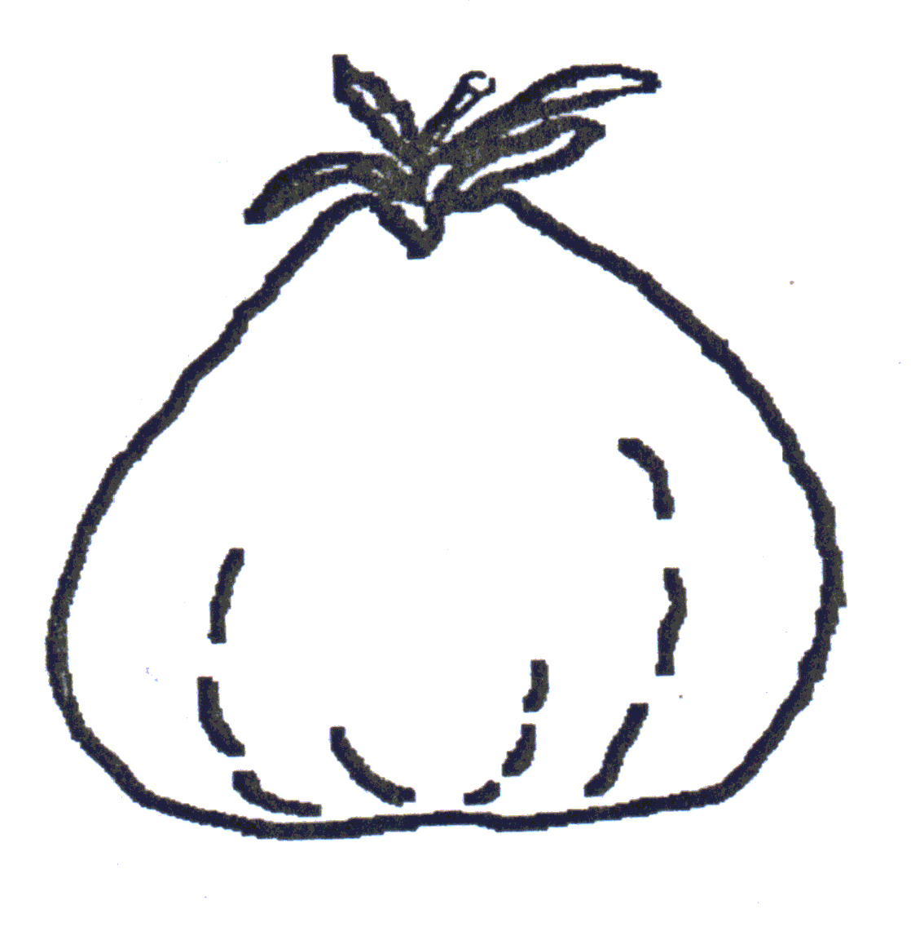 |  |  | 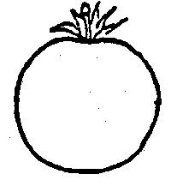
 |  | 11 |  | (parallel)  4 | (rounded)  3
 |  | obcordate |  | oblong | circular
 |  |  |  | 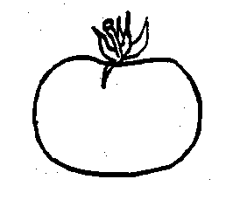
 |  |  |  | 2
 |  |  |  | oblate
 |  |  |  | 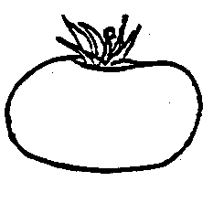
 |  |  |  | 1
 |  |  |  | flattened

The apex is considered to be the part that is farthest from the peduncle end.
Ad. 29: Fruit: ribbing at peduncle end

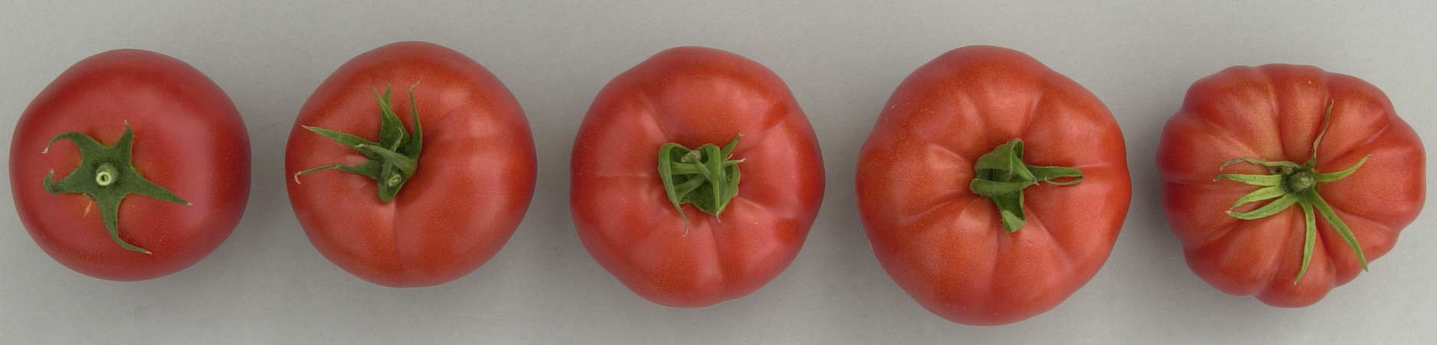
1 | 3 | 5 | 7 | 9
absent or very weak | weak | medium | strong | very strong

Ad. 30: Fruit: depression at peduncle end

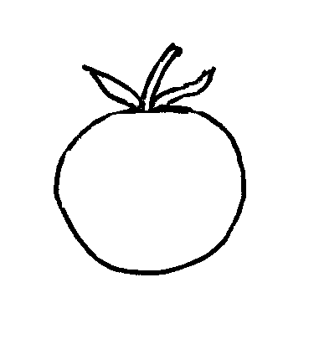 | 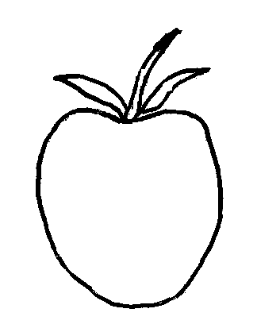 | 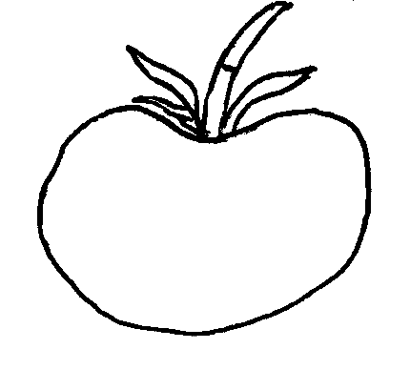 | 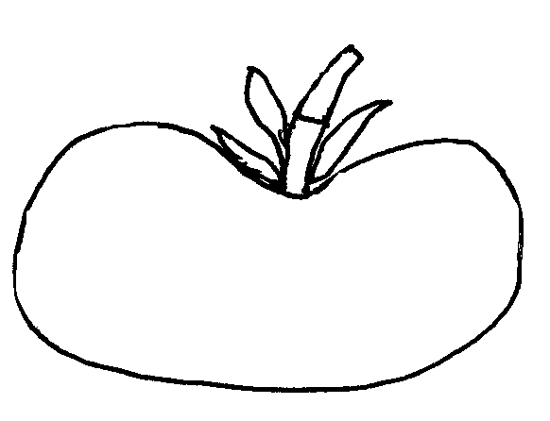
1 | 3 | 5 | 7
absent or  very weak | weak | medium | strong

Ad. 31: Fruit: size of peduncle scar

The size of the peduncle scar has to be observed as an absolute characteristic, i.e. irrespective of the size of the fruit. The peduncle should be removed and the green ring observed (not the full scar).

Ad. 32: Fruit: size of blossom scar

The size of the blossom scar has to be observed as an absolute characteristic, i.e. irrespective of the size of the fruit.

Ad. 33: Fruit: shape at blossom end

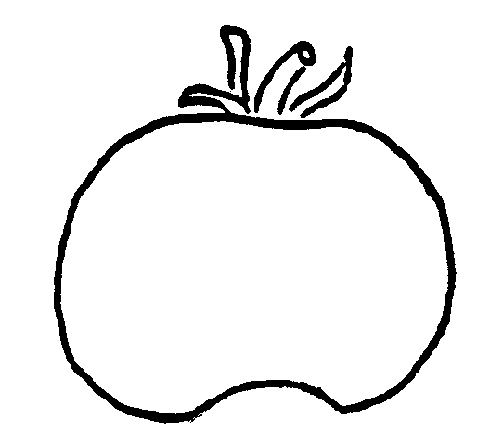 | 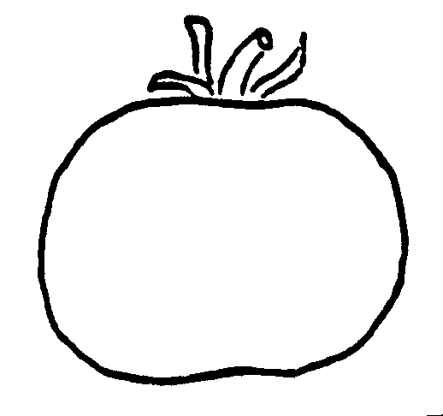 | 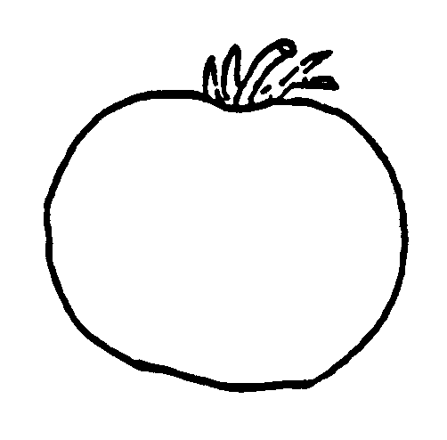 | 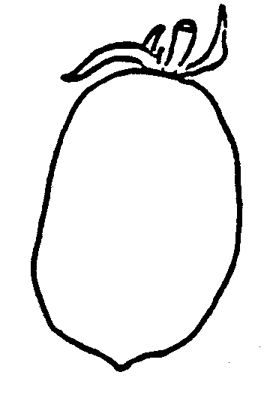 | 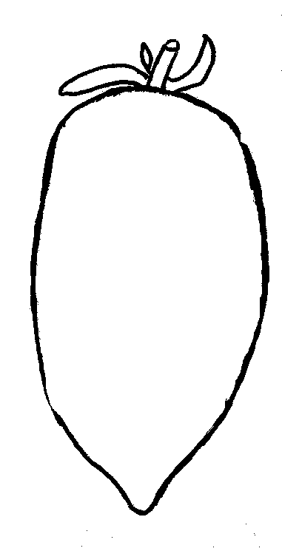
1 | 2 | 3 | 4 | 5
indented | indented to flat | flat | flat to pointed | pointed

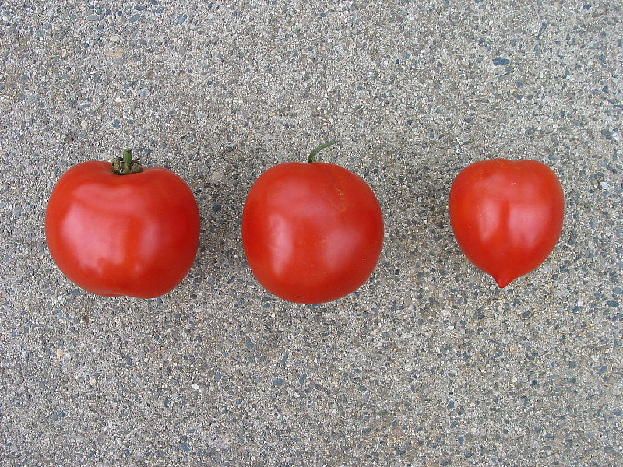
1 | 3 | 5
indented | flat | pointed

Ad. 34: Fruit: diameter of core in cross section (in relation to total diameter)

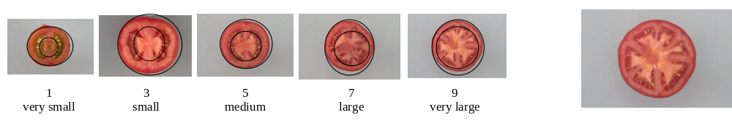
Ad. 35: Fruit: thickness of pericarp

The absolute thickness of the pericarp should be observed, i.e. irrespective of the size of the fruit.

Ad. 36: Fruit: number of locules

This characteristic is assessed by making cross sections of representative shaped and sized fruits but excluding the first and last fruits from the truss.

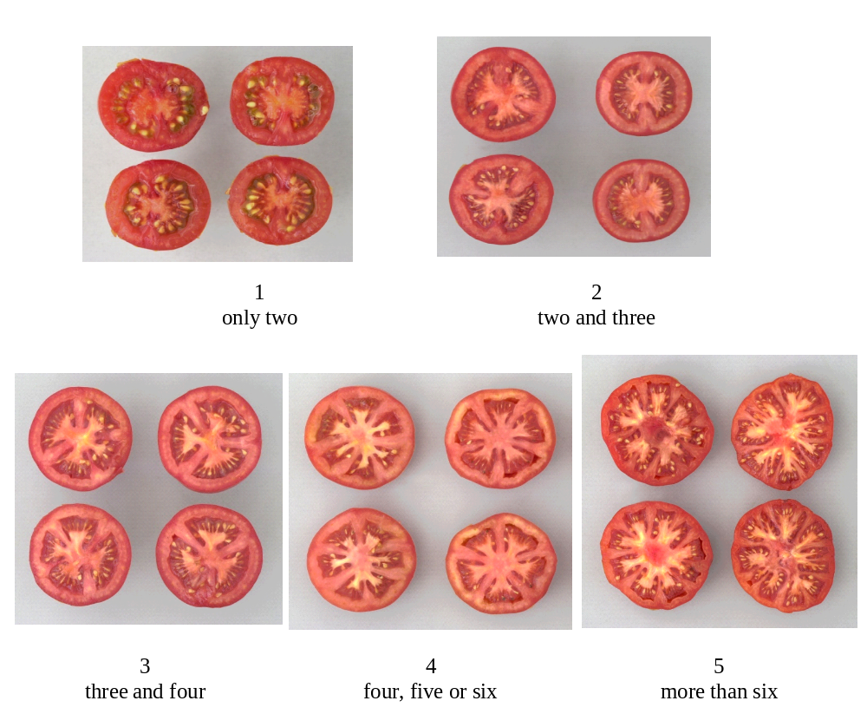

Ad. 37: Fruit: color (at maturity)

The color at maturity has to be observed after a full change of color, when placenta is found clearly in the cross section.

Ad. 38: Fruit: color of flesh (at maturity)

The color of flesh should be observed at maturity (see Ad. 44).

Ad. 40: Fruit: color of epidermis

The color of the epidermis should be observed after the epidermis has been peeled off the fruit.

Ad. 41: Fruit: firmness

Method

Harvesting stage: fruits should be harvested when they are completely coloured.

Determining firmness: determine by hand the firmness of the fruits compared to the standard varieties.

Ad. 42: Fruit: shelf-life

The length of shelf life is estimated by the number of weeks that the fruit remains commercially viable on the shelf.

Twenty fruits per plot (2 per plant) are picked from the 4th, 5th or 6th cluster in similar stages of exterior ripening (when green color disappears in half of whole fruit). Fruits are stored in boxes in single layers. The boxes can be stored one on top on another if they permit the air to circulate between them. The storage place does not need to be climatically controlled, but must have similar conditions to those in which the trial was performed, but not in direct sunshine. An observation is made every 7 days, noting the firmness of fruits, taking care not to damage them, and removing those accidentally damaged or rotten. The observation is made to determine when the firmness of fruits becomes no longer commercially viable (the firmness is lower than or equal to Note 3 “soft” in characteristics 40). The length of shelf life is calculated by the number of weeks between picking of fruits and the time that the firmness becomes no longer commercially viable.

The observations can be completed in the 8th week if some varieties still remain.

Ad. 43: Time of flowering

For staked varieties, this characteristic is assessed by observing the flowering date of the third flower on the second [and third] trusses, plant by plant. It is recommended not to record the time of flowering on the first truss, as the expression on the first truss is more influenced by the seed vigor and the plantation quality.

The date of flowering is recorded by the plot average, truss by truss.

For determinate non-staked varieties, it is recommended to grow them on pruned stakes on the main stem and to record the characteristics in the same way as those for ‘staked varieties’. On non-staked plants, this characteristic cannot be easily observed due to the branching of the plant.

Ad. 44: Time of maturity

This characteristic is assessed by observing the date of maturity of the first fully ripe fruit on the second truss, plant by plant. It is recommended not to record the time of maturity on the first truss, as the expression on the first truss is more influenced by the seed vigor and the plantation quality.

The date of maturity is recorded by the plot average, truss by truss.

This characteristic can be observed as described on all types of tomato varieties, irrespective whether the plants are staked or non-staked.

Ad. 45: Sensitivity to silvering

Method:

Evaluation: Evaluation is done on fully-grown plants

Execution of test: As silvering only occurs under specific growing conditions, these conditions have to be present during growth

Sowing: Under short day conditions (November/December in Northern Europe). Normal planting in the soil or in an artificial medium in the greenhouse

Temperature: day temperature maximum 18°C

Light: normal daylight

Growing method: no special method necessary

Duration of test: 4 - 5 months

Number of plants tested: minimum of 20

Observation of the expression: A visual survey has to be made on the presence of leaves that show signs of silvering

Standard varieties: expression absent: Marathon, Sano
expression present: Sonatine

It is to be noted that this characteristic may not be observable under “sunny” climates

Ad. 46: Resistance to Meloidogyne incognita (Mi)

1. Pathogen Meloidogyne incognita

3. Host species Solanum lycopersicum

4. Source of inoculum Naktuinbouw (NL) or GEVES (FR)

5. Isolate non-resistance breaking

6. Establishment isolate identity use rootstock or tomato standards

7. Establishment pathogenicity use susceptible rootstock or tomato standard

8. Multiplication inoculum

8.1 Multiplication medium living plant

8.2 Multiplication variety preferably resistant to powdery mildew

8.3 Plant stage at inoculation see 10.3

8.5 Inoculation method see 10.4

8.6 Harvest of inoculum root systems are cut with scissors into pieces of about 1 cm length

8.7 Check of harvested inoculum visual check for presence of root knots

8.8 Shelf life/viability inoculum 1 day

9. Format of the test

9.1 Number of plants per genotype 20 plants

9.2 Number of replicates 1 replicate

9.3 Control varieties

Susceptible Clairvil, Casaque Rouge

Moderately resistant Campeon, Madyta, Vinchy
Highly resistant Anabel, Anahu, Anahu x Casaque Rouge
9.4 Test design include standard varieties
9.5 Test facility greenhouse or climate room
9.6 Temperature not over 28° C
9.7 Light at least 12 h per day
10. Inoculation
10.1 Preparation inoculum small pieces of diseased root mixed with soil
mix soil and infested root pieces
10.2 Quantification inoculum soil: root ratio = 8:1, or depending on experience
10.3 Plant stage at inoculation seed, or cotyledons
10.4 Inoculation method plants are sown in infested soil or contamination of soil after sowing when plantlets are at cotyledon stage
10.7 Final observations 28 to 45 days after inoculation
11. Observations
11.1 Method root inspection
11.2 Observation scale symptoms:
galling, root malformation,
growth reduction, plant death
11.3 Validation of test evaluation of variety resistance should be calibrated with results of resistant and susceptible controls on standards
12. Interpretation of test results in comparison with control varieties:
To consider that resistant varieties may have a few plants with a few galls. These are not considered as off-types.
absent (susceptible) [1] growth strongly reduced, high gall count
intermediate
(moderately resistant) [2] medium growth reduction, medium gall count
present (highly resistant) [3] present; no growth reduction, no galls
13. Critical control points:
Avoid rotting of roots; high temperature causes breakdown of resistance.

Ad. 47: Resistance to Verticillium sp. (Va and Vd)

1. Pathogen Verticillium dahliae or Verticillium albo-atrum
3. Host species Solanum lycopersicum
4. Source of inoculum Naktuinbouw (NL) and GEVES (FR)
5. Isolate Race 0 (e.g. strain Toreilles 4-1-4-1)
8. Multiplication inoculum
8.1 Multiplication medium Potato Dextrose Agar, Agar Medium “S” of Messiaen
8.4 Inoculation medium water (for scraping agar plates) or Czapek Dox broth (3-7 d-old aerated culture at 20-25°C, in darkness)
8.6 Harvest of inoculum filter through double muslin cloth
8.7 Check of harvested inoculums spore count; adjust to 10⁶ per ml
8.8 Shelf life/viability inoculums 1 d at 4°C
9. Format of the test
9.1 Number of plants per genotype 35 seeds for 24 plants

9.2 Number of replicates 1 replicate
9.3 Control varieties
Susceptible Flix, Marmande verte, Clarion, Santonio, Anabel
Resistant Monalbo, Elias, Monalbo x Marmande verte, Daniela, Marmande VR
9.4 Test design 20 plants inoculated at least, 2 blanks at least
9.5 Test facility greenhouse or climate room
9.6 Temperature optimal 20-25°C, 20-22°C after inoculation
9.7 Light 12 h or longer
10. Inoculation
10.1 Preparation inoculums aerated, liquid culture (8.4)
10.2 Quantification inoculums count spores, adjust to 10⁶ per ml
10.3 Plant stage at inoculation cotyledon to 3rd leaf
10.4 Inoculation method roots are immersed for 4 to 15 min in spore suspension.
10.7 Final observations 14-33 d after inoculation
11. Observations
11.1 Method visual
11.2 Observation scale growth retardation, wilting, chlorosis, and vessel browning
11.3 Validation of test evaluation of variety resistance should be calibrated with results of resistant and susceptible controls.
12. Interpretation of test results in comparison with control varieties
absent [1] severe symptoms
present [9] no or mild symptoms
13. Critical control points:
All symptoms may be present in resistant varieties, but the severity will be distinctly less than in susceptible varieties. Usually resistant varieties will show significantly less growth retardation than susceptible varieties.
Ad. 48: Resistance to Fusarium oxysporum f. sp. lycopersici (Fol)

1. | Pathogen | Fusarium oxysporum f. sp. lycopersici
3. | Host species | Solanum lycopersicum
4. | Source of inoculum | Naktuinbouw (NL), GEVES (FR) or INIA (ES)
5. | Isolate | race 0EU/1US (e.g. strains Orange 71 or PRI 20698 or Fol 071)  race 1EU/2US (e.g. strains 4152 or PRI40698 or RAF 70)  race 2EU/3US (e.g. strain Fol029)
6. | Establishment isolate identity | use differential varieties (see ISF website: http://www.worldseed.org)
7. | Establishment pathogenicity | on susceptible tomato varieties
8. | Multiplication inoculum
8.1 | Multiplication medium | Potato Dextrose Agar, Medium “S” of Messiaen
8.4 | Inoculation medium | water for scraping agar plates or Czapek-Dox culture medium (7 d-old aerated culture)
8.6 | Harvest of inoculum | filter through double muslin cloth
8.7 | Check of harvested inoculum | spore count; adjust to 10⁶ per ml
8.8 | Shelflife/viability inoculum | 4-8 h, keep cool to prevent spore germination
9. | Format of the test
9.1 | Number of plants per genotype | at least 20 plants
9.2 | Number of replicates | 1 replicate
9.3.1 | Control varieties for the test with race 0EU/1US
 | Susceptible | Marmande, Marmande verte, Resal, Moneymaker
 | Resistant | Marporum, Larissa, “Marporum x Marmande verte”, Motelle, Gourmet, Mohawk, Tradiro
9.3.2 | Control varieties for the test with race 1EU/2US
 | Susceptible | Marmande verte, Cherry Belle, Roma, Marporum, Ranco, Moneymaker
 | Resistant | Tradiro, Odisea, “Motelle x Marmande verte”, Motelle
9.3.3 | Control varieties for the test with race 2EU/3US
 | Susceptible | Marmande verte, Motelle, Marporum
 | Resistant | Tributes, Murdoch, “Marmande verte x Florida”, Alliance, Florida, Ivanhoe
9.4 | Test design | >20 plants; e.g. 35 seeds for 24 plants, including 2 blanks
9.5 | Test facility | glasshouse or climate room
9.6 | Temperature | 24-28°C (severe test, with mild isolate)  20-24°C (mild test, with severe isolate)
9.7 | Light | 12 hours per day or longer
9.8 | Season | all seasons
9.9 | Special measures | slightly acidic peat soil is optimal;  keep soil humid but avoid water stress
10. | Inoculation
10.1 | Preparation inoculum | aerated Messiaen or PDA or Agar Medium S of Messiaen or Czapek Dox culture or scraping of plates
10.2 | Quantification inoculum | spore count, adjust to 10⁶ spores per ml, lower concentration for a very aggressive isolate
10.3 | Plant stage at inoculation | 10-18 d, cotyledon to first leaf
10.4 | Inoculation method | roots and hypocotyls are immersed in spore suspension for 5-15 min; trimming of roots is an option
10.7 | Final observations | 14-21 days after inoculation
11. | Observations
11.1 | Method | visual
11.2 | Observation scale | symptoms:  growth retardation, wilting, yellowing,  vessel browning extending above cotyledon
11.3 | Validation of test | evaluation of variety resistance should be calibrated with results of resistant and susceptible controls. Standards near borderline R/S will help to compare between labs.
12. | Interpretation of test results in comparison with control varieties
 | absent | [1] severe symptoms
 | present | [9] mild or no symptoms
13. | Critical control points | Test results may vary slightly in inoculum pressure due to differences in isolate, spore concentration, soil humidity and temperature.

Ad. 49: Resistance to Fusarium oxysporum f. sp. radicis-lycopersici (Forl)

1. Pathogen Fusarium oxysporum f. sp. radicis-lycopersici
3. Host species Solanum lycopersicum
4. Source of inoculum Naktuinbouw (NL) and GEVES (FR)
5. Isolate
7. Establishment pathogenicity symptoms on susceptible tomato Multiplication inoculum
8. Multiplication inoculum
8.1 Multiplication medium Potato Dextrose Agar or Medium agar “S” of Messiaen
8.4 Inoculation medium water for scraping agar plates or Czapek-Dox
(7 d-old aerated culture)
8.6 Harvest of inoculum filter through double muslin cloth
8.7 Check of harvested inoculum spore count; adjust to 10⁶ per ml
8.8 Shelf life/viability inoculum 4-8 h, keep cool to prevent spore germination
9. Format of the test
9.1 Number of plants per genotype at least 20 plants

9.2 Number of replicates 1 replicate
9.3 Control varieties

Susceptible Motelle, Moneymaker
Resistant Momor, “Momor x Motelle”
Remark “Momor x Motelle” has slightly weaker resistance than Momor
9.4 Test design >20 plants; e.g. 35 seeds for 24 plants, including 2 blanks
9.5 Test facility glasshouse or climate room
9.6 Temperature 24-28°C (severe test, with mild isolate)
17-24°C (mild test, with severe isolate)
9.7 Light at least 12 hours per day
9.8 Season all seasons
9.9 Special measures slightly acidic peat soil is optimal;
keep soil humid but avoid water stress
10. Inoculation
10.1 Preparation inoculum aerated culture or scraping of plates
10.2 Quantification inoculum spore count, adjust to 10⁶ spores per ml
10.3 Plant stage at inoculation 12-18 d, cotyledon to third leaf
10.4 Inoculation method roots and hypocotyls are immersed in spore suspension
for 5-15 min
10.7 Final observations 10-21 days after inoculation
11. Observations
11.1 Method visual; a few plants are lifted at the end of the test
11.2 Observation scale symptoms:
plant death, growth retardation caused by root degradation
root degradation, necrotic pinpoints and necrotic lesions on stems
11.3 Validation of test evaluation of variety resistance should be calibrated with results of resistant and susceptible controls
12. Interpretation of test results in comparison with control varieties
absent [1] symptoms
present [9] no symptoms
13. Critical control points:
Temperature should never exceed 27°C during the test period; frequent renewal of races may be needed because of loss of pathogenicity

Ad. 50: Resistance to Fulvia fulva (Ff) (ex Cladosporium fulvum)

1. Pathogen Fulvia fulva (ex Cladosporium fulvum)
3. Host species Solanum lycopersicum
4. Source of inoculum Naktuinbouw (NL) or GEVES (FR)
5. Isolate Race group 0, A, B, C, D, and E
6. Establishment isolate identity with genetically defined differentials from GEVES (FR)
A breaks Cf-2, B Cf-4, C Cf-2&4, D Cf-5, E Cf-2&4&5
7. Establishment pathogenicity symptoms on susceptible tomato
8. Multiplication inoculum
8.1 Multiplication medium Potato Dextrose Agar or Malt Agar or a synthetic medium
8.8 Shelf life/viability inoculum 4 hours, keep cool
9. Format of the test
9.1 Number of plants per genotype more than 20 plants

9.2 Number of replicates 1 replicate

9.3 Control varieties

Susceptible Monalbo, Moneymaker
Resistant for race 0 Angela, Estrella, Sonatine, Sonato, Vemone, Vagabond, IVT 1149, Vagabond × IVT 1149, IVT 1154
Resistant for race group A Angela, Estrella, Sonatine, Sonato
Resistant for race group B Angela, Estrella, Sonatine, Sonato, Vemone
Resistant for race group C Angela, Estrella, Sonatine
Resistant for race group D Estrella, Sonatine, Vemone
Resistant for race group E Sonatine, Jadviga, Rhianna, IVT 1154
9.5 Test facility glasshouse or climate room
9.6 Temperature day: 22° C, night: 20° or day: 25°C, night 20°C
9.7 Light 12 hours or longer
9.9 Special measures depending on facility and weather, there may be a need to raise the humidity
e.g. humidity tent closed 3-4 days after inoculation and after this, 66% until 80% closed during day, until end
10. Inoculation
10.1 Preparation inoculum prepare evenly colonized plates, e.g. 1 for 36 plants;
remove spores from plate by scraping with water with Tween20;
filter through double muslin cloth
10.2 Quantification inoculum count spores; adjust to 10⁵ spores per ml or more
10.3 Plant stage at inoculation 19-20 d (incl. 12 d at 24°), 2-3 leaves
10.4 Inoculation method spray on dry leaves
10.7 Final observations 14 days after inoculation
11. Observations
11.1 Method visual inspection of abaxial side of inoculated leaves
11.2 Observation scale Symptom: velvety, white spots
11.3 Validation of test evaluation of variety resistance should be calibrated with results of resistant and susceptible controls
12. Interpretation of test results in comparison with control varieties
absent [1] symptoms
present [9] no symptoms
Excessively high humidity may cause rugged brown spot on all leaves. These are not to be considered as off-types.
13. Critical control points:
Ff spores have a variable size and morphology. Small spores are also viable.
Fungal plates will gradually become sterile after 6-10 weeks. Store good culture at -80°C.
For practical purposes, it is not possible to keep plants longer than 14 days inside a tent.

Ad. 51: Resistance to Tomato mosaic virus (ToMV)

Resistance to strain 0, 1 and 2 to be tested in a bio-assay (method i) or in a DNA marker test (method ii), if appropriate.

- Bio-assay

1. | Pathogen | Tomato mosaic virus
3. | Host species | Solanum lycopersicum
4. | Source of inoculum | Naktuinbouw (NL), GEVES (FR) or INIA (ES, strain 0)
5. | Isolate | Strain 0 (e.g. isolate INRA Avignon 6-5-1-1), strain 1 and strain 2
6. | Establishment isolate identity | genetically defined tomato standards  Mobaci (Tm1), Moperou (Tm2), Momor (Tm2²)
7. | Establishment pathogenicity | on susceptible plant
8. | Multiplication inoculum
8.1 | Multiplication medium | living plant
8.2 | Multiplication variety | e.g. Moneymaker, Marmande
8.7 | Check of harvested inoculum | option: on Nicotiana tabacum “Xanthi”,  check lesions after 2 days
8.8 | Shelflife/viability inoculum | fresh>1 day, desiccated>1year
9. | Format of the test
9.1 | Number of plants per genotype | at least 20 plants
9.2 | Number of replicates | 1 replicate
9.3 | Control varieties
 | Susceptible | Marmande, Monalbo
 | Resistant for ToMV: 0 and 2 | Mobaci
 | Resistant for ToMV: 0 and 1 | Moperou
 | Resistant with necrosis | “Monalbo x Momor”
 | Resistant | Gourmet
9.4 | Test design | blank treatment with PBS and carborundum or similar buffer
9.5 | Test facility | Glasshouse or climate room
9.6 | Temperature | 24 to 26°C
9.7 | Light | 12 hours or longer
9.8 | Season | symptoms are more pronounced in summer
10. | Inoculation
10.1 | Preparation inoculum | 1 g leaf with symptoms with 10 ml PBS or similar buffer  homogenize, add carborundum to buffer (1g/30ml)
10.3 | Plant stage at inoculation | cotyledons or 2 leaves
10.4 | Inoculation method | gentle rubbing
10.7 | Final observations | 11-21 days after inoculation
11. | Observations
11.1 | Method | visual
11.2 | Observation scale | symptoms of susceptibility:  mosaic in top, leaf malformation  symptoms of resistance (based on hypersensitivity):  local necrosis, top necrosis, systemic necrosis
11.3 | Validation of test | evaluation of variety resistance should be calibrated with results of resistant and susceptible controls
 | Remark: | In some heterozygous varieties a variable proportion of plants may have severe systemic necrosis or some necrotic spots while the other plants have no symptoms. This proportion may vary between experiments.
12. | Interpretation of test results in comparison with control varieties
 | absent | [1] symptoms of susceptibility
 | present | [9] no symptoms, or symptoms of hypersensitive resistance
13. | Critical control points | Temperature and light may influence the development of necrosis. More light means more necrosis. At temperatures above 26°C the resistance may break down.  Resistant heterozygous varieties may have symptomless plants and plants with severe necrosis; in spite of apparent segregation the sample may be evaluated as uniform for resistance.  Note: Strain INRA Avignon 6-5-1-1 is recommended for ToMV: 0. This strain causes a striking yellow Aucuba mosaic.

(ii) DNA marker test

Resistance gene Tm2 gives resistance to ToMV. Gene Tm2 has two dominant allele for resistance: allele Tm2 is always associated with resistance to strain 0 and 1, allele Tm2² is always associated with resistance to strain 0, 1 and 2. The presence or absence of both allele for resistance can be detected by the co-dominant markers as described in Arens, P. et al (2010). Specific aspects:

1. | Pathogen | Tomato mosaic virus
2. | Functional gene | Tm2/2² (with two alleles for resistance Tm2 and Tm2² and one allele for susceptibility tm2)
3. | Primers
3.1 | Assay 1 to check resistance  allele Tm2 or Tm2² | Outer primer TMV-2286F: 5’GGGTATACTGGGAGTGTCCAATTC3’  Outer primer TMV-2658R: 5’CCGTGCACGTTACTTCAGACAA3’  Tm2² SNP2494F: 5’CTCATCAAGCTTACTCTAGCCTACTTTAGT3’  Tm2 SNP2493R:  5’CTGCCAGTATATAACGGTCTACCG3’
3.2 | Assay 2 to check allele for susceptibility or resistance | Outer primer TM2-748F:  5’CGGTCTGGGGAAAACAACTCT3’  Outer primer TM2-1256R: 5’CTAGCGGTATACCTCCACATCTCC3’  TM2-SNP901misR:  5’GCAGGTTGTCCTCCAAATTTTCCATC3’  TM2-SNP901misF: 5’CAAATTGGACTGACGGAACAGAAAGTT3’
4. | Format of the test
4.1 | Number of plants per genotype | at least 20 plants
4.2 | Control varieties | homozygous allele for susceptibility tm2 present: Mobaci, Monalbo, Moneymaker  homozygous allele for resistance Tm2 present: Moperou  homozygous allele for resistance Tm2² present: Mocimor, Momor
6. | PCR conditions | 1. Initial denaturation step at 94°C for 3 minutes  2. 35 cycles at 94°C for 1 minute, 55°C for 1 minute, 72°C for 2 minutes  3. Final extension step of 72°C for 10 minutes
8. | Interpretation of test results | The presence of the alleles tm2, Tm2, Tm2² lead to different interpretation for characteristics 51.1, 51.2 and 51.3, see table.  In case the DNA marker test result does not confirm the declaration in the TQ, a bio-assay should be performed to observe whether the variety is resistant due to another mechanism like gene Tm1.

Test result DNA marker test | tm2/tm2 | Tm2/tm2 or Tm2/Tm2 | Tm2²/tm2 or Tm2²/Tm2² or Tm2²/Tm2
51.1 Strain 0 | [1] absent | [9] resistant | [9] resistant
51.2 Strain 1 | [1] absent | [9] resistant | [9] resistant
51.3 Strain 2 | [1] absent | [1] absent | [9] resistant

Ad. 52: Resistance to Phytophthora infestans (Pi)

1. Pathogen Phytophthora infestans
3. Host species Solanum lycopersicum
4. Source of inoculum -
5. Isolate highly pathogenic on tomato
6. Establishment isolate identity biotest
7. Establishment pathogenicity biotest
8. Multiplication inoculum
8.1 Multiplication medium V8 Agar or PDA or Malt Agar medium
8.2 Multiplication variety susceptible tomato variety
8.3 Plant stage at inoculation 4 weeks
8.4 Inoculation medium water
8.5 Inoculation method spraying
8.6 Harvest of inoculum wash spores from wetted plates
8.7 Check of harvested inoculum count sporangiospores
8.8 Shelf life/viability inoculum 4 h after chilling at 8-10°C
9. Format of the test
9.1 Number of plants per genotype 20 plants

9.2 Number of replicates 1 replicate
9.3 Control varieties
Susceptible Saint Pierre, Heinz 1706
Resistant Pieraline, Heline, Pyros, “Pieraline x Pieralbo”, Fline
Remark heterozygote varieties may have a slightly lower level of expression of resistance.
9.5 Test facility glasshouse
9.6 Temperature 18°C
9.7 Light after inoculation darkness during 24 hours, thereafter 10 hour darkness per 24 hours
9.9 Special measures humidity tent during four days after inoculation
10. Inoculation
10.1 Preparation inoculum wash spores from sporulating leaves, chill at 8-10°C
Chilling will induce zoospore release
Remark use fresh spores from repeated infection cycles on tomato plants during 3 weeks before inoculation
10.2 Quantification inoculum count sporangiospores; adjust to 10⁴ spores per ml
10.3 Plant stage at inoculation 10 leaves developed (6 to 7 weeks)
10.4 Inoculation method spraying
10.7 Final observations 5-7 days after inoculation
11. Observations
11.1 Method visual
11.2 Observation scale symptoms: water-soaked lesions, yellowing, and death
11.3 Validation of test evaluation of variety resistance should be calibrated with results of resistant and susceptible controls
12. Interpretation of test results in comparison with control varieties
absent [1] severe symptoms
present [9] no or mild symptoms
13. Critical control points:
Resistance is only well-expressed in the adult plant.

Ad. 53: Resistance to Pyrenochaeta lycopersici (Pl)

1. | Pathogen | Pyrenochaeta lycopersici
2. | Quarantine status | No
3. | Host species | Solanum lycopersicum
4. | Source of inoculum | GEVES (FR)
5. | Isolate | e.g. strain Pl 21
6. | Establishment isolate identity | On susceptible plant
8. | Multiplication inoculum
8.1 | Multiplication medium | Messiaen agar or synthetic medium
8.4 | Inoculation medium | Autoclaved grains (e.g. barley)
8.5 | Inoculation method | Mix of contaminated grains (e.g. 1 kg) with inoculum (e.g. medium from 2 Petri dishes with mycelium)
8.6 | Harvest of inoculum | After 3 weeks
9. | Format of the test
9.1 | Number of plants per genotype | At least 20
9.2 | Number of replicates | 1 replicate
9.3 | Control varieties | Susceptible: Marmande verte  Resistant: Garance and (S. lycopersicum x S. habrochaites) Emperador
9.4 | Test design | add non inoculated plants
9.5 | Test facility | Greenhouse or climatic chamber
9.6 | Temperature | 20°C
9.7 | Light | At least 12h
10. | Inoculation
10.1 | Preparation inoculum | Homogenize the contaminated grains
10.3 | Plant stage at inoculation | 3-4 leaf stage
10.4 | Inoculation method | Transplanting of plantlets in a mixture of soil (e.g. 3750 ml of soil with 750 ml of inoculum)
10.7 | Final observations | 40 days post inoculation
11. | Observations
11.1 | Method | visual
11.2 | Observation scale | Class 0: no necrosic lesion on roots  Class 1: few small and uncoloured necrotic lesions  Class 2: some brown necrotic lesions clearly visible (less than half the surface of the pivot)  Class 3: several brown necrotic lesions clearly visible (more than half the surface of the pivot)  Class 4: complete necrosis or destruction of the pivot
11.3 | Validation of test | Evaluation of variety resistance should be calibrated with results of resistant and susceptible controls
12. | Interpretation of data in terms of UPOV characteristic states | Any variety judged to be of the same resistance level or higher than Garance is judged as resistant.  Classes 0, 1 and 2 are commonly judged as resistant – Note 9  Classes 3 and 4 are commonly judged as susceptible – Note 1
Ad. 54: Resistance to Stemphylium spp. (Ss)

1. Pathogen Stemphylium spp. e.g. Stemphylium solani
3. Host species Solanum lycopersicum
4. Source of inoculum GEVES (FR)
5. Isolate -
7. Establishment pathogenicity biotest
8. Multiplication inoculum
8.1 Multiplication medium PDA (12 hours per day under near-ultraviolet light to induce sporulation) or V8
9. Format of the test
9.1 Number of plants per genotype at least 20 plants

9.2 Number of replicates 1 replicate

9.3 Control varieties

Susceptible Monalbo
Resistant Motelle, F1 Motelle x Monalbo
9.5 Test facility greenhouse or climate cell
9.6 Temperature 24°C
9.7 Light 12 hours minimum
9.9 Special measures incubation in tunnel with 100 % relative humidity or humidity tent closed 5 days after inoculation, after this, 80% until end
10. Inoculation
10.1 Preparation inoculum sporulating plates (8.1) are scraped and air-dried overnight
The next day plates are soaked and stirred for 30 min in a beaker with demineralized water, or sporulating plates are scraped with water with Tween
The spore suspension is sieved through a double layer of muslin.
10.2 Quantification inoculum 5.10³ – 10⁵ spores per ml
10.3 Plant stage at inoculation 20-22 days (three expanded leaves)
10.4 Inoculation method spraying
10.7 Final observations 4 -10 days after inoculation
11. Observations
11.1 Method visual
11.2 Observation scale symptoms:
necrotic lesions on cotyledons and leaves;
yellowing of leaves
11.3 Validation of test evaluation of variety resistance should be calibrated with results of resistant and susceptible controls
12. Interpretation of test results in comparison with control varieties
absent [1] symptoms (11.2)
present [9] no symptoms, or less than resistant standard
13. Critical control points:
8.1 and 10.1
Note: Some isolates of Stemphylium cannot be classified easily as either Stemphylium solani or a related species. These Stemphylium isolates may still be useful for identifying resistance to Stemphylium solani.
Ad. 55: Resistance to Pseudomonas syringae pv. tomato (Pst)

1. Pathogen Pseudomonas syringae pv. tomato
3. Host species Solanum lycopersicum
4. Source of inoculum GEVES (FR) or Naktuinbouw (NL)
5. Isolate
6. Establishment isolate identity
7. Establishment pathogenicity biotest
8. Multiplication inoculum
8.1 Multiplication medium King’s B agar medium, darkness
8.2 Multiplication variety susceptible variety
8.4 Inoculation medium water
8.8 Shelf life/viability inoculum plates become old after 10 days
9. Format of the test
9.1 Number of plants per genotype at least 20 plants

9.2 Number of replicates 1 replicate
9.3 Control varieties

Susceptible Monalbo
Resistant Ontario 7710, “Monalbo x Ontario 7710”, Tradiro, Hypeel 45
9.5 Test facility greenhouse or growth chamber
9.6 Temperature day: 22° C, night: 16° C or 20°C
9.7 Light 12 hours
9.9 Special measures humidity tent needed for 3 days or longer
10. Inoculation
10.1 Preparation inoculum wash off spores from plate. Plate should be less than 2-4 days old.
10.2 Quantification inoculum dilution plating, density 10⁶ colony forming units per ml
10.3 Plant stage at inoculation three leaves expanded (20-22 days)
10.4 Inoculation method spraying a bacterial suspension on leaves
10.7 Final observations 8 days after inoculation or longer
11. Observations
11.1 Method visual
11.2 Observation scale bacterial speck, greasy in appearance with marginal chlorosis pinpoint lesions < 1.0 mm
11.3 Validation of test evaluation of variety resistance should be calibrated with results of resistant and susceptible controls
12. Interpretation of test results in comparison with control varieties
absent [1] bacterial speck
present [9] no symptoms or pinpoint lesions
13. Critical control points:
Strains may lose virulence in storage
Ad. 56: Resistance to Ralstonia solanacearum, race 1 (Rs)

1. Pathogen Ralstonia solanacearum (ex Pseudomonas solanacearum)
2. Quarantine status yes
3. Host species Solanum lycopersicum
4. Source of inoculum
5. Isolate Race 1 has a wide host range, including tomato.
Race 3 has a narrow host range, also including tomato
8. Multiplication inoculum
8.1 Multiplication medium Yeast Peptone Glucose (YPG) Agar or PYDAC
Special conditions: 25-30°C (Race 3 usually needs 20-23°C)
8.5 Inoculation method 2 ml of inoculum placed at the foot of each plantlet prior to transplanting
8.8 Shelf life/viability inoculum suspension in sterile distilled water at 15°C (<1 year)
9. Format of the test
9.1 Number of plants per genotype 20 plants

9.2 Number of replicates 1 replicate
9.3 Control varieties

Susceptible Floradel
Resistant Caraibo
9.5 Test facility climate room
9.6 Temperature day: 26-30° C; night: 25° C
9.7 Light 10 - 12 hours
9.9 Special measures high humidity
10. Inoculation
10.2 Quantification inoculum density 10⁷ colony forming units per ml
10.3 Plant stage at inoculation three to four well-developed leaves (3 weeks)
10.4 Inoculation method
10.7 Final observations 3 weeks after inoculation
11. Observations in intermediate resistance varieties, bacteria could be present in the lower part of the plant
11.3 Validation of test evaluation of variety resistance should be calibrated with results of resistant and susceptible controls
12. Interpretation of test results in comparison with control varieties
absent [1] symptoms
present [9] no symptoms, or less than resistant standard
13. Critical control points:
Ralstonia solanacearum has a quarantine status in some countries and is on the EPPO alert list.

Ad. 57: Resistance to Tomato yellow leaf curl virus (TYLCV)

(i) agroinoculation method

1. Pathogen Tomato yellow leaf curl virus (TYLCV) IL strain. (See note below)
2. Quarantine status yes (see 13.)
3. Host species Solanum lycopersicum
4. Source of inoculums Dr. Eduardo R. Bejarano, Plant Genetics Laboratory, IHSM-UMA-CSIC
5. Isolate Alm:Pep:99, strain IL
6. Establishment isolate identity
7. Establishment pathogenicity
8. Multiplication inoculum
8.1 Multiplication medium YEP/Kanamycin.
8.2 Multiplication variety
8.3 Plant stage at inoculation 3-4 leaf
8.4 Inoculation medium YEP
8.5 Inoculation method Stem puncture agroinfiltration. Plant agroinoculation is carried out using Agrobacterium tumefaciens transformed with plasmids containing the infectious clones (Morilla, et al. 2005. Phytopathology 95: 1089-1097)
8.6 Harvest of inoculums
8.7 Check of harvested inoculums
8.8 Shelflife/viability inoculums A. tumefaciens stocks are maintained frozen at -80ºC in 15-20% glycerol for long term storage. Cultures to be stored are typically started from a single colony and grown in 5 ml YEP +2.5 µl kanamycin (100mg/ml) during 48 h at 28ªC.
9. Format of the test
9.1 Number of plants per genotype 20
9.2 Number of replicates 2
9.3 Control varieties Susceptible: Moneymaker, Marmande,
Resistant: Delyca, Montenegro, Anastasia, TY20, Mohawk
9.4 Test design
9.5 Test facility Glasshouse or climatic chamber with permission to confined use of LMO/GMO, confinement level 1 (N-1)
9.6 Temperature 23-25°C
9.7 Light 16 h
9.8 Season
9.9 Special measures Permission to confined use of LMO/GMO, at least level 1 (N-1)Error: Reference source not found
10. Inoculation
10.1 Preparation inoculums Streak the surface of the frozen A. tumefaciens stock tube and submerge in 5 ml YEP+2.5 µl kanamycin (100mg/ml) during 48 h at 28ªC. Shaking is needed. Take 100 µl and place them into 100 ml YEP and 50 µl kanamycin (100mg/ml). Shake 48 h at 28ºC. Centrifuge the saturated culture for 20 min at 3500 rpm and discard supernatant.
10.2 Quantification inoculums Dissolve in sterile deionize water to a final OD ₆₀₀ of 1.
10.3 Plant stage at inoculation 3-4th leaf
10.4 Inoculation method Take up into a 1 ml syringe with a 27-gauge needle and few drops (about 20 µl of the culture) were deposited on 10-15 puncture wounds made with the needle into the stem of test tomato plants. Maintain on ice while inoculating plants.
10.5 First observation 20 days post inoculation
10.6 Second observation 30 dpi
*10.7 End of test –
Final observation 45 dpi
11. Observations
11.1 Method Visual
11.2 Observation scale Symptoms: leaf yellowing and curling
11.3 Validation of test Evaluation of variety resistance should be calibrated with results of resistant and susceptible controls
12. Interpretation of data in terms of UPOV characteristic states
absent [1] severe symptoms
present [9] no symptoms
13. Critical control points:
TYLCV is endemic in many tropical and subtropical areas and has a quarantine status in many countries with a temperate climate.
TYLCV-IL is the strain most widely spread worldwide. With this strain, symptoms do not appear in varieties with Ty-1 and Ty-2.
TYLCV is on the EPPO alert list. Some TYLCV resistant varieties may be susceptible to the closely related virus Tomato yellow leaf curl Sardinia virus (TYLCSV).

(ii) White fly inoculation method

1. Pathogen Tomato yellow leaf curl virus (TYLCV) IL strain
2. Quarantine status yes (see 13.)
3. Host species Solanum lycopersicum
4. Source of inoculum IHSM-UMA-CSIC or INIA (ES)
5. Isolate TYLCV-IL La Mayora
8. Multiplication inoculum White flies
8.6 Harvest of inoculum
9. Format of the test
9.1 Number of plants per genotype 20

9.2 Number of replicates Two replicates
9.3 Control varieties
Susceptible: Moneymaker, Marmande,
Resistant: Delyca, Montenegro, Anastasia, TY20, Mohawk
9.5 Test facility Greenhouse/plastic tunnel
9.9 Special measures prevent spread of white-flies
10. Inoculation
10.3 Plant stage at inoculation 2-4 weeks
10.4 Inoculation method vector (Bemisia white-flies carrying TYLCV-IL)
10.7 Final observations 1-2 months after inoculation
11. Observations
11.1 Method visual
11.2 Observation scale Symptoms: leaf yellowing and curling
11.3 Validation of test evaluation of variety resistance should be calibrated with results of resistant and susceptible controls
12. Interpretation of data in terms of UPOV characteristic states
absent [1] severe symptoms
present [9] no or mild symptoms
13. Critical control points:
TYLCV is endemic in many tropical and subtropical areas and has a quarantine status in many countries with a temperate climate.
TYLCV-IL is the strain most widely spread worldwide. With this strain, symptoms do not appear in varieties with Ty-1 and Ty-2.
Some TYLCV resistant varieties may be susceptible to the closely related virus Tomato yellow leaf curl Sardinia virus (TYLCSV).

Ad. 58: Resistance to Tomato spotted wilt virus (TSWV)

Resistance to strain 0 to be tested in a bio-assay (method i) or in a DNA marker test (method ii), if appropriate.

(i) Bio-assay

1. | Pathogen | Tomato spotted wilt virus
2. | Quarantine status | yes (see note below)
3. | Host species | Solanum lycopersicum
4. | Source of inoculum | Naktuinbouw (NL), GEVES (FR)
5. | Isolate | race 0, preferably a thrips-transmission deficient variant
7. | Establishment pathogenicity | biotest
8. | Multiplication inoculum
8.6 | Harvest of inoculum | symptomatic leaves may be stored at -70°C
9. | Format of the test
9.1 | Number of plants per genotype | 20 plants
9.2 | Number of replicates | 1 replicate
9.3 | Control varieties
 | Susceptible | Monalbo, Momor, Montfavet H 63.5
 | Resistant | Tsunami, Bodar, Mospomor, Lisboa
9.5 | Test facility | glasshouse or climatic chamber
9.6 | Temperature | 20°C
9.7 | Light | 12 hours or longer
9.9 | Special measures | prevent or combat thrips
10. | Inoculation
10.1 | Preparation inoculum | press symptomatic leaves in ice-cold buffer 0,01 M PBS, pH 7.4, with 0,01 M sodium sulfite or similar buffer  option: sieve the leaf sap through double muslin
10.3 | Plant stage at inoculation | one or two expanded leaves
10.4 | Inoculation method | mechanical, rubbing with carborundum on cotyledons, inoculum suspension < 10° C
10.7 | Final observations | 7-21 days after inoculation
11. | Observations
11.1 | Method | visual
11.2 | Observation scale | symptoms: top mosaic, bronzing, various malformations, necrosis
11.3 | Validation of test | evaluation of variety resistance should be calibrated with results of resistant and susceptible controls
12. | Interpretation of test results in comparison with control varieties
 | absent | [1] symptoms
 | present | [9] no symptoms
13. | Critical control points | TSWV has a quarantine status in some countries. TSWV is transmitted by Thrips tabaci and Western flower thrips (Frankliniella occidentalis). Pathotype 0 is defined by its inability to break resistance in tomato varieties carrying the resistance gene Sw-5.

(ii) DNA marker test

Dominant resistance gene Sw-5 is always associated with resistance to TSWV strain 0. The presence or absence of the allele for resistance can be detected by the co dominant marker as described in Dianese, E.C. et al (2010). Specific aspects:

1. | Pathogen | Tomato spotted wilt virus
2. | Functional gene | Sw-5b
3. | Primers
3.1 | Allele for susceptibility | Sw5-Vat1-F: 5’-ACAACATCAAACAATGTTAGCC-3’  Sw5-Vat2-F: 5’-CATCAAACAATGCAGTTAGCC-3’
3.2 | Allele for resistance | Sw5-Res-F: 5’-ATCAACCAATACAGCCTAACC-3
3.3 | Universal reverse | Sw5-universal-R: 5’-TTTCTCCCTGCAAGTTCACC-3’
3.4 | Allele specific probes | Sw5-Sus1:  5’-VIC-TACATTATGAAGGGTTAACAAG-MGB-NFQ-3’  Sw5-Sus2:  5’-6FAM-ACAACAGAGGGTTAACAAGTTTAGG-BHQ1-3’  Sw5-Res:  5’-TEXAS RED-TGGGCGAAAATCCCAACAAG-BHQ2-3’
4. | Format of the test
4.1 | Number of plants per genotype | at least 20 plants
4.2 | Control varieties | homozygous allele 1 for susceptibility present: Moneymaker  homozygous allele 2 for susceptibility present: Mountain Magic  homozygous allele for resistance present: Montealto  heterozygous (allele for resistance and allele 1 for susceptibility present): Bodar
6. | PCR conditions | 1. Initial denaturation step 10 min 95 °C  2. 40 cycles 15 sec 95 °C and 1 min 60°C. Every cycle ends with a plate reading.
8. | Interpretation of test results
 | absent | [1] allele(s) for susceptibility present and allele for resistance absent
 | present | [9] allele for resistance present (homozygous or heterozygous)  In case the DNA marker test result does not confirm the declaration in the TQ, a bio-assay should be performed to observe whether the variety is resistant due to another mechanism.

Ad. 59: Resistance to Leveillula taurica (Lt)

1. Pathogen Leveillula taurica
3. Host species Solanum lycopersicum
4. Source of inoculum no long term storage method is available
5. Isolate
8. Multiplication inoculum
8.1 Multiplication medium detached leaves of a susceptible host plant
9. Format of the test
9.1 Number of plants per genotype 20 plants

9.2 Number of replicates 1 replicate
9.3 Control varieties

Susceptible Monalbo, Montfavet H 63.5
Resistant Atlanta
10. Inoculation
10.3 Plant stage at inoculation adult plants
10.4 Inoculation method natural infection, mainly by wind dispersal of spores
10.7 Final observations before harvest
11. Observations
11.1 Method visual
11.2 Observation scale symptoms: Yellow chlorotic spots on upper side of leaves, mycelium on abaxial side of leaves
11.3 Validation of test evaluation of variety resistance should be calibrated with results of resistant and susceptible controls
12. Interpretation of test results in comparison with control varieties
absent [1] symptoms
present [9] no symptoms, or less than resistant standard
13. Critical control points:
Check cleistothecia under microscope to confirm presence of Leveillula and not another powdery mildew.

Ad. 60: Resistance to Oidium neolycopersici (On)

1. Pathogen Oidium neolycopersici (Powdery mildew)
3. Host species Solanum lycopersicum
4. Source of inoculum
5. Isolate see remark under 13
7. Establishment pathogenicity biotest
8. Multiplication inoculum
8.1 Multiplication medium plant
8.3 Plant stage at inoculation 3 weeks
8.4 Inoculation medium water
8.5 Inoculation method see 10.4
8.6 Harvest of inoculum by washing off
8.7 Check of harvested inoculum check for contaminants under microscope
8.8 Shelf-life/viability inoculum 1-2 hours
9. Format of the test
9.1 Number of plants per genotype 20 plants

9.2 Number of replicates 1 replicate

9.3 Control varieties

Susceptible Momor, Montfavet H 63.5

Resistant Atlanta, Romiro, PI-247087

9.5 Test facility glasshouse
9.6 Temperature 20°C or 18/24°C
9.7 Light 12 hours
10. Inoculation
10.1 Preparation inoculum collect spores in water
10.2 Quantification inoculum 10⁴ conidia/ml
10.3 Plant stage at inoculation 3 weeks
10.4 Inoculation method by spraying on leaves or dredging of leaves
10.7 Final observations 7-18 days after inoculation
11. Observations
11.1 Method visual
11.2 Observation scale 0. no sporulation
1. necrotic points and sometimes locally restricted sporulation
2. moderate sporulation
3. abundant sporulation
11.3 Validation of test evaluation of variety resistance should be calibrated with results of resistant and susceptible controls
12. Interpretation of test results in comparison with control varieties
absent [1] moderate or abundant sporulation
present [9] no or restricted sporulation
13. Critical control points:
Resistance-breaking isolates should be avoided. Resistance to O. neolycopersici is usually race-specific. However, as long as a differential series of tomato genotypes with well defined resistances is lacking, it will remain hard to conclude that different races of O. neolycopersici exist.

Ad. 61: Resistance to Tomato torrado virus (ToTV)

1. Pathogen Tomato torrado virus
2. Quarantine status in regions with temperate climate
3. Host species Solanum lycopersicum
4. Source of inoculum -
5. Isolate -
7. Establishment pathogenicity biotest
8. Multiplication inoculum
8.1 Multiplication medium Nicotiana tabacum ‘Xanthi’
8.3 Plant stage at inoculation cotyledon to first leaf
8.5 Inoculation method see 10.4
8.6 Harvest of inoculum after 3 weeks
8.7 Check of harvested inoculum plants yellow, systemic infection
8.8 Shelf-life/viability inoculum instable at room temperature
9. Format of the test
9.1 Number of plants per genotype 20 plants

9.2 Number of replicates 1 replicate

9.3 Control varieties

Susceptible Daniela

Resistant tomato Matias

9.5 Test facility glasshouse
9.6 Temperature 23°C during the day; 21°C during the night
9.7 Light 16 hours
10. Inoculation
10.3 Plant stage at inoculation 14 days
10.4 Inoculation method with ice-cold 0,01 M PBS pH 7 and carborundum
10.5 First observation 7 days after inoculation
10.6 Second observation 14 days after inoculation
10.7 Final observations 18 days after inoculation
11. Observations
11.1 Method visual
11.2 Observation scale necrotic spots on the top leaves
11.3 Validation of test evaluation of variety resistance should be calibrated with results of resistant and susceptible controls
12. Interpretation of test results in comparison with control varieties
absent [1] necrotic spots present
present [9] no symptoms
13. Critical control points:

ToTV is transmitted by white fly (Bemisia tabaci). Produce inoculum with ice-cold mortar and pestle.

During inoculation the temperature should be below 25°C

Note: Patents pending on part of the method: WO2006/085749 and WO2008/150158 and equivalents. Use solely for DUS purposes and for the development of variety descriptions by UPOV and authorities of UPOV members, courtesy to De Ruiter Seeds R&D B.V./Monsanto Invest N.V.

Literature
Ano, G., Brand, R., Causse, M., Chauvet, M., Damidaux, R., Laterrot, H., Philouze, J., Plages, J.N., Rousselle, 2006: La Tomate, in Histoire et amélioration de cinquante plantes cultivées au XXème siècle. Coordinatrice C. Doré, Collection « Savoir faire », Editions INRA Quae, Paris, FR, 840 pp.

Arens P., Mansilla C., Deinum D., Cavellini L., Moretti A., Rolland S., van der Schoot H., Calvache D., Ponz F., Collonnier C., Mathis R., Smilde D., Caranta C,; Vosman B., 2010. Development and evaluation of robust molecular markers linked to disease resistance in tomato for distinctness, uniformity and stability testing. Theoretical and applied genetics. 120(3): 655-64

Bai, Y. 2004. The genetics and mechanisms of resistance to tomato powdery mildew (Oidium neolycopersici) in Lycopersicon species. Thesis Wageningen University, The Netherlands.

Barbieri, M., et al., 2010. Introgressions of resistance to two Mediterranean virus species causing tomato yellow leaf curl into a valuable traditional tomato variety. Journal of Plant Pathology 92(2):485-493

Brand, R., 2000: Evolution des variétés de Tomate au cours du siècle, dans ‘La Tomate : pour un produit de qualité’, Edition Ctifl, C85105 (ouvrage collectif), FR, p. 97-105

Denby, L.G., Wooliams, G.E., 1962: The Development of Verticillium Resistant Strains of Established Tomato Varieties, Canadian Journal Plant Science 42, CA, pp. 681-685

Dianese, E.C. et al, 2010: Development of a locus-specific, co-dominant SCAR marker for assisted-selection of the Sw-5 (Topovirus resistance) gene cluster in a wide range of tomato accessions. Molecular Breeding, 25(1), pp. 133-142.

Garcia, S., et al., 2009. Resistance driven selection of begomoviruses associated with the TYLCV. Virus research 146: 66-72

Garland, S., Sharman, M., Persley, D. and McGrath, D. (2005) The development of an improved PCR-based marker system for Sw-5, an important TSWV resistance gene of tomato. Australian Journal of Agricultural Research, 56 (3): 285-289.

Gordillo, L.F. and M. R. Stevens (2008) Screening two Lycopersicon peruvianum collections for resistance to Tomato spotted wilt virus. Plant Disease 92(5): 694-704

Hubbeling, N., 1978. Breakdown of resistance to the Cf-5 gene in tomato by another new race of Fulvia fulva. Mededelingen van de Faculteit Landbouwwetenschappen Universiteit Gent 42/2

International Seed Federation (ISF): Trade Issues, Phytosanitary Matters, Pathogen coding, Strain Denomination, Differential sets. http://www.worldseed.org/isf/pathogen_coding_3.html

Kjellberg, L., 1973: Sortundersökningar av tomat enligt UPOV, Swedish University of Agricultural Sciences, Research Information Centre, Alnarp Trädgaard 162, SE

Laterrot, H., 1973: Sélection de variétés de Tomate résistantes aux Meloidogyne, OEPP/EPPO Bulletin 3(1), pp. 89-92

Laterrot, H., 1972: Sélection de tomates résistantes à Fusarium oxysporum f. sp. lycopersici, Phytopathologia Mediterranea, 11(3), Firenze, IT, pp. 154-158

Laterrot, H., 1981: La lutte génétique contre la Cladosporiose de la Tomate en France. P.H.M. Revue Horticole, No. 214, Montpellier, FR, pp. 27-30

Laterrot, H., 1973: Résistance de la Tomate au virus de la Mosaïque du Tabac. Difficultés rencontrées pour la sélection de variétés résistantes. Ann. Amelior. Plantes, 23 (49), pp. 287-313

Laterrot, H., 1990: Situation de la lutte génétique contre les parasites de la Tomate dans les pays méditerranéens. P.H.M. Revue Horticole, No. 303, Montpellier, FR

Laterrot, H., 1975: Sélection pour la résistance au Mildiou, Phytophthora infestans MONT. DE BARY chez la Tomate, Ann. Amelior. Plantes, 25 (2), pp.129-149

Laterrot, H., 1982: L’argenture de la Tomate. P.H.M. Revue Horticole, No. 225, Montpellier, FR, pp. 21/22

Laterrot, H., 1983: La lutte génétique contre la maladie des racines liégeuses de la Tomate, P.H.M. Revue Horticole, No. 238, Montpellier, FR, pp. 23-26

Laterrot, H., Blancard, D., 1983: Criblage d’une série de lignées et d’hybrides F1 de Tomate pour la résistance à la Stemphyliose, Phytopathologia Mediterranea, 22, Firenze, IT, pp. 188-193

Laterrot, H., Blancard, D., 1986: Les Stemphylia rencontrés sur la Tomate, Phytopathologia Mediterranea, 25, Firenze, IT, pp.140-144

Martin, G. B., A. Frary, T. Wu, S. Brommonschenkel, J. Chunwongse, E. D. Earle, S. D. Tanksley (1994) A member of the tomato Pto family confers sensitivity to fenthion resulting in rapid cell death. The Plant Cell 6: 1543-1552

Smilde, W.D., Peters, D., 2007: Pathotyping TSWV in pepper and tomato. In: K. Niemirowicz-Szczytt (ed.), Progress in Research on Capsicum and Eggplant, Proceedings of Eucarpia Meeting, Warszawa, PL, pp. 231-236

Technical Questionnaire
TECHNICAL QUESTIONNAIRE |  |  |  | Page {x} of {y} |  | Reference Number:
 |  |  |  |  |  | Application date:
 |  |  |  |  |  | (not to be filled in by the applicant)
TECHNICAL QUESTIONNAIRE
to be completed in connection with an application for plant breeders’ rights

1. Subject of the Technical Questionnaire
1.1 Botanical name |  |  | Solanum lycopersicum L.
1.2 Common name |  |  | Tomato
2. Applicant
Name
Address
Telephone No.
Fax No.
E-mail address
Breeder (if different from applicant)
3. Proposed denomination and breeder’s reference
Proposed denomination
(if available)

Breeder’s reference
#4. Information on the breeding scheme and propagation of the variety

4.1 Breeding scheme

(i) Inbred line [ ]
(ii) Hybrid [ ]
(iii) Open-pollinated variety [ ]
(iv) Other (provide details) [ ]

Variety resulting from:

4.1.1 Crossing

(a) controlled cross [ ]
(please state parent varieties)

(…………………..……………..…) x (……………..…………………..…)
female parent male parent

(b) partially known cross [ ]
(please state known parent variety(ies))

(…………………..……………..…) x (……………..…………………..…)
female parent male parent

(c) unknown cross [ ]

4.1.2 Mutation [ ]
(please state parent variety)

4.1.3 Discovery and development [ ]
(please state where and when discovered and how developed)

4.1.4 Other [ ]
(please provide details)

4.2 Method of propagating the variety

4.2.1 Seed-propagated varieties

(a) Self-pollination [ ]
(b) Cross-pollination
(i) population [ ]
(ii) synthetic variety [ ]
(c) Hybrid [ ]
(d) Other [ ]
(please provide details)

4.2.2 Vegetatively propagated varieties

(a) cuttings [ ]

(b) in vitro propagation [ ]

(c) other (state method) [ ]

4.2.3 Other [ ]
(please provide details)

5. Characteristics of the variety to be indicated (the number in brackets refers to the corresponding characteristic in Test Guidelines; please mark the note which best corresponds).

 | Characteristics |  |  |  |  |  | Example Varieties |  |  | Note
5.1  (2) | Plant: growth type
 | determinate |  |  |  |  |  | Campbell 1327, Prisca |  |  | 1 [ ]
 | indeterminate |  |  |  |  |  | Marmande VR,  Saint-Pierre,  San Marzano 2 |  |  | 2 [ ]
5.2  (10) | Leaf: type of blade
 | pinnate |  |  |  |  |  | Mikado, Pilot,  Red Jacket |  |  | 1 [ ]
 | bipinnate |  |  |  |  |  | Lukullus, Saint-Pierre |  |  | 2 [ ]
5.3  (19) | Peduncle: abscission layer
 | absent |  |  |  |  |  | Aledo, Bandera, Count, Lerica |  |  | 1 [ ]
 | present |  |  |  |  |  | Montfavet H 63.5, Roma |  |  | 9 [ ]
5.4  (21) | Fruit: green shoulder (before maturity)
 | absent |  |  |  |  |  | Felicia, Rio Grande, Trust |  |  | 1 [ ]
 | present |  |  |  |  |  | Daniela,  Montfavet H 63.5 |  |  | 9 [ ]
 | Characteristics |  |  |  |  |  | Example Varieties |  |  | Note
5.5  (26) | Fruit: size
 | very small |  |  |  |  |  | Cerise, Sweet 100 |  |  | 1 [ ]
 | very small to small |  |  |  |  |  |  |  |  | 2 [ ]
 | small |  |  |  |  |  | Early Mech, Europeel, Roma |  |  | 3 [ ]
 | small to medium |  |  |  |  |  |  |  |  | 4 [ ]
 | medium |  |  |  |  |  | Alphamech, Diego |  |  | 5 [ ]
 | medium to large |  |  |  |  |  |  |  |  | 6 [ ]
 | large |  |  |  |  |  | Carmello, Ringo |  |  | 7 [ ]
 | large to very large |  |  |  |  |  |  |  |  | 8 [ ]
 | very large |  |  |  |  |  | Erlidor, Lydia, Muril |  |  | 9 [ ]
5.6  (28) | Fruit: shape in longitudinal section
 | flattened |  |  |  |  |  | Campbell 28, Marmande VR |  |  | 1 [ ]
 | oblate |  |  |  |  |  | Montfavet H 63.4, Montfavet H 63.5 |  |  | 2 [ ]
 | circular |  |  |  |  |  | Cerise, Moneymaker |  |  | 3 [ ]
 | oblong |  |  |  |  |  | Early Mech, Peto Gro |  |  | 4 [ ]
 | cylindric |  |  |  |  |  | Hypeel 244, Macero II, San Marzano 2 |  |  | 5 [ ]
 | elliptic |  |  |  |  |  | Alcaria, Castone |  |  | 6 [ ]
 | cordate |  |  |  |  |  | Valenciano |  |  | 7 [ ]
 | ovate |  |  |  |  |  | Dualrow, Soto |  |  | 8 [ ]
 | obovate |  |  |  |  |  | Duquesa, Estelle Rimone, Rio Grande |  |  | 9 [ ]
 | pyriform |  |  |  |  |  | Europeel |  |  | 10 [ ]
 | obcordate |  |  |  |  |  | Cuore del Ponente, Magno |  |  | 11 [ ]
Ad. 28: Fruit: shape in longitudinal section

 |  | ← broadest part →
 |  | (below middle) | at middle | (above middle)

broad (compressed) ← width (ratio length/width) → narrow (elongated)
 |  | 10 | 8 | (parallel)  5 | (rounded)  6 | 9 | 7
 |  | pyriform | ovate | cylindric | elliptic | obovate | cordate
 |  | 11 |  | (parallel)  4 | (rounded)  3
 |  | obcordate |  | oblong | circular
 |  |  |  | 2
 |  |  |  | oblate
 |  |  |  | 1
 |  |  |  | flattened

The apex is considered to be the part that is farthest from the peduncle end.

 | Characteristics |  |  |  |  |  |  | Example Varieties |  |  | Note
5.7  (36) | Fruit: number of locules
 | only two |  |  |  |  |  |  | Early Mech, Europeel, San Marzano |  |  | 1 [ ]
 | two and three |  |  |  |  |  |  | Alphamech, Futuria |  |  | 2 [ ]
 | three and four |  |  |  |  |  |  | Montfavet H 63.5 |  |  | 3 [ ]
 | four, five or six |  |  |  |  |  |  | Raïssa, Tradiro |  |  | 4 [ ]
 | more than six |  |  |  |  |  |  | Marmande VR |  |  | 5 [ ]
5.8  (37) | Fruit: color (at maturity)
 | cream |  |  |  |  |  |  | Jazon, White Mirabell |  |  | 1 [ ]
 | yellow |  |  |  |  |  |  | Goldene Königin,  Yellow Pear |  |  | 2 [ ]
 | orange |  |  |  |  |  |  | Sungold |  |  | 3 [ ]
 | pink |  |  |  |  |  |  | Aichi First |  |  | 4 [ ]
 | red |  |  |  |  |  |  | Daniela, Ferline, Montfavet H 63.5 |  |  | 5 [ ]
 | brown |  |  |  |  |  |  | Ozyrys |  |  | 6 [ ]
 | green |  |  |  |  |  |  | Green Grape,  Green Zebra |  |  | 7 [ ]
5.9  (46) | Resistance to Meloidogyne incognita (Mi)
 | susceptible |  |  |  |  |  |  | Casaque Rouge |  |  | 1 [ ]
 | moderately resistant |  |  |  |  |  |  | Campeon, Madyta, Vinchy |  |  | 2 [ ]
 | highly resistant |  |  |  |  |  |  | Anabel, Anahu |  |  | 3 [ ]
5.10  (47) | Resistance to Verticillium sp. (Va and Vd) –Race 0
 | absent |  |  |  |  |  |  | Anabel, Marmande verte |  |  | 1 [ ]
 | present |  |  |  |  |  |  | Daniela, Marmande VR |  |  | 9 [ ]
 | Characteristics |  |  |  |  |  |  | Example Varieties |  |  | Note
5.11  (48.1) | Resistance to Fusarium oxysporum f. sp. lycopersici (Fol) Race 0EU/1US
 | absent |  |  |  |  |  |  | Marmande verte |  |  | 1 [ ]
 | present |  |  |  |  |  |  | Anabel, Marporum, Marsol |  |  | 9 [ ]
5.12  (48.2) | Resistance to Fusarium oxysporum f. sp. lycopersici (Fol) Race 1EU/2US
 | absent |  |  |  |  |  |  | Marmande verte |  |  | 1 [ ]
 | present |  |  |  |  |  |  | Motelle, Walter |  |  | 9 [ ]
5.13  (51.1) | Resistance to Tomato mosaic virus (ToMV) – Strain 0
 | absent |  |  |  |  |  |  | Monalbo, Moneymaker |  |  | 1 [ ]
 | present |  |  |  |  |  |  | Mobaci, Mocimor, Momor, Moperou |  |  | 9 [ ]
6. Similar varieties and differences from these varieties

Please use the following table and box for comments to provide information on how your candidate variety differs from the variety (or varieties) which, to the best of your knowledge, is (or are) most similar. This information may help the examination authority to conduct its examination of distinctness in a more efficient way.

Denomination(s) of variety(ies) similar to your candidate variety |  | Characteristic(s) in which your candidate variety differs from the similar variety(ies) |  |  | Describe the expression of the characteristic(s) for the similar variety(ies) |  |  |  | Describe the expression of the characteristic(s) for your candidate variety
Daniela |  | Fruit: green shoulder |  |  | present |  |  |  | absent
Comments:

#7. Additional information which may help in the examination of the variety

7.1 In addition to the information provided in sections 5 and 6, are there any additional characteristics which may help to distinguish the variety?

Yes [ ] No [ ]

(If yes, please provide details)

7.2 Are there any special conditions for growing the variety or conducting the examination?

Yes [ ] No [ ]

(If yes, please provide details)

7.3 Other information

7.3.1 Resistance to pests and diseases (please specify races/strains if possible)

absent present not tested
a) Sensitivity to silvering (char. 45) [ ] [ ] [ ]

Resistance to :

b) Fusarium oxysporum f. sp. radicis-lycopersici (char. 49) [ ] [ ] [ ]

c) Fulvia fulva:
(i) Race 0 (char. 50.1) [ ] [ ] [ ]
(ii) Group A (char. 50.2) [ ] [ ] [ ]
(iii) Group B (char. 50.3) [ ] [ ] [ ]
(iv) Group C (char. 50.4) [ ] [ ] [ ]
(v) Group D (char. 50.5) [ ] [ ] [ ]
(vi) Group E (char. 50.6) [ ] [ ] [ ]

d) Tomato mosaic virus
(i) Strain 1 (char. 51.2) [ ] [ ] [ ]
(ii) Strain 2 (char. 51.3) [ ] [ ] [ ]

e) Phytophtora infestans (char. 52) [ ] [ ] [ ]

f) Pyrenochaeta lycopersici (char. 53) [ ] [ ] [ ]

g) Stemphylium spp. (char. 54) [ ] [ ] [ ]

absent present not tested

h) Pseudomonas syringae pv. tomato (char. 55) [ ] [ ] [ ]

i) Ralstonia solanacearum race 1 (char. 56) [ ] [ ] [ ]

j) Tomato yellow leaf curl virus (char. 57) [ ] [ ] [ ]

k) Tomato spotted wilt virus (char. 58) [ ] [ ] [ ]

l) Leveillula taurica (char. 59) [ ] [ ] [ ]

m) Oidium neolycopersici (char. 60) [ ] [ ] [ ]

n) Tomato torrado virus (char. 61) [ ] [ ] [ ]

o) Others (please specify)

7.3.2 Special conditions for the examination of the variety

- Type of culture
- under glass [ ]

- in the open [ ]

- Main use
- fresh market or garden [ ]

- industrial processing (indicate type) [ ]

- pot plant [ ]

- other [ ]

8. Authorization for release

(a) Does the variety require prior authorization for release under legislation concerning the protection of the environment, human and animal health?

Yes [ ] No [ ]

(b) Has such authorization been obtained?
Yes [ ] No [ ]

If the answer to (b) is yes, please attach a copy of the authorization.

9. Information on plant material to be examined or submitted for examination.

9.1 The expression of a characteristic or several characteristics of a variety may be affected by factors, such as pests and disease, chemical treatment (e.g. growth retardants or pesticides), effects of tissue culture, different rootstocks, scions taken from different growth phases of a tree, etc.

9.2 The plant material should not have undergone any treatment which would affect the expression of the characteristics of the variety, unless the competent authorities allow or request such treatment. If the plant material has undergone such treatment, full details of the treatment must be given. In this respect, please indicate below, to the best of your knowledge, if the plant material to be examined has been subjected to:

(a) Microorganisms (e.g. virus, bacteria, phytoplasma) Yes [ ] No [ ]

(b) Chemical treatment (e.g. growth retardant, pesticide) Yes [ ] No [ ]

(c) Tissue culture Yes [ ] No [ ]

(d) Other factors Yes [ ] No [ ]

Please provide details for where you have indicated “yes”.

……………………………………………………………

10. I hereby declare that, to the best of my knowledge, the information provided in this form is correct:

Applicant’s name

Signature Date

[End of document]

* These names were correct at the time of the introduction of these Test Guidelines but may be revised or updated. [Readers are advised to consult the UPOV Code, which can be found on the UPOV Website (www.upov.int), for the latest information.]
Naktuinbouw: resistentie@naktuinbouw.nl
Geves: matref@geves.fr
Naktuinbouw: resistentie@naktuinbouw.nl
Geves: matref@geves.fr
Naktuinbouw: resistentie@naktuinbouw.nl
GEVES: matref@geves.fr
INIA: resistencias@inia.es
Naktuinbouw: resistentie@naktuinbouw.nl
Geves: matref@geves.fr
Naktuinbouw: resistentie@naktuinbouw.nl
Geves: matref@geves.fr
Naktuinbouw: resistentie@naktuinbouw.nl
GEVES: matref@geves.fr
INIA: resistencias@inia.es
GEVES: matref@geves.fr
Geves: matref@geves.fr
Geves: matref@geves.fr
Naktuinbouw: resistentie@naktuinbouw.nl
Source of inoculum: IHSM-UMA-CSIC edu_rodri@uma.es; INIA: resistencias@inia.es
The transformed Agrobacterium tumefaciens is a living modified organism (LMO; or genetically modified organism (GMO)) and in many countries it requires to comply with Cartagena Protocol on Biosafety in case of transboundary movement, transit, handling and use that may have adverse effects on the conservation and sustainable use of biological diversity, taking also into account risks to human health.
Source of inoculum: IHSM-UMA-CSIC, CSIC guillamon@eelm.csic.es or INIA: resistencias@inia.es
Naktuinbouw: resistentie@naktuinbouw.nl
Geves: matref@geves.fr
# Authorities may allow certain of this information to be provided in a confidential section of the Technical Questionnaire.
# Authorities may allow certain of this information to be provided in a confidential section of the Technical Questionnaire.

