 |  | E  TG/41/5

INTERNATIONAL UNION FOR THE PROTECTION  OF NEW VARIETIES OF PLANTS | UNION INTERNATIONALE POUR LA PROTECTION  DES OBTENTIONS VÉGÉTALES | INTERNATIONALER VERBAND ZUM SCHUTZ VON PFLANZEN-ZÜCHTUNGEN | UNIÓN INTERNACIONAL PARA LA PROTECCIÓN  DE LAS OBTENCIONES VEGETALES

GUIDELINES

FOR THE CONDUCT OF TESTS

FOR DISTINCTNESS, UNIFORMITY AND STABILITY

EUROPEAN PLUM

(Prunus domestica L.)

GENEVA
2002

Copies of this document are available on request at the price of 10 Swiss francs each, including surface mail, from the Office of UPOV, 34, chemin des Colombettes, P.O. Box 18, 1211 Geneva 20, Switzerland

This document or parts of it may be reproduced, translated and published without obtaining the specific consent of UPOV, provided that the source is acknowledged.

* * * * * * *
E
TG/41/5
ORIGINAL: English
DATE: 2002-04-17

INTERNATIONAL UNION FOR THE PROTECTION  OF NEW VARIETIES OF PLANTS | UNION INTERNATIONALE POUR LA PROTECTION  DES OBTENTIONS VÉGÉTALES | INTERNATIONALER VERBAND ZUM SCHUTZ VON PFLANZEN-ZÜCHTUNGEN | UNIÓN INTERNACIONAL PARA LA PROTECCIÓN  DE LAS OBTENCIONES VEGETALES

GUIDELINES

FOR THE CONDUCT OF TESTS

FOR DISTINCTNESS, UNIFORMITY AND STABILITY

EUROPEAN PLUM

(Prunus domestica L.)

These Guidelines should be read in conjunction with document TG/1/2, which contains explanatory notes on the general principles on which the Guidelines have been established.

TABLE OF CONTENTS PAGE

I. | Subject of these Guidelines ......................................................................... | 3
II. | Material Required ........................................................................................ | 3
III. | Conduct of Tests .......................................................................................... | 3
IV. | Methods and Observations........................................................................... | 4
V. | Grouping of Varieties .................................................................................. | 4
VI. | Characteristics and Symbols ........................................................................ | 4
VII. | Table of Characteristics ............................................................................... | 6
VIII. | Explanations on the Table of Characteristics .............................................. | 21
IX. | Literature ..................................................................................................... | 32
X. | Technical Questionnaire ............................................................................. | 33

I. Subject of these Guidelines

These Test Guidelines apply to all vegetatively propagated varieties for fruit production of Prunus domestica L. including its subspecies.

II. Material Required

1. The competent authorities decide when, where and in what quantity and quality the plant material required for testing the variety is to be delivered. Applicants submitting material from a State other than that in which the testing takes place must ensure that all customs formalities are complied with. As a minimum, the following quantity of plant material is recommended:

five one-year-old grafted trees.

2. It is recommended that one, and only one in each trial, of the following rootstock varieties should be used: ‘Saint-Julien d’Orléans’ or ‘Myrobalan B’ or any other rootstock specified by the competent authorities.

3. The plant material supplied should be visibly healthy, not lacking in vigor or affected by any important pests or diseases and should especially be free from viruses as required by the competent authority. It should preferably not be obtained from in vitro propagation. If it has been produced by in vitro propagation this fact must be stated by the applicant.

4. The plant material must not have undergone any treatment unless the competent authorities allow or request such treatment. If it has been treated, full details of the treatment must be given.

III. Conduct of Tests

- It is essential that the plants under test should produce at least two satisfactory crops of fruit for the examination.

2. The tests should normally be conducted at one place. If any important characteristics of the variety cannot be seen at that place, the variety may be tested at an additional place.

3. The tests should be carried out under conditions ensuring satisfactory growth for the expression of the relevant characteristics of the variety and for the conduct of the examination. Each test should be designed to result in a total of at least 5 trees. Separate plots for observation and for measuring can only be used if they have been subject to similar environmental conditions.

4. Additional tests for special purposes may be established.

IV. Methods and Observations

- Unless otherwise stated, all observations determined by measurement, weighing and counting should be made on 5 plants or 10 parts, 2 from each of 5 plants. All observations on the fruit should be made on a minimum of 10 typical fruits, 2 from each fruit tree.

2. For assessment of uniformity a population standard of 1% and an acceptance probability of at least 95% should be applied. In the case of a sample size of 5 plants no off-types are allowed.

3. Unless otherwise stated, all observations on the tree and on the one-year-old shoot should be made during winter on trees that have fruited at least once. The thickness of the shoot and the length of internodes should be observed in the middle of the shoot.

4. All observations on the vegetative bud should be made on one-year-old shoots.

5. Unless otherwise stated, all observations on the leaf should be made in summer on fully developed leaves from the middle third of a current season’s shoot.

6. Unless otherwise stated, all observations on the flower should be made on fully developed flowers at the beginning of anther dehiscence.

V. Grouping of Varieties

1. The collection of varieties to be grown should be divided into groups to facilitate the assessment of distinctness. Characteristics which are suitable for grouping purposes are those which are known from experience not to vary, or to vary only slightly within the variety. Their various states of expression should be fairly evenly distributed throughout the collection.

- It is recommended that the competent authorities use the following characteristics for grouping varieties:

(a) Fruit: size (characteristic 43);

(b) Fruit: shape in lateral view (characteristic 44);

(c) Fruit: ground color of skin (after removing bloom) (characteristic 50);

(d) Time of beginning of flowering (characteristic 61);

(e) Time of beginning of fruit ripening (characteristic 62).

VI. Characteristics and Symbols

1. To assess distinctness, uniformity and stability, the characteristics and their states as given in the Table of Characteristics should be used.

2. Notes (numbers), for the purposes of electronic data processing, are given opposite the states of expression for each characteristic.

3. Legend:

(*) Characteristics that should be used on all varieties in every growing period over which examinations are made and always be included in the variety descriptions, except when the state of expression of a preceding characteristic or regional environmental conditions render this impossible.

(+) See Explanations on the Table of Characteristics in Chapter VIII.

VII. Table of Characteristics/Tableau des caractères/Merkmalstabelle/Tabla de caracteres

 | English | français | deutsch | español | Example Varieties  Exemples  Beispielssorten  Variedades ejemplo | Note/  Nota
1.  (+) | Tree: vigor | Arbre: vigueur | Baum: Wuchsstärke | Árbol: vigor
 | weak | faible | gering | débil | Ruth Gerstetter | 3
 | medium | moyenne | mittel | medio | Felsina, Victoria | 5
 | strong | forte | stark | fuerte | Valor | 7
2. | Tree: density of crown | Arbre: densité de  la couronne | Baum: Kronendichte | Árbol: densidad de la copa
 | sparse | faible | locker | laxa | Čačanska najbolja,  Reine Claude verte | 3
 | medium | moyenne | mittel | media | Anna Späth, d’Ente | 5
 | dense | dense | dicht | densa | Mirabelle de Nancy | 7
3. | One-year-old shoot: attitude | Pousse d’un an: port | Einjähriger Trieb: Haltung | Rama de un año: porte
 | erect | dressé | aufrecht | erecto | Čačanska Julia, Empress, Reine Claude de Bavay | 1
 | semi-erect | demi-dressé | halbaufrecht | semierecto | d’Ente, Hanita | 3
 | horizontal | horizontal | waagerecht | horizontal | Graf Brühl, Gräfin Cosel, Reine Claude verte | 5
 | drooping | retombant | hängend | colgante | Primacotes | 7
4. | One-year-old shoot: thickness | Pousse d’un an: grosseur | Einjähriger Trieb: Dicke | Rama de un año: grosor
 | thin | fine | dünn | delgada | Precoce de Tour,  Victor Christian | 3
 | medium | moyenne | mittel | mediana | Reine Claude verte | 5
 | thick | grosse | dick | gruesa | Reine Claude de Bavay | 7
5. | One-year-old shoot: length of internodes | Pousse d’un an: longueur des entrenœuds | Einjähriger Trieb: Länge der Internodien | Rama de un año: longitud de los entrenudos
 | short | courts | kurz | cortos | Andrierez Plum,  California Blue | 3
 | medium | moyens | mittel | medios | Anna Späth,  Reine Claude verte | 5
 | long | longs | lang | largos | Angelina Burdett,  Reine Claude de Bavay | 7
6. | One-year-old shoot: pubescence (upper third) | Pousse d’un an: pilosité (tiers supérieur) | Einjähriger Trieb: Behaarung (oberes Drittel) | Rama de un año: pubescencia (en el tercio superior)
 | weak | faible | gering | débil | d’Ente, Felsina | 3
 | medium | moyenne | mittel | media | Reine Claude verte, Top | 5
 | strong | élevée | stark | fuerte | The Czar | 7
7. | One-year-old shoot: number of lenticels | Pousse d’un an: nombre de lenticelles | Einjähriger Trieb: Anzahl Lentizellen | Rama de un año: número de lenticelas
 | few | faible | gering | bajo | Anna Späth, Hauszwetsche | 3
 | medium | moyen | mittel | medio | d’Ente, Gräfin Cosel | 5
 | many | élevé | groß | alto | Graf Brühl,  Reine Claude de Bavay | 7
8. | One-year-old shoot: size of vegetative bud | Pousse d’un an: taille du bourgeon à bois | Einjähriger Trieb: Größe der vegetativen Knospe | Rama de un año: tamaño de la yema de madera
 | small | petit | klein | pequeña | Althanova, Elena | 3
 | medium | moyen | mittel | media | d’Ente, Empress | 5
 | large | gros | groß | grande | Golden Transparent | 7
9.  (+) | One-year-old shoot: shape of vegetative bud | Pousse d’un an: forme du bourgeon à bois | Einjähriger Trieb: Form der vegetativen Knospe | Rama de un año: forma de la yema de madera
 | acute | pointu | spitz | aguda | Anna Späth, Bountiful | 1
 | obtuse | obtus | stumpf | obtusa | Reine Claude d’Oullins | 2
 | rounded | arrondi | abgerundet | redondeada | Herman | 3
10.  (+) | One-year-old shoot: position of vegetative bud in relation to shoot | Pousse d’un an: position du bourgeon à bois par rapport au rameau | Einjähriger Trieb: Stellung der vegetativen Knospe im Verhältnis zum Trieb | Rama de un año: posición de la yema de madera en relación con la rama
 | adpressed | appliqué | anliegend | alineada | Anna Späth,  Marjorie’s Seedling | 1
 | slightly held out | légèrement décollé | leicht abstehend | ligeramente divergente | Coe’s Golden Drop,  Hanita | 2
 | markedly held out | nettement décollé | deutlich abstehend | fuertemente divergente | Herman, Victoria | 3
11.  (+) | One-year-old shoot: size of vegetative bud support | Pousse d’un an: taille du support du bourgeon à bois | Einjähriger Trieb: Größe des Wulstes der vegetativen Knospe | Rama de un año: tamaño del soporte de la yema de madera
 | small | petit | klein | pequeño | Belle de Louvein, Hanita | 3
 | medium | moyen | mittel | medio | The Czar, Felsina | 5
 | large | grand | groß | grande | Elena,  Reine Claude d’Oullins | 7
12.  (+) | One-year-old shoot: decurrence of vegetative bud support | Pousse d’un an: décurrence du support du bourgeon à bois | Einjähriger Trieb: Auslaufen des Wulstes der vegetativen Knospe | Rama de un año: decurrencia del soporte de la yema de madera
 | absent | absente | fehlend | ausente | Coe’s Golden Drop | 1
 | present | présente | vorhanden | presente | Laxton’s Cropper | 9
13. | Young shoot: anthocyanin coloration of growing tip (during rapid growth) | Jeune rameau: pigmentation anthocyanique de l’extrêmité (en cours de croissance rapide) | Junger Trieb: Anthocyanfärbung der Triebspitze (während des schnellen Wachstums) | Rama jóven:  pigmentación antociánica del ápice de crecimiento (durante el crecimiento rápido)
 | weak | faible | gering | débil | Herman,  Reine Claude d’Oullins | 3
 | medium | moyenne | mittel | media | Anna Späth, Hanita, Hauszwetsche | 5
 | strong | forte | stark | fuerte | Cambridge Gage, Felsina | 7
14.  (+) | Leaf blade: attitude in relation to shoot | Limbe: position par rapport au rameau | Blattspreite: Haltung im Verhältnis zum Trieb | Limbo: porte en relación con la rama
 | upwards | oblique vers le haut | aufwärts | ascendente |  | 1
 | outwards | perpendiculaire | abstehend | perpendicular | Early Laxton | 2
 | downwards | oblique vers le bas | hängend | descendente | Victoria | 3
15. | Leaf blade: length | Limbe: longueur | Blattspreite: Länge | Limbo: longitud
 | short | court | kurz | corto | Ruth Gerstetter | 3
 | medium | moyen | mittel | medio | Graf Brühl,  Reine Claude verte | 5
 | long | long | lang | largo | Anna Späth, d’Ente | 7
16. | Leaf blade: width | Limbe: largeur | Blattspreite: Breite | Limbo: anchura
 | narrow | étroit | schmal | estrecho | d’Ente, Hanita | 3
 | medium | moyen | mittel | medio | Graf Brühl,  Reine Claude verte | 5
 | broad | large | breit | ancho | Nordens, Valor | 7
17.  (*) | Leaf blade: ratio length/width | Limbe: rapport longueur/largeur | Blattspreite: Verhältnis Länge/Breite | Limbo: relación entre la longitud y la anchura
 | small | faible | klein | pequeña | Nordens, Valor | 3
 | medium | moyen | mittel | media | d’Ente, Hanita | 5
 | large | élevé | groß | grande | Anna Späth, Felsina, Hauszwetsche | 7
18.  (*)  (+) | Leaf blade: shape | Limbe: forme | Blattspreite: Form | Limbo: forma
 | ovate | ovale | eiförmig | oval |  | 1
 | elliptic | elliptique | elliptisch | elíptico | d’Ente, Top | 2
 | obovate | obovale | verkehrt eiförmig | oboval | Allgrove’s Superb, Hanita | 3
19.  (+) | Leaf blade: angle of apex (excluding tip) | Limbe: angle du sommet (hors extrémité) | Blattspreite: Winkel an der Spitze (ohne aufgesetzte Spitze) | Limbo: ángulo del extremo (excluyendo el ápice)
 | acute | aigu | spitz | agudo | Anna Späth,  Damson Prune | 1
 | right-angled | droit | rechtwinklig | en ángulo recto | d’Ente, Gräfin Cosel | 2
 | obtuse | obtus | stumpf | obtuso | Graf Brühl, Pershore | 3
20.  (*)  (+) | Leaf blade: shape of base | Limbe: forme de la base | Blattspreite: Form der Basis | Limbo: forma de la base
 | acute | pointue | spitz | aguda | Katinka, Top, Verity | 1
 | obtuse | obtuse | stumpf | obtusa | Anna Späth, Hanita | 2
 | truncate | tronquée | gerade | truncada | Marjorie’s Seedling | 3
21. | Leaf blade: green color of upper side | Limbe: couleur verte de la face supérieure | Blattspreite: Grünfärbung der Oberseite | Limbo: color verde del haz
 | light | claire | hell | claro | Ersinger Frühzwetsche | 3
 | medium | moyenne | mittel | medio | d’Ente, Katinka, Opal | 5
 | dark | foncée | dunkel | oscuro | Anna Späth, Elena | 7
22. | Leaf blade: glossiness of upper side | Limbe: brillance de la face supérieure | Blattspreite: Glanz der Oberseite | Limbo: brillo del haz
 | weak | faible | gering | débil | Early Rivers | 3
 | medium | moyenne | mittel | medio | Shropshire Damson | 5
 | strong | élevée | stark | fuerte | President | 7
23. | Leaf blade: pubescence of lower side | Limbe: pilosité de la face inférieure | Blattspreite: Behaarung der Unterseite | Limbo: pubescencia del envés
 | absent | nulle | fehlend | ausente | Reine Claude verte | 1
 | present | présente | vorhanden | presente | Anna Späth | 9
24.  (+) | Leaf blade: incisions of margin | Limbe: incisions du bord | Blattspreite: Randeinschnitte | Limbo: incisiones del borde
 | crenate | crénelées | gekerbt | crenadas | Hanita,  Reine Claude d’Oullins | 1
 | serrate | en dents de scie | gesägt | aserradas | Anna Späth,  Golden Bullace | 2
25. | Petiole: length | Pétiole: longueur | Blattstiel: Länge | Pecíolo: longitud
 | short | court | kurz | corto | Althanova | 3
 | medium | moyen | mittel | medio | d’Ente, Felsina | 5
 | long | long | lang | largo | Victoria | 7
26. | Petiole: pubescence of upper side | Pétiole: pilosité de la face supérieure | Blattstiel: Behaarung der Oberseite | Pecíolo: pubescencia de la parte superior
 | weak | faible | schwach | débil | Ruth Gerstetter, Hanita, Althanova | 3
 | medium | moyenne | mittel | media | d’Ente, Empress | 5
 | strong | forte | stark | fuerte | Herman,  Professeur Collumbien | 7
27. | Leaf: ratio length of leaf blade/length of petiole | Feuille: rapport longueur du limbe/longueur du pétiole | Blatt: Verhältnis Länge der Blattspreite/ Länge des Blattstiels | Hoja: relación entre la longitud del limbo y la longitud del pecíolo
 | small | faible | klein | pequeña | Graf Brühl,  Reine Claude verte | 3
 | medium | moyen | mittel | media | d’Ente, Hanita | 5
 | large | élevé | groß | grande | Hauszwetsche Typ Schüfer | 7
28. | Leaf: presence of nectaries | Feuille: présence de nectaires | Blatt: Vorhandensein von Nektarien | Hoja: presencia de nectarios
 | absent | absents | fehlend | ausentes | Anna Späth, Jefferson | 1
 | present | présents | vorhanden | presentes | Grand Duke, Victoria | 9
29. | Leaf: position of nectaries | Feuille: position des nectaires | Blatt: Sitz der Nektarien | Hoja: posición de los nectarios
 | predominantly on base of blade | le plus souvent à la base du limbe | vorwiegend an der Basis der Spreite | predominantemente en la base del limbo | Reine Claude de Bavay, Mirabelle de Metz | 1
 | equally on base of blade and petiole | également à la base du limbe et sur le pétiole | gleichermaßen an der Basis der Spreite und am Stiel | igualmente en la base del limbo y en el pecíolo | d’Ente,  Reine Claude verte | 2
 | predominantly on petiole | le plus souvent sur le pétiole | vorwiegend am Stiel | predominantemente en el pecíolo | Althanova | 3
30. | Flowering shoot: number of flowers | Rameau florifère: nombre de fleurs | Blühender Trieb: Anzahl Blüten | Rama floral: número de flores
 | few | faible | gering | bajo | d’Ente | 3
 | medium | moyen | mittel | medio | Felsina,  Reine Claude de Bavay | 5
 | many | élevé | groß | alto | Elena, Grand Prize | 7
31.  (*) | Flower: diameter (fully opened  flowers) | Fleur: diamètre (à plein épanouissement) | Blüte: Durchmesser (bei voll geöffneter Blüte) | Flor: diámetro (flores completamente abiertas)
 | small | petit | klein | pequeño | Early Laxton, Elena, Hanita | 3
 | medium | moyen | mittel | medio | Herman, Ruth Gerstetter,  Victoria, | 5
 | large | grand | groß | grande | Čaċanska najbolja, Felsina,  Reine Claude d’Oullins | 7
32. | Pedicel: length | Pédoncule: longueur | Blütenstiel: Länge | Pedicelo: longitud
 | short | court | kurz | corto | Reine Claude de Bavay,  Ruth Gerstetter | 3
 | medium | moyen | mittel | medio | Ersinger Frühzwetsche,  Reine Claude verte | 5
 | long | long | lang | largo | d’Ente, Felsina, Ortenauer | 7
 | very long | très long | sehr lang | muy largo | Graf Brühl | 9
33. | Pedicel: pubescence | Pédoncule: pilosité | Blütenstiel: Behaarung | Pedicelo: pubescencia
 | absent | absente | fehlend | ausente | Čaċanska najbolja,  Elena | 1
 | present | présente | vorhanden | presente | Ersinger Frühzwetsche | 9
34.  (+) | Calyx: attitude of sepals | Calice: position des sépales | Kelch: Stellung der Kelchblätter | Cáliz: porte de los sépalos
 | adpressed to petals | appliqués aux pétales | an Blütenblättern anliegend | alineado con los pétalos | Hanita,  Marjorie’s Seedling | 1
 | touching neither petals nor receptacle | écartés à la fois des pétales et du réceptacle | weder Blütenblätter noch Blütenboden berührend | sin tocar ni los pétalos ni el receptáculo | Anna Späth,  Reine Claude d’Oullins | 2
 | touching receptacle | appliqués au réceptacle | am Blütenboden anliegend | tocando el receptáculo | Čačanska rana, Washington | 3
35.  (*)  (+) | Sepal: shape | Sépale: forme | Kelchblatt: Form | Sépalo: forma
 | narrow elliptic | elliptique allongé | schmal elliptisch | elíptico estrecho | Prugna d’Italia,  Hauszwetsche | 1
 | elliptic | elliptique | elliptisch | elíptico | Reine Claude d’Oullins | 2
 | ovate | ovale | eiförmig | oval | Washington,  Coe’s Golden Drop | 3
 | broad ovate | ovale arrondi | breit eiförmig | oval ancho | The Czar | 4
 | triangular | triangulaire | dreieckig | triangular | Kirke’s | 5
36.  (*)  (+) | Flower: arrangement of petals | Fleur: arrangement des pétales | Blüte: Anordnung der Blütenblätter | Flor: disposición de los pétalos
 | free | libres | freistehend | libres | Anna Späth,  Prugna d’Italia | 1
 | touching | soudés | berührend | tocándose | Coe’s Golden Drop, Empress | 2
 | overlapping | chevauchants | überlappend | superponiéndose | Ontario, Ruth Gerstetter | 3
37.  (*) | Petal: size | Pétale: taille | Blütenblatt: Größe | Pétalo: tamaño
 | small | petit | klein | pequeño | Golden Bullace | 3
 | medium | moyen | mittel | medio | Königin Victoria | 5
 | large | grand | groß | grande | Reine Claude d’Oullins | 7
38.  (*)  (+) | Petal: shape | Pétale: forme | Blütenblatt: Form | Pétalo: forma
 | elliptic | elliptique | elliptisch | elíptico | Anna Späth, Opal | 1
 | broad elliptic | elliptique large | breit elliptisch | elíptico ancho | Graf Brühl | 2
 | circular | arrondi | rundlich | circular | Althanova, The Czar | 3
 | obovate | obovale | verkehrt eiförmig | oboval | Gräfin Cosel, Herman | 4
39. | Petal: undulation of margin | Pétale: ondulation du bord | Blütenblatt: Wellung des Randes | Pétalo: ondulación del borde
 | absent | absente | fehlend | ausente | Red Magnum | 1
 | present | présente | vorhanden | presente | Anna Späth | 9
40. | Stigma: position in relation to anthers | Stigmate: position par rapport aux anthères | Narbe: Stellung im Verhältnis zu den Staubbeuteln | Estigma: posición en relación con las anteras
 | below | au-dessous | unterhalb | por debajo | Althanova,  Ersinger Frühzwetsche | 1
 | at same level | au même niveau | in gleicher Höhe | al mismo nivel | Graf Brühl, Hanita,  Prugna d’Italia | 2
 | above | au-dessus | oberhalb | por encima | Herman,  Reine Claude verte | 3
41. | Anther: color (just before dehiscence) | Anthère: couleur (juste avant déhiscence) | Staubbeutel: Farbe (kurz vor dem Pollenstäuben) | Antera: color (justo antes de la dehiscencia)
 | yellowish | jaunâtre | gelblich | amarillento | d’Ente, Hanita, Victoria | 1
 | reddish orange | orange rougeâtre | rötlichorange | naranja rojizo | Gräfin Cosel, Valor, Reine Claude verte | 2
42. (*) | Ovary: pubescence | Ovaire: pilosité | Fruchtknoten: Behaarung | Ovario: pubescencia
 | absent | absente | fehlend | ausente | Hanita, Washington | 1
 | present | présente | vorhanden | presente | Anna Späth,  Belle de Louvain | 9
43. (*) | Fruit: size | Fruit: taille | Frucht: Größe | Fruto: tamaño
 | very small | très petit | sehr klein | muy pequeño | Mirabelle de Nancy | 1
 | small | petit | klein | pequeño | Bonne de Bry,  Hauszwetsche | 3
 | medium | moyen | mittel | medio | Hanita, Stanley | 5
 | large | gros | groß | grande | Nordens,  Reine Claude d’Oullins | 7
 | very large | très gros | sehr groß | muy grande | Giant | 9
44.  (*)  (+) | Fruit: shape in lateral view | Fruit: forme en vue latérale | Frucht: Form in der Seitenansicht | Fruto: forma (en vista lateral)
 | oblong | oblong | länglich | oblongo | Grand Prize | 1
 | elliptic | elliptique | elliptisch | elíptico | Empress, Victoria | 2
 | circular | arrondi | kreisförmig | circular | Fortune,  Mirabelle de Nancy | 3
 | oblate | aplati | breitrund | achatado | Althanova | 4
 | ovate | ovale | eiförmig | oval | Hanita, Stanley, Valjevka | 5
 | obovate | obovale | verkehrt eiförmig | oboval | Elena, President | 6
45.  (*) | Fruit: symmetry (in ventral view) | Fruit: symétrie (en vue de face) | Frucht: Symmetrie (bauchseits) | Fruto: simetría (en vista ventral)
 | symmetric | symétrique | symmetrisch | simétrico | Reine Claude verte | 1
 | asymmetric | asymétrique | asymmetrisch | asimétrico | Angelina Burdett,  Anna Späth | 2
46.  (*) | Fruit: depth of suture towards stalk end | Fruit: profondeur de la suture vers l’extrémité pédonculaire | Frucht: Tiefe der Naht zum Stielende hin | Fruto: profundidad de la sutura hacia el extremo peduncular
 | shallow | faible | flach | poco profunda | Hanita, Reine Claude Tardive de Chambourcy | 3
 | medium | moyenne | mittel | media | Reine Claude de Bavay | 5
 | deep | forte | tief | profunda |  | 7
47. | Fruit: depression at apex | Fruit: cuvette pistillaire | Frucht: Einsenkung am Scheitel | Fruto: depresión del ápice
 | absent or weak | absente ou faible | fehlend oder gering | ausente o débil | Jefferson,  Reine Claude verte | 1
 | intermediate | moyenne | mittel | media | Reine Claude d’Oullins | 2
 | strong | forte | stark | fuerte | Victoria | 3
48. | Fruit: pubescence at apex | Fruit: pilosité au sommet | Frucht: Behaarung am Scheitel | Fruto: pubescencia del ápice
 | absent | absente | fehlend | ausente | Ersinger Frühzwetsche, Ortenauer | 1
 | present | présente | vorhanden | presente | Anna Späth | 9
49. | Fruit: depth of stalk cavity | Fruit: profondeur de la cavité pédonculaire | Frucht: Tiefe der Stielhöhle | Fruto: profundidad de la cavidad peduncular
 | shallow | faible | flach | poco profunda | Anna Späth, Hanita, Monsieur Jaune | 3
 | medium | moyenne | mittel | media | Graf Brühl,  Reine Claude de Bavay | 5
 | deep | forte | tief | profunda | Bleue de Belgique, Gräfin Cosel | 7
50.  (*) | Fruit: ground color of skin (after removing bloom) | Fruit: couleur de fond de l’épiderme (sans la pruine) | Frucht: Grundfarbe der Haut (nach Entfernen der Bereifung) | Fruto: color de fondo de la epidermis (tras quitar la pruina)
 | greenish white | blanc verdâtre | grünlichweiß | blanco verdoso | Reine Claude diaphane | 1
 | green | vert | grün | verde | Reine Claude verte | 2
 | yellowish green | vert jaunâtre | gelblichgrün | verde amarillento | Reine Claude d’Oullins | 3
 | yellow | jaune | gelb | amarillo | Drap d’Or d’Espéren | 4
 | orange yellow | jaune orangé | orangegelb | amarillo anaranjado | Emma Leppermann | 5
 | red | rouge | rot | rojo | Victoria | 6
 | light violet | violet clair | hellviolett | violeta claro | Althanova, Opal | 7
 | purplish violet | violet pourpre | purpurviolett | violeta púrpura | d’Ente | 8
 | dark violet | violet foncé | dunkelviolett | violeta oscuro | Anna Späth,  Royal Blue | 9
 | violet blue | bleu violacé | violettblau | azul violáceo | Early Rivers, Valor | 10
 | dark blue | bleu foncé | dunkelblau | azul oscuro | Čačanska lepotica,  Čačanska najbolja | 11
51.  (*) | Fruit: color of flesh | Fruit: couleur de la chair | Frucht: Farbe des Fleisches | Fruto: color de la pulpa
 | whitish | blanchâtre | weißlich | blanquecino |  | 1
 | green | vert | grün | verde | Ersinger Frühzwetsche, Reine Claude verte | 2
 | yellowish green | vert jaunâtre | gelblichgrün | verde amarillento | Anna Späth,  Reine Claude d’Oullins, Ruth Gerstetter | 3
 | yellow | jaune | gelb | amarillo | Ariel, Graf Brühl, Monsieur Jaune | 4
 | orange | orange | orange | naranja | Early Transparent,  Gräfin Cosel, Hanita | 5
 | red | rouge | rot | rojo | Bountiful | 6
52.  (*) | Fruit: firmness of flesh | Fruit: fermeté de la chair | Frucht: Festigkeit des Fleisches | Fruto: firmeza de la pulpa
 | soft | molle | weich | blanda | Čačanska rodna, Empress, Gräfin Cosel | 3
 | medium | moyenne | mittel | media | Elena, Monsieur Jaune | 5
 | firm | ferme | fest | firme | Hauszwetsche, Nordens | 7
53. | Fruit: juiciness | Fruit: succulence | Frucht: Saftgehalt | Fruto: suculencia
 | low | faible | niedrig | Baja | Hauszwetsche, Top | 3
 | medium | moyenne | mittel | Media | Anna Späth | 5
 | high | forte | hoch | Alta | Čačanska najbolja, Jefferson | 7
54.  (*) | Fruit: degree of adherence of stone to flesh | Fruit: degré d’adhérence du noyau à la chair | Frucht: Stärke des Anhaftens des Steins am Fleisch | Fruto: grado de adherencia del hueso a la pulpa
 | non-adherent | non adhérent | nicht anhaftend | no adherente | Hauszwetsche, Kirke’s | 1
 | semi-adherent | semi-adhérent | teilweise anhaftend | semiadherente | Drap d’Or d’Espéren, Elena | 2
 | adherent | adhérent | anhaftend | adherente | Ersinger Frühzwetsche, Jefferson | 3
55.  (*)  (+) | Stone: general shape in lateral view | Noyau: forme générale en vue latérale | Stein: allgemeine Form in der Seitenansicht | Hueso: forma general en vista lateral
 | narrow elliptic | elliptique étroit | schmal elliptisch | elíptico estrecho | Drap d’Or d’Espéren, Ortenauer | 1
 | elliptic | elliptique | elliptisch | elíptico | Graf Brühl, Washington | 2
 | circular | arrondi | kreisförmig | circular | Early Transparent, Mirabelle de Nancy | 3
56.  (*)  (+) | Stone: shape in ventral view | Noyau: forme en vue de face | Stein: Form bauchseits | Hueso: forma en vista ventral
 | narrow elliptic | elliptique étroit | schmal elliptisch | elíptico estrecho | Hauszwetsche | 1
 | elliptic | elliptique | elliptisch | elíptico | Hanita, Washington | 2
 | broad elliptic | elliptique large | breit elliptisch | elíptico ancho | Gräfin Cosel,  Reine Claude verte | 3
 | cuneate | cunéiforme | keilförmig | cuneiforme | President | 4
57.  (+) | Stone: development of keel | Noyau: développement de la carène | Stein: Ausprägung des Kiels | Hueso: desarrollo de la quilla
 | weak | faible | gering | débil | d’Ente, Herman, Stanley | 3
 | medium | moyen | mittel | medio | Anna Späth,  Coes Golden Drop | 5
 | strong | fort | stark | fuerte | Althanova | 7
58.  (+) | Stone: texture of lateral surfaces | Noyau: texture des surfaces latérales | Stein: Struktur der seitlichen Oberflächen | Hueso: textura de las superficies laterales
 | grained | sableuse | körnig | granulosa | Chrudimer, Herman,  The Czar | 1
 | hammered | martelée | gehämmert | martilleada | Anna Späth, Elena, Valor | 2
59.  (+) | Stone: width at base | Noyau: troncature à la base | Stein: Breite an der Basis | Hueso: anchura en la base
 | narrow | étroite | schmal | estrecho | Kirke’s,  Mirabelle de Nancy | 3
 | medium | moyenne | mittel | medio | Hanita,  Marjorie’s Seedling | 5
 | broad | large | breit | ancho | Gräfin Cosel, Washington | 7
60.  (+) | Stone: shape of apex | Noyau: forme du pôle | Stein: Form der Spitze | Hueso: forma del ápice
 | acute | pointu | spitz | agudo | Čačanska rodna, Ortenauer, The Czar | 1
 | obtuse | obtus | stumpf | obtuso | Anna Späth, Hanita | 2
 | rounded | arrondi | abgerundet | redondeado | Althanova,  Monsieur Jaune | 3
61.  (*) | Time of beginning of flowering | Époque de début de floraison | Zeitpunkt des Blühbeginns | Época del inicio de la floración
 | very early | très précoce | sehr früh | muy temprana | Graf Brühl, Lützelsachser Frühzwetsche | 1
 | early | précoce | früh | temprana | Ruth Gerstetter, Utility | 3
 | medium | moyenne | mittel | media | d’Ente, Hanita,  Reine Claude verte | 5
 | late | tardive | spät | tardía | Elena, Hauszwetsche | 7
 | very late | très tardive | sehr spät | muy tardía | Hauszwetsche Typ Schüfer, Quetsche Blanche de Cétricourt | 9
62.  (*)  (+) | Time of beginning of fruit ripening | Époque de début de maturité des fruits | Zeitpunkt des Beginns der Fruchtreife | Época del comienzo de madurez del fruto
 | very early | très précoce | sehr früh | muy temprana | Ruth Gerstetter | 1
 | early | précoce | früh | temprana | Bonne de Bry,  Ersinger Frühzwetsche | 3
 | medium | moyenne | mittel | media | Graf Brühl,  Reine Claude verte | 5
 | late | tardive | spät | tardía | Čačanska rodna, d’Ente | 7
 | very late | très tardive | sehr spät | muy tardía | Elena, President,  Reine Claude de Bavay | 9

VIII. Explanations on the Table of Characteristics

Ad. 1: Tree: vigor

The vigor of the tree should be considered as the overall abundance of vegetative growth.

Ad. 9: One-year-old shoot: shape of vegetative bud

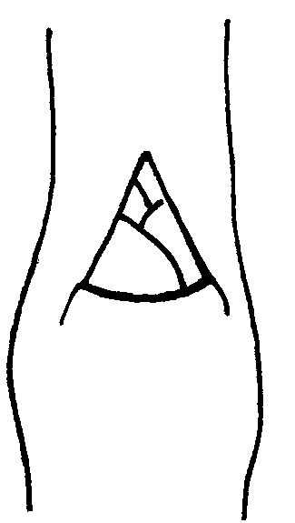 | 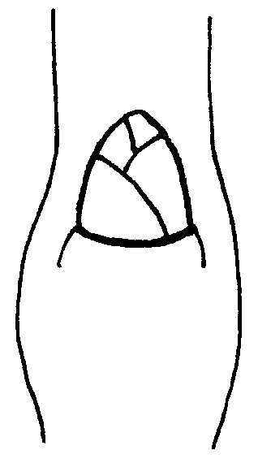 | 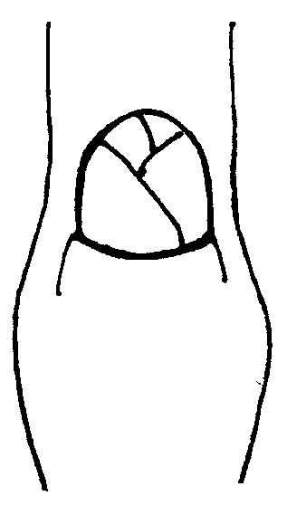
1 | 2 | 3
acute | obtuse | rounded

Ad. 10: One-year-old shoot: position of vegetative bud in relation to shoot

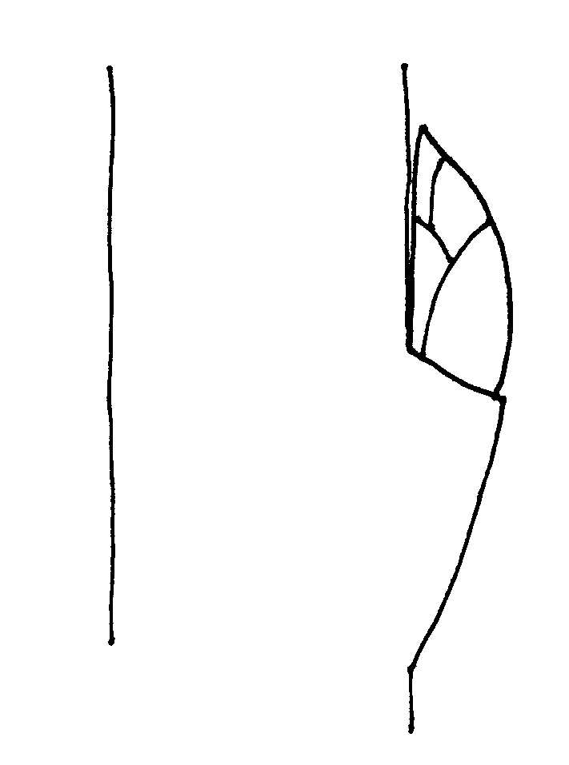 | 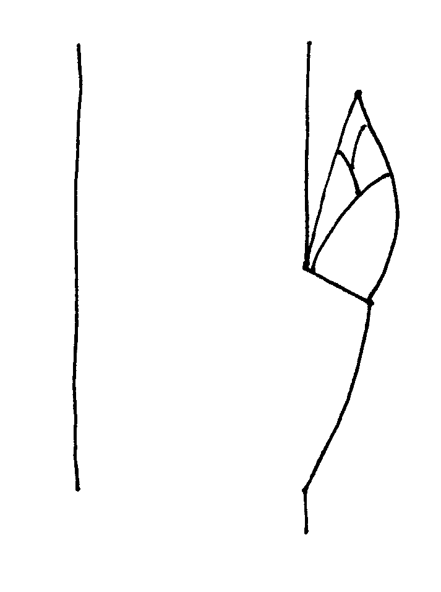 | 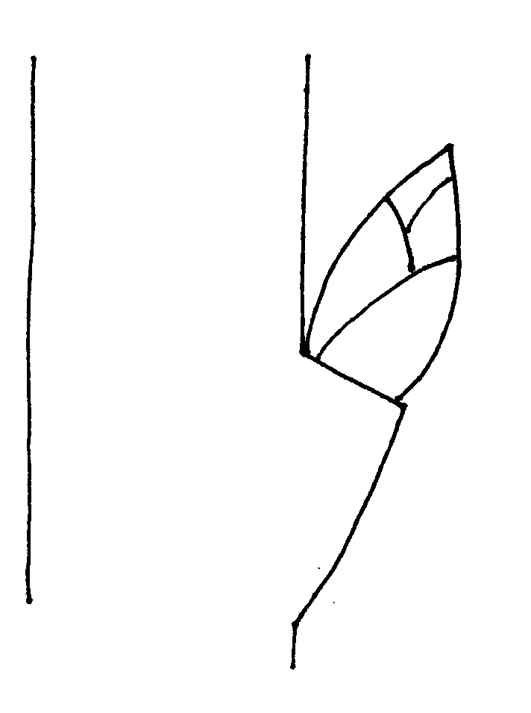
1 | 2 | 3
adpressed | slightly held out | markedly held out

Ad. 11: One-year-old shoot: size of vegetative bud support

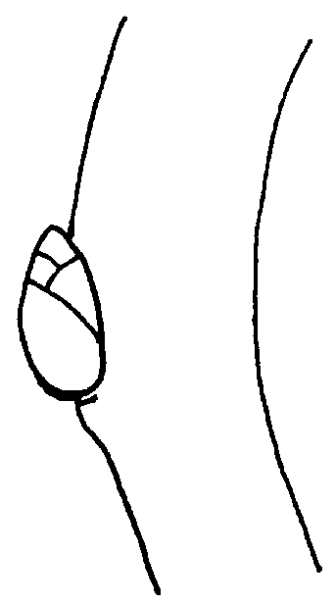 | 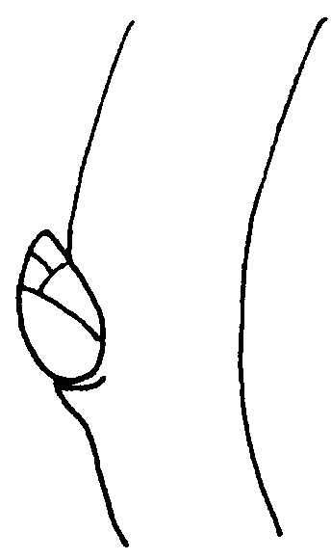 | 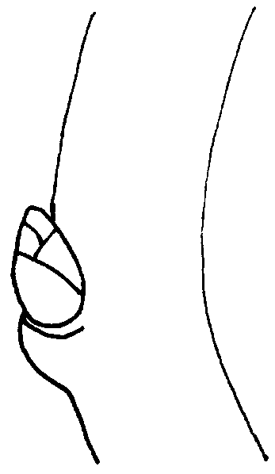
3 | 5 | 7
small | medium | large

Ad. 12: One-year-old shoot: decurrence of vegetative bud support

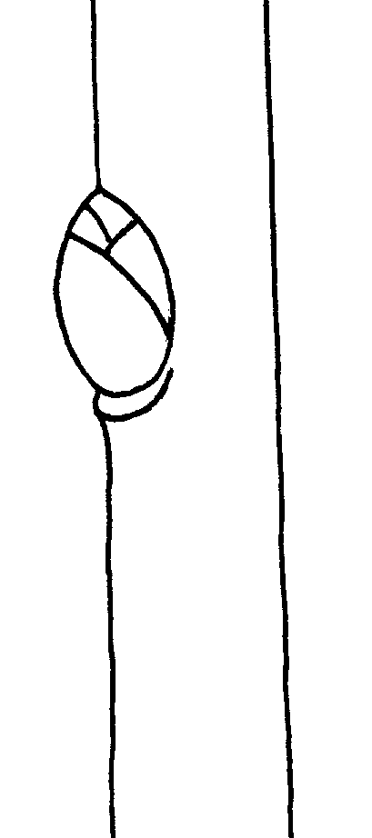 | 
1 | 9
absent | present

Ad. 14: Leaf blade: attitude in relation to shoot

The attitude of the leaf blade in relation to shoot should be observed in the morning.

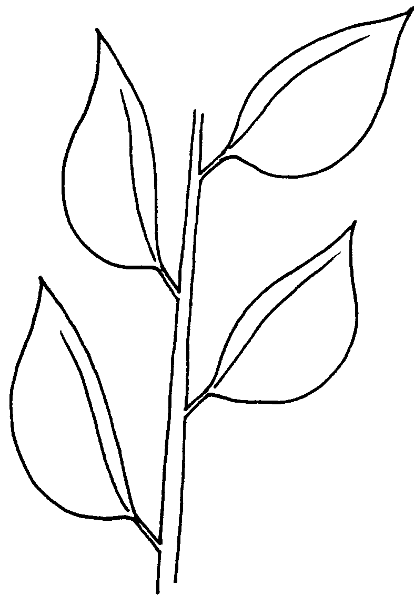 | 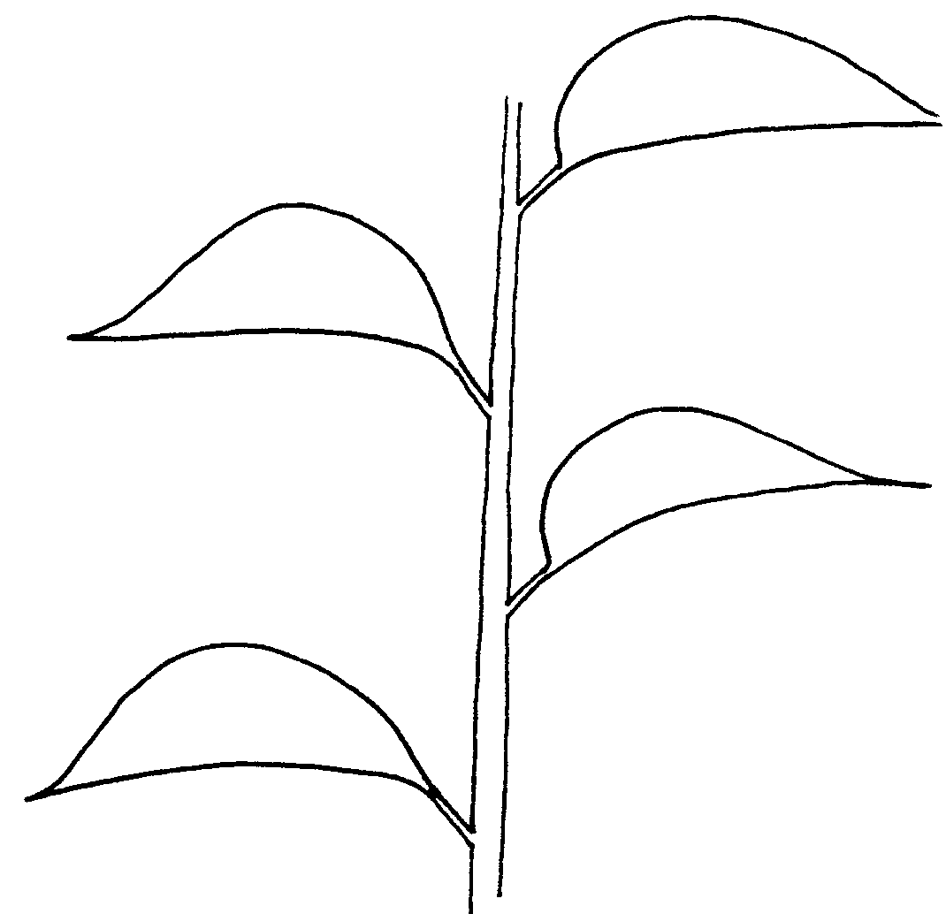 | 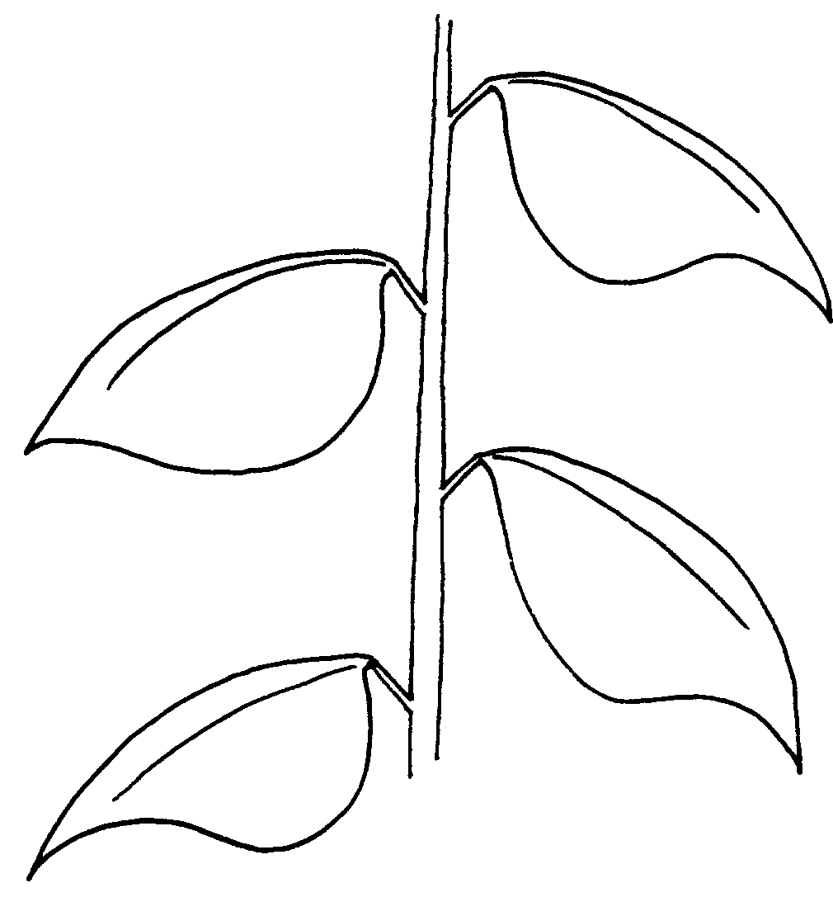
1 | 2 | 3
upwards | outwards | downwards

Ad. 18: Leaf blade: shape

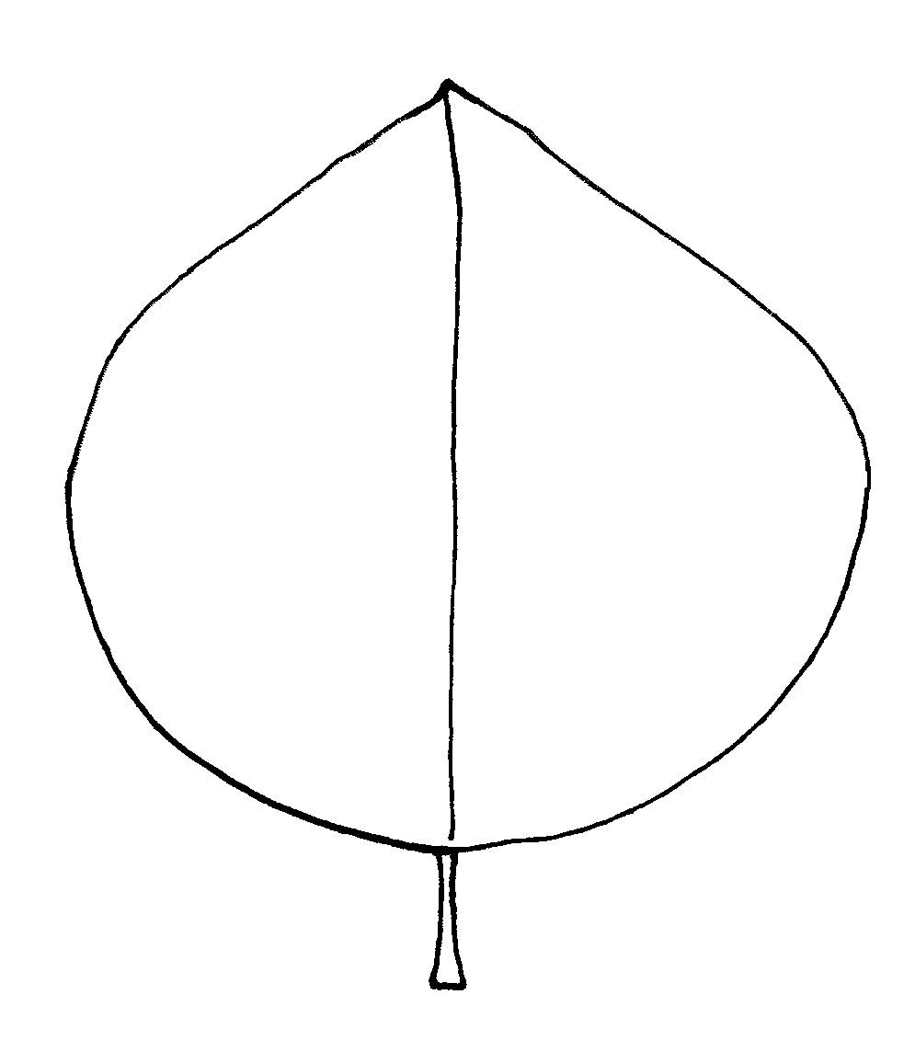 | 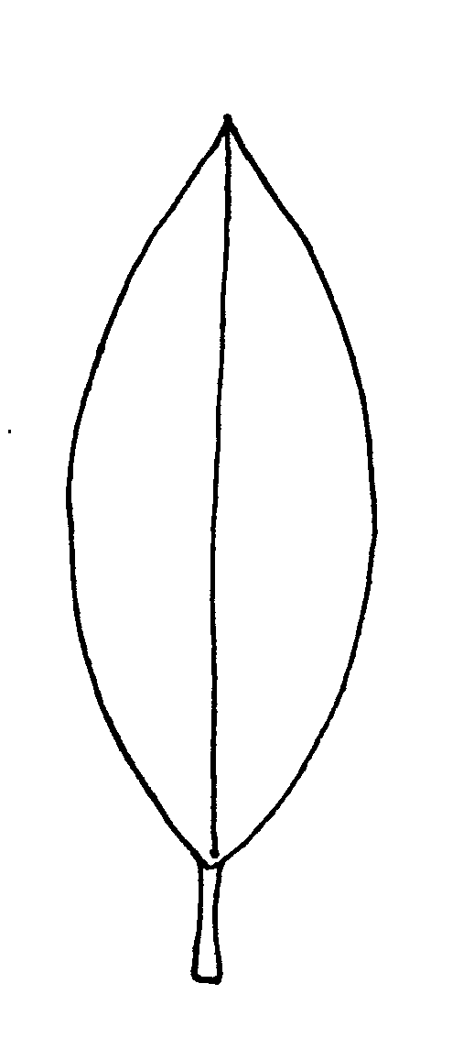 | 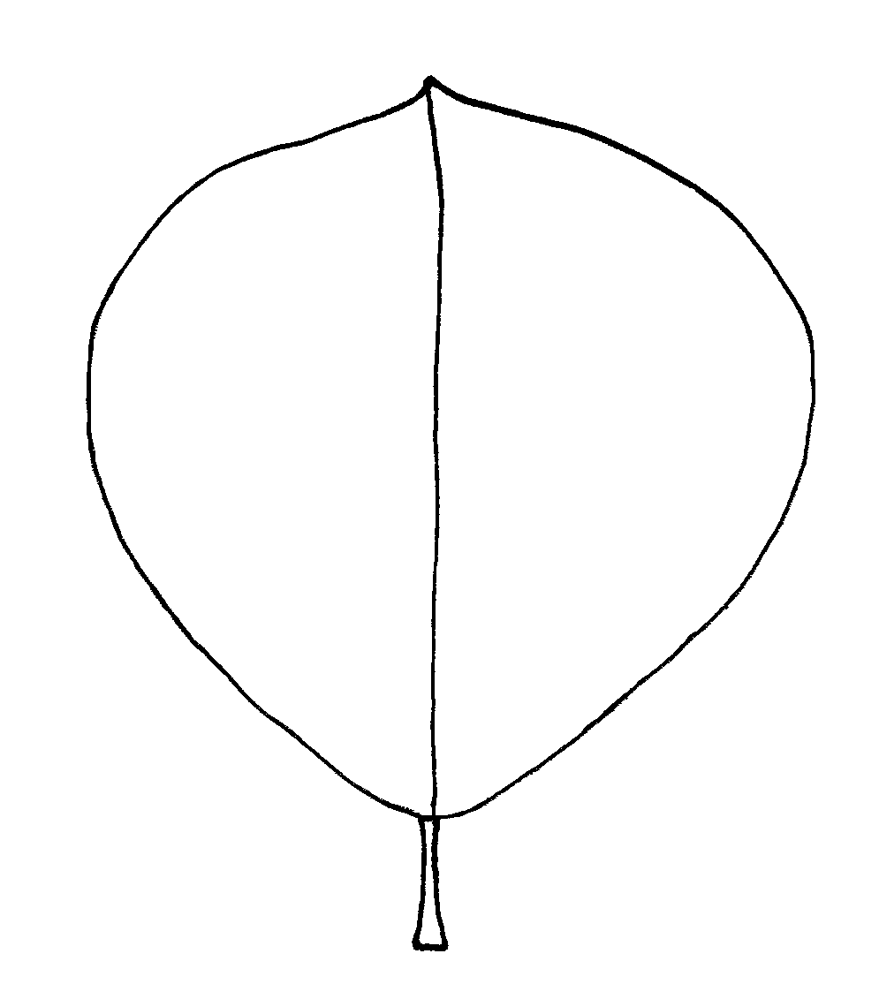
1 | 2 | 3
ovate | elliptic | obovate
Ad. 19: Leaf blade: angle of apex (excluding tip)

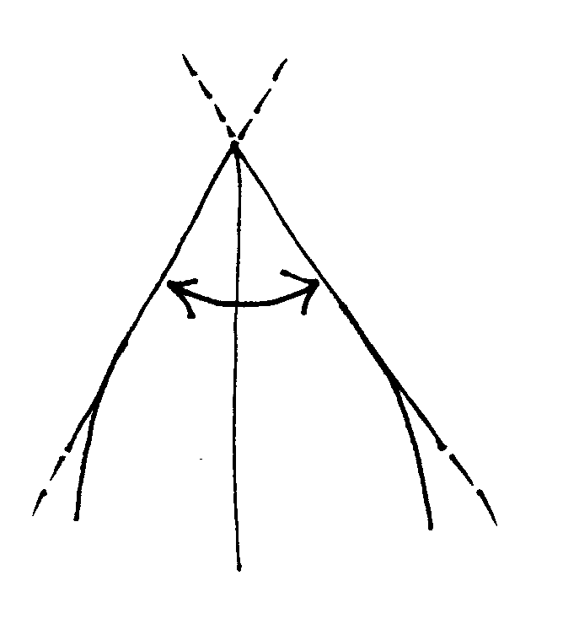 |  | 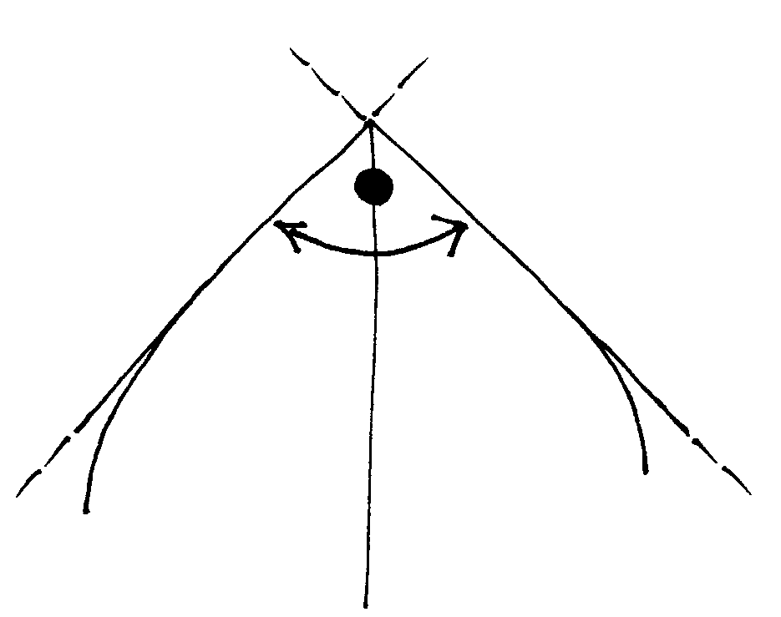 | 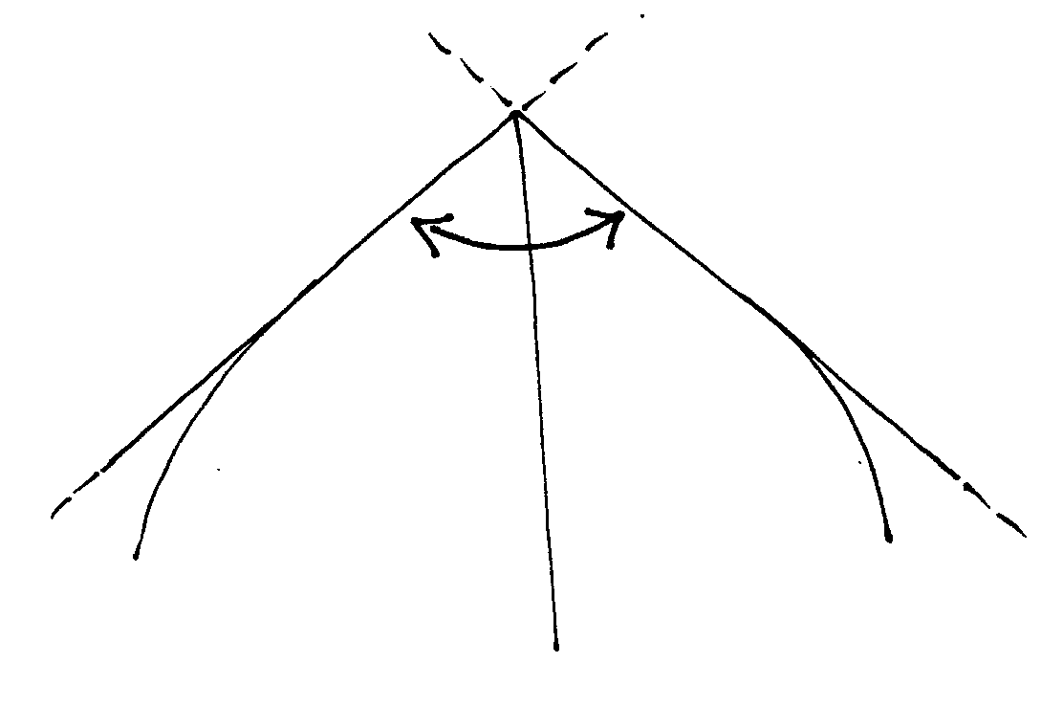
1 | 2 |  |  | 3
acute | right-angled |  |  | obtuse

Ad. 20: Leaf blade: shape of base

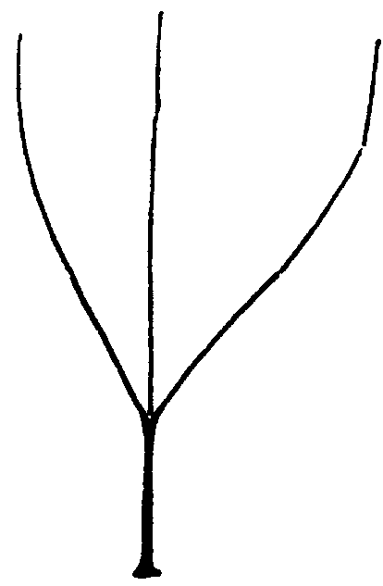 | 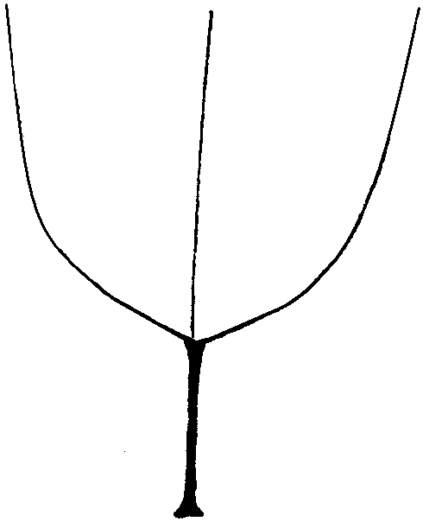 | 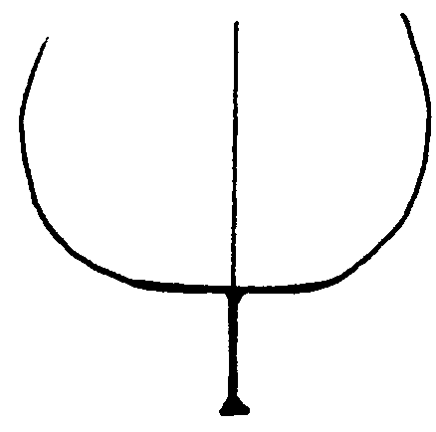
1 | 2 | 3
acute | obtuse | truncate
Ad. 24: Leaf blade: incisions of margin

 | 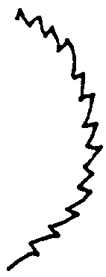
1 | 2
crenate | serrate

Ad. 34: Calyx: attitude of sepals

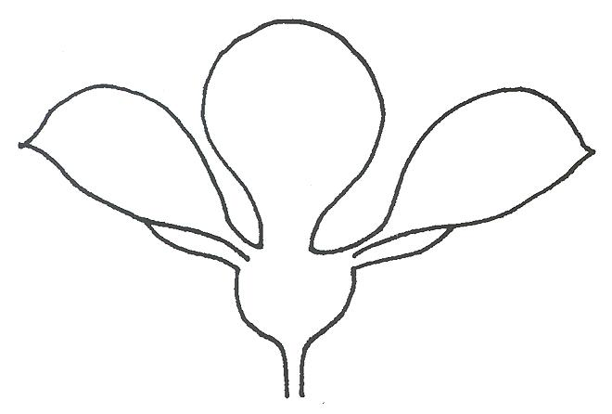 | 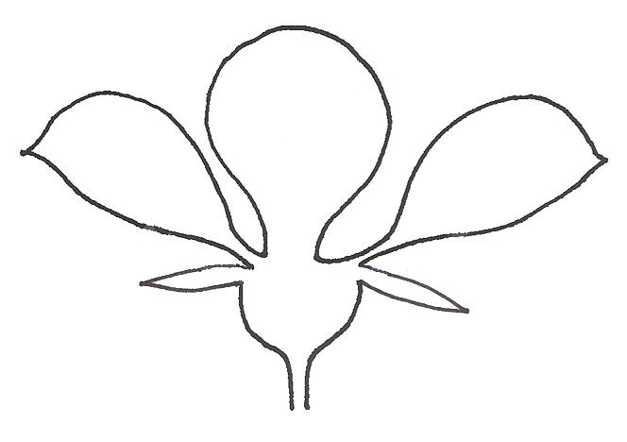 | 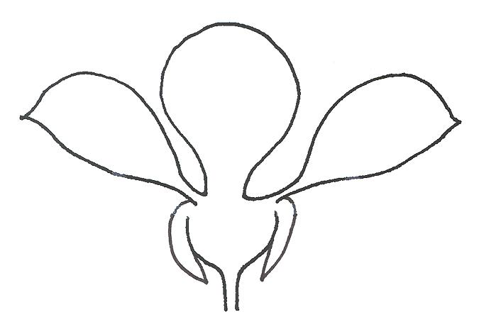
1 | 2 | 3
adpressed to petals | touching neither petals  nor receptacle | touching receptacle

Ad. 35: Sepal: shape

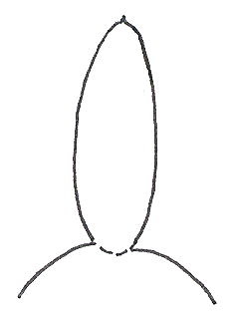 | 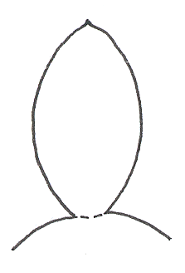 | 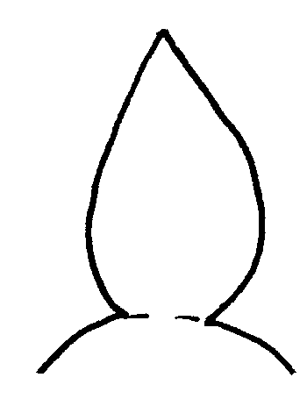
1 | 2 | 3
narow elliptic | elliptic | ovate

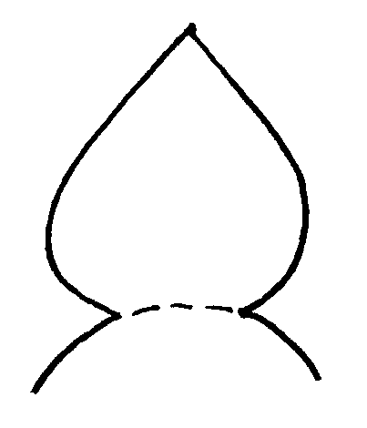 | 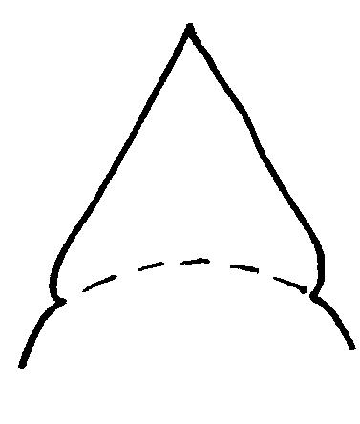
4 | 5
broad ovate | triangular

Ad. 36: Flower: arrangement of petals

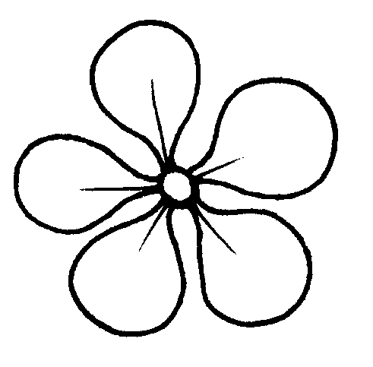 | 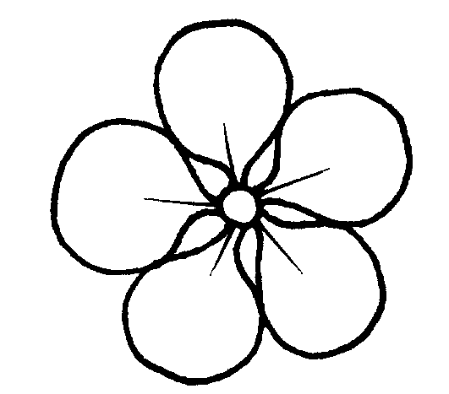 | 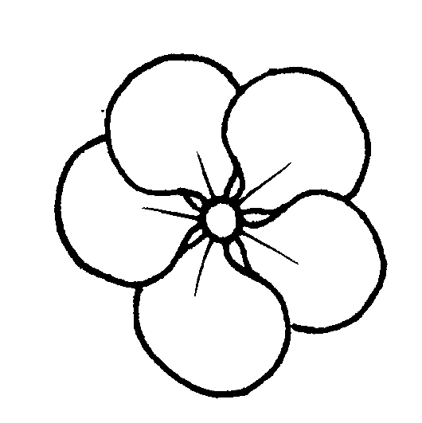
1 | 2 | 3
free | touching | overlapping
Ad. 38: Petal: shape

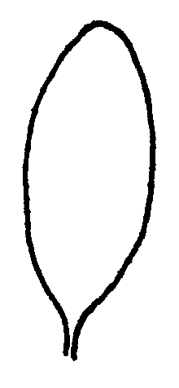 | 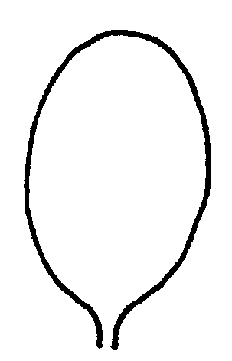 |  | 
1 | 2 | 3 | 4
elliptic | broad elliptic | circular | obovate

Ad. 44: Fruit: shape in lateral view
The following fruit shapes are presented as they appear in nature, nevertheless shape is to be observed in direction from the base (stalk end) to the top.

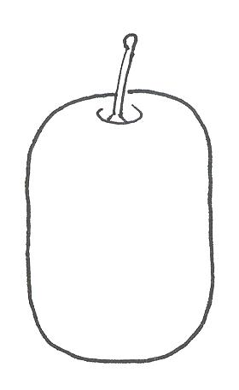 | 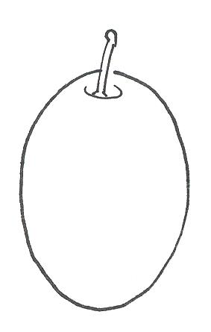 | 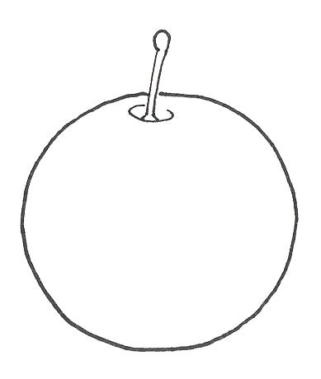
1 | 2 | 3
oblong | elliptic | circular

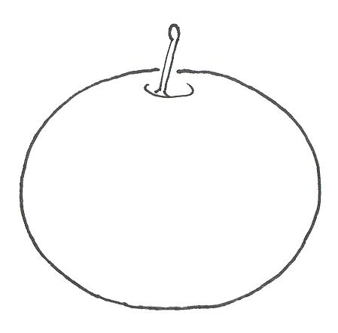 | 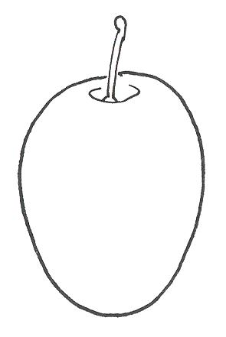 | 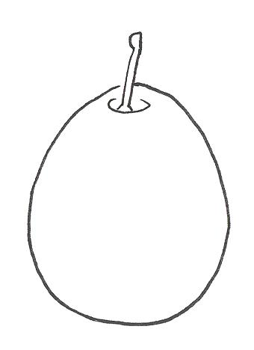
4 | 5 | 6
oblate | ovate | obovate

Ad. 55: Stone: general shape in lateral view

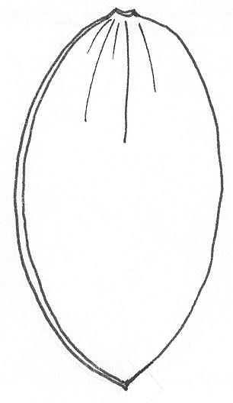 | 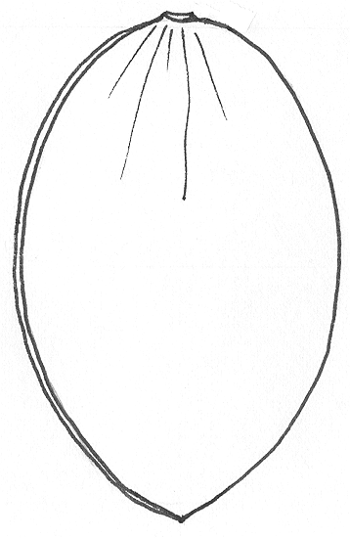 | 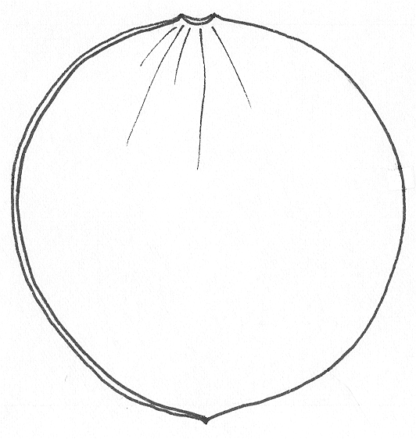
1 | 2 | 3
narrow elliptic | elliptic | circular

Ad. 56: Stone: shape in ventral view

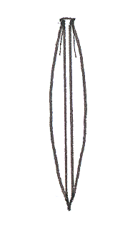 | 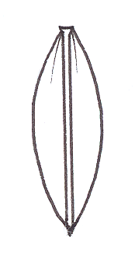 | 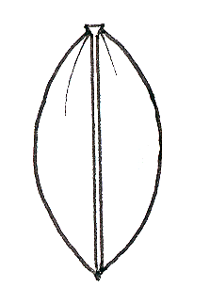 | 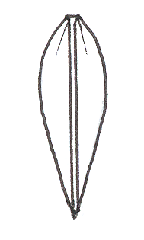
1 | 2 | 3 | 4
narrow elliptic | elliptic | broad elliptic | cuneate
Ad. 57: Stone: development of keel

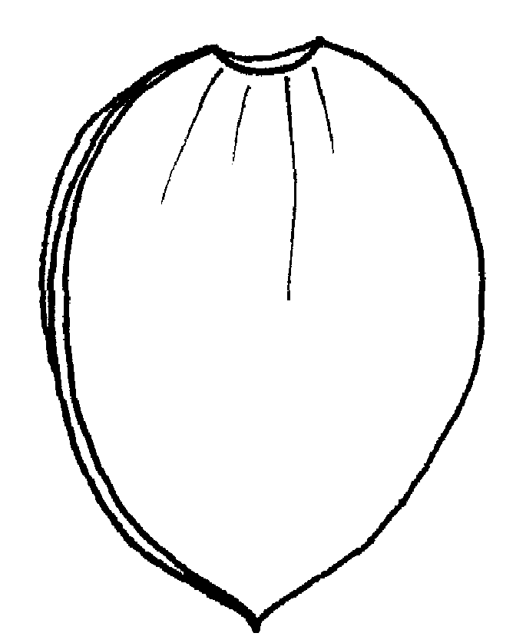 | 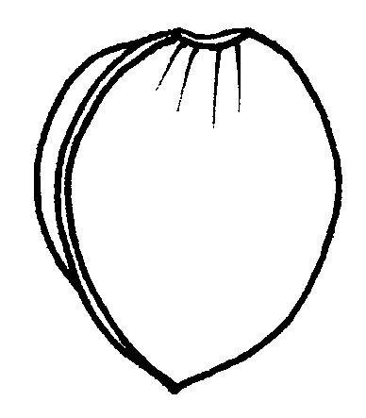 | 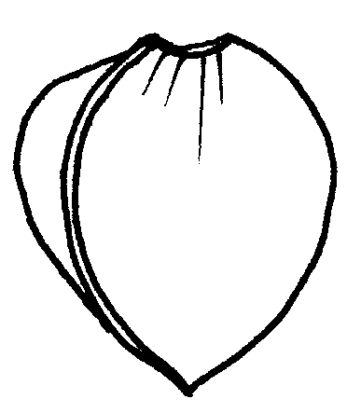
3 | 5 | 7
weak | medium | strong

Ad. 58: Stone: texture of lateral surfaces

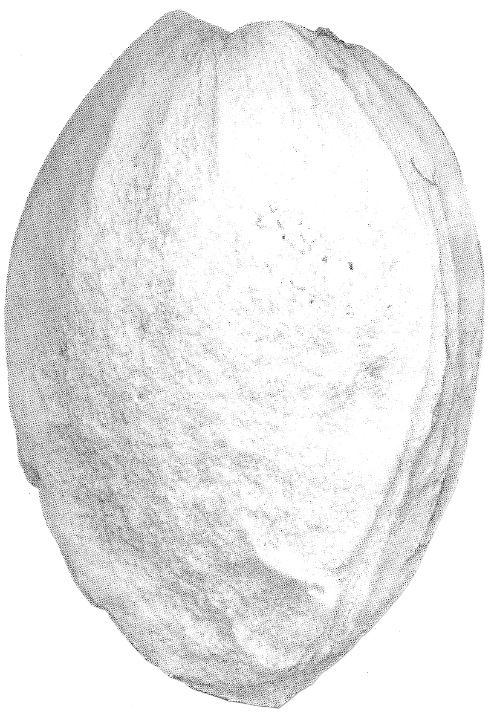 | 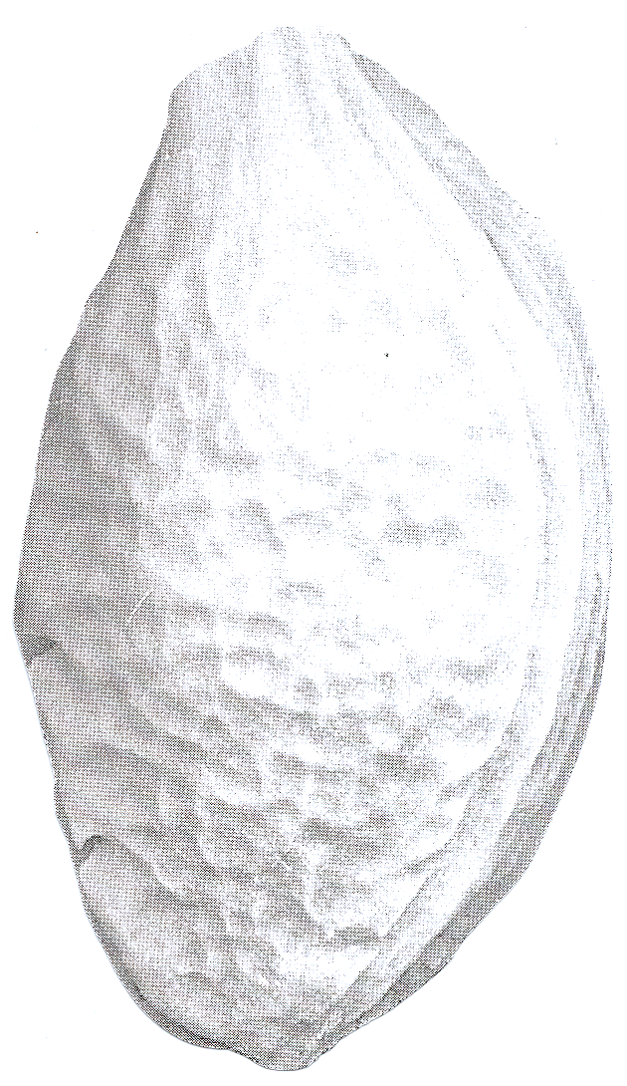
1 | 2
grained | hammered
Ad. 59: Stone: width at base

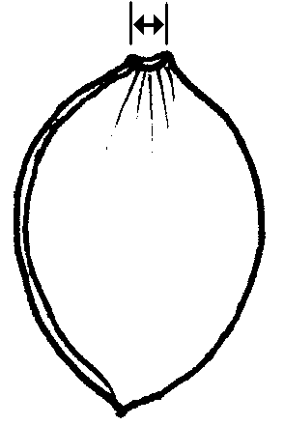 | 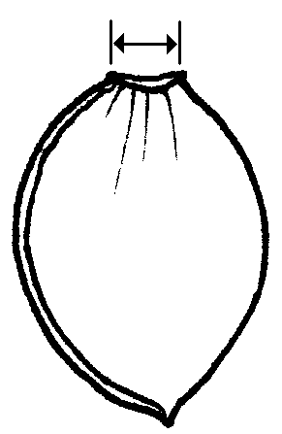 | 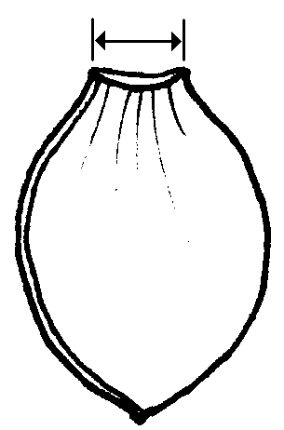
3 | 5 | 7
narrow | medium | broad

Ad. 60: Stone: shape of apex

 |  | 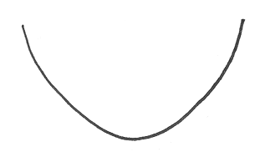
1 | 2 | 3
acute | obtuse | rounded

Ad. 62: Time of beginning of fruit ripening

The time of fruit ripening should be considered as the time of eating ripeness, when the fruit is most easily removed.

Synonyms of the example varieties:

Example Varieties | Synonyms
Althanova | Althann, Count Althanns Gage, Graf Althanns Reneklode, (Reine Claude) Conducta, Reine Claude (du comte) d’Althan
Čačanska Julia | Cacaks Julia
Čačanska lepotica | Cacaks Schöne
Čačanska najbolja | Cacaks Beste
Čačanska rana | Cacaks Frühe
Čačanska rodna | Cacaks Fruchtbare
Coe’s Golden Drop | Bury seedling, Goutte d’or de Coe, Silver prune
d’Ente | Agen (d’)Ente, Datte d’Agen, French prune, (Prune d’) Ente, Robe de Sergent
Drap d’Or d’Espéren | Golden Esperen
Ersinger Frühzwetsche | Ahlbachs Frühzwetsche, Eisentaler Frühzwetsche, Goldquelle, Quetsche précoce d’Ersingen, Weißentaler Frühzwetsche
Hauszwetsche | Altesse ordinaire, Bauernpflaume, Early Russian, Hauspflaume, Impératrice Violette, Quetsche commune (d’Allemagne), Quetsche d’Alsace, Quetsche de Metz, Quetsche de Namur
Kirke’s | Kirkes Pflaume
Mirabelle de Metz | Metzer Mirabelle, Mirabelle abricotée, Mirabelle aus Metz, Mirabelle petite
Mirabelle de Nancy | (Double) Drap d’Or, Double Mirabelle, Mirabelle grosse, Nancymirabelle
Monsieur hâtif | Early Orleans, Monsieur du Roi, Wilmot’s Orleans
President | Président
Prugna d’Italia | Altesse double, Bleue d’Italie, Fellenberg, Italian Prune, Italienische Zwetsche, Quetsche d’Italie
Reine Claude de Bavay | Monstrueuse de Bavay, Saint Clair
Reine Claude diaphane | Reine Claude de Guigne, Transparent Gage
Reine Claude d’Oullins | Fausse Reine Claude, Massot, Oullins Golden, Oullins Reneklode, Reine Claude précoce
Reine Claude verte | Damas gris, Dauphine, Green Gage, Große Grüne Reneklode, Reine Claude Dorée, Zuckerpflaume
The Czar | Le Tsar, Czar
Victoria | Königin Viktoria, Queen Victoria, Viktoriapflaume

IX. Literature

Anonymous: The Brooks and Olmo Register of Fruit & Nut Varieties. Alexandria VA, USA, ASHS Press, 3rd edition, 1997, 744 p.

Basso, M.; Faccioli, F. et al.: Le principali prugne coltivate in Italia. Bologna, 1978.

Bundessortenamt: Beschreibende Sortenliste Steinobst – Pflaume, Süßkirsche, Sauerkirsche. Hannover: Landbuch Verlag, 1997, 168 p.

Caillavet, H.: Variétés anciennes de pruniers domestiques. Paris: INRA et BRG, 1991, 540 p.

Dermine, E.; Liard, O.: Identification et Description de Variétés du Prunier Européen. Gembloux & Paris, 1957, 322 p.

Groh, W.: Anbau der Pflaume. Berlin: Deutscher Landwirtschaftsverlag, 1960, 152 p.

Hedrick, U.P.: The Plums of New York. State of New York – Dep. of Agric.: 18th Annual Report, Vol. 3, Part II. Albany, USA: J.B. Lyon Company, 1911, 616 p.

Nicotra, A.; Moser, L.; Cobianchi, D.; Damiano, D.; Faedi, W.: Monografia di cultivar di susino. Roma, 1983, 141 p.

Röder, K.: Sortenkundliche Untersuchungen an Prunus domestica. Halle (Saale): Kühn-Archiv Bd. 54, 1939, 131 p.

Taylor, H.V.: The Plums of England. London: Crosby Lockwood & Son, Ltd, 1949, 151 p.

X. Technical Questionnaire

Reference Number
(not to be filled in by the applicant)

TECHNICAL QUESTIONNAIRE
to be completed in connection with an application for plant breeders’ rights

1. Species Prunus domestica L.
EUROPEAN PLUM (Fruit varieties only)

2. Applicant (Name and address)

3. Proposed denomination or breeder’s reference

4. Information on origin, maintenance and reproduction of the variety

4.1 Origin

(a) Seedling of unknown parentage [ ]

(b) Produced by controlled pollination [ ]

− Seed bearing parent [ ]

................................................................................................

− Pollen parent [ ]

................................................................................................

(c) Produced by open pollination of
(indicate seed bearing parent plant) [ ]

................................................................................................

(d) Mutation or sport from (indicate original parent variety) [ ]

................................................................................................

(e) Discovery (indicate where and when) [ ]

................................................................................................

4.2 In vitro propagation

The plant material of the candidate variety has been obtained yes [ ]
by in vitro propagation no [ ]

4.3 Other type of multiplication (seed, leaf cutting, hardwood cutting, layer) [ ]

4.4 Virus status

The plant material is virus tested yes [ ]

no [ ]

If the answer to that question is yes, please indicate against which viruses

.......................................................................................................................

4.5 Other information

5. Characteristics of the variety to be indicated (the number in brackets refers to the corresponding characteristic in Test Guidelines; please mark the state of expression which best corresponds).
 | Characteristics | Example Varieties | Note
5.1  (43) | Fruit: size
 | very small | Mirabelle de Nancy | 1[ ]
 | small | Bonne de Bry,  Hauszwetsche | 3[ ]
 | medium | Hanita, Stanley | 5[ ]
 | large | Nordens  Reine Claude d’Oullins | 7[ ]
 | very large | Giant | 9[ ]
5.2  (44) | Fruit: shape in lateral view
 | oblong | Grand Prize | 1[ ]
 | elliptic | Empress, Victoria | 2[ ]
 | circular | Fortune, Mirabelle de Nancy | 3[ ]
 | oblate | Althanova | 4[ ]
 | ovate | Hanita, Stanley, Valjevka | 5[ ]
 | obovate | Elena, President | 6[ ]

 | Characteristics |  |  | Example Varieties |  | Note
5.3  (50) | Fruit: ground color of skin (after removing bloom)
 | greenish white |  |  | Reine Claude diaphane |  | 1[ ]
 | green |  |  | Reine Claude verte |  | 2[ ]
 | yellowish green |  |  | Reine Claude d’Oullins |  | 3[ ]
 | yellow |  |  | Drap d’Or d’Espéren |  | 4[ ]
 | orange yellow |  |  | Emma Leppermann |  | 5[ ]
 | red |  |  | Victoria |  | 6[ ]
 | light violet |  |  | Althanova, Opal |  | 7[ ]
 | purplish violet |  |  | d’Ente |  | 8[ ]
 | dark violet |  |  | Anna Späth, Royal Blue |  | 9[ ]
 | violet blue |  |  | Early Rivers, Valor |  | 10[ ]
 | dark blue |  |  | Čačanska lepotica  Čačanska najbolja |  | 11[ ]
5.4  (51) | Fruit: color of flesh
 | whitish |  |  |  |  | 1[ ]
 | green |  |  | Ersinger Frühzwetsche,  Reine Claude verte |  | 2[ ]
 | yellowish green |  |  | Anna Späth, Reine Claude d’Oullins, Ruth Gerstetter |  | 3[ ]
 | yellow |  |  | Ariel, Graf Brühl, Monsieur Jaune |  | 4[ ]
 | orange |  |  | Early Transparent,  Gräfin Cosel, Hanita |  | 5[ ]
 | red |  |  | Bountiful |  | 6[ ]
5.5  (54) | Fruit: degree of adherence of stone to flesh
 | non-adherent |  |  | Hauszwetsche, Kirke’s |  | 1[ ]
 | semi-adherent |  |  | Drap d’Or d’Espéren, Elena |  | 2[ ]
 | adherent |  |  | Ersinger Frühzwetsche, Jefferson |  | 3[ ]
5.6  (61) | Time of beginning of flowering
 | very early |  |  | Graf Brühl, Lützelsachser Frühzwetsche |  | 1[ ]
 | early |  |  | Ruth Gerstetter, Utility |  | 3[ ]
 | medium |  |  | d’Ente, Hanita, Reine Claude verte |  | 5[ ]
 | late |  |  | Elena, Hauszwetsche |  | 7[ ]
 | very late |  |  | Hauszwetsche Typ Schüfer,  Quetsche Blanche de Cétricourt |  | 9[ ]
5.7  (62) | Time of beginning of fruit ripening
 | very early |  |  | Ruth Gerstetter |  | 1[ ]
 | early |  |  | Bonne de Bry,  Ersinger Frühzwetsche |  | 3[ ]
 | medium |  |  | Graf Brühl, Reine Claude verte |  | 5[ ]
 | late |  |  | Čačanska rodna, d’Ente |  | 7[ ]
 | very late |  |  | Elena, President, Reine Claude de Bavay |  | 9[ ]
6. Similar varieties and differences from these varieties

Denomination of similar variety |  | Characteristic in which the similar variety is different ^{o)} | State of expression of similar variety |  | State of expression of candidate variety
______________
^{o)} In the case of identical states of expressions of both varieties, please indicate the size of the difference.

7. Additional information which may help to distinguish the variety

7.1 Resistance to pests and diseases

7.2 Special conditions for the examination of the variety

7.3 Other information

A representative color photo of the variety should be added in the Technical Questionnaire.

8. Authorisation for release:

(a) Does the variety require prior authorization for release under legislation concerning the protection of the environment, human or animal health?
Yes [ ] No [ ]

- Has such authorization been obtained?
Yes [ ] No [ ]

If the answer to that question is yes, please attach a copy of such an authorization.

[End of document]

