 |  | E  TG/40/7  ORIGINAL: English  DATE: 2008-04-09
INTERNATIONAL UNION FOR THE PROTECTION OF NEW VARIETIES OF PLANTS
GENEVA

 | BLACKCURRANT  UPOV Code: RIBES_NIG  Ribes nigrum L. | *

GUIDELINES

FOR THE CONDUCT OF TESTS

FOR DISTINCTNESS, UNIFORMITY AND STABILITY

Alternative Names:*

Botanical name | English | French | German | Spanish
Ribes nigrum L.,  Ribes dikuscha Fisch. ex Turcz.,  Ribes ussuriense Jancz. | Blackcurrant, Black Currant | Cassis | Schwarze  Johannisbeere | Grosellero negro, Casis

The purpose of these guidelines (“Test Guidelines”) is to elaborate the principles contained in the General Introduction (document TG/1/3), and its associated TGP documents, into detailed practical guidance for the harmonized examination of distinctness, uniformity and stability (DUS) and, in particular, to identify appropriate characteristics for the examination of DUS and production of harmonized variety descriptions.

ASSOCIATED DOCUMENTS

These Test Guidelines should be read in conjunction with the General Introduction and its associated TGP documents.

Other associated UPOV documents: TG/138 Ribes ×nidigrolaria R. & A. Bauer
TABLE OF CONTENTS PAGE

1. Subject of these Test Guidelines 3
2. Material Required 3
3. Method of Examination 3
3.1 Number of Growing Cycles 3
3.2 Testing Place 3
3.3 Conditions for Conducting the Examination 3
3.4 Test Design 4
3.5 Number of Plants / Parts of Plants to be Examined 4
3.6 Additional Tests 4
4. Assessment of Distinctness, Uniformity and Stability 4
4.1 Distinctness 4
4.2 Uniformity 5
4.3 Stability 5
5. Grouping of Varieties and Organization of the Growing Trial 5
6. Introduction to the Table of Characteristics 6
6.1 Categories of Characteristics 6
6.2 States of Expression and Corresponding Notes 6
6.3 Types of Expression 6
6.4 Example Varieties 6
6.5 Legend 6
7. Table of Characteristics/Tableau des caractères/Merkmalstabelle/Tabla de caracteres 7
8. Explanations on the Table of Characteristics 15
8.1 Explanations covering several characteristics 15
8.2 Explanations for individual characteristics 15
9. Literature 20
10. Technical Questionnaire 21

Subject of these Test Guidelines
These Test Guidelines apply to all varieties of Ribes nigrum L. (Ribes dikuscha Fisch. ex Turcz. and Ribes ussuriense Jancz.), of the family Grossulariaceae.

Material Required
2.1 The competent authorities decide on the quantity and quality of the plant material required for testing the variety and when and where it is to be delivered. Applicants submitting material from a State other than that in which the testing takes place must ensure that all customs formalities and phytosanitary requirements are complied with.

2.2 The material is to be supplied in the form of hardwood cuttings (without roots), rooted hardwood cuttings or in the form of plants with at least three shoots.

2.3 The minimum quantity of plant material, to be supplied by the applicant, should be:

10 hardwood cuttings (without roots),
5 rooted hardwood cuttings, or
5 plants with at least three shoots.

2.4 The plant material supplied should be visibly healthy, not lacking in vigor, nor affected by any important pest or disease.

2.5 The plant material should not have undergone any treatment which would affect the expression of the characteristics of the variety, unless the competent authorities allow or request such treatment. If it has been treated, full details of the treatment must be given.

Method of Examination

3.1 Number of Growing Cycles
3.1.1 The minimum duration of tests should normally be two independent growing cycles.

3.1.2 The growing cycle is considered to be the duration of a single growing season, beginning with vegetative bud burst, flowering and fruit harvest and concluding when the following dormant period ends with the swelling of new season buds.

3.2 Testing Place
Tests are normally conducted at one place. In the case of tests conducted at more than one place, guidance is provided in TGP/9 “Examining Distinctness”.

3.3 Conditions for Conducting the Examination
The tests should be carried out under conditions ensuring satisfactory growth for the expression of the relevant characteristics of the variety and for the conduct of the examination. In particular, it is essential that the plants produce a satisfactory crop of fruit in each of the two growing cycles.

3.4 Test Design
3.4.1 Each test should be designed to result in a total of at least 5 plants.

3.4.2 The design of the tests should be such that plants or parts of plants may be removed for measurement or counting without prejudice to the observations which must be made up to the end of the growing cycle.

3.5 Number of Plants / Parts of Plants to be Examined
Unless otherwise indicated, all observations should be made on 5 plants or parts taken from each of 5 plants. In the case of observations of parts taken from single plants, the number of parts to be taken from each of the plants should be 2.

3.6 Additional Tests
Additional tests, for examining relevant characteristics, may be established.

Assessment of Distinctness, Uniformity and Stability

4.1 Distinctness

4.1.1 General Recommendations
It is of particular importance for users of these Test Guidelines to consult the General Introduction prior to making decisions regarding distinctness. However, the following points are provided for elaboration or emphasis in these Test Guidelines.

4.1.2 Consistent Differences
The differences observed between varieties may be so clear that more than one growing cycle is not necessary. In addition, in some circumstances, the influence of the environment is not such that more than a single growing cycle is required to provide assurance that the differences observed between varieties are sufficiently consistent. One means of ensuring that a difference in a characteristic, observed in a growing trial, is sufficiently consistent is to examine the characteristic in at least two independent growing cycles.

4.1.3 Clear Differences
Determining whether a difference between two varieties is clear depends on many factors, and should consider, in particular, the type of expression of the characteristic being examined, i.e. whether it is expressed in a qualitative, quantitative, or pseudo-qualitative manner. Therefore, it is important that users of these Test Guidelines are familiar with the recommendations contained in the General Introduction prior to making decisions regarding distinctness.

4.2 Uniformity
4.2.1 It is of particular importance for users of these Test Guidelines to consult the General Introduction prior to making decisions regarding uniformity. However, the following points are provided for elaboration or emphasis in these Test Guidelines:

4.2.2 For the assessment of uniformity, a population standard of 1% and an acceptance probability of at least 95% should be applied. In the case of a sample size of 5 plants, no off-types are allowed.

4.3 Stability
4.3.1 In practice, it is not usual to perform tests of stability that produce results as certain as those of the testing of distinctness and uniformity. However, experience has demonstrated that, for many types of variety, when a variety has been shown to be uniform, it can also be considered to be stable.

4.3.2 Where appropriate, or in cases of doubt, stability may be tested, either by growing a further generation, or by testing a new plant stock to ensure that it exhibits the same characteristics as those shown by the previous material supplied.

Grouping of Varieties and Organization of the Growing Trial
5.1 The selection of varieties of common knowledge to be grown in the trial with the candidate varieties and the way in which these varieties are divided into groups to facilitate the assessment of distinctness are aided by the use of grouping characteristics.

5.2 Grouping characteristics are those in which the documented states of expression, even where produced at different locations, can be used, either individually or in combination with other such characteristics: (a) to select varieties of common knowledge that can be excluded from the growing trial used for examination of distinctness; and (b) to organize the growing trial so that similar varieties are grouped together.

5.3 The following have been agreed as useful grouping characteristics:

(a) One-year-old shoot: color (characteristic 4)
(b) Young shoot: anthocyanin coloration (characteristic 10)
(c) Fruit: color (characteristic 26)
(d) Time of beginning of fruit harvest (characteristic 30)

5.4 Guidance for the use of grouping characteristics, in the process of examining distinctness, is provided through the General Introduction.

Introduction to the Table of Characteristics

6.1 Categories of Characteristics

6.1.1 Standard Test Guidelines Characteristics
Standard Test Guidelines characteristics are those which are approved by UPOV for examination of DUS and from which members of the Union can select those suitable for their particular circumstances.

6.1.2 Asterisked Characteristics
Asterisked characteristics (denoted by *) are those included in the Test Guidelines which are important for the international harmonization of variety descriptions and should always be examined for DUS and included in the variety description by all members of the Union, except when the state of expression of a preceding characteristic or regional environmental conditions render this inappropriate.

6.2 States of Expression and Corresponding Notes
States of expression are given for each characteristic to define the characteristic and to harmonize descriptions. Each state of expression is allocated a corresponding numerical note for ease of recording of data and for the production and exchange of the description.

6.3 Types of Expression
An explanation of the types of expression of characteristics (qualitative, quantitative and pseudo-qualitative) is provided in the General Introduction.

6.4 Example Varieties
Where appropriate, example varieties are provided to clarify the states of expression of each characteristic.

6.5 Legend
(*) Asterisked characteristic – see Chapter 6.1.2

QL: Qualitative characteristic – see Chapter 6.3
QN: Quantitative characteristic – see Chapter 6.3
PQ: Pseudo-qualitative characteristic – see Chapter 6.3

(a)-(d) See Explanations on the Table of Characteristics in Chapter 8.1

(+) See Explanations on the Table of Characteristics in Chapter 8.2

Table of Characteristics/Tableau des caractères/Merkmalstabelle/Tabla de caracteres
 |  | English | français | Deutsch | español | Example Varieties/  Exemples/  Beispielssorten/  Variedades ejemplo | Note/  Nota
1.  (*) |  | Plant: height | Plante: hauteur | Pflanze: Höhe | Planta: altura
QN | (a) | very short | très courte | sehr niedrig | muy baja | Stuarts Green | 1
 |  | short | courte | niedrig | baja | Strata | 3
 |  | medium | moyenne | mittel | media | Ben Alder | 5
 |  | tall | haute | hoch | alta | Goliath | 7
 |  | very tall | très haute | sehr hoch | muy alta | Magnus | 9
2.  (*)  (+) |  | Plant: growth habit | Plante: port | Pflanze: Wuchsform | Planta: porte
QN | (a) | upright | dressé | aufrecht | erecta | Magnus, Westra | 1
 |  | semi-upright | demi-dressé | halbaufrecht | semierecta | Baldwin, Blackdown | 2
 |  | spreading | étalé | breitwüchsig | extendido | Tenah | 3
3. |  | Plant: number of basal shoots | Plante: nombre de pousses basales | Pflanze: Anzahl Basistriebe | Planta: número de ramas basales
QN | (a) | few | petit | gering | pocas | Baldwin Hilltop | 3
 |  | medium | moyen | mittel | medio | Ben Lomond | 5
 |  | many | grand | groß | abundantes | Blacksmith | 7
4.  (*)  (+) |  | One-year-old shoot: color | Rameau d’un an: couleur | Einjähriger Trieb: Farbe | Rama de un año: color
PQ | (a) | yellow brown | marron jaune | gelbbraun | marrón amarillento | Tenah | 1
 |  | red brown | brun-rouge | rotbraun | marrón rojizo |  | 2
 |  | brown | brun | braun | marrón | Hatton Black, Jet | 3
 |  | greyish | grisâtre | gräulich | grisáceo | Cotswold Cross | 4
5.  (*)  (+) |  | Vegetative bud: position in relation to shoot | Bourgeon végétatif: position par rapport au rameau | Vegetative Knospe: Stellung im Verhältnis zum Trieb | Yema vegetativa: Posición en relación con la rama
QN | (a) | adpressed or slightly held out | appliqué ou légèrement décollé | anliegend oder leicht abstehend | alineada o ligeramente divergente | Triton | 1
 |  | moderately held out | modérément décollé | mäßig abstehend | moderadamente divergente | Hatton Black | 2
 |  | strongly held out | fortement décollé | stark abstehend | fuertemente divergente | Baldwin | 3
6.  (*) |  | Vegetative bud: length | Bourgeon végétatif: longueur | Vegetative Knospe: Länge | Yema vegetativa: longitud
QN | (a) | short | court | kurz | corta | Ben Tirran | 3
 |  | medium | moyen | mittel | media | Hatton Black | 5
 |  | long | long | lang | larga | Laxton’s Tinker | 7
7.  (*)  (+) |  | Vegetative bud: shape of apex | Bourgeon végétatif: forme du sommet | Vegetative Knospe: Form der Spitze | Yema vegetativa: forma del ápice
PQ | (a) | narrow acute | aigu étroit | schmalspitz | aguda estrecha | Baldwin | 1
 |  | broad acute | aigu large | breitspitz | aguda ancha | Ben Nevis | 2
 |  | rounded | arrondi | abgerundet | redondeado | Goliath | 3
8.  (*) |  | Vegetative bud: anthocyanin coloration | Bourgeon végétatif: pigmentation anthocyanique | Vegetative Knospe: Anthocyanfärbung | Yema vegetativa: pigmentación antociánica
QN | (a) | absent or very weak | absente ou très faible | fehlend oder sehr gering | ausente o muy débil |  | 1
 |  | weak | faible | gering | débil | Ben Nevis | 3
 |  | medium | moyenne | mittel | media | Baldwin, Ben Lomond | 5
 |  | strong | forte | stark | fuerte | Cotswold Cross, Mammoth | 7
9.  (+) |  | Vegetative bud: bloom | Bourgeon végétatif: pruine | Vegetative Knospe: Belag | Yema vegetativa: pruina
QN | (a) | weak | faible | gering | débil | Roodknop | 3
 |  | medium | moyenne | mittel | media | Westwick Choice | 5
 |  | strong | forte | stark | fuerte | French | 7
10.  (*) |  | Young shoot: anthocyanin coloration | Jeune rameau: pigmentation anthocyanique | Jungtrieb: Anthocyanfärbung | Rama joven: pigmentación antociánica
QN | (b) | absent or very weak | absente ou très faible | fehlend oder sehr gering | ausente o muy débil | Goliath | 1
 |  | weak | faible | gering | débil | Roodknop | 3
 |  | medium | moyenne | mittel | media | Hatton Black | 5
 |  | strong | forte | stark | fuerte | Malvern Cross | 7
11. |  | Leaf blade: length | Limbe: longueur | Blattspreite: Länge | Limbo: longitud
QN | (b) | short | court | kurz | corto | Hatton Black, Magnus | 3
 |  | medium | moyen | mittel | medio | Baldwin,  Cotswold Cross | 5
 |  | long | long | lang | largo | Ben Sarek | 7
12. |  | Leaf blade: width | Limbe: largeur | Blattspreite: Breite | Limbo: anchura
QN | (b) | narrow | étroit | schmal | estrecho | Ben Nevis | 3
 |  | medium | moyen | mittel | medio | Goliath, Hatton Black | 5
 |  | broad | large | breit | ancho | Ojebyn | 7
 |  | very broad | très large | sehr breit | muy ancho | Ben Sarek | 9
13. |  | Leaf blade: ratio length/width | Limbe: rapport longueur/largeur | Blattspreite: Verhältnis Länge/Breite | Limbo: relación longitud/anchura
QN | (b) | small | faible | klein | pequeña | Narjadnaja | 3
 |  | medium | moyen | mittel | media | French, Rosenthals Langtraubige | 5
 |  | large | élevé | groß | grande | Silvergieters Schwarze, Wassil | 7
14.  (+) |  | Leaf blade: base | Limbe: base | Blattspreite: Basis | Limbo: base
QN | (b) | strongly open | fortement ouverte | stark offen | fuertemente abierta | French | 1
 |  | moderately open | modérément ouverte | mäßig offen | moderadamente abierta | Tor Cross | 2
 |  | weakly open | faiblement ouverte | schwach offen | débilmente abierta | Ometa | 3
 |  | touching | tangents | sich berührend | en contacto | Ben Nare | 4
 |  | overlapping | chevauchants | überlappend | solapada | Veloy | 5
15. |  | Leaf blade: intensity of green color (upper side) | Limbe: intensité de la couleur verte (face supérieure) | Blattspreite: Intensität der Grünfärbung (Oberseite) | Limbo: intensidad del color verde  (cara superior)
QN | (b) | light | claire | hell | clara | Malvern Cross | 3
 |  | medium | moyenne | mittel | media | Hatton Black | 5
 |  | dark | foncée | dunkel | oscura | Magnus, Strata | 7
16. |  | Leaf blade: glossi-ness (upper side) | Limbe: brilliance (face supérieure) | Blattspreite: Glanz (Oberseite) | Limbo: brillo  (cara superior)
QN | (b) | absent or weak | absente ou faible | fehlend oder gering | ausente o débil | Blacksmith | 1
 |  | medium | moyenne | mittel | medio | Andorine, Titania | 2
 |  | strong | forte | stark | fuerte | Jet | 3
17.  (*) |  | Petiole: anthocyanin coloration on upper side | Pétiole: pigmentation anthocyanique sur la face supérieure | Blattstiel: Anthocyanfärbung an der Oberseite | Pecíolo: pigmentación antociánica del haz
QN | (b) | absent or very weak | nulle ou très faible | fehlend oder sehr gering | ausente o muy débil | Goliath | 1
 |  | weak | faible | gering | débil | Laxton’s Tinker | 3
 |  | medium | moyenne | mittel | media | Baldwin | 5
 |  | strong | forte | stark | fuerte | Brødtorp | 7
18.  (+) |  | Plant: number of inflorescences per axil | Plante: nombre d’inflorescence par aisselle | Pflanze: Anzahl Blütenstände je Blattachsel | Planta: número de inflorescencias por axila
QN | (c) | one and two | une et deux | ein und zwei | una y dos | Magnus | 1
 |  | two to four | deux à quatre | zwei bis vier | de dos a cuatro | Hatton Black | 2
 |  | more than four | plus de quatre | mehr als vier | más de cuatro |  | 3
19.  (*)  (+) |  | Inflorescence:  length | Inflorescence: longueur | Blütenstand:  Länge | Inflorescencia: longitud
QN | (c) | short | courte | kurz | corta | Ben Sarek,  Cotswold Cross | 1
 |  | medium | moyenne | mittel | media | Baldwin | 2
 |  | long | longue | lang | larga | Ometa | 3
20. |  | Inflorescence: number of flowers | Inflorescence: nombre de fleurs | Blütenstand:  Anzahl Blüten | Inflorescencia: número de flores
QN | (c) | few | faible | gering | pocas | Ben Sarek, Magnus | 3
 |  | medium | moyen | mittel | medio | Ben Alders | 5
 |  | many | élevé | groß | abundantes | Ometa | 7
21.  (*) |  | Sepal: anthocyanin coloration | Sépale: pigmentation anthocyanique | Kelchblatt: Anthocyanfärbung | Sépalo: pigmentación antociánica
QN | (c) | absent or very weak | nulle ou très faible | fehlend oder sehr gering | ausente o muy débil |  | 1
 |  | weak | faible | gering | débil | Chereshneva,  Hatton Black | 3
 |  | medium | moyenne | mittel | media | Baldwin | 5
 |  | strong | forte | stark | fuerte | Ceres | 7
22.  (*) |  | Ovary: anthocyanin coloration | Ovaire: pigmentation anthocyanique | Fruchtknoten: Anthocyanfärbung | Ovario: pigmentación antociánica
QN | (c) | absent or very weak | nulle ou très faible | fehlend oder sehr gering | ausente o muy débil | Cotswold Cross | 1
 |  | weak | faible | gering | débil | Baldwin | 3
 |  | medium | moyenne | mittel | media | Chereshneva | 5
 |  | strong | forte | stark | fuerte | Laxton’s Tinker | 7
23.  (+) |  | Infructescence: type | Inflorescence: type | Fruchtstand: Typ | Inflorescencia: tipo
QN | (d) | simple | simple | einfach | simple |  | 1
 |  | raceme | grappe | Traube | racimo |  | 2
 |  | panicle 1 | panicule 1 | Rispe 1 | panícula 1 |  | 3
 |  | panicle 2 | panicule 2 | Rispe 2 | panícula 2 |  | 4
24.  (+) |  | Infructescence: range of fruit size | Infructescence : étendue de la taille des fruits | Fruchtstand:  Variationsbreite der Größe der Früchte | Infrutescencia: gama de tamaños de los frutos
QN | (d) | small | petite | klein | pequeño | Titania | 1
 |  | medium | moyenne | mittel | medio | Black Reward | 2
 |  | large | grande | groß | grande | Jet | 3
25.  (*)  (+) |  | Fruit: size | Fruit: taille | Frucht: Größe | Fruto: tamaño
QN | (e) | small | petite | klein | pequeño | Goliath, Sarolata | 3
 |  | medium | moyenne | mittel | medio | Baldwin | 5
 |  | large | grande | groß | grande | Titania | 7
 |  | very large | très grande | sehr groß | muy grande | Bona | 9
26.  (*) |  | Fruit: color | Fruit: couleur | Frucht: Farbe | Fruto: color
PQ | (e) | green | verte | grün | verde | Stuart’s Green | 1
 |  | brownish black | noir brunâtre | bräunlichschwarz | negro amarronado | Westwick Choice | 2
 |  | black | noire | schwarz | negro | Titania | 3
27. |  | Fruit: glossiness | Fruit: brillance | Frucht: Glanz | Fruto: brillo
QN | (e) | very weak | très faible | sehr gering | muy débil | Golubka | 1
 |  | weak | faible | gering | débil | Cotswold Cross | 3
 |  | medium | moyenne | mittel | medio | Titania | 5
 |  | strong | forte | stark | fuerte | Ben Tirran | 7
28.  (+) |  | Time of beginning of vegetative bud burst | Époque de début de débourrement | Zeitpunkt des Aufbruchs der vegetativen Knospe | Época de brotación de las yemas vegetativas
QN |  | early | précoce | früh | temprana | Cotswold Cross | 3
 |  | medium | moyenne | mittel | media | Laxton’s Tinker | 5
 |  | late | tardive | spät | tardía | Ben Lomond | 7
29.  (+) |  | Time of beginning of flowering | Époque de début de floraison | Zeitpunkt des Blühbeginns | Época de comienzo de la floración
QN |  | very early | très précoce | sehr früh | muy temprana | Brødtorp, Ceres | 1
 |  | early | précoce | früh | temprana | Kimberley, Malvern Cross | 3
 |  | medium | moyenne | mittel | media | Cotswold Cross, Goliath | 5
 |  | late | tardive | spät | tardía | Black Reward, Laxton’s Tinker | 7
 |  | very late | très tardive | sehr spät | muy tardía | Ben Avon, Jet | 9
30.  (*)  (+) | VG | Time of beginning of fruit harvest | Époque de début de la récolte de fruits | Zeitpunkt des Beginns der Fruchternte | Época de comienzo de la cosecha de frutas
QN |  | very early | très précoce | sehr früh | muy temprana | Boskoop Giant, Kimberley | 1
 |  | early | précoce | früh | temprana | Andega, Magnus | 3
 |  | medium | moyenne | mittel | media | Baldwin Hilltop, Goliath | 5
 |  | late | tardive | spät | tardía | Ben Alder, Ben Lomond, Hatton Black | 7
 |  | very late | très tardive | sehr spät | muy tardía | Jet | 9

Explanations on the Table of Characteristics

8.1 Explanations covering several characteristics
Characteristics containing the following key in the second column of the Table of Characteristics should be examined as indicated below:

(a) Plant, one-year-old shoot and vegetative bud: All observations should be made on dormant bushes in winter after at least one growing season. Vegetative bud: All observations should be made in the middle third of one year old shoots, before bud burst.
(b) Young shoot, leaf blade, petiole: All observations should be made in early summer. For leaf blade and petiole, mature leaves from the middle third of one year old shoots from the outside of the bush should be observed.
(c) Inflorescence, sepal, ovary: All observations should be made at full flowering.
(d) Infructescence: Unless otherwise stated, all observations should be made just before harvest. The infructescence is also known as the fruit truss or strig.
(e) Fruit: Unless otherwise stated, all observations should be made after harvest.

8.2 Explanations for individual characteristics
Ad. 2: Plant: growth habit

The growth habit is assessed using the relationship between plant height and plant width: an upright variety is taller than broad; a semi upright variety is approximately the same height as the width; a spreading variety is broader than tall.

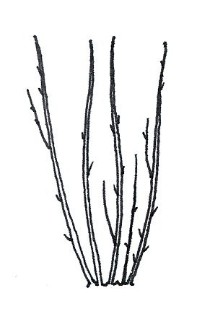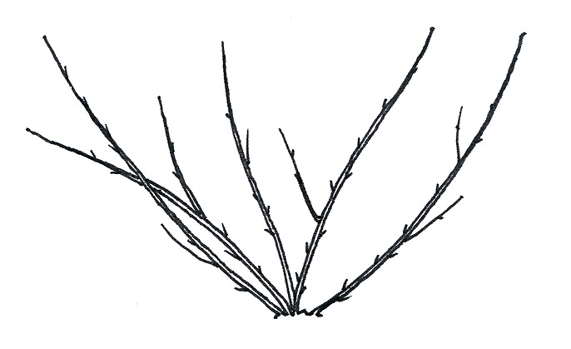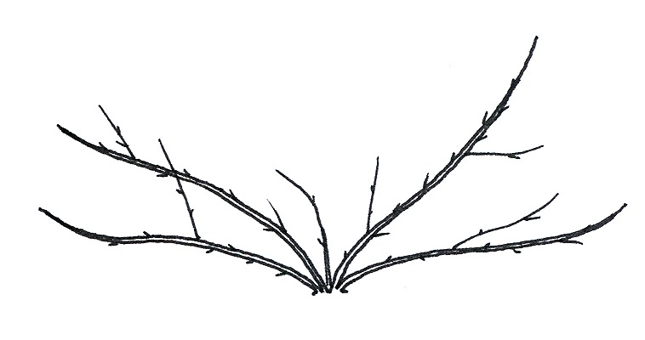

1 | 2 | 3
upright | semi-upright | spreading

Ad. 4: One-year-old shoot: color

Observations should be made on the middle third of a shoot on the outside of the bush.

Ad. 5: Vegetative bud: position in relation to shoot

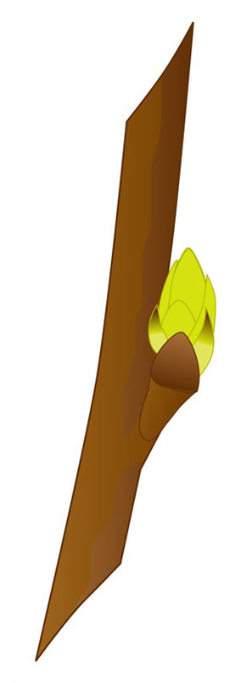 | 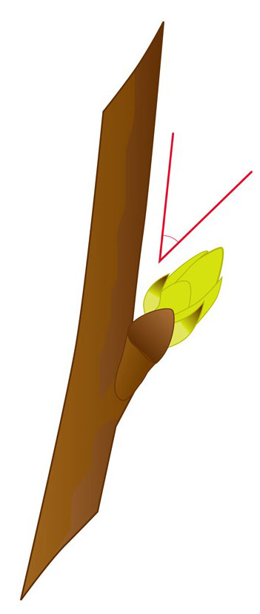 | 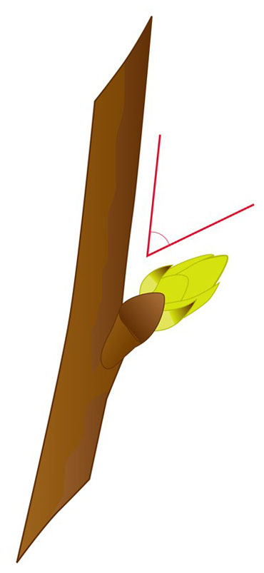
1 | 2 | 3
adpressed or slightly held out | moderately held out | strongly held out

Ad. 7: Vegetative bud: shape of apex

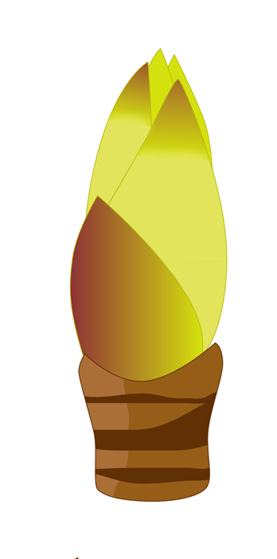 | 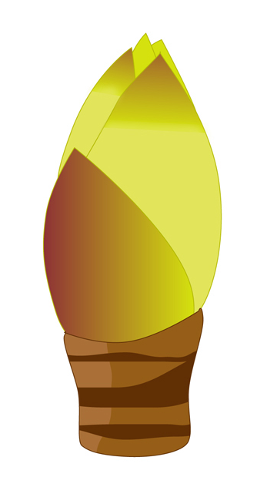
1 | 2 | 3
narrow acute | broad acute | rounded

Ad. 9: Vegetative bud: bloom

Vegetative bud bloom refers to the level of glaucosity on the bud.

Ad. 14: Leaf blade: base

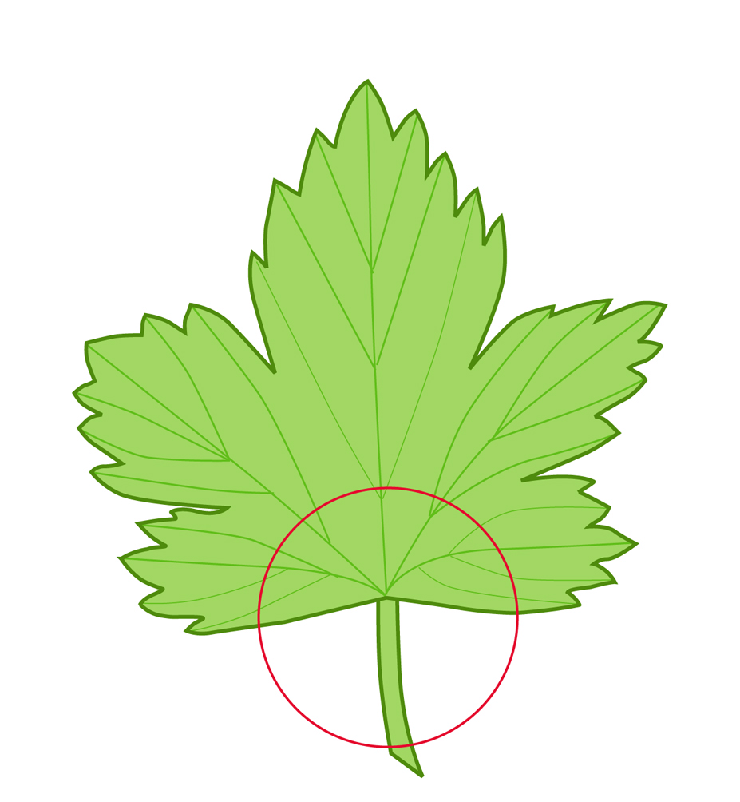 | 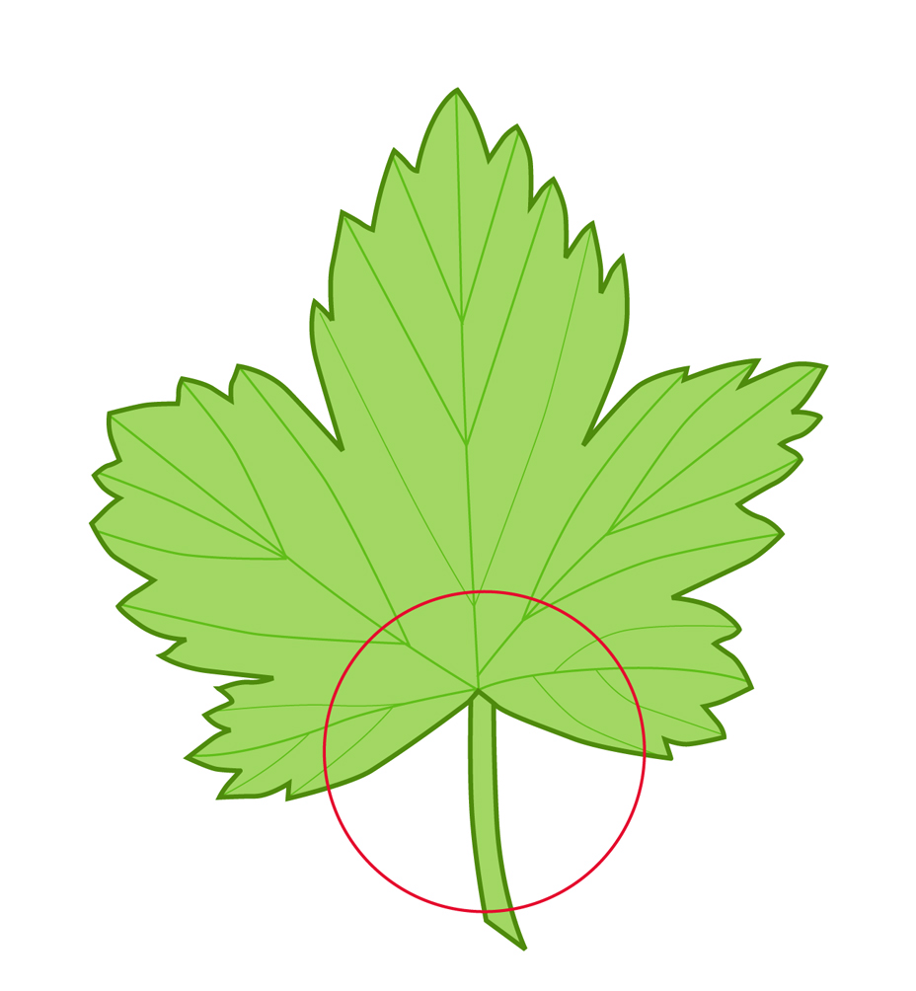 | 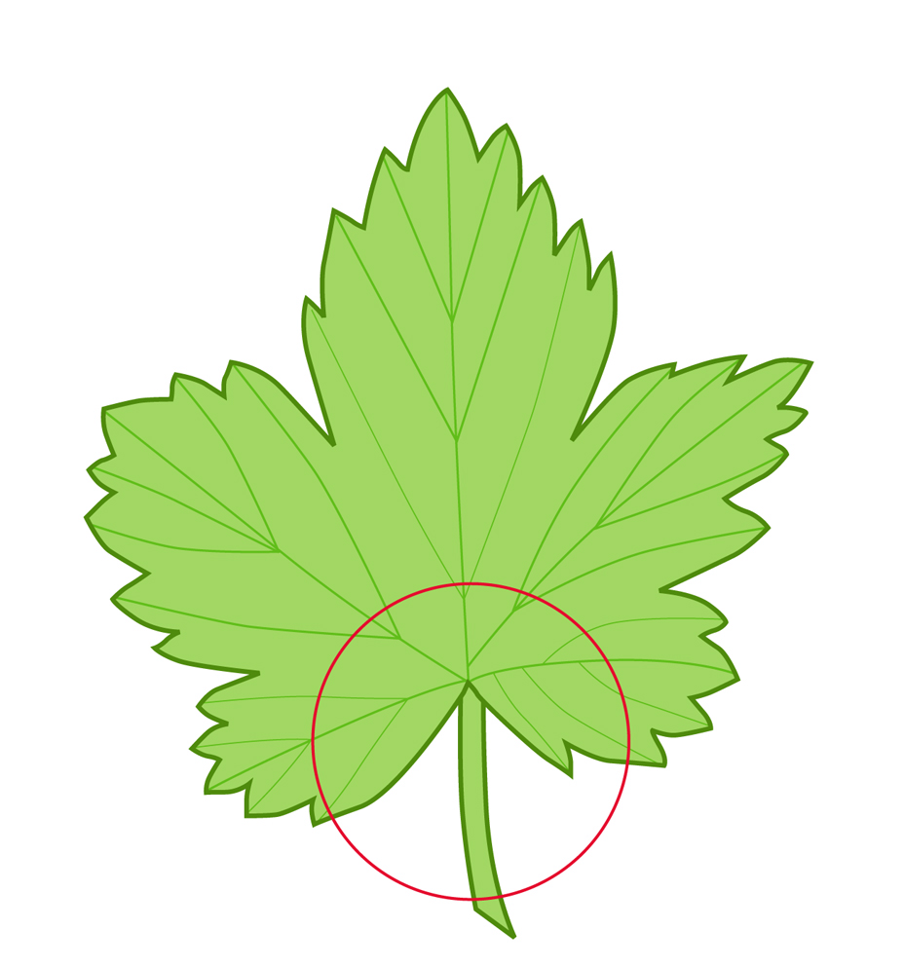
1 | 2 | 3
strongly open | moderately open | weakly open
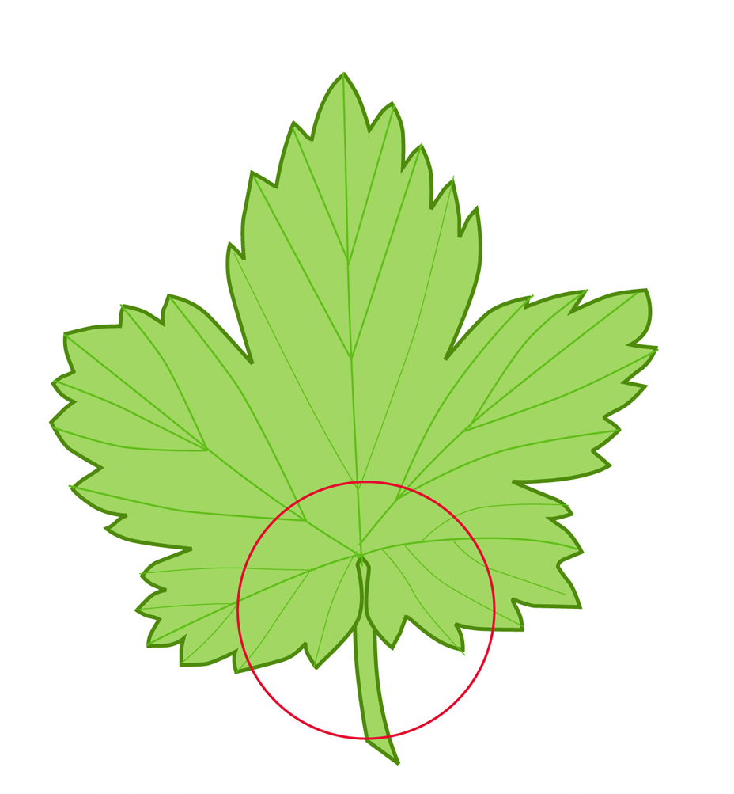 | 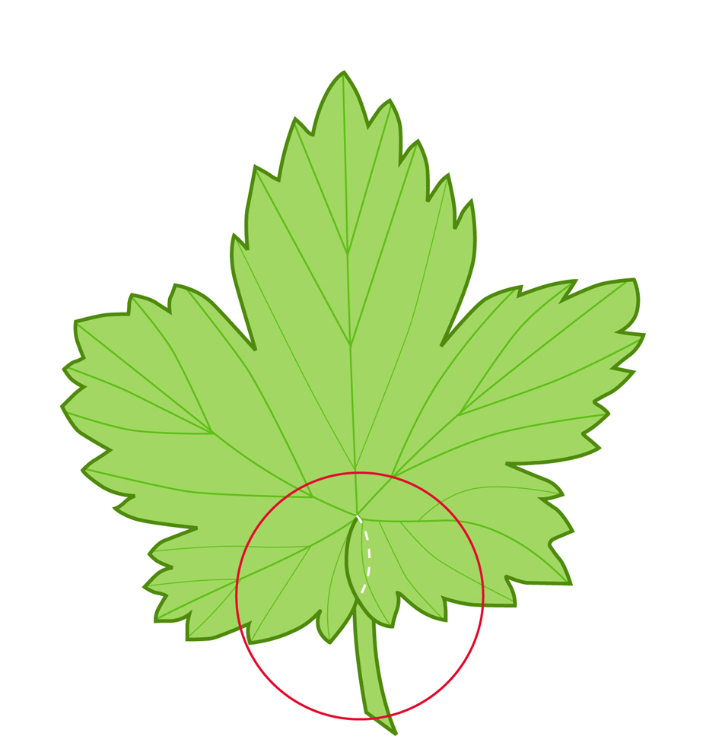
4 | 5
touching | overlapping

Ad. 18: Plant: number of inflorescences per axil

The number of inflorescences per axil is determined by observing the leaf axils in the upper third of a one year old shoot, at flowering.

Ad. 19: Inflorescence: length

The inflorescence length includes the peduncle.

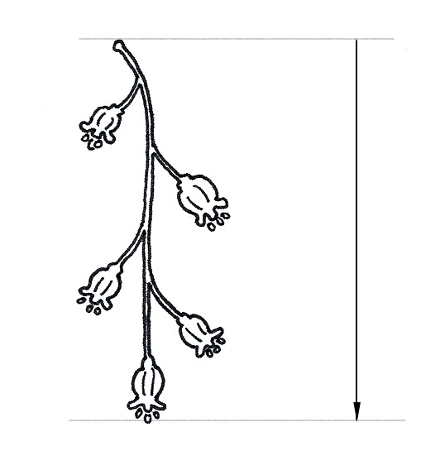

Ad. 23: Infructescence: type

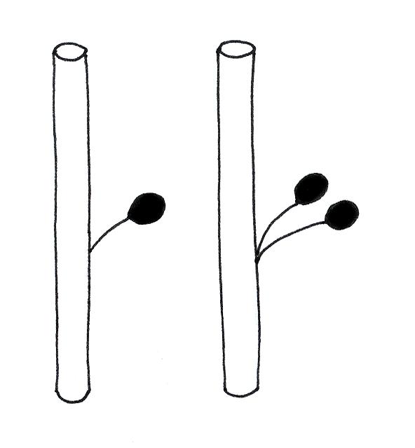 | 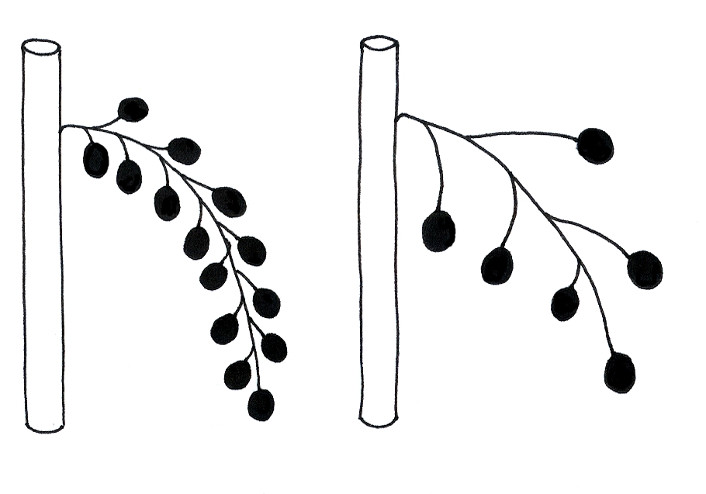
simple | raceme

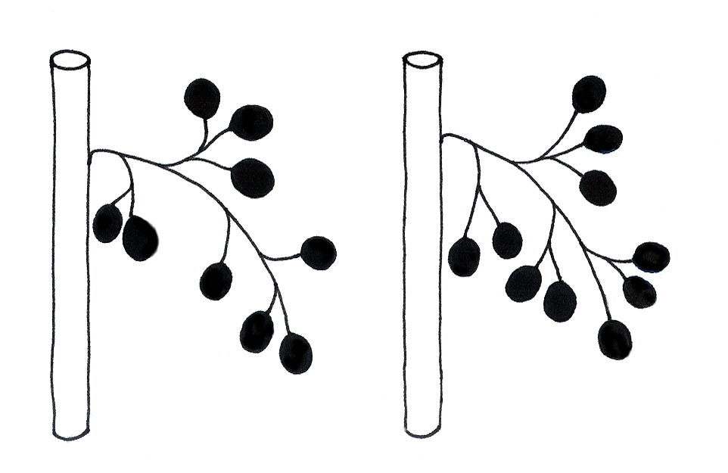 | 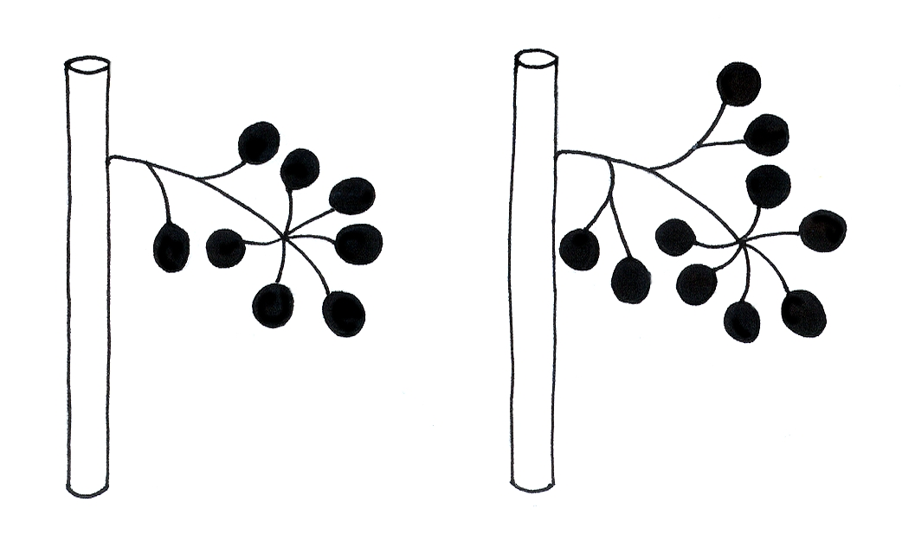
panicle 1 |  | panicle 2

Ad. 24: Infructescence: range of fruit size

The range of fruit size is determined by observing the range of individual fruit sizes within a single infructescence (fruiting truss).
Ad. 25: Fruit: size

Fruit size can be assessed by weight because the density of fruit flesh of all varieties is very similar. Fruit size should be determined by the weight of a minimum of 50 fruits, covering all fruit sizes present, harvested from the 5 plants.

Ad. 28: Time of beginning of vegetative bud burst

The time of beginning of vegetative bud burst is when the first green leaves on a bud are just visible.

Ad. 29: Time of beginning of flowering

The time of beginning of flowering is when 10% of flowers are fully open.

Ad. 30: Time of beginning of fruit harvest

The time of fruit harvest is when 10% of fruits have achieved full color.

Literature
Hedrick, U.P., 1925: The small fruits of New York. J.B. Lyon Company, Albany, US, 614 pp.

Keipert, K., 1981: Beerenobst. Angebaute Arten und Wildfrüchte. Eugen Ulmer Verlag, Stuttgart, DE, 349 pp.

Mühl, F., 1996: Beerenobst und Wildfrüchte. Obst- und Gartenbauverlag des Bayerischen Landesverbandes für Gartenbau und Landespflege, München, DE, 152 pp.

Sorge, P., 1991: Beerenobstsorten. Melsungen, Verlag J. Neumann-Neudamm, 2nd edition, Melsungen, DE, 259 pp.

Todd, J.C., 1962: Black Currant Varieties: Their Classification and Identification. Technical Bulletin No. 11, Ministry of Agriculture, Fisheries and Food, Her Majesty’s Stationary Office, London, GB, 94 pp.

Technical Questionnaire
TECHNICAL QUESTIONNAIRE |  |  |  | Page {x} of {y} |  | Reference Number:
 |  |  |  |  |  | Application date:
 |  |  |  |  |  | (not to be filled in by the applicant)
TECHNICAL QUESTIONNAIRE
to be completed in connection with an application for plant breeders’ rights

1. Subject of the Technical Questionnaire
1.1 Botanical name |  |  | Ribes nigrum L.  (Ribes dikuscha Fisch. ex Turcz., Ribes ussuriense Jancz.)
1.2 Common name |  |  | Blackcurrant; Black Currant
2. Applicant
Name
Address
Telephone No.
Fax No.
E-mail address
Breeder (if different from applicant)
3. Proposed denomination and breeder’s reference
Proposed denomination
(if available)
Breeder’s reference
#4. Information on the breeding scheme and propagation of the variety

4.1 Breeding scheme

Variety resulting from:

4.1.1 Crossing

(a) controlled cross [ ]
(please state parent varieties)
(b) partially known cross [ ]
(please state known parent variety(ies))
(c) unknown cross [ ]

4.1.2 Mutation [ ]
(please state parent variety)

4.1.3 Discovery and development [ ]
(please state where and when discovered
and how developed)

4.1.4 Other [ ]
(please provide details)

4.2 Method of propagating the variety

4.2.1 Vegetative propagation

(a) cuttings [ ]

(b) in vitro propagation [ ]

(c) other (state method) [ ]

4.2.2 Other [ ]
(please provide details)

5. Characteristics of the variety to be indicated (the number in brackets refers to the corresponding characteristic in Test Guidelines; please mark the note which best corresponds).

 | Characteristics |  |  |  |  |  | Example Varieties |  |  |  | Note
5.1  (2) | Plant: growth habit
 | upright |  |  |  |  |  | Magnus, Westra |  |  |  | 1[ ]
 | semi-upright |  |  |  |  |  | Baldwin, Blackdown |  |  |  | 2[ ]
 | spreading |  |  |  |  |  | Tenah |  |  |  | 3[ ]
5.2  (4) | One-year-old shoot: color
 | yellow brown |  |  |  |  |  | Tenah |  |  |  | 1[ ]
 | red brown |  |  |  |  |  |  |  |  |  | 2[ ]
 | brown |  |  |  |  |  | Hatton Black, Jet |  |  |  | 3[ ]
 | grayish |  |  |  |  |  | Cotswold Cross |  |  |  | 4[ ]
5.3  (10) | Young shoot: anthocyanin coloration
 | absent or very weak |  |  |  |  |  | Goliath |  |  |  | 1[ ]
 | weak |  |  |  |  |  | Roodknop |  |  |  | 3[ ]
 | medium |  |  |  |  |  | Hatton Black |  |  |  | 5[ ]
 | strong |  |  |  |  |  | Malvern Cross |  |  |  | 7[ ]
5.4  (25) | Fruit: size
 | small |  |  |  |  |  | Goliath, Sarolata |  |  |  | 3[ ]
 | medium |  |  |  |  |  | Baldwin |  |  |  | 5[ ]
 | large |  |  |  |  |  | Titania |  |  |  | 7[ ]
 | very large |  |  |  |  |  | Bona |  |  |  | 9[ ]
 | Characteristics |  |  |  |  |  | Example Varieties |  |  |  | Note
5.5  (26) | Fruit: color
 | green |  |  |  |  |  | Stuart’s Green |  |  |  | 1[ ]
 | brownish black |  |  |  |  |  | Westwick Choice |  |  |  | 2[ ]
 | black |  |  |  |  |  | Titania |  |  |  | 3[ ]
5.6  (30) | Time of beginning of fruit harvest
 | very early |  |  |  |  |  | Boskoop Giant, Kimberley |  |  |  | 1[ ]
 | early |  |  |  |  |  | Andega, Magnus |  |  |  | 3[ ]
 | medium |  |  |  |  |  | Baldwin Hilltop, Goliath |  |  |  | 5[ ]
 | late |  |  |  |  |  | Ben Alder, Ben Lomond, Hatton Black |  |  |  | 7[ ]
 | very late |  |  |  |  |  | Jet |  |  |  | 9[ ]
6. Similar varieties and differences from these varieties

Please use the following table and box for comments to provide information on how your candidate variety differs from the variety (or varieties) which, to the best of your knowledge, is (or are) most similar. This information may help the examination authority to conduct its examination of distinctness in a more efficient way.

Denomination(s) of variety(ies) similar to your candidate variety |  | Characteristic(s) in which your candidate variety differs from the similar variety(ies) |  |  | Describe the expression of the characteristic(s) for the similar variety(ies) |  |  | Describe the expression of the characteristic(s) for your candidate variety
Example |  | Plant: growth habit |  |  | semi-upright |  |  | upright
Comments:

#7. Additional information which may help in the examination of the variety

7.1 In addition to the information provided in sections 5 and 6, are there any additional characteristics which may help to distinguish the variety?

Yes [ ] No [ ]

(If yes, please provide details)

7.2 Are there any special conditions for growing the variety or conducting the examination?

Yes [ ] No [ ]

(If yes, please provide details)

7.3 Other information

A representative color photograph of the variety should accompany the Technical Questionnaire.

8. Authorization for release

(a) Does the variety require prior authorization for release under legislation concerning the protection of the environment, human and animal health?

Yes [ ] No [ ]

(b) Has such authorization been obtained?

Yes [ ] No [ ]

If the answer to (b) is yes, please attach a copy of the authorization.

9. Information on plant material to be examined or submitted for examination.

9.1 The expression of a characteristic or several characteristics of a variety may be affected by factors, such as pests and disease, chemical treatment (e.g. growth retardants or pesticides), effects of tissue culture, different rootstocks, scions taken from different growth phases of a tree, etc.

9.2 The plant material should not have undergone any treatment which would affect the expression of the characteristics of the variety, unless the competent authorities allow or request such treatment. If the plant material has undergone such treatment, full details of the treatment must be given. In this respect, please indicate below, to the best of your knowledge, if the plant material to be examined has been subjected to:

(a) Microorganisms (e.g. virus, bacteria, phytoplasma) Yes [ ] No [ ]

(b) Chemical treatment (e.g. growth retardant, pesticide) Yes [ ] No [ ]

(c) Tissue culture Yes [ ] No [ ]

(d) Other factors Yes [ ] No [ ]

Please provide details for where you have indicated “yes”.

……………………………………………………………

9.3 Has the plant material to be examined been tested for the presence of virus or other pathogens?

Yes [ ]
(please provide details as specified by the Authority)

No [ ]

10. I hereby declare that, to the best of my knowledge, the information provided in this form is correct:

Applicant’s name

Signature Date

[End of document]

* These names were correct at the time of the introduction of these Test Guidelines but may be revised or updated. [Readers are advised to consult the UPOV Code, which can be found on the UPOV Website (www.upov.int), for the latest information.]
# Authorities may allow certain of this information to be provided in a confidential section of the Technical Questionnaire.
# Authorities may allow certain of this information to be provided in a confidential section of the Technical Questionnaire.

