 |  | E
 | INCLUDEPICTURE "wordml://75.png" \* MERGEFORMATINET INCLUDEPICTURE "wordml://75.png" \* MERGEFORMATINET INCLUDEPICTURE "wordml://75.png" \* MERGEFORMATINET INCLUDEPICTURE "wordml://75.png" \* MERGEFORMATINET INCLUDEPICTURE "wordml://75.png" \* MERGEFORMATINET INCLUDEPICTURE "wordml://75.png" \* MERGEFORMATINET 
  TG/29/8
  ORIGINAL: English
  DATE: 2019-10-29
INTERNATIONAL UNION FOR THE PROTECTION OF NEW VARIETIES OF PLANTS
 | Geneva
  ALSTROEMERIA
  UPOV Code(s): ALSTR
  Alstroemeria L.
  *
GUIDELINES
FOR THE CONDUCT OF TESTS
FOR DISTINCTNESS, UNIFORMITY AND STABILITY

Alternative names:*

Botanical name | English | French | German | Spanish
  Alstroemeria L.
  Alstroemeria, Herb Lily
  Alstroemère,
  Lis des Incas
  Inkalilie
  Alstromeria

The purpose of these guidelines (“Test Guidelines”) is to elaborate the principles contained in the General Introduction (document TG/1/3), and its associated TGP documents, into detailed practical guidance for the harmonized examination of distinctness, uniformity and stability (DUS) and, in particular, to identify appropriate characteristics for the examination of DUS and production of harmonized variety descriptions.
ASSOCIATED DOCUMENTS
These Test Guidelines should be read in conjunction with the General Introduction and its associated TGP documents.

TABLE OF CONTENTS | PAGE
1. | SUBJECT OF THESE TEST GUIDELINES.......................................................................................................... | 3
2. | MATERIAL REQUIRED......................................................................................................................................... | 3
3. | METHOD OF EXAMINATION................................................................................................................................ | 3
3.1 | Number of Growing Cycles........................................................................................................................ | 3
3.2 | Testing Place............................................................................................................................................. | 3
3.3 | Conditions for Conducting the Examination............................................................................................... | 3
3.4 | Test Design................................................................................................................................................ | 3
3.5 | Additional Tests......................................................................................................................................... | 3

4. | ASSESSMENT OF DISTINCTNESS, UNIFORMITY AND STABILITY................................................................. | 4
4.1 | Distinctness............................................................................................................................................... | 4
4.2 | Uniformity.................................................................................................................................................. | 5
4.3 | Stability...................................................................................................................................................... | 5

5. | GROUPING OF VARIETIES AND ORGANIZATION OF THE GROWING TRIAL................................................ | 5
6. | INTRODUCTION TO THE TABLE OF CHARACTERISTICS................................................................................ | 6
6.1 | Categories of Characteristics..................................................................................................................... | 6
6.2 | States of Expression and Corresponding Notes........................................................................................ | 6
6.3 | Types of Expression.................................................................................................................................. | 6
6.4 | Example Varieties...................................................................................................................................... | 6
6.5 | Legend....................................................................................................................................................... | 7

7. | TABLE OF CHARACTERISTICS/TABLEAU DES CARACTÈRES/MERKMALSTABELLE/TABLA DE CARACTERES...................................................................................................................................................... | 8
8. | EXPLANATIONS ON THE TABLE OF CHARACTERISTICS............................................................................... | 18
8.1 | Explanations covering several characteristics........................................................................................... | 18
 | Explanations for individual characteristics................................................................................................. | 19
  8.2

9. | LITERATURE......................................................................................................................................................... | 33
10. | TECHNICAL QUESTIONNAIRE............................................................................................................................ | 34

1. | Subject of these Test Guidelines
  These Test Guidelines apply to all varieties of Alstroemeria L..

2. | Material Required
2.1
  The competent authorities decide on the quantity and quality of the plant material required for testing the variety and when and where it is to be delivered. Applicants submitting material from a State other than that in which the testing takes place must ensure that all customs formalities and phytosanitary requirements are complied with.
2.2
  The material is to be supplied in the form of young plants.
2.3
  The minimum quantity of plant material, to be supplied by the applicant, should be:
  8 plants
2.4
  The plant material supplied should be visibly healthy, not lacking in vigor, nor affected by any important pest or disease.
2.5
  The plant material should not have undergone any treatment which would affect the expression of the characteristics of the variety, unless the competent authorities allow or request such treatment. If it has been treated, full details of the treatment must be given.

3. | Method of Examination
3.1 | Number of Growing Cycles
3.1.1 | The minimum duration of tests should normally be a single growing cycle.
3.1.2 | The testing of a variety may be concluded when the competent authority can determine with certainty the outcome of the test.
3.2 | Testing Place
 | Tests are normally conducted at one place. In the case of tests conducted at more than one place, guidance is provided in TGP/9 “Examining Distinctness”.
3.3 | Conditions for Conducting the Examination
 | The tests should be carried out under conditions ensuring satisfactory growth for the expression of the relevant characteristics of the variety and for the conduct of the examination.
  3.3.1
 | Because daylight varies, color determinations made against a color chart should be made either in a suitable cabinet providing artificial daylight or in the middle of the day in a room without direct sunlight. The spectral distribution of the illuminant for artificial daylight should conform with the CIE Standard of Preferred Daylight D 6500 and should fall within the tolerances set out in the British Standard 950, Part I. These determinations should be made with the plant part placed against a white background. The color chart and version used should be specified in the variety description.
  3.3.2
3.4 | Test Design
  Each test should be designed to result in a total of at least 8 plants.
3.5 | Additional Tests
 | Additional tests, for examining relevant characteristics, may be established.

4. | Assessment of Distinctness, Uniformity and Stability
4.1 | Distinctness
4.1.1 | General Recommendations
 | It is of particular importance for users of these Test Guidelines to consult the General Introduction prior to making decisions regarding distinctness. However, the following points are provided for elaboration or emphasis in these Test Guidelines.
4.1.2 | Consistent Differences
 | The differences observed between varieties may be so clear that more than one growing cycle is not necessary. In addition, in some circumstances, the influence of the environment is not such that more than a single growing cycle is required to provide assurance that the differences observed between varieties are sufficiently consistent. One means of ensuring that a difference in a characteristic, observed in a growing trial, is sufficiently consistent is to examine the characteristic in at least two independent growing cycles.
4.1.3 | Clear Differences
 | Determining whether a difference between two varieties is clear depends on many factors, and should consider, in particular, the type of expression of the characteristic being examined, i.e. whether it is expressed in a qualitative, quantitative, or pseudo-qualitative manner. Therefore, it is important that users of these Test Guidelines are familiar with the recommendations contained in the General Introduction prior to making decisions regarding distinctness.
4.1.4
  Number of Plants or Parts of Plants to be Examined
  Unless otherwise indicated, for the purposes of distinctness, all observations on single plants should be made on 7 plants or parts of plants taken from each of 7 plants and any other observations made on all plants in the test, disregarding any off-type plants.
4.1.5 | Method of Observation
 | The recommended method of observing the characteristic for the purposes of distinctness is indicated by the following key in the Table of Characteristics (see document TGP/9 “Examining Distinctness”, Section 4 “Observation of characteristics”):
MG: single measurement of a group of plants or parts of plants
MS: measurement of a number of individual plants or parts of plants
VG: visual assessment by a single observation of a group of plants or parts of plants
VS: visual assessment by observation of individual plants or parts of plants

 | Type of observation: visual (V) or measurement (M)
 | “Visual” observation (V) is an observation made on the basis of the expert’s judgment. For the purposes of this document, “visual” observation refers to the sensory observations of the experts and, therefore, also includes smell, taste and touch. Visual observation includes observations where the expert uses reference points (e.g. diagrams, example varieties, side-by-side comparison) or non-linear charts (e.g. color charts). Measurement (M) is an objective observation against a calibrated, linear scale e.g. using a ruler, weighing scales, colorimeter, dates, counts, etc.
  Type of record: for a group of plants (G) or for single, individual plants (S)

  For the purposes of distinctness, observations may be recorded as a single record for a group of plants or parts of plants (G), or may be recorded as records for a number of single, individual plants or parts of plants (S). In most cases, “G” provides a single record per variety and it is not possible or necessary to apply statistical methods in a plant-by-plant analysis for the assessment of distinctness.
 | In cases where more than one method of observing the characteristic is indicated in the Table of Characteristics (e.g. VG/MG), guidance on selecting an appropriate method is provided in document TGP/9, Section 4.2.
4.2 | Uniformity
4.2.1 | It is of particular importance for users of these Test Guidelines to consult the General Introduction prior to making decisions regarding uniformity. However, the following points are provided for elaboration or emphasis in these Test Guidelines:
4.2.2
  These Test Guidelines have been developed for the examination of vegetatively propagated varieties. For varieties with other types of propagation, the recommendations in the General Introduction and document TGP/13 "Guidance for new types and species" Section 4.5 "Testing Uniformity" should be followed.
4.2.3
  For the assessment of uniformity of vegetatively propagated varieties, a population standard of 1% and an acceptance probability of at least 95% should be applied. In the case of a sample size of 8 plants, 1 off-type is allowed.
4.3 | Stability
4.3.1 | In practice, it is not usual to perform tests of stability that produce results as certain as those of the testing of distinctness and uniformity. However, experience has demonstrated that, for many types of variety, when a variety has been shown to be uniform, it can also be considered to be stable.
4.3.2 | Where appropriate, or in cases of doubt, stability may be further examined by testing a new plant stock to ensure that it exhibits the same characteristics as those shown by the initial material supplied.

5. | Grouping of Varieties and Organization of the Growing Trial
5.1 | The selection of varieties of common knowledge to be grown in the trial with the candidate varieties and the way in which these varieties are divided into groups to facilitate the assessment of distinctness are aided by the use of grouping characteristics.
5.2 | Grouping characteristics are those in which the documented states of expression, even where produced at different locations, can be used, either individually or in combination with other such characteristics: (a) to select varieties of common knowledge that can be excluded from the growing trial used for examination of distinctness; and (b) to organize the growing trial so that similar varieties are grouped together.
5.3 | The following have been agreed as useful grouping characteristics:
  (a)
  Plant: height (characteristic 1)
  (b)
  Leaf blade: variegation (characteristic 9)
  (c)
  Flower: main color (characteristic 13)

5.4 | Guidance for the use of grouping characteristics, in the process of examining distinctness, is provided through the General Introduction and document TGP/9 “Examining Distinctness”.

6. | Introduction to the Table of Characteristics
6.1 | Categories of Characteristics
6.1.1 | Standard Test Guidelines Characteristics
 | Standard Test Guidelines characteristics are those which are approved by UPOV for examination of DUS and from which members of the Union can select those suitable for their particular circumstances.
6.1.2 | Asterisked Characteristics
 | Asterisked characteristics (denoted by *) are those included in the Test Guidelines which are important for the international harmonization of variety descriptions and should always be examined for DUS and included in the variety description by all members of the Union, except when the state of expression of a preceding characteristic or regional environmental conditions render this inappropriate.
6.2 | States of Expression and Corresponding Notes
6.2.1 | States of expression are given for each characteristic to define the characteristic and to harmonize descriptions. Each state of expression is allocated a corresponding numerical note for ease of recording of data and for the production and exchange of the description.
6.2.2 | In the case of qualitative and pseudo-qualitative characteristics (see Chapter 6.3), all relevant states of expression are presented in the characteristic. However, in the case of quantitative characteristics with 5 or more states, an abbreviated scale may be used to minimize the size of the Table of Characteristics. For example, in the case of a quantitative characteristic with 9 states, the presentation of states of expression in the Test Guidelines may be abbreviated as follows:
State | Note
small | 3
medium | 5
large | 7

 | However, it should be noted that all of the following 9 states of expression exist to describe varieties and should be used as appropriate:
State | Note
very small | 1
very small to small | 2
small | 3
small to medium | 4
medium | 5
medium to large | 6
large | 7
large to very large | 8
very large | 9

6.2.3 | Further explanation of the presentation of states of expression and notes is provided in document TGP/7 “Development of Test Guidelines”.
6.3 | Types of Expression
 | An explanation of the types of expression of characteristics (qualitative, quantitative and pseudo-qualitative) is provided in the General Introduction.
6.4 | Example Varieties
 | Where appropriate, example varieties are provided to clarify the states of expression of each characteristic.

6.5 | Legend
 |  | English |  | français |  | deutsch | español | Example Varieties  Exemples  Beispielssorten  Variedades ejemplo | Note/  Nota
  1
  2
  3
  4
  5
  6
  7
  Name of characteristics in English
  Nom du caractère en français
  Name des Merkmals auf Deutsch
  Nombre del carácter en español
  states of expression
  types d’expression
  Ausprägungsstufen
  tipos de expresión

1 | Characteristic number
2 | (*) | Asterisked characteristic | – see Chapter 6.1.2
3 | Type of expression
 | QL | Qualitative characteristic | – see Chapter 6.3
 | QN | Quantitative characteristic | – see Chapter 6.3
 | PQ | Pseudo-qualitative characteristic | – see Chapter 6.3
4 | Method of observation (and type of plot, if applicable)
 | MG, MS, VG, VS |  | – see Chapter 4.1.5
5
  (+)
  See Explanations on the Table of Characteristics in Chapter 8.2
6
  (a)-(e)
  See Explanations on the Table of Characteristics in Chapter 8.1
7
  Not applicable

7. | Table of Characteristics/Tableau des caractères/Merkmalstabelle/Tabla de caracteres

 |  | English |  | français |  | deutsch | español | Example Varieties  Exemples  Beispielssorten  Variedades ejemplo | Note/  Nota
1. | (*) | QN | MG/MS/VG | (+) | (a)
  Plant: height
  Plante : hauteur
  Pflanze: Höhe
  Planta: altura
 |  | short |  | basse |  | niedrig | baja | Alsdun01, Tesnoram | 3
 |  | medium |  | moyenne |  | mittel | media | Konaribean, Tesrome | 5
 |  | tall |  | haute |  | hoch | alta | Konplatina, Zalsabri | 7
2. | (*) | QN | MG/MS/VG | (+) | (a)
  Stem: thickness
  Tige : épaisseur
  Stengel: Dicke
  Tallo: grosor
 |  | thin |  | fine |  | dünn | delgado | Alsdun01, Tesmoonli | 3
 |  | medium |  | moyenne |  | mittel | medio | Kongrenday, Zalsabri | 5
 |  | thick |  | épaisse |  | dick | grueso | Konplatina, Zalsatista | 7
3. |  | QN | VG |  | (a)
  Stem: anthocyanin coloration
  Tige : pigmentation anthocyanique
  Stengel: Anthocyanfärbung
  Tallo: pigmentación antociánica
 |  | absent or very weak |  | absente ou très faible |  | fehlend oder sehr gering | ausente o muy débil |  | 1
 |  | weak |  | faible |  | gering | débil |  | 3
 |  | medium |  | moyenne |  | mittel | media |  | 5
 |  | strong |  | forte |  | stark | fuerte |  | 7
4. |  | PQ | VG |  | (a)
  Stem: distribution of anthocyanin coloration
  Tige : répartition de la pigmentation anthocyanique
  Stengel: Verteilung der Anthocyanfärbung
  Tallo: distribución de la pigmentación antociánica
 |  | at base only |  | à la base uniquement |  | nur an der Basis | solo en la base | Konantarct | 1
 |  | basal half only |  | moitié basale uniquement |  | nur in basaler Hälfte | solo en la mitad inferior | Konalegria | 2
 |  | basal and apical part |  | partie basale et apicale |  | im basalen und apikalen Teil | en la zona inferior y apical | Zanalsron | 3
 |  | throughout |  | partout |  | überall | en la totalidad | Staqueen | 4
5. | (*) | QN | MG/MS/VG | (+) | (a), (b)
  Leaf: length
  Feuille : longueur
  Blatt: Länge
  Hoja: longitud
 |  | short |  | courte |  | kurz | corta | Konaribean, Zalsabri | 3
 |  | medium |  | moyenne |  | mittel | media | Alsdun01, Tesmars | 5
 |  | long |  | longue |  | lang | larga | Konplatina, Zanalsron | 7

 |  | English |  | français |  | deutsch | español | Example Varieties  Exemples  Beispielssorten  Variedades ejemplo | Note/  Nota
6. | (*) | QN | MG/MS/VG | (+) | (a), (b)
  Leaf: width
  Feuille : largeur
  Blatt: Breite
  Hoja: anchura
 |  | narrow |  | étroite |  | schmal | estrecha | Konplatina, Zanalsron | 3
 |  | medium |  | moyenne |  | mittel | media | Konaribean, Zalsabri | 5
 |  | broad |  | large |  | breit | ancha | Alsdun01, Tesnoram | 7
7. |  | QN | VG | (+) | (a), (b)
  Leaf blade: attitude
  Limbe : port
  Blattspreite: Haltung
  Limbo: porte
 |  | semi-erect |  | demi-dressé |  | halbaufrecht | semierecto |  | 3
 |  | horizontal |  | horizontal |  | waagerecht | horizontal |  | 5
 |  | semi-drooping |  | demi-retombant |  | halbüberhängend | semicolgante |  | 7
8. | (*) | QL | VG | (+) | (a), (b)
  Leaf blade: greyish colored longitudinal stripes
  Limbe : bandes longitudinales grisâtres
  Blattspreite: gräulich gefärbte Längsstreifen
  Limbo: estrías longitudinales de color grisáceo
 |  | absent |  | absentes |  | fehlend | ausentes |  | 1
 |  | present |  | présentes |  | vorhanden | presentes |  | 9
9. | (*) | QL | VG | (+) | (a), (b)
  Leaf blade: variegation
  Limbe : panachure
  Blattspreite: Panaschierung
  Limbo: variegación
 |  | absent |  | absente |  | fehlend | ausente |  | 1
 |  | present |  | présente |  | vorhanden | presente | Alsdun01 | 9
10. | (*) | QN | MG/MS/VG | (+) | (a)
  Umbel: length of rays
  Ombelle : longueur des rayons
  Dolde: Länge der Achsen
  Umbela: longitud de los radios
 |  | short |  | courte |  | kurz | corta | Alsdun01, Konaribean | 3
 |  | medium |  | moyenne |  | mittel | media | Konplatina, Tesmars | 5
 |  | long |  | longue |  | lang | larga | Konswitch | 7
11. | (*) | QN | MG/MS/VG |  | (a)
  Umbel: number of rays
  Ombelle : nombre de rayons
  Dolde: Anzahl Achsen
  Umbela: número de radios
 |  | few |  | faible |  | gering | bajo | Tesmoonli, Zapriliarange | 3
 |  | medium |  | moyen |  | mittel | medio | Konplatina, Zalsabri | 5
 |  | many |  | élevé |  | groß | alto | Alsdun01, Konaribean | 7

 |  | English |  | français |  | deutsch | español | Example Varieties  Exemples  Beispielssorten  Variedades ejemplo | Note/  Nota
12. | (*) | QN | MG/MS/VG | (+) | (a), (c)
  Flower: length of pedicel
  Fleur : longueur du pédicelle
  Blüte: Länge des Stiels
  Flor: longitud del pedicelo
 |  | short |  | courte |  | kurz | corta | Alsdun01, Zalsabri | 3
 |  | medium |  | moyenne |  | mittel | media | ESM T122, Konplatina | 5
 |  | long |  | longue |  | lang | larga | Tesmars, Tesnoram | 7

13. | (*) | PQ | VG |  | (a), (c), (d)
  Flower: main color
  Fleur : couleur principale
  Blüte: Hauptfarbe
  Flor: color principal
 |  | white |  | blanche |  | weiß | blanco | Konantarct, Tesmoonli | 1
 |  | yellow green |  | vert jaune |  | gelbgrün | verde amarillento | Kongrenday | 2
 |  | light yellow |  | jaune clair |  | hellgelb | amarillo claro | Gataran, Konwpearls | 3
 |  | medium yellow |  | jaune moyen |  | mittelgelb | amarillo medio | Konaribean | 4
 |  | orange |  | orange |  | orange | naranja | ESM T122, Staqueen | 5
 |  | light pink |  | rose clair |  | hellrosa | rosa claro | Tesnoram | 6
 |  | medium pink |  | rose moyen |  | mittelrosa | rosa medio | Zalsabri | 7
 |  | blue pink |  | bleu rose |  | blaurosa | rosa azulado | Konswitch | 8
 |  | orange red |  | rouge orangé |  | orangeroot | rojo anaranjado | Zalsance, Zapriliarange | 9
 |  | red |  | rouge |  | rot | rojo | Alsdun01 | 10
 |  | purple red |  | rouge pourpre |  | rotpurpurn | rojo púrpura | Konalegria, Tesrome | 11
 |  | light purple |  | pourpre clair |  | hellpurpurn | púrpura claro | Tesmars | 12
 |  | medium purple |  | pourpre moyen |  | mittelpurpurn | púrpura medio | Konplatina | 13
 |  | dark purple |  | pourpre foncé |  | dunkelpurpurn | púrpura oscuro | Zalsatista | 14
14. |  | QN | MG/MS/VG | (+) | (a), (c)
  Flower: length in frontal view
  Fleur : longueur en vue de face
  Blüte: Länge in Vorderansicht
  Flor: longitud en vista frontal
 |  | short |  | courte |  | kurz | corta | Konwpearls | 3
 |  | medium |  | moyenne |  | mittel | media | Alsdun01, Kongrenday | 5
 |  | long |  | longue |  | lang | larga | Gataran, Zalsatista | 7
15. |  | QN | MG/MS/VG | (+) | (a), (c)
  Flower: width in frontal view
  Fleur : largeur en vue de face
  Blüte: Breite in Vorderansicht
  Flor: anchura en vista frontal
 |  | narrow |  | étroite |  | schmal | estrecha | Konwpearls | 3
 |  | medium |  | moyenne |  | mittel | media | Tesmoonli, Zalsabri | 5
 |  | broad |  | large |  | breit | ancha | Gataran, Zalsatista | 7

 |  | English |  | français |  | deutsch | español | Example Varieties  Exemples  Beispielssorten  Variedades ejemplo | Note/  Nota
16. |  | QN | MG/MS/VG | (+) | (a), (c)
  Flower: ratio length/width in frontal view
  Fleur : rapport longueur/largeur en vue de face
  Blüte: Verhältnis Länge/Breite in Vorderansicht
  Flor: relación longitud/anchura en vista frontal
 |  | low |  | bas |  | klein | baja | Tespale | 3
 |  | medium |  | moyen |  | mittel | media | Gataran, Tesrome | 5
 |  | high |  | élevé |  | groß | alta | Konswitch | 7
17. |  | QN | MG/MS/VG | (+) | (a), (c)
  Flower: length in side view
  Fleur : longueur en vue de profil
  Blüte: Länge in Seitenansicht
  Flor: longitud en vista lateral
 |  | short |  | courte |  | kurz | corta |  | 3
 |  | medium |  | moyenne |  | mittel | media |  | 5
 |  | long |  | longue |  | lang | larga |  | 7
18. | (*) | PQ | VG | (+) | (a), (c)
  Outer tepal: shape of blade
  Tépale externe : forme du limbe
  Äußeres Perigonblatt: Form der Spreite
  Tépalo externo: forma del limbo
 |  | circular |  | circulaire |  | kreisförmig | circular |  | 1
 |  | broad elliptic |  | elliptique large |  | breit elliptisch | elíptica ancha | Konwpearls | 2
 |  | medium elliptic |  | elliptique moyen |  | mittel elliptisch | elíptica media | Zalsance | 3
 |  | broad obovate |  | obovale large |  | breit verkehrt eiförmig | oboval ancha | Alsdun01, Zalsatista | 4
 |  | medium obovate |  | obovale moyen |  | mittel verkehrt eiförmig | oboval media | Kongrenday | 5
19. |  | QN | VG | (+) | (a), (c)
  Outer tepal: emargination
  Tépale externe : échancrure
  Äußeres Perigonblatt: Kerbung
  Tépalo externo: emarginación
 |  | shallow |  | peu profonde |  | flach | poco profunda | Alsdun01, Konplatina | 3
 |  | medium |  | moyenne |  | mittel | media | Konswitch, Tesmoonli | 5
 |  | deep |  | profonde |  | tief | profunda | Tesrome, Zalsabri | 7
20. | (*) | PQ | VG |  | (a), (c), (d)
  Outer tepal: main color of outer side
  Tépale externe : couleur principale de la face externe
  Äußeres Perigonblatt: Hauptfarbe der Außenseite
  Tépalo externo: color principal del lado exterior
 |  | RHS Colour Chart (indicate reference number) |  | Code RHS des couleurs (indiquer le numéro de référence) |  | RHS-Farbkarte (Nummer angeben) | Carta de colores RHS (indicar número de referencia)

 |  | English |  | français |  | deutsch | español | Example Varieties  Exemples  Beispielssorten  Variedades ejemplo | Note/  Nota
21. | (*) | QN | VG | (+) | (a), (c)
  Outer tepal: green area of outer side
  Tépale externe : surface verte sur la face externe
  Äußeres Perigonblatt: grüne Fläche der Außenseite
  Tépalo externo: zona verde del lado exterior
 |  | absent or very small |  | nulle ou très petite |  | fehlend oder sehr klein | ausente o muy pequeña | Alsdun01, ESM T122 | 1
 |  | small |  | petite |  | klein | pequeña | Tesmoonli, Zalsabri | 2
 |  | medium |  | moyenne |  | mittel | media | Tesmars, Zalsanebli | 3
 |  | large |  | grande |  | groß | grande | Gataran | 4
 |  | very large |  | très grande |  | sehr groß | muy grande |  | 5
22. | (*) | PQ | VG |  | (a), (c), (d)
  Outer tepal: main color of central zone of inner side
  Tépale externe : couleur principale de la zone centrale de la face interne
  Äußeres Perigonblatt: Hauptfarbe der mittleren Zone der Innenseite
  Tépalo externo: color principal de la zona central del lado interior
 |  | RHS Colour Chart (indicate reference number) |  | Code RHS des couleurs (indiquer le numéro de référence) |  | RHS-Farbkarte (Nummer angeben) | Carta de colores RHS (indicar número de referencia)
23. | (*) | PQ | VG |  | (a), (c), (d)
  Outer tepal: main color of top zone of inner side (green area excluded)
  Tépale externe : couleur principale de la zone supérieure de la face interne (surface verte exclue)
  Äußeres Perigonblatt: Hauptfarbe der oberen Zone der Innenseite (grün Fläche ausgeschlossen)
  Tépalo externo: color principal de la zona superior del lado interior (excluida la zona verde)
 |  | RHS Colour Chart (indicate reference number) |  | Code RHS des couleurs (indiquer le numéro de référence) |  | RHS-Farbkarte (Nummer angeben) | Carta de colores RHS (indicar número de referencia)
24. | (*) | PQ | VG |  | (a), (c), (d)
  Outer tepal: main color of lateral zone of inner side
  Tépale externe : couleur principale de la zone latérale de la face interne
  Äußeres Perigonblatt: Hauptfarbe der seitlichen Zone der Innenseite
  Tépalo externo: color principal de la zona lateral del lado interior
 |  | RHS Colour Chart (indicate reference number) |  | Code RHS des couleurs (indiquer le numéro de référence) |  | RHS-Farbkarte (Nummer angeben) | Carta de colores RHS (indicar número de referencia)
25. | (*) | PQ | VG |  | (a), (c), (d)
  Outer tepal: main color of basal zone of inner side
  Tépale externe : couleur principale de la zone basale de la face interne
  Äußeres Perigonblatt: Hauptfarbe der basalen Zone der Innenseite
  Tépalo externo: color principal de la zona inferior del lado interior
 |  | RHS Colour Chart (indicate reference number) |  | Code RHS des couleurs (indiquer le numéro de référence) |  | RHS-Farbkarte (Nummer angeben) | Carta de colores RHS (indicar número de referencia)

 |  | English |  | français |  | deutsch | español | Example Varieties  Exemples  Beispielssorten  Variedades ejemplo | Note/  Nota
26. | (*) | QN | VG | (+) | (a), (c)
  Outer tepal: small stripes on marginal part of lateral zone of inner side
  Tépale externe : petites stries sur la partie marginale de la zone latérale de la face interne
  Äußeres Perigonblatt: kleine Streifen am Rand der seitlichen Zone der Innenseite
  Tépalo externo: estrías pequeñas en la parte marginal de la zona lateral del lado interior
 |  | absent or very few |  | aucune ou très peu |  | fehlend oder sehr wenige | ausentes o muy pocas | Alsdun01, Konplatina | 1
 |  | few |  | peu |  | wenige | pocas | Kongrenday | 3
 |  | medium |  | moyennement nombreuses |  | mittel | medias | Zalsatista | 5
 |  | many |  | nombreuses |  | viele | abundantes |  | 7
27. | (*) | QN | VG | (+) | (a), (c)
  Outer tepal: large stripes on inner side (marginal zone excluded)
  Tépale externe : larges stries sur la face interne (zone marginale exclue)
  Äußeres Perigonblatt: große Streifen an der Innenseite (Randzone ausgeschlossen)
  Tépalo externo: estrías anchas en el lado interior (excluida la zona marginal)
 |  | absent or very few |  | aucune ou très peu |  | fehlend oder sehr wenige | ausentes o muy pocas | Alsdun01, Konplatina | 1
 |  | few |  | peu |  | wenige | pocas | ESM T122 | 2
 |  | medium |  | moyennement nombreuses |  | mittel | medias |  | 3
 |  | many |  | nombreuses |  | viele | abundantes |  | 4
 |  | very many |  | très nombreuses |  | sehr viele | muy abundantes |  | 5
28. | (*) | PQ | VG | (+) | (a), (c)
  Inner lateral tepal: shape
  Tépale interne latéral : forme
  Inneres seitliches Perigonblatt: Form
  Tépalo lateral interno: forma
 |  | medium elliptic |  | elliptique moyen |  | mittel elliptisch | elíptica media | Tespolar, Zalsabri | 1
 |  | narrow elliptic |  | elliptique étroit |  | schmal elliptisch | elíptica estrecha | Kongrenday | 2
 |  | medium obovate |  | obovale moyen |  | mittel verkehrt eiförmig | oboval media | Zapriliarange | 3
 |  | narrow obovate |  | obovale étroit |  | schmal verkehrt eiförmig | oboval estrecha | Konwpearls | 4
29. | (*) | PQ | VG |  | (a), (c), (d), (e)
  Inner lateral tepal: main color of central zone
  Tépal interne latéral : couleur principale de la zone centrale
  Inneres seitliches Perigonblatt: Hauptfarbe der mittleren Zone
  Tépalo lateral interno: color principal de la zona central
 |  | RHS Colour Chart (indicate reference number) |  | Code RHS des couleurs (indiquer le numéro de référence) |  | RHS-Farbkarte (Nummer angeben) | Carta de colores RHS (indicar número de referencia)

 |  | English |  | français |  | deutsch | español | Example Varieties  Exemples  Beispielssorten  Variedades ejemplo | Note/  Nota
30. | (*) | PQ | VG |  | (a), (c), (d) , (e)
  Inner lateral tepal: main color of apical zone
  Tépale interne latéral : couleur principale de la zone apicale
  Inneres seitliches Perigonblatt: Hauptfarbe der apikalen Zone
  Tépalo lateral interno: color principal de la zona apical
 |  | RHS Colour Chart (indicate reference number) |  | Code RHS des couleurs (indiquer le numéro de référence) |  | RHS-Farbkarte (Nummer angeben) | Carta de colores RHS (indicar número de referencia)

31. | (*) | PQ | VG |  | (a), (c), (d), (e)
  Inner lateral tepal: main color of basal zone
  Tépale interne latéral : couleur principale de la zone basale
  Inneres seitliches Perigonblatt: Hauptfarbe der basalen Zone
  Tépalo lateral interno: color principal de la zona inferior
 |  | RHS Colour Chart (indicate reference number) |  | Code RHS des couleurs (indiquer le numéro de référence) |  | RHS-Farbkarte (Nummer angeben) | Carta de colores RHS (indicar número de referencia)
32. | (*) | QN | MG/VG | (+) | (a), (c), (e)
  Inner lateral tepal: number of stripes
  Tépale interne latéral : nombre de stries
  Inneres seitliches Perigonblatt: Anzahl Streifen
  Tépalo lateral interno: número de estrías
 |  | absent or very few |  | nul ou très faible |  | fehlend oder sehr gering | ausente o muy bajo | Tesmars | 1
 |  | few |  | faible |  | gering | bajo | Alsdun01 | 3
 |  | medium |  | moyen |  | mittel | medio | Konplatina, Zalsabri | 5
 |  | many |  | élevé |  | groß | alto | ESM T122, Gataran | 7
 |  | very many |  | très élevé |  | sehr groß | muy alto | Zalsatista | 9
33. | (*) | QN | VG | (+) | (a), (c), (e)
  Inner lateral tepal: area of striped zone
  Tépale interne latéral : surface occupée par la zone striée
  Inneres seitliches Perigonblatt: Fläche der gestreiften Zone
  Tépalo lateral interno: superficie de la zona estriada
 |  | small |  | petite |  | klein | pequeña | Tesmars | 3
 |  | medium |  | moyenne |  | mittel | media | Alsdun01, Zalsabri | 5
 |  | large |  | grande |  | groß | grande | Konplatina | 7
34. | (*) | QN | MG/MS/VG | (+) | (a), (c), (e)
  Inner lateral tepal: length of stripes
  Tépale interne latéral : longueur des stries
  Inneres seitliches Perigonblatt: Länge der Streifen
  Tépalo lateral interno: longitud de las estrías
 |  | very short |  | très courte |  | sehr kurz | muy corta |  | 1
 |  | short |  | courte |  | kurz | corta | Alsdun01, Tesmars | 3
 |  | medium |  | moyenne |  | mittel | media | Konaribean, Konplatina | 5
 |  | long |  | longue |  | lang | larga | Tesnoram, Zapriliarange | 7
 |  | very long |  | très longue |  | sehr lang | muy larga |  | 9

 |  | English |  | français |  | deutsch | español | Example Varieties  Exemples  Beispielssorten  Variedades ejemplo | Note/  Nota
35. | (*) | QN | MG/VG | (+) | (a), (c), (e)
  Inner lateral tepal: width of stripes
  Tépale interne latéral : largeur des stries
  Inneres seitliches Perigonblatt: Breite der Streifen
  Tépalo lateral interno: anchura de las estrías
 |  | very narrow |  | très étroite |  | sehr schmal | muy estrecha |  | 1
 |  | narrow |  | étroite |  | schmal | estrecha | Alsdun01, Konaribean | 3
 |  | medium |  | moyenne |  | mittel | media | Konplatina, Tesmoonli | 5
 |  | broad |  | large |  | breit | ancha | Konantarct, Zalsatista | 7
 |  | very broad |  | très large |  | sehr breit | muy ancha |  | 9
36. | (*) | PQ | VG |  | (a), (c), (d), (e)
  Inner median tepal: main color
  Tépale interne médian : couleur principale
  Inneres mittleres Perigonblatt: Hauptfarbe
  Tépalo medio interno: color principal
 |  | RHS Colour Chart (indicate reference number) |  | Code RHS des couleurs (indiquer le numéro de référence) |  | RHS-Farbkarte (Nummer angeben) | Carta de colores RHS (indicar número de referencia)
37. | (*) | PQ | VG |  | (a), (c), (d), (e)
  Inner median tepal: secondary color
  Tépale interne médian : couleur secondaire
  Inneres mittleres Perigonblatt: Sekundärfarbe
  Tépalo medio interno: color secundario
 |  | RHS Colour Chart (indicate reference number) |  | Code RHS des couleurs (indiquer le numéro de référence) |  | RHS-Farbkarte (Nummer angeben) | Carta de colores RHS (indicar número de referencia)
38. | (*) | QN | MG/VG |  | (a), (c), (e)
  Inner median tepal: number of stripes
  Tépale interne médian : nombre de stries
  Inneres mittleres Perigonblatt: Anzahl Streifen
  Tépalo medio interno: número de estrías
 |  | absent or very few |  | nul ou très faible |  | fehlend oder sehr gering | ausentes o muy bajo | Alsdun01, Tesmars | 1
 |  | few |  | faible |  | gering | bajo | Tesrome, Zalsabri | 3
 |  | medium |  | moyen |  | mittel | medio | ESM T122, Zanalsron | 5
 |  | many |  | élevé |  | groß | alto | Zalsatista | 7

 |  | English |  | français |  | deutsch | español | Example Varieties  Exemples  Beispielssorten  Variedades ejemplo | Note/  Nota
39. | (*) | PQ | VG | (+) | (a), (c)
  Anther: color
  Anthère : couleur
  Anthere: Farbe
  Antera: color
 |  | greenish |  | verdâtre |  | grünlich | verdoso | Konplatina, Tesmoonli | 1
 |  | yellowish |  | jaunâtre |  | gelblich | amarillento | Zalsabri | 2
 |  | orange |  | orange |  | orange | naranja | Alsdun01, Konaribean | 3
 |  | purplish |  | violacée |  | purpurn | purpúreo | Tespolar, Zalsanebli | 4
 |  | blue |  | bleue |  | blau | azul | Gataran, Konswitch | 5
 |  | brownish |  | brunâtre |  | bräunlich | pardusco |  | 6
 |  | medium grey |  | gris moyen |  | mittelgrau | gris medio |  | 7
 |  | dark grey |  | gris foncé |  | dunkelgrau | gris oscuro |  | 8
40. | (*) | PQ | VG |  | (a), (c), (d)
  Filament: main color
  Filet : couleur principale
  Staubfaden: Hauptfarbe
  Filamento: color principal
 |  | white |  | blanc |  | weiß | blanco | Konantarct, Zalsabri | 1
 |  | yellow |  | jaune |  | gelb | amarillo | ESM T122, Gataran | 2
 |  | orange |  | orange |  | orange | naranja | Konaribean | 3
 |  | orange red |  | rouge orangé |  | orangerot | rojo anaranjado | Alsdun01, Zalsance | 4
 |  | red |  | rouge |  | rot | rojo | Tesronto, Zaprikate | 5
 |  | pink |  | rose |  | rosa | rosa | Kongrenday, Tesnoram | 6
 |  | red purple |  | rouge pourpre |  | rotpurpurn | púrpura rojizo | Konalegria, Tesrome | 7
 |  | light purple |  | violet clair |  | hellpurpurn | púrpura claro | Konplatina, Tesmoonli | 8
 |  | medium purple |  | violet moyen |  | mittelpurpurn | púrpura medio | Tesmars, Zalsatista | 9
41. |  | QN | VG | (+) | (a), (c)
  Filament: number of spots
  Filet : nombre de taches
  Staubfaden: Anzahl Flecken
  Filamento: número de manchas
 |  | absent or very few |  | nul ou très faible |  | fehlend oder sehr wenige | ausentes o muy pocas |  | 1
 |  | few |  | faible |  | wenige | pocas |  | 2
 |  | medium |  | moyen |  | mittel | medias |  | 3
 |  | many |  | élevé |  | viele | abundantes |  | 4
 |  | very many |  | très élevé |  | sehr viele | muy abundantes |  | 5

 |  | English |  | français |  | deutsch | español | Example Varieties  Exemples  Beispielssorten  Variedades ejemplo | Note/  Nota
42. | (*) | QL | VG | (+) | (a), (c)
  Stigma: spots
  Stigmate : taches
  Narbe: Flecken
  Estigma: manchas
 |  | absent |  | absentes |  | fehlend | ausentes |  | 1
 |  | present |  | présentes |  | vorhanden | presentes |  | 9

43. | (*) | QN | VG | (+) | (a), (c)
  Ovary: extent of anthocyanin coloration
  Ovaire : étendue de la pigmentation anthocyanique
  Fruchtknoten: Ausdehnung der Anthocyanfärbung
  Ovario: extensión de la pigmentación antociánica
 |  | absent or very small |  | absente ou très petite |  | fehlend oder sehr klein | ausente o muy pequeña | Konswitch, Tesmoonli | 1
 |  | small |  | petite |  | klein | pequeña | Konplatina, Zalsabri | 3
 |  | medium |  | moyenne |  | mittel | media | Alsdun01, Zalsatista | 5
 |  | large |  | grande |  | groß | grande | Konaribean, Tesmars | 7
 |  | very large |  | très grande |  | sehr groß | muy grande | Tespale | 9

8. | Explanations on the Table of Characteristics
8.1 | Explanations covering several characteristics
 | Characteristics containing the following key in the Table of Characteristics should be examined as indicated below:
  (a)
  Observations should be made on the first fully developed stem when 50% of the flowers are open.
  (b)
  Observations should be made on leaves taken from the middle third of the stem.

(c)
Outer tepals

Observations should be made when the first anther of the individual flower is open.
INCLUDEPICTURE "wordml://76.png" \* MERGEFORMATINET INCLUDEPICTURE "wordml://76.png" \* MERGEFORMATINET INCLUDEPICTURE "wordml://76.png" \* MERGEFORMATINET INCLUDEPICTURE "wordml://76.png" \* MERGEFORMATINET INCLUDEPICTURE "wordml://76.png" \* MERGEFORMATINET INCLUDEPICTURE "wordml://76.png" \* MERGEFORMATINET 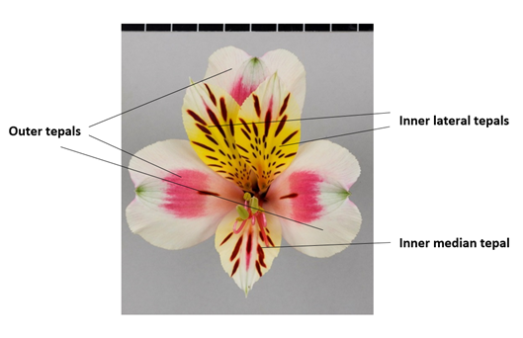
Inner lateral tepals
Inner median tepal
Outer tepal (inner side)
INCLUDEPICTURE "wordml://77.png" \* MERGEFORMATINET INCLUDEPICTURE "wordml://77.png" \* MERGEFORMATINET INCLUDEPICTURE "wordml://77.png" \* MERGEFORMATINET INCLUDEPICTURE "wordml://77.png" \* MERGEFORMATINET INCLUDEPICTURE "wordml://77.png" \* MERGEFORMATINET INCLUDEPICTURE "wordml://77.png" \* MERGEFORMATINET 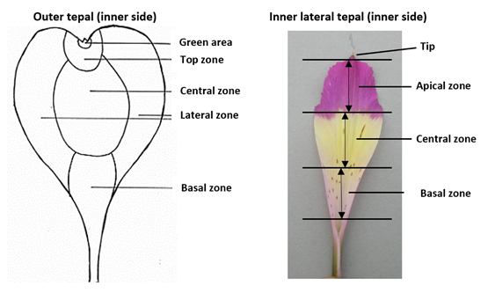
Inner lateral tepal (inner side)
Green area
Top zone

Central zone

Lateral zone

Basal zone
Tip

Apical zone

Central zone

Basal zone

  (d)
  (e)
  The main color is the color with the largest surface area. In cases where the areas of the main and secondary color are too similar to reliably decide which color has the largest surface area, the darker color is considered to be the main color.
  Observations should be made on the inner side.

8.2 | Explanations for individual characteristics
Ad. 1: Plant: height

Plant height should be observed from soil level to the top of the plant, including the flowers.

Ad. 2: Stem: thickness

Thickness should be assessed at the middle third of the stem.

Ad. 5: Leaf: length

INCLUDEPICTURE "wordml://78.png" \* MERGEFORMATINET INCLUDEPICTURE "wordml://78.png" \* MERGEFORMATINET INCLUDEPICTURE "wordml://78.png" \* MERGEFORMATINET INCLUDEPICTURE "wordml://78.png" \* MERGEFORMATINET INCLUDEPICTURE "wordml://78.png" \* MERGEFORMATINET INCLUDEPICTURE "wordml://78.png" \* MERGEFORMATINET 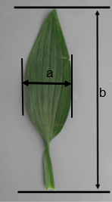 | a = Leaf: width  b = Leaf: length

Ad. 6: Leaf: width

See Ad. 5

Ad. 7: Leaf blade: attitude

INCLUDEPICTURE "wordml://79.png" \* MERGEFORMATINET INCLUDEPICTURE "wordml://79.png" \* MERGEFORMATINET INCLUDEPICTURE "wordml://79.png" \* MERGEFORMATINET INCLUDEPICTURE "wordml://79.png" \* MERGEFORMATINET INCLUDEPICTURE "wordml://79.png" \* MERGEFORMATINET INCLUDEPICTURE "wordml://79.png" \* MERGEFORMATINET 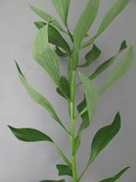 | INCLUDEPICTURE "wordml://80.png" \* MERGEFORMATINET INCLUDEPICTURE "wordml://80.png" \* MERGEFORMATINET INCLUDEPICTURE "wordml://80.png" \* MERGEFORMATINET INCLUDEPICTURE "wordml://80.png" \* MERGEFORMATINET INCLUDEPICTURE "wordml://80.png" \* MERGEFORMATINET INCLUDEPICTURE "wordml://80.png" \* MERGEFORMATINET 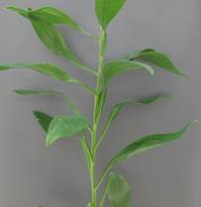 | INCLUDEPICTURE "wordml://81.png" \* MERGEFORMATINET INCLUDEPICTURE "wordml://81.png" \* MERGEFORMATINET INCLUDEPICTURE "wordml://81.png" \* MERGEFORMATINET INCLUDEPICTURE "wordml://81.png" \* MERGEFORMATINET INCLUDEPICTURE "wordml://81.png" \* MERGEFORMATINET INCLUDEPICTURE "wordml://81.png" \* MERGEFORMATINET 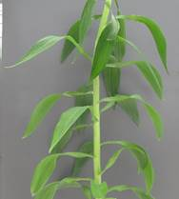
3 | 5 | 7
semi-erect | horizontal | semi-drooping

Ad. 8: Leaf blade: greyish colored longitudinal stripes

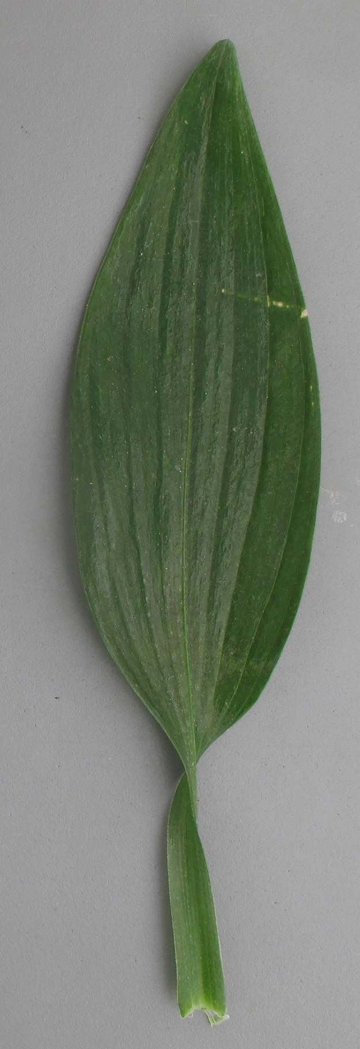 | 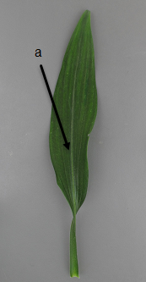  a = greyish colored stripe
1 | 9
absent | present

Ad. 9: Leaf blade: variegation
The upper side of the leaf should be observed. The greyish colored stripe of the midrib is not regarded as variegation.

INCLUDEPICTURE "wordml://82.png" \* MERGEFORMATINET INCLUDEPICTURE "wordml://82.png" \* MERGEFORMATINET INCLUDEPICTURE "wordml://82.png" \* MERGEFORMATINET INCLUDEPICTURE "wordml://82.png" \* MERGEFORMATINET INCLUDEPICTURE "wordml://82.png" \* MERGEFORMATINET 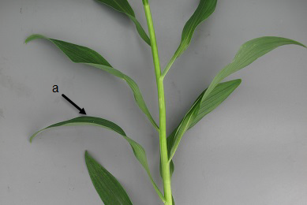 | a = upper side

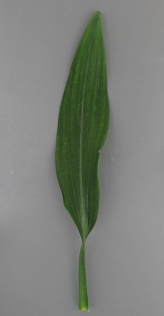 | INCLUDEPICTURE "wordml://84.png" \* MERGEFORMATINET INCLUDEPICTURE "wordml://84.png" \* MERGEFORMATINET INCLUDEPICTURE "wordml://84.png" \* MERGEFORMATINET INCLUDEPICTURE "wordml://84.png" \* MERGEFORMATINET INCLUDEPICTURE "wordml://84.png" \* MERGEFORMATINET INCLUDEPICTURE "wordml://84.png" \* MERGEFORMATINET 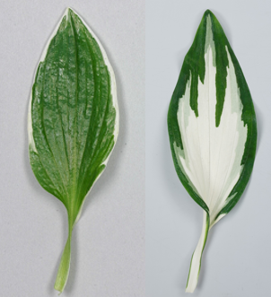
1 | 9
absent | present

Ad. 10: Umbel: length of rays

Observations should be made from the point of insertion to the base of the top flower bud.

INCLUDEPICTURE "wordml://87.png" \* MERGEFORMATINET INCLUDEPICTURE "wordml://87.png" \* MERGEFORMATINET INCLUDEPICTURE "wordml://87.png" \* MERGEFORMATINET INCLUDEPICTURE "wordml://87.png" \* MERGEFORMATINET INCLUDEPICTURE "wordml://87.png" \* MERGEFORMATINET INCLUDEPICTURE "wordml://87.png" \* MERGEFORMATINET 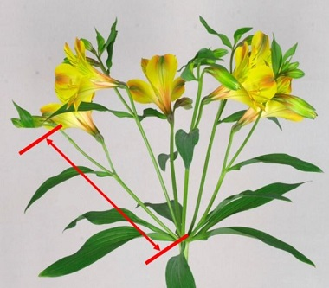

Ad. 12: Flower: length of pedicel

INCLUDEPICTURE "wordml://88.png" \* MERGEFORMATINET INCLUDEPICTURE "wordml://88.png" \* MERGEFORMATINET INCLUDEPICTURE "wordml://88.png" \* MERGEFORMATINET INCLUDEPICTURE "wordml://88.png" \* MERGEFORMATINET INCLUDEPICTURE "wordml://88.png" \* MERGEFORMATINET INCLUDEPICTURE "wordml://88.png" \* MERGEFORMATINET 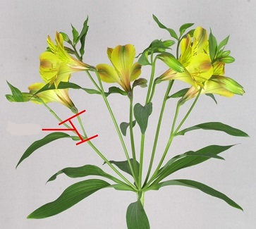

Ad. 14: Flower: length in frontal view
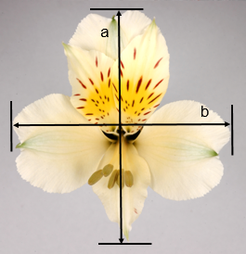 | a = Flower: length in frontal view  b = Flower: width in frontal view

Ad. 15: Flower: width in frontal view

See Ad. 14

Ad. 16: Flower: ratio length/width in frontal view
INCLUDEPICTURE "wordml://94.png" \* MERGEFORMATINET INCLUDEPICTURE "wordml://94.png" \* MERGEFORMATINET INCLUDEPICTURE "wordml://94.png" \* MERGEFORMATINET INCLUDEPICTURE "wordml://94.png" \* MERGEFORMATINET 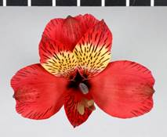 | INCLUDEPICTURE "wordml://95.png" \* MERGEFORMATINET INCLUDEPICTURE "wordml://95.png" \* MERGEFORMATINET INCLUDEPICTURE "wordml://95.png" \* MERGEFORMATINET INCLUDEPICTURE "wordml://95.png" \* MERGEFORMATINET 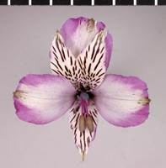 | INCLUDEPICTURE "wordml://96.png" \* MERGEFORMATINET INCLUDEPICTURE "wordml://96.png" \* MERGEFORMATINET INCLUDEPICTURE "wordml://96.png" \* MERGEFORMATINET INCLUDEPICTURE "wordml://96.png" \* MERGEFORMATINET 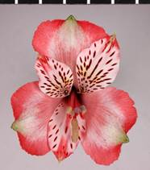
3 | 5 | 7
low | medium | high

Ad. 17: Flower: length in side view

INCLUDEPICTURE "wordml://95.png" \* MERGEFORMATINET INCLUDEPICTURE "wordml://95.png" \* MERGEFORMATINET INCLUDEPICTURE "wordml://95.png" \* MERGEFORMATINET INCLUDEPICTURE "wordml://95.png" \* MERGEFORMATINET INCLUDEPICTURE "wordml://95.png" \* MERGEFORMATINET INCLUDEPICTURE "wordml://95.png" \* MERGEFORMATINET 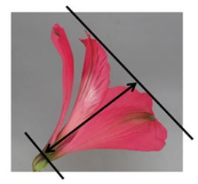

Ad. 18: Outer tepal: shape of blade

 |  | ← broadest part →
 |  | at middle | above middle
relative
width
narrow |  | 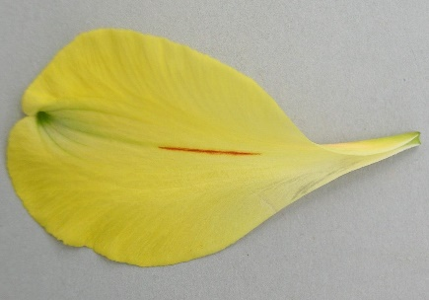  3  medium elliptic | 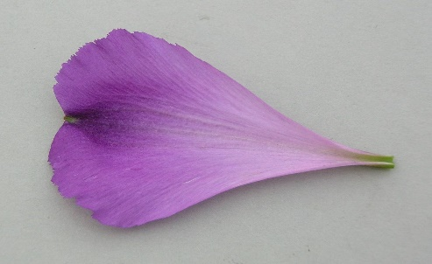  5  medium obovate
medium |  | 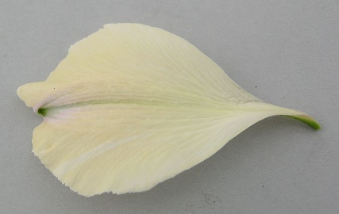  2  broad elliptic | 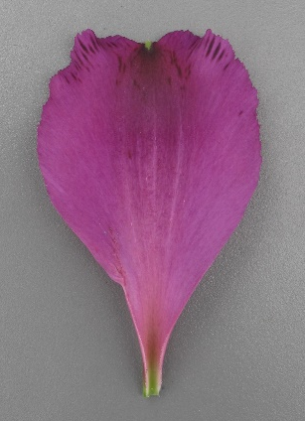  4  broad ovate
broad |  | 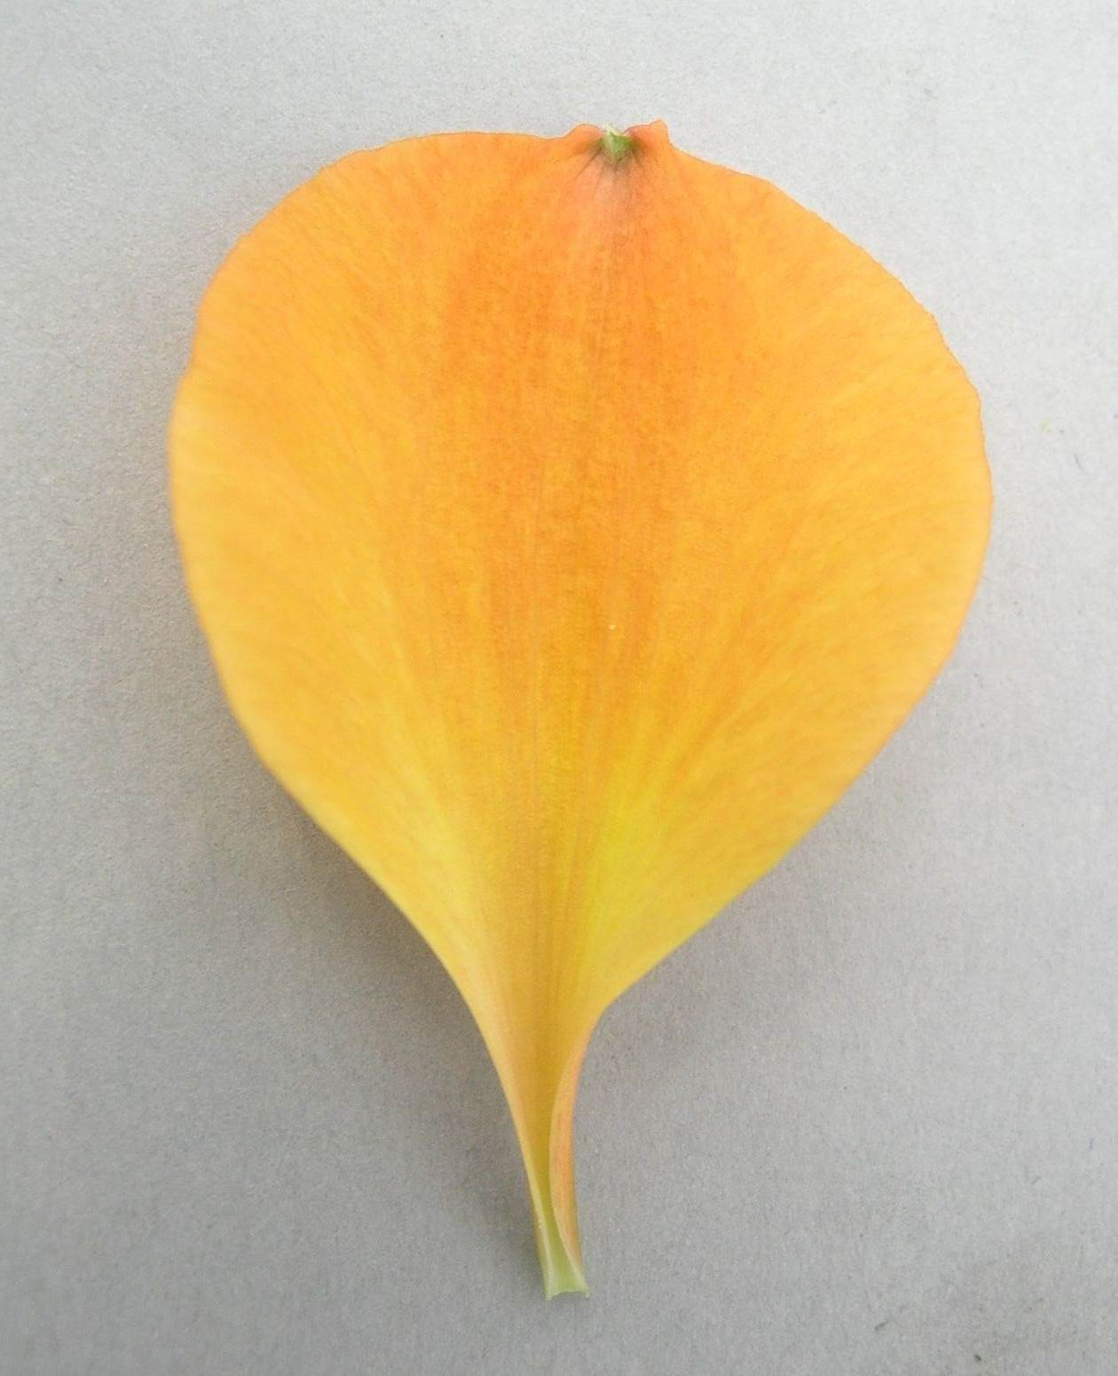  1  circular

Ad. 19: Outer tepal: emargination
INCLUDEPICTURE "wordml://84.png" \* MERGEFORMATINET INCLUDEPICTURE "wordml://84.png" \* MERGEFORMATINET 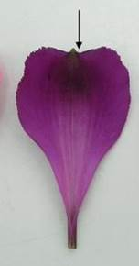 | INCLUDEPICTURE "wordml://85.png" \* MERGEFORMATINET INCLUDEPICTURE "wordml://85.png" \* MERGEFORMATINET 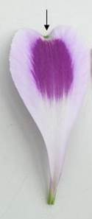 | INCLUDEPICTURE "wordml://99.png" \* MERGEFORMATINET INCLUDEPICTURE "wordml://99.png" \* MERGEFORMATINET INCLUDEPICTURE "wordml://99.png" \* MERGEFORMATINET INCLUDEPICTURE "wordml://99.png" \* MERGEFORMATINET INCLUDEPICTURE "wordml://99.png" \* MERGEFORMATINET INCLUDEPICTURE "wordml://99.png" \* MERGEFORMATINET 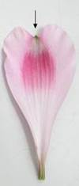
3 | 5 | 7
shallow | medium | deep

Ad. 21: Outer tepal: green area of outer side

INCLUDEPICTURE "wordml://100.png" \* MERGEFORMATINET INCLUDEPICTURE "wordml://100.png" \* MERGEFORMATINET INCLUDEPICTURE "wordml://100.png" \* MERGEFORMATINET INCLUDEPICTURE "wordml://100.png" \* MERGEFORMATINET INCLUDEPICTURE "wordml://100.png" \* MERGEFORMATINET INCLUDEPICTURE "wordml://100.png" \* MERGEFORMATINET 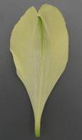 | INCLUDEPICTURE "wordml://101.png" \* MERGEFORMATINET INCLUDEPICTURE "wordml://101.png" \* MERGEFORMATINET INCLUDEPICTURE "wordml://101.png" \* MERGEFORMATINET INCLUDEPICTURE "wordml://101.png" \* MERGEFORMATINET INCLUDEPICTURE "wordml://101.png" \* MERGEFORMATINET INCLUDEPICTURE "wordml://101.png" \* MERGEFORMATINET 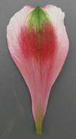 | INCLUDEPICTURE "wordml://102.png" \* MERGEFORMATINET INCLUDEPICTURE "wordml://102.png" \* MERGEFORMATINET INCLUDEPICTURE "wordml://102.png" \* MERGEFORMATINET INCLUDEPICTURE "wordml://102.png" \* MERGEFORMATINET INCLUDEPICTURE "wordml://102.png" \* MERGEFORMATINET INCLUDEPICTURE "wordml://102.png" \* MERGEFORMATINET 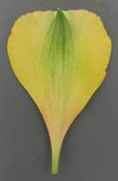 | INCLUDEPICTURE "wordml://103.png" \* MERGEFORMATINET INCLUDEPICTURE "wordml://103.png" \* MERGEFORMATINET INCLUDEPICTURE "wordml://103.png" \* MERGEFORMATINET INCLUDEPICTURE "wordml://103.png" \* MERGEFORMATINET INCLUDEPICTURE "wordml://103.png" \* MERGEFORMATINET INCLUDEPICTURE "wordml://103.png" \* MERGEFORMATINET 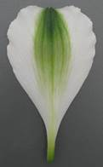
1 | 2 | 3 | 4
absent or very small | small | medium | large

Ad. 26: Outer tepal: small stripes on marginal part of lateral zone of inner side

INCLUDEPICTURE "wordml://104.png" \* MERGEFORMATINET INCLUDEPICTURE "wordml://104.png" \* MERGEFORMATINET INCLUDEPICTURE "wordml://104.png" \* MERGEFORMATINET INCLUDEPICTURE "wordml://104.png" \* MERGEFORMATINET INCLUDEPICTURE "wordml://104.png" \* MERGEFORMATINET INCLUDEPICTURE "wordml://104.png" \* MERGEFORMATINET 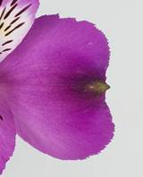 | INCLUDEPICTURE "wordml://105.png" \* MERGEFORMATINET INCLUDEPICTURE "wordml://105.png" \* MERGEFORMATINET INCLUDEPICTURE "wordml://105.png" \* MERGEFORMATINET INCLUDEPICTURE "wordml://105.png" \* MERGEFORMATINET INCLUDEPICTURE "wordml://105.png" \* MERGEFORMATINET INCLUDEPICTURE "wordml://105.png" \* MERGEFORMATINET 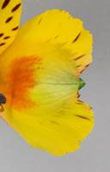 | INCLUDEPICTURE "wordml://106.png" \* MERGEFORMATINET INCLUDEPICTURE "wordml://106.png" \* MERGEFORMATINET INCLUDEPICTURE "wordml://106.png" \* MERGEFORMATINET INCLUDEPICTURE "wordml://106.png" \* MERGEFORMATINET INCLUDEPICTURE "wordml://106.png" \* MERGEFORMATINET INCLUDEPICTURE "wordml://106.png" \* MERGEFORMATINET 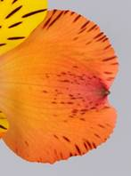 | INCLUDEPICTURE "wordml://107.png" \* MERGEFORMATINET INCLUDEPICTURE "wordml://107.png" \* MERGEFORMATINET INCLUDEPICTURE "wordml://107.png" \* MERGEFORMATINET INCLUDEPICTURE "wordml://107.png" \* MERGEFORMATINET INCLUDEPICTURE "wordml://107.png" \* MERGEFORMATINET INCLUDEPICTURE "wordml://107.png" \* MERGEFORMATINET 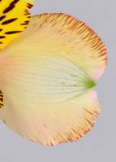
1 | 3 | 5 | 7
absent or very few | few | medium | many

Ad. 27: Outer tepal: large stripes on inner side (marginal zone excluded)

INCLUDEPICTURE "wordml://108.png" \* MERGEFORMATINET INCLUDEPICTURE "wordml://108.png" \* MERGEFORMATINET INCLUDEPICTURE "wordml://108.png" \* MERGEFORMATINET INCLUDEPICTURE "wordml://108.png" \* MERGEFORMATINET INCLUDEPICTURE "wordml://108.png" \* MERGEFORMATINET INCLUDEPICTURE "wordml://108.png" \* MERGEFORMATINET | INCLUDEPICTURE "wordml://109.png" \* MERGEFORMATINET INCLUDEPICTURE "wordml://109.png" \* MERGEFORMATINET INCLUDEPICTURE "wordml://109.png" \* MERGEFORMATINET INCLUDEPICTURE "wordml://109.png" \* MERGEFORMATINET INCLUDEPICTURE "wordml://109.png" \* MERGEFORMATINET INCLUDEPICTURE "wordml://109.png" \* MERGEFORMATINET 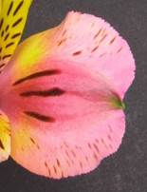 | INCLUDEPICTURE "wordml://110.png" \* MERGEFORMATINET INCLUDEPICTURE "wordml://110.png" \* MERGEFORMATINET INCLUDEPICTURE "wordml://110.png" \* MERGEFORMATINET INCLUDEPICTURE "wordml://110.png" \* MERGEFORMATINET INCLUDEPICTURE "wordml://110.png" \* MERGEFORMATINET INCLUDEPICTURE "wordml://110.png" \* MERGEFORMATINET 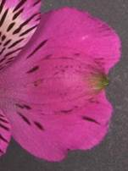 | INCLUDEPICTURE "wordml://111.png" \* MERGEFORMATINET INCLUDEPICTURE "wordml://111.png" \* MERGEFORMATINET INCLUDEPICTURE "wordml://111.png" \* MERGEFORMATINET INCLUDEPICTURE "wordml://111.png" \* MERGEFORMATINET INCLUDEPICTURE "wordml://111.png" \* MERGEFORMATINET INCLUDEPICTURE "wordml://111.png" \* MERGEFORMATINET 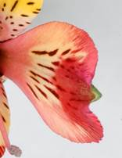
1 | 2 | 3 | 4
absent or very few | few | medium | many

Ad. 28: Inner lateral tepal: shape

 |  | ← broadest part →
 |  | at middle | above middle
relative
width
narrow |  | 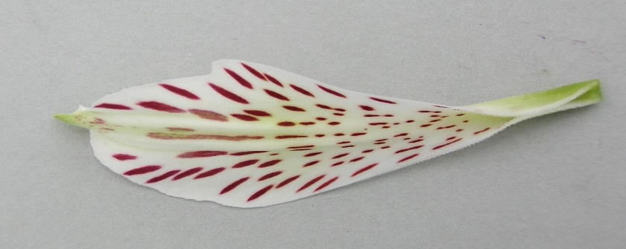  2  narrow elliptic | 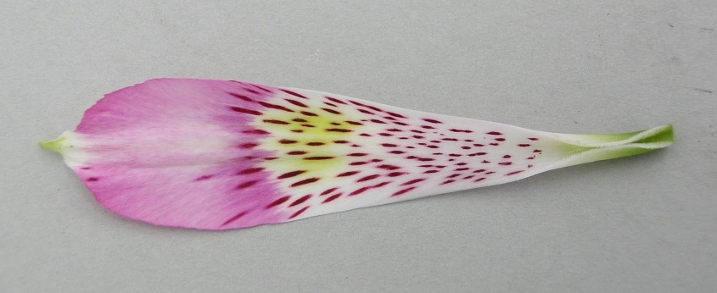  4  narrow obovate
medium |  | 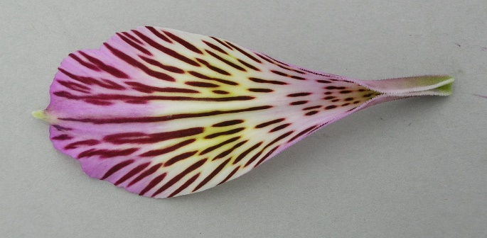  1  medium elliptic | 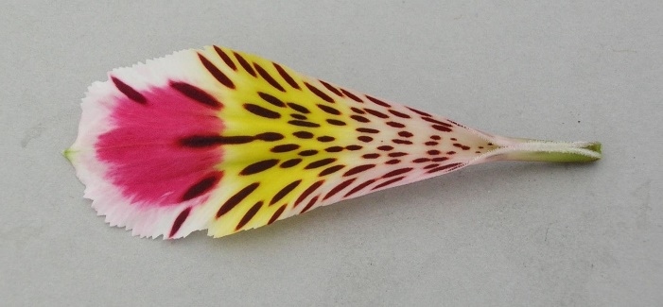  3  medium obovate

Ad. 32: Inner lateral tepal: number of stripes
INCLUDEPICTURE "wordml://113.png" \* MERGEFORMATINET INCLUDEPICTURE "wordml://113.png" \* MERGEFORMATINET INCLUDEPICTURE "wordml://113.png" \* MERGEFORMATINET INCLUDEPICTURE "wordml://113.png" \* MERGEFORMATINET INCLUDEPICTURE "wordml://113.png" \* MERGEFORMATINET INCLUDEPICTURE "wordml://113.png" \* MERGEFORMATINET 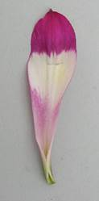 | INCLUDEPICTURE "wordml://114.png" \* MERGEFORMATINET INCLUDEPICTURE "wordml://114.png" \* MERGEFORMATINET INCLUDEPICTURE "wordml://114.png" \* MERGEFORMATINET INCLUDEPICTURE "wordml://114.png" \* MERGEFORMATINET INCLUDEPICTURE "wordml://114.png" \* MERGEFORMATINET INCLUDEPICTURE "wordml://114.png" \* MERGEFORMATINET 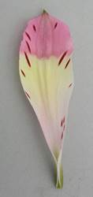 | INCLUDEPICTURE "wordml://115.png" \* MERGEFORMATINET INCLUDEPICTURE "wordml://115.png" \* MERGEFORMATINET INCLUDEPICTURE "wordml://115.png" \* MERGEFORMATINET INCLUDEPICTURE "wordml://115.png" \* MERGEFORMATINET INCLUDEPICTURE "wordml://115.png" \* MERGEFORMATINET INCLUDEPICTURE "wordml://115.png" \* MERGEFORMATINET 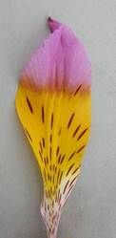 | INCLUDEPICTURE "wordml://116.png" \* MERGEFORMATINET INCLUDEPICTURE "wordml://116.png" \* MERGEFORMATINET INCLUDEPICTURE "wordml://116.png" \* MERGEFORMATINET INCLUDEPICTURE "wordml://116.png" \* MERGEFORMATINET INCLUDEPICTURE "wordml://116.png" \* MERGEFORMATINET INCLUDEPICTURE "wordml://116.png" \* MERGEFORMATINET 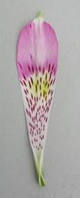 | INCLUDEPICTURE "wordml://117.png" \* MERGEFORMATINET INCLUDEPICTURE "wordml://117.png" \* MERGEFORMATINET INCLUDEPICTURE "wordml://117.png" \* MERGEFORMATINET INCLUDEPICTURE "wordml://117.png" \* MERGEFORMATINET INCLUDEPICTURE "wordml://117.png" \* MERGEFORMATINET INCLUDEPICTURE "wordml://117.png" \* MERGEFORMATINET 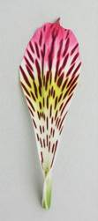
1 | 3 | 5 | 7 | 9
absent or very few | few | medium | many | very many

Ad. 33: Inner lateral tepal: area of striped zone

INCLUDEPICTURE "wordml://118.png" \* MERGEFORMATINET INCLUDEPICTURE "wordml://118.png" \* MERGEFORMATINET INCLUDEPICTURE "wordml://118.png" \* MERGEFORMATINET INCLUDEPICTURE "wordml://118.png" \* MERGEFORMATINET INCLUDEPICTURE "wordml://118.png" \* MERGEFORMATINET INCLUDEPICTURE "wordml://118.png" \* MERGEFORMATINET 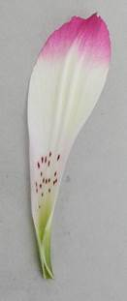 | INCLUDEPICTURE "wordml://119.png" \* MERGEFORMATINET INCLUDEPICTURE "wordml://119.png" \* MERGEFORMATINET INCLUDEPICTURE "wordml://119.png" \* MERGEFORMATINET INCLUDEPICTURE "wordml://119.png" \* MERGEFORMATINET INCLUDEPICTURE "wordml://119.png" \* MERGEFORMATINET INCLUDEPICTURE "wordml://119.png" \* MERGEFORMATINET 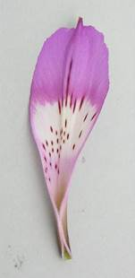 | INCLUDEPICTURE "wordml://120.png" \* MERGEFORMATINET INCLUDEPICTURE "wordml://120.png" \* MERGEFORMATINET INCLUDEPICTURE "wordml://120.png" \* MERGEFORMATINET INCLUDEPICTURE "wordml://120.png" \* MERGEFORMATINET INCLUDEPICTURE "wordml://120.png" \* MERGEFORMATINET INCLUDEPICTURE "wordml://120.png" \* MERGEFORMATINET 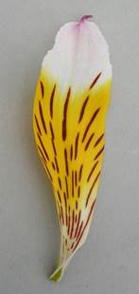
3 | 5 | 7
small | medium | large

Ad. 34: Inner lateral tepal: length of stripes
The longest stripes should be observed, excluding the stripe on the central vein.

INCLUDEPICTURE "wordml://121.png" \* MERGEFORMATINET INCLUDEPICTURE "wordml://121.png" \* MERGEFORMATINET INCLUDEPICTURE "wordml://121.png" \* MERGEFORMATINET INCLUDEPICTURE "wordml://121.png" \* MERGEFORMATINET INCLUDEPICTURE "wordml://121.png" \* MERGEFORMATINET INCLUDEPICTURE "wordml://121.png" \* MERGEFORMATINET 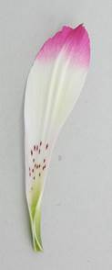 | INCLUDEPICTURE "wordml://122.png" \* MERGEFORMATINET INCLUDEPICTURE "wordml://122.png" \* MERGEFORMATINET INCLUDEPICTURE "wordml://122.png" \* MERGEFORMATINET INCLUDEPICTURE "wordml://122.png" \* MERGEFORMATINET INCLUDEPICTURE "wordml://122.png" \* MERGEFORMATINET INCLUDEPICTURE "wordml://122.png" \* MERGEFORMATINET 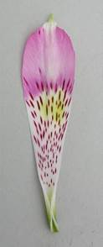 | INCLUDEPICTURE "wordml://123.png" \* MERGEFORMATINET INCLUDEPICTURE "wordml://123.png" \* MERGEFORMATINET INCLUDEPICTURE "wordml://123.png" \* MERGEFORMATINET INCLUDEPICTURE "wordml://123.png" \* MERGEFORMATINET INCLUDEPICTURE "wordml://123.png" \* MERGEFORMATINET INCLUDEPICTURE "wordml://123.png" \* MERGEFORMATINET 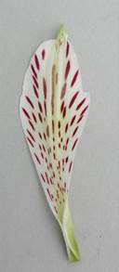 | INCLUDEPICTURE "wordml://124.png" \* MERGEFORMATINET INCLUDEPICTURE "wordml://124.png" \* MERGEFORMATINET INCLUDEPICTURE "wordml://124.png" \* MERGEFORMATINET INCLUDEPICTURE "wordml://124.png" \* MERGEFORMATINET INCLUDEPICTURE "wordml://124.png" \* MERGEFORMATINET INCLUDEPICTURE "wordml://124.png" \* MERGEFORMATINET 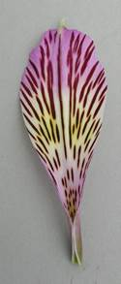 | INCLUDEPICTURE "wordml://125.png" \* MERGEFORMATINET INCLUDEPICTURE "wordml://125.png" \* MERGEFORMATINET INCLUDEPICTURE "wordml://125.png" \* MERGEFORMATINET INCLUDEPICTURE "wordml://125.png" \* MERGEFORMATINET INCLUDEPICTURE "wordml://125.png" \* MERGEFORMATINET INCLUDEPICTURE "wordml://125.png" \* MERGEFORMATINET
1 | 3 | 5 | 7 | 9
very short | short | medium | long | very long

Ad. 35: Inner lateral tepal: width of stripes

The widest stripes should be observed, excluding the stripe on the central vein.

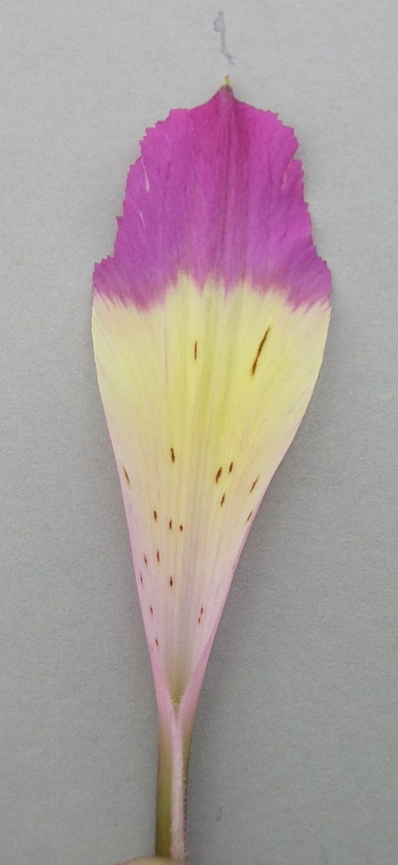 | 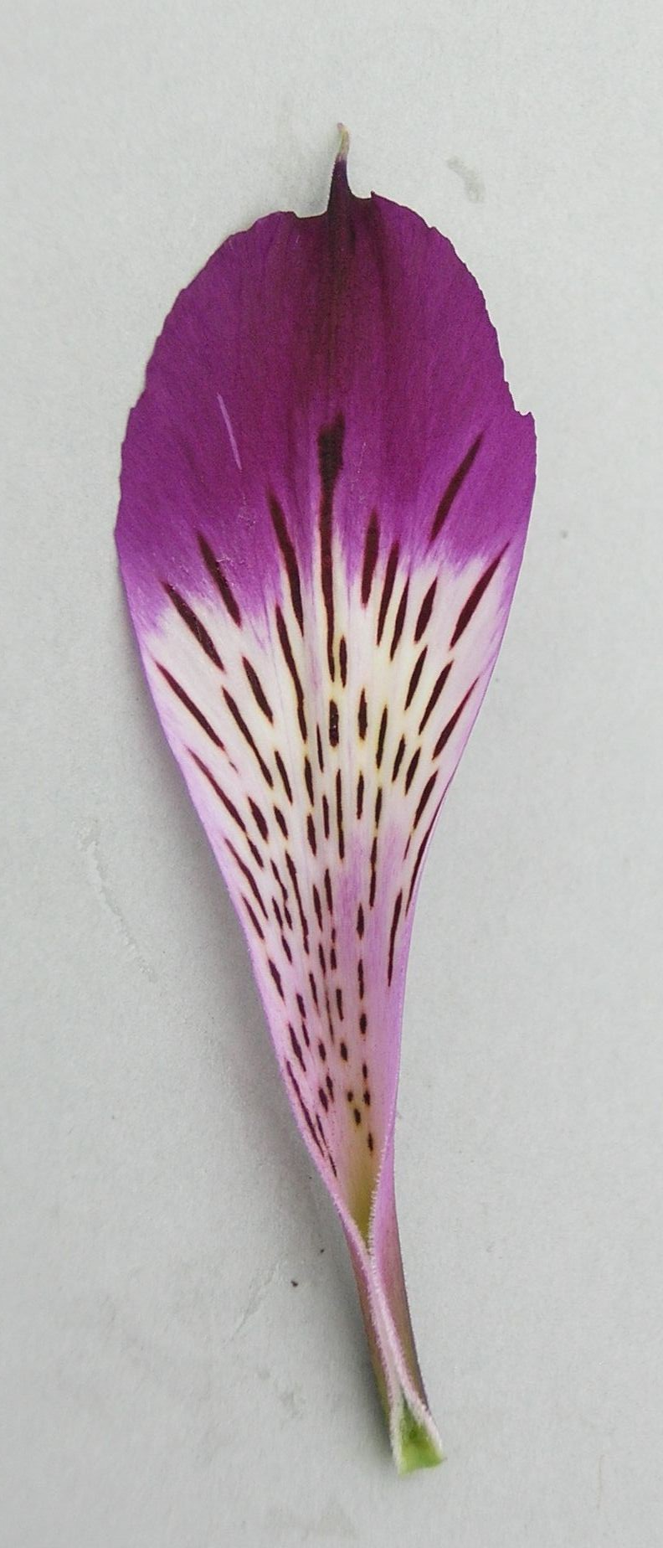 | 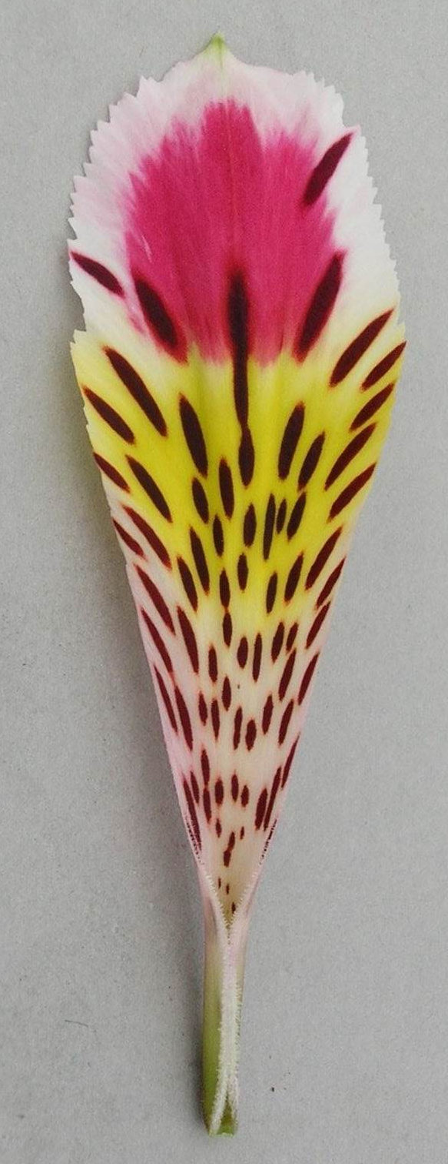 | 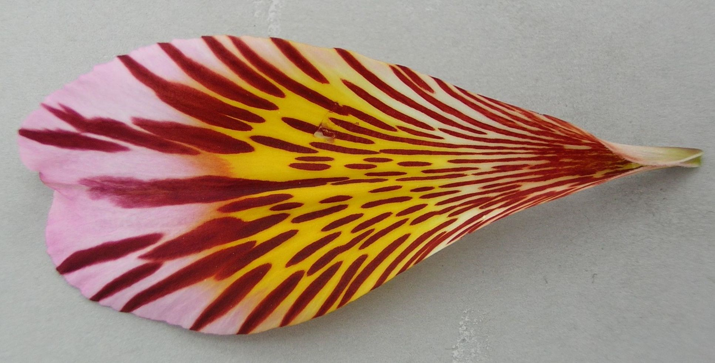 | 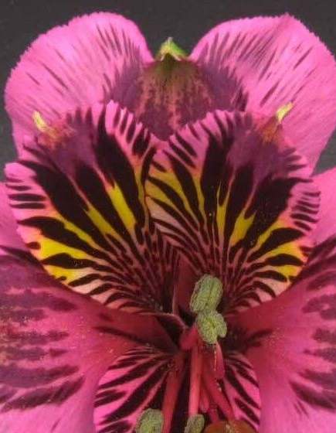
1 | 3 | 5 | 7 | 9
very narrow | narrow | medium | broad | very broad

Ad. 39: Anther: color

To be observed just before dehiscence.

Ad. 41: Filament: number of spots
INCLUDEPICTURE "wordml://133.png" \* MERGEFORMATINET INCLUDEPICTURE "wordml://133.png" \* MERGEFORMATINET INCLUDEPICTURE "wordml://133.png" \* MERGEFORMATINET INCLUDEPICTURE "wordml://133.png" \* MERGEFORMATINET 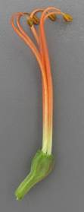 | INCLUDEPICTURE "wordml://134.png" \* MERGEFORMATINET INCLUDEPICTURE "wordml://134.png" \* MERGEFORMATINET INCLUDEPICTURE "wordml://134.png" \* MERGEFORMATINET INCLUDEPICTURE "wordml://134.png" \* MERGEFORMATINET 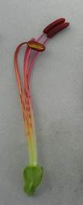 | INCLUDEPICTURE "wordml://135.png" \* MERGEFORMATINET INCLUDEPICTURE "wordml://135.png" \* MERGEFORMATINET INCLUDEPICTURE "wordml://135.png" \* MERGEFORMATINET INCLUDEPICTURE "wordml://135.png" \* MERGEFORMATINET 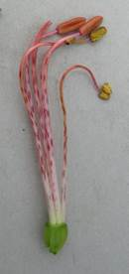
1 | 3 | 5
absent or very few | medium | very many

Ad. 42: Stigma: spots

INCLUDEPICTURE "wordml://135.png" \* MERGEFORMATINET INCLUDEPICTURE "wordml://135.png" \* MERGEFORMATINET INCLUDEPICTURE "wordml://135.png" \* MERGEFORMATINET INCLUDEPICTURE "wordml://135.png" \* MERGEFORMATINET INCLUDEPICTURE "wordml://135.png" \* MERGEFORMATINET INCLUDEPICTURE "wordml://135.png" \* MERGEFORMATINET 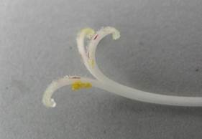

Ad. 43: Ovary: extent of anthocyanin coloration
INCLUDEPICTURE "wordml://136.png" \* MERGEFORMATINET INCLUDEPICTURE "wordml://136.png" \* MERGEFORMATINET INCLUDEPICTURE "wordml://136.png" \* MERGEFORMATINET INCLUDEPICTURE "wordml://136.png" \* MERGEFORMATINET INCLUDEPICTURE "wordml://136.png" \* MERGEFORMATINET INCLUDEPICTURE "wordml://136.png" \* MERGEFORMATINET 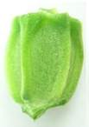 | INCLUDEPICTURE "wordml://137.png" \* MERGEFORMATINET INCLUDEPICTURE "wordml://137.png" \* MERGEFORMATINET INCLUDEPICTURE "wordml://137.png" \* MERGEFORMATINET INCLUDEPICTURE "wordml://137.png" \* MERGEFORMATINET INCLUDEPICTURE "wordml://137.png" \* MERGEFORMATINET INCLUDEPICTURE "wordml://137.png" \* MERGEFORMATINET 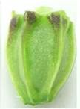 | INCLUDEPICTURE "wordml://138.png" \* MERGEFORMATINET INCLUDEPICTURE "wordml://138.png" \* MERGEFORMATINET INCLUDEPICTURE "wordml://138.png" \* MERGEFORMATINET INCLUDEPICTURE "wordml://138.png" \* MERGEFORMATINET INCLUDEPICTURE "wordml://138.png" \* MERGEFORMATINET INCLUDEPICTURE "wordml://138.png" \* MERGEFORMATINET 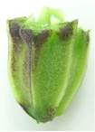 | INCLUDEPICTURE "wordml://139.png" \* MERGEFORMATINET INCLUDEPICTURE "wordml://139.png" \* MERGEFORMATINET INCLUDEPICTURE "wordml://139.png" \* MERGEFORMATINET INCLUDEPICTURE "wordml://139.png" \* MERGEFORMATINET INCLUDEPICTURE "wordml://139.png" \* MERGEFORMATINET INCLUDEPICTURE "wordml://139.png" \* MERGEFORMATINET 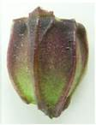 | INCLUDEPICTURE "wordml://140.png" \* MERGEFORMATINET INCLUDEPICTURE "wordml://140.png" \* MERGEFORMATINET INCLUDEPICTURE "wordml://140.png" \* MERGEFORMATINET INCLUDEPICTURE "wordml://140.png" \* MERGEFORMATINET INCLUDEPICTURE "wordml://140.png" \* MERGEFORMATINET INCLUDEPICTURE "wordml://140.png" \* MERGEFORMATINET 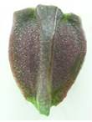
1 | 3 | 5 | 7 | 9
absent or very small | small | medium | large | very large

9.
Literature

Grunert, Ch., 1980: Das Blumenzwiebelbuch. Verlag Eugen Ulmer. Stuttgart, DE, x pp.

The Royal General Bulbgrowers' Association, 1991: International Checklist for Hyacinths and Miscellaneous Bulbs. Koninklijke Algemeene Vereeniging voor Bloembollencultuur. Hillegom, NL, pp. 15 to 47

10.
Technical Questionnaire

TECHNICAL QUESTIONNAIRE | Page {x} of {y} | Reference Number:

Application date:
(not to be filled in by the applicant)
TECHNICAL QUESTIONNAIRE
to be completed in connection with an application for plant breeders' rights

1. | Subject of the Technical Questionnaire
 |  | Botanical name
  1.1
  Alstroemeria L.
 |  | Common name
  1.2
  Alstroemeria, Herb Lily
  1.3
  Species:

2. | Applicant
 | Name
 | Address
 | Telephone No.
 | Fax No.
 | E-mail address
 | Breeder (if different from
 | applicant)

3. | Proposed denomination and breeder's reference
 | Proposed denomination
 | (if available)
 | Breeder's reference

TECHNICAL QUESTIONNAIRE |  |  | Page {x} of {y} | Reference Number:
#4. | Information on the breeding scheme and propagation of the variety
 | 4.1 | Breeding scheme
 | Variety resulting from:
  4.1.1
  Crossing
 |  | [ ]
  (a)
  controlled cross
  (please state parent varieties)
(…………………..……………..…) x (……………..…………………..…)

female parent male parent

 |  | [ ]
  (b)
  partially known cross
  (please state known parent variety(ies))
(…………………..……………..…) x (……………..…………………..…)

female parent male parent

 |  | [ ]
  (c)
  unknown cross
 |  | [ ]
  4.1.2
  Mutation
  (please state parent variety)
 |  | [ ]
  4.1.3
  Discovery and development
  (please state where and when discovered and how developed)
 | Other  (Please provide details) | [ ]
  4.1.4

TECHNICAL QUESTIONNAIRE  Page {x} of {y} | Reference Number:

 | 4.2 | Method of propagating the variety
 |  | [ ]
  4.2.1
  Seed-propagated varieties
  4.2.2
  Vegetative propagation
 |  | [ ]
  (a)
  In vitro propagation
 |  | [ ]
  (b)
  Division
 |  | [ ]
  (c)
  Other (state method)
 | Other  (Please provide details) | [ ]
  4.2.3

TECHNICAL QUESTIONNAIRE | Page {x} of {y} | Reference Number:

5. | Characteristics of the variety to be indicated (the number in brackets refers to the corresponding characteristic in Test Guidelines; please mark the note which best corresponds).

 | Characteristics | Example Varieties | Note
  5.1
  (1)
  Plant: height
  very short
  1 [ ]
  very short to short
  2 [ ]
  short
  Alsdun01, Tesnoram
  3 [ ]
  short to medium
  4 [ ]
  medium
  Konaribean, Tesrome
  5 [ ]
  medium to tall
  6 [ ]
  tall
  Konplatina, Zalsabri
  7 [ ]
  tall to very tall
  8 [ ]
  very tall
  9 [ ]
  5.2
  (9)
  Leaf blade: variegation
  absent
  1 [ ]
  present
  9 [ ]
  5.3
  (13)
  Flower: main color
  white
  Konantarct, Tesmoonli
  1 [ ]
  yellow green
  Kongrenday
  2 [ ]
  light yellow
  Gataran, Konwpearls
  3 [ ]
  medium yellow
  Konaribean
  4 [ ]
  orange
  ESM T122, Staqueen
  5 [ ]
  light pink
  Tesnoram
  6 [ ]
  medium pink
  Zalsabri
  7 [ ]
  blue pink
  Konswitch
  8 [ ]
  orange red
  Zalsance, Zapriliarange
  9 [ ]
  red
  Alsdun01
  10 [ ]
  purple red
  Konalegria, Tesrome
  11 [ ]
  light purple
  Tesmars
  12 [ ]
  medium purple
  Konplatina
  13 [ ]
  dark purple
  Zalsatista
  14 [ ]

TECHNICAL QUESTIONNAIRE | Page {x} of {y} | Reference Number:

6. | Similar varieties and differences from these varieties
Please use the following table and box for comments to provide information on how your candidate variety differs from the variety (or varieties) which, to the best of your knowledge, is (or are) most similar. This information may help the examination authority to conduct its examination of distinctness in a more efficient way.

  Denomination(s) of variety(ies) similar to your candidate variety
  Characteristic(s) in which your candidate variety differs from the similar variety(ies)
  Describe the expression of the characteristic(s) for the similar variety(ies)
  Describe the expression of the characteristic(s) for your candidate variety

Example
  Plant: height
  short
  medium

 | Comments:

TECHNICAL QUESTIONNAIRE | Page {x} of {y} | Reference Number:

#7. | Additional information which may help in the examination of the variety
7.1 | In addition to the information provided in sections 5 and 6, are there any additional characteristics which may help to distinguish the variety?
 | Yes | [ ] | No | [ ]
 | (If yes, please provide details)
7.2 | Are there any special conditions for growing the variety or conducting the examination?
 | Yes | [ ] | No | [ ]
 | (If yes, please provide details)
7.3 | Other information
A representative color photograph of the variety displaying its main distinguishing feature(s), should accompany the Technical Questionnaire. The photograph will provide a visual illustration of the candidate variety which supplements the information provided in the Technical Questionnaire.
The key points to consider when taking a photograph of the candidate variety are:
• Indication of the date and geographic location
• Correct labeling (breeder’s reference)
• Good quality printed photograph (minimum 10 cm x 15 cm) and/or sufficient resolution electronic format version (minimum 960 x 1280 pixels)”
Further guidance on providing photographs with the Technical Questionnaire is available in document TGP/7 "Development of Test Guidelines", Guidance Note 35 (http://www.upov.int/tgp/en/).
[The link provided may be deleted by members of the Union when developing authorities’ own test guidelines.]

TECHNICAL QUESTIONNAIRE
Page {x} of {y} | Reference Number:

8. | Authorization for release
 | (a) | Does the variety require prior authorization for release under legislation concerning the protection of the environment, human and animal health?
 |  | Yes | [ ] | No | [ ]
 | (b) | Has such authorization been obtained?
 |  | Yes | [ ] | No | [ ]
 | If the answer to (b) is yes, please attach a copy of the authorization.

9. Information on plant material to be examined or submitted for examination

9.1 The expression of a characteristic or several characteristics of a variety may be affected by factors, such as pests and disease, chemical treatment (e.g. growth retardants or pesticides), effects of tissue culture, different rootstocks, scions taken from different growth phases of a tree, etc.
9.2 The plant material should not have undergone any treatment which would affect the expression of the characteristics of the variety, unless the competent authorities allow or request such treatment. If the plant material has undergone such treatment, full details of the treatment must be given. In this respect, please indicate below, to the best of your knowledge, if the plant material to be examined has been subjected to:

 | (a) | Microorganisms (e.g. virus, bacteria, phytoplasma) | Yes [ ] | No [ ]
 | (b) | Chemical treatment (e.g. growth retardant, pesticide) | Yes [ ] | No [ ]
 | (c) | Tissue culture | Yes [ ] | No [ ]
 | (d) | Other factors | Yes [ ] | No [ ]
 | Please provide details for where you have indicated “yes”.

10. | I hereby declare that, to the best of my knowledge, the information provided in this form is correct:
 | Applicant’s name
 | Signature |  | Date

[End of document]

