 |  | E  TG/26/5 Corr. 2 Rev. Corr.  ORIGINAL: English  DATE: 2006-04-05 + 2008-08-15  + 2010-03-16 + 2020-12-17  + 2022-10-25
INTERNATIONAL UNION FOR THE PROTECTION OF NEW VARIETIES OF PLANTS
GENEVA

 | CHRYSANTHEMUM  UPOV Codes: CHRYS  Chrysanthemum L. | *

GUIDELINES

FOR THE CONDUCT OF TESTS

FOR DISTINCTNESS, UNIFORMITY AND STABILITY

Alternative Names:*

Botanical name | English | French | German | Spanish
Chrysanthemum L. | Chrysanthemum | Chrysanthème | Chrysantheme | Crisantemo

The purpose of these guidelines (“Test Guidelines”) is to elaborate the principles contained in the General Introduction (document TG/1/3), and its associated TGP documents, into detailed practical guidance for the harmonized examination of distinctness, uniformity and stability (DUS) and, in particular, to identify appropriate characteristics for the examination of DUS and production of harmonized variety descriptions.

ASSOCIATED DOCUMENTS

These Test Guidelines should be read in conjunction with the General Introduction and its associated TGP documents.

Other associated UPOV documents:

TG/222: Argyranthemum (Argyranthemum frutescens (L.) Schultz-Bip. (Chrysanthemum frutescens L.))
TABLE OF CONTENTS PAGE

1. Subject of these Test Guidelines 3
2. Material Required 3
3. Method of Examination 3
3.1 Number of Growing Cycles 3
3.2 Testing Place 3
3.3 Conditions for Conducting the Examination 3
3.4 Test Design 4
3.5 Number of Plants / Parts of Plants to be Examined 4
3.6 Additional Tests 4
4. Assessment of Distinctness, Uniformity and Stability 4
4.1 Distinctness 4
4.2 Uniformity 5
4.3 Stability 5
5. Grouping of Varieties and Organization of the Growing Trial 5
6. Introduction to the Table of Characteristics 6
6.1 Categories of Characteristics 6
6.2 States of Expression and Corresponding Notes 7
6.3 Types of Expression 7
6.4 Example Varieties 7
6.5 Legend 7
7. Table of Characteristics/Tableau des caractères/Merkmalstabelle/Tabla de caracteres 8
8. Explanations on the Table of Characteristics 38
8.1 Explanations covering several characteristics 38
8.2 Explanations for individual characteristics 39
9. Literature 57
10. Technical Questionnaire 58

Subject of these Test Guidelines
These Test Guidelines apply to all varieties of Chrysanthemum L.

Material Required
2.1 The competent authorities decide on the quantity and quality of the plant material required for testing the variety and when and where it is to be delivered. Applicants submitting material from a State other than that in which the testing takes place must ensure that all customs formalities and phytosanitary requirements are complied with.

2.2 The material is to be supplied in the form of unrooted cuttings.

2.3 The minimum quantity of plant material, to be supplied by the applicant, should be:

20 unrooted cuttings.

2.4 The plant material supplied should be visibly healthy, not lacking in vigor, nor affected by any important pest or disease.

2.5 The plant material should not have undergone any treatment which would affect the expression of the characteristics of the variety, unless the competent authorities allow or request such treatment. If it has been treated, full details of the treatment must be given.

Method of Examination

3.1 Number of Growing Cycles
The minimum duration of tests should normally be a single growing cycle.

3.2 Testing Place
Tests are normally conducted at one place. In the case of tests conducted at more than one place, guidance is provided in TGP/9 “Examining Distinctness”.

3.3 Conditions for Conducting the Examination
3.3.1 The tests should be carried out under conditions ensuring satisfactory growth for the expression of the relevant characteristics of the variety and for the conduct of the examination. In particular, growth regulators should not be used. Varieties should be disbudded if bred for such use, but where necessary, in the case of dual purpose varieties, distinctness should also be checked on non-disbudded plants.

3.3.2 Unless otherwise indicated, the optimum stage of development for the assessment of the characteristics is the time of full flowering

3.3.3 Because daylight varies, color determinations made against a color chart should be made either in a suitable cabinet providing artificial daylight or in the middle of the day in a room without direct sunlight. The spectral distribution of the illuminant for artificial daylight should conform with the CIE Standard of Preferred Daylight D 6500 and should fall within the tolerances set out in the British Standard 950, Part I. These determinations should be made with the plant part placed against a white background.

3.4 Test Design
3.4.1 Each test should be designed to result in a total of at least 20 plants.

3.4.2 The design of the tests should be such that plants or parts of plants may be removed for measurement or counting without prejudice to the observations which must be made up to the end of the growing cycle.

3.5 Number of Plants / Parts of Plants to be Examined
Unless otherwise indicated, all observations on single plants should be made on 10 plants or parts taken from each of 10 plants and any other observations made on all plants in the test.

3.6 Additional Tests
Additional tests, for examining relevant characteristics, may be established.

Assessment of Distinctness, Uniformity and Stability

4.1 Distinctness

4.1.1 General Recommendations

It is of particular importance for users of these Test Guidelines to consult the General Introduction prior to making decisions regarding distinctness. However, the following points are provided for elaboration or emphasis in these Test Guidelines.

4.1.2 Consistent Differences

The differences observed between varieties may be so clear that more than one growing cycle is not necessary. In addition, in some circumstances, the influence of the environment is not such that more than a single growing cycle is required to provide assurance that the differences observed between varieties are sufficiently consistent. One means of ensuring that a difference in a characteristic, observed in a growing trial, is sufficiently consistent is to examine the characteristic in at least two independent growing cycles.

4.1.3 Clear Differences

Determining whether a difference between two varieties is clear depends on many factors, and should consider, in particular, the type of expression of the characteristic being examined, i.e. whether it is expressed in a qualitative, quantitative, or pseudo-qualitative manner. Therefore, it is important that users of these Test Guidelines are familiar with the recommendations contained in the General Introduction prior to making decisions regarding distinctness.

4.2 Uniformity
4.2.1 It is of particular importance for users of these Test Guidelines to consult the General Introduction prior to making decisions regarding uniformity. However, the following points are provided for elaboration or emphasis in these Test Guidelines:

4.2.2 For the assessment of uniformity of vegetatively propagated varieties, a population standard of 1% and an acceptance probability of at least 95 % should be applied. In the case of a sample size of 20 plants, 1 off-type is allowed.

4.3 Stability
4.3.1 In practice, it is not usual to perform tests of stability that produce results as certain as those of the testing of distinctness and uniformity. However, experience has demonstrated that, for many types of variety, when a variety has been shown to be uniform, it can also be considered to be stable.

4.3.2 Where appropriate, or in cases of doubt, stability may be tested, either by growing a further generation, or by testing a new plant stock to ensure that it exhibits the same characteristics as those shown by the previous material supplied.

Grouping of Varieties and Organization of the Growing Trial
5.1 The selection of varieties of common knowledge to be grown in the trial with the candidate varieties and the way in which these varieties are divided into groups to facilitate the assessment of distinctness are aided by the use of grouping characteristics.

5.2 Grouping characteristics are those in which the documented states of expression, even where produced at different locations, can be used, either individually or in combination with other such characteristics: (a) to select varieties of common knowledge that can be excluded from the growing trial used for examination of distinctness; and (b) to organize the growing trial so that similar varieties are grouped together.

5.3 The following have been agreed as useful grouping characteristics:

(a) Plant: type (characteristic 2)

(b) Flower head: type (characteristic 30)

(c) Excluding double and daisy-eyed double varieties: Disc: type
(characteristic 31)

(d) Ray floret: number of colors of inner side (characteristic 62)

(e) Ray floret: main color of inner side (characteristic 63) with the following groups:
Gr. 1: white
Gr. 2: off-white
Gr. 3: yellow
Gr. 4: bronze
Gr. 5: orange
Gr. 6: orange pink
Gr. 7: pink
Gr. 8: red
Gr. 9: red purple
Gr. 10: purple
Gr. 11: green

(f) Ray floret: second color of inner side (characteristic 64) with the following groups:
Gr. 1: white
Gr. 2: off-white
Gr. 3: yellow
Gr. 4: bronze
Gr. 5: orange
Gr. 6: orange pink
Gr. 7: pink
Gr. 8: red
Gr. 9: red purple
Gr. 10: purple
Gr. 11: green

5.4 Guidance for the use of grouping characteristics, in the process of examining distinctness, is provided through the General Introduction.

Introduction to the Table of Characteristics

6.1 Categories of Characteristics
6.1.1 Standard Test Guidelines Characteristics

Standard Test Guidelines characteristics are those which are approved by UPOV for examination of DUS and from which members of the Union can select those suitable for their particular circumstances.

6.1.2 Asterisked Characteristics

Asterisked characteristics (denoted by *) are those included in the Test Guidelines which are important for the international harmonization of variety descriptions and should always be examined for DUS and included in the variety description by all members of the Union, except when the state of expression of a preceding characteristic or regional environmental conditions render this inappropriate.

6.2 States of Expression and Corresponding Notes
States of expression are given for each characteristic to define the characteristic and to harmonize descriptions. Each state of expression is allocated a corresponding numerical note for ease of recording of data and for the production and exchange of the description.

6.3 Types of Expression
An explanation of the types of expression of characteristics (qualitative, quantitative and pseudo-qualitative) is provided in the General Introduction.

6.4 Example Varieties
Where appropriate, example varieties are provided to clarify the states of expression of each characteristic.

6.5 Legend
(*) Asterisked characteristic – see Chapter 6.1.2

QL: Qualitative characteristic – see Chapter 6.3
QN: Quantitative characteristic – see Chapter 6.3
PQ: Pseudo-qualitative characteristic – see Chapter 6.3

(a)-(h) See Explanations on the Table of Characteristics in Chapter 8.1

(+) See Explanations on the Table of Characteristics in Chapter 8.2

Table of Characteristics/Tableau des caractères/Merkmalstabelle/Tabla de caracteres
 |  | English | français | deutsch | español | Example Varieties/  Exemples/  Beispielssorten/  Variedades ejemplo | Note/  Nota
1.  (*) |  | Plant: height | Plante: hauteur | Pflanze: Höhe | Planta: altura
QN | (a) | short | basse | niedrig | corta | Machismo Time | 3
 |  | medium | moyenne | mittel | media | Dekyen | 5
 |  | tall | haute | hoch | alta | Figrand | 7
2.  (*)  (+) |  | Plant: type | Plante: type | Pflanze: Typ | Planta: tipo
QL | (a) | non bushy | non buissonnant | nicht buschig | no arbustivo | Anastasia, Boulou, Casmo, Reagan | 1
 |  | bushy | buissonnant | buschig | arbustivo | Elda White, Golden Mariyo, Guitpolin, Tripoli | 2
3.  (*)  (+) |  | Only bushy varieties: Plant: growth habit | Variétés buissonnantes seulement: Plante: port | Nur buschige Sorten: Pflanze: Wuchsform | Únicamente variedades arbustivas: Planta: porte
PQ | (a) | upright | dressée | aufrecht | erecta | Golden Mariyo | 1
 |  | semi upright | demi-dressée | halbaufrecht | semierecta | Veria Dark | 2
 |  | hemispherical | hémisphérique | halbkugelförmig | hemisférica | Elda White | 3
 |  | spreading | étalée | breitwüchsig | extendida |  | 4
 |  | trailing | rampante | herunterhängend | rastrera | Fancy That | 5
4. |  | Only bushy varieties: Plant: density of branching | Variétés buissonnantes seulement: Plante: densité des ramifications | Nur buschige Sorten: Pflanze: Dichte der Verzweigung | Únicamente variedades arbustivas: Planta: densidad de la ramificación
QN | (a) | sparse | faible | locker | baja | Golden Mariyo | 3
 |  | medium | moyenne | mittel | media | Veria Dark | 5
 |  | dense | dense | dicht | alta | Elda White | 7
5. |  | Stem: color | Tige: couleur | Trieb: Farbe | Tallo: color
PQ | (a) | green | verte | grün | verde | Yoko Ono | 1
 | (b) | green tinged with purple or brown | verte teintée de pourpre ou de brun | grün meliert mit purpurn oder braun | verde teñido de púrpura o marrón | Fancy That | 2
 |  | brown | brun | braun | marrón |  | 3
 |  | purple | pourpre | purpurn | púrpura | Vymini | 4
6. |  | Stipule: size | Stipule: taille | Nebenblatt: Größe | Estípula: tamaño
QN | (a) | absent or very small | absente ou très petite | fehlend oder sehr klein | ausente o muy pequeña | Zeemimosa | 1
 | (b) | small | petite | klein | pequeña | Vymini | 3
 |  | medium | moyenne | mittel | media | Yoko Ono | 5
 |  | large | grande | groß | grande | Orinocco | 7
7.  (+) |  | Petiole: attitude | Pétiole: port | Blattstiel: Haltung | Peciolo: porte
QN | (a) | very strongly upwards | très dressé | sehr stark aufwärts gerichtet | fuertemente ascendente | Rex | 1
 | (c) | moderately upwards | moyennement dressé | leicht aufwärts gerichtet | moderadamente ascendente | Dekyen | 3
 |  | horizontal | horizontal | waagerecht | horizontal | Boris Becker | 5
 |  | moderately downwards | moyennement retombant | leicht abwärts gerichtet | moderadamente descendente | Breeze | 7
 |  | drooping | retombant | überhängend | colgante |  | 9
8. |  | Petiole: length relative to leaf length | Pétiole: longueur par rapport à la longueur de la feuille | Blattstiel: Länge im Verhältnis zur Blattlänge | Peciolo: longitud en relación con la longitud de la hoja
QN | (a) | short | court | kurz | corta | Vymini | 3
 | (c) | medium | moyen | mittel | media | Figrand | 5
 |  | long | long | lang | larga |  | 7
9.  (*) |  | Leaf: length including petiole | Feuille: longueur, pétiole compris | Blatt: Länge einschließlich Blattstiel | Hoja: longitud incluido el peciolo
QN | (a) | short | courte | kurz | corta | Molfetta Pink | 3
 | (c) | medium | moyenne | mittel | media | Figrand | 5
 |  | long | longue | lang | larga | Yellow Wonder | 7
10.  (*) |  | Leaf: width | Feuille: largeur | Blatt: Breite | Hoja: anchura
QN | (a) | narrow | étroite | schmal | estrecha | Molfetta Pink | 3
 | (c) | medium | moyenne | mittel | media | Figrand | 5
 |  | broad | large | breit | ancha | Buttermere Anne | 7
11.  (*) |  | Leaf: ratio length/width | Feuille: rapport longueur/largeur | Blatt Verhältnis Länge/Breite | Hoja: relación longitud/anchura
QN | (a) | low | faible | klein | baja | Buttermere Anne | 3
 | (c) | medium | moyen | mittel | media | Figrand | 5
 |  | high | élevé | groß | alta | Dekyen | 7
12.  (*)  (+) |  | Leaf: length of terminal lobe relative to leaf length | Feuille: longueur du lobe terminal par rapport à la longueur de la feuille | Blatt: Länge des Endlappens im Verhältnis zur Blattlänge | Hoja: longitud del lóbulo terminal en relación con la longitud de la hoja
QN | (a) | short | court | kurz | corta | Le Mans | 3
 | (c) | medium | moyen | mittel | media | Figrand | 5
 |  | long | long | lang | larga | Vymini | 7
13.  (*)  (+) |  | Leaf: depth of lowest lateral sinus | Feuille: profondeur du sinus latéral le plus bas | Blatt: Tiefe der untersten seitlichen Ausbuchtung | Hoja: profundidad del seno lateral inferior
QN | (a) | shallow | peu profonde | flach | poco profundo | Bea | 3
 | (c) | medium | moyenne | mittel | medio | Scott | 5
 |  | deep | profonde | tief | profundo | Figrand | 7
14. |  | Leaf: margins of lowest lateral sinus | Feuille: bords du sinus latéral le plus bas | Blatt: Ränder der untersten seitlichen Ausbuchtung | Hoja: márgenes de los senos laterales inferiores
PQ | (a) | diverging | divergents | auseinandergehend | divergentes | Zeemimosa | 1
 | (c) | parallel | parallèles | parallel | paralelos | Alma-Ata | 2
 |  | converging | convergents | zusammengehend | convergentes | Arusha Dark Pink | 3
 |  | touching | tangents | sich berührend | en contacto | Vymini | 4
 |  | overlapping | chevauchants | überlappend | superpuestos | Figrand | 5
15.  (*)  (+) |  | Leaf: predominant shape of base | Feuille: forme prédominante de la base | Blatt: überwiegende Form der Basis | Hoja: forma predominante de la base
PQ | (a) | acute | aiguë | spitz | aguda | Zeemimosa | 1
 | (c) | obtuse | obtuse | stumpf | obtusa | Machismo Time | 2
 |  | rounded | arrondie | abgerundet | redondeada | Repulse | 3
 |  | truncate | tronquée | gerade | truncada | Alma-Ata | 4
 |  | cordate | cordiforme | herzförmig | cordiforme | Scott | 5
 |  | asymmetric | asymétrique | asymmetrisch | asimétrica |  | 6
16. |  | Leaf: glossiness of upper side | Feuille: brillance de la face supérieure | Blatt: Glanz der Oberseite | Hoja: brillo del haz
QN | (a) | absent or very weak | nulle ou très faible | fehlend oder sehr gering | ausente o muy débil | Veria Dark | 1
 | (c) | weak | faible | gering | débil | Breeze | 2
 |  | strong | forte | stark | fuerte | Repulse | 3
17.  (*) |  | Leaf: green color of upper side | Feuille: couleur verte de la face supérieure | Blatt: Grünfärbung der Oberseite | Hoja: color verde del haz
QN | (a) | light | claire | hell | claro |  | 3
 | (c) | medium | moyenne | mittel | medio | Ruby Red Reagan | 5
 |  | dark | foncée | dunkel | oscuro | Dekyen | 7
18.  (*)  (+) |  | Excluding varieties of Chrysanthemum  ×morifolium: Leaf: upper side: prominence of pale margin | À l’exclusion des variétés de Chrysanthemum  ×morifolium: Feuille: face supérieure: prédominance du bord pâle | Ohne Sorten von Chrysanthemum  ×morifolium: Blatt: Oberseite: Ausprägung des hellen Randes | Excluidas las variedades de Chrysanthemum  ×morifolium: Hoja: haz: prominencia de la palidez del margen
QN | (a) | absent or very weak | nulle ou très faible | fehlend oder sehr gering | ausente o muy débil | Branjania Lotta | 1
 | (c) | weak | faible | gering | débil |  | 3
 |  | medium | moyenne | mittel | media | Mont Blanc | 5
 |  | strong | forte | stark | fuerte | Zeemimosa | 7
19.  (*)  (+) |  | Excluding varieties of Chrysanthemum ×morifolium: Leaf: pubescence of lower side | À l’exclusion des variétés de Chrysanthemum  ×morifolium: Feuille: pilosité de la face inférieure | Ohne Sorten von Chrysanthemum  ×morifolium: Blatt: Behaarung der Unterseite | Excluidas las variedades de Chrysanthemum ×morifolium: Hoja: pubescencia del envés
QN | (a) | weak | faible | gering | débil |  | 3
 | (c) | medium | moyenne | mittel | media | Benny | 5
 |  | strong | forte | stark | fuerte | Zeemimosa | 7
20.  (*)  (+) |  | Excluding varieties of Chrysanthemum  ×morifolium: Leaf: color of lower side | À l’exclusion des variétés de Chrysanthemum  ×morifolium: Feuille: couleur de la face inférieure | Ohne Sorten von Chrysanthemum  ×morifolium: Blatt: Farbe der Unterseite | Excluidas las variedades de Chrysanthemum  ×morifolium: Hoja: color del envés
PQ | (a)  (c) | RHS Colour Chart (indicate reference number) | Code de couleurs RHS (indiquer le numéro de référence) | RHS-Farbkarte (Nummer angeben) | Carta de Colores (indíquese el número de referencia)
21.  (+) |  | Leaf margin: number of indentations | Bord de la feuille: nombre de découpures | Blattrand: Anzahl Einschnitte | Margen foliar: número de indentaciones
QN | (a) | few | faible | wenige | poco | Bea | 3
 | (c) | medium | moyen | mittel | medio | Le Mans | 5
 |  | many | élevé | viele | mucho | Vymini | 7
22.  (+) |  | Leaf margin: depth of indentations | Bord de la feuille: profondeur des découpures | Blattrand: Tiefe der Einschnitte | Margen foliar: profundidad de las indentaciones
QN | (a) | shallow | peu profondes | flach | superficial | Anastasia | 3
 | (c) | medium | moyennes | mittel | media | Le Mans | 5
 |  | deep | profondes | tief | profunda | Machismo Time | 7
23.  (+) |  | Only non-bushy varieties  (see char. 2): Inflorescence: form | Variétés non buissonnantes seulement (voir car. 2): Inflorescence: forme | Nur nicht buschige Sorten (siehe Merkmal 2): Infloreszenz: Form | Únicamente variedades no arbustivas  (véase el carácter 2): Inflorescencia: forma
PQ | (d) | conical | conique | kegelförmig | cónica | Breeze | 1
 |  | deeply domed | fortement bombée | tief gewölbt | profundamente abovedada | Yoko Ono | 2
 |  | cylindrical | cylindrique | zylindrisch | cilíndrica | Premium Time | 3
 |  | corymbiform | corymbiforme | schirmförmig | corimbiforme | Machismo Time | 4
 |  | flat-corymbiform | plate-corymbiforme | flach schirmförmig | plana–corimbiforme |  | 5
24. |  | Only non-bushy varieties  (see char. 2): Inflorescence: width at widest point | Variétés non buissonnantes seulement (voir car. 2): Inflorescence: largeur au point le plus large | Nur nicht buschige Sorten (siehe Merkmal 2): Infloreszenz: Breite an der breitesten Stelle | Únicamente variedades no arbustivas  (véase el carácter 2): Inflorescencia: anchura del punto más amplio
QN | (d) | narrow | étroite | schmal | estrecho | Premium Time | 3
 |  | medium | moyenne | mittel | medio | Figrand | 5
 |  | broad | large | breit | amplio |  | 7
25.  (*)  (+) |  | Only non-bushy varieties  (see char. 2): Inflorescence: angle between primary lateral shoot and stem | Variétés non buissonnantes seulement (voir car. 2): Inflorescence: angle entre le rameau latéral primaire et la tige | Nur nicht buschige Sorten (siehe Merkmal 2): Infloreszenz: Winkel zwischen dem primären Seitentrieb und dem Haupttrieb | Únicamente variedades no arbustivas  (véase el carácter 2): Inflorescencia: ángulo existente entre el tallo y el tallo lateral principal
QN | (d) | small | petit | klein | pequeño | Delianne | 3
 |  | medium | moyen | mittel | medio | Dekyen | 5
 |  | large | grand | groß | grande | Repulse | 7
26.  (+) |  | Only non-bushy varieties  (see char. 2): Inflorescence: attitude of lateral flower heads | Variétés non buissonnantes seulement (voir car. 2): Inflorescence: port des capitules latéraux | Nur nicht buschige Sorten (siehe Merkmal 2): Infloreszenz: Haltung der seitlichen Blumen | Únicamente variedades no arbustivas  (véase el carácter 2): Inflorescencia: porte de los capítulos laterales
QN | (d) | upright | dressés | aufrecht | erectos | Scott | 1
 |  | semi upright | demi-dressés | halbaufrecht | semierectos | Ruby Red Reagan | 3
 |  | horizontal | horizontaux | waagerecht | horizontales | Premium Time | 5
 |  | moderately downwards | moyennement retombants | leicht abwärts gerichtet | moderadamente descendentes |  | 7
27.  (+) |  | Only non-bushy varieties: (see char. 2): Total number of flower heads per stem | Variétés non buissonnantes seulement (voir car. 2): Nombre total de capitules par tige | Nur nicht buschige Sorten (siehe Merkmal 2): Gesamtzahl der Blumen je Haupttrieb | Únicamente variedades no arbustivas: (véase el carácter 2): Número total de capítulos por tallo
QN | (d) | few | peu | wenige | poco | Delianne | 3
 |  | medium | moyen | mittel | medio | Vymini | 5
 |  | many | beaucoup | viele | mucho | Breeze | 7
28.  (+) |  | Only bushy varieties (see char. 2): Total number of flower heads per plant | Variétés buissonnantes seulement (voir car. 2): Nombre total de capitules par plante | Nur buschige Sorten (siehe Merkmal 2): Gesamtzahl der Blumen je Pflanze | Únicamente variedades arbustivas (véase el carácter 2): Número total de capítulos por planta
QN |  | few | peu | wenige | poco | Golden Mariyo | 3
 |  | medium | moyen | mittel | medio | Balios | 5
 |  | many | beaucoup | viele | mucho | Elda White | 7
29. |  | Flower bud: color of outer side just before opening | Bouton floral: couleur de la face externe juste avant l’épanouissement | Blütenknospe: Farbe der Außenseite unmittelbar vor der Öffnung | Botón floral: color de la parte externa justo antes de la apertura
PQ | (a)  (e) | RHS Colour Chart (indicate reference number) | Code de couleurs RHS (indiquer le numéro de référence) | RHS-Farbkarte (Nummer angeben) | Carta de Colores (indíquese el número de referencia)
30.  (*)  (+) |  | Flower head: type | Capitule: type | Blume: Typ | Capítulo: tipo
PQ | (e) | without ray florets | sans fleurs ligulées | ohne Zungenblüten | sin flores liguladas | Zeemimosa | 1
 |  | single | simple | einfach | sencillo | Repulse | 2
 |  | semi double | semi-double | halbgefüllt | semidoble | Figrand | 3
 |  | daisy-eyed double | double marguerite | gefüllt margeritenförmig | doble de tipo margarita | Veria Dark | 4
 |  | double | double | gefüllt | doble | Delianne | 5
31.  (*)  (+) |  | Excluding double and daisy-eyed double varieties: Disc: type | À l’exclusion des variétés doubles et doubles marguerites: Disque: type | Ohne gefüllte und gefüllt margeritenförmige Sorten: Scheibe: Typ | Excluidas las variedades con capítulo doble y doble de tipo margarita: Disco: tipo
QL | (e) | daisy | marguerite | margeritenförmig | margarita | Figrand | 1
 |  | anemone | anémone | anemoneförmig | anémona | Le Mans | 2
32.  (*) |  | Flower head: diameter (non-disbudded plants) | Capitule: diamètre (hors plantes à grosses fleurs) | Blume: Durchmesser (nicht einblumige Plfanzen) | Capítulo: diámetro (plantas no desyemadas)
QN | (d) | small | petit | klein | pequeño | Yoko Ono | 3
 | (e) | medium | moyen | mittel | medio | Ruby Red Reagan | 5
 |  | large | grand | groß | grande | Delianne | 7
33.  (*) |  | Flower head: diameter (disbudded plants) | Capitule: diamètre (plantes à grosses fleurs) | Blume: Durchmesser (einblumige Pflanzen) | Capítulo: diámetro (plantas desyemadas)
QN | (d) | small | petit | klein | pequeño | Boris Becker | 3
 | (e) | medium | moyen | mittel | medio |  | 5
 |  | large | grand | groß | grande | Anastasia | 7
34. |  | Flower head: height (non-disbudded plants) | Capitule: hauteur (hors plantes à grosses fleurs) | Blume: Höhe (nicht einblumige Plfanzen) | Capítulo: altura (plantas no desyemadas)
QN | (d) | low | court | niedrig | baja | Dekyen | 3
 | (e) | medium | moyen | mittel | media | Figrand | 5
 |  | high | haut | hoch | alta |  | 7
35. |  | Flower head: height (disbudded plants) | Capitule: hauteur (plantes à grosses fleurs) | Blume: Höhe (einblumige Pflanzen) | Capítulo: altura (plantas desyemadas)
QN | (d) | low | petite | gering | baja | Anastasia | 3
 | (e) | medium | moyenne | mittel | media | Anlymp | 5
 |  | high | haute | hoch | alta |  | 7
36. |  | Flower head: length of peduncle | Capitule: longueur du pédoncule | Blume: Länge des Stiels | Capítulo: longitud del pedúnculo
QN | (e) | short | court | kurz | corto | Vymini | 3
 |  | medium | moyen | mittel | medio | Delianne | 5
 |  | long | long | lang | largo | Ruby Red Reagan | 7
37. |  | Only semi double and daisy-eyed double varieties (see char. 30): Flower head: number of rows  of ray florets | Variétés semi-doubles et doubles marguerites seulement (voir car. 30): Capitule: nombre de rangs de fleurs ligulées | Nur halbgefüllte und gefüllt margeritenförmige Sorten (siehe Merkmal 30): Blume: Anzahl Reihen von Randblüten | Únicamente variedades con capítulo semidoble y doble de tipo margarita (véase el carácter 30): Capítulo: número de hileras de flores liguladas
QN | (e) | few | peu | wenige | poco | Vymini | 3
 |  | medium | moyen | mittel | medio | Fancy That | 5
 |  | many | beaucoup | viele | mucho | Veria Dark | 7
38.  (*) |  | Only single and  semi double varieties (see char. 30): Flower head: number of ray florets | Variétés simples et semi-doubles seulement (voir car. 30): Capitule: nombre de fleurs ligulées | Ohne einfache und halbgefüllte Sorten (siehe Merkmal 30): Blume: Anzahl Randblüten | Únicamente variedades con capítulo sencillo y semidoble (véase el carácter 30): Capítulo: número de flores liguladas
QN | (e) | few | peu | wenige | poco | Repulse | 3
 |  | medium | moyen | mittel | medio | Figrand | 5
 |  | many | beaucoup | viele | mucho | Vymini | 7
39.  (*) |  | Only daisy-eyed double and double varieties (see char. 30): Flower head: density of ray florets | Variétés doubles marguerites et doubles seulement (voir car. 30): Capitule: densité des fleurs ligulées | Ohne gefüllt margeritenförmige und gefüllte Sorten (siehe Merkmal 30): Blume: Dichte der Randblüten | Únicamente variedades con capítulo doble de tipo margarita y doble (véase el carácter 30): Capítulo: densidad de las flores liguladas
QN | (e) | sparse | faible | locker | baja | Balios | 3
 |  | medium | moyenne | mittel | media | Delianne | 5
 |  | dense | élevée | dicht | alta | Anlymp | 7
40.  (*)  (+) |  | Flower head: number of types of ray florets | Capitule: nombre de types de fleurs ligulées | Blume: Anzahl Typen der Randblüten | Capítulo: número de tipos de flores liguladas
PQ | (e) | one | un | einer | uno | Figrand | 1
 |  | two | deux | zwei | dos | Banjax | 2
 |  | more than two | plus de deux | mehr als zwei | más de dos | Arusha Dark Pink | 3
41.  (*)  (+) |  | Flower head: predominant type of ray floret | Capitule: type prédominant de fleur ligulée | Blume: überwiegender Typ der Randblüte | Capítulo: tipo predominante de flor ligulada
PQ | (e) | ligulate | ligulé | zungenförmig | ligulada | Figrand | 1
 |  | incurved | incurvé | aufgebogen | curvada hacia arriba | Anlymp, Boulou | 2
 |  | spatulate | spatulé | spatelförmig | espatulada | Banjax | 3
 |  | quilled | tubulé | röhrenförmig | enrollada | Anastasia | 4
 |  | funnel shaped | en forme d’entonnoir | trichterförmig | en forma de embudo | Repulse | 5
42.  (*)  (+) |  | Flower head: secondary type of ray floret | Capitule: type secondaire de fleur ligulée | Blume: sekundärer Typ der Randblüte | Capítulo: tipo secundario de flor ligulada
PQ | (e) | ligulate | ligulé | zungenförmig | ligulada |  | 1
 |  | incurved | incurvé | aufgebogen | curvada hacia arriba |  | 2
 |  | spatulate | spatulé | spatelförmig | espatulada | Arusha Dark Pink | 3
 |  | quilled | tubulé | röhrenförmig | enrollada | Banjax | 4
 |  | funnel shaped | en forme d’entonnoir | trichterförmig | en forma de embudo |  | 5
43.  (+) |  | Flower head: tertiary type of ray floret | Capitule: type tertiaire de fleur ligulée | Blume: tertiärer Typ der Randblüte | Capítulo: tipo terciario de flor ligulada
PQ | (e) | ligulate | ligulé | zungenförmig | ligulada |  | 1
 |  | incurved | incurvé | aufgebogen | curvada hacia arriba |  | 2
 |  | spatulate | spatulé | spatelförmig | espatulada |  | 3
 |  | quilled | tubulé | röhrenförmig | enrollada | Arusha Dark Pink | 4
 |  | funnel shaped | en forme d’entonnoir | trichterförmig | en forma de embudo |  | 5
44.  (*)  (+) |  | Only single and  semi double varieties (see char. 30): Ray floret:  attitude of basal part | Variétés simples et semi-doubles seulement (voir car. 30): Fleur ligulée: port de la partie basale | Nur einfache und halbgefüllte Sorten (siehe Merkmal 30): Randblüte: Haltung des basalen Teils | Únicamente variedades con capítulo sencillo y semidoble (véase el carácter 30): Flor ligulada: porte de la parte basal
QN | (e) | moderately ascending | moyennement remontante | leicht nach oben abstehend | moderadamente ascendente | Dekyen | 3
 | (f) | horizontal | horizontale | waagerecht | horizontal | Vymini | 5
 |  | moderately descending | moyennement retombante | leicht nach unten abstehend | moderadamente descendente | Tango | 7
45.  (+) |  | Ray floret: upper surface | Fleur ligulée: surface supérieure | Randblüte: Oberseite | Flor ligulada: cara superior
PQ | (e) | smooth | lisse | glatt | lisa | Elda White | 1
 | (f) | ribbed | côtelée | gerippt | acanalada | Ruby Red Reagan | 2
 |  | keeled | carénée | gekielt | carenada | Vymini | 3
46.  (+) |  | Ray floret: number of keels | Fleur ligulée: nombre de carènes | Randblüte: Anzahl Kiele | Flor ligulada: número de quillas
PQ | (e) | one | une | einer | una |  | 1
 | (f) | two | deux | zwei | dos | Vymini | 2
 |  | more than two | plus de deux | mehr als zwei | más de dos |  | 3
47.  (*) |  | Ray floret: length of corolla tube | Fleur ligulée: longueur du tube de la corolle | Randblüte: Länge der Kronröhre | Flor ligulada: longitud del tubo de la corola
QN | (e) | short | court | kurz | corto | Yoko Ono | 3
 | (f) | medium | moyen | mittel | medio |  | 5
 |  | long | long | lang | largo | Repulse | 7
48.  (*)  (+) |  | Ray floret: profile in cross section at widest point (non-quilled florets) | Fleur ligulée: profil en section transversale au point le plus large (fleurs ligulées non carénées) | Randblüte: Profil im Querschnitt an der breitesten Stelle (nicht röhrenförmige Randblüten) | Flor ligulada: perfil en sección transversal en el punto más amplio (flores liguladas no enrolladas)
QN | (e) | strongly concave with margins overlapping | fortement concave à bords chevauchants | stark konkav mit überlappenden Rändern | fuertemente cóncava con bordes superpuestos |  | 1
 | (f) | strongly concave with margins touching | fortement concave à bords tangents | stark konkav mit sich berührenden Rändern | fuertemente cóncava con bordes que se tocan |  | 2
 |  | strongly concave | fortement concave | stark konkav | fuertemente cóncava | Anlymp | 3
 |  | moderately concave | moyennement concave | mäßig konkav | moderadamente cóncava | Yoko Ono | 4
 |  | weakly concave | faiblement concave | schwach konkav | débilmente cóncava | Golden Mariyo | 5
 |  | flat | plate | flach | plana |  | 6
 |  | weakly convex | faiblement convexe | schwach konvex | débilmente cóncava | Le Mans | 7
 |  | moderately convex | moyennement convexe | mäßig konvex | moderadamente convexa | Machismo Time | 8
 |  | strongly convex | fortement convexe | stark konvex | fuertemente convexa |  | 9
 |  | strongly convex with margins touching | fortement convexe à bords tangents | stark konvex mit sich berührenden Rändern | fuertemente convexa con bordes que se tocan |  | 10
 |  | strongly convex with margins overlapping | fortement convexe à bords chevauchants | stark konvex mit überlappenden Rändern | fuertemente con bordes superpuestos |  | 11
49.  (+) |  | Ray floret: rolling of margin (non-quilled florets) | Fleur ligulée: enroulement du bord (fleurs ligulées non carénées) | Randblüte: Rollen des Randes (nicht röhrenförmige Randblüten) | Flor ligulada: curvatura del borde (flores liguladas no enrolladas)
QN | (e) | strongly involute | fortement involutif | stark einwärts gerollt | fuertemente curvado hacia adentro |  | 1
 | (f) | moderately involute | moyennement involutif | mittel einwärts gerollt | moderadamente curvado hacia adentro | Boris Becker | 2
 |  | weakly involute | faiblement involutif | leicht einwärts gerollt | débilmente curvado hacia adentro |  | 3
 |  | flat (not rolled) | plate (non enroulée) | flach (nicht gerollt) | plano (sin curvatura) | Figrand | 4
 |  | weakly revolute | faiblement révolutif | schwach auswärts gerollt | débilmente curvado hacia afuera | Tango | 5
 |  | moderately revolute | moyennement révolutif | mittel auswärts gerollt | moderadamente curvado hacia afuera | Machismo Time | 6
 |  | strongly revolute | fortement révolutif | stark auswärts gerollt | fuertemente curvado hacia afuera |  | 7
50. |  | Ray floret: position of part with rolled margin (non-quilled florets) | Fleur ligulée: position de la partie à bord enroulé (fleurs ligulées non carénées) | Randblüte: Position des gerollten Randes (ohne röhrenförmige Randblüten) | Flor ligulada: posición de la parte con borde curvado (flores liguladas no enrolladas)
PQ | (e) | basal quarter | quart basal | basales Viertel | zona inferior |  | 1
 | (f) | basal half | moitié basale | basale Hälfte | mitad zona inferior | Boris Becker | 2
 |  | basal three quarters | trois quarts basaux | basale drei Viertel | tres cuarto, zona inferior |  | 3
 |  | middle half | moitié médiane | mittlere Hälfte | mitad, zona central |  | 4
 |  | distal three quarters | trois quarts distaux | distale drei Viertel | tres cuartos, zona distal |  | 5
 |  | distal half | moitié distale | distale Hälfte | mitad, zona distal | Machismo Time | 6
 |  | distal quarter | quart distal | distales Viertel | zona distal |  | 7
 |  | throughout | totalité | überall | la totalidad |  | 8
51. |  | Ray floret: profile of tube (funnel-shaped, spatulate and quilled florets) | Fleur ligulée: profil du tube (fleurs en forme d'entonnoir, spatulées et tubulées) | Randblüte: Profil der Röhre (trichterförmige, spatelförmige und röhrenförmige Blüten) | Flor ligulada: perfil del tubo (flores en forma de embudo, espatuladas y enrolladas)
PQ | (e) | circular | circulaire | rund | circular | Repulse | 1
 | (f) | oblate | oblong | breitrund | achatado |  | 2
 |  | flattened | aplati | abgeflacht | aplanado | Anastasia | 3
 |  | triangular | triangulaire | dreieckig | triangular | Chatora | 4
52.  (*)  (+) |  | Ray floret: longitudinal axis | Fleur ligulée: axe longitudinal | Randblüte: Längsachse | Flor ligulada: eje longitudinal
PQ | (e) | incurving | incurvé | aufgebogen | curvado hacia arriba | Anlymp | 1
 | (f) | straight | droit | gerade | recto | Alma-Ata | 2
 |  | reflexing | récurvé | zurückgebogen | curvado hacia abajo | Ruby Red Reagan | 3
 |  | sinusoidal | sinusoïdal | buchtig | sinuosidal |  | 4
 |  | twisted | torsadé | verdreht | retorcido | Lunar Time | 5
 |  | broken | anguleux | geknickt | partido | Edokihachijo | 6
53. |  | Ray floret: longitudinal axis: part not straight (non-straight florets) | Fleur ligulée: axe longitudinal: part non droit (fleurs ligulées non droites) | Randblüte: Längsachse: nicht gerader Teil (nicht gerade Randblüten) | Flor ligulada: eje longitudinal: parte que no es recta (flores liguladas no rectas)
QN | (e) | distal quarter | quart distal | distales Viertel | cuarto distal | Ruby Red Reagan | 3
 | (f) | distal half | moitié distale | distale Hälfte | mitad distal | Anlymp | 5
 |  | distal three quarters | trois quarts distaux | distale drei Viertel | tres cuartos, zona distal |  | 7
54.  (+) |  | Ray floret: longitudinal axis: strength of curvature (non-straight florets) | Fleur ligulée: axe longitudinal: ampleur de la courbure (fleurs ligulées non droites) | Randblüte: Längsachse: Stärke der Biegung (nicht gerade Randblüten) | Flor ligulada: eje longitudinal: intensidad de la curvatura (flores liguladas no rectas)
QN | (e) | weak | faible | gering | débil | Ruby Red Reagan | 3
 | (f) | medium | moyenne | mittel | media | Anlymp | 5
 |  | strong | forte | stark | fuerte |  | 7
55.  (+) |  | Only semi double, daisy-eyed double and double varieties: Ray floret: longitudinal axis of inner row(s) (if different from outer row) | Variétés semi-double, double marguerite et double seulement: Fleur ligulée: axe longitudinal du (des) rang(s) interne(s) (si différentes du rang externe) | Nur halbgefüllte, gefüllt margeritenförmige, und gefüllte Sorten: Randblüte: Längsachse der inneren Reihe(n) (wenn von der äußeren Reihe verschieden) | Únicamente variedades con capítulo semidoble, doble de tipo margarita y doble: Flor ligulada: eje longitudinal de la(s) hilera(s) interior(es) (si es distinta de la hilera exterior)
PQ | (e) | incurving | incurvé | aufgebogen | curvado hacia arriba |  | 1
 | (f) | straight | droit | gerade | recto |  | 2
 |  | reflexing | récurvé | zurückgebogen | curvado hacia abajo |  | 3
 |  | sinusoidal | sinusoïdal | buchtig | sinuosidal |  | 4
 |  | twisted | torsadé | verdreht | retorcido |  | 5
 |  | broken | anguleux | geknickt | partido |  | 6
56. |  | Only semi double, daisy-eyed double and double varieties: Ray floret: longitudinal axis of inner row(s) (if different from outer row): part not straight (non-straight florets) | Variétés semi-double, double marguerite et double seulement: Fleur ligulée: axe longitudinal du (des) rang(s) interne(s) (si différentes du rang externe): part non droit (fleurs ligulées non droites) | Nur halbgefüllte, gefüllt margeritenförmige, und gefüllte Sorten: Randblüte: Längsachse der inneren Reihe(n) (wenn von der äußeren Reihe verschieden): nicht gerader Teil (nicht gerade Randblüten) | Únicamente variedades con capítulo semidoble, doble de tipo margarita y doble: Flor ligulada: eje longitudinal de la(s) hilera(s) interior(es) (si es distinta de la hilera exterior): parte que no es recta (flores liguladas no rectas)
QN | (e) | distal quarter | quart distal | distales Viertel | cuarto distal |  | 3
 | (f) | distal half | moitié distale | distale Hälfte | mitad distal |  | 5
 |  | distal three quarters | trois quarts distaux | distale drei Viertel | tres cuartos, zona distal |  | 7
57.  (+) |  | Only semi double, daisy-eyed double and double varieties: Ray floret: longitudinal axis of inner row(s) (if different from outer row): strength of curvature (non-straight florets) | Variétés semi-double, double marguerite et double seulement : Fleur ligulée: axe longitudinal du (des) rang(s) interne(s) (si différentes du rang externe): ampleur de la courbure (fleurs ligulées non droites) | Nur halbgefüllte, gefüllt margeritenförmige, und gefüllte Sorten: Randblüte: Längsachse der inneren Reihe(n) (wenn von der äußeren Reihe verschieden): Stärke der Biegung (nicht gerade Randblüten) | Únicamente variedades con capítulo semidoble, doble de tipo margarita y doble: Flor ligulada: eje longitudinal de la(s) hilera(s) interior(es (si es distinta de la hilera exterior): intensidad de la curvatura (flores liguladas no rectas)
QN | (e) | weak | faible | gering | débil |  | 3
 | (f) | medium | moyenne | mittel | media |  | 5
 |  | strong | forte | stark | fuerte |  | 7
58.  (*) |  | Ray floret: length | Fleur ligulée: longueur | Randblüte: Länge | Flor ligulada: longitud
QN | (e) | short | courte | kurz | corta | Dekyen | 3
 | (f) | medium | moyenne | mittel | media | Figrand | 5
 |  | long | longue | lang | larga | Delianne | 7
59.  (*) |  | Ray floret: width | Fleur ligulée: largeur | Randblüte: Breite | Flor ligulada: anchura
QN | (e) | narrow | étroite | schmal | estrecha | Dekyen | 3
 | (f) | medium | moyenne | mittel | media | Figrand | 5
 |  | broad | large | breit | ancha | Boulou | 7
60.  (*) |  | Ray floret: ratio length/width | Fleur ligulée: rapport longueur/largeur | Randblüte: Verhältnis Länge/Breite | Flor ligulada: relación longitud/anchura
QN | (e) | low | faible | klein | baja | Vymini | 3
 | (f) | medium | moyen | mittel | media | Figrand | 5
 |  | high | élevé | groß | alta | Delianne | 7
61.  (+) |  | Ray floret: shape of tip | Fleur ligulée: forme du sommet | Randblüte: Form der Spitze | Flor ligulada: forma del extremo
PQ | (e) | pointed | pointu | zugespitzt | en punta | Figrand | 1
 | (f) | rounded | arrondi | abgerundet | redondeada | Machismo Time | 2
 |  | truncate | tronqué | gerade | truncada |  | 3
 |  | emarginate | échancré | eingebuchtet | emarginada |  | 4
 |  | dentate | denté | gezähnt | dentada | Dekyen | 5
 |  | mamillate | mamelonné | warzenförmig | mamilar | North Bay | 6
 |  | fringed | frangé | gefranst | con flecos | Molfetta | 7
 |  | laciniate | lacinié | zerteilt | laciniada |  | 8
62.  (*) |  | Ray floret: number of colors of inner side | Fleur ligulée: nombre de couleurs de la face interne | Randblüte: Anzahl Farben der Innenseite | Flor ligulada: número de colores de la cara interna
PQ | (e) | one | une | eine | uno | Figrand | 1
 | (f) | two | deux | zwei | dos | Machismo Time | 2
 |  | more than two | plus de deux | mehr als zwei | más de dos |  | 3
63.  (*) |  | Ray floret: main color of inner side | Fleur ligulée: couleur principale de la face interne | Randblüte: Hauptfarbe der Innenseite | Flor ligulada: color principal de la cara interna
PQ | (e)  (f)  (g) | RHS Colour Chart (indicate reference number) | Code de couleurs RHS (indiquer le numéro de référence) | RHS-Farbkarte (Nummer angeben) | Carta de Colores (indíquese el número de referencia)
64.  (*) |  | Ray floret: second color of inner side | Fleur ligulée: couleur secondaire de la face interne | Randblüte: Sekundärfarbe der Innenseite | Flor ligulada: color secundario de la cara interna
PQ | (e)  (f)  (g) | RHS Colour Chart (indicate reference number) | Code de couleurs RHS (indiquer le numéro de référence) | RHS-Farbkarte (Nummer angeben) | Carta de Colores (indíquese el número de referencia)
65.  (*)  (+) |  | Ray floret: distribution of second color of inner side | Fleur ligulée: distribution de la couleur secondaire de la face interne | Randblüte: Position der Sekundärfarbe der Innenseite | Flor ligulada: distribución del color secundario de la cara interna
PQ | (e) | at tip | au sommet | an der Spitze | en el extremo |  | 1
 | (f) | distal quarter | sur le quart distal | distales Viertel | en un cuarto, zona distal |  | 2
 | (g) | distal half | sur la moitié distale | distale Hälfte | en la mitad, zona distal |  | 3
 |  | distal three quarters | sur les trois quarts distaux | distale drei Viertel | en tres cuartos, zona distal | Breeze | 4
 |  | basal three quarters | sur les trois quarts basaux | basale drei Viertel | en tres cuartos, zona inferior | Machismo Time | 5
 |  | basal half | sur la moitié basale | basale Hälfte | en la mitad, zona inferior | Culata | 6
 |  | basal quarter | sur le quart basal | basales Viertel | en un cuarto, zona inferior | Lunar Time | 7
 |  | at base | à la base | an der Basis | en la base |  | 8
 |  | on margin | sur le bord | am Rand | en el borde |  | 9
 |  | on marginal zone | sur la zone marginale | an der Randzone | en la zona del borde |  | 10
 |  | central bar | sur la barre centrale | Mittelstreifen | raya central | North Bay | 11
 |  | transverse zone [band] | sur la zone transversale  [bande] | Querzone [Band] | zona transversal [franja] |  | 12
 |  | throughout | sur la totalité | überall | en toda la superficie | Ceartist Pink | 13
66.  (*)  (+) |  | Ray floret: pattern of second color of inner side | Fleur ligulée: distribution de la couleur secondaire de la face interne | Randblüte: Position der Sekundärfarbe der Innenseite | Flor ligulada: distribución del color secundario de la cara interna
PQ | (e) | solid or nearly solid | uniforme ou presque | ganzflächig oder nahezu ganzflächig | uniforme o prácticamente uniforme | Machismo Time | 1
 | (f) | flushed | diffuse | flächig | difuso | Culata | 2
 | (g) | diffuse stripes | en bandes diffuses | diffuse Streifen | en franjas difusas |  | 3
 |  | clearly defined stripes | en bandes nettement définies | deutliche Streifen | en franjas claramente definidas |  | 4
 |  | flecked | tacheté | gefleckt | en manchas |  | 5
 |  | flecked and striped | tacheté et rayé | gefleckt und gestreift | en manchas y franjas | Ceartist Pink | 6
 |  | mottled | marbré | gepunktet | jaspeado |  | 7
67. |  | Ray floret: third color of inner side | Fleur ligulée: couleur tertiaire de la face interne | Randblüte: Tertiärfarbe der Innenseite | Flor ligulada: color terciario de la cara interna
PQ | (e)  (f)  (g) | RHS Colour Chart (indicate reference number) | Code de couleurs RHS (indiquer le numéro de référence) | RHS-Farbkarte (Nummer angeben) | Carta de Colores (indíquese el número de referencia)
68.  (+) |  | Ray floret: distribution of third color of inner side | Fleur ligulée: distribution de la couleur tertiaire de la face interne | Randblüte: Position der Tertiärfarbe der Innenseite | Flor ligulada: distribución del color terciario de la cara interna
PQ | (e) | at tip | au sommet | an der Spitze | en el extremo |  | 1
 | (f) | distal quarter | sur le quart distal | distales Viertel | en un cuarto, zona distal |  | 2
 | (g) | distal half | sur la moitié distale | distale Hälfte | en la mitad, zona distal |  | 3
 |  | distal three quarters | sur les trois quarts distaux | distale drei Viertel | en tres cuartos, zona distal |  | 4
 |  | basal three quarters | sur les trois quarts basaux | basale drei Viertel | en tres cuartos, zona inferior |  | 5
 |  | basal half | sur la moitié basale | basale Hälfte | en la mitad, zona inferior |  | 6
 |  | basal quarter | sur le quart basal | basales Viertel | en un cuarto, zona inferior |  | 7
 |  | at base | à la base | an der Basis | en la base |  | 8
 |  | on margin | sur le bord | am Rand | en el borde |  | 9
 |  | on marginal zone | sur la zone marginale | an der Randzone | en la zona del borde |  | 10
 |  | central bar | sur la barre centrale | Mittelstreifen | raya central |  | 11
 |  | transverse zone [band] | sur la zone transversale [bande] | Querzone [Band] | zona transversal [franja] |  | 12
 |  | throughout | sur la totalité | überall | en toda la superficie |  | 13
69.  (+) |  | Ray floret: pattern of third color of inner side | Fleur ligulée: distribution de la couleur tertiaire de la face interne | Randblüte: Position der Tertiärfarbe der Innenseite | Flor ligulada: distribución del color terciario de la cara interna
PQ | (e) | solid or nearly solid | uniforme ou presque | ganzflächig oder nahezu ganzflächig | uniforme o prácticamente uniforme |  | 1
 | (f) | flushed | diffuse | flächig | difuso |  | 2
 | (g) | diffuse stripes | en bandes diffuses | diffuse Streifen | en franjas difusas |  | 3
 |  | clearly defined stripes | en bandes nettement définies | deutliche Streifen | en franjas claramente definidas |  | 4
 |  | flecked | tacheté | gefleckt | en manchas |  | 5
 |  | flecked and striped | tacheté et rayé | gefleckt und gestreift | en manchas y franjas |  | 6
 |  | mottled | marbré | gepunktet | jaspeado |  | 7
70.  (*) |  | Ray floret: color of outer side compared to inner side (including tube for funnel-shaped, quilled, and spatulate florets) | Fleur ligulée: couleur de la face externe par rapport à la face interne (y compris le tube pour les fleurs en forme d'entonnoir, tubulées et spatulées) | Randblüte: Farbe der Außenseite im Vergleich zur Innenseite (einschließlich der Röhre für trichterförmige, röhrenförmige und spatelförmige Blüten) | Flor ligulada: color de la cara externa en comparación con la cara interna (incluido el tubo de las flores en forma de embudo, enrolladas y espatuladas)
QL | (e) | similar | similaire | ähnlich | similar | Figrand | 1
 | (f) | markedly different | nettement différente | deutlich verschieden | marcadamente distinto | Repulse | 2
71.  (*) |  | Ray floret: color of the outer side, where markedly different to inner side | Fleur ligulée: couleur de la face externe, si nettement différente de la face interne | Randblüte: Farbe der Außenseite, wenn deutlich verschieden von der Innenseite | Flor ligulada: color de la cara externa, si es marcadamente distinto al de la cara interna
PQ | (e)  (f) | RHS Colour Chart (indicate reference number) | Code de couleurs RHS (indiquer le numéro de référence) | RHS-Farbkarte (Nummer angeben) | Carta de Colores (indíquese el número de referencia)
72. |  | Only semi double, daisy-eyed double and double varieties (see char. 30): Ray floret: color of inner side of inner row(s) (if different from outer row) | Variétés semi-double, double marguerite et double seulement (voir car. 30): Fleur ligulée: couleur de la face interne (des) rang(s) interne(s) (si différentes du rang externe) | Nur halbgefüllte, gefüllt margeritenförmige, und gefüllte Sorten (siehe Merkmal 30): Randblüte: Farbe der Innenseite der inneren Reihe(n) (wenn von der äußeren Reihe verschieden) | Únicamente variedades con capítulo semidoble, doble de tipo margarita y doble (véase el carácter 30): Flor ligulada: color de la cara interna de la(s) hilera(s) interior(es) (si es distinta de la hilera exterior)
PQ | (e)  (f) | RHS Colour Chart (indicate reference number) | Code de couleurs RHS (indiquer le numéro de référence) | RHS-Farbkarte (Nummer angeben) | Carta de Colores (indíquese el número de referencia)
73. |  | Only semi double, daisy-eyed double and double varieties: (see char. 30):  Ray floret: color of outer side of inner row(s) (if different from outer row) | Variétés semi-double, double marguerite et double seulement (voir car. 30): Fleur ligulée: couleur de la face externe (des) rang(s) interne(s) (si différentes du rang externe) | Nur halbgefüllte, gefüllt margeritenförmige, und gefüllte Sorten (siehe Merkmal 30): Randblüte: Farbe der Außenseite der inneren Reihe(n) (wenn von der äußeren Reihe verschieden) | Únicamente variedades con capítulo semidoble, doble de tipo margarita y doble (véase el carácter 30): Flor ligulada: color de la cara externa de la(s) hilera(s) interior(es) (si es distinta de la hilera exterior)
PQ | (e)  (f) | RHS Colour Chart (indicate reference number) | Code de couleurs RHS (indiquer le numéro de référence) | RHS-Farbkarte (Nummer angeben) | Carta de Colores (indíquese el número de referencia)
74. |  | Only single and  semi double varieties (see char. 30) which are  daisy type (see char. 31): Disc: diameter | Variétés simples et semi-doubles seulement (voir car. 30) de type marguerite (voir car. 31): Disque: diamètre | Nur einfache und halbgefüllte Sorten (siehe Merkmal 30), mit margeriten-förmiger Scheibe (siehe Merkmal 31): Scheibe: Durchmesser | Únicamente variedades con capítulo sencillo y semidoble (véase el carácter 30) que sean del tipo margarita (véase el carácter 31): Disco: diámetro
QN | (e) | small | petit | klein | pequeño | Breeze | 3
 |  | medium | moyen | mittel | medio | Machismo Time | 5
 |  | large | grand | groß | grande | Figrand | 7
75. |  | Only single and  semi double varieties (see char. 30) which are anemone type (see char. 31): Disc: diameter | Variétés simples et semi-doubles seulement (voir car. 30) de type anémone (voir car. 31): Disque: diamètre | Nur einfache und halbgefüllte Sorten (siehe Merkmal 30), mit anemonen-förmiger Scheibe(siehe Merkmal 31): Scheibe: Durchmesser | Únicamente variedades con capítulo sencillo y semidoble (véase el carácter 30) que sean del tipo anémona (véase el carácter 31): Disco: diámetro
QN | (e) | small | petit | klein | pequeño | Billion Pink | 3
 |  | medium | moyen | mittel | medio | Le Mans | 5
 |  | large | grand | groß | grande | Banjax | 7
76.  (*)  (+) |  | Only single and  semi double varieties (see char. 30): Disc: diameter relative to head diameter | Variétés simples et semi-doubles seulement (voir car. 30): Disque: diamètre par rapport au diamètre de la tête | Nur einfache und halbgefüllte Sorten (siehe Merkmal 30): Scheibe: Durchmesser im Verhältnis zum Durchmesser der Blume | Únicamente variedades con capítulo sencillo y semidoble (véase el carácter 30): Disco: diámetro en relación con el diámetro del capítulo
QN | (e) | small | petit | klein | pequeño | Scott | 3
 |  | medium | moyen | mittel | medio | Figrand | 5
 |  | large | grand | groß | grande | Vymini | 7
77.  (+) |  | Only daisy type varieties (see char. 31): Disc: profile in cross section | Variétés de type marguerite seulement (voir car. 31): Disque: profil en section transversale | Nur Sorten mit margeritenförmiger Scheibe (siehe Merkmal 31): Scheibe: Profil im Querschnitt | Únicamente variedades del tipo margarita (véase el carácter 31): Disco: perfil en sección transversal
PQ | (e) | indented | denté | eingesenkt | hundido |  | 1
 |  | flat | plat | flach | plano | Dekyen | 2
 |  | slightly domed | légèrement bombé | leicht gewölbt | ligeramente abovedado | Vymini | 3
 |  | slightly conical | légèrement conique | leicht kegelförmig | ligeramente cónico |  | 4
 |  | strongly domed | fortement bombé | stark gewölbt | fuertemente abovedado | Tango | 5
 |  | strongly conical | fortement conique | stark kegelförmig | fuertemente cónico | Figrand | 6
78.  (*) |  | Only daisy type varieties (see char. 31): Disc: color group before anther dehiscence | Variétés de type marguerite seulement (voir car. 31): Disque: groupe de couleur avant la déhiscence des anthères | Nur Sorten mit margeritenförmiger Scheibe (siehe Merkmal 31): Scheibe: Farbgruppe vor dem Öffnen der Antheren | Únicamente variedades del tipo margarita (véase el carácter 31): Disco: grupo de color antes de la dehiscencia de la anteras
PQ | (e) | whitish | blanchâtre | weißlich | blancuzco |  | 1
 | (h) | green | vert | grün | verde | Figrand | 2
 |  | yellowish green | vert jaunâtre | gelblichgrün | verde amarillento | Machismo Time | 3
 |  | light yellow | jaune clair | hellgelb | amarillo claro |  | 4
 |  | medium yellow | jaune moyen | mittelgelb | amarillo medio |  | 5
 |  | yellow orange | jaune orangé | gelborange | naranja amarillento |  | 6
 |  | orange | orange | orange | naranja |  | 7
 |  | reddish brown | brun rougeâtre | rötlichbraun | marrón rojizo |  | 8
 |  | brown | brun | braun | marrón | Vymini | 9
 |  | brownish black | noir brunâtre | bräunlichschwarz | negro amarronado | Acapulco | 10
 |  | purplish black | noir violacé | purpurschwarz | negro púrpura |  | 11
79.  (*) |  | Only daisy type varieties (see char. 31): Disc: presence of dark spot at centre before anther dehiscence | Variétés de type marguerite seulement (voir car. 31): Disque: présence d’une tache sombre au centre avant la déhiscence des anthères | Nur Sorten mit margeritenförmiger Scheibe (siehe Merkmal 31): Scheibe: Vorhandensein des dunklen Flecks in der Mitte vor dem Öffnen der Antheren | Únicamente variedades del tipo margarita (véase el carácter 31): Disco: presencia de un punto oscuro en el centro antes de la dehiscencia de las anteras
QL | (e) | absent | absente | fehlend | ausente | Reagan | 1
 | (h) | present | présente | vorhanden | presente | High Way | 9
80. |  | Only daisy type varieties (see char. 31): Disc: size of dark spot at centre before anther dehiscence, relative to disc size | Variétés de type marguerite (voir car. 31): Disque: taille de la tache sombre au centre avant la déhiscence des anthères par rapport à la taille du disque | Nur Sorten mit margeritenförmiger Scheibe (siehe Merkmal 31): Scheibe: Größe des dunklen Flecks in der Mitte vor dem Öffnen der Antheren im Vergleich zur Größe der Scheibe | Únicamente variedades del tipo margarita (véase el carácter 31): Disco: tamaño del punto oscuro en el centro antes de la dehiscencia de las anteras, en relación con el tamaño del disco
QN | (e) | small | petite | klein | pequeño | Retaco | 3
 | (h) | medium | moyenne | mittel | medio | High Way | 5
 |  | large | grande | groß | grande | Vyking Orange | 7
81. |  | Only daisy type varieties (see char. 31): Disc: color of dark central spot before anther dehiscence | Variétés de type marguerite seulement (voir car. 31): Disque: couleur de la tache centrale sombre avant la déhiscence des anthères | Nur Sorten mit margeritenförmiger Scheibe (siehe Merkmal 31): Scheibe: Farbe des dunklen zentralen Flecks vor dem Öffnen der Antheren | Únicamente variedades del tipo margarita (véase el carácter 31): Disco: color del punto oscuro central antes de la dehiscencia de las anteras
PQ | (e)  (h) | RHS Colour Chart (indicate reference number) | Code de couleurs RHS (indiquer le numéro de référence) | RHS-Farbkarte (Nummer angeben) | Carta de Colores (indíquese el número de referencia)
82.  (*) |  | Only anemone type varieties (see char. 31): Disc: color before anther dehiscence | Variétés de type anémone seulement (voir car. 31): Disque: couleur avant la déhiscence des anthères | Nur Sorten mit anemonenförmiger Scheibe (siehe Merkmal 31): Scheibe: Farbe vor dem Öffnen der Antheren | Únicamente variedades del tipo anémona (véase el carácter 31): Disco: color antes de la dehiscencia de las anteras
PQ | (e)  (h) | RHS Colour Chart (indicate reference number) | Code de couleurs RHS (indiquer le numéro de référence) | RHS-Farbkarte (Nummer angeben) | Carta de Colores (indíquese el número de referencia)
83. |  | Only daisy type varieties (see char. 31): Disc: color group at anther dehiscence | Variétés de type marguerite seulement (voir car. 31): Disque: groupe de couleur à la déhiscence des anthères | Nur Sorten mit margeritenförmiger Scheibe (siehe Merkmal 31): Scheibe: Farbgruppe vor dem Öffnen der Antheren | Únicamente variedades del tipo margarita (véase el carácter 31): Disco: grupo de color en el momento de la dehiscencia de las anteras
PQ | (e) | whitish | blanchâtre | weißlich | blancuzco |  | 1
 |  | green | vert | grün | verde |  | 2
 |  | yellowish green | vert jaunâtre | gelblichgrün | verde amarillento | Figrand | 3
 |  | light yellow | jaune clair | hellgelb | amarillo claro |  | 4
 |  | medium yellow | jaune moyen | mittelgelb | amarillo medio |  | 5
 |  | yellow orange | jaune orangé | gelborange | naranja amarillo | Machismo Time | 6
 |  | orange | orange | orange | naranja |  | 7
 |  | reddish brown | brun rougeâtre | rötlichbraun | marrón rojizo | Vymini | 8
 |  | brown | brun | braun | marrón |  | 9
 |  | brownish black | noir brunâtre | bräunlichschwarz | negro amarronado |  | 10
 |  | purplish black | noir violacé | purpurschwarz | negro púrpura |  | 11
84.  (*) |  | Only anemone type varieties (see char. 31): Disc: color at anther dehiscence | Variétés de type anémone seulement (voir car. 31): Disque: couleur à la déhiscence des anthères | Nur Sorten mit anemonenförmiger Scheibe (siehe Merkmal 31): Scheibe: Farbe während des Öffnens der Antherens | Únicamente variedades del tipo anémona (véase el carácter 31): Disco: color en el momento de la dehiscencia de las anteras
PQ | (e) | RHS Colour Chart (indicate reference number) | Code de couleurs RHS (indiquer le numéro de référence) | RHS-Farbkarte (Nummer angeben) | Carta de Colores (indíquese el número de referencia)
85.  (+) |  | Only anemone type varieties (see char. 31): Disc floret: type | Variétés de type anémone seulement (voir car. 31): Fleuron: type | Nur Sorten mit anemonenförmiger Scheibe (siehe Merkmal 31): Scheibenblüte: Typ | Únicamente variedades del tipo anémona (véase el carácter 31): Flósculo del disco: tipo
PQ | (e) | needle shaped | en forme d’aiguille | nadelförmig | en forma de aguja | Billion Pink | 1
 |  | quilled | tubulé | röhrenförmig | en forma de pluma | Banjax | 2
 |  | funnel shaped | en entonnoir | trichterförmig | en forma de embudo |  | 3
 |  | enlarged tubular | tubulaire élargi | zungenförmig erweitert | tubular agrandado | Yovisalia | 4
 |  | petaloid | pétaloïde | petaloid | petaloide | Yograceland | 5
86. |  | Only anemone type varieties (see char. 31): Disc floret: length | Variétés de type anémone seulement (voir car. 31): Fleuron: longueur | Nur Sorten mit anemonenförmiger Scheibe (siehe Merkmal 31): Scheibenblüte: Länge | Únicamente variedades del tipo anémona (véase el carácter 31): flósculo del disco: longitud
QN | (e) | short | court | kurz | corto | Yovisalia | 3
 |  | medium | moyen | mittel | medio |  | 5
 |  | long | long | lang | largo | Banjax | 7
87. |  | Only anemone type varieties (see char. 31): Disc floret: color | Variétés de type anémone seulement (voir car. 31): Fleuron: couleur | Nur Sorten mit anemonenförmiger Scheibe (siehe Merkmal 31): Scheibenblüte: Farbe | Únicamente variedades del tipo anémona (véase el carácter 31): Flósculo del disco: color
PQ | (e) | RHS Colour Chart (indicate reference number) | Code de couleurs RHS (indiquer le numéro de référence) | RHS-Farbkarte (Nummer angeben) | Carta de Colores (indíquese el número de referencia)
88.  (+) |  | Response group (grown with precise daylength control) | Groupe de réponse (culture avec contrôle précis de la longueur du jour) | Reaktionsgruppe (mit kontrollierter Tageslänge angebaut) | Grupo de respuesta al fotoperíodo (cultivadas con control preciso de luz artificial)
PQ |  | less than 6 weeks | moins de 6 semaines | weniger als 6 Wochen | menos de 6 semanas |  | 1
 |  | 6 weeks | 6 semaines | 6 Wochen | 6 semanas | Dekyen | 2
 |  | 6.5 weeks | 6,5 semaines | 6,5 Wochen | 6,5 semanas |  | 3
 |  | 7 weeks | 7 semaines | 7 Wochen | 7 semanas | Figrand | 4
 |  | 7.5 weeks | 7,5 semaines | 7,5 Wochen | 7,5 semanas |  | 5
 |  | 8 weeks | 8 semaines | 8 Wochen | 8 semanas | Scott | 6
 |  | 8.5 weeks | 8,5 semaines | 8,5 Wochen | 8,5 semanas |  | 7
 |  | 9 weeks | 9 semaines | 9 Wochen | 9 semanas | Zeemimosa | 8
 |  | 10 weeks | 10 semaines | 10 Wochen | 10 semanas |  | 9
 |  | 11 weeks | 11 semaines | 11 Wochen | 11 semanas |  | 10
 |  | 12 weeks | 12 semaines | 12 Wochen | 12 semanas |  | 11
 |  | more than 12 weeks | plus de 12 semaines | mehr als 12 Wochen | más de 12 semanas |  | 12
89.  (+) |  | Only where grown without precise daylength control: Natural flowering period | Seulement en cas de culture sans contrôle précis de la longueur du jour: période de floraison naturelle | Nur wenn ohne kontrollierte Taglänge angebaut: Natürliche Blütezeit | Únicamente cuando se cultiven sin control preciso de la luz artificial: Período de floración natural
QN |  | early | précoce | früh | temprana |  | 3
 |  | medium | moyenne | mittel | media |  | 5
 |  | late | tardive | spät | tardía |  | 7

Explanations on the Table of Characteristics

8.1 Explanations covering several characteristics
Unless otherwise indicated below, all characteristics should be recorded at the time of full flowering. In single and semi double varieties this is when the outer two to three rows of disc florets in the terminal flower head have dehisced; in double flowered varieties it is when the terminal flower head is fully open but before it starts to look tired.

Characteristics containing the following key in the second column of the Table of Characteristics should be examined as indicated below:

(a) Plant, stem, stipule, petiole, leaf and bud characteristics should be observed when the terminal buds are showing full color, just before they begin to open.

(b) Stem and stipule characteristics should be observed on the middle third of the stem.

(c) Leaf characteristics should be observed on typical leaves taken from the middle third of the stem.

(d) In varieties bred to be grown as spray chrysanthemums, the lateral flower heads or lateral shoots are not removed. In varieties bred to be grown as disbud chrysanthemums, the lateral flower heads or lateral shoots (if existing) are removed at an early stage to leave just the terminal flower head. Some varieties are suitable for both types of culture.

- Characteristics 23 to 27, 32 and 34 should only be observed on varieties which are grown as sprays without disbudding. In the case of dual-purpose varieties, these characteristics should be observed on the non-disbudded part of the trial.

- Characteristics 33 and 35 should only be observed on varieties which are grown as disbuds. In the case of dual-purpose varieties, these characteristics should be observed on the disbudded part of the trial.

(e) Flower head characteristics should be recorded on the terminal flower head.

(f) Ray floret characteristics should be observed on the outermost rows of florets, unless otherwise indicated. If there are no ray florets, these characteristics are not recorded.

(g) The main color is the color with the largest total surface area, the second color (if present) is the color with the second largest total surface area, and the third color (if present) is that with the third largest total surface area.

(h) These characteristics should be observed after the flower bud has opened, but before the disc florets begin to dehisce.

8.2 Explanations for individual characteristics
Ad. 2: Plant: type

1. Non bushy: varieties with strong apical dominance which naturally produce a single stem, with or without lateral flower heads or lateral shoots, unless pinched.

2. Bushy: varieties with weak apical dominance which naturally produce bushy growth with no main single stem.

Ad. 3: Only bushy varieties: Plant: growth habit

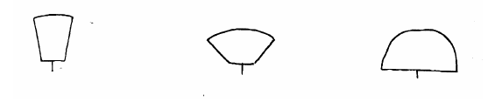
1 2 3
upright semi upright hemispherical

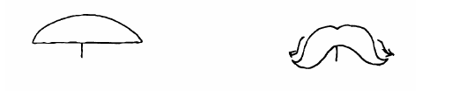
4 5
spreading trailing
Ad. 7: Petiole: attitude

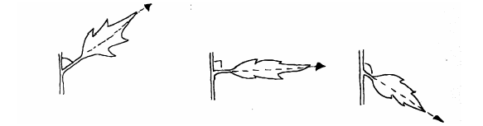
3 5 7
moderately horizontal moderately
upwards downwards

Ad. 12: Leaf: length of terminal lobe relative to leaf length

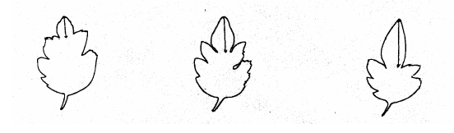
3 5 7
short medium long

Ad. 13: Leaf: depth of lowest lateral sinus

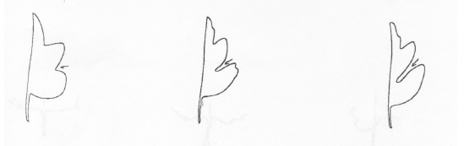
3 5 7
shallow medium deep
Ad. 15: Leaf: predominant shape of base

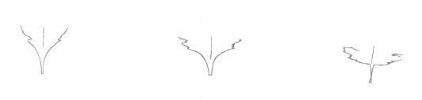
1 2 3
acute obtuse rounded

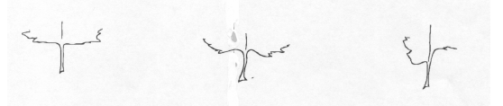
4 5 6
truncate cordate asymmetric

All varieties with asymmetric bases should be observed as state 6 for this characteristic, although the shape of the base of asymmetric varieties may be different from each other.

Ad. 18: Excluding varieties of Chrysanthemum ×morifolium: Leaf: upper side: prominence
of pale margin
3
weak
5
medium
7
strong
pale margin

Ad. 18: Excluding varieties of Chrysanthemum ×morifolium: Leaf: upper side: prominence of pale margin
Ad. 19: Excluding varieties of Chrysanthemum ×morifolium: Leaf: pubescence of lower side
Ad. 20: Excluding varieties of Chrysanthemum ×morifolium: Leaf: color of lower side

To be observed for all varieties of Chrysanthemum pacificum (Ajania pacifica) and all hybrids between Chrysanthemum pacificum and Chrysanthemum ×morifolium Ramat. (Chrysanthemum ×grandiflorum Ramat.)
Ad. 21: Leaf margin: number of indentations

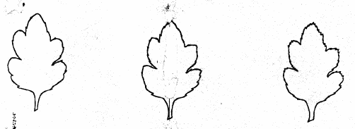
3 5 7
few medium many

Ad. 22: Leaf margin: depth of indentations

3 5 7
shallow medium deep

Ad. 23: Only non-bushy varieties (see char. 2): Inflorescence: form

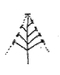
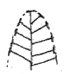
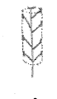
1 2 3
conical deeply doomed cylindrical
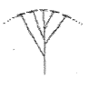

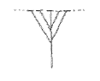

4 5
corymbiform flat-corymbiform
Ad. 25: Only non-bushy varieties (see char. 2): Inflorescence: angle between primary lateral shoot and stem

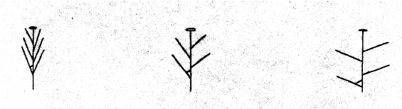
3 5 7
small medium large

Ad. 26: Only non-bushy varieties (see char. 2): Inflorescence: attitude of lateral flower heads

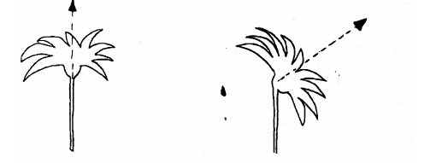
1 3
upright semi upright

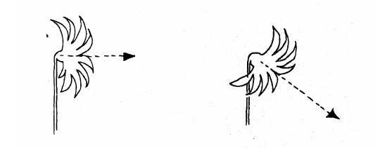
5 7
horizontal moderately downwards

Ad. 27: Only non-bushy varieties (see char. 2): Total number of flower heads per stem
Ad. 28: Only bushy varieties (see char. 2): Total number of flower heads per plant

The overall floriferoussness of the variety is assessed.

Ad. 30: Flower head: type

1. without ray florets: flower heads consist of disc florets only

2. single: flower heads with one row of ray florets, and a clearly defined central disc which is always visible.

3. semi double: flower heads with more than one row of ray florets, and a clearly defined central disc which is always visible.

4. daisy-eyed double: double flower heads where a disc is not visible in the early stages of flowering, but can be seen as the flower head opens fully. The disc is not always clearly defined.

5. double: double flower heads where a disc is not visible at any stage of flowering.

Ad. 31: Excluding double and daisy-eyed double varieties: Disc: type

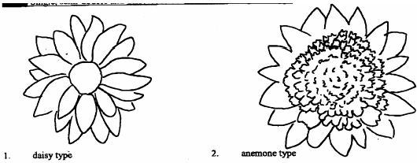

1

2
2

1 | 2
daisy | anemone

Ad. 40: Flower head: number of types of ray florets
The number of types of ray florets within the flower head is recorded as characteristic 40; the individual types are then described in characteristics 41 to 43.

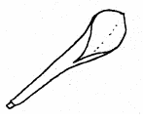
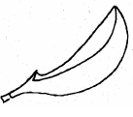
Ad. 41, 42 and 43: Flower head: predominant type of ray floret (41), secondary type of ray floret (42) and tertiary type of ray floret (43)
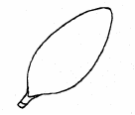
1 2 3
ligulate incurved spatulate
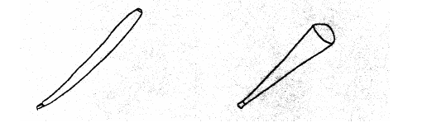

4 5
quilled funnel shaped
Ad. 44: Only single and semi double varieties (char. 30): Ray floret: attitude of basal part

5
horizontal
7
moderately descending
3
moderately ascending

Ad. 45: Ray floret: upper surface

As seen from above (top row) and in profile (bottom row):
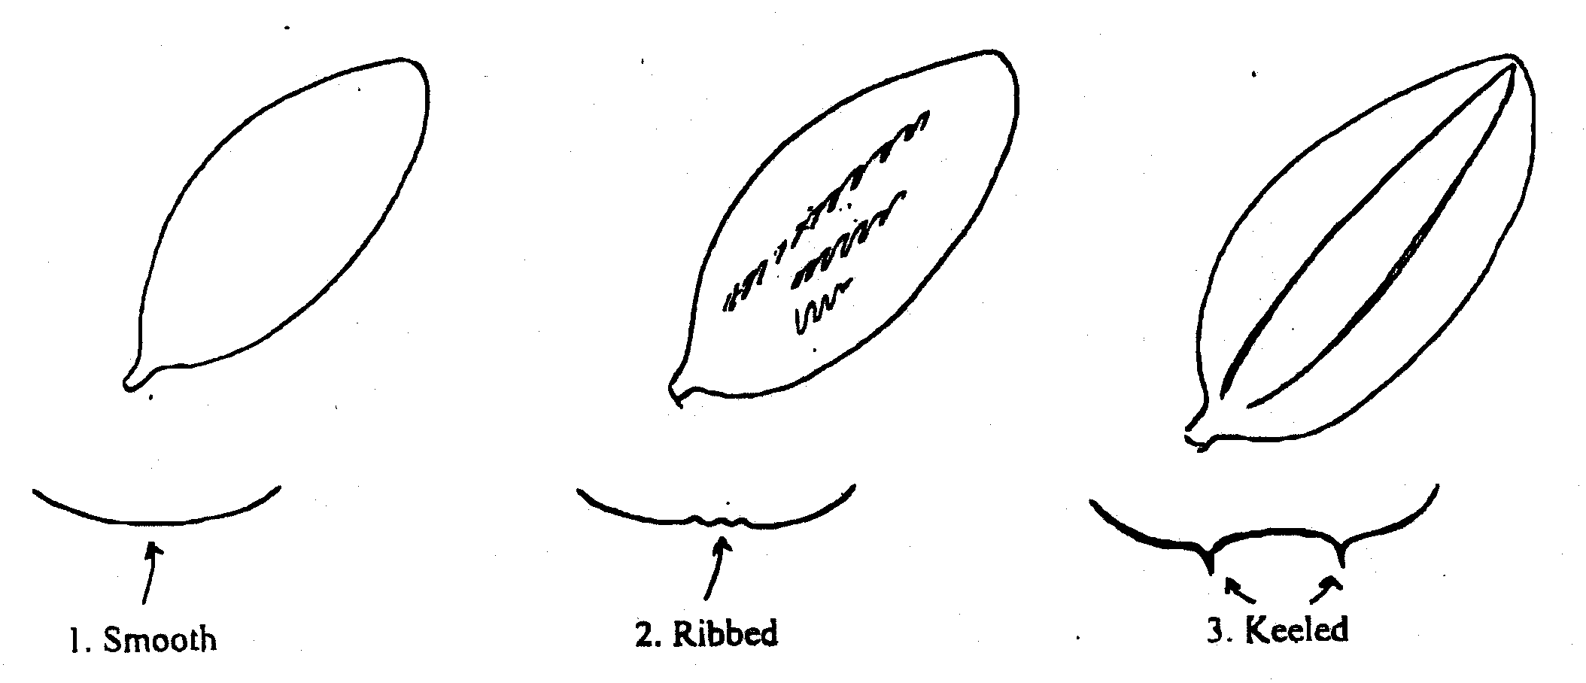
1 | 2 | 3
smooth | ribbed | keeled

Ad. 46: Ray floret: number of keels

As seen in profile
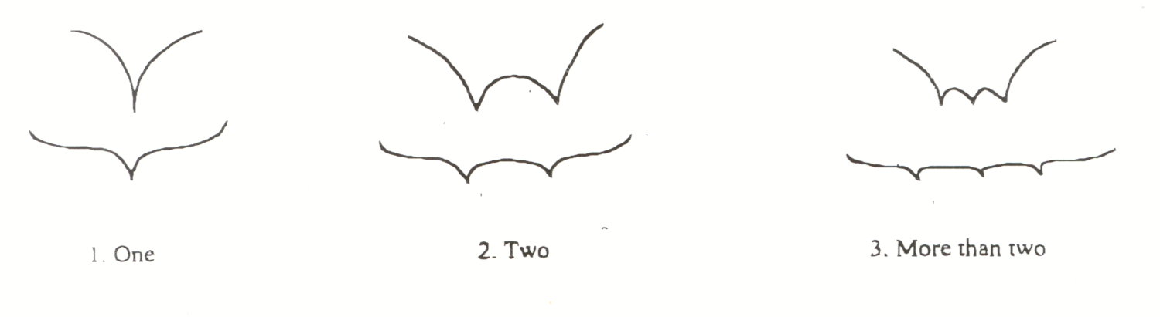
1 | 2 | 3
one | two | more than two
Ad. 48: Ray floret: profile in cross section at widest point (non-quilled florets)


1  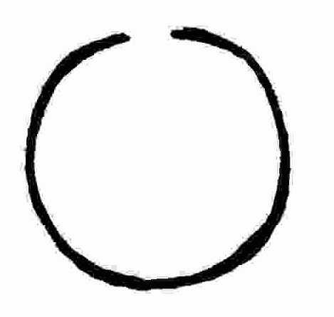strongly concave with margins overlapping | 2  strongly concave with margins touching | 3  strongly concave | 4  moderately concave
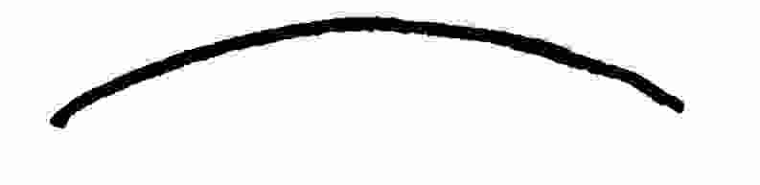5  weakly concave | 6  flat | 7  weakly convex | 8  moderately convex

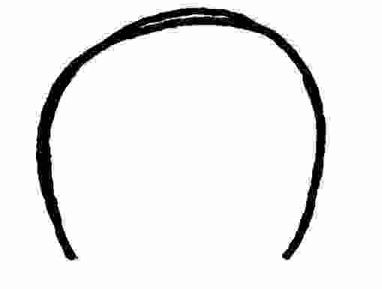
9  strongly convex | 10  strongly convex with margins touching | 11  strongly convex with margins overlapping

Ad. 49: Ray floret: rolling of margin (non-quilled florets)
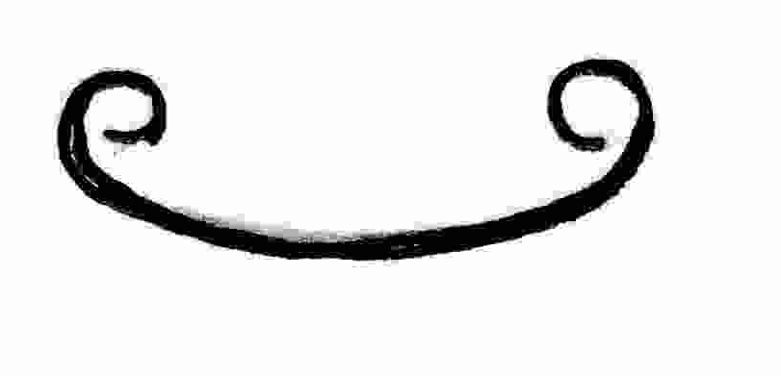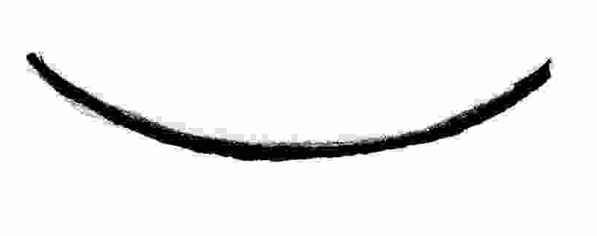
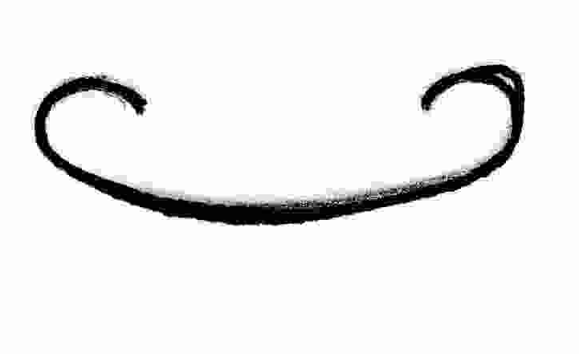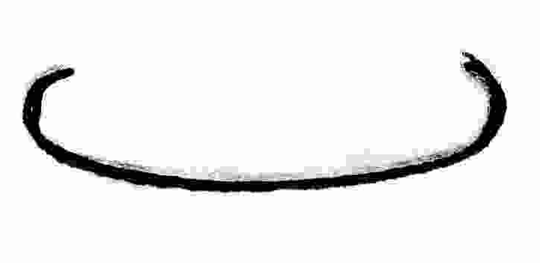

1 | 2 | 3 | 4
strongly involute | moderately involute | weakly involute | flat (not rolled)

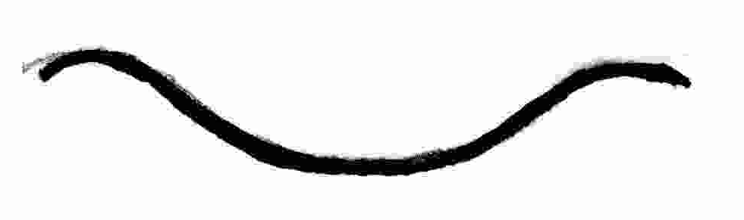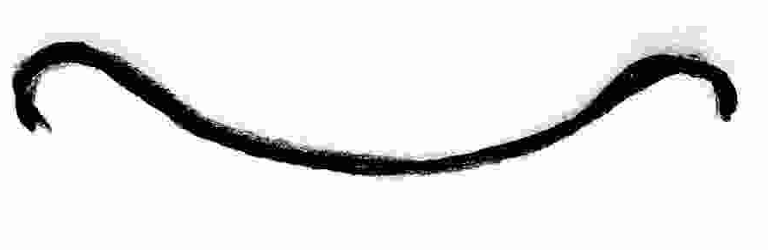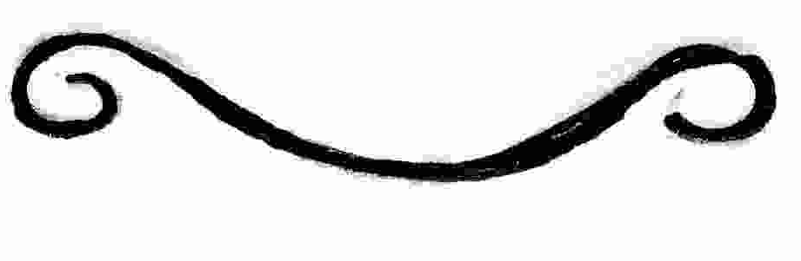

5 | 6 | 7
weakly revolute | moderately revolute | strongly revolute

Ad. 52: Ray floret: longitudinal axis
Ad. 55: Only semi double, daisy-eyed double and double varieties: Ray floret: longitudinal axis of inner row(s) (if different from outer row)
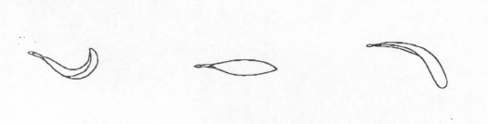  1 | 2 | 3
incurving | straight | reflexing
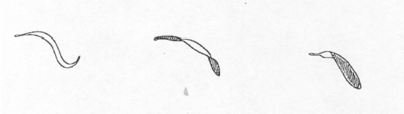

4 | 5 | 6
sinusoidal | twisted | broken
Ad. 54: Ray floret: longitudinal axis: strength of curvature (non-straight florets)
Ad. 57: Only semi-double, daisy-eyed double and double varieties: Ray floret: longitudinal axis of inner row(s) (if different from outer row): strength of curvature (non-straight florets)

3 | 5 | 7
weak | medium | strong

Ad. 61: Ray floret: shape of tip
1
pointed
3
truncate
2
rounded
4
emarginate
5
dentate
6
mamillate
7
fringed
8
laciniate

Ad. 65: Ray floret: distribution of second color of inner side
Ad. 68: Ray floret: distribution of third color of inner side
1
at tip
2
distal quarter
3
distal half
4
distal three quarters
5
basal three quarters
6
basal half
7
basal quarter
8
at base
9
on margin
11
central bar
12
transverse zone [band]
13
throughout
10
on marginal zone
Ad. 66: Ray floret: pattern of second color of inner side
Ad. 69: Ray floret: pattern of third color of inner side
1
solid or nearly solid
3
diffuse stripes
4
clearly defined stripes
5
flecked
6
flecked and striped
7
mottled

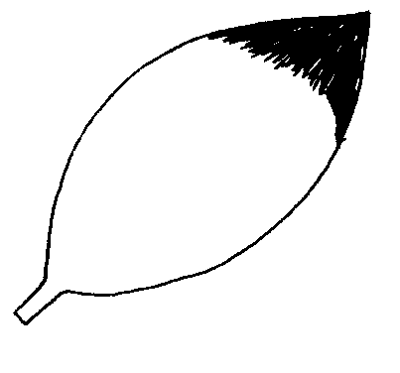 | 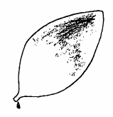 | 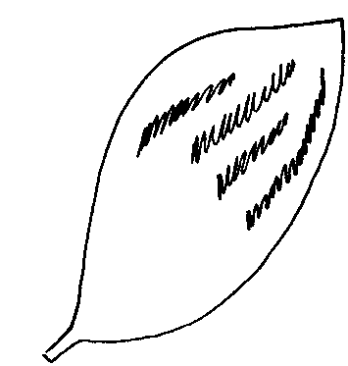
2
flushed
Ad. 76: Only single and semi double varieties (see char. 30): Disc: diameter relative to head diameter

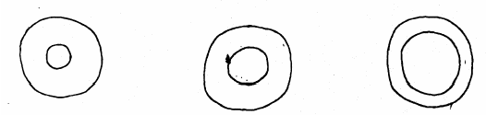
3 | 5 | 7
small | medium | large

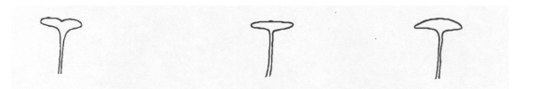
Ad. 77: Only daisy type varieties (see char. 31): Disc: profile in cross section

1 | 2 | 3
indented | flat | slightly domed

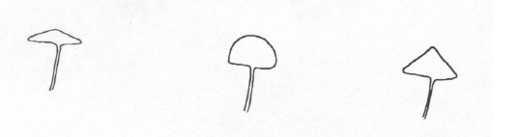

4 | 5 | 6
slightly conical | strongly domed | strongly conical

Ad. 85: Only anemone type varieties (see char. 31): Disc floret: type

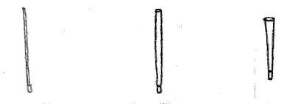

1 | 2 | 3
needle shaped | quilled | funnel shaped
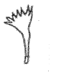
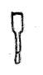
4 | 5
enlarged tubular | petaloid

Ad. 88: Response group (grown with precise daylength control)
Ad. 89: Only where grown without precise daylength control: Natural flowering period

Chrysanthemums can be grown under a very wide range of cultural regimes depending on climate and region. Varieties may be specifically adapted to one form of culture or another, or they may be multi-purpose, and this should be taken into consideration when designing the trial and selecting comparison varieties.

When varieties are grown and flowered by means of precise artificial daylength control, under an All Year Round (AYR) type system, the Response Group (characteristic 88) can be recorded.

The Response Group is defined as the time from the start of the short day treatment to the production of an inflorescence with at least four fully developed heads in 50% of the plants.

For varieties grown under natural environmental control, the Natural Flowering Period (characteristic 89) should be recorded.

Exact comparisons between varieties for these characteristics are only meaningful when the varieties are grown under the same conditions and at the same location.

Literature
Machin, Barrie, 1996: Cut flower chrysanthemum production, Grower Books, Swanley, Kent, GB

Machin, Barrie, 1997: Pot chrysanthemum production, Grower Books, Swanley, Kent, GB

Royal Horticultural Society, 1992: The New RHS Dictionary of Gardening, Macmillan, London, GB

Technical Questionnaire
TECHNICAL QUESTIONNAIRE |  |  |  | Page {x} of {y} |  | Reference Number:
 |  |  |  |  |  | Application date:
 |  |  |  |  |  | (not to be filled in by the applicant)
TECHNICAL QUESTIONNAIRE
to be completed in connection with an application for plant breeders’ rights

1. Subject of the Technical Questionnaire (please indicate the relevant species):

1.1 Botanical name |  |  | Chrysanthemum L.
1.2 Common name |  |  | Chrysanthemum
1.3 Species or interspecific hybrid (please specify)
2. Applicant
Name
Address
Telephone No.
Fax No.
E-mail address
Breeder (if different from applicant)
3. Proposed denomination and breeder’s reference
Proposed denomination
(if available)

Breeder’s reference
#4. Information on the breeding scheme and propagation of the variety

4.1 Breeding scheme

Variety resulting from:

4.1.1 Crossing

(a) controlled cross [ ]
(please state parent varieties)

(b) partially known cross [ ]
(please state known parent variety(ies))

(c) unknown cross [ ]

4.1.2 Mutation [ ]
(please state parent variety)

4.1.3 Discovery and development [ ]
(please state where and when discovered
and how developed)

4.1.4 Other [ ]
(please provide details)

4.2 Method of propagating the variety

4.2.1 Vegetative propagation

(a) cuttings [ ]

(b) in vitro propagation [ ]

(c) other (state method) [ ]

4.2.2 Seed [ ]

4.2.3 Other [ ]
(please provide details)

5. Characteristics of the variety to be indicated (the number in brackets refers to the corresponding characteristic in Test Guidelines; please mark the note which best corresponds).
 | Characteristics |  |  |  |  | Example Varieties |  |  |  | Note
5.1.  (1) | Plant: height
 | short |  |  |  |  | Machismo Time |  |  |  | 3[ ]
 | medium |  |  |  |  | Dekyen |  |  |  | 5[ ]
 | tall |  |  |  |  | Figrand |  |  |  | 7[ ]
5.2  (2) | Plant: type
 | non bushy |  |  |  |  | Anastasia, Boulou, Casmo, Reagan |  |  |  | 1[ ]
 | bushy |  |  |  |  | Elda White, Golden Mariyo, Guitpolin, Tripoli |  |  |  | 2[ ]
5.3  (30) | Flower head: type
 | without ray florets |  |  |  |  | Zeemimosa |  |  |  | 1[ ]
 | single |  |  |  |  | Repulse |  |  |  | 2[ ]
 | semi double |  |  |  |  | Figrand |  |  |  | 3[ ]
 | daisy-eyed double |  |  |  |  | Veria Dark |  |  |  | 4[ ]
 | double |  |  |  |  | Delianne |  |  |  | 5[ ]
5.4  (31) | Excluding double and daisy-eyed double varieties:  Disc: type
 | daisy |  |  |  |  | Figrand |  |  |  | 1[ ]
 | anemone |  |  |  |  | Le Mans |  |  |  | 2[ ]
5.5(i)  (32) | Flower head: diameter (non-disbudded plants)
 | small |  |  |  |  | Yoko Ono |  |  |  | 3[ ]
 | medium |  |  |  |  | Ruby Red Reagan |  |  |  | 5[ ]
 | large |  |  |  |  | Delianne |  |  |  | 7[ ]
5.5(ii)  (33) | Flower head: diameter (disbudded plants)
 | small |  |  |  |  | Boris Becker |  |  |  | 3[ ]
 | medium |  |  |  |  |  |  |  |  | 5[ ]
 | large |  |  |  |  | Anastasia |  |  |  | 7[ ]
 | Characteristics |  |  |  |  | Delianne |  |  |  | Note
5.6  (41) | Flower head: predominant type of ray floret
 | ligulate |  |  |  |  | Figrand |  |  |  | 1[ ]
 | incurved |  |  |  |  | Anlymp, Boulou |  |  |  | 2[ ]
 | spatulate |  |  |  |  | Banjax |  |  |  | 3[ ]
 | quilled |  |  |  |  | Anastasia |  |  |  | 4[ ]
 | funnel shaped |  |  |  |  | Repulse |  |  |  | 5[ ]
5.7  (62) | Ray floret: number of colors of inner side
 | one |  |  |  |  | Figrand |  |  |  | 1[ ]
 | two |  |  |  |  | Machismo Time |  |  |  | 2[ ]
 | more than two |  |  |  |  |  |  |  |  | 3[ ]
5.8(i)  (63) | Ray floret: main color of inner side
RHS Colour Chart (indicate reference number)
...........................................................................
5.8(ii)  (63) | Ray floret: main color of inner side
 | white |  |  |  |  | Anastasia |  |  |  | 1[ ]
 | off-white |  |  |  |  | Delianne |  |  |  | 2[ ]
 | yellow |  |  |  |  | Veria Dark |  |  |  | 3[ ]
 | bronze |  |  |  |  | Machismo Time |  |  |  | 4[ ]
 | orange |  |  |  |  | Balios |  |  |  | 5[ ]
 | orange pink |  |  |  |  | Reagan Elite Salmon |  |  |  | 6[ ]
 | pink |  |  |  |  | Reagan |  |  |  | 7[ ]
 | red |  |  |  |  | Ruby Red Reagan |  |  |  | 8[ ]
 | red purple |  |  |  |  | Scott |  |  |  | 9[ ]
 | purple |  |  |  |  |  |  |  |  | 10[ ]
 | green |  |  |  |  | Yoko Ono |  |  |  | 11[ ]
 | other color (indicate)  ..................................... |  |  |  |  |  |  |  |  | 12[ ]
 | Characteristics |  |  |  |  | Example Varieties |  |  |  | Note
5.9(i)  (64) | Ray floret: second color of inner side
RHS Colour Chart (indicate reference number)
...........................................................................
5.9(ii)  (64) | Ray floret: second color of inner side
 | white |  |  |  |  |  |  |  |  | 1[ ]
 | off-white |  |  |  |  |  |  |  |  | 2[ ]
 | yellow |  |  |  |  |  |  |  |  | 3[ ]
 | bronze |  |  |  |  |  |  |  |  | 4[ ]
 | orange |  |  |  |  |  |  |  |  | 5[ ]
 | orange pink |  |  |  |  |  |  |  |  | 6[ ]
 | pink |  |  |  |  | North Bay |  |  |  | 7[ ]
 | red |  |  |  |  | Machismo Time |  |  |  | 8[ ]
 | red purple |  |  |  |  | Orinocco |  |  |  | 9[ ]
 | purple |  |  |  |  |  |  |  |  | 10[ ]
 | green |  |  |  |  |  |  |  |  | 11[ ]
 | other color (indicate)  ..................................... |  |  |  |  |  |  |  |  | 12[ ]
6. Similar varieties and differences from these varieties

Please use the following table and box for comments to provide information on how your candidate variety differs from the variety (or varieties) which, to the best of your knowledge, is (or are) most similar. This information may help the examination authority to conduct its examination of distinctness in a more efficient way.

Denomination(s) of variety(ies) similar to your candidate variety |  | Characteristic(s) in which your candidate variety differs from the similar variety(ies) |  |  | Describe the expression of the characteristic(s) for the similar variety(ies) |  | Describe the expression of the characteristic(s) for your candidate variety
Example |  | Flower head: diameter |  |  | small |  | medium
Comments:

#7. Additional information which may help in the examination of the variety

7.1 In addition to the information provided in sections 5 and 6, are there any additional characteristics which may help to distinguish the variety?
Yes [ ] No [ ]

(If yes, please provide details)

7.2 Are there any special conditions for growing the variety or conducting the examination?
Yes [ ] No [ ]

(If yes, please provide full details including reason)

7.3 Use

Please complete according to the growing regime to which the variety is primarily adapted:

7.3.1 Is the variety intended to be grown

(a) in the glasshouse or under other protection [ ]
(b) outdoors [ ]

7.3.2 Is the variety intended to be grown with artificial daylength control

(a) yes [ ]
indicate response group in days ……….
(b) no [ ]
indicate natural flowering season ………

7.3.3 Is the variety intended for disbudding

(a) yes [ ]
(b) no [ ]

7.3.4 Is the main use of the variety:

(a) pot plant [ ]
(b) cut flower [ ]
(c) garden [ ]
(d) other [ ]

(please provide details)…………………………..

7.4 A representative color photograph of the variety should accompany the Technical Questionnaire.

8. Authorization for release

(a) Does the variety require prior authorization for release under legislation concerning the protection of the environment, human and animal health?

Yes [ ] No [ ]

(b) Has such authorization been obtained?

Yes [ ] No [ ]

If the answer to (b) is yes, please attach a copy of the authorization.

9. Information on plant material to be examined or submitted for examination.

9.1 The expression of a characteristic or several characteristics of a variety may be affected by factors, such as pests and disease, chemical treatment (e.g. growth retardants or pesticides), effects of tissue culture, different rootstocks, scions taken from different growth phases of a tree, etc.

9.2 The plant material should not have undergone any treatment which would affect the expression of the characteristics of the variety, unless the competent authorities allow or request such treatment. If the plant material has undergone such treatment, full details of the treatment must be given. In this respect, please indicate below, to the best of your knowledge, if the plant material to be examined has been subjected to:

(a) Microorganisms (e.g. virus, bacteria, phytoplasma) Yes [ ] No [ ]

(b) Chemical treatment (e.g. growth retardant, pesticide) Yes [ ] No [ ]

(c) Tissue culture Yes [ ] No [ ]

(d) Other factors Yes [ ] No [ ]

Please provide details for where you have indicated “yes”.

……………………………………………………………

10. I hereby declare that, to the best of my knowledge, the information provided in this form is correct:

Applicant’s name

Signature Date

[End of document]

* These names were correct at the time of the introduction of these Test Guidelines but may be revised or updated. [Readers are advised to consult the UPOV Code, which can be found on the UPOV Website (www.upov.int), for the latest information.]
# Authorities may allow certain of this information to be provided in a confidential section of the Technical Questionnaire.
# Authorities may allow certain of this information to be provided in a confidential section of the Technical Questionnaire.

