 |  | E  TG/22/10 Rev.  ORIGINAL: English  DATE: 2012-03-28
INTERNATIONAL UNION FOR THE PROTECTION OF NEW VARIETIES OF PLANTS
GENEVA

 | STRAWBERRY  UPOV Code: FRAGA  Fragaria L. | *

GUIDELINES

FOR THE CONDUCT OF TESTS

FOR DISTINCTNESS, UNIFORMITY AND STABILITY

Alternative Names:*

Botanical name | English | French | German | Spanish
Fragaria L. | Strawberry | Fraisier | Erdbeere | Fresa, Frutilla

The purpose of these guidelines (“Test Guidelines”) is to elaborate the principles contained in the General Introduction (document TG/1/3), and its associated TGP documents, into detailed practical guidance for the harmonized examination of distinctness, uniformity and stability (DUS) and, in particular, to identify appropriate characteristics for the examination of DUS and production of harmonized variety descriptions.

ASSOCIATED DOCUMENTS

These Test Guidelines should be read in conjunction with the General Introduction and its associated TGP documents.
TABLE OF CONTENTS PAGE

1. Subject of these Test Guidelines 3
2. Material Required 3
3. Method of Examination 3
3.1 Number of Growing Cycles 3
3.2 Testing Place 3
3.3 Conditions for Conducting the Examination 3
3.4 Test Design 3
3.5 Number of Plants / Parts of Plants to be Examined 4
3.6 Additional Tests 4
4. Assessment of Distinctness, Uniformity and Stability 4
4.1 Distinctness 4
4.2 Uniformity 4
4.3 Stability 5
5. Grouping of Varieties and Organization of the Growing Trial 5
6. Introduction to the Table of Characteristics 6
6.1 Categories of Characteristics 6
6.2 States of Expression and Corresponding Notes 6
6.3 Types of Expression 6
6.4 Example Varieties 6
6.5 Legend 6
7. Table of Characteristics/Tableau des caractères/Merkmalstabelle/Tabla de caracteres 7
8. Explanations on the Table of Characteristics 20
8.1 Explanations covering several characteristics 20
8.2 Explanations for individual characteristics 21
9. Literature 28
10. Technical Questionnaire 29

Subject of these Test Guidelines
These Test Guidelines apply to all varieties of Fragaria L. of the family Rosaceae.

Material Required
2.1 The competent authorities decide on the quantity and quality of the plant material required for testing the variety and when and where it is to be delivered. Applicants submitting material from a State other than that in which the testing takes place must ensure that all customs formalities and phytosanitary requirements are complied with.

2.2 The material is to be supplied in the form of young plants or seed.

2.3 The minimum quantity of plant material, to be supplied by the applicant, should be:

Vegetatively propagated varieties: 20 young plants
Seed propagated varieties: sufficient seed to produce 40 plants, or 40 young plants

2.4 The plant material supplied should be visibly healthy, not lacking in vigor, nor affected by any important pest or disease.

2.5 The plant material should not have undergone any treatment which would affect the expression of the characteristics of the variety, unless the competent authorities allow or request such treatment. If it has been treated, full details of the treatment must be given.

Method of Examination

3.1 Number of Growing Cycles
The minimum duration of tests should normally be two independent growing cycles.

3.2 Testing Place
Tests are normally conducted at one place. In the case of tests conducted at more than one place, guidance is provided in TGP/9 “Examining Distinctness”.

3.3 Conditions for Conducting the Examination
The tests should be carried out under conditions ensuring satisfactory growth for the expression of the relevant characteristics of the variety and for the conduct of the examination. In particular, it is essential that the plants produce a satisfactory crop of fruit in each of the two growing cycles.

3.4 Test Design
3.4.1 In the case of vegetatively propagated varieties, each test should be designed to result in a total of at least 20 plants.

3.4.2 In the case of seed-propagated varieties, each test should be designed to result in a total of at least 40 plants.
3.4.3 The design of the tests should be such that plants or parts of plants may be removed for measurement or counting without prejudice to the observations which must be made up to the end of the growing cycle.

3.5 Number of Plants / Parts of Plants to be Examined
Unless otherwise indicated, all observations on single plants should be made on 20 plants or parts taken from each of 20 plants and any other observations made on all plants in the test. In the case of observations of parts taken from single plants, the number of parts to be taken from each of the plants should be 2.

3.6 Additional Tests
Additional tests, for examining relevant characteristics, may be established.

Assessment of Distinctness, Uniformity and Stability

4.1 Distinctness
4.1.1 General Recommendations

It is of particular importance for users of these Test Guidelines to consult the General Introduction prior to making decisions regarding distinctness. However, the following points are provided for elaboration or emphasis in these Test Guidelines.

4.1.2 Consistent Differences

The differences observed between varieties may be so clear that more than one growing cycle is not necessary. In addition, in some circumstances, the influence of the environment is not such that more than a single growing cycle is required to provide assurance that the differences observed between varieties are sufficiently consistent. One means of ensuring that a difference in a characteristic, observed in a growing trial, is sufficiently consistent is to examine the characteristic in at least two independent growing cycles.

4.1.3 Clear Differences

Determining whether a difference between two varieties is clear depends on many factors, and should consider, in particular, the type of expression of the characteristic being examined, i.e. whether it is expressed in a qualitative, quantitative, or pseudo-qualitative manner. Therefore, it is important that users of these Test Guidelines are familiar with the recommendations contained in the General Introduction prior to making decisions regarding distinctness.

4.2 Uniformity
4.2.1 It is of particular importance for users of these Test Guidelines to consult the General Introduction prior to making decisions regarding uniformity. However, the following points are provided for elaboration or emphasis in these Test Guidelines:

4.2.2 For the assessment of uniformity, a population standard of 1% and an acceptance probability of at least 95% should be applied. In the case of a sample size of 20 plants, 1 off-type is allowed. In the case of a sample size of 40 plants, 2 off-types are allowed.

4.3 Stability
4.3.1 In practice, it is not usual to perform tests of stability that produce results as certain as those of the testing of distinctness and uniformity. However, experience has demonstrated that, for many types of variety, when a variety has been shown to be uniform, it can also be considered to be stable.

4.3.2 Where appropriate, or in cases of doubt, stability may be tested, either by growing a further generation, or by testing a new seed or plant stock to ensure that it exhibits the same characteristics as those shown by the previous material supplied.

Grouping of Varieties and Organization of the Growing Trial
5.1 The selection of varieties of common knowledge to be grown in the trial with the candidate varieties and the way in which these varieties are divided into groups to facilitate the assessment of distinctness are aided by the use of grouping characteristics.

5.2 Grouping characteristics are those in which the documented states of expression, even where produced at different locations, can be used, either individually or in combination with other such characteristics: (a) to select varieties of common knowledge that can be excluded from the growing trial used for examination of distinctness; and (b) to organize the growing trial so that similar varieties are grouped together.

5.3 The following have been agreed as useful grouping characteristics:

(a) Plant: growth habit (characteristic 1)
(b) Petal: color of upper side (characteristic 27)
(c) Fruit: size (characteristic 29)
(d) Fruit: shape (characteristic 30)
(e) Fruit: color (characteristic 32)
(f) Type of bearing (characteristic 48)

5.4 Guidance for the use of grouping characteristics, in the process of examining distinctness, is provided through the General Introduction.

Introduction to the Table of Characteristics

6.1 Categories of Characteristics
6.1.1 Standard Test Guidelines Characteristics

Standard Test Guidelines characteristics are those which are approved by UPOV for examination of DUS and from which members of the Union can select those suitable for their particular circumstances.

6.1.2 Asterisked Characteristics

Asterisked characteristics (denoted by *) are those included in the Test Guidelines which are important for the international harmonization of variety descriptions and should always be examined for DUS and included in the variety description by all members of the Union, except when the state of expression of a preceding characteristic or regional environmental conditions render this inappropriate.

6.2 States of Expression and Corresponding Notes
States of expression are given for each characteristic to define the characteristic and to harmonize descriptions. Each state of expression is allocated a corresponding numerical note for ease of recording of data and for the production and exchange of the description.

6.3 Types of Expression
An explanation of the types of expression of characteristics (qualitative, quantitative and pseudo qualitative) is provided in the General Introduction.

6.4 Example Varieties
Where appropriate, example varieties are provided to clarify the states of expression of each characteristic.

6.5 Legend
(*) Asterisked characteristic – see Chapter 6.1.2

QL: Qualitative characteristic – see Chapter 6.3
QN: Quantitative characteristic – see Chapter 6.3
PQ: Pseudo-qualitative characteristic – see Chapter 6.3

(a)-(d) See Explanations on the Table of Characteristics in Chapter 8.1

(+) See Explanations on the Table of Characteristics in Chapter 8.2

Table of Characteristics/Tableau des caractères/Merkmalstabelle/Tabla de caracteres
 |  |  |  |  |  |  | English |  |  | français |  |  |  |  |  |  |  | Deutsch |  |  |  |  |  | español |  |  |  | Example Varieties/  Exemples/  Beispielssorten/  Variedades ejemplo |  |  |  |  |  |  | Note/  Nota
1  (*)  (+) |  |  |  |  |  |  | Plant: growth habit |  |  | Plante : port |  |  |  |  |  |  |  | Pflanze: Wuchsform |  |  |  |  |  | Planta: porte
QN |  |  |  | (a) |  |  | upright |  |  | dressé |  |  |  |  |  |  |  | aufrecht |  |  |  |  |  | erecto |  |  |  | Benton, Darselect, Gorella |  |  |  |  |  |  | 1
 |  |  |  |  |  |  | semi-upright |  |  | demi-dressé |  |  |  |  |  |  |  | halbaufrecht |  |  |  |  |  | semierecto |  |  |  | Cirafine, Senga Sengana |  |  |  |  |  |  | 2
 |  |  |  |  |  |  | spreading |  |  | étalé |  |  |  |  |  |  |  | breitwüchsig |  |  |  |  |  | abierto |  |  |  | Darsidor, Pantagruella |  |  |  |  |  |  | 3
2.  (+) |  |  |  |  |  |  | Plant: density of foliage |  |  | Plante : densité du feuillage |  |  |  |  |  |  |  | Pflanze: Dichte des Laubes |  |  |  |  |  | Planta: densidad del follaje
QN |  |  |  | (a) |  |  | sparse |  |  | lâche |  |  |  |  |  |  |  | locker |  |  |  |  |  | escasa |  |  |  | Ciflorette, Elista |  |  |  |  |  |  | 3
 |  |  |  |  |  |  | medium |  |  | moyenne |  |  |  |  |  |  |  | mittel |  |  |  |  |  | media |  |  |  | Cirafine, Gorella |  |  |  |  |  |  | 5
 |  |  |  |  |  |  | dense |  |  | dense |  |  |  |  |  |  |  | dicht |  |  |  |  |  | densa |  |  |  | Cirano, Talisman |  |  |  |  |  |  | 7
3.  (+) |  |  |  |  |  |  | Plant: vigor |  |  | Plante : vigueur |  |  |  |  |  |  |  | Pflanze: Wuchsstärke |  |  |  |  |  | Planta: vigor
QN |  |  |  | (a) |  |  | weak |  |  | faible |  |  |  |  |  |  |  | gering |  |  |  |  |  | débil |  |  |  | Senga Precosa |  |  |  |  |  |  | 3
 |  |  |  |  |  |  | medium |  |  | moyenne |  |  |  |  |  |  |  | mittel |  |  |  |  |  | medio |  |  |  | Gorella |  |  |  |  |  |  | 5
 |  |  |  |  |  |  | strong |  |  | forte |  |  |  |  |  |  |  | stark |  |  |  |  |  | fuerte |  |  |  | Elsanta, Grande |  |  |  |  |  |  | 7
4.  (*) |  |  |  |  |  |  | Plant: position of inflorescence in relation to foliage |  |  | Plante : position de l’inflorescence par rapport au feuillage |  |  |  |  |  |  |  | Pflanze: Stellung des Blütenstandes im Verhältnis zum Laub |  |  |  |  |  | Planta: posición de la inflorescencia en relación con el follaje
QN |  |  |  | (c) |  |  | beneath |  |  | en dessous |  |  |  |  |  |  |  | unterhalb |  |  |  |  |  | por debajo |  |  |  | Crusader |  |  |  |  |  |  | 1
 |  |  |  |  |  |  | same level |  |  | au même niveau |  |  |  |  |  |  |  | gleich hoch |  |  |  |  |  | a la misma altura |  |  |  | Astino,  Cambridge Favourite |  |  |  |  |  |  | 2
 |  |  |  |  |  |  | above |  |  | au-dessus |  |  |  |  |  |  |  | oberhalb |  |  |  |  |  | por encima |  |  |  | Direktor Paul Wallbaum |  |  |  |  |  |  | 3
5.  (*) |  |  |  |  |  |  | Plant: number of stolons |  |  | Plante : nombre de stolons |  |  |  |  |  |  |  | Pflanze: Anzahl Ausläufer |  |  |  |  |  | Planta: número de estolones
QN |  |  |  | (b) |  |  | absent or very few |  |  | nul ou très petit |  |  |  |  |  |  |  | fehlend oder sehr gering |  |  |  |  |  | ausente o muy escasos |  |  |  | Leo Alba, Rügen |  |  |  |  |  |  | 1
 |  |  |  |  |  |  | few |  |  | petit |  |  |  |  |  |  |  | gering |  |  |  |  |  | escaso |  |  |  | Marala, Sans Rivale |  |  |  |  |  |  | 3
 |  |  |  |  |  |  | medium |  |  | moyen |  |  |  |  |  |  |  | mittel |  |  |  |  |  | medio |  |  |  | Anabelle, Gorella |  |  |  |  |  |  | 5
 |  |  |  |  |  |  | many |  |  | grand |  |  |  |  |  |  |  | groß |  |  |  |  |  | muchos |  |  |  | Cambridge Favourite, Macherauchs Frühernte |  |  |  |  |  |  | 7
6.  (+) |  |  |  |  |  |  | Stolon: anthocyanin coloration |  |  | Stolon : pigmentation anthocyanique |  |  |  |  |  |  |  | Ausläufer: Anthocyanfärbung |  |  |  |  |  | Estolón: pigmentación antociánica
QN |  |  |  | (b) |  |  | absent or very weak |  |  | nulle ou très faible |  |  |  |  |  |  |  | fehlend oder sehr gering |  |  |  |  |  | ausente o muy débil |  |  |  | Tioga |  |  |  |  |  |  | 1
 |  |  |  |  |  |  | weak |  |  | faible |  |  |  |  |  |  |  | gering |  |  |  |  |  | débil |  |  |  | Cijosée, Tenira |  |  |  |  |  |  | 3
 |  |  |  |  |  |  | medium |  |  | moyenne |  |  |  |  |  |  |  | mittel |  |  |  |  |  | media |  |  |  | Darselect, Gorella |  |  |  |  |  |  | 5
 |  |  |  |  |  |  | strong |  |  | forte |  |  |  |  |  |  |  | stark |  |  |  |  |  | fuerte |  |  |  | Cigaline,  Royal Sovereign |  |  |  |  |  |  | 7
 |  |  |  |  |  |  | very strong |  |  | très forte |  |  |  |  |  |  |  | sehr stark |  |  |  |  |  | muy fuerte |  |  |  | Arking, Frel |  |  |  |  |  |  | 9
7. |  |  |  |  | Stolon: density of pubescence |  |  |  | Stolon : densité de la pilosité |  |  |  |  |  | Ausläufer: Dichte der Behaarung |  |  |  |  | Estolón: densidad de la pubescencia
QN | (b) |  |  |  | sparse |  |  |  | lâche |  |  |  |  |  | locker |  |  |  |  | laxa |  |  |  |  |  | Chandler, Elista, Vigerla |  |  |  |  |  | 1
 |  |  |  |  | medium |  |  |  | moyenne |  |  |  |  |  | mittel |  |  |  |  | media |  |  |  |  |  | Cambridge Favourite, Gariguette |  |  |  |  |  | 2
 |  |  |  |  | dense |  |  |  | dense |  |  |  |  |  | dicht |  |  |  |  | densa |  |  |  |  |  | Grande, Siabelle |  |  |  |  |  | 3
8.  (+) |  |  |  |  | Leaf: size |  |  |  | Feuille : taille |  |  |  |  |  | Blatt: Größe |  |  |  |  | Hoja: tamaño
QN | (a) |  |  |  | small |  |  |  | petite |  |  |  |  |  | klein |  |  |  |  | pequeño |  |  |  |  |  | Everest |  |  |  |  |  | 3
 |  |  |  |  | medium |  |  |  | moyenne |  |  |  |  |  | mittel |  |  |  |  | medio |  |  |  |  |  | Camarosa |  |  |  |  |  | 5
 |  |  |  |  | large |  |  |  | grande |  |  |  |  |  | groß |  |  |  |  | grande |  |  |  |  |  | Darselect |  |  |  |  |  | 7
9. |  |  |  |  | Leaf: color of upper side |  |  |  | Feuille : couleur de la face supérieure |  |  |  |  |  | Blatt: Farbe der Oberseite |  |  |  |  | Hoja: color del haz
PQ | (a) |  |  |  | yellow green |  |  |  | jaune vert |  |  |  |  |  | gelbgrün |  |  |  |  | verde amarillento |  |  |  |  |  | Tristar |  |  |  |  |  | 1
 |  |  |  |  | light green |  |  |  | vert clair |  |  |  |  |  | hellgrün |  |  |  |  | verde claro |  |  |  |  |  | Aliso, Cigaline,  Georg Soltwedel |  |  |  |  |  | 2
 |  |  |  |  | medium green |  |  |  | vert moyen |  |  |  |  |  | mittelgrün |  |  |  |  | verde medio |  |  |  |  |  | Darselect, Gorella |  |  |  |  |  | 3
 |  |  |  |  | dark green |  |  |  | vert foncé |  |  |  |  |  | dunkelgrün |  |  |  |  | verde oscuro |  |  |  |  |  | Direktor Paul Wallbaum, Macherauchs Frühernte |  |  |  |  |  | 4
 |  |  |  |  | blue green |  |  |  | bleu vert |  |  |  |  |  | blaugrün |  |  |  |  | verde azulado |  |  |  |  |  | Mrak |  |  |  |  |  | 5
10.  (*)  (+) |  |  |  |  | Leaf: blistering |  |  |  | Feuille : clôqure |  |  |  |  |  | Blatt: Blasigkeit |  |  |  |  | Hoja: abullonado
QN | (a) |  |  |  | absent or weak |  |  |  | absente ou faible |  |  |  |  |  | fehlend oder gering |  |  |  |  | ausente o débil |  |  |  |  |  | Anabelle, Bemanil, Marmion |  |  |  |  |  | 1
 |  |  |  |  | medium |  |  |  | moyenne |  |  |  |  |  | mittel |  |  |  |  | medio |  |  |  |  |  | Cigaline, Senga Precosa |  |  |  |  |  | 2
 |  |  |  |  | strong |  |  |  | forte |  |  |  |  |  | stark |  |  |  |  | fuerte |  |  |  |  |  | Cijosée, Jamil,  Marie France |  |  |  |  |  | 3
11.  (*) |  |  |  |  | Leaf: glossiness |  |  |  | Feuille : brillance |  |  |  |  |  | Blatt: Glanz |  |  |  |  | Hoja: brillo
QN | (a) |  |  |  | absent or weak |  |  |  | nulle ou faible |  |  |  |  |  | fehlend oder gering |  |  |  |  | ausente o débil |  |  |  |  |  | Aptos, Bogota, Mrak |  |  |  |  |  | 1
 |  |  |  |  | medium |  |  |  | moyenne |  |  |  |  |  | mittel |  |  |  |  | medio |  |  |  |  |  | Darestivale, Irvine |  |  |  |  |  | 2
 |  |  |  |  | strong |  |  |  | forte |  |  |  |  |  | stark |  |  |  |  | fuerte |  |  |  |  |  | Mara des Bois,  Sweet Delight, Tioga |  |  |  |  |  | 3
12. |  |  |  |  |  | Leaf: variegation |  |  |  |  |  |  | Feuille : panachure |  |  | Blatt: Panaschierung |  |  |  |  | Hoja: variegación
QL |  | (a) |  |  |  | absent |  |  |  |  |  |  | absente |  |  | fehlend |  |  |  |  | ausente |  |  |  |  |  |  |  |  |  | 1
 |  |  |  |  |  | present |  |  |  |  |  |  | présente |  |  | vorhanden |  |  |  |  | presente |  |  |  |  |  |  |  |  |  | 9
13.  (*) |  |  |  |  |  | Terminal leaflet: length in relation to width |  |  |  |  |  |  |  | Foliole terminale : longueur par rapport à la largeur |  |  | Endfieder: Länge im Verhältnis zur Breite |  |  |  |  | Folíolo terminal: anchura en relación con la longitud
QN | (a) |  |  |  |  | shorter |  |  |  |  |  |  |  | plus courte |  |  | kürzer |  |  |  |  | más corto |  |  |  |  | Siabelle |  |  | 1
 |  |  |  |  |  | equal |  |  |  |  |  |  |  | égale |  |  | gleichlang |  |  |  |  | igual |  |  |  |  | Chandler, Crusader |  |  | 2
 |  |  |  |  |  | moderately longer |  |  |  |  |  |  |  | modérément plus longue |  |  | etwas länger |  |  |  |  | moderadamente más largo |  |  |  |  | Elsanta, Montrose, Redgauntlet |  |  | 3
 |  |  |  |  |  | much longer |  |  |  |  |  |  |  | beaucoup plus longue |  |  | viel länger |  |  |  |  | mucho más largo |  |  |  |  | Gariguette, Macherauchs Frühernte |  |  | 4
14.  (*)  (+) |  |  |  |  |  | Terminal leaflet: shape of base |  |  |  |  |  |  |  | Foliole terminale : forme de la base |  |  | Endfieder: Form der Basis |  |  |  |  | Folíolo terminal: forma de la base
PQ | (a) |  |  |  |  | acute |  |  |  |  |  |  |  | pointue |  |  | spitz |  |  |  |  | aguda |  |  |  |  | Gorella, Regina |  |  | 1
 |  |  |  |  |  | obtuse |  |  |  |  |  |  |  | obtuse |  |  | stumpf |  |  |  |  | obtusa |  |  |  |  | Darselect,  Senga Sengana |  |  | 2
 |  |  |  |  |  | rounded |  |  |  |  |  |  |  | arrondie |  |  | abgerundet |  |  |  |  | redondeada |  |  |  |  | Crusader, Florika,  Marie France |  |  | 3
15.  (+) |  |  |  |  |  | Terminal leaflet: margin |  |  |  |  |  |  |  | Foliole terminale : bord |  |  | Endfieder: Rand |  |  |  |  | Folíolo terminal: borde
PQ | (a) |  |  |  |  | serrate |  |  |  |  |  |  |  | dentelé |  |  | gesägt |  |  |  |  | serradas |  |  |  |  | Garriguette, Tenira |  |  | 1
 |  |  |  |  |  | serrate to crenate |  |  |  |  |  |  |  | dentelé à crénelé |  |  | gesägt bis gekerbt |  |  |  |  | serradas a crenadas |  |  |  |  |  |  |  | 2
 |  |  |  |  |  | crenate |  |  |  |  |  |  |  | crénelé |  |  | gekerbt |  |  |  |  | crenadas |  |  |  |  | Cambridge Favourite, Gentonova, Irvine |  |  | 3
16.  (+) |  |  |  |  |  | Terminal leaflet: shape in cross section |  |  |  |  |  |  |  | Foliole terminale : forme en section transversale |  |  | Endfieder: Form im Querschnitt |  |  |  |  | Folíolo terminal: forma de la sección transversal
QN | (a) |  |  |  |  | concave |  |  |  |  |  |  |  | concave |  |  | konkav |  |  |  |  | cóncava |  |  |  |  | Hapil, Ostara,  Senga Precosana |  |  | 1
 |  |  |  |  |  | straight |  |  |  |  |  |  |  | droite |  |  | gerade |  |  |  |  | plana |  |  |  |  | Georg Soltwedel,  Mara des Bois |  |  | 2
 |  |  |  |  |  | convex |  |  |  |  |  |  |  | convexe |  |  | konvex |  |  |  |  | convexa |  |  |  |  | Cambridge Favourite, Domanil,  Madame Moutot |  |  | 3
17. |  |  |  |  | Petiole: length |  |  |  | Pétiole : longueur |  |  |  |  |  | Blattstiel: Länge |  |  |  |  | Peciolo: longitud
QN | (a) |  |  |  | short |  |  |  | court |  |  |  |  |  | kurz |  |  |  |  | corta |  |  |  |  |  | Pantagruella |  |  |  |  |  | 3
 |  |  |  |  | medium |  |  |  | moyen |  |  |  |  |  | mittel |  |  |  |  | media |  |  |  |  |  | Polka |  |  |  |  |  | 5
 |  |  |  |  | long |  |  |  | long |  |  |  |  |  | lang |  |  |  |  | larga |  |  |  |  |  | Darselect |  |  |  |  |  | 7
18.  (+) |  |  |  |  | Petiole: attitude of hairs |  |  |  | Pétiole : port des poils |  |  |  |  |  | Blattstiel: Haarstellung |  |  |  |  | Peciolo: porte de los pelos
QN | (a) |  |  |  | upwards |  |  |  | érigé |  |  |  |  |  | aufwärts |  |  |  |  | ascendente |  |  |  |  |  | Elista, Georg Soltwedel |  |  |  |  |  | 1
 |  |  |  |  | slightly outwards |  |  |  | légèrement étalé |  |  |  |  |  | leicht abstehend |  |  |  |  | ligeramente hacia afuera |  |  |  |  |  | Darselect, Elsanta |  |  |  |  |  | 2
 |  |  |  |  | horizontal |  |  |  | horizontal |  |  |  |  |  | waagerecht |  |  |  |  | horizontal |  |  |  |  |  | Cambridge Favourite, Direktor Paul Wallbaum, Mara des Bois |  |  |  |  |  | 3
19. |  |  |  |  |  |  |  | Stipule: anthocyanin coloration |  |  | Stipule : pigmentation anthocyanique |  |  |  |  |  |  |  | Nebenblatt: Anthocyanfärbung |  |  |  |  |  | Estípulas: pigmentación antociánica
QN |  |  | (b) |  |  |  |  | absent or very weak |  |  | nulle ou très faible |  |  |  |  |  |  |  | fehlend oder sehr gering |  |  |  |  |  | ausente o muy débil |  |  |  | Elista |  |  |  |  | 1
 |  |  |  |  |  |  |  | weak |  |  | faible |  |  |  |  |  |  |  | gering |  |  |  |  |  | débil |  |  |  | Crusader |  |  |  |  | 3
 |  |  |  |  |  |  |  | medium |  |  | moyenne |  |  |  |  |  |  |  | mittel |  |  |  |  |  | media |  |  |  | Gorella |  |  |  |  | 5
 |  |  |  |  |  |  |  | strong |  |  | forte |  |  |  |  |  |  |  | stark |  |  |  |  |  | fuerte |  |  |  | Talisman |  |  |  |  | 7
 |  |  |  |  |  |  |  | very strong |  |  | très forte |  |  |  |  |  |  |  | sehr stark |  |  |  |  |  | muy fuerte |  |  |  | Royal Sovereign |  |  |  |  | 9
20. |  |  |  |  |  | Inflorescence: number of flowers |  |  |  |  |  |  | Inflorescence : nombre de fleurs |  |  | Blütenstand: Anzahl Blüten |  |  |  |  | Inflorescencia: número de flores
QN |  | (c) |  |  |  | few |  |  |  |  |  |  | petit |  |  | gering |  |  |  |  | bajo |  |  |  |  |  | Pantagruella |  |  |  | 3
 |  |  |  |  |  | medium |  |  |  |  |  |  | moyen |  |  | mittel |  |  |  |  | medio |  |  |  |  |  | Lambada |  |  |  | 5
 |  |  |  |  |  | many |  |  |  |  |  |  | grand |  |  | groß |  |  |  |  | alto |  |  |  |  |  | Elsanta |  |  |  | 7
21.  (+) |  |  |  |  |  | Pedicel: attitude of hairs |  |  |  |  |  |  | Pédicelle : port des poils |  |  | Blütenstiel: Haarstellung |  |  |  |  | Pedicelo: porte de los pelos
QN |  | (d) |  |  |  | upwards |  |  |  |  |  |  | érigé |  |  | aufwärts |  |  |  |  | hacia arriba |  |  |  |  |  | Cigaline |  |  |  | 1
 |  |  |  |  |  | slightly outwards |  |  |  |  |  |  | légèrement étalé |  |  | leicht abstehend |  |  |  |  | ligeramente hacia afuera |  |  |  |  |  | Darselect |  |  |  | 2
 |  |  |  |  |  | horizontal |  |  |  |  |  |  | horizontal |  |  | waagerecht |  |  |  |  | horizontal |  |  |  |  |  | Parker |  |  |  | 3
22. |  |  |  |  |  | Flower: diameter |  |  |  |  |  |  | Fleur : diamètre |  |  | Blüte: Durchmesser |  |  |  |  | Flor: diámetro
QN |  | (c) |  |  |  | small |  |  |  |  |  |  | petit |  |  | klein |  |  |  |  | pequeña |  |  |  |  |  | Rapella, Redgauntlet |  |  |  | 3
 |  |  |  |  |  | medium |  |  |  |  |  |  | moyen |  |  | mittel |  |  |  |  | media |  |  |  |  |  | Gorella, Mara des Bois |  |  |  | 5
 |  |  |  |  |  | large |  |  |  |  |  |  | grand |  |  | groß |  |  |  |  | grande |  |  |  |  |  | Darselect, Domanil |  |  |  | 7
23.  (*)  (+) |  |  |  |  |  |  | Flower: arrangement of petals |  |  |  |  | Fleur : disposition des pétales |  |  |  |  |  | Blüte: Anordnung der Blütenblätter |  |  |  |  | Flor: disposición de los pétalos
QN |  |  |  | (c) |  |  | free |  |  |  |  | disjoints |  |  |  |  |  | freistehend |  |  |  |  | libre |  |  |  |  | Cirafine, Talisman |  |  |  |  | 1
 |  |  |  |  |  |  | touching |  |  |  |  | tangents |  |  |  |  |  | sich berührend |  |  |  |  | en contacto |  |  |  |  | Darsidor, Regina |  |  |  |  | 2
 |  |  |  |  |  |  | overlapping |  |  |  |  | chevauchants |  |  |  |  |  | überlappend |  |  |  |  | solapada |  |  |  |  | Florika, Senga Gigana |  |  |  |  | 3
24.  (*)  (+) |  |  |  |  |  |  | Flower: size of calyx in relation to corolla |  |  |  |  | Fleur : taille du calice par rapport à celle de la corolle |  |  |  |  |  | Blüte: Größe des Kelchs im Ver-hältnis zur Krone |  |  |  |  | Flor: tamaño del cáliz en relación con la corola
QN |  |  |  | (c) |  |  | smaller |  |  |  |  | plus petit |  |  |  |  |  | kleiner |  |  |  |  | más pequeño |  |  |  |  | Bogota, Grande, Nordika |  |  |  |  | 1
 |  |  |  |  |  |  | same size |  |  |  |  | de même taille |  |  |  |  |  | gleich groß |  |  |  |  | tamaño idéntico |  |  |  |  | Darselect, Korona |  |  |  |  | 2
 |  |  |  |  |  |  | larger |  |  |  |  | plus grand |  |  |  |  |  | größer |  |  |  |  | mayor |  |  |  |  | Cigoulette, Regina |  |  |  |  | 3
25.  (*) |  |  |  |  |  |  | Flower: stamen |  |  |  |  | Fleur : étamine |  |  |  |  |  | Blüte: Staubfaden |  |  |  |  | Flor: estambre
QL |  |  |  | (c) |  |  | absent |  |  |  |  | absente |  |  |  |  |  | fehlend |  |  |  |  | ausente |  |  |  |  | Pandora, Yamasaka |  |  |  |  | 1
 |  |  |  |  |  |  | present |  |  |  |  | présente |  |  |  |  |  | vorhanden |  |  |  |  | presente |  |  |  |  | Gariguette |  |  |  |  | 9
26. |  |  |  |  |  |  | Petal: length in relation to width |  |  |  |  | Pétale : longueur par rapport à la largeur |  |  |  |  |  | Blütenblatt: Länge im Verhältnis zur Breite |  |  |  |  | Pétalo: anchura en relación con la longitud
QN |  |  |  | (c) |  |  | much shorter |  |  |  |  | beaucoup plus court |  |  |  |  |  | viel kürzer |  |  |  |  | mucho más corto |  |  |  |  | Florika, Senga Gigana |  |  |  |  | 1
 |  |  |  |  |  |  | moderately shorter |  |  |  |  | modérément plus court |  |  |  |  |  | etwas kürzer |  |  |  |  | moderadamente más corto |  |  |  |  | Gento Nova, Tioga |  |  |  |  | 2
 |  |  |  |  |  |  | equal |  |  |  |  | égal |  |  |  |  |  | gleichlang |  |  |  |  | igual |  |  |  |  | Darselect, Redgauntlet |  |  |  |  | 3
 |  |  |  |  |  |  | moderately longer |  |  |  |  | modérément plus long |  |  |  |  |  | etwas länger |  |  |  |  | moderadamente más largo |  |  |  |  | Ciflorette, Elsanta, Gorella |  |  |  |  | 4
 |  |  |  |  |  |  | much longer |  |  |  |  | beaucoup plus long |  |  |  |  |  | viel länger |  |  |  |  | mucho más largo |  |  |  |  | Talisman |  |  |  |  | 5
27.  (*) |  |  |  |  |  |  | Petal: color of upper side |  |  |  |  | Pétale : couleur de la face supérieure |  |  |  |  |  | Blütenblatt: Farbe der Oberseite |  |  |  |  | Pétalo: color del haz
PQ |  |  |  | (c) |  |  | greenish white |  |  |  |  | blanc verdâtre |  |  |  |  |  | grünlichweiß |  |  |  |  | blanco verdoso |  |  |  |  |  |  |  |  |  | 1
 |  |  |  |  |  |  | white |  |  |  |  | blanc |  |  |  |  |  | weiß |  |  |  |  | blanco |  |  |  |  | Gariguette |  |  |  |  | 2
 |  |  |  |  |  |  | pink |  |  |  |  | rose |  |  |  |  |  | rosa |  |  |  |  | rosa |  |  |  |  | Frel, Marajox, Pikan |  |  |  |  | 3
 |  |  |  |  |  |  | red |  |  |  |  | rouge |  |  |  |  |  | rot |  |  |  |  | rojo |  |  |  |  | Tarpan |  |  |  |  | 4
28.  (*) |  |  |  |  |  |  | Fruit: length in relation to width |  |  |  |  | Fruit : longueur par rapport à la largeur |  |  |  |  |  | Frucht: Länge im Verhältnis zur Breite |  |  |  |  | Fruto: anchura en relación con la longitud
QN |  |  |  | (d) |  |  | much shorter |  |  |  |  | beaucoup plus court |  |  |  |  |  | viel kürzer |  |  |  |  | mucho más corto |  |  |  |  | Early Dawn |  |  |  |  | 1
 |  |  |  |  |  |  | moderately shorter |  |  |  |  | modérément plus court |  |  |  |  |  | etwas kürzer |  |  |  |  | moderadamente más corto |  |  |  |  | Elista, Madame Moutot |  |  |  |  | 2
 |  |  |  |  |  |  | equal |  |  |  |  | égal |  |  |  |  |  | gleichlang |  |  |  |  | igual |  |  |  |  | Gento Nova, Gorella, Merton Dawn |  |  |  |  | 3
 |  |  |  |  |  |  | moderately longer |  |  |  |  | modérément plus long |  |  |  |  |  | etwas länger |  |  |  |  | moderadamente más largo |  |  |  |  | Gariguette, Talisman |  |  |  |  | 4
 |  |  |  |  |  |  | much longer |  |  |  |  | beaucoup plus long |  |  |  |  |  | viel länger |  |  |  |  | mucho más largo |  |  |  |  | Ciflorette, Marie France |  |  |  |  | 5
29. (*)  (+) |  |  |  |  | Fruit: size |  |  |  | Fruit : taille |  |  |  |  |  | Frucht: Größe |  |  |  |  | Fruto: tamaño
QN | (d) |  |  |  | very small |  |  |  | très petit |  |  |  |  |  | sehr klein |  |  |  |  | muy pequeño |  |  |  |  |  | Astino, Frel |  |  |  |  |  | 1
 |  |  |  |  | small |  |  |  | petit |  |  |  |  |  | klein |  |  |  |  | pequeño |  |  |  |  |  | Senga Precosa |  |  |  |  |  | 3
 |  |  |  |  | medium |  |  |  | moyen |  |  |  |  |  | mittel |  |  |  |  | medio |  |  |  |  |  | Mara des Bois,  Senga Tigaiga |  |  |  |  |  | 5
 |  |  |  |  | large |  |  |  | grand |  |  |  |  |  | groß |  |  |  |  | grande |  |  |  |  |  | Darselect, Domanil |  |  |  |  |  | 7
 |  |  |  |  | very large |  |  |  | très grand |  |  |  |  |  | sehr groß |  |  |  |  | muy grande |  |  |  |  |  | Maxim |  |  |  |  |  | 9
30.  (*)  (+) |  |  |  |  | Fruit: shape |  |  |  | Fruit : forme |  |  |  |  |  | Frucht: Form |  |  |  |  | Fruto: forma
PQ | (d) |  |  |  | reniform |  |  |  | réniforme |  |  |  |  |  | nierenförmig |  |  |  |  | reniforme |  |  |  |  |  | Early Dawn, Favette |  |  |  |  |  | 1
 |  |  |  |  | conical |  |  |  | conique |  |  |  |  |  | kegelförmig |  |  |  |  | cónica |  |  |  |  |  | Gorella, Matis |  |  |  |  |  | 2
 |  |  |  |  | cordate |  |  |  | cordiforme |  |  |  |  |  | herzförmig |  |  |  |  | cordiforme |  |  |  |  |  | Direktor Paul Wallbaum |  |  |  |  |  | 3
 |  |  |  |  | ovoid |  |  |  | ovoïde |  |  |  |  |  | eiförmig |  |  |  |  | ovoide |  |  |  |  |  | Florika, Macherauchs Frühernte |  |  |  |  |  | 4
 |  |  |  |  | cylindrical |  |  |  | cylindrique |  |  |  |  |  | zylindrisch |  |  |  |  | cilíndrica |  |  |  |  |  | Chandler, Marie France |  |  |  |  |  | 5
 |  |  |  |  | rhomboid |  |  |  | rhomboïde |  |  |  |  |  | rhomboid |  |  |  |  | rhomboide |  |  |  |  |  | Gariguette, Pantagruella |  |  |  |  |  | 6
 |  |  |  |  | obloid |  |  |  | obloïde |  |  |  |  |  | abgeplattet |  |  |  |  | obloide |  |  |  |  |  | Elista |  |  |  |  |  | 7
 |  |  |  |  | globose |  |  |  | globuleux |  |  |  |  |  | kugelförmig |  |  |  |  | globosa |  |  |  |  |  | Grande,  Madame Moutot |  |  |  |  |  | 8
 |  |  |  |  | wedged |  |  |  | cunéiforme |  |  |  |  |  | keilförmig |  |  |  |  | cuneiforme |  |  |  |  |  | Georg Soltwedel |  |  |  |  |  | 9
31.  (+) |  |  |  |  | Fruit: difference in shape of terminal and other fruits |  |  |  | Fruit : différence de forme des fruits aînés et cadets |  |  |  |  |  | Frucht: Formunterschied zwischen Terminal- und anderen Früchten |  |  |  |  | Fruto: diferencia de forma entre los frutos terminales y los otros frutos
QN |  |  |  |  | none or very slight |  |  |  | aucune ou très petite |  |  |  |  |  | fehlend oder sehr gering |  |  |  |  | ninguna o muy leve |  |  |  |  |  | Cambridge Favourite, Vigerla |  |  |  |  |  | 1
 |  |  |  |  | slight |  |  |  | petite |  |  |  |  |  | gering |  |  |  |  | leve |  |  |  |  |  | Gariguette,  Senga Sengana |  |  |  |  |  | 3
 |  |  |  |  | moderate |  |  |  | moyenne |  |  |  |  |  | mittel |  |  |  |  | moderada |  |  |  |  |  | Darselect, Gorella |  |  |  |  |  | 5
 |  |  |  |  | large |  |  |  | grande |  |  |  |  |  | stark |  |  |  |  | grande |  |  |  |  |  | Bogota,  Georg Soltwedel Talisman |  |  |  |  |  | 7
 |  |  |  |  | very large |  |  |  | très grande |  |  |  |  |  | sehr stark |  |  |  |  | muy grande |  |  |  |  |  | Maxim |  |  |  |  |  | 9
32.  (*) |  |  |  |  | Fruit: color |  |  |  | Fruit : couleur |  |  |  |  |  | Frucht: Farbe |  |  |  |  | Fruto: color
PQ | (d) |  |  |  | whitish yellow |  |  |  | jaune blanchâtre |  |  |  |  |  | weißlichgelb |  |  |  |  | amarillo blanquecino |  |  |  |  |  | Weisse Ananas |  |  |  |  |  | 1
 |  |  |  |  | light orange |  |  |  | orange clair |  |  |  |  |  | hellorange |  |  |  |  | anaranjado claro |  |  |  |  |  | Madame Moutot, Merton Dawn |  |  |  |  |  | 2
 |  |  |  |  | medium orange |  |  |  | orange moyen |  |  |  |  |  | mittelorange |  |  |  |  | naranja medio |  |  |  |  |  | Cambridge Favourite |  |  |  |  |  | 3
 |  |  |  |  | orange red |  |  |  | rouge orangé |  |  |  |  |  | orangerot |  |  |  |  | rojo anaranjado |  |  |  |  |  | Ciflorette, Gorella |  |  |  |  |  | 4
 |  |  |  |  | medium red |  |  |  | rouge moyen |  |  |  |  |  | mittelrot |  |  |  |  | rojo medio |  |  |  |  |  | Elsanta,  Royal Sovereign |  |  |  |  |  | 5
 |  |  |  |  | dark red |  |  |  | rouge foncé |  |  |  |  |  | dunkelrot |  |  |  |  | rojo oscuro |  |  |  |  |  | Seascape,  Senga Sengana |  |  |  |  |  | 6
 |  |  |  |  | blackish red |  |  |  | rouge noirâtre |  |  |  |  |  | schwärzlichrot |  |  |  |  | rojo negruzco |  |  |  |  |  | Honey Oya, Rubina |  |  |  |  |  | 7
33.  (+) |  |  |  |  | Fruit: evenness of color |  |  |  | Fruit : uniformité de la couleur |  |  |  |  |  | Frucht: Gleich-mäßigkeit der Farbe |  |  |  |  | Fruto: uniformidad del color
QN | (d) |  |  |  | even or very slightly uneven |  |  |  | uniforme ou très légèrement irrégulière |  |  |  |  |  | gleichmäßig oder sehr leicht ungleichmäßig |  |  |  |  | uniforme o muy leve irregularidad |  |  |  |  |  | Valeta |  |  |  |  |  | 1
 |  |  |  |  | slightly uneven |  |  |  | légèrement irrégulière |  |  |  |  |  | leicht ungleichmäßig |  |  |  |  | ligeramente irregular |  |  |  |  |  | Tamella |  |  |  |  |  | 2
 |  |  |  |  | strongly uneven |  |  |  | fortement irrégulière |  |  |  |  |  | stark ungleichmäßig |  |  |  |  | muy irregular |  |  |  |  |  | Marie France |  |  |  |  |  | 3
34. |  |  |  |  | Fruit: glossiness |  |  |  | Fruit : brillance |  |  |  |  |  | Frucht: Glanz |  |  |  |  | Fruto: brillo
QN | (d) |  |  |  | weak |  |  |  | faible |  |  |  |  |  | gering |  |  |  |  | débil |  |  |  |  |  | Bemanil,  Madame Moutot |  |  |  |  |  | 1
 |  |  |  |  | medium |  |  |  | moyenne |  |  |  |  |  | mittel |  |  |  |  | medio |  |  |  |  |  | Darselect,  Macherauchs Frühernte |  |  |  |  |  | 2
 |  |  |  |  | strong |  |  |  | forte |  |  |  |  |  | stark |  |  |  |  | fuerte |  |  |  |  |  | Elsanta, Redgauntlet |  |  |  |  |  | 3
35.  (+) |  |  |  |  | Fruit: evenness of surface |  |  |  | Fruit : uniformité de la surface |  |  |  |  |  | Frucht: Gleichmäßigkeit der Oberfläche |  |  |  |  | Fruto: uniformidad de la superficie
QN | (d) |  |  |  | even or very slightly uneven |  |  |  | uniforme ou très légèrement irrégulière |  |  |  |  |  | gleichmäßig oder sehr leicht ungleichmäßig |  |  |  |  | uniforme o muy leve irregularidad |  |  |  |  |  | Valeta |  |  |  |  |  | 1
 |  |  |  |  | slightly uneven |  |  |  | légèrement irrégulière |  |  |  |  |  | leicht ungleichmäßig |  |  |  |  | ligeramente irregular |  |  |  |  |  | Senga Precosana |  |  |  |  |  | 2
 |  |  |  |  | strongly uneven |  |  |  | fortement irrégulière |  |  |  |  |  | stark ungleichmäßig |  |  |  |  | muy irregular |  |  |  |  |  | Redgauntlet |  |  |  |  |  | 3
36.  (+) |  |  |  |  | Fruit: width of band without achenes |  |  |  | Fruit : largeur de la zone sans akènes |  |  |  |  |  | Frucht: Breite der nüßchenfreie Zone |  |  |  |  | Fruto: anchura de la banda sin aquenios
QN | (d) |  |  |  | absent or very narrow |  |  |  | nulle ou très petite |  |  |  |  |  | fehlend oder sehr schmal |  |  |  |  | ausente o muy estrecha |  |  |  |  |  | Senga Sengana |  |  |  |  |  | 1
 |  |  |  |  | narrow |  |  |  | petite |  |  |  |  |  | schmal |  |  |  |  | estrecha |  |  |  |  |  | Elsanta, Mara des Bois, Pandora |  |  |  |  |  | 3
 |  |  |  |  | medium |  |  |  | moyenne |  |  |  |  |  | mittel |  |  |  |  | mediana |  |  |  |  |  | Darselect, Gariguette |  |  |  |  |  | 5
 |  |  |  |  | broad |  |  |  | grande |  |  |  |  |  | breit |  |  |  |  | ancha |  |  |  |  |  | Pantagruella |  |  |  |  |  | 7
 |  |  |  |  | very broad |  |  |  | très grande |  |  |  |  |  | sehr breit |  |  |  |  | muy ancha |  |  |  |  |  | Belrubi, Earliglo |  |  |  |  |  | 9
37.  (*)  (+) |  |  |  |  | Fruit: position of achenes |  |  |  | Fruit : implantation des akènes |  |  |  |  |  | Frucht: Position der Nüßchen |  |  |  |  | Fruto: posición de los aquenios
QN | (d) |  |  |  | below surface |  |  |  | enfoncés |  |  |  |  |  | eingesenkt |  |  |  |  | debajo de la superficie |  |  |  |  |  | Cirafine, Elista |  |  |  |  |  | 1
 |  |  |  |  | level with surface |  |  |  | affleurants |  |  |  |  |  | eben |  |  |  |  | a la misma altura que la superficie |  |  |  |  |  | Darselect, Regina |  |  |  |  |  | 2
 |  |  |  |  | above surface |  |  |  | en saillie |  |  |  |  |  | aufsitzend |  |  |  |  | por encima de la superficie |  |  |  |  |  | Brighton, Rigensa |  |  |  |  |  | 3
38.  (+) |  |  |  |  | Fruit: position of calyx attachment |  |  |  | Fruit : port de l’attache du calice |  |  |  |  |  | Frucht: Stellung des Kelchansatzes |  |  |  |  | Fruto: posición de la inserción del cáliz
QN | (d) |  |  |  | inserted |  |  |  | inséré |  |  |  |  |  | eingesenkt |  |  |  |  | insertada |  |  |  |  |  | Aliso, Favette |  |  |  |  |  | 1
 |  |  |  |  | level with fruit |  |  |  | au niveau de la surface du fruit |  |  |  |  |  | eben |  |  |  |  | a la misma altura que el fruto |  |  |  |  |  | Cambridge Favourite, Talisman |  |  |  |  |  | 2
 |  |  |  |  | raised |  |  |  | érigé |  |  |  |  |  | aufsitzend |  |  |  |  | elevada |  |  |  |  |  | Gariguette, Regina |  |  |  |  |  | 3
39.  (+) |  |  |  |  | Fruit: attitude of sepals |  |  |  | Fruit : port des sépales |  |  |  |  |  | Frucht: Haltung  der Kelchblätter |  |  |  |  | Fruto: porte de los sépalos
QN | (d) |  |  |  | upwards |  |  |  | érigé |  |  |  |  |  | aufwärts |  |  |  |  | hacia arriba |  |  |  |  |  | Bounty, Gariguette |  |  |  |  |  | 1
 |  |  |  |  | outwards |  |  |  | étalé |  |  |  |  |  | abstehend |  |  |  |  | hacia afuera |  |  |  |  |  | Angélina, Framura |  |  |  |  |  | 2
 |  |  |  |  | downwards |  |  |  | retombant |  |  |  |  |  | abwärts |  |  |  |  | hacia abajo |  |  |  |  |  | Ciflorette, Elvira |  |  |  |  |  | 3
40.  (+) |  |  |  |  | Fruit: diameter of calyx in relation to diameter of fruit |  |  |  | Fruit : diamètre du calice par rapport à celui du fruit |  |  |  |  |  | Frucht: Durch-messer des Kelchs im Verhältnis zum Durchmesser der Frucht |  |  |  |  | Fruto: diámetro del cáliz en relación con el diámetro del fruto
QN | (d) |  |  |  | much smaller |  |  |  | beaucoup plus petit |  |  |  |  |  | viel kleiner |  |  |  |  | mucho menor |  |  |  |  |  | Favette, Lumina |  |  |  |  |  | 1
 |  |  |  |  | slightly smaller |  |  |  | légèrement plus petit |  |  |  |  |  | etwas kleiner |  |  |  |  | ligeramente menor |  |  |  |  |  | Ostara, Senga Sengana |  |  |  |  |  | 2
 |  |  |  |  | same size |  |  |  | de même taille |  |  |  |  |  | gleich groß |  |  |  |  | tamaño idéntico |  |  |  |  |  | Cirafine, Tenira |  |  |  |  |  | 3
 |  |  |  |  | slightly larger |  |  |  | légèrement plus grand |  |  |  |  |  | etwas größer |  |  |  |  | ligeramente mayor |  |  |  |  |  | Darselect, Senga Precosa |  |  |  |  |  | 4
 |  |  |  |  | much larger |  |  |  | beaucoup plus grand |  |  |  |  |  | viel größer |  |  |  |  | mucho mayor |  |  |  |  |  | Angélina,  Cambridge Favourite |  |  |  |  |  | 5
41. |  |  |  |  | Fruit: adherence of calyx |  |  |  | Fruit : adhérence du calice |  |  |  |  |  | Frucht: Anhaften des Kelchs |  |  |  |  | Fruto: adherencia del cáliz
QN | (d) |  |  |  | very weak |  |  |  | très faible |  |  |  |  |  | sehr gering |  |  |  |  | muy débil |  |  |  |  |  | Confitura, Primek |  |  |  |  |  | 1
 |  |  |  |  | weak |  |  |  | faible |  |  |  |  |  | gering |  |  |  |  | débil |  |  |  |  |  | Senga Precosa, Siabelle |  |  |  |  |  | 3
 |  |  |  |  | medium |  |  |  | moyenne |  |  |  |  |  | mittel |  |  |  |  | media |  |  |  |  |  | Mara des Bois,  Senga Sengana |  |  |  |  |  | 5
 |  |  |  |  | strong |  |  |  | forte |  |  |  |  |  | stark |  |  |  |  | fuerte |  |  |  |  |  | Darselect, Redgauntlet |  |  |  |  |  | 7
 |  |  |  |  | very strong |  |  |  | très forte |  |  |  |  |  | sehr stark |  |  |  |  | muy fuerte |  |  |  |  |  | Rainier |  |  |  |  |  | 9
42. |  |  |  |  | Fruit: firmness |  |  |  | Fruit : fermeté |  |  |  |  |  | Frucht: Festigkeit |  |  |  |  | Fruto: firmeza
QN | (d) |  |  |  | very soft |  |  |  | très mou |  |  |  |  |  | sehr weich |  |  |  |  | muy blanda |  |  |  |  |  | Madame Moutot,  Marie France |  |  |  |  |  | 1
 |  |  |  |  | soft |  |  |  | mou |  |  |  |  |  | weich |  |  |  |  | blanda |  |  |  |  |  | Gento, Grande |  |  |  |  |  | 3
 |  |  |  |  | medium |  |  |  | moyen |  |  |  |  |  | mittel |  |  |  |  | media |  |  |  |  |  | Gariguette, Gorella |  |  |  |  |  | 5
 |  |  |  |  | firm |  |  |  | ferme |  |  |  |  |  | fest |  |  |  |  | firme |  |  |  |  |  | Darselect, Tigaiga |  |  |  |  |  | 7
 |  |  |  |  | very firm |  |  |  | très ferme |  |  |  |  |  | sehr fest |  |  |  |  | muy firme |  |  |  |  |  | Holiday, Parker |  |  |  |  |  | 9
43.  (+) |  |  |  |  | Fruit: color of flesh (excluding core) |  |  |  | Fruit : couleur de la chair (à l’exclusion du cœur) |  |  |  |  |  | Frucht: Farbe des Fleisches (ohne Innenstrunk) |  |  |  |  | Fruto: color de la pulpa (excluido el corazón)
PQ | (d) |  |  |  | whitish |  |  |  | blanchâtre |  |  |  |  |  | weißlich |  |  |  |  | blanquecino |  |  |  |  |  | Madame Moutot, Regina |  |  |  |  |  | 1
 |  |  |  |  | light pink |  |  |  | rose pâle |  |  |  |  |  | hellrosa |  |  |  |  | rosa claro |  |  |  |  |  | Direktor Paul Wallbaum,  Senga Precosa |  |  |  |  |  | 2
 |  |  |  |  | orange red |  |  |  | rouge orangé |  |  |  |  |  | orangerot |  |  |  |  | rojo anaranjado |  |  |  |  |  | Elsanta, Talisman |  |  |  |  |  | 3
 |  |  |  |  | light red |  |  |  | rouge clair |  |  |  |  |  | hellrot |  |  |  |  | rojo claro |  |  |  |  |  | Cambridge Favourite, Ciflorette |  |  |  |  |  | 4
 |  |  |  |  | medium red |  |  |  | rouge moyen |  |  |  |  |  | mittelrot |  |  |  |  | rojo medio |  |  |  |  |  | Gariguette, Elista |  |  |  |  |  | 5
 |  |  |  |  | dark red |  |  |  | rouge foncé |  |  |  |  |  | dunkelrot |  |  |  |  | rojo oscuro |  |  |  |  |  | Senga Tigaiga |  |  |  |  |  | 6
44.  (+) |  |  |  |  | Fruit: color of core |  |  |  | Fruit : couleur du cœur |  |  |  |  |  | Frucht: Farbe des Innenstrunks |  |  |  |  | Fruto: color del corazón
PQ | (d) |  |  |  | white |  |  |  | blanc |  |  |  |  |  | weiß |  |  |  |  | blanco |  |  |  |  |  |  |  |  |  |  |  | 1
 |  |  |  |  | light red |  |  |  | rouge clair |  |  |  |  |  | hellrot |  |  |  |  | rojo claro |  |  |  |  |  | Figaro |  |  |  |  |  | 2
 |  |  |  |  | medium red |  |  |  | rouge moyen |  |  |  |  |  | mittelrot |  |  |  |  | rojo medio |  |  |  |  |  |  |  |  |  |  |  | 3
45. |  |  |  |  | Fruit: cavity |  |  |  | Fruit : cavité |  |  |  |  |  | Frucht: Höhle |  |  |  |  | Fruto: cavidad
QN | (d) |  |  |  | absent or small |  |  |  | nulle ou petite |  |  |  |  |  | fehlend oder klein |  |  |  |  | ausente o pequeña |  |  |  |  |  | Gerida, Onebor |  |  |  |  |  | 1
 |  |  |  |  | medium |  |  |  | moyenne |  |  |  |  |  | mittel |  |  |  |  | mediana |  |  |  |  |  | Agana, Douglas |  |  |  |  |  | 2
 |  |  |  |  | large |  |  |  | grande |  |  |  |  |  | groß |  |  |  |  | grande |  |  |  |  |  | Cortina, Fiesta |  |  |  |  |  | 3
46.  (*) |  |  |  |  | Time of beginning of flowering |  |  |  | Époque de début de floraison |  |  |  |  |  | Zeitpunkt des Blühbeginns |  |  |  |  | Época de inicio de  la floración
QN |  |  |  |  | very early |  |  |  | très précoce |  |  |  |  |  | sehr früh |  |  |  |  | muy temprana |  |  |  |  |  | Karina, Sweet Charlie |  |  |  |  |  | 1
 |  |  |  |  | early |  |  |  | précoce |  |  |  |  |  | früh |  |  |  |  | temprana |  |  |  |  |  | Gariguette, Pantagruella |  |  |  |  |  | 3
 |  |  |  |  | medium |  |  |  | moyenne |  |  |  |  |  | mittel |  |  |  |  | media |  |  |  |  |  | Cambridge Favourite, Elsanta |  |  |  |  |  | 5
 |  |  |  |  | late |  |  |  | tardive |  |  |  |  |  | spät |  |  |  |  | tardía |  |  |  |  |  | Daisy, Tago |  |  |  |  |  | 7
 |  |  |  |  | very late |  |  |  | très tardive |  |  |  |  |  | sehr spät |  |  |  |  | muy tardía |  |  |  |  |  | Marzheyw, Pandora |  |  |  |  |  | 9
47.  (+) |  |  |  |  | Time of beginning of fruit ripening |  |  |  | Époque de début de maturité des fruits |  |  |  |  |  | Zeitpunkt des Beginns der Fruchtreife |  |  |  |  | Época de inicio de maduración del fruto
QN |  |  |  |  | very early |  |  |  | très précoce |  |  |  |  |  | sehr früh |  |  |  |  | muy temprana |  |  |  |  |  |  |  |  |  |  |  | 1
 |  |  |  |  | early |  |  |  | précoce |  |  |  |  |  | früh |  |  |  |  | temprana |  |  |  |  |  |  |  |  |  |  |  | 3
 |  |  |  |  | medium |  |  |  | moyenne |  |  |  |  |  | mittel |  |  |  |  | media |  |  |  |  |  |  |  |  |  |  |  | 5
 |  |  |  |  | late |  |  |  | tardive |  |  |  |  |  | spät |  |  |  |  | tardía |  |  |  |  |  |  |  |  |  |  |  | 7
 |  |  |  |  | very late |  |  |  | très tardive |  |  |  |  |  | sehr spät |  |  |  |  | muy tardía |  |  |  |  |  |  |  |  |  |  |  | 9
48.  (*)  (+) |  |  |  |  | Type of bearing |  |  |  | Type de fructification |  |  |  |  |  | Remontierneigung |  |  |  |  | Tipo de fructificación
PQ |  |  |  |  | not remontant |  |  |  | non remontante |  |  |  |  |  | nicht remontierend |  |  |  |  | unífera |  |  |  |  |  | Cambridge Favourite, Gariguette |  |  |  |  |  | 1
 |  |  |  |  | partially remontant |  |  |  | partiellement remontante |  |  |  |  |  | teilweise remontierend |  |  |  |  | semibífera o semifloreciente |  |  |  |  |  | Redgauntlet,  Sweet Charlie |  |  |  |  |  | 2
 |  |  |  |  | fully remontant |  |  |  | pleinement remontante |  |  |  |  |  | vollständig remontierend |  |  |  |  | bífera o refloreciente |  |  |  |  |  | Brighton, Cirafine,  Mara des Bois |  |  |  |  |  | 3
 |  |  |  |  | day neutral |  |  |  | insensible à la photopériode |  |  |  |  |  | tagneutral |  |  |  |  | fotoindiferente o indiferente al fotoperíodo |  |  |  |  |  | Florika |  |  |  |  |  | 4

Explanations on the Table of Characteristics

8.1 Explanations covering several characteristics
Characteristics containing the following key in the second column of the Table of Characteristics should be examined as indicated below:

(a) Observations on the plant and leaf which should be made on plants shortly before the beginning of fruit ripening. Observations on the leaf which should be made on fully-developed leaves.

(b) Observations on the stipule and the stolon which should be made after the end of bearing (excluding day-neutral varieties).

(c) Observations of the inflorescence (including the flower) which should be made on plants when they are in full flower. Unless otherwise indicated, observations on the flower should not be made on the terminal flower. In the case of remontant varieties, the characteristics should be observed on the first flush of flowers.

- Unless otherwise indicated, observations on the fruit should not be made on terminal fruits.

terminal flower / fruit

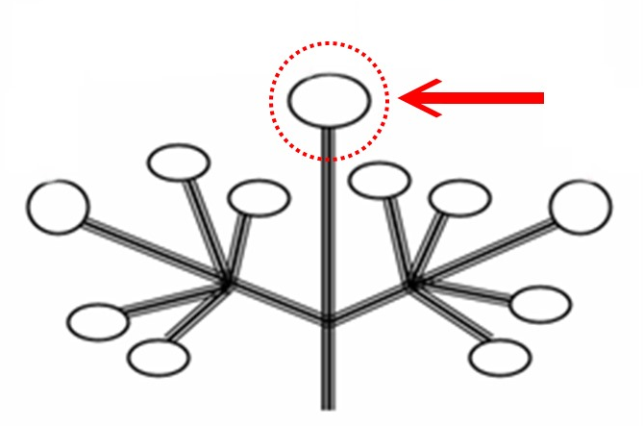

8.2 Explanations for individual characteristics
Ad. 1: Plant: growth habit

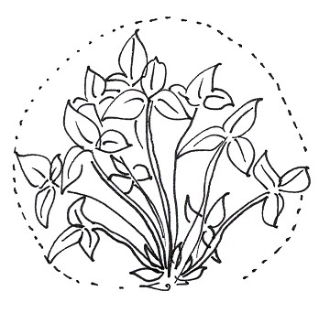 | 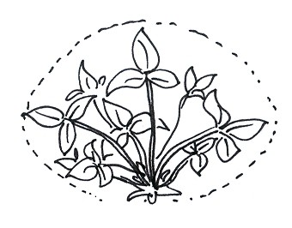 | 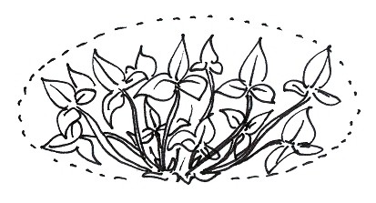
1 | 2 | 3
upright | semi-upright | spreading

Ad. 2: Plant: density of foliage

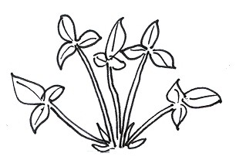 | 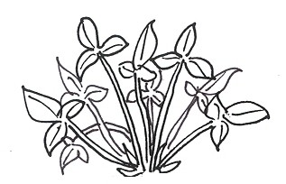 | 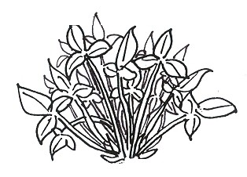
3 | 5 | 7
sparse | medium | dense

Ad. 3: Plant: vigor

The plant vigor should be considered as the overall abundance of vegetative growth.

Ad. 6: Stolon: anthocyanin coloration

The anthocyan coloration should be observed on the middle third of the stolon.

Ad. 8: Leaf: size
size of leaf

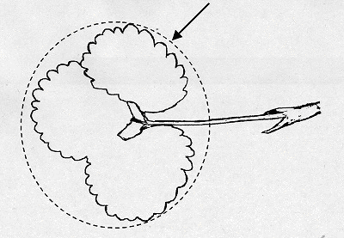

The size of leaf excludes the petiole and stipules.

Ad. 10: Leaf: blistering

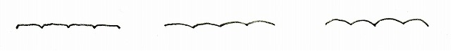
1 | 2 | 3
absent or weak | medium | strong

Ad. 14: Terminal leaflet: shape of base
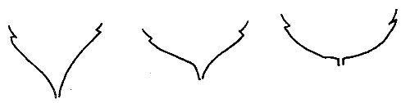

1 | 2 | 3
acute | obtuse | rounded
Ad. 15: Terminal leaflet: margin
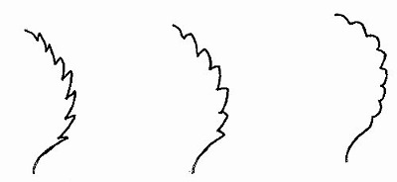

1 | 2 | 3
serrate | serrate to crenate | crenate

Ad. 16: Terminal leaflet: shape in cross section



1 | 2 | 3
concave | straight | convex

Ad. 18: Petiole: attitude of hairs
Ad. 21: Pedicel: attitude of hairs

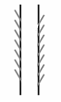 | 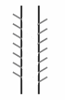 | 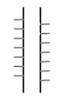
1 | 2 | 3
upwards | slightly outwards | horizontal

Ad. 23: Flower: arrangement of petals
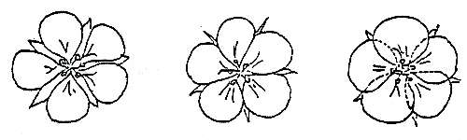
1 |  | 2 |  | 3
free |  | touching |  | overlapping
Ad. 24: Flower: size of calyx in relation to corolla

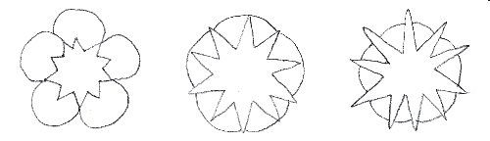
1 |  | 2 |  | 3
smaller |  | same size |  | larger

Ad. 29: Fruit: size

The fruit size is determined by the length, height and thickness.

Ad. 30: Fruit: shape
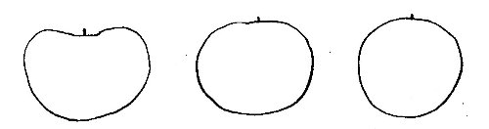 |  | 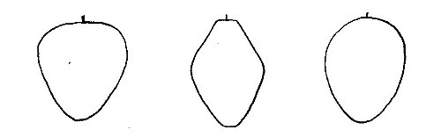 |  | 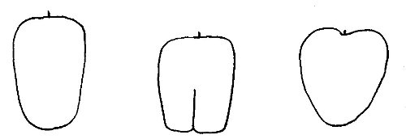
1 |  | 2 |  | 3
reniform |  | conical |  | cordate

4 |  | 5 |  | 6
ovoid |  | cylindrical |  | rhomboid

7 |  | 8 |  | 9
obloid |  | globose |  | wedged
Ad. 31: Fruit: difference in shape of terminal and other fruits

The diagram in Chapter 8.1 (d) illustrates the terminal and other fruits.

Ad. 33: Fruit: evenness of color

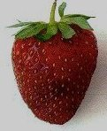 |  | 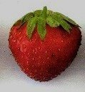 |  | 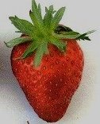
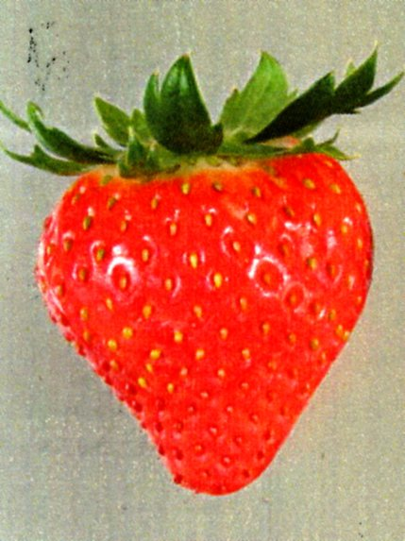 |  | 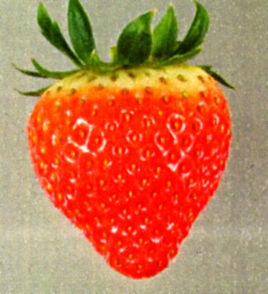 |  | 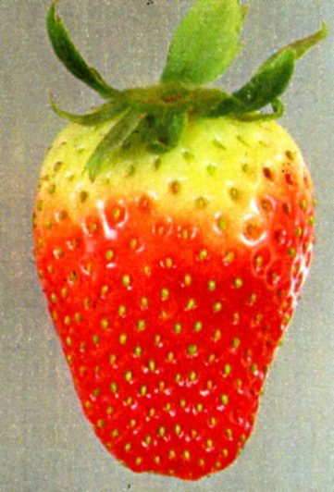
1 |  | 2 |  | 3
even or very slightly uneven |  | slightly uneven |  | strongly uneven

Ad. 35: Fruit: evenness of surface

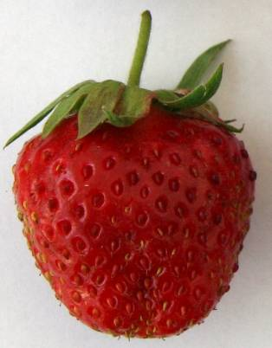 |  | 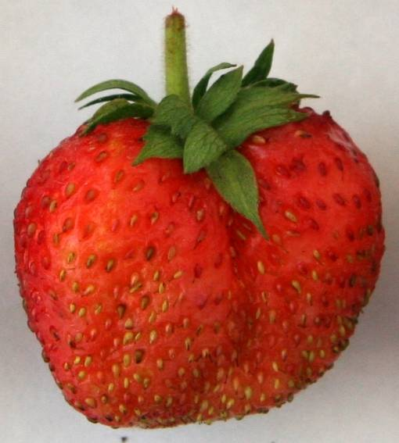 |  | 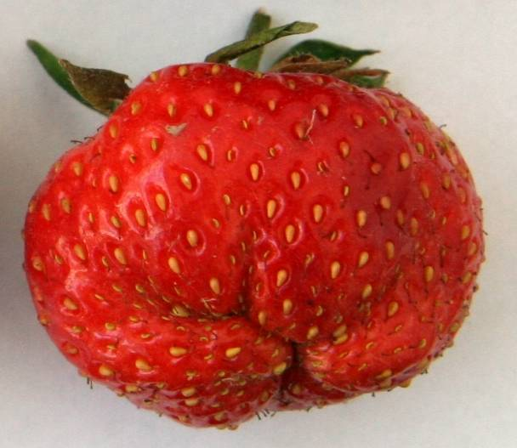
1 |  | 2 |  | 3
even or very slightly uneven |  | slightly uneven |  | strongly uneven

Ad. 36: Fruit: width of band without achenes

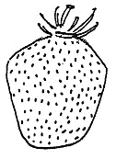 |  | 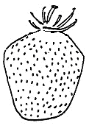 |  | 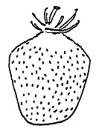
1 |  | 3 |  | 5
absent or very narrow |  | narrow |  | medium

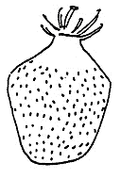 |  | 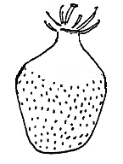
7 |  | 9
broad |  | very broad

Ad. 37: Fruit: position of achenes

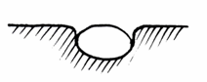 | 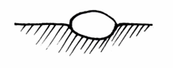 | 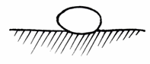
1 | 2 | 3
below surface | level with surface | above surface

Ad. 38: Fruit: position of calyx attachment

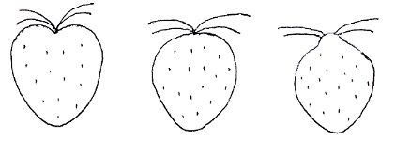
1 | 2 | 3
inserted | level with fruit | raised
Ad. 39: Fruit: attitude of sepals
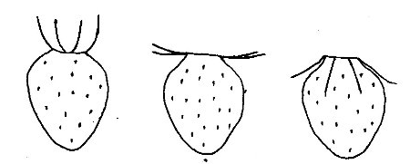
1 | 2 | 3
upwards | outwards | downwards

Ad. 40: Fruit: diameter of calyx in relation to diameter of fruit

The diameter of calyx is measured with the sepals held flat.

Ad. 43: Fruit: color of flesh (excluding core)
Ad. 44: Fruit: color of core
core
flesh

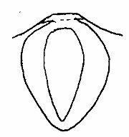

Ad. 47: Time of beginning of fruit ripening

The time when the first fruit in the first cluster ripen.

Ad. 48: Type of bearing

Not remontant: Flowering and fruiting only once in a season;
Partly remontant: The potential to flower and fruit twice in a season, but strongly influenced by the environment;
Fully remontant: Flowering and fruiting twice in a season, largely irrespective of the environment;
Day neutral: Flowering and fruiting multiple times, continuously in a season. Do not require decreasing day length for flower induction. In cases where stolons are observed, therefore, stolons produce flowers and fruits in the same season as the plant producing the stolon.

Literature
Baldini, E., Branzanti, E.C., 1964: Monografia delle principali cultivar di fragola non rifiorenti. Ist, Coltiv. Arboree, Università, Bologna, IT, 240 pp.

Bazzocchi, R., Branzanti, E.C., Cristoferi, G., Rosati, P., 1972: Monografia delle principali cultivar di fragola non rifiorenti, (2○), C.N.R., Bologna, IT, 226 pp.

Brossier, J.-O., 1962: Variétés de fraisiers non remontantes inscrites au catalogue des espèces et variétés, leur détermination et leur description. Institut national de la recherche agronomique (INRA), Paris, FR.

Bundessortenamt (ed.), 1995: Beschreibende Sortenliste Beerenobst. Landbuch Verlag, Hannover, DE, 131 pp.

Centre technique interprofessionnel des fruits et légumes (ed.), 1997: La fraise - Plant et variétés. Paris, FR, 103 pp.

Dale, A.; Luby, J.J., 1990: The strawberry into the 21st century - Proceedings of the Third North American Strawberry Conference. Houston, Texas. Timber Press, Portland, Oregon, US.

Fischer, M., 1995: Farbatlas Obstsorten. Eugen Ulmer Verlag, Stuttgart, DE.

Götz, G., Silbereisen, R., 1989: Obstsorten-Atlas Kernobst, Steinobst, Beerenobst, Schalenobst. Eugen Ulmer GmbH & Co.

Groupe d'Étude de contrôle des variétés et des Semences (GEVES), 2003: Les Variétés de Fraisier - anciennes, actuelles, nouvelles (CD-ROM). La Miniére, FR.

Japan Seed Trade Association, 1978: The report on the characterization and classification of strawberry varieties, Japan Seed Trade Association, Tokyo (by consignment of the MAFF), JP, 20 pp.

Müllier, Bissmann, Poenicke, Rosenthal, Schindler: Deutschlands Obstsorten. Bd. 7, Fachhandel für Gartenbau, Kötzschenbroda-Dresden, Winzerstr. 55, DE.

Naumann, W.-D; Seipp, D.; 1989: Erdbeeren. Ulmer Verlag, Stuttgart, DE, 256 pp.

Sorge, P., 1984: Beerenobstsorten. Neumann Verlag, Leipzig-Radebeul, DE, 259 pp.

Technical Questionnaire
TECHNICAL QUESTIONNAIRE |  |  | Page {x} of {y} | Reference Number:
 |  |  |  | Application date:
 |  |  |  | (not to be filled in by the applicant)
TECHNICAL QUESTIONNAIRE
to be completed in connection with an application for plant breeders’ rights

1. Subject of the Technical Questionnaire
1.1 Genus
1.1.1 Botanical name |  | Fragaria L.
1.1.2 Common name |  | Strawberry
1.2 Species / Group
(please complete)
2. Applicant
Name
Address
Telephone No.
Fax No.
E-mail address
Breeder (if different from applicant)
3. Proposed denomination and breeder’s reference
Proposed denomination
(if available)

Breeder’s reference
#4. Information on the breeding scheme and propagation of the variety

4.1 Breeding scheme

Variety resulting from:

4.1.1 Crossing

(a) controlled cross [ ]
(please state parent varieties)
(b) partially known cross [ ]
(please state known parent variety(ies))
(c) unknown cross [ ]

4.1.2 Mutation [ ]
(please state parent variety)

4.1.3 Discovery and development [ ]
(please state where and when discovered
and how developed)

4.1.4 Other [ ]
(please provide details)

  - Method of propagating the variety

4.2.1 Vegetative propagation

(a) cuttings [ ]

(b) in vitro propagation [ ]

(c) other (state method) [ ]

4.2.2 Seed [ ]

4.2.3 Other [ ]
(please provide details)

5. Characteristics of the variety to be indicated (the number in brackets refers to the corresponding characteristic in Test Guidelines; please mark the note which best corresponds).

 | Characteristics |  |  |  | Example Varieties |  | Note
5.1  (1) | Plant: growth habit
 | upright |  |  |  | Benton, Darselect, Gorella |  | 1[ ]
 | semi-upright |  |  |  | Cirafine,  Senga Sengana |  | 2[ ]
 | spreading |  |  |  | Darsidor, Pantagruella |  | 3[ ]
5.2  (27) | Petal: color of upper side
 | greenish white |  |  |  |  |  | 1[ ]
 | white |  |  |  | Gariguette |  | 2[ ]
 | pink |  |  |  | Frel, Marajox, Pikan |  | 3[ ]
 | red |  |  |  | Tarpan |  | 4[ ]
5.3  (29) | Fruit: size
 | very small |  |  |  | Astino, Frel |  | 1[ ]
 | small |  |  |  | Senga Precosa |  | 3[ ]
 | medium |  |  |  | Mara des Bois,  Senga Tigaiga |  | 5[ ]
 | large |  |  |  | Darselect, Domanil |  | 7[ ]
 | very large |  |  |  | Maxim |  | 9[ ]
 | Characteristics |  |  |  | Example Varieties |  | Note
5.4  (30) | Fruit: shape
 | reniform |  |  |  | Early Dawn, Favette |  | 1[ ]
 | conical |  |  |  | Gorella, Matis |  | 2[ ]
 | cordate |  |  |  | Direktor Paul Wallbaum |  | 3[ ]
 | ovoid |  |  |  | Florika,  Macherauchs Frühernte |  | 4[ ]
 | cylindrical |  |  |  | Chandler, Marie France |  | 5[ ]
 | rhomboid |  |  |  | Gariguette, Pantagruella |  | 6[ ]
 | obloid |  |  |  | Elista |  | 7[ ]
 | globose |  |  |  | Grande,  Madame Moutot |  | 8[ ]
 | wedged |  |  |  | Georg Soltwedel |  | 9[ ]
5.5  (32) | Fruit: color
 | whitish yellow |  |  |  | Weisse Ananas |  | 1[ ]
 | light orange |  |  |  | Madame Moutot, Merton Dawn |  | 2[ ]
 | medium orange |  |  |  | Cambridge Favourite |  | 3[ ]
 | orange red |  |  |  | Ciflorette, Gorella |  | 4[ ]
 | medium red |  |  |  | Elsanta,  Royal Sovereign |  | 5[ ]
 | dark red |  |  |  | Seascape,  Senga Sengana |  | 6[ ]
 | blackish red |  |  |  | Honey Oya, Rubina |  | 7[ ]
 | Characteristics |  |  |  | Example Varieties |  | Note
5.6  (48) | Type of bearing
 | not remontant |  |  |  | Cambridge Favourite, Gariguette |  | 1[ ]
 | partially remontant |  |  |  | Redgauntlet,  Sweet Charlie |  | 2[ ]
 | fully remontant |  |  |  | Brighton, Cirafine,  Mara des Bois |  | 3[ ]
 | day neutral |  |  |  | Florika |  | 4[ ]

 | TECHNICAL QUESTIONNAIRE |  | Page {x} of {y} |  | Reference Number:
6. Similar varieties and differences from these varieties

Please use the following table and box for comments to provide information on how your candidate variety differs from the variety (or varieties) which, to the best of your knowledge, is (or are) most similar. This information may help the examination authority to conduct its examination of distinctness in a more efficient way.

 | Denomination(s) of variety(ies) similar to your candidate variety | Characteristic(s) in which your candidate variety differs from the similar variety(ies) |  | Describe the expression of the characteristic(s) for the similar variety(ies) |  | Describe the expression of the characteristic(s) for your candidate variety
 | Example | Fruit color |  | orange red |  | orange
 | Comments:
#7. Additional information which may help in the examination of the variety

7.1 In addition to the information provided in sections 5 and 6, are there any additional characteristics which may help to distinguish the variety?

Yes [ ] No [ ]

(If yes, please provide details)

7.2 Are there any special conditions for growing the variety or conducting the examination?

Yes [ ] No [ ]

(If yes, please provide details)

7.3 Main use

(a) Fruit [ ]

(b) Ornamental [ ]

7.4 A representative color photograph of the variety should accompany the Technical Questionnaire.

8. Authorization for release

(a) Does the variety require prior authorization for release under legislation concerning the protection of the environment, human and animal health?

Yes [ ] No [ ]

(b) Has such authorization been obtained?

Yes [ ] No [ ]

If the answer to (b) is yes, please attach a copy of the authorization.

9. Information on plant material to be examined or submitted for examination.

9.1 The expression of a characteristic or several characteristics of a variety may be affected by factors, such as pests and disease, chemical treatment (e.g. growth retardants or pesticides), effects of tissue culture, different rootstocks, scions taken from different growth phases of a tree, etc.

9.2 The plant material should not have undergone any treatment which would affect the expression of the characteristics of the variety, unless the competent authorities allow or request such treatment. If the plant material has undergone such treatment, full details of the treatment must be given. In this respect, please indicate below, to the best of your knowledge, if the plant material to be examined has been subjected to:

(a) Microorganisms (e.g. virus, bacteria, phytoplasma) Yes [ ] No [ ]

(b) Chemical treatment (e.g. growth retardant, pesticide) Yes [ ] No [ ]

(c) Tissue culture Yes [ ] No [ ]

(d) Other factors Yes [ ] No [ ]

Please provide details for where you have indicated “yes”.

……………………………………………………………

9.3 Has the plant material to be examined been tested for the presence of virus or other pathogens?

Yes [ ]
(please provide details as specified by the Authority)

No [ ]

10. I hereby declare that, to the best of my knowledge, the information provided in this form is correct:

Applicant’s name

Signature Date

[End of document]

* These names were correct at the time of the introduction of these Test Guidelines but may be revised or updated. [Readers are advised to consult the UPOV Code, which can be found on the UPOV Website (www.upov.int), for the latest information.]
# Authorities may allow certain of this information to be provided in a confidential section of the Technical Questionnaire.
# Authorities may allow certain of this information to be provided in a confidential section of the Technical Questionnaire.

