 |  | E
 | 
  TG/14/10
  ORIGINAL: English
  DATE: 2023-10-24
INTERNATIONAL UNION FOR THE PROTECTION OF NEW VARIETIES OF PLANTS
 | Geneva
  APPLE
  (Fruit Varieties)
  UPOV Code(s): MALUS_DOM
  Malus domestica (Suckow) Borkh.
  *
GUIDELINES
FOR THE CONDUCT OF TESTS
FOR DISTINCTNESS, UNIFORMITY AND STABILITY

Alternative names:*

Botanical name | English | French | German | Spanish
  Malus domestica (Suckow) Borkh.
  Apple
  Pommier,
  Pommier commun
  Apfel
  Manzano

The purpose of these guidelines (“Test Guidelines”) is to elaborate the principles contained in the General Introduction (document TG/1/3), and its associated TGP documents, into detailed practical guidance for the harmonized examination of distinctness, uniformity and stability (DUS) and, in particular, to identify appropriate characteristics for the examination of DUS and production of harmonized variety descriptions.

ASSOCIATED DOCUMENTS
These Test Guidelines should be read in conjunction with the General Introduction and its associated TGP documents.
Other associated UPOV documents:
  TG/163 Apple Rootstocks
  TG/192 Ornamental Apple

TABLE OF CONTENTS | PAGE
1. | SUBJECT OF THESE TEST GUIDELINES.......................................................................................................... | 3
2. | MATERIAL REQUIRED......................................................................................................................................... | 3
3. | METHOD OF EXAMINATION................................................................................................................................ | 3
3.1 | Number of Growing Cycles........................................................................................................................ | 3
3.2 | Testing Place............................................................................................................................................. | 3
3.3 | Conditions for Conducting the Examination............................................................................................... | 3
3.4 | Test Design................................................................................................................................................ | 4
3.5 | Additional Tests......................................................................................................................................... | 4

4. | ASSESSMENT OF DISTINCTNESS, UNIFORMITY AND STABILITY................................................................. | 4
4.1 | Distinctness............................................................................................................................................... | 4
4.2 | Uniformity.................................................................................................................................................. | 5
4.3 | Stability...................................................................................................................................................... | 5

5. | GROUPING OF VARIETIES AND ORGANIZATION OF THE GROWING TRIAL................................................ | 6
6. | INTRODUCTION TO THE TABLE OF CHARACTERISTICS................................................................................ | 6
6.1 | Categories of Characteristics..................................................................................................................... | 6
6.2 | States of Expression and Corresponding Notes........................................................................................ | 6
6.3 | Types of Expression.................................................................................................................................. | 6
6.4 | Example Varieties...................................................................................................................................... | 7
6.5 | Legend....................................................................................................................................................... | 7

7. | TABLE OF CHARACTERISTICS/TABLEAU DES CARACTÈRES/MERKMALSTABELLE/TABLA DE CARACTERES...................................................................................................................................................... | 8
8. | EXPLANATIONS ON THE TABLE OF CHARACTERISTICS............................................................................... | 26
8.1 | Explanations covering several characteristics........................................................................................... | 26
 | Explanations for individual characteristics................................................................................................. | 26
  8.2
8.3 | BBCH-Scale for the description of the phenological growth stages of pome fruit…………………………. | 36

9. | LITERATURE......................................................................................................................................................... | 38
10. | TECHNICAL QUESTIONNAIRE............................................................................................................................ | 39

1. | Subject of these Test Guidelines
  These Test Guidelines apply to all varieties of Malus domestica (Suckow) Borkh. except for varieties used only as rootstock varieties (see TG/163) or only as ornamental varieties (see TG/192).

2. | Material Required
2.1
  The competent authorities decide on the quantity and quality of the plant material required for testing the variety and when and where it is to be delivered. Applicants submitting material from a State other than that in which the testing takes place must ensure that all customs formalities and phytosanitary requirements are complied with.
2.2
  The material is to be supplied in the form of trees, on a rootstock specified by the competent authority, or in the form of budsticks or graftwood.
2.3
  The minimum quantity of plant material, to be supplied by the applicant, should be:
(a) varieties resulting from crossing:
5 trees, budsticks or shoots for grafting;
(b) varieties resulting from mutation:
10 trees, budsticks or shoots for grafting.

2.4
  The plant material supplied should be visibly healthy, not lacking in vigor, nor affected by any important pest or disease.
2.5
  The plant material should not have undergone any treatment which would affect the expression of the characteristics of the variety, unless the competent authorities allow or request such treatment. If it has been treated, full details of the treatment must be given.

3. | Method of Examination
3.1 | Number of Growing Cycles
 | The minimum duration of tests should normally be two independent growing cycles.
  3.1.1
 | The two independent growing cycles may be observed from a single planting, examined in two separate growing cycles.
  3.1.2
  3.1.3
  In particular, it is essential that the trees produce a satisfactory crop of fruit in each of the two growing cycles.
  3.1.4
  The growing cycle is considered to be the duration of a single growing season, beginning with the dormancy period, followed by bud burst (flowering and/or vegetative), flowering and fruit harvest and concluding when the following dormant period starts.
 | The testing of a variety may be concluded when the competent authority can determine with certainty the outcome of the test.
  3.1.5
3.2 | Testing Place
 | Tests are normally conducted at one place. In the case of tests conducted at more than one place, guidance is provided in TGP/9 “Examining Distinctness”.
3.3 | Conditions for Conducting the Examination
 | The tests should be carried out under conditions ensuring satisfactory growth for the expression of the relevant characteristics of the variety and for the conduct of the examination.
  3.3.1
3.3.2 | The optimum stage of development for the assessment of each characteristic is indicated by a number in the Table of Characteristics. The stages of development denoted by each number are described in Chapter 8.3

3.4 | Test Design
  3.4.1
  In the case of varieties resulting from crossing, each test should be designed to result in a total of at least 5 trees.
  3.4.2
  In the case of varieties resulting from mutation, each test should be designed to result in a total of at least 10 trees.

  3.4.3
  The design of the tests should be such that plants or parts of plants may be removed for measurement or counting without prejudice to the observations which must be made up to the end of the growing cycle.
3.5 | Additional Tests
 | Additional tests, for examining relevant characteristics, may be established.

4. | Assessment of Distinctness, Uniformity and Stability
4.1 | Distinctness
4.1.1 | General Recommendations
 | It is of particular importance for users of these Test Guidelines to consult the General Introduction prior to making decisions regarding distinctness. However, the following points are provided for elaboration or emphasis in these Test Guidelines.
4.1.2 | Consistent Differences
 | The differences observed between varieties may be so clear that more than one growing cycle is not necessary. In addition, in some circumstances, the influence of the environment is not such that more than a single growing cycle is required to provide assurance that the differences observed between varieties are sufficiently consistent. One means of ensuring that a difference in a characteristic, observed in a growing trial, is sufficiently consistent is to examine the characteristic in at least two independent growing cycles.
4.1.3 | Clear Differences
 | Determining whether a difference between two varieties is clear depends on many factors, and should consider, in particular, the type of expression of the characteristic being examined, i.e. whether it is expressed in a qualitative, quantitative, or pseudo-qualitative manner. Therefore, it is important that users of these Test Guidelines are familiar with the recommendations contained in the General Introduction prior to making decisions regarding distinctness.
4.1.4
  Number of Plants or Parts of Plants to be Examined
  Unless otherwise indicated, for the purposes of distinctness, all observations on single plants should be made on 3 plants or parts of plants taken from each of 3 plants and any other observations made on all plants in the test, disregarding any off-type plants.
4.1.5 | Method of Observation
 | The recommended method of observing the characteristic for the purposes of distinctness is indicated by the following key in the Table of Characteristics (see document TGP/9 “Examining Distinctness”, Section 4 “Observation of characteristics”):

MG: single measurement of a group of plants or parts of plants
MS: measurement of a number of individual plants or parts of plants
VG: visual assessment by a single observation of a group of plants or parts of plants
VS: visual assessment by observation of individual plants or parts of plants

 | Type of observation: visual (V) or measurement (M)
 | “Visual” observation (V) is an observation made on the basis of the expert’s judgment. For the purposes of this document, “visual” observation refers to the sensory observations of the experts and, therefore, also includes smell, taste and touch. Visual observation includes observations where the expert uses reference points (e.g. diagrams, example varieties, side-by-side comparison) or non-linear charts (e.g. color charts). Measurement (M) is an objective observation against a calibrated, linear scale e.g. using a ruler, weighing scales, colorimeter, dates, counts, etc.
  Type of record: for a group of plants (G) or for single, individual plants (S)
  For the purposes of distinctness, observations may be recorded as a single record for a group of plants or parts of plants (G), or may be recorded as records for a number of single, individual plants or parts of plants (S). In most cases, “G” provides a single record per variety and it is not possible or necessary to apply statistical methods in a plant-by-plant analysis for the assessment of distinctness.
 | In cases where more than one method of observing the characteristic is indicated in the Table of Characteristics (e.g. VG/MG), guidance on selecting an appropriate method is provided in document TGP/9, Section 4.2.
4.2 | Uniformity
4.2.1 | It is of particular importance for users of these Test Guidelines to consult the General Introduction prior to making decisions regarding uniformity. However, the following points are provided for elaboration or emphasis in these Test Guidelines:
  4.2.2
  These Test Guidelines have been developed for the examination of vegetatively propagated varieties. For varieties with other types of propagation, the recommendations in the General Introduction and document TGP/13 "Guidance for new types and species" Section 4.5 "Testing Uniformity" should be followed.
4.2.3
  For the assessment of uniformity of varieties resulting from crossing, a population standard of 1% and an acceptance probability of at least 95% should be applied. In the case of a sample size of 5 plants, no off-types are allowed.
4.2.4
  For the assessment of uniformity of varieties resulting from mutation, a population standard of 1% and an acceptance probability of at least 95% should be applied. In the case of a sample size of 10 plants, 1 off-type is allowed.
4.3 | Stability
4.3.1 | In practice, it is not usual to perform tests of stability that produce results as certain as those of the testing of distinctness and uniformity. However, experience has demonstrated that, for many types of variety, when a variety has been shown to be uniform, it can also be considered to be stable.
4.3.2 | Where appropriate, or in cases of doubt, stability may be further examined by testing a new plant stock to ensure that it exhibits the same characteristics as those shown by the initial material supplied.

5. | Grouping of Varieties and Organization of the Growing Trial
5.1 | The selection of varieties of common knowledge to be grown in the trial with the candidate varieties and the way in which these varieties are divided into groups to facilitate the assessment of distinctness are aided by the use of grouping characteristics.
5.2 | Grouping characteristics are those in which the documented states of expression, even where produced at different locations, can be used, either individually or in combination with other such characteristics: (a) to select varieties of common knowledge that can be excluded from the growing trial used for examination of distinctness; and (b) to organize the growing trial so that similar varieties are grouped together.
5.3 | The following have been agreed as useful grouping characteristics:
  (a)
  Tree: type (characteristic 2)
  (b)
  Only varieties with Tree type: ramified: Tree: habit (characteristic 3)
  (c)
  Fruit: shape (characteristic 26)
  (d)
  Fruit: hue of over color (characteristic 30)
  (e)
  Fruit: relative area of over color (characteristic 32)
  (f)
  Fruit: pattern of over color (characteristic 33)
  (g)
  Fruit: main color of flesh (characteristic 45)
  (h)
  Time of beginning of flowering (characteristic 49)
  (i)
  Time of eating maturity (characteristic 51)

5.4 | Guidance for the use of grouping characteristics, in the process of examining distinctness, is provided through the General Introduction and document TGP/9 “Examining Distinctness”.

6. | Introduction to the Table of Characteristics
6.1 | Categories of Characteristics
6.1.1 | Standard Test Guidelines Characteristics
 | Standard Test Guidelines characteristics are those which are approved by UPOV for examination of DUS and from which members of the Union can select those suitable for their particular circumstances.
6.1.2 | Asterisked Characteristics

 | Asterisked characteristics (denoted by *) are those included in the Test Guidelines which are important for the international harmonization of variety descriptions and should always be examined for DUS and included in the variety description by all members of the Union, except when the state of expression of a preceding characteristic or regional environmental conditions render this inappropriate.
6.2 | States of Expression and Corresponding Notes
6.2.1 | States of expression are given for each characteristic to define the characteristic and to harmonize descriptions. Each state of expression is allocated a corresponding numerical note for ease of recording of data and for the production and exchange of the description.
6.2.2 | All relevant states of expression are presented in the characteristic.
6.2.3 | Further explanation of the presentation of states of expression and notes is provided in document TGP/7 “Development of Test Guidelines”.
6.3 | Types of Expression
 | An explanation of the types of expression of characteristics (qualitative, quantitative and pseudo-qualitative) is provided in the General Introduction.

6.4 | Example Varieties
Where appropriate, example varieties are provided to clarify the states of expression of each characteristic.

Other Names of the Example Varieties:

Example varieties | Synonyms
Api Noir | Schwarzer Noir
Auralia | Tumanga
Canada gris | Kanadarenette; Reinette de Caen
Cox's Orange Pippin | Cox Orangenrenette
Gloster | Gloster 69
Golden Delicious | Gelber Köstlicher
Ingrid Marie | Hoed Orange
Rambour d'Hiver  Tenroy | Rheinischer Winterrambur  Royal Gala
Teser | TSR 29
Transparente de Croncels | Yellow Transparent
Šampion | Shampion
Schone van Boskoop | Belle de Boskoop; Schöner aus Boskoop
Tenroy | Royal Gala
White Transparent | Papirovka, Transparente Jaune, Weißer Klarapfel

6.5 | Legend
 |  | English |  | français |  | deutsch | español | Example Varieties  Exemples  Beispielssorten  Variedades ejemplo | Note/  Nota
  1
  2
  3
  4
  5
  6
  7
  Name of characteristics in English
  Nom du caractère en français
  Name des Merkmals auf Deutsch
  Nombre del carácter en español
  states of expression
  types d’expression
  Ausprägungsstufen
  tipos de expresión

1 | Characteristic number
2 | (*) | Asterisked characteristic | – see Chapter 6.1.2
3 | Type of expression
 | QL | Qualitative characteristic | – see Chapter 6.3
 | QN | Quantitative characteristic | – see Chapter 6.3
 | PQ | Pseudo-qualitative characteristic | – see Chapter 6.3
4 | Method of observation (and type of plot, if applicable)
 | MG, MS, VG, VS |  | – see Chapter 4.1.5
5
  (+)
  See Explanations on the Table of Characteristics in Chapter 8.2
6
  (a)-(f)
  See Explanations on the Table of Characteristics in Chapter 8.1
7
  Growth stage key See Explanations on the Table of Characteristics in Chapter 8.3

7. | Table of Characteristics/Tableau des caractères/Merkmalstabelle/Tabla de caracteres

 |  | English |  | français |  | deutsch | español | Example Varieties  Exemples  Beispielssorten  Variedades ejemplo | Note/  Nota
1. |  | QN | MG/VG | (+) |  | 00 or 39
  Tree: vigor
  Arbre : vigueur
  Baum: Wuchsstärke
  Árbol: vigor
 |  | very weak |  | très faible |  | sehr gering | muy débil | Grenadier,  Nield’s Drooper | 1
 |  | very weak to weak |  | très faible à faible |  | sehr gering bis gering | muy débil a débil | James Grieve, Redkan | 2
 |  | weak |  | faible |  | gering | débil | Alkmene, Regine | 3
 |  | weak to medium |  | faible à moyenne |  | gering bis mittel | débil a medio | Piros, Pomforyou, Renora | 4
 |  | medium |  | moyenne |  | mittel | medio | Gala, Pinova, Trajan | 5
 |  | medium to strong |  | moyenne à forte |  | mittel bis stark | medio a fuerte | Dalili, Pia, Pivita | 6
 |  | strong |  | forte |  | stark | fuerte | Elstar, Rafzubin, Santana | 7
 |  | strong to very strong |  | forte à très forte |  | stark bis sehr stark | fuerte a muy fuerte | Bay 3484, Collina,  Cripps Pink | 8
 |  | very strong |  | très forte |  | sehr stark | muy fuerte | Gloster, Ingrid Marie | 9
2. | (*) | QL | VG | (+) | (a) | 00
  Tree: type
  Arbre : type
  Baum: Typ
  Árbol: tipo
 |  | columnar |  | colonnaire |  | säulenförmig | columnar | MacExcel, Wijcik | 1
 |  | ramified |  | ramifié |  | verzweigt | ramificado | Elstar, Golden Delicious | 2
3. | (*) | PQ | VG | (+) | (a) | 00
  Only varieties with Tree type: ramified: Tree: habit
  Seulement les variétés avec Type d'arbre : ramifié : Arbre : port
  Nur Sorten mit Baumtyp: verzweigt: Baum: Wuchsform
  Solo variedades con Árbol tipo: ramificado: Árbol: hábito
 |  | upright |  | dressé |  | aufrecht | erguido | Alkmene, Fresco, Solaris | 1
 |  | upright to spreading |  | dressé à étalé |  | aufrecht bis auseinanderfallend | erguido a extendido | Akane, Arkcharm, Harmensz, Katrina, Reka | 2
 |  | spreading |  | étalé |  | auseinanderfallend | extendido | Pinova, Redkan, Topaz | 3
 |  | drooping |  | retombant |  | herabhängend | colgante | Idared, James Grieve, Pivita | 4
 |  | weeping |  | pleureur |  | lang überhängend | llorón | Gerlinde, Nield’s Drooper | 5
4. | (*) | QN | MG/VG | (+) | (b) | 00
  One-year-old shoot: length of internode
  Rameau d'un an : longueur des entre-nœuds
  Einjähriger Trieb: Internodienlänge
  Rama de un año: longitud de los entrenudos
 |  | very short |  | très courte |  | sehr kurz | muy corta | MacExcel, Wijcik | 1
 |  | very short to short |  | très courte à courte |  | sehr kurz bis kurz | muy corta a corta | Alkmene, Coxcolumnar, Tuscan | 2
 |  | short |  | courte |  | kurz | corta | Florina | 3
 |  | short to medium |  | courte à moyenne |  | kurz bis mittel | corta a media | Ahrista, Margol | 4
 |  | medium |  | moyenne |  | mittel | media | Jonagold, Redaphough | 5
 |  | medium to long |  | moyenne à longue |  | mittel bis lang | media a larga | Constance, Crowngold, Nicoter, Stela | 6
 |  | long |  | longue |  | lang | larga | Auralia | 7
 |  | long to very long |  | longue à très longue |  | lang bis sehr lang | larga a muy larga | Angold | 8
 |  | very long |  | très longue |  | sehr lang | muy larga | Teser | 9
5. | (*) | QN | MG/VG | (+) | (b) | 00
  One-year-old shoot: number of lenticels
  Rameau d'un an : nombre de lenticelles
  Einjähriger Trieb: Anzahl Lentizellen
  Rama de un año: número de lenticelas
 |  | few |  | petit |  | gering | bajo | Alkmene,  Bramley’s Seedling | 1
 |  | medium |  | moyen |  | mittel | medio | Cox’s Orange Pippin | 2
 |  | many |  | élevé |  | groß | alto | Mutsu, SQ 159 | 3
6. | (*) | QN | VG | (+) | (c) | 71-77
  Leaf blade: attitude in relation to shoot
  Limbe : port par rapport au rameau
  Blattspreite: Haltung im Verhältnis zum Trieb
  Limbo: porte en relación con la rama
 |  | upwards |  | dressé |  | aufwärts gerichtet | ascendente | Delblush, Elstar, Fresco, Redkan, Santana | 1
 |  | upwards to outwards |  | dressé à perpendiculaire |  | aufwärts gerichtet bis abstehend | ascendente a horizontal | Jugala, Prem A 153, Resista, Sweet Lady | 2
 |  | outwards |  | perpendiculaire |  | abstehend | horizontal | Cripps Pink, Jonagold, Pinova, Pomforyou, Schone van Boskoop | 3
 |  | downwards |  | retombant |  | abwärts gerichtet | descendente | Fuji BC, Himekami, Rewena | 4
7. | (*) | QN | MG/VG | (+) | (c) | 71-77
  Leaf blade: length
  Limbe : longueur
  Blattspreite: Länge
  Limbo: longitud
 |  | very short |  | très courte |  | sehr kurz | muy corta | Mars, Reanda | 1
 |  | very short to short |  | très courte à courte |  | sehr kurz bis kurz | muy corta a corta | Coxcolumnar, Goldstar | 2
 |  | short |  | courte |  | kurz | corta | Ariwa, Gusto | 3
 |  | short to medium |  | courte à moyenne |  | kurz bis mittel | corta a media | Braeburn, Fuji BC, Topaz | 4
 |  | medium |  | moyenne |  | mittel | media | Cripps Red, Dalili, Elstar | 5
 |  | medium to long |  | moyenne à longue |  | mittel bis lang | media a larga | Jonagold, Pinova, Santana | 6
 |  | long |  | longue |  | lang | larga | Fresco, Minnewashta, Monidel | 7
 |  | long to very long |  | longue à très longue |  | lang bis sehr lang | larga a muy larga | Pomforyou, Pompink | 8
 |  | very long |  | très longue |  | sehr lang | muy larga | Northpole, Telamon | 9
8. | (*) | QN | MG/VG | (+) | (c) | 71-77
  Leaf blade: width
  Limbe : largeur
  Blattspreite: Breite
  Limbo: anchura
 |  | very narrow |  | très étroite |  | sehr schmal | muy estrecha | Coxdwarf | 1
 |  | very narrow to narrow |  | très étroite à étroite |  | sehr schmal bis schmal | muy estrecha a estrecha | Cox La Vera, Dalinco | 2
 |  | narrow |  | étroite |  | schmal | estrecha | Braeburn,  La Flamboyante | 3
 |  | narrow to medium |  | étroite à moyenne |  | schmal bis mittel | estrecha a media | Dalili, Dalinbel, Elstar, Topaz | 4
 |  | medium |  | moyenne |  | mittel | media | Cripps Red, Nicoter, Pinova, Santana | 5
 |  | medium to broad |  | moyenne à large |  | mittel bis breit | media a ancha | Cripps Pink, Jonagold, Rubinola, Zari | 6
 |  | broad |  | large |  | breit | ancha | Jonagored, Rubinstep | 7
 |  | broad to very broad |  | large à très large |  | breit bis sehr breit | ancha a muy ancha | Pomforyou | 8
 |  | very broad |  | très large |  | sehr breit | muy ancha | Charlotte, Northpole | 9
9. | (*) | QN | MG/VG | (+) | (c) | 71-77
  Leaf blade: ratio length/width
  Limbe : rapport longueur/largeur
  Blattspreite: Verhältnis Länge/Breite
  Limbo: relación longitud/anchura
 |  | very low |  | très bas |  | sehr klein | muy baja |  | 1
 |  | very low to low |  | très bas à bas |  | sehr klein bis klein | muy baja a baja | Reanda | 2
 |  | low |  | bas |  | klein | baja | Goldstar | 3
 |  | low to medium |  | bas à moyen |  | klein bis mittel | baja a media | Bay 3484, Rubinola | 4
 |  | medium |  | moyen |  | mittel | media | Cripps Pink, Rafzubin, Santana | 5
 |  | medium to high |  | moyen à élevé |  | mittel bis groß | media a alta | Braeburn, Cripps Red, Elstar, Pinova | 6
 |  | high |  | élevé |  | groß | alta | Fiesta, Minnewashta | 7
 |  | high to very high |  | élevé à très élevé |  | groß bis sehr groß | alta a muy alta | Civni, Monidel | 8
 |  | very high |  | très élevé |  | sehr groß | muy alta | Dalinco, Telamon | 9
10. |  | PQ | VG |  | (c) | 71-77
  Leaf blade: color
  Limbe : couleur
  Blattspreite: Farbe
  Limbo: color
 |  | light green |  | vert clair |  | hellgrün | verde claro |  | 1
 |  | light to medium green |  | vert clair à moyen |  | hellgrün bis mittelgrün | verde claro a medio | Maribelle | 2
 |  | medium green |  | vert moyen |  | mittelgrün | verde medio | Civni, Cripps Pink, Ecolette | 3
 |  | medium to dark green |  | vert moyen à foncé |  | mittelgrün bis dunkelgrün | verde medio a oscuro | Braeburn,  Karmijn de Sonnaville,  La Flamboyante, Pomforyou | 4
 |  | dark green |  | vert foncé |  | dunkelgrün | verde oscuro |  | 5
 |  | light purple red |  | rouge-pourpre clair |  | hellpurpurrot | rojo púrpura claro |  | 6
 |  | medium purple red |  | rouge-pourpre moyen |  | mittelpurpurrot | rojo púrpura medio |  | 7
 |  | dark purple red |  | rouge-pourpre foncé |  | dunkelpurpurrot | rojo púrpura oscuro | Luresweet, R201 | 8
11. |  | QN | VG |  | (c) | 71-77
  Leaf blade: glossiness
  Limbe : brillance
  Blattspreite: Glanz
  Limbo: brillo
 |  | absent or weak |  | absente ou faible |  | fehlend oder gering | ausente o débil | Blahova Libovice, Solaris | 1
 |  | medium |  | moyenne |  | mittel | medio | Elstar, Falstaff | 2
 |  | strong |  | forte |  | stark | fuerte | Elise, Fresco, Idared | 3
12. | (*) | QN | VG | (+) | (c) | 71-77
  Leaf blade: incisions of margin
  Limbe : incisions du bord
  Blattspreite: Randeinschnitte
  Limbo: incisiones del borde
 |  | crenate |  | crénelées |  | gekerbt | crenadas | Braeburn, Pinova, Santana | 1
 |  | crenate to serrate |  | crénelées à dentelées |  | gekerbt bis gesägt | crenadas a serradas | Ecolette, Elstar, Tenroy | 2
 |  | serrate |  | dentelées |  | gesägt | serradas | Fuji, Jonagold, Mutsu | 3
13. |  | PQ | VG | (+) | (c) | 71-77
  Leaf blade: shape in cross-section
  Limbe : forme en section transversale
  Blattspreite: Form im Querschnitt
  Limbo: forma en sección transversal
 |  | v-shaped |  | en forme de V |  | v-förmig | en forma de v | Frureru | 1
 |  | concave |  | concave |  | konkav | cóncava | Alkmene, Clivia, Gloster, Piros | 2
 |  | flat with reflexed margins |  | plate, avec des bords réfléchis |  | flach mit gebogenen Rändern | plana con bordes curvados | Rambour d’Hiver | 3
 |  | flat |  | plate |  | flach | plana | Bittenfelder Sämling, Minnewashta | 4
 |  | convex |  | convexe |  | konvex | convexa | Collina, Vicking | 5
14. | (*) | QN | MG/VG | (+) | (c) | 71-77
  Petiole: length
  Pétiole : longueur
  Blattstiel: Länge
  Peciolo: longitud
 |  | very short |  | très courte |  | sehr kurz | muy corta |  | 1
 |  | very short to short |  | très courte à courte |  | sehr kurz bis kurz | muy corta a corta | Jonagold | 2
 |  | short |  | courte |  | kurz | corta | Delgollune, Jonagored | 3
 |  | short to medium |  | courte à moyenne |  | kurz bis mittel | corta a media | Bay 3484, Dalinbel | 4
 |  | medium |  | moyenne |  | mittel | media | Cripps Pink, Ecolette, Nicoter, Pinova, Topaz | 5
 |  | medium to long |  | moyenne à longue |  | mittel bis lang | media a larga | Civni, Cripps Red, Elstar | 6
 |  | long |  | longue |  | lang | larga | Resista | 7
 |  | long to very long |  | longue à très longue |  | lang bis sehr lang | larga a muy larga | Pomforyou, Trajan | 8
 |  | very long |  | très longue |  | sehr lang | muy larga | Northpole, Pompink | 9
15. |  | QN | MG/VG | (+) | (c) | 71-77
  Leaf: ratio length of leaf blade / length of petiole
  Feuille : rapport longueur du limbe / longueur du pétiole
  Blatt: Verhältnis Blattspreitenlänge / Blattstiellänge
  Hoja: relación longitud del limbo / longitud del peciolo
 |  | very low |  | très bas |  | sehr klein | muy baja |  | 1
 |  | low |  | bas |  | klein | baja |  | 2
 |  | medium |  | moyen |  | mittel | media |  | 3
 |  | high |  | élevé |  | groß | alta |  | 4
 |  | very high |  | très élevé |  | sehr groß | muy alta |  | 5
16. |  | QN | VG |  | (c) | 71-77
  Petiole: extent of anthocyanin coloration from base
  Pétiole : étendue de la pigmentation anthocyanique depuis la base
  Blattstiel: Ausdehnung der Anthocyanfärbung von der Basis aus
  Peciolo: extensión de la pigmentación antociánica desde la base
 |  | absent or very small |  | absente ou très petite |  | fehlend oder sehr klein | ausente o muy pequeña | Befresh | 1
 |  | small |  | petite |  | klein | pequeña | Civni, Cripps Red, Jonagold | 2
 |  | medium |  | moyenne |  | mittel | media | Braeburn, Dalinbel, Pilot | 3
 |  | large |  | grande |  | groß | grande | Pomforyou, Scired | 4
 |  | very large |  | très grande |  | sehr groß | muy grande | Bay 3484 | 5
17. | (*) | QN | MG/VG | (+) | (d) | 60-65
  Flower: diameter
  Fleur : diamètre
  Blüte: Durchmesser
  Flor: diámetro
 |  | very small |  | très petit |  | sehr klein | muy pequeño | Spätblühender Taffetapfel | 1
 |  | small |  | petit |  | klein | pequeño | Pia, Pingo | 2
 |  | medium |  | moyen |  | mittel | medio | Civni, Elstar, Pinova | 3
 |  | large |  | grand |  | groß | grande | Delcorf, Rafzubin, Zari | 4
 |  | very large |  | très grand |  | sehr groß | muy grande | Astramel | 5
18. | (*) | QN | VG | (+) | (d) | 60-65
  Flower: arrangement of petals
  Fleur : disposition des pétales
  Blüte: Anordnung der Blütenblätter
  Flor: disposición de los pétalos
 |  | free |  | libre |  | freistehend | separada | Braeburn, Nicoter, Scifresh | 1
 |  | intermediate |  | intermédiaire |  | intermediär | intermedia | Civni, Elstar, Pinova, Topaz | 2
 |  | overlapping |  | chevauchante |  | überlappend | solapada | Cripps Red, Pomforyou, Šampion | 3
19. |  | QN | VG | (+) | (d) | 60-65
  Flower: position of stigmas relative to anthers
  Fleur : position des stigmates par rapport aux anthères
  Blüte: Stellung der Narben im Vergleich zu den Antheren
  Flor: posición de los estigmas en relación con las anteras
 |  | below |  | au-dessous |  | unterhalb | por debajo | Bay 3484, Braeburn, Pomforyou, Topaz | 1
 |  | same level |  | même niveau |  | auf gleicher Höhe | al mismo nivel | Cripps Pink, Ecolette, Pinova, Santana | 2
 |  | above |  | au-dessus |  | oberhalb | por encima | Civni, Elstar, Nicoter, Rafzubin | 3
20. |  | QN | VG | (+) | (d) | 65-69
  Flower: anthocyanin coloration at base of filament
  Fleur : pigmentation anthocyanique à la base du filament
  Blüte: Anthocyanfärbung an der Basis des Staubfadens
  Flor: pigmentación antociánica en la base de los estambres
 |  | absent or very weak |  | absente ou très faible |  | fehlend oder sehr gering | ausente o muy débil | Braeburn, Cripps Pink, Karneval, Minnewashta | 1
 |  | weak |  | faible |  | gering | débil | Bruggers Festivale, Dalinbel, Red Jonaprince | 2
 |  | medium |  | moyenne |  | mittel | media | Elstar | 3
 |  | strong |  | forte |  | stark | fuerte | Weirouge | 4
 |  | very strong |  | très forte |  | sehr stark | muy fuerte | Luregust | 5
21. |  | QN | VG |  |  | 73-74
  Young fruit: relative area of over color
  Jeune fruit : surface relative du lavis
  Junge Frucht: Anteil der Deckfarbe
  Fruto joven: zona relativa del color superficial
 |  | absent or very small |  | absente ou très petite |  | fehlend oder sehr gering | ausente o muy pequeña | Norhey | 1
 |  | very small to small |  | très petite à petite |  | sehr gering bis gering | muy pequeña a pequeña | Nicogreen | 2
 |  | small |  | petite |  | gering | pequeña | Cripps Pink, Delcorf, Nicoter | 3
 |  | small to medium |  | petite à moyenne |  | gering bis mittel | pequeña a media | Braeburn, Tenroy, Topaz | 4
 |  | medium |  | moyenne |  | mittel | media | Elstar, Golden Delicious | 5
 |  | medium to large |  | moyenne à grande |  | mittel bis hoch | media a grande | Pinova, Solaris | 6
 |  | large |  | grande |  | hoch | grande | Delblush, Rafzubin | 7
 |  | large to very large |  | grande à très grande |  | hoch bis sehr hoch | grande a muy grande | Jolana | 8
 |  | very large |  | très grande |  | sehr hoch | muy grande | Bay 3484, Luregust | 9
22. | (*) | QN | MG |  | (e) | 89
  Fruit: weight
  Fruit : poids
  Frucht: Gewicht
  Fruto: peso
 |  | very low |  | très faible |  | sehr niedrig | muy bajo | Api Noir | 1
 |  | very low to low |  | très faible à faible |  | sehr niedrig bis niedrig | muy bajo a bajo | Norhey | 2
 |  | low |  | faible |  | niedrig | bajo | Heco, Trajan | 3
 |  | low to medium |  | faible à moyen |  | niedrig bis mittel | bajo a medio | Bay 3484, Pomforyou | 4
 |  | medium |  | moyen |  | mittel | medio | Cripps Pink, Elstar, Pinova, Topaz | 5
 |  | medium to high |  | moyen à élevé |  | mittel bis hoch | medio a alto | Golden Delicious, Santana | 6
 |  | high |  | élevé |  | hoch | alto | Jonagold, Nicoter | 7
 |  | high to very high |  | élevé à très élevé |  | hoch bis sehr hoch | alto a muy alto | Nicogreen | 8
 |  | very high |  | très élevé |  | sehr hoch | muy alto | Howgate Wonder, Pisaxa | 9
23. | (*) | QN | MG/VG | (+) | (e) | 89
  Fruit: height
  Fruit : hauteur
  Frucht: Höhe
  Fruto: altura
 |  | very short |  | très courte |  | sehr niedrig | muy baja | Norhey | 1
 |  | very short to short |  | très courte à courte |  | sehr niedrig bis niedrig | muy baja a baja | Heco | 2
 |  | short |  | courte |  | niedrig | baja | Trajan | 3
 |  | short to medium |  | courte à moyenne |  | niedrig bis mittel | baja a media | Elstar, Pomforyou, Topaz | 4
 |  | medium |  | moyenne |  | mittel | media | Bay 3484,  La Flamboyante,  Santana | 5
 |  | medium to tall |  | moyenne à haute |  | mittel bis hoch | media a alta | Cripps Pink, Pinova, Šampion | 6
 |  | tall |  | haute |  | hoch | alta | Golden Delicious, Jonagold | 7
 |  | tall to very tall |  | haute à très haute |  | hoch bis sehr hoch | alta a muy alta | Pisaxa | 8
 |  | very tall |  | très haute |  | sehr hoch | muy alta | Befresh | 9
24. | (*) | QN | MG/VG | (+) | (e) | 89
  Fruit: diameter
  Fruit : diamètre
  Frucht: Durchmesser
  Fruto: diámetro
 |  | very small |  | très petit |  | sehr klein | muy pequeño | Nela, Scarlet Surprise, Summerred | 1
 |  | very small to small |  | très petit à petit |  | sehr klein bis klein | muy pequeño a pequeño | Heco | 2
 |  | small |  | petit |  | klein | pequeño |  | 3
 |  | small to medium |  | petit à moyen |  | klein bis mittel | pequeño a medio | Cox’s Orange Pippin, Cripps Pink, Dalili, Pomforyou | 4
 |  | medium |  | moyen |  | mittel | medio | Elstar, Pinova, Topaz | 5
 |  | medium to large |  | moyen à grand |  | mittel bis groß | medio a grande | Braeburn, Nicoter | 6
 |  | large |  | grand |  | groß | grande | Dalinbel, Jonagold | 7
 |  | large to very large |  | grand à très grand |  | groß bis sehr groß | grande a muy grande | Befresh, Ontario | 8
 |  | very large |  | très grand |  | sehr groß | muy grande | Bramley’s Seedling | 9
25. | (*) | QN | MG/VG |  | (e) | 89
  Fruit: ratio height/diameter
  Fruit : rapport hauteur/diamètre
  Frucht: Verhältnis Höhe/Durchmesser
  Fruto: relación altura/diámetro
 |  | very low |  | très bas |  | sehr klein | muy baja |  | 1
 |  | very low to low |  | très bas à bas |  | sehr klein bis klein | muy baja a baja | Brettacher, Ingol | 2
 |  | low |  | bas |  | klein | baja | Auralia, Harmensz | 3
 |  | low to medium |  | bas à moyen |  | klein bis mittel | baja a media | Dalinbel, Elstar,  Karmijn de Sonnaville | 4
 |  | medium |  | moyen |  | mittel | media | Ecolette, Fuji BC, Pomforyou, Santana | 5
 |  | medium to high |  | moyen à élevé |  | mittel bis groß | media a alta | Civni, Jonagold, Rafzubin | 6
 |  | high |  | élevé |  | groß | alta | Braeburn,  Golden Delicious, Pinova | 7
 |  | high to very high |  | élevé à très élevé |  | groß bis sehr groß | alta a muy alta | Cripps Pink, Dalili | 8
 |  | very high |  | très élevé |  | sehr groß | muy alta | Rewena, Saturn | 9
26. | (*) | PQ | VG | (+) | (e) | 89
  Fruit: shape
  Fruit : forme
  Frucht: Form
  Fruto: forma
 |  | flat globose conic |  | conique globuleuse plate |  | flach kugel-kegelförmig | plana globosa cónica | Melrose | 1
 |  | oblate |  | arrondie-aplatie |  | breitrund | achatada | Bramley’s Seedling, Lipno | 2
 |  | circular |  | circulaire |  | kreisförmig | circular | Dalinbel, Rubinola, Topaz | 3
 |  | elliptic |  | elliptique |  | elliptisch | elíptica | Fuji BC, Minnewashta | 4
 |  | square |  | équilatérale |  | quadratisch | cuadrada | Bonita | 5
 |  | oblong |  | oblongue |  | rechteckig | oblonga | Čadel, Renora | 6
 |  | ovate |  | ovale |  | eiförmig | oval | Cripps Pink, Delcorf | 7
 |  | conic |  | conique |  | kegelförmig | cónica | Civni, Elstar, Nicoter, Pinova, Rafzubin | 8
 |  | conic waisted |  | conique étranglée |  | tailliert kegelförmig | cónica entallada | Gloster, Redkan | 9
 |  | obconic |  | obconique |  | verkehrt kegelförmig | obcónica | Empire | 10
27. |  | QN | VG |  | (e) | 89
  Fruit: ribbing
  Fruit : côtes
  Frucht: Rippung
  Fruto: acostillado
 |  | absent or weak |  | absentes ou faibles |  | fehlend oder gering | ausente o débil | Elstar, Harmensz, Pinova, Scifresh, SQ 159 | 1
 |  | medium |  | moyennes |  | mittel | medio | Cripps Pink, Dalili, Pilot, Santana | 2
 |  | strong |  | fortes |  | stark | fuerte | Redkan | 3
28. |  | QN | VG |  | (e) | 89
  Fruit: crowning at calyx end
  Fruit : couronnement au sommet du calice
  Frucht: Höcker oder Wülste am Kelchende
  Fruto: coronado del extremo del cáliz
 |  | absent or weak |  | absent ou faible |  | fehlend oder gering | ausente o débil | Elstar, Fresco, Heco, Schone van Boskoop | 1
 |  | medium |  | moyen |  | mittel | medio | Luregust, Pinova, Santana, Scifresh, Topaz | 2
 |  | strong |  | fort |  | stark | fuerte | Redkan | 3
29. | (*) | PQ | VG | (+) | (e) | 89
  Fruit: ground color
  Fruit : couleur du fond
  Frucht: Grundfarbe
  Fruto: color de fondo
 |  | not visible |  | non visible |  | nicht sichtbar | no visible | Bay 3484, Lurefresh, Luregust, Red Jonaprince | 1
 |  | whitish yellow |  | jaune blanchâtre |  | weißlichgelb | amarillo blanquecino | Heco | 2
 |  | yellow |  | jaune |  | gelb | amarillo | Rea Gold, Scifresh, Solaris | 3
 |  | whitish green |  | vert blanchâtre |  | weißlichgrün | verde blanquecino | Fuji BC, MC 38, Pomforyou, Pompink | 4
 |  | yellow green |  | vert-jaune |  | gelbgrün | verde amarillento | Jonagold, Pia, Suntan | 5
 |  | green |  | vert |  | grün | verde | Canada gris,  Granny Smith, Ontario, Tuscan | 6
30. | (*) | PQ | VG | (+) | (e), (f) | 89
  Fruit: hue of over color
  Fruit : teinte du lavis
  Frucht: Ton der Deckfarbe
  Fruto: tono del color superficial
 |  | orange red |  | rouge orangé |  | orangerot | rojo anaranjado | Goldstar, Rea Gold, Solaris | 1
 |  | pink red |  | rouge-rose |  | rosarot | rojo rosado | Cripps Pink, Delorgue | 2
 |  | red |  | rouge |  | rot | rojo | Pinova, Prima,  Red Elstar, Tenroy | 3
 |  | purple red |  | rouge-pourpre |  | purpurrot | rojo púrpura | Bay 3484, Luresweet,  MC 38, Spartan | 4
 |  | brown red |  | rouge-brun |  | braunrot | rojo amarronado | Braeburn, Fiesta, Fresco, Fuji BC, Suntan | 5
31. | (*) | QN | VG |  | (e), (f) | 89
  Fruit: intensity of over color
  Fruit : intensité du lavis
  Frucht: Intensität der Deckfarbe
  Fruto: intensidad del color superficial
 |  | very light |  | très claire |  | sehr hell | muy clara | Alexis | 1
 |  | very light to light |  | très claire à claire |  | sehr hell bis hell | muy clara a clara | Golden Delicious, Solaris | 2
 |  | light |  | claire |  | hell | clara | Tenroy, Tuscan | 3
 |  | light to medium |  | claire à moyenne |  | hell bis mittel | clara a media | Elstar, Monidel, Rafzubin | 4
 |  | medium |  | moyenne |  | mittel | media | Cripps Pink, Pia, Pilot, Remo | 5
 |  | medium to dark |  | moyenne à foncée |  | mittel bis dunkel | media a oscura | Fiesta, James Grieve, Jonagold, Suntan | 6
 |  | dark |  | foncée |  | dunkel | oscura | Elise,  Jonagored, Lurefresh, Scired | 7
 |  | dark to very dark |  | foncée à très foncée |  | dunkel bis sehr dunkel | oscura a muy oscura | Bay 3484, Obelisk,  Red Jonaprince, Redkan | 8
 |  | very dark |  | très foncée |  | sehr dunkel | muy oscura | B 8 A 3-323, CIVG 198 | 9
32. | (*) | QN | VG |  | (e), (f) | 89
  Fruit: relative area of over color
  Fruit : surface relative du lavis
  Frucht: Anteil der Deckfarbe
  Fruto: zona relativa del color superficial
 |  | absent or very small |  | absente ou très petite |  | fehlend oder sehr gering | ausente o muy pequeña | Granny Smith, Tuscan | 1
 |  | very small to small |  | très petite à petite |  | sehr gering bis gering | muy pequeña a pequeña | Golden Delicious | 2
 |  | small |  | petite |  | gering | pequeña | Auralia,  Cox’s Orange Pippin, Goldstar, Solaris | 3
 |  | small to medium |  | petite à moyenne |  | gering bis mittel | pequeña a media | Charlotte,  Schone van Boskoop | 4
 |  | medium |  | moyenne |  | mittel | media | Dalili, Elstar, Minnewashta, Rea Gold | 5
 |  | medium to large |  | moyenne à grande |  | mittel bis groß | media a grande | Heco, Pia, Rafzubin | 6
 |  | large |  | grande |  | groß | grande | Fiesta, Santana, Suntan, Tenroy | 7
 |  | large to very large |  | grande à très grande |  | groß bis sehr groß | grande a muy grande | Mars, Rosy Glow, SQ 159 | 8
 |  | very large |  | très grande |  | sehr groß | muy grande | Bay 3484, MC 38,  Red Jonaprince, Redkan | 9
33. | (*) | PQ | VG | (+) | (e), (f) | 89
  Fruit: pattern of over color
  Fruit : répartition du lavis
  Frucht: Muster der Deckfarbe
  Fruto: forma de disposición del color superficial
 |  | only solid flush |  | seulement en plages continues |  | nur ganzflächig | de manera puramente uniforme | Bay 3484,  Red Jonaprince, Telamon | 1
 |  | solid flush with stripes |  | en plages continues avec des stries |  | ganzflächig mit Streifen | uniforme con estrías | Bruggers Festivale, Charlotte, Cripps Pink, Dalili,  James Grieve Esselborn, Pingo | 2
 |  | only stripes |  | stries seulement |  | nur Streifen | sólo estrías | Dülmener Rosenapfel | 3
 |  | flushed and mottled |  | en plages continues et tachetée |  | flächig und gepunktet | uniforme y jaspeada | Dalinbel, Scifresh | 4
 |  | flushed, striped and mottled |  | en plages continues, striée et tachetée |  | flächig, gestreift und gesprenkelt | uniforme, estriada y jaspeada | Elstar, Pinova, Rafzubin, Topaz | 5
 |  | marbled |  | marbrée |  | marmoriert | veteada | Karneval | 6
34. |  | QN | VG |  | (e) | 89
  Fruit: conspicuousness of stripes
  Fruit : netteté des stries
  Frucht: Ausprägung von Streifen
  Fruto: visibilidad de las estrías
 |  | absent or weak |  | absente ou faible |  | fehlend oder gering | ausente o débil | Eden | 1
 |  | medium |  | moyenne |  | mittel | media | Tenroy | 2
 |  | strong |  | forte |  | stark | fuerte | Caudle | 3
35. | (*) | QN | VG | (+) | (e) | 89
  Fruit: area of russet around stalk attachment
  Fruit : surface de liège autour du pédoncule
  Frucht: Fläche der Berostung im Bereich des Stielansatzes
  Fruto: zona de russeting en torno a la base peduncular
 |  | absent or small |  | absente ou petite |  | fehlend oder klein | ausente o pequeña | Dalili, Jonagold, Pinova, Tuscan | 1
 |  | medium |  | moyenne |  | mittel | media | Charlotte, Nela, Pilot, Prima | 2
 |  | large |  | grande |  | groß | grande | Elstar, Holsteiner Cox, Schone van Boskoop, Suntan | 3
36. |  | QN | VG | (+) | (e) | 89
  Fruit: area of russet on cheeks
  Fruit : surface de liège sur les joues
  Frucht: Fläche der Berostung auf den Wangen
  Fruto: zona de russeting de las caras
 |  | absent or small |  | absente ou petite |  | fehlend oder klein | ausente o pequeña | Gala, Jonagold, Monidel, Obelisk, Pia, Pilot | 1
 |  | medium |  | moyenne |  | mittel | media | Lurefresh,  Schone van Boskoop, Suntan | 2
 |  | large |  | grande |  | groß | grande | Canada gris,  Egremont Russet, Zabergäurenette | 3
37. | (*) | QN | VG | (+) | (e) | 89
  Fruit: area of russet around eye basin
  Fruit : surface de liège autour de la cuvette de l’œil
  Frucht: Fläche der Berostung im Bereich der Kelchgrube
  Fruto: zona de russeting de la cavidad del ojo
 |  | absent or small |  | absente ou petite |  | fehlend oder klein | ausente o pequeña | Gala, Jonagold, Pinova, Prima | 1
 |  | medium |  | moyenne |  | mittel | media | Elstar, Holsteiner Cox | 2
 |  | large |  | grande |  | groß | grande | Egremont Russet, Fresco, Schone van Boskoop, Suntan | 3
38. |  | QN | MG/VG | (+) | (e) | 89
  Fruit: number of lenticels
  Fruit : nombre de lenticelles
  Frucht: Anzahl Lentizellen
  Fruto: número de lenticelas
 |  | very few |  | très petit |  | sehr gering | muy bajo |  | 1
 |  | few |  | petit |  | gering | bajo | Coxcolumnar, Rewena | 2
 |  | medium |  | moyen |  | mittel | medio | Elstar, Pia, Pinova, Redkan, Tenroy | 3
 |  | many |  | élevé |  | groß | alto | Dalili, Honeycrisp, Jonagored, Scifresh | 4
 |  | very many |  | très élevé |  | sehr groß | alto a muy alto | Hidden Rose | 5
39. | (*) | QN | MG/VG | (+) | (e) | 89
  Fruit: length of stalk
  Fruit : longueur du pédoncule
  Frucht: Länge des Stiels
  Fruto: longitud del pedúnculo
 |  | very short |  | très courte |  | sehr kurz | muy corta |  | 1
 |  | short |  | courte |  | kurz | corta | Holsteiner Cox, Minnewashta, Telamon, Trajan, Tuscan | 2
 |  | medium |  | moyenne |  | mittel | media | Bay 3484, Lurefresh, Nicoter | 3
 |  | long |  | longue |  | lang | larga | Elise, Pinova, Rafzubin, Tenroy | 4
 |  | very long |  | très longue |  | sehr lang | muy larga | Rewena | 5
40. | (*) | QN | MG/VG | (+) | (e) | 89
  Fruit: depth of stalk cavity
  Fruit : profondeur de la cavité du pédoncule
  Frucht: Tiefe der Stielgrube
  Fruto: profundidad de la cavidad peduncular
 |  | very shallow |  | très peu profonde |  | sehr flach | muy poco profunda |  | 1
 |  | shallow |  | peu profonde |  | flach | poco profunda | Pomfit, Pompink, Rafzubin, Suntan, Trajan | 2
 |  | medium |  | moyenne |  | mittel | media | Dalili, Elstar, Fiesta, Topaz | 3
 |  | deep |  | profonde |  | tief | profunda | Jonagold, MC 38,  Rosy Glow | 4
 |  | very deep |  | très profonde |  | sehr tief | muy profunda |  | 5
41. |  | QN | VG |  | (e) | 89
  Fruit: calyx eye
  Fruit : œil du calice
  Frucht: Kelch
  Fruto: ojo de cáliz
 |  | closed |  | fermé |  | geschlossen | cerrado |  | 1
 |  | partially open |  | partiellement ouvert |  | unvollständig geöffnet | parcialmente abierto |  | 2
 |  | fully open |  | entièrement ouvert |  | vollständig offen | completamente abierto |  | 3
42. | (*) | QN | MG/VG | (+) | (e) | 89
  Fruit: depth of eye basin
  Fruit : profondeur de la cuvette de l’œil
  Frucht: Tiefe der Kelchgrube
  Fruto: profundidad de la cavidad del ojo
 |  | very shallow |  | très peu profonde |  | sehr flach | muy poco profunda |  | 1
 |  | shallow |  | peu profonde |  | flach | poco profunda | Braeburn, Lurefresh | 2
 |  | medium |  | moyenne |  | mittel | media | Obelisk, Pinova, Scifresh, Topaz | 3
 |  | deep |  | profonde |  | tief | profunda | Dalili, Elstar, Jonagold | 4
 |  | very deep |  | très profonde |  | sehr tief | muy profunda | MC 38 | 5
43. | (*) | QN | MG/VG | (+) | (e) | 89
  Fruit: width of eye basin
  Fruit : largeur de la cuvette de l’œil
  Frucht: Breite der Kelchgrube
  Fruto: anchura de la cavidad del ojo
 |  | very narrow |  | très étroite |  | sehr schmal | muy estrecha |  | 1
 |  | narrow |  | étroite |  | schmal | estrecha | SQ 159 | 2
 |  | medium |  | moyenne |  | mittel | media | Braeburn, Elstar, Minnewashta, Pia, Tenroy | 3
 |  | broad |  | large |  | breit | ancha | Bruggers Festivale, Dalili, Dalinbel, Obelisk | 4
 |  | very broad |  | très large |  | sehr breit | muy ancha | Solaris | 5
44. | (*) | QN | MG/VG | (+) | (e) | 89
  Fruit: firmness of flesh
  Fruit : fermeté de la chair
  Frucht: Festigkeit des Fleisches
  Fruto: firmeza de la pulpa
 |  | very soft |  | très molle |  | sehr weich | muy blanda | Transparente de Croncels | 1
 |  | soft |  | molle |  | weich | blanda | Bay 3484, Pia, Pingo, Piros, Tuscan | 2
 |  | medium |  | moyenne |  | mittel | media | Obelisk, Red Fuji, Santana,  Schone van Boskoop, Topaz | 3
 |  | firm |  | ferme |  | fest | firme | Braeburn, Pilot | 4
 |  | very firm |  | très ferme |  | sehr fest | muy firme | LB 4852 | 5
45. | (*) | PQ | VG | (+) | (e) | 89
  Fruit: main color of flesh
  Fruit : couleur principale de la chair
  Frucht: Hauptfarbe des Fleisches
  Fruto: color principal de la pulpa
 |  | white |  | blanc |  | weiß | blanco | Akane, Minnewashta, Pia, Spartan | 1
 |  | greenish |  | verdâtre |  | grünlich | verdoso | Angold, Gloster,  Granny Smith, Northpole, Telamon | 2
 |  | yellowish white |  | blanc jaunâtre |  | gelblichweiß | blanco amarillento | Elstar, Jonagold, Pinova, Rafzubin | 3
 |  | yellowish |  | jaunâtre |  | gelblich | amarillento | Coxcolumnar, Pisaxa, Topaz, Zari | 4
 |  | orangish |  | orangée |  | blassorange | anaranjado | Ladina,  Transcendent Crab | 5
 |  | pinkish |  | rosâtre |  | blassrosa | rosado | Pomfit | 6
 |  | reddish |  | rougeâtre |  | rötlich | rojizo | Bay 3484, Lureprec | 7
46. | (*) | PQ | VG | (+) | (e) | 89
  Fruit: secondary color of flesh
  Fruit : couleur secondaire de la chair
  Frucht: Sekundärfarbe des Fleisches
  Fruto: color secundario de la pulpa
 |  | none |  | aucune |  | keine | ninguno | Gloster, Pinova, Zari | 1
 |  | white |  | blanc |  | weiß | blanco | Luresweet, Pomfital 1 | 2
 |  | greenish |  | verdâtre |  | grünlich | verdoso |  | 3
 |  | yellowish white |  | blanc jaunâtre |  | gelblichweiß | blanco amarillento | Bay 4584, Lureprec, Weirouge | 4
 |  | yellowish |  | jaunâtre |  | gelblich | amarillento | Y101 | 5
 |  | orangish |  | orangée |  | blassorange | anaranjado |  | 6
 |  | pinkish |  | rosâtre |  | blassrosa | rosado | Tiara, Y102 | 7
 |  | reddish |  | rougeâtre |  | rötlich | rojizo |  | 8
47. |  | QN | VG | (+) | (e) | 89
  Fruit: extent of secondary color of flesh
  Fruit : étendue de la couleur secondaire de la chair
  Frucht: Ausbreitung der Sekundärfarbe des Fleisches
  Fruto: extensión del color secundario de la pulpa
 |  | very small |  | très petite |  | sehr gering bis gering | muy pequeña |  | 1
 |  | small |  | petite |  | gering | pequeña |  | 2
 |  | medium |  | moyenne |  | mittel | media | Bay 3484, Y102 | 3
 |  | large |  | grande |  | groß | grande |  | 4
 |  | very large |  | très grande |  | sehr groß | muy grande | Luregust | 5
48. | (*) | PQ | VG | (+) | (e) | 89
  Flesh color: distribution of pinkish or reddish coloration
  Couleur de la chair : distribution de la coloration rosâtre ou rougeâtre
  Fruchtfleischfarbe: Verteilung der blassrosa oder rötlichen Färbung
  Color de la pulpa: distribución de la coloración rosada o rojiza
 |  | none |  | aucune |  | keine | ninguna | Gloster, Pinova, Zari | 1
 |  | under skin only |  | sous l’épiderme seulement |  | nur unter der Haut | sólo bajo la epidermis | Pomfit, Y102 | 2
 |  | around core only |  | autour du cœur seulement |  | nur um das Kerngehäuse | sólo alrededor del corazón | R 201 | 3
 |  | under skin and around core |  | sous l’épiderme et autour du cœur |  | unter der Haut und um das Kerngehäuse | bajo la epidermis y alrededor del corazón | Lureprec | 4
 |  | throughout |  | partout |  | überall | en la totalidad | Y101 | 5
49. | (*) | QN | MG/VG | (+)
  Time of beginning of flowering
  Époque du début de floraison
  Zeitpunkt des Blühbeginns
  Época de inicio de la floración
 |  | very early |  | très précoce |  | sehr früh | muy temprana | Anna, Ein-Shemer | 1
 |  | very early to early |  | très précoce à précoce |  | sehr früh bis früh | muy temprana a temprana | Collina, Delblush, Pompink | 2
 |  | early |  | précoce |  | früh | temprana | Astramel, Civni, Idared, Topaz | 3
 |  | early to medium |  | précoce à moyenne |  | früh bis mittel | temprana a media | Cripps Red, Dalili,  James Grieve, Jonagored | 4
 |  | medium |  | moyenne |  | mittel | media | Braeburn, Rafzubin, Tenroy,  White Transparent, Zari | 5
 |  | medium to late |  | moyenne à tardive |  | mittel bis spät | media a tardía | Elise, Gala,  Granny Smith, Sansa | 6
 |  | late |  | tardive |  | spät | tardía | Golden Delicious,  Karmijn de Sonnaville, Reine de Reinettes, Sirprize | 7
 |  | late to very late |  | tardive à très tardive |  | spät bis sehr spät | tardía a muy tardía | Delorina, Suntan | 8
 |  | very late |  | très tardive |  | sehr spät | muy tardía | Spätblühender Taffetapfel | 9
50. |  | QN | MG/VG | (+)
  Time for harvest
  Époque de récolte
  Zeitpunkt der Pflückreife
  Época de la cosecha
 |  | extremely early |  | extrêmement précoce |  | extrem früh | extremadamente temprana | Astramel, Collina,  White Transparent | 1
 |  | extremely early to very early |  | extrêmement précoce à très précoce |  | extrem früh bis sehr früh | extremadamente temprana a muy temprana | Piros | 2
 |  | very early |  | très précoce |  | sehr früh | muy temprana | Arkcharm, Lena, Minnewashta, Nela | 3
 |  | very early to early |  | très précoce à précoce |  | sehr früh bis früh | muy temprana a temprana | Bruggers Festivale, Coxcolumnar, Dalili | 4
 |  | early |  | précoce |  | früh | temprana | Akane, Delorgue,  James Grieve, Monidel, Sansa | 5
 |  | early to medium |  | précoce à moyenne |  | früh bis mittel | temprana a media | Gerlinde, Prima, Santana, Zari | 6
 |  | medium |  | moyenne |  | mittel | media | Bay 3484, Fiesta, Rubinola | 7
 |  | medium to late |  | moyenne à tardive |  | mittel bis spät | media a tardía | Civni, Elstar,  Karmijn de Sonnaville, Saturn, Suntan, Tenroy | 8
 |  | late |  | tardive |  | spät | tardía | Jonagold, Pomforyou, Redkan, Sirprize, Telamon | 9
 |  | late to very late |  | tardive à très tardive |  | spät bis sehr spät | tardía a muy tardía | Florina, Golden Delicious, La Flamboyante, Pinova, Pompink, Topaz | 10
 |  | very late |  | très tardive |  | sehr spät | muy tardía | Delblush, Delgollune,  Fuji BC, Mutsu, Nicoter | 11
 |  | very late to extremely late |  | très tardive à extrêmement tardive |  | sehr spät bis extrem spät | muy tardía a extremadamente tardía | Braeburn, Fuji | 12
 |  | extremely late |  | extrêmement tardive |  | extrem spät | extremadamente tardía | Cripps Pink, Cripps Red, Granny Smith, Iduna | 13
51. | (*) | QN | MG/VG | (+)
  Time of eating maturity
  Époque de maturité pour la consommation
  Zeitpunkt der Genussreife
  Época de madurez para el consumo
 |  | extremely early |  | extrêmement précoce |  | extrem früh | extremadamente temprana | Samo | 1
 |  | extremely early to very early |  | extrêmement précoce à très précoce |  | extrem früh bis sehr früh | extremadamente temprana a muy temprana | Astramel, Julia | 2
 |  | very early |  | très précoce |  | sehr früh | muy temprana | Discovery, Helios, Nela | 3
 |  | very early to early |  | très précoce à précoce |  | sehr früh bis früh | muy temprana a temprana | Bruggers Festivale, Minnewashta | 4
 |  | early |  | précoce |  | früh | temprana | Alkmene, Gravensteiner, James Grieve, Transparente de Croncels | 5
 |  | early to medium |  | précoce à moyenne |  | früh bis mittel | temprana a media | Santana | 6
 |  | medium |  | moyenne |  | mittel | media | Elstar, Gala,  Holsteiner Cox,  Reine de Reinettes | 7
 |  | medium to late |  | moyenne à tardive |  | mittel bis spät | media a tardía | Honeycrisp, Karneval, Rubinstep | 8
 |  | late |  | tardive |  | spät | tardía | Golden Delicious, Jonagold, Pinova, Topaz | 9
 |  | late to very late |  | tardive à très tardive |  | spät bis sehr spät | tardía a muy tardía | Nicoter, Pilot, Scifresh, Solaris | 10
 |  | very late |  | très tardive |  | sehr spät | muy tardía | Braeburn, Florina | 11
 |  | very late to extremely late |  | très tardive à extrêmement tardive |  | sehr spät bis extrem spät | muy tardía a extremadamente tardía | Elise | 12
 |  | extremely late |  | extrêmement tardive |  | extrem spät | extremadamente tardía | Cripps Pink,  Granny Smith | 13

8. | Explanations on the Table of Characteristics
8.1 | Explanations covering several characteristics
 | Characteristics containing the following key in the Table of Characteristics should be examined as indicated below:
  (a)
  Observations should be made after at least one satisfactory crop of fruit.
  (b)
  Observations should be made in the middle third of lateral dormant shoots in winter, after at least one satisfactory crop of fruit.
  (c)
  Observations should be made on fully developed leaves from the middle third of vigorous vegetative current season shoot.
  (d)
  Observations should be made on second or subsequent flowers, at the start of anther dehiscence.
  (e)
  Observations should be made on fruits when they are ripe for eating.
  (f)
  The over color is considered a second color such as a flush which develops over time, covering the ground color of the fruit.

 | Explanations for individual characteristics
  8.2
Ad. 1: Tree: vigor

The vigor of the tree should be considered as the overall abundance of vegetative growth, after at least one satisfactory crop of fruit. It can either be assessed at the peak of vegetative growth in summer (growth stage 39), or during the dormant season before pruning (stage 00), considering shoot length and thickness, and trunk diameter.

Ad. 2: Tree: type

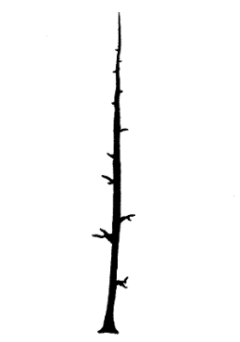 | 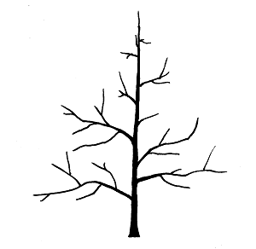
1 | 2
columnar | ramified

Ad. 3: Only varieties with Tree type: ramified: Tree: habit

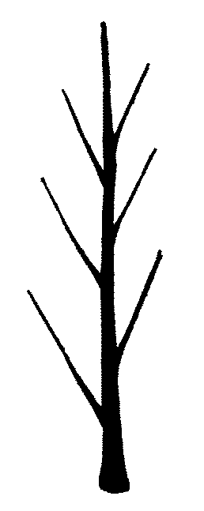 | 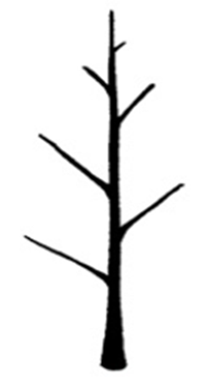 | 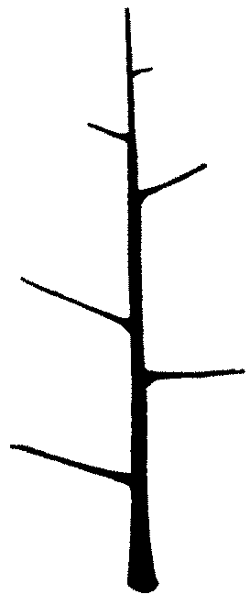 | 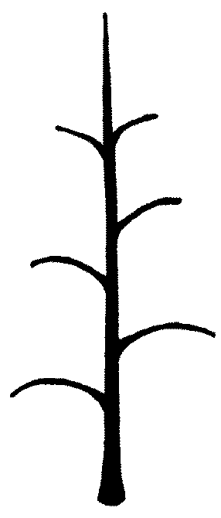 | 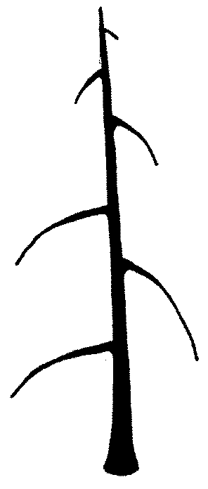
1 | 2 | 3 | 4 | 5
upright | upright to spreading | spreading | drooping | weeping

Ad. 4: One-year-old shoot: length of internode

Observations should be made using a vernier caliper gauge.

Ad. 5: One-year-old shoot: number of lenticels

Observations should be made by counting in a defined area [e.g. an area of 1 cm²] or by visual assessment of the density of lenticels on the bark.

Ad. 6: Leaf blade: attitude in relation to shoot

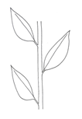 | 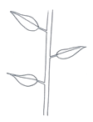 | 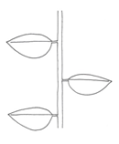 | 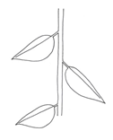
1 | 2 | 3 | 4
upwards | upwards to outwards | outwards | downwards

Ad. 7: Leaf blade: length

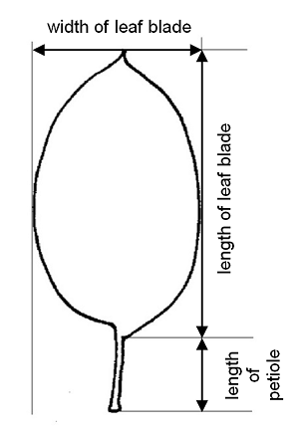

Ad. 8: Leaf blade: width

See Ad. 7

Ad. 9: Leaf blade: ratio length/width

See Ad. 7

Ad. 12: Leaf blade: incisions of margin

The predominant type of incision at distal half should be observed.

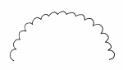 | 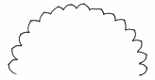 | 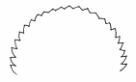
1 | 2 | 3
crenate | crenate to serrate | serrate

Ad. 13: Leaf blade: shape in cross-section

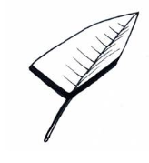 | 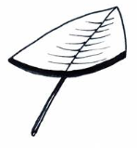 | 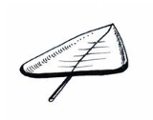
1 | 2 | 3
v-shaped | concave | flat with reflexed margins

 | 
4 | 5
flat | convex

Ad. 14: Petiole: length

See Ad. 7

Ad. 15: Leaf: ratio length of leaf blade / length of petiole

See Ad. 7

Ad. 17: Flower: diameter

Observations should be made with petals pressed into a horizontal position.

Ad. 18: Flower: arrangement of petals

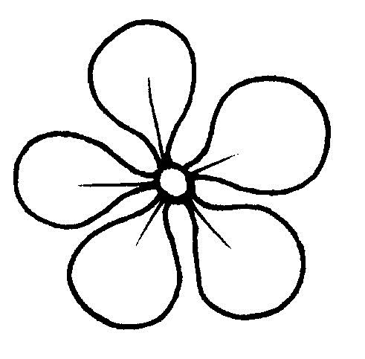 | 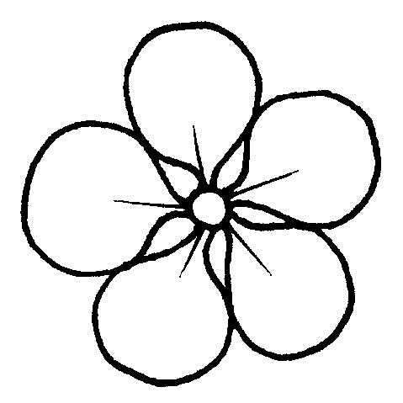 | 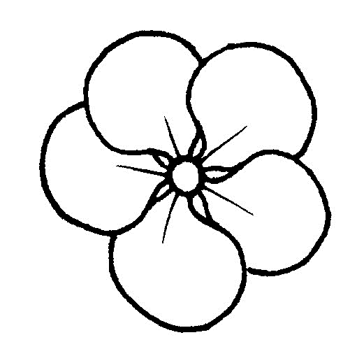
1 | 2 | 3
free | intermediate | overlapping

Ad. 19: Flower: position of stigmas relative to anthers

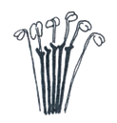 | 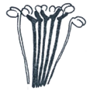 | 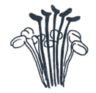
1 | 2 | 3
below | same level | above

Ad. 20: Flower: anthocyanin coloration at base of filament

Observations should be made just after petal drop.

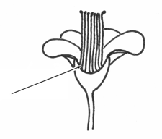

Ad. 23: Fruit: height

The maximum height should be observed.

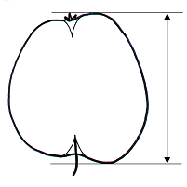

Ad. 24: Fruit: diameter

The maximum diameter should be observed.

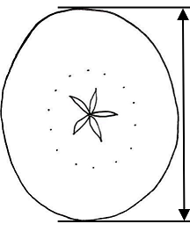

Ad. 26: Fruit: shape

 |  |  | ← ratio height / diameter →
 |  |  | low | medium | high
← broadest part → | above middle |  |  | 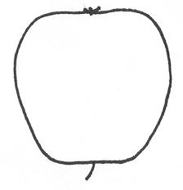  10  obconic
← broadest part → | at middle |  | 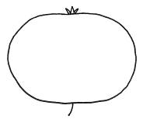  2  oblate | 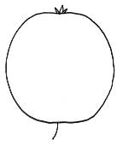  3  circular | 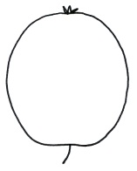  4  elliptic | 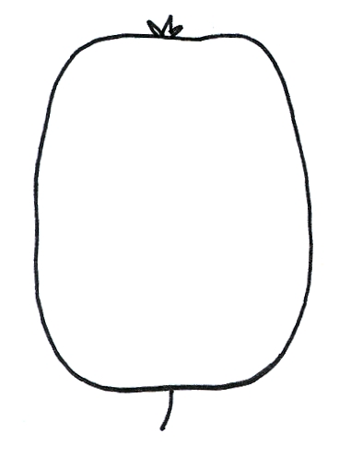  6  oblong
← broadest part → | at middle |  |  | 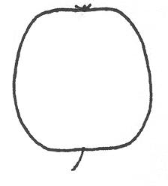  5  square
← broadest part → | below middle |  | 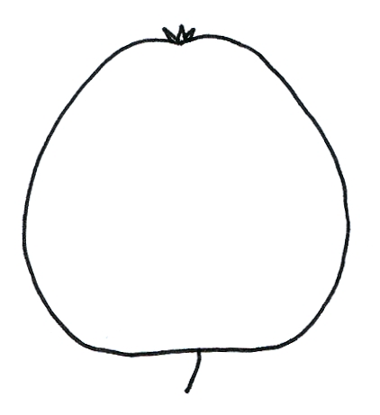  1  flat globose conic | 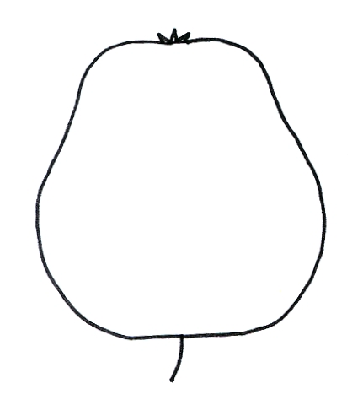  9  conic waisted | 8  conic | 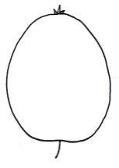  7  ovate

Ad. 29: Fruit: ground color

The ground color is the first color to appear chronologically during the development of the fruit.

Ad. 30: Fruit: hue of over color

Observations should be made after removing the bloom.

Ad. 33: Fruit: pattern of over color

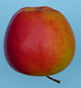 | 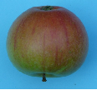 | 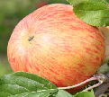
1 | 2 | 3
only solid flush | solid flush with stripes | only stripes (no flush)
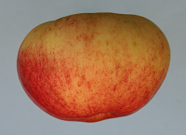 | 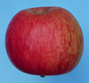 | 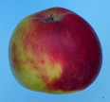
4 | 5 | 6
flushed and mottled | flushed, striped and mottled | marbled

Ad. 35: Fruit: area of russet around stalk attachment

See Ad. 40.

The russet is a dull brown rough finish on the skin.

Ad. 36: Fruit: area of russet on cheeks

See Ad. 35.

Observations should be made on the outer part of the fruit skin, in the area between the stalk cavity and the eye basin (see Ad. 40: fruit outline between the lines through e-f and a-b).

Ad. 37: Fruit: area of russet around eye basin

See Ad. 35 and Ad. 40.

Ad. 38: Fruit: number of lenticels

Observations should be made in the central part of the fruit, by counting (in a defined area [e.g. an area of 1 cm²]) or by visual assessment of the density of lenticels on the skin.

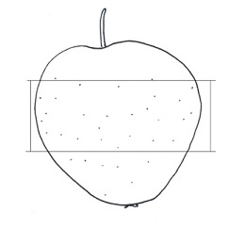

Ad. 39: Fruit: length of stalk

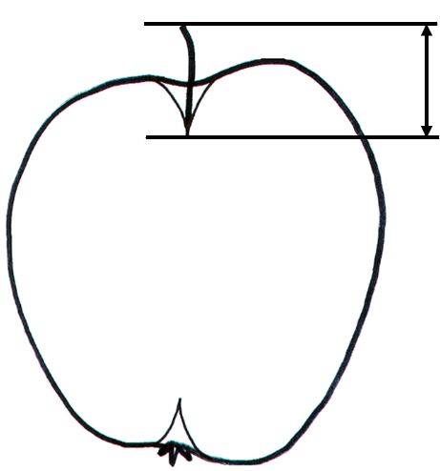

Ad. 40: Fruit: depth of stalk cavity

Fruits should be cut through the central axis as accurately as possible. Stalk cavity and eye basin depth and width should be measured from the sectioned fruits. The following diagram indicates the position of lines scored, using a knife or scalpel, on the fruit prior to measuring these characteristics.
• The lines a-b and e-f must be at right angles to the axis of the fruit. (A plastic protractor can be used to ensure accuracy.)
• The line a-b is marked at the base of the sepals.
• The line e-f is marked at the insertion of the stalk.
• The lines a-c and b-d indicate the eye basin depth. They are drawn at right angles to the line a-b to the point where the basin curve levels out.
• The lines e-g and f-h indicate the stalk cavity depth. They are drawn at right angles to the line e-f to the point where the stalk cavity curve levels out.
• In the case of asymmetric or irregular sections, observations should be made on the larger side (i.e. in case of depths of stalk cavity: e-g instead of f-h; in case of depth of eye basin: a-c instead of b-d).

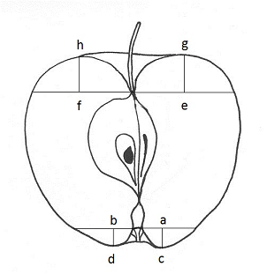 | f-h = depth of stalk cavity (characteristic 40)  a-c = depth of eye basin (characteristic 42)  a-b = width of eye basin (characteristic 43)

Ad. 42: Fruit: depth of eye basin

See Ad. 40.

Ad. 43: Fruit: width of eye basin

See Ad. 40.

Ad. 44: Fruit: firmness of flesh

Observations can be made by measuring, using a penetrometer.

Ad. 45: Fruit: main color of flesh

The main color is the color with the largest surface area. The secondary color is the color with the second largest surface area. In cases where the areas of the main and secondary color are too similar to reliably decide which color has the largest area, the darker color is considered to be the main color.

Ad. 46: Fruit: secondary color of flesh

See Ad. 45.

Ad. 47: Fruit: extent of secondary color of flesh

See Ad. 45

Ad. 48: Flesh color: distribution of pinkish or reddish coloration

To be observed in cross section.

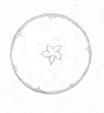 |  | 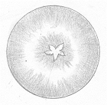
2 | 3 | 4
under skin only | around core only | under skin and around core
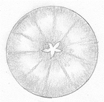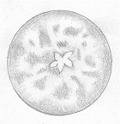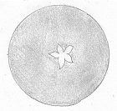
5
throughout

Ad. 49: Time of beginning of flowering

The time of beginning of flowering is reached when 10% of the flowers are fully open.

Ad. 50: Time for harvest

The time for harvest is reached when fruits are ripe for picking and can most easily be picked from the trees. As this physiological stage of the fruit is characterized by a regression of starch content in the flesh, the time for harvest can also be determined by assessing the starch content.

Ad. 51: Time of eating maturity

The time of eating maturity is reached when the fruit is ripe for eating and has reached its optimum flavor and aroma. Eating maturity can be reached on trees or in cold chambers. As this physiological stage of the fruit is characterized by a degradation of starch content in the flesh, the time of eating maturity can also be determined by assessing the starch content.

  8.3
  BBCH-Scale for the description of the phenological growth stages of pome fruit

Stage | Explanation
Principal growth stage 0: Bud development
00 | Dormancy: leaf buds and the thicker inflorescence buds closed and covered by dark brown scales
01 | Beginning of bud swelling (leaf buds); buds visibly swollen, bud scales elongated, with light colored patches
03 | End of leaf bud swelling: bud scales light colored with some parts densely covered by hairs
07 | Beginning of bud break: first green leaf tips just visible
09 | Green leaf tips about 5 mm above bud scales
Principal growth stage 1: Leaf development
10 | Green leaf tips 10 mm above the bud scales; first leaves separating (mouse-ear stage)
11 | First leaves unfolded (others still unfolding)
15 | More leaves unfolded, not yet at full size
19 | First leaves fully expanded
Principal growth stage 2: (not applicable)
Principal growth stage 3: Shoot development¹⁾
¹⁾ From terminal buds
31 | Beginning of shoot growth: axes of developing shoots visible
32 | Shoots about 20 % of final length
39 | Shoots about 90 % of final length
Principal growth stage 4: (not applicable)
Principal growth stage 5: lnflorescence emergence
51 | Inflorescence buds swelling: lnflorescence buds swelling: bud scales elongated, with light buds closed, light brown scales colored patches visible
52 | End of bud swelling: light colored bud scales visible with parts densely covered by hairs
53 | Bud burst: green leaf tips enclosing flowers visible
54 | Mouse-ear stage: green leaf tips 10 mm above bud scales; first leaves separating Flower buds visible (still closed)
55 | Flower buds visible (still closed)
56 | Green bud stage: single flowers separating (still closed)
57 | Red bud stage: flower petals elongating; sepals slightly open; petals just visible
59 | Most flowers with petals forming a hollow ball
Principal growth stage 6: Flowering
60 | First flowers open
61 | Beginning of flowering: about 10 % of flowers open
65 | Full flowering: at least 50 % of flowers open, first petals falling
67 | Flowers fading: majority of Flowers fading: majority of petals fallen
69 | End of flowering: all petals fallen
Principal growth stage 7: Development of fruit
71 | Fruit size up to 10 mm; fruit fall after flowering
72 | Fruit size up to 20 mm
73 | Second fruit fall
74 | Fruit diameter up to 40 mm; fruit erect (T-stage: underside of fruit and stalk forming a T)
75 | Fruit about half final size
77 | Fruit about 70 % of final size
Principal growth stage 8: Maturity of fruit and seed
81 | Beginning of ripening: lightening of cultivar-specific fruit color
85 | Advanced ripening: increase in intensity of cultivar-specific color
87 | Fruit ripe for picking
89 | Fruit ripe for consumption: fruit have typical taste and firmness
Principal growth stage 9: Senescence, beginning of dormancy
91 | Shoot growth completed; terminal bud developed; foliage still fully green
92 | Leaves begin to discolor
93 | Beginning of leaf fall
97 | All leaves fallen
99 | Harvested product

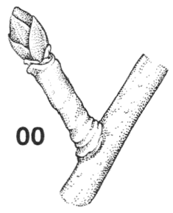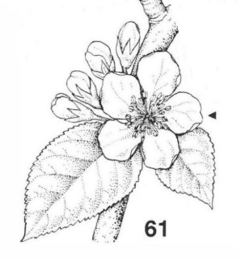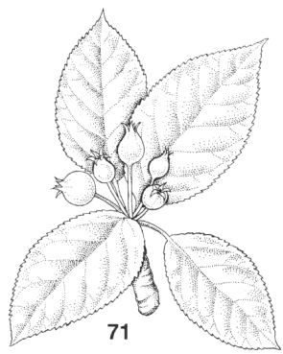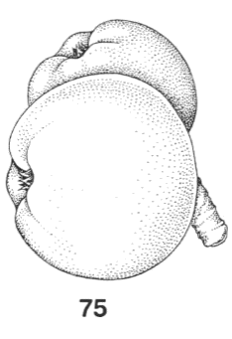

(taken from: Biologische Bundesanstalt für Land- und Forstwirtschaft [1997])

9. | Literature

Aeppli, A., Gremminger, U., Rapillard, Ch., Röthlisberger, K., 1983: 100 Obstsorten. Verlag Landwirtschaftliche Lehrmittelzentrale Zollikofen, CH

Aomori-ken, 1977: The report on the characterization and classification of apple varieties. Aomori-ken, JP

Baldini, E., Sansavini, S., 1967: Monografia delle principale cultivar di melo. Istituto di coltivazioni arboree dell’Università di Bologna, IT

Bergamini, A., Faedi, W. 1983 and 1985: Monografia di cultivar di melo. Volumes I + II, Ministero Agricoltura e Foreste, Roma, IT

Biologische Bundesanstalt für Land- und Fortswirtschaft (Editor), 1997: Growth Stages of Plants / Entwicklungsstadien von Pflanzen / Estadios de las Plantas / Stades de Développement des Plantes. BBCH- Monograph. Blackwell Wissenschaftsverlag Berlin, DE, Wien, AU

Brozik, S., Regius J., 1957: Termeszett gyumolcsfajtaink Almastermesuek. Alma Fruit varieties Apple. Mezogazdasagi Kiado, Budapest, HU

Bultitude, J., 1983: A Guide to the Identification of International Varieties. Macmillan Reference Books, Macmillan Press, London, GB

Dvorak, A., et al., 1956: Jablka (Apple). Academia Praha, CZ

Fischer, M., 1995: Farbatlas Obstsorten. Eugen Ulmer Verlag, Stuttgart, DE

Fleckinger, J., 1948: Les stades végétatives des arbres frutiers, en rapport avec les traitements. Pomology Français 1948, supplements 81-93, FR

Khanizadeh, S. and Cousineau, J., 1998: Our Apples – Les Pommiers de chez nous. Agriculture and Agri-Food Canada, St.-Jean-sur Richelieu, Quebec, CA

Kessler, H., 1948: Apfelsorten der Schweiz. Verlag Verbandsdruckerei AG Bern, CH

Krümmel, H., Groh W., Friedrich, G., 1956: Deutsche Obstsorten. Deutscher Bauernverlag, Berlin, DE

Meier, U., 1997: Growth stages of mono- and dicotyledonous plants. Blackwell, Berlin, Vienna.

Morgan, J., Richards, A., 2002: The Book of Apples. Ebury Press, London, GB

Nilsson, Anton, 1987: Vara applesorter. Allmanna Forlaget AB, Stockholm SE

Petzold, H., 1990: Apfelsorten. Verlag Neumann, Leipzig, Radebeul, DE

Silbereisen, R., 1980: Apfelsorten. 2nd. ed., Verlag Eugen Ulmer, Stuttgart, DE

Smith, M.W.G., 1971: National Apple Register of the United Kingdom. Ministry of Agriculture, Fisheries & Food, London, GB

Toth, G. M., 2001: Gyumolcseszet. Primom, Nyiregyhaza, HU

10. | Technical Questionnaire

TECHNICAL QUESTIONNAIRE | Page {x} of {y} | Reference Number:

Application date:
(not to be filled in by the applicant)
TECHNICAL QUESTIONNAIRE
to be completed in connection with an application for plant breeders' rights

1. | Subject of the Technical Questionnaire
 |  | Botanical name
  1.1
  Malus domestica (Suckow) Borkh.
 |  | Common name
  1.2
  Apple

2. | Applicant
 | Name
 | Address
 | Telephone No.
 | Fax No.
 | E-mail address
 | Breeder (if different from
 | applicant)

3. | Proposed denomination and breeder's reference
 | Proposed denomination
 | (if available)
 | Breeder's reference

TECHNICAL QUESTIONNAIRE |  |  | Page {x} of {y} | Reference Number:
 | Information on the breeding scheme and propagation of the variety
  #4.
 | 4.1 | Breeding scheme
 | Variety resulting from:
  4.1.1
  Crossing
 |  | [ ]
  (a)
  controlled cross
(please state parent variety)

(…………………..……………..…) x (……………..…………………..…)

female parent male parent

 |  | [ ]
  (b)
  partially known cross
(please state known parent variety(ies))

(…………………..……………..…) x (……………..…………………..…)

female parent male parent

 |  | [ ]
  (c)
  unknown cross
 |  | [ ]
  4.1.2
  Mutation
  (please state parent variety)
 |  | [ ]
  4.1.3
  Discovery and development
  (please state where and when discovered and how developed)
 | Other  (Please provide details) | [ ]
  4.1.4

TECHNICAL QUESTIONNAIRE | Page {x} of {y} | Reference Number:

 | 4.2 | Method of propagating the variety
  4.2.1
  Vegetative propagation
 |  | [ ]
  (a)
  Budding or grafting
 |  | [ ]
  (b)
  Other (state method)
 | Other  (Please provide details) | [ ]
  4.2.2

TECHNICAL QUESTIONNAIRE | Page {x} of {y} | Reference Number:

5. | Characteristics of the variety to be indicated (the number in brackets refers to the corresponding characteristic in Test Guidelines; please mark the note which best corresponds).

 | Characteristics | Example Varieties | Note
  5.1
  (2)
  Tree: type
  columnar
  MacExcel, Wijcik
  1 [ ]
  ramified
  Elstar, Golden Delicious
  2 [ ]
  5.2
  (3)
  Only varieties with Tree type: ramified: Tree: habit
  upright
  Alkmene, Fresco, Solaris
  1 [ ]
  upright to spreading
  Akane, Arkcharm, Harmensz, Katrina, Reka
  2 [ ]
  spreading
  Pinova, Redkan, Topaz
  3 [ ]
  drooping
  Idared, James Grieve, Pivita
  4 [ ]
  weeping
  Gerlinde, Nield’s Drooper
  5 [ ]
  5.3
  (26)
  Fruit: shape
  flat globose conic
  Melrose
  1 [ ]
  oblate
  Bramley’s Seedling, Lipno
  2 [ ]
  circular
  Dalinbel, Rubinola, Topaz
  3 [ ]
  elliptic
  Fuji BC, Minnewashta
  4 [ ]
  square
  Bonita
  5 [ ]
  oblong
  Renora, Čadel
  6 [ ]
  ovate
  Cripps Pink, Delcorf
  7 [ ]
  conic
  Civni, Elstar, Nicoter, Pinova, Rafzubin
  8 [ ]
  conic waisted
  Gloster, Redkan
  9 [ ]
  obconic
  Empire
  10 [ ]
  5.4
  (30)
  Fruit: hue of over color
  orange red
  Goldstar, Rea Gold, Solaris
  1 [ ]
  pink red
  Cripps Pink, Delorgue
  2 [ ]
  red
  Pinova, Prima, Red Elstar, Tenroy
  3 [ ]
  purple red
  Bay 3484, Luresweet, MC 38, Spartan
  4 [ ]
  brown red
  Braeburn, Fiesta, Fresco, Fuji BC, Suntan
  5 [ ]

TECHNICAL QUESTIONNAIRE | Page {x} of {y} | Reference Number:

 | Characteristics | Example Varieties | Note
  5.5
  (32)
  Fruit: relative area of over color
  absent or very small
  Granny Smith, Tuscan
  1 [ ]
  very small to small
  Golden Delicious
  2 [ ]
  small
  Auralia, Cox’s Orange Pippin, Goldstar, Solaris
  3 [ ]
  small to medium
  Charlotte, Schone van Boskoop
  4 [ ]
  medium
  Dalili, Elstar, Minnewashta, Rea Gold
  5 [ ]
  medium to large
  Heco, Pia, Rafzubin
  6 [ ]
  large
  Fiesta, Santana, Suntan, Tenroy
  7 [ ]
  large to very large
  Mars, Rosy Glow, SQ 159
  8 [ ]
  very large
  Bay 3484, MC 38, Red Jonaprince, Redkan
  9 [ ]
  5.6
  (33)
  Fruit: pattern of over color
  only solid flush
  Bay 3484, Red Jonaprince, Telamon
  1 [ ]
  solid flush with stripes
  Bruggers Festivale, Charlotte, Cripps Pink, Dalili, James Grieve Esselborn, Pingo
  2 [ ]
  only stripes
  Dülmener Rosenapfel
  3 [ ]
  flushed and mottled
  Dalinbel, Scifresh
  4 [ ]
  flushed, striped and mottled
  Elstar, Pinova, Rafzubin, Topaz
  5 [ ]
  marbled
  Karneval
  6 [ ]
  5.7
  (45)
  Fruit: main color of flesh
  white
  Akane, Minnewashta, Pia, Spartan
  1 [ ]
  greenish
  Angold, Gloster, Granny Smith, Northpole, Telamon
  2 [ ]
  yellowish white
  Elstar, Jonagold, Pinova, Rafzubin
  3 [ ]
  yellowish
  Coxcolumnar, Pisaxa, Topaz, Zari
  4 [ ]
  orangish
  Ladina, Transcendent Crab
  5 [ ]
  pinkish
  Pomfit
  6 [ ]
  reddish
  Bay 3484, Lureprec
  7 [ ]

TECHNICAL QUESTIONNAIRE | Page {x} of {y} | Reference Number:

 | Characteristics | Example Varieties | Note
  5.8
  (49)
  Time of beginning of flowering
  very early
  Anna, Ein-Shemer
  1 [ ]
  very early to early
  Collina, Delblush, Pompink
  2 [ ]
  early
  Astramel, Civni, Idared, Topaz
  3 [ ]
  early to medium
  Cripps Red, Dalili, James Grieve, Jonagored
  4 [ ]
  medium
  Braeburn, Rafzubin, Tenroy, White Transparent, Zari
  5 [ ]
  medium to late
  Elise, Gala, Granny Smith, Sansa
  6 [ ]
  late
  Golden Delicious, Karmijn de Sonnaville, Reine de Reinettes, Sirprize
  7 [ ]
  late to very late
  Delorina, Suntan
  8 [ ]
  very late
  Spätblühender Taffetapfel
  9 [ ]
  5.9
  (50)
  Time for harvest
  extremely early
  Astramel, Collina, White Transparent
  1 [ ]
  extremely early to very early
  Piros
  2 [ ]
  very early
  Arkcharm, Lena, Minnewashta, Nela
  3 [ ]
  very early to early
  Bruggers Festivale, Coxcolumnar, Dalili
  4 [ ]
  early
  Akane, Delorgue, James Grieve, Monidel, Sansa
  5 [ ]
  early to medium
  Gerlinde, Prima, Santana, Zari
  6 [ ]
  medium
  Bay 3484, Fiesta, Rubinola
  7 [ ]
  medium to late
  Civni, Elstar, Karmijn de Sonnaville, Saturn, Suntan, Tenroy
  8 [ ]
  late
  Jonagold, Pomforyou, Redkan, Sirprize, Telamon
  9 [ ]
  late to very late
  Florina, Golden Delicious, La Flamboyante, Pinova, Pompink, Topaz
  10 [ ]
  very late
  Delblush, Delgollune, Fuji BC, Mutsu, Nicoter
  11 [ ]
  very late to extremely late
  Braeburn, Fuji
  12 [ ]
  extremely late
  Cripps Pink, Cripps Red, Granny Smith, Iduna
  13 [ ]

TECHNICAL QUESTIONNAIRE | Page {x} of {y} | Reference Number:

 | Characteristics | Example Varieties | Note
  5.10
  (51)
  Time of eating maturity
  extremely early
  Samo
  1 [ ]
  extremely early to very early
  Astramel, Julia
  2 [ ]
  very early
  Discovery, Helios, Nela
  3 [ ]
  very early to early
  Bruggers Festivale, Minnewashta
  4 [ ]
  early
  Alkmene, Gravensteiner, James Grieve, Transparente de Croncels
  5 [ ]
  early to medium
  Santana
  6 [ ]
  medium
  Elstar, Gala, Holsteiner Cox, Reine de Reinettes
  7 [ ]
  medium to late
  Honeycrisp, Karneval, Rubinstep
  8 [ ]
  late
  Golden Delicious, Jonagold, Pinova, Topaz
  9 [ ]
  late to very late
  Nicoter, Pilot, Scifresh, Solaris
  10 [ ]
  very late
  Braeburn, Florina
  11 [ ]
  very late to extremely late
  Elise
  12 [ ]
  extremely late
  Cripps Pink, Granny Smith
  13 [ ]

TECHNICAL QUESTIONNAIRE | Page {x} of {y} | Reference Number:

6. | Similar varieties and differences from these varieties
Please use the following table and box for comments to provide information on how your candidate variety differs from the variety (or varieties) which, to the best of your knowledge, is (or are) most similar. This information may help the examination authority to conduct its examination of distinctness in a more efficient way.

  Denomination(s) of variety(ies) similar to your candidate variety
  Characteristic(s) in which your candidate variety differs from the similar variety(ies)
  Describe the expression of the characteristic(s) for the similar variety(ies)
  Describe the expression of the characteristic(s) for your candidate variety

Example
  One-year-old shoot: number of lenticels
  few
  many

 | Comments:

TECHNICAL QUESTIONNAIRE | Page {x} of {y} | Reference Number:

 | Additional information which may help in the examination of the variety
  #7.
7.1 | In addition to the information provided in sections 5 and 6, are there any additional characteristics which may help to distinguish the variety?
 | Yes | [ ] | No | [ ]
 | (If yes, please provide details)
7.2 | Are there any special conditions for growing the variety or conducting the examination?
 | Yes | [ ] | No | [ ]
 | (If yes, please provide details)
7.3 | Other information
A representative color photograph of the variety displaying its main distinguishing feature(s), should accompany the Technical Questionnaire. The photograph will provide a visual illustration of the candidate variety which supplements the information provided in the Technical Questionnaire.
The key points to consider when taking a photograph of the candidate variety are:
• Indication of the date and geographic location
• Correct labeling (breeder’s reference)
• Good quality printed photograph (minimum 10 cm x 15 cm) and/or sufficient resolution electronic format version (minimum 960 x 1280 pixels)”
Further guidance on providing photographs with the Technical Questionnaire is available in document TGP/7 "Development of Test Guidelines", Guidance Note 35 (http://www.upov.int/tgp/en/).
[The link provided may be deleted by members of the Union when developing authorities’ own test guidelines.]
In the case of mutant varieties, (a) characteristic(s) should be indicated in which the candidate variety differs from the variety it has originated from, or from any other mutant variety of the same origin, if not provided already under 6.

Denomination(s) of variety(ies) similar to your candidate variety | Characteristic(s) in which your candidate variety differs | Describe the expression of the characteristic(s) for the similar variety(ies) | Describe the expression of the characteristic(s) for your candiate variety

TECHNICAL QUESTIONNAIRE | Page {x} of {y} | Reference Number:

8. | Authorization for release
 | (a) | Does the variety require prior authorization for release under legislation concerning the protection of the environment, human and animal health?
 |  | Yes | [ ] | No | [ ]
 | (b) | Has such authorization been obtained?
 |  | Yes | [ ] | No | [ ]
 | If the answer to (b) is yes, please attach a copy of the authorization.

9. Information on plant material to be examined or submitted for examination

9.1 The expression of a characteristic or several characteristics of a variety may be affected by factors, such as pests and disease, chemical treatment (e.g. growth retardants or pesticides), effects of tissue culture, different rootstocks, scions taken from different growth phases of a tree, etc.
9.2 The plant material should not have undergone any treatment which would affect the expression of the characteristics of the variety, unless the competent authorities allow or request such treatment. If the plant material has undergone such treatment, full details of the treatment must be given. In this respect, please indicate below, to the best of your knowledge, if the plant material to be examined has been subjected to:

 | (a) | Microorganisms (e.g. virus, bacteria, phytoplasma) | Yes [ ] | No [ ]
 | (b) | Chemical treatment (e.g. growth retardant, pesticide) | Yes [ ] | No [ ]
 | (c) | Tissue culture | Yes [ ] | No [ ]
 | (d) | Other factors | Yes [ ] | No [ ]
 | Please provide details for where you have indicated “yes”.

10. | I hereby declare that, to the best of my knowledge, the information provided in this form is correct:
 | Applicant’s name
 | Signature |  | Date

[End of document]

