 |  | E  TG/12/9 Rev. 2  ORIGINAL: English  DATE: 2005-04-06 + 2012-03-28 +  2015-03-25
INTERNATIONAL UNION FOR THE PROTECTION OF NEW VARIETIES OF PLANTS
GENEVA

 | FRENCH BEAN  UPOV code: PHASE_VUL  Phaseolus vulgaris L. | *

GUIDELINES

FOR THE CONDUCT OF TESTS

FOR DISTINCTNESS, UNIFORMITY AND STABILITY

Alternative Names:*

Botanical name | English | French | German | Spanish
Phaseolus vulgaris L. | French Bean | Haricot | Gartenbohne | Judía común, Alubia

The purpose of these guidelines (“Test Guidelines”) is to elaborate the principles contained in the General Introduction (document TG/1/3), and its associated TGP documents, into detailed practical guidance for the harmonized examination of distinctness, uniformity and stability (DUS) and, in particular, to identify appropriate characteristics for the examination of DUS and production of harmonized variety descriptions.

ASSOCIATED DOCUMENTS

These Test Guidelines should be read in conjunction with the General Introduction and its associated TGP documents.

TABLE OF CONTENTS PAGE

1. Subject of these Test Guidelines 3
2. Material Required 3
3. Method of Examination 3
3.1 Number of Growing Cycles 3
3.2 Testing Place 3
3.3 Conditions for Conducting the Examination 3
3.4 Test Design 4
3.5 Number of Plants / Parts of Plants to be Examined 4
3.6 Additional Tests 4
4. Assessment of Distinctness, Uniformity and Stability 4
4.1 Distinctness 4
4.2 Uniformity 5
4.3 Stability 5
5. Grouping of Varieties and Organization of the Growing Trial 5
6. Introduction to the Table of Characteristics 6
6.1 Categories of Characteristics 6
6.2 States of Expression and Corresponding Notes 6
6.3 Types of Expression 6
6.4 Example Varieties 6
6.5 Legend 6
7. Table of Characteristics/Tableau des caractères/Merkmalstabelle/Tabla de caracteres 8
8. Explanations on the Table of Characteristics 23
8..1 Explanations covering several characteristics 9
8..2 Explanations for individual characteristics 9
9. Literature 36
10. Technical Questionnaire 38

- Subject of these Test Guidelines
These Test Guidelines apply to all varieties of Phaseolus vulgaris L.

- Material Required
2.1 The competent authorities decide on the quantity and quality of the plant material required for testing the variety and when and where it is to be delivered. Applicants submitting material from a State other than that in which the testing takes place must ensure that all customs formalities and phytosanitary requirements are complied with.

2.2 The material is to be supplied in the form of seed.

2.3 The minimum quantity of plant material, to be supplied by the applicant, should be:

1.5 kg or 15,000 seeds.

The seed should meet the minimum requirements for germination, species and analytical purity, health and moisture content, specified by the competent authority. In cases where the seed is to be stored, the germination capacity should be as high as possible and should, be stated by the applicant.

2.4 The plant material supplied should be visibly healthy, not lacking in vigor, nor affected by any important pest or disease.

2.5 The plant material should not have undergone any treatment which would affect the expression of the characteristics of the variety, unless the competent authorities allow or request such treatment. If it has been treated, full details of the treatment must be given.

- Method of Examination

3.1 Number of Growing Cycles
The minimum duration of tests should normally be two independent growing cycles.

3.2 Testing Place
Tests are normally conducted at one place. In the case of tests conducted at more than one place, guidance is provided in TGP/9 “Examining Distinctness”.

3.3 Conditions for Conducting the Examination
3.3.1 The tests should be carried out under conditions ensuring satisfactory growth for the expression of the relevant characteristics of the variety and for the conduct of the examination.

3.3.2 The recommended method of observing the characteristic is indicated by the following key in the second column of the Table of Characteristics:

MG: single measurement of a group of plants or parts of plants
MS: measurement of a number of individual plants or parts of plants
VG: visual assessment by a single observation of a group of plants or parts of plants
VS: visual assessment by observation of individual plants or parts of plants

3.4 Test Design
3.4.1 For dwarf beans, each test should be designed to result in a total of at least 150 plants, which should be divided between two or more replicates.

3.4.2 For climbing beans, each test should be designed to result in a total of at least 60 plants, which should be divided between two or more replicates.

3.5 Number of Plants / Parts of Plants to be Examined
Unless otherwise indicated, all observations should be made on 20 plants or parts taken from each of 20 plants.

3.6 Additional Tests
Additional tests, for examining relevant characteristics, may be established.

- Assessment of Distinctness, Uniformity and Stability

4.1 Distinctness

4.1.1 General Recommendations

It is of particular importance for users of these Test Guidelines to consult the General Introduction prior to making decisions regarding distinctness. However, the following points are provided for elaboration or emphasis in these Test Guidelines.

4.1.2 Consistent Differences

The differences observed between varieties may be so clear that more than one growing cycle is not necessary. In addition, in some circumstances, the influence of the environment is not such that more than a single growing cycle is required to provide assurance that the differences observed between varieties are sufficiently consistent. One means of ensuring that a difference in a characteristic, observed in a growing trial, is sufficiently consistent is to examine the characteristic in at least two independent growing cycles.

4.1.3 Clear Differences

Determining whether a difference between two varieties is clear depends on many factors, and should consider, in particular, the type of expression of the characteristic being examined, i.e. whether it is expressed in a qualitative, quantitative, or pseudo-qualitative manner. Therefore, it is important that users of these Test Guidelines are familiar with the recommendations contained in the General Introduction prior to making decisions regarding distinctness.

4.2 Uniformity
4.2.1 It is of particular importance for users of these Test Guidelines to consult the General Introduction prior to making decisions regarding uniformity. However, the following points are provided for elaboration or emphasis in these Test Guidelines:

4.2.2 For the assessment of uniformity, a population standard of 1% and an acceptance probability of at least 95% should be applied. In the case of a sample size of 60 plants, 2 off-types are allowed. In the case of a sample size of 150 plants, 4 off-types are allowed.

4.3 Stability
4.3.1 In practice, it is not usual to perform tests of stability that produce results as certain as those of the testing of distinctness and uniformity. However, experience has demonstrated that, for many types of variety, when a variety has been shown to be uniform, it can also be considered to be stable.

4.3.2 Where appropriate, or in cases of doubt, stability may be tested, either by growing a further generation, or by testing a new seed stock to ensure that it exhibits the same characteristics as those shown by the previous material supplied.

- Grouping of Varieties and Organization of the Growing Trial
5.1 The selection of varieties of common knowledge to be grown in the trial with the candidate varieties and the way in which these varieties are divided into groups to facilitate the assessment of distinctness are aided by the use of grouping characteristics.

5.2 Grouping characteristics are those in which the documented states of expression, even where produced at different locations, can be used, either individually or in combination with other such characteristics: (a) to select varieties of common knowledge that can be excluded from the growing trial used for examination of distinctness; and (b) to organize the growing trial so that similar varieties are grouped together.

5.3 The following have been agreed as useful grouping characteristics:

(a) Plant: growth type (characteristic 3)
(b) Flower: color of standard (characteristic 16)
(c) Pod: shape in cross section (through seed) (characteristic 22)
(d) Pod: ground color (characteristic 24)
(e) Pod: stringiness of ventral suture (characteristic 29)
(f) Seed: number of colors (characteristic 43)
(g) Seed: main color (largest area) (characteristic 44)
(h) Seed: secondary color (characteristic 45)
(i) Resistance to Bean common mosaic necrosis virus (BCMNV) (characteristic 50)

5.4 Guidance for the use of grouping characteristics, in the process of examining distinctness, is provided through the General Introduction.

- Introduction to the Table of Characteristics

6.1 Categories of Characteristics
6.1.1 Standard Test Guidelines Characteristics

Standard Test Guidelines characteristics are those which are approved by UPOV for examination of DUS and from which members of the Union can select those suitable for their particular circumstances.

6.1.2 Asterisked Characteristics

Asterisked characteristics (denoted by *) are those included in the Test Guidelines which are important for the international harmonization of variety descriptions and should always be examined for DUS and included in the variety description by all members of the Union, except when the state of expression of a preceding characteristic or regional environmental conditions render this inappropriate.

6.2 States of Expression and Corresponding Notes
States of expression are given for each characteristic to define the characteristic and to harmonize descriptions. Each state of expression is allocated a corresponding numerical note for ease of recording of data and for the production and exchange of the description.

6.3 Types of Expression
An explanation of the types of expression of characteristics (qualitative, quantitative and pseudo-qualitative) is provided in the General Introduction.

6.4 Example Varieties
Where appropriate, example varieties are provided to clarify the states of expression of each characteristic.

6.5 Legend
(*) Asterisked characteristic

QL Qualitative characteristic
QN Quantitative characteristic
PQ Pseudo-qualitative characteristic

MG: single measurement of a group of plants or parts of plants – see Chapter 3.3.2
MS: measurement of a number of individual plants or parts of plants – see Chapter 3.3.2
VG: visual assessment by a single observation of a group of plants or parts of plants – see Chapter 3.3.2
VS: visual assessment by observation of individual plants or parts of plants –
see Chapter 3.3.2

(+) See Explanations on the Table of Characteristics in Chapter 8.

(C)/(D) Growth type of example variety: C = climbing variety
D = dwarf variety.

- Table of Characteristics/Tableau des caractères/Merkmalstabelle/Tabla de caracteres
 |  | English | français | deutsch | español | Example Varieties/  Exemples/  Beispielssorten/  Variedades ejemplo | Note/  Nota
1. | VG | Plant: anthocyanin coloration of hypocotyl | Plante: pigmentation anthocyanique de l’hypocotyle | Pflanze: Anthocyan-färbung des Hypokotyls | Planta: pigmentación antociánica del hipocótilo
QL |  | absent | absente | fehlend | ausente | Tuf (D) | 1
 |  | present | présente | vorhanden | presente | Delinel (D), Vilbel (D) | 9
2. | VG | Plant: intensity of anthocyanin coloration of hypocotyl | Plante: intensité de la pigmentation anthocyanique de l’hypocotyle | Pflanze: Intensität der Anthocyanfärbung des Hypokotyls | Planta: intensidad de la pigmentación antociánica del hipocótilo
QN |  | weak | faible | gering | débil | Kentucky Wonder (C) | 3
 |  | medium | moyenne | mittel | media | Haibushi (C) | 5
 |  | strong | forte | stark | fuerte | Kurokinugasa (C) | 7
3.  (*) | VG | Plant: growth type | Plante: type de croissance | Pflanze: Wuchstyp | Planta: tipo de crecimiento
QL |  | dwarf | nain | Buschform | mata baja | Callide (D), Capitole (D) | 1
 |  | climbing | à rames | Stangenform | de enrame | Phenomene (C), Bacle (C) | 2
4. | VG | Climbing beans only: Plant: architecture | Haricot à rames seulement: Plante: architecture | Nur Stangenbohnen: Pflanze: Wuchsform | Sólo varieadades de enrame: Planta: forma
QL |  | pyramidal | pyramidale | pyramidenförmig | piramidal | Haricot maïs (C) | 1
 |  | rectangular | rectangulaire | rechteckig | rectangular | Hilda (C) | 2
5. | VG | Dwarf beans only: Plant: type | Haricot nain seulement: Plante: type | Nur Buschbohnen: Pflanze: Typ | Sólo variadades de mata baja: Planta: tipo
PQ |  | non-trailing | non grimpant | keine Ausläufer bildend | no rastrero | Callide (D), Capitole (D) | 1
 |  | trailing | grimpant | Ausläufer bildend | rastrero | Great Northern (D), Felspar (D), Spinel (D) | 2
6. | MG/ MS/ VG | Dwarf beans only: Plant: height | Haricot nain seulement: Plante: hauteur | Nur Buschbohnen: Pflanze: Höhe | Sólo variadades de mata baja: Planta: altura
QN |  | short | petite | niedrig | baja | Goldfish (D) | 3
 |  | medium | moyenne | mittel | media | Fori (D) | 5
 |  | tall | grande | hoch | alta | Nerina (D), Rote von Paris (D) | 7
7. | MG/ VG | Climbing beans only Plant: start of climbing (80% of plants) | Haricot à rames seulement: Plante: précocité d’enroulement (80% des plantes) | Nur Stangenbohnen: Pflanze: Rankbeginn (80 % der Pflanzen) | Sólo variadades de enrame: Planta: época en que empieza a trepar (80% de las plantas)
QN |  | early | précoce | früh | temprana | Perle von Marbach (C) | 3
 |  | medium | moyenne | mittel | media | Trebona (C) | 5
 |  | late | tardive | spät | tardía | Record (C) | 7
8.  (+) | VG | Climbing beans only: Plant: speed of climbing | Haricot à rames seulement: Plante: vitesse de croissance | Nur Stangenbohnen: Pflanze: Geschwindigkeit des Emporrankens | Sólo variadades de enrame: Planta: velocidad a la que trepa
QN |  | slow | lente | langsam | lenta |  | 3
 |  | medium | moyenne | mittel | media | Meicy (C) | 5
 |  | fast | rapide | schnell | rápida | Perle von Marbach (C) | 7
9.  (*) | VG | Leaf: intensity of green color | Feuille: intensité de couleur verte | Blatt: Intensität der Grünfärbung | Hoja: intensidad del color verde
QN | (a) | very light | très claire | sehr hell | muy clara |  | 1
 |  | light | claire | hell | clara | Goldelfe (C), Rote von Paris (D) | 3
 |  | medium | moyenne | mittel | media | Fori (D), Valja (D) | 5
 |  | dark | foncée | dunkel | oscura | Dubra (D), Goldfish (D), Silvia (C) | 7
 |  | very dark | très foncée | sehr dunkel | muy oscura | Diva (D) | 9
10. | VG | Leaf: rugosity | Feuille: rugosité | Blatt: Wölbung zwischen den Nerven | Hoja: rugosidad
QN | (a) | absent or very weak | nulle ou très faible | fehlend oder sehr gering | ausente o muy débil | IPR Gruana (C),  IPR Uirapuru (C) ,
 |  | weak | faible | gering | débil | Goldfish (D), Groffy (D), Record (C), Valja (D) | 3
 |  | medium | moyenne | mittel | media | Butterzart (D), Filetty (D), Fori (D), Neckarkönigin (C) | 5
 |  | strong | forte | stark | fuerte | Loma (D) | 7
 |  | very strong | très forte | sehr stark | muy fuerte | Brede Z.dr (D) | 9
11. | VG | Terminal leaflet: size | Foliole terminale: taille | Endblattfieder: Größe | Folíolo terminal: tamaño
QN | (a) | small | petite | klein | pequeño | Goldfish (D) | 3
 |  | medium | moyenne | mittel | medio | Prelude (D) | 5
 |  | large | grande | groß | grande | Facta (D), Longking (D), Rote von Paris (D) | 7
12.  (+) | VG | Terminal leaflet: shape | Foliole terminale: forme | Endblattfieder: Form | Folíolo terminal: forma
PQ | (a) | triangular | triangulaire | dreieckig | triangular | Aber (D), Candide (D) | 1
 |  | triangular to circular | triangulaire à circulaire | dreieckig bis rundlich | triangular a circular | Facta (D) | 2
 |  | circular | circulaire | rund | circular | Acarli (D), Felix (D), Niver (D) | 3
 |  | circular to rhombic | circulaire à losangique | rund bis rautenförmig | circular a rómbica | Calas (D), Capitole (D), Dorabel (D) | 4
 |  | rhombic | losangique | rautenförmig | rómbica | Ace (D), Carlyn (D), Madrigal (D) | 5
13.  (+) | VG | Terminal leaflet: length of tip | Foliole terminale: longueur du sommet | Endblattfieder: Länge der Spitze | Folíolo terminal: longitud del ápice
QN | (a) | short | court | kurz | corto |  | 1
 |  | medium | moyen | mittel | medio | Goldfish (D), Tuf (D) | 2
 |  | long | long | lang | largo | Flo (D), Nerina (D), Prelude (D) | 3
14. | VG | Dwarf beans only: Inflorescences: position (at full flowering) | Haricot nain seulement: Inflorescences: position (à pleine floraison) | Nur Buschbohnen: Blütenstände: Sitz (in voller Blüte) | Sólo variedades de mata baja: Inflorescencias: ubicación (en plena floración)
QN |  | predominantly in foliage | principalement dans le feuillage | vorwiegend im Laub | predominantemente en el follaje | Ryco (D) | 1
 |  | intermediate | intermédiaire | intermediär | intermedio | Tuf (D), Valja (D) | 2
 |  | predominantly above foliage | principalement  au-dessus du feuillage | vorwiegend über dem Laub | predominantemente por encima del follaje | Daisy (D), Goldetta (D), | 3
15. | VG | Flower: size of bracts | Fleur: taille des bractées florales | Blüte: Größe der Brakteen | Flor: tamaño de las bracteas
QN |  | small | petites | klein | pequeño | Fanion (D), Fidel (C), Markant (C), Nerina (D), Ryco (D) | 3
 |  | medium | moyennes | mittel | medio | Meicy (C), Torrina (D) | 5
 |  | large | grandes | groß | grande | Juni (D), Label (D), Pfälzer Toplong (C) | 7
16.  (*) | VG | Flower: color of standard | Fleur: couleur de l’étendard | Blüte: Farbe der Fahne | Flor: color del estandarte
PQ |  | white | blanc | weiß | blanco | Tuf (D) | 1
 |  | pinkish white | rosâtre blanc | zartrosa weiß | blanco rosáceo | Mira (D) | 2
 |  | pink | rose | rosa | rosa | Maxi (D), Vilbel (D) | 3
 |  | violet | violet | violett | violeta | Delinel (D), Purple Teepee (D) | 4
17.  (*) | VG | Flower: color of wing | Fleur: couleur de l’aile | Blüte: Farbe des Flügels | Flor: color del ala
PQ |  | white | blanche | weiß | blanco | Tuf (D) | 1
 |  | pinkish white | rosâtre blanc | zartrosa weiß | blanco rosáceo | Signal (D) | 2
 |  | pink | rose | rosa | rosa | Maxi (D), Vilbel (D) | 3
 |  | violet | violette | violett | violeta | Delinel (D), Purple Teepee (D) | 4
18.  (*) | MS | Dwarf beans only: Pod: length (excluding beak) | Haricot nain seulement: Gousse: longueur (style exclu) | Nur Buschbohnen Hülse: Länge (ohne Zahn) | Sólo variedades de mata baja: Vaina: longitud (excluida el pico)
QN | (b) | very short | très courte | sehr kurz | muy corta |  | 1
 |  | short | courte | kurz | corta | Prelude (D), Tuf (D) | 3
 |  | medium | moyenne | mittel | media | Amity (D), Lusia (D) | 5
 |  | long | longue | lang | larga | Dubra (D), Loma (D) | 7
 |  | very long | très longue | sehr lang | muy larga | Daisy (D), Longking (D), Maja (D) | 9
19.  (*) | MS | Climbing beans only: Pod: length  (as for 18) | Haricot à rames seulement: Gousse: longueur (comme pour 18) | Nur Stangenbohnen: Hülse: Länge (wie unter 18) | Sólo variedades de enrame: Vaina: longitud (como en 18)
QN | (b) | very short | très courte | sehr kurz | muy corta |  | 1
 |  | short | courte | kurz | corta | Juwagold (C) | 3
 |  | medium | moyenne | mittel | media |  | 5
 |  | long | longue | lang | larga | Fidel (C) | 7
 |  | very long | très longue | sehr lang | muy larga | Toplong (C) | 9
20.  (+) | MS | Pod: width | Gousse: largeur | Hülse: Breite | Vaina: anchura
QN | (b) | narrow | étroite | schmal | estrecha | Cabri (D), Necores (C), Tuf (D) | 3
 |  | medium | moyenne | mittel | media | Meicy (C), Regulex (D) | 5
 |  | broad | large | breit | ancha | Perle von Marbach (C), Pfälzer Juni (D) | 7
21.  (+) | MS | Pod: thickness | Gousse: épaisseur | Hülse: Dicke | Vaina: espesor
QN | (b) | very thin | très fine | sehr dünn | muy fina | Booster (D) | 1
 |  | thin | fine | dünn | fina | Bergamo (D), Rentegevers (C) | 3
 |  | medium | moyenne | mittel | media | Impact (D), Flagrano (D), Donna (C) | 5
 |  | thick | épaisse | dick | gruesa | Emerite (C),  Mondiam (D), Maxidor (D) | 7
 |  | very thick | très épaisse | sehr dick | muy gruesa | Kerprim (D), Hilda (C) | 9
22.  (*)  (+) | VG | Pod: shape in cross section (through seed) | Gousse: forme en section transversale (au niveau d’un grain) | Hülse: Form im Querschnitt (durch den Samen) | Vaina: forma en sección transversal (a nivel de una semilla)
PQ | (b) | elliptic | elliptique | elliptisch | elíptica |  | 1
 |  | ovate | ovale | eiförmig | oval | Pascal (D), Pfälzer Juni (D), Regulex (D) | 2
 |  | cordate | cordiforme | herzförmig | cordiforme | Daisy (D) | 3
 |  | circular | circulaire | rund | circular | Tuf (D) | 4
 |  | eight-shaped | en huit | Form einer liegenden Acht (breitrund) | en forma de ocho | Tendercrop White Seeded (D) | 5
23.  (+) | MS | Pod: ratio thickness/width | Gousse: rapport épaisseur/largeur | Hülse: Verhältnis Dicke/Breite | Vaina: relación espesor/anchura
QN | (b) | small | petit | klein | pequeña | Pascal (D), Pfälzer Juni (D), Regulex (D) | 3
 |  | medium | moyen | mittel | mediana | Tuf (D) | 5
 |  | large | grand | groß | grande | Tendercrop White Seeded (D) | 7
24.  (*)  (+) | VG | Pod: ground color | Gousse: couleur de fond | Hülse: Grundfarbe | Vaina: color de base
PQ | (b) | yellow | jaune | gelb | amarillo | Goldfish (D), Golddukat (D), Goldmarie (C) | 1
 |  | green | verte | grün | verde | Diva (D), Filetty (D), Fortissima (C) | 2
 |  | violet | violette | violett | violeta | Purpiat (D), Purple Teepee (D) | 3
25.  (+) | VG | Pod: intensity of ground color | Gousse: intensité de la couleur de fond | Hülse: Intensität der Grundfarbe | Vaina: intensidad del color de base
QN | (b) | light | faible | hell | débil | Erato (D),  Fortissima (C) | 3
 |  | medium | moyenne | mittel | media | Gabriella (D),  Fillety (D)  Prelude (D) | 5
 |  | dark | forte | dunkel | fuerte | Goldukat (D),  Decibel (D),  Purpiat (D) | 7
26.  (*) | VG | Pod: presence of secondary color | Gousse: présence d'une couleur secondaire | Hülse: Vorhandensein der Nebenfarbe | Vaina: presencia de un color secundario
QL | (c) | absent | absente | fehlend | ausente | Tuf (D) | 1
 |  | present | présente | vorhanden | presente | Marbel (D) | 9
27.  (*) | VG | Pod: secondary color | Gousse: couleur secondaire | Hülse: Nebenfarbe | Vaina: color secundario
PQ | (c) | pink | rose | rosa | rosa | IPR Juriti (C) | 1
 |  | red | rouge | rot | roja | Borlotto lingua di fuoco 2 (C) | 2
 |  | violet | violette | violett | violeta | Marbel (D) | 3
28. | VG | Pod: density of flecks of secondary color | Gousse: densité des taches de la couleur secondaire | Hülse: Dichte der Flecken der Nebenfarbe | Vaina: densidad de las manchas del color secundario
QN | (c) | sparse | faible | locker | escasa |  | 3
 |  | medium | moyenne | mittel | media |  | 5
 |  | dense | forte | dicht | densa |  | 7
29.  (*)  (+) | VG | Pod: stringiness of ventral suture | Gousse: fil de la suture ventrale | Hülse: Fädigkeit der Bauchnaht | Vaina: filamento de la sutura ventral
QL | (b) | absent | absent | fehlend | ausente | Cabri (D), Tuf (D) | 1
 |  | present | présent | vorhanden | presente | Facta (D), Marbel (D) | 9
30.  (+) | VG | Pod: degree of curvature | Gousse: degré de la courbure | Hülse: Stärke der Krümmung | Vaina: grado de curvatura
QN | (b) | absent or very slight | nulle ou très faible | fehlend oder sehr gering | ausente o muy débil |  | 1
 |  | weak | faible | gering | débil | Nerina (D) | 3
 |  | medium | moyenne | mittel | medio |  | 5
 |  | strong | forte | stark | fuerte | Goldfish (D), Groffy (D), Ryco (D) | 7
 |  | very strong | très forte | sehr stark | muy fuerte |  | 9
31.  (+) | VG | Pod: shape of curvature | Gousse: forme de la courbure | Hülse: Art der Krümmung | Vaina: forma de la curvatura
PQ | (b) | concave | concave | konkav | cóncava | Admires (D) | 1
 |  | s-shaped | en S | s-förmig | en forma de S | Ideaal (D) | 2
 |  | convex | convexe | konvex | convexa | Calima (D) | 3
32.  (+) | VG | Pod: shape of distal part (excluding beak) | Gousse: forme de la partie distale (style exclu) | Hülse: Form des Hülsenendes (ohne Zahn | Vaina: forma de la parte distal (excluido el pico)
PQ | (b) | acute | aiguë | spitz | aguda | Aiguillon (D), Calas (D), Cesar (D) | 1
 |  | acute to truncate | aiguë à tronquée | leicht abgestumpft | aguda a truncada | Faria (D), Aiguille vert (D) | 2
 |  | truncate | tronquée | stumpf | truncada | Afrio (D), Alcade (D), Divel (D) | 3
33.  (*) | MS/ VG | Pod: length of beak | Gousse: longueur du style | Hülse: Zahnlänge | Vaina: longitud del pico
QN | (b) | short | court | kurz | corta | Amity (D), Ryco (D) | 3
 |  | medium | moyen | mittel | media | Goldfish (D), Optimus (D) | 5
 |  | long | long | lang | larga | Facta (D), Golddukat (D), Vilbel (D) | 7
34. | VG | Pod: curvature of beak | Gousse: courbure du style | Hülse: Zahnkrümmung | Vaina: curvatura del pico
QN | (b) | absent or very weak | nulle ou très faible | fehlend oder sehr gering | ausente o muy débil |  | 1
 |  | weak | faible | gering | débil | Nerina (D) | 3
 |  | medium | moyenne | mittel | media |  | 5
 |  | strong | forte | stark | fuerte | Goldfish (D),  Groffy (D), Ryco (D) | 7
 |  | very strong | très forte | sehr stark | muy fuerte |  | 9
35. | VG | Pod: texture of surface | Gousse: texture de la surface | Hülse: Beschaffenheit der Oberfläche | Vaina: textura de la superficie
QN | (b) | smooth or slightly rough | lisse ou légérement rugueuse | glatt oder etwas rauh | lisa o ligeramente rugosa | Prelude (D), Tuf (D) | 1
 |  | moderately rough | moyennement rugueuse | mäßig rauh | moderadamente rugosa | Blauhilde (C), Daisy (D), Longking (D) | 2
 |  | very rough | très rugueuse | sehr rauh | muy rugosa |  | 3
36. | VS | Pod: constrictions (at dry stage) | Gousse: étranglements (au stade sec) | Hülse: Einschnürungen (zur Trockenreife) | Vaina: estrangulamientos (estado de vaina seca)
QN | (c) | absent or very weak | absents ou très faibles | fehlend oder sehr gering | ausentes o muy débiles | Pascal (D), Regulex (D) | 1
 |  | moderate | moyens | mäßig | medios |  | 2
 |  | strong | forts | stark | fuertes | Mechelse Tros (C) | 3
37.  (*)  (+) | MG | Seed: weight | Grain: poids | Samen: Gewicht | Semilla: peso
QN | (d) | very low | très petit | sehr niedrig | muy ligero | Cabri (D), Decibel (D), Label (D) | 1
 |  | low | petit | niedrig | ligero | Belfin (D), Ingo (D) | 3
 |  | medium | moyen | mittel | medio | Duplika (D), Juwagold (C), Konservenstolz (D) | 5
 |  | high | élevé | hoch | elevado | Fidel (C), Regulex (D) | 7
 |  | very high | très élevé | sehr hoch | muy elevado | Facta (D), Precores (C), Rote von Paris (D) | 9
38.  (+) | VG | Seed: shape in longitudinal section | Grain: forme en section longitudinale | Samen: Form im Längsschnitt | Semilla: forma en la sección longitudinal
PQ | (d) | circular | circulaire | rund | circular | Coblan (D), Coco nain blanc précoce (D), Rapsani (D) | 1
 |  | circular to elliptic | circulaire à elliptique | rund bis elliptisch | circular a elíptica | Coco noir (D) | 2
 |  | elliptic | elliptique | elliptisch | elíptica | Nerina (D), Pros (D), Tuf (D) | 3
 |  | kidney-shaped | réniforme | nierenförmig | reniforme | Orex (D), Palmares (D), Re Mida (D), Rubico (D) | 4
 |  | rectangular | rectangulaire | rechteckig | rectangular | Polanka (D) | 5
39. | VG | Varieties with kidney shaped seed only: Seed: degree of curvature | Variétés à grain réniforme seulement: Grain: degré de courbure | Nur Sorten mit nierenförmigen Samen: Samen: Grad der Krümmung | Sólo variedades de semilla reniforme: semilla: grado de curvatura
QN | (d) | weak | faible | gering | débil | Farcybel (D), Janus (D), Jakar (D), | 3
 |  | medium | moyenne | mittel | medio | Faria (D), Farno (D), Niver (D) | 5
 |  | strong | forte | stark | fuerte | Chevrier vert (D), Hador(D) | 7
40.  (+) | VG | Seed: shape in cross section | Grain: forme en section transversale | Samen: Form im Querschnitt | Semilla: forma en sección transversal
PQ | (d) | flat | aplatie | flach | plana | Soisson nain hatif (D) | 1
 |  | narrow elliptic | elliptique étroite | schmal elliptisch | elíptica estrecha | Roi de Belges (D), Samurai (D) | 2
 |  | medium elliptic | elliptique moyen | mittel elliptisch | elíptica media | Orlinel (D), Pluto (D), Rachel (D) | 3
 |  | broad elliptic | elliptique large | breit elliptisch | elíptica ancha | Obélisque (D), Odessa (D), Primanor (D) | 4
 |  | circular | circulaire | rund | circular | Pactol (D), Romulus (D), Starnel (D) | 5
41.  (+) | MS/ VG | Seed: width in cross section | Grain: largeur en coupe transversale | Samen: Breite im Querschnitt | Semilla: anchura en sección transversal
QN | (d) | narrow | étroit | schmal | estrecha | Cabri (D),  Golddukat (D) | 3
 |  | medium | moyen | mittel | mediana |  | 5
 |  | broad | large | breit | ancha | Pfälzer Juni (D),  Rote von Paris (D) | 7
42.  (+) | MS/  VG | Seed: length | Grain: longueur | Samen: Länge | Semilla: longitud
QN | (d) | short | courte | kurz | corta | Raba (D) | 3
 |  | medium | moyenne | mittel | media | Igolomska (D) | 5
 |  | long | longue | lang | larga | Nigeria (D) | 7
43.  (*) | VG | Seed: number of colors | Grain: nombre de couleurs | Samen: Anzahl Farben | Semilla: número de colores
QL | (d) | one | une | eine | uno |  | 1
 |  | two | deux | zwei | dos |  | 2
 |  | more than two | plus de deux | mehr als zwei | más de dos |  | 3
44.  (*) | VG | Seed: main color (largest area) | Grain: couleur principale (surface la plus grande) | Samen: Hauptfarbe (größte Fläche) | Semilla: color principal (superficie mayor)
PQ | (d) | white | blanche | weiß | blanco | Goldfish (D), Tuf (D) | 1
 |  | green or greenish | verte ou verdâtre | grün oder grünlich | verde o verdoso | Muriel (D), Pascal (D) | 2
 |  | grey | grise | grau | gris | Centaure (D), Opal (D) | 3
 |  | yellow | jaune | gelb | amarillo | Gele Citroen (D) | 4
 |  | beige | beige | beige | beige | Blauhilde (C), Purple Teepee (D) | 5
 |  | brown | brune | braun | marrón | Primel (D), Sunray (D) | 6
 |  | red | rouge | rot | rojo | Flageolet rouge (D) | 7
 |  | violet | violette | violett | violeta | Garrafal enana (D), Surpasse phenix (D) | 8
 |  | black | noire | schwarz | negro | Delinel (D), Vilbel (D) | 9
45.  (*)  (+) | VG | Seed: secondary color | Grain: couleur secondaire | Samen: Nebenfarbe | Semilla: color secundario
PQ | (d) | grey | grise | grau | gris |  | 1
 |  | yellow | jaune | gelb | amarillo |  | 2
 |  | beige | beige | beige | beige | Abonder (D), Tarot (D) | 3
 |  | brown | brune | braun | marrón | Talisman (D) | 4
 |  | red | rouge | rot | rojo | Fori (D) | 5
 |  | violet | violette | violett | violeta | Marbel (D) | 6
 |  | black | noire | schwarz | negro | Brittle Wax (D) | 7
46.  (+) |  | Seed: distribution of secondary color | Grain: répartition de la couleur secondaire | Samen: Verteilung der Nebenfarbe | Semilla: distribución del color secundario
 | (d) | around hilum | autour du hile | um den Nabel | alrededor del hilo | Brittle Wax (D) | 1
QL |  | on half of grain | sur la moitié du grain | auf der Hälfte des Samens | en la mitad de la semilla |  | 2
 |  | on entire grain | sur tout le grain | auf dem ganzen Samen | en toda la semilla |  | 3
47. | VG | Seed: veining | Grain: veinure | Samen: Aderung | Semilla: venación
QN | (d) | weak | faible | gering | débil | Prelude (D), Ryco (D) | 3
 |  | medium | moyenne | mittel | media | Loma (D) | 5
 |  | strong | forte | stark | fuerte | Daisy (D), Flo (D) | 7
48.  (*) | MG | Time of flowering (50% of the plants with at least one flower) | Epoque de floraison (50% des plantes avec au moins une fleur) | Zeitpunkt der Blüte (50 % der Pflanzen zeigen mindestens eine Blüte) | Época de floración (50% de las plantas con al menos una flor)
QN |  | very early | très précoce | sehr früh | muy temprana | Pfälzer Juni (D) | 1
 |  | early | précoce | früh | temprana | Fortissima (C), Perle von Marbach (C), Prelude (D) | 3
 |  | medium | moyenne | mittel | media | Fanion (D), Groffy (D), Hilda (C), Precores (C) | 5
 |  | late | tardive | spät | tardía | Necores (C) | 7
 |  | very late | très tardive | sehr spät | muy tardía |  | 9
49.  (+) |  | Resistance to Colletotrichum lindemuthianum (Cl) | Résistance à Colletotrichum lindemuthianum (Cl) | Resistenz gegen Colletotrichum lindemuthianum (Cl) | Resistencia a Colletotrichum lindemuthianum (Cl)
49.1  (*) | VS/  VG | Race 6 | Pathotype 6 | Pathotyp 6 | Patotipo 6
QL |  | absent | absente | fehlend | ausente | Goldrush, Masai,  Michelet à longue cosse | 1
 |  | present | présente | vorhanden | presente | Booster, Pastoral | 9
49.2 | VS/  VG | Race Kappa | Pathotype Kappa | Pathotyp Kappa | Patotipo Kappa
QL |  | absent | absente | fehlend | ausente | Goldrush, Masai,  Michelet à longue cosse | 1
 |  | present | présente | vorhanden | presente | Booster, Pastoral | 9
50.  (*)  (+) | VS/  VG | Resistance to Bean common mosaic necrosis virus (BCMNV) | Résistance au Bean common mosaic necrosis virus (BCMNV) | Resistenz gegen Bean common mosaic necrosis virus (BCMNV) | Resistencia al Bean common mosaic necrosis virus (BCMNV)
PQ |  | absent | absente | fehlend | ausente | Dufrix, Flandria | 1
 |  | present with necrosis | présente avec nécroses | vorhanden mit Nekrose | presente con necrosis | Booster, Odessa | 2
 |  | present without symptoms | présente sans symptômes | vorhanden ohne Symptome | presente sin síntomas | Bizet | 3
51.  (+) | VS/  VG | Resistance to Pseudomonas savastanoi pv. phaseolicola (Psp) | Résistance à Pseudomonas savastanoi pv. phaseolicola (Psp) | Resistenz gegen Pseudomonas savastanoi pv. phaseolicola (Psp) | Resistencia a Pseudomonas savastanoi pv. phaseolicola (Psp)
 |  | Race 6 | Pathotype 6 | Pathotyp 6 | Patotipo 6
QL |  | absent | absente | fehlend | ausente | Michelet à longue cosse (D) | 1
 |  | present | présente | vorhanden | presente | Masai (D), Vaillant (D) | 9
52.  (+) | VG | Resistance to Xanthomonas axonopodis pv. phaseoli (Xap) | Résistance à Xanthomonas axonopodis pv. phaseoli (Xap) | Resistenz gegen Xanthomonas axonopodis pv. phaseoli (Xap) | Resistencia a Xanthomonas axonopodis pv. phaseoli (Xap)
QL |  | absent | absente | fehlend | ausente | Echo (D), Keygold (D) | 1
 |  | present | présente | vorhanden | presente | Walley (US line) (D) | 9

- Explanations on the Table of Characteristics

8.1 Explanations covering several characteristics
Characteristics containing the following key in the second column of the Table of Characteristics should be examined as indicated below:

(a) Leaf: All observations on the leaf should be made at the time of full flowering (all plants with flowers in bloom).
(b) Pod: All observations on the pod should be made at the time of fresh market maturity.
(c) Pod: Observations which should be made at the dry seed stage.
(d) Seed: All observations on the seed should be made on dry seed harvested from the plots

8.2 Explanations for individual characteristics
Ad. 8: Climbing beans only: Plant: speed of climbing

Number of days between the cotyledon leaf stage and reaching a height of 1.5 meters.

Ad. 12: Terminal leaflet: shape

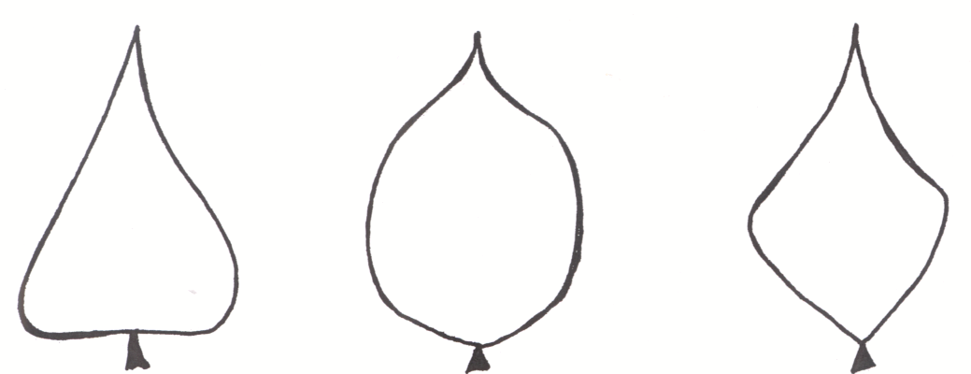

1 | 3 | 5
triangular | circular | quadrangular

Ad. 13: Terminal leaflet: lenght of tip

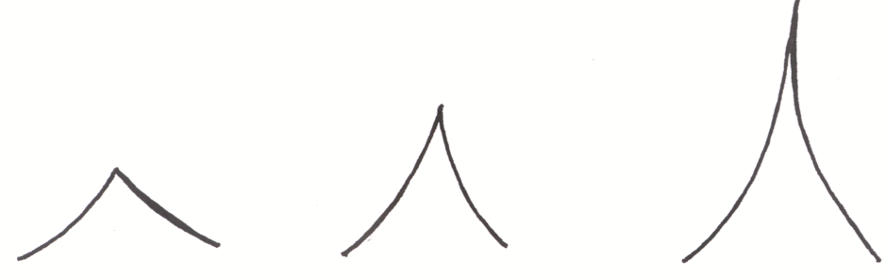

1 |  | 2 |  | 3
short | medium |  | long

Ad. 20: Pod: width
Ad. 21: Pod: thickness
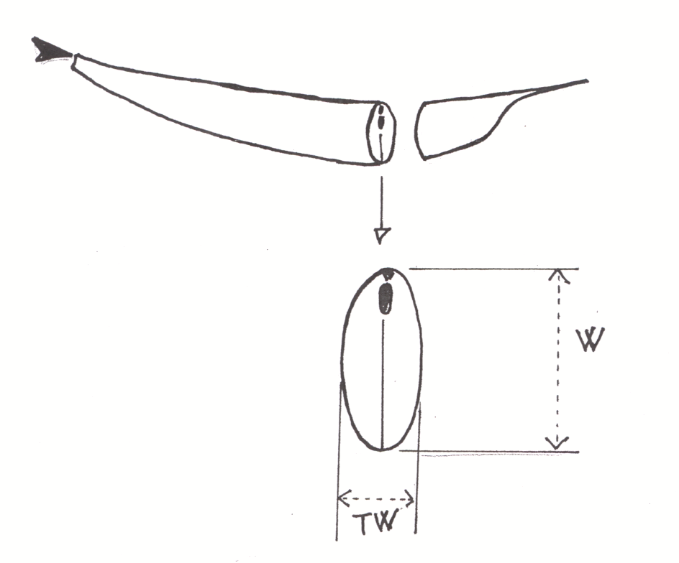
width
(characteristic 20)

thickness (characteristic 21)

Ad. 22: Pod: shape in cross section (through seed)

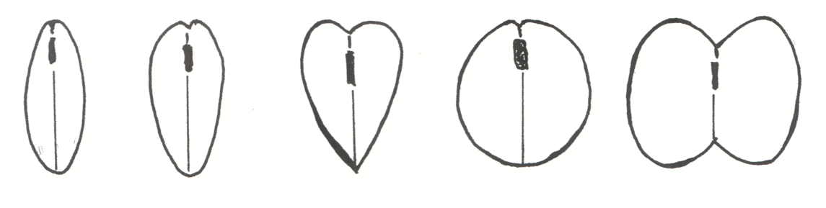

1 | 2 | 3 | 4 | 5
elliptic | ovate | cordate | circular | eight-shaped

Ad. 23: Pod: ratio thickness/width

= thickness/width
(see characteristics 21 and 20)

Ads. 24, 25: Pod: ground color (24) and intensity of ground color (25)

 | Characteristic 24: Pod: ground color
Characteristic 25: Pod: intensity of ground color | yellow (1) | green (2) | violet (3)
light (3) | Erato (D), Frühe dickfleischige Wachs (D), Goldmarie (C), | Fortissima (C), Rabl (D), Ragalla (D), Ryco (D)
medium (5) | Gabriella (D), Goldelfe (C), Goldfish (D) | Filetty (D), Prelude (D), Tuf (D)
dark (7) | Golddukat (D) | Decibel (D), Diva (D), Verona (D), Vilbel (D), | Blauhilde (C), Purpiat (D), Purple Teepee (D)

Ad. 29: Pod: stringiness of ventral suture

This characteristic should be observed just after the fresh market stage, by breaking the beak and pulling it from the pod. The stringiness emerges from the ventral suture of the pod.

The strings are very strong and should not be confused with the oakum, for example, which has a weaker structure.

Ad. 30: Pod: degree of curvature

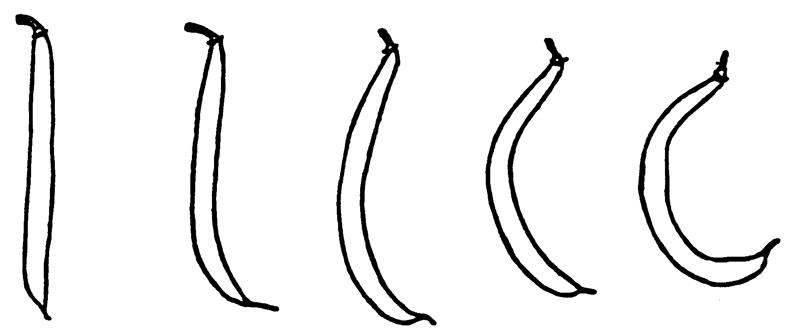

1  absent or very slight | 3  weak | 5  medium | 7  strong | 9  very strong

Ad. 31: Pod: shape of curvature

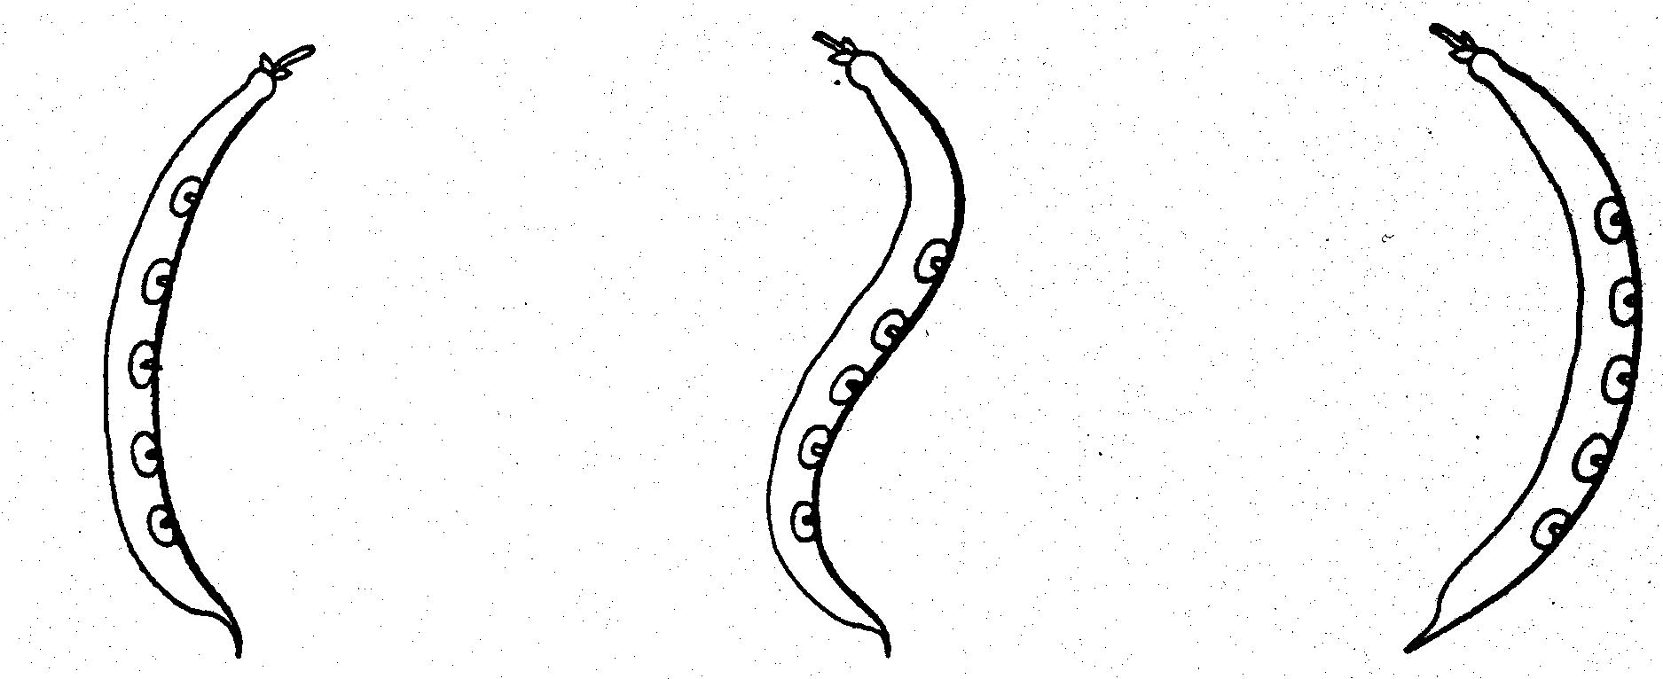
1  concave | 2  s-shaped | 3  convex

Ad. 32: Pod: shape of distal part (excluding beak)

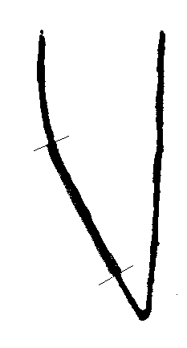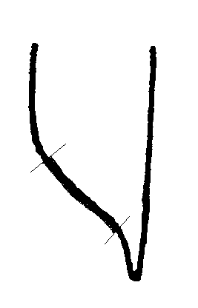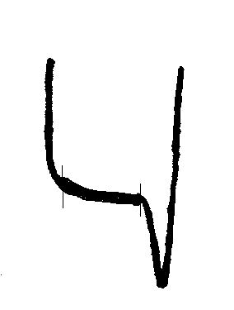

1  acute | 2  acute to truncate | 3  truncate

Ad. 37: Seed: weight

The seed weight should be measured on four samples of 100 seeds.

Ad. 38: Seed: shape in longitudinal section

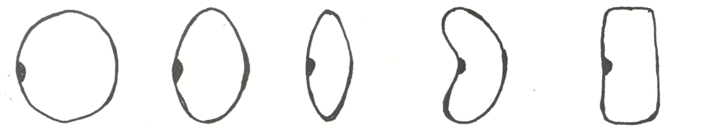
1  circular | 2  circular to elliptic | 3  elliptic | 4  kidney-shaped | 5  rectangular

Ad. 40, 41, 42: Seed: shape in cross section (40), width in cross section (41), length (42)

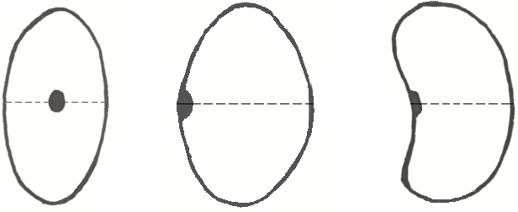
Characteristic42
Characteristic 41
Characteristic 41
X
Y
Example 1
Example 2

Characteristic 40: shape in cross section (X-Y = cross section)
Characteristic 41: width in cross section
Characteristic 42: length

Ad. 45: Seed: secondary color

The secondary color is the color with the second largest area. If several secondary colors exist, the competent authorities will add one or more characteristics as necessary.

Ad. 46: Seed: distribution of secondary color

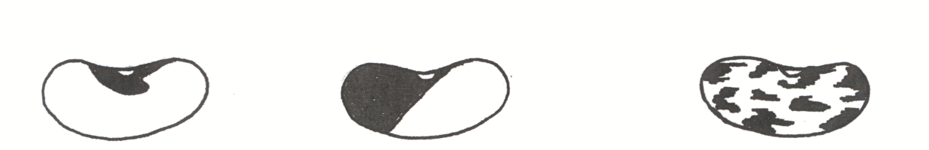

1  around hilum | 2  on half of grain | 3  on entire grain

Ad. 49: Resistance to Resistance to Colletotrichum lindemuthianum (Cl)

1. | Pathogen | Colletotrichum lindemuthianum (Cl)
2. | Quarantine status | No
3. | Host species | Phaseolus vulgaris
4. | Source of inoculum | GEVES (FR), Naktuinbouw (NL), INIA (ES)
5. | Isolate | 6, Kappa
6. | Establishment isolate identity | On differentials:

 | Old race name: |  |  | - | (no longer in TG) Lambda | Kappa
 | Binary race name: |  |  | 6 | 55 | 31
Differential |  | Gene | Binary
A | Michelite |  | 1 | R | S | S
B | Michigan Dark Red Kidney | Co-1 | 2 | S | S | S
C | Perry Marrow | Co-1³ | 4 | S | S | S
D | Cornell 49242 | Co-2 (Are) | 8 | R | R | S
E | Widusa | Co-1⁵ | 16 | R | S | S
F | Kaboon | Co-1² | 32 | R | S | R
G | Mexico 222 | Co-3 | 64 | R | R | R
H | PI 207262 |  | 128 | R | R | R
I | TO | Co-4 | 256 | R | R | R
J | TU | Co-5 | 512 | R | R | R
K | AB 136 | Co-6 | 1024 | R | R | R
L | G 2333 | Co-4-2/5/7 | 2048 | R | R | R

7. | Establishment pathogenicity | On susceptible variety
8. | Multiplication inoculum
8.1 | Multiplication medium | PDA (Potato Dextose Agar) or Mathur medium (20-25°C)
8.2 | Multiplication variety | -
8.3 | Plant stage at inoculation | Seed for soaking  5 days old seedlings for spraying
8.4 | Inoculation medium | -
8.5 | Inoculation method | Soaking or spraying seedlings
8.6 | Harvest of inoculum | Scrape spores with scraper from 7-20 days old plates grown at 20-25°C
8.7 | Check of harvested inoculum | Count spores and adjust to 10⁶ spores per mL
8.8 | Shelflife/viability inoculum | About 4 hours  Long term storage of strains: at -80°C in 20% glycerol
9. | Format of the test
9.1 | Number of plants per genotype | At least 20 plants
9.2 | Number of replicates | -
9.3 | Control varieties
 | Susceptible: | Goldrush, Michelet à longue cosse, Masai
 | Resistant for race 6 and race Lambda: | Booster, Pastoral
9.4 | Test design | -
9.5 | Test facility | Climate cell
9.6 | Temperature | 20-22°C
9.7 | Light | -
9.8 | Season | -
9.9 | Special measures | Plants are placed in high humidity
10. | Inoculation
10.1 | Preparation inoculum | Culture on PDA or Mathur medium
10.2 | Quantification inoculum | Count spores and adjust to 10⁶ spores per mL
10.3 | Plant stage at inoculation | Pre-germinated seed for soaking  5 days old seedlings for spraying
10.4 | Inoculation method | One of two methods may be applied:  - Soaking pre-germinated seeds in a spore suspension for 2 minutes. Seeds are planted in soil after inoculation  - Spraying cotyledons with inoculum suspension 5 days after sowing
10.5 | First observation | 7 days after inoculation
10.6 | Second observation | 12 days after inoculation
10.7 | Final observations | 14 days after inoculation
11. | Observations
11.1 | Method | Visual observation of symptoms
11.2 | Observation scale | 0: no symptoms  1: weak reaction with small superficial necrosis (dots or stripes)  2: necrotic lesions larger than 3 mm and/or deeply sunk into the tissue of hypocotyls and/or stems  3: dying plants
11.3 | Validation of test | Control varieties must show expected symptoms
11.4 | Off-types | -
12. | Interpretation of data in terms of  UPOV characteristic states | -
 | For soaking seeds: | Resistant [9]: class 0 and 1  Susceptible [1]: class 2 and 3
 | For spraying cotyledons: | Some flecks of necrosis can occur in the stem and some in the cotyledons of resistant varieties
13. | Critical control points | Monitor the inoculation pressure with a suitable variety e.g. with Pastoral. This variety has a weaker resistance and can give an indication of aggressiveness of the test.

Ad. 50: Resistance to Bean common mosaic necrosis virus (BCMNV)

1. | Pathogen | Bean common mosaic necrosis virus (BCMNV)
2. | Quarantine status | No
3. | Host species | Phaseolus vulgaris
4. | Source of inoculum | GEVES (FR), Naktuinbouw (NL), INIA (ES)
5. | Isolate | NL3 or NL5 (Pathogenicity group VI)
6. | Establishment isolate identity | On differentials Widusa and Top Crop;  Widusa (I) must show top or vein necrosis;  Top Crop (bc-1, I) must show only local necrosis
7. | Establishment pathogenicity | On susceptible variety
8. | Multiplication inoculum
8.1 | Multiplication medium | -
8.2 | Multiplication variety | Dufrix or Flandria
8.3 | Plant stage at inoculation | First leaf expanded (8-12 days)
8.4 | Inoculation medium | PBS (Phosphate Buffer Saline) and carborundum
8.5 | Inoculation method | Rubbing
8.6 | Harvest of inoculum | Pick leaves with mosaic and/or leaf rolling 14 days after inoculation on susceptible variety
8.7 | Check of harvested inoculum | -
8.8 | Shelflife/viability inoculum | Very long in dry or freeze dried leaves
9. | Format of the test
9.1 | Number of plants per genotype | 20
9.2 | Number of replicates | 2
9.3 | Control varieties
 | Susceptible: | Dufrix, Flandria
 | Resistant with necrosis: | Booster, Odessa
 | Resistant without necrosis: | Bizet
9.4 | Test design | Glasshouse or climatic chamber
9.5 | Test facility | Glasshouse
9.6 | Temperature | Initial 5-7 days after inoculation:  25° day / 18°C night or 30°C day and night  After 5-7 days:  25°C day and night
9.7 | Light | See remark 13.
9.8 | Season | -
9.9 | Special measures | Rinse leaves after inoculation to reduce damage by carborundum
10. | Inoculation
10.1 | Preparation inoculum | Maceration in PBS
10.2 | Quantification inoculum | -
10.3 | Plant stage at inoculation | First leaf expanded (8-12 days after sowing)
10.4 | Inoculation method | Rubbing
10.5 | First observation | 6 days after inoculation
10.6 | Second observation | 9 days after inoculation
10.7 | Final observations | 14 days after inoculation
11. | Observations
11.1 | Method | Visual observation
11.2 | Observation scale | 1: mosaic and/or leaf rolling  2: top necrosis, vein necrosis and/or small necrotic lesions  3: no symptoms
11.3 | Validation of test | Control varieties must show expected symptoms
11.4 | Off-types | -
12. | Interpretation of data in terms of  UPOV characteristic states | Classify in three classes corresponding with observation scale:  1: resistant absent  2: resistant present with necrosis  3: resistant present without necrosis
13. | Critical control points | Temperature-dependent expression of symptoms in some varieties, necrosis increasing with temperature. Light may also enhance symptom development.

Ad. 51: Resistance to Pseudomonas savastanoi pv. phaseolicola (Psp)

1. | Pathogen | Pseudomonas savastanoi pv. phaseolicola (Psp)
2. | Quarantine status | No
3. | Host species | Phaseolus vulgaris
4. | Source of inoculum | GEVES (FR), Naktuinbouw (NL), HRI (GB), INIA (ES)
5. | Isolate | Race 6
6. | Establishment isolate identity | All differentials should be susceptible (Canadian Wonder, A52, Red Mexican UI3, Mesunka, A53, A43, Guatemala 196-B)
7. | Establishment pathogenicity | On susceptible variety
8. | Multiplication inoculum
8.1 | Multiplication medium | King’s B or Yeast Dextrose Agar at 27°C
8.2 | Multiplication variety | -
8.3 | Plant stage at inoculation | First leaf (9-14 days after sowing)
8.4 | Inoculation medium | Tap water or saline solution (0.85% NaCl)
8.5 | Inoculation method | -
8.6 | Harvest of inoculum | 4 days after start of pure culture
8.7 | Check of harvested inoculum | -
8.8 | Shelflife/viability inoculum | The number of subculturing before inoculation shall not exceed 2 and the inoculation shall be done within 2-3 days.
9. | Format of the test
9.1 | Number of plants per genotype | 20
9.2 | Number of replicates | 2
9.3 | Control varieties
 | Susceptible | Michelet à longue cosse
 | Resistant | Masai, Vaillant
9.4 | Test design | -
9.5 | Test facility | Glasshouse or climate cell
9.6 | Temperature | 22/20°C day/night or 20°C day and night
9.7 | Light | -
9.8 | Season | -
9.9 | Special measures | High humidity required during first 1-3 days after inoculation
10. | Inoculation
10.1 | Preparation inoculum | Rinse bacteria from plate with tap water and add 2 g carborundum per 100 ml or rinse bacteria with saline solution (0.85% NaCl).
10.2 | Quantification inoculum | 10⁸ cfu/ ml or 1-2 full-grown plates per 100 ml water for 100 plants
10.3 | Plant stage at inoculation | First pair of leaves spreading (9-14 days after sowing)
10.4 | Inoculation method | Rubbing with sponge or inoculation by spraying leaves with pressure (2 bars) until runoff. For this purpose several types of equipment may be used: atomizer or paint brush with a pressure supplier.
10.5 | First observation | 7 days after inoculation
10.6 | Second observation | 14 days after inoculation
10.7 | Final observations | -
11. | Observations
11.1 | Method | Visual observation
11.2 | Observation scale
 | Resistant [9] | No symptoms or necrotic pinpoints
 | Susceptible [1] | Light green halo around minute lesions  Water soaked (“oily”) lesions (few or many)  Water soaked lesions, later turning necrotic  Deformation and chlorosis on first trifoliate leaves  Necrosis on stems  Dying plants
11.3 | Validation of test | Control varieties must show expected symptoms
11.4 | Off-types | -
12. | Interpretation of data in terms of  UPOV characteristic states | 11.2
13. | Critical control points | Inoculation may produce some damage on susceptible and resistant plants.  Maintenance of isolate: beware that the colony may die after keeping 3 weeks on plate.

Ad. 52: Resistance to Xanthomonas axonopodis pv. phaseoli (Xap)

1. | Pathogen | Xanthomonas axonopodis pv. phaseoli (Xap)
2. | Quarantine status | yes
3. | Host species | Phaseolus vulgaris
4. | Source of inoculum | Vegetable Research Institute, Budapest (HU)
5. | Isolate | Isolate 422
6. | Establishment isolate identity | -
7. | Establishment pathogenicity | -
8. | Multiplication inoculum
8.1 | Multiplication medium | Yeast Glucose Agar  (20 g yeast extract powder, 20 g glucose, 20 g CaCO₃, 20 g agar/ 1000 ml distilled water)
8.2 | Multiplication variety | -
8.3 | Plant stage at inoculation | First leaf pair 2-3 cm long
8.4 | Inoculation medium | -
8.5 | Inoculation method | 100% relative humidity during 2 days after inoculation, later normal humidity
8.6 | Harvest of inoculum | -
8.7 | Check of harvested inoculum | -
8.8 | Shelflife/viability inoculum | -
9. | Format of the test
9.1 | Number of plants per genotype | -
9.2 | Number of replicates | -
9.3 | Control varieties | -
9.4 | Test design | -
9.5 | Test facility
9.6 | Temperature | 26/20°C day/night or 28/25°C day/night
9.7 | Light | -
9.8 | Season | -
9.9 | Special measures | 100% relative humidity during 2 days after inoculation, later normal humidity
10. | Inoculation
10.1 | Preparation inoculum | -
10.2 | Quantification inoculum | 10⁸ cfu/ml
10.3 | Plant stage at inoculation | -
10.4 | Inoculation method | Mechanical, with camel hair brush or inoculation by spraying leaves with pressure (2 bars) until run-off. For this purpose several types of equipment may be used: atomizer or paint brush with a pressure supplier.
10.5 | First observation | 7 days after inoculation
10.6 | Second observation | 14 days after inoculation
10.7 | Final observations | When infected leaves are fully developed
11. | Observations
11.1 | Method | -
11.2 | Observation scale | Visual
 | Susceptible [1] | Extensive necrosis sometimes surrounded by an increasing ring of chlorotic tissue
 | Resistant [9] | Cell-sized brownish or red necrotic spots
11.3 | Validation of test | -
11.4 | Off-types | -
12. | Interpretation of data in terms of  UPOV characteristic states | 11.2
13. | Critical control points | -

- Literature

Anonymous, 1931: “Beans of New York” in “Vegetables of New York,” Vol. I, Part 2 (Hedrick, U.P., a.o.), State of New York Educational Department, pp. 110

Anonymous, 1983: “Description et essai de classification des variétés de haricot nain” (jusqu’au 30-11-81), Institut national de la recherche agronomique (INRA-GEVES), Mons, 80200 Peronne, France, pp. 232

Chopinet, R., Trebuchet, G., Drouzy, J.: “Essai de Classification et d’Identification des principales variétés de haricots cultivées en France,” Vilmorin

Coyne, D.P., Schuster, M.L., Shaugnessy, L., 1966: “Inheritance of resitance to Halo Blight and Common Blight bacteria in Phaseolus vulgaris variety cross,” Plant Dis.Reg., 50: 1: pp. 29-32.

Diaz, G., Nunez, R., 1971: “Descripción morfológica de 18 variedades de judia de verdeo,” Instituto Nacional de Semillas y Plantas de Vivero, Zaragoza, Spain

Drijfhout, E., 1978: “Genetic interaction between Phaseolus vulgaris and bean common mosaic virus with implications for strain identification and breeding for resistance,” Agricultural Research Report 872, Centre for Agricultural Publishing and Documentation, Wageningen, NL

INVULFEC, 1970: “Le haricot vert,” Paris, France

Mckern, N.M., Mintz, G.I., Burnett, O.W., Mishra, A., Whittaker, L.A., Silbernagel, M.J., Ward, C.W., Shulala, D.P., 1992: “Isolates of Bean Common Mosaic Virus Comprising Two Distinct Potyviruses, Etiology Vol. 82, No. 9, pp. 923-929

Patel, P.N., Walker, J.C., 1966: Inheritance of tolerance to Halo Blight in bean,” Phytopath., 56: pp. 681-682

Puerto Romero, J., 1961: “Variedades de judia cultivadas en España,” Ministerio de Agricultura, Madrid, Spain

Szarka, J., Velich, I., 1978: “ Survey of bacterium species causing disease of bean in Hungary,” Test Methods, Bulletin of the Vegetable Crops Research Institute Kecskemét, Hungary, 13: pp. 17-23

Szarka, J., Velich, I., 1978: “Leaf reactions of bean lines and varieties to Pseudomonas phaseolicola (Burk) Dowson,” Annual Report Bean Improvement Cooperative, Fort Collins, USA, 21: pp. 57-58

Szarka, J., Velich, I., 1979: “Study of the aggressivity of isolates belonging to the Pseudomonas phaseolicola (Burkh.) Dowson,” Annual Report Bean Improvement cooperative, Fort Collins, USA. 22: pp. 64-65

Szarka, J., 1986: “Pathogenicity spectrum in the species Xanthomonas phaseoli within the species Phaseolus vulgaris,” Bulletin of the Vegetable Crops Research Institute Kecskemét, Hungary 22: pp. 123-127

Szarka, J., 1993: “Testing new sources of resistance to Xanthomonas campestris pv. phaseoli in bean breeding,” Bulletin of the Vegetable Crops Research Institute Kecskemét, Hungary 25: pp. 75-79

Velich, I., Szarka, J., Neda, P., Toth, V., 1991: “Iallel analysis of reaction of bean to Pseudomonas and Xanthomonas,” Annual Report Bean Impr. Coop., Fort Colling, USA, 34: pp. 31-32

Velich, I., Szarka, J., Neda, P., Csizmadia, L., 1991: “New possibilities in the resistance breeding for bacterial diseases in bean,” Bulletin of the Vegetable Crops Research Institute Kecskemét, Hungary, 24: pp. 57-64

- Technical Questionnaire
TECHNICAL QUESTIONNAIRE |  |  |  | Page {x} of {y} |  | Reference Number:
 |  |  |  |  |  | Application date:
 |  |  |  |  |  | (not to be filled in by the applicant)
TECHNICAL QUESTIONNAIRE
to be completed in connection with an application for plant breeders’ rights

1. Subject of the Technical Questionnaire
1.1 Botanical name |  |  | Phaseolus vulgaris L.
1.2 Common Name |  |  | French Bean
2. Applicant
Name
Address
Telephone No.
Fax No.
E-mail address
Breeder (if different from applicant)
3. Proposed denomination and breeder’s reference
Proposed denomination
(if available)

Breeder’s reference
#4. Information on the breeding scheme and propagation of the variety

4.1 Breeding scheme

Variety resulting from:

4.1.1 Crossing

(a) controlled cross [ ]
(please state parent varieties)
(b) partially known cross [ ]
(please state known parent variety(ies))
(c) unknown cross [ ]

4.1.2 Mutation [ ]
(please state parent variety)

4.1.3 Discovery and development [ ]
(please state where and when discovered and
how developed)

4.1.4 Other [ ]
(please provide details)

4.2 Method of propagating the variety

4.2.1 Seed-propagated varieties

(a) Self-pollination [ ]

(b) Other [ ]
(please provide details)

5. Characteristics of the variety to be indicated (the number in brackets refers to the corresponding characteristic in Test Guidelines; please mark the note which best corresponds).

 | Characteristics |  |  |  |  |  | Example Varieties |  |  | Note
5.1  (3) | Plant: growth type
 | dwarf |  |  |  |  |  | Callide (D), Capitole (D) |  |  | 1[ ]
 | climbing |  |  |  |  |  | Phenomene (C), Bacle (C) |  |  | 2[ ]
5.2  (16) | Flower: color of standard
 | white |  |  |  |  |  | Tuf (D) |  |  | 1[ ]
 | pinkish white |  |  |  |  |  | Mira (D) |  |  | 2[ ]
 | pink |  |  |  |  |  | Maxi (D), Vilbel (D) |  |  | 3[ ]
 | violet |  |  |  |  |  | Delinel (D), Purple Teepee (D) |  |  | 4[ ]
5.3  (18) | Dwarf beans only: Pod: length (excluding beak)
 | very short |  |  |  |  |  |  |  |  | 1[ ]
 | short |  |  |  |  |  | Prelude (D), Tuf (D) |  |  | 3[ ]
 | medium |  |  |  |  |  | Amity (D), Lusia (D) |  |  | 5[ ]
 | long |  |  |  |  |  | Dubra (D), Loma (D) |  |  | 7[ ]
 | very long |  |  |  |  |  | Daisy (D), Longking (D), Maja (D) |  |  | 9[ ]
5.4  (19) | Climbing beans only: Pod: length (as for 18)
 | very short |  |  |  |  |  |  |  |  | 1[ ]
 | short |  |  |  |  |  | Juwagold (C) |  |  | 3[ ]
 | medium |  |  |  |  |  |  |  |  | 5[ ]
 | long |  |  |  |  |  | Fidel (C) |  |  | 7[ ]
 | very long |  |  |  |  |  | Toplong (C) |  |  | 9[ ]
 | Characteristics |  |  |  |  |  | Example Varieties |  |  | Note
5.5  (22) | Pod: shape in cross section (through seed)
 | narrow elliptic |  |  |  |  |  |  |  |  | 1[ ]
 | ovate |  |  |  |  |  | Pascal (D), Pfälzer Juni (D), Regulex (D) |  |  | 2[ ]
 | cordate |  |  |  |  |  | Daisy (D) |  |  | 3[ ]
 | circular |  |  |  |  |  | Tuf (D) |  |  | 4[ ]
 | eight shaped |  |  |  |  |  | Tendercrop White Seeded (D) |  |  | 5[ ]
5.6  (24) | Pod: ground color
 | yellow |  |  |  |  |  | Gold fish (D), Golddukat (D), Goldmarie (C) |  |  | 1[ ]
 | green |  |  |  |  |  | Fortissima (C), Filetty (D), Diva (D) |  |  | 2[ ]
 | violet |  |  |  |  |  | Purpiat (D), Purple Teepee (D) |  |  | 3[ ]
5.7  (29) | Pod: stringiness on ventral suture
 | absent |  |  |  |  |  | Cabri (D), Tuf (D) |  |  | 1[ ]
 | present |  |  |  |  |  | Facta (D), Marbel (D) |  |  | 9[ ]
5.8  (43) | Seed: number of colors
 | one |  |  |  |  |  |  |  |  | 1[ ]
 | two |  |  |  |  |  |  |  |  | 2[ ]
 | more than two |  |  |  |  |  |  |  |  | 3[ ]
 | Characteristics |  |  |  |  |  | Example Varieties |  |  | Note
5.9  (44) | Seed: main color (largest area)
 | white |  |  |  |  |  | Goldfish (D), Tuf (D) |  |  | 1[ ]
 | green or greenish |  |  |  |  |  | Muriel (D), Pascal (D) |  |  | 2[ ]
 | grey |  |  |  |  |  | Centaure (D), Opal (D) |  |  | 3[ ]
 | yellow |  |  |  |  |  | Gele Citroen (D) |  |  | 4[ ]
 | beige |  |  |  |  |  | Blauhilde (C), Purple Teepee (D) |  |  | 5[ ]
 | brown |  |  |  |  |  | Primel (D), Sunray (D) |  |  | 6[ ]
 | red |  |  |  |  |  | Flageolet rouge (D) |  |  | 7[ ]
 | violet |  |  |  |  |  | Garrafal enana (D),  Surpasse phenix (D) |  |  | 8[ ]
 | black |  |  |  |  |  | Delinel (D), Vilbel (D) |  |  | 9[ ]
5.10  (45) | Seed: secondary color
 | grey |  |  |  |  |  |  |  |  | 1[ ]
 | yellow |  |  |  |  |  |  |  |  | 2[ ]
 | beige |  |  |  |  |  | Abonder (D), Tarot (D) |  |  | 3[ ]
 | brown |  |  |  |  |  | Talisman (D) |  |  | 4[ ]
 | red |  |  |  |  |  | Fori (D) |  |  | 5[ ]
 | violet |  |  |  |  |  | Marbel (D) |  |  | 6[ ]
 | black |  |  |  |  |  | Brittle Wax (D) |  |  | 7[ ]
5.11  (48) | Time of flowering (50% of the plants with at least one flower)
 | very early |  |  |  |  |  | Pfälzer Juni (D) |  |  | 1[ ]
 | early |  |  |  |  |  | Fortissima (C),  Perle von Marbach (C), Prelude (D) |  |  | 3[ ]
 | medium |  |  |  |  |  | Fanion (D), Groffy (D), Hilda (C), Precores (C) |  |  | 5[ ]
 | late |  |  |  |  |  | Necores (C) |  |  | 7[ ]
 | very late |  |  |  |  |  |  |  |  | 9[ ]
 | Characteristics |  |  |  |  |  | Example Varieties |  |  | Note
5.12  (49.1) | Resistance to Colletotrichum lindemuthianum (Cl)
 | Race 6
 | absent |  |  |  |  |  | Goldrush, Masai,  Michelet à longue cosse |  |  | 1[ ]
 | present |  |  |  |  |  | Booster, Pastoral |  |  | 9[ ]
5.13  (49.2) | Resistance to Colletotrichum lindemuthianum (Cl)
 | Race Kappa
 | absent |  |  |  |  |  | Goldrush, Masai,  Michelet à longue cosse |  |  | 1[ ]
 | present |  |  |  |  |  | Booster, Pastoral |  |  | 9[ ]
5.14  (50) | Resistance to Bean common mosaic necrosis virus (BCMNV)
 | absent |  |  |  |  |  | Dufrix, Flandria |  |  | 1[ ]
 | present with necrosis |  |  |  |  |  | Booster, Odessa |  |  | 2[ ]
 | present without symptoms |  |  |  |  |  | Bizet |  |  | 3[ ]
5.15  (51) | Resistance to Pseudomonas savastanoi pv. phaseolicola (Psp)
 | Race 6
 | absent |  |  |  |  |  | Michelet à longue cosse (D) |  |  | 1[ ]
 | present |  |  |  |  |  | Masai (D), Vaillant (D) |  |  | 9[ ]
6. Similar varieties and differences from these varieties

Please use the following table and box for comments to provide information on how your candidate variety differs from the variety (or varieties) which, to the best of your knowledge, is (or are) most similar. This information may help the examination authority to conduct its examination of distinctness in a more efficient way.

Denomination(s) of variety(ies) similar to your candidate variety |  | Characteristic(s) in which your candidate variety differs from the similar variety(ies) |  |  | Describe the expression of the characteristic(s) for the similar variety(ies) |  |  | Describe the expression of the characteristic(s) for your candidate variety
Example |  | Terminal leaflet:  size |  |  | medium |  |  | small
Comments:

#7. Additional information which may help in the examination of the variety

7.1 In addition to the information provided in sections 5 and 6, are there any additional characteristics which may help to distinguish the variety?

Yes [ ] No [ ]

(If yes, please provide details)

7.2 Are there any special conditions for growing the variety or conducting the examination?

Yes [ ] No [ ]

(If yes, please provide details)

7.3 Other information

8. Authorization for release

(a) Does the variety require prior authorization for release under legislation concerning the protection of the environment, human and animal health?

Yes [ ] No [ ]

(b) Has such authorization been obtained?

Yes [ ] No [ ]

If the answer to (b) is yes, please attach a copy of the authorization.

9. Information on plant material to be examined or submitted for examination.

9.1 The expression of a characteristic or several characteristics of a variety may be affected by factors, such as pests and disease, chemical treatment (e.g. growth retardants or pesticides), effects of tissue culture, different rootstocks, scions taken from different growth phases of a tree, etc.

9.2 The plant material should not have undergone any treatment which would affect the expression of the characteristics of the variety, unless the competent authorities allow or request such treatment. If the plant material has undergone such treatment, full details of the treatment must be given. In this respect, please indicate below, to the best of your knowledge, if the plant material to be examined has been subjected to:

(a) Microorganisms (e.g. virus, bacteria, phytoplasma) Yes [ ] No [ ]

(b) Chemical treatment (e.g. growth retardant, pesticide) Yes [ ] No [ ]

(c) Tissue culture Yes [ ] No [ ]

(d) Other factors Yes [ ] No [ ]

Please provide details of where you have indicated “yes”.

……………………………………………………………

9.3 Has the plant material to be examined been tested for the presence of virus or other pathogens?

Yes [ ]
(please provide details as specified by the Authority)

No [ ]

10. I hereby declare that, to the best of my knowledge, the information provided in this form is correct:

Applicant’s name

Signature Date

[End of document]

* These names were correct at the time of the introduction of these Test Guidelines but may be revised or updated. [Readers are advised to consult the UPOV Code, which can be found on the UPOV Website (www.upov.int), for the latest information.]
# Authorities may allow certain of this information to be provided in a confidential section of the Technical Questionnaire.
# Authorities may allow certain of this information to be provided in a confidential section of the Technical Questionnaire.

