 |  | E  TG/11/8 Rev. 2  ORIGINAL: English  DATE: 2006-04-05 + 2010-03-24  + 2022-10-25
INTERNATIONAL UNION FOR THE PROTECTION OF NEW VARIETIES OF PLANTS
GENEVA

 | ROSE  UPOV Code: ROSAA  Rosa L. | *

GUIDELINES

FOR THE CONDUCT OF TESTS

FOR DISTINCTNESS, UNIFORMITY AND STABILITY

Alternative Names:*

Botanical name | English | French | German | Spanish
Rosa L. | Rose | Rosier | Rose | Rosal

The purpose of these guidelines (“Test Guidelines”) is to elaborate the principles contained in the General Introduction (document TG/1/3), and its associated TGP documents, into detailed practical guidance for the harmonized examination of distinctness, uniformity and stability (DUS) and, in particular, to identify appropriate characteristics for the examination of DUS and production of harmonized variety descriptions.

ASSOCIATED DOCUMENTS

These Test Guidelines should be read in conjunction with the General Introduction and its associated TGP documents.

TABLE OF CONTENTS PAGE

1. Subject of these Test Guidelines 3
2. Material Required 3
3. Method of Examination 3
3.1 Duration of Tests 3
3.2 Testing Place 3
3.3 Conditions for Conducting the Examination 3
3.4 Test Design 4
3.5 Number of Plants / Parts of Plants to be Examined 4
3.6 Additional Tests 4
4. Assessment of Distinctness, Uniformity and Stability 4
4.1 Distinctness 4
4.2 Uniformity 5
4.3 Stability 5
5. Grouping of Varieties and Organization of the Growing Trial 5
6. Introduction to the Table of Characteristics 6
6.1 Categories of Characteristics 6
6.2 States of Expression and Corresponding Notes 7
6.3 Types of Expression 7
6.4 Example Varieties 7
6.5 Legend 7
7. Table of Characteristics 8
8. Explanations on the Table of Characteristics 27
8.1 Explanations covering several characteristics 27
8.2 Explanations for individual characteristics 27
8.3 Growing types 35
9. Literature 36
10. Technical Questionnaire 37

Subject of these Test Guidelines
These Test Guidelines apply to all varieties of Rosa L. of the family Rosaceae.

Material Required
2.1 The competent authorities decide on the quantity and quality of the plant material required for testing the variety and when and where it is to be delivered. Applicants submitting material from a State other than that in which the testing takes place must ensure that all customs formalities and phytosanitary requirements are complied with.

2.2 Cut-flower type trial: the material is to be supplied in the form of young plants of commercial standard with their own roots, unless the variety does not grow with its own roots, in which case grafted plants and/or budwood of the variety would be required.

Garden and pot type trials: the material is to be supplied in the form of young plants growing with their own roots, or grafted on a rootstock .

2.3 The minimum quantity of plant material, to be supplied by the applicant, should be:

Cut-flower type trial:
9 plants
Garden and pot type trials:
6 plants.

2.4 In cases where grafted plants are supplied, the applicant should state the rootstock which has been used.

2.5 The plant material should not have undergone any treatment which would affect the expression of the characteristics of the variety, unless the competent authorities allow or request such treatment. If it has been treated, full details of the treatment must be given.

Method of Examination

3.1 Number of Growing Cycles
The minimum duration of tests should normally be a single growing cycle.

3.2 Testing Place
Tests are normally conducted at one place. In the case of tests conducted at more than one place, guidance is provided in TGP/9 “Examining Distinctness”.

3.3 Conditions for Conducting the Examination
3.3.1 The tests should be carried out under conditions ensuring satisfactory growth for the expression of the relevant characteristics of the variety and for the conduct of the examination. In particular, it may be necessary for separate growing trials to be established for cut-flower types, garden types and pot types in order to ensure the satisfactory growth of varieties of those types (see Chapter 8.3). These Test Guidelines provide information to cover such a situation.

3.3.2 Unless otherwise stated, all observations should be made at the time of full flowering. For cut-flower types, the plants should not be observed in the first flush of flowering.

3.3.3 Because daylight varies, color determinations made against a color chart should be made either in a suitable cabinet providing artificial daylight or in the middle of the day in a room without direct sunlight. The spectral distribution of the illuminant for artificial daylight should conform with the CIE Standard of Preferred Daylight D 6500 and should fall within the tolerances set out in the British Standard 950, Part I. These determinations should be made with the plant part placed against a white background.

3.4 Test Design
3.4.1 The design of the tests should be such that plants or parts of plants may be removed for measurement or counting without prejudice to the observations which must be made up to the end of the growing cycle.

3.4.2 Cut-flower type trial: each test should be designed to result in a total of at least nine plants.

3.4.3 Garden and pot type trials: each test should be designed to result in a total of at least six plants.

3.5 Number of Plants / Parts of Plants to be Examined
3.5.1 Cut-flower type trial: Unless otherwise indicated, all observations should be made on nine plants or parts taken from each of nine plants.

    - Garden and pot type trials: Unless otherwise indicated, all observations should be made on six plants or parts taken from each of six plants.

3.6 Additional Tests
Additional tests, for examining relevant characteristics, may be established.

Assessment of Distinctness, Uniformity and Stability

4.1 Distinctness
4.1.1 General Recommendations

It is of particular importance for users of these Test Guidelines to consult the General Introduction prior to making decisions regarding distinctness. However, the following points are provided for elaboration or emphasis in these Test Guidelines.

4.1.2 Consistent Differences

The differences observed between varieties may be so clear that more than one growing cycle is not necessary. In addition, in some circumstances, the influence of the environment is not such that more than a single growing cycle is required to provide assurance that the differences observed between varieties are sufficiently consistent. One means of ensuring that a difference in a characteristic, observed in a growing trial, is sufficiently consistent is to examine the characteristic in at least two independent growing cycles.

4.1.3 Clear Differences

Determining whether a difference between two varieties is clear depends on many factors, and should consider, in particular, the type of expression of the characteristic being examined, i.e. whether it is expressed in a qualitative, quantitative, or pseudo-qualitative manner. Therefore, it is important that users of these Test Guidelines are familiar with the recommendations contained in the General Introduction prior to making decisions regarding distinctness.

4.2 Uniformity
4.2.1 It is of particular importance for users of these Test Guidelines to consult the General Introduction prior to making decisions regarding uniformity. However, the following points are provided for elaboration or emphasis in these Test Guidelines:

4.2.2 For the assessment of uniformity, a population standard of 1% and an acceptance probability of at least 95 % should be applied. In the case of sample sizes of 6 plants and 9 plants, one off-type is allowed.

4.3 Stability
4.3.1 In practice, it is not usual to perform tests of stability that produce results as certain as those of the testing of distinctness and uniformity. However, experience has demonstrated that, for many types of variety, when a variety has been shown to be uniform, it can also be considered to be stable.

4.3.2 Where appropriate, or in cases of doubt, stability may be tested, either by growing a further generation, or by testing a new plant stock to ensure that it exhibits the same characteristics as those shown by the previous material supplied.

Grouping of Varieties and Organization of the Growing Trial
5.1 The selection of varieties of common knowledge to be grown in the trial with the candidate varieties and the way in which these varieties are divided into groups to facilitate the assessment of distinctness are aided by the use of grouping characteristics.

5.2 Grouping characteristics are those in which the documented states of expression, even where produced at different locations, can be used, either individually or in combination with other such characteristics: (a) to select varieties of common knowledge that can be excluded from the growing trial used for examination of distinctness; and (b) to organize the growing trial so that similar varieties are grouped together.

5.3 The following have been agreed as useful grouping characteristics:

(a) Plant: growth type (characteristic 1) [G] and [P] only
(b) Flower: type (characteristic 21)
(c) Flower: color group (characteristic 23)
(d) Flower: diameter (characteristic 26)
(e) Petal: number of colors on inner side (basal spot excluded) (characteristic 40)
(f) Petal: main color on the outer side (only if clearly different from inner side) (characteristic 50) with the following groups:
Group 1: green
Group 2: light yellow
Group 3: medium yellow
Group 4: orange
Group 5: pink
Group 6: red
Group 7: purple red
Group 8: brown red

  - Guidance for the use of grouping characteristics, in the process of examining distinctness, is provided through the General Introduction.

  - Where separate growing trials are used for cut-flower types (C), garden types (G) and pot rose types (P) (see Section 3.3.1), varieties should be included in the appropriate growing trial(s) in order to ensure an effective examination of distinctness. In particular, it may be appropriate to include a variety in both the garden type trial and the cut-flower type trial or to include a variety in both the garden type trial and pot type trial.

6. Introduction to the Table of Characteristics

6.1 Categories of Characteristics
6.1.1 Standard Test Guidelines Characteristics

Standard Test Guidelines characteristics are those which are approved by UPOV for examination of DUS and from which members of the Union can select those suitable for their particular circumstances.

6.1.2 Asterisked Characteristics

Asterisked characteristics (denoted by *) are those included in the Test Guidelines which are important for the international harmonization of variety descriptions and should always be examined for DUS and included in the variety description by all members of the Union, except when the state of expression of a preceding characteristic or regional environmental conditions render this inappropriate.

6.2 States of Expression and Corresponding Notes
States of expression are given for each characteristic to define the characteristic and to harmonize descriptions. Each state of expression is allocated a corresponding numerical note for ease of recording of data and for the production and exchange of the description.

6.3 Types of Expression
An explanation of the types of expression of characteristics (qualitative, quantitative and pseudo-qualitative) is provided in the General Introduction.

6.4 Example Varieties
Where appropriate, example varieties are provided to clarify the states of expression of each characteristic. The type is indicated in brackets after the name of the example variety as follows:

(C) cut-flower type
(G) garden type
(P) pot type

6.5 Legend
(*) Asterisked characteristic – see Chapter 6.1.2

QL Qualitative characteristic – see Chapter 6.3
QN Quantitative characteristic – see Chapter 6.3
PQ Pseudo-qualitative characteristic – see Chapter 6.3

(a) – (c) See Explanations on the Table of Characteristics in Chapter 8.1

(+) See Explanations on the Table of Characteristics in Chapter 8.2

[C] to be examined in cut-flower type trial
[G] to be examined in garden type trial
[P] to be examined in pot type trial

(C) cut-flower type
(G) garden type
(P) pot-rose type

Table of Characteristics/Tableau des caractères/Merkmalstabelle/Tabla de caracteres
 |  | English | français | deutsch | español | Example Varieties/ Exemples/ Beispielssorten/ Variedades ejemplo | Note/  Nota
1.  (*) | [G]  [P] | Plant: growth type | Plante: type de croissance | Pflanze: Wuchstyp | Planta: crecimiento
PQ |  | miniature | miniature | Minirose | miniatura |  | 1
 |  | dwarf | nain | Zwergrose | enano | Korverlandus (G) | 2
 |  | bed | de massif | Beetrose | de macizo | Taneidol (G) | 3
 |  | shrub | en buisson | Strauchrose | arbustivo | Kolmag (G) | 4
 |  | climber | grimpant | Kletterrose | trepador | Noasafa (G) | 5
 |  | ground cover | couvre-sol | Bodendeckerrose | tapizante | Meifafio (G) | 6
2.  (*)  (+) | [G]  [P] | Excluding varieties with growth type climber: Plant: growth habit | À l’exclusion des variétés du type de croissance grimpant: Plante: port | Ohne Sorten mit Wuchstyp Kletterrose: Pflanze: Wuchsform | Excluidas las variedades de crecimiento trepador: Planta: porte
QN |  | upright | dressé | aufrecht | erecto | Poulhi008 (P) | 1
 |  | semi upright | demi-dressé | halbaufrecht | semierecto | Tantasch (G); Korkallet (P) | 3
 |  | intermediate | intermédiaire | mittel | medio | Poulkrid (G); Evera107 (P) | 5
 |  | moderately spreading | modérément divergent | mittel breitwüchsig | moderadamente rastrero | Meibonrib (G) | 7
 |  | strongly spreading | fortement divergent | stark breitwüchsig | fuertemente rastrero | Korkilgwen (G) | 9
3. | [C]  [G[ | Plant: height (during second flush) | Plante: hauteur (pendant la deuxième pousse) | Pflanze: Höhe (während des zweiten Blütenflors) | Planta: altura (durante la segunda brotación)
QN |  | very short | très basse | sehr niedrig | muy baja | Lenwiga (G) | 1
 |  | short | basse | niedrig | baja | Noason (G) | 3
 |  | medium | moyenne | mittel | media | Macrexy (G); Ruiy5451 (C) | 5
 |  | tall | haute | hoch | alta | Seliron (C); Tanakinom (G) | 7
 |  | very tall | très haute | sehr hoch | muy alta | Macyefre (G) | 9
4.  (+) |  | Young shoot: anthocyanin coloration | Jeune rameau: pigmentation anthocyanique | Junger Trieb: Anthocyanfärbung | Tallo joven: coloración antociánica
QL |  | absent | absente | fehlend | ausente | Poulans (G); Poulra019 (P) | 1
 |  | present | présente | vorhanden | presente | Ruirovingt (C); Taneidol (G);  Ruiy1549 (P) | 9
5.  (+) |  | Young shoot: intensity of anthocyanin coloration | Jeune rameau: intensité de la pigmentation anthocyanique | Junger Trieb: Intensität der Anthocyanfärbung | Tallo joven: intensidad de la coloración antociánica
QN |  | very weak | très faible | sehr gering | muy débil | Presur (C); Poulen003 (G); Poulpollo (P) | 1
 |  | weak | faible | gering | débil | Ruirovingt (C); Baipeace (G); Ruitrot (P) | 3
 |  | medium | moyenne | mittel | media | Schetroje (C); Noala (G); Delpajor (P) | 5
 |  | strong | forte | stark | fuerte | Selaurum (C); Korozon (G); Korbigman (P) | 7
 |  | very strong | très forte | sehr stark | muy fuerte | Pekcoujenny (C); TAN96051 (G) | 9
6. |  | Stem: number of prickles (excluding very small and hair-like prickles ) | Tige: nombre d’aiguillons (aiguillons très courts et aiguillons capillaires exclus) | Stiel: Anzahl Stacheln (außer sehr kleine und haarähnliche Stacheln) | Tallo: número de espinas (excluidas las espinas muy pequeñas y similares a los pelos)
QN |  | absent or very few | nul ou très petit | fehlend oder sehr gering | ausente o muy bajo | Ruiorg (G); Meibegil (P) | 1
 |  | few | petit | gering | bajo | Schremna (C); Kortionza (G); Poulcolop (P) | 3
 |  | medium | moyen | mittel | medio | Selaurum (C); Bokramar (G); Kormisso (P) | 5
 |  | many | grand | groß | alto | Meineble (G); Evera105 (P) | 7
 |  | very many | très grand | sehr groß | muy alto | Deljam (G) | 9
7. |  | Prickles: predominant color  (as for 6) | Aiguillons: couleur prédominante (comme pour 6) | Stacheln vorwiegende Farbe (wie für 6) | Espinas: color predominante (como en el 6)
PQ | (a) | greenish | verdâtre | grünlich | verdoso | Presur (C); Kolmag (G); Poulcar (P) | 1
 |  | yellowish | jaunâtre | gelblich | amarillento | Ruiy0775 (P) | 2
 |  | reddish | rougeâtre | rötlich | rojizo | Bokrarug (G); Delpajor (P) | 3
 |  | purplish | pourpre | purpurn | purpúreo | Kornairol (G); Evera102 (P) | 4
8. |  | Leaf: size | Feuille: taille | Blatt: Größe | Hoja: tamaño
QN | (a) | small | petite | klein | pequeño | Predesplen (C); Kordenzen (G); Ruibrei (P) | 3
 |  | medium | moyenne | mittel | medio | Pekcoujenny (C); Tantasch (G); Korrecalam (P) | 5
 |  | large | grande | groß | grande | Poultime (G); Poulhi018 (P) | 7
9. |  | Leaf: intensity of green color (upper side) | Feuille: intensité de la couleur verte (face supérieure) | Blatt: Intensität der Grünfärbung (Oberseite) | Hoja: intensidad del color verde (parte superior)
QN | (a) | light | claire | hell | claro | Interlis (C); Tanjuwe (G); Evergreen (P) | 3
 |  | medium | moyenne | mittel | medio | Korplapei (C); Poulrus (G); Korrecalam (P) | 5
 |  | dark | foncée | dunkel | oscuro | Korparesni (G); Poulflag (P) | 7
10. | [G]  [P] | Leaf: anthocyanin coloration | Feuille: pigmentation anthocyanique | Blatt: Anthocyanfärbung | Hoja: coloración antociánica
QL | (a) | absent | absente | fehlend | ausente | Poulac005 (G); Meikilaylo (P) | 1
 |  | present | présente | vorhanden | presente | Kornairol (G); Evera102 (P) | 9
11.  (*) |  | Leaf: glossiness of upper side | Feuille: brillance de la face supérieure | Blatt: Glanz der Oberseite | Hoja: brillo de la parte superior
QN | (a) | absent or very weak | nulle ou très faible | fehlend oder sehr gering | ausente o muy débil | Somnip (G); Evera105 (P) | 1
 |  | weak | faible | gering | débil | Korcilmo (C); Meilauron (G); Korscherki (P) | 3
 |  | medium | moyenne | mittel | medio | Interlis (C); Dicmoust (G); Ruiy0775 (P) | 5
 |  | strong | forte | stark | fuerte | Pekcoujenny (C); Wekpaltlez (G); Poulhi008 (P) | 7
 |  | very strong | très forte | sehr stark | muy fuerte |  | 9
12.  (*) |  | Leaflet: undulation of margin | Foliole: ondulation du bord | Blatt Wellung des Randes | Folíolo: ondulación del margen
QN | (a) | absent or very weak | nulle ou très faible | fehlend oder sehr gering | ausente o muy débil | Poulaksel (G); Poulyn (P) | 1
 |  | weak | faible | gering | débil | Korcilmo (C); Meihecluz (G); Delpajor (P) | 3
 |  | medium | moyenne | mittel | media | Ruirovingt (C); Korkilgwen (G); Korbigman (P) | 5
 |  | strong | forte | stark | fuerte | Predepass (C); Noatraum (G); Ruiz0123 (P) | 7
 |  | very strong | très forte | sehr stark | muy fuerte |  | 9
13.  (*) |  | Terminal leaflet: shape of blade | Foliole terminale: forme du limbe | Endfieder: Form der Spreite | Folíolo terminal: forma del limbo
PQ | (a) | narrow elliptic | elliptique étroit | schmal elliptisch | elíptica estrecha | Korverlandus (G); Ruiz29924 (P) | 1
 |  | medium elliptic | elliptique moyen | mittel elliptisch | elíptica media | Korflapei (C); Meihuterb (G); Ruiz14914 (P) | 2
 |  | ovate | ovale | eiförmig | oval | Interlis (C); Noahan (G); Evera102 (P) | 3
 |  | circular | circulaire | rund | circular | Poulna (G) | 4
14.  (+) | [C] | Terminal leaflet: shape of base of blade | Foliole terminale: forme de la base du limbe | Endfieder: Form der Basis der Spreite | Folíolo terminal: forma de la base del limbo
PQ | (a) | acute | aiguë | spitz | aguda | Tanotika (C) | 1
 |  | obtuse | obtuse | stumpf | obtusa | Schetroje (C) | 2
 |  | rounded | arrondie | abgerundet | redondeada | Korcilmo (C) | 3
 |  | cordate | cordiforme | herzförmig | cordiforme |  | 4
15.  (+) |  | Terminal leaflet: shape of apex of blade | Foliole terminale: forme du sommet du limbe | Endfieder: Form der Spitze der Spreite | Folíolo terminal: forma del ápice del limbo
PQ | (a) | acuminate | acuminée | zugespitzt | acuminado | Meihuterb (G); Poulberty (P) | 1
 |  | acute | aiguë | spitz | agudo | Interlis (C); Heleva (G); Kormutric (P) | 2
 |  | obtuse | obtuse | stumpf | obtuso | Pekcourofondu (G) | 3
 |  | rounded | arrondie | abgerundet | redondeado | Ruirovingt (C); Tantumleh (G) | 4
16.  (+) | [G]  [P] | Flowering shoot: flowering laterals | Rameau florifère: ramifications florifères | Blütentrieb: blühende Seitentriebe | Ramas florales: ramificaciones laterales
QL |  | absent | absentes | fehlend | ausentes |  | 1
 |  | present | présentes | vorhanden | presentes |  | 9
17.  (+) | [G]  [P] | Flowering shoot: number of flowering laterals | Rameau florifère: nombre de ramifications florifères | Blütentrieb: Anzahl blühender Seitentriebe | Ramas florales: número de ramificaciones laterales
QN |  | very few | très petit | sehr gering | muy bajo |  | 1
 |  | few | petit | gering | bajo | Tanidrak (G); Poulra022 (P) | 3
 |  | medium | moyen | mittel | medio | Dicentice (G); Poulhi019 (P) | 5
 |  | many | grand | groß | alto | Korgazell (G); Ruiy0775 (P) | 7
 |  | very many | très grand | sehr groß | muy alto | Korglolev (P) | 9
18.  (+) | [G] [P] | Only varieties with no flowering laterals: Flowering shoot: number of flowers | Seulement les variétés sans ramifications florifères: Rameau florifère: nombre de fleurs | Nur Sorten ohne blühende Seitentriebe: Blütentrieb: Anzahl Blüten | Únicamente variedades sin ramificaciones laterales: Rama floral: número de flores
 |  | very few | très petit | sehr gering | muy bajo |  | 1
 |  | few | petit | gering | bajo |  | 3
 |  | medium | moyen | mittel | medio |  | 5
 |  | many | grand | groß | alto |  | 7
 |  | very many | très grand | sehr groß | muy alto |  | 9
19.  (+) | [G] [P] | Only varieties with flowering laterals: Flowering shoot: number of flowers per lateral | Seulement les variétés à ramifications florifères: Rameau florifère: nombre de fleurs par ramification | Nur Sorten mit blühenden Seitentrieben: Blütentrieb: Anzahl Blüten pro Seitentrieb | Únicamente variedades con ramificaciones laterales: Rama floral: número de flores por ramificación lateral
QN |  | very few | très petit | sehr gering | muy bajo | Somnip (G); Ruiklinko (P) | 1
 |  | few | petit | gering | bajo | Noaley (G); Korselug (P) | 3
 |  | medium | moyen | mittel | medio | Poulanlis (G); Poulbao (P) | 5
 |  | many | grand | groß | alto | TAN97274 (G); Ruitween (P) | 7
 |  | very many | très grand | sehr groß | muy alto | Noamet (G); Poulra017 (P) | 9
20.  (+) | [G] [P] | Flower bud: shape in longitudinal section | Bouton floral: forme en section longitudinale | Blütenknospe: Form im Längsschnitt | Botón floral: forma en sección longitudinal
PQ |  | elliptic | elliptique | elliptisch | elíptico | Ruivierneg (G); Poulra021 (P) | 1
 |  | medium ovate | ovale moyen | mittel eiförmig | oval medio | Noasafa (G); Evergreen (P) | 2
 |  | broad ovate | ovale large | breit eiförmig | oval ancho | Meisardan (G); Korstrunek (P) | 3
21.  (*)  (+) | [G] [P] | Flower: type | Fleur: type | Blüte: Typ | Flor: tipo
QN | (b) | single | simple | einfach | única | Noastrauss (G) | 1
 |  | semi-double | demi-double | halbgefüllt | semidoble | Poulfiry (G); Poulnil (P) | 2
 |  | double | double | gefüllt | doble | TAN97103 (G); Korlobea (P) | 3
22.  (*) |  | Flower: number of petals | Fleur: nombre de pétales | Blüte: Anzahl Blütenblätter | Flor: número de pétalos
QN | (b) | very few | très petit | sehr gering | muy bajo | Noala (G); Delmitaf (P) | 1
 |  | few | petit | gering | bajo | Predesplen (C); Tananilov (G); Korbersoma (P) | 3
 |  | medium | moyen | mittel | medio | Ruiy5451 (C); Poulscots (G); Ruiklinko (P) | 5
 |  | many | grand | groß | alto | Lexani (C); Ruiharl (G); Meiraktas (P) | 7
 |  | very many | très grand | sehr groß | muy alto | Meiroupis (G); Poulwen (P) | 9
23.  (*)  (+) |  | Flower: color group | Fleur: groupe de couleur | Blüte: Farbgruppe | Flor: grupo de color
PQ | (b) | white or near white | blanc ou presque blanc | weiß oder fast weiß | blanco o casi blanco | Korcilmo (C); Meilontig (G); Poulra022 (P) | 1
 |  | white blend | mélange blanc | weiß gemischt | mezcla de blanco | Speclown (C);  TAN98505 (C);  TAN97123 (G); Rush (G) | 2
 |  | green | vert | grün | verde | Nirpgreenl (C); Korewala (P) | 3
 |  | yellow | jaune | gelb | amarillo | Korflapei (C); Poulyc004 (G); Delmitaf (P) | 4
 |  | yellow blend | mélange de jaune | gelb gemischt | mezcla de amarillo | TAN00125 (C); Rumba (G); Ruiabri (P) | 5
 |  | orange | orange | orange | naranja | Alsever (P); Tanoranbon (G) | 6
 |  | orange blend | mélange d’orange | orange gemischt | mezcla de naranja | Presur (C); Meishulo (P) | 7
 |  | pink | rose | rosa | rosa | Schremeen3001 (C); Noasia (G); Korfonsova (P) | 8
 |  | pink blend | mélange de rose | rosa gemischt | mezcla de rosa | Schremna (C); Korfeining (G); Poulmeno (P) | 9
 |  | red | rouge | rot | rojo | Predepass (C); Noafeuer (G); Ruikenre (P) | 10
 |  | red blend | mélange de rouge | rot gemischt | mezcla de rojo | Meilambra (C); Interuspa (G); Delmigre (P) | 11
 |  | red purple | violacé | rotpurpurn | púrpura rojizo | Nirpillpro (C); Poulac016 (P) | 12
 |  | purple | pourpre | purpurn | púrpura | Olyung (C); Stebigpu (G) | 13
 |  | violet blend | mélange de violet | violett gemischt | mezcla de violeta | Scholtec (C); Korflieder (P) | 14
 |  | brown blend | mélange de brun | braun gemischt | mezcla de marrón | Simcho (G) | 15
 |  | multicolored | multicolore | mehrfarbig | multicolor | Delmitaf (P) | 16
24.  (+) | [G] | Only varieties with flower type: double: Flower: color of center | Seulement variétés à type de fleur : double : Fleur: couleur du centre | Nur Sorten mit Blütentyp: gefüllt: Blüte: Farbe der Mitte | Solo variedades con flor tipo: doble: Flor: color del centro
PQ | (b) | green | vert | grün | verde |  | 1
 |  | yellow | jaune | gelb | amarillo |  | 2
 |  | orange | orange | orange | naranja |  | 3
 |  | pink | rose | rosa | rosa |  | 4
 |  | red | rouge | rot | rojo |  | 5
 |  | purple | pourpre | purpurn | púrpura |  | 6
25. | [G] [P] | Only varieties with flower type: double: Flower: density of petals | Seulement variétés à type de fleur : double : Fleur: densité des pétales | Nur Sorten mit Blütentyp: gefüllt: Blüte: Dichte der Blütenblätter | Solo variedades con flor tipo: doble: Flor: densidad de los pétalos
QN | (b) | very loose | très lâche | sehr locker | muy ligera |  | 1
 |  | loose | lâche | locker | ligera | Interladru (G) | 3
 |  | medium | moyenne | mittel | media | Meitrainaz (G) | 5
 |  | dense | dense | dicht | densa | Ausencart (G); Poulhi017 (P) | 7
26.  (*) |  | Flower: diameter | Fleur: diamètre | Blüte: Durchmesser | Flor: diámetro
QN | (b) | very small | très petit | sehr klein | muy pequeño | Noastrauss (G); Poulset (P) | 1
 |  | small | petit | klein | pequeño | Interlis (C); Clb.canibo 82 (G); Meiraktas (P) | 3
 |  | medium | moyen | mittel | medio | Schremna (C); Poulberg (G); Ruiz1491 (P) | 5
 |  | large | grand | groß | grande | Selaurum (C); Adesmanod (G); Korewala (P) | 7
 |  | very large | très grand | sehr groß | muy grande | Koranderer (G); Evera116 (P) | 9
27.  (*)  (+) |  | Flower: shape | Fleur: forme | Blüte: Form | Flor: forma
PQ | (b) | round | arrondie | rund | redonda | Ruirovingt (C); Meiouscki (G); Evera101 (P) | 1
 |  | irregularly rounded | irrégulièrement arrondie | unregelmäßig rund | irregularmente redondeada | Ruyi5451 (C); Kormarec (G); Korkallet (P) | 2
 |  | star-shaped | étoilée | sternförmig | en forma de estrella | Predesplen (C); Anakissi (G);  Poulra023 (P) | 3
28.  (+) | [C]  [G] | Flower: profile of upper part | Fleur: profil de la partie supérieure | Blüte: Profil des oberen Teils | Flor: perfil de la parte superior
PQ | (b) | flat | droite | flach | plano | Ausmol (G); Interlis (C) | 1
 |  | flattened convex | convexe aplatie | abgeflacht konvex | convexo aplanado | Pekcoujenny (G); Ruyi5451 (C) | 2
 |  | convex | convexe | konvex | convexo | Jacakor (G) | 3
29.  (*)  (+) | [C] [G] | Flower: profile of lower part | Fleur: profil de la partie inférieure | Blüte: Profil des unteren Teils | Flor: perfil de la parte inferior
PQ | (b) | concave | concave | konkav | cóncavo | Aushunter (G); Selaurum (C) | 1
 |  | flat | plate | flach | plano | Meitonje (G); Predesplen (C) | 2
 |  | flattened convex | convexe aplatie | abgeflacht konvex | convexo aplanado | Korflapei (C); Meironsse (G) | 3
 |  | convex | convexe | konvex | convexo | Jacare (G) | 4
30. |  | Flower: fragrance | Fleur: parfum | Blüte: Duft | Flor: fragancia
QN | (b) | absent or weak | nul ou très faible | fehlend oder gering | ausente o débil | Predesplen (C); Ruimats (G); Evera107 (P) | 1
 |  | medium | moyen | mittel | media | Poulsolo (G); Korduftoro (P) | 2
 |  | strong | fort | stark | fuerte | Tananilov (G) | 3
31.  (*)  (+) |  | Sepal: extensions | Sépale: extensions | Kelchblatt: Zipfelbildung | Sépalo: extensiones
QN | (b) | absent or very weak | absentes ou très faibles | fehlend oder sehr gering | ausentes o muy débiles | Pouldron (G); Ruirowho (P) | 1
 |  | weak | faibles | gering | débiles | Interlis (C); Ruiharl (G); Everos (P) | 3
 |  | medium | moyennes | mittel | medias | Predesplen (C); Tankissi (G); Ruiklinko (P) | 5
 |  | strong | fortes | stark | fuertes | Spekes, Pekcoujenny (C); Meipeluj (G); Koranalafi (P) | 7
 |  | very strong | très fortes | sehr stark | muy fuertes |  | 9
32.  (+) |  | Petals: reflexing of petals one-by-one | Pétales: enroulement des pétales un par un | Blütenblätter: nacheinander erfolgende Biegung der Blütenblätter | Pétalos: curvatura de los pétalos uno por uno
QL | (b) | absent | absente | fehlend | ausente | Meidonets (G); Poulberty (P) | 1
 | (c ) | present | présente | vorhanden | presente | Baipeace (G); Korpidanz (P) | 9
33.  (*) |  | Petal: shape | Pétale: forme | Blütenblatt: Form | Pétalo: forma
PQ | (b) | elliptic | elliptique | elliptisch | elíptica |  | 1
 | (c) | transverse elliptic | elliptique transverse | quer elliptisch | elíptica transversal | Selaurum (C) | 2
 |  | obovate | obovale | verkehrt eiförmig | oboval | Korcilmo (C) | 3
 |  | obcordate | obcordé | verkehrt herzförmig | obcordada |  | 4
 |  | rounded | arrondi | abgerundet | redondeada | Schremna (C); Meihecluz (G); Poulac002 (P) | 5
34. |  | Petal: incisions | Pétale: incisions | Blütenblatt: Einschnitte | Pétalo: incisiones
QN | (b) | absent or very weak | absentes ou très faibles | fehlend oder sehr gering | ausentes o muy débiles | TAN98130 (G) | 1
 | (c) | weak | faibles | gering | débiles | Selaurum(C); Poulac008 (G); Poulneto (P) | 3
 |  | medium | moyennes | mittel | medias | Ruirovingt (C); Reubis (G) | 5
 |  | strong | fortes | stark | fuertes | Interladru (G) | 7
 |  | very strong | très fortes | sehr stark | muy fuertes |  | 9
35. |  | Petal: reflexing of margin | Pétale: courbure du bord | Blütenblatt: Biegung des Randes | Pétalo: curvatura del borde
QN | (b) | absent or very weak | absente ou très faible | fehlend oder sehr gering | ausente o muy débil | Ausjame (C); Noaheim (G); Asia (P) | 1
 | (c) | weak | faible | gering | débil | Koretyal (C); Kortwente (G); Delpajor (P) | 3
 |  | medium | moyenne | mittel | media | Schremna (C); Poulduce (G); Ruiklinko (P) | 5
 |  | strong | forte | stark | fuerte | Predesplen (C); Ruivierneg (G); Poulra023 (P) | 7
 |  | very strong | très forte | sehr stark | muy fuerte | Selaurum (C); Tanziewsim (G); Korduftoro (P) | 9
36. |  | Petal: undulation | Pétale: ondulation | Blütenblatt: Wellung | Pétalo: ondulación
QN | (b) | absent or very weak | absente ou très faible | fehlend oder sehr gering | ausente o muy débil | Ausjame (C); Ruisjkol (G); Poulbao (P) | 1
 | (c) | weak | faible | gering | débil | Ruiy5451 (C); Meilauron (G); Ruirowho (P) | 3
 |  | medium | moyenne | mittel | media | Schremna (C); Poulgelb (G); Evera101 (P) | 5
 |  | strong | forte | stark | fuerte | Koretyal (C); Delpabra (G); Poulra023 (P) | 7
 |  | very strong | très forte | sehr stark | muy fuerte | Korbraufo (G) | 9
37.  (*) | [G] [P] | Petal: size | Pétale: taille | Blütenblatt: Größe | Pétalo: tamaño
QN |  | very small | très petit | sehr klein | muy pequeño | Poulemb (G) | 1
 | (b) | small | petit | klein | pequeño | Ruibleu (G); Meishulo (P) | 3
 | (c) | medium | moyen | mittel | medio | Tanweisa (G); Korbigman (P) | 5
 |  | large | grand | groß | grande | Meimucas (G); Evera116 (P) | 7
 |  | very large | très grand | sehr groß | muy grande | Pekcoufeudor (G) | 9
38.  (*) | [C] | Petal: length | Pétale: longueur | Blütenblatt: Länge | Pétalo: longitud
QN | (b) | very short | très court | sehr kurz | muy corto |  | 1
 | (c) | short | court | kurz | corto | Interlis (C) | 3
 |  | medium | moyen | mittel | medio | Predesplen (C) | 5
 |  | long | long | lang | largo | Selaurum (C) | 7
 |  | very long | très long | sehr lang | muy largo |  | 9
39.  (*) | [C] | Petal: width | Pétale: largeur | Blütenblatt: Breite | Pétalo: anchura
QN | (b) | very narrow | très étroit | sehr schmal | muy estrecho |  | 1
 | (c) | narrow | étroit | schmal | estrecho | Interlis (C) | 3
 |  | medium | moyen | mittel | medio | Predesplen (C) | 5
 |  | broad | large | breit | ancho | Selaurum (C) | 7
 |  | very broad | très large | sehr breit | muy ancho |  | 9
40.  (*) |  | Petal: number of colors on inner side (basal spot excluded) | Pétale: nombre de couleurs sur la face interne (tache basale exclue) | Blütenblatt: Anzahl Farben der Innenseite (ohne basalen Fleck) | Pétalo: número de colores de la cara interna (excluida la mancha basal)
QL | (b) | one | une | eine | uno | Selaurum (C);  TAN98130 (G); Ruibrei (P) | 1
 | (c) | two | deux | zwei | dos | Baipeace (G); Delki (P) | 2
 |  | more than two | plus de deux | mehr als zwei | más de dos | Delstrisang (G) | 3
41.  (*) |  | Only varieties with one color on inner side of petal: Petal: intensity of color (basal spot excluded) | Seulement les variétés à une couleur sur la face interne du pétale: Pétale: intensité de la couleur (tache basale exclue) | Nur Sorten mit einer Farbe der Innenseite des Blütenblattes: Blütenblatt: Intensität der Farbe (ohne basalen Fleck) | Únicamente variedades con un color en la cara interna del pétalo: Pétalo: intensidad del color (excluida la mancha basal)
QN | (b) | lighter towards the base | plus claire vers la base | heller zur Basis hin | más claro hacia la base | Interlis (C); Poulen012 (G); Ruiz29924 (P) | 1
 | (c) | even | uniforme | gleichmäßig | uniforme | Selaurum (C); Tan98130 (G); Poulra017 (P) | 2
 |  | lighter towards the top | plus claire vers le haut | heller zur Spitze hin | más claro hacia la parte superior | Predesplen (C); Orasoglo (G); Poulhi002 (P) | 3
42.  (*) |  | Petal: main color on the inner side (main color is that with largest surface area) | Pétale: couleur principale sur la face interne (la couleur principale étant celle qui occupe la plus grande surface) | Blütenblatt: Hauptfarbe der Innenseite (die Hauptfarbe ist diejenige mit der größten Fläche) | Pétalo: color principal de la cara interna (el color principal es el color que ocupa la superficie más grande)
PQ | (b)  (c) | RHS Colour Chart (indicate reference number) | Code RHS des couleurs (indiquer le numéro de référence) | RHS-Farbkarte (Nummer angeben) | Carta de colores RHS (sírvase indicar el número de referencia)
43.  (*) |  | Only varieties with two or more colors on inner side of petal: Petal: secondary color (basal spot excluded) | Seulement les variétés à deux couleurs ou plus sur la face interne du pétale: Pétale: couleur secondaire (tache basale exclue) | Nur Sorten mit zwei oder mehr Farben an der Innenseite des Blütenblattes: Blütenblatt: Sekundärfarbe (ohne basalen Fleck) | Únicamente variedades con dos o más colores en la cara interna del pétalo: Pétalo: color secundario (excluida la mancha basal)
PQ | (b)  (c) | RHS Colour Chart (indicate reference number) | Code RHS des couleurs (indiquer le numéro de référence) | RHS-Farbkarte (Nummer angeben) | Carta de colores RHS (sírvase indicar el número de referencia)
44. |  | Only varieties with more than two colors on inner side of petal: Petal: tertiary color (basal spot excluded) | Seulement les variétés à plus de deux couleurs sur la face interne du pétale: Pétale: couleur tertiaire (tache basale exclue) | Nur Sorten mit mehr als zwei Farben an der Innenseite des Blütenblattes: Blütenblatt: Tertiärfarbe (ohne basalen Fleck) | Únicamente variedades con más de dos colores en la cara interna del pétalo: Pétalo: color terciario (excluida la mancha basal)
PQ | (b) | white | blanche | weiß | blanco |  | 1
 | (c) | green | verte | grün | verde |  | 2
 |  | light yellow | jaune clair | hellgelb | amarillo claro |  | 3
 |  | medium yellow | jaune moyen | mittelgelb | amarillo medio | Delstrisang (G) | 4
 |  | orange | orange | orange | naranja |  | 5
 |  | pink | rose | rosa | rosa |  | 6
 |  | red | rouge | rot | rojo |  | 7
 |  | purple red | violacé | purpurrot | rojo púrpura |  | 8
 |  | brown red | rouge-brun | braunrot | rojo pardo |  | 9
 |  | purple | pourpre | purpurn | púrpura |  | 10
45.  (*)  (+) |  | Only varieties with two or more colors on inner side of petal: Petal: distribution of secondary color on inner side (basal spot excluded) | Seulement les variétés à deux couleurs ou plus sur la face interne du pétale: Pétale: distribution de la couleur secondaire sur la face interne (tache basale exclue) | Nur Sorten mit zwei oder mehr Farben an der Innenseite des Blütenblattes: Blütenblatt: Verteilung der Sekundärfarbe an der Innenseite (ohne basalen Fleck) | Únicamente variedades con dos o más colores en la cara interna del pétalo: Pétalo: distribución del color secundario en la cara interna (excluida la mancha basal)
PQ | (b) | at base | à la base | an der Basis | en la base |  | 1
 | (c) | at apex | au sommet | an der Spitze | en el ápice |  | 2
 |  | at marginal zone | sur le bord | an der Randzone | en la zona del borde | Panhurem (G); Korbuntea (P) | 3
 |  | as a flush | en plages | als Anflug | difusa | Wekquaneze (G) | 4
 |  | as segments or stripes | en segments ou stries | als Segmente oder Streifen | en segmentos o rayas | Delstrisang (G): Delmigre (P) | 5
 |  | as speckles | en taches | als Flecken | moteado |  | 6
46.  (+) |  | Only varieties with more than two colors on inner side of petal: Petal: distribution of tertiary color on inner side (basal spot excluded) | Seulement les variétés à plus de deux couleurs sur la face interne du pétale: Pétale: distribution de la couleur tertiaire sur la face interne (tache basale exclue) | Nur Sorten mit mehr als zwei Farben an der Innenseite des Blütenblattes: Blütenblatt: Verteilung der Tertiärfarbe an der Innenseite (ohne basalen Fleck) | Únicamente variedades con más de dos colores en la cara interna del pétalo: Pétalo: distribución del color terciario en la cara interna (mancha basal excluida)
PQ | (b) | at base | à la base | an der Basis | en la base |  | 1
 | (c) | at apex | au sommet | an der Spitze | en el ápice |  | 2
 |  | at marginal zone | sur le bord | an der Randzone | en la zona del borde |  | 3
 |  | as a flush | en plages | als Anflug | difuso |  | 4
 |  | as segments or stripes | en segments ou stries | als Segmente oder Streifen | en segmentos o rayas | Delstrisang (G) | 5
 |  | as speckles | en taches | als Flecken | moteado |  | 6
47.  (*) |  | Petal: basal spot on the inner side | Pétale: tache basale sur la face interne | Blütenblatt: basaler Fleck an der Innenseite | Pétalo: mancha basal en la cara interna
QL | (b) | absent | absente | fehlend | ausente | Korflapei (C); Pouldom (G); Korewala (P) | 1
 | (c) | present | présente | vorhanden | presente | Ruirovingt (C); Meipeluj (G); Poulper029 (P) | 9
48.  (*)  (+) |  | Petal: size of basal spot on inner side | Pétale: taille de la tache basale sur la face interne | Blütenblatt: Größe des basalen Flecks an der Innenseite | Pétalo: tamaño de la mancha basal en la cara interna
QN | (b) | very small | très petite | sehr klein | muy pequeño | Seliron (C); Evera104 (P) | 1
 | (c) | small | petite | klein | pequeño | Ruiy5451 (C); Noawel (G); Korrovino (P) | 3
 |  | medium | moyenne | mittel | medio | Presur (C); Kordenzen (G); Poulhi008 (P) | 5
 |  | large | grande | groß | grande | Poulmanti (G); Koranalafii (P) | 7
 |  | very large | très grande | sehr groß | muy grande | Tanispil (G) | 9
49.  (*) |  | Petal: color of basal spot on inner side | Pétale: couleur de la tache basale sur la face interne | Blütenblatt: Farbe des basalen Flecks an der Innenseite | Pétalo: color de la mancha basal en la cara interna
PQ | (b) | white | blanche | weiß | blanco | Seliron (C); Speruge (G); Ruiz0206 (P) | 1
 | (c) | greenish | verdâtre | grünlich | verdoso | Interlis (C); Korkopap (G); Poulra002 (P) | 2
 |  | light yellow | jaune clair | hellgelb | amarillo claro | Schremna (C); Poulerry (G); Korpidanz (P) | 3
 |  | medium yellow | jaune moyen | mittelgelb | amarillo medio | Ruiy5451 (C); Stebigpu (G); Korbever (P) | 4
 |  | orange yellow | jaune orangé | orangengelb | amarillo anaranjado | Selaurum (C); Korsetag (G); Poulnil (P) | 5
 |  | orange | orange | orange | naranja | Tanziewsim (G); Poulfio (P) | 6
50.  (*) |  | Petal: main color on the outer side (only if clearly different from inner side) | Pétale: couleur principale sur la face externe (seulement si nettement différente de celle de la face interne) | Blütenblatt: Hauptfarbe der Außenseite (nur wenn deutlich von der Innenseite verschieden) | Pétalo: color principal de la cara externa (únicamente si se distingue claramente de la cara interna)
PQ | (b)  (c) | RHS Colour Chart (indicate reference number) | Code RHS des couleurs (indiquer le numéro de référence) | RHS-Farbkarte (Nummer angeben) | Carta de colores RHS (sírvase indicar el número de referencia)
51. |  | Outer stamen: predominant color of filament | Étamine extérieure: couleur prédominante des filets | Äußeres Staubblatt: überwiegende Farbe des Staubfadens | Estambre exterior: color predominante del filamento
PQ | (b) | white | blanche | weiß | blanco | Helklewi (G); Koralbavan (P) | 1
 |  | green | verte | grün | verde | Interlis (C); Kornemuta (G); Kornemut (P) | 2
 |  | light yellow | jaune clair | hellgelb | amarillo claro | Pouljill (G) | 3
 |  | medium yellow | jaune moyen | mittelgelb | amarillo medio | Korplapei (C); Meikrotal (G); Meirosfon (P) | 4
 |  | orange | orange | orange | naranja | Ruiy5451 (C); Ruiskopoul (G); Everrom (P) | 5
 |  | pink | rose | rosa | rosa | Korfasso (G); Ruiowko (P) | 6
 |  | red | rouge | rot | rojo | Predesplen (C); Pekoucan (G); Espever (P) | 7
 |  | brown red | rouge-brun | braunrot | rojo pardo | Schweizer Woche (G) | 8
 |  | purple | pourpre | purpurn | púrpura | Heltscher (G); Ruiovat (P) | 9
52. | [G] | Seed vessel: size (at petal fall) | Réceptacle du fruit: taille (à l’époque de la chute des pétales) | Fruchtknoten: Größe (zum Zeitpunkt des Blütenblattfallens) | Pericarpio: tamaño (a la caída del pétalo)
QN |  | very small | très petit | sehr klein | muy pequeño |  | 1
 |  | small | petit | klein | pequeño | Poulemb (G) | 3
 |  | medium | moyen | mittel | medio | Kolmag (G) | 5
 |  | large | grand | groß | grande | Super Dagmar (G) | 7
 |  | very large | très grand | sehr groß | muy grande |  | 9
53.  (+) | [G] | Hip: shape in longitudinal section | Cynorhodon: forme en section longitudinale | Hagebutte: Form im Längsschnitt | Escaramujo: forma en sección longitudinal
PQ |  | funnel-shaped | en entonnoir | trichterförmig | en forma de embudo | Meidrason (G) | 1
 |  | pitcher-shaped | en cruche | becherförmig | en forma de jarra | Korparesni (G) | 2
 |  | pear-shaped | piriforme | birnenförmig | en forma de pera | Tanzahde (G) | 3
54.  (+) | [G] | Hip: color (at mature stage) | Cynorhodon: couleur (à maturité) | Hagebutte: Farbe (im Reifestadium) | Escaramujo: color (en la época de madurez)
PQ |  | yellow | jaune | gelb | amarillo |  | 1
 |  | orange | orange | orange | naranja |  | 2
 |  | red | rouge | rot | rojo |  | 3
 |  | brown | brun | braun | marrón |  | 4
 |  | black | noir | schwarz | negro |  | 5

Explanations on the Table of Characteristics

8.1 Explanations covering several characteristics
Characteristics containing the following key in the second column of the Table of Characteristics should be examined as indicated below:

(a) Observations on the leaves and the leaflets should be made on the middle third of the stem.

(b) Observations on the flower which should be made on a just fully “opened” flower (at the time of anther dehiscence).

(c) Observations on the petal which should be made on:
Double flowers: on a petal from the 3rd outer whorl .
Semi double flowers: on a petal from the middle whorl.

8.2 Explanations for individual characteristics
Ad. 2: Excluding varieties with growth type climber: Plant: growth habit

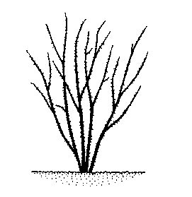
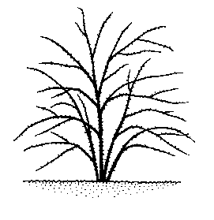

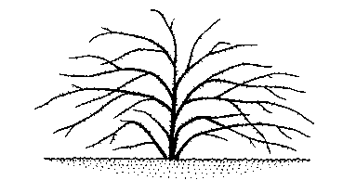

1 | 3 | 5
upright | semi upright | intermediate

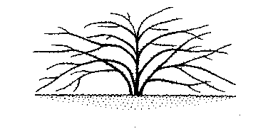
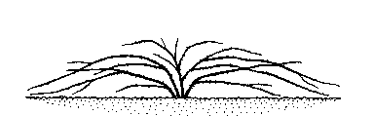

7 |  | 9
moderately spreading |  | strongly spreading

Ad. 4: Young shoot: anthocyanin coloration
Ad. 5: Young shoot: intensity of anthocyanin coloration

Observations should be made on the distal third of a shoot with a length of approximately 20 cm. The leaves should be included in the observations.

Ad. 14: Terminal leaflet: shape of base of blade

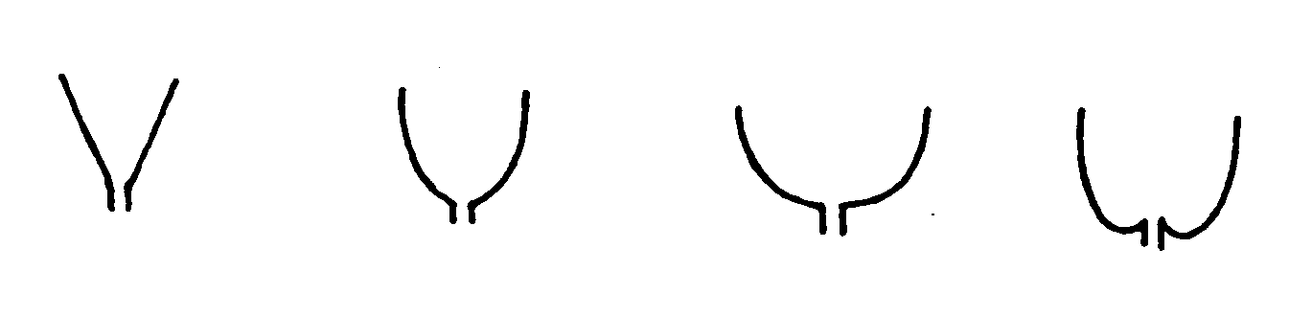
1 | 2 | 3 | 4
acute | obtuse | rounded | cordate

Ad. 15: Terminal leaflet: shape of apex of blade

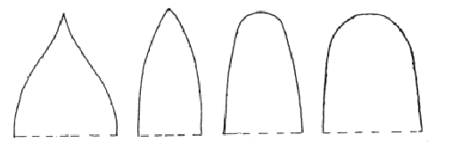1 | 2 | 3 | 4
acuminate | acute | obtuse | rounded

Ad. 16: Flowering shoot: flowering laterals

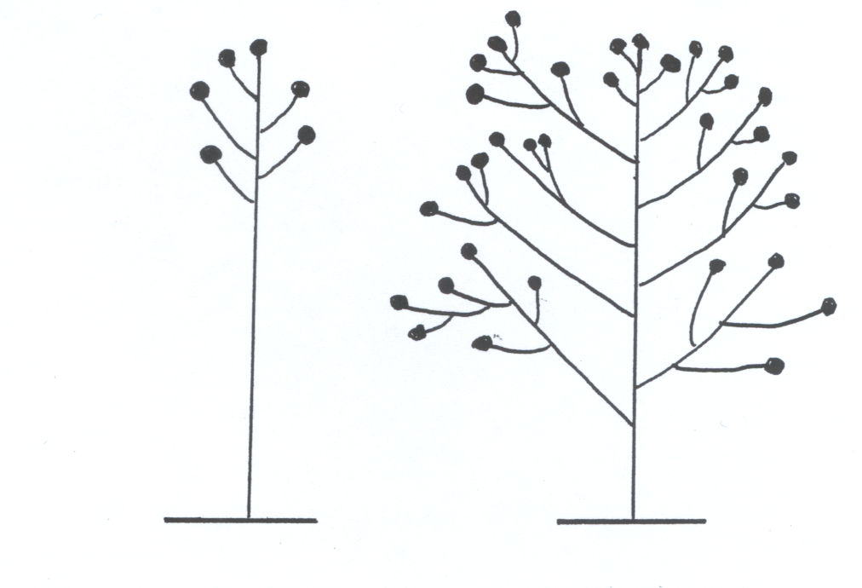
1 | 1
absent | present

Ad. 17: Flowering shoot: number of flowering laterals
Ad. 18: Only varieties with no flowering laterals: Flowering shoot: number of flowers
Ad. 19: Only varieties with flowering laterals: Flowering shoot: number of flowers per lateral

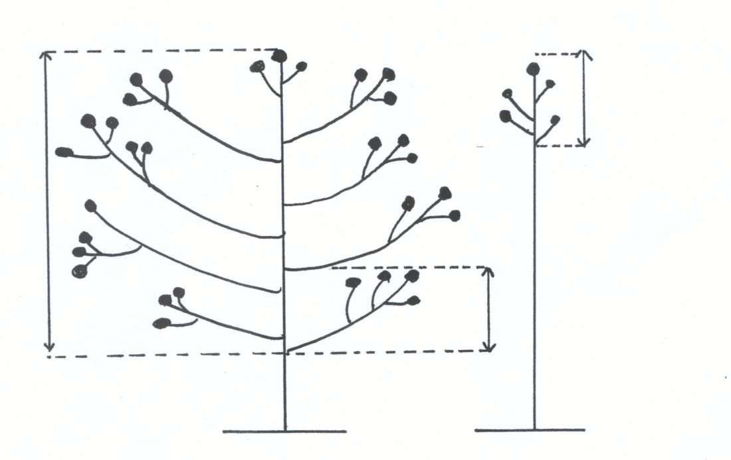
Ad. 19
Ad. 18
Ad. 17
Ad. 20: Flower bud: shape in longitudinal section

Observations should be made just before the separation of the sepals.

Ad. 21: Flower: type

Single: maximum of 7 petals;
Semi-double: 8 to 20 petals;
Double: more than 20 petals

Ad. 23: Flower: color group

Blend means a smooth transition between colors. For multicolored varieties there are sharply defined contrasting zones.

2: white blend: includes varieties which are primarily white, but show some tones of some other hues (like pink, red, red pink, purple)

5: yellow blend: includes varieties which are primarily yellow, but show some tones of some other hues (like pink, red, red pink).

7: orange blend: includes varieties which are primarily orange, but show some tones of some other hues (like yellow, purple).

9: pink blend: includes varieties which are primarily pink, but show some tones of some other hues (like orange, yellow, purple)

11: red blend: includes varieties which are primarily red, but show some tones of some other hues (like yellow, orange).

14: violet blend: includes varieties which are primarily violet but show some tones of some other hues (like mauve and/or lavender).

15: brown blend: includes varieties which are primarily brown but show some tones of some other hues (like red)

16: multicolored: varieties with more than one color in sharply defined contrasting zones (not blend colors).

Ad. 24: Only varieties with flower type: double: Flower: color of the center

Only varieties with a clearly defined color difference between the center of the flower and the outer part of the flower, viewed from above.

Ad. 27: Flower: shape
 | 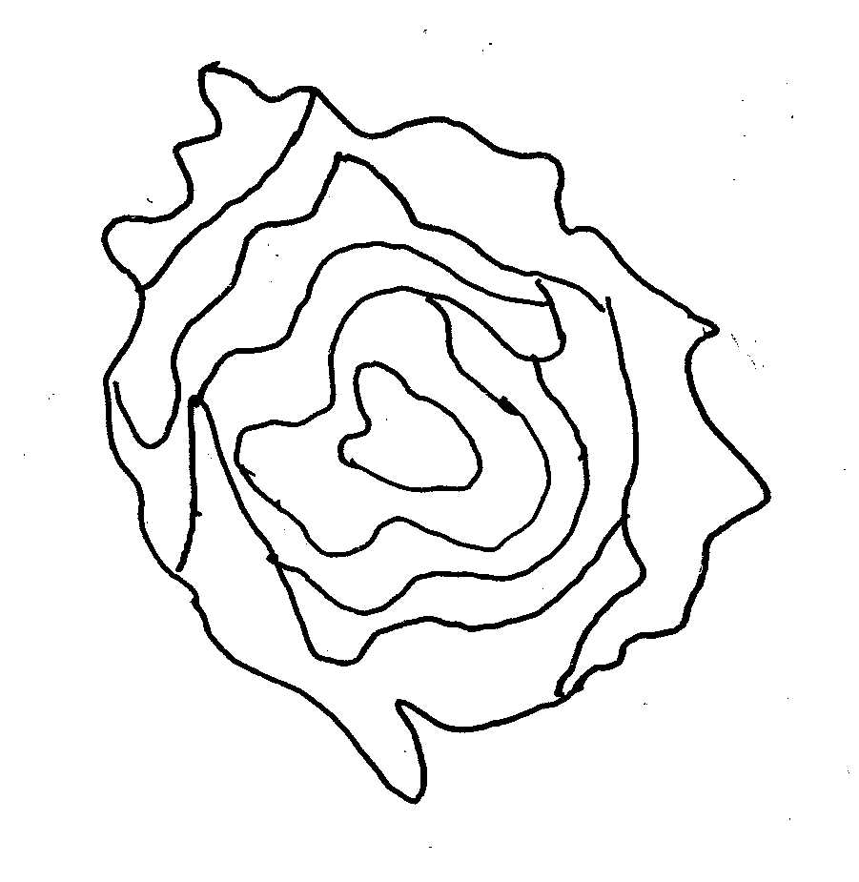 | 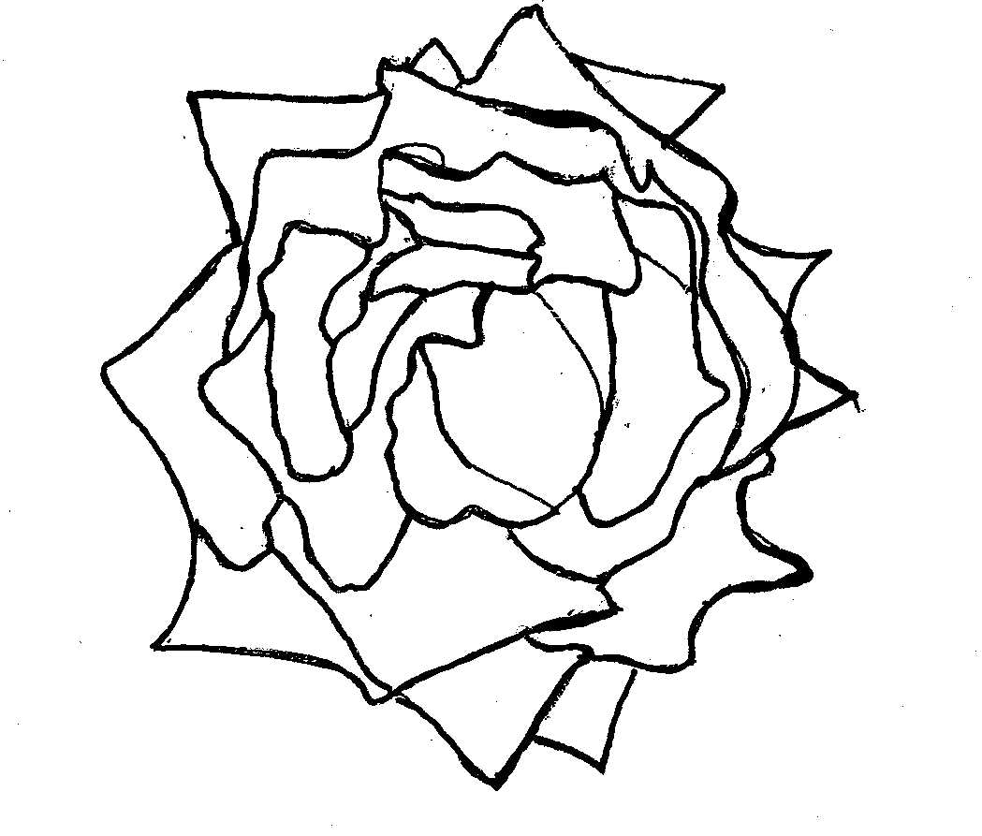
1 | 2 | 3
round | irregularly rounded | star-shaped

Ad. 28: Flower: profile of upper part

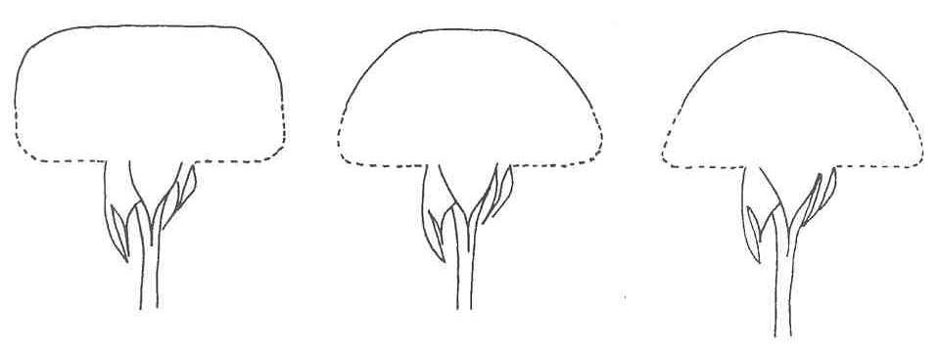
1 | 2 | 3
flat | flattened convex | convex

Ad. 29: Flower: profile of lower part

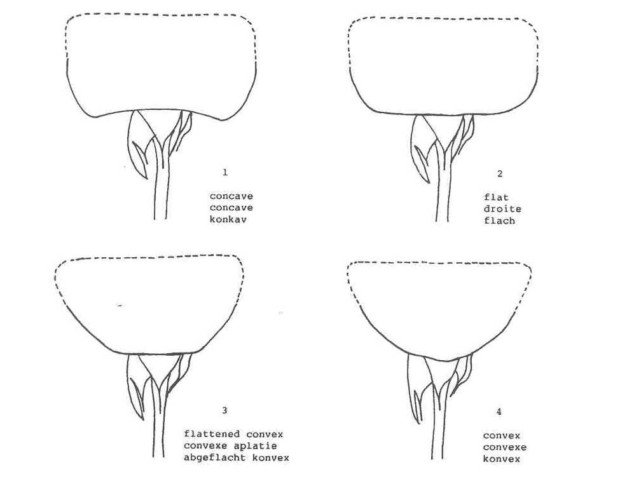

Ad. 31: Sepal: extensions
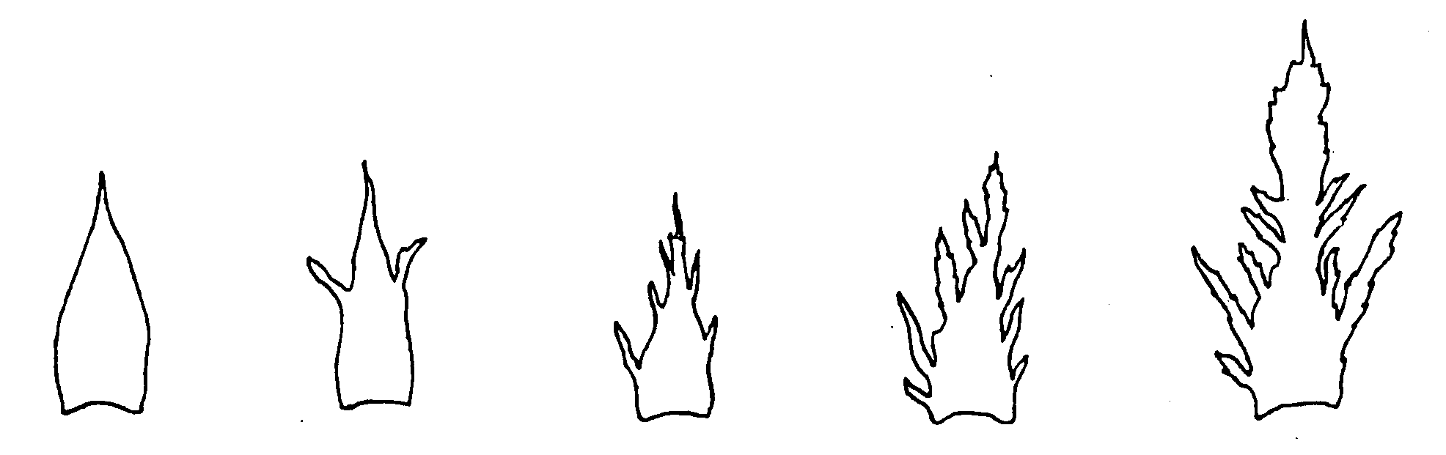
1 | 3 | 5 | 7 | 9
absent or  very weak | weak | medium | strong | very strong

Ad. 32: Petals: reflexing of petals one-by-one

Example over a period of time of a variety where the petals open simulatenously, i.e. petals reflexing one-by-one is absent.

Time

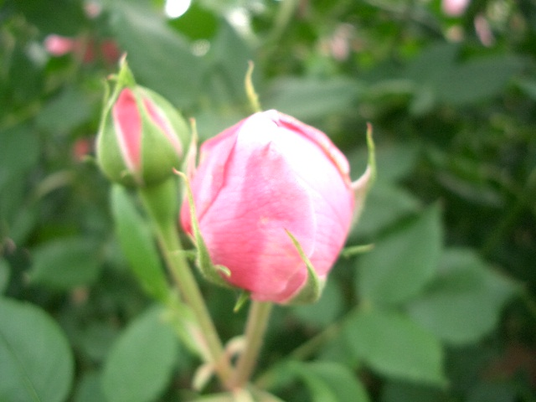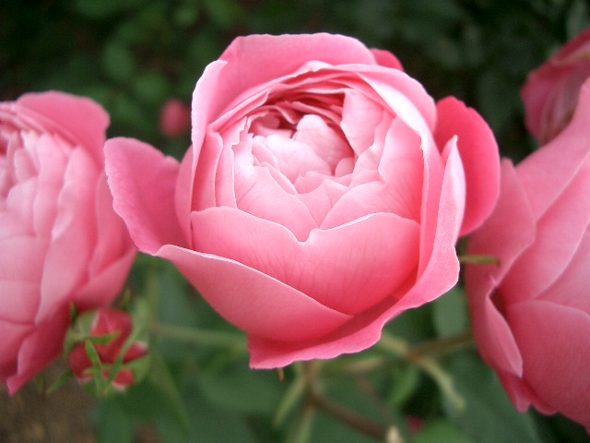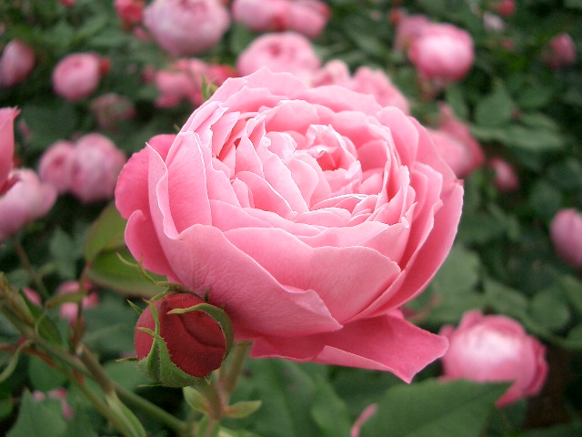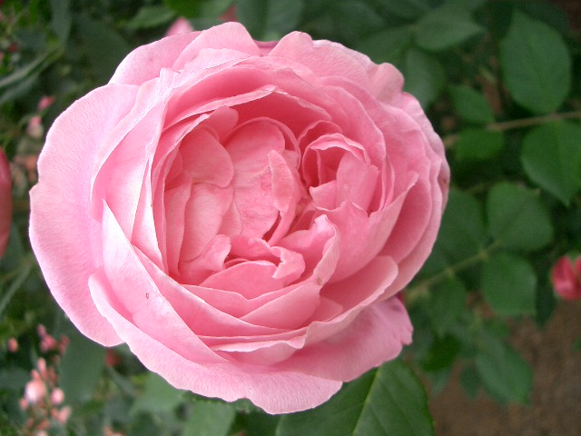

1
absent

Example over a period of time of a variety where the petals reflex one-by-one.

Time

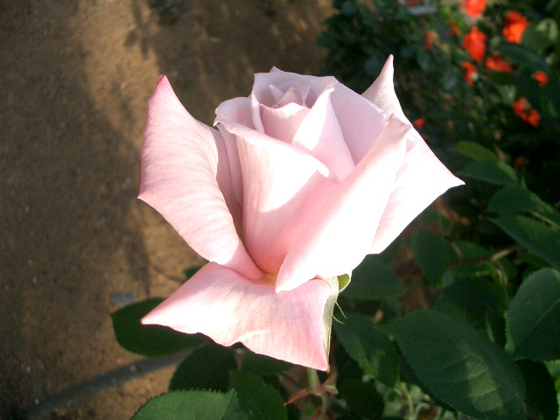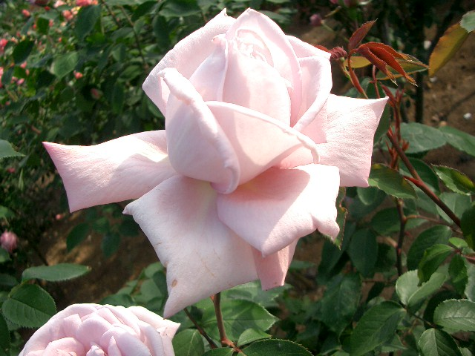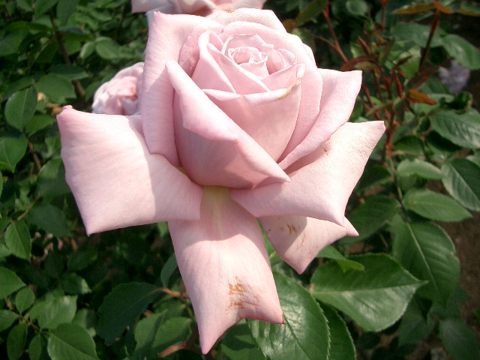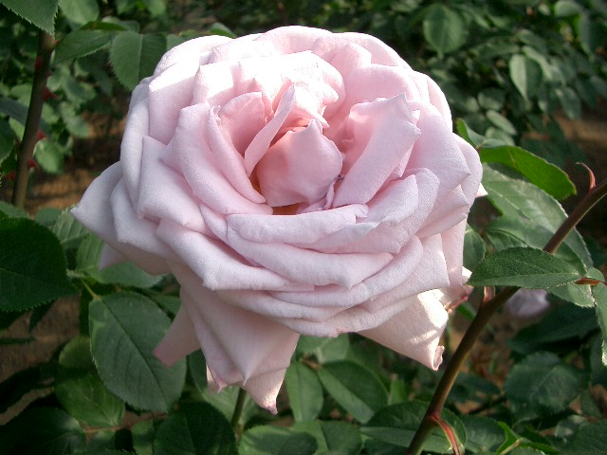

9
present

Ad. 45: Only varieties with two or more colors on inner side of petal: Petal: distribution of secondary color on inner side (basal spot excluded)
Ad. 46: Only varieties with more than two colors on inner side of petal: Petal: distribution of tertiary color on inner side (basal spot excluded)

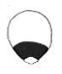 | 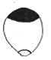 | 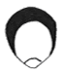 | 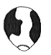 | 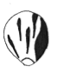 | 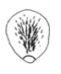
1 | 2 | 3 | 4 | 5 | 6
at base | at apex | at marginal zone | as a flush | as segments or stripes | as speckles
Ad. 48: Petal: size of basal spot on inner side

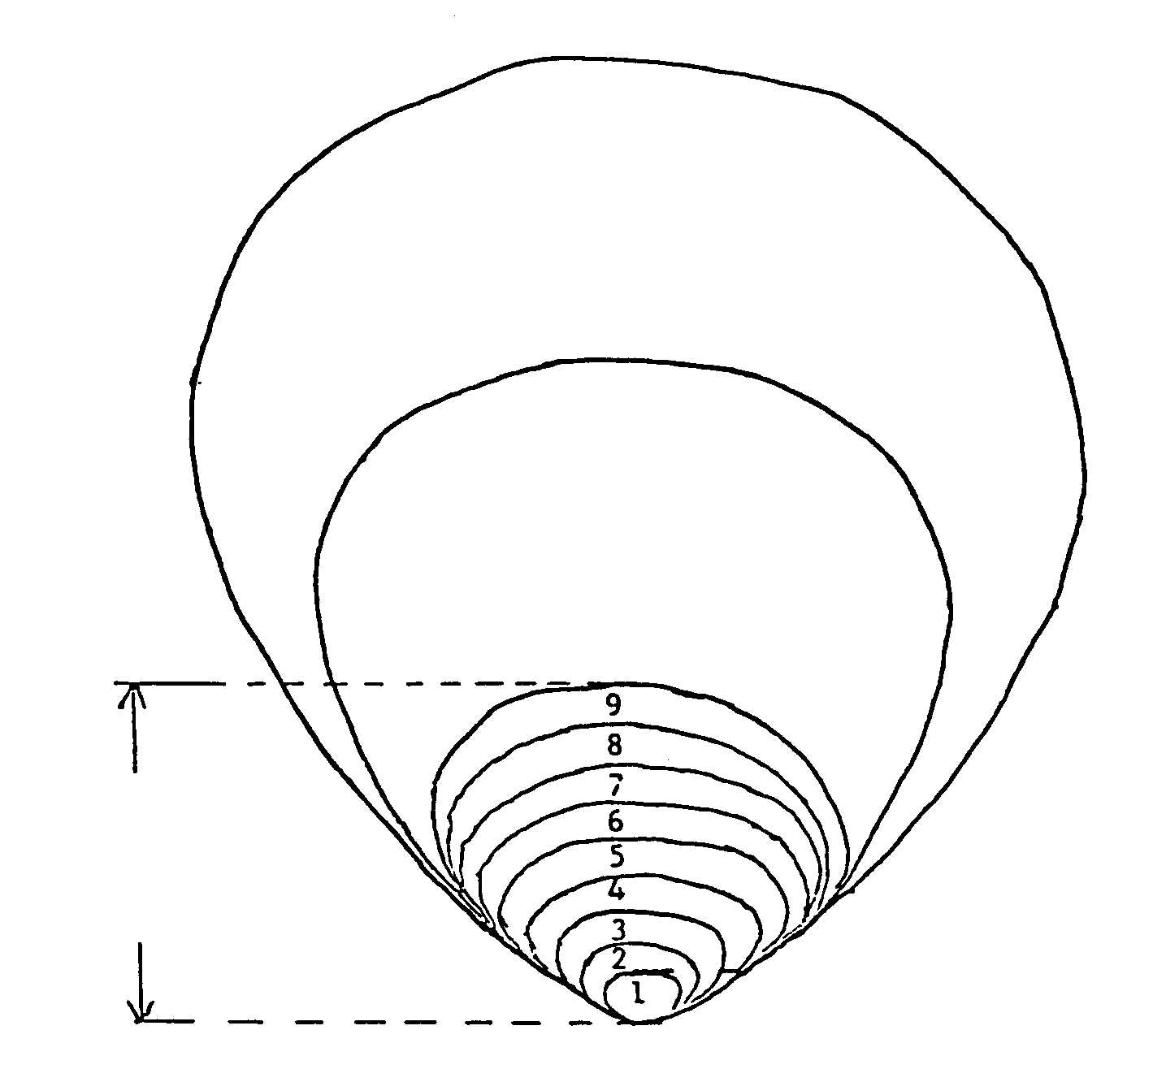
Marginal zone
Middle zone

Basal spot

Ad. 53: Hip: shape in longitudinal section
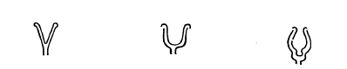  1 | 2 | 3
funnel-shaped | pitcher-shaped | pear-shaped

Ad 54: Hip: color (at mature stage)

Varieties grown for hips only.

8.3 Growing types
As explained in Chapter 3.3.1, it may be necessary for separate growing trials to be established for cut-flower types, garden types and pot types in order to ensure the satisfactory growth of varieties of those types (see Chapter 8.3). The following information is provided with regard to growing conditions for different types of varieties and information which may help in deciding on the type of trial(s) which may be appropriate for a variety:

Cut-flower types

Breeding is done in a limited gene pool. In general, such types of variety belong to the Hybrid Tea Roses and have the following features:

- not very tolerant to low temperatures: heated greenhouses required for good crop development in temperate zones;
- protection needed against sun or rain, in warm climates;
- disbudding, in order to produce one large flower per stem, always necessary by removing the laterals in the inflorescence and for spray varieties by removing the terminal flower;
- usually having less and smaller prickles than garden and pot rose types;
- most cut-flower types have double flowers, but are sometimes semi-double.

Garden types
Breeding is done in a rather large gene pool, in most cases much broader and different from the other types. In general, such types of variety have the following features:

- tolerant of lower temperatures in general;
- type and size of prickles less or not important compared to cut-flower and pot types (breeding is sometimes focussed on large prickles often of a contrasting color);
- all flower types (single, semi- double and double) can be seen in garden types;
- growth habit varies from narrow bushy to creeping;
- includes container and patio roses.

Pot types
Breeding is mainly done in a gene pool which is different from the cut-flower and garden types. In general, such types of variety have the following features:

- concern only types used as houseplants and produced in greenhouses or other sheltered conditions;
- plants with limited plant height and diameter;
- nearly always have semi-double or double flowers;
- do not include container and or patio roses, which should be treated as garden types.

Literature
Charles Quest-Ritson and Brigit Quest-Ritson: American Rose Society Encyclopedia of Roses; American Rose Soc., ISBN 07894996755

Margaret Olds. 1998 (Managing Editor): Botanica’s Roses - The Encyclopedia of Roses, Random House Australia Pty, ISBN 1566491762 – Raincost Books Vancouver BC Canada, 704 pp

Peter Beales, September 1997: Classic Roses: An Illustrated Encyclopedia and Growers Manual of Old Roses, Shrub Roses and climbers, ISBN 0805055843, Timber Press

Peter Schneider, 2004: Combined Rose List 2004, The International Rose Directory, P.O. Box 677, Mantua, OH 44255 USA

Thomas Debener and Prof. Serge Gudin, 2003: Encyclopedia of Rose Science 3 Volume Set, ed. Prof. Andrew Roberts, dr. Academic Press Oct. 2003, ISBN 0122276205

Academic Press New York, 2000: Modern roses X1, The World Encyclopedia of Roses, ISBN 0-12-155053-2

Moody, Mary and Peter Harkness (eds). 1992: The Illustrated Encyclopedia of Roses, Timber Press, Portland OR: Timber Press.

Nico Vermeulen, 2002: Rozenencyclopedie, Rebo Productions 2002, ISBN 9036613418

Technical Questionnaire
TECHNICAL QUESTIONNAIRE |  |  |  | Page {x} of {y} |  | Reference Number:
 |  |  |  |  |  | Application date:
 |  |  |  |  |  | (not to be filled in by the applicant)
TECHNICAL QUESTIONNAIRE
to be completed in connection with an application for plant breeders’ rights

1. Subject of the Technical Questionnaire
1.1 Botanical name |  |  | Rosa L.
1.2 Common name |  |  | Rose
2. Applicant
Name
Address
Telephone No.
Fax No.
E-mail address
Breeder (if different from applicant)
3. Proposed denomination and breeder’s reference
Proposed denomination
(if available)

Breeder’s reference
#4. Information on the breeding scheme and propagation of the variety

4.1 Breeding scheme

Variety resulting from:

4.1.1 Crossing

(a) controlled cross [ ]
(please state parent varieties)
(b) partially known cross [ ]
(please state known parent variety(ies))
(c) unknown cross [ ]

4.1.2 Mutation [ ]
(please state parent variety)

4.1.3 Discovery and development [ ]
(please state where and when discovered
and how developed)

4.1.4 Other [ ]
(please provide details)

4.2 Method of propagating the variety

(a) grafting [ ]
(please specify rootstock)

(b) cuttings [ ]

(c) in vitro propagation [ ]

(d) other (please provide details) [ ]

5. Characteristics of the variety to be indicated (the number in brackets refers to the corresponding characteristic in Test Guidelines; please mark the note which best corresponds).

 | Characteristics |  |  |  |  |  | Example Varieties |  |  | Note
5.1  (1) | Plant: growth type
 | miniature |  |  |  |  |  |  |  |  | 1[ ]
 | dwarf |  |  |  |  |  | Korverlandus (G) |  |  | 2[ ]
 | bed |  |  |  |  |  | Taneidol (G) |  |  | 3[ ]
 | shrub |  |  |  |  |  | Kolmag (G) |  |  | 4[ ]
 | climber |  |  |  |  |  | Noasafa (G) |  |  | 5[ ]
 | ground cover |  |  |  |  |  | Meifafio (G) |  |  | 6[ ]
5.2  (6) | Stem: number of prickles (excluding very small and hair-like prickles)
 | absent or very few |  |  |  |  |  | Ruiorg (G); Meibegil (P) |  |  | 1[ ]
 | very few to few |  |  |  |  |  |  |  |  | 2[ ]
 | few |  |  |  |  |  | Schremna (C); Kortionza (G); Poulcolop (P) |  |  | 3[ ]
 | few to medium |  |  |  |  |  |  |  |  | 4[ ]
 | medium |  |  |  |  |  | Selaurum (C); Bokramar (G); Kormisso (P) |  |  | 5[ ]
 | medium to many |  |  |  |  |  |  |  |  | 6[ ]
 | many |  |  |  |  |  | Meineble (G); Evera105 (P) |  |  | 7[ ]
 | many to very many |  |  |  |  |  |  |  |  | 8[ ]
 | very many |  |  |  |  |  | Deljam (G) |  |  | 9[ ]
 | Characteristics |  |  |  |  |  | Example Varieties |  |  | Note
5.3  (7) | Prickles: predominant color (as for 6)
 | greenish |  |  |  |  |  | Presur (C); Kolmag (G); Poulcar (P) |  |  | 1[ ]
 | yellowish |  |  |  |  |  | Ruiy0775 (P) |  |  | 2[ ]
 | reddish |  |  |  |  |  | Bokrarug (G); Delpajor (P) |  |  | 3[ ]
 | purplish |  |  |  |  |  | Kornairol (G); Evera102 (P) |  |  | 4[ ]
5.4  (21) | Flower: type
 | single |  |  |  |  |  | Noastrauss (G) |  |  | 1[ ]
 | semi-double |  |  |  |  |  | Poulfiry (G); Poulnil (P) |  |  | 2[ ]
 | double |  |  |  |  |  | TAN97103 (G); Korlobea (P) |  |  | 3[ ]
5.5  (22) | Flower: number of petals
 | very few |  |  |  |  |  | Noala (G); Delmitaf (P) |  |  | 1[ ]
 | very few to few |  |  |  |  |  |  |  |  | 2[ ]
 | few |  |  |  |  |  | Predesplen (C); Tananilov (G); Korbersoma (P) |  |  | 3[ ]
 | few to medium |  |  |  |  |  |  |  |  | 4[ ]
 | medium |  |  |  |  |  | Ruiy5451 (C); Poulscots (G); Ruiklinko (P) |  |  | 5[ ]
 | medium to many |  |  |  |  |  |  |  |  | 6[ ]
 | many |  |  |  |  |  | Lexani (C); Ruiharl (G); Meiraktas (P) |  |  | 7[ ]
 | many to very many |  |  |  |  |  |  |  |  | 8[ ]
 | very many |  |  |  |  |  | Meiroupis (G); Poulwen (P) |  |  | 9[ ]
 | Characteristics |  |  |  |  |  | Example Varieties |  |  | Note
5.6  (23) | Flower: color group
 | white or near white |  |  |  |  |  | Korcilmo (C); Meilontig (G); Poulra022 (P) |  |  | 1[ ]
 | white blend |  |  |  |  |  | Speclown (C); TAN98505 (C);  TAN97123 (G); Rush (G) |  |  | 2[ ]
 | green |  |  |  |  |  | Nirpgreenl (C); Korewala (P) |  |  | 3[ ]
 | yellow |  |  |  |  |  | Korflapei (C); Poulyc004 (G); Delmitaf (P) |  |  | 4[ ]
 | yellow blend  (includes varieties which are primarily yellow, but show some tones of some other hues) |  |  |  |  |  | TAN00125 (C); Rumba (G); Ruiabri (P) |  |  | 5[ ]
 | orange |  |  |  |  |  | Alsever (P); Tanoranbon (G) |  |  | 6[ ]
 | orange blend  (includes varieties which are primarily orange, but show some tones of some other hues) |  |  |  |  |  | Presur (C); Meishulo (P) |  |  | 7[ ]
 | pink |  |  |  |  |  | Schremeen3001 (C); Noasia (G); Korfonsova (P) |  |  | 8[ ]
 | pink blend  (includes varieties which are primarily pink, but show some tones of some other hues) |  |  |  |  |  | Schremna (C); Korfeining (G)  Poulmeno (P) |  |  | 9[ ]
 | red |  |  |  |  |  | Predepass (C); Noafeuer (G); Ruikenre (P) |  |  | 10[ ]
 | red blend  (includes varieties which are primarily red, but show some tones of some other hues) |  |  |  |  |  | Meilambra (C); Interuspa (G);  Delmigre (P) |  |  | 11[ ]
 | red purple |  |  |  |  |  | Nirpillpro (C); Poulac016 (P) |  |  | 12[ ]
 | purple |  |  |  |  |  | Olyung (C); Stebigpu (G) |  |  | 13[ ]
 | violet blend  (includes varieties which are primarily violet but show some tones of some other hues (like mauve and/or lavender ) |  |  |  |  |  | Scholtec (C); Korflieder (P) |  |  | 14[ ]
 | brown blend  (includes varieties which are primarily brown but show some tones of some other hues (like red) |  |  |  |  |  | Simcho (G) |  |  | 15[ ]
 | multicolored  (varieties with more than one color in sharply defined contrasting zones which are primarily contrasting multicolored only (not blend colors)) |  |  |  |  |  | Delmitaf (P) |  |  | 16[ ]
 | Characteristics |  |  |  |  |  | Example Varieties |  |  | Note
5.7  (26) | Flower: diameter
 | very small |  |  |  |  |  | Noastrauss (G); Poulset (P) |  |  | 1[ ]
 | very small to small |  |  |  |  |  |  |  |  | 2[ ]
 | small |  |  |  |  |  | Interlis (C); Clb.canibo 82 (G);  Meiraktas (P) |  |  | 3[ ]
 | small to medium |  |  |  |  |  |  |  |  | 4[ ]
 | medium |  |  |  |  |  | Schremna (C); Poulberg (G);  Ruiz1491 (P) |  |  | 5[ ]
 | medium to large |  |  |  |  |  |  |  |  | 6[ ]
 | large |  |  |  |  |  | Selaurum (C); Adesmanod (G);  Korewala (P) |  |  | 7[ ]
 | large to very large |  |  |  |  |  |  |  |  | 8[ ]
 | very large |  |  |  |  |  | Koranderer (G); Evera116 (P) |  |  | 9[ ]
5.8  (27) | Flower: shape
 | round |  |  |  |  |  | Ruirovingt (C); Meiouscki (G); Evera101 (P) |  |  | 1[ ]
 | irregularly rounded |  |  |  |  |  | Ruyi5451 (C); Kormarec (G); Korkallet (P) |  |  | 2[ ]
 | star-shaped |  |  |  |  |  | Predesplen (C); Anakissi (G);  Poulra023 (P) |  |  | 3[ ]
5.9  (30) | Flower: fragrance
 | absent or weak |  |  |  |  |  | Predesplen (C); Ruimats (G); Evera107 (P) |  |  | 1[ ]
 | medium |  |  |  |  |  | Poulsolo (G); Korduftoro (P) |  |  | 2[ ]
 | strong |  |  |  |  |  | Tananilov (G) |  |  | 3[ ]
5.10  (40) | Petal: number of colors on inner side (basal spot excluded)
 | one |  |  |  |  |  | Selaurum (C), TAN98130 (G);  Ruibrei (P) |  |  | 1[ ]
 | two |  |  |  |  |  | Baipeace (G); Delki (P) |  |  | 2[ ]
 | more than two |  |  |  |  |  | Delstrisang (G) |  |  | 3[ ]
6. Similar varieties and differences from these varieties

Please use the following table and box for comments to provide information on how your candidate variety differs from the variety (or varieties) which, to the best of your knowledge, is (or are) most similar. This information may help the examination authority to conduct its examination of distinctness in a more efficient way.

Denomination(s) of variety(ies) similar to your candidate variety |  | Characteristic(s) in which your candidate variety differs from the similar variety(ies) |  |  | Describe the expression of the characteristic(s) for the similar variety(ies) |  |  | Describe the expression of the characteristic(s) for your candidate variety
Example |  | Plant: height |  |  | short |  |  | tall
Comments:

#7. Additional information which may help in the examination of the variety

7.1 In addition to the information provided in sections 5 and 6, are there any additional characteristics which may help to distinguish the variety?

Yes [ ] No [ ]

(If yes, please provide details)

7.2 Are there any special conditions for growing the variety or conducting the examination?

Yes [ ] No [ ]

(If yes, please provide details)

7.3 Main use

(a) grown in the open:
- garden [ ]
- rootstock [ ]
- stem builder [ ]
- cut-berry production [ ]
- other [ ]
(please indicate)

……………………………………………………………

(b) grown under glass or other protection
- cut-flower production
- single flowering type [ ]
- spray type [ ]

- pot rose
- indoor (houseplant) [ ]
- outdoor (terrace, balcony plant) [ ]

7.4 A representative color photograph of the variety should accompany the Technical Questionnaire.

8. Authorization for release

(a) Does the variety require prior authorization for release under legislation concerning the protection of the environment, human and animal health?

Yes [ ] No [ ]

(b) Has such authorization been obtained?

Yes [ ] No [ ]

If the answer to (b) is yes, please attach a copy of the authorization.

9. Information on plant material to be examined or submitted for examination.

9.1 The expression of a characteristic or several characteristics of a variety may be affected by factors, such as pests and disease, chemical treatment (e.g. growth retardants or pesticides), effects of tissue culture, different rootstocks, scions taken from different growth phases of a tree, etc.

9.2 The plant material should not have undergone any treatment which would affect the expression of the characteristics of the variety, unless the competent authorities allow or request such treatment. If the plant material has undergone such treatment, full details of the treatment must be given. In this respect, please indicate below, to the best of your knowledge, if the plant material to be examined has been subjected to:

(a) Microorganisms (e.g. virus, bacteria, phytoplasma) Yes [ ] No [ ]

(b) Chemical treatment (e.g. growth retardant, pesticide) Yes [ ] No [ ]

(c) Tissue culture Yes [ ] No [ ]

(d) Other factors Yes [ ] No [ ]

Please provide details for where you have indicated “yes”.

……………………………………………………………

10. I hereby declare that, to the best of my knowledge, the information provided in this form is correct:

Applicant’s name

Signature Date

[End of document]

* These names were correct at the time of the introduction of these Test Guidelines but may be revised or updated. [Readers are advised to consult the UPOV Code, which can be found on the UPOV Website (www.upov.int), for the latest information.]
# Authorities may allow certain of this information to be provided in a confidential section of the Technical Questionnaire.
# Authorities may allow certain of this information to be provided in a confidential section of the Technical Questionnaire.

