 |  | E  TG/7/10 Rev. 3  ORIGINAL: English  DATE: 2009-04-01 + 2014-04-09  + 2018-10-30 + 2019-06-14  + 2022-10-25
INTERNATIONAL UNION FOR THE PROTECTION OF NEW VARIETIES OF PLANTS
GENEVA

 | PEA  UPOV Code: PISUM_SAT  Pisum sativum L. | *

GUIDELINES

FOR THE CONDUCT OF TESTS

FOR DISTINCTNESS, UNIFORMITY AND STABILITY

Alternative Names:*

Botanical name | English | French | German | Spanish
Pisum sativum L, Pisum arvense L. | Pea | Pois | Erbse | Guisante, Arveja

The purpose of these guidelines (“Test Guidelines”) is to elaborate the principles contained in the General Introduction (document TG/1/3), and its associated TGP documents, into detailed practical guidance for the harmonized examination of distinctness, uniformity and stability (DUS) and, in particular, to identify appropriate characteristics for the examination of DUS and production of harmonized variety descriptions.

ASSOCIATED DOCUMENTS

These Test Guidelines should be read in conjunction with the General Introduction and its associated TGP documents.
TABLE OF CONTENTS PAGE

1. Subject of these Test Guidelines 3
2. Material Required 3
3. Method of Examination 3
3.1 Number of Growing Cycles 3
3.2 Testing Place 3
3.3 Conditions for Conducting the Examination 3
3.4 Test Design 4
3.5 Number of Plants / Parts of Plants to be Examined 4
3.6 Additional Tests 4
4. Assessment of Distinctness, Uniformity and Stability 4
4.1 Distinctness 4
4.2 Uniformity 5
4.3 Stability 5
5. Grouping of Varieties and Organization of the Growing Trial 5
6. Introduction to the Table of Characteristics 6
6.1 Categories of Characteristics 6
6.2 States of Expression and Corresponding Notes 6
6.3 Types of Expression 7
6.4 Example Varieties 7
6.5 Legend 7
7. Table of Characteristics/Tableau des caractères/Merkmalstabelle/Tabla de caracteres 8
8. Explanations on the Table of Characteristics 23
8.1 Explanations covering several characteristics 23
8.2 Explanations for individual characteristics 23
9. Literature 47
10. Technical Questionnaire 49

Subject of these Test Guidelines
These Test Guidelines apply to all varieties of Pisum sativum L.

Material Required
2.1 The competent authorities decide on the quantity and quality of the plant material required for testing the variety and when and where it is to be delivered. Applicants submitting material from a State other than that in which the testing takes place must ensure that all customs formalities and phytosanitary requirements are complied with.

2.2 The material is to be supplied in the form of seed.

2.3 The minimum quantity of plant material, to be supplied by the applicant, should be:

1,000 g or at least 12,000 seeds.

2.4 The seed should meet the minimum requirements for germination, species and analytical purity, health and moisture content, specified by the competent authority. In cases where the seed is to be stored, the germination capacity should be as high as possible and should, be stated by the applicant.

2.5 The plant material supplied should be visibly healthy, not lacking in vigor, nor affected by any important pest or disease.

2.6 The plant material should not have undergone any treatment which would affect the expression of the characteristics of the variety, unless the competent authorities allow or request such treatment. If it has been treated, full details of the treatment must be given.

Method of Examination

3.1 Number of Growing Cycles
The minimum duration of tests should normally be two independent growing cycles.

3.2 Testing Place
Tests are normally conducted at one place. In the case of tests conducted at more than one place, guidance is provided in TGP/9 “Examining Distinctness”.

3.3 Conditions for Conducting the Examination
3.3.1 The tests should be carried out under conditions ensuring satisfactory growth for the expression of the relevant characteristics of the variety and for the conduct of the examination.

3.3.2 The optimum stage of development for the assessment of each characteristic is indicated by a number in the second column of the Table of Characteristics. The stages of development denoted by each number are described at the end of Chapter 8.
3.3.3 The recommended method of observing the characteristic is indicated by the following key in the second column of the Table of Characteristics:

MG: single measurement of a group of plants or parts of plants
MS: measurement of a number of individual plants or parts of plants
VG: visual assessment by a single observation of a group of plants or parts of plants
VS: visual assessment by observation of individual plants or parts of plants

3.4 Test Design
3.4.1 Each test should be designed to result in a total of at least 100 plants, which should be divided between two or more replicates.

3.4.2 The design of the tests should be such that plants or parts of plants may be removed for measurement or counting without prejudice to the observations which must be made up to the end of the growing cycle.

3.5 Number of Plants / Parts of Plants to be Examined
Unless otherwise indicated, all observations on single plants should be made on 20 plants or parts taken from each of 20 plants and any other observations made on all plants in the test.

3.6 Additional Tests
Additional tests, for examining relevant characteristics, may be established.

Assessment of Distinctness, Uniformity and Stability

4.1 Distinctness
4.1.1 General Recommendations

It is of particular importance for users of these Test Guidelines to consult the General Introduction prior to making decisions regarding distinctness. However, the following points are provided for elaboration or emphasis in these Test Guidelines.

4.1.2 Consistent Differences

The differences observed between varieties may be so clear that more than one growing cycle is not necessary. In addition, in some circumstances, the influence of the environment is not such that more than a single growing cycle is required to provide assurance that the differences observed between varieties are sufficiently consistent. One means of ensuring that a difference in a characteristic, observed in a growing trial, is sufficiently consistent is to examine the characteristic in at least two independent growing cycles.

4.1.3 Clear Differences

Determining whether a difference between two varieties is clear depends on many factors, and should consider, in particular, the type of expression of the characteristic being examined, i.e. whether it is expressed in a qualitative, quantitative, or pseudo-qualitative manner. Therefore, it is important that users of these Test Guidelines are familiar with the recommendations contained in the General Introduction prior to making decisions regarding distinctness.

4.2 Uniformity
4.2.1 It is of particular importance for users of these Test Guidelines to consult the General Introduction prior to making decisions regarding uniformity. However, the following points are provided for elaboration or emphasis in these Test Guidelines:

4.2.2 For the assessment of uniformity, a population standard of 1% and an acceptance probability of at least 95% should be applied. In the case of a sample size of 100 plants, 3 off-types are allowed.

4.3 Stability
4.3.1 In practice, it is not usual to perform tests of stability that produce results as certain as those of the testing of distinctness and uniformity. However, experience has demonstrated that, for many types of variety, when a variety has been shown to be uniform, it can also be considered to be stable.

4.3.2 Where appropriate, or in cases of doubt, stability may be tested, either by growing a further generation, or by testing a new seed stock to ensure that it exhibits the same characteristics as those shown by the previous material supplied.

Grouping of Varieties and Organization of the Growing Trial
5.1 The selection of varieties of common knowledge to be grown in the trial with the candidate varieties and the way in which these varieties are divided into groups to facilitate the assessment of distinctness are aided by the use of grouping characteristics.

5.2 Grouping characteristics are those in which the documented states of expression, even where produced at different locations, can be used, either individually or in combination with other such characteristics: (a) to select varieties of common knowledge that can be excluded from the growing trial used for examination of distinctness; and (b) to organize the growing trial so that similar varieties are grouped together.

5.3 The following have been agreed as useful grouping characteristics:

- Plant: anthocyanin coloration (characteristic 1)
- Stem: fasciation (characteristic 3)
- Stem: length (characteristic 4)
- Stem: number of nodes up to and including first fertile node (characteristic 5)
- Leaf: leaflets (characteristic 8)
- Stipule: flecking (characteristic 20)
- Only varieties with stem fasciation absent: Plant: maximum number of flowers per node (characteristic 25)
- Pod: length (characteristic 37)
- Pod: parchment (characteristic 39)
- Excluding varieties with pod parchment: entire: Pod: thickened wall (characteristic 40)
- Only varieties with Pod: thickened wall: absent: Pod: shape of distal part (characteristic 41)
- Pod: curvature (characteristic 42)
- Pod: color (characteristic 43)
- Immature seed: intensity of green color (characteristic 47)
- Seed: type of starch grains (characteristic 49)
- Seed: color of cotyledon (characteristic 52)
- Only varieties with plant anthocyanin coloration present: Seed: marbling of testa (characteristic 53)
- Only varieties with plant anthocyanin coloration present: Seed: violet or pink spots on testa (characteristic 54)
- Seed: hilum color (characteristic 55)
- Seed: weight (characteristic 57)
- Resistance to Fusarium oxysporum f. sp. pisi – Race 1 (characteristic 58)
- Resistance to Erysiphe pisi Syd. (characteristic 59)

5.4 Guidance for the use of grouping characteristics, in the process of examining distinctness, is provided through the General Introduction.

Introduction to the Table of Characteristics

6.1 Categories of Characteristics
6.1.1 Standard Test Guidelines Characteristics

Standard Test Guidelines characteristics are those which are approved by UPOV for examination of DUS and from which members of the Union can select those suitable for their particular circumstances.

6.1.2 Asterisked Characteristics

Asterisked characteristics (denoted by *) are those included in the Test Guidelines which are important for the international harmonization of variety descriptions and should always be examined for DUS and included in the variety description by all members of the Union, except when the state of expression of a preceding characteristic or regional environmental conditions render this inappropriate.

6.2 States of Expression and Corresponding Notes
States of expression are given for each characteristic to define the characteristic and to harmonize descriptions. Each state of expression is allocated a corresponding numerical note for ease of recording of data and for the production and exchange of the description.

6.3 Types of Expression
An explanation of the types of expression of characteristics (qualitative, quantitative and pseudo-qualitative) is provided in the General Introduction.

6.4 Example Varieties
Where appropriate, example varieties are provided to clarify the states of expression of each characteristic.

6.5 Legend
(*) Asterisked characteristic – see Chapter 6.1.2

(QL) Qualitative characteristic – see Chapter 6.3
(QN) Quantitative characteristic – see Chapter 6.3
(PQ) Pseudo-qualitative characteristic – see Chapter 6.3

MG, MS, VG, VS: See Chapter 3.3.3

(a)-(d) See Explanations on the Table of Characteristics in Chapter 8.1
(+) See Explanations on the Table of Characteristics in Chapter 8.2

Table of Characteristics/Tableau des caractères/Merkmalstabelle/Tabla de caracteres
 |  |  | English |  | français | deutsch | español | Example Varieties/  Exemples/  Beispielssorten/  Variedades ejemplo | Note/  Nota
1.  (*)  (+) | 30- 240  VG |  | Plant: anthocyanin coloration |  | Plante: pigmentation anthocyanique | Pflanze: Anthocyan-färbung | Planta: pigmentación antociánica
QL |  |  | absent |  | absente | fehlend | ausente | Avola, Solara | 1
 |  |  | present |  | présente | vorhanden | presente | Pidgin, Rosakrone | 9
2. | 30- 240  VG |  | Stem: anthocyanin coloration of axil |  | Tige: pigmentation anthocyanique à l’aisselle | Stengel: Anthocyanfärbung der Achsel | Tallo: pigmentación antociánica de la axila
QL |  |  | absent |  | absente | fehlend | ausente | Avola, Maro | 1
 |  |  | single ring |  | anneau simple | einfacher Ring | anillo simple | Assas, Tirabeque | 2
 |  |  | double ring |  | anneau double | doppelter Ring | anillo doble | Caroubel | 3
3.  (*)  (+) | 30-  199  VG |  | Stem: fasciation |  | Tige: fasciation | Stengel: Verbänderung | Tallo: fasciación
QL |  |  | absent |  | absente | fehlend | ausente | Avola, Solara | 1
 |  |  | present |  | présente | vorhanden | presente | Bikini, Rosakrone | 9
4.  (*)  (+) | 240- 250  MS |  | Stem: length |  | Tige: longueur | Stengel: Länge | Tallo: longitud
QN |  |  | very short |  | très petite | sehr kurz | muy corto | Zephyr | 1
 |  |  | short |  | petite | kurz | corto | Nobel, Mini | 3
 |  |  | medium |  | moyenne | mittel | medio | Calibra, Xantos | 5
 |  |  | long |  | grande | lang | largo | Blauwschokker, Livia | 7
 |  |  | very long |  | très grande | sehr lang | muy largo | Mammoth Melting Sugar | 9
5.  (*)  (+) | 210-240  MS |  | Stem: number of nodes up to and including first fertile node |  | Tige : nombre de nœuds jusqu’au premier nœud fertile inclus | Stengel: Anzahl Knoten bis einschließlich des ersten Blütenstandes | Tallo: número de nudos hasta el primer nudo fértil, con inclusión de éste
QN |  |  | very few |  | très peu | sehr gering | muy bajo | Kelvil | 1
 |  |  | few |  | peu | gering | bajo | Smart, Zero4 | 3
 |  |  | medium |  | moyen | mittel | medio | Markana, Susan | 5
 |  |  | many |  | élevé | groß | alto | Cooper | 7
 |  |  | very many |  | très élevé | sehr groß | muy alto | Regina | 9
6.  (*) | 40-240  VG |  | Foliage: color |  | Feuillage: couleur | Laub: Farbe | Follaje: color
PQ |  |  | yellow green |  | vert jaune | gelbgrün | verde amarillento | Pilot | 1
 |  |  | green |  | vert | grün | verde | Avola, Paris, Progreta, Waverex | 2
 |  |  | blue green |  | vert bleu | blaugrün | verde azulado | Polar | 3
7. | 40-240  VG |  | Only varieties with foliage color: green (Char. 6, state 2): Foliage: intensity of color |  | Variétés avec couleur du feuillage seulement : vert (car. 6, état 2) : Feuillage : intensité de la couleur | Nur Sorten mit Laubfarbe: grün (Merkmal 6, Stufe 2): Laub: Intensität der Farbe | Sólo variedades con color de follaje: verde (car. 6, estado 2): Follaje: intensidad del color
QN |  |  | light |  | claire | hell | claro | Paris, Twinkle | 3
 |  |  | medium |  | moyenne | mittel | medio | Lisa, Rondo | 5
 |  |  | dark |  | foncée | dunkel | oscuro | Waverex | 7
8.  (*) | 20- 240  VG |  | Leaf: leaflets |  | Feuille: folioles | Blatt: Blattfiedern | Hoja: folíolos
QL |  |  | absent |  | absentes | fehlend | ausentes | Hawk, Solara | 1
 |  |  | present |  | présentes | vorhanden | presentes | Avola, Rhea | 9
9.  (+) | 200-240  MS/  VG |  | Leaf: maximum number of leaflets |  | Feuille : nombre maximum de folioles | Blatt: maximale Anzahl Blattfiedern | Hoja: número máximo de folíolos
QN |  |  | few |  | petit | gering | bajo | Jof | 3
 |  |  | medium |  | moyen | mittel | medio | Dark Skin Perfection, Finale | 5
 |  |  | many |  | grand | groß | alto | Ultimo | 7
10. | 216-226  MS/  VG |  | Leaflet: size |  | Foliole : taille | Blattfieder: Größe | Folíolo: tamaño
QN | (a) |  | very small |  | très petite | sehr klein | muy pequeño | Payette | 1
 |  |  | small |  | petite | klein | pequeño | Mini | 3
 |  |  | medium |  | moyenne | mittel | medio | Finale | 5
 |  |  | large |  | grande | groß | grande | Alderman | 7
 |  |  | very large |  | très grande | sehr groß | muy grande | Mammoth Melting Sugar | 9
11. | 216-226  MS/  VG |  | Leaflet: length |  | Foliole: longueur | Blattfieder: Länge | Folíolo: longitud
QN | (a) |  | short |  | courte | kurz | corto | Eagle, Polar | 3
 |  |  | medium |  | moyenne | mittel | medio | Bohatyr, Dakota | 5
 |  |  | long |  | longue | lang | largo | Delikata,  Mammoth Melting Sugar | 7
12. | 216-226  MS/  VG |  | Leaflet: width |  | Foliole: largeur | Blattfieder: Breite | Folíolo: anchura
QN | (a) |  | narrow |  | étroite | schmal | estrecho | Alouette, Grapis | 3
 |  |  | medium |  | moyenne | mittel | medio | Dakota, Irina | 5
 |  |  | broad |  | large | breit | ancho | Adept, Tirabeque | 7
13.  (+) | 216-226  MS/  VG |  | Leaflet: position of broadest part |  | Foliole : position de la partie la plus large | Blattfieder: Position des breitesten Teils | Folíolo: posición de la parte más ancha
QN | (a) |  | at middle or slightly towards base |  | au milieu ou légèrement vers la base | in der Mitte oder leicht zur Basis hin | en el centro o ligeramente hacia la base | Nobel, Salome | 1
 |  |  | moderately towards base |  | plus ou moins vers la base | mäßig zur Basis hin | moderadamente hacia la base | Columbia, Maro | 2
 |  |  | strongly towards base |  | fortement vers la base | stark zur Basis hin | fuertemente hacia la base | Griffin, Progreta | 3
14.  (+) | 30-240  VG |  | Leaflet: dentation |  | Foliole : dentelure | Blattfieder: Zähnung | Folíolo: indentación
QN | (a) |  | absent or very weak |  | absente ou très faible | fehlend oder sehr gering | ausente o muy débil | Progreta | 1
 |  |  | weak |  | faible | gering | débil | Snowflake | 3
 |  |  | medium |  | moyenne | mittel | media | Cabree | 5
 |  |  | strong |  | forte | stark | fuerte | Amos | 7
 |  |  | very strong |  | très forte | sehr stark | muy fuerte | Sugar Star | 9
15.  (*)  (+) | 216-226 MS/  VG |  | Stipule: length |  | Stipule: longueur | Nebenblatt: Länge | Estípula: longitud
QN | (b) |  | short |  | courte | kurz | corta | Eagle, Steffi | 3
 |  |  | medium |  | moyenne | mittel | media | Timo, Twinkle | 5
 |  |  | long |  | longue | lang | larga | Alderman, Rhea | 7
16.  (*)  (+) | 216-226 MS/  VG |  |  | Stipule: width | Stipule: largeur | Nebenblatt: Breite | Estípula: anchura
QN | (b) |  |  | narrow | étroite | schmal | estrecha | Eagle, Steffi | 3
 |  |  |  | medium | moyenne | mittel | media | Timo, Twinkle | 5
 |  |  |  | broad | large | breit | ancha | Mammoth Melting Sugar | 7
17. | 216-226 MS/ VG |  |  | Stipule: size | Stipule: taille | Nebenblatt: Größe | Estípula: tamaño
QN | (b) |  |  | small | petite | klein | pequeña | Dakota, Zero4 | 3
 |  |  |  | medium | moyenne | mittel | media | Jackpot, Misty | 5
 |  |  |  | large | grande | groß | grande | Beetle, Mammoth Melting Sugar | 7
18.  (+) | 216-226 MS/  VG |  |  | Stipule: length from axil to tip | Stipule : longueur de l’aisselle à la pointe | Nebenblatt: Länge zwischen der Achsel und der Spitze | Estípula: longitud desde la axila hasta la punta
QN | (b) |  |  | short | courte | kurz | corta | Fortress, Zero4 | 3
 |  |  |  | medium | moyenne | mittel | media | Cabree, Orka | 5
 |  |  |  | long | longue | lang | larga | Beetle, Mammoth Melting Sugar | 7
19.  (+) | 216-226 VG/ MS |  |  | Stipule: length of lobe below axil | Stipule : longueur du lobe en dessous de l’aisselle | Nebenblatt: Länge des Lappens unter der Achsel | Estípula: longitud del lóbulo bajo la axila
QN | (b) |  |  | absent or very short | absente ou très courte | fehlend oder sehr kurz | ausente o muy corto |  | 1
 |  |  |  | short | courte | kurz | corto | Dakota, Ramrod | 3
 |  |  |  | medium | moyenne | mittel | medio | Kahuna, Twinkle | 5
 |  |  |  | long | longue | lang | largo | Eden, Quantum | 7
20.  (*)  (+) | 200-240  VG |  |  | Stipule: flecking | Stipule: macules | Nebenblatt: Marmorierung | Estípula: moteado
QL |  |  |  | absent | absentes | fehlend | ausente | Lisa, Tafila | 1
 |  |  |  | present | présentes | vorhanden | presente | Avola, Maro | 9
21.  (+) | 200-240  VG |  |  | Stipule: density of flecking | Stipule : densité des macules | Nebenblatt: Dichte der Marmorierung | Estípula: densidad del moteado
QN |  |  |  | very sparse | très lâche | sehr locker | muy laxa | Progreta | 1
 |  |  |  | sparse | lâche | locker | laxa | Backgammon, Waxwing | 3
 |  |  |  | medium | moyenne | mittel | media | Accent, Ambassador | 5
 |  |  |  | dense | dense | dicht | densa | Avola, Zelda | 7
 |  |  |  | very dense | très dense | sehr dicht | muy densa | Oregon Sugar Pod | 9
22.  (+) | 216-226  MS/  VG |  |  | Petiole: length from axil to first leaflet or tendril | Pétiole: longueur de l’aisselle à la première foliole ou vrille | Blattstiel: Länge von der Achsel zur ersten Blattfieder oder Ranke | Pecíolo: longitud desde la axila hasta el primer folíolo o zarcillo
QN |  |  |  | short | courte | kurz | corta | Hellas, Keo | 3
 |  |  |  | medium | moyenne | mittel | media | Avola, Solara | 5
 |  |  |  | long | longue | lang | larga | Saskia, Tafila | 7
23.  (+) | 216-226 MS/ VG |  |  | Only varieties with leaflets absent: Petiole: length from axil to last tendril | Variétés sans folioles seulement : Pétiole : longueur de l’aisselle à la dernière vrille | Nur Sorten ohne Blattfiedern: Blattstiel: Länge von der Achsel zur letzten Ranke | Sólo variedades sin folíolos: Pecíolo: longitud desde la axila hasta el último zarcillo
QN |  |  |  | short | courte | kurz | corta | Choucas, Fredrio | 3
 |  |  |  | medium | moyenne | mittel | media | Alambo, Alezan | 5
 |  |  |  | long | longue | lang | larga | Arosa, Calao | 7
24.  (*)  (+) | 214  MG |  |  | Time of flowering | Époque de floraison | Zeitpunkt der Blüte | Época de floración
QN |  |  |  | very early | très précoce | sehr früh | muy temprana | Tempo | 1
 |  |  |  | early | précoce | früh | temprana | Smart, Zero4 | 3
 |  |  |  | medium | moyenne | mittel | media | Carlton, Waverex | 5
 |  |  |  | late | tardive | spät | tardía | Cooper, Purser | 7
 |  |  |  | very late | très tardive | sehr spät | muy tardía | Livioletta | 9
25.  (*) (+) | 216-226  MS/  VG |  |  | Only varieties with stem fasciation absent: Plant: maximum number of flowers per node | Variétés sans fasciation de la tige uniquement : Plante : nombre maximal de fleurs par nœud | Nur Sorten ohne Verbänderung des Stengels: Pflanze: maximale Anzahl Blüten pro Knoten | Sólo variedades sin fasciación del tallo: Planta: número máximo de flores por nudo
QN |  |  |  | one | une | eine | una | Progress No. 9, Tyla | 1
 |  |  |  | two | deux | zwei | dos | Banff, Cooper | 3
 |  |  |  | three | trois | drei | tres | Ultimo, Zodiac | 5
 |  |  |  | four or more | quatre ou plus | vier oder mehr | cuatro o más | Arnesa, Calibra, Survivor | 7
26.  (*) | 216-218  VG |  |  | Only varieties with plant anthocyanin coloration present: Flower: color of wing | Variétés avec pigmentation anthocyanique de la plante uniquement : Fleur : couleur de l’aile | Nur Sorten mit Anthocyanfärbung der Pflanze: Blüte: Farbe des Flügels | Sólo variedades con pigmentación antociánica de la planta: Flor: color del ala
PQ | (b) |  |  | white with pink blush | rose pâle | blassrosa | blanco rosáceo |  | 1
 |  |  |  | pink | rose | rosa | rosa | Rosakrone | 2
 |  |  |  | reddish purple | pourpre rougeâtre | rötlich purpur | púrpura rojizo | Assas | 3
27.  (+) | 216-218  VG |  |  | Only varieties with plant anthocyanin coloration absent: Flower: color of standard | Variétés sans pigmentation anthocyanique de la plante uniquement : Fleur : couleur de l’étendard | Nur Sorten ohne Anthocyanfärbung der Pflanze: Blüte: Farbe der Fahne | Sólo variedades sin pigmentación antociánica de la planta: Flor: color del estandarte
PQ | (b) |  |  | white | blanc | weiß | blanco | Gloton, Record | 1
 |  |  |  | whitish cream | blanc à crème | weiß bis cremefarben | crema blanquecino | Cooper, Maro | 2
 |  |  |  | cream | crème | cremefarben | crema | Orcado | 3
28.  (+) | 216-218 MS/  VG |  |  | Flower: width of standard | Fleur: largeur de l’étendard | Blüte: Breite der Fahne | Flor: anchura del estandarte
QN | (b) |  |  | narrow | étroite | schmal | estrecho | Eagle, Progreta | 3
 |  |  |  | medium | moyenne | mittel | medio | Bikini, Cooper | 5
 |  |  |  | broad | large | breit | ancho | Pilot, Tafila | 7
29.  (*)  (+) | 216-218  VG |  |  | Flower: shape of base of standard | Fleur : forme de la base de l’étendard | Blüte: Form des Fahnengrunds | Flor: forma de la base del estandarte
QN | (b) |  |  | strongly raised | fortement cunéiforme | stark keilförmig | fuertemente cuneiforme |  | 1
 |  |  |  | moderately raised | modérément cunéiforme | mäßig keilförmig | moderadamente cuneiforme | Progreta | 3
 |  |  |  | level | droite | gerade | recto | Markado, Solara | 5
 |  |  |  | moderately arched | modérément arquée | mäßig zweilappig | moderadamente arqueado | Avola, Cooper | 7
 |  |  |  | strongly arched | fortement arquée | stark zweilappig | fuertemente arqueado | Bohatyr, Kennedy | 9
30.  (+) | 216-218  VG |  |  | Flower: undulation of standard | Fleur : ondulation de l’étendard | Blüte: Wellung der Fahne | Flor: ondulación del estandarte
QN | (b) |  |  | absent or very weak | nulle ou très faible | fehlend oder sehr gering | ausente o muy débil | Ultimo, Woody | 1
 |  |  |  | weak | faible | gering | débil | Cooper, Dakota | 3
 |  |  |  | medium | moyenne | mittel | media | Ibiza, Kodiak | 5
 |  |  |  | strong | forte | stark | fuerte | Koka, Reveille | 7
 |  |  |  | very strong | très forte | sehr stark | muy fuerte | Téléphone nain, Télévision | 9
31. | 216-218  VG |  |  | Flower: width of upper sepal | Fleur: largeur du sépale supérieur | Blüte: Breite des oberen Kelchblatts | Flor: anchura del sépalo superior
QN | (b) |  |  | narrow | étroite | schmal | estrecho | Abador | 3
 |  |  |  | medium | moyenne | mittel | medio | Conservor | 5
 |  |  |  | broad | large | breit | ancho | Kodiak | 7
32.  (+) | 212-240  VG |  |  | Flower: shape of apex of upper sepal | Fleur : forme du sommet du sépale supérieur | Blüte: Form der Spitze des oberen Kelchblatts | Flor: forma del ápice del sépalo superior
PQ | (b) |  |  | acuminate | acuminé | mit aufgesetzter Spitze | acuminado | Dawn | 1
 |  |  |  | acute | aigu | spitz | agudo | Kelvedon Wonder | 2
 |  |  |  | rounded | arrondi | abgerundet | redondeado | Kodiak | 3
33.  (+) | 218-245 MS/ VS |  |  | Peduncle: length of spur | Pédoncule : longueur de l’éperon | Blütenstandsstiel: Länge des Bukettriebs | Pedúnculo: longitud del espolón
QN | (b) |  |  | short | courte | kurz | corto | Cabro, Kirio | 3
 |  |  |  | medium | moyenne | mittel | medio | Metaxa, Rialto | 5
 |  |  |  | long | longue | lang | largo | Alezan, Calao | 7
34.  (+) | 235-245  MS/  VG |  |  | Peduncle: length from stem to first pod | Pédoncule : longueur de la tige à la première gousse | Blütenstandsstiel: Länge vom Stengel bis zur ersten Hülse | Pedúnculo: longitud desde el tallo hasta la primera vaina
QN | (c) |  |  | short | courte | kurz | corta | Goblin, Orcado | 3
 |  |  |  | medium | moyenne | mittel | media | Bohatyr, Maro | 5
 |  |  |  | long | longue | lang | larga | Kabuki, Reveille | 7
35.  (+) | 235-245 MS/ VS |  |  | Peduncle: length between first and second pods | Pédoncule : longueur entre les première et deuxième gousses | Blütenstandsstiel: Länge zwischen der ersten und der zweiten Hülse | Pedúnculo: longitud entre la primera y la segunda vaina
QN | (c) |  |  | short | courte | kurz | corta | Alize, Atila | 3
 |  |  |  | medium | moyenne | mittel | media | Kirio | 5
 |  |  |  | long | longue | lang | larga | Aladin | 7
36.  (+) | 235-245 MS |  |  | Peduncle: number of bracts | Pédoncule : nombre de bractées | Blütenstandsstiel: Anzahl Deckblätter | Pedúnculo: número de brácteas
QN | (b) |  |  | absent or few | aucuns ou rares | fehlend oder gering | nulo o bajo | Fauvette, Kirio | 1
 |  |  |  | medium | moyennes | mittel | medio | Delta, Duez | 2
 |  |  |  | many | nombreuses | groß | alto | Eiffel, Goelan | 3
37.  (*) |  | 240  MS/  VG |  | Pod: length | Gousse: longueur | Hülse: Länge | Vaina: longitud
QN |  | (c) |  | very short | très courte | sehr kurz | muy corta | Cepia, Vermio | 1
 |  |  |  | short | courte | kurz | corta | Progreta, Solara | 3
 |  |  |  | medium | moyenne | mittel | media | Cooper, Jof | 5
 |  |  |  | long | longue | lang | larga | Hurst Green Shaft, Protor | 7
 |  |  |  | very long | très longue | sehr lang | muy larga | Tirabeque | 9
38.  (*)  (+) |  | 240  MS/  VG |  | Pod: width | Gousse : largeur | Hülse: Breite | Vaina: anchura
QN |  | (c) |  | very narrow | très étroite | sehr schmal | muy estrecha | Claire | 1
 |  |  |  | narrow | étroite | schmal | estrecha | Picar, Ultimo | 3
 |  |  |  | medium | moyenne | mittel | media | Progreta, Solara | 5
 |  |  |  | broad | large | breit | ancha | Finale, Kahuna | 7
 |  |  |  | very broad | très large | sehr breit | muy ancha | Kennedy | 9
39.  (*)  (+) |  | 310  VG |  | Pod: parchment | Gousse: parchemin | Hülse: Pergament-schicht | Vaina: pergamino
QL |  | (c) |  | absent or partial | absent ou partiel | fehlend oder partiell vorhanden | ausente o parcial | Sugar Ann | 1
 |  |  |  | entire | complet | vollständig vorhanden | completo | Avola, Solara | 2
40.  (*)  (+) |  | 240  VG |  | Excluding varieties with pod parchment: entire: Pod: thickened wall | A l’exclusion des variétés avec gousse : parchemin : complet : Gousse : paroi épaisse | Außer Sorten mit Hülse: Pergament-schicht: vollständig vorhanden: Hülse: verdickte Wand | Excluyendo las variedades con vaina: pergamino: completo: Vaina: valva gruesa
QL |  | (c) |  | absent | absente | fehlend | ausente | Nofila, Reuzensuiker | 1
 |  |  |  | present | présente | vorhanden | presente | Cygnet, Sugar Ann | 9
41.  (*)  (+) |  | 240  VG |  | Only varieties with Pod: thickened wall absent: Pod: shape of distal part | Seulement variétés avec Gousse : paroi épaisse : absente : Gousse : forme de la partie distale | Nur Sorten mit Hülse: verdickte Wand: fehlend: Hülse: Form des distalen Teils | Sólo variedades con Vaina: valva gruesa: ausente: Vaina: forma de la parte distal
QL |  | (c) |  | pointed | pointue | zugespitzt | puntiaguda | Jof, Oskar | 1
 |  |  |  | blunt | tronquée | stumpf | roma | Avola, Solara | 2
42.  (*)  (+) |  | 240  VG |  | Pod: curvature | Gousse : courbure | Hülse: Krümmung | Vaina: curvatura
QN |  | (c) |  | absent or very weak | absente ou très faible | fehlend oder sehr gering | ausente o muy débil | Finale, Maro | 1
 |  |  |  | weak | faible | gering | débil | Eagle, Span | 3
 |  |  |  | medium | moyenne | mittel | media | Carlton,  Hurst Green Shaft | 5
 |  |  |  | strong | forte | stark | fuerte | Delikata, Jof | 7
 |  |  |  | very strong | très forte | sehr stark | muy fuerte | Oskar | 9
43.  (*)  (+) |  | 230-240  VG | Pod: color |  | Gousse: couleur | Hülse: Farbe | Vaina: color
PQ |  | (c) | yellow |  | jaune | gelb | amarillo |  | 1
 |  |  | green |  | verte | grün | verde | Avola, Solara | 2
 |  |  | blue green |  | vert bleu | blaugrün | verde azulado | Show Perfection | 3
 |  |  | purple |  | pourpre | purpur | púrpura | Blauwschokker | 4
44. |  | 230-240  VG | Only varieties with pod color green (Char. 43: state 2): intensity of green color |  | Seulement variétés avec gousse de couleur verte (char. 43, niveau 2) : intensité de la couleur verte | Nur Sorten mit Grünfärbung der Hülse (Merkmal 43, Stufe 2): Intensität der grünen Farbe | Sólo variedades con vaina de color verde (car. 43: estado 2): intensidad del color verde
QN |  | (c) | light |  | claire | hell | claro | Solara, Ultimo | 3
 |  |  | medium |  | moyenne | mittel | medio |  | 5
 |  |  | dark |  | foncée | dunkel | oscuro | Dark Skin Perfection, Hawaii | 7
45.  (*)  (+) |  | 240-245  VG | Excluding varieties with pod parchment: entire: Pod: suture strings |  | A l’exclusion des variétés avec gousse : parchemin : complet : Gousse : fils de la suture | Außer Sorten mit Hülse: Pergament-schicht: vollständig vorhanden: Hülse: Fäden der Naht | Excluyendo las variedades con vaina: pergamino: completo: Vaina: hilos de la sutura
QL |  | (c) | absent |  | absents | fehlend | ausentes | Nofila, Sugar Lace |  | 1
 |  |  | present |  | présents | vorhanden | presentes | Crispi, Reuzensuiker |  | 9
46.  (*)  (+) |  | 226  MS | Pod: number of ovules |  | Gousse: nombre d’ovules | Hülse: Anzahl Samenanlagen | Vaina: número de óvulos
QN |  | (c) | few |  | faible | gering | bajo | De Grace, Phoenix |  | 3
 |  |  | medium |  | moyen | mittel | medio | Backgammon, Hawk |  | 5
 |  |  | many |  | élevé | groß | alto | Karisma |  | 7
47.  (*)  (+) |  | 230-240  VG | Immature seed: intensity of green color |  | Graine immature: intensité de la couleur verte | Unreifer Samen: Intensität der grünen Farbe | Semilla inmadura: intensidad del color verde
QN |  |  | light |  | claire | hell | claro | Solara, Ultimo |  | 3
 |  |  | medium |  | moyenne | mittel | medio |  |  | 5
 |  |  | dark |  | foncée | dunkel | oscuro | Dark Skin Perfection, Hawaii |  | 7
48.  (+) |  | 320  VG | Seed: shape |  | Graine: forme | Samen: Form | Semilla: forma
PQ |  |  | ellipsoid |  | ovoïde | eiförmig | elipsoide | Solara | 1
 |  |  | cylindrical |  | cylindrique | zylindrisch | cilíndrica | Span, Timo | 2
 |  |  | rhomboid |  | rhomboïde | rhomboid | romboidal | Maro, Progreta | 3
 |  |  | irregular |  | irrégulier | unregelmäßig | irregular |  | 4
49.  (*)  (+) |  | 320  VG | Seed: type of starch grains |  | Graine: type de grains d’amidon | Samen: Typ des Stärkekorns | Semilla: tipo de granos de almidón
QL |  |  | simple |  | simple | einfach | simples | Adagio, Maro, Solara | 1
 |  |  | compound |  | composé | zusammengesetzt | compuestos | Avola, Polar | 2
50.  (*)  (+) |  | 320  VG | Only varieties with seed shape: cylindrical; and type of starch grain: simple: Seed: wrinkling of cotyledon |  | Seulement variétés avec forme cylindrique de la graine; et type de grain d’amidon : simple : Graine : rides sur les cotylédons | Nur Sorten mit Samenform: zylindrisch, und Typ des Stärkekorns: einfach: Samen: Schrumpfung des Keimblatts | Sólo variedades con forma de semilla: cilíndrica; y tipo de grano de almidón: simple: Semilla: corrugación del cotiledón
QL |  |  | absent |  | absentes | fehlend | ausente | Atila, Paris | 1
 |  |  | present |  | présentes | vorhanden | presente | Allsweet, Zorba | 9
51.  (*) |  | 320  VG | Only varieties with seed: type of starch grains: compound: Seed: intensity of wrinkling of cotyledon |  | Seulement variétés avec graine : type de grains d’amidon : composé : Graine : intensité des rides sur les cotylédons | Nur Sorten mit Samen: Typ des Stärkekorns: zusammengesetzt: Samen: Stärke der Schrumpfung des Keimblatts | Sólo variedades con semilla: tipo de grano de almidón: compuesto: Semilla: intensidad de la corrugación del cotiledón
QN |  |  | weak |  | faible | gering | débil | Darfon, Zefier | 3
 |  |  | medium |  | moyenne | mittel | media | Ziggy | 5
 |  |  | strong |  | forte | stark | fuerte | Oskar, Quad | 7
 |  |  | very strong |  | très forte | sehr stark | muy fuerte |  | 9
52.  (*) (+) |  | 320  VG | Seed: color of cotyledon |  | Graine: couleur des cotylédons | Samen: Farbe des Keimblatts | Semilla: color del cotiledón
PQ |  |  | green |  | verts | grün | verde | Avola, Solara | 1
 |  |  | yellow |  | jaunes | gelb | amarillo | Caractacus, Hardy | 2
 |  |  | orange |  | oranges | orange | naranja | Oliver | 3
53.  (*) |  | 320  VG | Only varieties with plant anthocyanin coloration present: Seed: marbling of testa |  | Variétés avec pigmentation anthocyanique de la plante seulement : Graine: marbrure des téguments | Nur Sorten mit Anthocyanfärbung der Pflanze: Samen: Marmorierung der Samenschale | Sólo variedades con pigmentación antociánica de la planta: Semilla: jaspeado del tegumento
QL |  | (d) | absent |  | absente | fehlend | ausente | Rhea, Rif | 1
 |  |  | present |  | présente | vorhanden | presente | Assas, Pidgin | 9
54.  (*) |  | 320  VG | Only varieties with plant anthocyanin coloration present: Seed: violet or pink spots on testa |  | Variétés avec pigmentation anthocyanique de la plante seulement : Graine: taches violettes ou roses sur les téguments | Nur Sorten mit Anthocyanfärbung der Pflanze: Samen: violette oder rosa Punktierung auf der Samenschale | Sólo variedades con pigmentación antociánica de la planta: Semilla: manchas violetas o rosas en el tegumento
QL |  | (d) | absent |  | absentes | fehlend | ausentes | Pidgin, Rif | 1
 |  |  | faint |  | faibles | gering | débiles | Assas, Susan | 2
 |  |  | intense |  | intenses | intensiv | intensas | Arvika, Rhea | 3
55.  (*)  (+) |  | 320  VG | Seed: hilum color |  | Graine: couleur du hile | Samen: Farbe des Nabels | Semilla: color del hilio
QL |  | (d) | same color as testa |  | même couleur que les téguments | gleiche Farbe wie die Samenschale | del mismo color que el tegumento | Avola, Solara | 1
 |  |  | darker than testa |  | plus foncée que les téguments | dunkler als die Samenschale | más oscuro que el tegumento | Nofila, Rif | 2
56. |  | 320  VG | Only varieties with plant anthocyanin coloration present: Seed: color of testa |  | Variétés avec pigmentation anthocyanique de la plante seulement : Graine: couleur du tégument | Nur Sorten mit Anthocyanfärbung der Pflanze: Samen: Farbe der Samenschale | Sólo variedades con pigmentación antociánica de la planta: Semilla: color del tegumento
PQ |  | (d) | reddish brown |  | brun rougeâtre | rötlichbraun | marrón rojizo | Rhea, Rosakrone | 1
 |  |  | brown |  | brun | braun | marrón | Pidgin | 2
 |  |  | brownish green |  | vert brunâtre | bräunlichgrün | verde amarronado | Lisa, Susan | 3
57.  (*)  (+) |  | 320  MG | Seed: weight |  | Graine: poids | Samen: Gewicht | Semilla: peso
QN |  |  | very low |  | très faible | sehr niedrig | muy bajo | Ultimo | 1
 |  |  | low |  | faible | niedrig | bajo | Hawk, Iceberg | 3
 |  |  | medium |  | moyen | mittel | medio | Mammoth Melting Sugar, Phoenix | 5
 |  |  | high |  | élevé | hoch | alto | Kennedy, Maro | 7
 |  |  | very high |  | très élevé | sehr hoch | muy alto | Bamby, Kabuki | 9
58.  (+) |  | VG | Resistance to Fusarium oxysporum f. sp. pisi  Race 1 |  | Résistance à Fusarium oxysporum f. sp. pisi  Race 1 | Resistenz gegen Fusarium oxysporum f. sp. pisi  Pathotyp 1 | Resistencia a Fusarium oxysporum f. sp. pisi  Raza 1
QL |  |  | absent |  | absente | fehlend | ausente | Aviron, Bartavelle, Curling, Digit | 1
 |  |  | present |  | présente | vorhanden | presente | Austronaute, Bingo, Foudre, Kristoff, Namrata, New Era, Nina, Roitelet | 9
59.  (+) |  | VG | Resistance to Erysiphe pisi Syd. |  | Résistance à Erysiphe pisi Syd. | Resistenz gegen Erysiphe pisi Syd. | Resistencia a Erysiphe pisi Syd.
QL |  |  | absent |  | absente | fehlend | ausente | Aladin, Astronaute, Aviron, Cabree, Dexter, Ottoman | 1
 |  |  | present |  | présente | vorhanden | presente | Alezan, Boogie, Ema, LG Amigo,  Stratagem (JI2302),  Sugar Bon, Vivaldi | 9
60.  (+) |  | VG | Resistance to Ascochyta pisi,  Race C |  | Résistance à Ascochyta pisi,  Race C | Resistenz gegen Ascochyta pisi,  Pathotyp C | Resistencia a Ascochyta pisi,  Raza C
QL |  |  | absent |  | absente | fehlend | ausente | Crecerelle, Kelvedon Wonder | 1
 |  |  | present |  | présente | vorhanden | presente | Madonna, Nina, Rondo | 9

Explanations on the Table of Characteristics

8.1 Explanations covering several characteristics
Characteristics containing the following key in the second column of the Table of Characteristics should be examined as indicated below:

(a) Leaflet: Unless otherwise indicated, all observations should be made on the first leaflet at the second flowering node.
(b) Stipule, flower and peduncle: Unless otherwise indicated, all observations should be made at the second flowering node
(c) Pod: Unless otherwise indicated, all observations should be made at the second fertile node
(d) Seed of varieties with plant anthocyanin coloration present contain tannins in the testa, which may darken with age, obscuring the expression of other seed characteristics. Recording of these seed characteristics should be carried out within nine months of harvest; assessment is easiest under conditions of bright natural daylight.

8.2 Explanations for individual characteristics
Ad. 1: Plant: anthocyanin coloration

The anthocyanin coloration should be recorded as present if anthocyanin occurs in one or more of the following: seed, foliage, stem, axil, flower or pod.

Ad. 3: Stem: fasciation

Fasciated stems may be ribbed and flattened up to a width of 3 cm; several apical growing points often result in multiple flowers or pods at the top of the plant.

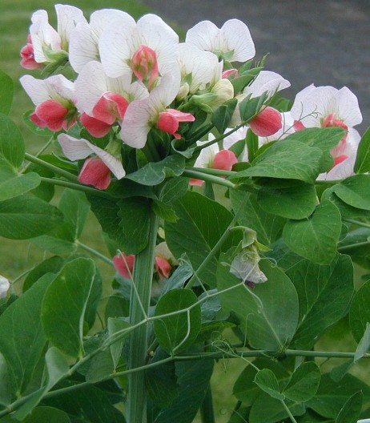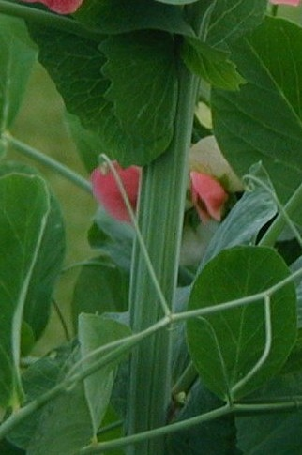
multiple flowers
ribbed stems

Ad. 4: Stem: length

Only the main stem should be recorded. The observations should be made on harvested plants when seed is green and fully developed. The measurement should include the first two nodes with ‘scale’ leaves.

Ad. 5: Stem: number of nodes up to and including first fertile node

Only the main stem should be recorded. The first two nodes, which have ‘scale’ leaves, should be included in all node counts.

Ad. 9: Leaf: maximum number of leaflets

Assessment should be made over the whole plant.

Ad. 13: Leaflet: position of broadest part

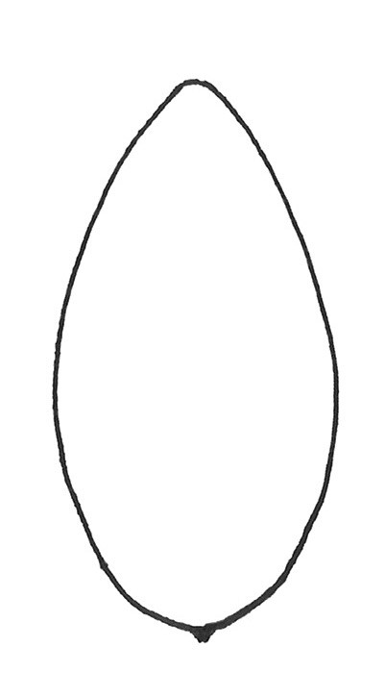 | 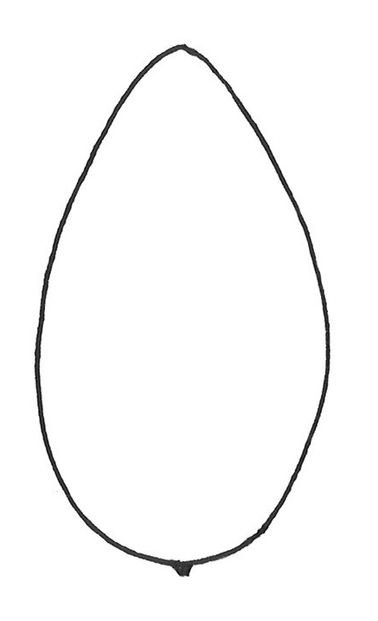 | 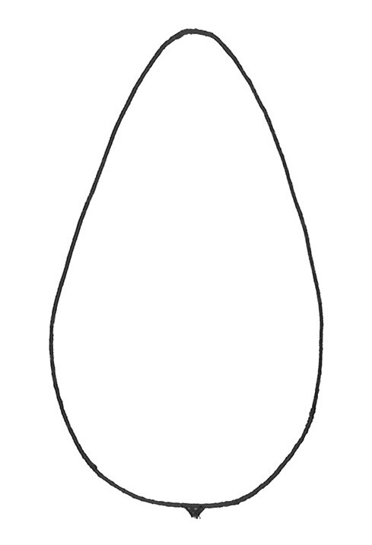
1 | 2 | 3
at middle or slightly towards base | moderately towards base | strongly towards base

Ad. 14: Leaflet: dentation

The maximum expression should be recorded; observations should only be made on the main stem (excluding aerial and basal branches), and above node six.

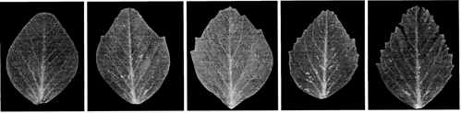
1 | 3 | 5 | 7 | 9
absent or very weak | weak | medium | strong | very strong

Ad. 15: Stipule: length
Ad. 16: Stipule: width
Ad. 18: Stipule: length from axil to tip
Ad. 19: Stipule: length of lobe below axil

Observations should be made on stipules which have been detached from the plant and flattened.
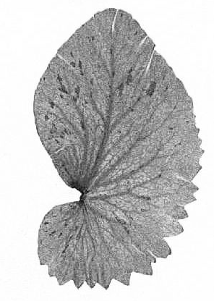

A

E

F

H

G

B

C

D

C

Stipule: length (15) A - B
Stipule: width (16) C - D
Stipule: length from axil to tip (18) E - F
Stipule: length of lobe below axil (19) G - H
(perpendicular to the line E – G)

Ad. 20: Stipule: flecking
Ad. 21: Stipule: density of flecking

Assessment should be made on the main stem only. The presence of flecking on any stipule on the main stem means that flecking is present. It should be ensured that foliage at the lowest nodes has not senesced before assessment. The plant should have at least eight nodes, since flecking in some varieties may not be expressed at lower nodes.
The density of flecking should be observed on the part of the plant with most flecking.

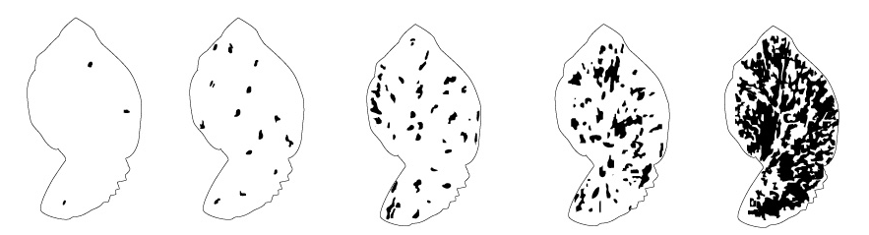

1 | 3 | 5 | 7 | 9
very sparse | sparse | medium | dense | very dense

Ad. 22: Petiole: length from axil to first leaflet or tendril
Ad. 23: Only varieties with leaflets absent: Petiole: length from axil to last tendril

Petiole length from axil to the first leaflet or tendril (22) A - B
Total length of petiole including tendrils (23) A - C

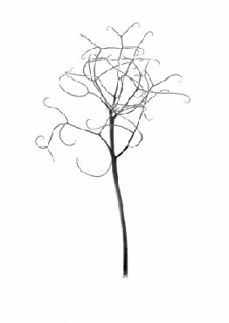
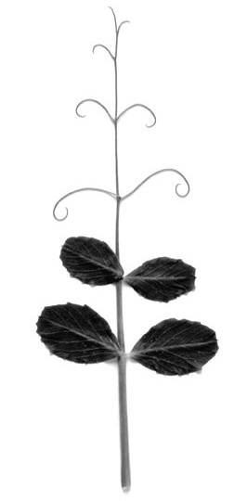
C
B
A
B

A

Ad. 24: Time of flowering

The time of flowering is when 30% of plants have at least one flower open.

Ad. 25: Only varieties with stem fasciation absent: Plant: maximum number of flowers per node

Assessment should be made over all flowering nodes on the main stem of the plant. A count is made of the maximum number of flowers at any node on each plant examined. An average is then calculated for the total number of plants examined per plot.
As flower set is dependent on temperature and available soil moisture, it is not unusual to record mean flower numbers between 1, 2 and 3 flowers. Mean values within 0.2 of a whole number should be rounded to that number for descriptive purposes e.g. mean 1.2 will be one flowered (note 1) and 1.8 will be two flowered note 3). All other mean values will fall into the intermediate states e.g. 1.3 or 1.7 will be one to two flowered (note 2).

Ad. 27: Only varieties with plant anthocyanin coloration absent: Flower: color of standard

The color of standard should be recorded on flowers which are fully opened and fresh.

Ad. 28: Flower: width of standard

The standard should be detached from the flower and flattened on a hard, flat surface.

Ad. 29: Flower: shape of base of standard

The standard should be detached and flattened on a hard, flat surface.

 |  | 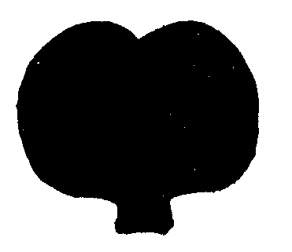 | 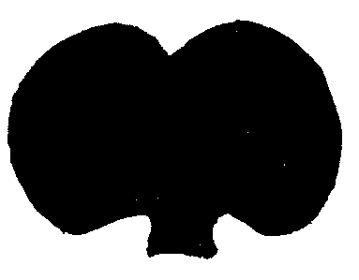 | 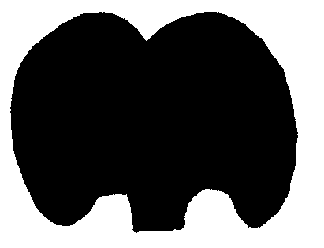
1 | 3 | 5 | 7 | 9
strongly raised | moderately raised | level | moderately arched | strongly arched

Ad. 30: Flower: undulation of standard

The maximum expression on the plant should be recorded. Flowers recorded should be fully opened and not senescing.

Ad. 32: Flower: shape of apex of upper sepal

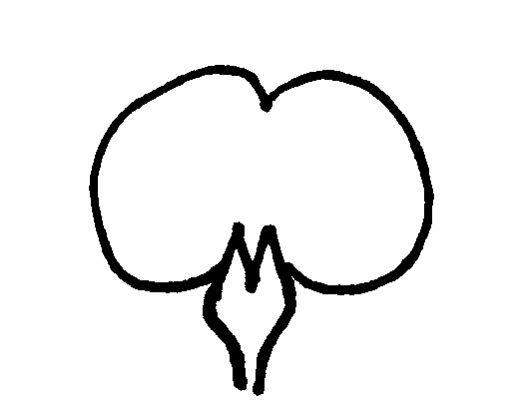  apex of upper sepal | 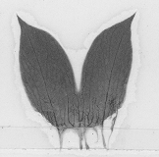 | 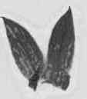 | 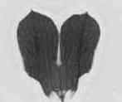
back of flower standard | 1 | 2 | 3
 | acuminate | acute | rounded

Ad. 33: Peduncle: length of spur
Ad. 34: Peduncle: length from stem to first pod
Ad. 35: Peduncle: length between first and second pods

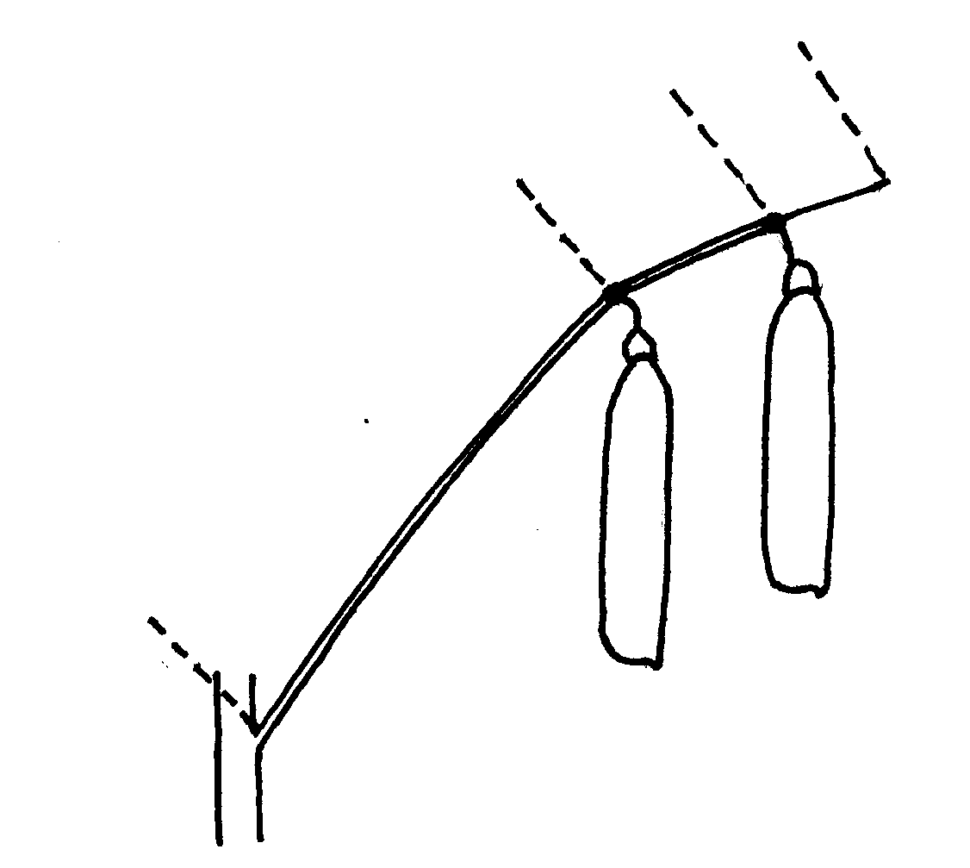
A
B
C
D
A – B = Peduncle: length from stem to first pod (34)

B – C = Peduncle: length between first and second pods (35)

C – D = Peduncle: length of spur (33)

Ad. 36: Peduncle: number of bracts

Bracts are modified leaves which occur on the peduncle. The number of bracts is calculated on the basis of averages across plants.
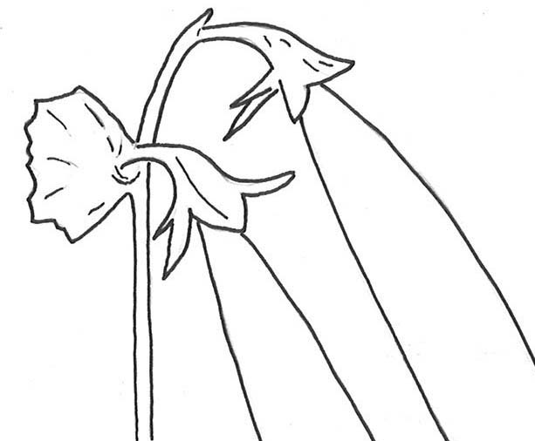
bract
peduncle

Ad. 38: Pod: width

The observations should be made on well developed green pods; the width is assessed from suture to suture on unopened pods.
A

Ad. 39: Pod: parchment
(viewed on the inside of the pod wall)

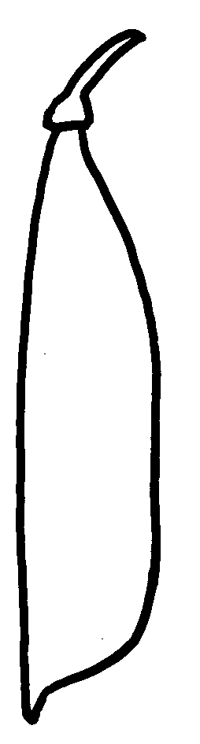 | 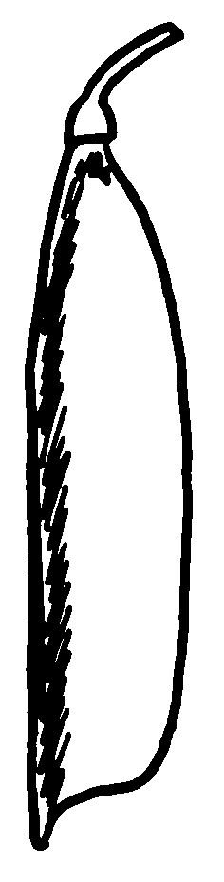 | 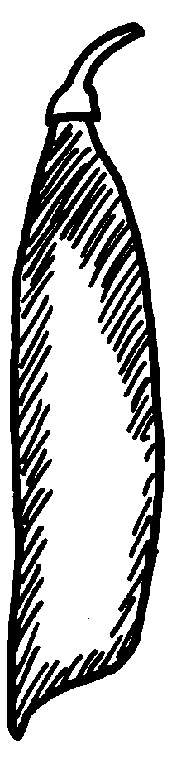 | 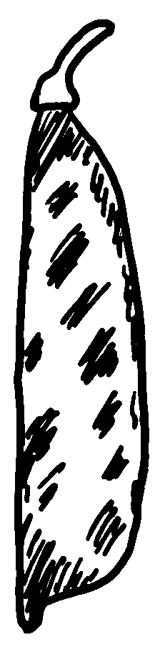 | 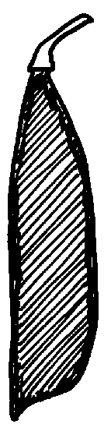
1 |  |  |  | 2
absent or partial |  |  |  | entire

(l) The observations should be made on dry pods with the exception of ‘Snap Peas’. Snap Peas (Sugar Peas with thickened pod walls) are best recorded when green, in order to minimize fungal infection which can prevent observation of the parchment.

(2) The pod should be opened along the suture without damaging the edges of the two sides of the pod. The distribution of sclerenchyma, which makes up the parchment, may either be observed by staining (a drop of Phloroglucinol dissolved in Ethanol followed by a drop of concentrated (37%) Hydrochloric Acid), or by reflecting light (preferably daylight) on the inside of the pod wall.

(3) In the case of varieties with the state “entire”, the parchment will occur as a thick layer in all pods.

Ad. 40: Excluding varieties with pod parchment: entire: Pod: thickened wall

The observations should be made on well developed pods not showing any signs of senescence. Unopened harvested pods should be cut in cross section to examine pod wall thickness.

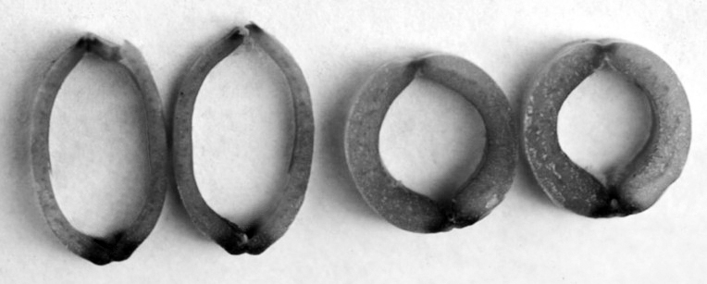
1 | 9
absent | present

Ad. 41: Only varieties with Pod: thickened wall: absent: Pod: shape of distal part

Observations should be made on several nodes of each plant when pods are fully developed, but before any senescence.

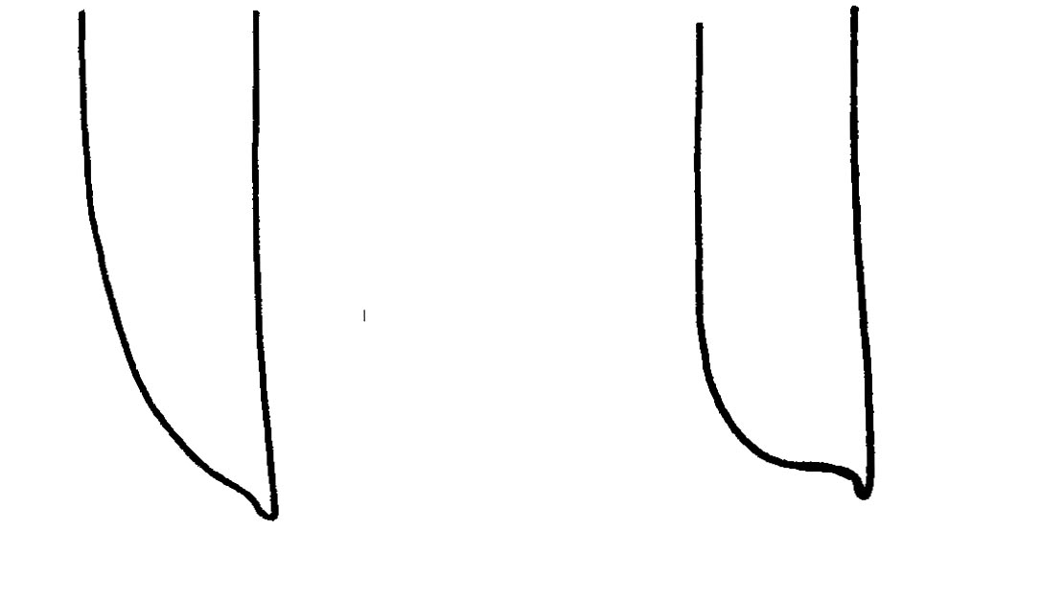
1 | 2
pointed | blunt

Ad. 42: Pod: curvature

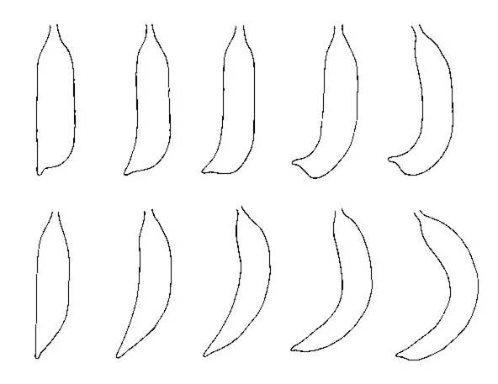
1 | 3 | 5 | 7 | 9
absent or very weak | weak | medium | strong | very strong

Ad. 43: Pod: color

Green pods may be pale or dark, the color is correlated with pale or dark immature seed color.
Blue green pods are dark and slightly bluish. The color develops with time, and may be more accentuated in hotter, drier conditions.
Purple pods may be entirely purple or partially purple; occasionally the amount and distribution of anthocyanin may vary within the plant.

Ad. 45: Excluding varieties with pod parchment: entire: Pod: suture strings

When temperatures exceed 20º C, the formation of suture strings is delayed. Observations should be made on fully developed pods.
Varieties with rudimentary suture strings are considered as state “absent”.

Ad. 46: Pod: number of ovules

The number of ovules is best recorded when the pods are flat. The number of ovules should be observed before seed development.
Ad. 47: Immature seed: intensity of green color

Immature seed color in some varieties with green cotyledons may appear creamy white before the seed is fully developed. Observations should be made on fully developed, fresh seed in a side-by-side comparison with example varieties.

Ad. 48: Seed: shape

Seeds which grow nearest the peduncle end or the distal end of the pod (‘end seeds’) are rounded on the radicle or the distal (opposite to the radicle) surfaces and should be excluded before shape is assessed. ‘Golf ball’ and other irregular dimpling should be ignored.

Orientate the seed so that the hilum is at the upper right hand side with radicle on top.

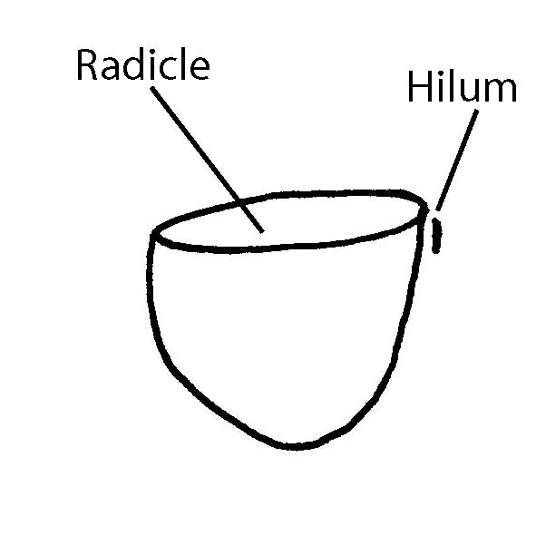
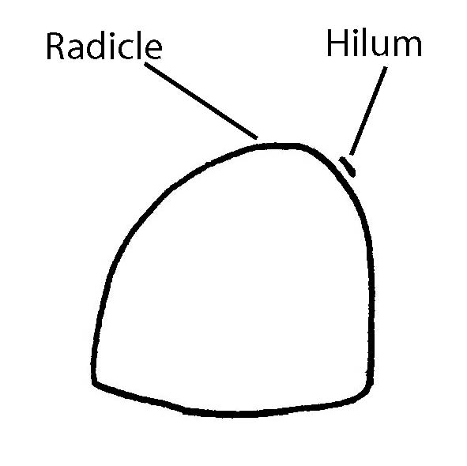

If the seed is rounded on the radicle surface only, it is an end seed growing nearest the peduncle end of the pod. |  | If the seed is rounded on the distal surface only, it is an end seed growing nearest the distal end of the pod.

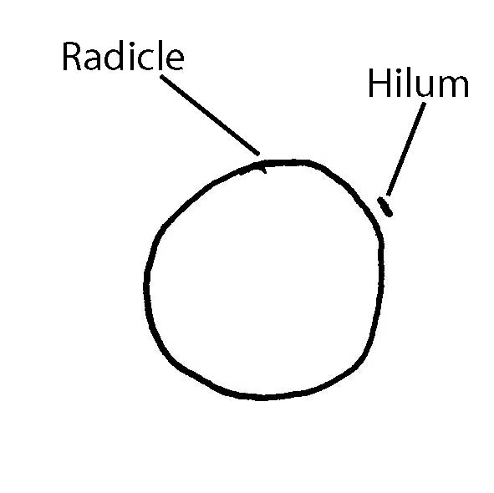
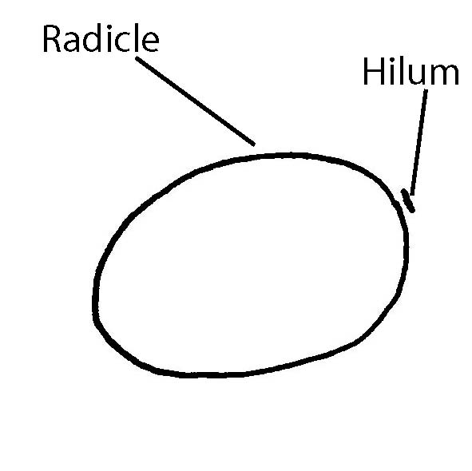
1. Ellipsoid

Seeds with no, or very weak, compression
on the radicle and/or the distal surfaces

2. Cylindrical
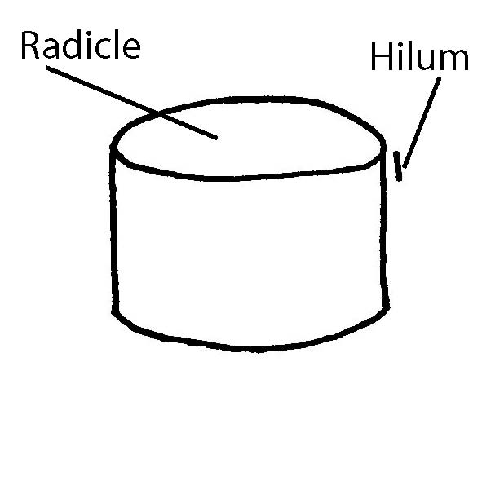
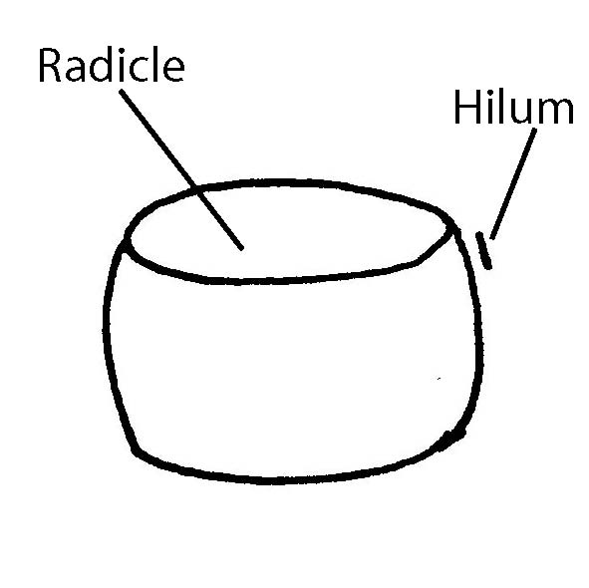
Seeds compressed on the radicle and distal
surfaces. Square to rectangular or with
rounded sides in longitudinal section.

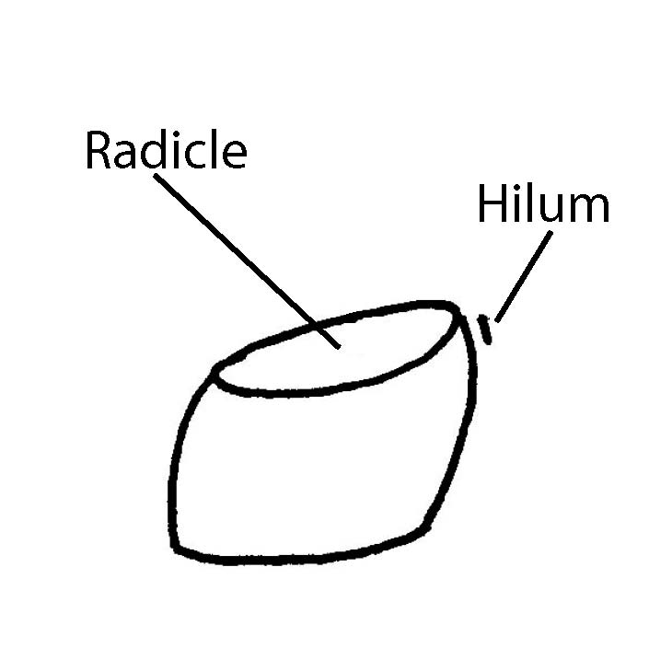
3. Rhomboid

Seeds irregularly compressed on
the radicle and distal surfaces, but
also irregularly compressed on the
abaxial surfaces.

4. Irregular

Seeds irregularly compressed; not one of the above shapes.

Ad. 49: Seed: type of starch grains

(l) Following the removal of the testa, fine fragments of tissue should be extracted from the cotyledon and placed on a microscope slide. A droplet of water is added to the extracted tissue and another microscope slide is placed on top. The tissue and water mixture is then squashed gently between the two slides. Too much pressure during squashing results in fragmentation of the grains, too little pressure will not provide a layer thin enough for examination.

(2) A microscope with transmitted light, using X16 eye-pieces and either X10 or X40 objectives, is most suitable for examination. For examination of compound grains the larger objectives will be required.

(3) Simple grains resemble wheat seeds or coffee beans in shape, often with what looks like a suture line running along their length.

(4) Compound grains look irregularly star-shaped and appear to be made of a number of segments. The center of the grains may appear cross-shaped. In varieties with high sweetness, compound starch grains are very small and few in number.

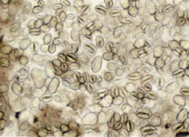 | 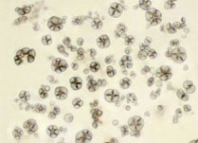
1 | 2
simple | compound

Ad. 50: Only varieties with seed shape: cylindrical; and type of starch grain: simple: Seed: wrinkling of cotyledon

‘Golf ball’ and large dimples should be ignored in the assessment of cotyledon wrinkling.

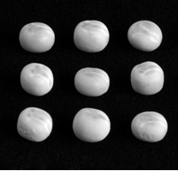 |  | 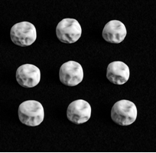
1 |  | 9
absent |  | present

Ad. 52: Seed: color of cotyledon

Following the removal of the testa, the seed is cut along the line of the cotyledon suture. Assessment of both external (abaxial) and internal (adaxial) surfaces of the cotyledon may be necessary. Immature seeds should be excluded from the assessment.

The expression varies with environmental conditions:
- bleaching, caused by sunlight or chemical changes in the plant, can remove color from seeds making it difficult to determine cotyledon color; cutting the seed in half enables the assessment of the internal color which may be less affected.
- color becomes dull with age, even if seed is stored in cold, dark conditions.
- color can darken in the presence of high amounts of Tragacanth oil occurring on the underside of the testa. This fades as the seed ages. Seeds with tannin may darken with age.
- orange cotyledons can be difficult to determine without reference to an example variety.

Ad. 55: Seed: hilum color

The hilum area should be lightly polished with a cloth before recording, to remove any loose tissue present. In varieties with plant anthocyanin present, the testa will contain tannins which vary in color from reddish brown to brown to brownish green. Where the hilum color is darker than the testa, melanin pigment is expressed as a black or dark brown color. It can be difficult to assess hilum color if the testa tannins darken with age; assessment should therefore be made within nine months of seed harvest.

Ad. 57: Seed: weight

Seed weight should be measured on at least two samples of 100 seeds. Immature and infected seeds should be excluded.

Ad. 58: Resistance to Fusarium oxysporum f. sp. pisi race 1

1. | Pathogen | Fusarium oxysporum f. sp. pisi (race 1)
2. | Quarantine status | no
3. | Host species | Pea – Pisum sativum L.
4. | Source of inoculum | GEVES (FR), INIA (ES) or SASA (GB)
5. | Isolate | Fusarium oxysporum f. sp. pisi race 1 strain  E.g. Reference strain validated in an inter laboratory test:  = MAT/REF 04-02-01-01Error: Reference source not found
6. | Establishment isolate identity | genetically defined pea controls  See ISF website  https://www.worldseed.org/our-work/plant-health/differential-hosts/  Version July 2019

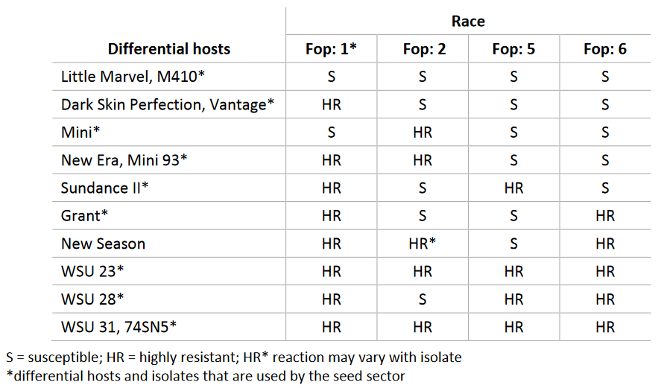
Courtesy of International Seed Federation.

7. | Establishment pathogenicity | Test on susceptible plants
8. | Multiplication inoculum
8.1 | Multiplication medium | Multiplication on agar medium: malt Agar or PDA for example
8.4 | Inoculation medium | Multiplication on agar medium: water for scraping agar plates.  Multiplication on liquid medium: Potato Dextrose Broth, Kerrs broth or Czapek-Dox (3 to 7 days old aerated culture) for example.
8.6 | Harvest of inoculum | see 10.1
8.7 | Check of harvested inoculum | see 10.2
8.8 | Shelflife/viability inoculum | Between 4 and 8 hours, keep cool to prevent germination of spores. The spores can be stored more than 3 years at -20°C.
9. | Format of the test
9.1 | Number of plants per genotype | At least 20 inoculated plants and 5 non inoculated plants per genotype to be able to judge growth reduction.
9.2 | Number of replicates | -
9.3 | Control varieties | Susceptible controls: Bartavelle  Resistant controls: New Era and Nina
9.5 | Test facility | Climate room or greenhouse.
9.6 | Temperature | 20-25°C
9.7 | Light | 12 hours or longer
9.9 | Special measures | It is important to compare the inoculated plants with the non-inoculated control plants of the same sample. This allows interpretation of symptoms of root rot, senescence or 'wilting' caused by the stress of having roots cut and not symptoms caused by F. oxysporum infection.
10. | Inoculation
10.1 | Preparation inoculum | Initial fungal growth on agar plates (Malt or PDA). This is then used as liquid medium inoculum after removing hyphal fragments by filtering solution through muslin cloth.  For liquid medium, filter through muslin cloth to remove large hyphal fragments.
10.2 | Quantification inoculum | 10⁶ spores/ml
10.3 | Plant stage at inoculation | seeds or 2 week old seedlings (2-3 nodes stage).
10.4 | Inoculation methods | For seeds:  sowing in contaminated substrate (soil-based substrate), 750 ml of suspension of spores at 10⁶ sp/ml for 5 l of substrate.  For 2 week old seedlings:  Sowing in a mix of vermiculite + soil or soil-based substrate  Cut the apical 2/3 of the roots, dip the remaining roots of the seedling in the spores suspension for 1 to 5 minutes and transplant in clean soil based substrate in a new tray.
10.7 | Final observations | 28 days post-inoculation.
11. | Observations
11.1 | Method | Visual
11.2 | Observation scale | Class 0: No symptoms or equivalent to non-inoculated control, 1 or 2 senesced (wilted/dried) lower leaves and slight reduction in growth compared to non-inoculated control of same variety are acceptable.  Class 1: Range from a few chlorotic or wilted/senesced leaves not present on, or more than on the non-inoculated control, up to many leaves with symptoms of senescence or wilting, some leaf drop, upper part of the plant still green and growing.  Class 2: Range from most of the plant wilted or senesced but still alive, to plants brown and dead with stem collapsed.  Classes 0 and 1 are generally resistant. Class 2 is generally susceptible.

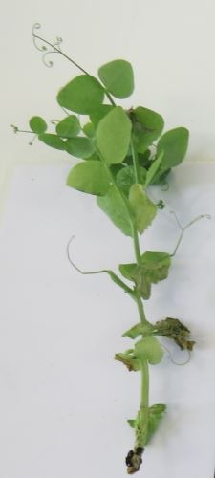 | 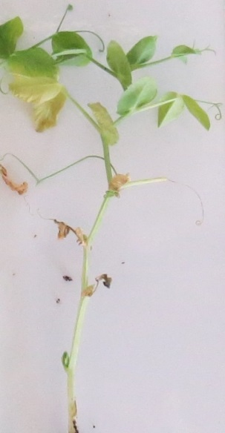 | 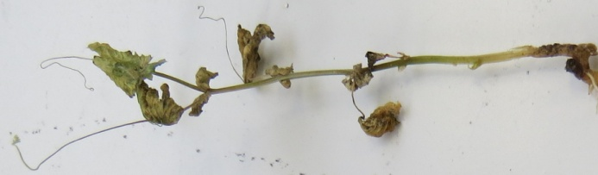 | 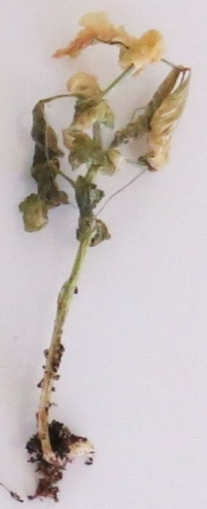
Class 0 | Class 1 | Class 2
Courtesy of GEVES-SNES in the framework of CPVO Harmores project.

11.3 | Validation of test | Evaluation of variety resistance should be calibrated with results of resistant and susceptible controls (distribution of plants per symptoms classes, eventually completed by a disease index).  New Era expresses weak symptoms and variations can occur in these weak symptoms depending on the aggressiveness of the test conditions.  Susceptible: lower level of resistance than New Era (Bartavelle is highly susceptible)  Resistant: same or higher level of resistance than New Era (Nina is highly resistant)
12. | Interpretation of data in terms of UPOV characteristic states
 | absent [1] | susceptible
 | present [9] | resistant
13. | Critical control points | Each lab has to define the best method of inoculation in its lab depending on controls results.  Inoculation by sowing in contaminated soil can in some cases lead to germination problems, particularly if the humidity of the soil is too high during the test. No conclusion can be done in this case, and the test should be repeated.

Ad. 59: Resistance to Erysiphe pisi Syd.

1. | Pathogen | Powdery mildew – Erysiphe pisi
2. | Quarantine status | No
3. | Host species | Pea – Pisum sativum L
4. | Source of inoculum | GEVES (FR)
5. | Isolate | Erysiphe pisi  e.g. Reference strain validated in an inter laboratory test  isolate 2430  =MAT/REF/ 04-17-01Error: Reference source not found
6. | Establishment isolate identity | Validation by use specific EryF/EryR primers to validate the species of Erysiphe (use ITS primers from Attanayake et al, 2010.)
7. | Establishment pathogenicity | use susceptible variety (e.g. Aladin, Cabree or Ottoman)
8. | Multiplication inoculum
8.1 | Multiplication medium | Living plant
8.2 | Multiplication variety | See 7.
8.3 | Plant stage at inoculation | See 10.3
8.4 | Inoculation medium
8.5 | Inoculation method | See 10.4
8.6 | Harvest of inoculum | For spraying by washing off with demineralized water  For dry sprinkling by detaching leaves of a susceptible host plant
8.7 | Check of harvested inoculum | Visual check for presence of sporulation
8.8 | Shelf life/viability inoculum | 1-2 hours
9. | Format of the test
9.1 | Number of plants per genotype | 20 plants
9.2 | Number of replicates | -
9.3 | Control varieties | Susceptible:  For vegetable crops: Cabree  For agricultural crops: Aladin, Ottoman  Resistant:  For vegetable crop: Ema, Sugar Bon, Vivaldi, Stratagem (JI2302),  For agricultural crop: Alezan
9.4 | Test design | Exclude non-inoculated control plants of the same sample as it is impossible to place them exactly in the same conditions (due to risk of contamination)
9.5 | Test facility | green house or climatic room
9.6 | Temperature | It is advised to perform the test at 20°C, but depending on laboratory conditions, test can be performed at temperature as high as 25°C. It is advised not to go below 18°C.
9.7 | Light | at least 12h per day
9.8 | Season
9.9 | Special measures
10. | Inoculation
10.1 | Preparation inoculum | By spraying:  Washing off from leaves by vigorous shaking in a closed container containing water. Sieve the suspension through muslin cloth.  By sprinkling:  Selection of leaves with strong sporulation.
10.2 | Quantification inoculum | By spraying:  Counting spores; spores density should be 1x10⁵ to 1x10⁶ spores/mL  By sprinkling:  An estimated proportion of one diseased plant (with a strong sporulation) can be used to inoculate 10 plants.
10.3 | Plant stage at inoculation | 3-4 leaf stage
10.4 | Inoculation method | By spraying:  Spraying of the suspension of spores on leaves  By sprinkling of the spores from the susceptible control plants used for multiplication:  To detach the spores for inoculation, the multiplication control plants are shaken above the tray of tested plants.
10.5 | First observation
10.6 | Second observation
10.7 | Final observations | Between 14-21 dpi, when sporulation is well expressed on the susceptible control.
11. | Observations
11.1 | Method | Visual
11.2 | Observation scale
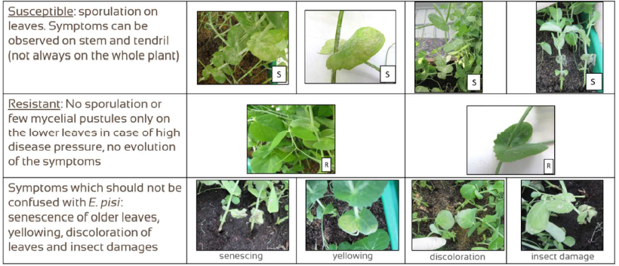
Courtesy of GEVES-SNES in the framework of CPVO Harmores project.

11.3 | Validation of test | Evaluation of variety resistance should be calibrated with results of resistant and susceptible controls.  Susceptible:  sporulation on leaves. These symptoms can be observed on stem and tendril (not always on the whole plant).  Resistant:  No sporulation or few mycelial pustules only on the lower leaves in case of high disease pressure, no evolution of the symptoms
11.4 | Off-types | -
12. | Interpretation of data in terms of UPOV characteristic states | Absent (susceptible) [1]  Present (resistant) [9]
13. | Critical control points | Watering for plant growth on the substrate (no spraying) to avoid washing the spores off the surface of the leaves.  It is not possible to revive frozen spores. This pathogen is an obligate biotroph and cannot survive outside a living plant.

Ad. 60: Resistance to Ascochyta pisi, Race C

1. | Pathogen | Ascochyta pisi
2. | Quarantine status | No
3. | Host species | Pea – Pisum sativum L.
4. | Source of inoculum | GEVES (FR) or SASA (UK)
5. | Isolate | Ascochyta pisi race C  E.g.: Reference strain validated in an inter-laboratory test  - strain 21A.13.  = MAT/REF/ 04-17-01Error: Reference source not found
6. | Establishment isolate identity | Genetically defined on Pea controls  https://www.worldseed.org/our-work/plant-health/differential-hosts/  Version July 2019

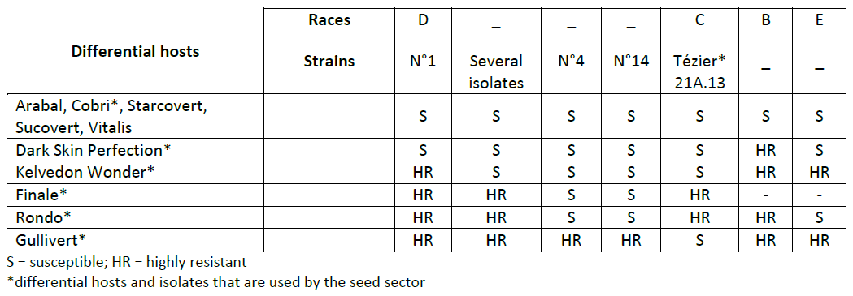
Courtesy of International Seed Federation.

7. | Establishment pathogenicity | Test on susceptible plants
8. | Multiplication inoculum
8.1 | Multiplication medium | V8 agar or Mathur medium or Potato Dextrose Agar or a synthetic  medium.
8.2 | Multiplication variety | -
8.3 | Plant stage at inoculation | -
8.4 | Inoculation medium | water, option: add Tween 80 (wetting agent to aid dispersal of spores, e.g. 0.4%)
8.5 | Inoculation method | -
8.6 | Harvest of inoculum | See 10.1
8.7 | Check of harvested inoculum | See 10.2
8.8 | Shelf life/viability inoculum | Between 4 and 8 hours, keep cool to prevent spores’ germination
9. | Format of the test
9.1 | Number of plants per genotype | At least 20 inoculated plants and 5 non-inoculated plants per variety.
9.2 | Number of replicates | -
9.3 | Control varieties | Susceptible controls: Crecerelle, Kelvedon Wonder  Resistant controls: Madonna or Rondo (lower resistance thresholds) and Nina (higher resistance control)
9.4 | Test design | -
9.5 | Test facility | Climatic room or greenhouse.
9.6 | Temperature | 20°C
9.7 | Light | 12 hours or longer
9.8 | Season | -
9.9 | Special measures | High humidity or watering by spraying 2 or 3 times per day.
10. | Inoculation
10.1 | Preparation inoculum | Remove hyphal fragments by straining solution through muslin cloth.
10.2 | Quantification inoculum | 10⁶ spores/mL (to adapt depending on conditions of tests).
10.3 | Plant stage at inoculation | 2 week old seedlings (i.e. 2-3 node stage).
10.4 | Inoculation method | Spraying on green leaves without surface moisture.
10.5 | First observation
10.6 | Second observation
10.7 | Final observations | 10-18 days post-inoculation.
11. | Observations
11.1 | Method | Visual
11.2 | Observation scale | Class 0: no symptoms  Class 1: few small superficial necrosis  Class 2: bigger darker and deep necrosis  Class 3: necrosis at each level of the plant or serious symptoms surrounding the stem
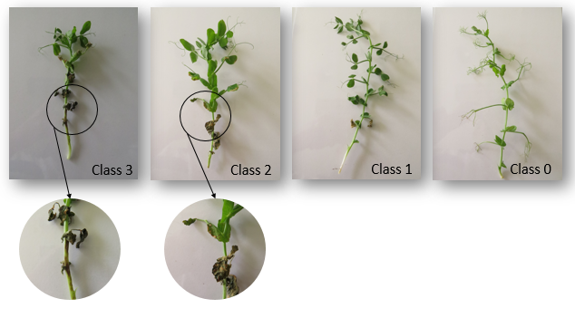
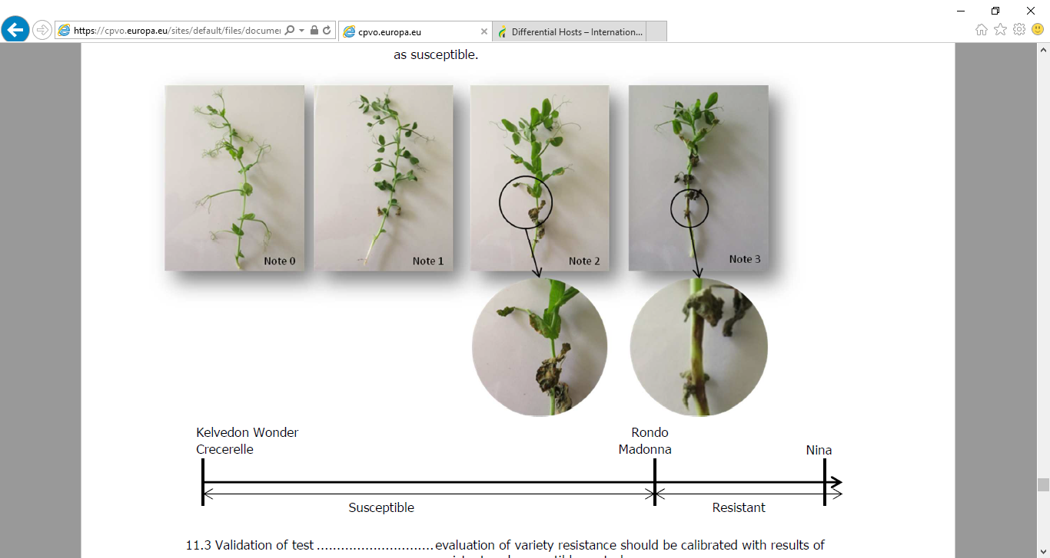
Courtesy of GEVES-SNES in the framework of CPVO Harmores project.

11.3 | Validation of test | Evaluation of variety resistance should be calibrated with results of  resistant and susceptible controls.
11.4 | Off-types
12. | Interpretation of data in terms of UPOV characteristic states | Susceptible:  Crecerelle or Kelvedon Wonder are susceptible controls. Varieties with a lower level of resistance than Madonna or Rondo will be interpreted as susceptible.  Resistant:  Madonna, Rondo, and Nina are resistant controls. Varieties with the same or higher level of resistance than Madonna or Rondo will be interpreted as resistant.  absent .............................. [1] susceptible  present ............................. [9] resistant
13. | Critical control points | -

KEY FOR THE GROWTH STAGES
CLE POUR LES STADES DE CROISSANCE
SCHLÜSSEL FÜR DIE ENTWICKLUNGSSTADIEN
CLAVE PARA LOS ESTADOS DE DESARROLLO

Key
Clé General Description Description générale Allgemeine Beschreibung Descripción general
Schlüssel
Clave

0 Germination Germination Keimung Germinación

00 Dry seed Graine sèche Trockenkorn Semilla seca

10 Seedling growth Croissance de la plantule Wachstum des Keimlings Desarrollo de las plántulas

16 Young seedling with first Jeune plantule avec Junger Keimling mit ersten Plántula joven con la primera
scale leaf developed première feuille à écailles entwickelten Schuppenblättern hoja escamosa desarrollada
développée

18 Young seedling with second Jeune plantule avec Junger Keimling mit zweiten Plántula joven con la segunda
scale leaf developed deuxième feuille à écailles entwickelten Schuppenblättern hoja escamosa desarrollada
développée

20 First pair of stipules Première paire de stipules Erstes Paar Nebenblätter Primer par de estípulas en el
at the third node fully au niveau du troisième noeud am dritten Knoten voll nivel del tercer nudo
opened complètement ouverte geöffnet completamente abiertas

22 Stipules at the fourth Stipules au niveau du Nebenblätter am vierten Estípulas en el nivel del cuarto
node fully opened quatrième noeud complètement Knoten voll geöffnet nudo completamente abiertas
ouverts

25 Stipules at the fifth Stipules au niveau du Nebenblätter am fünften Estípulas en el nivel del quinto
node fully opened cinquième noeud complètement Knoten voll geöffnet nudo completamente abiertas
ouverts

28 Stipules at the sixth Stipules au niveau du Nebenblätter am sechsten Estípulas en el nivel del sexto
node fully opened sixième noeud complètement Knoten voll geöffnet nudo completamente abiertas
ouverts

30 Vegetative growth Croissance végétative Vegetatives Wachstum Crecimiento vegetativo

31 Stipules at the Stipules au niveau du Nebenblätter am siebenten Estípulas en el nivel del
seventh node fully opened septième noeud complètement Knoten voll geöffnet séptimo nudo completamente
ouverts abiertas

34 Stipules at the Stipules au niveau du Nebenblätter am achten Estípulas en el nivel del
eighth node fully opened huitième noeud complètement Knoten voll geöffnet octavo nudo completamente
ouverts abiertas

40 Stipules at the Stipules au niveau du Nebenblätter am zehnten Estípulas en el nivel del
tenth node fully opened dixième noeud complètement Knoten voll geöffnet décimo nudo completamente
ouverts abiertas

n Stipules at the Stipules au niveau du Nebenblätter am N-ten Estípulas en el nivel del
Nth node fully opened N-ième noeud complètement Knoten voll geöffnet enésimo nudo completamente
ouverts abiertas

200 Reproductive stage Stade de reproduction Generatives Stadium Estadio reproductivo

200 Initiation of first flower Apparition de la première Beginn der ersten Blüte Aparición de la primera flor
fleur

206 Development of first Développement de la première Entwicklung der ersten in Desarrollo de la primera
flower bud enclosed fleur, mais à l’intérieur Nebenblätter eingeschlossenen yema floral, cubierta por
in stipules des stipules Blütenknospe hojas escamosas

208 Development and Développement et parfois Entwicklung und manchmal Desarrollo y, en ocasiones,
sometimes elongation allongement du pédoncule Verlängerung des Blüten- elongación del pedúnculo
of peduncle standstiels

Key
Clé General Description Description générale Allgemeine Beschreibung Descripción general
Schlüssel
Clave

210 Emergence of first Apparition du premier Erscheinen der ersten Aparición de la primera
flower bud from bourgeon à fleurs hors Blütenknospe aus den yema floral fuera de las
stipules des stipules Nebenblättern hojas escamosas

212 Emergence of Apparition des étendards Erscheinen der Fahne aus Aparición de los estandartes
standards from the calyx hors du calice dem Kelch fuera del cáliz

214 Opening of the Ouverture des étendards et Oeffnen der Fahne und Apertura de los estandartes
standards and apparition des ailes Erscheinen der Flügel y aparición de las alas
emergence of the
wings

216 Slight opening of the Légère ouverture des ailes Leichtes Oeffnen der Flügel Ligera apertura de las alas
wings to show the keel découvrant la carène und Erscheinen des Kieles para mostrar la quilla

218 Standards usually fully Etendards généralement Fahnen normalerweise voll Estandartes normalmente
opened complètement ouverts geöffnet abiertos por completo

220 Standards beginning to Etendards commençant à se Fahnen beginnen am Rand zu Los estandartes comienzan a
crumple at the margins friper sur les bords kräuseln arrugarse en los bordes

222 Standards and wings Etendards et ailes Fahnen und Flügel weisen Los estandartes y las alas
showing signs of présentant des signes de Zeichen des Welkens auf presentan signos de marchitez
withering flétrissure

224 Emergence of the first Apparition de la première Erscheinen der ersten Aparición de la primera
flat pod gousse aplatie flachen Hülse vaina plana

226 Elongation of the flat pod Allongement de la gousse Verlängerung der flachen Elongación de la vaina plana
with clearly visible ovules aplatie avec des ovules Hülse mit deutlich sicht- con los óvulos claramente
nettement visibles baren Samenanlagen visibles

230 Swelling of the ovules and Gonflement des ovules et Schwellen der Samenanlagen Hinchazón de los óvulos y
slight swelling of the pod léger renflement de la und leichtes Schwellen der ligera hinchazón de la valva
wall paroi de la gousse Hülsenwand de la vaina

235 Green seed rounded becoming Graine verte arrondie Grüner rundlicher Samen wird La semilla verde redondeada
slightly firm; pods almost devenant légèrement ferme; leicht fest; Hülse fast voll- se hace ligeramente firme;
fully swollen or developed gousses presque entièrement kommen geschwollen oder vainas casi completamente
formées ou développées entwickelt hinchadas o desarrolladas

240 Green seed firm, becoming Graine verte ferme, devenant Grüner Samen fest; wird Semilla verde firme,
starchy; pods fully amylacée; gousses leicht stärkehaltig; Hülsen volviéndose almidonada;
developed or swollen pleinement développées ou voll entwickelt oder vainas completamente
gonflées geschwollen desarrolladas o hinchadas

245 Green seed becoming pale, Graine verte devenant pâle, Grüner Samen wird blass, La semilla verde se vuelve
testas tough; pod téguments épais; gousse Samenschale fest; Hülse pálida, tegumentos
beginning to lose color commençant à se décolorer beginnt Farbe zu verlieren endurecidos; la vaina
comienza a perder color

250 Stem and lower foliage Tige et feuillage inférieur Stengel und niedrige Blätter El tallo y el follaje inferior
becoming yellowish devenant jaunâtre werden gelblich amarillean

255 Seed drying and becoming Dessèchement de la graine Samen trocknet und wird gelb- La semilla se seca y se vuelve
yellowish green; pod devenant vert jaunâtre; lichgrün; Hülse wird verde amarillenta; la vaina
becoming wrinkled gousse commençant à se rider schrumpfig comienza a arrugarse

260 Lower foliage becoming Feuillage inférieur devenant Untere Blätter werden am Rand El follaje inferior se seca en
dry at margins sec sur les bords trocken los bordes

265 Seed yellowish green; Graine vert jaunâtre; Samen gelblichgrün; Hülsen Semillas verdes amarillentas;
pods wrinkled, pale green gousses ridées vert pâle schrumpfig, blassgrün vainas arrugadas de color
verde pálido

Key
Clé General Description Description générale Allgemeine Beschreibung Descripción general
Schlüssel
Clave

270 Lower foliage becoming Feuillage inférieur Untere Blätter werden trocken Follaje inferior seco y
dry and papery devenant sec et semblable und papierartig apergaminado
à du papier

275 Seed yellowish-white Graine blanc jaunâtre Samen gelblichweiss und Semilla blanca amarillenta y
and rubbery; pods et caoutchouteuse; gousse gummiartig; Hülsen schrumpfig de consistencia gomosa;
wrinkled and yellowish- ridée et de couleur vert und gelblichgrün vainas arrugadas y verdes
green jaunâtre amarillentas

280 Stem drying out, becom- Dessèchement de la tige Stengel trocknet aus, wird Tallo seco, adquiriendo un
ing yellowish green devenant vert jaunâtre gelblichgrün color verde amarillento

285 Lowest pods yellowish- Gousses inférieures de Unterste Hülsen gelblich- Las vainas inferiores de color
brown, dry and papery couleur brun jaunâtre, braun, trocken und marrón amarillento, secas y
sèches et semblables papierartig apergaminadas
à du papier

290 Stem becoming stiff Tige devenant érigée et Stengel wird steif und zer- El tallo se vuelve rígido
and brittle and fragile, et de couleur brechlich und erscheint y frágil y de color blanco
appearing yellowish- blanc jaunâtre gelblichweiss amarillento
white

300 Lower and middle nodes Feuillage sec et semblable Untere und mittlere Knoten Follaje seco y apergaminado
with dry papery foliage; à du papier sur tous les mit trockenen, papierartigen en los nudos medios e
lower pods dry and papery noeuds inférieurs et médians; Blättern; untere Hülsen inferiores; vainas inferiores
gousses inférieures sèches trocken und papierartig secas y apergaminadas
et semblables à du papier

305 All nodes with dry papery Feuillage sec et semblable Alle Knoten mit trockenen, Follaje seco y apergaminado
foliage; lower and à du papier sur tous les papierartigen Blättern; en todos los nudos;
middle pods dry and noeuds; gousses inférieures untere und mittlere Hülsen vainas medias secas y
papery et médianes sèches et trocken und papierartig apergaminadas
semblables à du papier

310 All nodes with dry papery Feuillage et gousses secs et Alle Knoten mit trockenen, Follaje y vainas secos y
foliage and pods; seed semblables à du papier sur papierartigen Blättern und apergaminados en todos los
drying but not hard tous les noeuds; graine se Hülsen; Samen trocknet, ist nudos; la semillas se secan,
desséchant, mais non dure aber noch nicht hart pero no están duras

320 Hard dry seed Graine dure et sèche Harter trockener Samen Semillas duras y secas

Literature
Biddle, A.J., Knott, C.M., 1988: The Pea Growing Handbook. Sixth edition. Ed. G.P. Gent. Processors and Growers Research Organisation, Peterborough, GB.

Blixt, S., 1972: Mutation Genetics in Pisum. Agri. Hort. Genet., 30, pp. 1-293.

Blixt, S., 1974: The Pea. In Handbook of Genetics. Ed.R.C. King, Plenum Press, New York, US.

Blixt, S., 1977: The Gene Symbols of Pisum. Pisum Newsletter, 9 (suppl.).

Casey, R., Davies, D.R., CAB International 1993: Peas: Genetics, Molecular Biology and Biotechnology. Biotechnology in Agriculture Series, No. 10.

Cousin, R., 1974: Les pois. Étude génétique des caractères, classification, caractéristiques variétales portant sur les variétés inscrites au catalogue officiel français. Institut national de la recherche agronomique, Paris, FR.

Fourmant, R., 1956: Les variétés de pois cultivés en France. Institut national de la recherche agronomique, Paris, FR.

Gallais et Bannerot, 1992: Amélioration des espèces végétales cultivées. Objectifs et critères de sélection, édition Quae, FR

Hagedorn, D.J., 1984: Compendium of Pea Diseases. The American Phytopathological Society, Minnesota, LISA, US.

Harmores 2 CPVO project (http://www.cpvo.europa.eu/main/en/home/documents-and-publications/technical-projects-reports)

Hedrick, U.P., 1928: The Vegetables of New York. Vol. Part I: Peas. New York Agricultural Experiment Station Albany, New York, US.

Khvostova, V.V., 1983: Genetics and Breeding of Peas. Amerind Publishing Co. Pvt. Ltd. New Delhi, IN.

Lamprecht, H., 1974: Monographie der Gattung Pisum. Steiermarkische Landesdruckerei, Graz, AT.

Makasheva, R.Kh., 1983: The Pea. Amerind Publishing Co. Pvt. Ltd., New Delhi, IN.

Marx, G.A., 1977: Classification, Genetics and Breeding. in ‘The Physiology of the Garden Pea’ (J.F. Sutcliffe and J.S. Pate, eds.) pp. 21-44. Academic Press. London and Orlando, GB.

Murfet, I.C., 1976: Physiological genetics of flowering in ‘Physiology of the garden pea’, Academic Press.

Murfet, I.C. 1985: in ‘CRC Handbook of Flowering’ Ed. A.H. Halevy, CRC Press, Boca Raton, IV, pp. 97-126.

Murfet, I.C., Reid, J.B., 1985: The control of flowering and internode length in Pisum. In “The Pea Crop - a basis for improvement” Eds. Hebblethwaite, Heath, Dawkins. Butterworths, London, 6, pp. 67-80.

Technical Questionnaire
TECHNICAL QUESTIONNAIRE |  |  |  | Page {x} of {y} |  | Reference Number:
 |  |  |  |  |  | Application date:
 |  |  |  |  |  | (not to be filled in by the applicant)
TECHNICAL QUESTIONNAIRE
to be completed in connection with an application for plant breeders’ rights

1. Subject of the Technical Questionnaire
1.1 Botanical name |  |  | Pisum sativum L.
1.2 Common name |  |  | Pea
2. Applicant
Name
Address
Telephone No.
Fax No.
E-mail address
Breeder (if different from applicant)
3. Proposed denomination and breeder’s reference
Proposed denomination
(if available)

Breeder’s reference
#4. Information on the breeding scheme and propagation of the variety

4.1 Breeding scheme

Variety resulting from:

4.1.1 Crossing

(a) controlled cross [ ]
(please state parent varieties)
(b) partially known cross [ ]
(please state known parent variety(ies))
(c) unknown cross [ ]

4.1.2 Mutation [ ]
(please state parent variety)

4.1.3 Discovery and development [ ]
(please state where and when discovered and how developed)

4.1.4 Other [ ]
(please provide details)

4.2 Method of propagating the variety

5. Characteristics of the variety to be indicated (the number in brackets refers to the corresponding characteristic in Test Guidelines; please mark the note which best corresponds).

 | Characteristics |  |  |  |  |  | Example Varieties |  |  |  |  | Note
5.1  (1) | Plant: anthocyanin coloration
 | absent |  |  |  |  |  | Avola, Solara |  |  |  |  | 1 [ ]
 | present |  |  |  |  |  | Pidgin, Rosakrone |  |  |  |  | 9 [ ]
5.2  (3) | Stem: fasciation
 | absent |  |  |  |  |  | Avola, Solara |  |  |  |  | 1 [ ]
 | present |  |  |  |  |  | Bikini, Rosakrone |  |  |  |  | 9 [ ]
5.3  (4) | Stem: length
 | very short |  |  |  |  |  | Zephyr |  |  |  |  | 1 [ ]
 | short |  |  |  |  |  | Nobel, Mini |  |  |  |  | 3 [ ]
 | medium |  |  |  |  |  | Calibra, Xantos |  |  |  |  | 5 [ ]
 | long |  |  |  |  |  | Blauwschokker, Livia |  |  |  |  | 7 [ ]
 | very long |  |  |  |  |  | Mammoth Melting Sugar |  |  |  |  | 9 [ ]
5.4  (5) | Stem: number of nodes up to and including first fertile node
 | very few |  |  |  |  |  | Kelvil |  |  |  |  | 1 [ ]
 | few |  |  |  |  |  | Smart, Zero4 |  |  |  |  | 3 [ ]
 | medium |  |  |  |  |  | Markana, Susan |  |  |  |  | 5 [ ]
 | many |  |  |  |  |  | Cooper |  |  |  |  | 7 [ ]
 | very many |  |  |  |  |  | Regina |  |  |  |  | 9 [ ]
 | Characteristics |  |  |  |  |  | Example Varieties |  |  |  |  | Note
5.5  (6) | Foliage: color
 | yellow green |  |  |  |  |  | Pilot |  |  |  |  | 1 [ ]
 | green |  |  |  |  |  | Avola, Paris, Progreta, Waverex |  |  |  |  | 2 [ ]
 | blue green |  |  |  |  |  | Polar |  |  |  |  | 3 [ ]
5.6  (8) | Leaf: leaflets
 | absent |  |  |  |  |  | Hawk, Solara |  |  |  |  | 1 [ ]
 | present |  |  |  |  |  | Avola, Rhea |  |  |  |  | 9 [ ]
5.7  (20) | Stipule: flecking
 | absent |  |  |  |  |  | Lisa, Tafila |  |  |  |  | 1 [ ]
 | present |  |  |  |  |  | Avola, Maro |  |  |  |  | 9 [ ]
5.8  (24) | Time of flowering
 | very early |  |  |  |  |  | Tempo |  |  |  |  | 1 [ ]
 | early |  |  |  |  |  | Smart, Zero4 |  |  |  |  | 3 [ ]
 | medium |  |  |  |  |  | Carlton, Waverex |  |  |  |  | 5 [ ]
 | late |  |  |  |  |  | Cooper, Purser |  |  |  |  | 7 [ ]
 | very late |  |  |  |  |  | Livioletta |  |  |  |  | 9 [ ]
5.9  (25) | Only varieties with stem fasciation absent:  Plant: maximum number of flowers per node
 | one |  |  |  |  |  | Progress No. 9, Tyla |  |  |  |  | 1 [ ]
 | two |  |  |  |  |  | Banff, Cooper |  |  |  |  | 3 [ ]
 | three |  |  |  |  |  | Ultimo, Zodiac |  |  |  |  | 5 [ ]
 | four or more |  |  |  |  |  | Arnesa, Calibra,  Survivor |  |  |  |  | 7 [ ]
 | Characteristics |  |  |  |  |  | Example Varieties |  |  |  |  | Note
5.10  (26) | Only varieties with plant anthocyanin coloration present:  Flower: color of wing
 | white with pink blush |  |  |  |  |  |  |  |  |  |  | 1 [ ]
 | pink |  |  |  |  |  | Rosakrone |  |  |  |  | 2 [ ]
 | reddish purple |  |  |  |  |  | Assas |  |  |  |  | 3 [ ]
5.11  (29) | Flower: shape of base of standard
 | strongly raised |  |  |  |  |  |  |  |  |  |  | 1 [ ]
 | moderately raised |  |  |  |  |  | Progreta |  |  |  |  | 3 [ ]
 | level |  |  |  |  |  | Markado, Solara |  |  |  |  | 5 [ ]
 | moderately arched |  |  |  |  |  | Avola, Copper |  |  |  |  | 7 [ ]
 | strongly arched |  |  |  |  |  | Bohatyr, Kennedy |  |  |  |  | 9 [ ]
5.12  (37) | Pod: length
 | very short |  |  |  |  |  | Cepia, Vermio |  |  |  |  | 1 [ ]
 | short |  |  |  |  |  | Progreta, Solara |  |  |  |  | 3 [ ]
 | medium |  |  |  |  |  | Copper, Jof |  |  |  |  | 5 [ ]
 | long |  |  |  |  |  | Hurst Green Shaft, Protor |  |  |  |  | 7 [ ]
 | very long |  |  |  |  |  | Tirabeque |  |  |  |  | 9 [ ]
5.13  (38) | Pod: width
 | very narrow |  |  |  |  |  | Claire |  |  |  |  | 1 [ ]
 | narrow |  |  |  |  |  | Picar, Ultimo |  |  |  |  | 3 [ ]
 | medium |  |  |  |  |  | Progreta, Solara |  |  |  |  | 5 [ ]
 | broad |  |  |  |  |  | Finale, Kahuna |  |  |  |  | 7 [ ]
 | very broad |  |  |  |  |  | Kennedy |  |  |  |  | 9 [ ]
5.14  (39) | Pod: parchment
 | absent or partial |  |  |  |  |  | Sugar Ann |  |  |  |  | 1 [ ]
 | entire |  |  |  |  |  | Avola, Solara |  |  |  |  | 2 [ ]
 | Characteristics |  |  |  |  |  | Example Varieties |  |  |  |  | Note
5.15  (40) | Excluding varieties with pod parchment: entire: Pod: thickened wall
 | absent |  |  |  |  |  | Nofila, Reuzensuiker |  |  |  |  | 1 [ ]
 | present |  |  |  |  |  | Cygnet, Sugar Ann |  |  |  |  | 9 [ ]
5.16  (41) | Only varieties with Pod: thickened wall: absent: Pod: shape of distal part
 | pointed |  |  |  |  |  | Jof, Oskar |  |  |  |  | 1 [ ]
 | blunt |  |  |  |  |  | Avola, Solara |  |  |  |  | 2 [ ]
5.17  (42) | Pod: curvature
 | absent or very weak |  |  |  |  |  | Finale, Maro |  |  |  |  | 1 [ ]
 | weak |  |  |  |  |  | Eagle, Span |  |  |  |  | 3 [ ]
 | medium |  |  |  |  |  | Carlton,  Hurst Green Shaft |  |  |  |  | 5 [ ]
 | strong |  |  |  |  |  | Delikata, Jof |  |  |  |  | 7 [ ]
 | very strong |  |  |  |  |  | Oskar |  |  |  |  | 9 [ ]
5.18  (43) | Pod: color
 | yellow |  |  |  |  |  |  |  |  |  |  | 1 [ ]
 | green |  |  |  |  |  | Avola, Solara |  |  |  |  | 2 [ ]
 | blue green |  |  |  |  |  | Show Perfection |  |  |  |  | 3 [ ]
 | purple |  |  |  |  |  | Blauwschokker |  |  |  |  | 4 [ ]
5.19  (45) | Excluding varieties with pod parchment: entire: Pod: suture strings
 | absent |  |  |  |  |  | Nofila, Sugar Lace |  |  |  |  | 1 [ ]
 | present |  |  |  |  |  | Crispi, Reuzensuiker |  |  |  |  | 9 [ ]
5.20  (46) | Pod: number of ovules
 | few |  |  |  |  |  | De Grace, Phoenix |  |  |  |  | 3 [ ]
 | medium |  |  |  |  |  | Backgammon, Hawk |  |  |  |  | 5 [ ]
 | many |  |  |  |  |  | Karisma |  |  |  |  | 7 [ ]
 | Characteristics |  |  |  |  |  | Example Varieties |  |  |  |  | Note
5.21  (47) | Immature seed: intensity of green color
 | light |  |  |  |  |  | Solara, Ultimo |  |  |  |  | 3 [ ]
 | medium |  |  |  |  |  |  |  |  |  |  | 5 [ ]
 | dark |  |  |  |  |  | Dark Skin Perfection, Hawaii |  |  |  |  | 7 [ ]
5.22  (49) | Seed: type of starch grains
 | simple |  |  |  |  |  | Adagio, Maro, Solara, |  |  |  |  | 1 [ ]
 | compound |  |  |  |  |  | Avola, Polar |  |  |  |  | 2 [ ]
5.23  (52) | Seed: color of cotyledon
 | green |  |  |  |  |  | Avola, Solara |  |  |  |  | 1 [ ]
 | yellow |  |  |  |  |  | Caractacus, Hardy |  |  |  |  | 2 [ ]
 | orange |  |  |  |  |  | Oliver |  |  |  |  | 3 [ ]
5.24  (53) | Only varieties with plant anthocyanin coloration present:  Seed: marbling of testa
 | absent |  |  |  |  |  | Rhea, Rif |  |  |  |  | 1 [ ]
 | present |  |  |  |  |  | Assas, Pidgin |  |  |  |  | 9 [ ]
5.25  (54) | Only varieties with plant anthocyanin coloration present:  Seed: violet or pink spots on testa
 | absent |  |  |  |  |  | Pidgin, Rif |  |  |  |  | 1 [ ]
 | faint |  |  |  |  |  | Assas, Susan |  |  |  |  | 2 [ ]
 | intense |  |  |  |  |  | Arvika, Rhea |  |  |  |  | 3 [ ]
5.26  (55) | Seed: hilum color
 | same color as testa |  |  |  |  |  | Avola, Solara |  |  |  |  | 1 [ ]
 | darker than testa |  |  |  |  |  | Nofila, Rif |  |  |  |  | 2 [ ]
 | Characteristics |  |  |  |  |  | Example Varieties |  |  |  |  | Note
5.27  (57) | Seed: weight
 | very low |  |  |  |  |  | Ultimo |  |  |  |  | 1 [ ]
 | low |  |  |  |  |  | Hawk, Iceberg |  |  |  |  | 3 [ ]
 | medium |  |  |  |  |  | Mammoth Melting Sugar, Phoenix |  |  |  |  | 5 [ ]
 | high |  |  |  |  |  | Kennedy, Maro |  |  |  |  | 7 [ ]
 | very high |  |  |  |  |  | Bamby, Kabuki |  |  |  |  | 9 [ ]
6. Similar varieties and differences from these varieties

Please use the following table and box for comments to provide information on how your candidate variety differs from the variety (or varieties) which, to the best of your knowledge, is (or are) most similar. This information may help the examination authority to conduct its examination of distinctness in a more efficient way.

Denomination(s) of variety(ies) similar to your candidate variety |  | Characteristic(s) in which your candidate variety differs from the similar variety(ies) |  |  | Describe the expression of the characteristic(s) for the similar variety(ies) |  |  | Describe the expression of the characteristic(s) for your candidate variety
Example |  | Time of flowering |  |  | early |  |  |  | medium
Comments:

#7. Additional information which may help in the examination of the variety

7.1 In addition to the information provided in sections 5 and 6, are there any additional characteristics which may help to distinguish the variety?

Yes [ ] No [ ]

(If yes, please provide details)

7.2 Are there any special conditions for growing the variety or conducting the examination?

Yes [ ] No [ ]

(If yes, please provide details)

7.3 Other information

Use
fresh market [ ]
canning [ ]
freezing [ ]
dry seed for human consumption [ ]
dry protein [ ]
forage [ ]
other (please specify) [ ]

………………………………………………..

Resistance to disease
Resistant Susceptible Not tested
Fusarium oxysporum f. sp. pisi (Race 1) (Common Wilt) [ ] [ ] [ ]
Erysiphe pisi Syd. (Powdery mildew) [ ] [ ] [ ]
Ascochyta pisi (leaf and pod spot) Race C [ ] [ ] [ ]

Resistance to other diseases
(please give details below)

………………………………………………

8. Authorization for release

(a) Does the variety require prior authorization for release under legislation concerning the protection of the environment, human and animal health?

Yes [ ] No [ ]

(b) Has such authorization been obtained?

Yes [ ] No [ ]

If the answer to (b) is yes, please attach a copy of the authorization.

9. Information on plant material to be examined or submitted for examination.

9.1 The expression of a characteristic or several characteristics of a variety may be affected by factors, such as pests and disease, chemical treatment (e.g. growth retardants or pesticides), effects of tissue culture, different rootstocks, scions taken from different growth phases of a tree, etc.

9.2 The plant material should not have undergone any treatment which would affect the expression of the characteristics of the variety, unless the competent authorities allow or request such treatment. If the plant material has undergone such treatment, full details of the treatment must be given. In this respect, please indicate below, to the best of your knowledge, if the plant material to be examined has been subjected to:

(a) Microorganisms (e.g. virus, bacteria, phytoplasma) Yes [ ] No [ ]

(b) Chemical treatment (e.g. growth retardant, pesticide) Yes [ ] No [ ]

(c) Tissue culture Yes [ ] No [ ]

(d) Other factors Yes [ ] No [ ]

Please provide details for where you have indicated “yes”.

……………………………………………………………

10. I hereby declare that, to the best of my knowledge, the information provided in this form is correct:

Applicant’s name

Signature Date

[End of document]

* These names were correct at the time of the introduction of these Test Guidelines but may be revised or updated. [Readers are advised to consult the UPOV Code, which can be found on the UPOV Website (www.upov.int), for the latest information.]
matref@geves.fr
resistencias@inia.es
Marian.McEwan@sasa.gov.scot
Harmores 2 CPVO project: https://cpvo.europa.eu/sites/default/files/documents/vem15_7_b_harmores_2_final_report.pdf
matref@geves.fr
Harmores 2 CPVO project: https://cpvo.europa.eu/sites/default/files/documents/vem15_7_b_harmores_2_final_report.pdf
https://cpvo.europa.eu/sites/default/files/documents/report_harmores_3_final_meeting_v0_0.pdf
matref@geves.fr
Marian.McEwan@sasa.gov.scot
Harmores 2 CPVO project: https://cpvo.europa.eu/sites/default/files/documents/vem15_7_b_harmores_2_final_report.pdf
# Authorities may allow certain of this information to be provided in a confidential section of the Technical Questionnaire.
# Authorities may allow certain of this information to be provided in a confidential section of the Technical Questionnaire.

