 | F
Union internationale pour la protection des obtentions végétales

Conseil  Cinquante-huitième session ordinaire  Genève, 25 octobre 2024 | C/58/17  Original : anglais  Date : 21 septembre 2024
FAITS NOUVEAUX CONCERNANT LE PROJET DE LOI SUR LA PROTECTION DES OBTENTIONS VÉGÉTALES DES ÉMIRATS ARABES UNIS
Document établi par le Bureau de l’Union
Avertissement : le présent document ne représente pas les principes ou les orientations de l’UPOV
L’objet du présent document est d’inviter le Conseil à examiner les faits nouveaux concernant le “Projet de loi sur la protection des obtentions végétales” des Émirats arabes unis et de confirmer sa décision positive du 28 juillet 2020 concernant la conformité avec les dispositions de l’Acte de 1991 de la Convention internationale pour la protection des obtentions végétales.

GÉNÉRALITÉS

Le Gouvernement des Émirats arabes unis a engagé la procédure pour devenir membre de l’UPOV en envoyant une lettre datée du 28 avril 2020, adressée au Secrétaire général de l’UPOV, dans laquelle S. E. le Sultan Abdulla AlHebsi, sous-secrétaire adjoint au secteur des régions du Ministère du changement climatique et de l’environnement, demandait l’examen de la conformité du projet de loi sur la protection des obtentions végétales des Émirats arabes unis (ci-après dénommé “projet de loi”) avec l’Acte de 1991 de la Convention UPOV. Conformément à la circulaire UPOV E-20/101 datée du 28 juillet 2020, le Conseil a examiné le projet de loi et a décidé par correspondance :

“a) de prendre note de l’analyse figurant dans le document C/Analysis/2020/2;

“b) de rendre une décision positive concernant la conformité du ‘projet de loi sur la protection des obtentions végétales des Émirats arabes unis’ avec l’Acte de 1991 de la Convention internationale pour la protection des obtentions végétales, ce qui permettra aux Émirats arabes unis, une fois que le projet de loi aura été adopté sans changement et que la loi sera entrée en vigueur, de déposer son instrument d’adhésion à l’Acte de 1991, et

“c) d’autoriser le Secrétaire général à informer le Gouvernement des Émirats arabes unis de cette décision.”

Modifications apportées à la loi de 2021 sur la protection des obtentions végétales des Émirats arabes unis, par rapport au texte soumis au Conseil en 2020

Dans une lettre datée du 18 mars 2024, reçue par le Bureau de l’Union le 25 juillet 2024 et adressée au Secrétaire général de l’UPOV (voir l’annexe I), le sous-secrétaire au Ministère du changement climatique et de l’environnement, M. Mohammed Saeed Sultan Al Nuaimi, a informé le Secrétaire général de l’UPOV que certaines modifications avaient été apportées au projet de loi et a demandé la confirmation de l’avis positif du Conseil quant à la conformité du projet de loi.

Les modifications apportées au texte du projet de loi, par rapport au texte du projet de loi soumis au Conseil en 2020, sont présentées en mode révision à l’annexe II du présent document (en anglais).

Le projet de loi sur la protection des obtentions végétales des Émirats arabes unis, dans sa dernière version de 2024, figure à l’annexe III du présent document (en anglais).

Conclusion

Compte tenu de ce qui précède, de l’avis du Bureau de l’Union, les modifications introduites dans le projet de loi n’ont pas d’incidence sur les dispositions de fond de l’Acte de 1991 de la Convention UPOV.

Le Conseil est invité à :

a) noter que certaines dispositions du projet de loi sur la protection des obtentions végétales des Émirats arabes unis, dans la dernière version de 2024, contiennent des modifications du texte des dispositions correspondantes du projet de loi présenté au Conseil en 2020 (décision du Conseil prise par correspondance, conformément à la circulaire E-20/101 de l’UPOV du 28 juillet 2020),

b) convenir que les modifications apportées au projet de loi sur la protection des obtentions végétales des Émirats arabes unis, dans sa dernière version de 2024 (projet de loi de 2024), telles qu’elles figurent à l’annexe II du présent document, n’ont pas d’incidence sur les dispositions de fond de l’Acte de 1991 de la Convention UPOV et, sous réserve de cet accord,

c) confirmer la décision sur la conformité du 28 juillet 2020 et à prier le Bureau de l’Union d’informer le Gouvernement des Émirats arabes unis que, après l’adoption du projet de loi de 2024 sans modification, l’instrument d’adhésion des Émirats arabes unis pourra être déposé.

[Les annexes suivent]

Traduction d’une lettre datée du 18 mars 2024 (référence : MOCCAE/EA/665/2024)

adressée par : Mohammed Saeed Sultan Al Nuaimi
Sous-secrétaire du Ministère du changement climatique et de l’environnement
Émirats arabes unis

à : M. Daren Tang
Secrétaire général
Union internationale pour la protection des obtentions végétales (UPOV)
34, chemin des Colombettes
CH-1211 Genève 20
upov.mail@upov.int

Objet : Projet de loi sur la protection des obtentions végétales

Monsieur le Secrétaire général,

Dans une lettre datée du 28 avril 2020, les Émirats arabes unis ont demandé l’examen, par le Conseil de l’UPOV, de la conformité du projet de loi sur la protection des obtentions végétales (ci-après dénommé “projet de loi”) avec l’Acte de 1991 de la Convention UPOV (ci-après dénommé “Acte de 1991”).

Conformément à la circulaire UPOV E-20/101 du 28 juillet 2020, le Conseil a décidé, par correspondance, de rendre une décision positive sur la conformité du “Projet de loi sur la protection des obtentions végétales des Émirats arabes unis” avec l’Acte de 1991 de la Convention internationale pour la protection des obtentions végétales. Nous avons le plaisir de vous informer que le Ministère du changement climatique et de l’environnement des Émirats arabes unis est sur le point d’achever la procédure d’approbation du projet de loi sur la protection des obtentions végétales, auquel certaines modifications ont été apportées.

En outre, nous souhaiterions demander au Bureau de l’Union de préparer un document reprenant les modifications apportées au texte du projet de loi examiné par le Conseil de l’UPOV en 2020, afin d’inviter celui-ci à confirmer sa décision positive de 2020, par correspondance.

Veuillez trouver ci-joint le projet de loi sur la protection des obtentions végétales à toutes fins utiles.

Veuillez agréer, Monsieur le Secrétaire général, l’assurance de ma considération distinguée.

(Signé : Mohammed Saeed Sultan Al Nuaimi)

Pièces jointes : Traduction officielle de la loi dans l’une des langues de l’UPOV (français, allemand, anglais, espagnol)

[L’annexe II suit]
(EN ANGLAIS)

CHANGES INTRODUCED ON THE DRAFT LAW ON PLANT VARIETY PROTECTION OF THE UNITED ARAB EMIRATES IN RELATION TO THE TEXT PRESENTED TO THE COUNCIL IN 2020

The changes introduced in the text of the draft Law, as a result of the parliamentary procedure, in relation to the text of the Draft Law submitted to the Council in 2020 are presented in revision mode in this Annex.

Strikethrough indicates deletion from the text presented to the Council in 2020.

Underlining indicates insertion to the text presented to the Council in 2020.

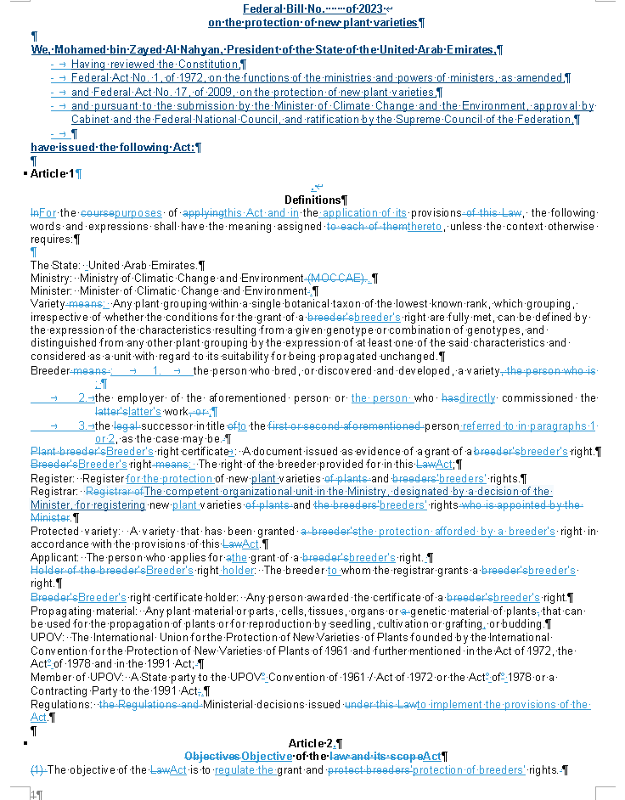

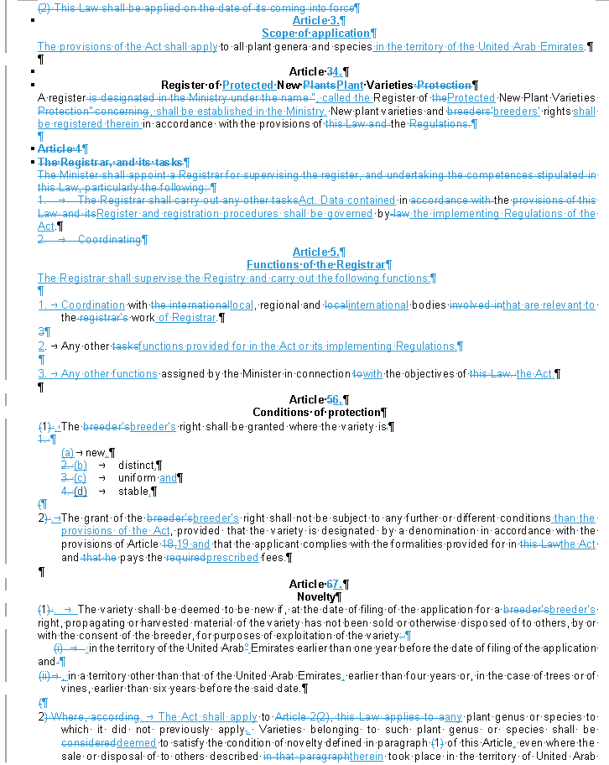

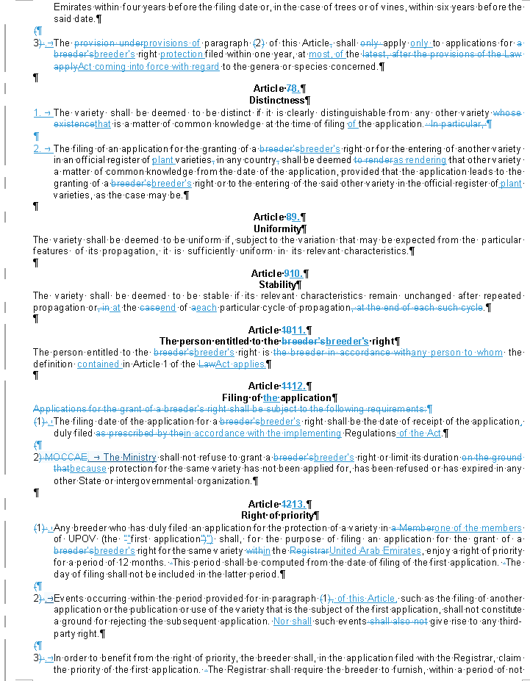

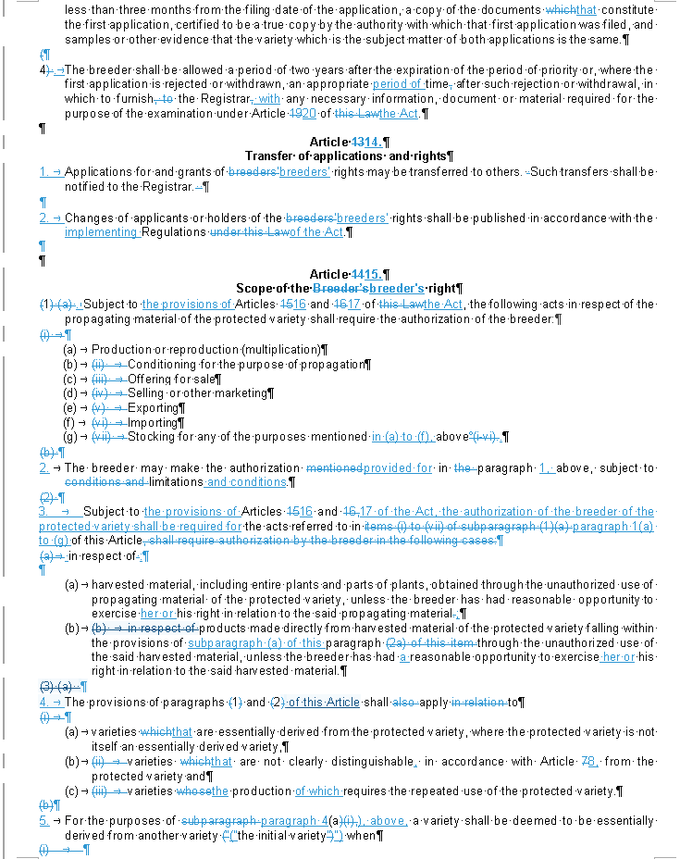

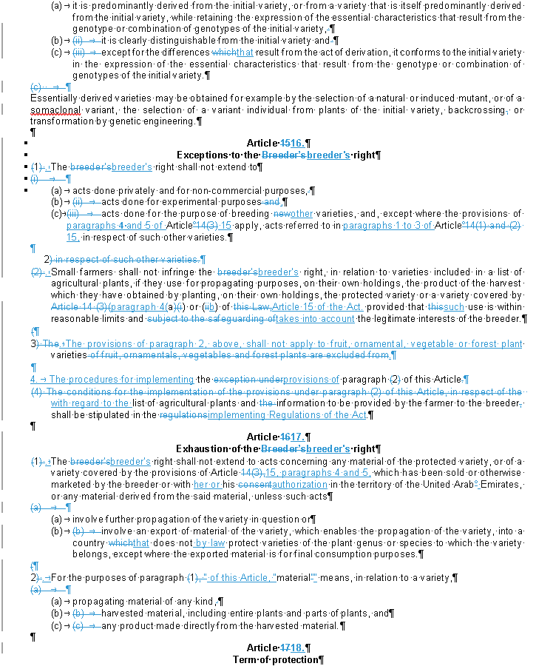

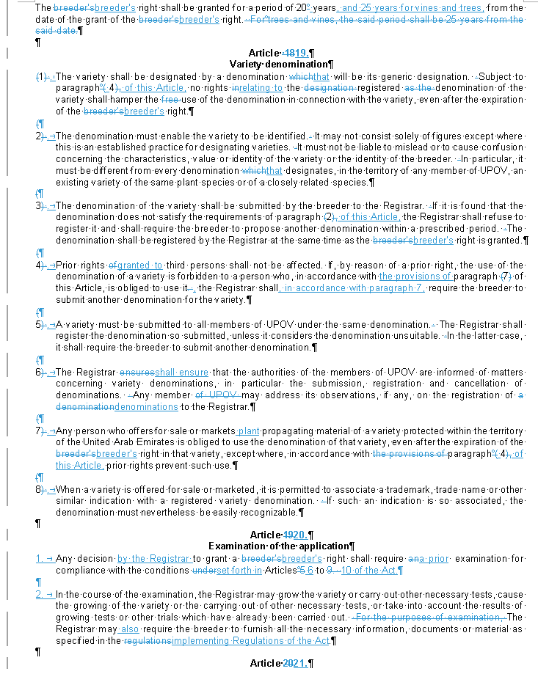

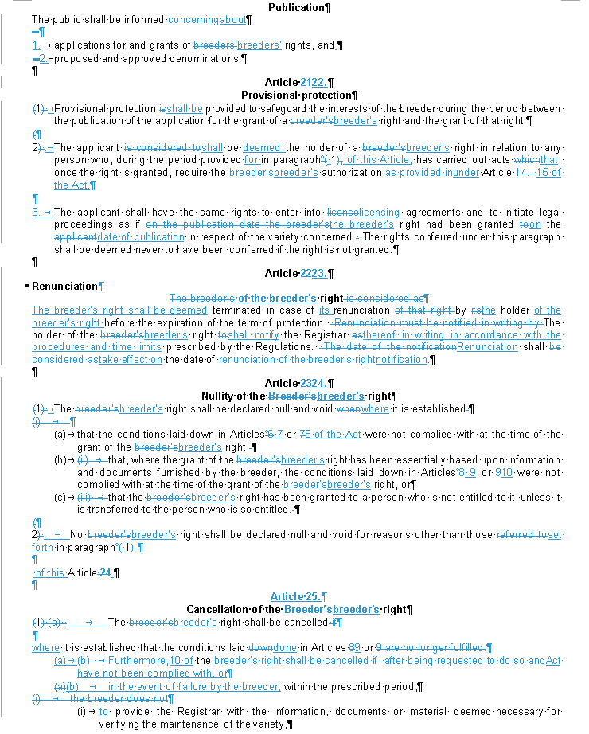

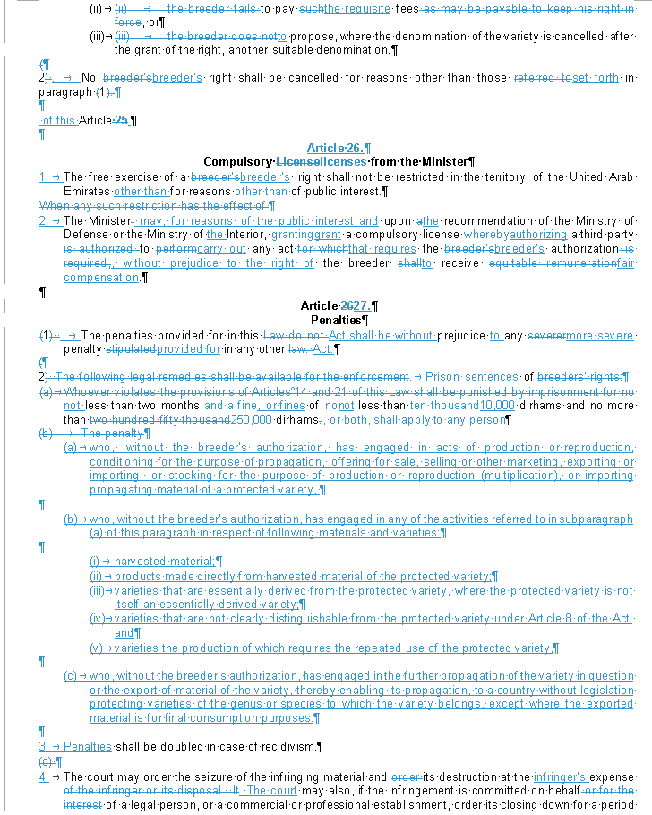

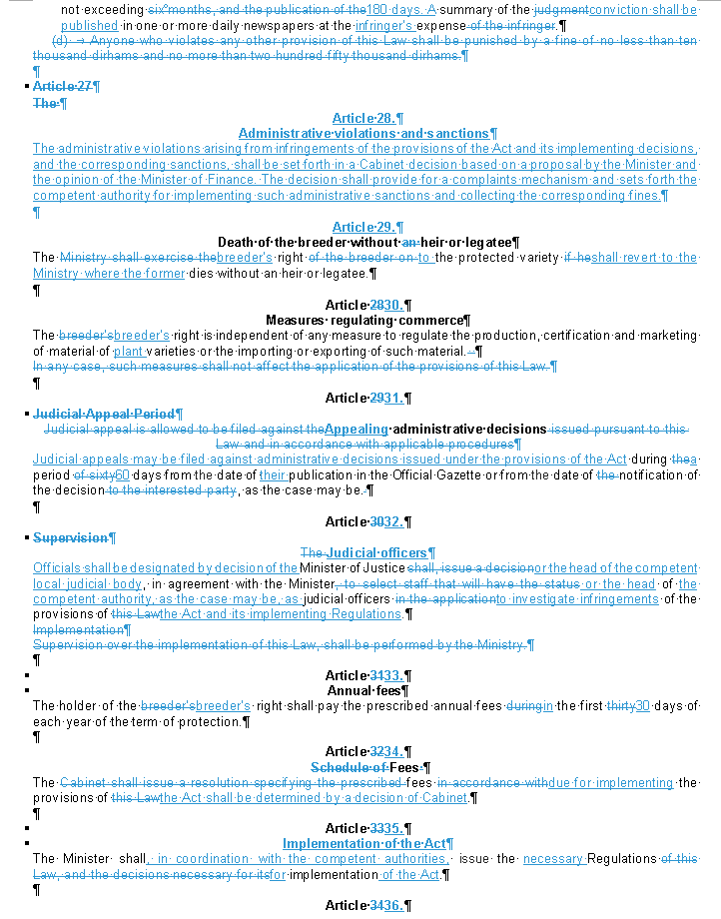

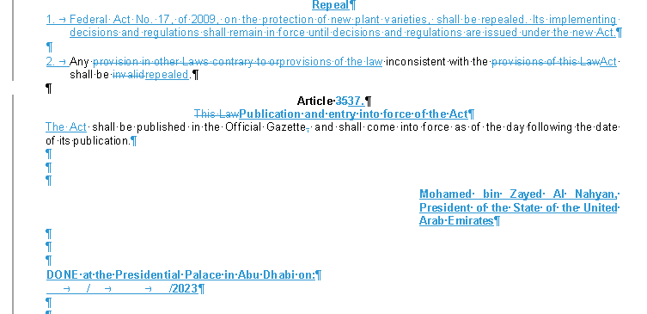

[L’annexe III suit]

(EN ANGLAIS)

[Translation]
[Original: Arabic]

Federal Bill No. of 2024
on the protection of new plant varieties

We, Mohamed bin Zayed Al Nahyan, President of the State of the United Arab Emirates,
- Having reviewed the Constitution,
- Federal Act No. 1, of 1972, on the functions of the ministries and powers of ministers, as amended,
- and Federal Act No. 17, of 2009, on the protection of new plant varieties,
- and pursuant to the submission by the Minister of Climate Change and the Environment, approval by Cabinet and the Federal National Council, and ratification by the Supreme Council of the Federation,

have issued the following Act:

Article 1.
Definitions
For the purposes of this Act and in the application of its provisions, the following words and expressions shall have the meaning assigned thereto, unless the context otherwise requires:

The State: United Arab Emirates.
Ministry: Ministry of Climatic Change and Environment.
Minister: Minister of Climatic Change and Environment.
Variety: Any plant grouping within a single botanical taxon of the lowest known rank, which grouping, irrespective of whether the conditions for the grant of a breeder's right are fully met, can be defined by the expression of the characteristics resulting from a given genotype or combination of genotypes, and distinguished from any other plant grouping by the expression of at least one of the said characteristics and considered as a unit with regard to its suitability for being propagated unchanged.
Breeder: 1. the person who bred, or discovered and developed, a variety;
2. the employer of the aforementioned person or the person who directly commissioned the latter's work;
3. the successor in title to the person referred to in paragraphs 1 or 2, as the case may be.
Breeder's right certificate : A document issued as evidence of a grant of a breeder's right.
Breeder's right: The right of the breeder provided for in this Act;
Register: Register for the protection of new plant varieties and breeders' rights.
Registrar: The competent organizational unit in the Ministry, designated by a decision of the Minister, for registering new plant varieties and breeders' rights.
Protected variety: A variety that has been granted the protection afforded by a breeder's right in accordance with the provisions of this Act.
Applicant: The person who applies for the grant of a breeder's right.
Breeder's right holder: The breeder to whom the registrar grants a breeder's right.
Breeder's right certificate holder: Any person awarded the certificate of a breeder's right.
Propagating material: Any plant material or parts, cells, tissues, organs or genetic material of plants that can be used for the propagation of plants or for reproduction by seedling, cultivation or grafting, or budding.
UPOV: The International Union for the Protection of New Varieties of Plants founded by the International Convention for the Protection of New Varieties of Plants of 1961 and further mentioned in the Act of 1972, the Act of 1978 and in the 1991 Act;
Member of UPOV: A State party to the UPOV Convention of 1961 / Act of 1972 or the Act of 1978 or a Contracting Party to the 1991 Act.
Regulations: Ministerial decisions issued to implement the provisions of the Act.

Article 2.
Objective of the Act
The objective of the Act is to regulate the grant and protection of breeders' rights.

Article 3.
Scope of application
The provisions of the Act shall apply to all plant genera and species in the territory of the United Arab Emirates.

Article 4.
Register of Protected New Plant Varieties
A register, called the Register of Protected New Plant Varieties, shall be established in the Ministry. New plant varieties and breeders' rights shall be registered therein in accordance with the provisions of the Act. Data contained in the Register and registration procedures shall be governed by the implementing Regulations of the Act.

Article 5.
Functions of the Registrar
The Registrar shall supervise the Registry and carry out the following functions:

1. Coordination with local, regional and international bodies that are relevant to the work of Registrar.

2. Any other functions provided for in the Act or its implementing Regulations.

3. Any other functions assigned by the Minister in connection with the objectives of the Act.

Article 6.
Conditions of protection
1. The breeder's right shall be granted where the variety is

(a) new,
(b) distinct,
(c) uniform and
(d) stable.

2. The grant of the breeder's right shall not be subject to any further or different conditions than the provisions of the Act, provided that the variety is designated by a denomination in accordance with the provisions of Article 19 and that the applicant complies with the formalities provided for in the Act and pays the prescribed fees.

Article 7.
Novelty
1. The variety shall be deemed to be new if, at the date of filing of the application for a breeder's right, propagating or harvested material of the variety has not been sold or otherwise disposed of to others, by or with the consent of the breeder, for purposes of exploitation of the variety in the territory of the United Arab Emirates earlier than one year before the date of filing of the application and, in a territory other than that of the United Arab Emirates, earlier than four years or, in the case of trees or of vines, earlier than six years before the said date.

2. The Act shall apply to any plant genus or species to which it did not previously apply. Varieties belonging to such plant genus or species shall be deemed to satisfy the condition of novelty defined in paragraph 1 of this Article, even where the sale or disposal of to others described therein took place in the territory of United Arab Emirates within four years before the filing date or, in the case of trees or of vines, within six years before the said date.

3. The provisions of paragraph 2 of this Article shall apply only to applications for breeder's right protection filed within one year, at most, of the Act coming into force with regard to the genera or species concerned.

Article 8.
Distinctness
1. The variety shall be deemed to be distinct if it is clearly distinguishable from any other variety that is a matter of common knowledge at the time of filing of the application.

2. The filing of an application for the granting of a breeder's right or for the entering of another variety in an official register of plant varieties in any country shall be deemed as rendering that other variety a matter of common knowledge from the date of the application, provided that the application leads to the granting of a breeder's right or to the entering of the said other variety in the official register of plant varieties, as the case may be.

Article 9.
Uniformity
The variety shall be deemed to be uniform if, subject to the variation that may be expected from the particular features of its propagation, it is sufficiently uniform in its relevant characteristics.

Article 10.
Stability
The variety shall be deemed to be stable if its relevant characteristics remain unchanged after repeated propagation or at the end of each particular cycle of propagation.

Article 11.
The person entitled to the breeder's right
The person entitled to the breeder's right is any person to whom the definition contained in Article 1 of the Act applies.

Article 12.
Filing of the application
1. The filing date of the application for a breeder's right shall be the date of receipt of the application, duly filed in accordance with the implementing Regulations of the Act.

2. The Ministry shall not refuse to grant a breeder's right or limit its duration because protection for the same variety has not been applied for, has been refused or has expired in any other State or intergovernmental organization.

Article 13.
Right of priority
1. Any breeder who has duly filed an application for the protection of a variety in one of the members of UPOV (the “first application”) shall, for the purpose of filing an application for the grant of a breeder's right for the same variety in the United Arab Emirates, enjoy a right of priority for a period of 12 months. This period shall be computed from the date of filing of the first application. The day of filing shall not be included in the latter period.

2. Events occurring within the period provided for in paragraph 1 of this Article, such as the filing of another application or the publication or use of the variety that is the subject of the first application, shall not constitute a ground for rejecting the subsequent application. Nor shall such events give rise to any third-party right.

3. In order to benefit from the right of priority, the breeder shall, in the application filed with the Registrar, claim the priority of the first application. The Registrar shall require the breeder to furnish, within a period of not less than three months from the filing date of the application, a copy of the documents that constitute the first application, certified to be a true copy by the authority with which that first application was filed, and samples or other evidence that the variety which is the subject matter of both applications is the same.

4. The breeder shall be allowed a period of two years after the expiration of the period of priority or, where the first application is rejected or withdrawn, an appropriate period of time after such rejection or withdrawal, in which to furnish the Registrar with any necessary information, document or material required for the purpose of the examination under Article 20 of the Act.

Article 14.
Transfer of applications and rights
1. Applications for and grants of breeders' rights may be transferred to others. Such transfers shall be notified to the Registrar.

2. Changes of applicants or holders of the breeders' rights shall be published in accordance with the implementing Regulations of the Act.

Article 15.
Scope of the breeder's right
1. Subject to the provisions of Articles 16 and 17 of the Act, the following acts in respect of the propagating material of the protected variety shall require the authorization of the breeder:

- Production or reproduction (multiplication)
- Conditioning for the purpose of propagation
- Offering for sale
- Selling or other marketing
- Exporting
- Importing
- Stocking for any of the purposes mentioned in (a) to (f), above.

2. The breeder may make the authorization provided for in paragraph 1, above, subject to limitations and conditions.

3. Subject to the provisions of Articles 16 and 17 of the Act, the authorization of the breeder of the protected variety shall be required for the acts referred to in paragraph 1(a) to (g) of this Article in respect of:

- harvested material, including entire plants and parts of plants, obtained through the unauthorized use of propagating material of the protected variety, unless the breeder has had reasonable opportunity to exercise her or his right in relation to the said propagating material;
- products made directly from harvested material of the protected variety falling within the provisions of subparagraph (a) of this paragraph through the unauthorized use of the said harvested material, unless the breeder has had a reasonable opportunity to exercise her or his right in relation to the said harvested material.

4. The provisions of paragraphs 1 and 2 of this Article shall apply to

- varieties that are essentially derived from the protected variety, where the protected variety is not itself an essentially derived variety,
- varieties that are not clearly distinguishable, in accordance with Article 8, from the protected variety and
- varieties the production of which requires the repeated use of the protected variety.

5. For the purposes of paragraph 4(a), above, a variety shall be deemed to be essentially derived from another variety (“the initial variety”) when

- it is predominantly derived from the initial variety, or from a variety that is itself predominantly derived from the initial variety, while retaining the expression of the essential characteristics that result from the genotype or combination of genotypes of the initial variety,
- it is clearly distinguishable from the initial variety and
- except for the differences that result from the act of derivation, it conforms to the initial variety in the expression of the essential characteristics that result from the genotype or combination of genotypes of the initial variety.

Essentially derived varieties may be obtained for example by the selection of a natural or induced mutant, or of a somaclonal variant, the selection of a variant individual from plants of the initial variety, backcrossing or transformation by genetic engineering.

Article 16.
Exceptions to the breeder's right
1. The breeder's right shall not extend to

- acts done privately and for non-commercial purposes,
- acts done for experimental purposes,
- acts done for the purpose of breeding other varieties, and, except where the provisions of paragraphs 4 and 5 of Article 15 apply, acts referred to in paragraphs 1 to 3 of Article 15, in respect of such other varieties.

2. Small farmers shall not infringe the breeder's right, in relation to varieties included in a list of agricultural plants, if they use for propagating purposes, on their own holdings, the product of the harvest which they have obtained by planting, on their own holdings, the protected variety or a variety covered by paragraph 4(a) or (b) of Article 15 of the Act. provided that such use is within reasonable limits and takes into account the legitimate interests of the breeder.

3. The provisions of paragraph 2, above, shall not apply to fruit, ornamental, vegetable or forest plant varieties.

4. The procedures for implementing the provisions of paragraph 2 of this Article with regard to the list of agricultural plants and information to be provided by the farmer to the breeder shall be stipulated in the implementing Regulations of the Act.

Article 17.
Exhaustion of the breeder's right
1. The breeder's right shall not extend to acts concerning any material of the protected variety, or of a variety covered by the provisions of Article 15, paragraphs 4 and 5, which has been sold or otherwise marketed by the breeder or with her or his authorization in the territory of the United Arab Emirates, or any material derived from the said material, unless such acts

- involve further propagation of the variety in question or
- involve an export of material of the variety, which enables the propagation of the variety, into a country that does not by law protect varieties of the plant genus or species to which the variety belongs, except where the exported material is for final consumption purposes.

2. For the purposes of paragraph 1 of this Article, “material” means, in relation to a variety,

- propagating material of any kind,
- harvested material, including entire plants and parts of plants, and
- any product made directly from the harvested material.

Article 18.
Term of protection
The breeder's right shall be granted for a period of 20 years, and 25 years for vines and trees, from the date of the grant of the breeder's right.

Article 19.
Variety denomination
1. The variety shall be designated by a denomination that will be its generic designation. Subject to paragraph 4 of this Article, no rights relating to the registered denomination of the variety shall hamper the use of the denomination in connection with the variety, even after the expiration of the breeder's right.

2. The denomination must enable the variety to be identified. It may not consist solely of figures except where this is an established practice for designating varieties. It must not be liable to mislead or to cause confusion concerning the characteristics, value or identity of the variety or the identity of the breeder. In particular, it must be different from every denomination that designates, in the territory of any member of UPOV, an existing variety of the same plant species or of a closely related species.

3. The denomination of the variety shall be submitted by the breeder to the Registrar. If it is found that the denomination does not satisfy the requirements of paragraph 2 of this Article, the Registrar shall refuse to register it and shall require the breeder to propose another denomination within a prescribed period. The denomination shall be registered by the Registrar at the same time as the breeder's right is granted.

4. Prior rights granted to third persons shall not be affected. If, by reason of a prior right, the use of the denomination of a variety is forbidden to a person who, in accordance with the provisions of paragraph 7 of this Article, is obliged to use it, the Registrar shall, in accordance with paragraph 7, require the breeder to submit another denomination for the variety.

5. A variety must be submitted to all members of UPOV under the same denomination. The Registrar shall register the denomination so submitted, unless it considers the denomination unsuitable. In the latter case, it shall require the breeder to submit another denomination.

6. The Registrar shall ensure that the authorities of the members of UPOV are informed of matters concerning variety denominations, in particular the submission, registration and cancellation of denominations. Any member may address its observations, if any, on the registration of denominations to the Registrar.

7. Any person who offers for sale or markets plant propagating material of a variety protected within the territory of the United Arab Emirates is obliged to use the denomination of that variety, even after the expiration of the breeder's right in that variety, except where, in accordance with paragraph 4 of this Article, prior rights prevent such use.

8. When a variety is offered for sale or marketed, it is permitted to associate a trademark, trade name or other similar indication with a registered variety denomination. If such an indication is so associated, the denomination must nevertheless be easily recognizable.

Article 20.
Examination of the application
1. Any decision by the Registrar to grant a breeder's right shall require a prior examination for compliance with the conditions set forth in Articles 6 to 10 of the Act.

2. In the course of the examination, the Registrar may grow the variety or carry out other necessary tests, cause the growing of the variety or the carrying out of other necessary tests, or take into account the results of growing tests or other trials which have already been carried out. The Registrar may also require the breeder to furnish all the necessary information, documents or material as specified in the implementing Regulations of the Act.

Article 21.
Publication
The public shall be informed about

1. applications for and grants of breeders' rights, and
2. proposed and approved denominations.

Article 22.
Provisional protection
1. Provisional protection shall be provided to safeguard the interests of the breeder during the period between the publication of the application for the grant of a breeder's right and the grant of that right.

2. The applicant shall be deemed the holder of a breeder's right in relation to any person who, during the period provided for in paragraph 1 of this Article, has carried out acts that, once the right is granted, require the breeder's authorization under Article 15 of the Act.

3. The applicant shall have the same rights to enter into licensing agreements and to initiate legal proceedings as if the breeder's right had been granted on the date of publication in respect of the variety concerned. The rights conferred under this paragraph shall be deemed never to have been conferred if the right is not granted.

Article 23.
Renunciation of the breeder's right
The breeder's right shall be deemed terminated in case of its renunciation by the holder of the breeder's right before the expiration of the term of protection. The holder of the breeder's right shall notify the Registrar thereof in writing in accordance with the procedures and time limits prescribed by the Regulations. Renunciation shall take effect on the date of notification.

Article 24.
Nullity of the breeder's right
1. The breeder's right shall be declared null and void where it is established

- that the conditions laid down in Articles 7 or 8 of the Act were not complied with at the time of the grant of the breeder's right,
- that, where the grant of the breeder's right has been essentially based upon information and documents furnished by the breeder, the conditions laid down in Articles 9 or 10 were not complied with at the time of the grant of the breeder's right, or
- that the breeder's right has been granted to a person who is not entitled to it, unless it is transferred to the person who is so entitled.

2. No breeder's right shall be declared null and void for reasons other than those set forth in paragraph 1 of this Article.

Article 25.
Cancellation of the breeder's right
1. The breeder's right shall be cancelled

- where it is established that the conditions laid done in Articles 9 or 10 of the Act have not been complied with, or
- in the event of failure by the breeder, within the prescribed period,

- to provide the Registrar with the information, documents or material deemed necessary for verifying the maintenance of the variety,
- to pay the requisite fees, or
- to propose, where the denomination of the variety is cancelled after the grant of the right, another suitable denomination.

2. No breeder's right shall be cancelled for reasons other than those set forth in paragraph 1 of this Article.

Article 26.
Compulsory licenses from the Minister
1. The free exercise of a breeder's right shall not be restricted in the territory of the United Arab Emirates other than for reasons of public interest.

2. The Minister may, for reasons of the public interest and upon the recommendation of the Ministry of Defense or the Ministry of the Interior, grant a compulsory license authorizing a third party to carry out any act that requires the breeder's authorization, without prejudice to the right of the breeder to receive fair compensation.

Article 27.
Penalties
1. The penalties provided for in this Act shall be without prejudice to any more severe penalty provided for in any other Act.

2. Prison sentences of not less than two months, or fines of not less than 10,000 dirhams and no more than 250,000 dirhams, or both, shall apply to any person

- who, without the breeder's authorization, has engaged in acts of production or reproduction, conditioning for the purpose of propagation, offering for sale, selling or other marketing, exporting or importing, or stocking for the purpose of production or reproduction (multiplication), or importing propagating material of a protected variety,

- who, without the breeder's authorization, has engaged in any of the activities referred to in subparagraph (a) of this paragraph in respect of following materials and varieties:

- harvested material;
- products made directly from harvested material of the protected variety;
- varieties that are essentially derived from the protected variety, where the protected variety is not itself an essentially derived variety;
- varieties that are not clearly distinguishable from the protected variety under Article 8 of the Act; and
- varieties the production of which requires the repeated use of the protected variety,

- who, without the breeder's authorization, has engaged in the further propagation of the variety in question or the export of material of the variety, thereby enabling its propagation, to a country without legislation protecting varieties of the genus or species to which the variety belongs, except where the exported material is for final consumption purposes.

3. Penalties shall be doubled in case of recidivism.
4. The court may order the seizure of the infringing material and its destruction at the infringer's expense. The court may also, if the infringement is committed on behalf of a legal person, or a commercial or professional establishment, order its closing down for a period not exceeding 180 days. A summary of the conviction shall be published in one or more daily newspapers at the infringer's expense.

Article 28.
Administrative violations and sanctions
The administrative violations arising from infringements of the provisions of the Act and its implementing decisions, and the corresponding sanctions, shall be set forth in a Cabinet decision based on a proposal by the Minister and the opinion of the Minister of Finance. The decision shall provide for a complaints mechanism and sets forth the competent authority for implementing such administrative sanctions and collecting the corresponding fines.

Article 29.
Death of the breeder without heir or legatee
The breeder's right to the protected variety shall revert to the Ministry where the former dies without an heir or legatee.

Article 30.
Measures regulating commerce
The breeder's right is independent of any measure to regulate the production, certification and marketing of material of plant varieties or the importing or exporting of such material.

Article 31.
Appealing administrative decisions
Judicial appeals may be filed against administrative decisions issued under the provisions of the Act during a period 60 days from the date of their publication in the Official Gazette or from the date of notification of the decision, as the case may be.

Article 32.
Judicial officers
Officials shall be designated by decision of the Minister of Justice or the head of the competent local judicial body, in agreement with the Minister or the head of the competent authority, as the case may be, as judicial officers to investigate infringements of the provisions of the Act and its implementing Regulations.

Article 33.
Annual fees
The holder of the breeder's right shall pay the prescribed annual fees in the first 30 days of each year of the term of protection.

Article 34.
Fees
The fees due for implementing the provisions of the Act shall be determined by a decision of Cabinet.

Article 35.
Implementation of the Act
The Minister shall, in coordination with the competent authorities, issue the necessary Regulations for implementation of the Act.

Article 36.
Repeal
1. Federal Act No. 17, of 2009, on the protection of new plant varieties, shall be repealed. Its implementing decisions and regulations shall remain in force until decisions and regulations are issued under the new Act.

2. Any provisions of the law inconsistent with the Act shall be repealed.

Article 37.
Publication and entry into force of the Act
The Act shall be published in the Official Gazette and shall come into force as of the day following the date of its publication.

Mohamed bin Zayed Al Nahyan, President of the State of the United Arab Emirates

DONE at the Presidential Palace in Abu Dhabi on:
/ /2024

[Fin de l’annexe III et du document]

