|  |  |
| --- | --- |
|  | E |
| International Union for the Protection of New Varieties of Plants |  |

|  |  |
| --- | --- |
| Working Group on harvested Material and Unauthorized use of Propagating Material  Fourth Meeting  Geneva, October 25, 2023 | WG-HRV/4/2  Original: English  Date: October 20, 2023 |

PROPOSAL TO revise THE “EXPLANATORY NOTES ON PROPAGATING MATERIAL under the UPOV Convention” AND PROSPECTS OF COMMISSIONING A STUDY ON THE “SCOPE OF THE BREEDER’S RIGHT” AND THE RELATIONSHIP WITH THE “EXHAUSTION OF THE BREEDER’S RIGHT”

Document prepared by the office of the Union

Disclaimer: this document does not represent UPOV policies or guidance

# Executive summary

The purpose of this document is to invite the Working Group on harvested material and unauthorized use of propagating material (WG-HRV) to consider:

(a) the next step concerning the proposals on the Explanatory Notes on Propagating Material under the UPOV Convention agreed by the WG-HRV at its third meeting on March 21, 2023; and

(b) the replies to UPOV Circular E 23/071 of April 5, 2023, on the proposed issues and suggested authors for a study on the “Scope of the Breeder’s Right” which would consider Article 14(1) and (2) of the 1991 Act, including the notions of “unauthorized use” and “reasonable opportunity”, and the relationship with the “Exhaustion of the Breeder’s Right” in Article 16 of the 1991 Act, based on an analysis of the Records of the 1991 Act Diplomatic Conference and its preparatory work.

The WG-HRV is invited to:

(a) note the information provided in this document;

(b) propose to the CAJ at its eighty-first session to approve the revision of the “Explanatory Notes on Propagating Material under the UPOV Convention”, (UPOV/EXN/PPM/1) as set out in paragraph 5 of this document;

(c) note the replies to UPOV Circular E-23/071, as set out in paragraphs 9 and 10 and the Annex of this document; and

(d) consider that the Office of the Union would propose the basis of a study, including terms of reference, timeline and author (s), if appropriate, for consideration by the WG-HRV at its next meeting, as set out in paragraph 15 of this document.

The structure of this document is as follows:

Executive summary 1

BACKGROUND 2

PROPOSAL TO AMEND THE EXPLANATORY NOTES ON PROPAGATING MATERIAL 2

Factors that HAVE BEEN considered in relation to propagating material 2

PROPOSAL FOR A study on the “Scope of the Breeder’s Right” and the relationship with the “Exhaustion of the Breeder’s Right” 3

UPOV Circular E-23/071 of April 5, 2023 3

Proposed Experts 3

Scope of the study 4

ANNEX RESPONSES RECEIVED IN REPLY TO UPOV CIRCULAR E-23/071 OF APRIL 5, 2023

Appendix I: Australia

Appendix II: Brazil

Appendix III: European Union

Appendix IV: Japan

Appendix V: Republic of Korea

Appendix VI: Joint contribution from the African Seed Trade Association (AFSTA), Asia and Pacific Seed Association (APSA), Croplife International, Euroseeds, International Community of Breeders of Asexually Reproduced Horticultural Plants (CIOPORA), International Seed Federation (ISF) and Seed Association of the Americas (SAA)

Appendix VII: International Association of Horticultural Producers (AIPH)

# BACKGROUND

Background to this document is available in documents WG-HRV/3/2 “Proposals concerning the Explanatory Notes on Propagating Material under the UPOV Convention” and WG-HRV/3/3 “Perspectives on “unauthorized use” under Article 14(2) of the 1991 Act of the UPOV Convention”.

# PROPOSAL TO AMEND THE EXPLANATORY NOTES ON PROPAGATING MATERIAL

The WG-HRV, at its third meeting, held in Geneva on March 21, 2023, agreed to modify the section “Factors that have been considered in relation to propagating material”, as presented below. The changes agreed at the meeting are presented in manual revision mode and highlighted in yellow and previously agreed changes are highlighted in grey, for ease of reference.

Factors that HAVE BEEN considered in relation to propagating material

The UPOV Convention does not provide a definition of “propagating material”. Propagating material encompasses reproductive and vegetative propagating material. The following are non-exhaustive examples of factors, ~~that have been considered by members of the Union in relation to~~ one or more of which could be used to decide whether material is propagating material. Those factors should be considered in the context of each member of the Union and the particular circumstances.

(i) plant or part of plants used for the variety reproduction;

(ii) whether the material has been ~~or may be~~ used to propagate the variety;

(iii) whether the material is capable has an innate capability of producing entire plants of the variety (e.g. seed, tubers);

(iv) (vii) when harvested whether the material, has the potential ~~including harvested material~~, could be used as propagating material, it can be considered as through the use of propagating techniques material (e.g. cuttings, tissue culture);

(v) (iv) whether there has been a custom/practice of using the material for propagating purposes or, as a result of new developments, there is a new custom/practice of using the material for that purpose;

~~(vi) (v) the intention on the part of those concerned (producer, seller, supplier, buyer, recipient, user);~~

(vi~~i~~) (vi) if, based on the nature and condition of the material and/or the form of its use, it can be determined that the material is “propagating material”; ~~or~~

(vii~~i~~) the variety material where conditions and mode of its production meet the purpose of reproduction of new plants of the variety but not of final consumption.

The above text is not intended as a definition of “propagating material”.

(see document WG-HRV/3/4 “Report”, paragraph 7).

Following the agreement of the above text in the WG-HRV, it is proposed to present the text to the CAJ for adoption.

The WG-HRV is invited to propose to the CAJ at its eighty-first session to approve the revision of the “Explanatory Notes on Propagating Material under the UPOV Convention” (UPOV/EXN/PPM/1), as set out in paragraph 5 of this document.

# PROPOSAL FOR A study on the “Scope of the Breeder’s Right” and the relationship with the “Exhaustion of the Breeder’s Right”

The WG-HRV, at its third meeting, held in Geneva on March 21, 2023, agreed to organize a study to assist in its deliberations on the “Scope of the Breeder’s Right” in Article 14(1) and (2) of the 1991 Act, including the notions of “unauthorized use” and “reasonable opportunity” and the relationship with the “Exhaustion of the Breeder’s Right” in Article 16 of the 1991 Act.

The WG-HRV agreed to invite the members of the WG-HRV to propose issues and/or suggest authors for a study on the “Scope of the Breeder’s Right” in Article 14(1) and (2) of the 1991 Act, including the notions of “unauthorized use” and “reasonable opportunity” and the relationship with the “Exhaustion of the Breeder’s Right” in Article 16 of the 1991 Act, based on an analysis of the Records of the 1991 Act Diplomatic Conference and its preparatory work.  The WG-HRV agreed that, based on the replies received, the Office of the Union would propose the basis of a study, including terms of reference, timeline and author (s), if appropriate, for consideration by the WG-HRV at its next meeting (see document WG-HRV/3/4 “Report”, paragraphs 11, 17 and 18).

## UPOV Circular E-23/071 of April 5, 2023

The Office of the Union issued UPOV Circular E-23/071 on April 5, 2023, inviting the members of the WG-HRV to propose issues and/or suggest authors for a study on the “Scope of the Breeder’s Right” in Article 14(1) and (2) of the 1991 Act, including the notions of “unauthorized use” and “reasonable opportunity” and the relationship with the “Exhaustion of the Breeder’s Right” in Article 16 of the 1991 Act, based on an analysis of the Records of the 1991 Act Diplomatic Conference and its preparatory work.

In reply to UPOV Circular E-23/071 of April 5, 2023, the Office of the Union received contributions from Australia, Brazil, European Union, Japan, Republic of Korea, International Association of Horticultural Producers (AIPH) and joint contribution from the African Seed Trade Association (AFSTA), Asia and Pacific Seed Association (APSA), Croplife International, Euroseeds, International Community of Breeders of Asexually Reproduced Horticultural Plants (CIOPORA), International Seed Federation (ISF) and Seed Association of the Americas (SAA) which are reproduced in the Annex to this document.

The following paragraphs present a summary of the experts proposed and the comments received on the scope of the study.

### Proposed Experts

The European Union and the International Association of Horticultural Producers have proposed that a group of experts should carry out the study. Brazil has proposed two experts and others have proposed individuals.

|  |  |
| --- | --- |
| **Member of the WG-HRV** | **Proposed Experts – see CV in Annex** |
| Australia | Charles Lawson |
| Brazil | Rodrigo Dolabella  Vivianne Kunisawa |
| European Union | Axel Metzger  Sven Bostyn  Pilar Montero  A professor from the Max Planck Institute (no name proposed) |
| Japan | Joseph Strauss |
| AIPH | Huib Ghisen, as part of a team |

### Scope of the study

At its third meeting, the WG-HRV agreed on the following scope:

“Scope of the Breeder’s Right” in Article 14(1) and (2) of the 1991 Act, including the notions of “unauthorized use” and “reasonable opportunity” and the relationship with the “Exhaustion of the Breeder’s Right” in Article 16 of the 1991 Act, based on an analysis of the Records of the 1991 Act Diplomatic Conference and its preparatory work.”

In reply to UPOV Circular E-23/071 of April 5, 2023, members of the WG-HRV have made comments and proposals in relation to the scope of the study, as follows:

#### European Union

“-Scope of the Breeder’s Right” in Article 14(1) and (2) of the 1991 Act, including the notions of “unauthorized use” and “reasonable opportunity” and the relationship with the “Exhaustion of the Breeder’s Right” in Article 16 of the 1991 Act, based on an analysis of the Records of the 1991 Act Diplomatic Conference and its preparatory work and available case law (CJEU).

“-Interpretation of the sentence “the breeder may make his authorization subject to conditions and limitations” in Article 14(1)(b) of the UPOV Convention, as this sentence represents the point of interplay between the statutory plant variety protection law and the private contractual law.”

#### Japan

*“First question*

“Does the cascade principle (Article 14(2)) and exhaustion principle (Article 16) conform with the literal interpretation of 14 (1) offered by some, where, authorization for any acts relating to a harvested material is excluded?

*“Second question*

“What were the reasons behind the decision of the delegation of the 91 Convention to delete the use of propagating material for the purpose of producing harvested material from the acts listed for authorization under Article 14 (1).

*“Third question*

“The Diplomatic Delegation for 1991 Convention specifically decided to address the issue of the 1978 Convention, in which the protection for harvested material was extremely limited. How and where was the problem of extending breeders right to harvested material, addressed after the provision on the use of propagating material for the purpose of producing harvested material were deleted from Article 14(1)? How were the decision to include the provision for the breeder to put limitations and conditions on the authorizations of Article 14 (1), instead of the aforementioned deletion, a remedy to the problem of strengthening breeders’ rights for harvested material?   
Would the inclusion of the condition clause, allow for the breeders to condition or limit ways or areas of production of harvested material, which otherwise would be implicit in the authorization of sales or production of propagating material?

*“Fourth question*

“Finally, what are the relationships between Article 14(1) and article 14(2)?

*“Fifth question*

“What was “authorization” in Article 14 intended to cover as the delegations of the 91 Convention seem to place the words in a different and broader context, than what is suggested in the explanatory note. Does it include the notion of a formal consent? In relation to that, what does “unauthorized” use mean?”

#### Republic of Korea

Republic of Korea has emphasized that the scope of the study should not go beyond the UPOV Convention.

#### Joint contribution from Breeders’ Associations

“1. Elements: Legal History and Background at UPOV – Legislation & Jurisprudence in the member states

“2. Data to be gathered: we propose UPOV generates a questionnaire on the basis of the proposal, to be sent out to all UPOV members asking them to provide feedback.”

#### International Association of Horticultural Producers (AIPH)

“AIPH has emphasized that the study should set out the full rationale of the provisions in the UPOV Convention on harvested material and the importance to go back and study the history of the conception of the principle of harvested material.”

Considering that the question on whether a team or an individual shall be asked to make a study has been raised, as well as the many comments and proposals on the scope of the study, the Office of the Union needs further input from the WG-HRV during the meeting on 25 October 2023 before pursuing with the next steps. The members of the WG-HRV are invited to provide comments on the mentioned matters during the meeting.

Based on the replies received, and the discussions during the fourth meeting of the WG-HRV, the Office of the Union would propose the basis of a study, including terms of reference, timeline and author (s), if appropriate, for consideration by the WG-HRV at its next meeting. It is proposed to organize the meeting virtually in March 2024, a date to be established.

The WG-HRV is invited to:

(a) note the information provided in this document;

(b) propose to the CAJ at its eighty-first session to approve the revision of the “Explanatory Notes on Propagating Material under the UPOV Convention”, (UPOV/EXN/PPM/1) as set out in paragraph 5 of this document;

(c) note the replies to UPOV Circular E23/071, as set out in paragraphs 9 and 10 and the Annex of this document; and

(d) consider that the Office of the Union would propose the basis of a study, including terms of reference, timeline and author (s), if appropriate, for consideration by the WG-HRV at its next meeting, as set out in paragraph 15 of this document..

[Annex follows]

RESPONSES RECEIVED IN REPLY TO UPOV CIRCULAR E-23/071 OF APRIL 5, 2023

This Annex contains the following:

Appendix I: Australia

Appendix II: Brazil

Appendix III: European Union

Appendix IV: Japan

Appendix V: Republic of Korea

Appendix VI: Joint contribution from the African Seed Trade Association (AFSTA), Asia and Pacific Seed Association (APSA), Croplife International, Euroseeds, International Community of Breeders of Asexually Reproduced Horticultural Plants (CIOPORA), International Seed Federation (ISF) and Seed Association of the Americas (SAA)

Appendix VII: International Association of Horticultural Producers (AIPH)

[Appendix I follows]

AUSTRALIA

“Dear UPOV Secretariat,

“We would like to suggest Prof Charles Lawson for the proposed study, his biography is copied below. Prof Lawson has recently completed research for us on Exhaustion of a PBR and Harvested Material in the context of the Australian Plant Breeder’s Rights Act which included studying issues similar in scope to those discussed at the recent working group meeting. While the focus was the Australian PVP system, his research involved considering the related Articles of the UPOV Convention, including analysis of records of the Diplomatic Conference.  The completed reports are available online: [University of Queensland PBR policy research | IP Australia](https://www.ipaustralia.gov.au/tools-and-research/professional-resources/data-research-and-reports/publications-and-reports/2022/12/20/05/47/University-of-Queensland-PBR-policy-research).

“Charles Lawson is a Professor in the Griffith Law School, Griffith University. He studied science and law at The Australian National University and holds a Bachelor of Science with Honours in biochemistry and genetics and a Bachelor of Laws. He also holds a Doctor of Philosophy from the ANU’s Research School of Biological Sciences in molecular biology and biochemistry and a Master of Laws from Queensland University of Technology for research into gene patenting and competition. Before joining the university sector, he worked as a lawyer in both the private and public sectors, including at the Australian Government Solicitor and the Commonwealth Department of Finance and Deregulation. His research focus is on patents, plant breeder’s rights, sharing biological materials and public administration law. He has published widely with over 150 refereed publications and a number of consultancies delivering reports to Australian and international governmental institutions including IP Australia, the United Nations Food and Agriculture Organisation and the International Union for the Protection of New Varieties of Plants.

“Kind regards

“Isabel”

[Appendix II follows]

BRAZIL

“Dear UPOV,

“In response to the request to indicate topics and people to prepare a study regarding the scope of the breeder’s right and notions of unauthorized use and reasonable opportunity, follow suggestions of names and contacts of people that were shared with SNPC by the private sector:

“(i) Rodrigo Dolabella: +55 61 99110 9783; [rodrigo.dolabella@gmail.com](mailto:rodrigo.dolabella@gmail.com)

(<https://br.linkedin.com/in/rodrigo-dolabella-2a368340?trk=people-guest_people_search-card>); and

„(ii) Viviane Kunisawa: +55 11 98080 7005; [viviane.kunisawa@lickslegal.com](mailto:viviane.kunisawa@lickslegal.com)

(<https://br.linkedin.com/in/viviane-yumy-kunisawa/pt>).

“Best regards,

“Stefânia.”

[Appendix III follows]

EUROPEAN UNION

“Dear Mr Button, dear Peter,

“We would like to present the following suggestions in relation to your request concerning the organisation of a study (UPOV Circular E-23/071):

“Scope of the study:

“-Scope of the Breeder’s Right” in Article 14(1) and (2) of the 1991 Act, including the notions of “unauthorized use” and “reasonable opportunity” and the relationship with the “Exhaustion of the Breeder’s Right” in Article 16 of the 1991 Act, based on an analysis of the Records of the 1991 Act Diplomatic Conference and its preparatory work and available case law (CJEU).

“-Interpretation of the sentence “the breeder may make his authorization subject to conditions and limitations” in Article 14(1)(b) of the UPOV Convention, as this sentence represents the point of interplay between the statutory plant variety protection law and the private contractual law.

“Possible authors:

“- Axel Metzger: Professor of Civil law and Intellectual Property at Humboldt-University in Berlin and member of the Board of Appeal of the CPVO

“- Sven Bostyn: Professor at University of Copenhagen (Faculty of Law)

“- Pilar Montero: Professor of Commercial Law, University of Alicante

“-Professor from the Max Planck Institute, Department of Intellectual property and Competition law (<https://www.ip.mpg.de/en/>).

“We suggest to work with several experts coming from different universities/institutions and countries as to ensure the diversity of independent views and to form an independent expert group that would together submit a report to the UPOV/CAJ. The WG-HRV should be available to support the study and answer any possible questions.  The expert group, once agreed in the CAJ, should organise its work and start before the end of 2023. The study could take about 6 months with a possibility for extension. So the study could be delivered by 30 June 2024. The way of working, independency and timelines should be included in the ToR.

“Kind regards,

“Päivi Mannerkorpi”

[Appendix IV follows]

JAPAN

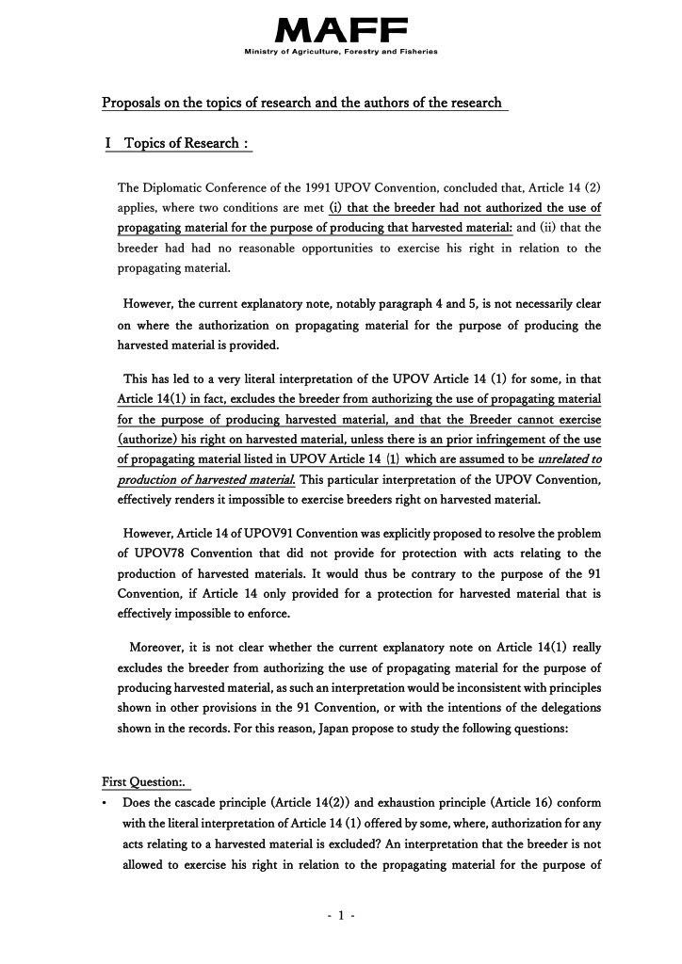

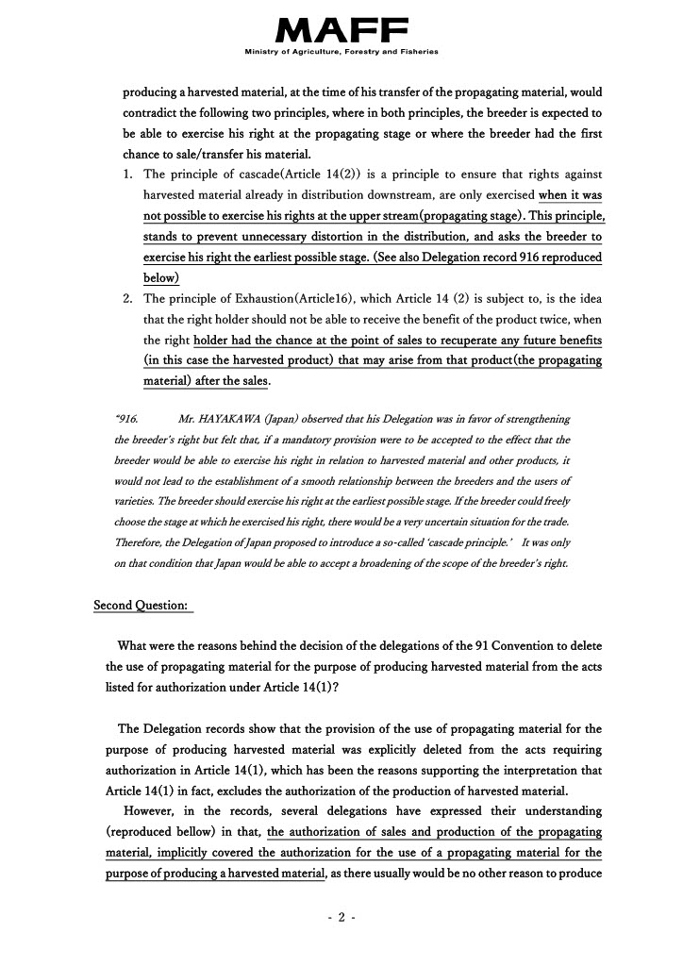

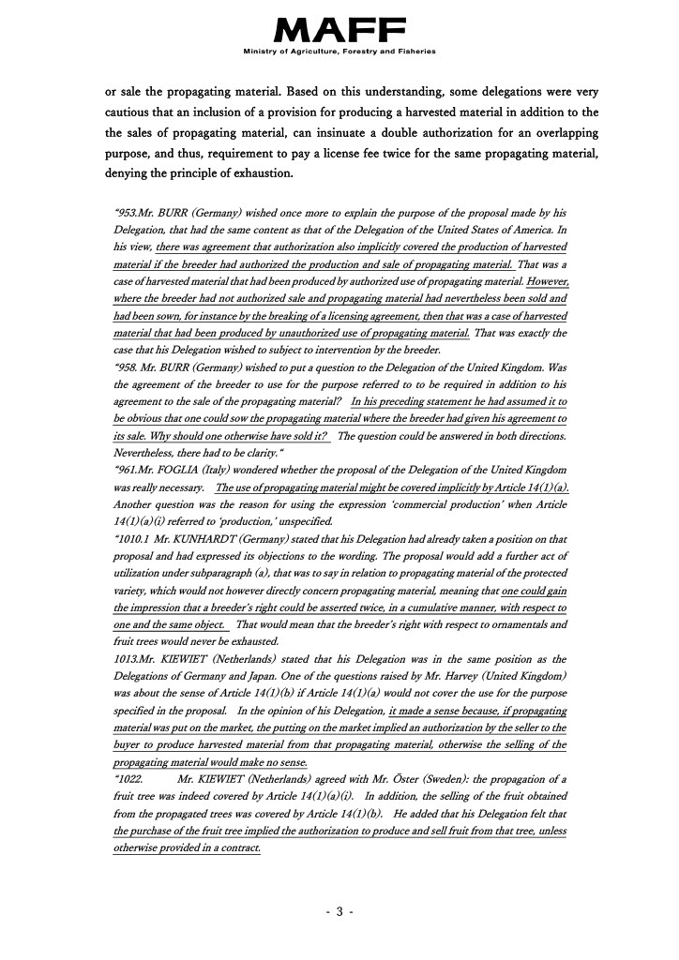

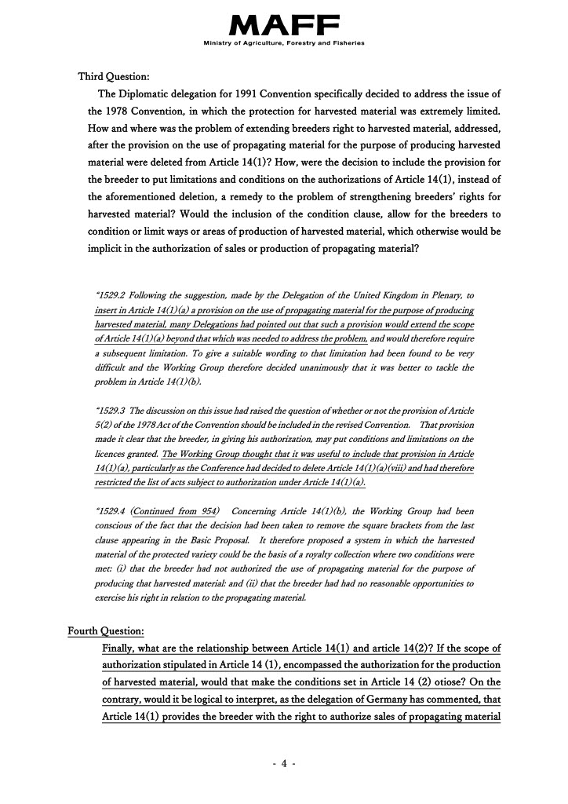

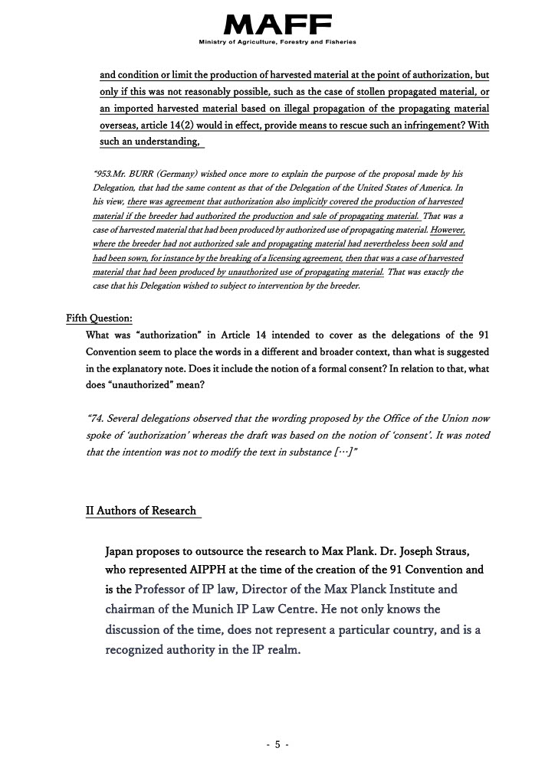

[Appendix V follows]

REPUBLIC OF KOREA

“Dear sir,

“First of all, I am sorry for the late reply.

“Regarding study group, on behalf of Korea Seed & Variety Service, I just would like to express my opinion in stead of proposing specific issue.

“I hope that the subject of this study be within the scope of UPOV Convention and also be studied in the scope of Convention because if something goes beyond Convention, it could shake the foundation of Convention.

“Anyway, I support this study and am interested in future findings of it about the scope of breeder's right based on 1991 Act including the notion of 'unauthorized use'.

“Yours sincerely,

“PARK Chan Woong”

[Appendix VI follows]

JOINT CONTRIBUTION FROM THE AFRICAN SEED TRADE ASSOCIATION (AFSTA), ASIA AND PACIFIC SEED ASSOCIATION (APSA), CROPLIFE INTERNATIONAL, EUROSEEDS, INTERNATIONAL COMMUNITY OF BREEDERS OF ASEXUALLY REPRODUCED HORTICULTURAL PLANTS (CIOPORA), INTERNATIONAL SEED FEDERATION (ISF) AND SEED ASSOCIATION OF THE AMERICAS (SAA)

“Dear UPOV office,

“In response to Circular E-23/071, regarding the WG-HRV proposal for issues, we would like to make the following suggestions:

“1. Elements: Legal History and Background at UPOV – Legislation & Jurisprudence in the member states

“2. Data to be gathered: we propose UPOV generates a questionnaire on the basis of the proposal, to be sent out to all UPOV members asking them to provide feedback.

“Best regards,

“Marcel Bruins

“On behalf of the Task Force HRV, consisting of representatives of AFSTA, APSA, CIOPORA, Croplife International, Euroseeds, ISF and SAA”

[Appendix VII follows]

INTERNATIONAL ASSOCIATION OF HORTICULTURAL PRODUCERS (AIPH)

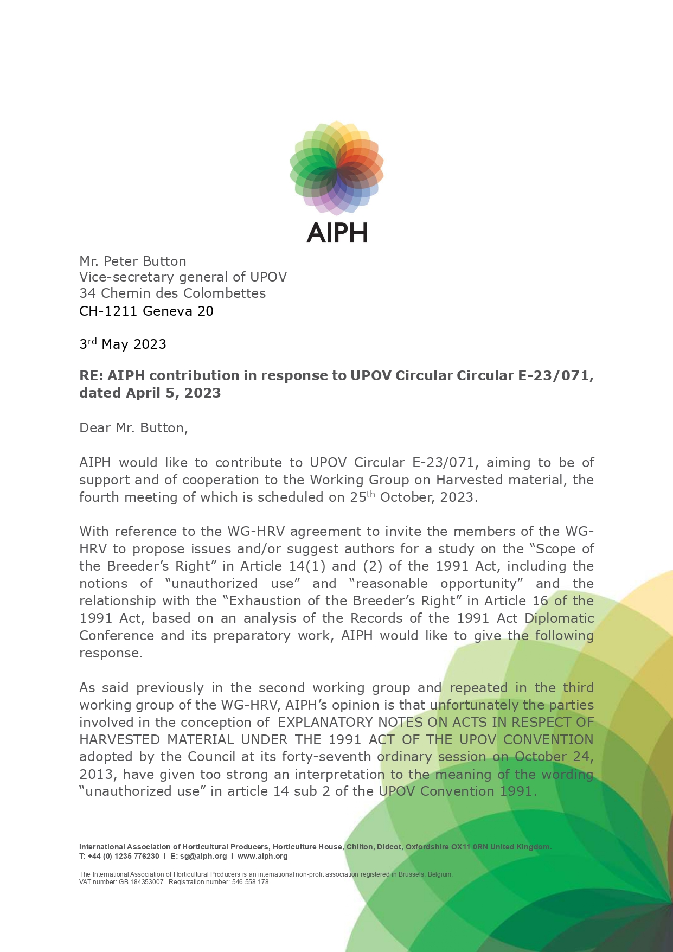

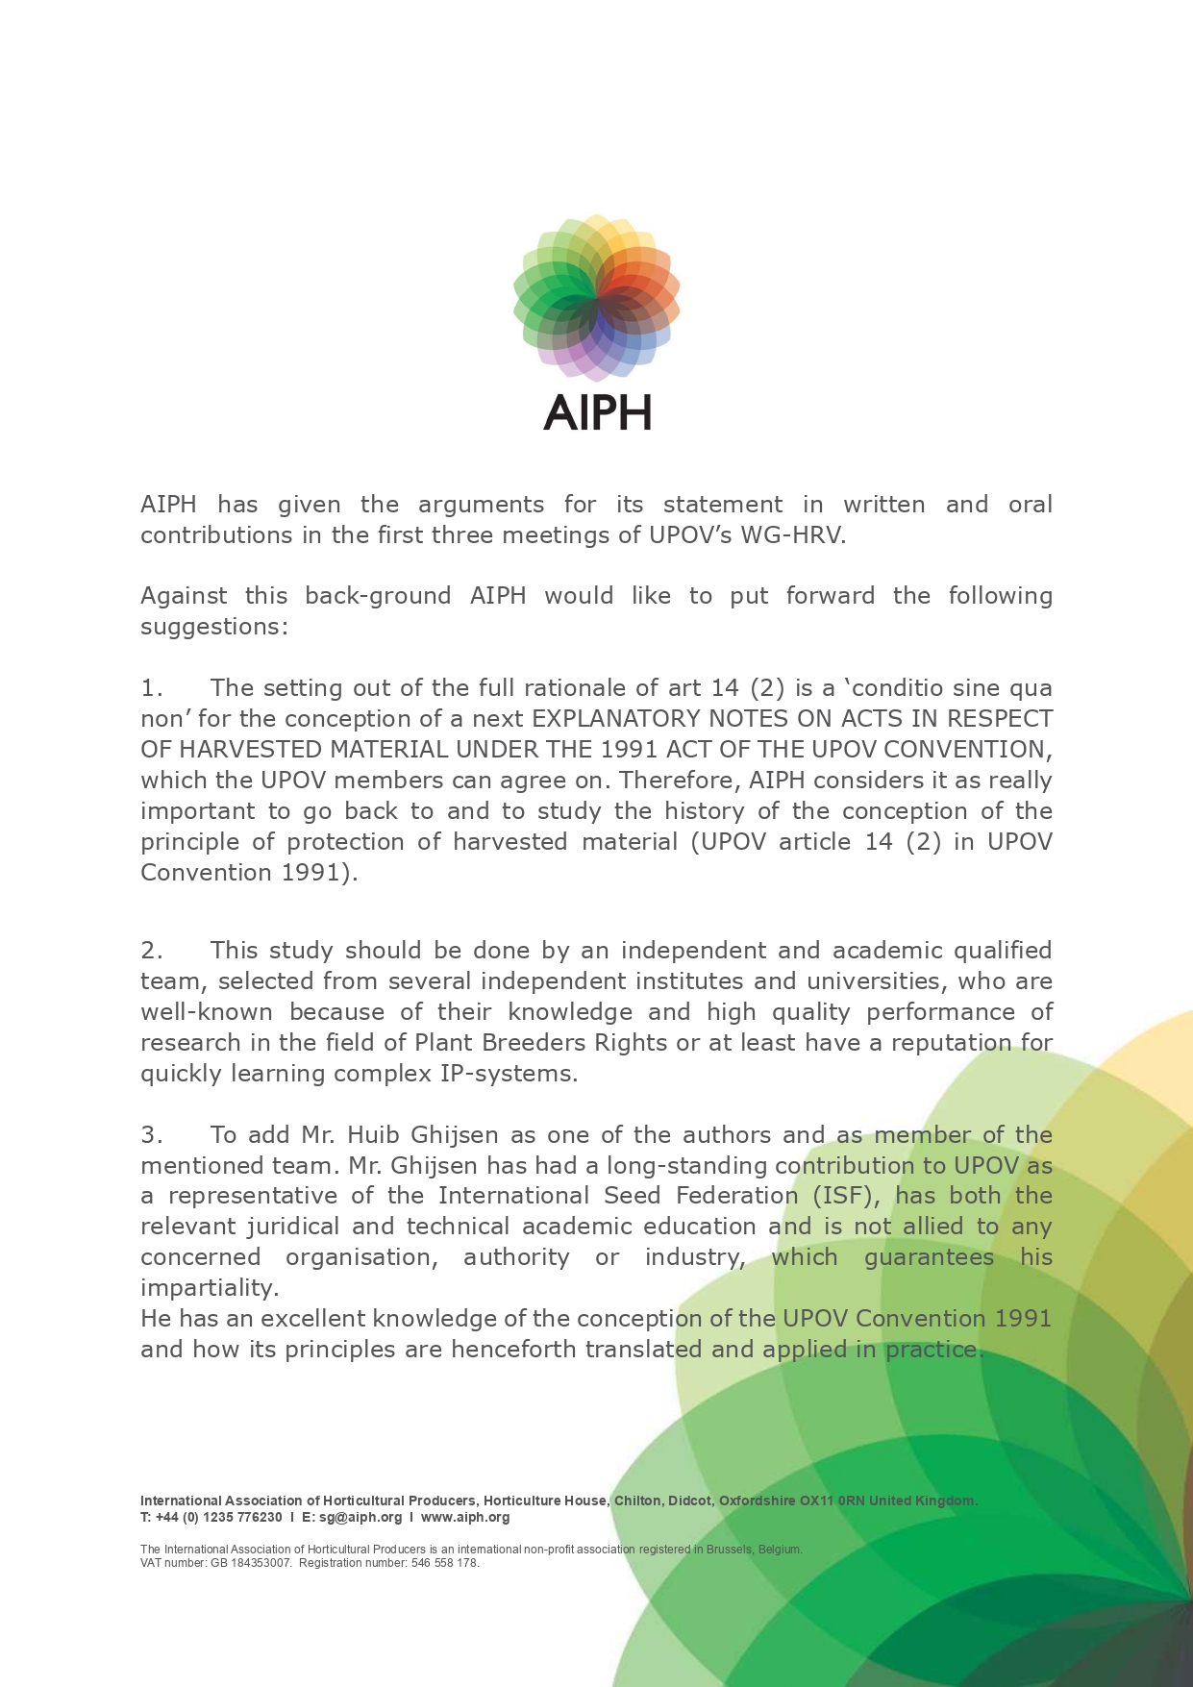

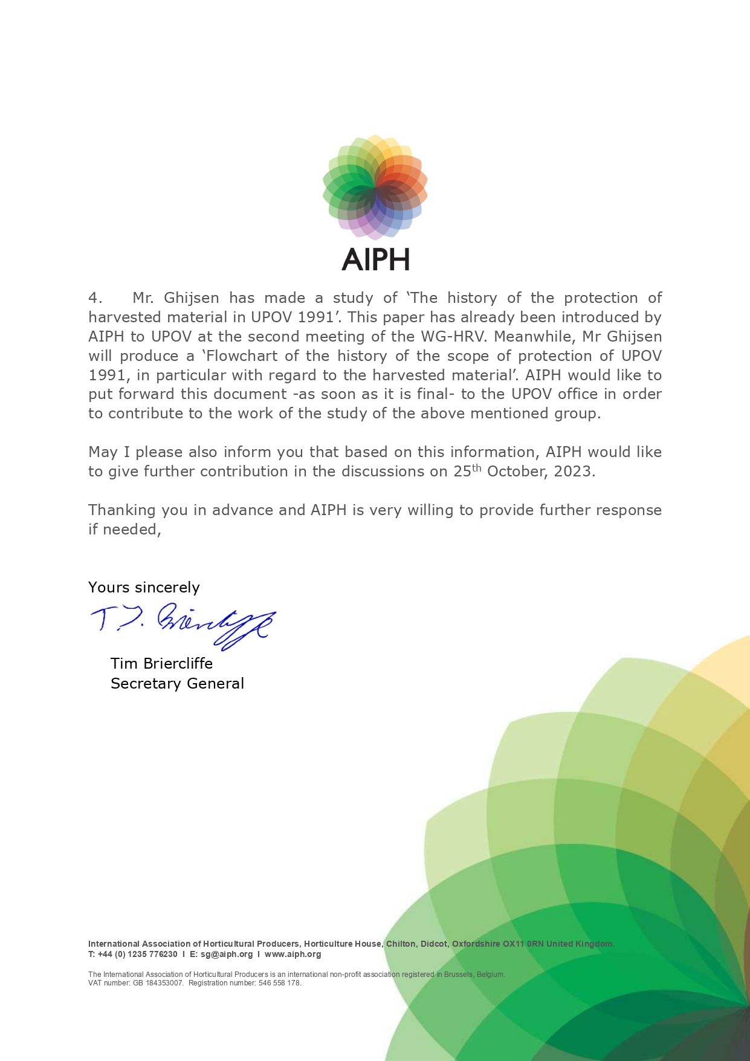

[End of Annex and of document]