E
International Union for the Protection of New Varieties of Plants

Working Group on Essentially Derived Varieties (WG-EDV)  Second Meeting  Geneva, February 4, 2021 | UPOV/WG-EDV/2/2  Original: English  Date: January 26, 2021
Joint presentation by breeders’ organizations and discussion in relation to issues for consideration
prepared by the Office of the Union
Disclaimer: this document does not represent UPOV policies or guidance
The Working Group on Essentially Derived Varieties (WG-EDV), at its first meeting via electronic means, held on December 8, 2020, considered document UPOV/WG-EDV/1/2 “Work Plan”.

The WG-EDV agreed, as a first step in informing its work, to invite the breeders’ organizations to present an overview of the aspects of document UPOV/EXN/EDV/2 that they would wish to be reviewed to reflect the practice and understanding of breeders on essentially derived varieties and to present proposals on those aspects.

The WG-EDV agreed that the joint presentation by the international breeders’ organizations that were members of the WG-EDV, be made at its second meeting, followed by discussion and consideration of the presentation by the WG-EDV in relation to the issues identified in Annex II to document UPOV/WG-EDV/1/2 (see https://www.upov.int/meetings/en/details.jsp?meeting_id=60508).

On the basis of the discussion at the second meeting of the WG-EDV, the WG-EDV agreed to request the Office of the Union to prepare a preliminary draft text for a revision of UPOV/EXN/EDV/2 for consideration by the WG-EDV at its third meeting.

The WG-EDV agreed the following timeline:

February 4, 2021 | Second Meeting of the WG-EDV (by virtual means):  - Joint presentation by breeders’ organizations and discussion in relation to issues for consideration.  (presentation to be posted at least 1 week in advance of the second meeting)
April/May 2021  [date to be decided] | Third Meeting of the WG-EDV (by virtual means):  - consideration by the WG-EDV of a preliminary draft text for revision of UPOV/EXN/EDV/2  (to be posted at least 4 weeks before the third meeting)
June/July 2021  [date to be decided] | Consideration of UPOV/EXN/EDV/3/Draft 1 by correspondence  (6 weeks for comments)
October 2021  [date to be decided] | Fourth Meeting of the WG-EDV (at the fringes of the CAJ session)  - consideration of UPOV/EXN/EDV/3/Draft 2 by correspondence  (to be posted 6 weeks before the fourth meeting in English)

The joint presentation by the international breeders’ organizations is reproduced in Annex I to this document. The narrative of the presentation provided by the breeders’ organizations is reproduced in Annex II of this document.

The following approach is proposed for consideration of this matter at the second meeting of the WG-EDV:

- Introduction of this document;
- Presentation by the international breeders’ organizations (25 minutes);
- Comments and questions from the WG-EDV in relation to the issues identified in Annex II to document UPOV/WG-EDV/1/2 (see https://www.upov.int/meetings/en/details.jsp?meeting_id=60508); and
- Conclusions on a basis for drafting of a preliminary draft text, by the Office of the Union, for a revision of UPOV/EXN/EDV/2 for consideration by the WG-EDV at its third meeting.

In order to facilitate discussions at the WG-EDV, the members of the WG-EDV are invited to send comments or questions on the presentation and its narrative, reproduced in Annexes I and II, respectively, to this document by February 2, 2021. Comments or questions that are not received in advance may also be raised at the meeting.

The WG-EDV is invited to consider the joint presentation by the international breeders’ organizations, in conjunction with the issues identified in Annex II to document UPOV/WG-EDV/1/2 (see https://www.upov.int/meetings/en/details.jsp?meeting_id=60508), as set out in paragraphs 7 and 8, above.

[Annexes follow]

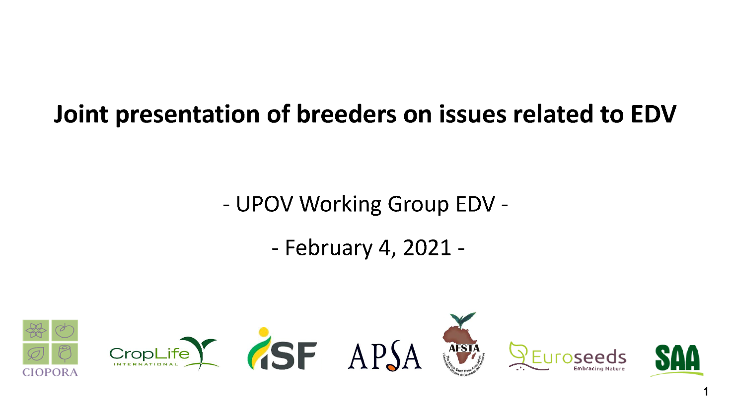

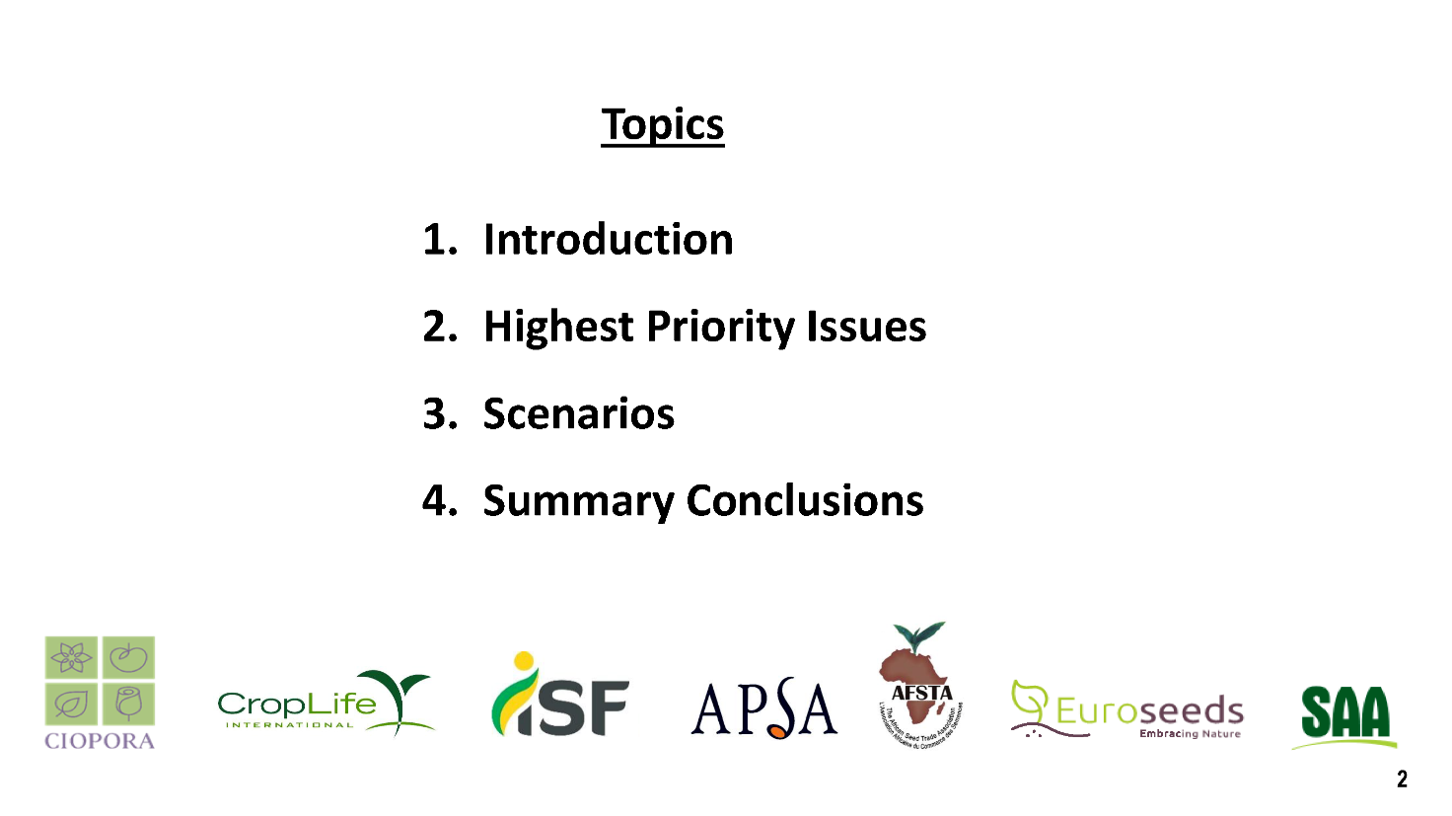

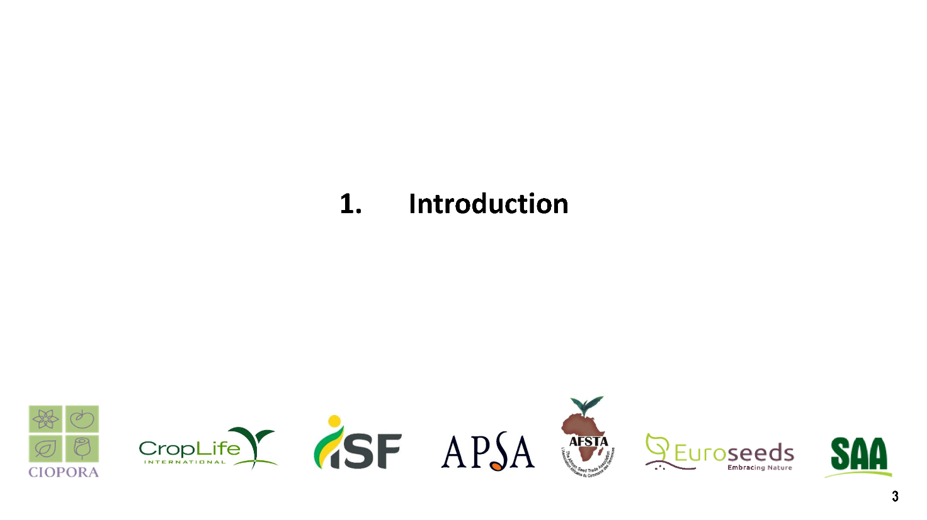

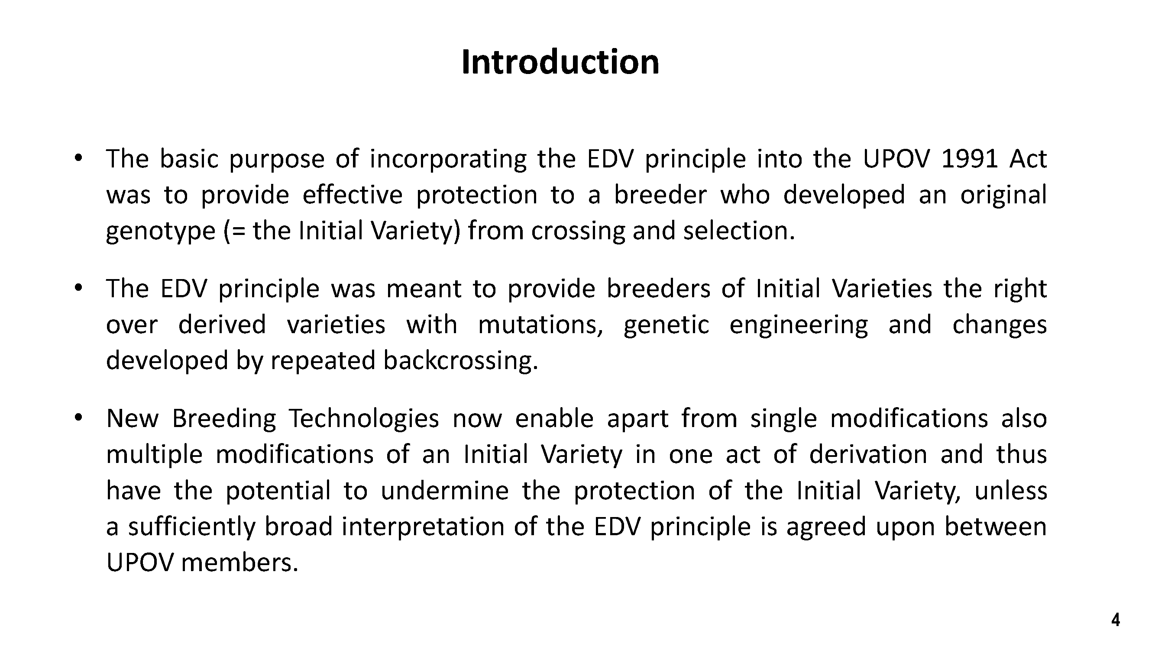

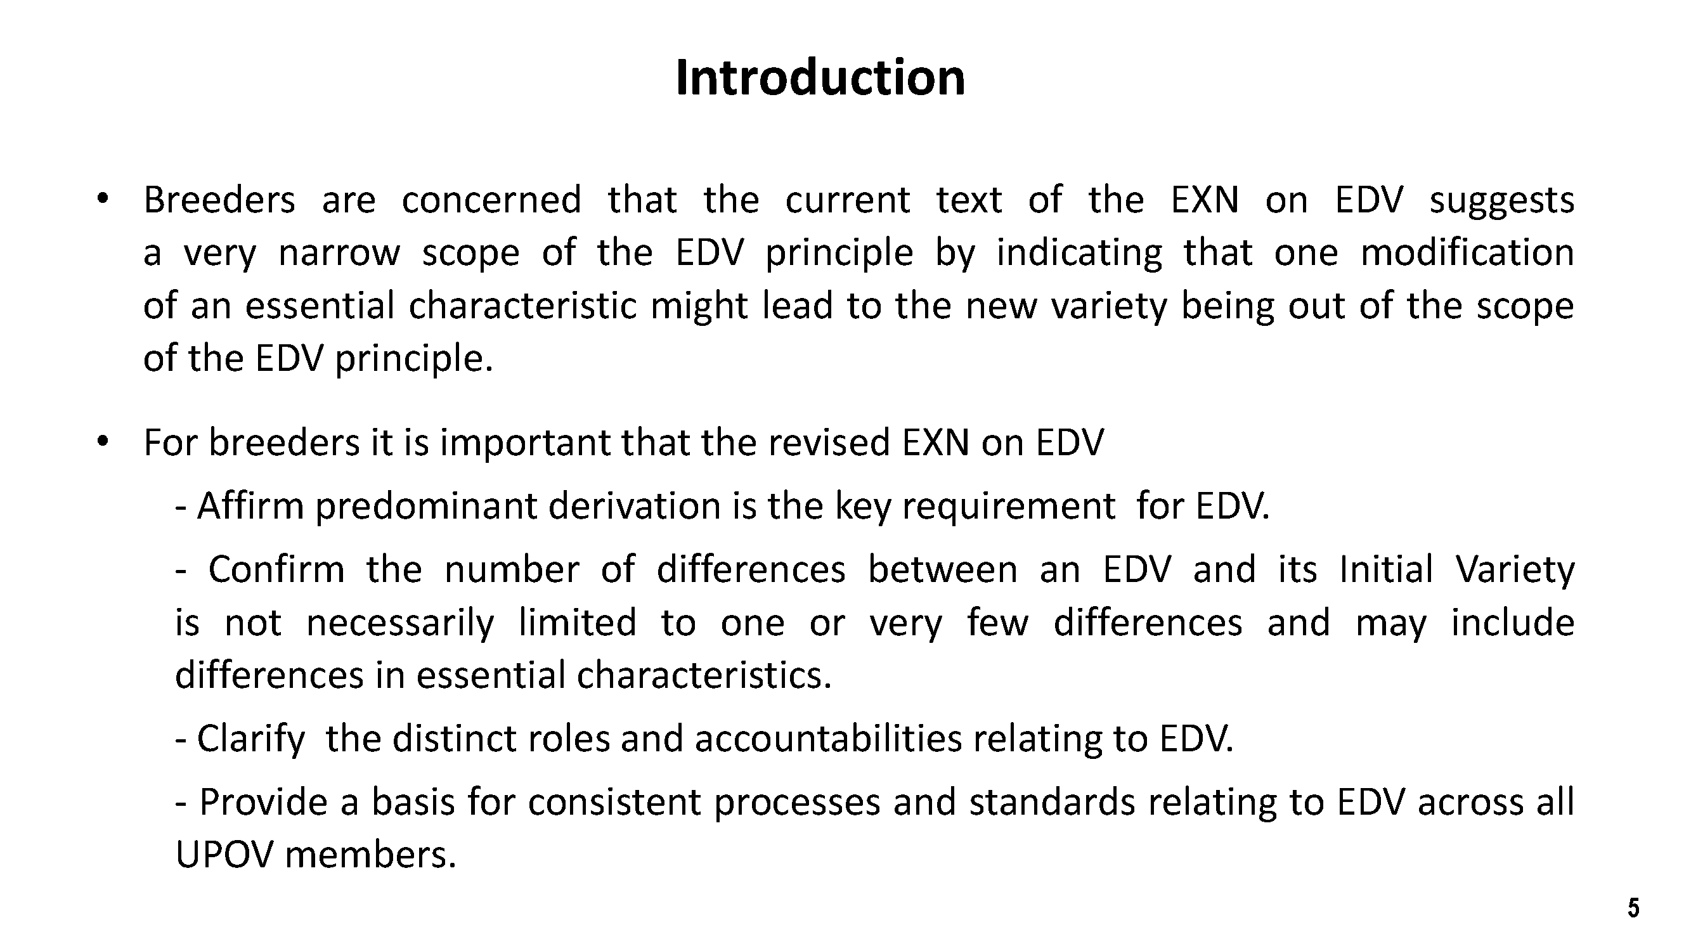

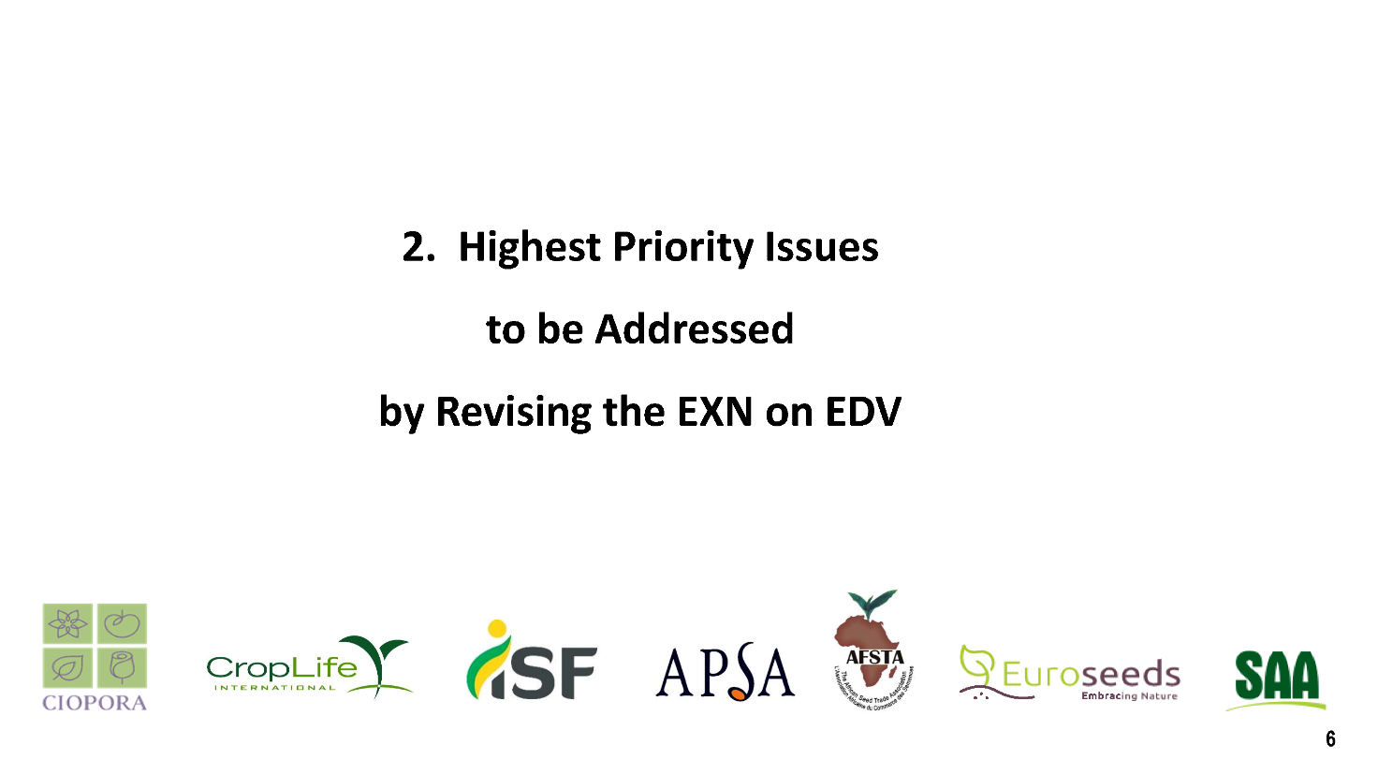

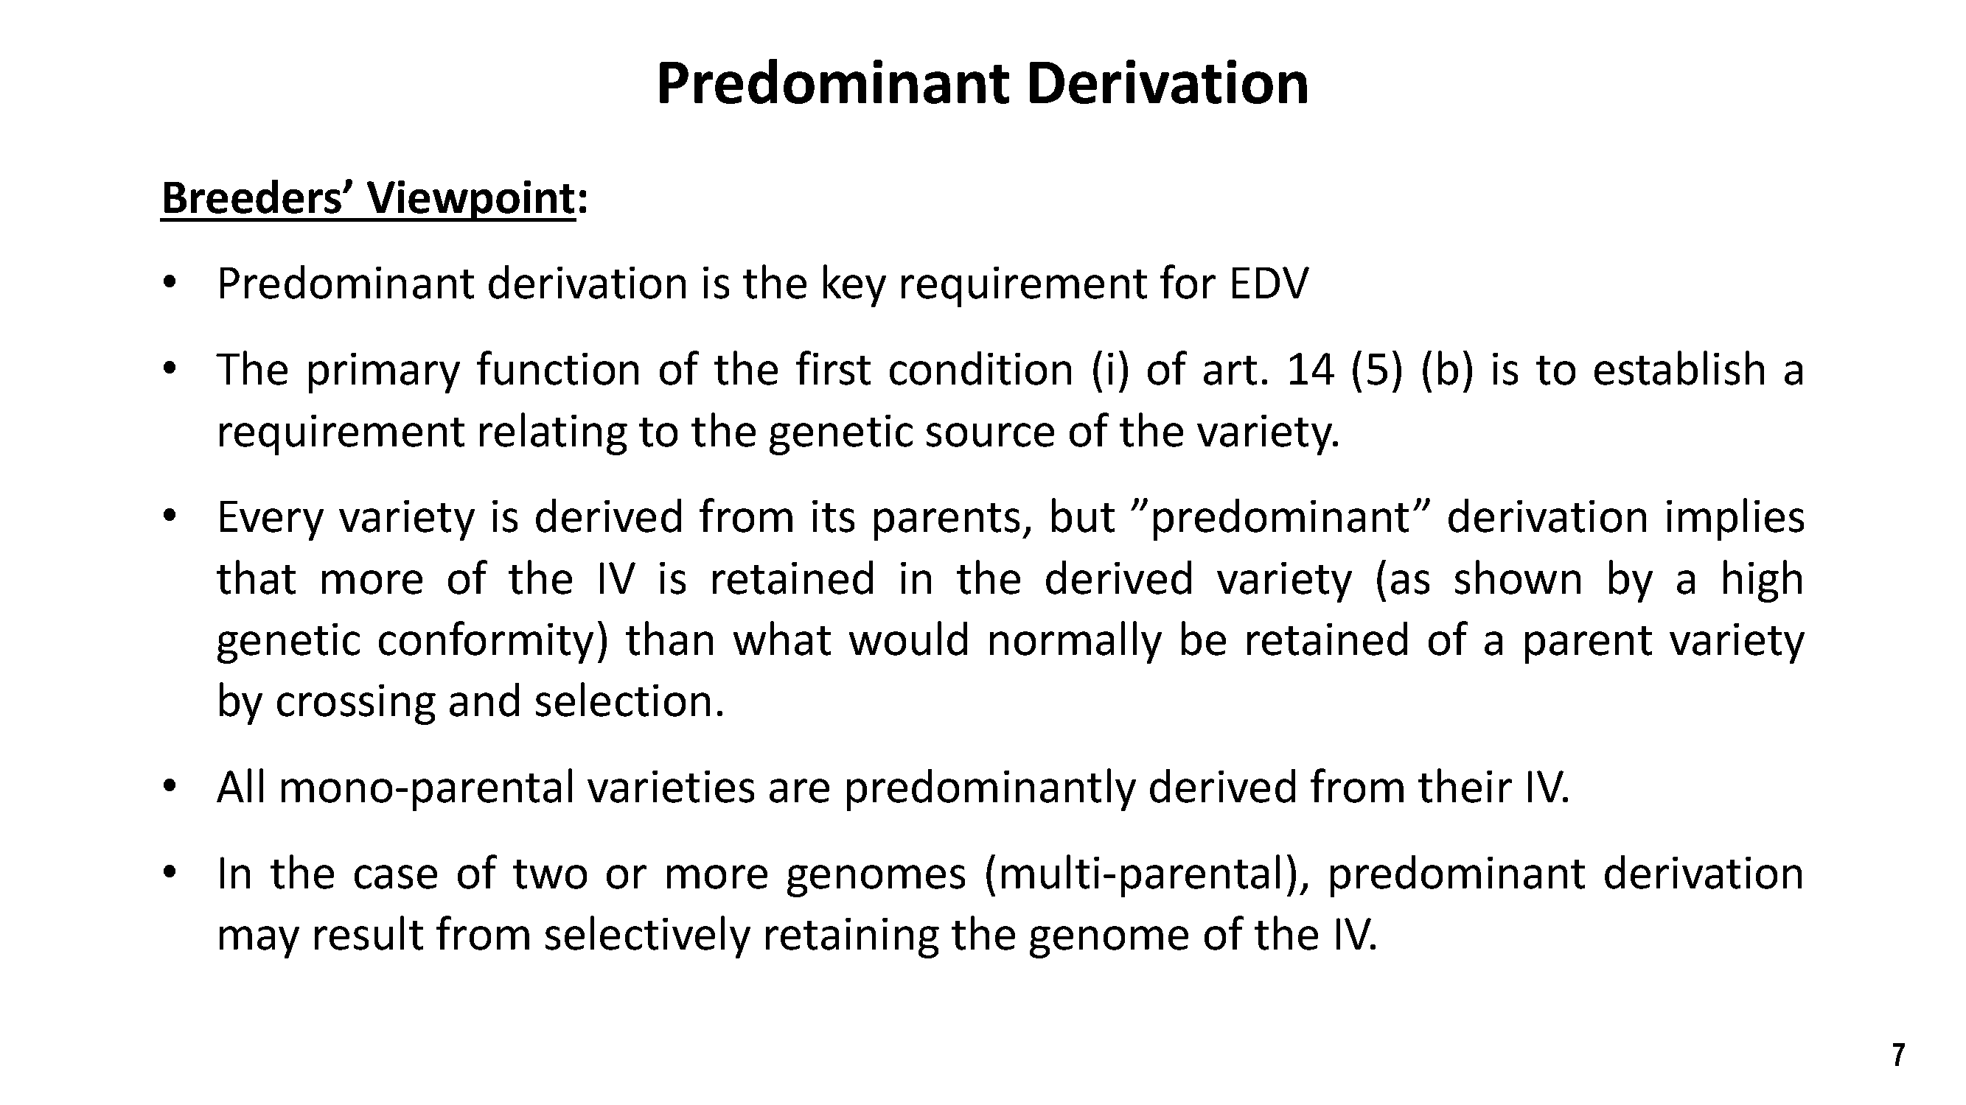

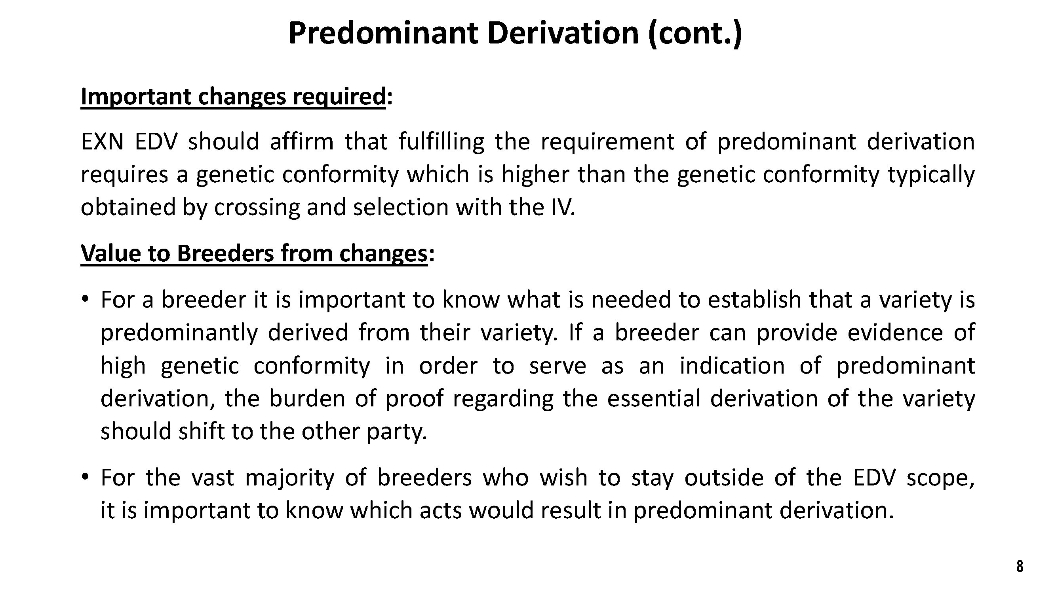

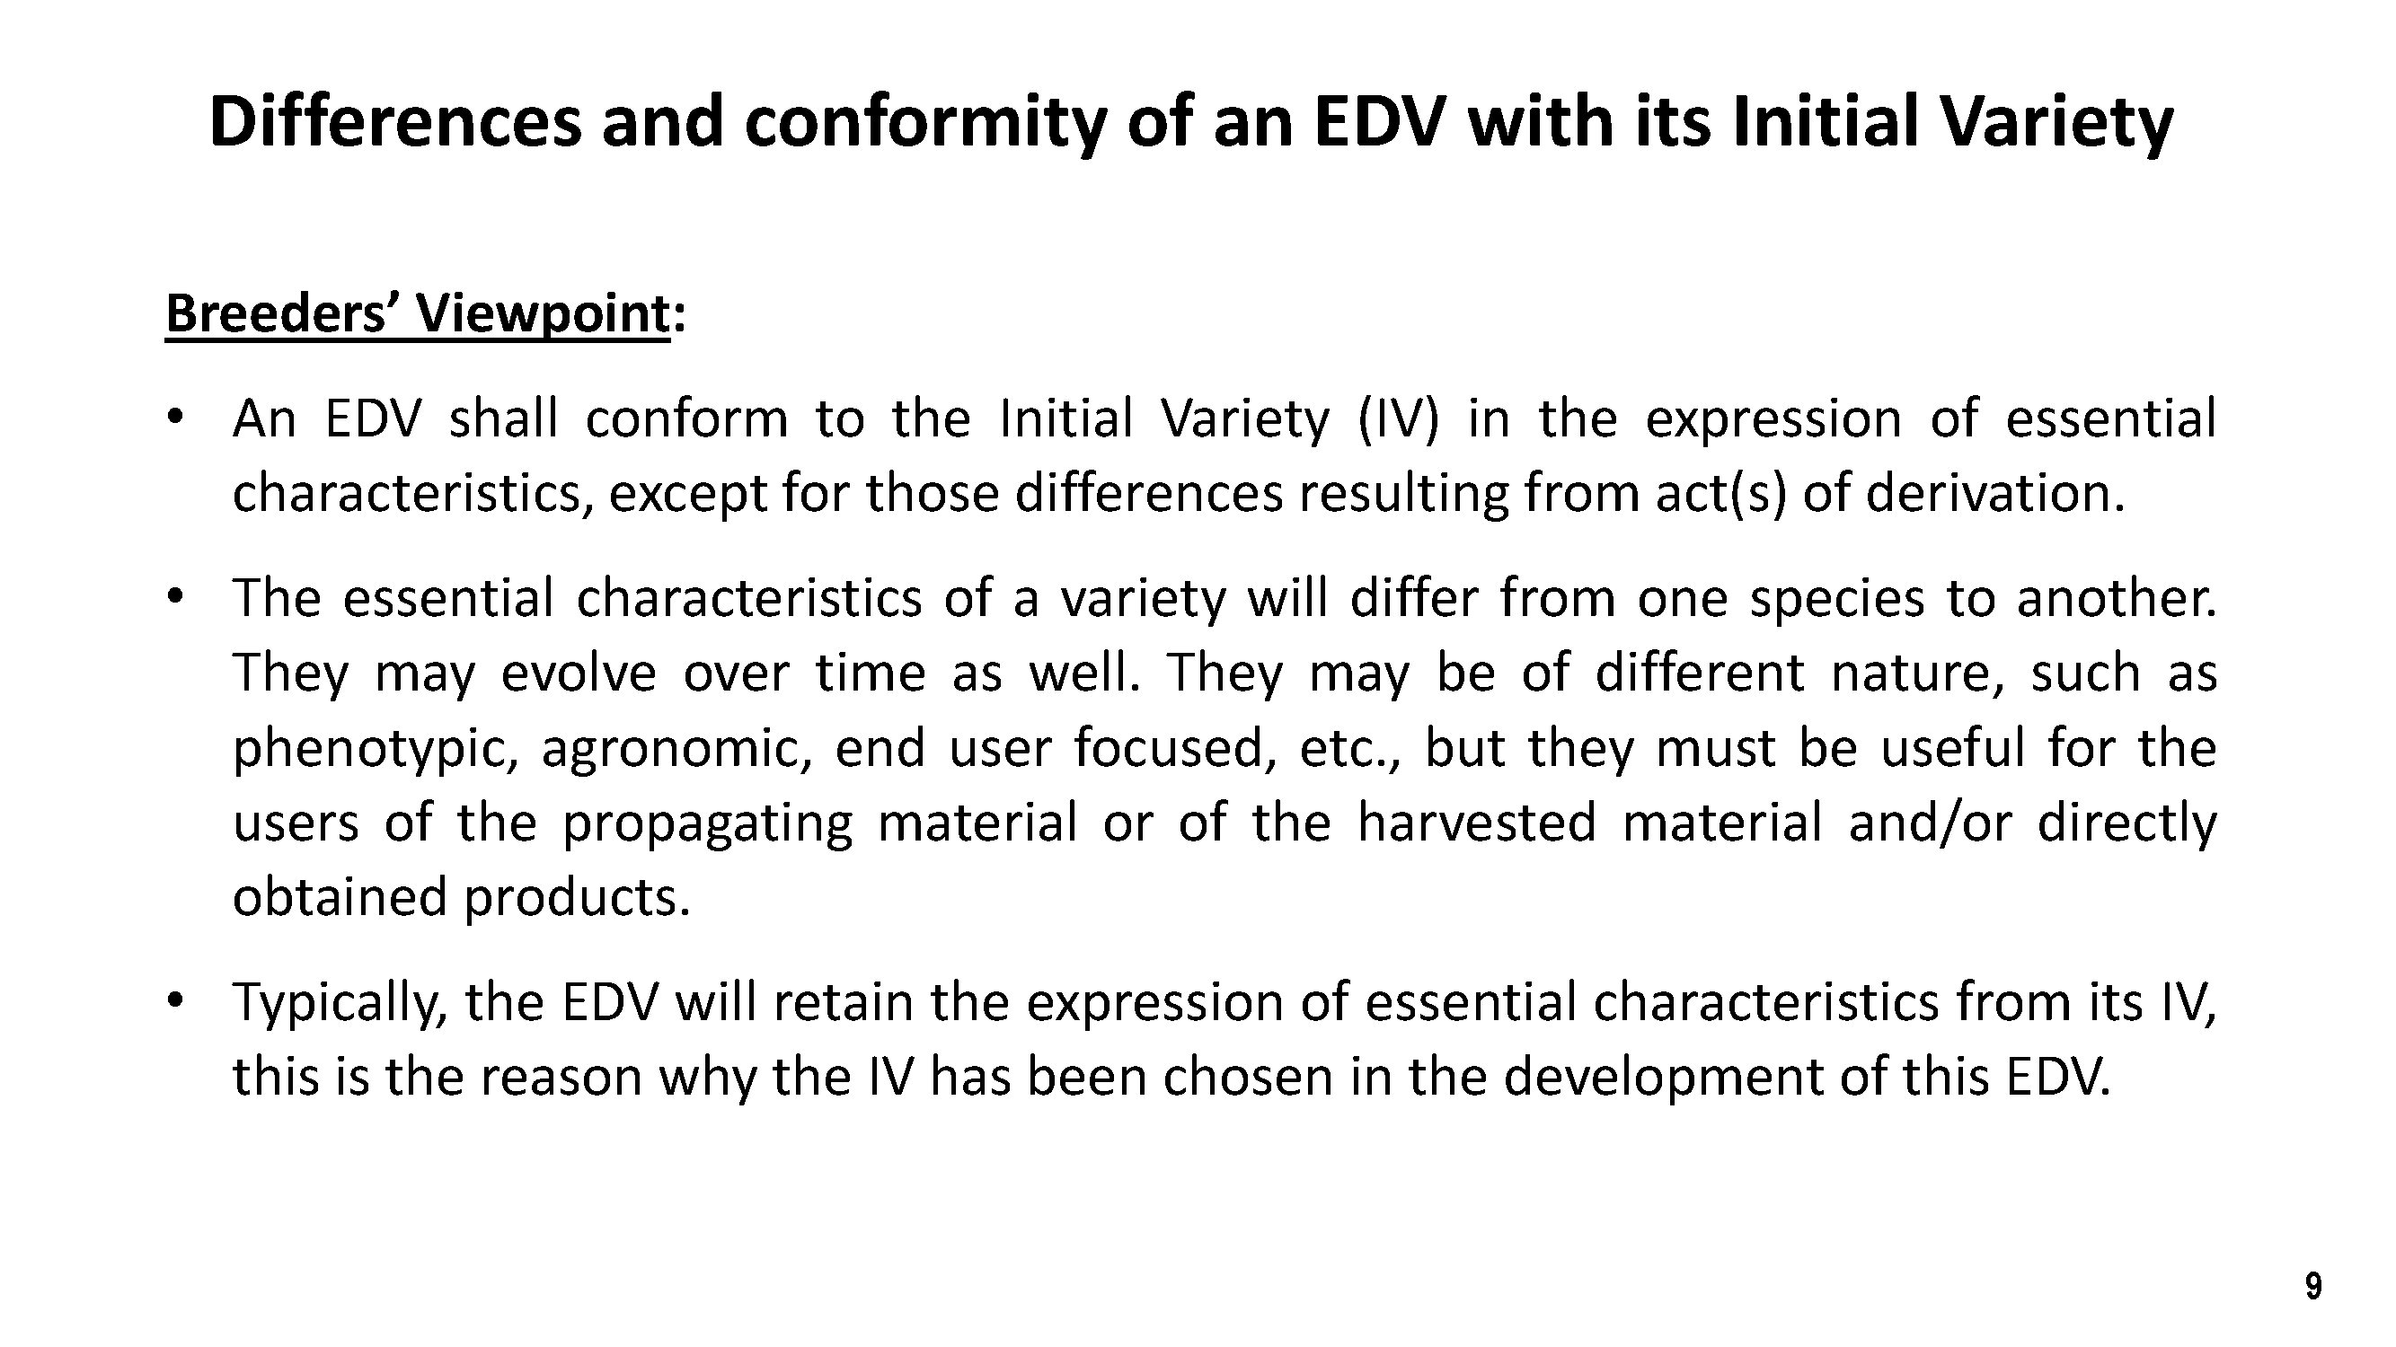

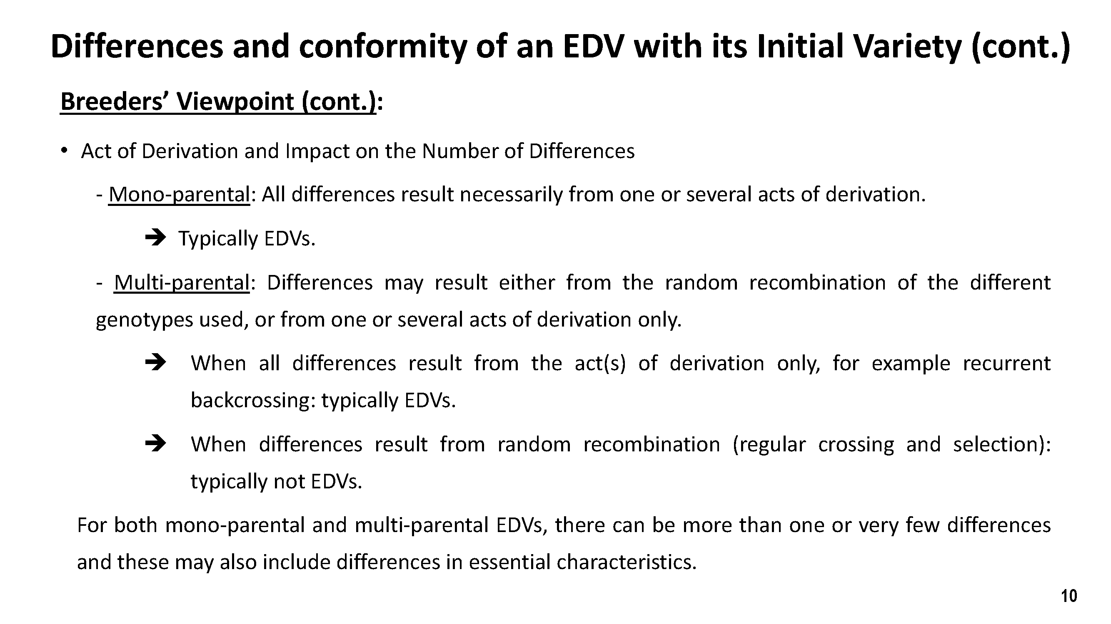

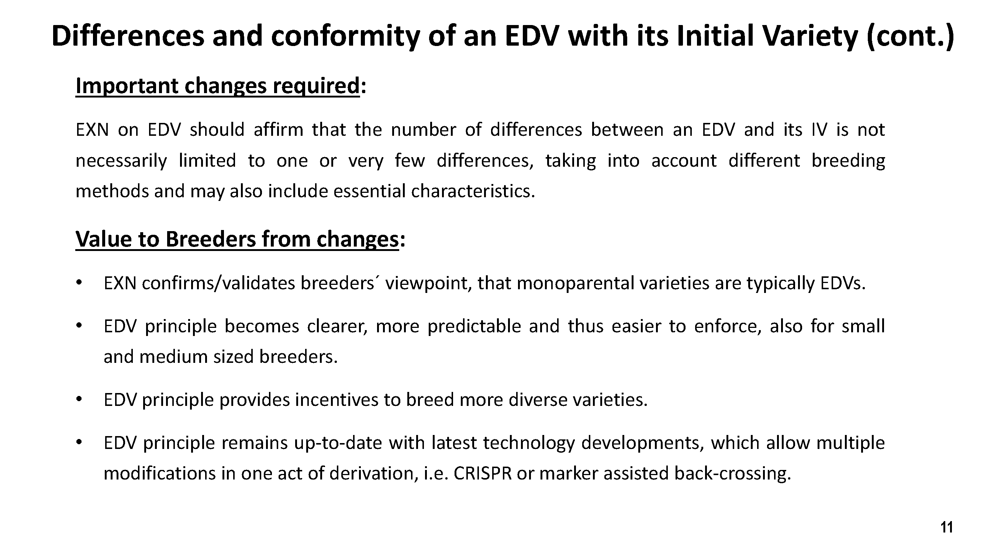

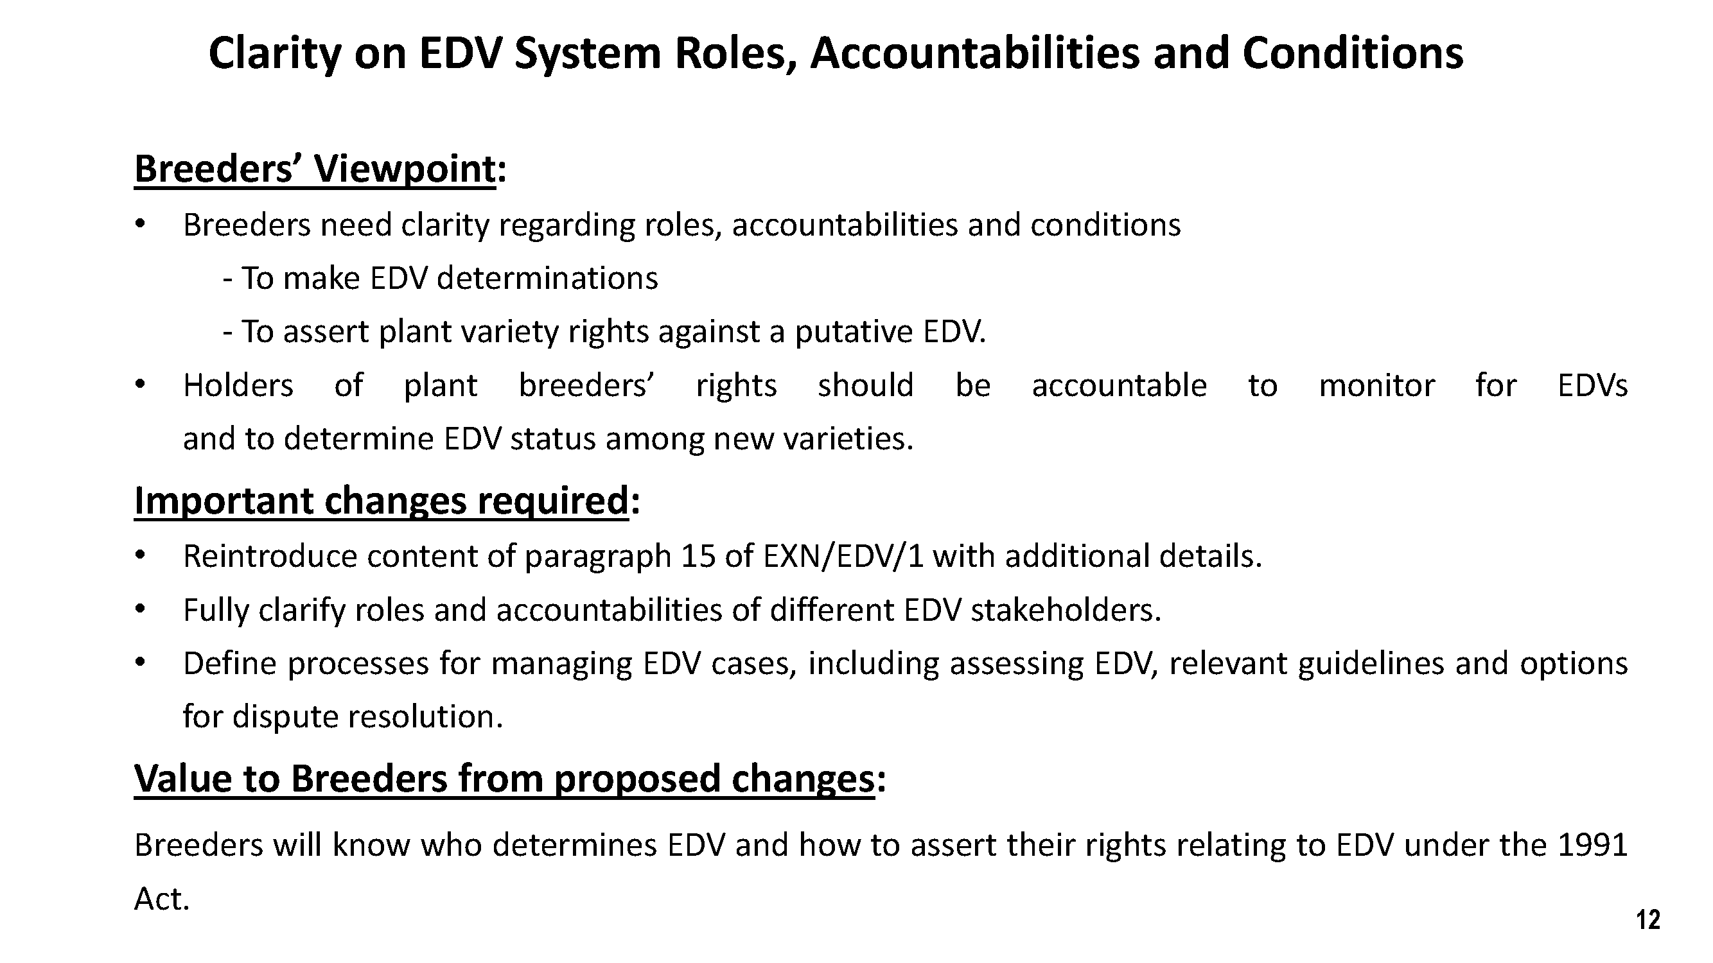

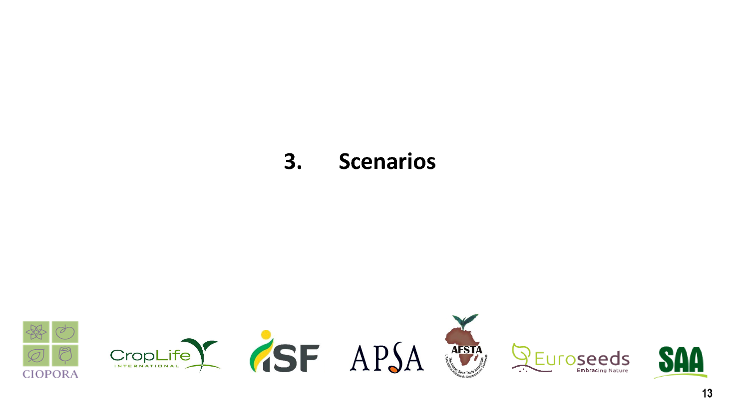

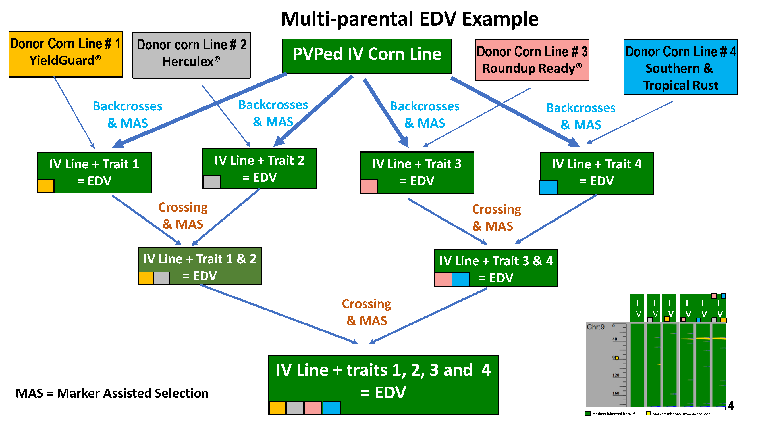

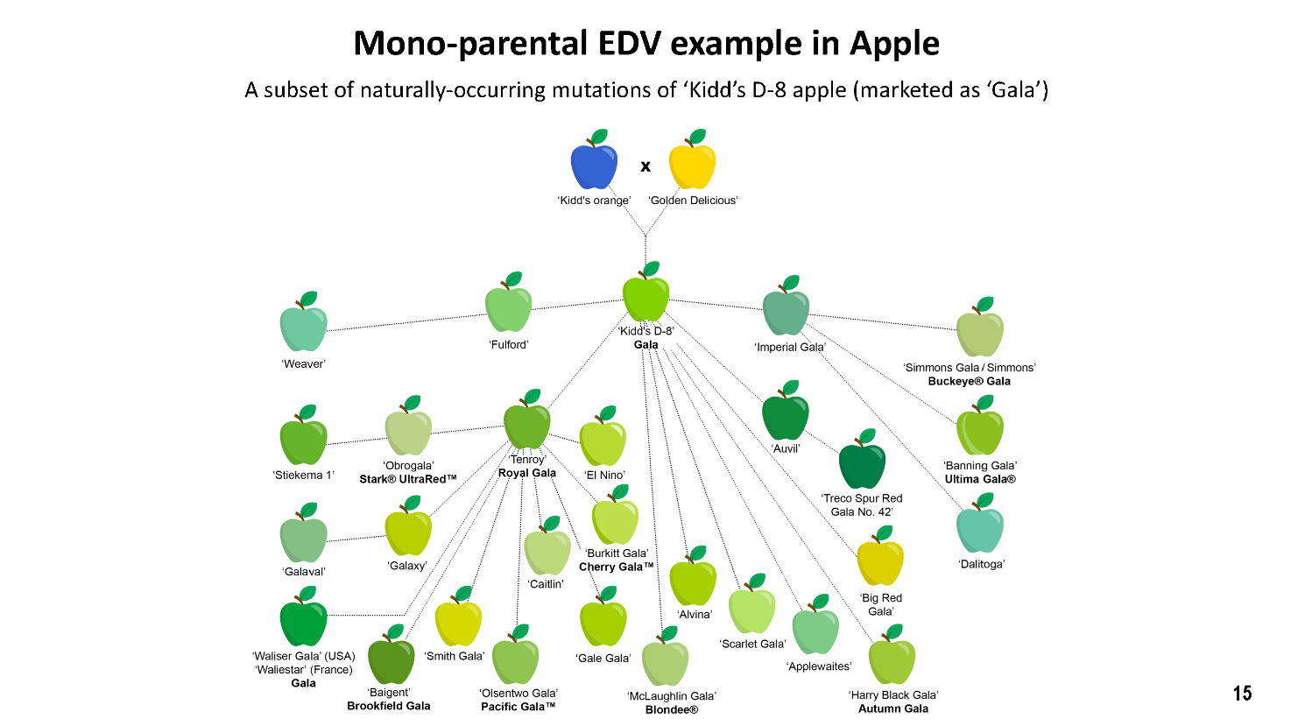

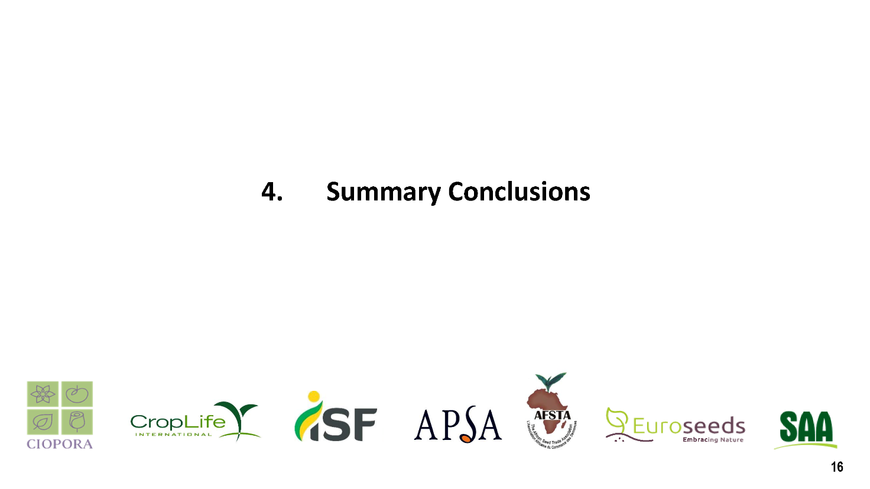

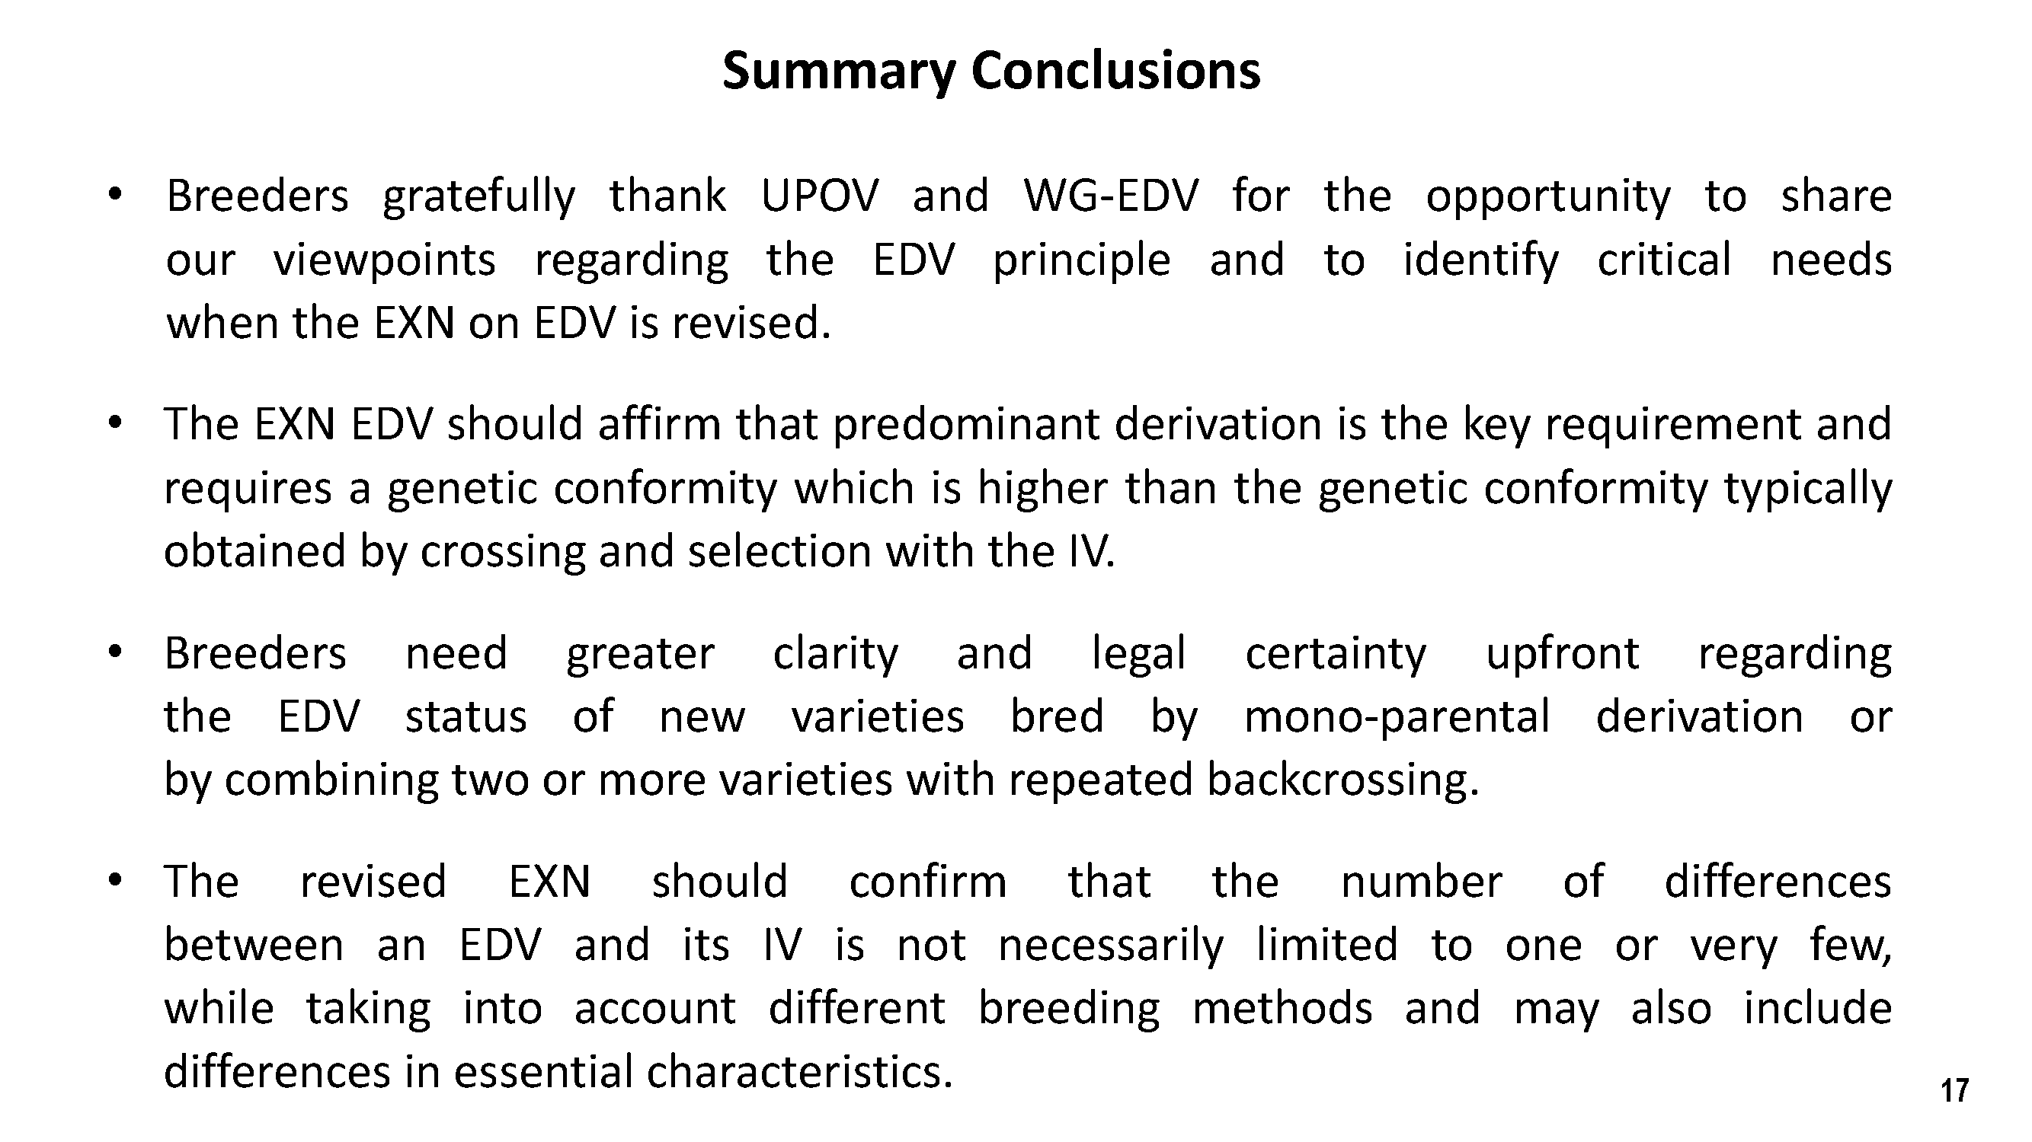

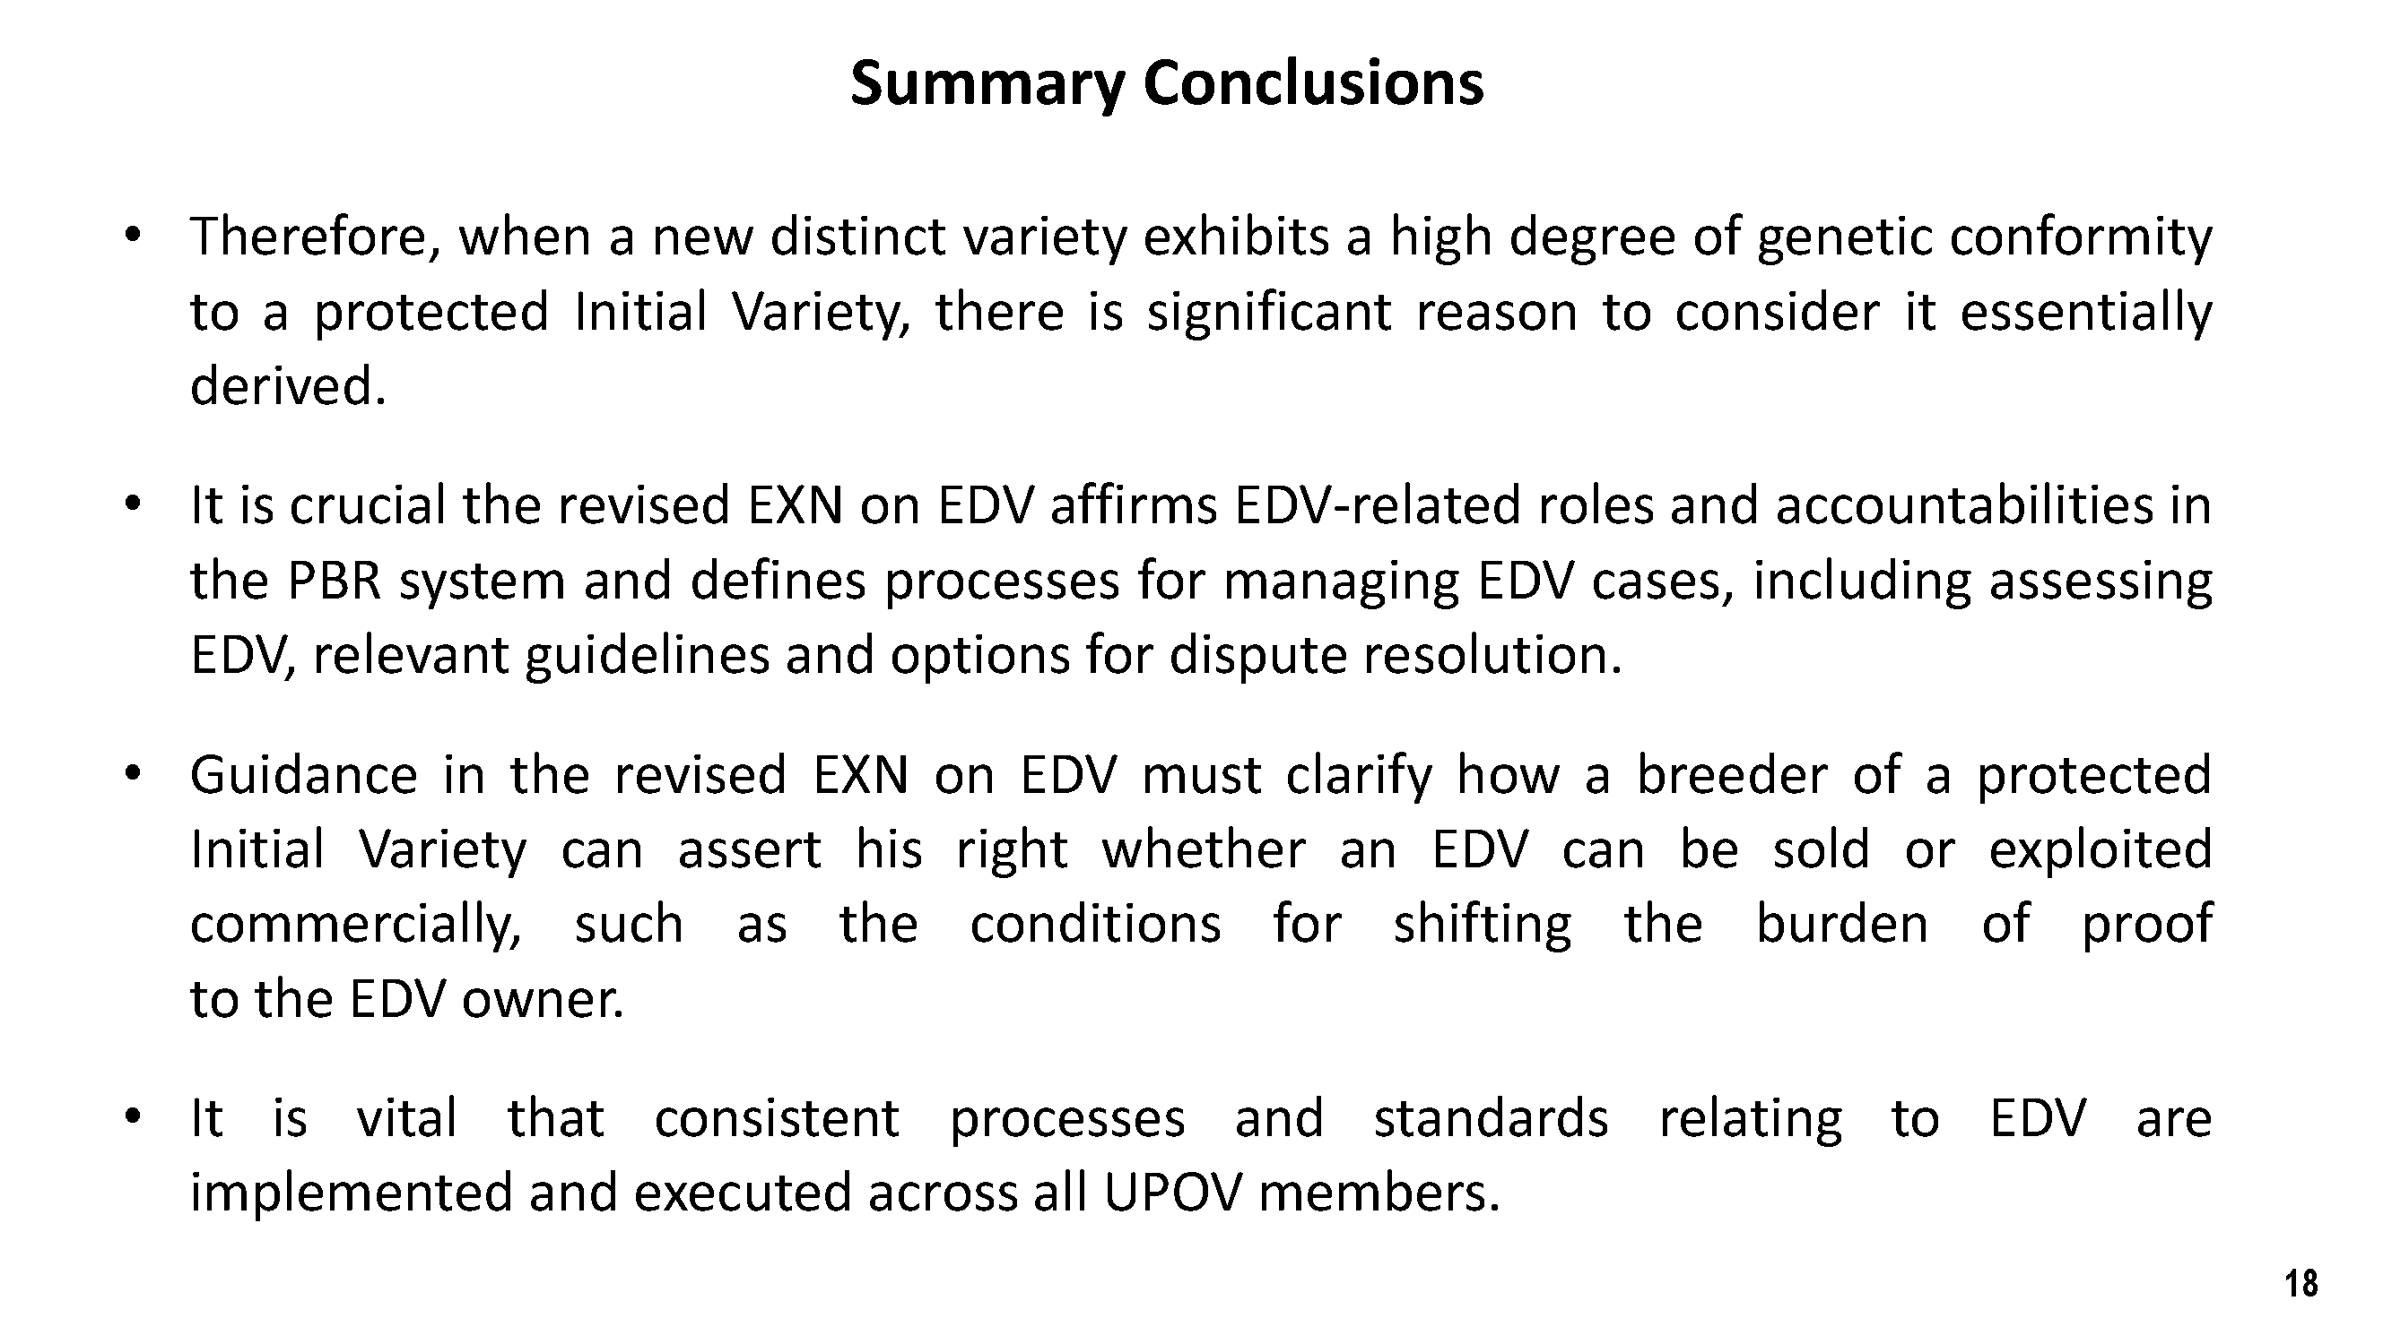

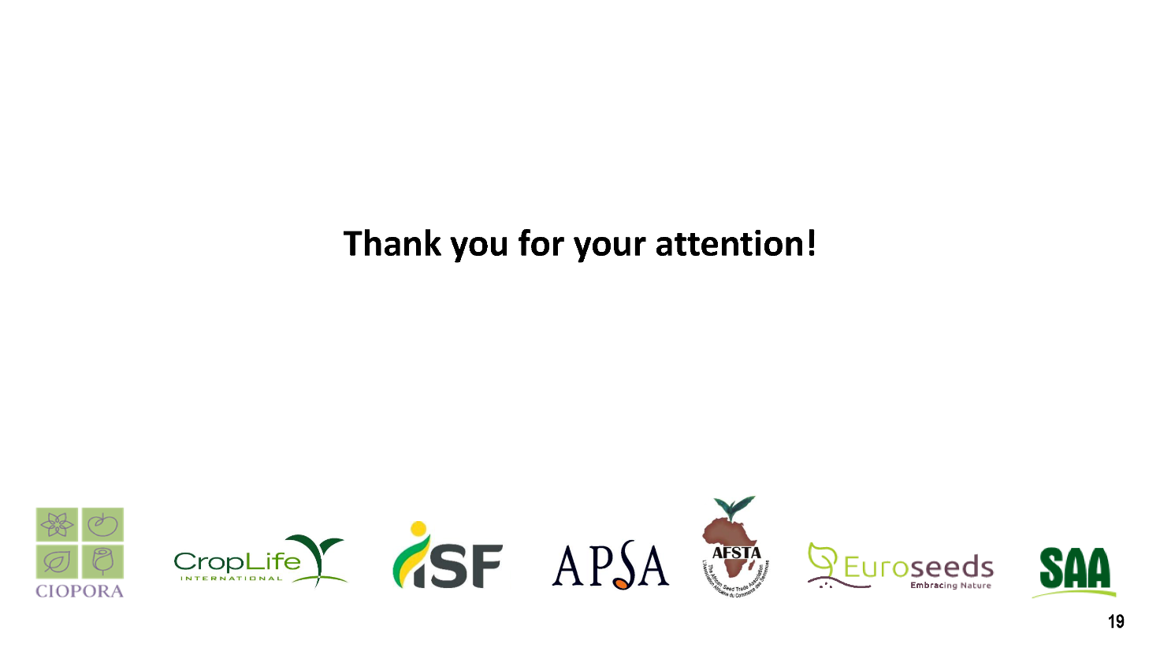

[Annex II follows]

NARRATIVE OF THE PRESENTATION

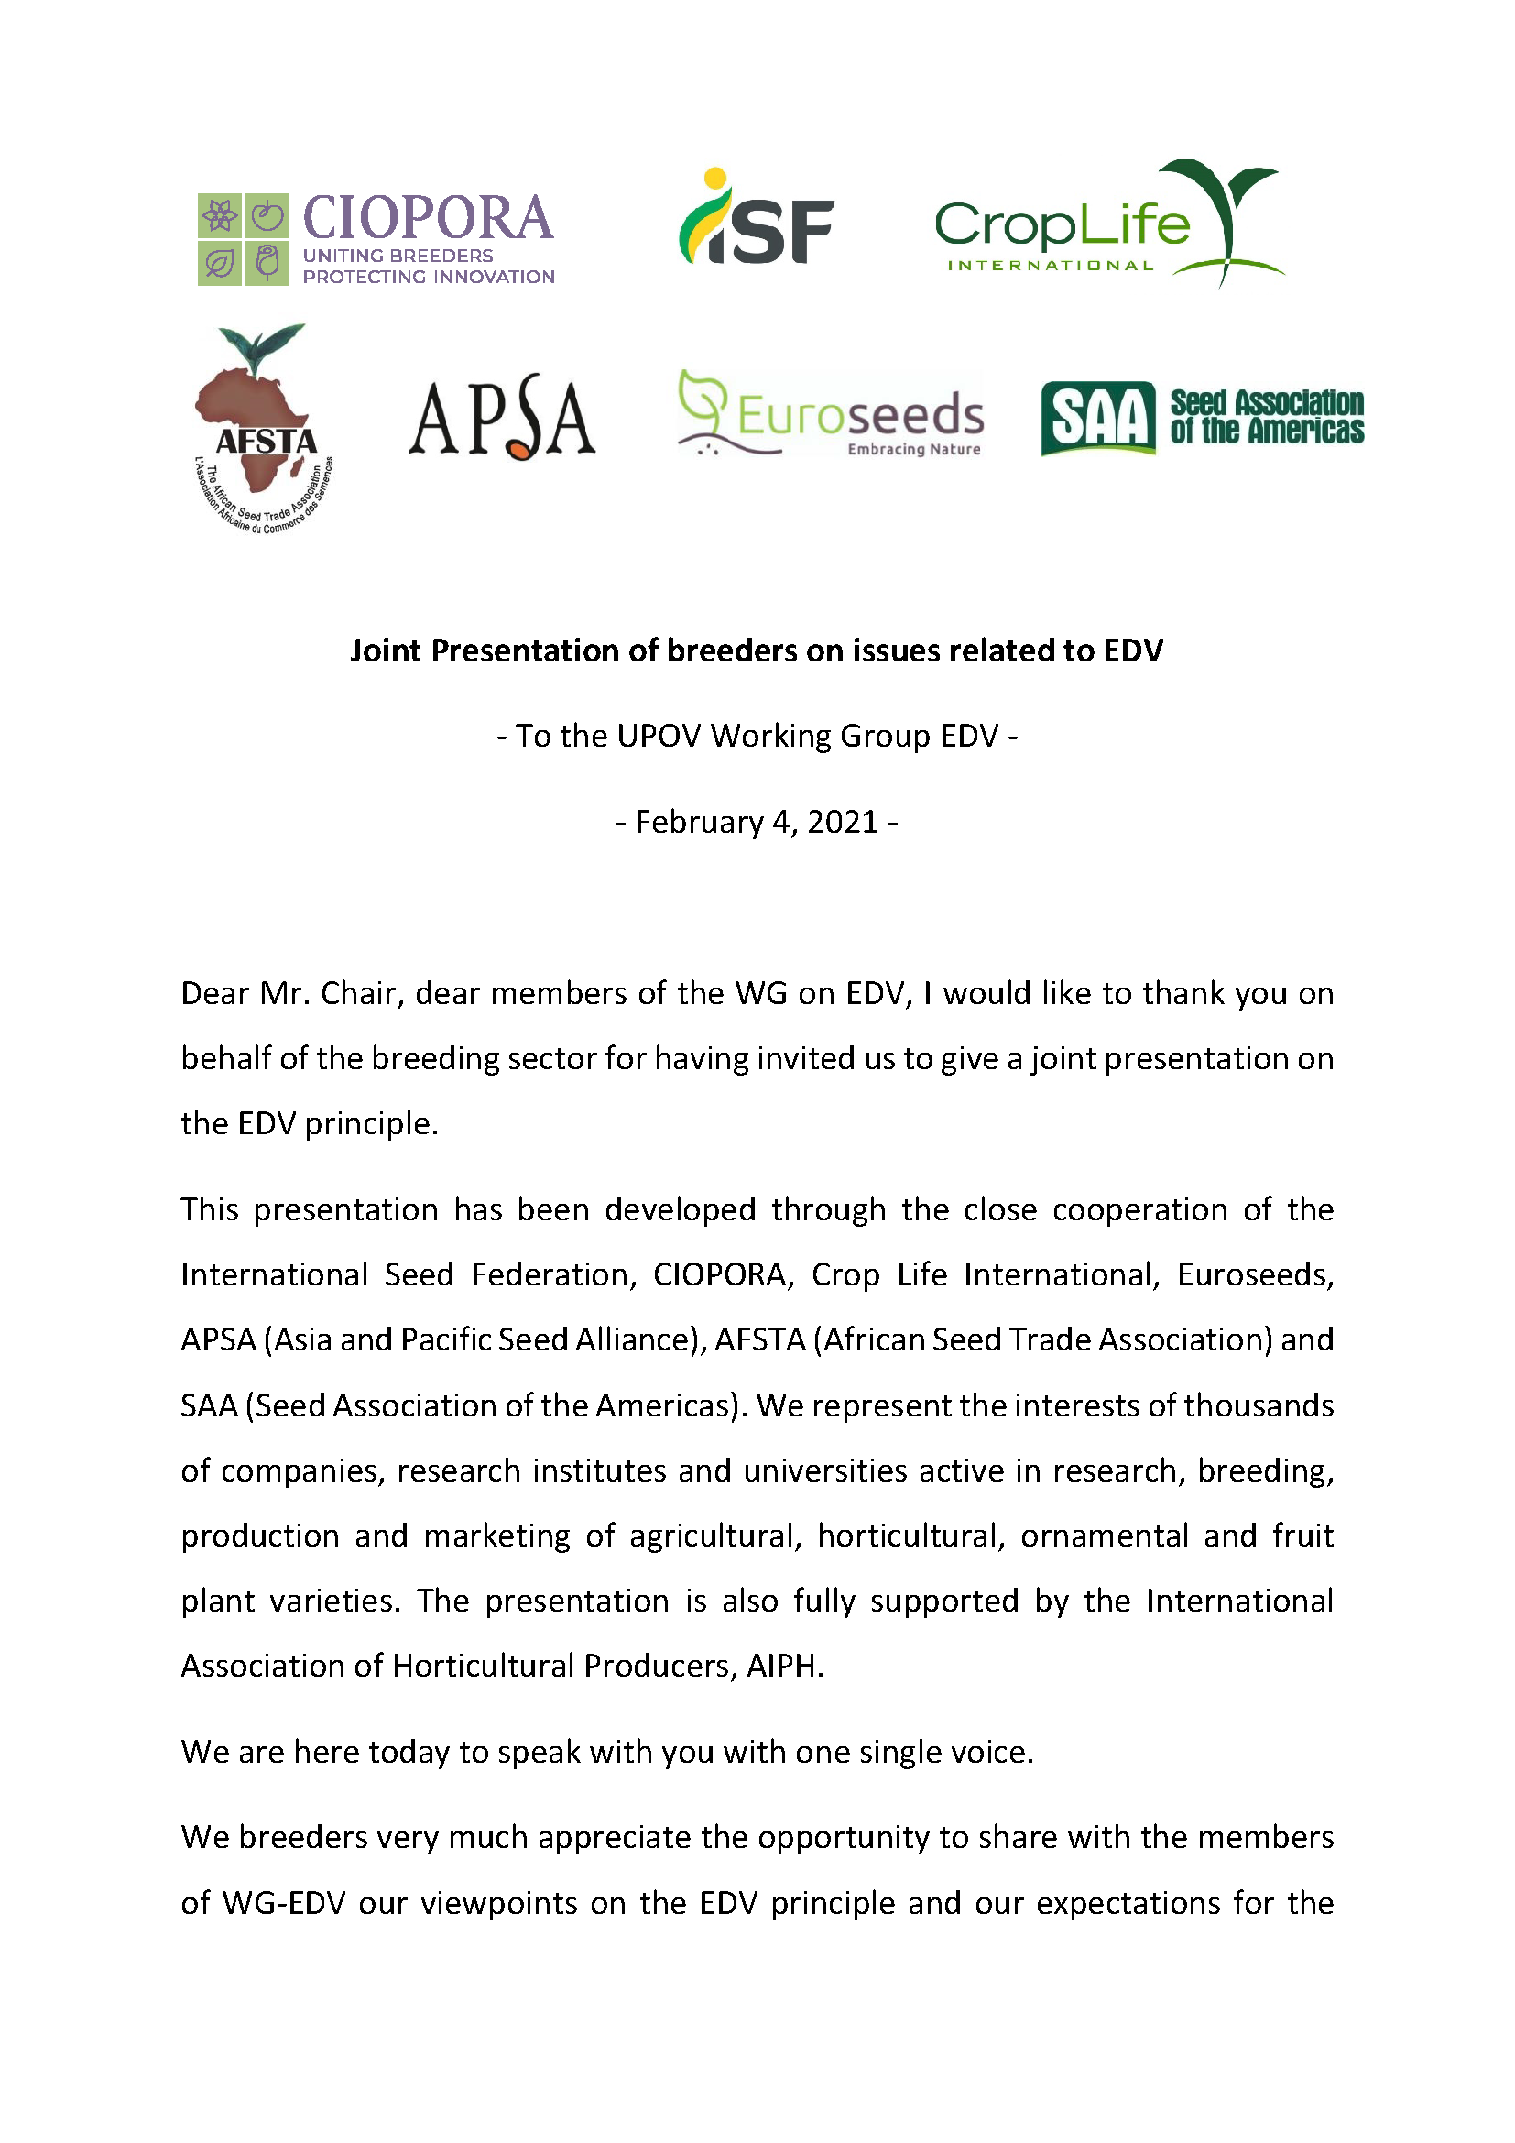
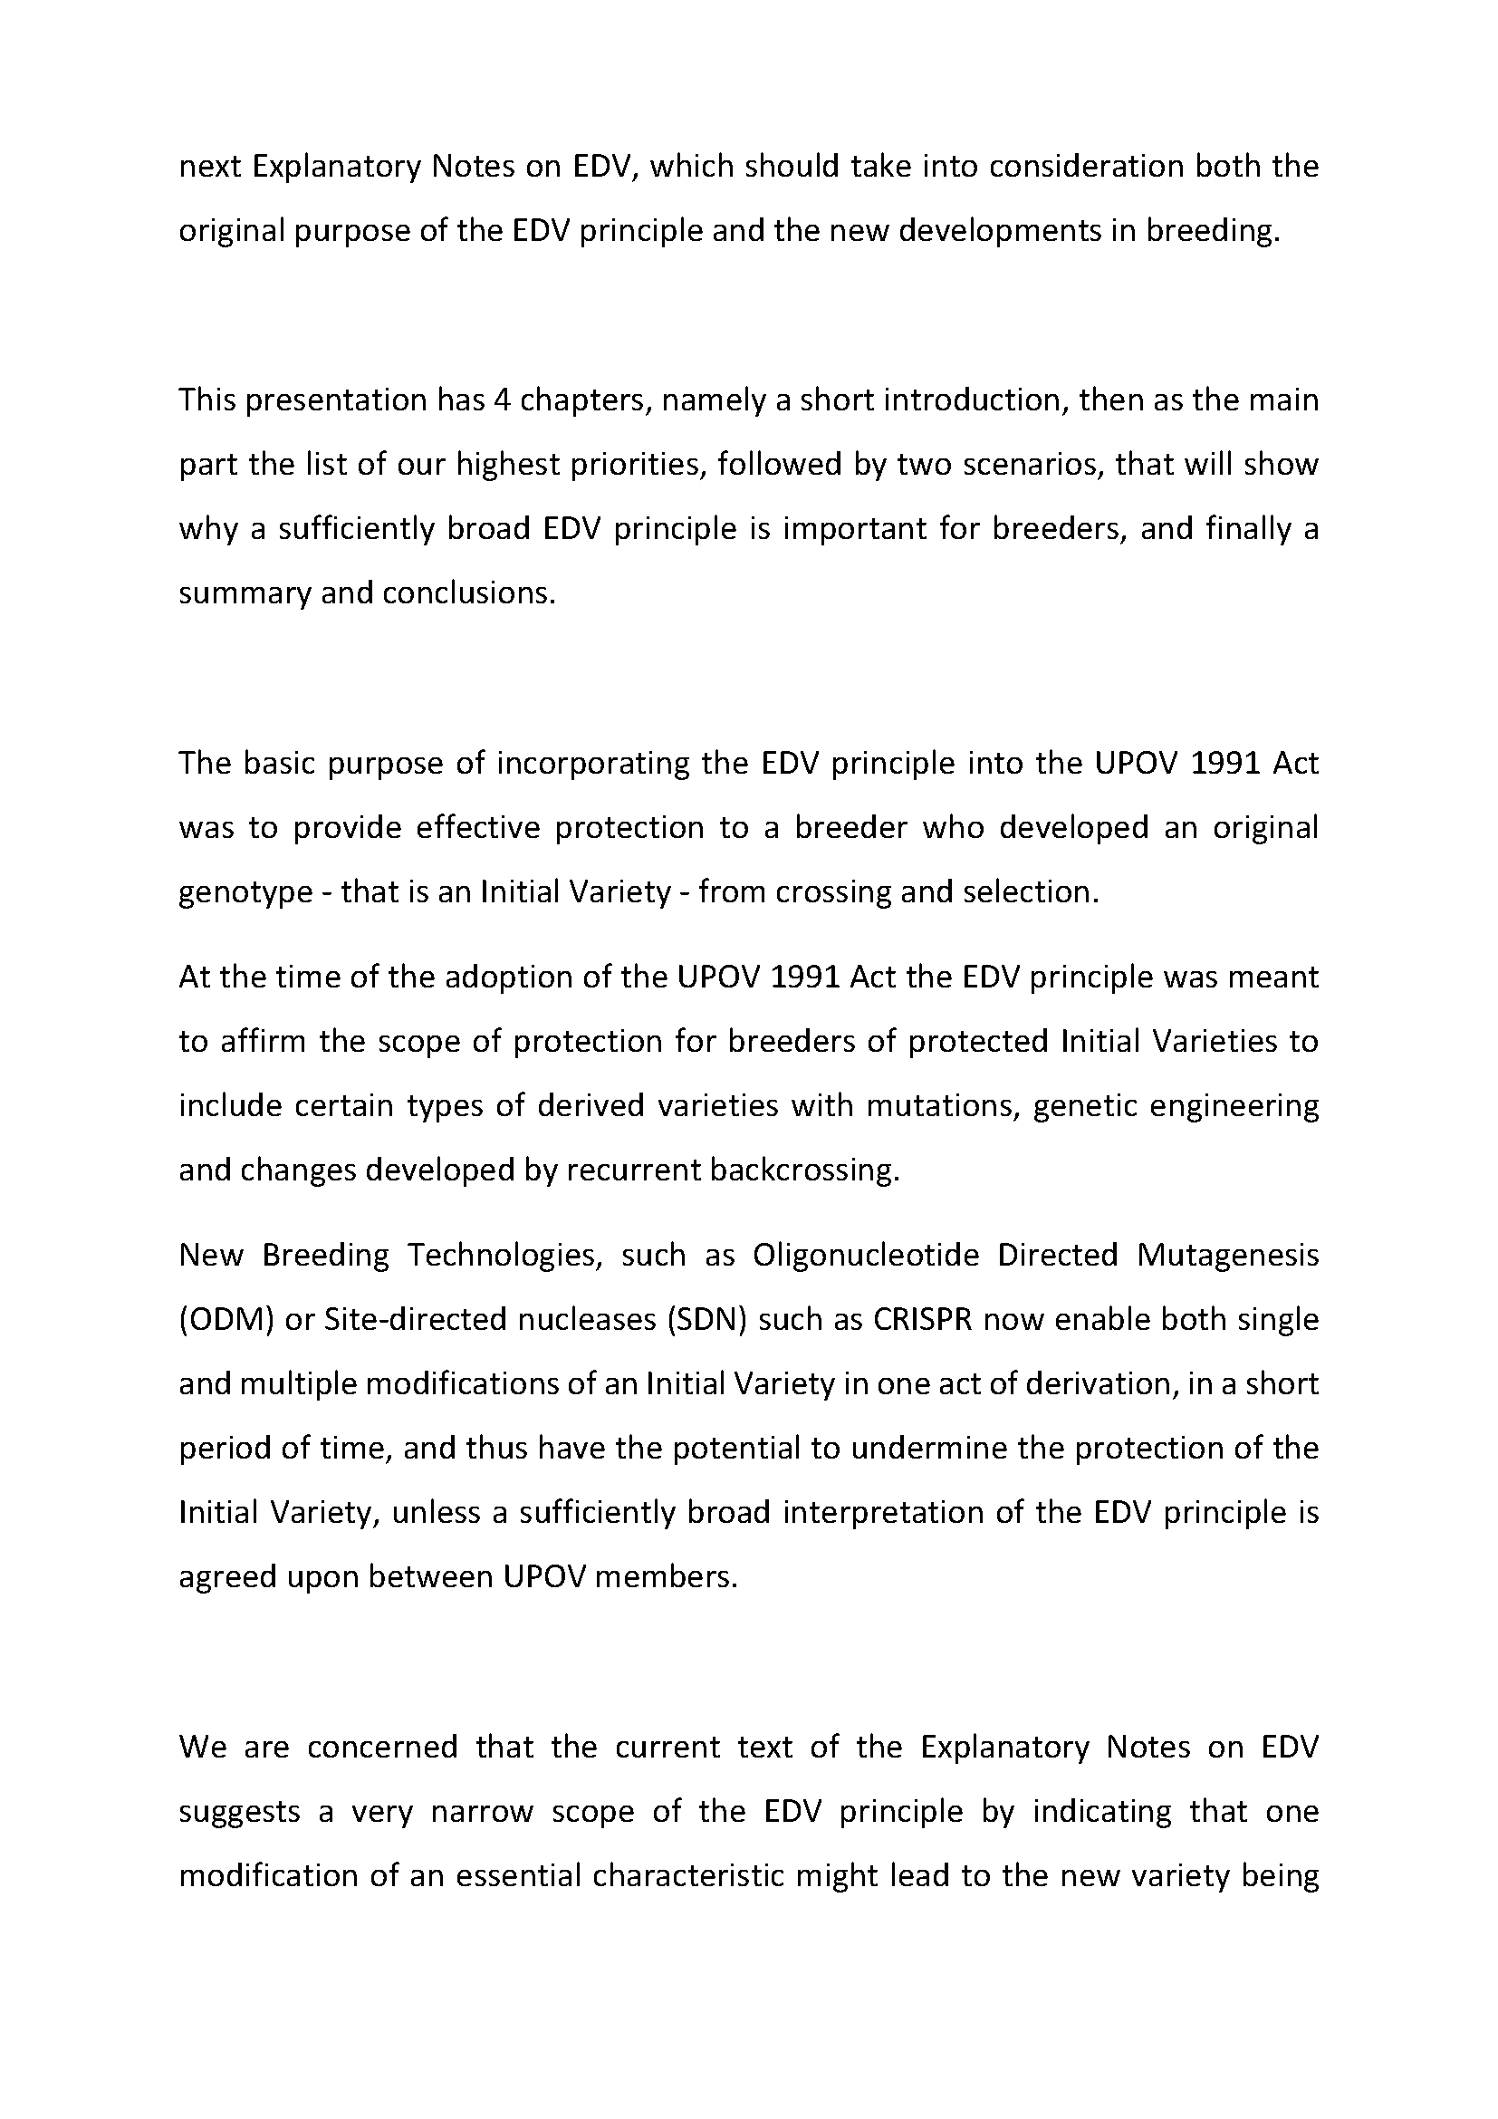

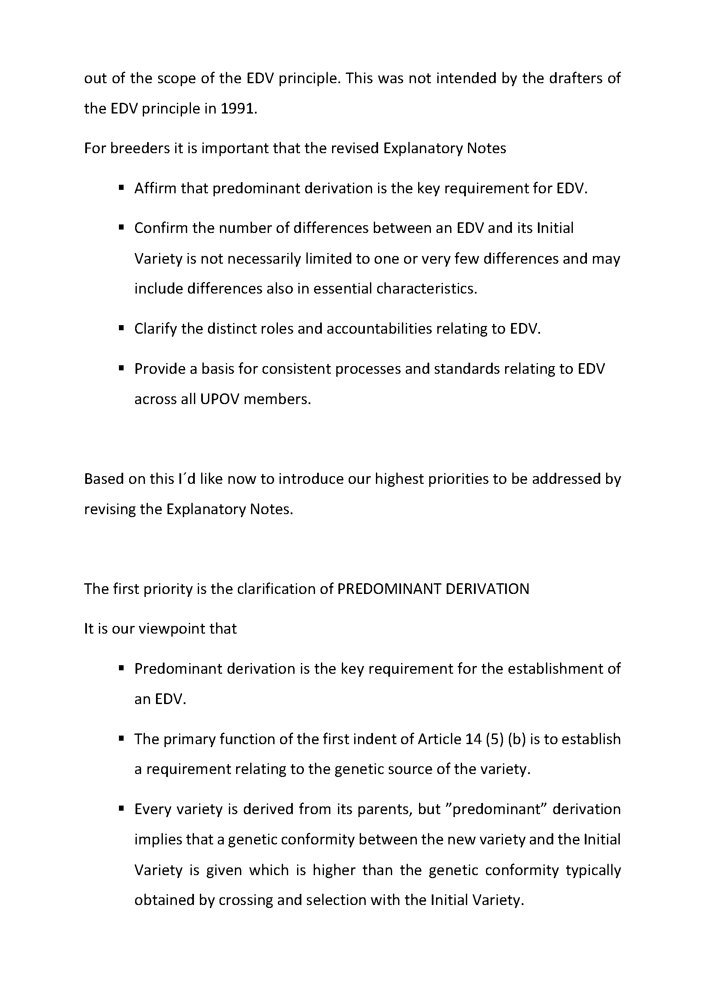

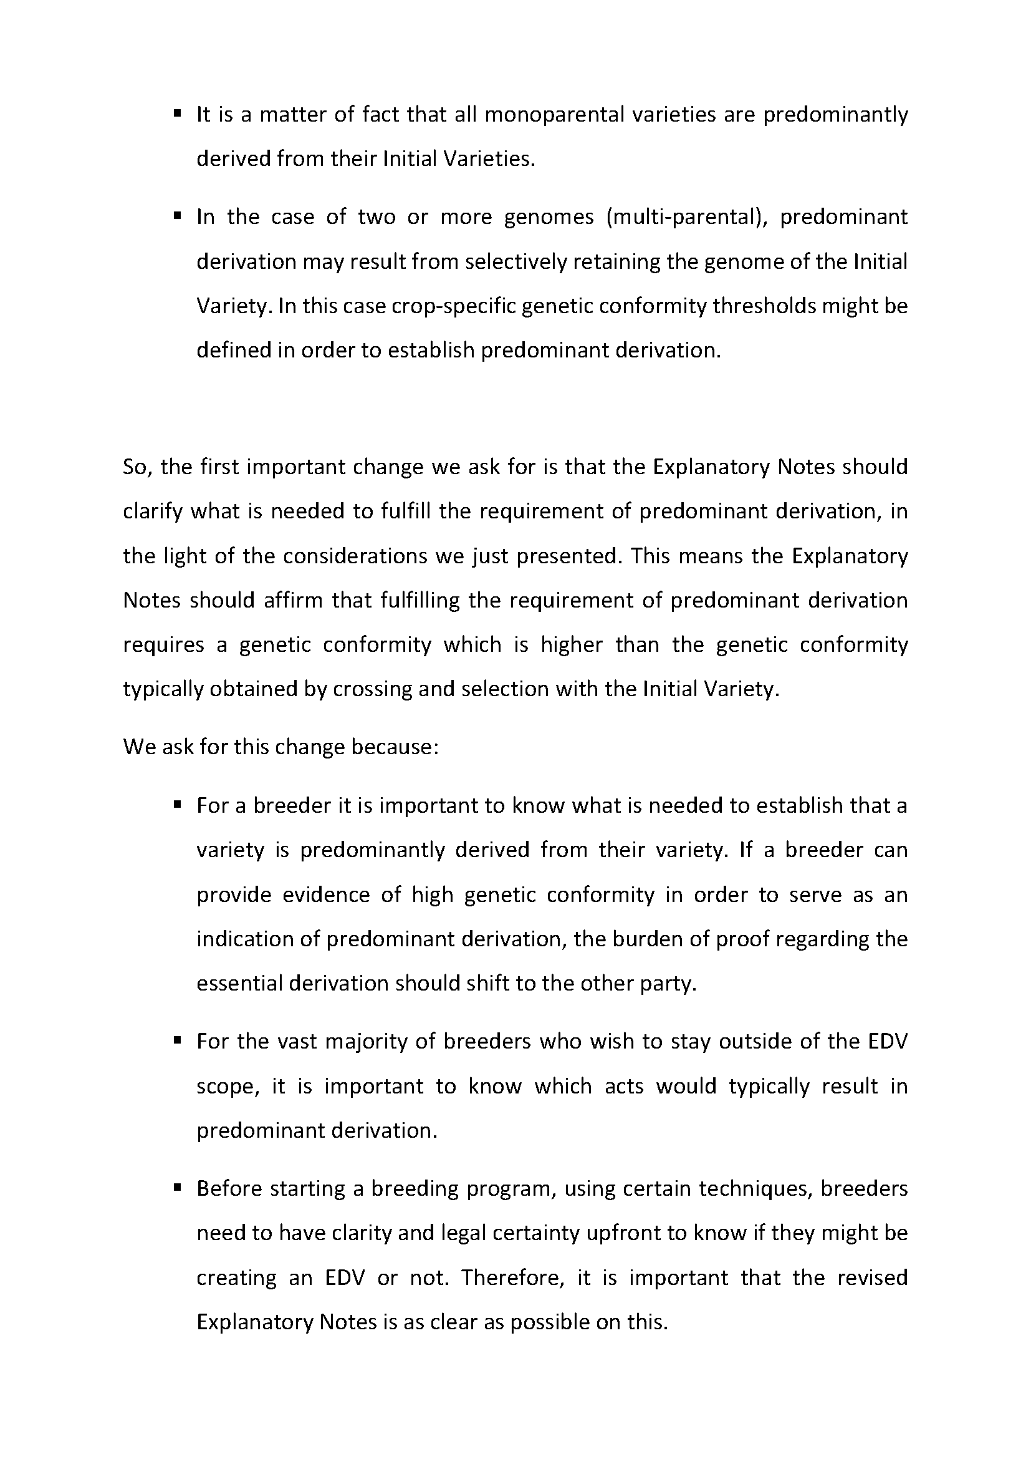

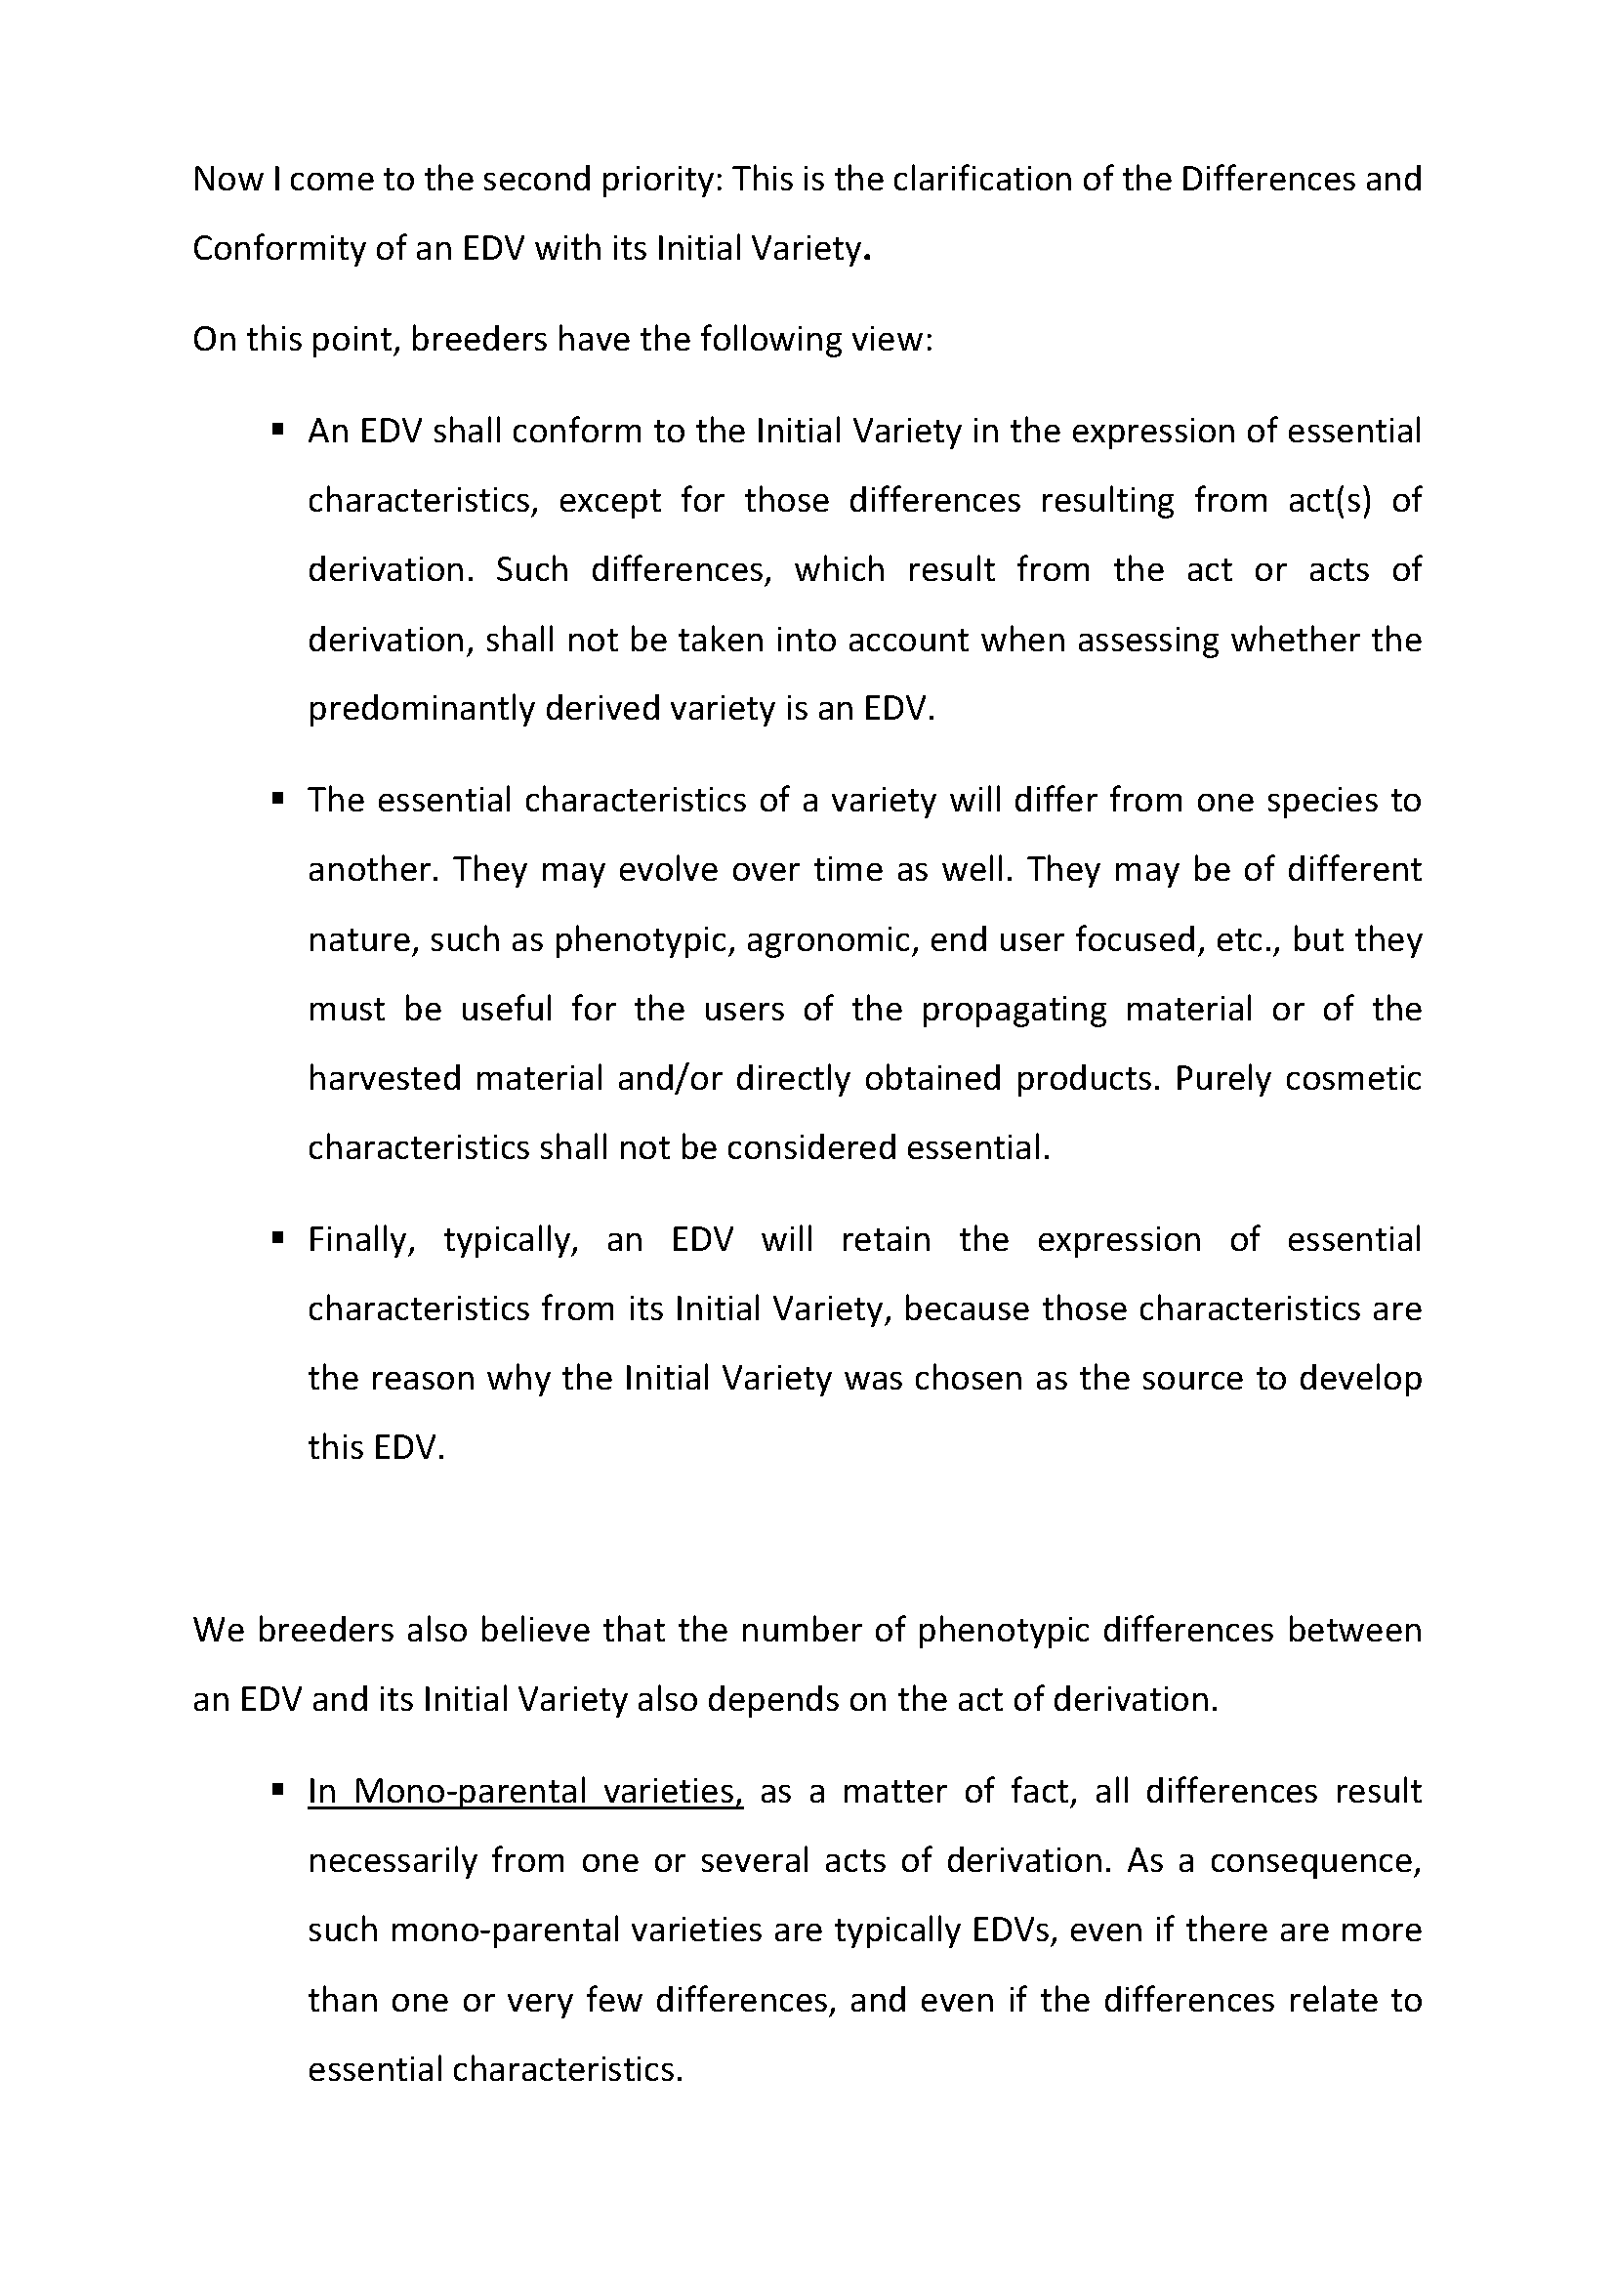

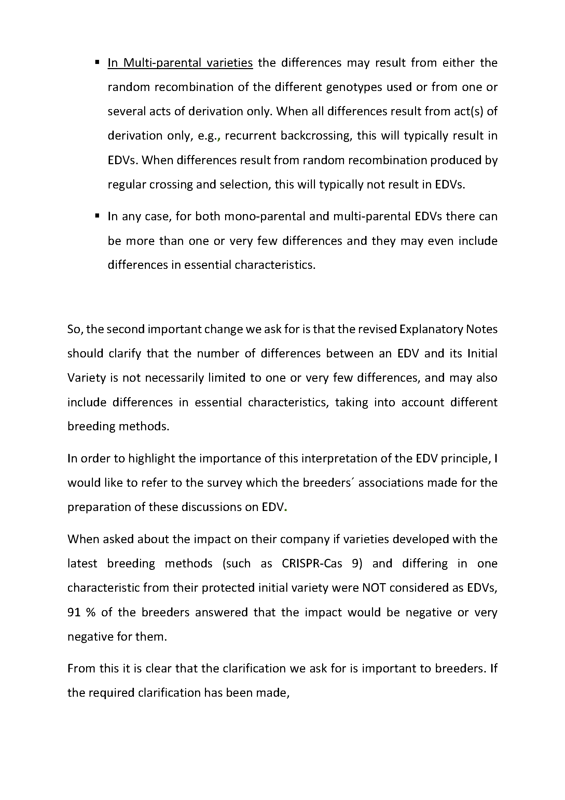

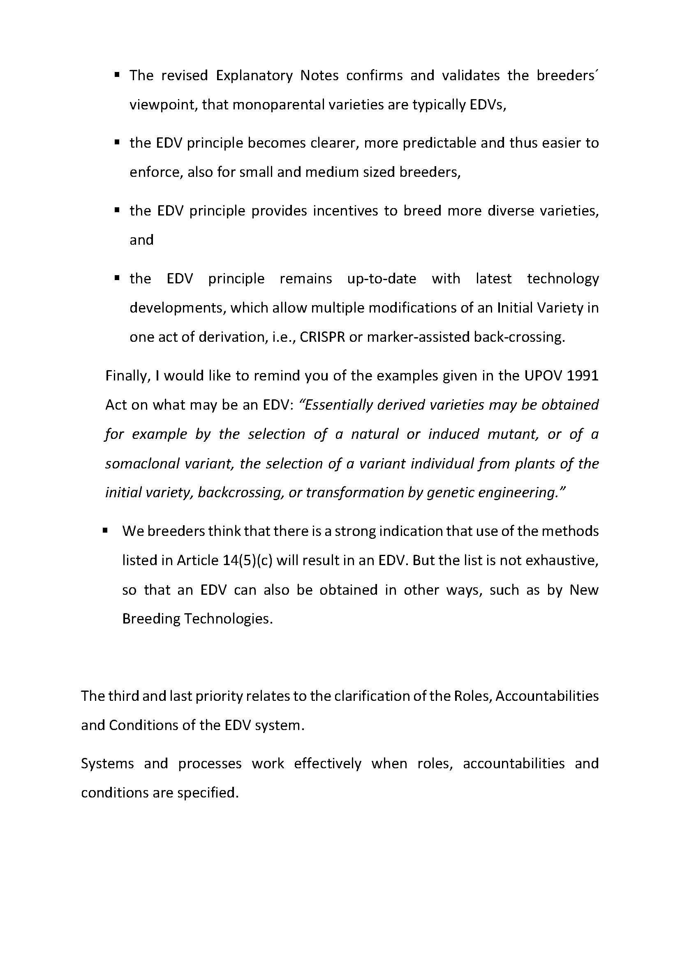

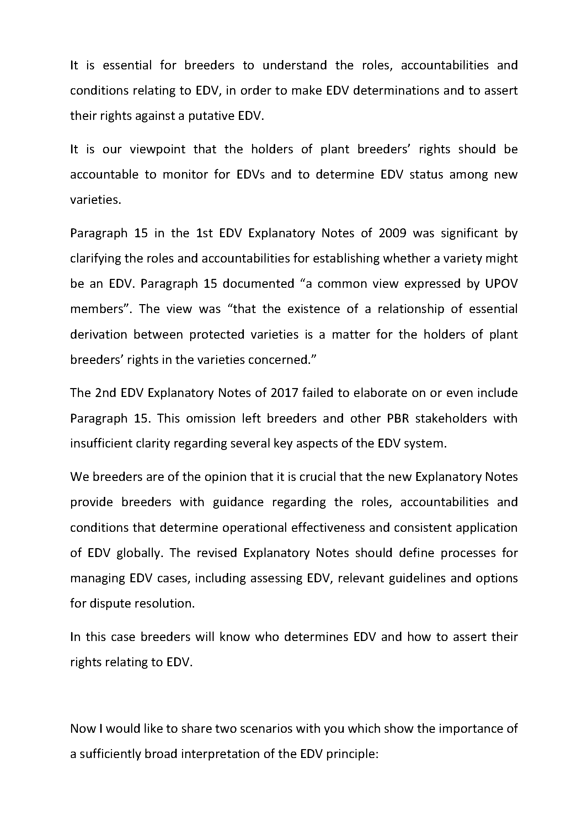

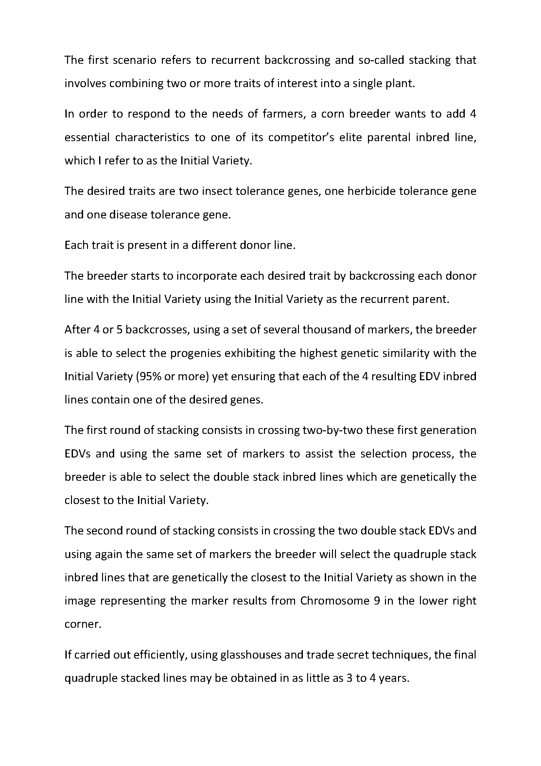

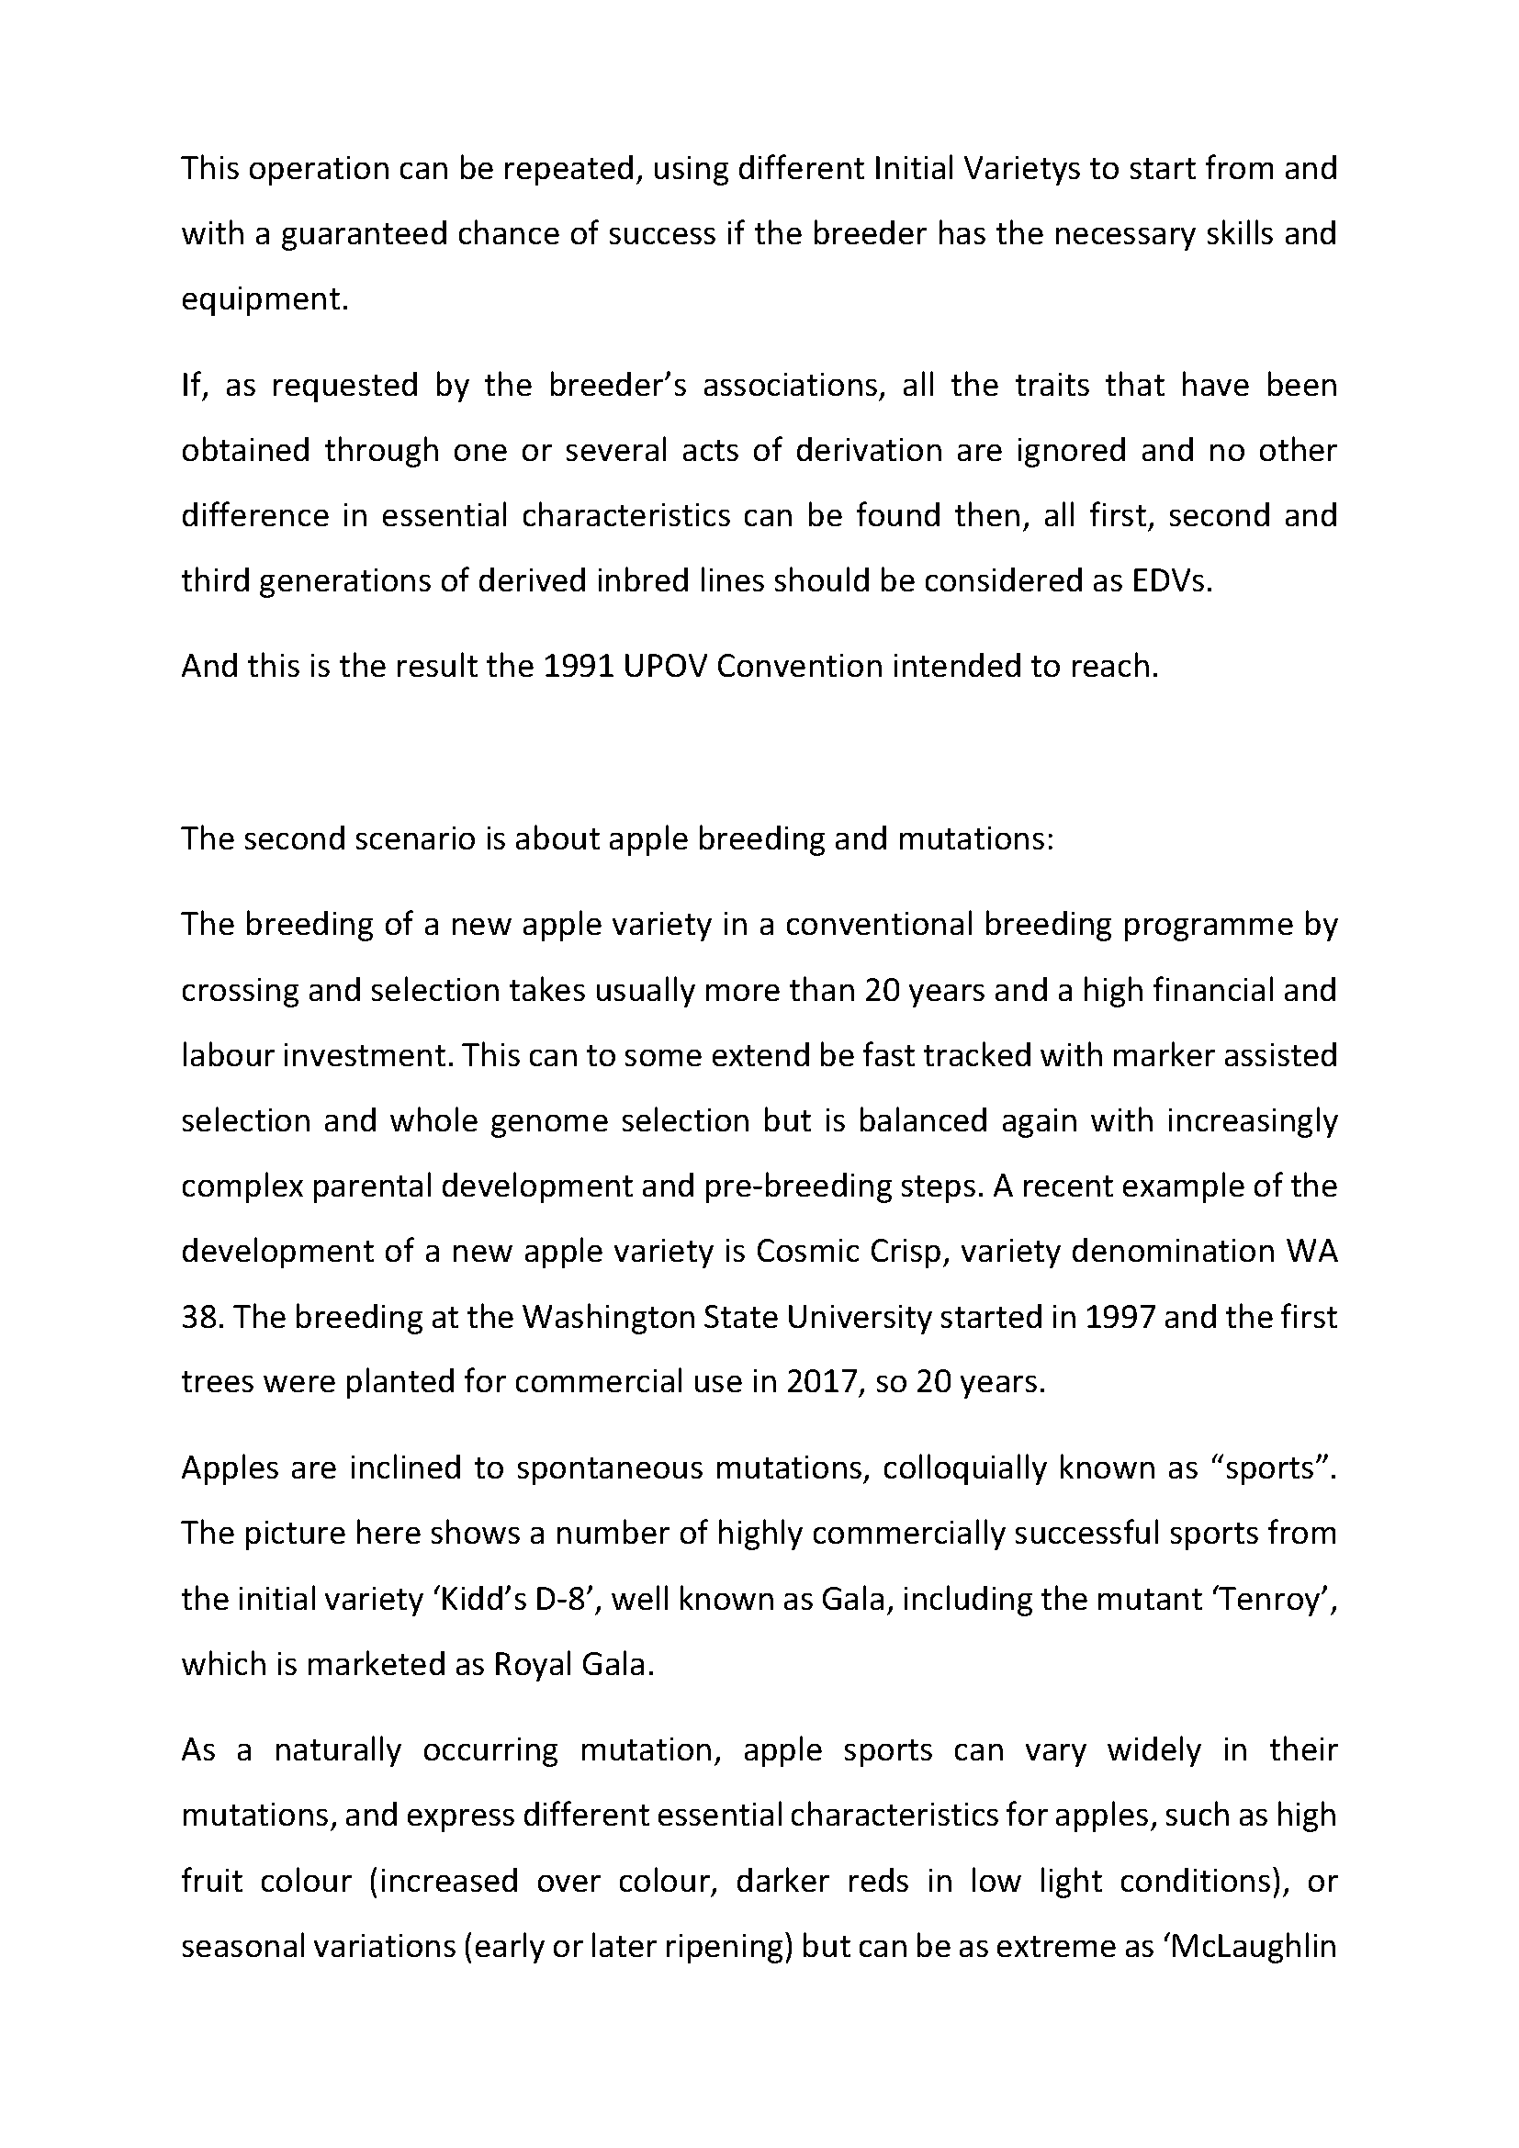

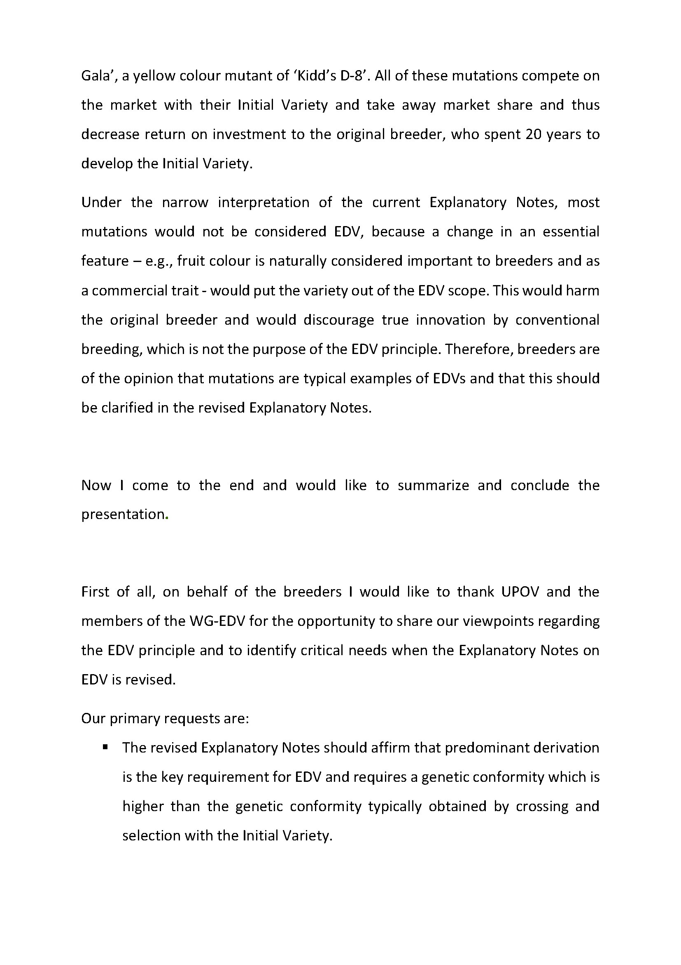

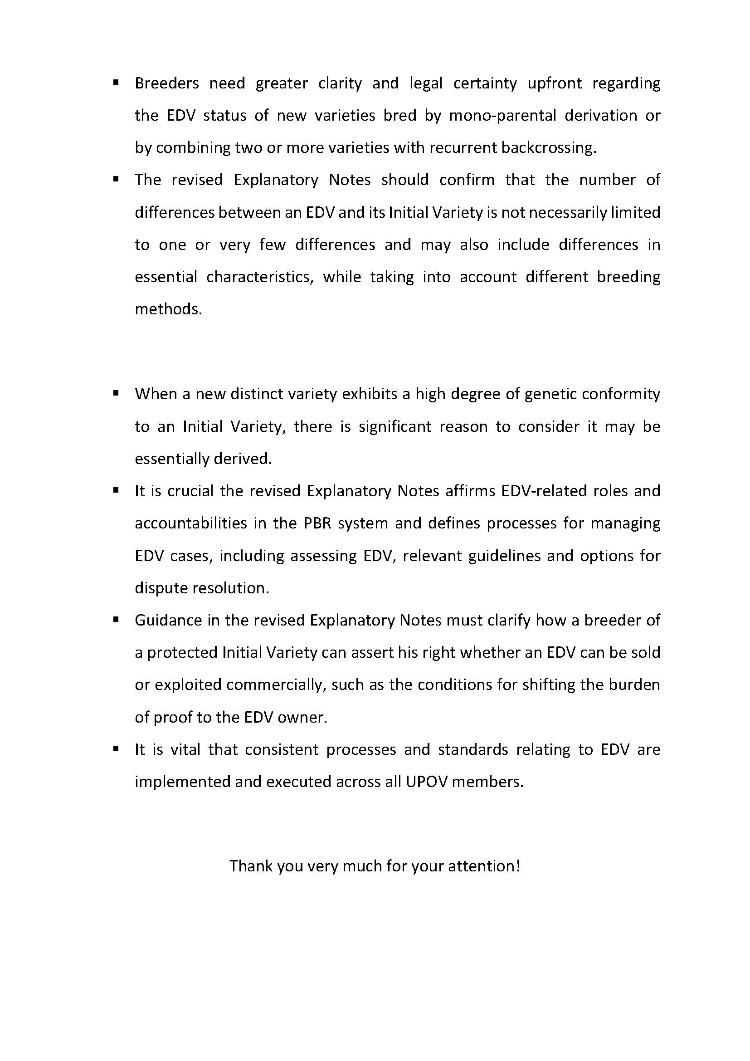
[End of Annex II and of document]

see document UPOV/WG-EDV/1/3 “Report”, paragraphs 5 to 9, available at: https://www.upov.int/meetings/en/details.jsp?meeting_id=60508.

