E
UPOV/WG-DST/2/4
ORIGINAL: English
DATE: July 21, 2015
INTERNATIONAL UNION FOR THE PROTECTION OF NEW VARIETIES OF PLANTS
Geneva
Working Group for the Development of a UPOV Denomination Similarity Search Tool
Second Meeting
Geneva, June 9, 2015
intermediate Report of the WG-DST Test study
Document prepared by an expert from WIPO
Disclaimer: this document does not represent UPOV policies or guidance
The Annex to this document contains a copy of a presentation made to the WG-DST Test Study, at its second meeting, on the intermediate results of the Test Study.

[Annex follows]

INTERMEDIATE REPORT OF THE WG-DST TEST STUDY

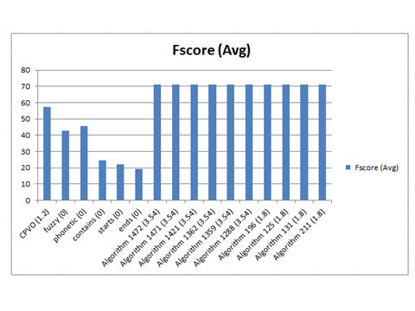

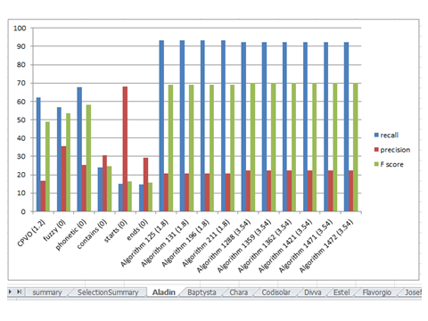

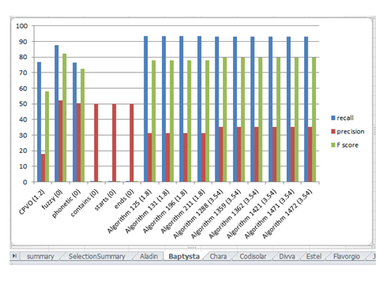

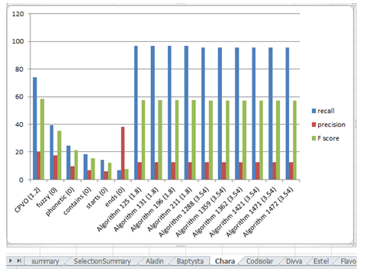

[End of Annex and of document]

