E
UPOV/WG-DST/1/2
ORIGINAL: English
DATE: September 4, 2014
INTERNATIONAL UNION FOR THE PROTECTION OF NEW VARIETIES OF PLANTS
Geneva
Working group FOR THE DEVELOPMENT OF A UPOV denomination SIMILARITY search tool
First Session
Geneva, September 3, 2014
The cpvo similarity search tool

Document prepared by the European Union
Disclaimer: this document does not represent UPOV policies or guidance

The Annex to this document contains a copy of a presentation made by Mr. Jean Maison, Community Plant Variety Office of the European Union (CPVO), at the Working Group on Variety Denomination Search Tool (WG-DST), on the CPVO similarity search tool.

[Annex follows]

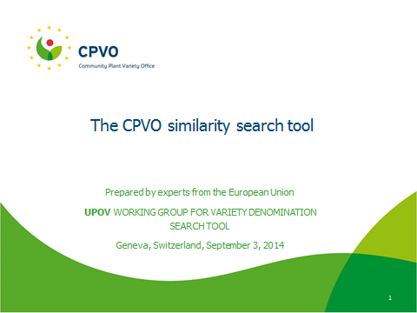

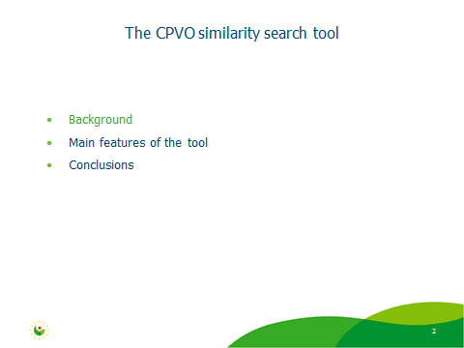

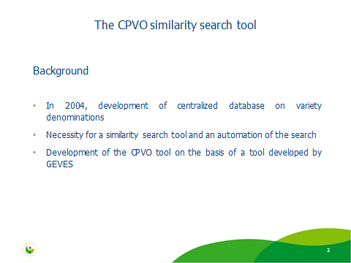

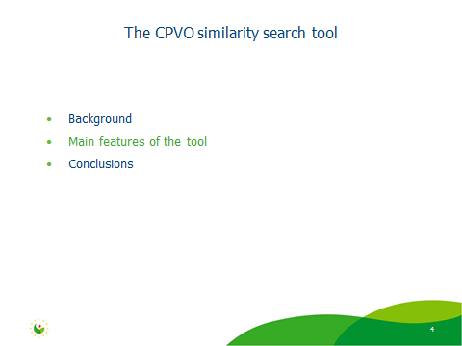

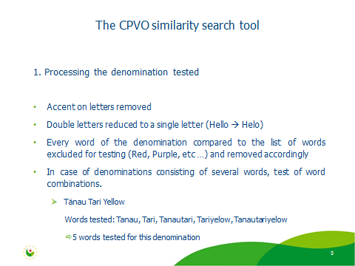

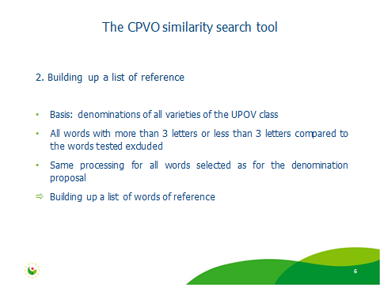

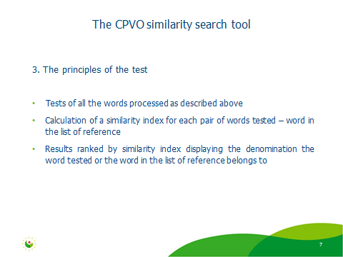

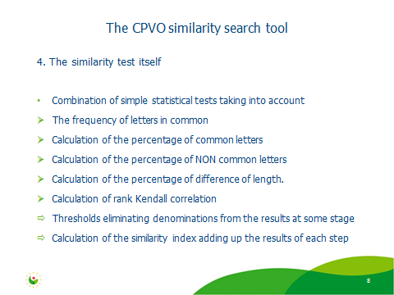

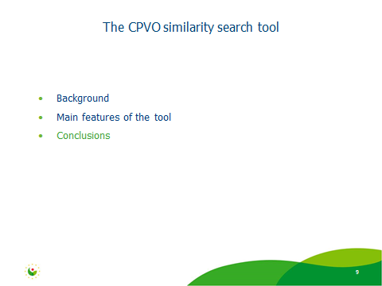

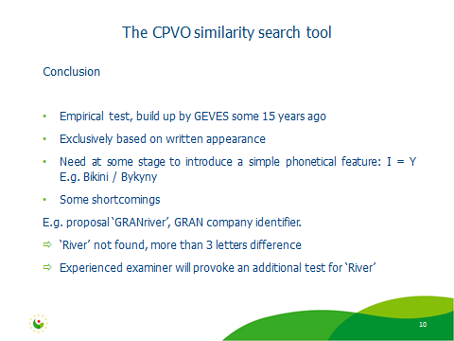

[End of Annex and of document]

