E
International Union for the Protection of New Varieties of Plants

Working Group on DUS Support  Second Meeting  Geneva, February 8, 2023 | UPOV/WG-DUS/2/2  Original: English  Date: January 26, 2023
Options to address issues raised
Document prepared by the Office of the Union
Disclaimer: this document does not represent UPOV policies or guidance

Executive summary

The purpose of this document is to present proposals for consideration by the Working Group on DUS Support (WG-DUS) to improve the technical support provided by UPOV for DUS examination, as identified by participants in the interviews of members and observers reported in document TC/58/18 “Survey on the needs of members and observers in relation to TWPs”.

The following areas are particularly discussed in this document:

(i) procedure for development and revision of Test Guidelines;
(ii) disseminating information on new developments in DUS examination; and
(iii) the organization of UPOV technical meetings.

The WG-DUS is invited to:

(a) consider the alternative options to organize UPOV annual technical meetings, as set out in paragraphs 12 to 16 of this document;

(b) consider the proposed procedure for development and revision of UPOV Test Guidelines, as set out in paragraphs 18 to 22 of this document; and

(c) consider possible performance indicators to assess the measures proposed, as set out in paragraph 27 of this document.

The structure of this document is as follows:

Executive summary 1
Background 2
First meeting of the Working Group on DUS Support 2
Options to address issues raised. 2
Organization of UPOV Annual Technical Meetings 3
TWPs alternating physical and virtual meetings 5
Annual physical meetings of combined TWPs 6
Annual Technical Conference 6
UPOV Test Guidelines 7
Procedure for development and adoption of Test Guidelines 7
Technical Working Party on Testing Methods and Techniques 8
Performance indicators 8

Annex I Alternative arrangements for UPOV technical meetings
Annex II Additional elements to address issues raised

The following abbreviations are used in this document:

ATM: Annual Technical Conference
TC: Technical Committee
TC-EDC: Enlarged Editorial Committee
TWA: Technical Working Party for Agricultural Crops
TWF: Technical Working Party for Fruit Crops
TWM: Technical Working Party on Testing Methods and Techniques
TWO: Technical Working Party for Ornamental Plants and Forest Trees
TWPs: Technical Working Parties
TWV: Technical Working Party for Vegetables
WG-DUS: Working Group on DUS Support

Background

The background to this matter is provided in documents TC/58/18 “Survey on the needs of members and observers in relation to TWPs” and TC/58/31 “Report”, paragraphs 60 to 64.

First meeting of the Working Group on DUS Support

The WG-DUS, at its first meeting, considered the list of issues in Circular E-22/215 and agreed they should be amended to read as follows (see document WG-DUS/1/1 “Report”, paragraph 6):

- What we should aim to deliver:

- Harmonized procedures;
- Information on developments;
- Interaction between experts and integration of new experts in UPOV’s work;
- Training.

- Aspects to be considered:

- avoid unnecessary repetition of content across meetings;
- integrating TWM-related matters into meetings/events with DUS examiners;
- time for members’ presentations on DUS procedures;
- visits to field trials with sufficient time for engagement (e.g. ring-tests);
- providing opportunities for experts to meet and exchange views;
- facilitating hands-on training;
- focus Test Guidelines discussion on revising existing TGs, including improving explanations and usability;
- hybrid or online Test Guidelines meetings to increase involvement of experts and members;
- facilitate drafting national test guidelines through access to other members’ test guidelines and experts who can assist drafting;
- other cross-cutting matters historically considered by TWPs (e.g. TGP documents, UPOV code etc.).

The WG-DUS, at its first meeting, agreed to invite the Office of the Union to prepare a document with proposals in relation to the recommendations in document TC/58/18, on the basis of the above issues and the views expressed during the meeting. The document would be circulated prior to the second meeting of the WG-DUS (see document TC/58/31 “Report”, paragraph 7).

Options to address issues raised.

This document focuses on three elements considered essential for the discussion on improving the support provided by UPOV for DUS examination. These elements are:

(i) organization of discussion on UPOV Test Guidelines;

(ii) dissemination of information on new developments for DUS testing that is now contained in the Technical Working Party on Testing Methods and Techniques (TWM) to participants in other TWPs (e.g. molecular techniques, phenotypic applications and statistical methods); and

(iii) organization of the annual technical meetings.

To streamline discussions, proposals on other subjects from document TC/58/18 that contain less elements for discussion are presented in Annex II to this document.

On the basis of discussions at the first meeting of the WG-DUS, the initiatives presented in document TC/58/18 “Survey on the needs of members and observers in relation to TWPs” are further elaborated in the following sections.

Organization of UPOV Annual Technical Meetings

Different alternatives could be envisaged to improve the organization of UPOV annual technical meetings. The following table provides a summary of key aspects of different alternatives in relation to the annual technical meetings:

Alternative  Aspects | TWPs alternating physical and virtual meetings | Annual physical (hybrid) meetings of TWPs with 2 TWPs meeting jointly | Annual Technical Conference
Periodicity | Annual | Annual | Annual
Type of meeting | Technical Working Party | Technical Working Party | Conference (not a Technical Working Party)
Format of meeting | One year fully online; alternating with another year of physical meeting (hybrid) | physical meeting (hybrid) | physical meeting (hybrid)
Proposals to TC | Yes | Yes | No
Crops covered | separate meetings for Agricultural, Fruits, Ornamental and Forest Trees; and Vegetables | meetings of Agricultural crops in conjunction with Vegetables; and Fruit crops in conjunction with Ornamental Plants and Forest Trees | All crop types
Crop specific sessions | integrated in the format of the TWPs | integrated in the format of the TWPs | Yes. Parallel sessions per crop type as part of the program
Remarks | Arrangement agreed by the TC in 2022 | More opportunity for presentation of TWM matters. | Increased interaction with other relevant experts (e.g. breeders; farmers and growers; researchers)
Participants | Restricted to members and accredited observers | Restricted to members and accredited observers | Open meeting
Test Guidelines | as now but with proposals for greater efficiency (see below) | as now but with proposals for greater efficiency (see below) | Not discussed. Separate online crop subgroups with reports from leading experts during crop specific sessions to report directly to TC
TGP documents | no change | no change but more efficient discussions because there will be joint TWP discussions | Not discussed. Separate online crop subgroups with reports from leading experts during crop specific sessions to report directly to TC
Consequences to UPOV structure | maintain same structure of TWPs (see organigram) | maintain same structure of TWPs (see organigram) | deletion of the Technical Working Parties as UPOV bodies, introduction of subgroups (see organigram)
Total number of meetings per year | 5 (TWA, TWF, TWM, TWO and TWV) | 2 or 3 (TWA+TWV; TWF+TWO; and TWM) | 1 Annual Technical Conference

TWPs alternating physical and virtual meetings

The TC, at its fifty-seventh session, agreed that the TWP sessions would be scheduled one year as a virtual meeting and the following year as a physical meeting (e.g. 2023: virtual; 2024: physical) (see document TC/57/25 “Report”, paragraph 64). The following organigram describes the structure of UPOV technical meetings:

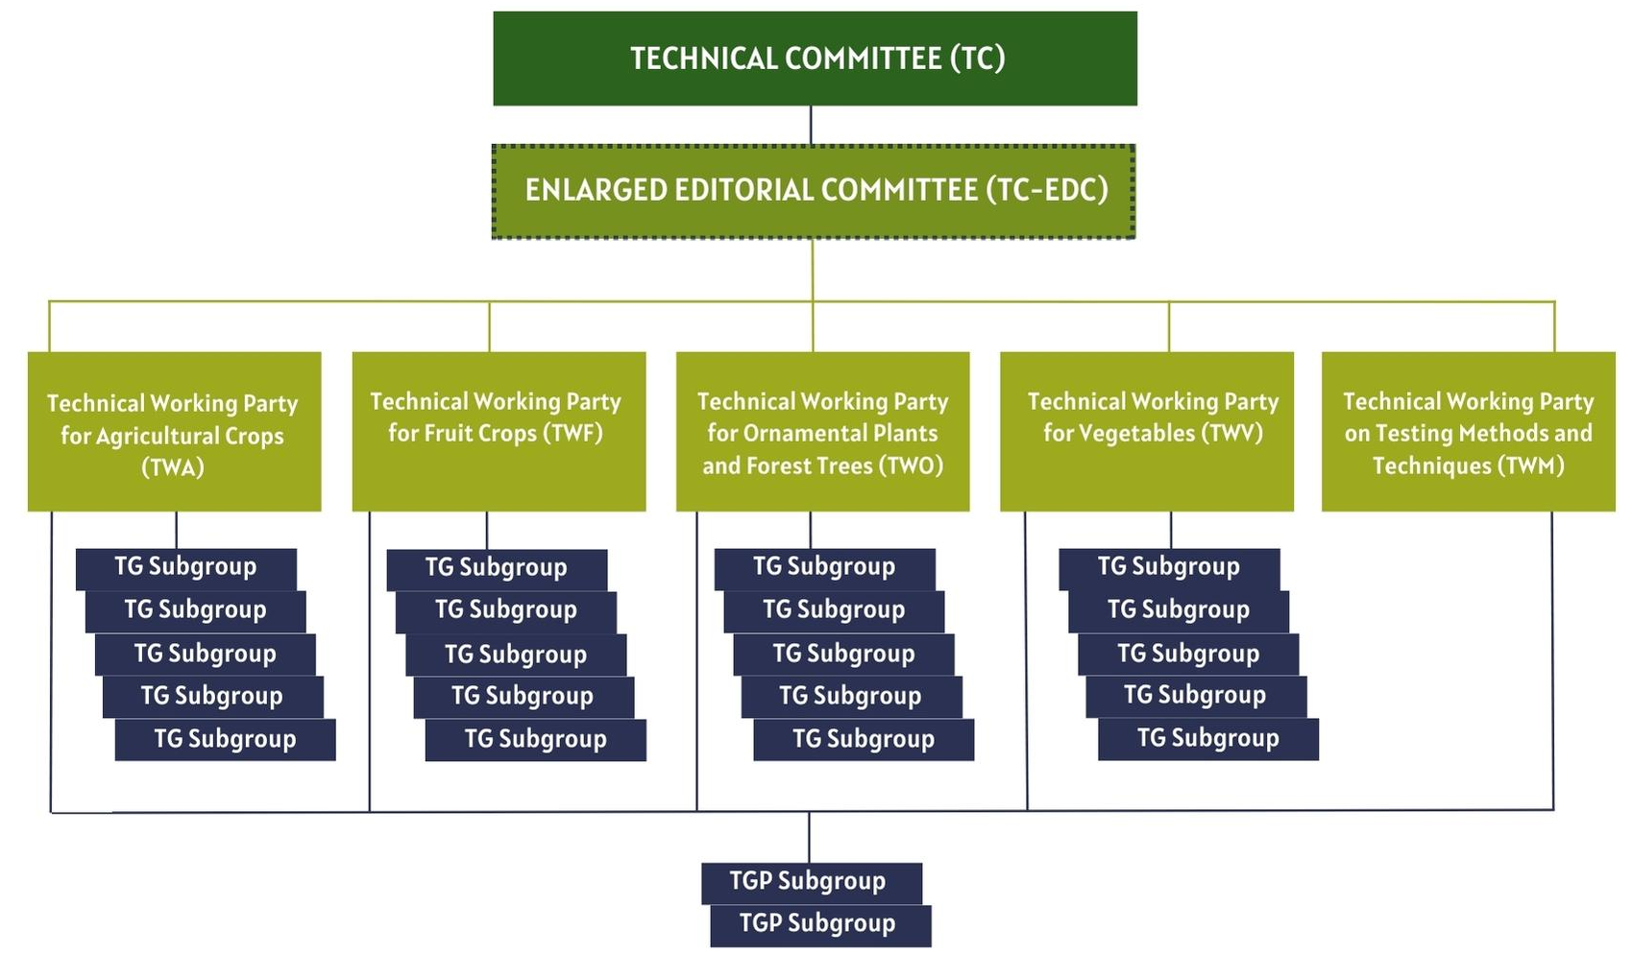

Annual physical meetings of combined TWPs

The following organigram describes the possible structure of UPOV technical meetings with combined meetings of the Technical Working Party for Agricultural Crops with the Technical Working Party for Vegetables as well as the combined meetings of the Technical Working Party for Fruit Crops with the Technical Working Party for Ornamental Plants and Forest Trees. The content of the Technical Working Party on Testing Methods and Techniques would be presented during the sessions of each of the combined TWPs meetings, as appropriate:
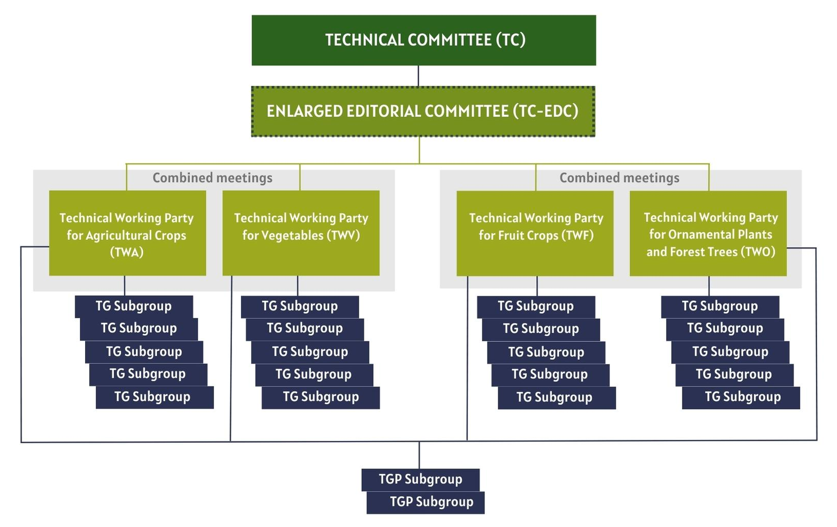

Annual Technical Conference

Deleting the Technical Working Parties and organizing one Annual Technical Conference would change the organigram of UPOV annual technical meetings as follows:

Further details on each of the alternatives to organize UPOV annual technical meetings is provided in Annex I to this document.

The WG-DUS is invited to consider the alternative options to organize UPOV annual technical meetings, as set out in paragraphs 12 to 16 of this document.

UPOV Test Guidelines

The procedure for developing and revising UPOV Test Guidelines as well as member’s test guidelines is set out in document TGP/7 “Development of Test Guidelines”.

The procedure leaves room for the TC to continue commissioning the drafting of new Test Guidelines where it would not increase the percentage of PVP applications covered by UPOV Test Guidelines. The criteria set out in document TGP/7 could be revised for further clarity in relation to commissioning the drafting of new Test Guidelines only when these would be expected to significantly increase the percentage of PVP applications covered by UPOV TGs. This would not prevent members to draft national test guidelines for such crops.

It should be noted that the possibility foreseen in document TGP/7 to discuss the creation or revision of UPOV Test Guidelines outside the annual TWP meetings is not often used. Online meetings are now widely used and could improve considerably the way Test Guidelines are discussed. It would enable crop experts not attending TWP meetings to contribute to discussions. It would also allow discussions during TWP meetings to focus on particular aspects of previously discussed drafts instead of considering the whole document.

Some of the reasons for the limited use of online meetings are the requirement set out in document TGP/7 to use the web-based TG template and specific rules on participation and timetable for preparing and commenting on documents. Document TGP/7 could be revised on these points to make best use of members’ resources during the intersessional period between the annual TWP meetings.

Once the above issues are addressed, the following situation could be expected (depending on the choice between alternatives on how to organize the annual technical meetings):

- Discussion on Test Guidelines would be organized in TG subgroups allowing optimal time and maximum participation by crop experts.
- A leading expert would be appointed to chair the subgroup discussions and be responsible for planning and organizing the work to develop or revise Test Guidelines.
- The subgroups would have flexibility to decide on virtual or (partly) physical meetings and agree on the frequency and duration of meetings. As far as possible, time zone constraints would be taken into account. Physical meetings would be in hybrid format.
- The leading expert would decide whether the UPOV Office would be required to assist the work of the subgroup.
- Progress in subgroups discussions would be reported by the leading experts during the crop specific meetings in the Annual Technical Conference or at the Technical Working Party concerned.
- Only final draft Test Guidelines agreed by the Subgroup would be presented for consideration of the full document at the TWP.
- Any crosscutting issues or outstanding matters identified by the subgroups would be considered at the TWP concerned or the TC.
- At the request of the Leading Expert, the Chair of the Technical Working Party may agree to have a subgroup discussion in the relevant TWP/ATM meeting.

Procedure for development and adoption of Test Guidelines

- The leading expert would decide on the practical organization of the drafting process. The use of the web-based TG template during the drafting process would be optional, except that the final draft would need to be prepared in the web-based TG template format.
- Once agreed by the subgroup and accepted by the TWP, the leading expert would prepare a version of the draft Test Guidelines to be presented to the Editorial Committee prior to submission to the TC for adoption.
- If the format of the Annual Technical Conference is chosen, the TC would designate experts to become members of the Editorial Committee for a three-year term. TC-EDC designated experts should provide expertise in different crop types (agricultural, fruit, ornamental and forest trees and vegetables) and UPOV languages.
- The role of the TC-EDC would, as now, be to ensure the quality of TGs, in accordance with UPOV guidance (e.g. TGP documents).

The WG-DUS is invited to consider the proposed procedure for development and revision of UPOV Test Guidelines, as set out in paragraphs 18 to 22 of this document.

Technical Working Party on Testing Methods and Techniques

The Technical Working Party on Testing Methods and Techniques (TMV) discusses developments that may be important for DUS examination in all genera and species. New molecular methods, the use of phenotypic techniques to measure and observe characteristics and statistical tools are of great importance for the work in all TWPs. Therefore, interaction between TWM experts should be promoted with those of other TWPs to note and discuss developments in the TWM areas of expertise.

The TC, at its fifty-seventh session, agreed that the TWM would meet electronically in 2022 and would assess the need to meet physically in the future, according to the range of topics to be covered. UPOV technical meetings organized in the future should provide sufficient opportunities for online presentations by the TWM experts for crop experts, as appropriate.

In case the technical meetings are organized as “annual physical meetings of combined TWPs” or as “Annual Technical Conference”, the TWM would be held in conjunction with these meetings.

Performance indicators

In relation to assessing success of the recommended proposals, the following performance indicators are proposed:

(a) Harmonized procedures

- Number of UPOV members using UPOV Technical Questionnaires
- Test Guidelines covering [94]% of all PVP applications in UPOV members
- Use of UPOV member test guidelines by other UPOV members to develop national test guidelines where there are no UPOV Test Guidelines
- Number of DUS reports used by other members (take-over and examination on behalf)

(b) Training

- Number of DUS examiners and administrators that have UPOV certification (see International Certificate on Plant Variety Protection)

The WG-DUS is invited to consider possible performance indicators to assess the measures proposed, as set out in paragraph 27 of this document.

[Annexes follow]

ALTERNATIVE ARRANGEMENTS FOR UPOV TECHNICAL MEETINGS

Alternative: Technical Working Parties to meet alternating physical/virtual

The TC, at its fifty-seventh session, agreed that the TWP sessions would be scheduled one year as a virtual meeting and the following year as a physical meeting (e.g. 2023: virtual; 2024: physical) (see document TC/57/25 “Report”, paragraph 64). It is proposed that the meetings comprise the following activities:

In the year of a physical (hybrid) meeting
- Presentations and discussions on current technical issues, including DUS trials, testing methods, including molecular techniques and other topics proposed by the TC
- Demonstrations of DUS trials and examination procedures, in the host country
- Discussions on Test Guidelines
- Discussions on TGP documents, if appropriate
- Ring tests: planning; evaluation and discussion of results
- Meeting rooms and scheduling of time to facilitate cooperation (e.g. bilateral discussions)
- Visits to plant breeders

In the year of a virtual meeting
- Presentations and discussions on current technical issues, including DUS trials, testing methods, including molecular techniques and other topics proposed by the TC
- Discussions on Test Guidelines
- Discussions on TGP documents, if appropriate
- Ring tests: planning; evaluation and discussion of results
- Breakout sessions and scheduling of time to facilitate cooperation (e.g. bilateral discussions)

The TC would decide the date and place of the meeting and the general content of the program. The detailed program would be arranged by the host and the Office of the Union in consultation with the Chairperson of the Technical Committee.

Tentative Model for the program of alternating Physical and Virtual Technical Working Party Meetings:

Physical meeting

 | Monday | Tuesday | Wednesday | Thursday | Friday
09.00 | Opening  Presentations and discussions on current technical issues, including members’ presentations on DUS procedures, testing methods, molecular techniques and other topics proposed by the TC | Presentations and discussions on current technical issues, including members’ presentations on DUS procedures, testing methods, molecular techniques and other topics proposed by the TC | Technical Visit | Presentations and discussions on current technical issues, including members’ presentations on DUS procedures, testing methods, molecular techniques and other topics proposed by the TC | Presentations and discussions on current technical issues, including members’ presentations on DUS procedures, testing methods, molecular techniques and other topics proposed by the TC
10.30 Coffee
11.00
12.45 Lunch |  |  |  |  | Closing of Session
14.00 | Presentations by TWM experts | Presentations by TWM experts |  | Presentations by TWM experts
15.30 Coffee
16.00 | Bilateral meetings |  |  | Bilateral meetings
18.00 | Reception

Tentative Model for the program of alternating Physical and Virtual Technical Working Party Meetings:

Virtual meeting

 | Monday | Tuesday | Wednesday | Thursday | Friday
Session A | Opening  Presentations and discussions on current technical issues, including members’ presentations on DUS procedures, testing methods, molecular techniques and other topics proposed by the TC | Presentations and discussions on current technical issues, including members’ presentations on DUS procedures, testing methods, molecular techniques and other topics proposed by the TC | Presentations and discussions on current technical issues, including members’ presentations on DUS procedures, testing methods, molecular techniques and other topics proposed by the TC | Presentations and discussions on current technical issues, including members’ presentations on DUS procedures, testing methods, molecular techniques and other topics proposed by the TC | Presentations and discussions on current technical issues, including members’ presentations on DUS procedures, testing methods, molecular techniques and other topics proposed by the TC
Break
Session B
Break
Session C | Presentations by TWM experts | Presentations by TWM experts | Presentations by TWM experts | Presentations by TWM experts | Adoption of report  Close of session

Alternative: Two combined Technical Working Parties meeting physically every year

To organize every year two combined events bringing together at the same place and during the same week (1) TWA and TWV; and (2) TWO and TWF. The TWPs would have separate discussions on their crop-specific topics and TG’s during three days, with one day for joint discussions and presentations and one day for visits to trials and/or breeders. If appropriate, the focus of the visits could alternate each year, i.e. agricultural crops for even years and vegetables for odd years.

The TWM would meet jointly with TWA/TWV and TWF/TWO to promote further interaction and joint discussions. The TWM would meet with each joint TWP in alternate years.

The meetings would be hosted by members of the Union in hybrid format except for the field visits, although the host could offer a virtual visit by video.

The program would be structured as follows:

- Presentations and discussions on current technical issues, including DUS trials, testing methods, including molecular techniques and other topics proposed by the TC
- Demonstrations of DUS trials and examination procedures in the host country
- Discussions on Test Guidelines and TGP documents, if appropriate
- Ring tests: planning; evaluation and discussion of results
- Meeting rooms and scheduling of time to facilitate cooperation (e.g. bilateral discussions)
- Visits to plant breeders

The TC would decide the date and place of the meeting and the general content of the program. The detailed program would be arranged by the host and the Office of the Union in consultation with the Chairperson of the Technical Committee.

Tentative model program of work for an annual physical (hybrid) meeting of combined TWPs (joint TWA + TWV; and TWF + TWO)

 | Monday | Tuesday |  | Wednesday | Thursday |  | Friday
 |  | TWP 1 | TWP 2 |  | TWP 1 | TWP 2
09.00 | Opening  Cross-cutting issues  Presentations and discussions on current technical issues, including members’ presentations on DUS procedures, testing methods, molecular techniques and other topics proposed by the TC | Crop-specific topics  Presentations and discussions on current technical issues, including members’ presentations on DUS procedures, testing methods, molecular techniques and other topics proposed by the TC | Crop-specific topics  Presentations and discussions on current technical issues, including members’ presentations on DUS procedures, testing methods, molecular techniques and other topics proposed by the TC | Technical Visit | Crop-specific topics  Presentations and discussions on current technical issues, including members’ presentations on DUS procedures, testing methods, molecular techniques and other topics proposed by the TC | Crop-specific topics  Presentations and discussions on current technical issues, including members’ presentations on DUS procedures, testing methods, molecular techniques and other topics proposed by the TC | Cross-cutting issues  Presentations and discussions on current technical issues, including members’ presentations on DUS procedures, testing methods, molecular techniques and other topics proposed by the TC
10.30 Coffee
11.00
12.45 Lunch |  |  |  |  |  |  | Close of Session
14.00 |  | Presentations by TWM experts |  |  | Presentations by TWM experts
15.30 Coffee
16.00 |  | Bilateral meetings | Bilateral meetings |  | Bilateral meetings | Bilateral meetings
18.00 | Reception

Alternative: Annual Technical Conference

Replace Technical Working Party meetings by a single Annual Technical Conference, hosted by a member of the Union, comprising the following activities:

- Presentations and discussions on current technical issues, including DUS trials, testing methods, molecular techniques, phenotypic techniques, statistical methods and other topics proposed by the TC
- Thematic sessions covering particular crop sectors
- Demonstrations on DUS examination, including visits to trial sites in the host country
- Ring tests: planning; evaluation and discussion of results
- Exhibition of research (poster sessions)
- Meeting rooms to facilitate cooperation (e.g. bilateral discussions)
- Visits to plant breeders

The Annual Technical Conference would not take decisions. Participation would be open with the aim of attracting participation by, plant breeders, farmers, growers and researchers. All decisions on technical matters would remain with the Technical Committee (TC).

The TC would decide the date and place of the conferences and the general content of the program. The detailed program would be arranged by the host and the Office of the Union in consultation with the Chairperson of the Technical Committee. Parts of the Annual Technical Conferences would allow virtual participation.

The resources required to host such a conference could be substantially different from those for hosting a Technical Working Party. Therefore, it should be accepted that the host could charge a fee to participants in relation to the costs involved in hosting the event. The host should also have the possibility to seek funding from suitable sources to contribute to the cost of hosting the event.

With regard to practical training, technical visits to trials in the host country and the conduct of ring tests are valuable elements for practical training. However, practical DUS training beyond these initiatives, would be most effective if organized by UPOV members separately from the Annual Technical Conference.

Tentative Model work plan for an Annual Technical Meeting

 | Monday | Tuesday | Wednesday | Thursday | Friday
09.00 | Opening  Presentations and discussions on current technical issues, including members’ presentations on DUS procedures, testing methods, molecular techniques and other topics proposed by the TC | Science day  Presentations and discussions on current technical issues, including members’ presentations on DUS procedures, testing methods, molecular techniques and other topics proposed by the TC | Technical Visit | Presentations and discussions on current technical issues, including members’ presentations on DUS procedures, testing methods, molecular techniques and other topics proposed by the TC | Presentations and discussions on current technical issues, including members’ presentations on DUS procedures, testing methods, molecular techniques and other topics proposed by the TC
10.30 Coffee
11.00
12.45 Lunch
14.00 |  | Poster session
15.30 Coffee
16.00 | Crop-specific meetings:  Agricultural crops;  Fruit crops;  Ornamental plants and forest trees; and  Vegetables; | Crop-specific meetings:  Agricultural crops;  Fruit crops;  Ornamental plants and forest trees; and  Vegetables; |  | Crop-specific meetings: Agricultural crops; Fruit crops; Ornamental plants and forest trees; and  Vegetables; | Crop-specific meetings: Agricultural crops; Fruit crops; Ornamental plants and forest trees; and  Vegetables;
18.00 | Reception
[Annex II follows]
ADDITIONAL ELEMENTS TO ADDRESS ISSUES RAISED

UPOV members test guidelines

UPOV Test Guidelines cover approximately 94% of all applications filed in UPOV members. Test Guidelines for remaining crops would be dealt with by supporting the development or information from members’ national test guidelines. New Test Guidelines would not be commissioned, unless strategically important for UPOV.

Developing UPOV Test Guidelines for the more than 3000 genera and species that are not currently covered by UPOV Test Guidelines would not be feasible. To address the need for guidance on DUS testing of these species, UPOV provides information on practical experience and existing cooperation of UPOV members in the GENIE database. The feedback from the survey was that this information is not regularly maintained and used by all members.

It is proposed that the Office of the Union would stop requesting information on practical knowledge and cooperation in DUS examination. Information on practical experience can be derived by searching the PLUTO database for members receiving recent applications. Guidance would be developed to explain how to use the PLUTO database to obtain that information. UPOV is currently developing a DUS Exchange platform as part of the e-PVP initiative, which would provide practical assistance for cooperation in DUS examination (see DUS report exchange platform (E-PVP)).

A number of UPOV members have developed their own test guidelines for species for which there are no UPOV Test Guidelines. Enabling UPOV members to make their test guidelines available to other UPOV members would provide a practical resource and could facilitate cooperation for crops without UPOV Test Guidelines.

- The web-based TG template would be expanded to enable drafting of individual authorities’ test guidelines.
- The content of individual authorities’ test guidelines developed using the web-based TG template would be made available to UPOV members in a searchable format.
- It would be clarified for users that national authorities’ test guidelines would be the sole responsibility of the respective UPOV member.

Members seeking assistance to develop their national test guidelines would be directed to the list of contact persons for international cooperation in DUS examination (see: https://www.upov.int/databases/en/contact_cooperation.html). Members willing to provide mentoring to others on drafting national test guidelines would be indicated in the list.

TGP documents

Matters that would require amending or developing guidance in TGP documents would be dealt with by subgroups established by the Technical Committee (TC). These subgroups would meet online and report to the TC any proposals.

The TGP subgroups established by the TC would have a leading expert that would chair the discussions. The leading expert would be in charge of presenting the findings of the subgroup and any proposals to the TC.

Training

Training is one of the corner stones of the UPOV system and helps to guarantee the harmonized application of the UPOV system by all members of the Union. Not only the training in the administrative and legal elements of the system, but also in the technical aspects around the testing of varieties. Technical training has theoretical backgrounds as described in the various UPOV guidance documents, but the application of this theory in practice is an important element of the training.

The UPOV Office will ensure that theoretical training material will be available in the form of Distance learning Courses and Training Webinars. New Modules will be developed for the training of Experts and on the content and use of TGP documents and other UPOV information material.
Training webinars

Training webinars could be conducted to address topics of particular relevance, as defined by the TC in response to requests from members and/or observers.

Training on drafting Test Guidelines and applying UPOV guidance would be developed and offered to leading experts and other experts as webinars and video recordings.

The Technical Working Parties preparatory webinars held in 2021 and 2022 have been recorded and made available on the UPOV YouTube channel (available at: https://www.youtube.com/playlist?list=PLiCnDr7C9sxZhQPuuAPPW1xY_o_EvTFfN). A similar webinar structure could be used to enable sharing of experiences from members on particular aspects of DUS examination. Video recordings of webinars would constitute a library of online resources.

Distance learning courses

The interviews revealed the need to update the distance learning courses and to offer training for breeders on DUS examination. A new course could be developed to explain how to use UPOV guidance on DUS examination. Consideration could also be given to how to increase access to distance learning courses for plant breeders and PVP applicants.

One of the findings of the interviews was that the content of TGP documents is not easily accessible to those that were not involved in the drafting of the documents. A distance learning course could be developed to explain the guidance in TGP documents for DUS examination.

UPOV training webpage

The UPOV training webpage provides information on distance learning courses and other training, including assistance offered by members (see https://www.upov.int/resource/en/training.html). This webpage could be used to provide further information on possibilities for training provided by members.

The training webpage would be used to promote requests and offers for training and related cooperation, as proposed by members and relevant organizations.

International Certificate on Plant Variety Protection

In order to provide more impact in training and assistance from available resources, resources will be increasingly channeled to virtual training programs and re-usable materials, additional distance learning courses, video demonstrations, webinars and virtual practical guides, in order to reduce the need for in situ training and to increase outreach. Furthermore, in conjunction with relevant partners, it has been agreed to develop an international curriculum leading to UPOV-recognized qualifications.

A plan is under development and will be presented to the Consultative Committee for consideration at its one hundred and first session to be held on October 26, 2023. As a part of that plan, consideration will be given to awarding credits to participation in, and contribution to, the work of the Technical Committee and Technical Working Parties/Technical Meetings.

[End of Annex II and of document]

Held via electronic means on November 25, 2022

