E
EAF/4/2
ORIGINAL: English
DATE: October 10, 2014
INTERNATIONAL UNION FOR THE PROTECTION OF NEW VARIETIES OF PLANTS
Geneva
MEETING ON THE DEVELOPMENT OF A PROTOTYPE ELECTRONIC FORM
Fourth Meeting
Geneva, October 14, 2014
Overview of the PROTOTYPE Electronic FORM Project
Document prepared by the Office of the Union
Disclaimer: this document does not represent UPOV policies or guidance
The purpose of this document is to provide an overview of the prototype electronic form project and to report on developments since the third meeting on the development of a prototype electronic form, held in Geneva on April 9, 2014.

BACKGROUND

Aim

The original description of the aim of the project on a prototype electronic form was to develop a multilingual, electronic form containing questions relevant for plant breeders’ rights (PBRs) applications. The aim of the prototype would be to develop an electronic form covering all relevant information required for a PBR application in the members of the Union concerned and with questions translated in the relevant languages for the members of the Union concerned (see document CAJ/66/5 “Electronic Application Systems”, paragraph 2).

Prototype

At its sixty-third session, held on April 7, 2011, the CAJ expressed its support to develop a Linear Blank Form for PBR Applications with the following features (see document CAJ/63/10 “Report”, paragraphs 61 to 63):

- users* could select the language in which the items in the Linear Blank Form for PBR Applications would be presented (Input Template language);

- users could select (a) language(s) in which the completed Linear Form for PBR Applications could be downloaded (Output Template language);

- users could choose the format in which to download the completed Linear Form for PBR Applications: Word, Excel, XML and/or PDF;

- users could choose to store the input data in an associated database (hosted by UPOV), in order, for example, to allow further downloading in different languages and/or formats. The data would be password protected and the password would only be issued to the user concerned; and

- a disclaimer that the use of the information associated with the Linear Blank Form for the filing of an application for a breeder’s right with the authority of a member of the Union would be the responsibility of the user.

The CAJ noted that the languages in which the Linear Blank Form for PBR Applications would be developed would be prioritized on the basis of discussions with the international breeders’ organizations and according to available resources. In the case of languages other than English, French, German and Spanish, interested members of the Union would be consulted before the relevant language versions were made available on the UPOV website. In addition, there would be an explanation that the translations had not been adopted by the Council.

The CAJ noted that ISF would be willing to contribute financial resources to the development of the Linear Blank Form for PBR Applications on the basis of the concept set out above. The development of a Linear Blank Form for PBR Applications on the basis of the concept set out above is henceforth referred to as the “Electronic Blank Form”. Since the sixty-third session of the CAJ, ISF has confirmed that it would contribute 7,500 Swiss Francs to the development of the Electronic Blank Form.

The Administrative and Legal Committee (CAJ) at its sixty-sixth session in Geneva on October 29, 2012, endorsed the development of a prototype electronic form for interested members of the Union and agreed that the key aspects of the prototype from the perspective of members of the Union would be as follows (see document CAJ/66/8 “Report on the Conclusions”, paragraphs 22 and 23):

Form Content: The UPOV electronic form would contain all items required by the participating members of the Union, i.e. it would contain all items in the UPOV Model Application Form and, in addition, items required for an application in the participating member of the Union concerned. Applicants would select the members of the Union in which they wish to make an application and all relevant items for the selected members of the Union would be presented for completion.

Status: Participating members of the Union would decide the status of any data provided via the UPOV electronic form for their own situation.

Data format: The UPOV electronic form would enable data to be transferred to participating members of the Union in Word, Excel, PDF or XML format. The participating members of the Union would decide in which format(s) to accept data. In the case of XML format, a standard format would be developed, based on WIPO standard ST.96.
Languages: The UPOV electronic form would present all items (questions) in English, French, German and Spanish. Translations for all items (questions) in other languages would be provided by the participating members of the Union, with a suitable disclaimer.

Crops/species: Crops/species for the prototype would be one or more of:

Wheat (Triticum aestivum L.); Maize (Zea mays L.);
Potato (Solanum tuberosum L.); Lettuce (Lactuca sativa L.);
Tomato (Solanum lycopersicum L.); Pea (Pisum sativum L.);
and Ryegrass (Lolium L.);

and one or more of:

Rose (Rosa L.); Chrysanthemum (Chrysanthemum L.);
Carnation (Dianthus L.); Pelargonium (Pelargonium L'Hér. ex Ait.);
Petunia (Petunia Juss.); Peach (Prunus persica (L.) Batsch);
and Apple (Malus domestica Borkh.).

Participating members of the Union would be able to select the crops/species in which to participate, i.e. the UPOV electronic form for each crop/species could have different participating members of the Union. The selection of the crops/species for the prototype would be made by the Office of the Union in consultation with the participating members of the Union, ISF and CIOPORA.

Partners: The partners in the development of the prototype would be the participating members of the Union (including the continued participation of the Community Plant Variety Office of the European Union (CPVO)), Office of the Union, WIPO Internet Services Section, WIPO Standards Section, WIPO Global Database Service, ISF and CIOPORA.

Meetings: Meetings for the development of the prototype would, in general, be held in Geneva with an option to participate by web conference.

The CAJ noted that, whilst the prototype would be based on selected crops / species the electronic application system project was intended to be relevant for all crops / species. The CAJ also noted that participation in the prototype did not require members of the Union to have electronic application systems in place (see document CAJ/66/8 “Report on the Conclusions”, paragraph 24).

The CAJ at its sixty-seventh session in Geneva on March 21, 2013, considered documents CAJ/67/8 “Electronic application systems” and CAJ/67/13 “Report on developments in the Technical Committee”. The CAJ noted the oral report by the Office of the Union of the meeting on the development of a prototype electronic form, held in Geneva on the evening of March 20, 2013. In particular, it was informed that the prototype electronic form would be initially developed for lettuce, potato, rose and apple. It was also informed that it had been agreed, in the first instance, to prepare all questions in the form in English and in the languages of the members of the Union concerned for their own questions (see document CAJ/67/15 “Report”, paragraph 66).

At the meeting on the development of a prototype electronic form, held in Geneva on October 24, 2013, an illustrative “mock-up” of parts of the prototype electronic form was presented. It was agreed that a complete “mock-up” should be presented at the subsequent meeting on April 9, 2014, which would be the basis to develop a fully working prototype. It was further agreed that the prototype would be developed in English only and the Technical Questionnaire would be for Lettuce (Lactuca sativa L.).

Participating members

At the third meeting on the development of a prototype electronic form, held in Geneva on April 9, 2014, It was confirmed that the participating members of the Union were: Argentina; Australia; Brazil; Canada; Colombia; Dominican Republic; European Union; Japan; Mexico; New Zealand; Paraguay; Republic of Korea; Switzerland; United States of America and Viet Nam (see document EAF/3/3 Report, paragraph 9).

ACTIONS AND PROGRAM AGREED AT THE THIRD MEETING

At the third meeting on the development of a prototype electronic form, held in Geneva on April 9, 2014, the following timetable was agreed for the development of the prototype (see document EAF/3/3 Report, paragraph 28):

Participating members to send their database structure, XML format or interface tables (requirement for participation in the project)  Circular to be sent, requesting input from participants (PVP Offices + Breeders) | by June 15, 2014
Analysis of databases of participating members, design of the database structure and data interface tables | by September 2014
Consolidation of questions (bi/multilateral communication) | by September 2014
Finalization of project brief and request for cost estimate from approved supplier | June 2014
Agreement on the database structure/ import-export option/ interface tables format | October 2014
Start of the project | October 2014
Presentation of the prototype to the CAJ and Council | October 2015

The following features were agreed for inclusion in the version 1 of the prototype:

- all the features presented in the mock-up,
- an administration interface with a dashboard to edit, submit or delete information,
- a possibility to import and export XML information.

The following aspects were agreed not to be included in the version 1 of the prototype but in the final version:
- payment authorization,
- different languages,
- possibility for participating UPOV members to introduce or modify their questions in the form,
- technical aspects such as: business support for applicants; routine maintenance provisions; compliance with WCAG; legal aspect and disclaimer.

It was agreed to consider the following items at the subsequent meeting:

(a) Phase 1:
(i) Presentation of “mock-up” of prototype electronic form and proposals concerning “core” questions (presentation by the Office of the Union and the External Web Applications Section of WIPO)
(ii) Analysis of information provided by participating members, design of the database structure and PVP data format (presentations by the Office of the Union and the External Web Applications Section of WIPO)
(iii) WIPO Standards ST.96 and ST.67 and standardization for data not covered by ST.96 and ST.67 (presentations by the Office of the Union and the Standards Section of WIPO)
(iv) Presentation of administration interface and user authentication (presentation by the External Web Applications Section of WIPO)
(v) Presentation of project brief and time table (presentation by the Office of the Union).
(b) Phase 2:
(i) Payment authorization (presentation by the Office of the Union and the External Web Applications Section of WIPO)
(ii) Different languages (presentation by the Office of the Union)
(iii) Possibility for participating UPOV members to introduce or modify their questions in the form (presentation by the Office of the Union and the External Web Applications Section of WIPO)
(iv) Technical aspects such as: business support for applicants; routine maintenance provisions; compliance with Web Content Accessibility Guidelines (WCAG); legal aspects and disclaimer (presentation by the Office of the Union).

DEVELOPMENTS SINCE THE THIRD MEETING

As reported in Circular E-14/191, of July 17, 2014, Mrs. Hend Madhour, has started a contract with UPOV as a database modeler.

The Objectives of the prototype are summarized as follows:

- to enable data exchange and facilitate applications for Plant Breeder’s Right (PBR) :

- 1. develop a common data format_XML Schema (based on WIPO Standard ST. 96) for PBR Data Exchange;
- 2. design a database;
- 3. develop an Electronic Data Interchange system to allow data transfer (with import/export interfaces) between applicants and authorities;
- 4. develop an on-line electronic application form.
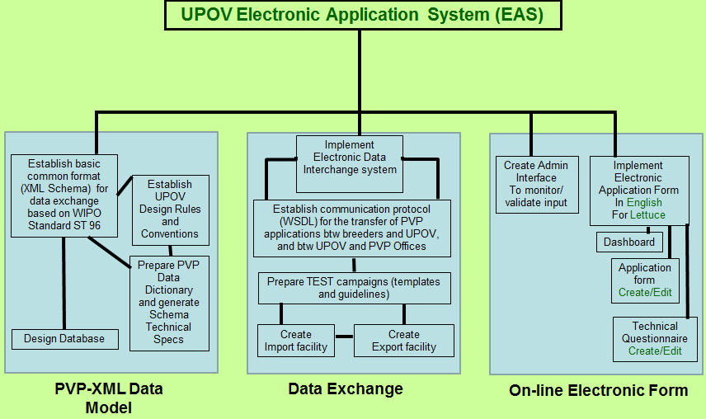

The Operational objectives are summarized as follows:

- 1. set up a common format to facilitate electronic data exchange;
- 2. allow applicants to upload and retrieve data from the database;
- 3. allow applicants (i.e. breeders) and authorities (i.e. PVP Offices) to exchange electronic data on a routine basis;
- 4. allow applicants to make an application on-line by selecting one or several UPOV members in which they wish to make an application, and generate output in a format that can be used by different authorities.

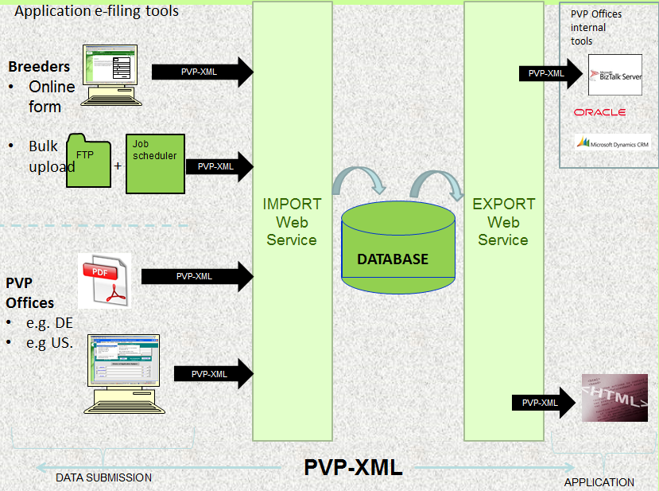

Developments in relation to the data model and data exchange are presented in document EAF/4/3 “Data exchange and data model”.

Developments in relation to the on-line electronic form are presented in document EAF/4/4 “Electronic form”.

[End of document]

* The term “user” is used instead of “applicant” or “breeder”, in order to avoid any implication that the use of the Linear Blank Form for PBR Applications might indicate that an application is being filed for a plant breeder’s right.

