E
EAF/3/3
ORIGINAL: English
DATE: September 12, 2014
INTERNATIONAL UNION FOR THE PROTECTION OF NEW VARIETIES OF PLANTS
Geneva
MEETING ON THE DEVELOPMENT OF A PROTOTYPE ELECTRONIC FORM
Third Meeting
Geneva, April 9, 2014
REPORT
adopted by the meeting on the development of a prototype electronic form
Disclaimer: this document does not represent UPOV policies or guidance

Welcome and opening

The meeting on the development of a prototype electronic form (“meeting”) was opened and chaired by Mr. Peter Button, Vice Secretary-General, UPOV, who welcomed the participants in Geneva and those who participated in the meeting by means of electronic conference.

The list of participants is reproduced in Annex I to this report.

Approval of the agenda

The meeting adopted the draft agenda (document EAF/3/1 Rev.), as circulated to the participants in advance of the meeting.

Experiences of participating members of the Union with electronic application systems

(a) Community Plant Variety Office of the European Union (CPVO)

Mr. Jean Maison and Mr. Marc Rouillard, Community Plant Variety Office of the European Union (CPVO), made a presentation on “Experience of the CPVO with electronic application systems”, a copy of which is attached as Annex II to this report.

(b) Republic of Korea

Mr. Seung-In YI, Examiner (Senior Researcher), Plant Variety Protection Division, Korea Seed & Variety Service (KSVS), made a presentation on “PVP electronic application system of KSVS”, a copy of which is attached as Annex III to this report.

(c) United States of America

Mr. Paul M. Zankowski, Commissioner, Plant Variety Protection Office, United States Department of Agriculture (USDA), made a presentation on “US PVP office electronic application processing system”, a copy of which is attached as Annex IV to this report.

Developments concerning the prototype electronic form

The meeting considered document EAF/3/2 “Developments concerning the prototype electronic form”.

It was recalled that the key aspects of the prototype from the perspective of members of the Union are as follows (see document CAJ/68/8 “Electronic application systems”):

Form Content: The UPOV electronic form would contain all items required by the participating members of the Union, i.e. it would contain all items in the UPOV Model Application Form and, in addition, items required for an application in the participating member of the Union concerned. Applicants would select the members of the Union in which they wish to make an application and all relevant items for the selected members of the Union would be presented for completion.

Status: Participating members of the Union would decide the status of any data provided via the UPOV electronic form for their own situation.

Data format: The UPOV electronic form would enable data to be transferred to participating members of the Union in Word, Excel, PDF or XML format. The participating members of the Union would decide in which format(s) to accept data. In the case of XML format, a standard format would be developed, based on WIPO standard ST.96.

Languages: The UPOV electronic form would present all items (questions) in English, French, German and Spanish. Translations for all items (questions) in other languages would be provided by the participating members of the Union, with a suitable disclaimer.

Crops/species: Crops/species for the prototype would be:

Lettuce (Lactuca sativa L.);
Potato (Solanum tuberosum L.);
Rose (Rosa L.)
Apple (Malus domestica Borkh.).

Partners: The partners in the development of the prototype would be the participating members of the Union (including the continued participation of the Community Plant Variety Office of the European Union (CPVO)), Office of the Union, WIPO Internet Services Section (now WIPO External Web Applications Section), WIPO Standards Section, WIPO Global Database Service, ISF and CIOPORA.

It was reported that the participating members of the Union were: Argentina; Australia; Brazil; Canada; Colombia; Dominican Republic; European Union; Japan; Mexico; New Zealand; Paraguay; Republic of Korea; Switzerland; United States of America and Viet Nam.

(a) Form content

(i) presentation of “mock-up” of prototype electronic form and project brief

It was recalled that it had been agreed during the meeting on the development of a prototype electronic form, held in Geneva on October 24, 2013, that the “mock-up” would be the basis to develop a fully working prototype. The “mock-up” and prototype would be in English only and the Technical Questionnaire (TQ) would be for Lettuce (Lactuca sativa L.) (see document EAF/2/3 “Report”, paragraph 18).

A second phase of the “mock-up” of the prototype electronic form was presented at the meeting by the Office of the Union and by the WIPO External Web Applications Section. It was noted that the “mock-up” contained the questions from the UPOV Model Application Form, and additional questions which were not covered by the UPOV Model Application Form’s questions, as provided by the following participating members of the Union: Australia, Brazil, Canada, European Union, Japan, Mexico, New Zealand, Republic of Korea, Switzerland, United States of America and Viet Nam. The mock-up is available under: http://upov.appls.org/upov/login.html.
An illustrative application, to present how the questions might be displayed, when for instance applying for lettuce in Canada (CA), the European Union (QZ) and New Zealand (NZ) was also demonstrated: http://upov.appls.org/upovdemo/login.html.

(ii) proposals concerning “core” questions

It was recalled that, as a first step, all questions will be provided by the participating members of the Union in English plus the language of the member of the Union for its own questions. The participating members of the Union will also provide translations of all questions in their own language.

It was noted that information from the application forms received from participating members of the Union had been compiled in Annexes I and II of document EAF/3/2, which contain a summary of the questions in the UPOV Model Application Form and additional questions (Annex I) and the questions from the TQ of the UPOV Test Guidelines for Lettuce (Lactuca sativa L.) (TG/13/10 Rev.) (Annex II).

It was noted that Annex III to document EAF/3/2 provided a proposal for the “core” questions to be included in the prototype electronic form, on the basis that more than 50% of participating members included the questions.

It was agreed that the proposal for the “core” questions to be included in the prototype electronic form would be discussed at a subsequent meeting.

(iii) timetable for the launch of the prototype electronic form

It was agreed that the timetable for the launch of the prototype electronic form should be considered in relation to the other items to be discussed (see future actions)

(iv) arrangements for updating the form by participating members of the Union

It was agreed that the arrangements for updating the form by participating members of the Union would be discussed at a subsequent meeting, once the first phase of the prototype electronic form had been developed.

(b) Status

(i) user authentication

The possible options for level of authentication required to enter information (e.g. user name and password, digital certificate, electronic signature, etc.) were presented at the meeting by the WIPO External Web Applications Section, giving the example of an existing WIPO Accounts (e.g. WIPO Identity Management (IDM) system for authentication of users). It was agreed to follow the same approach for the development of the first phase of the prototype electronic form.

(ii) payment systems

A demonstration of payment method for fees (e.g. electronic payment) was made at the meeting by the WIPO External Web Applications Section. It was agreed that it would be necessary to provide the possibility for applicants to pay in different currencies (e.g. CHF, US$, €) and to include a fee calculator.

It was agreed that this aspect would not be included in the phase 1 of the prototype but would be included in the final version.

(c) Data format

(i) WIPO Standards ST.96 and ST.67

Mr. Yun Young-Woo, Senior Industrial Property Information Officer, Standards Section of WIPO, reported that there had been no new developments in relation to WIPO Standard ST.96 and ST.67 since the last meeting held on October 24, 2013 (see document EAF/2/3 “Report”, paragraph 16). It was noted that the next XML4IP Task Force meeting would take place in London, United Kingdom, from November 10 to 14, 2014.

(ii) standardization for data not covered by ST.96 and ST.67

Mr. Marc Rouillard, CPVO, made a presentation on “Standardization for data not covered by ST.96”, a copy of which is attached as Annex V to this report.

It was agreed that an important first step in the development of a prototype electronic application system would be to understand the data structure used by authorities (i.e. PVP offices) and applicants (i.e. breeders). Therefore, it was agreed to ask participants to provide information on their databases as follows:

- application forms
- database model (structure)
- any documentation on the database model (e.g. data dictionary)
- naming conventions
- design rules (design pattern)
- description of the standard format for sending or receiving data and a sample data file (XML, csv, etc.)
- a list of fields and business rules for populating data
- specific constraints:
  - mandatory fields
  - optional fields
  - default values for fields
  - integrity constraints
- any additional documentation and other information available at hand (e.g. PowerPoint presentations of the system)
and/or
- XML schema of your data model (XSD file).

It was agreed that only participants who provided the necessary level of information, as indicated above, could be assured that the format would be compatible with their databases. Participants would also need to allocate time and resources (including the person with relevant IT knowledge of the database) for the following:

- to clarify their data requirements, and
- test the import / export facility of PVP data to / from their internal system to the UPOV database Form.

(d) Technical aspects

technical and business support for applicants

routine maintenance provisions

compliance with Web Content Accessibility Guidelines (WCAG)

It was agreed that technical aspects above would be discussed at a subsequent meeting.

(e) Legal aspects and disclaimer

It was noted, in relation to legal aspects that the prototype electronic form would need to respect national or regional legislation (e.g. disclaimer, communication, correspondence route). It was agreed that legal aspects and disclaimer would be discussed at a subsequent meeting.

Future actions and program

The following timetable was agreed for the development of the prototype:

Participating members to send their database structure, XML format or interface tables (requirement for participation in the project)  Circular to be sent, requesting input from participants (PVP Offices + Breeders) | by June 15, 2014
Analysis of databases of participating members, design of the database structure and data interface tables | by September 2014
Consolidation of questions (bi/multilateral communication) | by September 2014
Finalization of project brief and request for cost estimate from approved supplier | June 2014
Agreement on the database structure/ import-export option/ interface tables format | October 2014
Start of the project | October 2014
Presentation of the prototype to the CAJ and Council | October 2015

The following features were agreed for inclusion in the version 1 of the prototype:

- all the features presented in the mock-up,
- an administration interface with a dashboard to edit, submit or delete information,
- a possibility to import and export XML information.

The following aspects were agreed not to be included in the version 1 of the prototype but in the final version:
- payment authorization,
- different languages,
- possibility for participating UPOV members to introduce or modify their questions in the form,
- technical aspects such as: business support for applicants; routine maintenance provisions; compliance with WCAG; legal aspect and disclaimer.

It was agreed to consider the following items at the subsequent meeting:

(a) Phase 1:
(i) Presentation of “mock-up” of prototype electronic form and proposals concerning “core” questions (presentation by the Office of the Union and the External Web Applications Section of WIPO)
(ii) Analysis of information provided by participating members, design of the database structure and PVP data format (presentations by the Office of the Union and the External Web Applications Section of WIPO)
(iii) WIPO Standards ST.96 and ST.67 and standardization for data not covered by ST.96 and ST.67 (presentations by the Office of the Union and the Standards Section of WIPO)
(iv) Presentation of administration interface and user authentication (presentation by the External Web Applications Section of WIPO)
(v) Presentation of project brief and time table (presentation by the Office of the Union).
(b) Phase 2:
(i) Payment authorization (presentation by the Office of the Union and the External Web Applications Section of WIPO)
(ii) Different languages (presentation by the Office of the Union)
(iii) Possibility for participating UPOV members to introduce or modify their questions in the form (presentation by the Office of the Union and the External Web Applications Section of WIPO)
(iv) Technical aspects such as: business support for applicants; routine maintenance provisions; compliance with Web Content Accessibility Guidelines (WCAG); legal aspects and disclaimer (presentation by the Office of the Union).

Date of next meeting

It was agreed that the next meeting would be held in Geneva on October 14, 2014, at 18.00, with the possibility of participation by means of electronic conference.

This report was adopted by correspondence.
[Annexes follow]

EAF/3/3

ANNEX I

LIST OF PARTICIPANTS

 | i. MEMBERS
 | ARGENTINA
Alberto BALLESTEROS, Examiner for Cereal, Cotton and Forage Crops/Examinador técnico, Registro de Variedades, Instituto Nacional de Semillas (INASE), Venezuela 162, 3 piso, of. 347, C1095AAD Buenos Aires
(tel.: +54 11 3220 5424 fax: +54 11 4349 2444 e-mail: aballesteros@inase.gov.ar)
 | AUSTRALIa
Nik HULSE, Senior Examiner of PBR, Plant Breeder's Rights Office, IP Australia, 47 Bowes Street, Phillip ACT 2606
(tel.:+61 2 6283 7982 fax: +61 2 6283 7999 e-mail: nik.hulse@ipaustralia.gov.au)
 | BRAZIL
 | 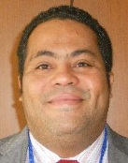 | Fabrício SANTANA SANTOS, Coordinator, National Plant Variety Protection Office (SNPC), Esplanada dos Ministerios, Bloco ‘D’, Anexo A, Sala 250, CEP 70043-900 Brasilia , D.F.  (tel.: +55 61 3218 2923 fax: +55 61 3224 2842 e-mail: fabricio.santos@agricultura.gov.br)
 | CANADA
Anthony PARKER, Commissioner, Plant Breeders’ Rights Office, Canadian Food Inspection Agency (CFIA), 59, Camelot Drive, Ottawa Ontario K1A 0Y9
(tel.: +1 613 7737188 fax: +1 613 7737261 e-mail: anthony.parker@inspection.gc.ca)
 | CHILE
Manuel TORO UGALDE, Jefe Subdepartamento, Registro de Variedades Protegidas, División Semillas, Servicio Agrícola y Ganadero (SAG), Paseo Bulnes 140, piso 2, 1167-21 Santiago de Chile
(tel.: +562 23451561 ext 3063 fax: +56 2 6972179 e-mail: manuel.toro@sag.gob.cl)
 | COLOMBIA
Ana Luisa DÍAZ JIMÉNEZ (Sra.), Directora Técnica de Semillas, Dirección Técnica de Semillas, Instituto Colombiano Agropecuario (ICA), Carrera 41 No. 17-81, Piso 4°, Zona Industrial de Puente Aranda, Bogotá D.C.
(tel.: +57 1 3323700 fax: +57 1 3323700 e-mail: ana.diaz@ica.gov.co)
 | ECUADOR
Lilián CARRERA GONZÁLEZ (Sra.), Directora Nacional de Obtenciones Vegetales, Instituto Ecuatoriano de la Propiedad Intelectual (IEPI), Av. República 396 y Diego de Almagro, Edif. Forum 300, Planta Baja, Mezzanine, Pisos 1, 3, 5 y 8, 89-62 Quito
(tel.: +593 2394 0000 ext 1400 fax: +593 998241492 e-mail: lmcarrera@iepi.gob.ec)
 | 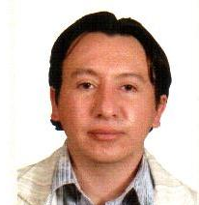 | Edison TROYA ARMIJOS, Experto principal en obtenciones vegetales, Instituto Ecuatoriano de la Propiedad Intelectual (IEPI), Edificio Forum 300, Av. República 396 y Almagro, Pichincha, Quito  (tel.: +593 2 3940002 Ext. 1402 e-mail: etroya@iepi.gob.ec)
 | EUROPEAN UNION
Jean MAISON, Deputy Head, Technical Unit, Community Plant Variety Office (CPVO), CS10121, 49101 Angers CEDEX 02
(tel.: +33 2 4125 6435 fax: +33 2 4125 6410 e-mail:maison@cpvo.europa.eu)
[via Webex]
Marc ROUILLARD, Webmaster, Supporting Services, Community Plant Variety Office (CPVO), 3, boulevard Maréchal Foch, B.P. 10121, F-49101 ANGERS Cedex 02, France
(tel.: +33 0241 256456 fax +33 0241 256410 e-mail rouillard@cpvo.europa.eu)
[via Webex]
 | JAPAN
Yoshihiko AGA, Associate Director for International Affairs, New Business and Intellectual Property Division, Food Industry Affairs Bureau, Ministry of Agriculture, Forestry and Fisheries (MAFF), 1-2-1 Kasumigaseki, Chiyoda-ku, 100-8950 Tokyo
(tel.: +81 3 6738 6444 fax: +81 3 3502 5301 e-mail: yoshihiko_aga@nm.maff.go.jp)
Takayuki MATSUI, Director, Plant Variety Protection Office, New Business and Intellectual Property Division, Food Industry Affairs Bureau, Ministry of Agriculture, Forestry and Fisheries (MAFF), 1-2-1, Kasumigaseki, Chiyoda-ku, 100-8950 Tokyo
(tel.: +81 3 6738 6446 fax: +81 3 3502 6572 e-mail: takayuki_matui@nm.maff.go.jp)
Kenji NUMAGUCHI, Examiner, Plant Variety Protection Office, New Business and Intellectual Property Division, Seeds and Seedlings Division Agricultural Production Bureau, Ministry of Agriculture, Forestry and Fisheries (MAFF), 1-2-1 Kasumigaseki, Chiyoda-ku, 100-8950 Tokyo
(tel.: +81 3 6738 6449 fax: +81 3 3502 6572 e-mail: kenji_numaguchi@nm.maff.go.jp)
 | MEXICO
 | 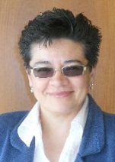 | Enriqueta MOLINA MACÍAS (Srta.), Directora General, Servicio Nacional de Inspección y Certificación de Semillas (SNICS), Secretaría de Agricultura, Ganadería, Desarrollo Rural, Pesca y Alimentación (SAGARPA), Av. Presidente Juárez 13, Col. El Cortijo, 54000 Tlalnepantla, Estado de México  (tel.: +52 55 36220667 fax: +52 55 3622 0670 e-mail: enriqueta.molina@snics.gob.mx)
 | 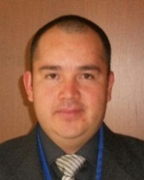 | Eduardo PADILLA VACA, Director de Registro de Variedades Vegetales, Servicio Nacional de Inspección y Certificación de Semillas (SNICS), Av. Presidente Juárez 13, Col. El Cortijo, 54000 Tlalnepantla, Estado de México  (tel.: +52 55 3622 0667 fax: +52 55 3622 0670 e-mail: eduardo.padilla@snics.gob.mx)
 | 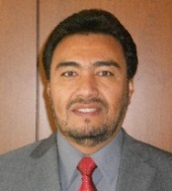 | Alejandro F. BARRIENTOS-PRIEGO, Profesor, Departamento de Fitotecnia, Universidad Autónoma Chapingo (UACh), Km. 38.5 Carretera México-Texcoco, CP 56230, Chapingo, Estado de México  (tel.: +52 59 59 52 1559 fax: +52 595 9521642 e-mail: abarrien@gmail.com)
 | NEW ZEALAND
Christopher J. BARNABY, Assistant Commissioner / Principal Examiner, Plant Variety Rights Office, Intellectual Property Office of New Zealand, Private Bag 4714, Christchurch 8140
(tel.:+64 3 9626206 fax: +64 3 9626202 e-mail: Chris.Barnaby@pvr.govt.nz)
 | OMAN
Ali AL LAWATI, Plant Genetic Resources Expert, The Research Council, Oman Animal and Plant Genetic Resources, P.O. Box 1422, CP 130, Muscat
(tel.: + +968 24509891 fax: +968 24509820 e-mail: ali.allawati@trc.gov.om)
 | REPUBLIC OF KOREA
Seung-In YI, Examiner (Senior Researcher), Plant Variety Protection Division, Korea Seed & Variety Service (KSVS), Anyang-ro 184, Manan-Gu, Anyang City, Kyunggi-do 430-016
(tel.: +82 31 467 0112 fax: +82 31 467 0116 e-mail: seedin@korea.kr)
 | SWITZERLAND
Manuela BRAND (Frau), Leiterin, Büro für Sortenschutz, Fachbereich Pflanzengesundheit und Sorten, Office fédéral de l’agriculture (OFAG), Mattenhofstrasse 5, CH-3003 Bern
(tel.: +41 31 322 2524 fax: +41 31 322 2634 e-mail: manuela.brand@blw.admin.ch)
 | UNITED STATES OF AMERICA
Paul M. ZANKOWSKI, Commissioner, Plant Variety Protection Office, USDA, AMS, S&T, Plant Variety Protection Office, 1400 Independence Ave., S.W., Room 4512 - South Building, Mail Stop 0273, Washington D.C. 20250-0274
(tel.: +1 202 720-1128 fax: +1 202 260-8976 e-mail: paul.zankowski@ams.usda.gov)
Fawad S. SHAH, Director, Seed Regulatory and Testing Division, United States Department of Agriculture, 801 Summit Crossing Place, Suite C, Gastonia, NC 28054
(tel.: +1 704 810 8884 fax: +1 704 852 4109 e-mail: fawad.shah@ams.usda.gov)
Ruihong GUO (Ms.), Deputy Administrator, AMS, Science & Technolgoy Program, United States Department of Agriculture (USDA), 1400 Independence Avenue, SW, Room 3543 - South Building, Mail Stop 0270, Washington D.C.
(tel.: +1 202 720 8556 fax: +1 202 720 8477 e-mail: ruihong.guo@ams.usda.gov)
Francesca ABII (Ms.), Senior Project Manager, U.S. Plant Variety Protection Office, USDA, AMS, S&T, Plant Variety Protection Office, 1400 Independence Avenue S.W., Room 4512 South Building, Mail Stop 0273, Washington D.C. D.C.
(tel.: +1 202 690 2062 e-mail: francesca.abii@ams.usda.gov)
[via Webex]

 | ii. ORGANIZATIONS
 | INTERNATIONAL COMMUNITY OF BREEDERS OF ASEXUALLY REPRODUCED ORNAMENTAL AND FRUIT PLANTS (CIOPORA)
Edgar KRIEGER, Secretary General, International Community of Breeders of Asexually Reproduced Ornamental and Fruit Plants (CIOPORA), Gänsemkarkt 45, 20354 Hamburg, Germany
(tel.: +49 40 555 63702 fax: +49 40 555 63703 e-mail: edgar.krieger@ciopora.org)
[via Webex]
 | CROPLIFE INTERNATIONAL
Marcel BRUINS, Consultant, CropLife International, 326, Avenue Louise, Box 35, 1050 Bruxelles, Belgique
(tel.: +32 2 542 0410 fax: +32 2 542 0419 e-mail: mbruins1964@gmail.com)
 | INTERNATIONAL SEED FEDERATION (ISF)
Piero SISMONDO, Director of Technology and Trade, International Seed Federation, Chemin du Reposoir 7, 1206 Nyon, Switzerland
(tel.: +41 22 365 4420 fax: +41 22 365 4421)
Brad HALL, Senior Research Assistant, DuPont Pioneer, 7301 NW 62nd Avenue, P.O. Box 85, Johnston, Iowa, United States of America
(tel.: +1 515 535 6975 fax: +1 515 535 2125 e-mail: brad.hall@pioneer.com)
[via Webex]

Sietske WOUDA (Mrs.), PVP/R Operational Manager, Syngenta, Syngenta Seeds BV, Westeinde 62, 1601 BK Enkhuizen , Netherlands
(tel.: +31 228 366204 e-mail: sietske.wouda@syngenta.com)
[via Webex]
Astrid M. SCHENKEVELD (Mrs.), Specialist, Variety Registration & Protection, Rijk Zwaan, Zaadteelt en Zaadhandel B.V., Burg. Crezeelaan 40, 2678 ZG De Lier ,
Netherlands
(tel.: +31 174532414 e-mail: a.schenkeveld@rijkzwaan.nl)
Veronique BEEREN, Department Plant Variety Protection and Trademarks, Nunhems B.V., Netherlands
(tel.: +31 (0)475 599149 fax: +31 (0)475 599223 e-mail: veronique.beek@bayer.com)
[via Webex]

Titus T. DE VRIES, Limagrain, Netherlands
(e-mail: titus-de.Vries@limagrain.com)
[via Webex]

 | Iii. OFFICE OF WIPO
 |  | Michael JUNG, Head, External Web Applications Section, IP Office Business Solutions Division, Global Infrastructure Sector
 |  | Monica DEDU (Ms.), Project Manager, External Web Applications Section, IP Office Business Solutions Division, Global Infrastructure Sector
 |  | YUN Young-Woo, Senior Industrial Property Information Officer, Standards Section,
 | iv. OFFICE OF UPOV
 |  | Peter BUTTON, Vice Secretary-General
 | 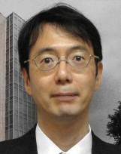 | Jun KOIDE, Technical/Regional Officer (Asia)
 |  | Ben RIVOIRE, Technical/Regional Officer (Africa, Arab countries)
 |  | Leontino TAVEIRA, Technical/Regional Officer (Latin America, Caribbean countries)
 |  | Ariane BESSE (Ms.), Administrative Assistant

[Annex II follows]

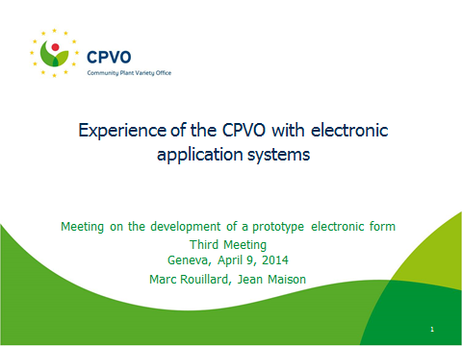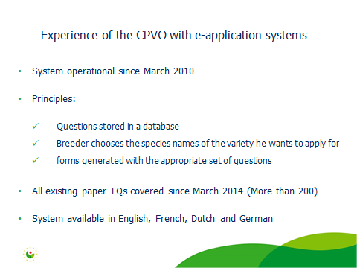

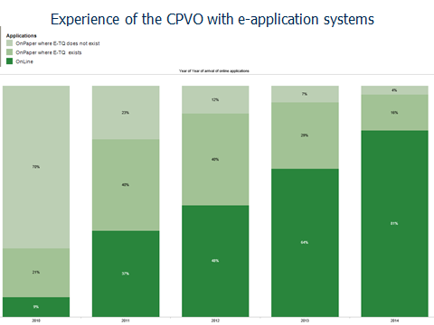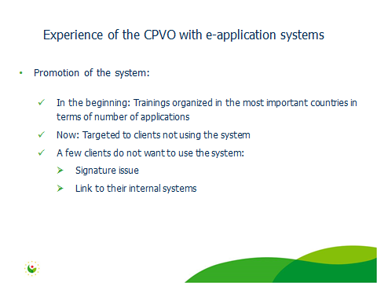

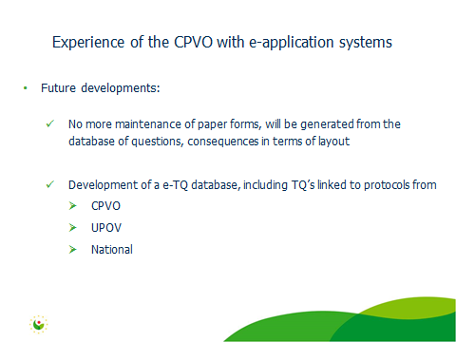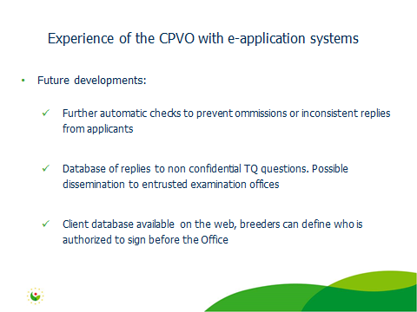

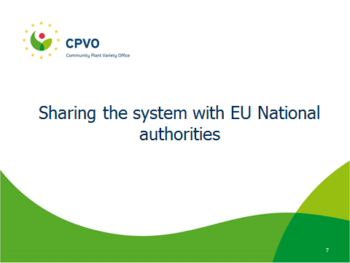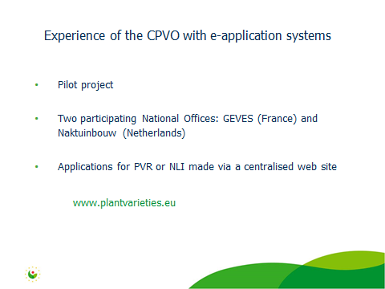

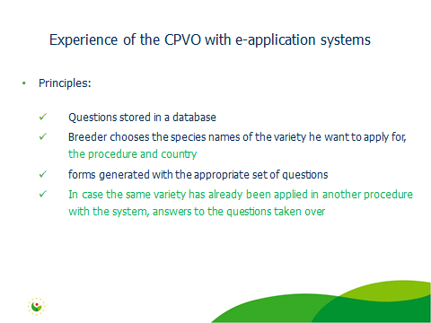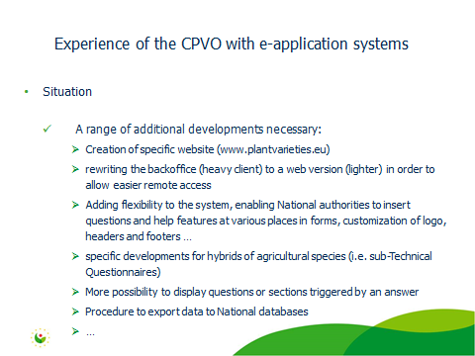

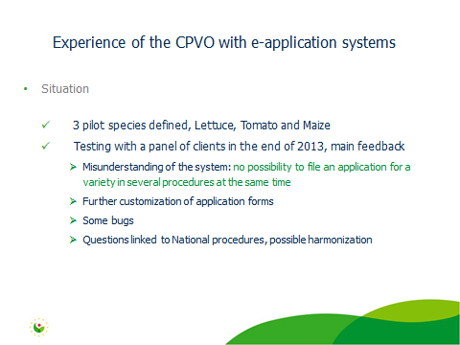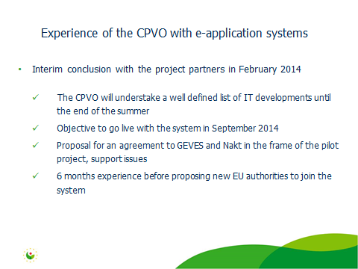

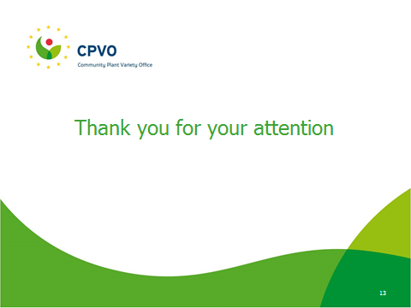

[Annex III follows]

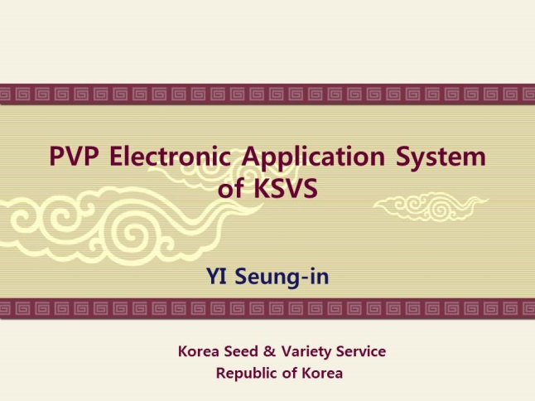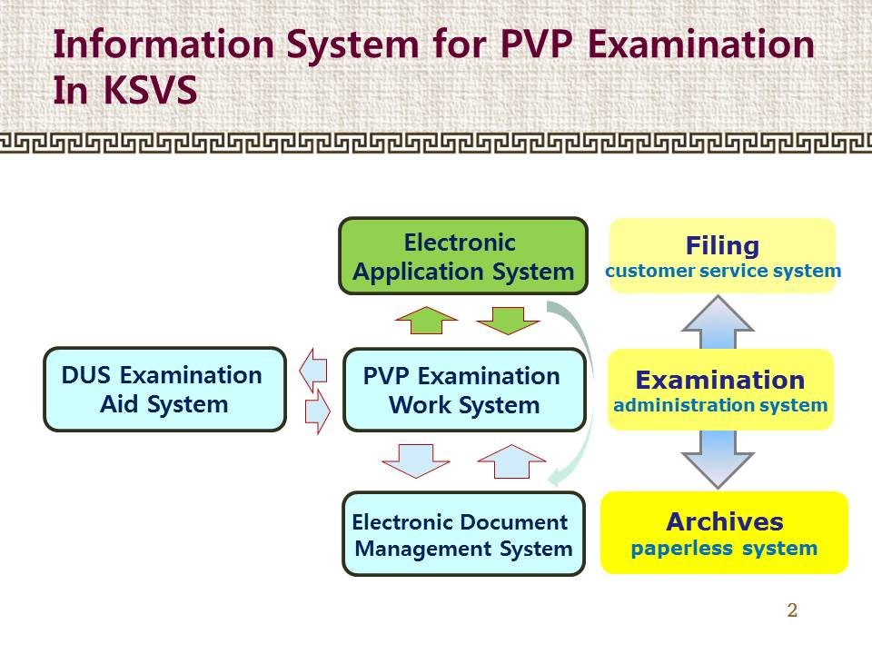

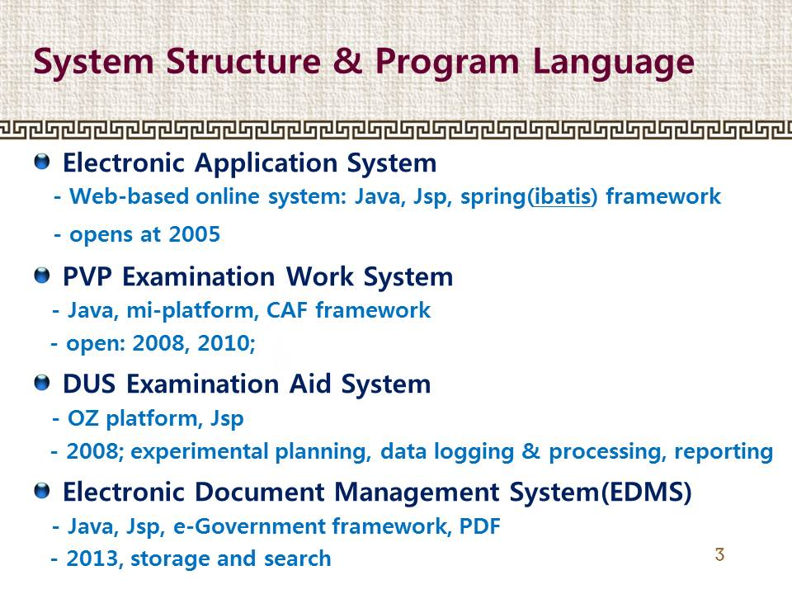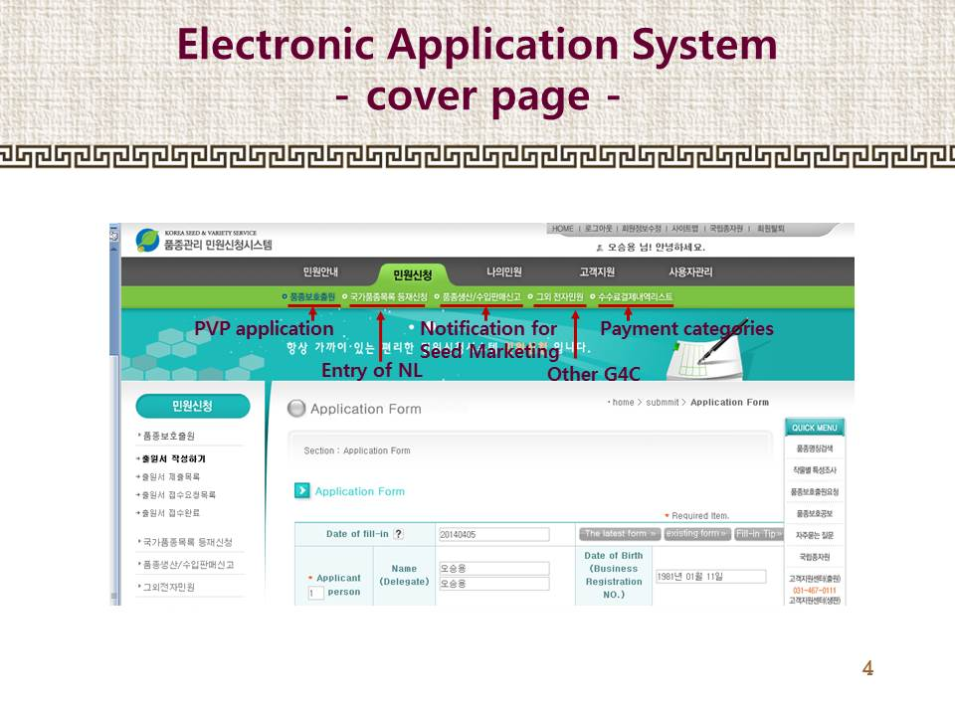

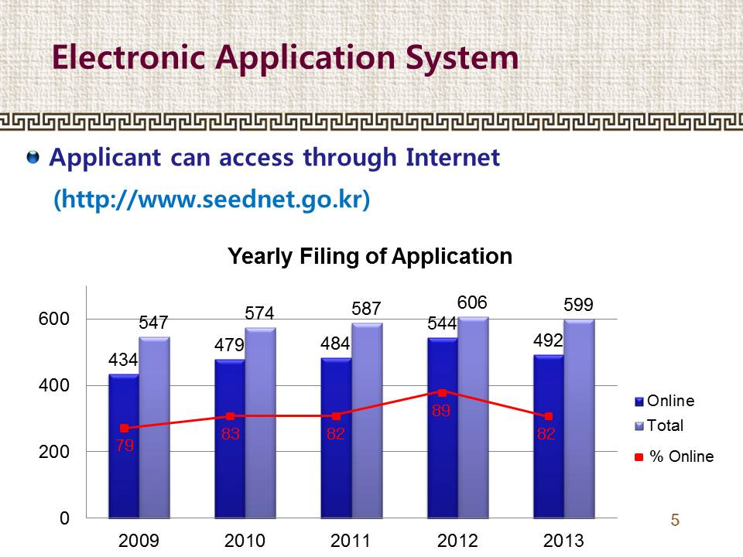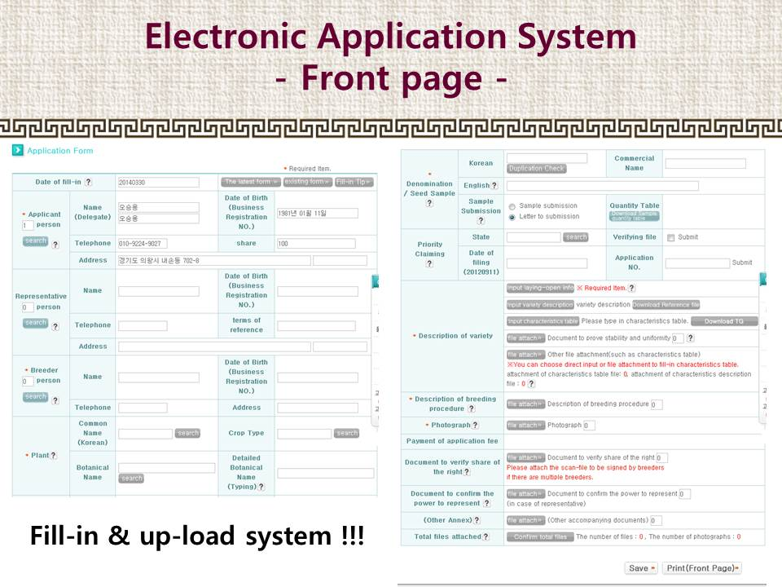
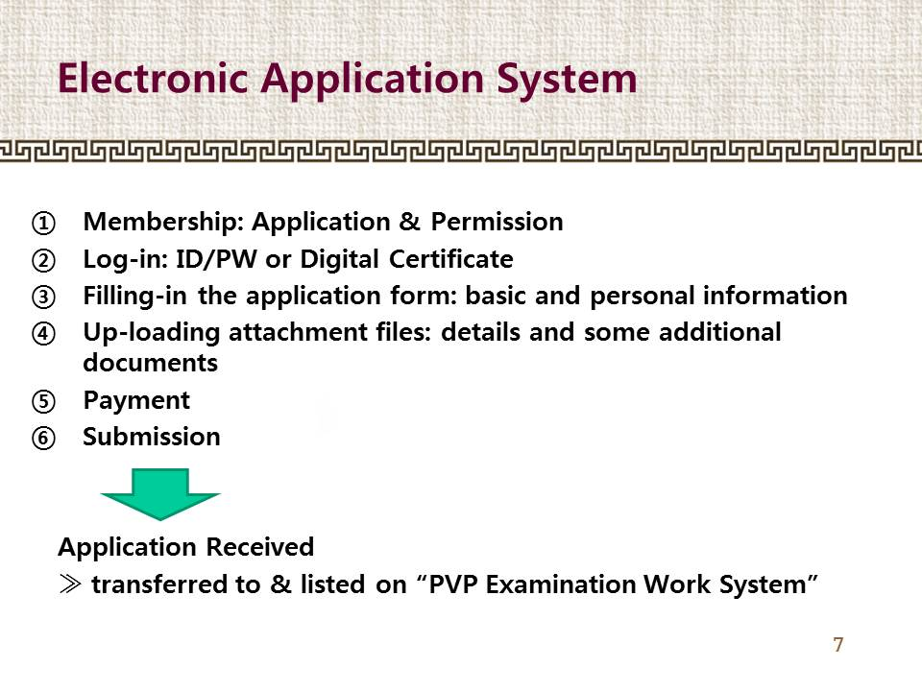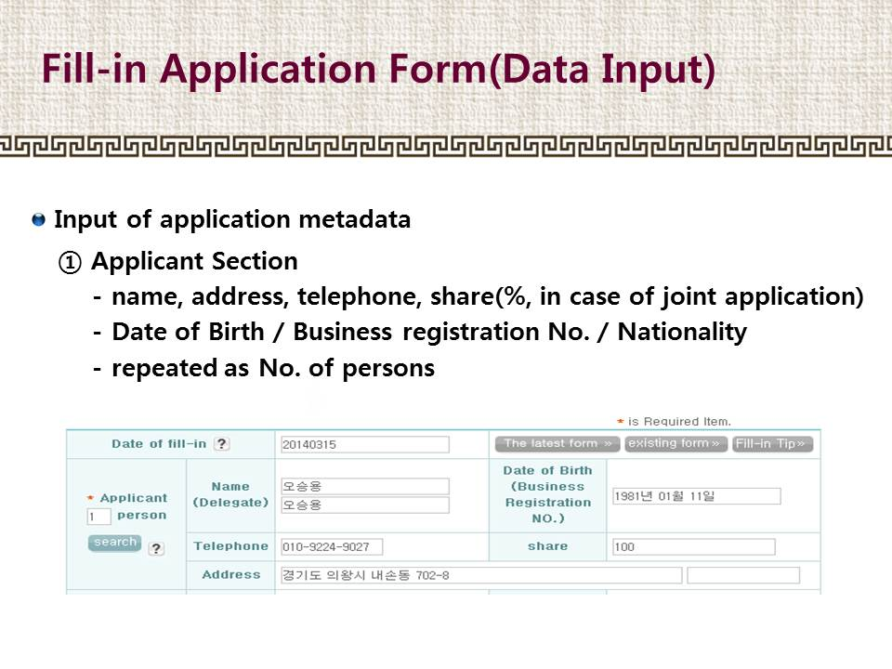

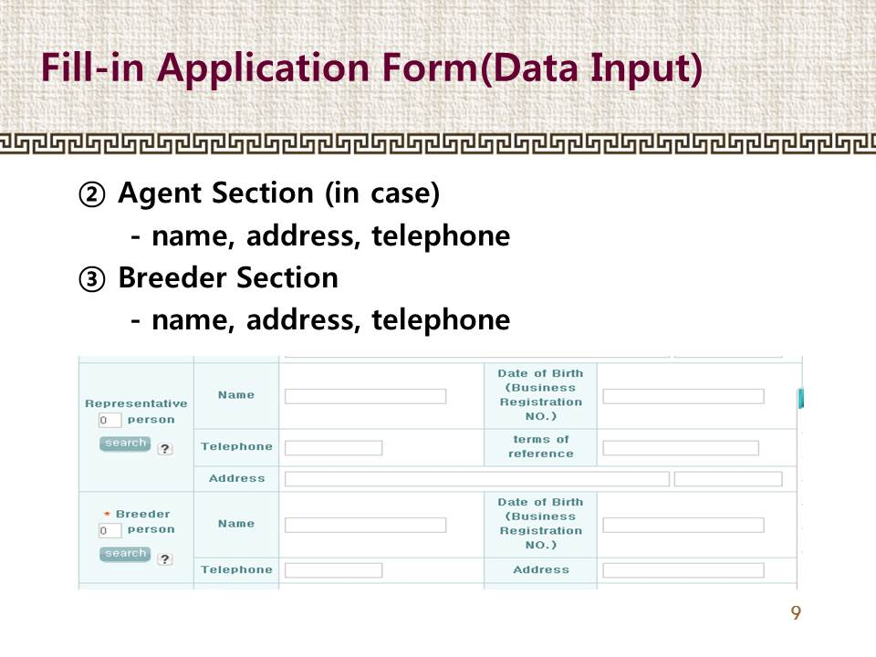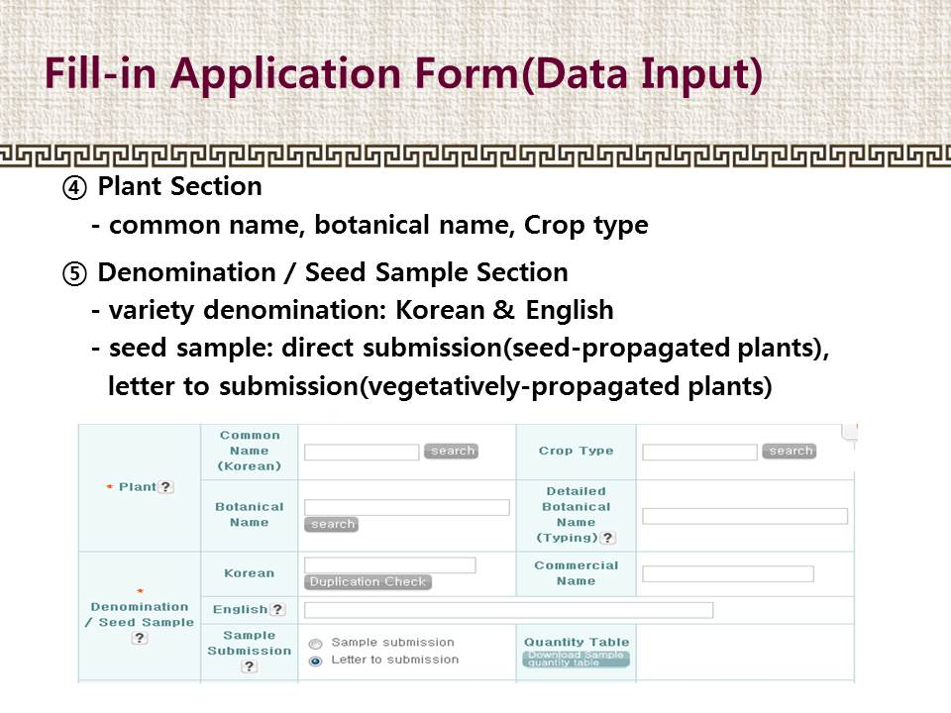

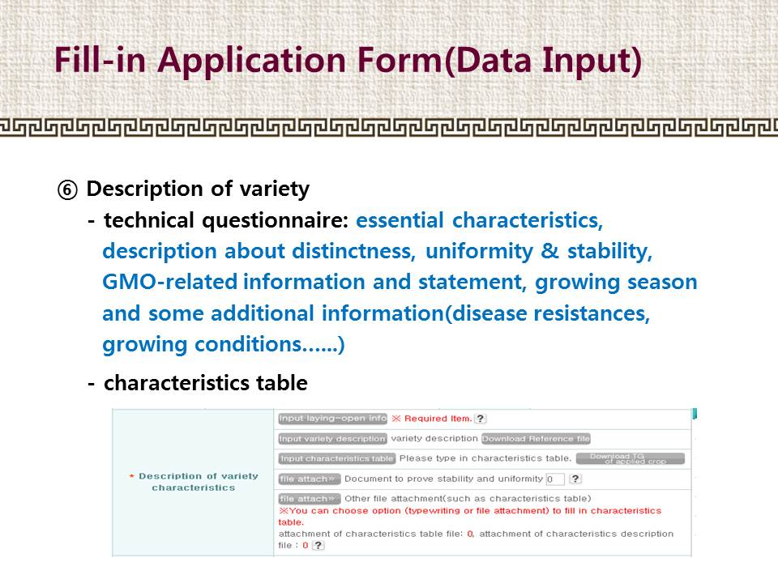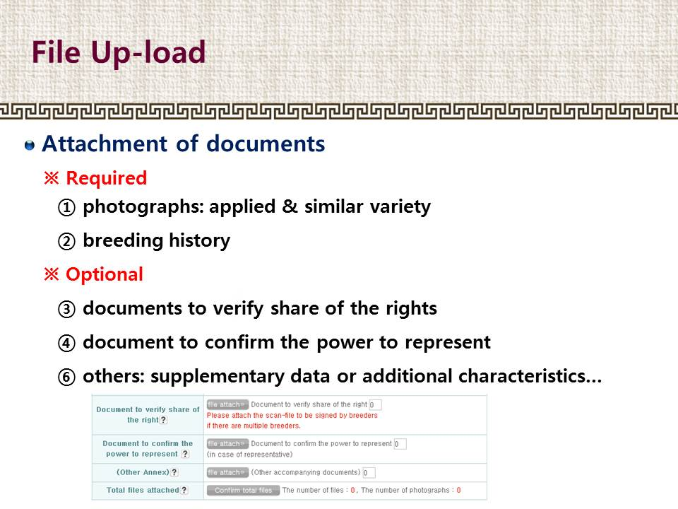

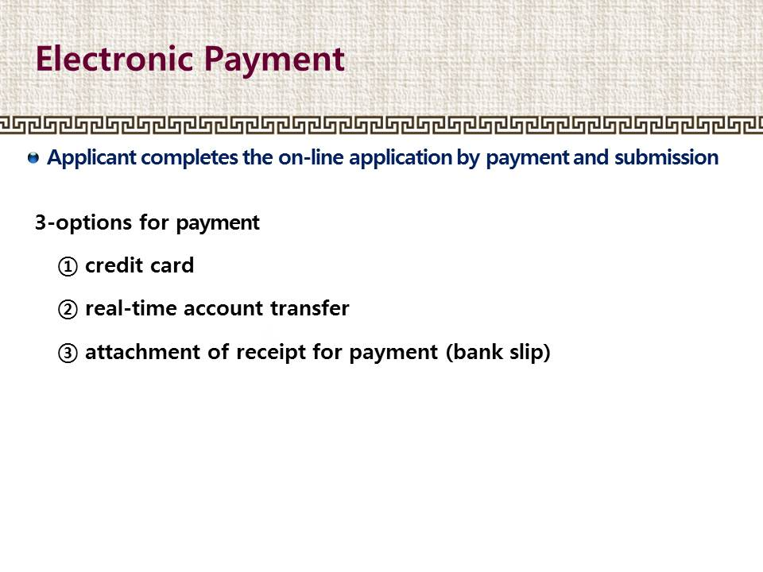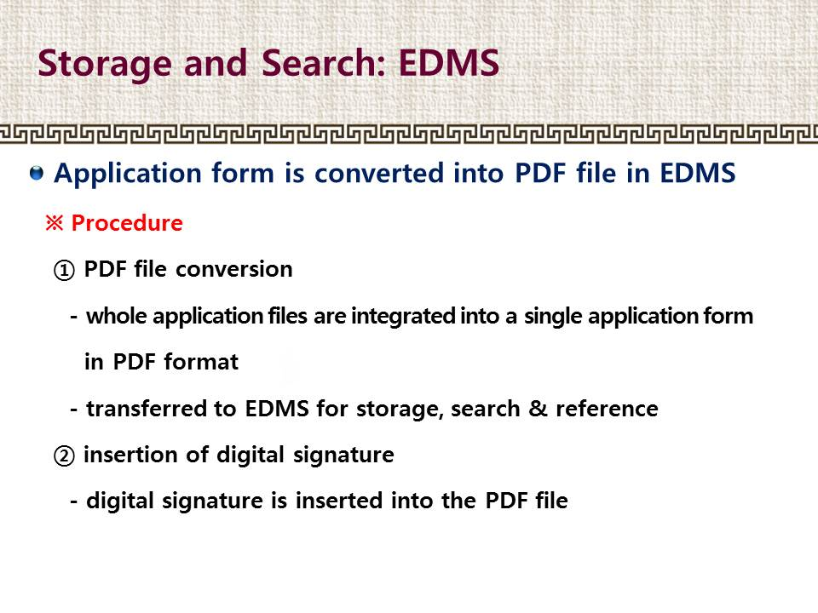

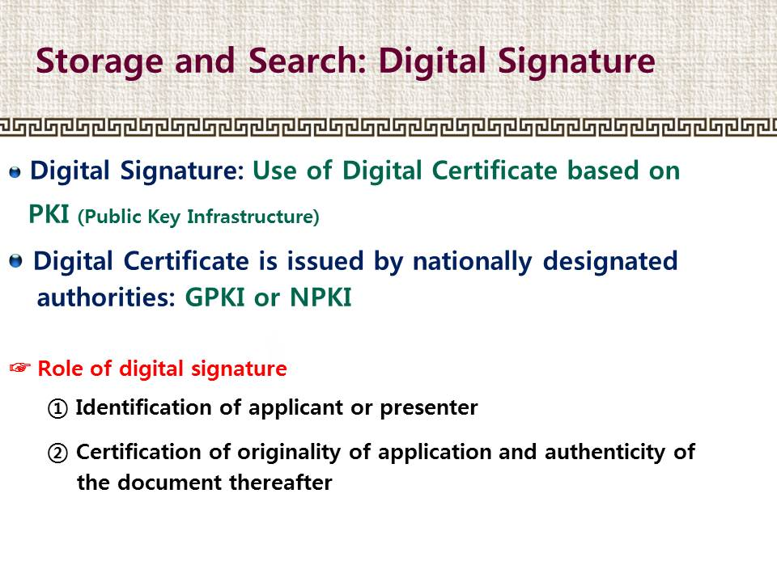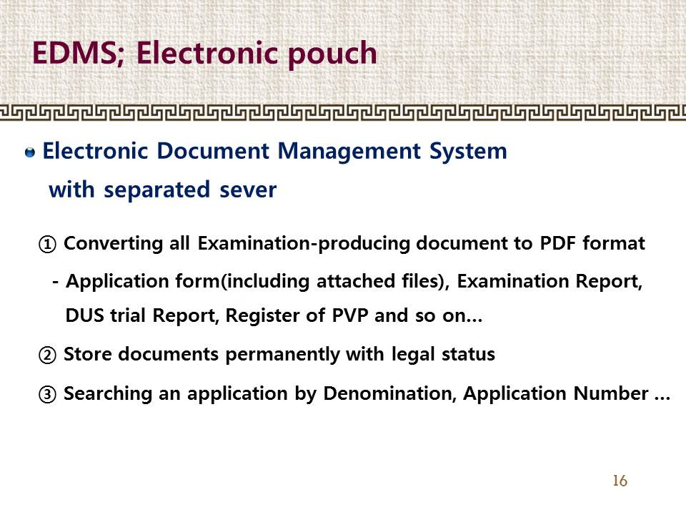

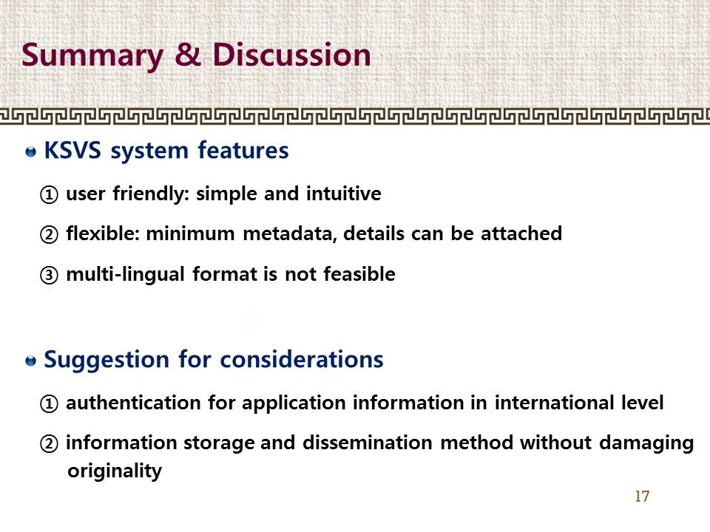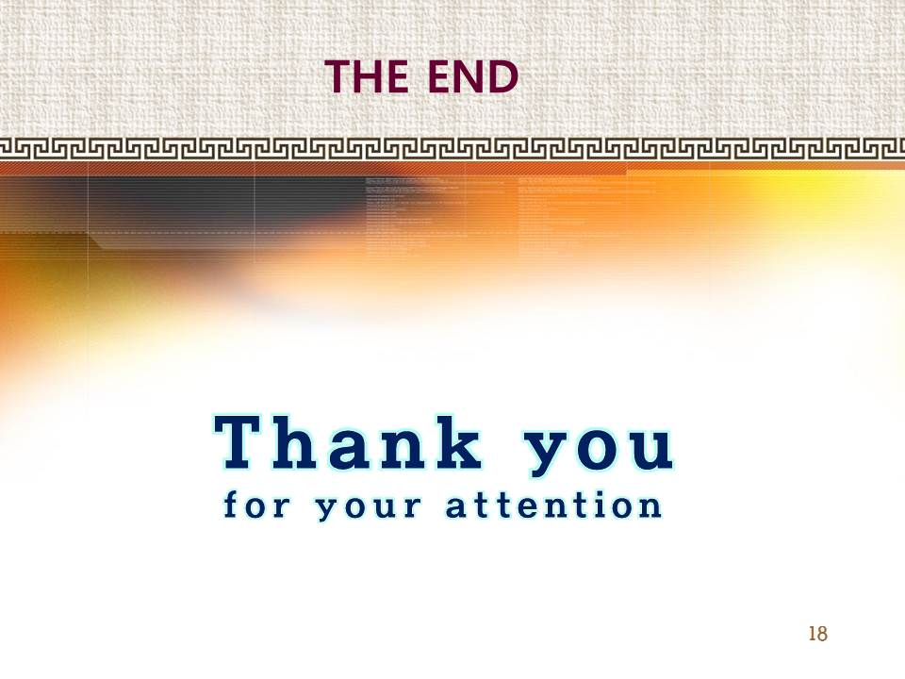

[Annex IV follows]

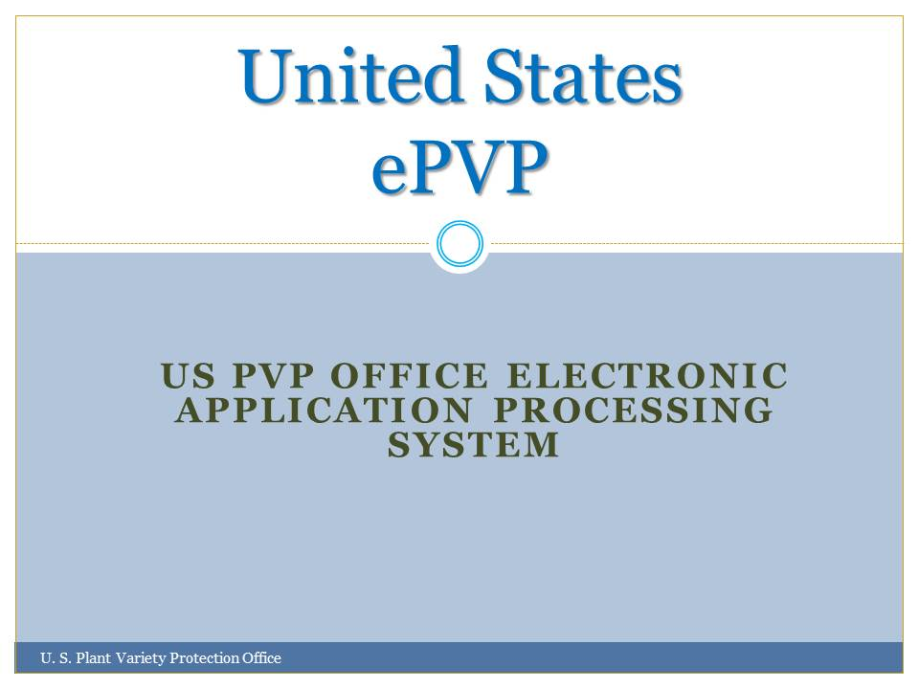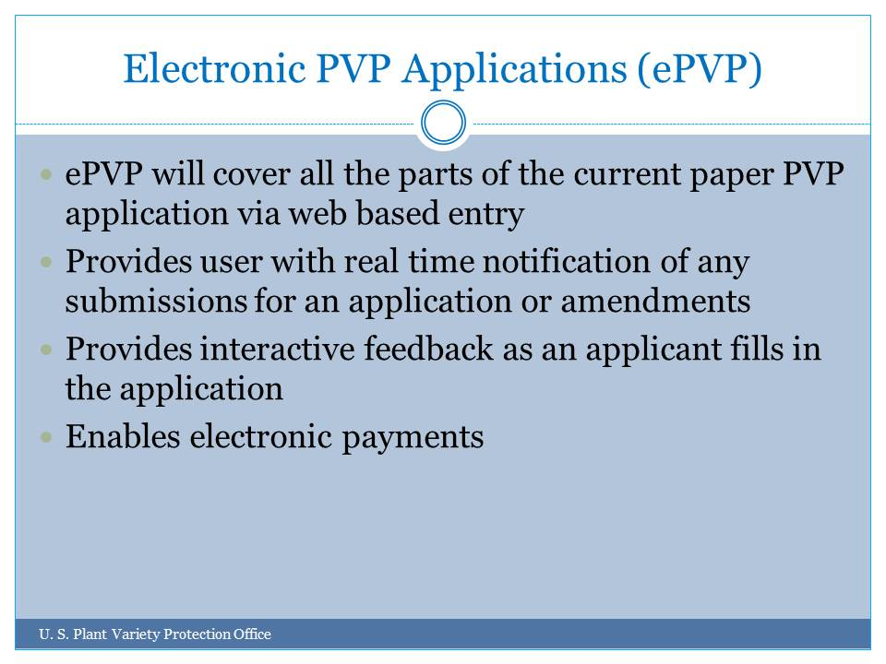

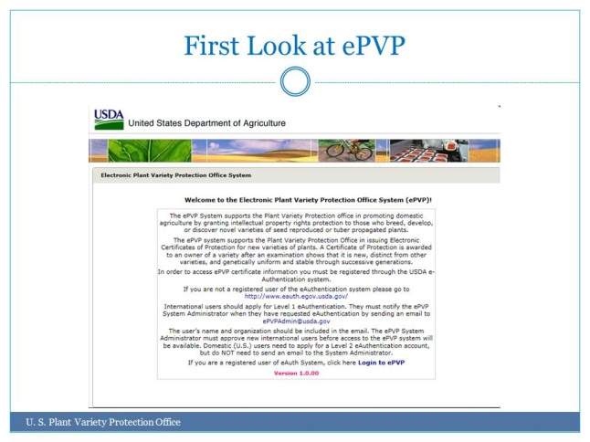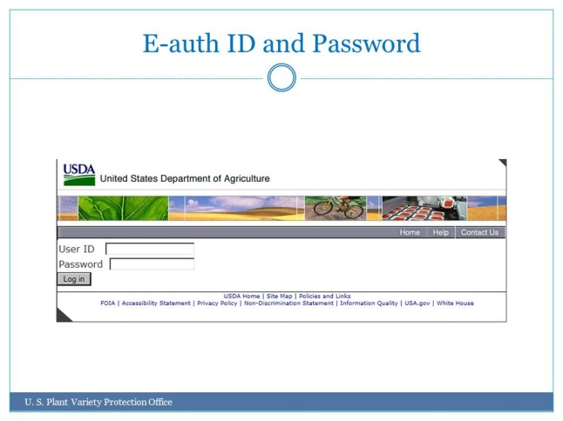

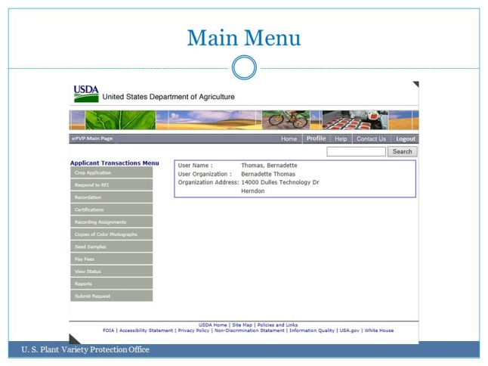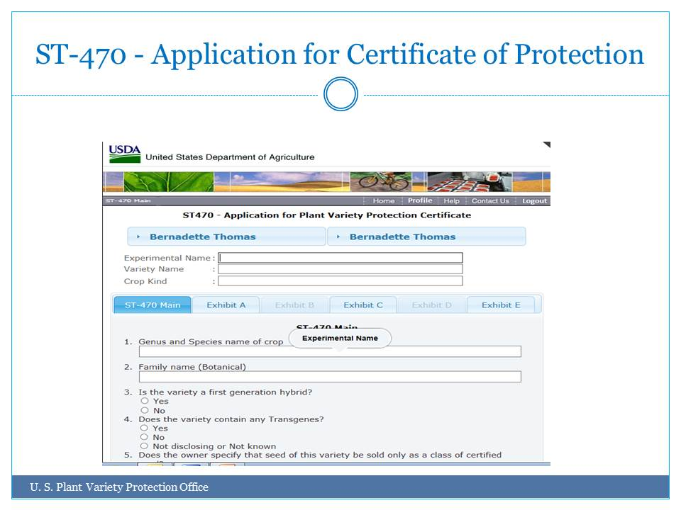

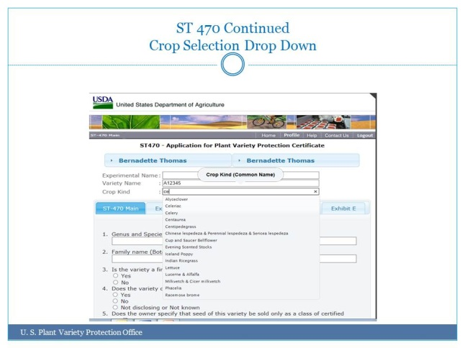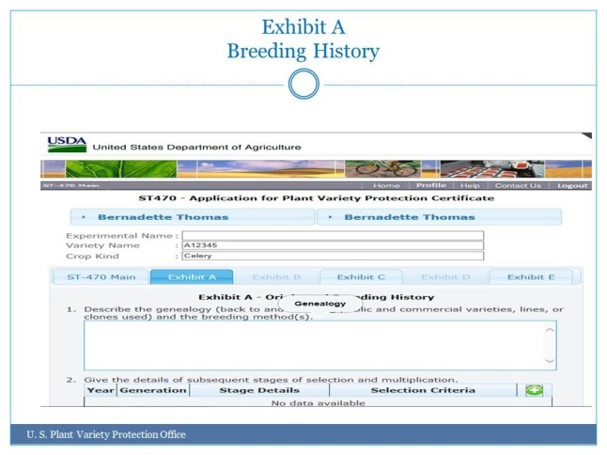

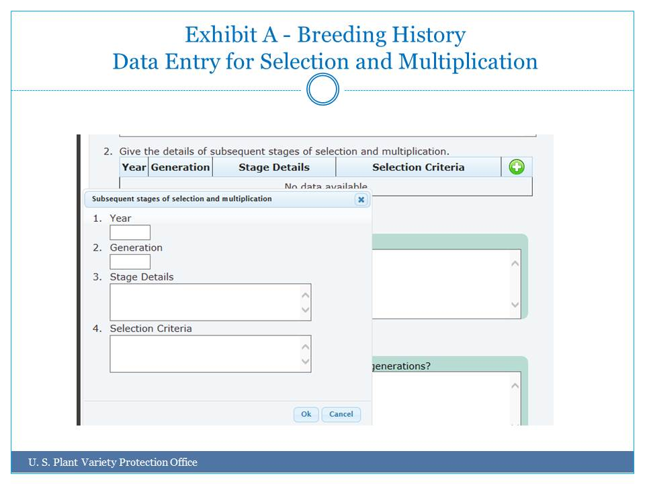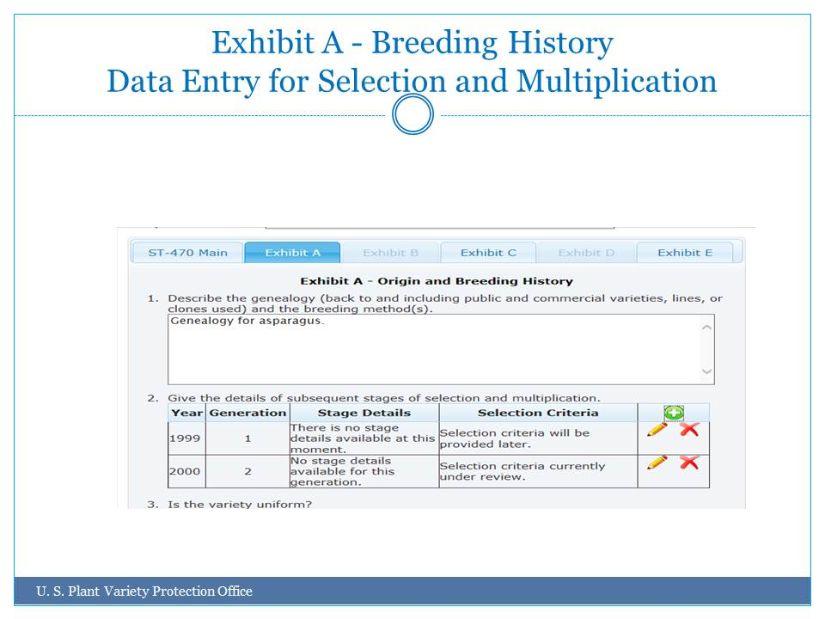

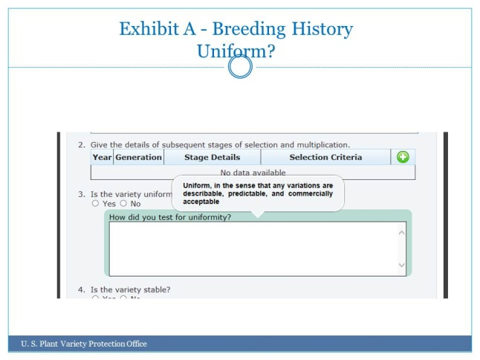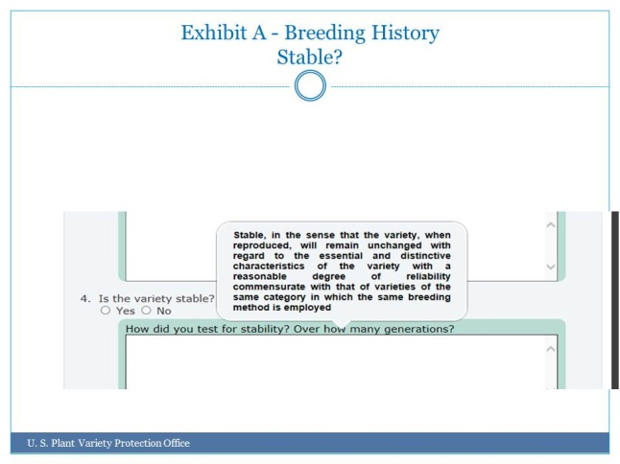

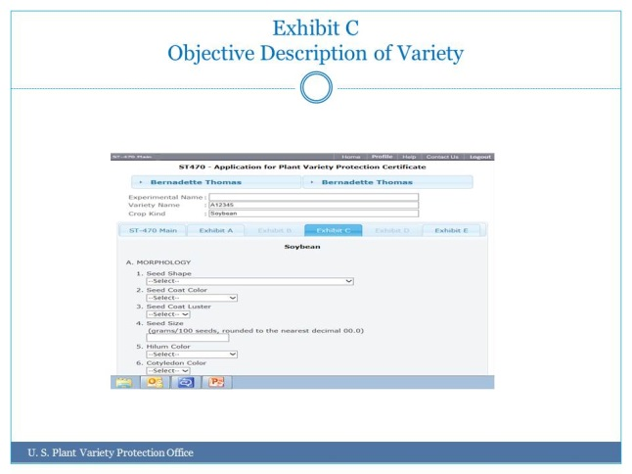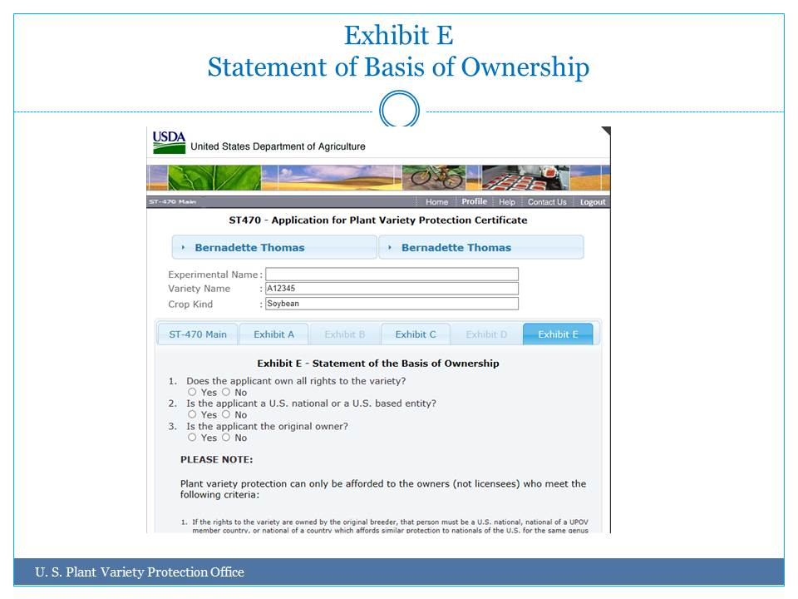

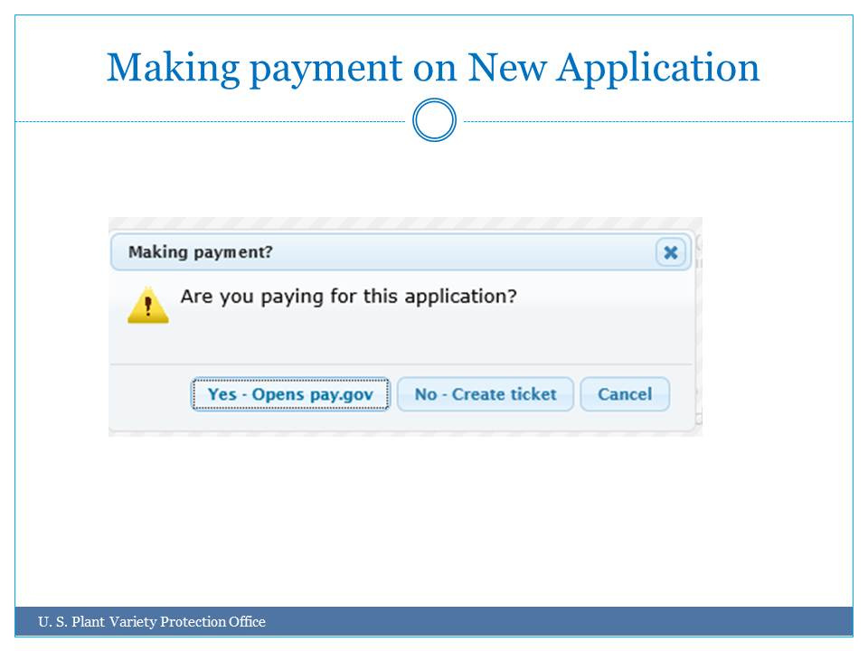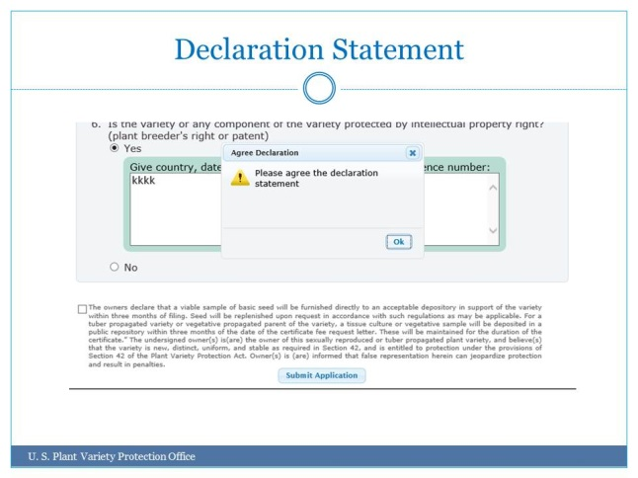

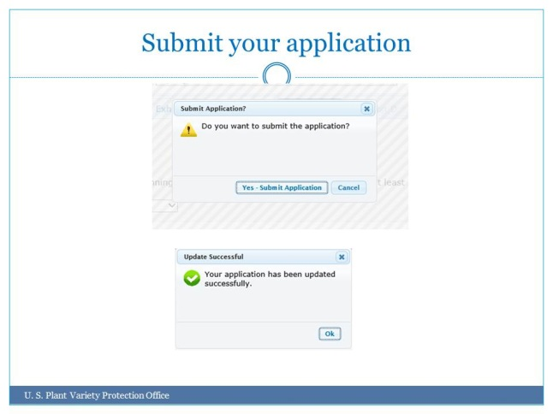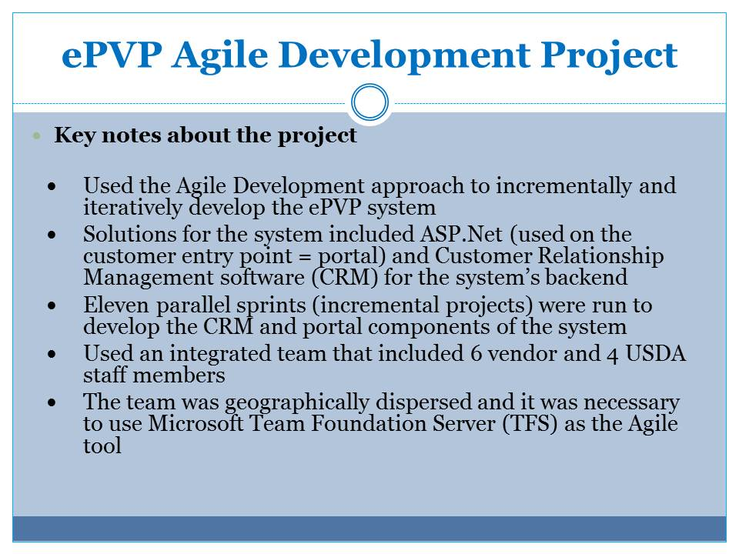

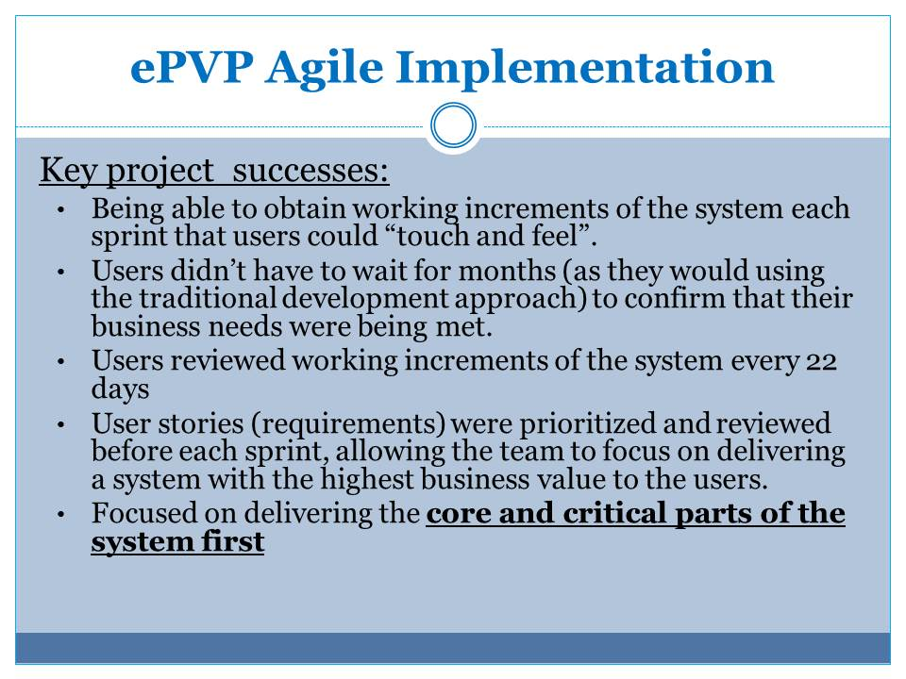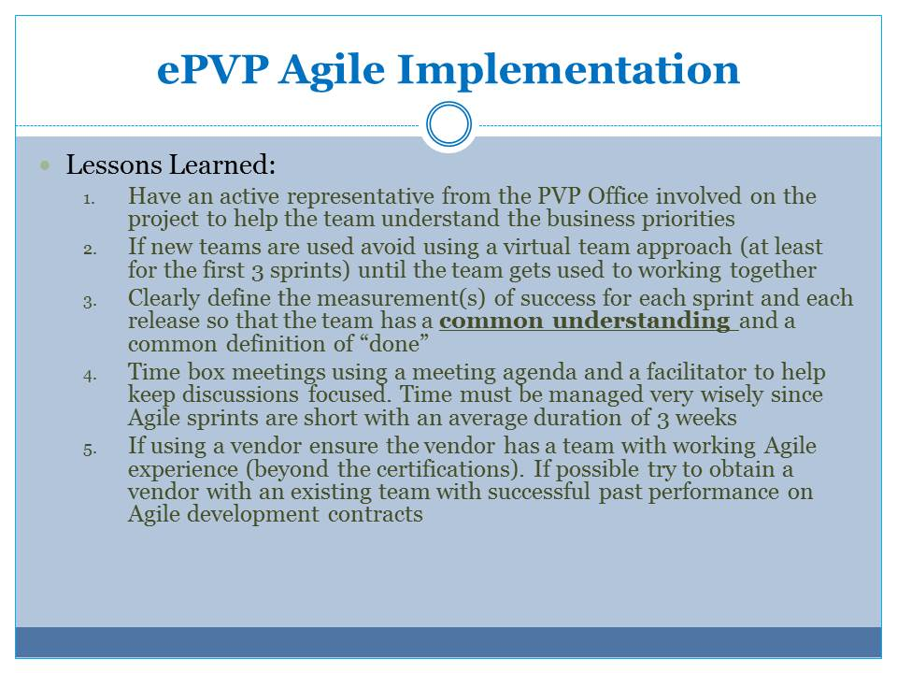

[Annex V follows]

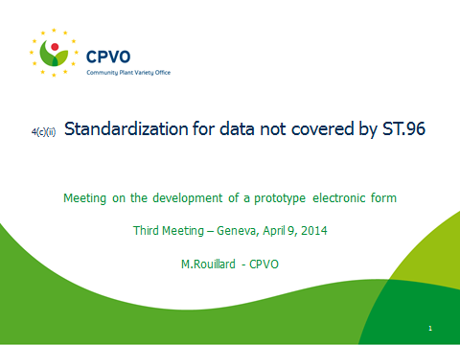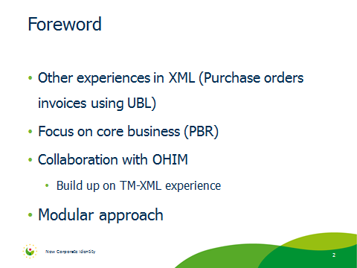

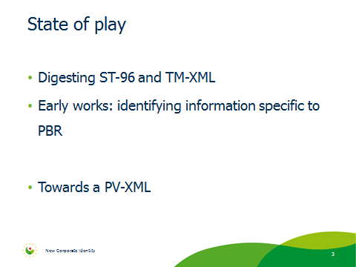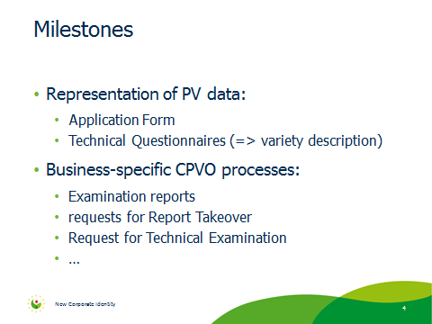

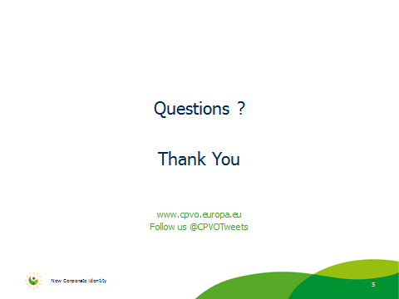

[End of Annex V and of document]

