E
International Union for the Protection of New Varieties of Plants

Meeting on the development of an electronic application form  Twentieth Meeting  October 25, 2022 (hybrid meeting) | UPOV/EAF/20/3  Original: English  Date: March 9, 2023
REPORT
adopted by the Meeting on the Development of an Electronic Application Form
Disclaimer: this document does not represent UPOV policies or guidance

Welcome and opening

The twentieth meeting on the development of an electronic form (EAF/20 meeting), which was held as a hybrid meeting (physical/virtual means), was opened and chaired by Mr. Peter Button, Vice Secretary-General of UPOV, who welcomed the participants.

The list of participants is reproduced in Annex I to this report.

Approval of the agenda

The meeting adopted the draft agenda as proposed in document UPOV/EAF/20/1.

Developments concerning UPOV PRISMA

The meeting considered document UPOV/EAF/20/2 Corr. “Developments concerning UPOV PRISMA” and received a presentation by the Office of the Union on the latest developments concerning UPOV PRISMA, a copy of which is reproduced in Annex II to this document.

Use of UPOV PRISMA (as of September 30, 2022)

The EAF/20 participants noted the information on the use of UPOV PRISMA as of September 30, 2022, as reported in Annex II of this report.

Launch of Version 2.8

The EAF/20 participants noted that UPOV PRISMA Version 2.8 was planned to be deployed in November 2022, with the following:

- Forms updated for France, the Netherlands and the United Kingdom;
- CPVO Technical Questionnaires updated for Lettuce and Rose;
- Expanded coverage of the United States of America to include all crops and species except for the ones in the list below. UPOV TG characteristics will be used:
Common Name | Botanical Name
Alfalfa | Medicago sativa L.
Barley | Hordeum vulgare L.
Bentgrass | Agrostis capillaris L.
Bermudagrass | Cynodon dactylon (L.) Pers. var. dactylon
Bluegrass | Poa pratensis L.
Cauliflower | Brassica oleracea L. var. botrytis L.
Corn | Zea mays L.
Cotton | Gossypium hirsutum L.
Field Bean | Phaseolus vulgaris L.
Fine Fescue | Festuca rubra L. var. rubra
Garden Bean | Phaseolus vulgaris L.
Marigold | Tagetes patula L.
Muskmelon | Cucumis melo L.
Oat | Avena sativa L.
Onion | Allium cepa L.
Pea | Pisum sativum L.
Peanut | Arachis hypogaea L.
Pumpkin | Cucurbita pepo L.
Rice | Oryza sativa L.
Ryegrass | Lolium multiflorum Lam.
Safflower | Carthamus tinctorius L.
Sorghum | Sorghum bicolor (L.) Moench
Tall and Meadow Fescue | Festuca pratensis Hudson
Triticale | x Triticosecale Wittm.
Vinca | Catharanthus roseus (L.) G. Don
Watermelon | Citrullus lanatus (Thunb.) Matsum. & Nakai var. lanatus
Zinnia | Zinnia elegans Jacq.

- Republic of Moldova: use of the United Kingdom’s Technical Questionnaire for Sugarbeet
- Allow the possibility to upload multiple attachments for the same question;
- In the email notification message, remove the reference to the “applicant” since it is not correct when an agent submits the application data;
- For agents, accept invitations in bulk instead;
- Add an additional "notes" field to the agent profile to allow agents to provide further information to breeders/applicants, such as services offered and languages spoken;
- Improve the download functionality for PVP Offices by including UPOV code information for crops not covered by UPOV TG and the addition of the following columns for the United Kingdom as a proof of concept):
  - Country of Origin
  - NLI Maintainer
  - NLI Agent
  - NLI Applicant
  - PBR Breeder
  - PBR Applicant
  - PBR Agent
  - Date PBR application received
  - Date NL application Received
  - Provisional Marketing Authorisation Code
  - Provisional Marketing Authorisation Date
  - Seed Weight ;
- Improve the loading performance of the dashboard.

Other developments

IT Quality Software Audit

The Office of the Union recalled that a code audit had been organized, which had produced the following recommendations:
- Implement best practices in terms of coding in order to avoid concurrency and performance issues;
- Move to the cloud for a better resource management at infrastructure level and keep following the highest security standards ;
- Develop a dedicated configuration interface for a controlled management of the forms.

The EAF/20 participants noted the report on the following plans for implementing the above recommendations:

- Recommendation 1 (best practices in terms of coding) would be implemented in Version 2.8;
- Recommendation 2 (Migration to the cloud); and,
- Recommendation 3 (Development of a dedicated configuration interface) would be implemented in Version 2.9.

Improvement of user-friendliness of UPOV PRISMA

The EAF/20 participants noted the report on the feedback received in the second meeting with UPOV PRISMA Task Force group held on June 2022 and the plan for implementation in Version 2.10.

CPVO participation in UPOV PRISMA

The EAF/20 participants noted that in order to achieve and maintain synchronization of TQs between UPOV PRISMA and CPVO (see documents UPOV/EAF/16/3 “Report” paragraph 18, UPOV/EAF/17/3 “Report” paragraph 32 and UPOV/EAF/18/3 “Report” paragraph 12) the following projects had been agreed with CPVO:

- Project 1: “Audit” (current issues/ states of affairs) for exchange of data between UPOV PRISMA and CPVO in both directions (Status: completed);
- Project 2: Part A: Resolving current issues; Part B : Synchronizing changes by UPOV/CPVO (Status: ongoing on the basis of information provided in Project 1);
- Project 3: Implementation of Project 2 outcome: Bi-directional exchange of application data (lettuce, tomato, rose) (Status: ongoing on the basis of information provided in Project 1);
- Project 4: Bulk upload of Maize applications from UPOV to CPVO (Status: ongoing on the basis of information provided in Project 1);
- Project 5: “Transitional arrangements”, to communicate to applicants about the situations in which they can use UPOV PRISMA for applications at the CPVO and the measures that need to be taken until all issues have been resolved (Status: ongoing).

The EAF/20 participants noted the report on each project (as of October 28, 2022), as reported in Annex II of this report.

The EAF/20 participants noted the transitional arrangements agreed by UPOV and CPVO in relation to Project 5, as reported in Annex II of this report.

Coverage of Test Guidelines: Sugar Beet

The EAF/20 participants approved the procedure for utilizing authorities’ TQs as presented in document UPOV/EAF/19/2 Rev. Corr., paragraphs 24 and 25:

1. Request from Authority A for a specific crop (Authority A TQ)
2. Inform other participating authorities in UPOV PRISMA
3. Circulate the Authority A TQ to see if participating UPOV members that use the UPOV TQ for all genera and species would prefer to:
(a) use Authority A TQ or
(b) continue using the generic TQ
4. Implement Authority A TQ for UPOV members who wish to use Authority A TQ (subject to available resources).

The EAF/20 participants noted that the proposed new procedure was applied for the United Kingdom TQ for Sugar Beet, and that in Version 2.8 the Republic of Moldova would use the United Kingdom TQ for Sugar Beet.

Version 2.9

The EAF/20 participants noted that it would be possible to make applications to Japan and e-PVP Asia in Version 2.9 (see document TC/57/9 “Cooperation in Examination”, paragraph 13).

The EAF/20 participants noted that Version 2.9 was planned to be launched in March 2023.

Version 2.10

The EAF/20 participants noted that on the basis of the request for new developments made by PVP Offices and registered users (see paragraph 29 to 31 of document UPOV/EAF/20/2 Corr.), the following new coverage and functionalities were planned to be introduced in Version 2.10:

- Expand the crop coverage for China as follows:
Common Name | Botanical Name | UPOV TG
Soya bean | Glycine max (L.) Merrill | TG/80/6
Kiwifruit | Actinidia Lindl. | TG/98/7
Sunflower | Helianthus annuus L. | TG/81/6
Tomato | Solanum lycopersicum L. | TG/44/11
Hot pepper | Capsicum annuum L | TG/76/8
Anthurium | Anthurium Schott | TG/86/5
Guzmania | Guzmania Ruiz et Pav. | TG/182/4
Cucumber | Cucumis sativus L. | TG/61/7
Melon | Cucumis melo L. | TG/104/5
Morchella | Morchella Dill. ex Pers. | National TG
- Brazil to join UPOV PRISMA for a limited set of crops. The final list had not been decided.
- Bulk Upload (for maize, United Kingdom);
- Move UPOV PRISMA to the cloud;
- Implement the new screen design for Start New Application and Copy Application; and
- Bulk invoice upon request.

The EAF/20 participants noted that Version 2.10 was planned to be launched in September 2023.

Planned FUTURE developments (after version 2.10)

Coverage

The EAF/20 participants noted that the following UPOV members had previously expressed an interest in participating in UPOV PRISMA: Bosnia and Herzegovina, Brazil, Egypt, Japan, Nicaragua, Singapore, United Republic of Tanzania and Uzbekistan. The Office of the Union would consult the UPOV members concerned to discuss their requirements and timeline for joining UPOV PRISMA.

User-friendliness of the tool

The EAF/20 participants noted that the following elements would be considered after 2023 to increase the user-friendliness of UPOV PRISMA:

- Addition of non UPOV TQ characteristics in TQ Section 7 instead of TQ Section 5 (see document UPOV/EAF/17/3 “Report” paragraph 19);
- Crop-specific TQs beyond Test Guidelines (see document UPOV/EAF/16/3 “Report” paragraph 18).

New functionalities

The EAF/20 participants noted that the following new functionalities would be considered for possible development:

- Machine translation (see document UPOV/EAF/16/3 “Report” paragraph 18);
- Information on DUS cooperation (DUS Arrangement Recommendation Tool (DART)) (see document UPOV/EAF/16/3 “Report”, paragraph 18).

Meetings on the development of an electronic application form (EAF) (UPOV PRISMA)

The EAF/20 participants noted the proposal to expand the scope of EAF meetings to also cover e-PVP modules to be made to the CAJ at its seventy-ninth session (see document CAJ/79/10 “Meetings on the development of an electronic application form (EAF)”, paragraphs 40 to 42).

Date of next meeting

The next meeting of the EAF was agreed to be held by electronic means on March 15, 2023 at 12 pm.

This report was adopted by correspondence.

[Annex I follows]

LISTE DES PARTICIPANTS / LIST OF PARTICIPANTS / LISTA DE LOS PARTICIPANTES

(dans l’ordre alphabétique des noms français des membres /
in the alphabetical order of the French names of the Members /
por orden alfabético de los nombres en francés de los miembros)
I. MEMBRES / MEMBERS / MIEMBROS
AFRIQUE DU SUD / SOUTH AFRICA / SUDÁFRICA
Noluthando NETNOU-NKOANA (Ms.), Director, Genetic Resources, Department of Agriculture, Rural development and Land Reform, Pretoria
(e-mail: noluthandon@daff.gov.za)
ARGENTINE / ARGENTINA / ARGENTINA
María Laura VILLAMAYOR (Sra.), Coordinadora de Relaciones Institucionales e Interjurisdiccionales, Instituto Nacional de Semillas (INASE), Secretaría de Agricultura, Ganadería, Pesca y Alimentación, Buenos Aires
(e-mail: mlvillamayor@inase.gob.ar)
AUSTRALIE / AUSTRALIA / AUSTRALIA
Nik HULSE (Mr.), Director, Policy and International Affairs, Policy and Stakeholders Group, IP Australia, Woden
(e-mail: nik.hulse@ipaustralia.gov.au)
CANADA / CANADA / CANADÁ
Ashley BALCHIN (Ms.), Examiner, Plant Breeders' Rights Office, Canadian Food Inspection Agency (CFIA), Ottawa
(e-mail: ashley.balchin@inspection.gc.ca)
Renée CLOUTIER (Ms.), Examiner, Plant Breeders' Rights Office, Canadian Food Inspection Agency (CFIA), Ottawa
(e-mail: Renee.Cloutier@inspection.gc.ca)
Jennifer ROACH (Ms.), Examiner, Plant Breeders' Rights Office, Canadian Food Inspection Agency (CFIA), Ottawa
(e-mail: jennifer.roach@inspection.gc.ca)
Sarah GRENIER (Ms.), Program Officer, Plant Breeders' Rights Office, Canadian Food Inspection Agency (CFIA), Ottawa
(e-mail: sarah.grenier@inspection.gc.ca)
CHILI / CHILE / CHILE / CHILE
Manuel Antonio TORO UGALDE (Sr.), Jefe Sección, Registro de Variedades Protegidas, Departamento de Semillas y Plantas, Servicio Agrícola y Ganadero (SAG), Santiago de Chile
(e-mail: manuel.toro@sag.gob.cl)
CHINE / CHINA / CHINA
Yehan CUI (Mr.), Principal Consultant, Division of Plant Variety Protection, Development Center of Science and Technology (DCST), Ministry of Agriculture and Rural Affairs (MARA), Beijing
(e-mail: cuiyehan@agri.gov.cn)
ÉGYPTE / EGYPT / EGIPTO
Shymaa ABOSHOSHA (Ms.), Agronomist, Plant Variety Protection Office (PVPO), Central Administration for Seed Testing and Certification (CASC), Giza
(e-mail: sh_z9@hotmail.com)
ESTONIE / ESTONIA / ESTONIA
Laima PUUR (Ms.), Counsellor, Organic Farming and Seed Department, Estonian Agricultural and Food Board, Viljandi
(e-mail: laima.puur@pta.agri.ee)
ÉTATS-UNIS D'AMÉRIQUE / UNITED STATES OF AMERICA / ESTADOS UNIDOS DE AMÉRICA
Christian HANNON (Mr.), Patent Attorney, Office of Policy and International Affairs (OPIA), U.S. Patent and Trademark Office (USPTO), Alexandria
(e-mail: christian.hannon@uspto.gov)
FÉDÉRATION DE RUSSIE / RUSSIAN FEDERATION / FEDERACIÓN DE RUSIA
Irina NOVGORODSKAYA (Ms.), Leading Agronomist, Fodder Crops and Maize Department, Russian Federation for Selection Achievements Test and Protection, Moscow
(e-mail: metod@gossortrf.ru)
FRANCE / France / FRANCIA
Yvane MERESSE (Mme), Responsable INOV, Groupe d'Étude et de Contrôle des Variétés et des Semences (GEVES), Beaucouzé cedex
(e-mail: yvane.meresse@geves.fr)
ISRAËL / ISRAEL / ISRAEL
Dikla DABBY-NAOR (Ms.), Chairperson, Plant Breeders' Rights Council, Ministry of Agriculture and Rural Development, Beit-Dagan
(e-mail: diklad@moag.gov.il)
JAPON / JAPAN / JAPÓN
Yoshiyuki OHNO (Mr.), Examiner, Intellectual Property Division, Export and International Affairs Bureau, Ministry of Agriculture, Forestry and Fisheries (MAFF), Tokyo
(e-mail: yoshiyuki_ono300@maff.go.jp)
KENYA / Kenya / KENYA
Simon Mucheru MAINA (Mr.), Head, Seed Certification and Plant Variety Protection, Kenya Plant Health Inspectorate Service (KEPHIS), Nairobi
(e-mail: smaina@kephis.org)
MAROC / MOROCCO / MARRUECOS
Zoubida TAOUSSI (Mme), Responsable de la protection des obtentions végétales, Office National de Sécurité Sanitaire de Produits Alimentaires (ONSSA), Rabat
(e-mail: ztaoussi67@gmail.com)
MEXIQUE / MEXICO / MÉXICO
Raymundo Jesus ROSARIO REYES (Sr.), Subdirector de Registro y Control de Variedades, Servicio Nacional de Inspección y Certificación de Semillas (SNICS), Secretaria de Agricultura y Desarrollo Rural (Agricultura), Ciudad de México
(e-mail: raymundo.rosario@snics.gob.mx)
NOUVELLE-ZÉLANDE / NEW ZEALAND / NUEVA ZELANDIA
Christopher James BARNABY (Mr.), PVR Manager / Assistant Commissioner, Plant Variety Rights Office, Intellectual Property Office of New Zealand, Ministry of Business, Innovation and Employment, Christchurch
(e-mail: Chris.Barnaby@pvr.govt.nz)
PAYS-BAS / NETHERLANDS / PAÍSES BAJOS
Wim SANGSTER (Mr.), DUS Specialist, Naktuinbouw, Roelofarendsveen
(e-mail: w.sangster@naktuinbouw.nl)
Monique HOOGENBOOM-TEEUWEN (Ms.), Manager Team Support, Rassenonderzoek, Naktuinbouw, Roelofarendsveen
(e-mail: m.hoogenboom@rasraad.nl)
PÉROU / PERU / PERU / PERÚ
Sara Karla QUINTEROS MALPARTIDA (Sra.), Coordinadora de Conocimientos Colectivos y Variedades Vegetales, Dirección de Invenciones y Nuevas Tecnologías, Instituto Nacional de Defensa de la Competencia y de la Protección de la Propiedad Intelectual (INDECOPI), Lima
(e-mail: squinteros@indecopi.gob.pe)
RÉPUBLIQUE DE MOLDOVA / REPUBLIC OF MOLDOVA / REPÚBLICA DE MOLDOVA
Ala GUSAN (Ms.), Chief expert, Patents Division, Inventions and Plant Varieties Department, State Agency on Intellectual Property of the Republic of Moldova (AGEPI), Chisinau
(e-mail: ala.gusan@agepi.gov.md)
RÉPUBLIQUE Dominicaine / dominican REPUBLIC / REPÚBLICA Dominicana
María Ayalivis GARCÍA MEDRANO (Sra.), Directora, Oficina para el Registro de Variedades y Obtenciones Vegetales (OREVADO), Santo Domingo
(e-mail: mgarcia@orevado.gob.do)
Octavio Augusto BERAS-GOICO JUSTINIANO (Sr.), Encargado del Departamento Legal, Oficina de Registro de Variedades y Obtenciones Vegetales (OREVADO), Santo Domingo
(e-mail: ota470@gmail.com)
ROYAUME-UNI / UNITED KINGDOM / REINO UNIDO
Caroline POWER (Ms.), Higher Executive Officer Team Leader for UK National Listing & UK Plant Breeders’ Rights Administration, Animal and Plant Health Agency (APHA), Cambridge
(e-mail: caroline.power@apha.gov.uk)
SERBIE / SERBIA / SERBIA
Gordana LONCAR (Ms.), Senior Adviser for Plant Variety protection, Plant Protection Directorate, Group for Plant Variety Protection and Biosafety, Ministry of Agriculture, Forestry and Water Management, Belgrade
(e-mail: gordana.loncar@minpolj.gov.rs)
SUISSE / SWITZERLAND / SUIZA
Manuela BRAND (Ms.), Plant Variety Rights Office, Office fédéral de l'agriculture (OFAG), Bern
(e-mail: manuela.brand@blw.admin.ch)
TUNISIE / TUNISIA / TÚNEZ
Omar BRAHMI (M.), Chef, Service d'évaluation, d'homologation et de protection des obtentions végétales, Direction Général de la Santé Végétale et de Contrôle des Intrants Agricoles, Ministère de l'Agriculture, des Ressources Hydrauliques et de la Pêche, Tunis
(e-mail: brahmi_omar@yahoo.fr)
UKRAINE / Ukraine / UCRANIA
Halyna KARAZHBEI (Ms.), Head, Division of Registration of Plant Variety Rights, Department of Agrarian Development, Kyiv
(e-mail: galinakar@ukr.net)
UNION EUROPÉENNE / EUROPEAN UNION / UNIÓN EUROPEA
Jean MAISON (Mr.), Deputy Head, Technical Unit, Community Plant Variety Office (CPVO), Angers
(e-mail: maison@cpvo.europa.eu)
uruguaY / Uruguay / Uruguay / Uruguay
Daniel BAYCE MUÑOZ (Sr.), Director Ejecutivo, Instituto Nacional de Semillas (INASE), Canelones
(e-mail: dbayce@inase.uy)
II. ORGANISATIONS / ORGANIZATIONS / ORGANIZACIONES
INTERNATIONAL SEED FEDERATION (ISF)
Rose-Lyne SCHOTTLER (Ms.), PVP Analyst and Coordinator, CORTEVA, Aussonne, France
(e-mail: roselyne.schottler@corteva.com)
Astrid M. SCHENKEVELD (Ms.), Specialist, Plant Breeder's Rights & Variety Registration | Legal, Rijk Zwaan Zaadteelt en Zaadhandel B.V., De Lier, Netherlands
(e-mail: a.schenkeveld@rijkzwaan.nl)
Maria José VILLALÓN-ROBLES (Ms.), EMEA Vegetable Seeds PVP Lead, Bayer - Crop Science, Bergschenhoek
(e-mail: mariajose.villalonrobles@bayer.com)
Emerson LIMBERGER (Mr.), Research Scientist, Corteva Agriscence, France
(e-mail: emerson.limberger@corteva.com)
COMMUNAUTÉ INTERNATIONALE DES OBTENTEURS DE PLANTES HORTICOLES À REPRODUCTION ASEXUÉE (CIOPORA) /
INTERNATIONAL COMMUNITY OF BREEDERS OF ASEXUALLY REPRODUCED HORTICULTURAL PLANTS (CIOPORA) /
Comunidad Internacional de Obtentores de Plantas Hortícolas de Reproducción Asexuada (CIOPORA)
Paulo PERALTA (Mr.), Technical Expert, International Community of Breeders of Asexually Reproduced Horticultural Plants (CIOPORA), Hamburg, Germany
(e-mail: paulo.peralta@ciopora.org)
Hélène JOURDAN (Mme), Secrétaire générale, Association des Obtenteurs Horticoles Européens (AOHE), Responsable COV & Marques, Meilland International S.A., Le Luc en Provence
(e-mail: licprot@meilland.com)
ASSOCIATION DES OBTENTEURS HORTICOLES EUROPÉENS (AOHE) /
ASSOCIATION OF EUROPEAN HORTICULTURAL BREEDERS (AOHE) /
ASOCIACIÓN DE OBTENTORES HORTÍCOLAS EUROPEOS (AOHE)
Hélène JOURDAN (Mme), Secrétaire générale, Association des Obtenteurs Horticoles Européens (AOHE), Responsable COV & Marques, Meilland International S.A., Le Luc en Provence
(e-mail: licprot@meilland.com)
SEED ASSOCIATION OF THE AMERICAS (SAA)
Diego A. RISSO (Sr.), Director Ejecutivo, Seed Association of the Americas (SAA), Montevideo, Uruguay
(e-mail: drisso@saaseed.org)
Stevan MADJARAC (Mr.), Germplasm IP Lead, Bayer Crop Science, Ankeny, United States of America
(e-mail: stevan.madjarac@bayer.com)
III. BUREAU / OFFICER / OFICINA
Peter BUTTON (Mr.), Chair
IV. BUREAU DE L’UPOV / OFFICE OF UPOV / OFICINA DE LA UPOV
Peter BUTTON (Mr.), Vice Secretary-General
Yolanda HUERTA (Ms.), Legal Counsel and Director of Training and Assistance
Leontino TAVEIRA (Mr.), Head of Technical Affairs and Regional Development (Latin America, Caribbean)
Hend MADHOUR (Ms.), IT Officer
Manabu SUZUKI (Mr.), Technical/Regional Officer (Asia)
Amit SHARMA (Mr.), IT Support Officer
Ariane BESSE (Ms.), Administrative Assistant
Kees VAN ETTEKOVEN (Mr.), Technical Expert

[l’Annexe II suit /
Annex II follows /
sigue el Anexo II]

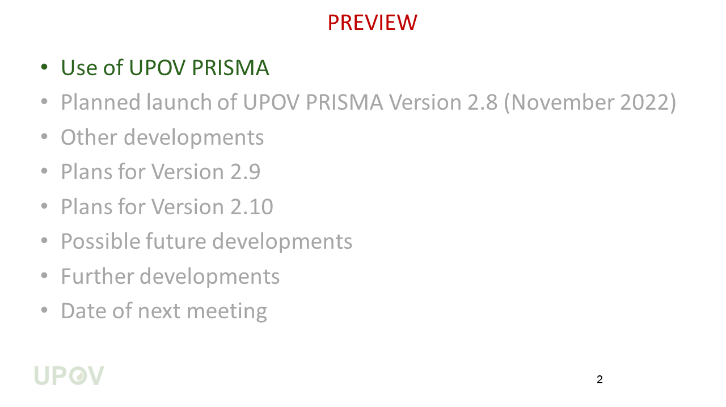
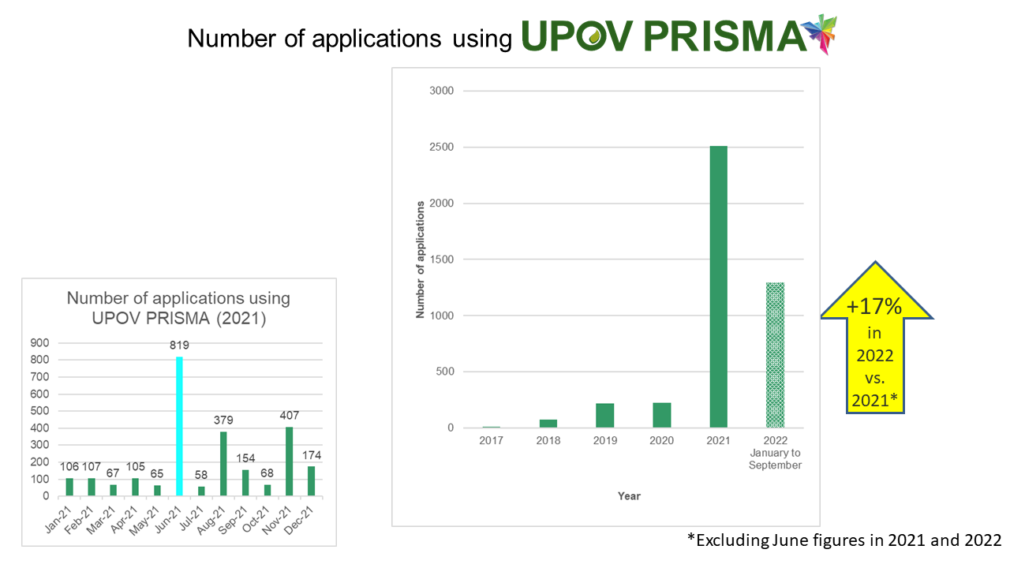
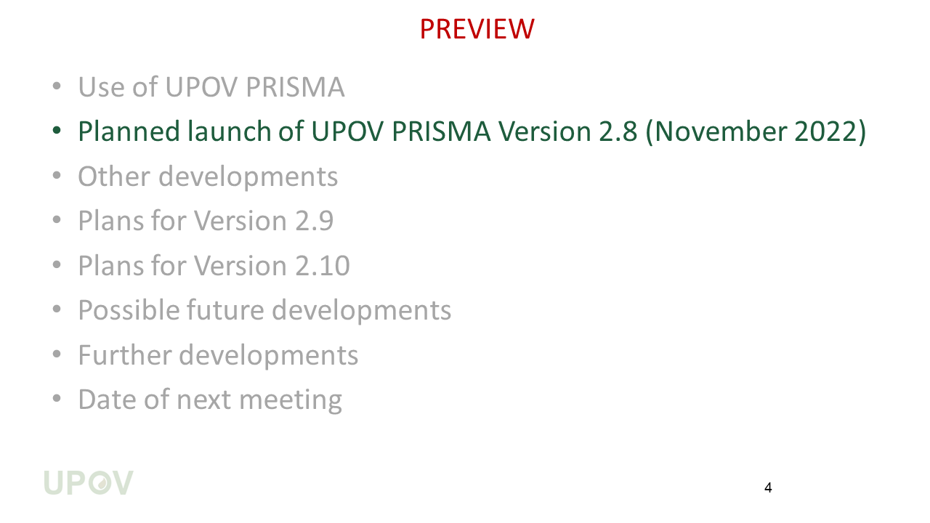
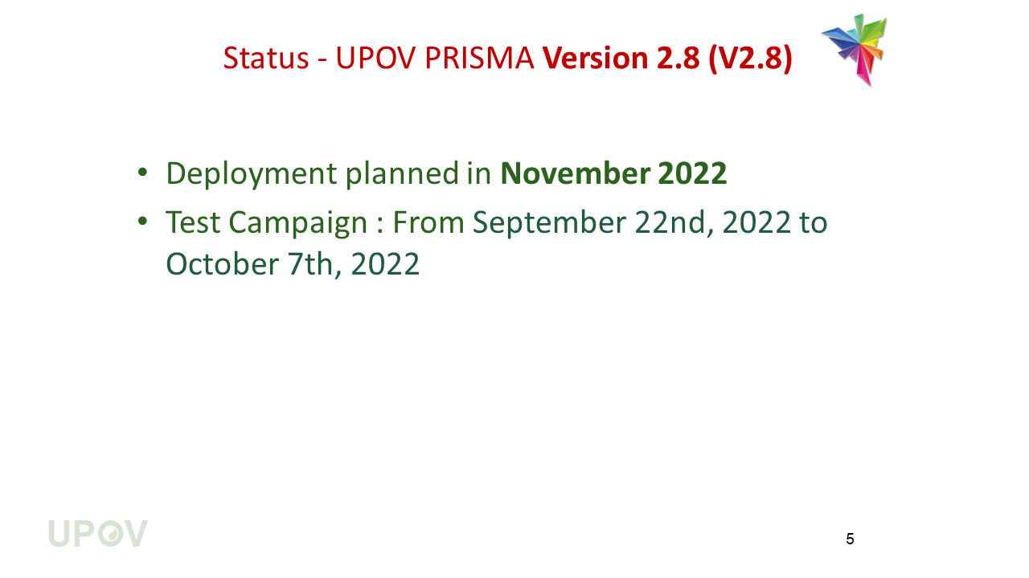
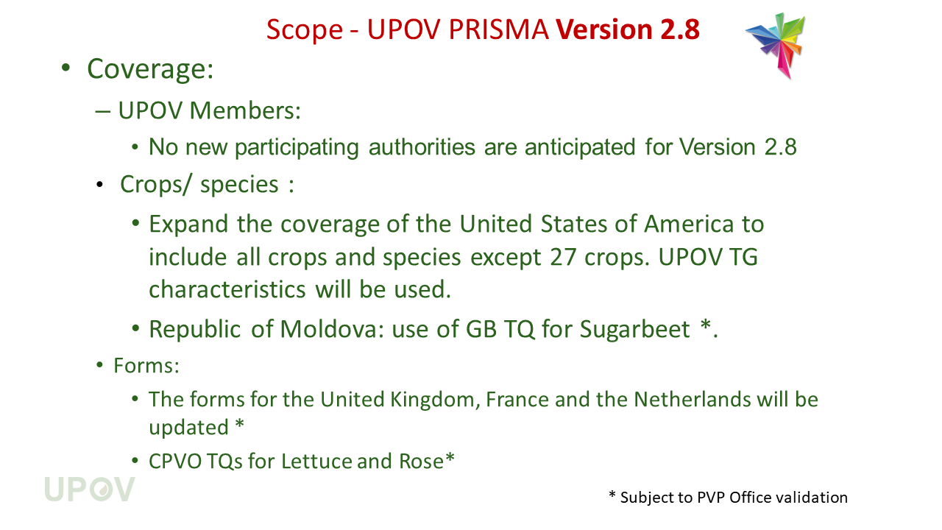
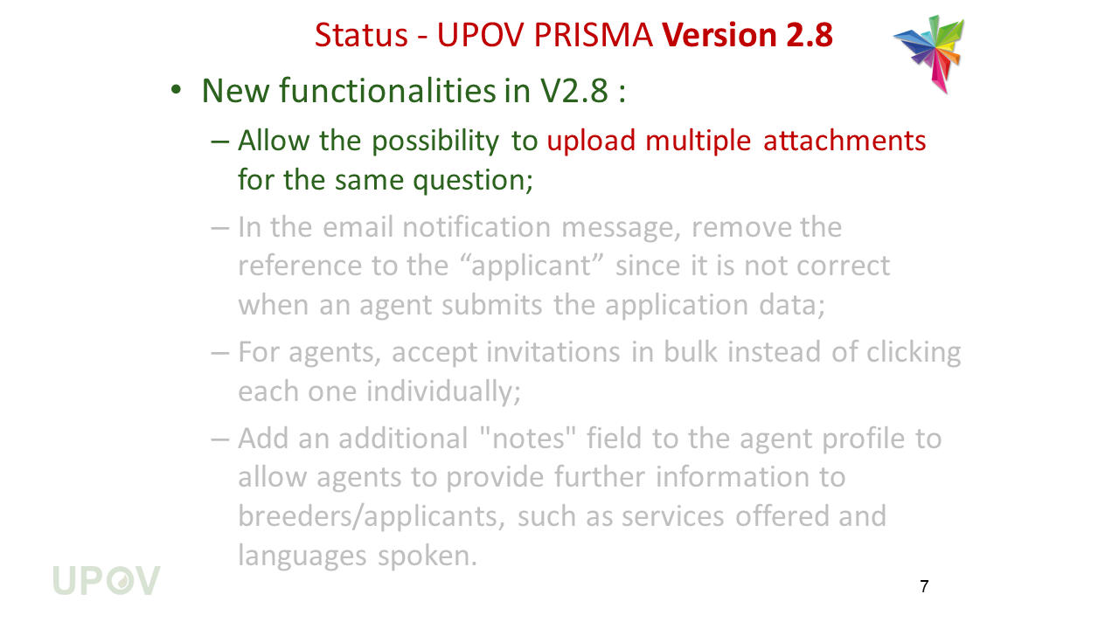
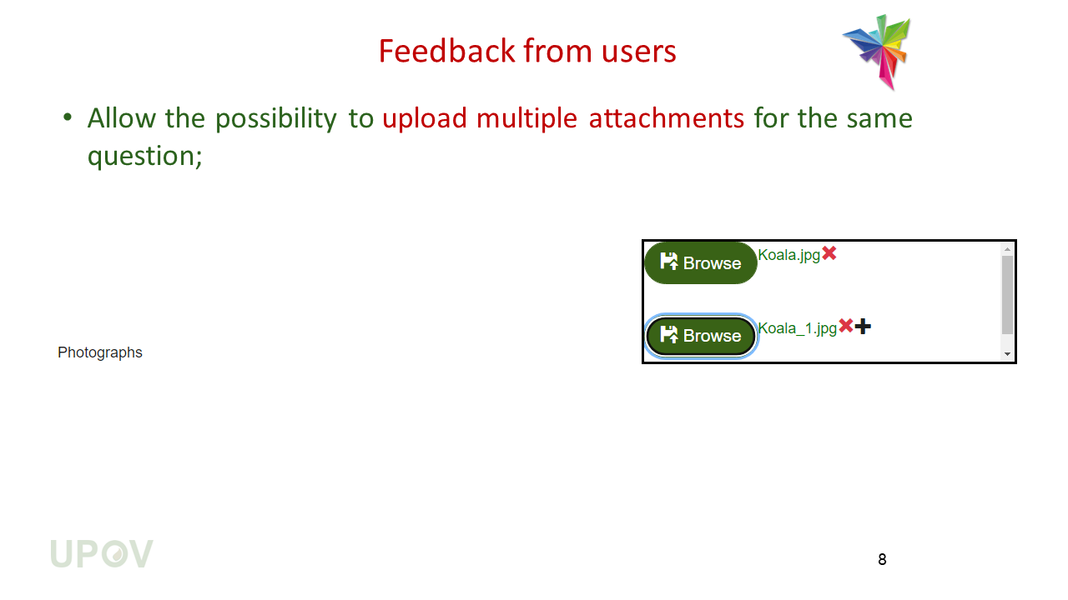
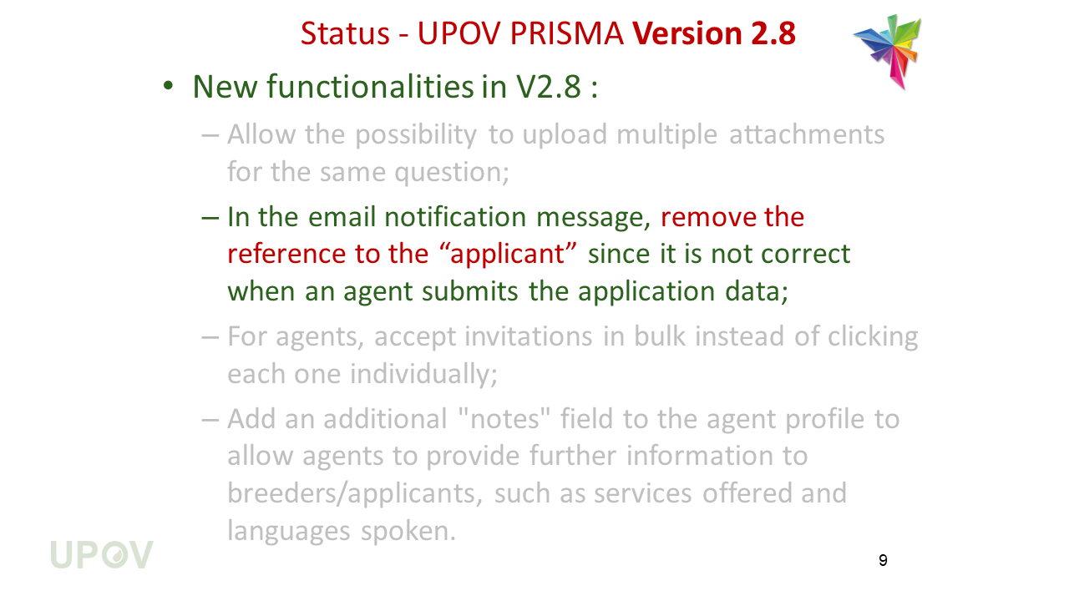
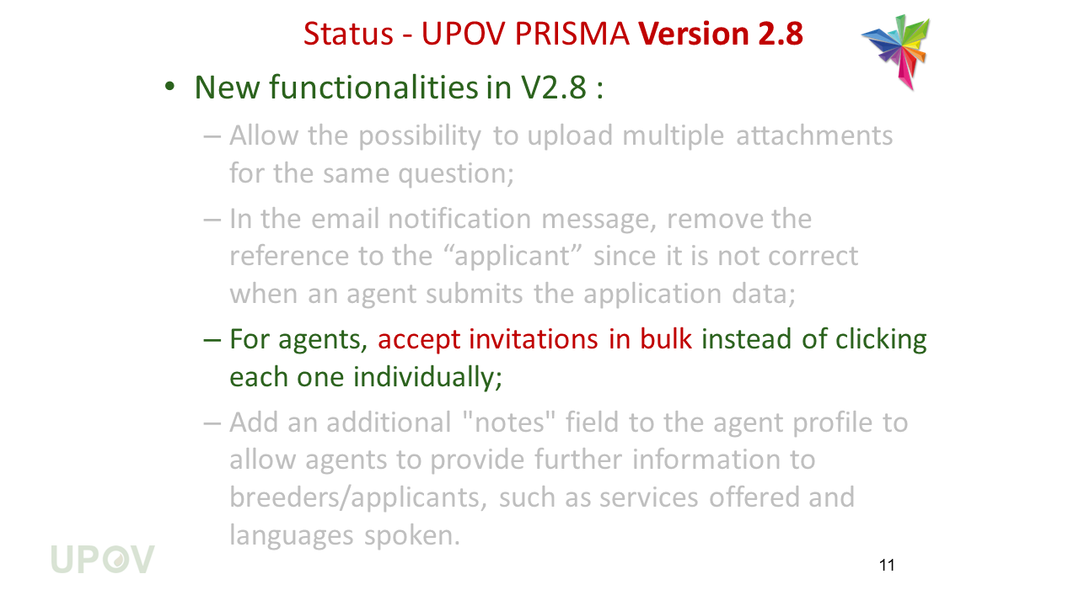
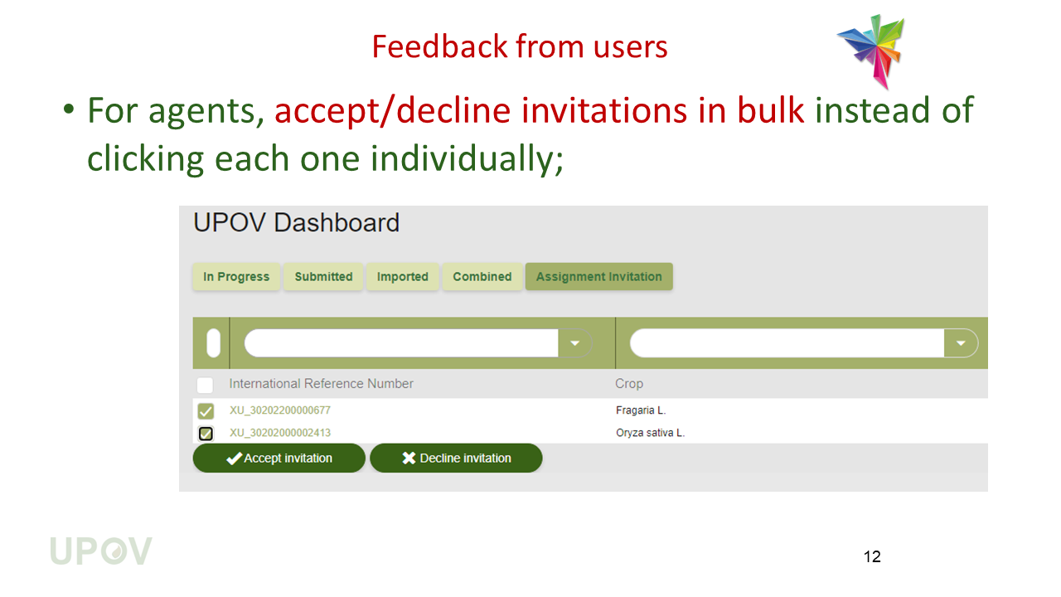
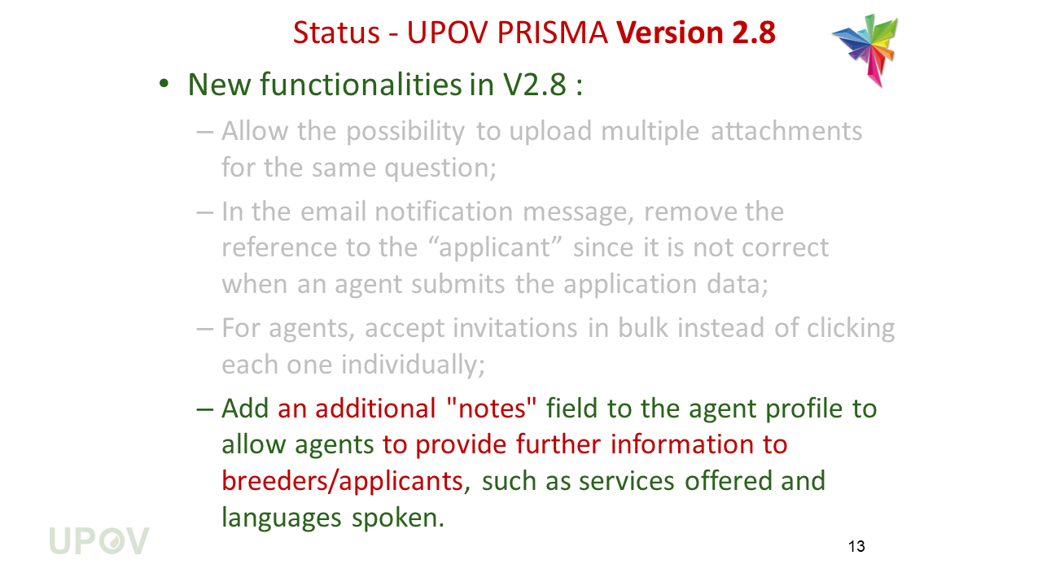
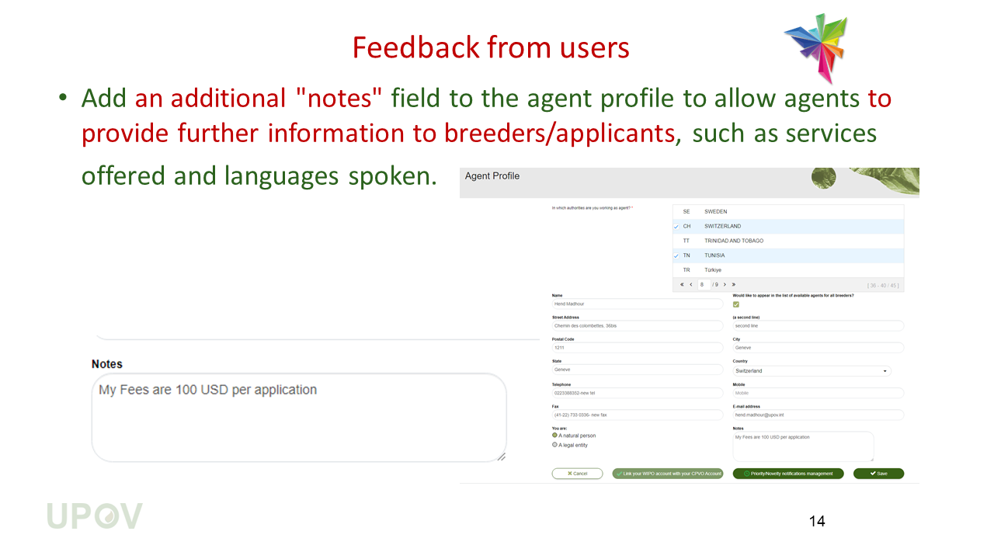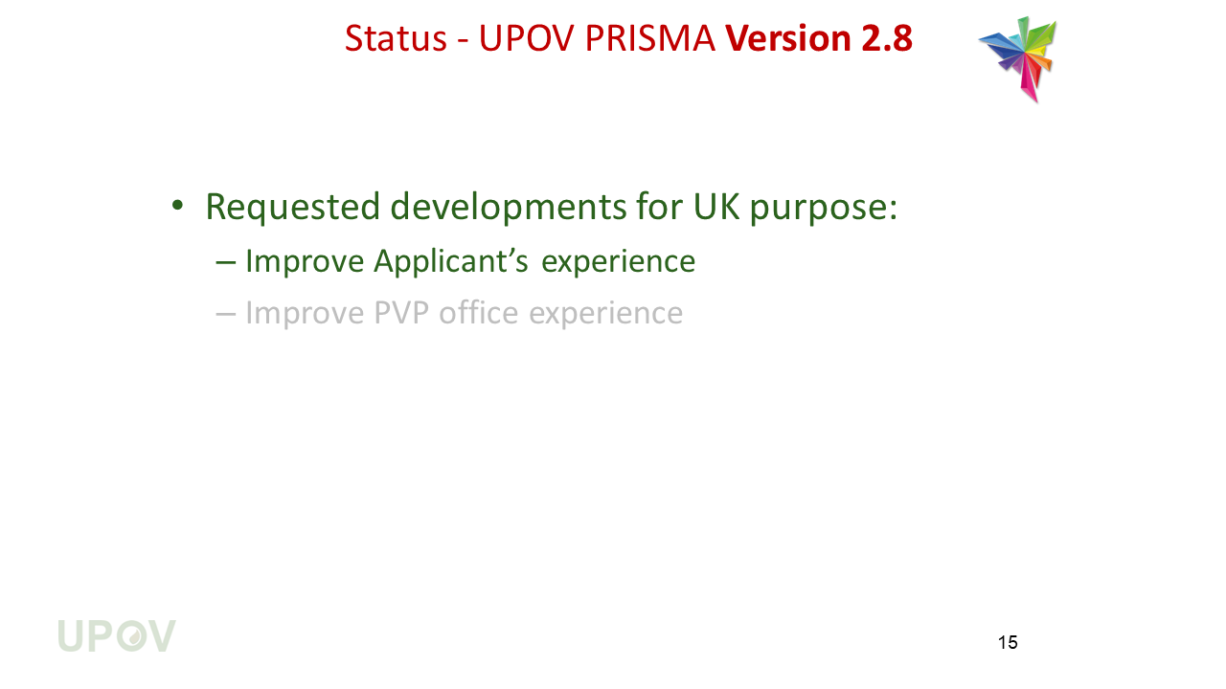
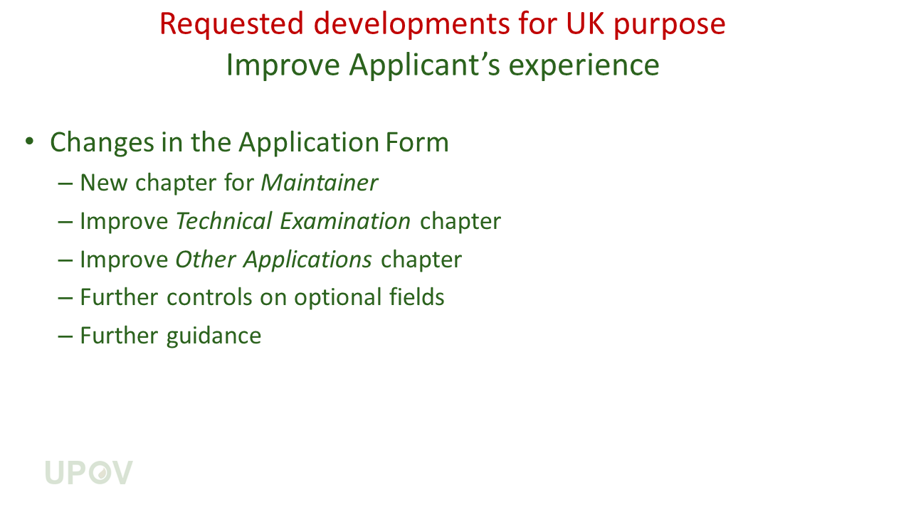
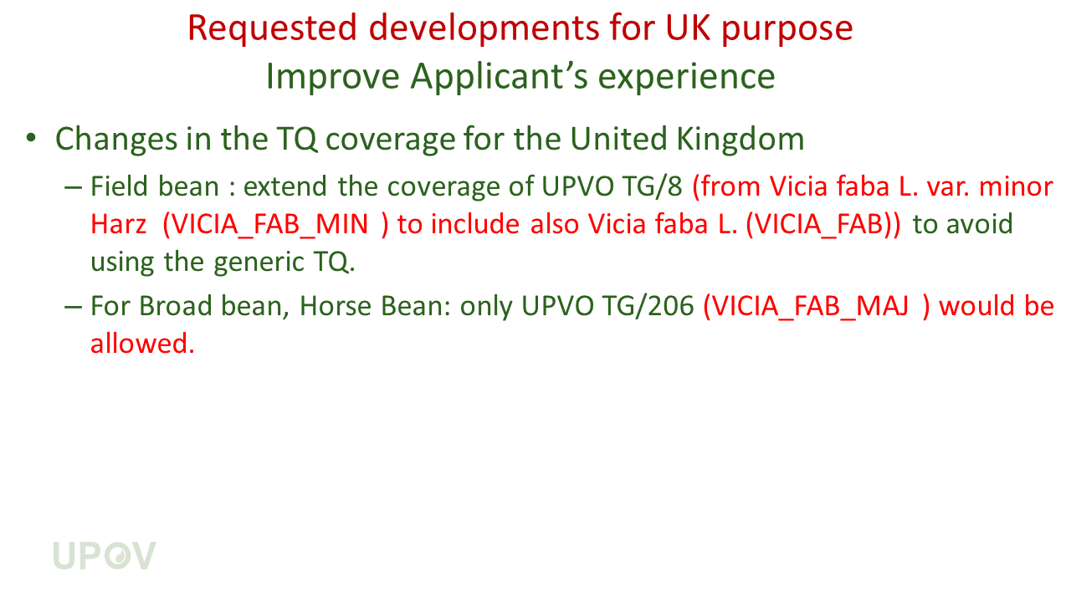
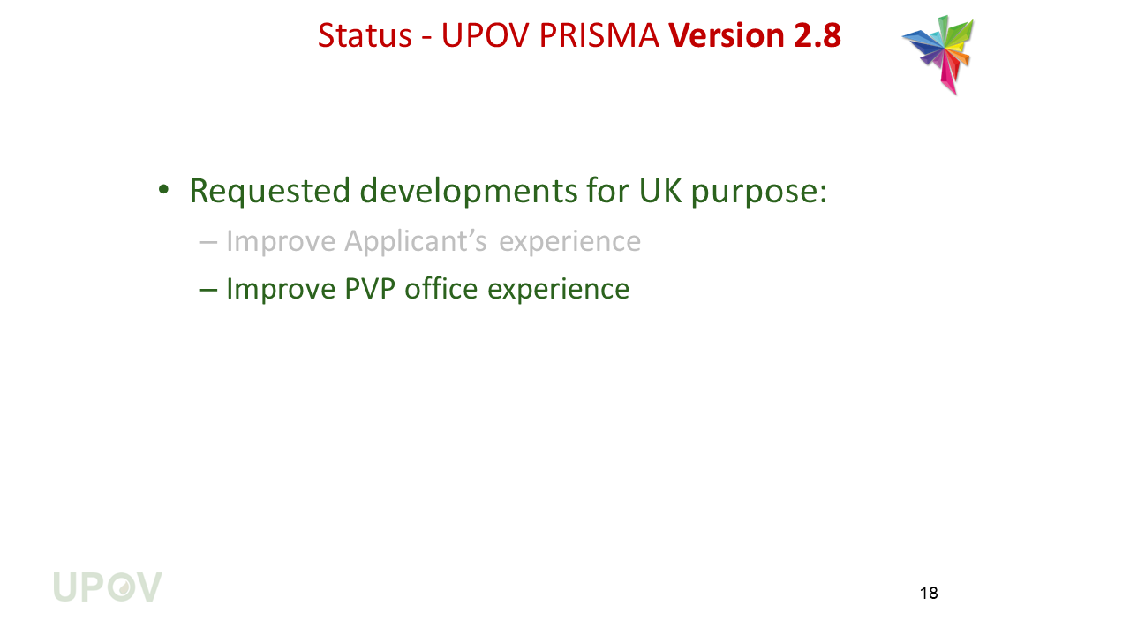
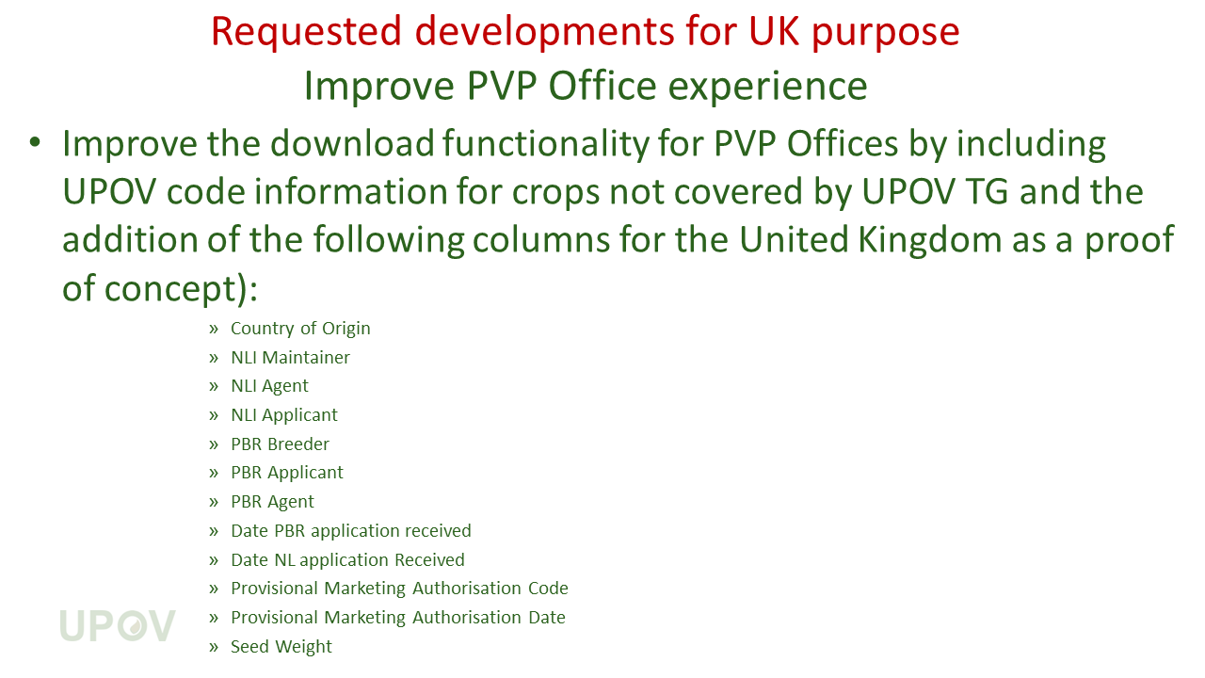
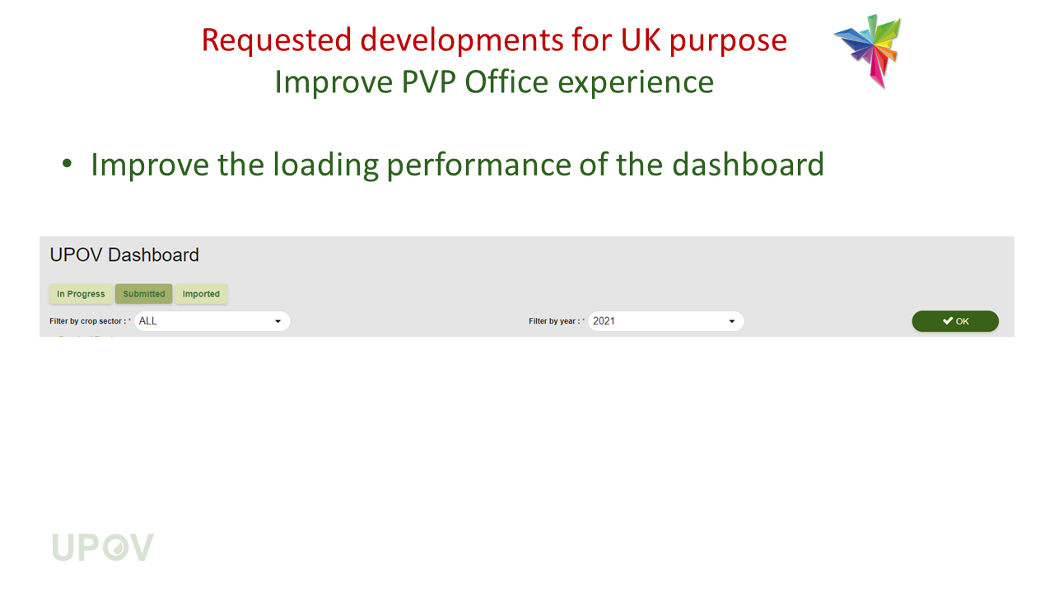
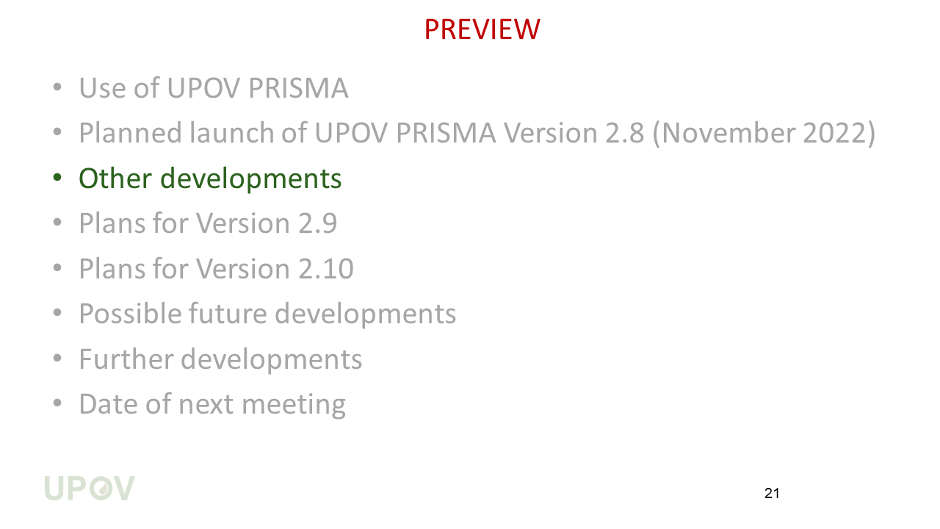
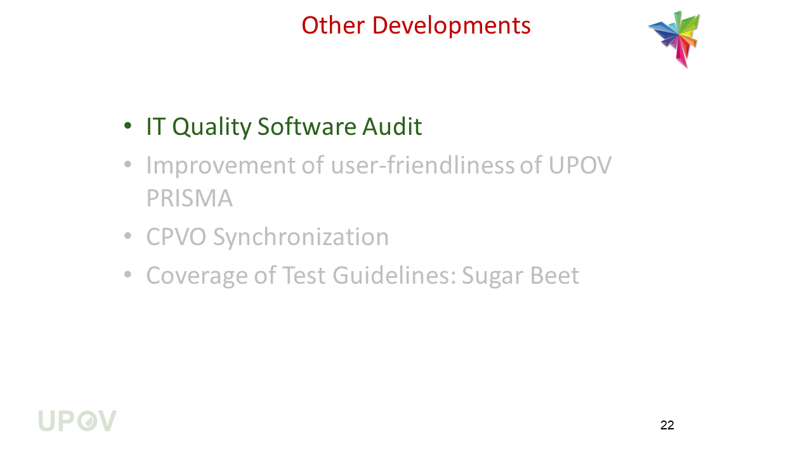
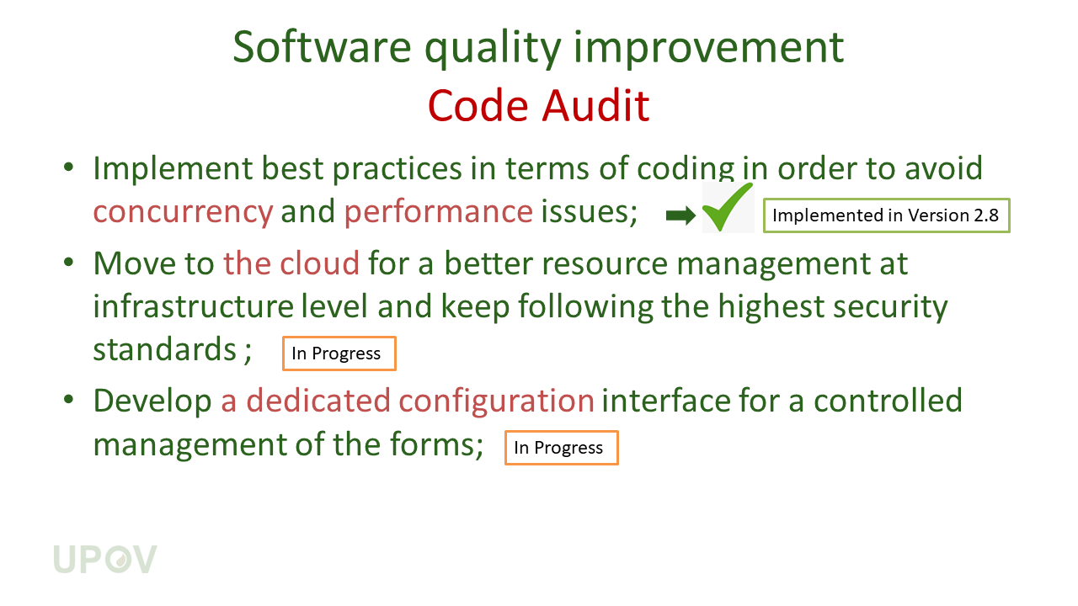
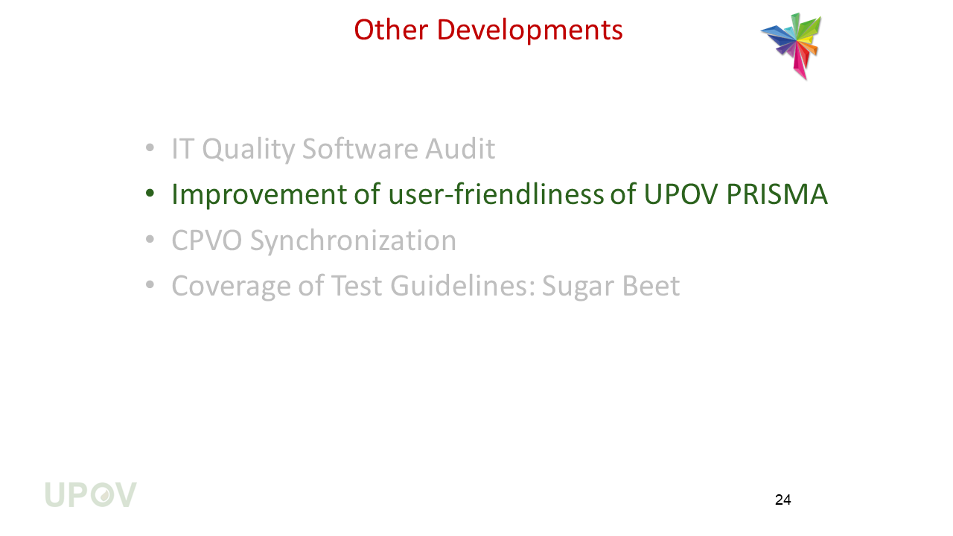
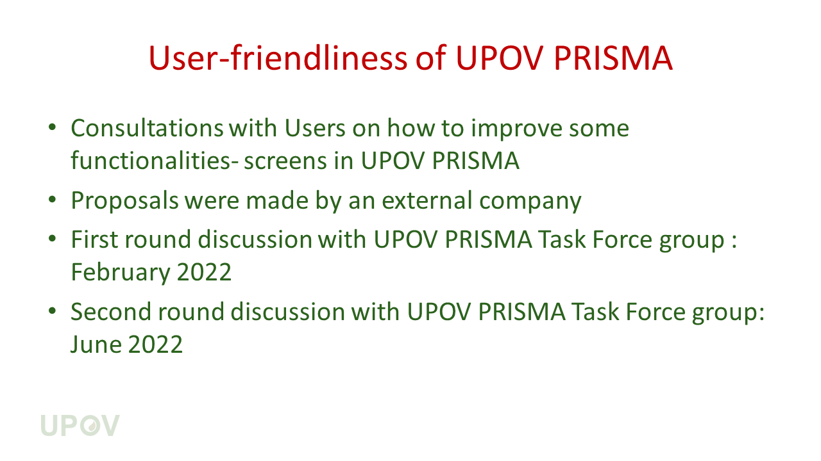
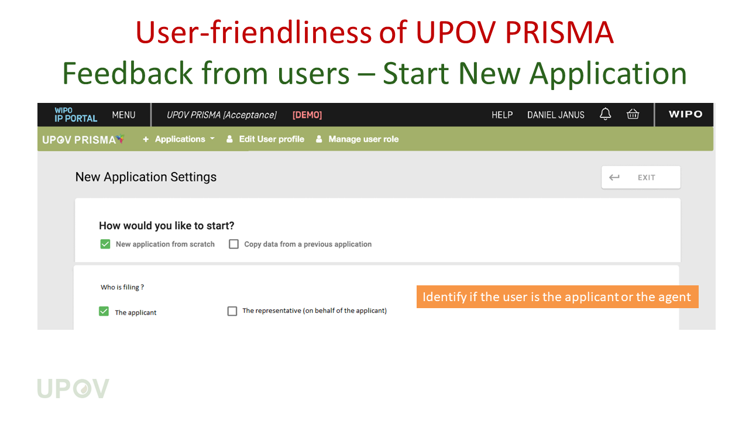
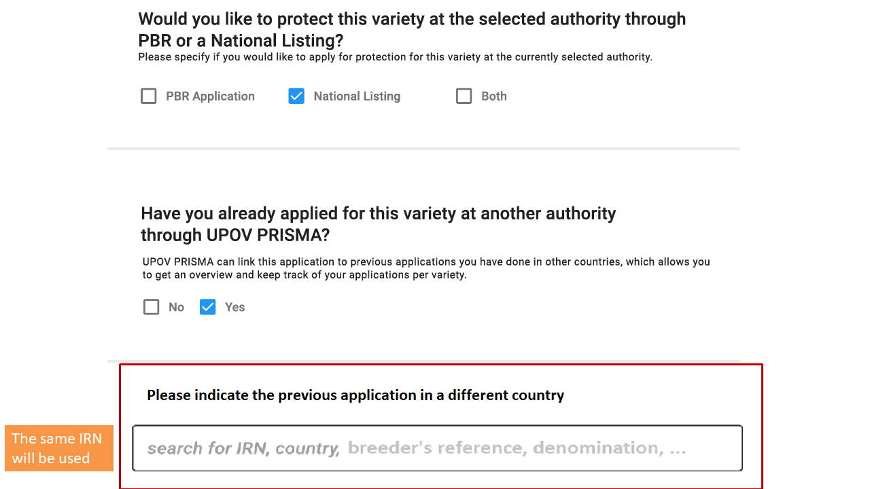
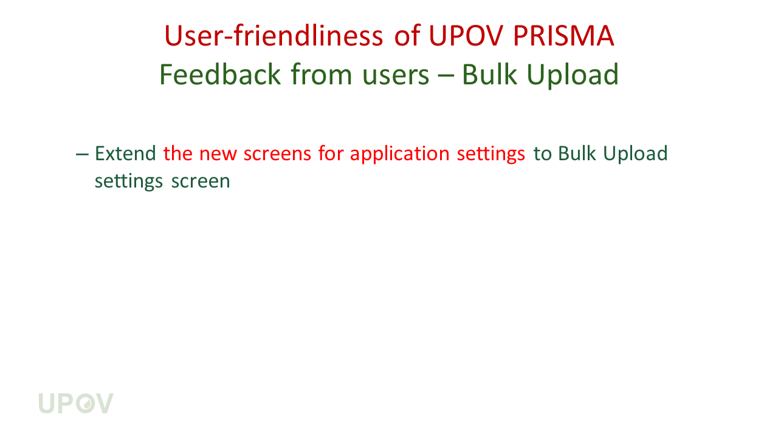
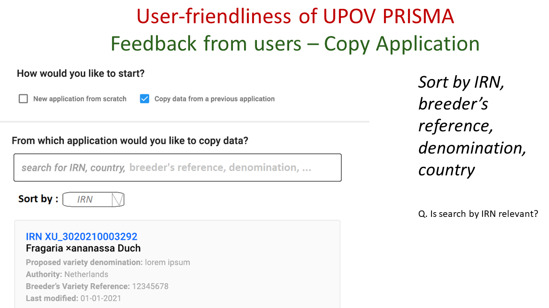
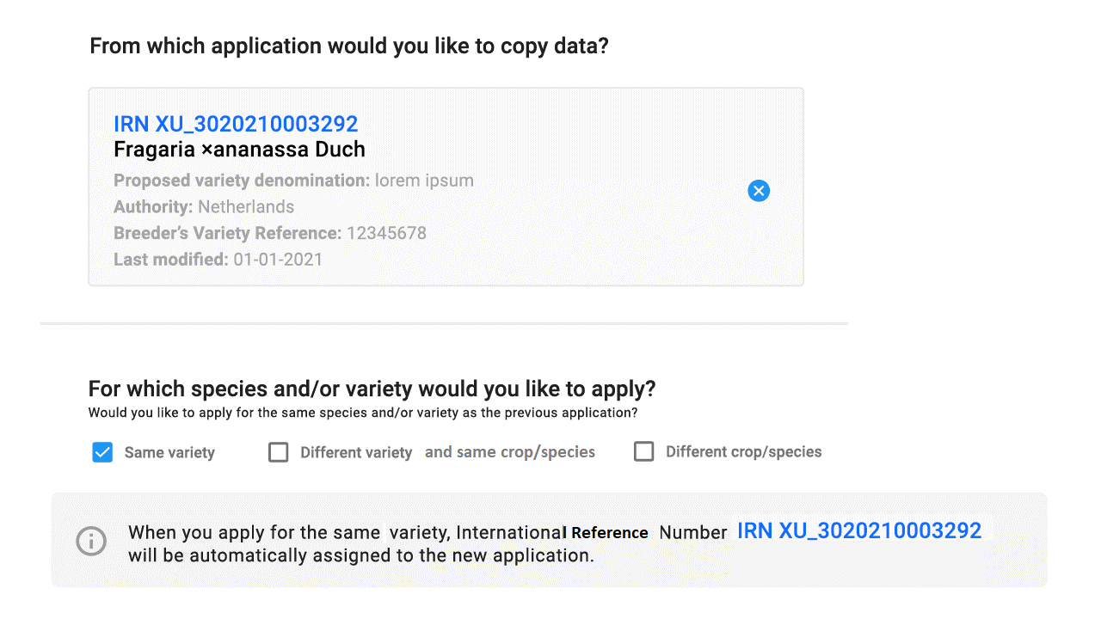
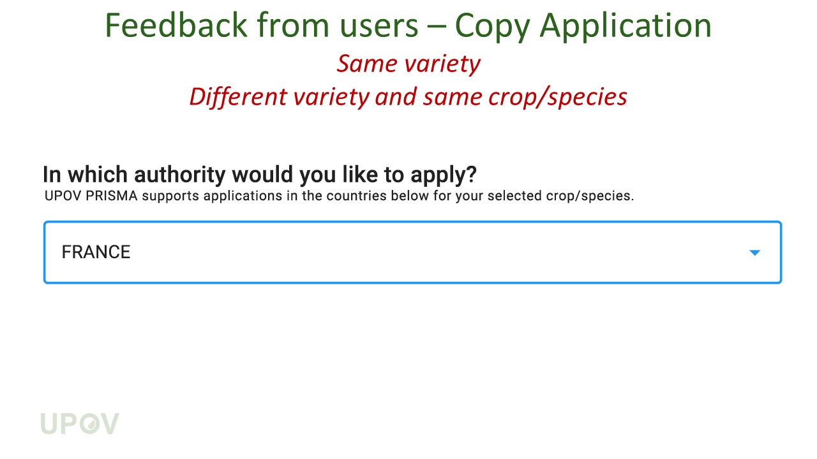
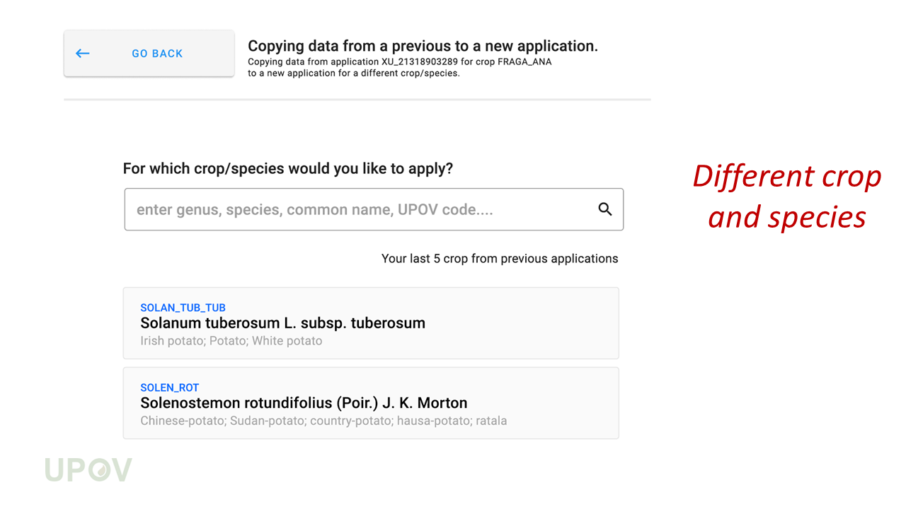
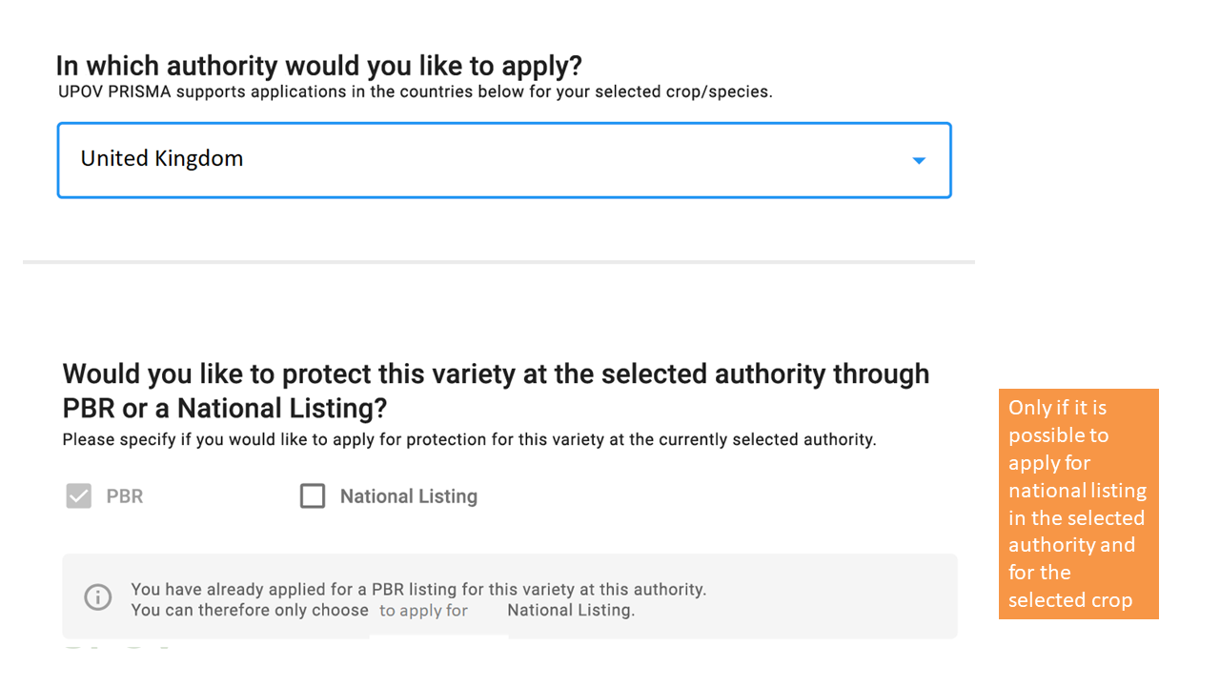
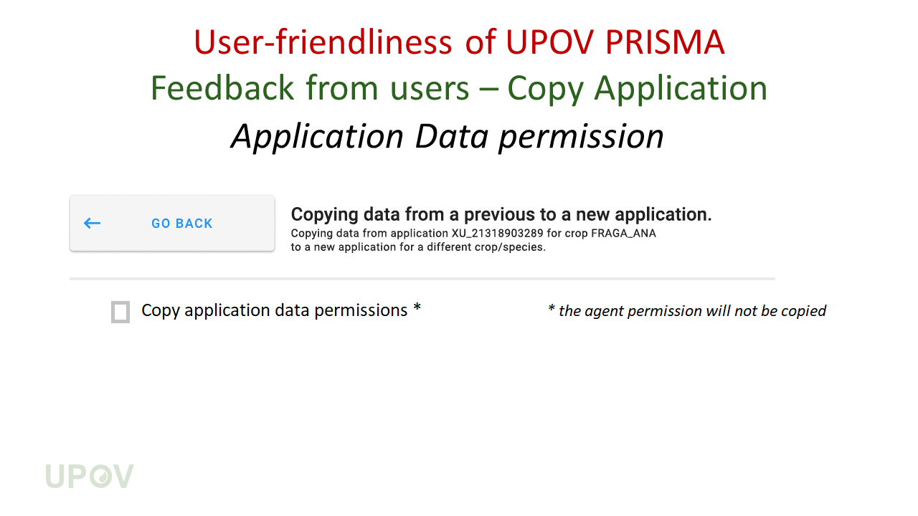
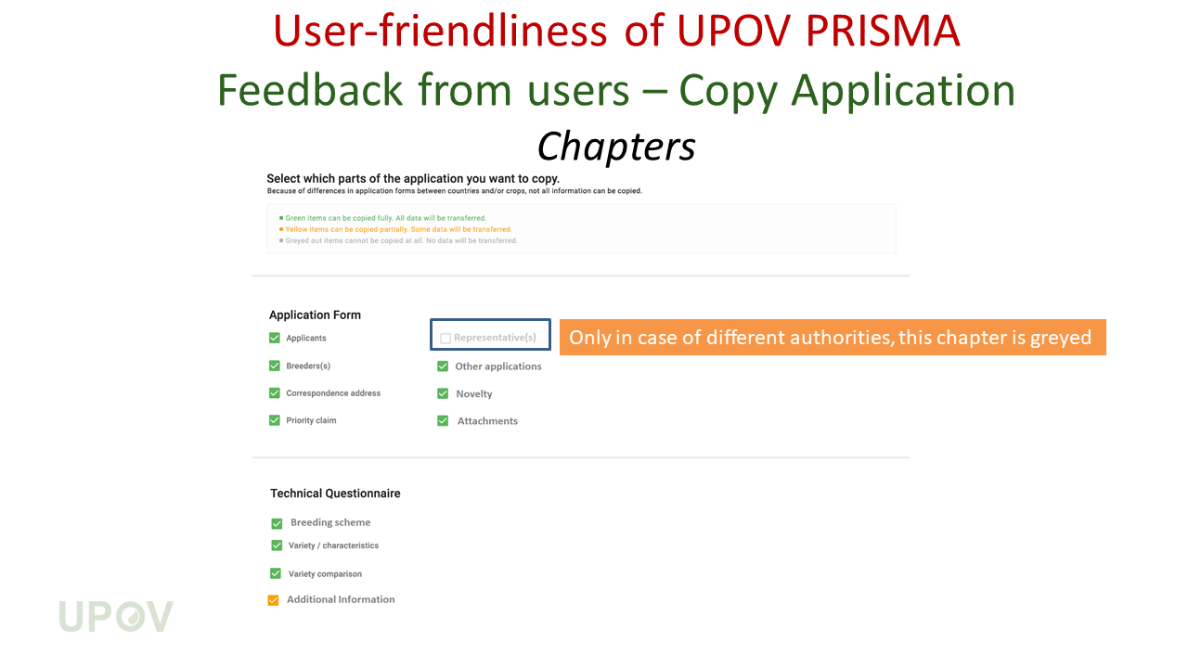
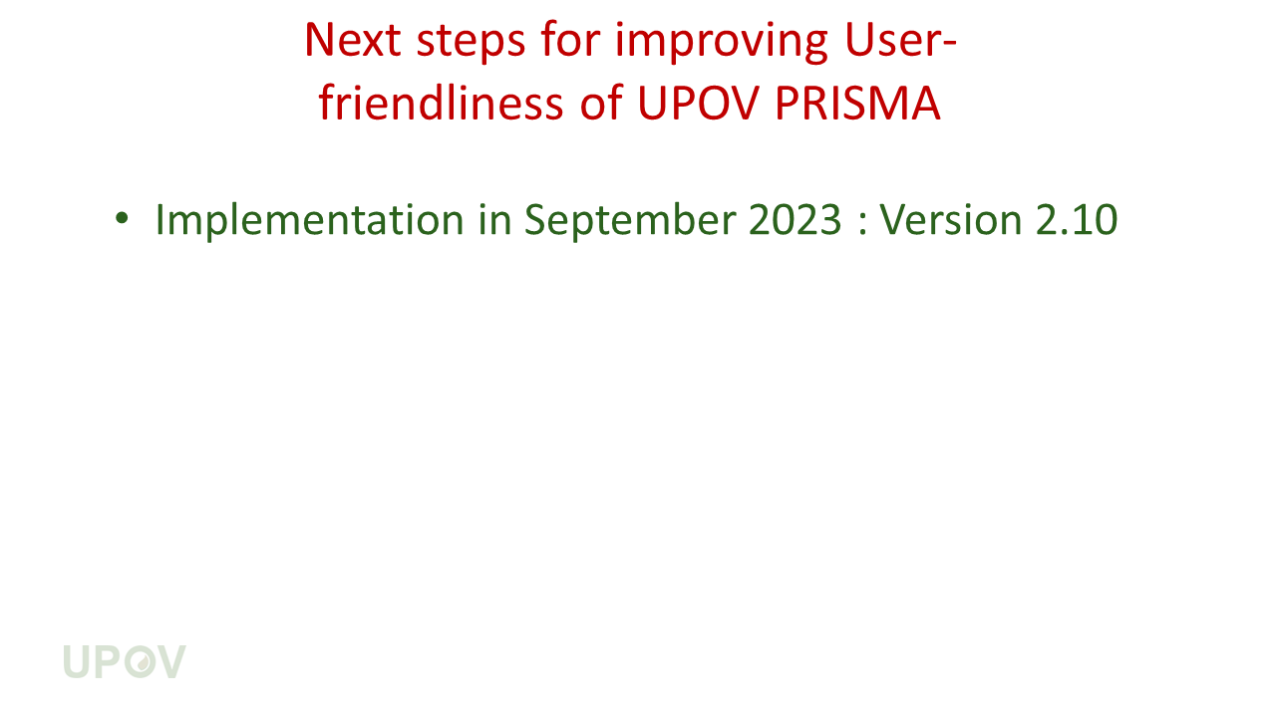
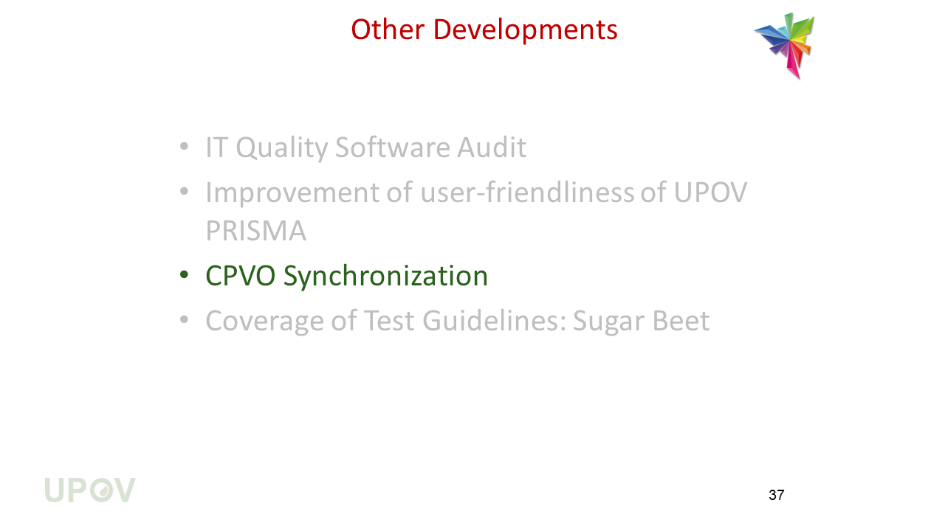
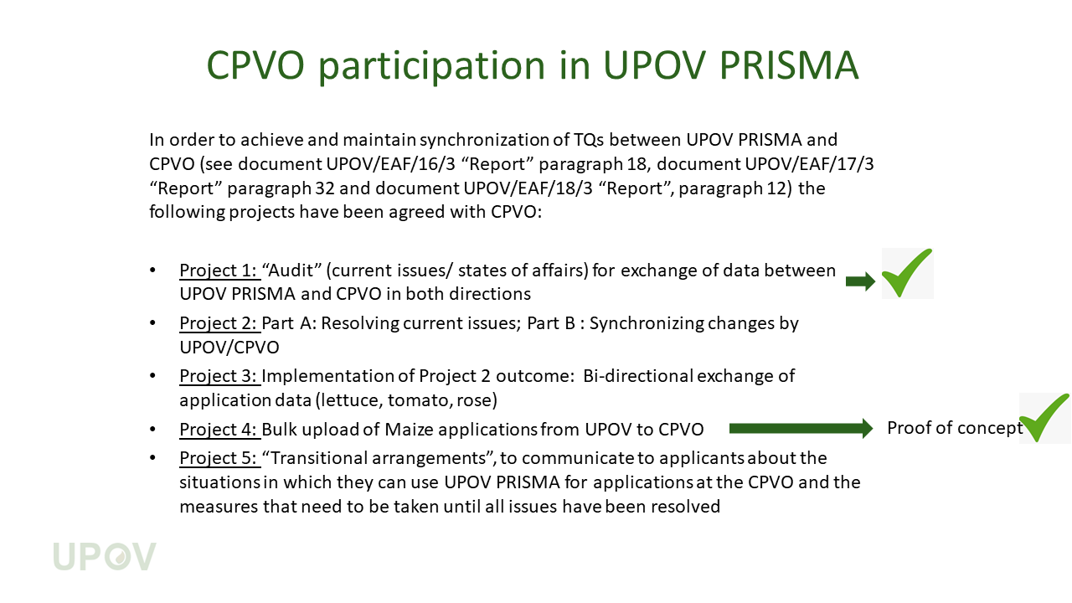
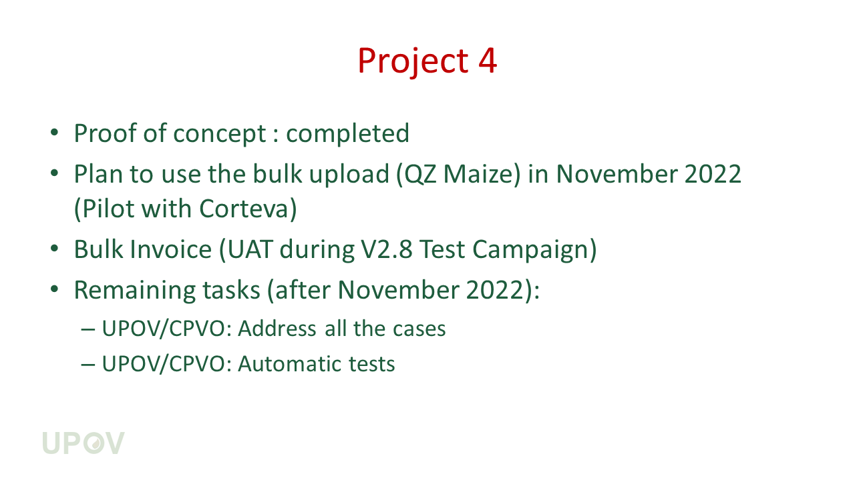
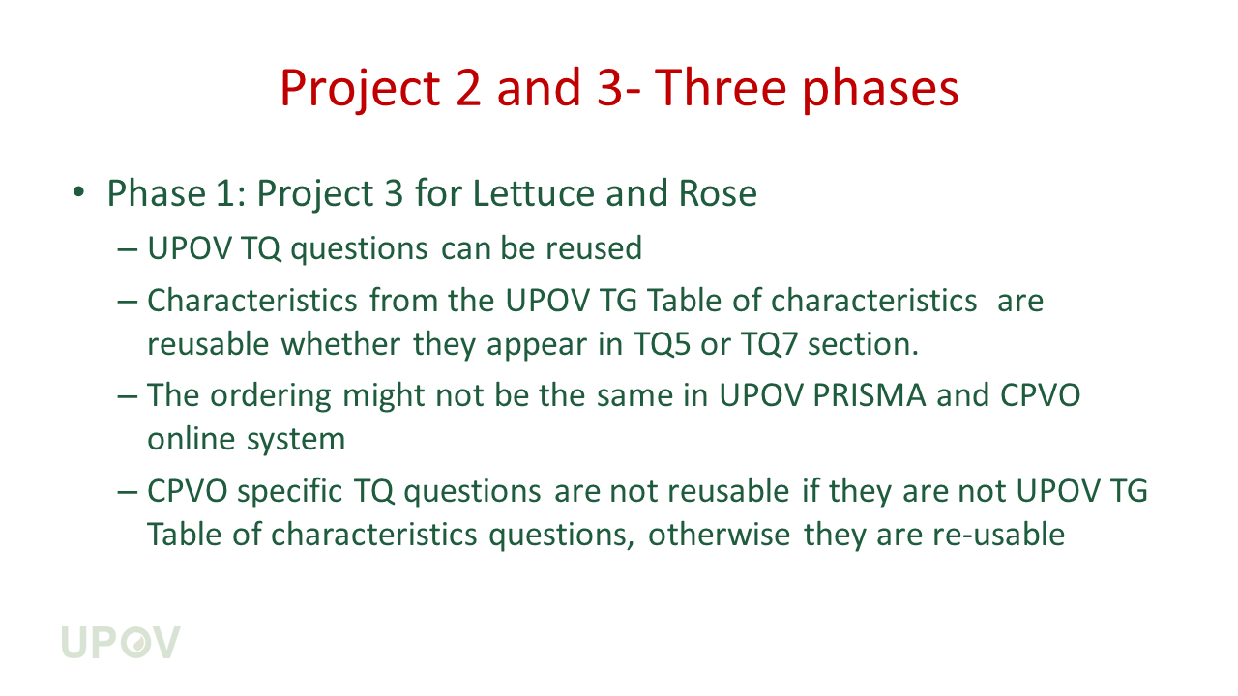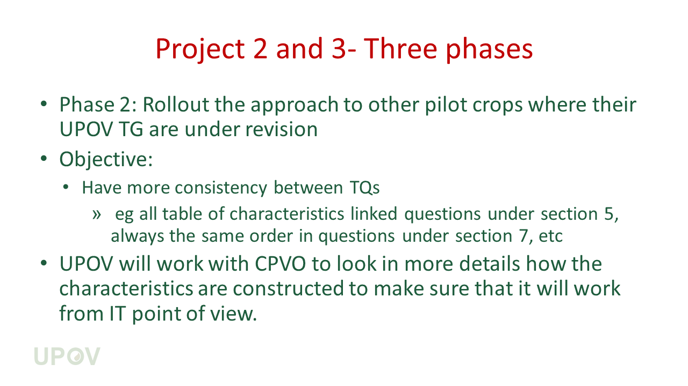
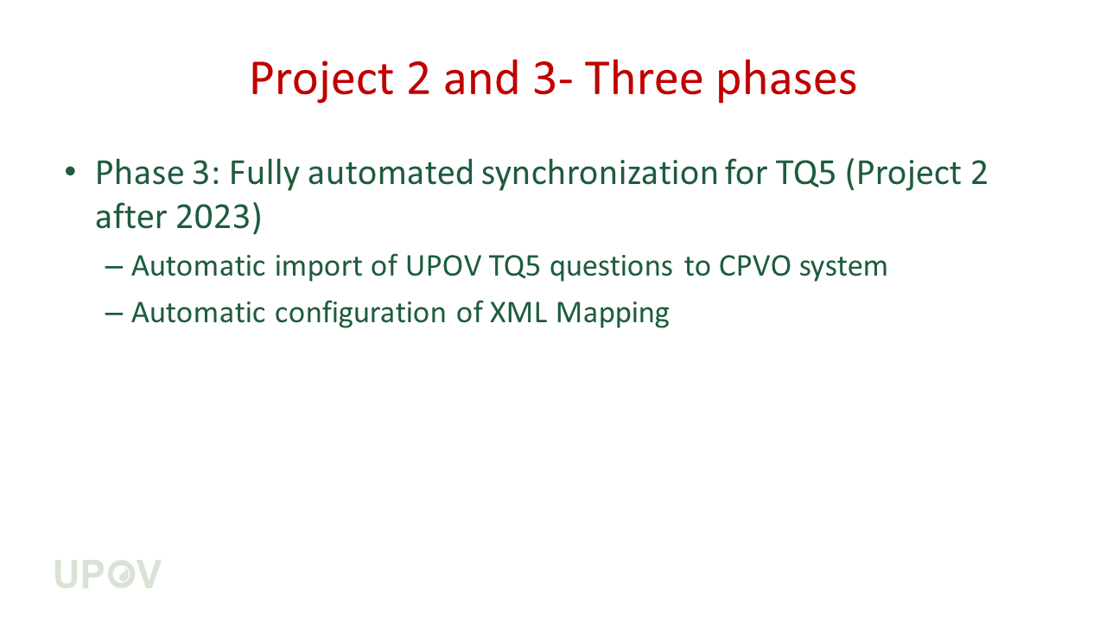
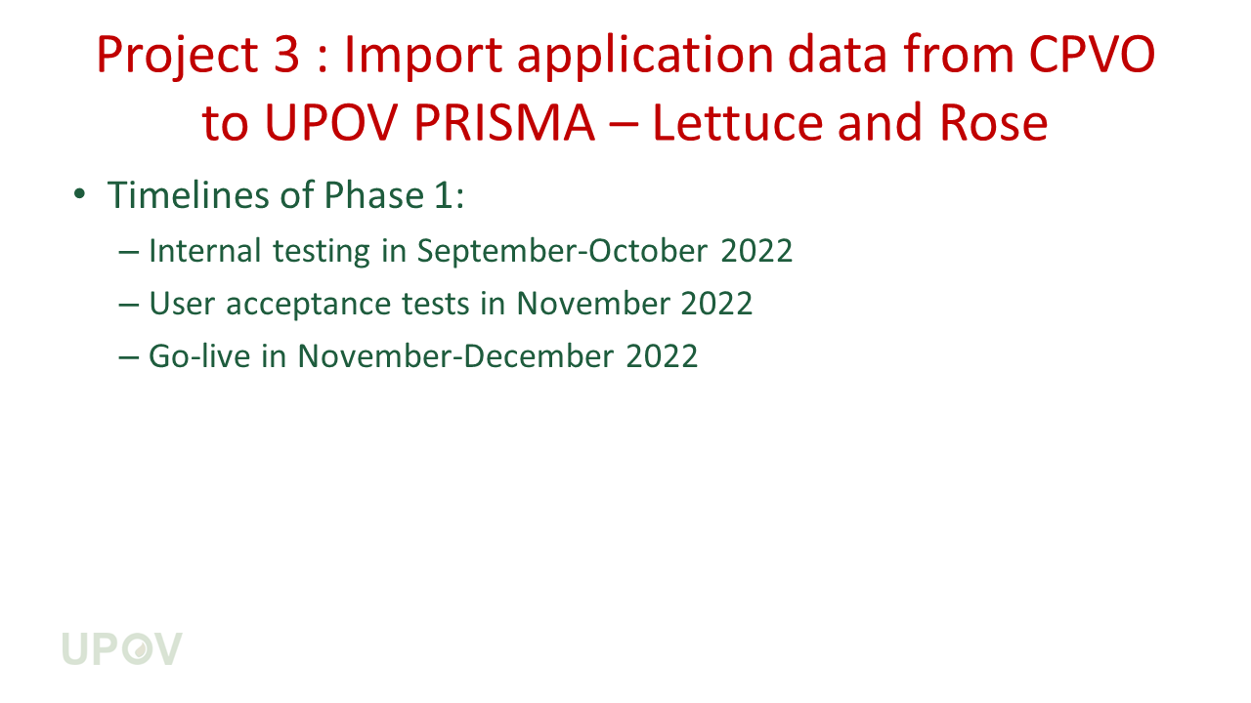
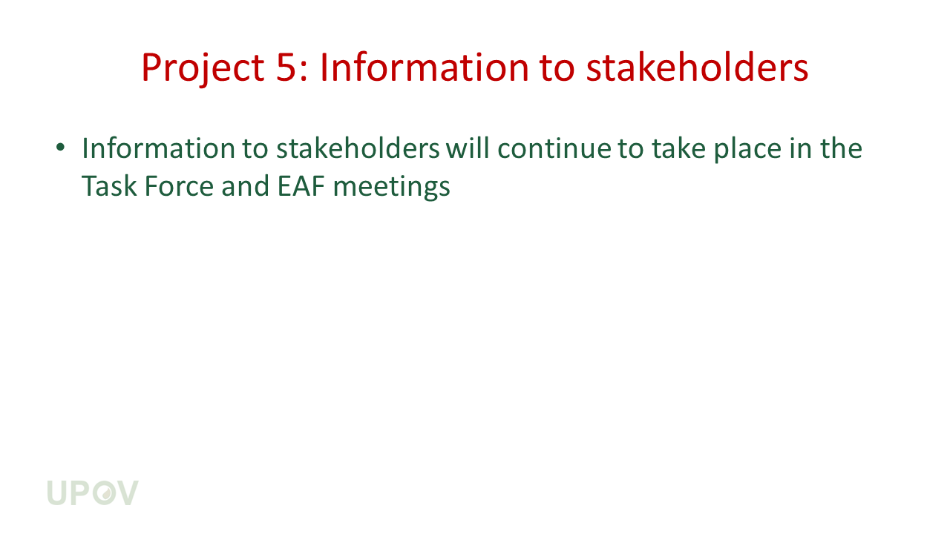
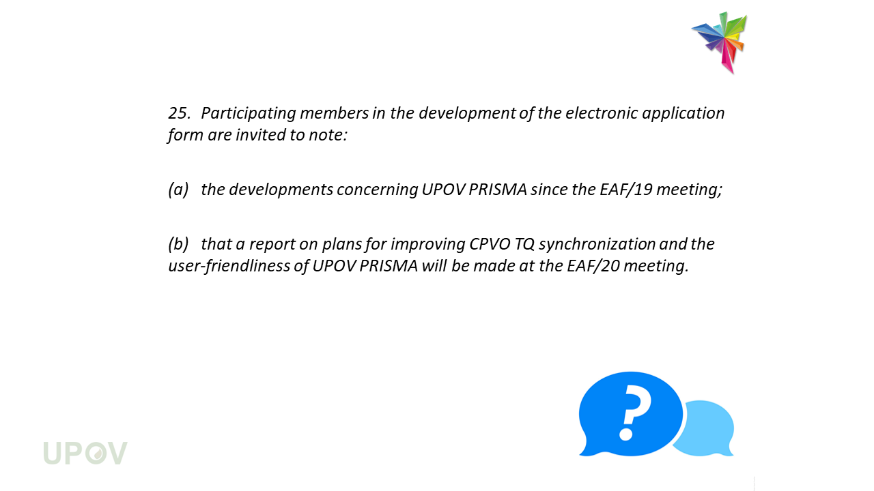
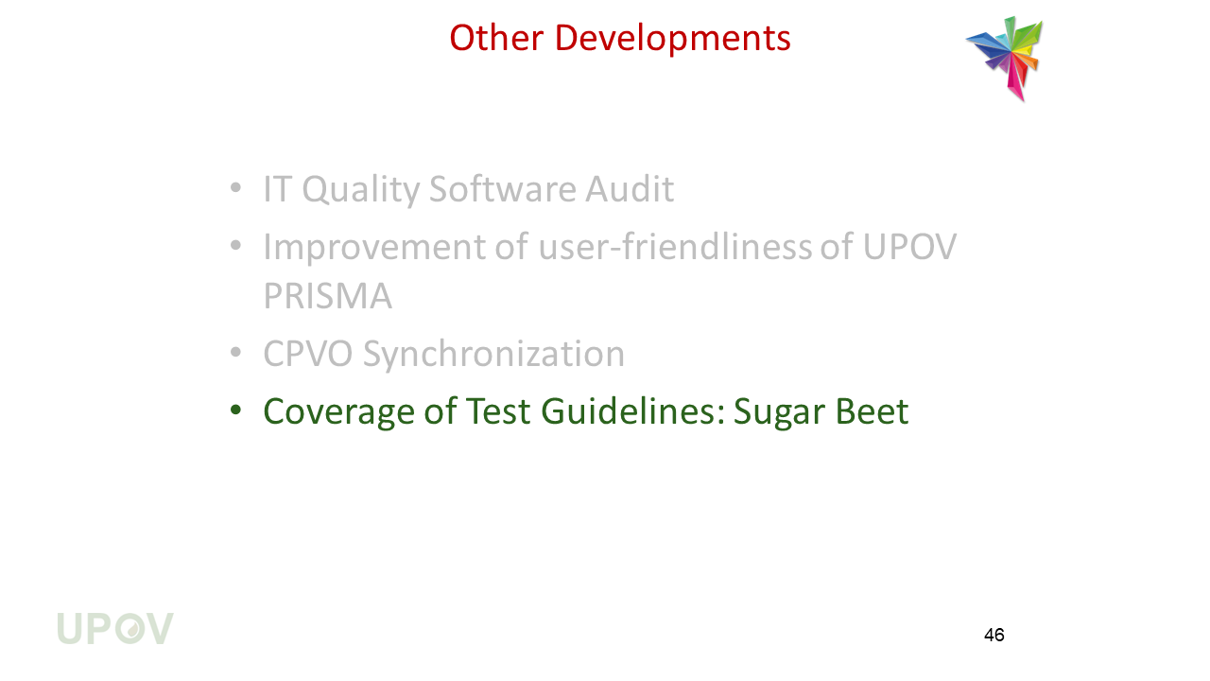
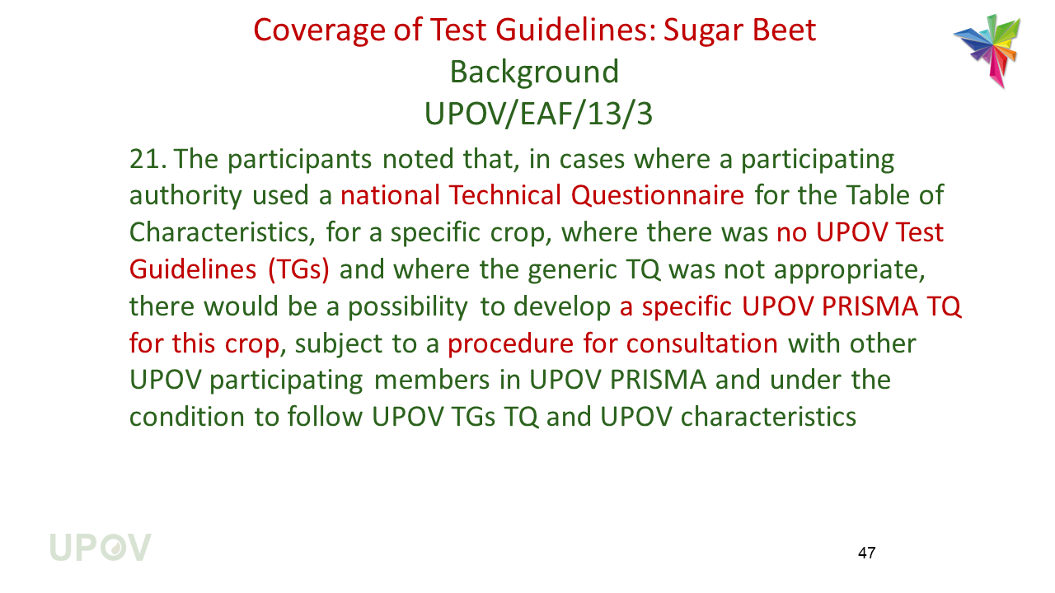
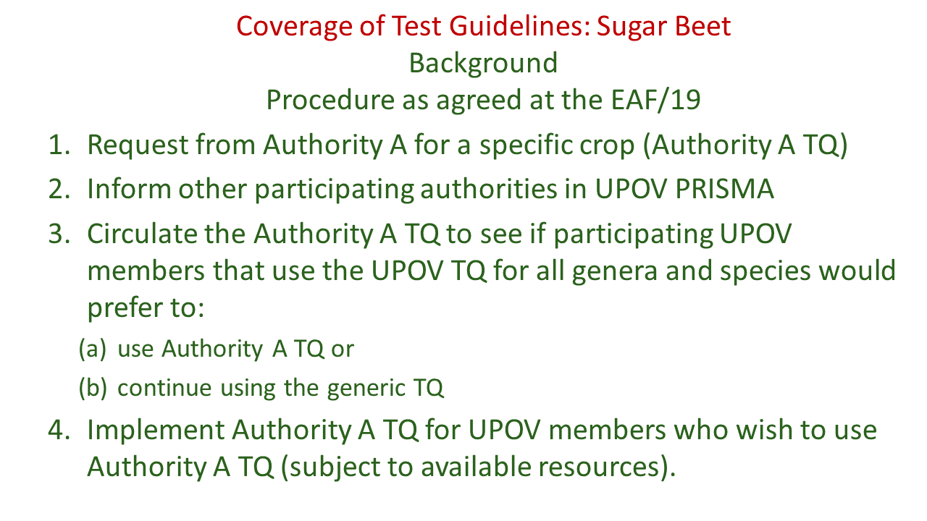
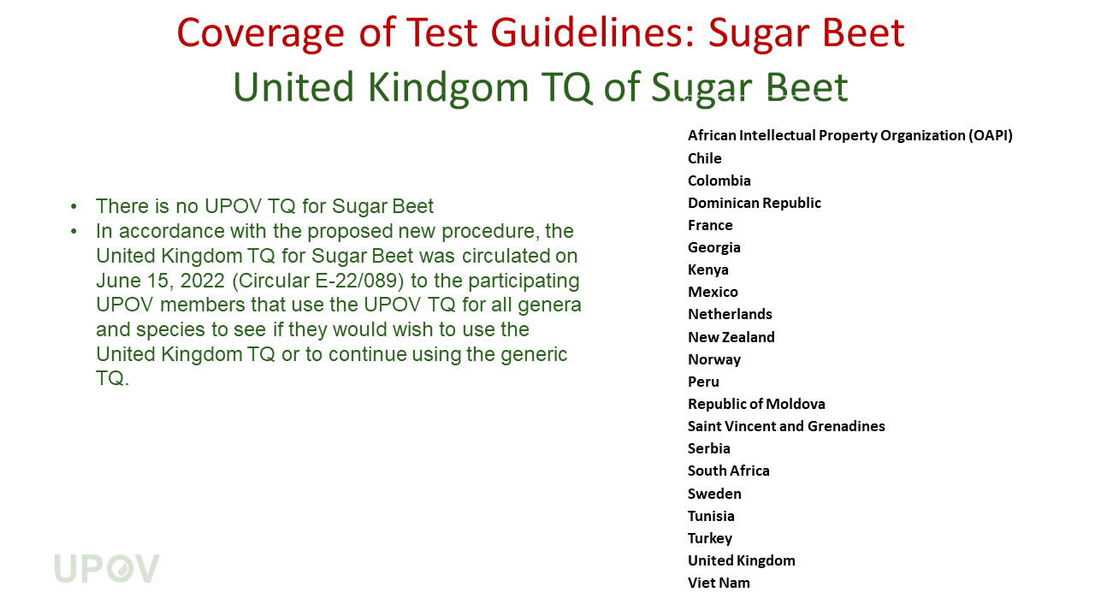
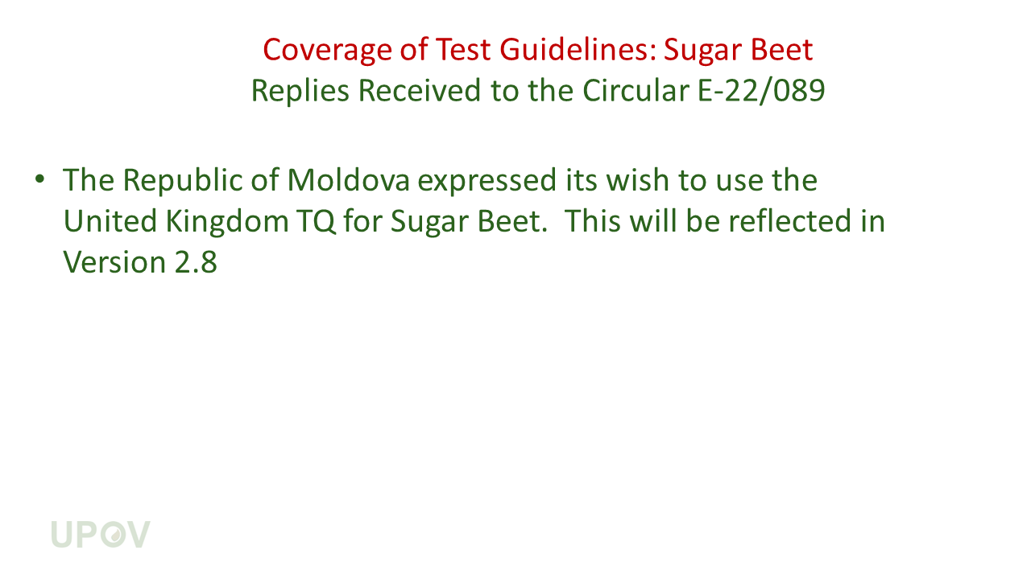
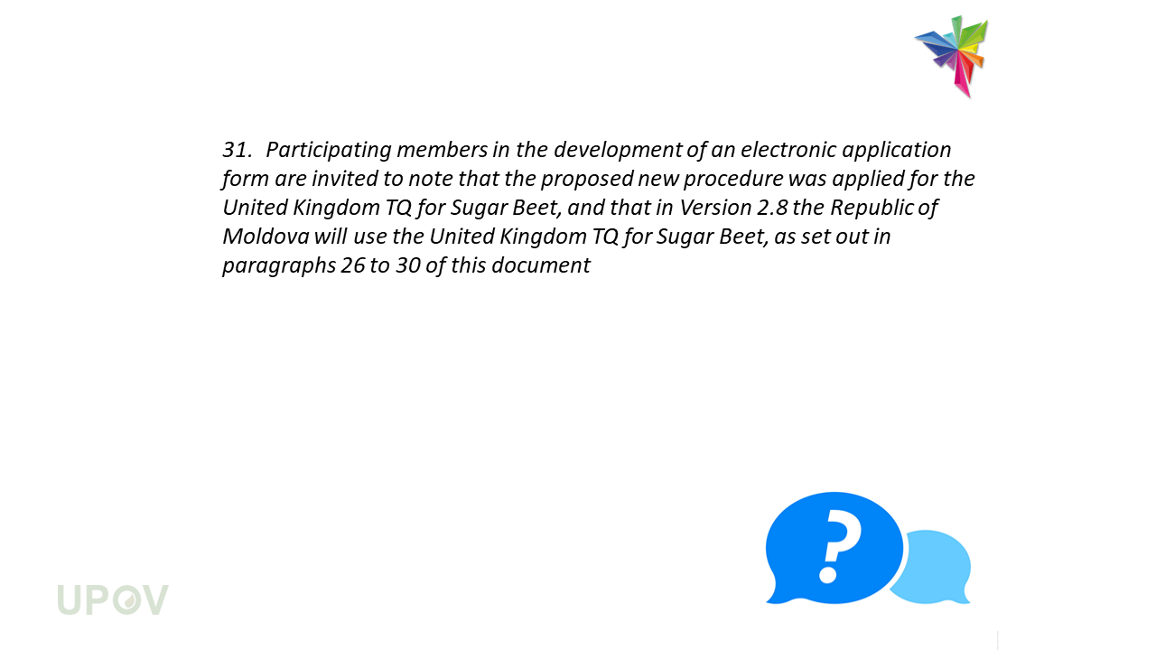
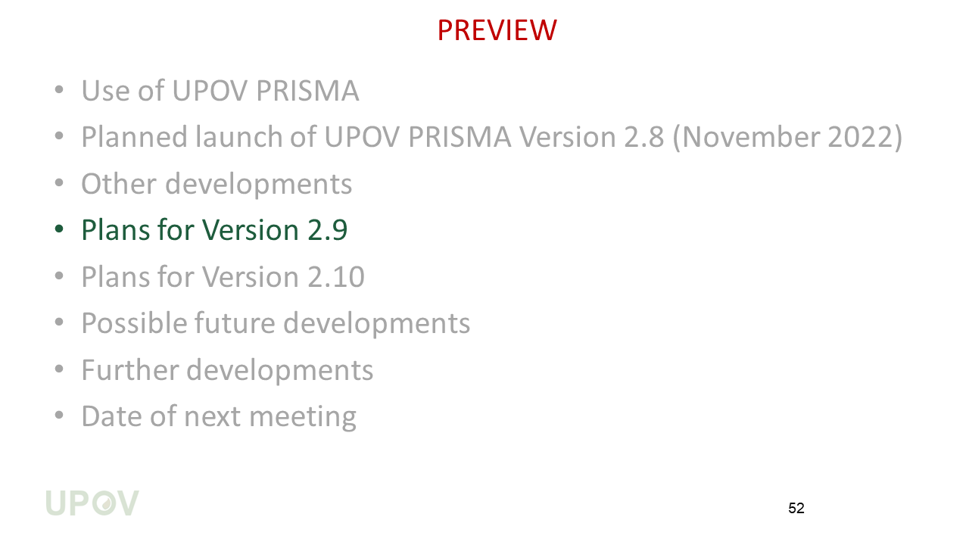
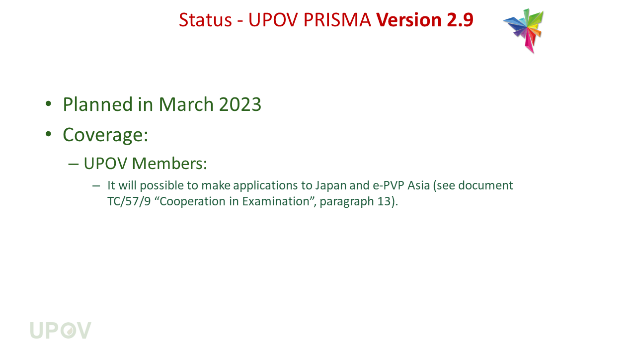
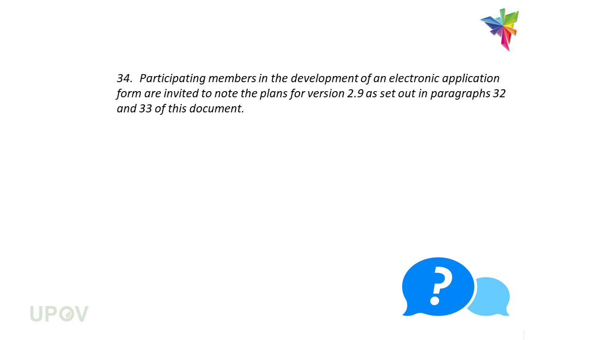
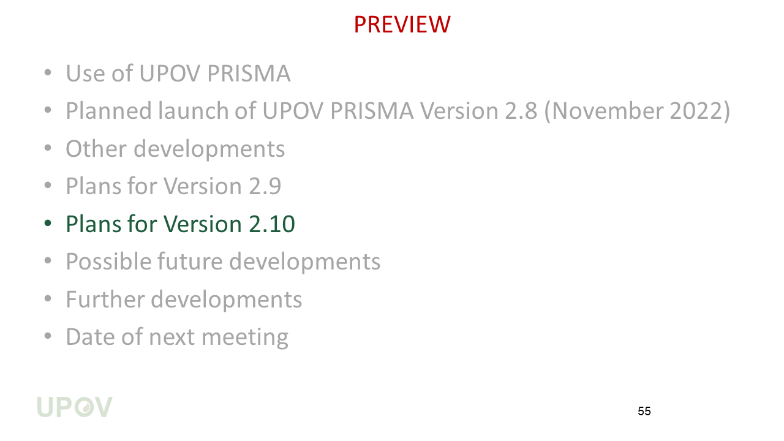
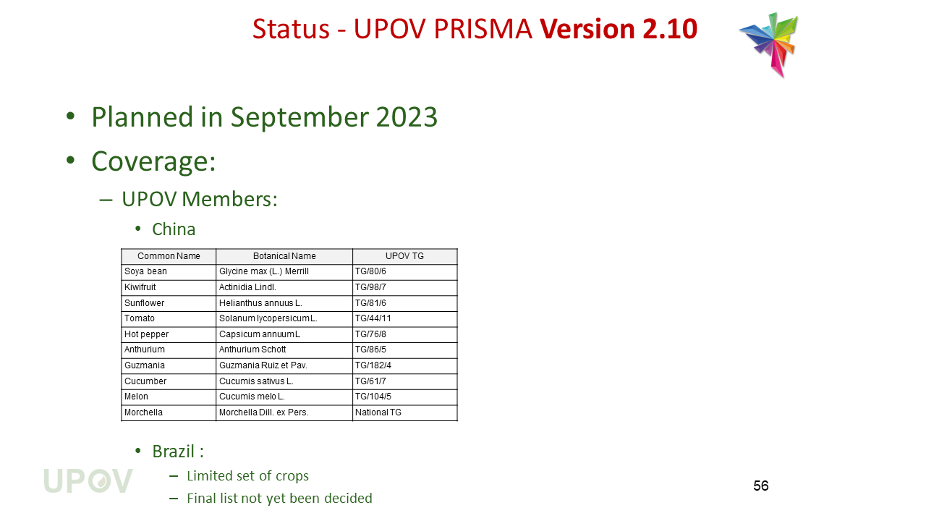
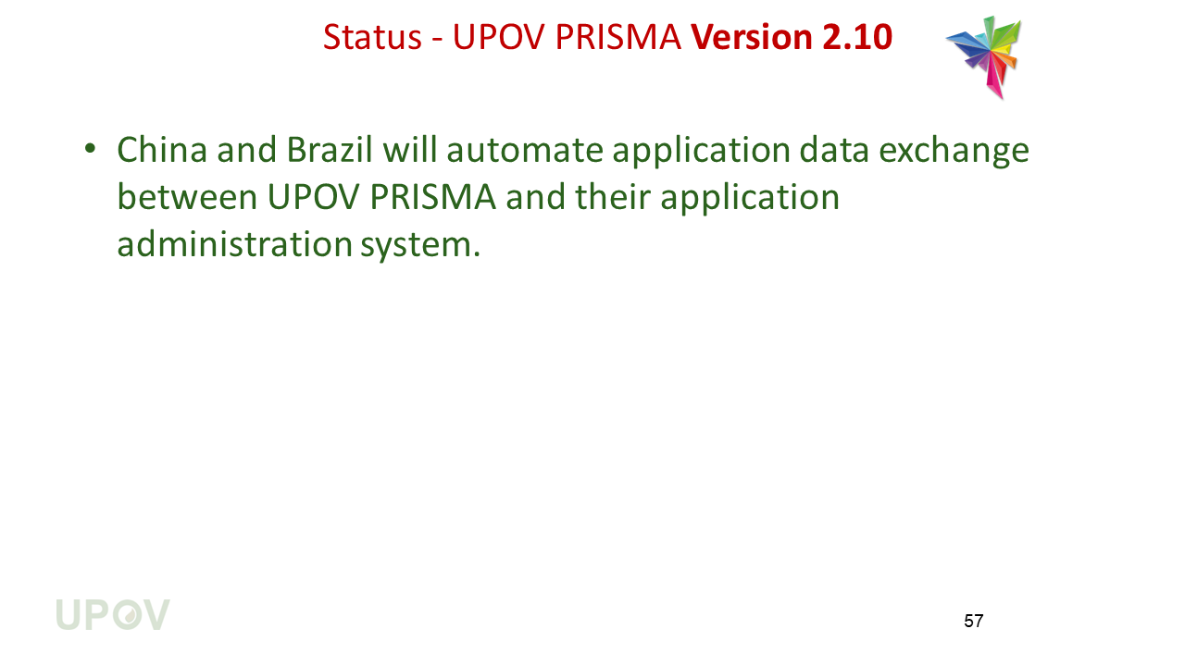
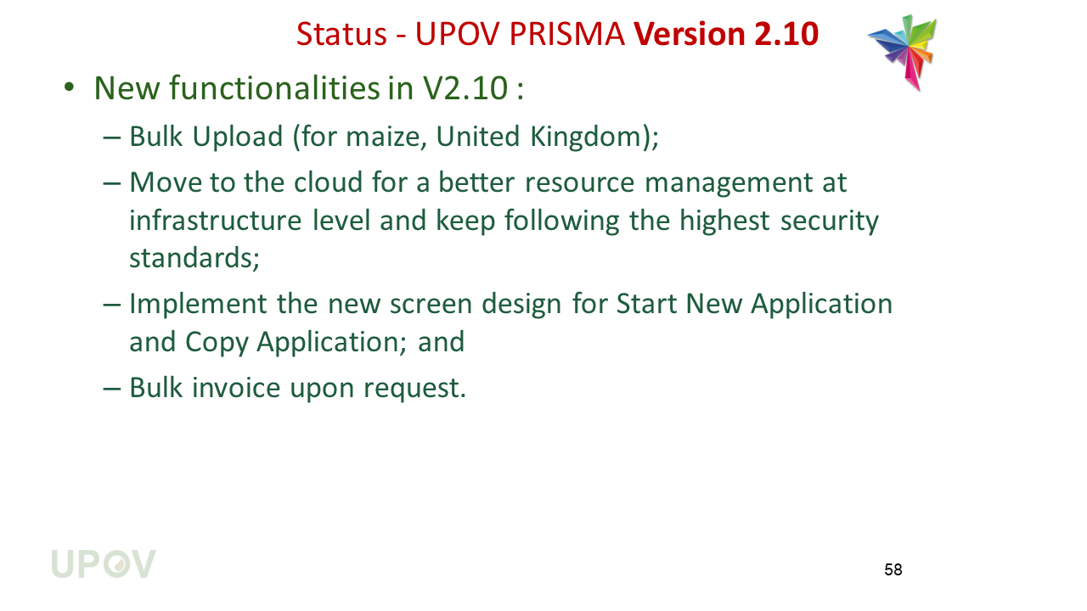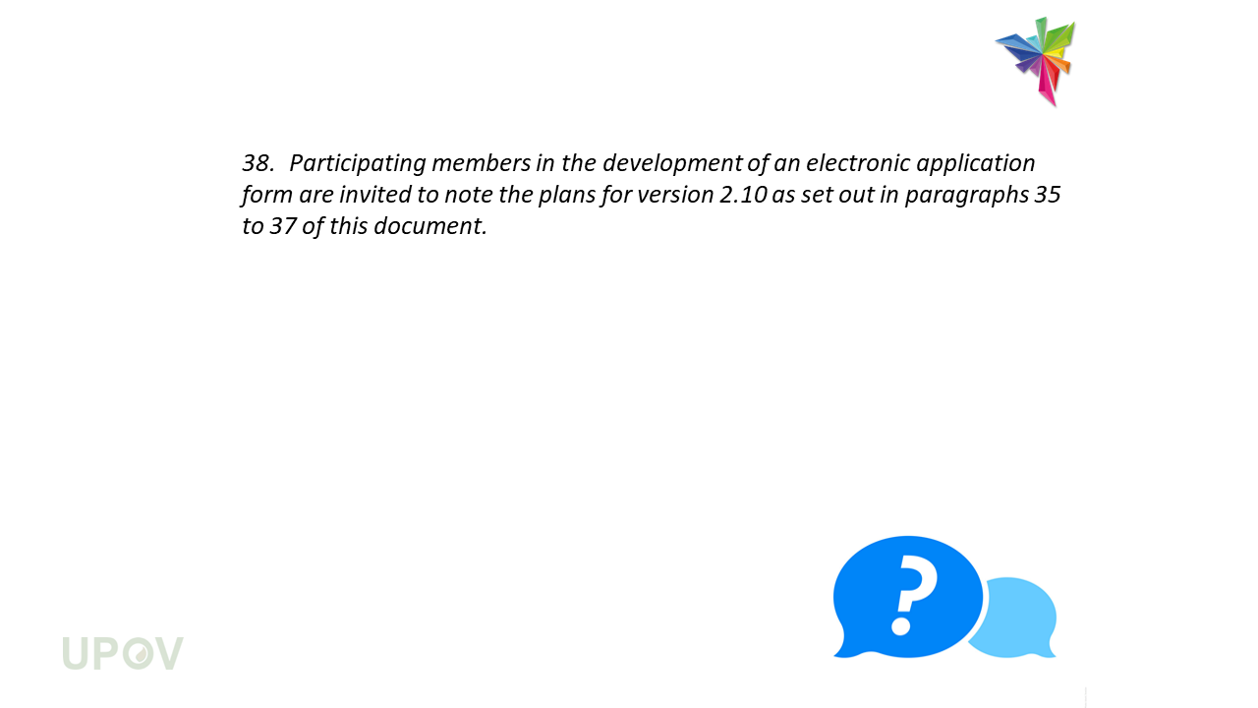
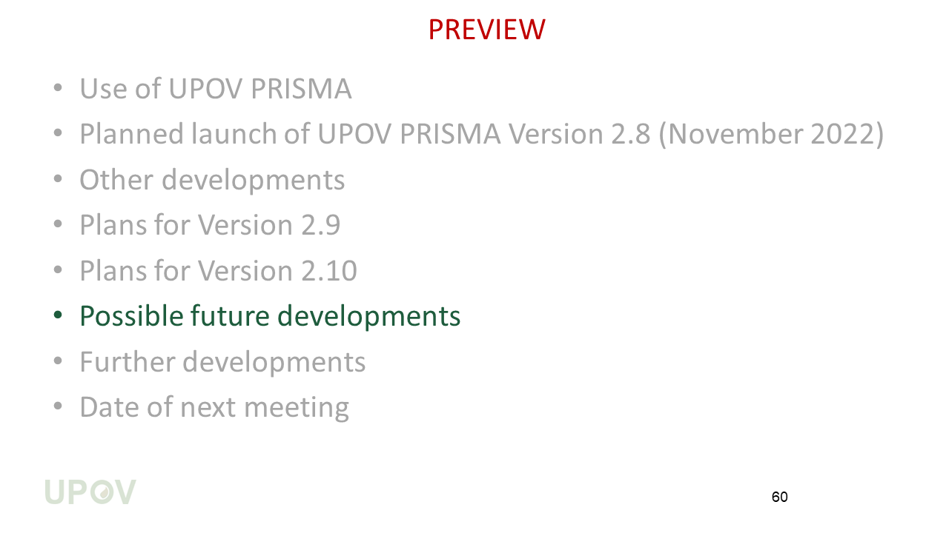
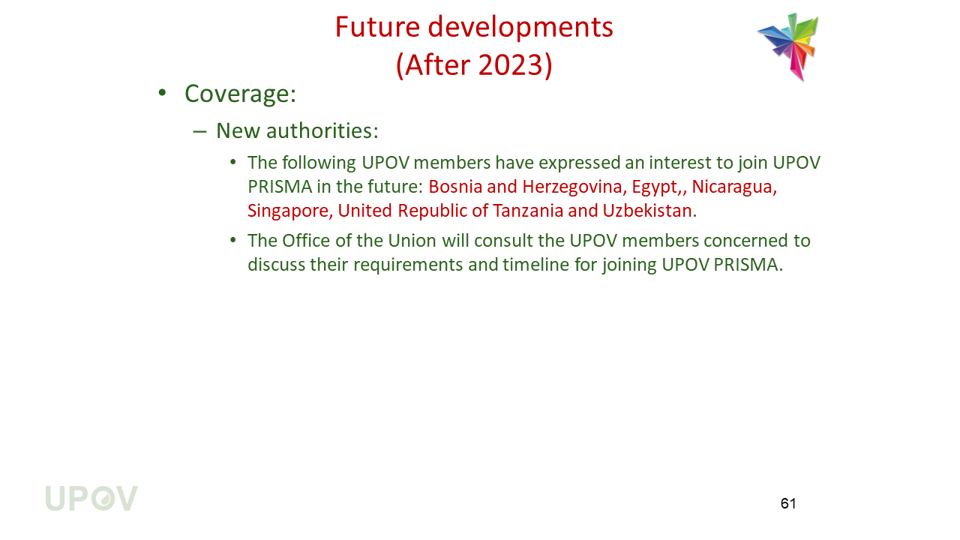
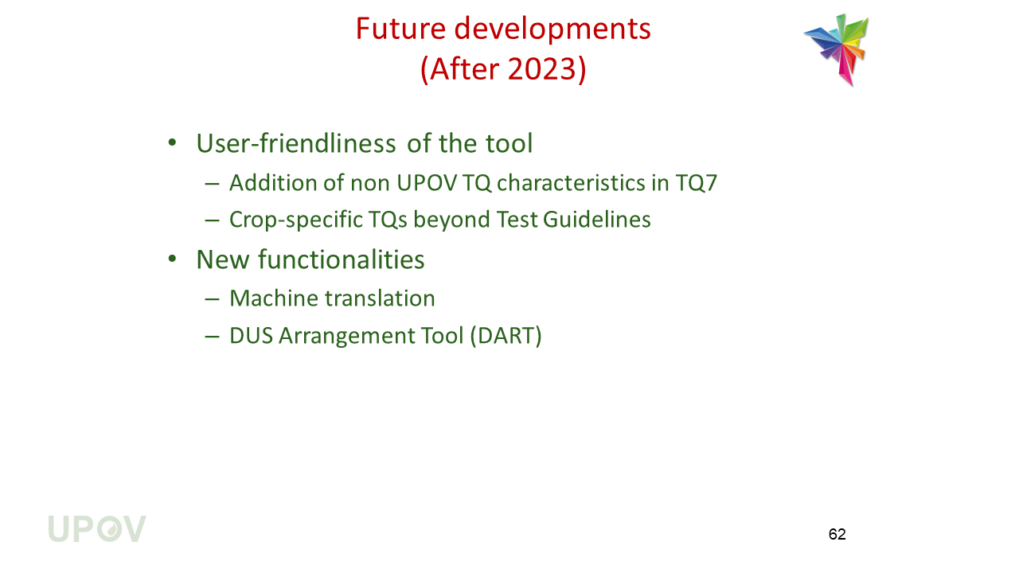
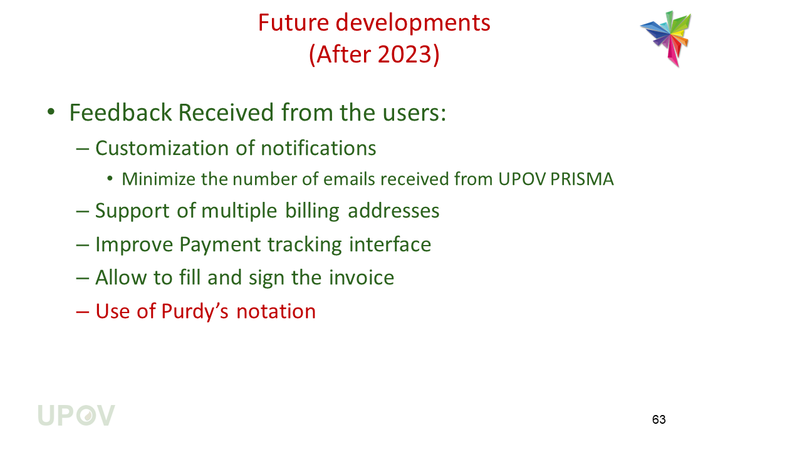
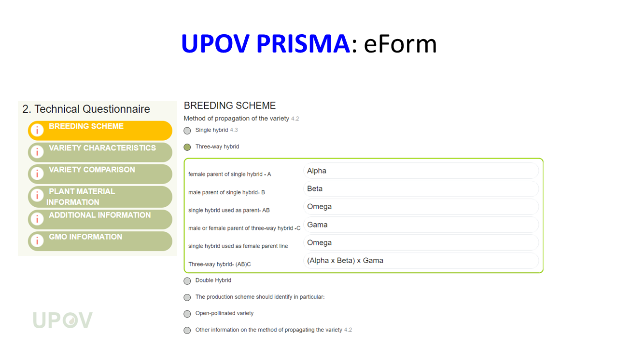
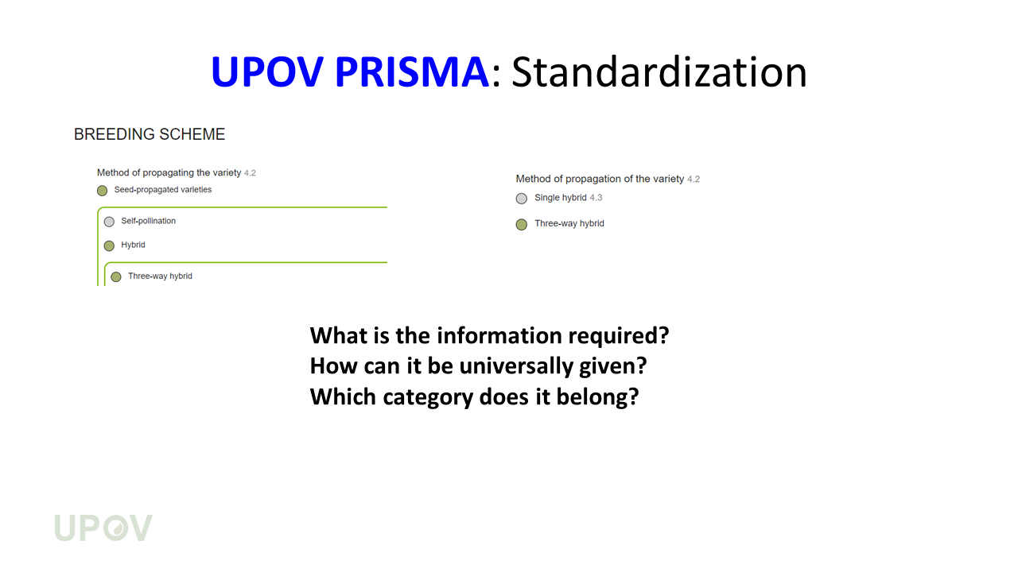
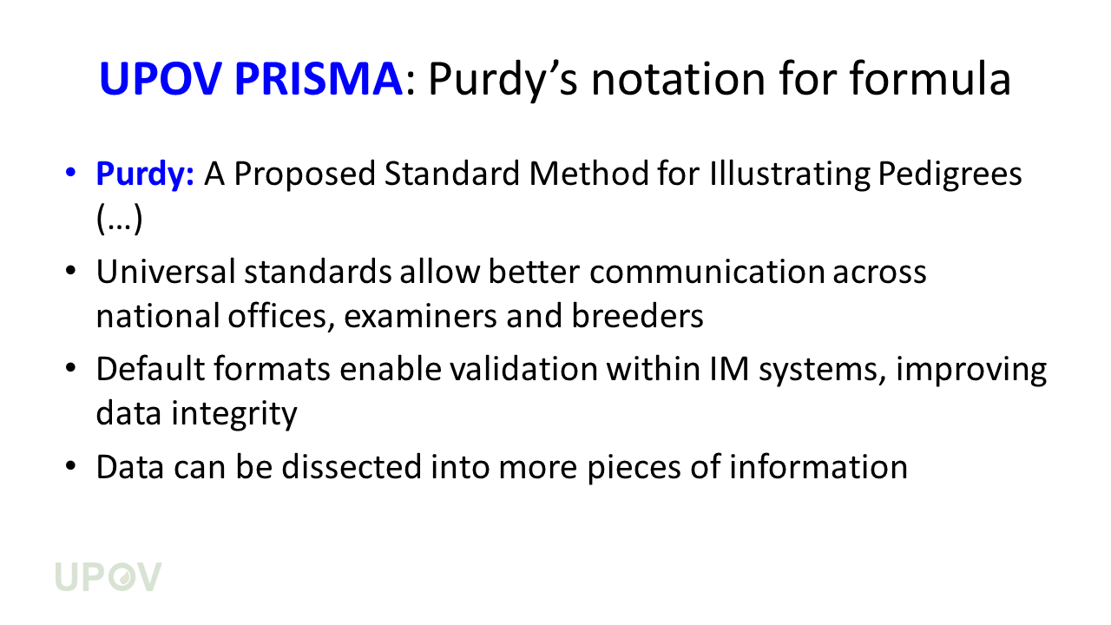
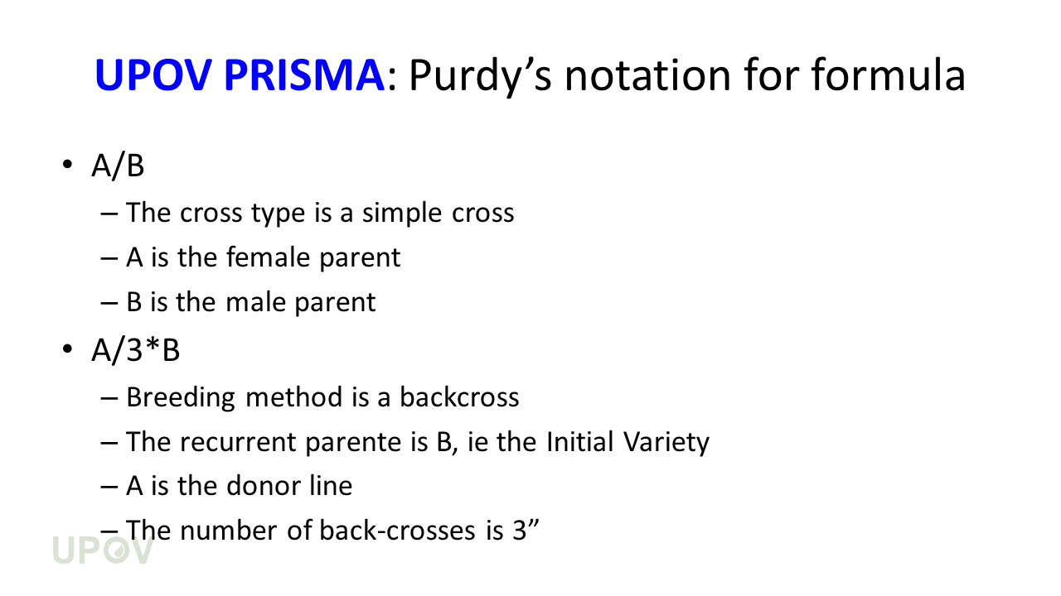
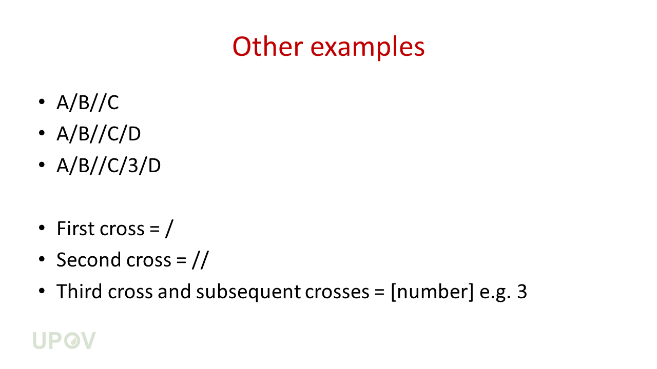
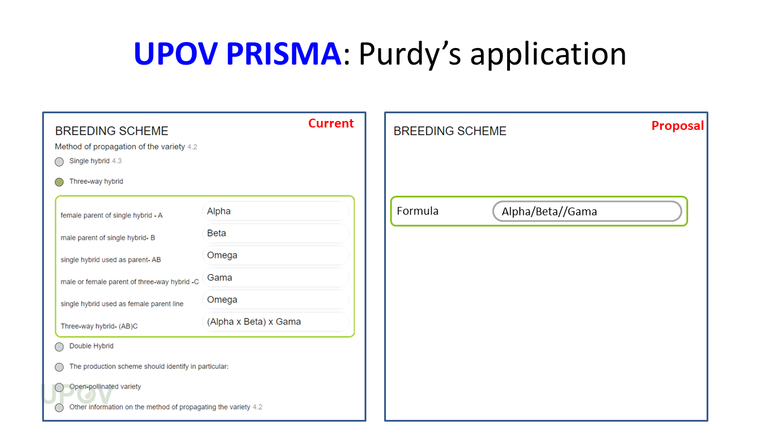
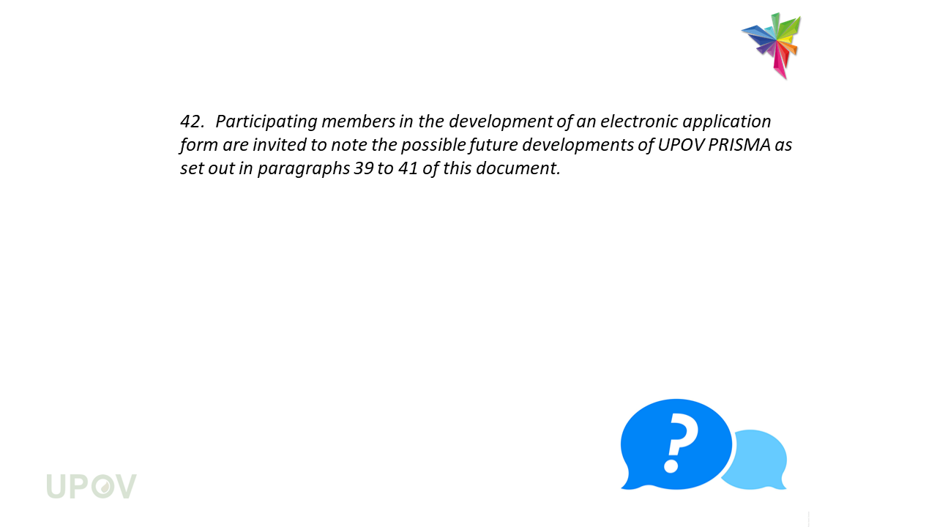
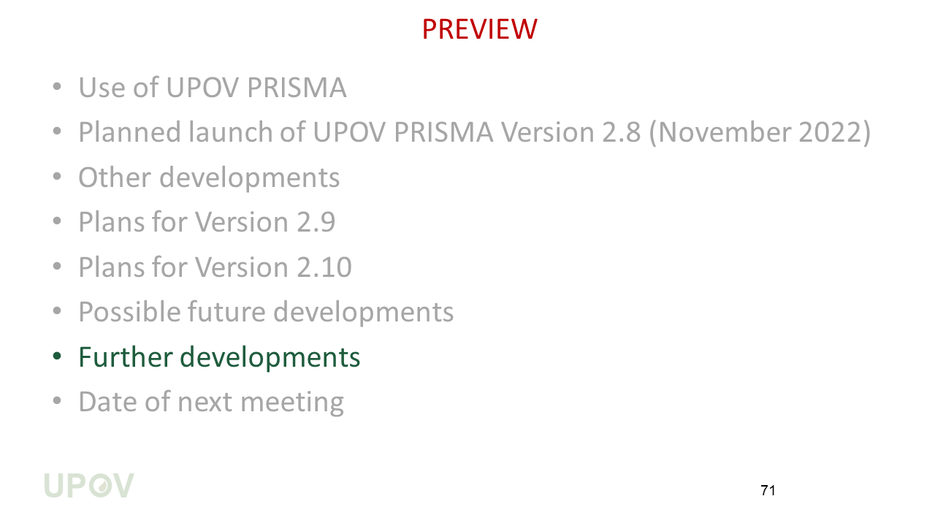
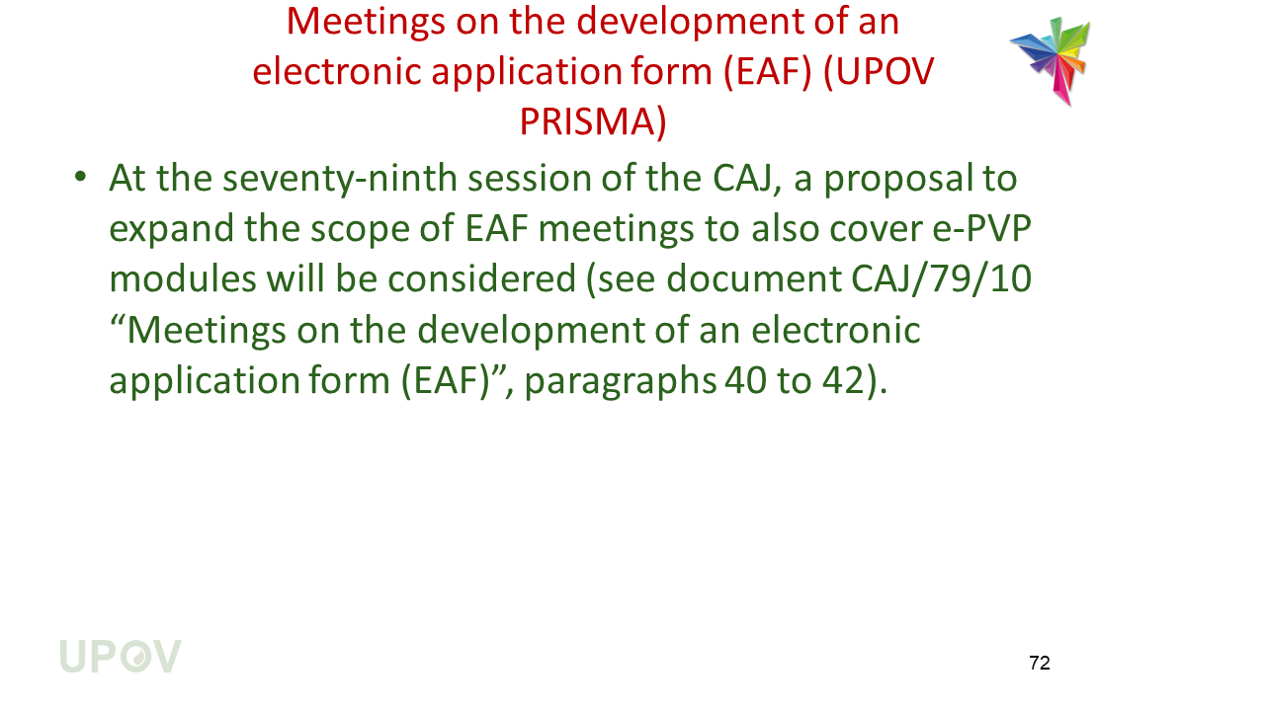
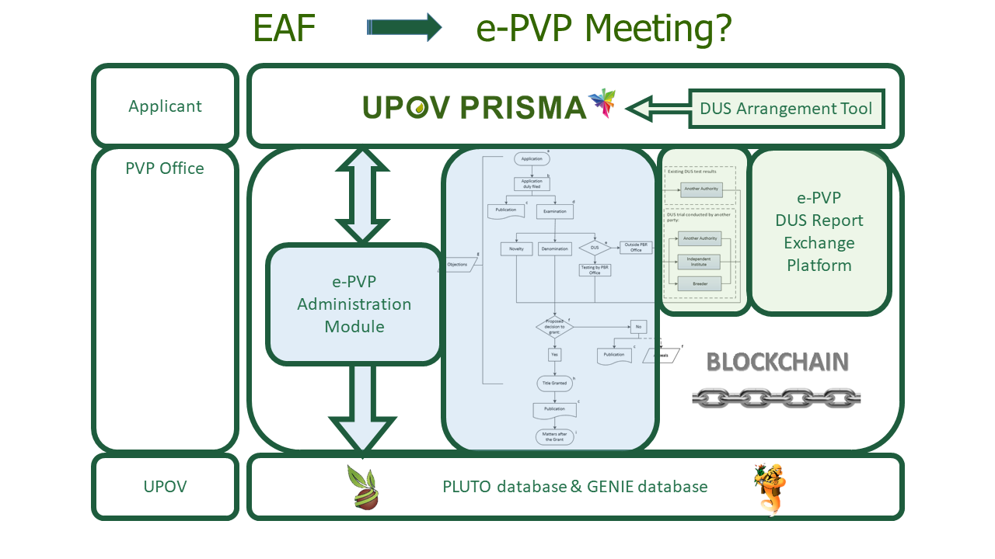
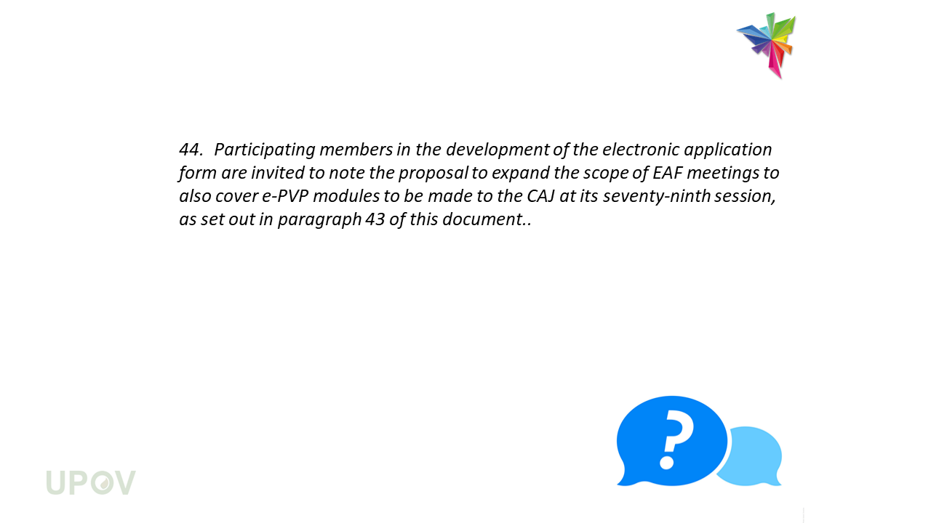
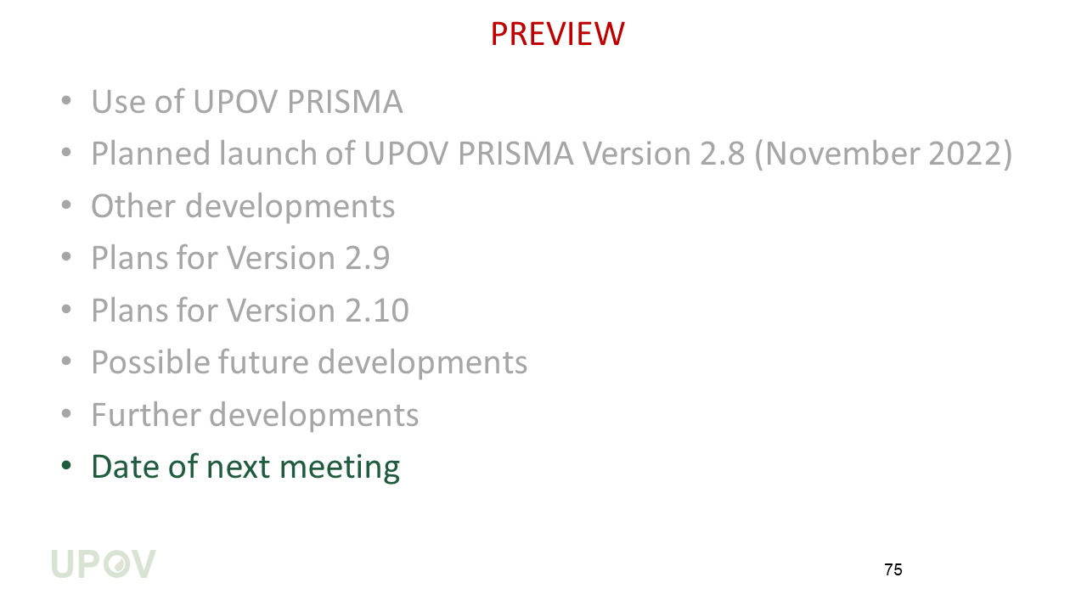
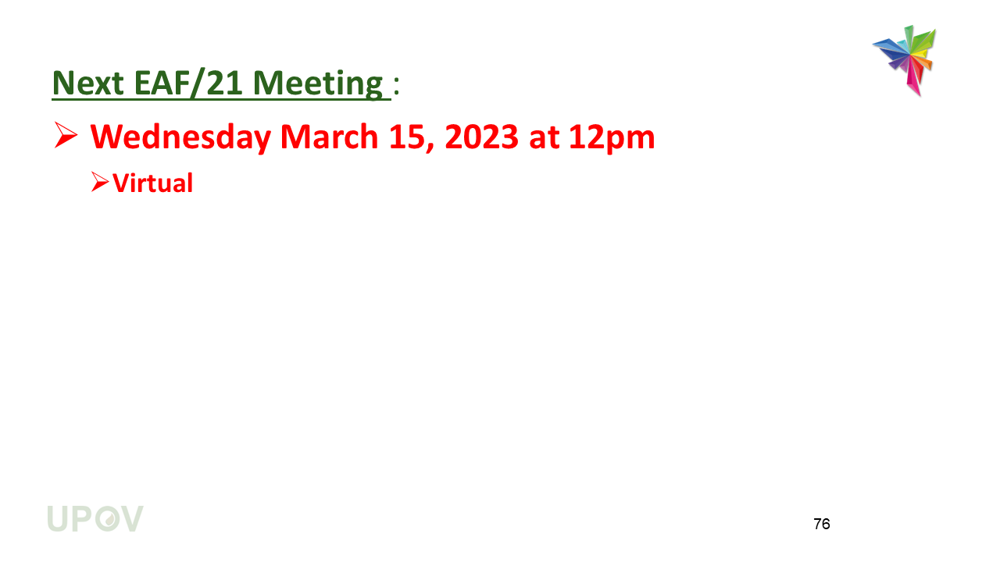

[End of Annex II and of document]

