E
International Union for the Protection of New Varieties of Plants

Meeting on the development of an electronic application form  Nineteenth Meeting  Geneva, March 16, 2022 (virtual meeting) | UPOV/EAF/19/2 Rev. Corr.  Original: English  Date: March 15, 2022
DEVELOPMENTS CONCERNING UPOV PRISMA
prepared by the Office of the Union
Disclaimer: this document does not represent UPOV policies or guidance

EXECUTIVE SUMMARY

The purpose of this document is to report on developments since the eighteenth meeting on the development of an electronic application form (“EAF/18 meeting”), held by electronic means on October 21, 2021, and to present the planned future developments.

Participating members in the development of the electronic application form are invited to:

- note the developments concerning UPOV PRISMA since the EAF/18 meeting;
- note that a report on plans for improving CPVO TQ synchronization and the user-friendliness of UPOV PRISMA will be made at the EAF/19 meeting;
- approve the procedure for utilizing authorities’ TQs as presented in paragraphs 24 and 25;
- note that the United Kingdom TQ would be circulated to the participating UPOV members that use the UPOV TQ for all genera and species to see if they would wish to use the United Kingdom TQ or to continue using the generic TQ;
- note the plans for Version 2.8, as set out in paragraphs 28 to 31 of this document;
- note the possible future developments of UPOV PRISMA as set out in paragraphs 33 to 38 of this document;
- note that a presentation of the new organization of the UPOV PRISMA support and development team will be made at EAF/19 meeting.

The structure of this document is as follows:
EXECUTIVE SUMMARY 1
Use of UPOV PRISMA (as of January 31, 2022) 2
Number of submissions via UPOV PRISMA 2
Launch of Version 2.7 2
UPOV members 2
Crops/species 2
New functionalities 2
IT Quality Software Audit 3
Improvement of user-friendliness of UPOV PRISMA 3
CPVO participation in UPOV PRISMA 3
Coverage of Test Guidelines: sugar beet 4
Version 2.8 6
UPOV member coverage 6
Updating of forms 6
Functionalities 6
Planned release date 6
Planned future developments (after Version 2.8) 6
Registered Users 6
Coverage 7
User-friendliness of the tool 7
New functionalities 7
IT improvements 7
UPOV PRISMA SUPPORT and development TEAM 7
Date of next meeting 7

Use of UPOV PRISMA (as of January 31, 2022)

Information on the use of UPOV PRISMA, is provided below:

Number of submissions via UPOV PRISMA

 | 2017 | 2018 | 2019 | 2020 | 2021 | 2022
January | 1 |  | 7 | 18 | 106 | 232
February |  | 3 | 9 | 5 | 107
March | 2 | 3 | 6 | 21 | 67
April |  | 3 | 22 | 11 | 105
May | 1 | 1 | 32 | 11 | 65
June |  | 7 | 10 | 18 | 821
July |  | 7 | 3 | 9 | 58
August |  | 1 | 7 | 11 | 378
September | 3 | 8 | 16 | 29 | 154
October | 1 | 19 | 29 | 16 | 68
November | 3 | 16 | 26 | 41 | 406
December | 3 | 9 | 49 | 31 | 174
Total | 14 | 77 | 216 | 221 | 2509 | 232

Launch of Version 2.7

Version 2.7 of UPOV PRISMA (Version 2.7) was deployed in January 2022, which incorporated the following.

UPOV members

Saint Vincent and Grenadines was introduced in UPOV PRISMA as a new participating authority.

Crops/species

Forms were updated for the following participating PBR authorities: European Union, and the Netherlands.

New functionalities

The following new functionalities were introduced:

- Possibility to download the list of applications as displayed in the dashboard for PVP office in Excel format;
- Introduction of the WIPO IP Portal navigation bar;
- Bulk Upload (for maize, European Union);
- Provide the Co-agent with the right to view applications of other colleagues.

IT Quality Software Audit

It was noted at the EAF/18 meeting that in order to reduce the risk of problems when introducing new versions and/ or new functionalities, the following steps would be taken (see document UPOV/EAF/18/3 “Report”):

- Appoint an external company to perform a software quality audit;
- Organize user acceptance testing (UAT) before going live with any new functionalities.

As reported at the EAF/18 meeting, an external company was appointed to perform a software quality audit and reported that according to the test maturity model, UPOV PRISMA had reached maturity level 2: “the organization has a fundamental test approach where some common test practices are implemented such as planning, monitoring and control over test activities”. The following recommendations were provided to move to maturity level 3: “the organization is rather proactive and the test approach is documented and described in standards, procedures, tools and methods”:

- Know the users and how UPOV PRISMA is used;
- Focus on what is important and urgent: Automate test cases for regression on the functionalities mostly used and the functionalities that generate 80% of the bugs;
- Define a clear Test strategy document;
- For each new requirement, an impact analysis should be made;
- Define a standard process for test case creation;
- Use a test repository tool.

A report on the progress on implementing each of the recommendations will be made at the EAF/19 meeting.

In relation to user acceptance testing (UAT), it is planned to consult the UPOV PRISMA “Task Force” Group before implementing new functionalities.

Further to the above measures to improve the quality of the UPOV PRISMA software, it was decided to organize a code audit, which produced the following recommendations:

- Implement best practices in terms of coding in order to avoid concurrency and performance issues;
- Move to the cloud for a better resource management at infrastructure level and keep following the highest security standards ;
- Develop a dedicated configuration interface for a controlled management of the forms;

It is planned to start the implementation of the recommendations in 2022. A report on progress on implementing the recommendations will be made at future EAF meetings.

Improvement of user-friendliness of UPOV PRISMA

In order to improve the user-friendliness of UPOV PRISMA consultations were organized with users to review certain current existing functionalities (copy functionality, assignment of roles) (see document UPOV/EAF/17/3 “Report”, paragraph 22 and document UPOV/EAF/18/3 “Report”, paragraphs 15 and 16).
Participants in the UPOV PRISMA Task Force Group were consulted on the proposals made to improve the interface and the navigation through the system.
A report on plans for improving user-friendliness of UPOV PRISMA will be made at the EAF/19 meeting.

CPVO participation in UPOV PRISMA

Since EAF/18 meeting the following online meetings UPOV PRISMA Task Force Group were organized on CPVO participation in UPOV PRISMA:

- November 15, 2021, and February 15, 2022 with interim meetings between CPVO and UPOV.
In order to achieve and maintain synchronization of TQs between UPOV PRISMA and CPVO (see document UPOV/EAF/16/3 “Report” paragraph 18, document UPOV/EAF/17/3 “Report” paragraph 32 and document UPOV/EAF/18/3 “Report”, paragraph 12) the following projects have been agreed with CPVO:

- Project 1: “Audit” (current issues/ states of affairs) for exchange of data between UPOV PRISMA and CPVO in both directions
- Project 2: Part A: Resolving current issues; Part B : Synchronizing changes by UPOV/CPVO
- Project 3: Implementation of Project 2 outcome: Bi-directional exchange of application data (lettuce, tomato, rose)
- Project 4: Bulk upload of Maize applications from UPOV to CPVO
- Project 5: “Transitional arrangements”, to communicate to applicants about the situations in which they can use UPOV PRISMA for applications at the CPVO and the measures that need to be taken until all issues have been resolved

A report on progress made for each project will be made at the EAF/19 meeting.

Participating members in the development of the electronic application form are invited to note:

- the developments concerning UPOV PRISMA since the EAF/18 meeting;

- that a report on plans for improving CPVO TQ synchronization and the user-friendliness of UPOV PRISMA will be made at the EAF/19 meeting.

Coverage of Test Guidelines: sugar beet

In relation to the coverage of the Test Guidelines, the following was agreed at the EAF/13 meeting (see document UPOV/EAF/13/3 “Report”, paragraphs 19 to 22):

“20. The participants received a presentation from the Office of the Union, as reproduced in the Annex II of document UPOV/EAF/12/3 “Report”, and noted that, for UPOV members following the UPOV Test Guidelines, where there were no UPOV Test Guidelines for a particular crop/species, a generic TQ was available. Alternatively, UPOV members could link these crop/species to a suitable UPOV TG. It was explained that it would not be appropriate to use national TGs for such crops/species because of the high level of maintenance, the translation burden and lack of harmonization. However, it would be possible for UPOV members participating in UPOV PRISMA to agree a common TQ and thereby to retain harmonization and minimize translation work.

“21. The participants noted that, in cases where a participating authority used a national Technical Questionnaire for the Table of Characteristics, for a specific crop, where there was no UPOV Test Guidelines (TGs) and where the generic TQ was not appropriate, there would be a possibility to develop a specific UPOV PRISMA TQ for this crop, subject to a procedure for consultation with other UPOV participating members in UPOV PRISMA and under the condition to follow UPOV TGs TQ and UPOV characteristics.

“22. The participants noted the process of consultation for authorities who do not follow the general approach but follow UPOV TGs TQ and UPOV characteristics, as follows:

1. Request from Country A for a specific crop (Country A TQ)
2. Inform other participating authorities in UPOV PRISMA
3. Circulate the Country A TQ to see if there are any objections to use as UPOV PRISMA TQ
4. If no objections: Country A TQ becomes UPOV PRISMA TQ (subject to resources available)
5. If objections: discussion among interested authorities to explore possibilities to develop a harmonized TQ (and then back to 3)

Any new request would be reported at the subsequent EAF meeting.”

There are no UPOV Test Guidelines for sugar beet and the approach above was considered but initial feedback indicated that it could be problematic to seek to apply a specific TQ for all UPOV members that use the UPOV TQ for all genera and species.

On the basis of the feedback received, it is proposed to amend the procedure above as follows:

1. Request from Authority A for a specific crop (Authority A TQ)
2. Inform other participating authorities in UPOV PRISMA
3. Circulate the Authority A TQ to see if participating UPOV members that use the UPOV TQ for all genera and species would prefer to:
(a) use Authority A TQ or
(b) continue using the generic TQ
4. Implement Authority A TQ for UPOV members who wish to use Authority A TQ (subject to available resources).

According to the above procedure, more than one authority could make their TQ available for use by other participating UPOV members that use the UPOV TQ for all genera and species.

The United Kingdom has a specific TQ, a copy of which is provided in the Annex to this document. In accordance with the proposed new procedure, the United Kingdom TQ would be circulated to the following participating UPOV members that use the UPOV TQ for all genera and species to see if they would wish to use the United Kingdom TQ or to continue using the generic TQ:

Authority
African Intellectual Property Organization (OAPI)
Chile
Colombia
Dominican Republic
France
Georgia
Kenya
Mexico
Netherlands
New Zealand
Norway
Peru
Republic of Moldova
Saint Vincent and Grenadines
Serbia
South Africa
Sweden
Tunisia
Turkey
United Kingdom
Viet Nam

Participating members in the development of the electronic application form are invited to

- approve the procedure for utilizing authorities’ TQs as presented in paragraphs 24 and 25; and

- note that the United Kingdom TQ would be circulated to the participating UPOV members that use the UPOV TQ for all genera and species to see if they would wish to use the United Kingdom TQ or to continue using the generic TQ.

Version 2.8

UPOV member coverage

No new participating authorities are anticipated for Version 2.8:

Updating of forms

The forms for France and the Netherlands will be updated.

Functionalities

The following functionalities are planned to be introduced in Version 2.8:

- Bulk Upload (Maize, United Kingdom);
- Bulk invoice upon request;
- Improve the download functionality for PVP Offices by including UPOV code information for crops not covered by UPOV TG and the addition of following columns (only for United Kingdom as Proof of Concept):
  - Country of Origin
  - NLI Maintainer
  - NLI Agent
  - NLI Applicant
  - PBR Breeder
  - PBR Applicant
  - PBR Agent
  - Date PBR application received
  - Date NL application Received
  - Provisional Marketing Authorisation Code
  - Provisional Marketing Authorisation Date
  - Seed Weight

Planned release date

It is planned to release Version 2.8 of UPOV PRISMA in October 2022.

Participating members in the development of the electronic application form are invited to note the plans for Version 2.8, as set out in paragraphs 28 to 31 of this document.

Planned future developments (after Version 2.8)

Registered Users

The following requests have been received from users for new functionalities:

- Allow the possibility to upload multiple attachments for the same question;
- In the email notification message, remove the reference to the “applicant” since it is not correct when an agent submits the application data;
- For agents, accept invitations in bulk instead of clicking each one individually;
- Add an additional "notes" field to the agent profile to allow agents to provide further information to breeders/applicants, such as services offered and languages spoken.

It is planned to address these requests after Version 2.8 has been implemented.

Coverage

The following UPOV members have expressed an interest to join UPOV PRISMA in the future: Bosnia and Herzegovina, Brazil, Egypt, Japan, Nicaragua, Singapore, United Republic of Tanzania and Uzbekistan. The Office of the Union will consult the UPOV members concerned to discuss their requirements and timeline for joining UPOV PRISMA.

User-friendliness of the tool

The following elements would be considered at a later stage to increase the user-friendliness of UPOV PRISMA, according to resources available:

- Addition of non UPOV TQ characteristics in TQ Section 7 instead of TQ Section 5 (see document EAF/17/3 “Report” paragraph 19);
- Crop-specific TQs beyond Test Guidelines (see document EAF/16/3 “Report” paragraph 18).

New functionalities

The following new functionalities will be considered for possible development:

- Machine translation (see document EAF/16/3 “Report” paragraph 18);
- Information on DUS cooperation (DUS Arrangement Recommendation Tool (DART)) (see document EAF/16/3 “Report” paragraph 18).

IT improvements

The following IT improvements will be considered for possible development at a later stage and according to resources available:

- Improve the performance of form generation.

Participating members in the development of the electronic application form are invited to note the possible future developments of UPOV PRISMA as set out in paragraphs 33 to 38 of this document.

UPOV PRISMA SUPPORT and development TEAM

A presentation of the new organization of the UPOV PRISMA support and development team will be made at EAF/19 meeting.

Participating members in the development of the electronic application form are invited to note that a presentation of the new organization of the UPOV PRISMA support and development team will be made at EAF/19 meeting.

Date of next meeting

The date of the twentieth meeting of the EAF (EAF/20 meeting) is proposed to be held by virtual means on October 20, 2022.

[Annex follows]

UPOV/EAF/19/2 Rev. Corr.

ANNEX

United Kingdom Technical Questionnaire for Sugar beet (generated from UPOV PRISMA)

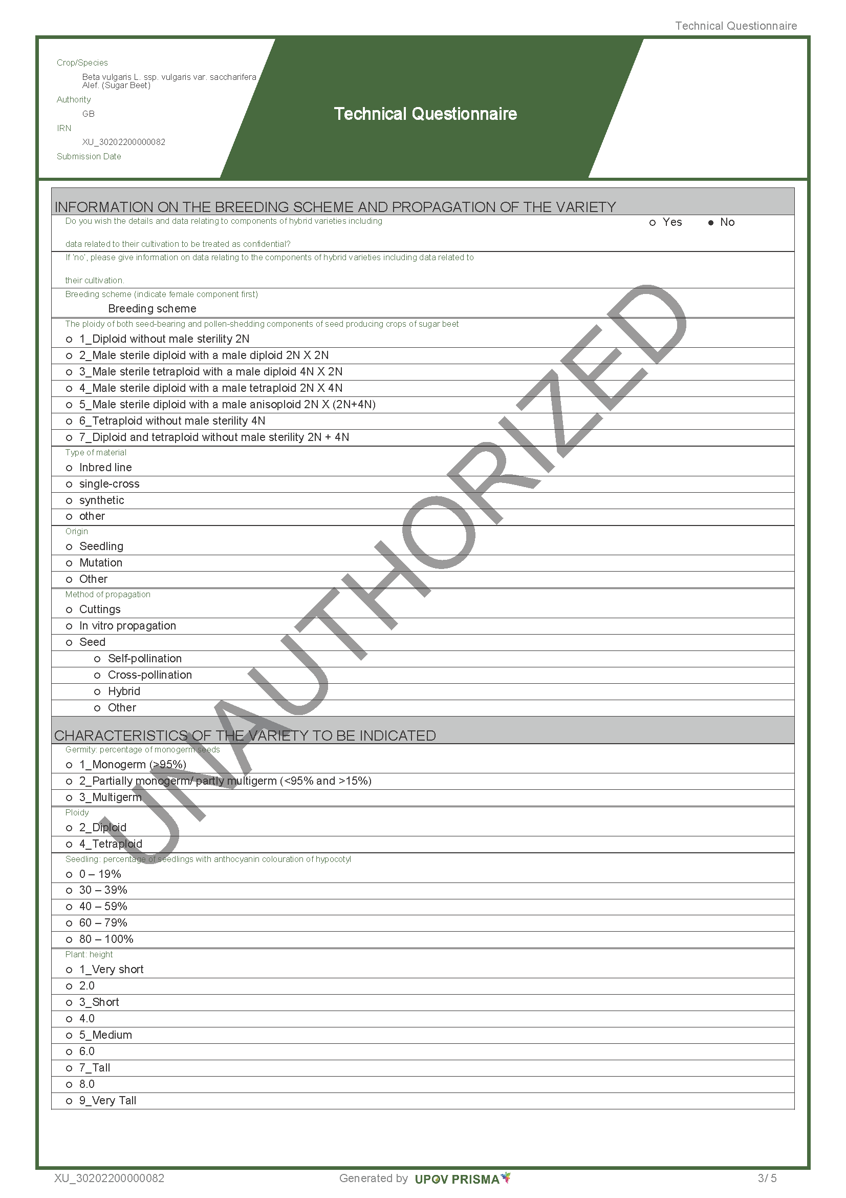
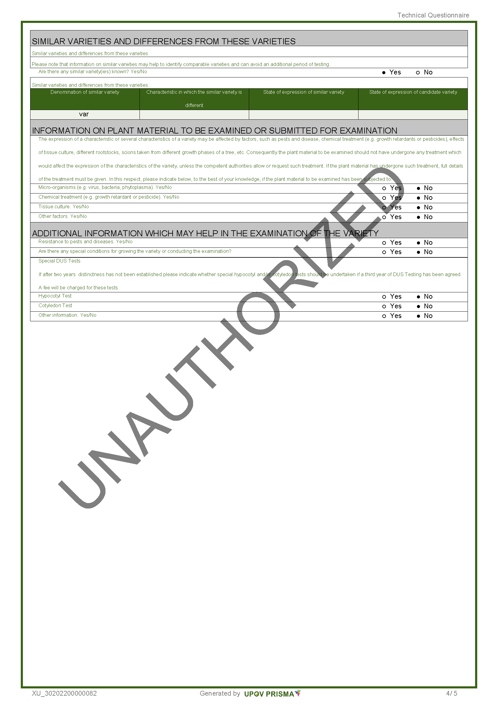
[End of Annex and of document]

