E
International Union for the Protection of New Varieties of Plants

Meeting on the development of an electronic application form  Eighteenth Meeting  Geneva, October 21, 2021 | UPOV/EAF/18/2 Corr..  Original: English  Date: October 20, 2021
DEVELOPMENTS CONCERNING UPOV PRISMA
prepared by the Office of the Union
Disclaimer: this document does not represent UPOV policies or guidance

EXECUTIVE SUMMARY

The purpose of this document is to report on developments since the seventeenth meeting on the development of an electronic application form (“EAF/17 meeting”), held by electronic means on March 25, 2021, and to present the planned future developments.

Participating members in the development of the electronic application form are invited to:

- note the developments concerning UPOV PRISMA since the EAF/17 meeting;
- note that a report on plans for online workshops with users to improve the user-friendliness of UPOV PRISMA will be made at the EAF/18 meeting;
- note the plans for Version 2.7, as set out in paragraphs 22 to 27 of this document; and
- note the possible future developments of UPOV PRISMA as set out in paragraphs 29 to 33.

The structure of this document is as follows:
EXECUTIVE SUMMARY 1
BACKGROUND 2
DEVELOPMENTS AT THE eaf/17 meeting 2
DEVELOPMENTS SINCE THE EAF/17 MEETING 2
Use of UPOV PRISMA (as of September 30, 2021) 2
Number of submissions via UPOV PRISMA 2
Submissions in UPOV PRISMA by crop type 2
Number of submissions by participating Authority in UPOV PRISMA 2
Launch of Version 2.6 2
UPOV members 2
Crops/ species 2
New functionalities 2
Other developments 2
Requests for new developments 2
PVP offices 2
Registered Users 2
Version 2.7 2
UPOV member coverage: 2
Functionalities: 2
Release of Version 2.7: 2
Possible FUTURE developments 2
Coverage 2
User-friendliness of the tool 2
New functionalities 2
IT improvements 2
Date of next meeting 2

BACKGROUND

The background to the development of the EAF is provided in document UPOV/EAF/17/2 “Developments concerning the electronic application form”.

DEVELOPMENTS AT THE eaf/17 meeting

The Report of EAF/17 meeting (document UPOV/EAF/17/3) is available at: https://www.upov.int/edocs/mdocs/upov/en/upov_eaf_17/upov_eaf_17_3.pdf .

DEVELOPMENTS SINCE THE EAF/17 MEETING

Use of UPOV PRISMA (as of September 30, 2021)

Information on the use of UPOV PRISMA, is provided below:

Number of submissions via UPOV PRISMA

 | 2017 | 2018 | 2019 | 2020 | 2021
January | 1 |  | 7 | 18 | 107
February |  | 3 | 9 | 5 | 107
March | 2 | 3 | 6 | 21 | 67
April |  | 3 | 22 | 11 | 105
May | 1 | 1 | 33 | 11 | 65
June |  | 7 | 10 | 18 | 822
July |  | 7 | 3 | 9 | 58
August |  | 1 | 7 | 11 | 379
September | 3 | 8 | 16 | 29 | 154
October | 1 | 19 | 29 | 16
November | 3 | 16 | 26 | 41
December | 3 | 9 | 51 | 32
Total | 14 | 77 | 219 | 222 | 1864

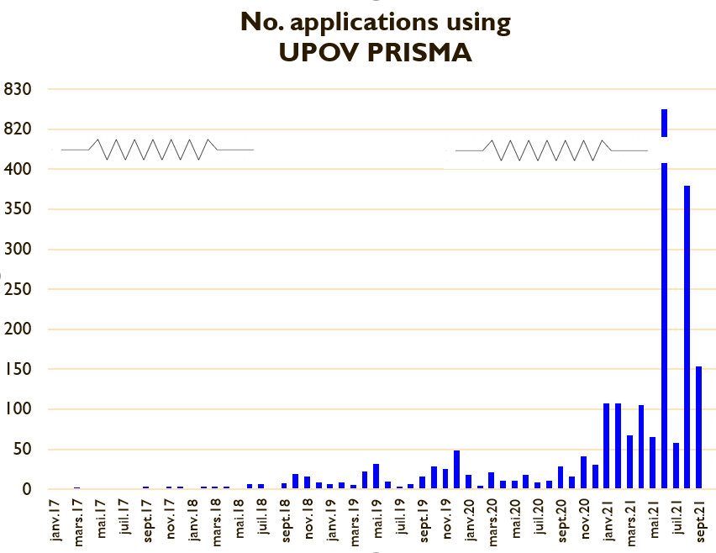

APPLICATIONS in UPOV PRISMA (annual)

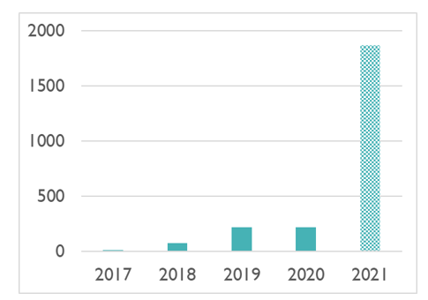

Submissions in UPOV PRISMA by crop type

Number of submissions by participating Authority in UPOV PRISMA

Authority |  | Number of submissions in UPOV PRISMA in 2017 | Number of submissions in UPOV PRISMA in 2018 | Number of submissions in UPOV PRISMA in 2019 | Number of submissions in UPOV PRISMA in 2020 | Number of submissions in UPOV PRISMA in 2021  (as of 30/09/2021) | Total Number of submissions in UPOV PRISMA  (as of 30/09/2021)
African Intellectual Property Organization (OAPI) | OA |  |  | 3 | 1 |  | 4
Argentina | AR |  |  |  |  |  | -
Australia | AU |  | 10 | 17 | 36 | 23 | 86
Bolivia (Plurinational State of)* | BO |  |  | 2 |  |  | 2
Canada | CA |  | 6 | 27 | 17 | 19 | 69
Chile | CL | 3 |  | 3 | 1 | 8 | 12
China | CN |  |  |  |  |  | -
Colombia | CO |  |  | 4 | 2 | 2 | 5
Costa Rica | CR |  |  | 4 | 1 |  | 5
Dominican Republic | DO |  |  | 2 | 2 | 1 | 5
Ecuador | EC |  |  |  | 2 | 2 | 4
European Union | QZ |  | 8 | 38 | 13 | 20 | 79
France | FR |  |  | 20 | - | 3 | 23
Georgia | GE |  |  | 2 | 1 | 3 | 6
Kenya | KE |  | 13 | 6 | 14 | 10 | 43
Morocco | MA |  |  |  |  |  | -
Mexico | MX |  | 7 | 7 | 13 | 11 | 38
Netherlands | NL | 1 | 8 | 12 | 6 |  | 27
New Zealand | NZ | 5 | 3 | 8 | 5 | 18 | 39
Norway | NO | 1 |  | 5 | 7 |  | 13
Paraguay* | PY |  |  |  |  |  | -
Peru | PE |  |  |  | 2 | 1 | 3
Republic of Moldova | MD |  |  | 2 |  |  | 2
Republic of Korea | KR |  |  | 1 | 1 |  | 2
Serbia | RS |  |  | 2 | 1 | 3 | 6
South Africa | ZA |  | 2 | 3 | 2 | 4 | 11
Sweden | SE |  |  | 1 |  |  | 1
Switzerland | CH | 2 | 3 | 4 | 16 | 6 | 31
Trinidad and Tobago | TT |  |  |  |  |  | -
Tunisia | TN |  | 2 | 4 |  | 1 | 7
Turkey | TR |  | 6 | 23 | 54 | 43 | 126
United Kingdom | GB |  | 3 | 18 | 22 | 1683 | 1726
United States of America | US |  | 6 | 1 | 3 | 4 | 14
Uruguay | UY |  |  |  |  | 3 | 3
Viet Nam | VN |  |  |  |  |  | -
Total | 35 | 14 | 77 | 219 | 222 | 1864 | 2392
*Until required information is provided, applicants will not be able to submit application data

Number of Registered Users

Launch of Version 2.6

The current Version of UPOV PRISMA (Version 2.6) was deployed in July 2021.

UPOV members

No new additional participating PBR authorities were introduced in Version 2.6.

Crops/species

The crop coverage in UPOV PRISMA has been changed in Version 2.6, as follows:

Authority |  | Anticipated new crop coverage
Morocco | MA | Blackberry, blueberry, raspberry, strawberry,

Forms have been updated for the following participating PBR authorities: Mexico, Norway and United Kingdom.

New functionalities

The following new functionalities were introduced in Version 2.6:

- Addition of Technical Questionnaires for parental lines (Winter Oil Seed Rape , Barley, Maize and Field Bean);
- Improvement of auto-save functionality;
- Possibility to make bulk payments by introducing “Add to Basket” functionality.

Other developments

IT Quality Software Audit

It was noted at the EAF/17 meeting that in order to reduce the risk of problems when introducing new versions and/ or new functionalities, the following steps would be taken (see document UPOV/EAF/17/3 “Report”):
- Appoint an external company to perform a software quality audit;
- Organize user acceptance testing (UAT) before going live with any new functionalities.

The Office of the Union appointed an external company to perform a software quality audit.

According to the test maturity model, UPOV PRISMA has reached maturity level 2: “the organization has a fundamental test approach where some common test practices are implemented such as planning, monitoring and control over test activities”. The following recommendations were provided to move to maturity level 3: “the organization is rather proactive and the test approach is documented and described in standards, procedures, tools and methods”:

- Know the users and how UPOV PRISMA is used;
- Focus on what is important and urgent: Automate test cases for regression on the functionalities mostly used and the functionalities that generate 80% of the bugs;
- Define a clear Test strategy document;
- For each new requirement, an impact analysis should be made;
- Define a standard process for test case creation;
- Use a test repository tool.

The above 6 recommendations have been implemented. In particular, to limit the risk of negative impacts when introducing new functionalities, regression tests are being automated.

UPOV PRISMA “Task Force” Group

The plan to work with a “Task Force” of users to be identified by CIOPORA and ISF was reported at the EAF/17 meeting. In 2021, the following online meetings/ testing campaigns were organized:

- March 12, 2021 a first Task Force meeting was held;
- A User Acceptance Test campaign was organized for the new Auto-save function (March 22 to 26, 2021 and April 6 to 16, 2021) with the participation of the Task Force;
- A User Acceptance Test campaign was organized for the new addition of Technical Questionnaires for parental lines, especially in the scope of applications for Winter Oil Seed Rape and Barley (July 5 to 7, 2021) with the participation of the Task Force; and
- Meetings with the Task Force and the CPVO on CPVO participation in UPOV PRISMA were held on April 30, 2021 and September 19, 2021, with interim meetings between CPVO and UPOV.

CPVO Synchronization

In order to achieve and maintain synchronization of TQs between UPOV PRISMA and CPVO (see document EAF/16/3 “Report” paragraph 18 and document UPO/EAF/17/3 paragraph 32) the following projects have been agreed with CPVO:

- Project 1: “Audit” (current issues/ states of affairs) for exchange of data between UPOV PRISMA and CPVO in both directions (Status: completed)
- Project 2: Part A: Resolving current issues; Part B : Synchronizing changes by UPOV/CPVO (Status: ongoing on the basis of information provided in Project 1)
- Project 3: Implementation of Project 2 outcome: Bi-directional exchange of application data (lettuce, tomato, rose) (Status: ongoing on the basis of information provided in Project 1)
- Project 4: Bulk upload of Maize applications from UPOV to CPVO (Status: ongoing on the basis of information provided in Project 1)
- Project 5: “Transitional arrangements”, to communicate to applicants about the situations in which they can use UPOV PRISMA for applications at the CPVO and the measures that need to be taken until all issues have been resolved (Status: ongoing)

Workshop with Users to Improve user-friendliness of UPOV PRISMA

As a first step to identify ways to improve the user-friendliness of UPOV PRISMA (see document UPOV/EAF/17/3, paragraph 21), online workshops will be organized with users to review certain current existing functionalities (e.g. copy functionality, assignment of roles).
Users were consulted in September 2021 on functionalities that should be improved on the “Start New Application and Copy Functionality”. 96 responses were received as of October 11, 2021.

A report on plans for the online workshops will be made at the EAF/18 meeting.

Participating members in the development of the electronic application form are invited to note:

- the developments concerning UPOV PRISMA since the EAF/17 meeting;

- that a report on plans for online workshops with users to improve the user-friendliness of UPOV PRISMA will be made at the EAF/18 meeting.

Requests for new developments

PVP offices

Since the EAF/17 meeting, the following requests have been received from PVP Offices:

- Add the possibility to download the list of applications as displayed in the dashboard for PVP office in Excel format;
- Update of forms for Netherlands, France and European Union.

Registered Users

Since the EAF/17 meeting, the following requests have been received from users for new functionalities:

- The possibility to access the basket anytime when the user is in UPOV PRISMA. This will be achieved when introducing the WIPO IP Portal navigation bar in the next release (Version 2.7). A report on the progress made in relation to the integration of UPOV PRISMA into the WIPO IP Portal will be made at the EAF/18 meeting.
- The possibility to use a different billing addresses for the same company. An interim solution has been developed.

It is planned to address these issues by the end of 2021, subject to available resources.

Version 2.7

UPOV member coverage

The following new UPOV member coverage is anticipated for Version 2.7:

- Saint Vincent and Grenadines (New);
- Update of forms for European Union, France, and the Netherlands.

Functionalities

The following functionalities are planned to be introduced in Version 2.7:

- Bulk Upload (for maize , European Union);
- Provide the Co-agent with the right to view applications of other colleagues.

Release of Version 2.7

It is planned to release Version 2.7 of UPOV PRISMA in December 2021.

Participating members in the development of the electronic application form are invited to note the plans for Version 2.7, as set out in paragraphs 22 to 27 of this document.

Possible FUTURE developments

Coverage

The Office of the Union will consult relevant participating PBR authorities concerning their requirements and timeline to:

- include National Listing in UPOV PRISMA (see document EAF/15/3 “Report” paragraph 12);
- introduce machine-to-machine links/ communication to UPOV PRISMA (see document EAF/15/3 “Report” paragraph 12).

The following UPOV members have expressed an interest to join UPOV PRISMA in the future: Bosnia and Herzegovina, Brazil, Japan, Nicaragua, Singapore, United Republic of Tanzania and Uzbekistan. The Office of the Union will consult the UPOV members concerned to discuss their requirements and timeline for joining UPOV PRISMA.

User-friendliness of the tool

It was agreed at the EAF/17 meeting that the following elements would be considered after 2021 to increase the user-friendliness of UPOV PRISMA:

- Addition of non UPOV TQ characteristics in TQ Section 7 instead of TQ Section 5 (see document EAF/17/3 “Report” paragraph 19);
- Crop-specific TQs beyond Test Guidelines (see document EAF/16/3 “Report” paragraph 18).
- TQ Synchronization between UPOV PRISMA and CPVO (see document EAF/16/3 “Report” paragraph 18 and paragraph 17 of this document);
- Improvement of the copy functionality and Start New application (according to the outcomes of the workshops organized with users, see paragraph 19 of this document).

New functionalities

The following new functionalities will be considered for possible development:

- Machine translation (see document EAF/16/3 “Report” paragraph 18);
- Information on DUS cooperation (DUS Arrangement Recommendation Tool (DART)) (see document EAF/16/3 “Report” paragraph 18).

IT improvements

The following IT improvements will be considered for possible development after Version 2.7:

- Improve the performance of form generation.

Participating members in the development of the electronic application form are invited to note the possible future developments of UPOV PRISMA as set out in paragraphs 29 to 33.

Date of next meeting

The date of the nineteenth meeting of the EAF (EAF/19 meeting) is proposed to be held by virtual means on March 16, 2022.

[End of document]

