E
International Union for the Protection of New Varieties of Plants

Meeting on the development of an electronic application form  Sixteenth Meeting  Geneva, October 23, 2020 | UPOV/EAF/16/2  Original: English  Date: October 14, 2020
Developments concerning UPOV PRISMA
Document prepared by the Office of the Union
Disclaimer: this document does not represent UPOV policies or guidance

EXECUTIVE SUMMARY

The purpose of this document is to report on developments since the fifteenth meeting on the development of an electronic application form (“EAF/14 meeting”), held by electronic means on March 26, 2020, and to present the plans concerning future developments.

Participating members in the development of the electronic application form are invited to note the developments concerning UPOV PRISMA, as set out in this document and to consider the plans for the next steps of UPOV PRISMA.

The structure of this document is as follows:
EXECUTIVE SUMMARY 1
BACKGROUND 2
DEVELOPMENTS AT THE eaf/15 meeting 2
DEVELOPMENTS SINCE THE EAF/15 MEETING 2
Launch of UPOV PRISMA Version 2.4 2
Use of UPOV PRISMA (as of September 30, 2020) 2
Number of PBR submissions via UPOV PRISMA: 2
Number of National Listing* submissions via UPOV PRISMA 2
Number of submissions (PBR + NLI) per month via UPOV PRISMA 3
Number of submissions (PBR + NLI) via UPOV PRISMA chronologically 3
Submissions (PBR + NLI) by crop type in UPOV PRISMA 3
Number of PBR submissions per participating Authority in UPOV PRISMA 4
Communication and promotion 4
Feedback 5
IT matters 5
Information in UPOV PRISMA 5
Analysis of Technical Questionnaires 5
VERSION 2.5 6
Timetable for release 6
Coverage 6
UPOV members 6
Crops/ species 6
New Functionalities 6
Communication and Promotion plans 7
Future Versions 7
Coverage 7
Next developments 7
Addition of non UPOV TQ characteristics 7

BACKGROUND

The background to the development of the EAF is provided in document UPOV/EAF/14/2 “Developments concerning the electronic application form”.

DEVELOPMENTS AT THE eaf/15 meeting

At the Fifteenth Meeting on the Development of an Electronic Application Form (“EAF/15 meeting”), which was organized via electronic means on March 26, 2020, the participants considered document UPOV/EAF/15/2 “Developments concerning UPOV PRISMA” and received a presentation from the Office of the Union. The report of the meeting is provided in document EAF/15/3 “Report”.

DEVELOPMENTS SINCE THE EAF/15 MEETING

Launch of UPOV PRISMA Version 2.4

The current version of UPOV PRISMA (Version 2.4) was released on February 24, 2020. More details about the coverage are provided in document UPOV/EAF/15/2 “Developments concerning UPOV PRISMA”.

Use of UPOV PRISMA (as of September 30, 2020)

Information on the use of UPOV PRISMA, is provided below:

Number of PBR submissions via UPOV PRISMA:

 | 2017 | 2018 | 2019 | 2020
January | 1 |  | 7 | 18
February |  | 3 | 9 | 5
March | 2 | 3 | 6 | 21
April |  | 3 | 23 | 11
May | 1 | 1 | 33 | 11
June |  | 7 | 10 | 18
July |  | 7 | 3 | 9
August |  | 1 | 6 | 11
September | 3 | 8 | 14 | 29
October | 1 | 19 | 29
November | 3 | 16 | 26
December | 3 | 9 | 49
Total | 14 | 77 | 215 | 133

Number of National Listing* submissions via UPOV PRISMA

 | 2019 | 2020
January |  | -
February |  | -
March |  | -
April |  | -
May |  | -
June |  | -
July |  | -
August | 1 | -
September | 2 | -
October | -
November | -
December | 2
Total | 5 | 0
*functionality introduced in Version 2.2- June 2019

Number of submissions (PBR + NLI) per month via UPOV PRISMA

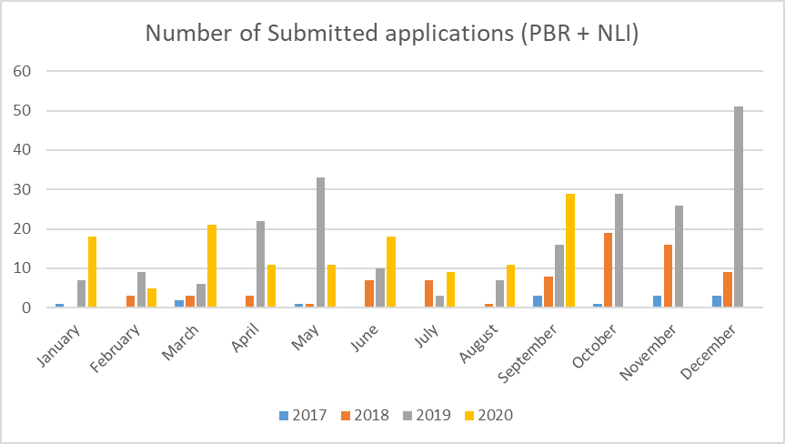

Number of submissions (PBR + NLI) via UPOV PRISMA chronologically

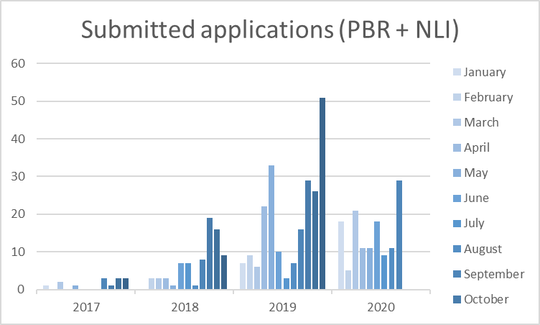

Submissions (PBR + NLI) by crop type in UPOV PRISMA

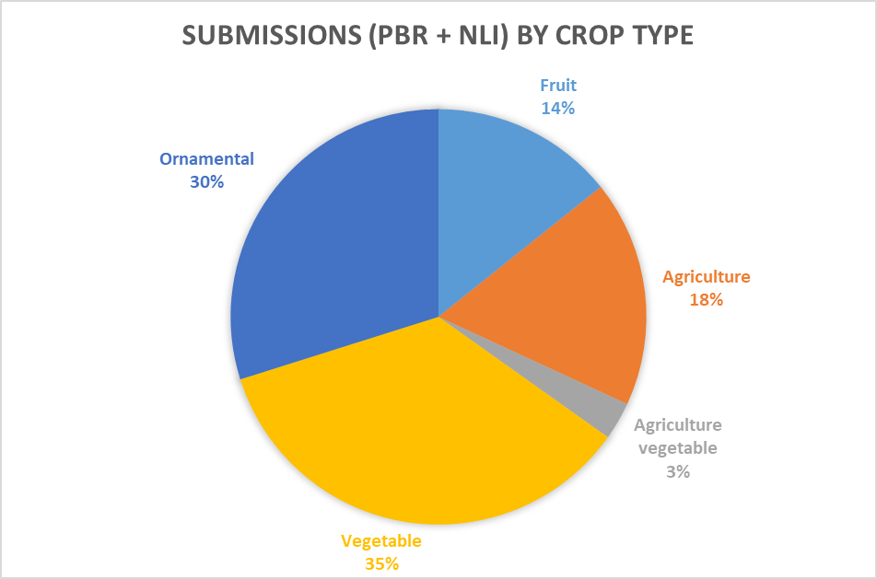

Number of PBR submissions per participating Authority in UPOV PRISMA

Authority |  | Total Number of PBR submissions in UPOV PRISMA | Number of PBR submissions in UPOV PRISMA in 2020  (as of 30/09/2020)
African Intellectual Property Organization (OAPI) | OA | 3
Argentina | AR | -
Australia | AU | 50 | 21
Bolivia (Plurinational State of)* | BO | 2
Canada | CA | 42 | 9
Chile | CL | 6
China | CN | -
Colombia | CO | 5 | 1
Costa Rica | CR | 4
Dominican Republic | DO | 2
Ecuador | EC | 1 | 1
European Union | QZ | 49 | 4
France | FR | 20
Georgia | GE | 3 | 1
Kenya | KE | 31 | 12
Morocco | MA | -
Mexico | MX | 22 | 8
Netherlands | NL | 23 | 2
New Zealand | NZ | 20 | 4
Norway | NO | 11 | 5
Paraguay* | PY | -
Peru | PE | 1 | 1
Republic of Moldova | MD | 2
Republic of Korea | KR | 2 | 1
Serbia | RS | 2
South Africa | ZA | 6 | 1
Sweden | SE | 1
Switzerland | CH | 12 | 3
Trinidad and Tobago | TT | -
Tunisia | TN | 6
Turkey | TR | 65 | 36
United Kingdom | GB | 42 | 21
United States of America | US | 9 | 2
Uruguay | UY | -
Viet Nam | VN | -
Total | 35 | 442 | 133
*Until required information is provided, applicants will not be able to submit application data for the concerned authorities

An oral report on latest developments will be made at the EAF/16 meeting.

Communication and promotion

In response to the results of the survey conducted in 2019 (see document EAF/14/03 “Report” paragraphs 10 and 11), it was concluded that resources should be focused on meeting the needs of existing users of UPOV PRISMA in 2020 rather than focusing on increasing the number of users, until users had full confidence in the system. Therefore, since the EAF/15 meeting, UPOV PRISMA communication and promotion was focused on individual support via direct contacts and training sessions with individuals and companies (breeders and agents) that were using, or had expressed an intention to use, UPOV PRISMA.

Participating members in the development of the electronic application form are invited to note developments in relation to UPOV PRISMA.

Feedback

IT matters

The following requests were received by users:

- Need to automatically save application data in case of inactivity period in the system/session;
- Improve the speed of response of the system;
- Increase the maximum size of attachments (e.g. for pictures);
- Implement machine-to-machine communication with all PVP Offices that have electronic application systems.

Items (a) to (c) will be addressed in Version 2.5. In relation to machine-to-machine communication, it will be a matter for each participating PBR authority to decide when to proceed and will be subject to available resources.

Information in UPOV PRISMA

The following requests were received in relation to the information provided in UPOV PRISMA:

- Priority should be placed on working with participating PBR authorities to ensure that all related information is complete and updated in a timely way before extending UPOV PRISMA to additional UPOV members (see UPOV PRISMA Terms of Use available at: https://www.upov.int/upovprisma/en/termsuse.html “Provide the Office of the Union with the most recent and updated application forms”);
- Need to increase coverage for important crops in participating PBR authorities that do not cover all crops/species in UPOV PRISMA;
- Ensure that all participating PBR authorities in UPOV PRISMA acknowledge receipt of the application data submission within a reasonable amount of time (see UPOV PRISMA Terms of Use available at: https://www.upov.int/upovprisma/en/termsuse.html “Acknowledge receipt in UPOV PRISMA of any application data submitted via UPOV PRISMA within 7 days”);
- Ensure that all requirements of participating PBR authorities are specified in UPOV PRISMA to avoid requests for additional information after data submission via UPOV PRISMA (see UPOV PRISMA Terms of Use available at: https://www.upov.int/upovprisma/en/termsuse.html “Specify all documents required for accepting a completed application and ensure all required information can be provided in UPOV PRISMA”);
- Avoid loss of confidence in UPOV PRISMA by withdrawing PBR authority participation where the UPOV PRISMA Terms of Use are not fulfilled.

In order to ensure confidence in UPOV PRISMA, the Office of the Union plans to contact, individually, all participating PBR authorities to check the information currently available in UPOV PRISMA and to inform the Office of the Union on any need to update the forms and/or requirements before December 31, 2020.

Analysis of Technical Questionnaires

The EAF/14 meeting noted that a report on variation between the technical questionnaires of participating authorities in UPOV PRISMA and the UPOV model application form, would be provided at the EAF/15 meeting, according to available resources.

The EAF/15 meeting participants noted that there had not been sufficient resources to produce a report for the EAF/15 meeting on variation between the technical questionnaires of participating authorities in UPOV PRISMA and the UPOV model application form,. It therefore agreed to invite the Office of the Union to present a report at the EAF/16 meeting (see document EAF/15/3 “Report”).
A report on variation between the technical questionnaires of participating authorities in UPOV PRISMA and the UPOV model application form will be presented at the EAF/16 meeting. The report will be made available to participating PBR authorities and UPOV PRISMA users.

VERSION 2.5

Timetable for release

Version 2.5 is anticipated to be released in December 2020.

Coverage

UPOV members

The following participating PBR authorities have informed the Office of the Union of updates of their application or technical questionnaire forms, which will be implemented in Version 2.5, or earlier according to available resources:

- Chile
- European Union
- Mexico
- Switzerland

Crops/ species

Anticipated changes in Version 2.5:

Authority |  | Anticipated new crop coverage in Version 2.5
European Union | QZ | Maize

New Functionalities

As presented at the EAF/15 meeting, the following new functionalities are planned to be introduced in Version 2.5:

- New version of payment interface (Epay V2) to facilitate payment by PayPal, China Union Pay and Bulk payment;
- National Listing for United Kingdom;
- Bulk upload functionality;
- Customization of OAPI form layout (already made available).

On the basis of feedback received, the following new functionalities are planned to be introduced in Version 2.5:

- Automatically save the application data in case of a period of inactivity;
- Improve system performance;
- Avoid simultaneous access to the same application data by colleagues from the same organization (application data lock functionality);
- Allow co-agents to appear in the public list of agents available for breeders;
- Allow uploading of large attachments;
- Allow the possibility to attach documents as an interim solution when a PBR authority revises its application or technical questionnaire forms;
- Improve user interface for copy functionality.

Participating members in the development of the electronic application form are invited to consider the plans for UPOV PRISMA Version 2.5, as set out in paragraphs 18 to 22.

Communication and Promotion plans

The focus for UPOV PRISMA communication in the first half of 2021 will continue to be on individual support via direct contacts and training sessions for existing UPOV PRISMA users.

UPOV PRISMA promotional material (leaflets, infographics, quick guides, PowerPoint slides) remain available in different languages (see document UPOV/EAF/15/2 “Developments concerning UPOV PRISMA”). Participating PBR authorities are invited to contact the Office of the Union to obtain promotional material, in order to diffuse the information to their applicants.

Future Versions

Coverage

The following members have expressed an interest to join UPOV PRISMA at a future date: Bosnia and Herzegovina, Japan, Nicaragua, Singapore, United Republic of Tanzania and Uzbekistan. The Office of the Union will discuss with those UPOV Members their latest plans to join UPOV PRISMA and expected timeline.

Next developments

In a future version, it is proposed to work on the following:

- Addition of non UPOV TQ characteristics in TQ Section 7 instead of TQ Section 5 (see paragraphs 28 to 31 of this document);
- Synchronization between UPOV PRISMA and CPVO for TQ changes;
- Information on DUS cooperation (DUS Arrangement Recommendation Tool (DART));
- More PBR authorities with machine-to-machine links/ communication to UPOV PRISMA;
- Machine translation;
- Additional participating PBR authorities with National Listing;
- Crop-specific TQs beyond Test Guidelines.

Addition of non UPOV TQ characteristics

The efficiency of UPOV PRISMA is greatly enhanced for applicants where participating UPOV members follow the UPOV Test Guidelines, particularly the Technical Questionnaire in the Test Guidelines (TGs), because this means that the same information can be used in other applications. Furthermore, this also greatly reduces the cost of operating UPOV PRISMA by reducing the need for customized TQs and subsequent translation in all UPOV PRISMA supported languages. At present, information on characteristics that are not included in UPOV TQs is requested in a customized version of TQ5 which requires more work for the Office of the Union because it diverges from the TQ in the adopted UPOV TGs and therefore cannot be generated automatically.

Currently, 22 of the 35 UPOV members participating in UPOV PRISMA indicate that they follow the UPOV Test Guidelines. However, it has become apparent that, for certain crops/species, the Technical Questionnaires in the TGs do not always reflect the Technical Questionnaires being used by the UPOV members concerned, indicating that a review and possible revision of the Technical Questionnaires in the TGs concerned might be appropriate to meet the objectives of the TGs, to improve the efficiency of UPOV PRISMA for applicants and to reduce UPOV’s costs in maintaining UPOV PRISMA.

At their sessions in 2020, the members of the Union present at the TWPs were invited to provide information on differences between their technical questionnaires and the Technical Questionnaires in the adopted TGs. The information will be presented to the Technical Committee at its fifty-sixth session to be held on October 26 and 27, 2020 by electronic means, to assist in the planning of Test Guidelines revisions (see document TC/56/2 “Test Guidelines” paragraphs 23 to 26).

In future versions of UPOV PRISMA (from 2021 on), for participating PBR authorities in UPOV PRISMA, which require information on characteristics that are not included in the UPOV TQ to be included in UPOV PRISMA (e.g. Netherlands), it is proposed to include them in Section 7 of the UPOV PRISMA TQ instead of Section 5 (Option 2 below), on the basis of the following analysis:

Option 1: To include characteristics that are not included in the UPOV TQ in Section 5 (i.e. Characteristics of the variety) of the UPOV PRISMA TQ:

Advantages:
  - The information provided will be reusable in subsequent applications (crop-dependent data reusability)
  - The output form will be similar to the current forms (Forms display in line with national TQ forms)

Disadvantages:
- The UPOV PRISMA data structure would need to be updated (PVP-XML should include the standard structure (i.e. Characteristic name + States of Expression))
- Additional development costs are foreseen (Code generation)
- A new deployment of the system would be required for each update

Option 2: To include characteristics that are not included in the UPOV TQ in Section 7 (i.e. Additional Information) of the UPOV PRISMA TQ:

Advantages:
  - The UPOV PRISMA data structure (PVP-XML) does not need to be updated
  - No additional development costs are foreseen on the UPOV side but work is required on the PVP Office side (preparation of data in a predefined excel template is required (to be done by PVP office))
  - No new deployment of the system would be required
  - Rapid response to request for inclusion (Fast integration of new/updated characteristics)
  - The output forms will remain similar to the current forms in the case of machine-to-machine communication or customized layout (No impact on the form layout)
  - The concerned PBR Authority will have the possibility for their applicants to use UPOV PRISMA for all genera & species, thereby remaining in Approach 1 (i.e. the TQ in UPOV PRISMA would be identical to the TQ in the adopted UPOV TGs) (see document EAF/10/3 “Report” paragraphs 12 and 13)

Disadvantages:
- The information provided by the applicant would not be reusable in a subsequent application, as it would be inserted as free text (no data reusability between different authorities). However, this is not considered to be a major disadvantage because the characteristics are not harmonized with other UPOV members
- The display of output forms might be different from the PBR authority TQ forms (i.e. the numbering or the order of the sections)

Participating members in the development of the electronic application form are invited to note the proposed future developments of UPOV PRISMA as set out in paragraphs 27 to 31.

[End of document]

