E
International Union for the Protection of New Varieties of Plants

Meeting on the development of an electronic application form  Fourteenth Meeting  Geneva, October 28, 2019 | UPOV/EAF/14/2  Original: English  Date: October 18, 2019
Developments concerning UPOV PRISMA
Document prepared by the Office of the Union
Disclaimer: this document does not represent UPOV policies or guidance

EXECUTIVE SUMMARY

The purpose of this document is to report on developments since the thirteenth meeting (“EAF/13 meeting”) on the development of the electronic application form (EAF), held in Geneva on March 28, 2019, and to present proposals for future developments.

Participating members in the development of the electronic application form are invited to note the developments concerning UPOV PRISMA, as set out in this document; and to consider the plans for the next steps of UPOV PRISMA, to be presented at the EAF/14 meeting.

The structure of this document is as follows:
EXECUTIVE SUMMARY 1
BACKGROUND 2
DEVELOPMENTS AT THE eaf/13 meeting 2
DEVELOPMENTS SINCE THE EAF/13 MEETING 2
Version 2.2 2
Participating UPOV members and crops/species covered 2
Languages 3
New Functionalities 3
Use of UPOV PRISMA 4
Number of PBR submissions via UPOV PRISMA: (as of September 30, 2019) 4
Number of National Listing submissions via UPOV PRISMA (functionality introduced in Version 2.2- June 2019): (as of September 30, 2019) 4
Number of new user registrations in UPOV PRISMA: (as of September 30, 2019) 4
Number of submissions per participating Authority in UPOV PRISMA: (as of September 30, 2019) 5
Number of submissions by crop type in UPOV PRISMA: (as of September 30, 2019) 5
UPOV PRISMA Surveys 6
Background 6
ADquation Survey of Registered Users 6
Recommendations from the survey 6
UPOV Survey of Stakeholders 7
Follow-up and action plan after the surveys 7
Communication AND PROMOTION 9
financing OF UPOV PRISMA 10
PLANNED FUTURE DEVELOPMENTS 10
Version 2.3 10
Timetable for release 10
Coverage 10
New Functionalities 11
Version 2.4 11
Timetable for release 11
Coverage 11
New Functionalities 11
Future potential developments 12

ANNEX I: UPOV PRISMA TERMS OF USE

ANNEX II: UPOV PRISMA KEY COMMUNICATION MESSAGES

BACKGROUND

The background to the development of the EAF is provided in document UPOV/EAF/13/2 “Developments concerning the electronic application form”.

DEVELOPMENTS AT THE eaf/13 meeting

At the thirteenth Meeting on the Development of an Electronic Application Form (“EAF/13 meeting”), held in Geneva on March 28, 2019, the participants considered document UPOV/EAF/13/2 Corr. “Developments concerning UPOV PRISMA” and received a presentation from the Office of the Union. The report of the meeting is provided in document EAF/13/3 “Report”.

DEVELOPMENTS SINCE THE EAF/13 MEETING

Version 2.2

Version 2.2 of UPOV PRISMA was released on June 13, 2019.

Participating UPOV members and crops/species covered

The table below summarizes the participating PVP Offices and the crops supported in UPOV PRISMA Version 2.2 (changes from Version 2.1 are highlighted):

Authority |  | Crop coverage in Version 2.2
African Intellectual Property Organization (OAPI) | OA | All genera and species
Argentina | AR | Apple Fruit Varieties, Barley, Black Radish, Oriental Radish, Brussels Sprouts, Cauliflower, Chinese Cabbage, Grapevine, Maize, Melon, Potato, Rose, Shallot, Grey Shallot, Soya Bean, Spinach, Sweet Pepper, Hot Pepper, Paprika, Chili, Tomato Rootstocks, Watermelon, Welsh Onion, Japanese Bunching Onion, Wheat, Egg Plant, Witloof Chicory, Broad Bean, Fig, Papaya, Salvia, Green onion, Indian mustard, Sugarcane, Cotton
Australia | AU | All genera and species
Bolivia (Plurinational State of) | BO | All genera and species
Canada | CA | All genera & species excluding algae, bacteria and fungi
Chile | CL | All genera and species
China | CN | Lettuce
Colombia | CO | All genera and species
Costa Rica | CR | All genera and species
Dominican Republic | DO | All genera and species
Ecuador | EC | All genera and species
European Union | QZ | All genera & species excluding agricultural crops apart from bent, cocksfoot, meadow fescue, fescue, ryegrass, timothy, potato, soyabean and pea
France | FR | All genera & species
Georgia | GE | Maize, Wheat, Field Bean, French Bean, Apple (fruit varieties), Pear, Barley, Oats, Potato, Cherry (Sweet Cherry), Raspberry, Tomato, Peach, Hazelnut, Blackberry, Soya Bean, Sunflower, Walnut, Blueberry, Chick-Pea, Lentil
Kenya | KE | All genera and species
Mexico | MX | All genera and species
Netherlands | NL | All genera and species
New Zealand | NZ | All genera and species
Norway | NO | All genera and species
Paraguay | PY | Soya bean
Republic of Moldova | MD | Maize, Wheat, Pea, Barley, European Plum, Tomato, Grapevine, Sweet Pepper, Hot Pepper, Paprika, Chili, Sunflower, Walnut, Apple Fruit Varieties, Lettuce, Potato, Rose, Soya bean, Oats, Rye, Strawberry, Blackberry
Republic of Korea | KR | Apple Fruit Varieties, Lettuce, Potato, Soya bean, Rose
Serbia | RS | Apple Fruit Varieties and Rose, Raspberry and Blueberry
South Africa | ZA | All genera and species
Sweden | SE | All genera and species
Switzerland | CH | All genera and species
Trinidad and Tobago | TT | Anthuriums , Bromeliaceae, Heliconiaceae, Orchidaceae, Sterculiaceae, Cajanus cajans, Vigna sp., Theobroma cacao L.
Tunisia | TN | All genera and species
Turkey | TR | All genera and species
United Kingdom | GB | All genera and species
United States of America | US | 192 crops including Lettuce, Potato, Soya bean and Wheat
Uruguay | UY | All genera & species
Viet Nam | VN | 15 selected crops
Total | 33

Languages

The languages supported in Version 2.2 are as follows (changes from Version 2.1 are highlighted):

Navigation languages | Output form languages
- Chinese  - English  - French  - German  - Japanese  - Korean  - Russian  - Spanish  - Turkish  - Vietnamese | - Chinese  - English  - French  - German  - Georgian  - Korean  - Norwegian  - Romanian  - Spanish  - Serbian  - Swedish  - Turkish  - Vietnamese

New Functionalities

Additional functionalities were introduced, as follows:

- Application data for national listing for Netherlands;
- Enhancement of agent role (“handshake” functionality);
- Improved copy functionality;
- Full scale for states of expression / notes in variety characteristics and variety comparisons.

Use of UPOV PRISMA

Information on the use of UPOV PRISMA to September 30, 2019, is provided below:

Number of PBR submissions via UPOV PRISMA: (as of September 30, 2019)

 | 2017 | 2018 | 2019
January | 1 |  | 7
February |  | 3 | 9
March | 2 | 3 | 6
April |  | 3 | 23
May | 1 | 1 | 33
June |  | 7 | 10
July |  | 7 | 3
August |  | 1 | 6
September | 3 | 8 | 14
October | 1 | 19
November | 3 | 16
December | 3 | 9
Total | 14 | 77 | 111
Annual increase (%) | - | 450% | 236%  (January-September)

Number of National Listing submissions via UPOV PRISMA (functionality introduced in Version 2.2- June 2019): (as of September 30, 2019)

 | 2019
August | 1
September | 2
Total | 3

Number of new user registrations in UPOV PRISMA: (as of September 30, 2019)
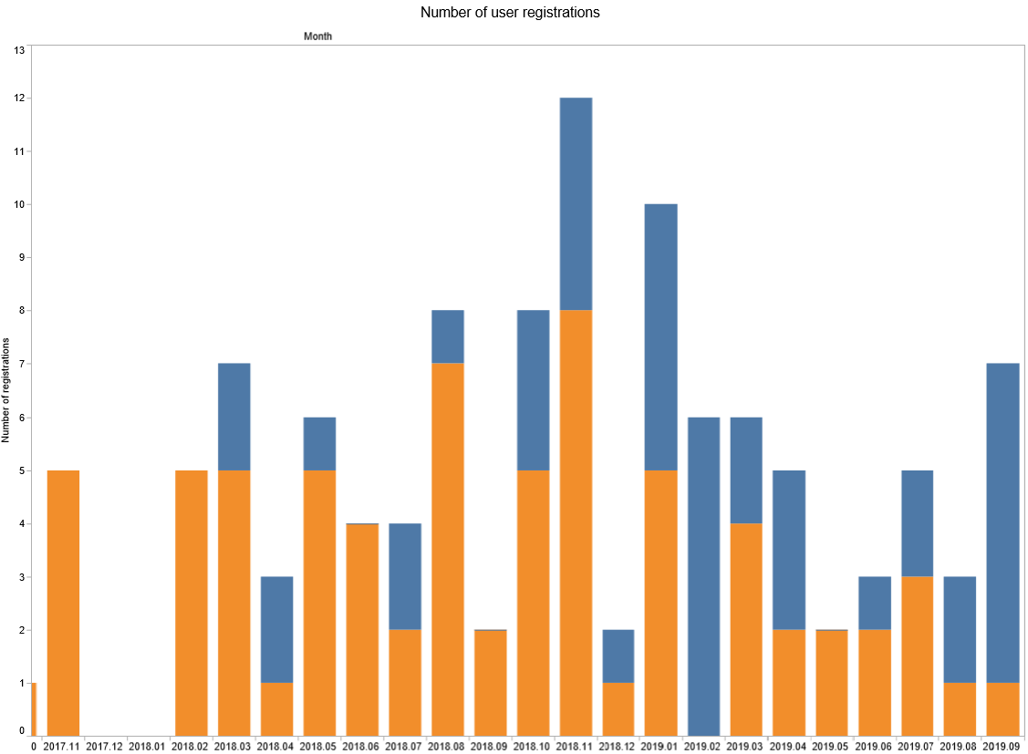

Number of submissions per participating Authority in UPOV PRISMA: (as of September 30, 2019)

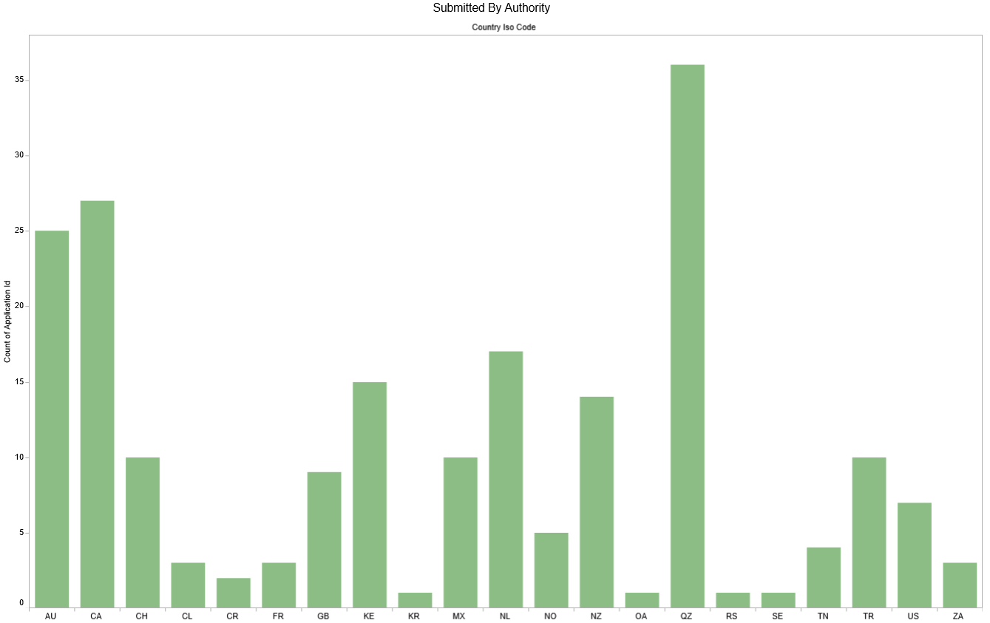

Number of submissions by crop type in UPOV PRISMA: (as of September 30, 2019)

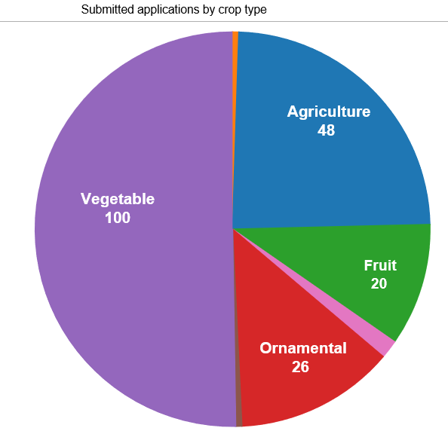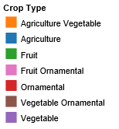

An oral report on latest developments will be made at the EAF/14 meeting.

Participating members in the development of the electronic application form are invited to note developments in relation to UPOV PRISMA.

UPOV PRISMA Surveys

Background

The participants at the EAF/13 meeting noted that a survey on the suitability of financing options would be conducted with registered entities in UPOV PRISMA and to a wider group of potential users and interested experts in UPOV. The survey would help to assess the value of the service offered by UPOV PRISMA and help to determine a suitable fee for UPOV PRISMA (see document EAF/13/3 “Report” paragraph 33).

It was noted by the participants at the EAF/13 meeting that the results of the survey, together with proposals for the financing of UPOV PRISMA would be reported at the subsequent EAF meeting (see document EAF/13/3 “Report” paragraph 34).

ADquation Survey of Registered Users

Objective and target of the survey

In order to assess the value of the service provided and to determine a suitable fee for UPOV PRISMA, the Office of the Union conducted an independent survey of registered users of UPOV PRISMA. On the basis of a Request for Proposals from market study providers, ADquation was selected to conduct the survey.

At the time of the survey (April 2019), 103 entities had registered in UPOV PRISMA. Some entities had submitted applications via UPOV PRISMA, some had drafted applications but not submitted data, while some others had registered but had not been active.

Two forms of survey were established.

- Qualitative survey (“One-to-one interviews”) with 20 registered users selected by ADquation; and
- Quantitative survey (Online questionnaire) sent to all 103 registered users.

The Qualitative survey involved in-depth conversations with interviewees to explain their views and experiences of UPOV PRISMA. ADquation chose 20 registered users for telephone interviews conducted by ADquation interviewers in English, French or Spanish. Ten users had already submitted applications (7 breeders and 3 agents) and 10 had registered but had not submitted applications (9 breeders and 1 agent). The main goals of the survey for “active users” were to receive information on user experience, identify the benefits of UPOV PRISMA and to determine a suitable fee. The main goals of the survey for “inactive” registered entities were to identify difficulties encountered and to assess a suitable fee at which it would be acceptable to use UPOV PRISMA. Respondents were from nine countries: Australia, Canada, France, Mexico, Netherlands, New Zealand, Norway, Spain and United Kingdom.

The quantitative survey took the form of an online questionnaire with 32 questions on: respondents profile and PVP application submission process; UPOV PRISMA usage; UPOV PRISMA perception; proposed improvements; and UPOV PRISMA pricing. 103 entities (222 persons) were invited to complete the survey. Thirty-seven responses were received (36% response rate based on the number of entities) with 31 breeders and 6 agents. Nine entities participated in both the qualitative and the quantitative survey. The answers received were from 14 countries: Australia, Belgium, Chile, Denmark, France, Germany, Italy, Latvia, Mexico, Netherlands, New Zealand, Norway, United Kingdom and United States of America.

Recommendations from the survey

On the basis of the replies to the surveys, the recommendations made by ADquation were as follows:

- Very risky to make users pay for UPOV PRISMA at that time because of technical problems
- However thanks to their trust in the concept, in UPOV and in its team, all remain confident in the UPOV PRISMA and will be willing to pay a fee when it is fully operational
- Defects to solve and missing features to develop (priority ranking)
  - Solve IT bugs / technical problems
  - Make sure that all countries and crops are regularly checked (updated form, translations…)
  - Ongoing inclusion of new countries / new crops
- In parallel, advise to work with UPOV members with the following objectives
- Ongoing harmonization of application forms between countries
- Improve the communication between members and applicants during the process (mainly acknowledgement of receipt)
- While introducing UPOV PRISMA, avoid too strong promises (in particular time-saving) and focus on smooth process and serenity (peace of mind)
- Individual support is crucial to make sure users are able
- to complete a whole application, in all situations
- to connect all third-parties in an appropriate way and with the appropriate rights
- Video training is not sufficient despite the feeling of easiness it provides. Direct contact is recommended
- Once all the evolutions are set up, we advise a price between 100 € (110 CHF) and 150 € (170 CHF)

ADquation have been invited to make a brief presentation on the survey findings and to answer questions at the EAF/14 meeting and at the ninety-sixth session of the Consultative Committee.

UPOV Survey of Stakeholders

Following the completion of the ADquation survey, an online survey was conducted by the Office of the Union using a set of questions selected from the ADquation online survey. This survey, conducted in June 2019, was offered to UPOV members, PVP Office contacts, users of UPOV services and breeders. The survey was completed by 14 respondents, of which 3 were breeders or agents.

Follow-up and action plan after the surveys

On the basis of the information obtained from the ADquation survey, the following approach is proposed:

- to address technical issues and improve the user experience:
  - design and integrate semi-automatic testing to identify and eliminate IT bugs;
  - provide a direct communication route to the UPOV PRISMA helpdesk;
  - redesign user interface for a better user experience;
  - develop an approach to ensure that receipt of application data is acknowledged by PVP Offices and that data are duly and promptly processed;
  - introduce new functionalities to improve the value of UPOV PRISMA, within available resources (e.g. DUS Arrangement Tool);
- introduce measures to ensure that information and forms in UPOV PRISMA are complete and up-to-date and arrange for verification of translations by relevant persons;
- expand geographical and crop coverage of UPOV PRISMA and inclusion of coverage of national listing, as far as resources allow, with priority being given to items (a) and (b);
- explore opportunities to facilitate harmonization of forms where appropriate;
- amend UPOV PRISMA promotion material to focus on the benefits of a smooth and reliable process, rather than time-saving; and
- explore possibilities to assist members of the Union to receive, process and manage application data.

Automatic testing (paragraph 23 (a) (i))

Semi-automatic test cases will be used to identify technical issues, which will be fixed before a fee is introduced for UPOV PRISMA. An oral report on progress will be made at the EAF/14 meeting.

Direct communication tool (paragraph 23 (a) (ii))

An online messaging system has been introduced and will be presented at the EAF/14 meeting.

User interface (paragraph 23 (a) (iii))

A specialized agency (VanBerlo) has been recruited to provide guidance on improving the user interface. An oral report on progress will be made at the EAF/14 meeting.

Application data processing (paragraph 23 (a) (iv))

The existing UPOV PRISMA Terms of Use (available at: https://www.upov.int/upovprismausers/en/termsuse.html) are reproduced in Annex I of this document. It is proposed to update the Terms of Use by introducing the following elements, under the “Specific acknowledgment for PVP Offices” section:

In particular, the PBR authority agrees to the following:
  - Be part of UPOV PRISMA PBR Application Tool (letter to be signed by the Representative to the UPOV Council of the UPOV member concerned)
  - Provide the Office of the Union with the most recent and updated application forms (including Technical Questionnaire)
  - Provide the Office of the Union with relevant verified translations (if applicable)
  - Complete the “Information for applicants” (PVP Office procedures) to be made available for applicants and provide updates as necessary
  - Test and check the output forms during the relevant Test campaigns
  - Specify all documents required for accepting a completed application and ensure all required information can be provided in UPOV PRISMA (with an exception for the electronic signature, if appropriate)
  - Accept application data submitted via UPOV PRISMA without the need for further data or information (except for signature)
  - Accept application data by machine-to-machine data transfer or as provided and presented in the output format (PDF), or provide a stylesheet or information that should be displayed on the PDF to be acceptable (e.g. logo)
  - Inform the Office of the Union of any changes or updates in the application forms (including Technical Questionnaire) and accept data according to the earlier version until UPOV PRISMA is updated - UPOV PRISMA will be updated at the next release or within 6 months following notification thereof, whatever is the sooner
  - Acknowledge receipt in UPOV PRISMA of any application data submitted via UPOV PRISMA within 7 days
  - Indicate the filing date in UPOV PRISMA within 7 days after it is duly filed with the participating PVP Office
  - PVP Office not to charge a higher application fee when receiving application data through UPOV PRISMA
  - Communicate information to applicants on the possibility to use UPOV PRISMA
  - Permit UPOV to disclose data about the number and crop types of applications received via UPOV PRISMA (no data on individual application will be disclosed)

Participation in UPOV PRISMA would require agreement to the Terms of Use. In the case of current participating member of the Union, agreement would be needed to be included before the introduction of a fee for UPOV PRISMA.

New functionalities (paragraph 23 (a) (v))

The proposal for the new functionalities in UPOV PRISMA, together with the workplan, are presented in the section “Planned Future Developments”.

Accuracy and completeness of the information and translations provided (paragraph 23 (b))

See paragraph 27 “Application data processing”.

Expand coverage for countries and/ or crops (paragraph 23 (c))

The policy for the expansion of the coverage of UPOV PRISMA is as follows (see document EAF/10/3 “Report”, paragraphs 12 and 13):

“12. The participants noted that the three possible approaches for including crop/species for participating members of the Union, would be:

Approach 1: UPOV Technical Questionnaire (TQ)

The TQ in UPOV PRISMA would be identical to the TQ in the adopted UPOV Test Guidelines (TGs). For crops/species for which there is no adopted UPOV TGs, the TQ in UPOV PRISMA would be based on the structure of the TQ in document TGP/7 “Development of Test Guidelines”.

Approach 2: Customized characteristics

The TQ in UPOV PRISMA would be the same for all crops (non crop-specific) except for “characteristics of the variety” (Section 5 of the UPOV TQ or equivalent) and “similar varieties and differences from these varieties” (Section 6 of the UPOV TQ or equivalent)). The characteristics in the TQ in UPOV PRISMA would be:

(i) UPOV TG characteristics,
(ii) Authority specific characteristics
(iii) Free text information

Approach 3: Customized TQ

The TQ in UPOV PRISMA would contain crop-specific sections other than those specified in Approach 2.

13. The participants noted that according to the approach, the number of crop and species that could be covered for each authority in future versions of the tool would be different. For Approach 1, all crops could be easily covered. For Approaches 2 and 3 considerably more time would be needed and new crops would be added according to available resources and the degree of customization that was required.”

Harmonization of forms (paragraph 23 (d))

At the EAF/13 meeting (see document EAF/13/3 “Report, paragraph 23), it was agreed to generate a report for participating authorities, upon request, on the extent to which their forms were harmonized with other UPOV members and the UPOV model application form.

It is proposed that a report be sent to participating authorities, at the earliest opportunity according to available resources, and to all new participating UPOV Member before joining UPOV PRISMA.

UPOV PRISMA Promotion (paragraph 23 (e))

See “Communication and Promotion section”.

PVP Office management Interface (paragraph 23 (f))

To assist members of the Union to receive, process and manage application data from UPOV PRISMA, it is proposed to develop a PVP Office management interface. A report on progress will be made at the EAF/14 meeting.

Participating members in the development of the electronic application form are invited to:

(a) note the outcomes of the surveys; and

(b) consider the proposals in paragraphs 23 to 34.

Communication AND PROMOTION

Since the EAF/13 meeting, the following initiatives have been taken:

- information on UPOV PRISMA use and/or new functionalities via social media (UPOV PRISMA LinkedIn showcase, available at: https://www.linkedin.com/showcase/24973258/; UPOV PRISMA Twitter account, available at: https://twitter.com/upovprisma; and UPOV twitter and LinkedIn accounts)
- creation of new Powtoons targeted at agents;

- providing the necessary information (e.g. links, logo) for participating members in UPOV PRISMA to update their website.

The key communication messages for UPOV PRISMA are provided in Annex II.

With regard to training and support, it is proposed to organize webinars in 2020 to address the following topics, raised by users during the surveys:

- How to personalize alerts and notifications for Novelty and Priority
- How to select an agent in UPOV PRISMA
- How to link “my UPOV PRISMA” account with “my CPVO” account
- How to start a new application and copy data from an existing application data to a subsequent one
- How to do a bulk upload of several applications
- How to follow-up on the status of my submitted application in UPOV PRISMA

Those webinars will be recorded and made available on the UPOV PRISMA website.

Participating members in the development of the electronic application form are invited to note the plans for communication concerning UPOV PRISMA.

financing OF UPOV PRISMA

Proposals concerning financial aspects of UPOV PRISMA will be considered by the Consultative Committee at its ninety-sixth session, to be held in Geneva, on October 31, 2019 and, if appropriate, by the Council at its fifty-third ordinary session, to be held in Geneva on November 1, 2019.

Participating members in the development of the electronic application form are invited to note that financing of UPOV PRISMA will be considered by the Consultative Committee at its ninety-sixth session and, if appropriate, by the Council at its fifty-third ordinary session.

PLANNED FUTURE DEVELOPMENTS

Version 2.3

Timetable for release

Version 2.3 is anticipated to be launched in October 2019. An oral report on progress will be made at the EAF/14 meeting.

Coverage

UPOV members

Since EAF/13 the following authorities have confirmed their intention to be part of Version 2.3:

Authority |  | intention to participate in Version 2.3 | Anticipated crop coverage in Version 2.3
Morocco | MA |  | Melon
Peru | PE |  | All genera and species

Crops/ species

In relation to anticipated coverage of crop and species in UPOV PRISMA Version 2.3, the table below shows the changes compared to Version 2.2 for authorities participating in Version 2.2:
Authority |  | Anticipated additional crop coverage in Version 2.3
VietNam | VN | Poinsettia (Euphorbia pulcherrima Willd. Ex klotzsch)  Sun flower (Helianthus annuus L.)  Dahlia (Dahlia)  Carnation (Dianthus caryophyllus L.  Cabbage (Brassica oleracea L.:  Brassica (White Cabbage Group);  Brassica (Savoy Cabbage Group);  Brassica (Red Cabbage Group))  Onion (Allium fistulosum L.  Kohlrabi (Brassica oleracea L. convar. acephala (DC.) Alef. var. gongylodes L.; Brassica oleracea L. Gongylodes Group)
Republic of Moldova | MD | Sour cherry - Prunus cerasus L.  Pear - Pyrus communis L.  Raspberry - Rubus idaeus L.  Sunflower - Helianthus annuus L.  Onion Allium cepa L.

New Functionalities

In Version 2.3 the following new functionalities are planned to be introduced and will be presented at the EAF/14 meeting:

- Live chat helpdesk;
- Extension of the workflow until the assignment of the filing date;
- Machine-to-machine communication for lettuce, potato, soybean and wheat for the United States of America.

Version 2.4

Timetable for release

Version 2.4 is anticipated to be released in December 2019.

Coverage

UPOV members

It is anticipated that apart from Japan, no new authorities are foreseen in Version 2.4, because priority will be given to addressing technical issues before introducing a fee for UPOV PRISMA.

Crops/ species

In relation to the anticipated increased coverage of crop and species in UPOV PRISMA Version 2.4, the table below shows the changes compared to Version 2.3:

Authority |  | intention to participate in Version 2.4 | Anticipated crop coverage in Version 2.4
Japan | JP |  | Not yet confirmed

New Functionalities

In Version 2.4 the following new functionalities are planned to be introduced and will be presented at the EAF/14 meeting:

- New version of payment interface (Epay V2);
- Machine-to-machine communication (Kenya);
- Allow PVP Office/ breeders/ agents to provide comments on each question;
- Enhancement of copy functionality (highlight entry fields not filed in after copy);
- Improvement of generic UPOV PRISMA PDF layout;
- Customization of OAPI Form Layout (addition of logo).

Future potential developments

The following members have previously expressed their interest to join UPOV PRISMA at a future date: Bosnia and Herzegovina, Nicaragua, Singapore, United Republic of Tanzania and Uzbekistan.

In relation to the anticipated increased coverage of crop and species in UPOV PRISMA future Versions, the table below shows the changes anticipated:

Authority |  | Anticipated new Crop coverage in Future Versions
Argentina | AR | Indian mustard, Lettuce
Morocco | MA | Tomato, Potato, lettuce, Onion
United States of America | US | 102 new crops

In a future Version a “PVP Office management Interface”, as reported in paragraph 34 of this document, may be introduced. A report on progress will be made at a next EAF meeting.

Participating members in the development of the electronic application form are invited to consider the planned developments for UPOV PRISMA Versions 2.3 and 2.4 and potential future developments as set out in paragraphs 42 to 52.

[Annexes follow]

UPOV PRISMA Terms of Use
General acknowledgment before you register
The data transmitted using UPOV PRISMA does not constitute the official application for a breeder’s right. The authority entrusted with the task of granting breeders’ rights (PBR authority) retains full responsibility in relation to the requirements concerning the filing of applications and grants of breeders’ rights in accordance with the legislation of the member of the Union concerned.
Reference in these terms of use to the term “PBR authority” should be understood as covering also the term “PVP Office”.
Specific acknowledgment for PVP Offices
The PBR authority agrees to these terms of use and agrees to follow the user guide for the PVP Offices for application data transmitted using UPOV PRISMA.
Specific acknowledgment for UPOV PRISMA users
The user of UPOV PRISMA agrees to these terms of use and agrees to follow the user guide for breeders for application data transmitted using UPOV PRISMA. The user of UPOV PRISMA retains full responsibility in relation to the completeness and accuracy of the data transmitted using the UPOV PRISMA, including the requirements to obtain a filing date. For matters concerning those requirements, users of UPOV PRISMA should contact the relevant PBR authority, contact details for which are provided at https://www.upov.int/members/en/pvp_offices.html
By registering for, and subsequently accessing or using UPOV PRISMA, you acknowledge that you have read, accepted and agreed to these Terms of Use and agree to follow the User Guides, as updated from time to time and published in the UPOV PRISMA webpage.
In accessing and using the UPOV PRISMA, you agree:
- to use UPOV PRISMA strictly in accordance with these Terms of Use and User Guides, as updated from time to time and published in the UPOV PRISMA webpage;
- to provide true and correct information in connection with UPOV PRISMA, including application data made via UPOV PRISMA;
- not to falsely represent your company/organization/in your use of UPOV PRISMA; and
- to respect third parties rights.
Using UPOV PRISMA
The date and time of receipt of data submitted electronically using UPOV PRISMA is the local date and time in the selected PBR authority at the time when the data was submitted via UPOV PRISMA. When the data is completed and submitted electronically, the data is transferred directly to the selected PBR authority. The date and time of submission will appear in the confirmation email sent to you. This information will also appear in the dashboard in UPOV PRISMA. If a confirmation email is not received you should contact the UPOV PRISMA team at prisma@upov.int. The same International Reference Number will be assigned to application data submitted for the same variety.
Operation of UPOV PRISMA
UPOV PRISMA has been implemented in a technical environment which is designed to provide high availability and to be reasonably fault tolerant.
You acknowledge and agree that your use of UPOV PRISMA on an “as is, as available” basis. UPOV makes no representation and gives no warranty that the service provided via UPOV PRISMA will meet your requirements, be uninterrupted, timely or error-free. You should promptly notify the UPOV PRISMA team at prisma@upov.int if you discover or suspect any error or malfunction in UPOV PRISMA. The UPOV PRISMA team will attempt to inform you as soon as possible of any outage that might materially affect your normal use of UPOV PRISMA. However, UPOV will not be liable for delay to transactions or disruptions to your operations, or those of your PVP Office/organization/company arising directly or indirectly from any such outage. It is in your best interest to ensure that you have adequate contingency plans to protect the integrity of your business operations and those of your organization/company and to ensure you and your organization/company can proceed despite any disruption or delay occurring in respect of UPOV PRISMA.
UPOV may alter, suspend or decommission UPOV PRISMA at any time without giving reasons. Where possible, the UPOV PRISMA team will attempt to give a reasonable prior notice of any such action. You should promptly notify the UPOV PRISMA team at prisma@upov.int if you discover or suspect any error or malfunction in UPOV PRISMA. In such an event, you agree to promptly provide to the UPOV PRISMA team information and details regarding any error or malfunction of UPOV PRISMA to the extent reasonably necessary to identify, confirm, investigate and rectify any such errors or difficulties (including where relevant any details of your operating environment or that of your PVP Office/ organization/company).
Access and Password
When you register in UPOV PRISMA, through WIPO Account, you need to provide a username and password that can later be used to log on to the UPOV PRISMA secure facilities. This username and password is linked to your WIPO account and consequently allows you to access UPOV PRISMA.
Encryption together with your username and passwords ensures the confidentiality, integrity and authenticity of your application data. It is your responsibility to protect your password from disclosure to unauthorized individuals. Registered PVP Offices/organizations/companies should only allow authorized individuals access to the username and password. Do not distribute or publish, in any form, this information to unauthorized individuals.
You agree to:
- be responsible for all activities that occur under your username and password;
- maintain the confidentiality of your password;
- change your password on a regular basis;
- not save your password on the computer that you are using to access UPOV PRISMA;
- change your password if it becomes known to unauthorized persons;
- inform the UPOV PRISMA team at prisma@upov.int if you leave your registered PVP Office/organization/company;
- contact the UPOV PRISMA team at prisma@upov.int if your username or password have been lost, stolen or otherwise compromised; and
- log out at the end of each session. Your session will expire automatically after two hours or after one hour idle time.
Security
The Information Security controls within UPOV PRISMA will be based upon the ISO/IEC 27001/2 controls frameworks as relevant. These controls may be supplemented from other control frameworks as applicable. The Information Risk Management framework, which is defined within the ISMS Manual, is derived from the ISO/IEC 27005 Standard for Information Risk Management, and is aligned with the Organizational Enterprise Risk Management framework.
It is a condition of you using UPOV PRISMA that you must not:
- tamper with other accounts, or commit unauthorized intrusion into any part of UPOV PRISMA;
- attempt to bypass any security controls;
- use UPOV PRISMA in a manner that encumbers disk space, processors or other system resources;
- make deliberate attempts to interfere with the functionality of UPOV PRISMA, overload UPOV PRISMA or attempt to disable a host;
- attempt to use UPOV PRISMA without authorization; and
- transmit any file with malicious content.
Monitoring
The effective management and security of UPOV PRISMA requires that usage is routinely monitored and analyzed for evidence of misuse and attempted or actual security breaches. You consent to this monitoring being undertaken by UPOV PRISMA team in connection with your use of UPOV PRISMA.
Payment of fees
The payment of UPOV PRISMA fee for all users of UPOV PRISMA should be done online following the instructions provided in the payment gateway.
The following link contains the list of PBR authorities that have requested that the application fee be paid using UPOV PRISMA. In such a case the payment of UPOV PRISMA fee and the application fee should be all done online following the instructions provided in the payment gateway.
For the other PBR authorities, the application fee is to be paid directly to the PBR authorities.
The applicable payments are made through the payment gateway by credit card or bank transfer.
Unless otherwise indicated, the payment of the UPOV PRISMA fee is in Swiss francs (CHF).
For those PBR authorities that have requested that the application fee be paid using UPOV PRISMA please consult the following link for the applicable currency.
The transfer of money concerning the application fee to the PBR authority will be effected as soon as possible but may take a few days after receiving the money from the user.
The application data is transferred to the selected PBR authority without waiting for the transfer of money concerning the UPOV PRISMA fee and/or application fee, if applicable. As provided in the acknowledgement above, the user of UPOV PRISMA is responsible for fulfilling the requirements concerning the filing of applications and grants of breeders’ rights in accordance with the legislation of the member of the Union concerned.
Support
The UPOV PRISMA team will ordinarily provide business and technical support for the UPOV PRISMA from 9 am to 5 pm, Geneva time, Monday to Friday (excluding UPOV official holidays and shut-down periods as specified on the UPOV PRISMA website).
Termination of Use
You may inactivate your registration with UPOV PRISMA at any time through the user role management interface.
UPOV may immediately terminate your registration, access to and use of UPOV PRISMA by notice to you, if it determines that you have breached any of these Terms of Use.
UPOV may also suspend, and/or terminate your registration, use of or access to UPOV PRISMA for its own reasons and without any fault on your part provided that in such circumstances the UPOV PRISMA team will attempt to give you a reasonable time prior written notice of such suspension, termination where it considers that this is appropriate in its absolute discretion.
UPOV will not transfer any application data from you via UPOV PRISMA after the date of termination.

Settlement of Disputes and Applicable Law
Users of UPOV PRISMA shall make their best efforts to amicably settle any dispute arising out of the use of UPOV PRISMA. If not settled amicably within sixty days after receipt by one Party of the other Party's written request for such amicable settlement, the dispute may be referred by either Party to arbitration in accordance with the United Nations Commission on International Trade Law (UNCITRAL) Arbitration Rules then in force. The appointing authority shall be the Secretary General of the Permanent Court of Arbitration. The place of arbitration shall be Geneva, Switzerland. The language to be used in the arbitral proceedings shall be English or French. The decisions of the arbitral tribunal shall be based on general principles of international commercial law. The arbitral tribunal shall have no authority to award punitive damages and no authority to award interest in excess of the London Inter-Bank Offered Rate (LIBOR) then prevailing, and any such interest shall be simple interest only. The Parties shall be bound by any arbitration award rendered as a result of such arbitration as the final adjudication of such a dispute.
Privileges and Immunities
Nothing in or relating to the use of UPOV PRISMA shall be deemed a waiver, express or implied, of any of the privileges and immunities of UPOV.
Updated on: January 22, 2018

[Annex II follows]

UPOV PRISMA KEY COMMUNICATION MESSAGES

- Objectives

- To increase number of users
- To increase number of participating PVP Authorities
- To increase coverage in terms of crops/species

- Target audience and key messages

- PVP Offices
- Breeders
- PVP Agents

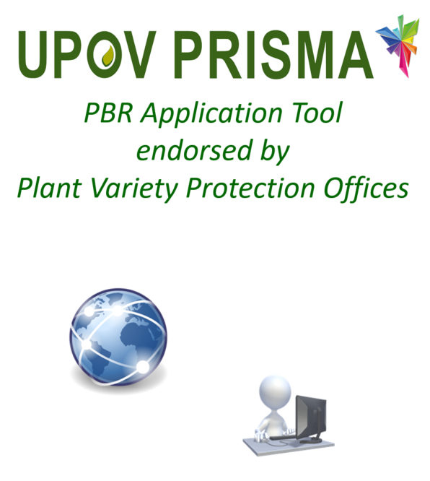

PVP OFFICES

Motivations
- Make PBR applications easier for their applicants (residents & non-residents)
- Offer on-line tool to their applicants (if relevant)
- Increase PBR applications
- Increase income (for PVP Offices/ for UPOV)
- Offer National listing through UPOV PRISMA (e.g. for NL)
What actions do we want them to take

- Join UPOV PRISMA
- Follow UPOV TQs
- Cover all crops / species
- Promote tool with their applicants
- Provide incentives to use (e.g. discount)

Key Messages

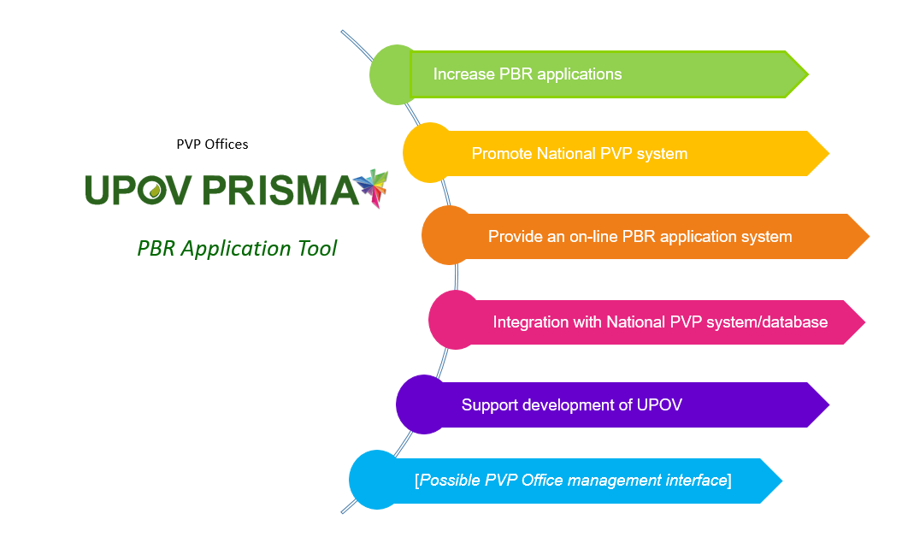

BREEDERS

Motivations
- Efficient and reliable tool to submit applications
- Applications made according to PVP Office requirements
- Applications processed efficiently
- Access to the most recent information

What actions do we want them to take

- Use UPOV PRISMA to make PBR applications for participating UPOV members
- Promote UPOV PRISMA to their agents (when relevant)

Key Messages

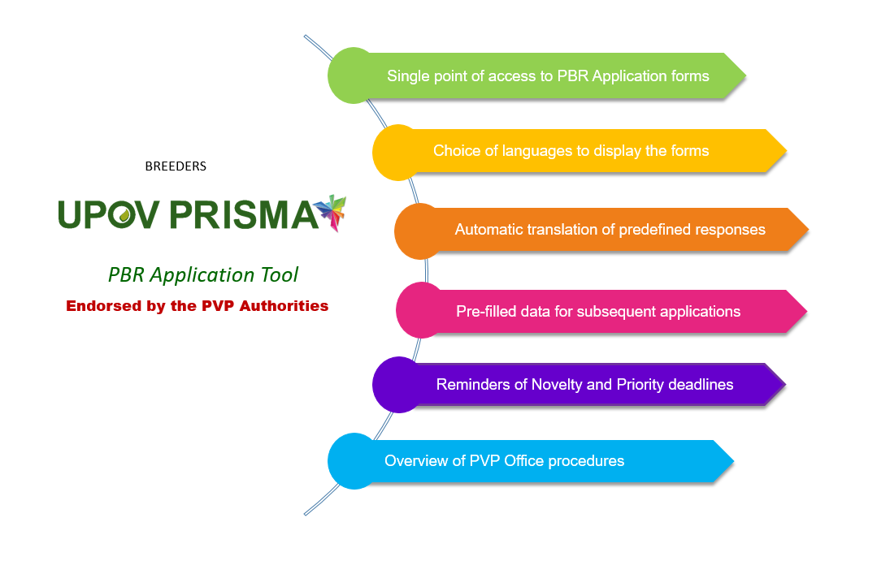

PVP AGENTS
IP Agents / Law Firms / Qualified Persons

Motivations
- Efficient and reliable tool
- Raise awareness of service provided
What actions do we want them to do

- Use UPOV PRISMA
- Promote UPOV PRISMA to their clients (breeders)

Key Messages

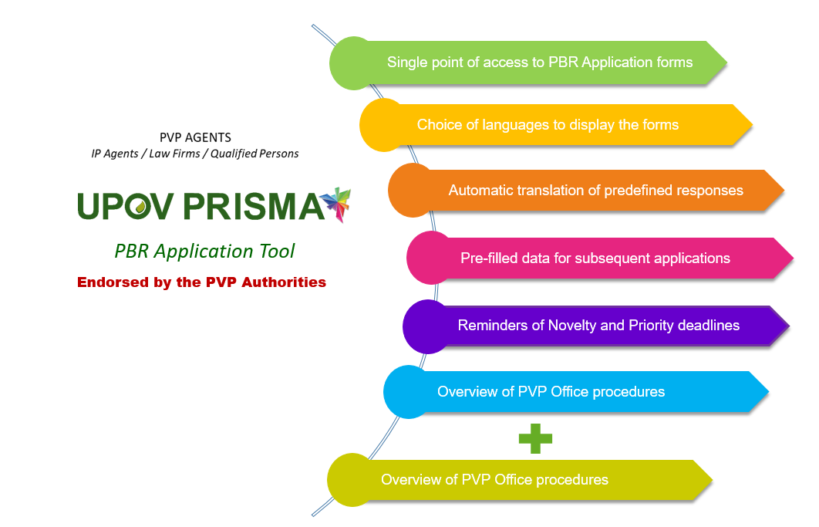

[End of Annex II and of document]

