E
International Union for the Protection of New Varieties of Plants

Meeting on the Development of an electronic application form  Tenth Meeting  Geneva, October 27, 2017 | UPOV/EAF/10/2  Original: English  Date: October 9, 2017
Developments concerning the Electronic Application Form
Document prepared by the Office of the Union
Disclaimer: this document does not represent UPOV policies or guidance

EXECUTIVE SUMMARY

The purpose of this document is to report on developments since the ninth meeting (“EAF/9 meeting”) on the development of the electronic application form (EAF), held in Geneva on April 7, 2017, and to present proposals for future developments.

Participating members in the development of the electronic application form are invited to:

- note the developments concerning EAF Version 1.1 and the plans for the development of Version 2.0, as set out in this document;

- note that a report will be made by the Office of the Union on the decisions taken by the Council at its fifty-first ordinary session in relation to the EAF PBR Tool, and in particular with regard to the name of the EAF and the financing of the EAF;

- note the developments concerning communications, as set out in paragraphs 25 to 27;

- consider the proposals for future developments of the EAF, as set out in paragraphs 28 to 30;

- consider the proposed timetable for the next versions of the EAF and the requirements for members of the Union to join the EAF, as set out in paragraphs 32 and 33.

The structure of this document is as follows:
EXECUTIVE SUMMARY 1
BACKGROUND 2
DEVELOPMENTS AT THE NINTH MEETING ON THE DEVELOPMENT OF A PROTOTYPE ELECTRONIC FORM 2
DEVELOPMENTS SINCE EAF/9 2
Versions 2
Version 1.1 2
Version 2.0 3
Name 5
Communication 5
PROPOSED FUTURE DEVELOPMENTS 6
Functionalities 6
Payment 6
Breeding Scheme 6
FinancING OF THE EAF 6
Version 2.1 7

BACKGROUND

The background to the development of the EAF is provided in document UPOV/EAF/9/2 Corr.2 “Developments concerning the prototype electronic form project”.

DEVELOPMENTS AT THE NINTH MEETING ON THE DEVELOPMENT OF A PROTOTYPE ELECTRONIC FORM

At the Ninth meeting on the development of a prototype electronic form (EAF/9 meeting), held in Geneva on April 7, 2017, the participating members considered document UPOV/EAF/9/2 Corr.2 “Developments concerning the Electronic Application Form” and received a presentation from the Office of the Union (see document UPOV/EAF/9/3 “Report”, paragraphs 4 to 30).

DEVELOPMENTS SINCE EAF/9

Versions

The current version of the EAF, released in July 2017, is Version 1.1. Version 2.0 is anticipated to be released in early 2018.

Version 1.1

Participating UPOV members and crops/species covered

The table below summarizes the participating PVP Offices and the crops supported in EAF Version 1.1:

Authority | Soya Bean | Lettuce | Apple fruit varieties | Rose | Potato | Total
Argentina |  | - |  |  |  | 4
Australia |  |  |  |  |  | 5
Chile |  |  |  |  |  | 5
China | - |  | - |  | - | 2
Colombia | - | - | - |  | - | 1
France |  |  |  |  |  | 5
Kenya |  |  |  |  |  | 5
Netherlands |  |  |  |  |  | 5
New Zealand | - |  |  |  |  | 4
Norway |  |  |  |  |  | 5
Republic of Moldova |  |  |  |  |  | 5
Switzerland |  |  |  |  |  | 5
Tunisia |  |  |  |  |  | 5
Turkey |  |  |  |  |  | 5
United States of America |  |  | - | - |  | 3
Uruguay |  | - |  | - |  | 3
16 | 13 | 13 | 13 | 14 | 14

Languages

EAF Version 1.0 presented all webpages and items (questions) for all application forms and technical questionnaires for all participating PVP Offices in English, French, German and Spanish (“navigation languages”). Chinese was added as a navigation language in EAF Version 1.1.

EAF Version 1.1 generates application forms and technical questionnaires in the languages required by the participating PVP Offices (“output form languages”). For Version 1.1 the output form languages were English, French, German, Spanish, Chinese, Norwegian, Romanian and Turkish.
It is recalled that the information must be completed by the applicant in an acceptable language for the PVP Office concerned, although answers selected from drop-down lists (e.g. characteristics and states of expression) will be automatically translated for the navigation languages.

Style sheet for the application form

The participants in the EAF/9 meeting noted that, where requested by PVP Offices, it would be possible to have a customized format for the application form to be received by the PVP Office (e.g. addition of national coding reference to the form, PVP Office logo) if the relevant information was provided according to a specified format.

Version 2.0

Participating UPOV members

Participation in EAF Version 2.0 is possible for authorities that participated in the development of Prototype Electronic Form (PV2) and in the development of the Electronic Application Form Versions 1.0 or 1.1 (African Intellectual Property Organization (OAPI), Argentina, Australia, Bolivia (Plurinational State of), Brazil, Chile, China, Canada, Colombia, Czech Republic, European Union, France, Georgia, Japan, Kenya, Mexico, Netherlands, New Zealand, Norway, Paraguay, Republic of Korea, Republic of Moldova, South Africa, Switzerland, Tunisia, Turkey, United States of America, Uruguay and Viet Nam), according to available resources.

Members of the Union that did not participate in the development of a Prototype Electronic Form (PV2) or in the development of the Electronic Application Form Versions 1.0 or 1.1 will need to provide their forms for relevant crops (application form and technical questionnaire) in a UPOV language and, if appropriate, to provide translations of the questions of the application forms and technical questionnaires of the other languages used in the EAF. The timetable for addition of new members of the Union will be developed according to available resources and will vary according to the content of the application forms and technical questionnaires.

Circular E-17/132, issued on July 26, 2017, invited all participating members in the development of an Electronic Application Form (PV2 and Version 1.0 and 1.1) to inform the Office of the Union of their wish to participate in Version 2.0 of the EAF. After the launch of Version 2.0, other members of the Union will be invited to indicate their wish to participate in a subsequent release of the EAF.

Crops/species

There are three possible approaches for including crop/species for participating members of the Union:

- Approach 1: UPOV Technical Questionnaire (TQ)

The TQ in the EAF is identical to the TQ in the adopted UPOV Test Guidelines (TGs). For crops/species for which there is no adopted UPOV TG, the TQ in the EAF will be based on the structure of the TQ in document TGP/7 “Development of Test Guidelines”.

- Approach 2: Customized characteristics

The TQ in the EAF is the same for all crops (non-crop specific) except for “characteristics of the variety” (Section 5 of the UPOV TQ or equivalent) and “similar varieties and differences from these varieties” (Section 6 of the UPOV TQ or equivalent). The characteristics in the TQ in the EAF would be:

  - UPOV TG characteristics
  - Authority specific characteristics
  - Free text information

- Approach 3: Customized TQ

The TQ in the EAF will contain crop-specific sections, other than those specified in Approach 2.

According to the approach, the number of crop and species to be covered by each authority in Version 2.0 of the EAF will be different. For Approach 1, all crops will be available in Version 2.0 if the PVP Office so requests. For Approaches 2 and 3, new crops will be added at the request of the PVP Offices concerned according to available resources and the degree of customization that is required.

For Approach 1 (UPOV TQ), it is proposed that the date of update of the EAF after revision of a UPOV TG would be the date of publication of the corresponding UPOV TG on the website.

For Approach 3 (Customized TQ), each new form will be included in the system for subsequent versions (twice a year) according to resources allocated.

Anticipated coverage of Version 2.0

The following UPOV members had expressed their intention to participate in the Version 2.0 of the EAF (Circular E-17/132) as of September 15, 2017:

Authority |  | currently participating  in Version 1.0 or 1.1 | intention to participate  in Version 2.0 | Anticipated crops coverage
Argentina | AR |  |  | Apple Fruit Varieties, Potato, Rose, Soyabean and Wheat, Barley, Maize, Grapevine
Australia | AU |  |  | All genera & species
Bolivia (Plurinational State of) | BO |  |  | Rice, wheat
Canada | CA |  |  | All genera & species excluding algae, bacteria and fungi
Chile | CL |  |  | All genera & species
China | CN |  |  | Lettuce, Rose
Colombia | CO |  |  | Rose, Carnation, Alstroemeria, Chrysanthemum, Gypsophila
European Union | QZ |  |  | Apple Fruit Varieties, Lettuce, Potato, Rose, Soyabean
France | FR |  |  | All genera & species
Georgia | GE |  |  | Maize, Wheat, Field Bean, French Bean, Apple (fruit varieties), Pear, Barley, Oats, Potato, Cherry (Sweet Cherry), Raspberry, Tomato, Peach, Hazelnut, Blackberry, Soya Bean, Sunflower, Walnut, Blueberry, Chick-Pea, Lentil
Japan | JP |  |  | to be confirmed
Kenya | KE |  |  | All genera & species
Mexico | MX |  |  | 87 selected crops
Netherlands | NL |  |  | All genera & species
New Zealand | NZ |  |  | All genera & species
Norway | NO |  |  | All genera & species
Paraguay | PY |  |  | Soyabean
Republic of Moldova | MD |  |  | Maize, Wheat, Pea, Barley, European Plum, Tomato, Grapevine, Sweet Pepper, Hot Pepper, Paprika, Chili, Sunflower, Walnut, Apple Fruit Varieties, Lettuce, Potato, Rose, Soyabean
Switzerland | CH |  |  | All genera & species
Tunisia | TN |  |  | All genera & species
Turkey | TR |  |  | All genera & species
United States of America | US |  |  | Lettuce, Potato, Soyabean and Wheat
Uruguay | UY |  |  | All genera & species
Total |  | 16 | 23

Languages

EAF Version 2.0 will continue to present all items (questions) in English, French, German and Spanish. Translations for items (questions) for new PVP offices and new crops/species in other languages (e.g. Chinese) will be made available if provided by the participating members of the Union, with a suitable disclaimer.

Users are required to provide information (answers) in a language accepted by the PVP Office concerned, which will be indicated in the form.

Tentative timetable for the EAF version 2.0

Participating members in the development of the Version 2.0 of the EAF will be invited to test the tool through different releases during the test campaign in November-December 2017. Subject to their validation, Version 2.0 would be released in January 2018.

Name

The participants in the EAF/9 meeting agreed the name “PRISMA” (Plant variety data Routing Information System using Multilingual Application forms) as a new name for the EAF and the following logo, presented at the meeting:

The EAF/9 meeting agreed that the name “PRISMA” and the proposed logo should be proposed for approval at the fifty-first ordinary session of the Council, to be held in Geneva on October 26, 2017. Any decision taken by the Council at its fifty-first ordinary session, will be reported to the EAF/10 meeting.

Communication

The following initiatives have been taken:

- at the launch of the EAF, on January 9, 2017, a webpage was created for the EAF, available at: http://www.upov.int/upoveaf, containing all necessary information to access and use the EAF;

- at the launch of the EAF, the Office of the Union informed breeders’ organizations and PVP Offices on the availability of the system (see Circulars E-17/007, E-17/008 and E-17/009), also inviting them to inform all their relevant stakeholders;

- the following communication materials have been developed and diffused to requesting UPOV members and breeders’ organizations (still available on demand):

  - posters and roll-up banners in English, Spanish and Chinese (as reproduced in Annex I of this document),
  - flyers in English, French, Spanish and Chinese (as reproduced in Annex II of this document),
  - a series of tutorials have been created (in English) and posted on the UPOV website with subtitles in French, Spanish, Arabic, Chinese, Japanese and Korean;

- 5 meetings (including online sessions & webinars) have been organized for individual applicants or groups of applicants upon request;

- presentations have been made at the following meetings: ISF congress, EAPVP Forum, ESA congress, AOHE Annual meeting and SAA congress;
- a LinkedIn page has been created, available at: https://www.linkedin.com/showcase/24973258/;

- the Office of the Union had invited PVP Offices to diffuse the information on the availability of the EAF tool to potential users (e.g. breeders, representatives, agents, etc.) and to add a link to the EAF on their own websites (see Circular E-17/138)

  - as of October 6, 2017, the following members had provided a link on their official webpage to the EAF PBR Tool: Netherlands, New Zealand, Republic of Moldova and Turkey.

Briefing sessions in English, French and Spanish will be organized at the fringes of the UPOV sessions to be held in Geneva in October 2017 (see Circular E-17/139)

The Office of the Union is working on a communication plan for 2018 which includes the following elements:

- press articles ;
- updated communication materials (posters, flyers, tutorials) with the new name and logo and the new coverage of crops and countries;
- update of the UPOV EAF PBR webpage with new testimonials from breeders and PVP Offices;
- targeted communication to potential users of the UPOV EAF PBR Tool (e.g. agents, representatives, breeding companies, breeders’ associations)
- training sessions (in situ and online);
- participation in international breeders’ events (ISF, AOHE, CIOPORA, ASTA…)
- inclusion of information in existing training programs (e.g. breeders ’s academy, training for PVP officers, UPOV’s training programs…).

PROPOSED FUTURE DEVELOPMENTS

Functionalities

Payment

Payment in the UPOV EAF PBR Tool is currently possible via bank transfer. Payment by credit card will be available in Version 2.0.

Additional payment methods may be introduced in subsequent versions of the tool, e.g. current account or e-wallet. It is proposed to investigate those different possibilities and to report on their possible development at a subsequent EAF meeting.

Breeding Scheme

It is proposed to indicate the breeding scheme section in the tool with a pre-defined list of options. This functionality will be presented and considered by the participants of the EAF/10 meeting.

FinancING OF THE EAF

Proposals concerning financial aspects of the EAF will be considered by the Consultative Committee at its ninety-fourth session, to be held in Geneva, on October 25, 2017 and, if appropriate, by the Council at its fifty-first ordinary session, to be held in Geneva on October 26, 2017. Any decision taken will be reported to the EAF/10 meeting.

Version 2.1

It is proposed to work on a new release of the EAF PBR Tool (Version 2.1) in mid-2018. Version 2.1 will contain more functionalities and UPOV members, according to available resources and availability of the necessary information from participating UPOV members.

Members of the Union wishing to join the EAF PBR Tool and that have not participated in PV2 or Version 1.1 will be included in Version 2.1, or subsequent Versions. Such members of the Union would need to provide their forms for the selected crops (application form and technical questionnaire) in a UPOV language and, if appropriate, to provide translations of the questions of the applications forms and technical questionnaires of the other participating members of the Union. The timetable for release of Version 2.1 for addition of new members of the Union will be subject to available resources and will vary according to the content of the applications forms and technical questionnaires.

Participating members in the development of the electronic application form are invited to:

- note the developments concerning EAF Version 1.1 and the plans for the development of Version 2.0, as set out in this document;

- note that a report will be made by the Office of the Union on the decisions taken by the Council at its fifty-first ordinary session in relation to the EAF PBR Tool, and in particular with regard to the name of the EAF and the financing of the EAF;

- note the developments concerning communications, as set out in paragraphs 25 to 27;

- consider the proposals for future developments of the EAF, as set out in paragraphs 28 to 30;

- consider the proposed timetable for the next versions of the EAF and the requirements for members of the Union to join the EAF, as set out in paragraphs 32 and 33.

[Annexes follow]

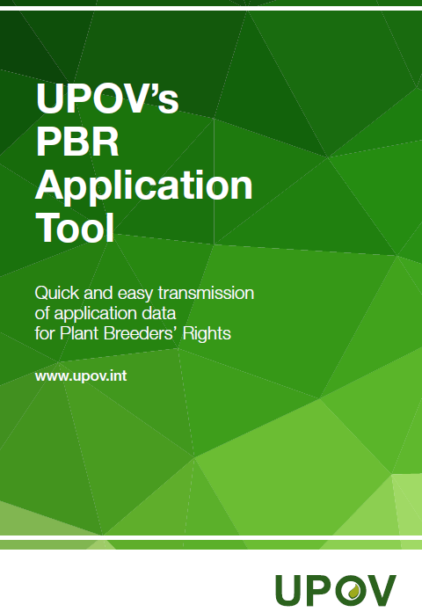

[Annex II follows]

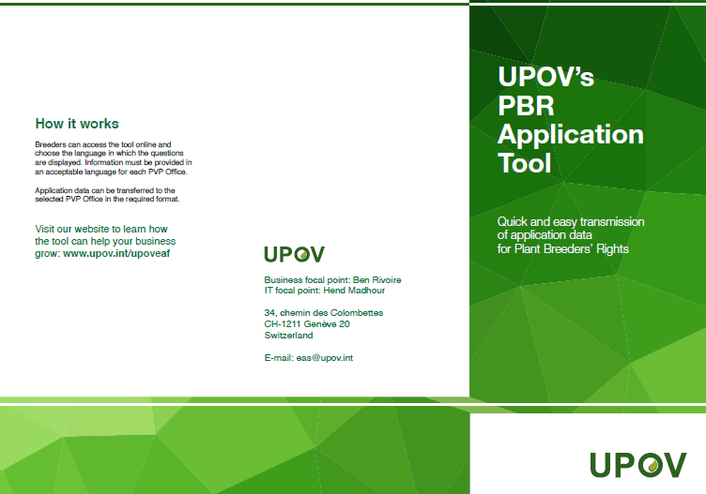

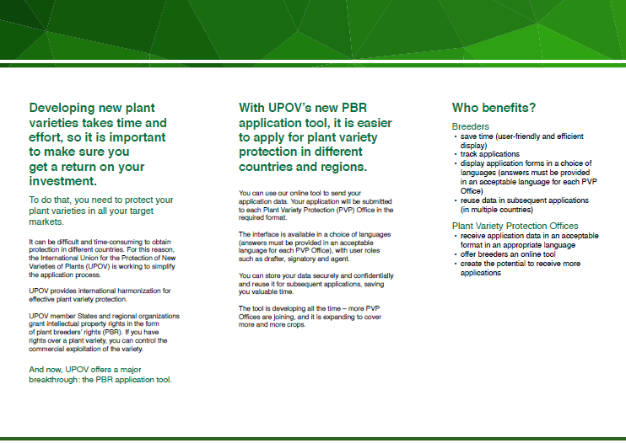
[End of Annex II and of document]

