 | E
International Union for the Protection of New Varieties of Plants

Technical Working Party for Vegetables  Sixtieth Session  Pacific Grove, United States of America, May 18 to 21, 2026 | TWV/60/5  Original: English  Date: April 22, 2026
Assessing distinctness in disease resistance characteristics
Document prepared by an expert from the Netherlands (Kingdom of the)
Disclaimer: this document does not represent UPOV policies or guidance
Document TGP/12 “Guidance on Certain Physiological Characteristics” was developed many years ago based on understanding of disease resistances at that time. The breeding activities have not remained static in recent decades, which has created the need to revise this document.

Disease resistance characteristics can be classified into three types according to UPOV terminology: qualitative (QL), quantitative (QN) and pseudo-qualitative (PQ).

During the last TWV/59 meeting, discussion took place on how to assess distinctness for all types of resistance characteristics.

The purpose of this document is to clarify the assessment of distinctness for each type of resistance characteristics.

Assessment of distinctness for qualitative resistance characteristics (QL)

Since qualitative resistances are mostly based on a single gene, only two states of expression exist, absent and present.

Qualitative resistance characteristics are particularly suitable as grouping characteristics.

As there is a clear gap between susceptible varieties (resistance gene(s) absent) and resistant varieties (resistance gene(s) present) the difference between the two states of expression is clear in every test.

In this case, the assessment of distinctness between varieties with state 1 (absent) and state 9 (present) is therefore very clear. Varieties assessed in different tests, with different notes/states, can always be considered as distinct.

The results of the resistance test are clear and consistent, so in most cases there is no need to include a threshold control variety in a test for this type of disease.

However, in some cases where e.g. resistance shows incomplete penetrance, the environmental factors can influence not only the expression level between varieties but also the variation within a variety. Incomplete penetrance sometimes occurs in resistant plants, where a gene for resistance is phenotypically expressed only in a certain percentage of the population, even if all plants are genetically resistant. In these cases, a threshold control is necessary to calibrate and interpret the range of symptoms expression within a variety (e.g. Fusarium species).

Therefore, we could categorize qualitative resistance characteristics (QL) into two different subtypes:

a) qualitative resistance characteristics (QL) without threshold needed

Examples of qualitative diseases resistances (QL) with two states of expression:

Resistance to Cladosporium cucumerinum (Ccu) in cucumber (TG/61/7 Rev. 3), agreed as useful grouping characteristic

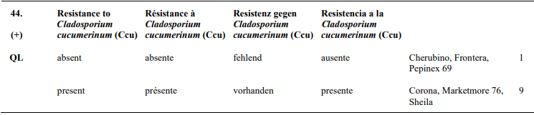

Resistance to Tomato spotted wilt virus (TSWV) in tomato (TG/44/12), agreed as useful grouping characteristic

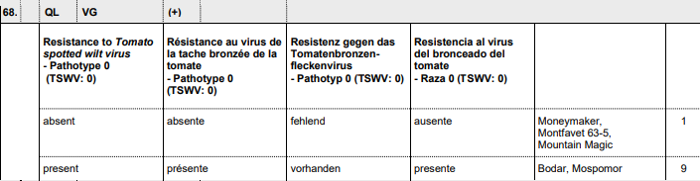

b) qualitative resistance characteristics (QL) with threshold needed

Resistance to Fusarium oxysporum f. sp. lycopersici Race 1EU/2EU in tomato (TG/44/12), agreed as useful grouping characteristic

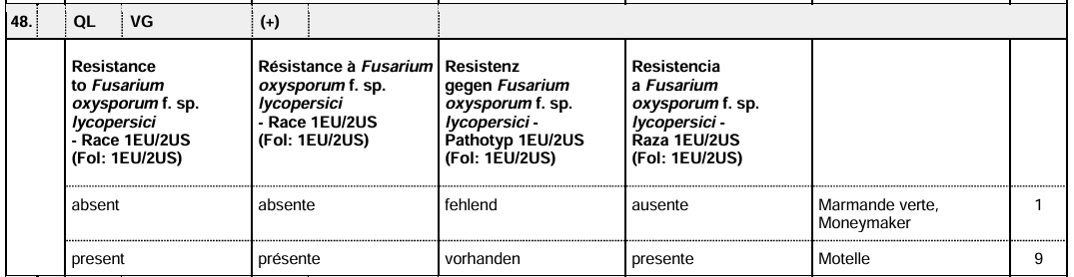

Assessment of distinctness for quantitative resistance characteristics (QN)

Quantitative resistance is mostly based on two or more genes. Therefore, there are more than two states of expression.

Three different subtypes of QN resistance characteristics can be distinguished:

- Diseases regulated by two genes, where three states of expression can be defined

- With a clear gap between at least two of the three states of expression

In this case the distribution is not completely continuous, but there is a gap between susceptible varieties and varieties with a medium or high level of resistance.

A threshold variety is needed in each test to define the lowest level of resistance as the border between the susceptible varieties and varieties with a level of resistance.

It is important to note that for this type of resistance characteristics, the aggressiveness of the test can significantly influence the behavior of the threshold(s). Therefore, the given state of expression is always in relation to the threshold variety.

Because of the gap, distinctness between susceptible and resistant varieties, even assessed in a different test can be based on a one note difference using the same test protocol with the same threshold variety. Additionally, statistical analysis could be used to support the decision.

This type of resistance characteristic is suitable as grouping characteristics between susceptible varieties and varieties with a certain level of resistance.

Example of quantitative disease resistance (QN) with three states of expression of type i.

Resistance to Powdery mildew (Podosphaera xanthii) (Px) in cucumber (TG/61/7 Rev. 3), agreed as useful grouping characteristic:

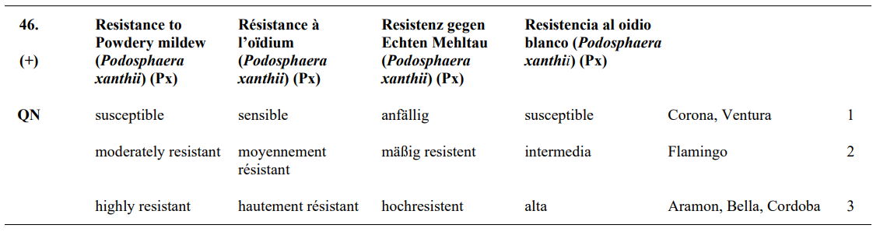

According to current wording in UPOV Test Guidelines the states of expression of this characteristic can be read as: 1/absent or very low; 2/medium; 3/high. This might be adjusted in future revision.

- Without a clear gap between the three states of expression

In this case the distribution is completely continuous, there is no clear gap between the three states of expression.

Threshold varieties are needed in each test to define the border between the different levels of expression.

This type of resistance characteristic is not suitable as grouping characteristic. Varieties can only be considered distinct having been subject to side-by-side comparison and described with different notes in the same trial. Additionally, statistical analysis could be used to support the decision.

Example of quantitative disease resistance (QN) with three states of expression of type ii

Resistance to Cucumber green mottle mosaic virus (CGMMV) in cucumber (pending revision)
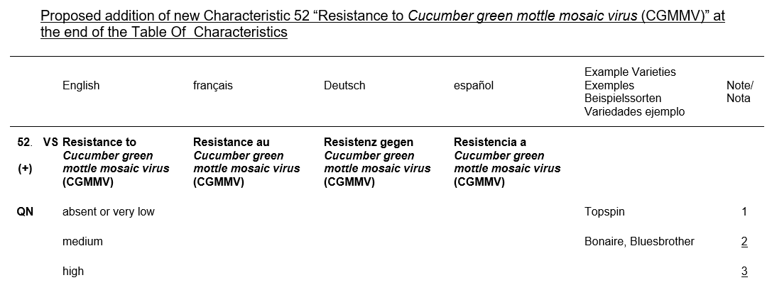

In case of CGMMV, there is currently no example or control variety for state of expression 3 (high), as it does not exist yet.

- Diseases regulated by multiple genes, where nine states of expression can be defined

In this case the distribution is completely continuous, there is no clear gap between the nine states of expression.

Distinctness is based on the same criteria as for morphological QN characteristics, which means that in general varieties with 2 notes difference can be considered as distinct.

This type of resistance characteristic is in general not suitable as grouping characteristic.

Example of quantitative diseases resistances (QN) with nine states of expression:

Resistance to Colletotrichum trifolii in luzerne (TG/6/5):

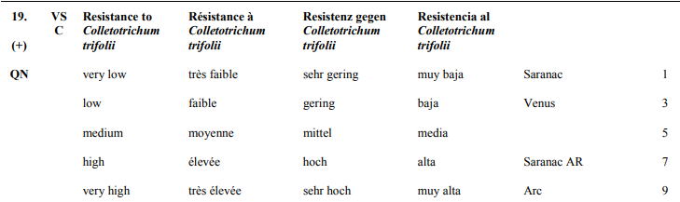

Assessment of distinctness for Pseudo-qualitative resistance characteristics (PQ)

Pseudo-qualitative resistances are based on at least two genes and are discontinuously expressed in more than one dimension. This type of resistance results in different phenotypes/types of symptoms, which can be considered as the two dimensions.

Distinctness is based on the same criteria as for morphological PQ characteristics, which means that in general varieties with 1 note difference can be considered as distinct, even if assessed in a different test.

Example of pseudo-qualitative diseases resistances (PQ) with three states of expression:

Resistance to Bean Common Mosaic Virus (BCMNV) in French bean (TG/12/9 Rev. 2), agreed as useful grouping characteristic:

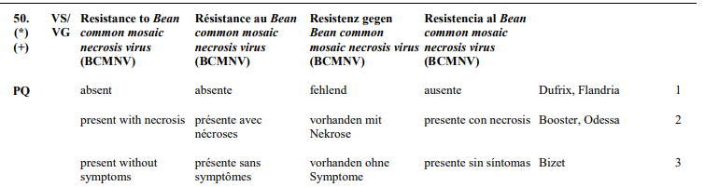

Resistance to BCMNV in beans is controlled by a complex genetic system involving one dominant gene (I) and several recessive genes (bc series).

Overview of all types of resistance characteristics:

Types of resistance characteristics | Subtypes | States of expression | Description | Abbreviation | Suitable for grouping
QL | a | 1/9 | qualitative resistance characteristics (QL) without threshold needed | QL(a) | yes
 | b | 1/9 | qualitative resistance characteristics (QL) with threshold needed | QL(b) | yes
QN | a(i) | 1/2/3/ or 1/2-3 | quantitative resistance characteristics (QN) with gap | QN (a i) | yes
 | a(ii) | 1-2-3 | quantitative resistance characteristics (QN) without gap | QN (a ii) | no
 | b | 1 to 9 | quantitative resistance characteristics (QN) | QN (b) | yes,same as QN morph. char. with difference of at least 2 notes
PQ |  | 1/2/3 | pseudo-qualitative diseases resistances (PQ) | PQ | yes

The Annex to this document contains a presentation on “Assessing distinctness in disease resistance characteristics”.

[Annex follows]



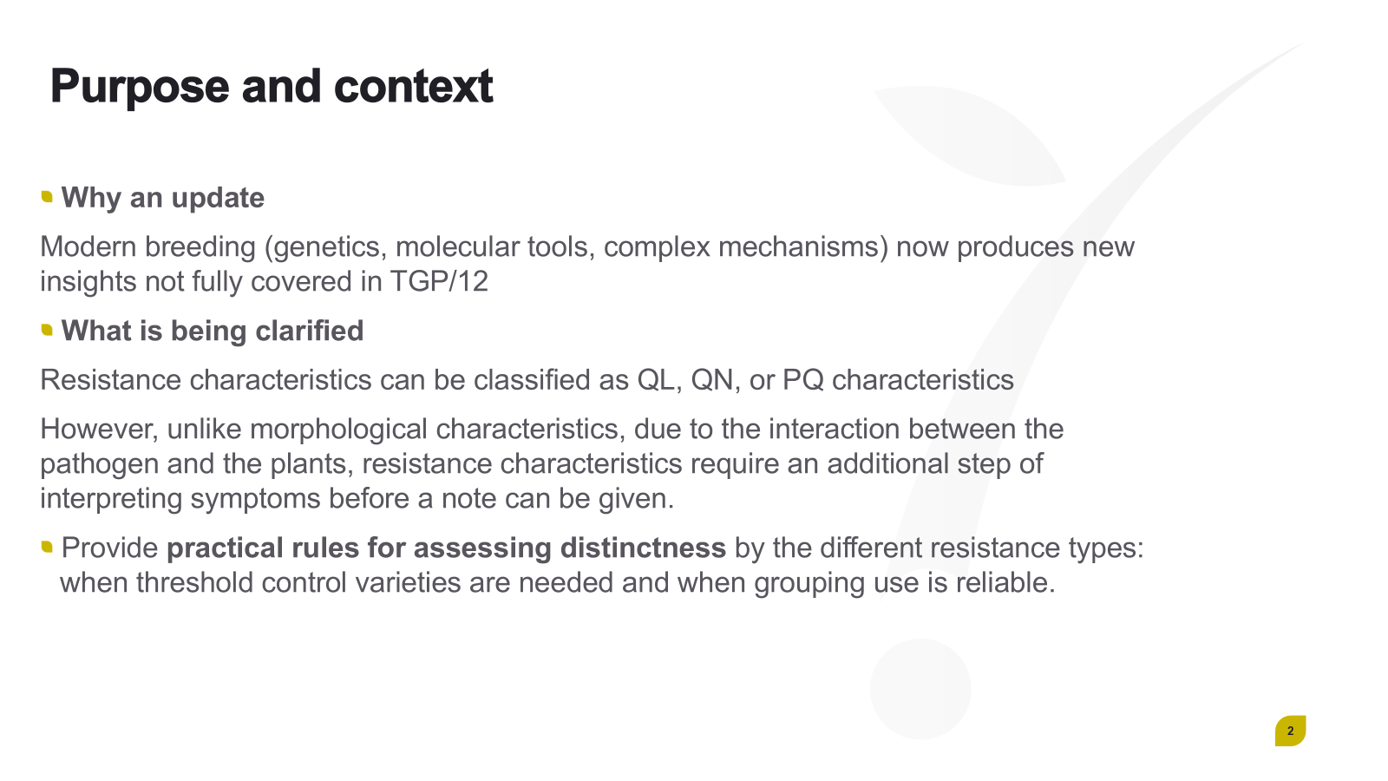

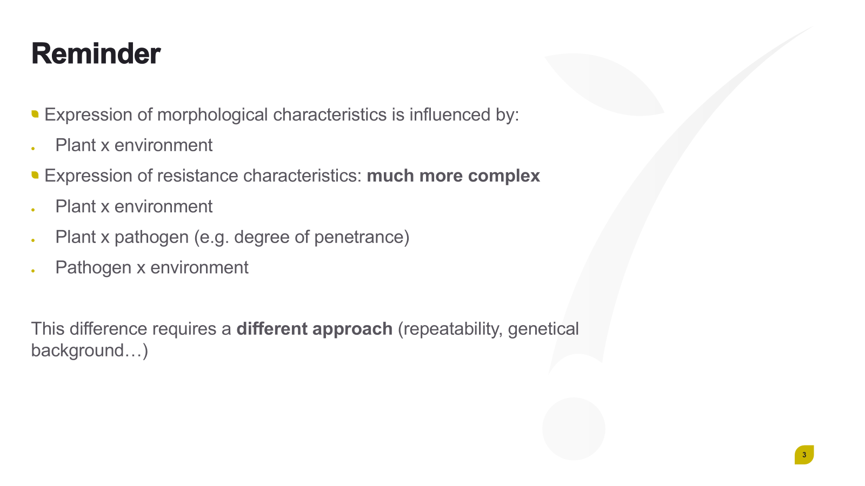

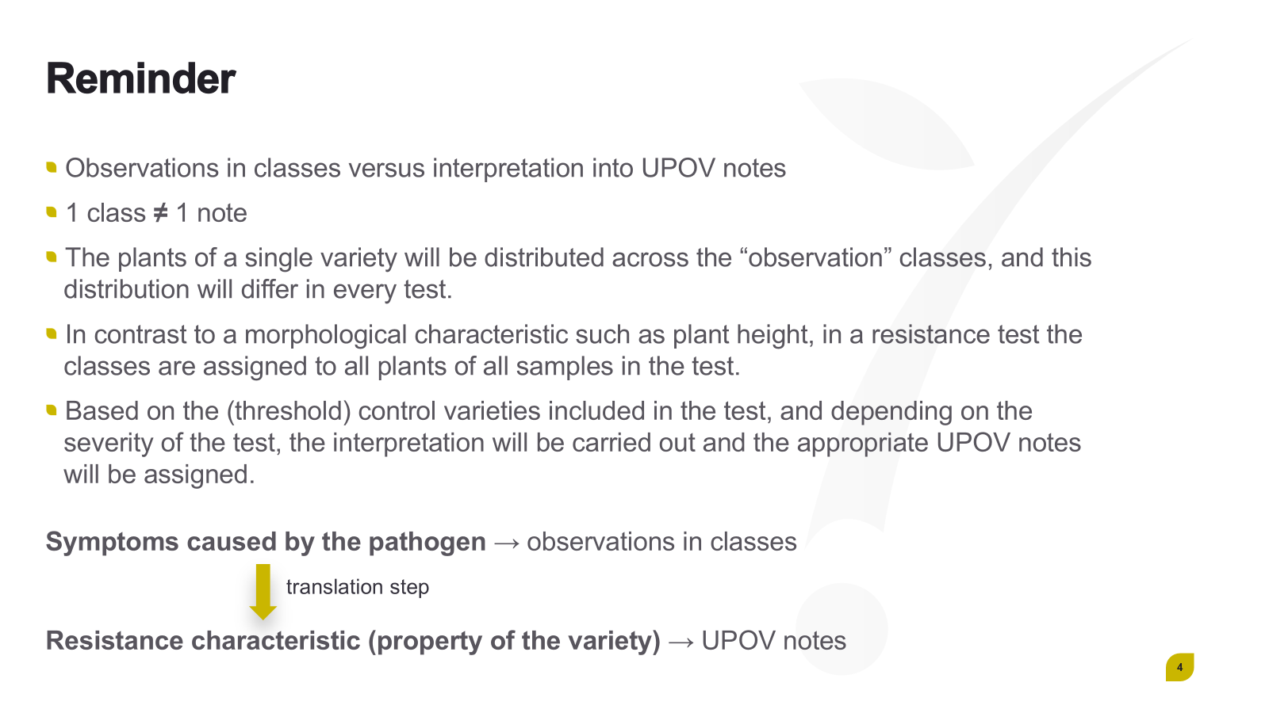

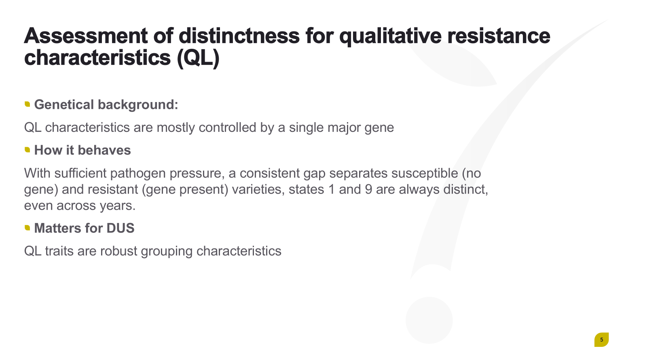

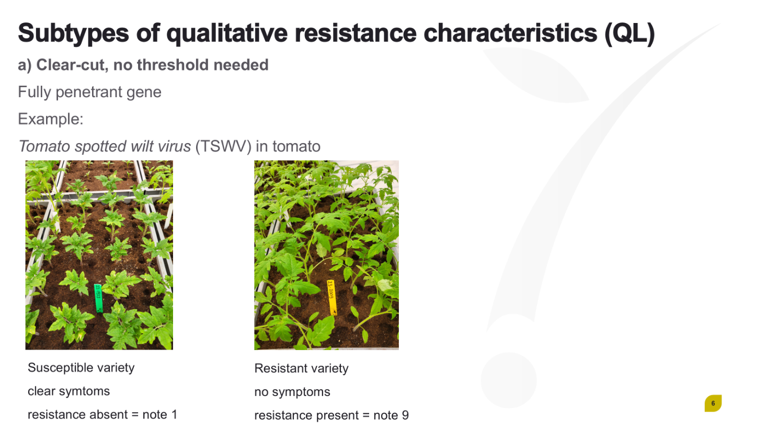

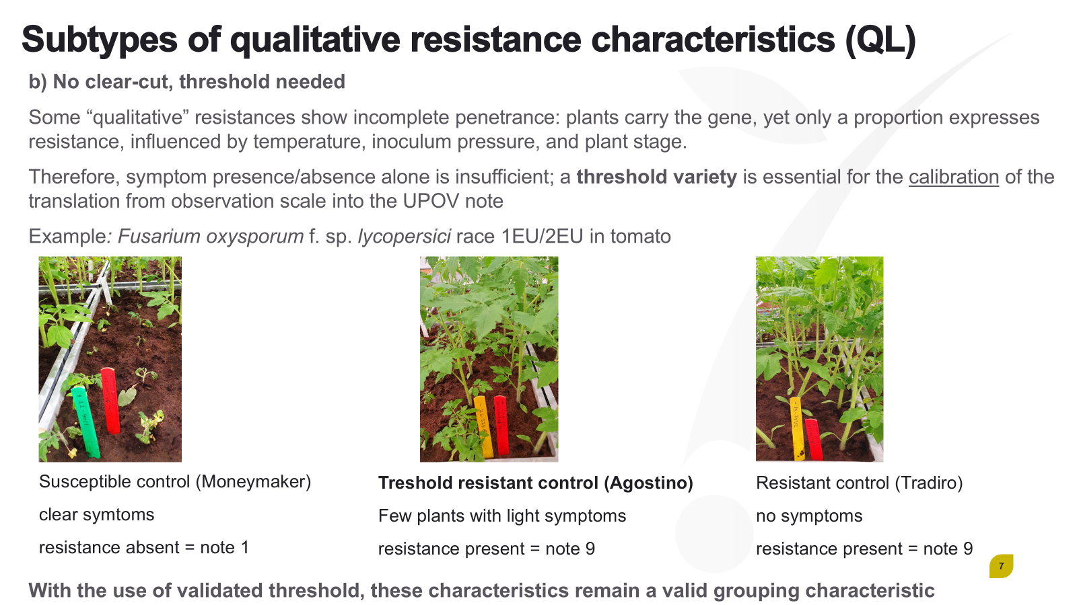

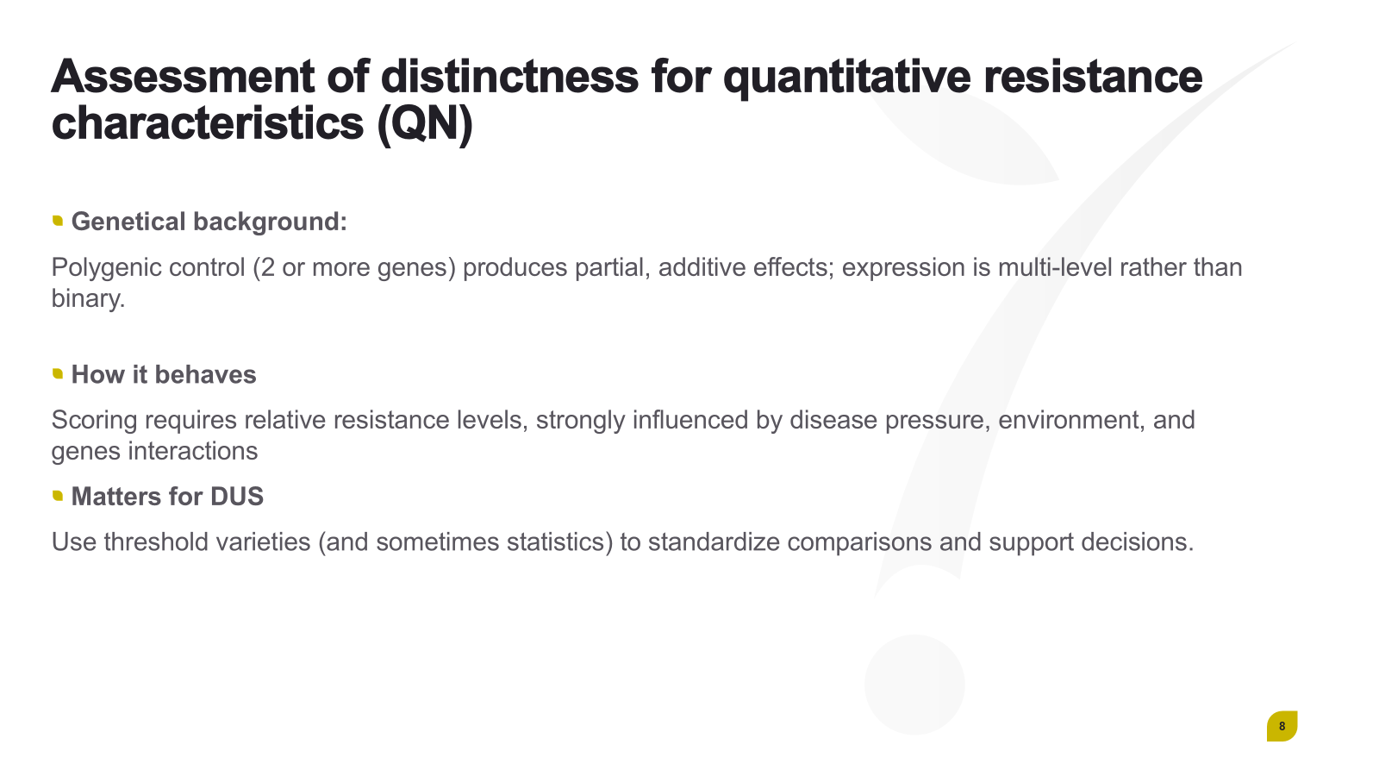

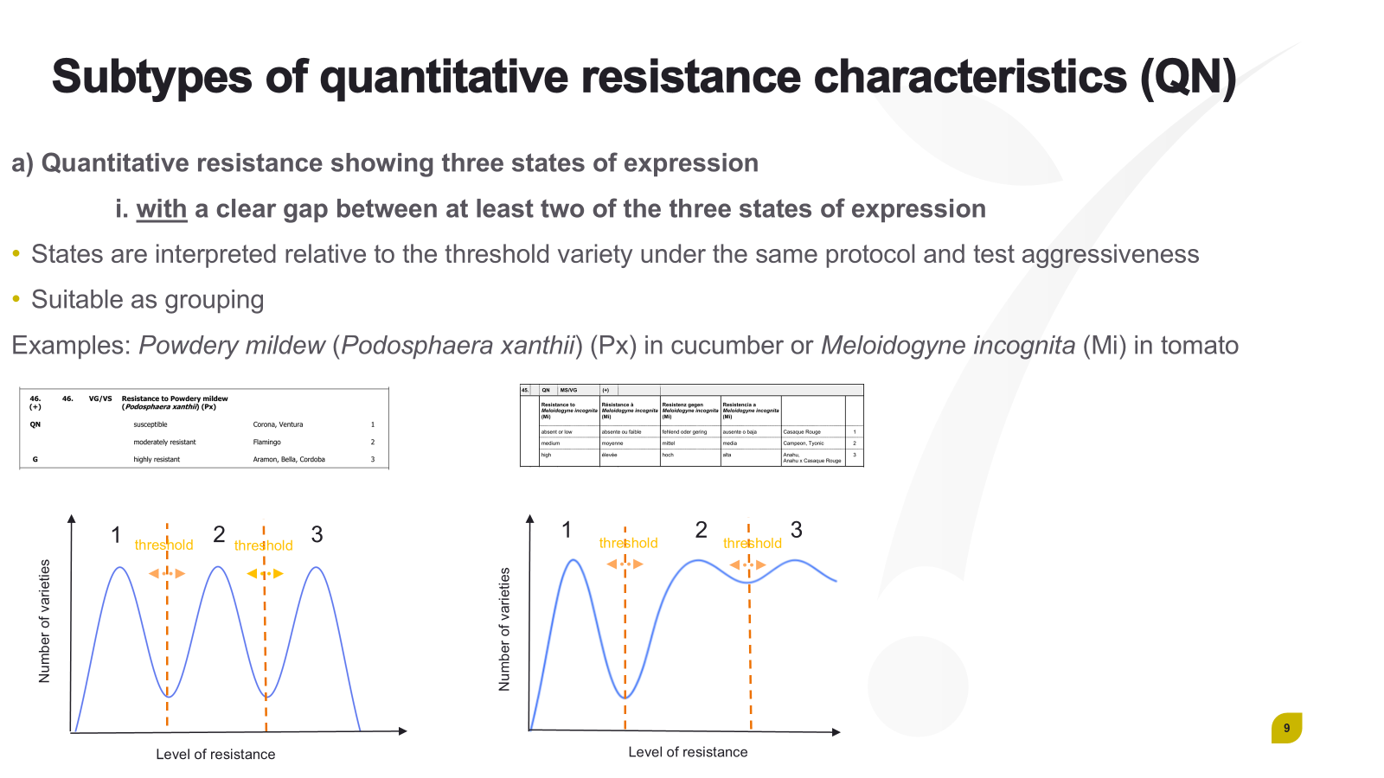

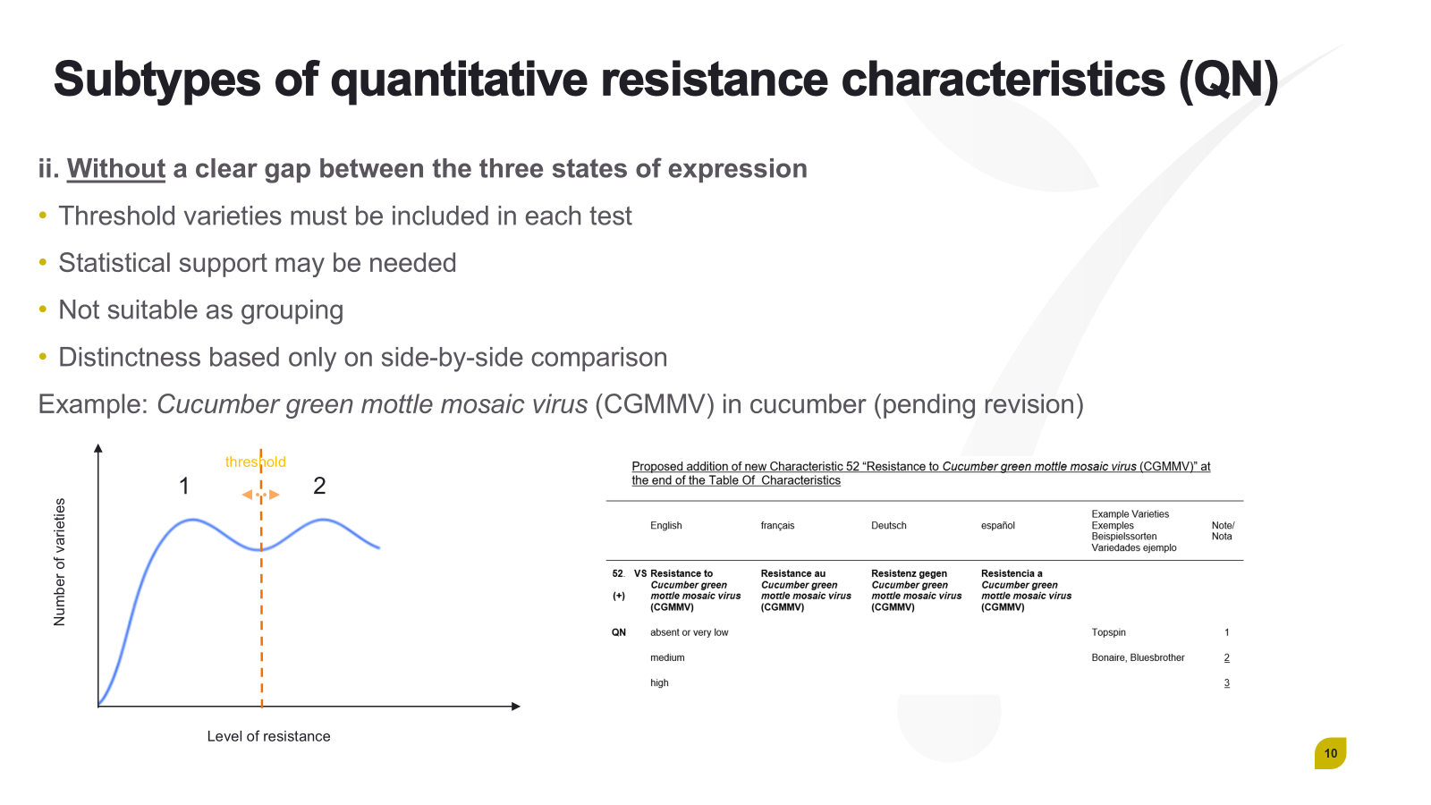

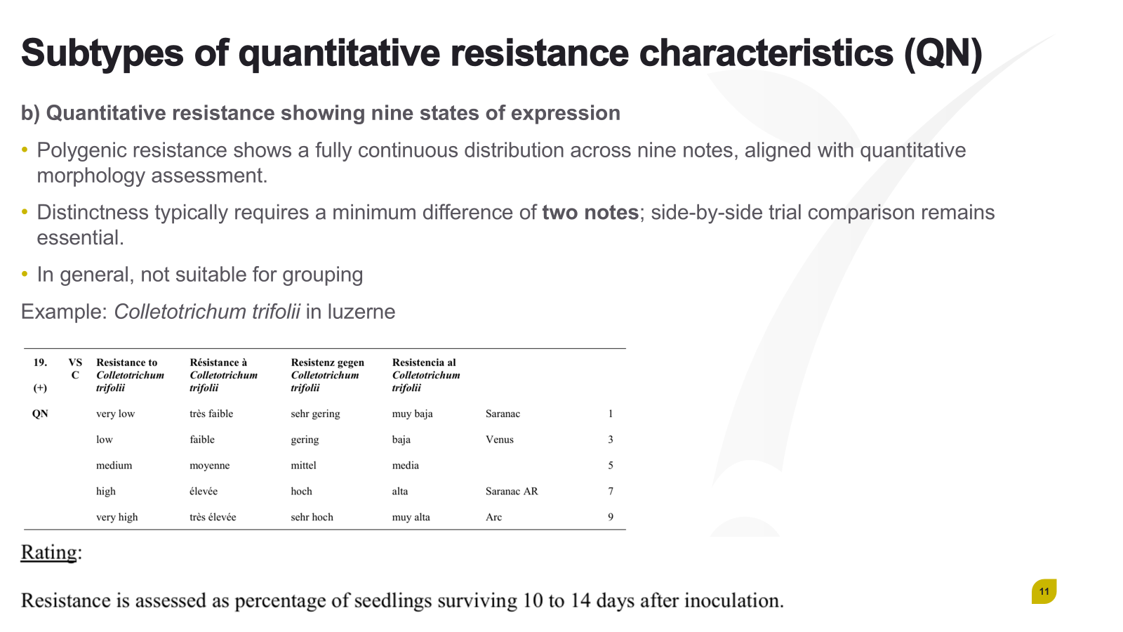

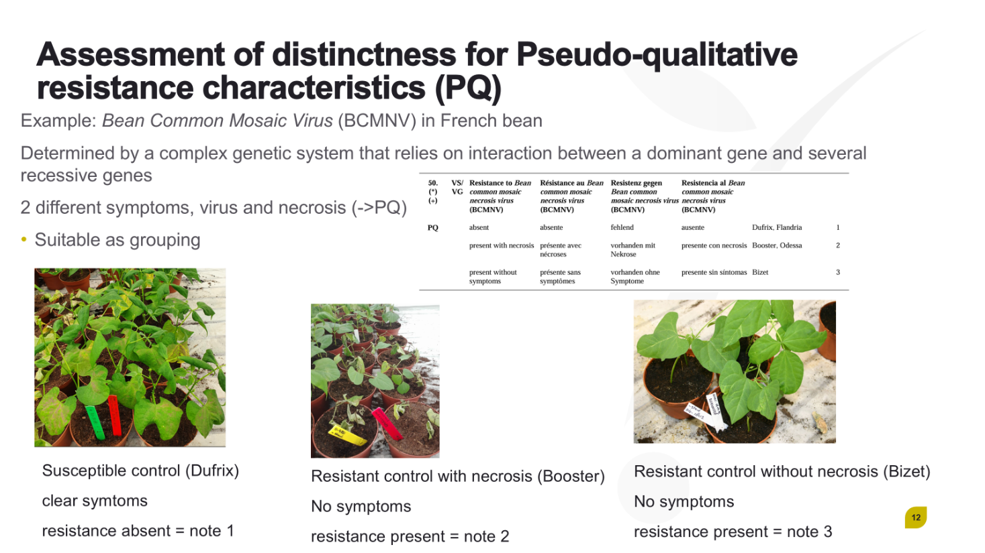

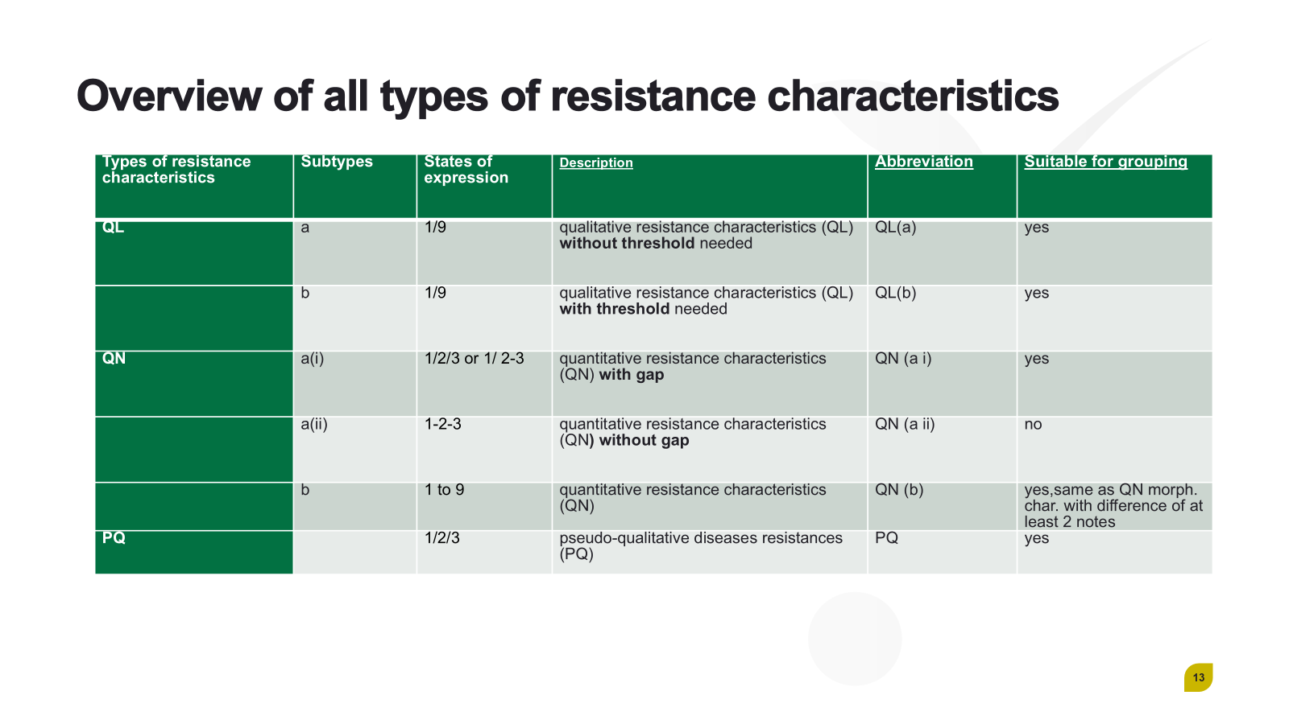



[End of Annex and of document]

