 | E
International Union for the Protection of New Varieties of Plants

Technical Working Party for Vegetables  Sixtieth Session  Pacific Grove, United States of America, May 18 to 21, 2026 | TWV/60/3  Original: English  Date: April 9, 2026
Partial revision of the Test Guidelines for TOMATO ROOTSTOCKS
Document prepared by an expert from the Netherlands (Kingdom of)
Disclaimer: this document does not represent UPOV policies or guidance
The purpose of this document is to present a proposal for a partial revision of the Test Guidelines for Tomato rootstocks (document TG/294/1 Rev. 5).

The Technical Working Party for Vegetables (TWV), at its fifty-ninth session, agreed that the Test Guidelines for Tomato rootstocks (Solanum habrochaites S. Knapp & D.M. Spooner; Solanum lycopersicum L. x Solanum habrochaites S. Knapp & D.M. Spooner; Solanum lycopersicum L. x
Solanum peruvianum (L.) Mill). be partially revised (see document TWV/59/19 “Report”, Annex IV).

The following changes are proposed:

- Characteristic and explanation Ad. 22 “Resistance to Meloidogyne incognita (Mi)” (Nematodes): to change the states of expression (same as in the Test Guidelines for Tomato) and control varieties
The proposed changes are presented below in highlight and underline (insertion) and strikethrough (deletion).

Proposal to change characteristic and explanation Ad. 22 “Resistance to Meloidogyne incognita (Mi)”

Current wording

22.  (*)  (+) | VG | Resistance to Meloidogyne incognita (Mi) | Résistance à Meloidogyne incognita (Mi) | Resistenz gegen Meloidogyne incognita (Mi) | Resistencia a Meloidogyne incognita (Mi)
QN |  | susceptible | sensible | anfällig | susceptible | Bruce | 1
 |  | moderately resistant | moyennement résistant | mäßig resistent | moderadamente resistente |  | 2
 |  | highly resistant | hautement résistant | hoch resistent | muy resistente | Emperador | 3

Ad. 22: Resistance to Meloidogyne incognita (Mi)
1. | Pathogen | Meloidogyne incognita
2. | Quarantine status | -
3. | Host species | Tomato - Solanum lycopersicum
4. | Source of inoculum | GEVES (FR) or INIA – CSIC (ES) or Naktuinbouw (NL)
5. | Isolate | non-resistance breaking
6. | Establishment isolate identity | use tomato standards
7 | Establishment pathogenicity | use susceptible rootstock or tomato standard
8. | Multiplication inoculum
8.1 | Multiplication medium | living plant
8.2 | Multiplication variety | susceptible variety, preferably resistant to powdery mildew
8.3 | Plant stage at inoculation | 2nd leaf stage
8.5 | Inoculation method | deposit of piece of inoculated roots in soil (around 5-10g near each plant, to adapt depending on the population aggressivity)
8.6 | Harvest of inoculum | 6 to 10 weeks after inoculation, root systems are cut with scissors into pieces of about 1 cm length
8.7 | Check of harvested inoculum | visual check for presence of root knots and ripe egg masses
8.8 | Shelf life/viability inoculum | 1 day
9. | Format of the test
9.1 | Number of plants per genotype | 30 plants  Remark: knowing that germination in rootstocks might be low and/or irregular it is recommended to sow more seeds to be sure to get at least 30 plants.  It is recommended to include in the test, 10 non-inoculated plants, to be able to identify a possible lack of germination or a delay in plant growth, due to the material.
9.2 | Number of replicates | at least 2, preferably 3 to allow statistical analysis
9.3 | Control varieties | Susceptible: Bruce and (Solanum lycopersicum) Casaque Rouge  Intermediate resistant: (Solanum lycopersicum)  Campeon, Tyonic  Highly resistant: Emperador
9.4 | Test design | 3 replicates of 10 plants in different trays by variety
9.5 | Test facility | greenhouse or climate room
9.6 | Temperature | 20-26°C, the temperature should be adapted, depending on the aggressiveness of the test, to obtain the expected response of the controls, but should not exceed 26°C. Higher temperatures will cause breakdown of resistance.
9.7 | Light | at least 12 h per day
10 | Inoculation
10.1 | Preparation inoculum | small pieces of diseased roots mixed with soil
10.2 | Quantification inoculum | Quantity of inoculum depends on aggressiveness of test and growing conditions (e.g. between 30g to 60g of inoculated roots for 100 plants in a tray of 45*30 cm containing approximately 5.5 kg of substrate); galls should be homogeneously mixed with soil.
10.3 | Plant stage at inoculation | seed
10.4 | Inoculation method | Seeds are sown in non-inoculated soil and inoculation of soil and inoculation of soil is done after sowing when plantlets are at cotyledon stage.
10.7 | End of test | 28 to 45 days after inoculation depending on test conditions (temperature, season)
11. | Observations
11.1 | Method | root inspection per plant
11.2 | Observation scale
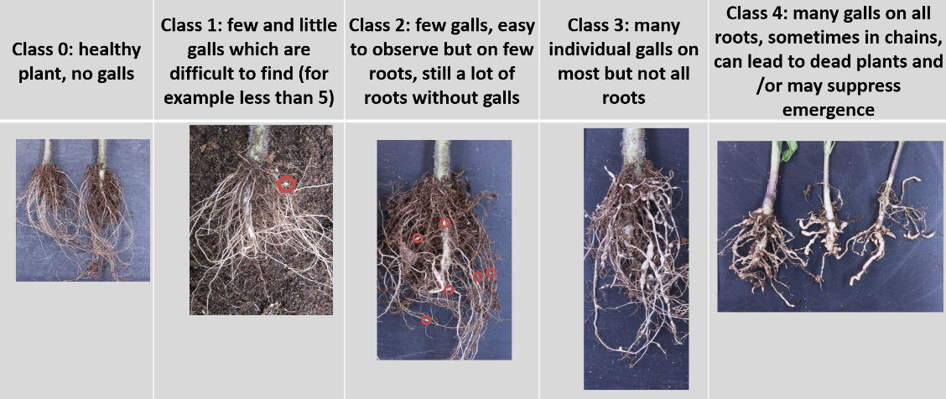

11.3 | Validation of test | Validation on controls. Expected reactions of controls:  Susceptible control: most plants at classes 3 and 4.  Highly resistant: most plants at classes 0 and 1.  Intermediate resistant: clearly different from other controls with majority of plants around class 2.
12. | Interpretation of data in terms of UPOV characteristic states | [1] Susceptible: variety very similar to susceptible control  [2] Intermediate resistant: variety very similar to intermediate resistant control  [3] Highly resistant: variety very similar to highly resistant control  If results are not clear, statistical analysis is advised.  If significantly different from the controls, a retest is advised to check if the result is stable.
13. | Critical control points | Avoid overwatering. This may result in rotting of roots.  In case of aggressive test, decrease the quantity of inoculum.

Proposed new wording

22.  (*)  (+) | VG | Resistance to Meloidogyne incognita (Mi) | Résistance à Meloidogyne incognita (Mi) | Resistenz gegen Meloidogyne incognita (Mi) | Resistencia a Meloidogyne incognita (Mi)
QN |  | susceptible  absent or low | sensible  absente ou faible | anfällig  fehlend oder gering | susceptible  ausente o baja | Bruce | 1
 |  | moderately resistant  medium | moyennement resistant  moyenne | mäßig resistent  mittel | moderadamente resistente  media | Emperador | 2
 |  | highly resistant  high | hautement resistant  élevée | hoch resistent  hoch | muy resistente  alta | Emperador Araucaria | 3

Ad. 22: Resistance to Meloidogyne incognita (Mi)
1. | Pathogen | Meloidogyne incognita
2. | Quarantine status | -
3. | Host species | Tomato - Solanum lycopersicum
4. | Source of inoculum | GEVES (FR) or INIA – CSIC (ES) or Naktuinbouw (NL)
5. | Isolate | non-resistance breaking
6. | Establishment isolate identity | use tomato standards
7 | Establishment pathogenicity | use susceptible rootstock or tomato standard
8. | Multiplication inoculum
8.1 | Multiplication medium | living plant
8.2 | Multiplication variety | susceptible variety, preferably resistant to powdery mildew
8.3 | Plant stage at inoculation | 2nd leaf stage
8.5 | Inoculation method | deposit of piece of inoculated roots in soil (around 5-10g near each plant, to adapt depending on the population aggressivity)
8.6 | Harvest of inoculum | 6 to 10 weeks after inoculation, root systems are cut with scissors into pieces of about 1 cm length
8.7 | Check of harvested inoculum | visual check for presence of root knots and ripe egg masses
8.8 | Shelf life/viability inoculum | 1 day
9. | Format of the test
9.1 | Number of plants per genotype | 30 plants  Remark: knowing that germination in rootstocks might be low and/or irregular it is recommended to sow more seeds to be sure to get at least 30 plants.  It is recommended to include in the test, 10 non-inoculated plants, to be able to identify a possible lack of germination or a delay in plant growth, due to the material.
9.2 | Number of replicates | at least 2, preferably 3 to allow statistical analysis
9.3 | Control varieties | ISF definitions:
 | Susceptible | Bruce and (Solanum lycopersicum) Casaque Rouge
 | Intermediate resistant | Optifort and (Solanum lycopersicum) Campeon, Tyonic
 | Highly resistant | Emperador Araucaria and (Solanum lycopersicum) Arletta, Anahu, Anahu x Casaque Rouge
9.4 | Test design | 3 replicates of 10 plants in different trays by variety
9.5 | Test facility | greenhouse or climate room
9.6 | Temperature | 20-26°C, the temperature should be adapted, depending on the aggressiveness of the test, to obtain the expected response of the controls, but should not exceed 26°C. Higher temperatures will cause breakdown of resistance.
9.7 | Light | at least 12 h per day
10. | Inoculation
10.1 | Preparation inoculum | small pieces of diseased roots mixed with soil
10.2 | Quantification inoculum | Quantity of inoculum depends on aggressiveness of test and growing conditions (e.g. between 30g to 60g of inoculated roots for 100 plants in a tray of 45*30 cm containing approximately 5.5 kg of substrate); galls should be homogeneously mixed with soil.
10.3 | Plant stage at inoculation | seed
10.4 | Inoculation method | Seeds are sown in non-inoculated soil and inoculation of soil and inoculation of soil is done after sowing when plantlets are at cotyledon stage.
10.7 | End of test | 28 to 45 days after inoculation depending on test conditions (temperature, season)
11. | Observations
11.1 | Method | root inspection per plant
11.2 | Observation scale
11.3 | Validation of test | Validation on controls. Expected reactions of controls:  Susceptible control: most plants at classes 3 and 4.  Highly resistant: most plants at classes 0 and 1.  Intermediate resistant: clearly different from other controls with majority of plants around class 2.
12. | Interpretation of data in terms of UPOV characteristic states | [1] Susceptible absent or low: variety very similar to susceptible control.  [2] Intermediate resistant medium: variety very similar to intermediate resistant control.  [3] Highly resistant high: variety very similar to highly resistant control.  If results are not clear, statistical analysis is advised.  If significantly different from the controls, a retest is advised to check if the result is stable.
13. | Critical control points | Avoid overwatering. This may result in rotting of roots.  In case of aggressive test, decrease the quantity of inoculum.

[End of document]

held via electronic means, from May 5 to 8, 2025.
GEVES; matref@geves.fr
INIA; resistencias@inia.es
Naktuinbouw; resistentie@naktuinbouw.nl
GEVES; matref@geves.fr
INIA; resistencias@inia.es
Naktuinbouw; resistentie@naktuinbouw.nl
ISF, https://www.worldseed.org

