 | E
International Union for the Protection of New Varieties of Plants

Technical Working Party for Vegetables  Sixtieth Session  Pacific Grove, United States of America, May 18 to 21, 2026  Technical Working Party on Testing Methods and Techniques  Fourth Session  Cambridge, United Kingdom, June 2 to 5, 2026  Technical Working Party for Agricultural Crops  Fifty-Fifth Session  Seoul, Republic of Korea, June 15 to 18, 2026  Technical Working Party for Ornamental Plants and Forest Trees  Fifty-Eighth Session  Virtual meeting, July 6 to 9, 2026  Technical Working Party for Fruit Crops  Fifty-Seventh Session  Leipzig, Germany, September 7 to 10, 2026 | TWP/10/3  Original: English  Date: April 22, 2026
Measures to improve support provided for DUS examination
Document prepared by the Office of the Union
Disclaimer: this document does not represent UPOV policies or guidance

Executive SUMMARY

The purpose of this document is to report on measures to improve support provided for DUS examination at sessions of the UPOV Technical Working Parties and through UPOV tools and the Test Guidelines for variety examination.

Presentations about characteristics and challenges drafting national test guidelines

From 2026, the Technical Working Parties (TWPs) will provide an opportunity to discuss matters relevant to drafting national test guidelines, such as characteristics, approaches or challenges for DUS examination. These discussions would not be linked to developing UPOV Test Guidelines while benefiting from the expertise of UPOV members at the TWPs. UPOV members are invited to use this opportunity to present the challenges they face when developing national test guidelines and seek solutions with the TWPs.

Proposals to improve UPOV Test Guidelines

The Technical Committee (TC) Subgroup on Test Guidelines developed a number of proposals for improving the Test Guidelines, which will be considered by the TWPs regarding clarification of their scope, priorities and resources for implementation

Criteria to access the online tool for drafting Test Guidelines (TG Template)

The access of interested experts to the TG Template is currently not regulated and all participants at TWPs can provide comments on draft Test Guidelines. The TWPs will be invited to consider whether to develop criteria for granting access to the TG Template to ensure coordination within each UPOV member and observer when providing comments on draft Test Guidelines.

Drafting partial revisions of Test Guidelines using the TG Template

UPOV has developed the web-based Test Guidelines Template (TG Template) to implement the guidance for drafting Test Guidelines provided in document TGP/7 “Development of Test Guidelines. Recent developments in the TG Template enabled expanding its use to draft partial revisions of Test Guidelines, with a new functionality to compare documents and show changes. The TWPs will be invited to consider the use of the TG Template for drafting partial revisions of Test Guidelines, while noting that the partial revision of Test Guidelines developed before 2008 would require additional steps to align with the current UPOV standards.

The structure of this document is as follows:
Executive SUMMARY 1
Support for drafting national test guidelines 2
Procedure for discussing matters relevant for drafting national test guidelines at Technical Working Parties 3
Presentations from UPOV members 3
Possible Measures on Test Guidelines (TG) and online tool for drafting Test Guidelines 3
Subgroup on Test Guidelines 3
Developments in 2025 3
Proposals 4
The Web-based Test Guidelines Template (TG Template) 4
Access for Interested Experts 4
Drafting of partial revisions using the web-based TG Template 5
Matters for information 5
TG Template developments 5
Recording outcome of discussions on draft Test Guidelines using the TG Template (live editing) 5
Release of a new version 6
Test Guidelines translation 6
Developments in 2026 6
Measures to enhance cooperation in examination 6
“Environmental effect in expression of characteristics” and “Completeness and relevance of variety collections” 6
“Phytosanitary matters that prevent or delay submission of plant material” 7
“Increase information on arrangements for testing at breeders’ premises” 7

Annex I Background to “support for drafting national test guidelines”
Annex II TC Subgroup on Test Guidelines: 2025 consultation of Technical Working Parties
Annex III TC Subgroup on Test Guidelines: Summary of discussions at TWO, TWV, TWA and TWF in 2025

The following abbreviations are used in this document:

TC: Technical Committee
TC-EDC: Enlarged Editorial Committee
TWA: Technical Working Party for Agricultural Crops
TWF: Technical Working Party for Fruit Crops
TWM: Technical Working Party on Testing Methods and Techniques
TWO: Technical Working Party for Ornamental Plants and Forest Trees
TWPs: Technical Working Parties
TWV: Technical Working Party for Vegetables

Support for drafting national test guidelines

This section reports on the inclusion in the TWP agendas of an opportunity for UPOV members’ presentations about characteristics, approaches or challenges for DUS examination that are faced when drafting national test guidelines.

Procedure for discussing matters relevant for drafting national test guidelines at Technical Working Parties

The TC, at its sixty-first session, agreed to invite the TWPs, at their sessions in 2026, to organize the agenda for discussions on Test Guidelines providing an opportunity for UPOV members to present characteristics, approaches or challenges for DUS examination relevant for drafting national test guidelines on the following basis:

- Discussions on matters relevant for national test guidelines would support UPOV members efforts to promote the development of new plant varieties of a wider range of crops.

- Discussions on matters relevant for national test guidelines would have a specific space in the TWPs agenda different from discussions on international harmonization through developing of UPOV Test Guidelines.

- UPOV members would provide the expertise to support discussions on matters relevant for the development of national test guidelines in accordance with UPOV guidance.

- Discussions on matters relevant for national test guidelines would be reported to the TC for guidance and adjusting procedures, subject to the resources of the UPOV Office.

- The use of the TG template for the development of national test guidelines would be provided to UPOV members, subject to the availability of additional resources for the development of the required functionalities.

Presentations from UPOV members

The TWA, TWF, TWO and TWV, at their sessions in 2026 will consider the agenda item “Support for drafting national test guidelines”. UPOV members are invited to make presentations on characteristics, approaches or challenges for DUS examination relevant for drafting national test guidelines for discussion during the sessions.

UPOV members are invited to present characteristics, approaches or challenges for DUS examination relevant for drafting national test guidelines, as set out in paragraph 10 of this document.

Possible Measures on Test Guidelines (TG) and online tool for drafting Test Guidelines

Subgroup on Test Guidelines

In 2023, the Technical Committee agreed a series of measures to improve support provided for DUS examination, including the online tool for drafting Test Guidelines (web-based TG template) and the structure of the Test Guidelines. The TC agreed to establish a Subgroup on Test Guidelines, with terms of reference provided in document TC/59/28 “Report”, paragraph 61. This section reports on the recommendations from the Subgroup on Test Guidelines.

Developments in 2025

In October 2025, the TC¹ noted the report from the leading expert of the TC Subgroup on Test Guidelines, Ms. Margaret Wallace (United Kingdom), on discussions held at the TWO, TWV, TWA and TWF on improving the Test Guidelines structure, the web-based TG template and the creation of national test guidelines. The discussion topics and outcome of discussions at each TWP are provided in Annexes II and III to this document.

The TC agreed that the proposals from the Subgroup for improving the Test Guidelines should be presented to the TWPs, at their sessions in 2026, to clarify their scope and priorities for better understanding the resources required for their implementation.

Proposals

The TWPs are invited to consider the options for improving the Test Guidelines and the web-based TG template put forward by the Subgroup on Test Guidelines. The TWPs are invited to clarify the scope, establish priorities and consider alternatives to resource the implementation of the following proposals:

- It is recommended that consideration is given to the need to review the standard wording of the Test Guidelines.

- It is recommended that the format of the Test Guidelines should be revised to take advantage of the opportunities for interactive viewing when accessed electronically:
  - Active links to UPOV Guidance
  - Pop-ups and hints
  - Zoom
  - Video explanations

- It is recommended that consideration be given to the layout of the Test Guidelines to bring the additional information and diagrams closer to (or within) the table of contents.

- It is recommended that additional information provided in a Test Guidelines (for example details of a molecular technique or a laboratory test) should have a harmonized template across all guidelines.

- It is recommended that the format and layout of the Test Guidelines is such that it can be translated using automated electronic methods.

- It is recommended that the removal of the four UPOV languages from the table of characteristics be considered.

- It is recommended that consideration be given to the process of revising Test Guidelines, in particular to partial updates that affect only one part of the document, for example the technical questionnaire or single characteristics.

- It is recommended that consideration be given to producing the technical questionnaires in a document separate to the Test Guidelines. It is important that the technical questionnaire be reviewed along with a revision of the Test Guidelines. However, it is not considered necessary for the Test Guidelines to be reviewed along with a revision of the Technical Questionnaire.

The TWPs are invited to consider the options for improving the Test Guidelines and the TG template, as set out in paragraph 15 of this document.

The Web-based Test Guidelines Template (TG Template)

Access for Interested Experts

The procedure to grant access to the TG Template for interested experts has been revised in response to the increasing number of participants at TWP sessions and ensure access to crop experts. A new automated procedure let users choose their TWPs when logging in; once validated by the UPOV Office, experts gain access to all draft Test Guidelines discussed at the TWP of their choice. The new procedure was informed to all Leading and Interested Experts, as well as to the designated persons at the TWPs for each UPOV member and observer.

The UPOV Office received requests from interested experts to support the efforts for coordination within the delegations of UPOV members and observers when providing comments to draft Test Guidelines. The access of interested experts to the TG Template is currently not regulated. All participants registered at any given TWP session are granted access to the TG Template upon request to the UPOV Office, which enables receiving automatic reminders and providing comments on draft Test Guidelines.

Next steps

The TWPs are invited to consider whether to develop criteria for granting access to interested experts to the TG Template and ensure coordination when providing comments on Test Guidelines.

The TWPs are invited to consider whether to develop criteria for granting access to Interested Experts to the TG template, as set out in paragraph 19 of this document.

Drafting of partial revisions using the web-based TG Template

The TG Template was enhanced in 2025 with the introduction of a new functionality to compare documents and show changes between versions of draft Test Guidelines. Currently, partial revisions of Test Guidelines are prepared and discussed outside of the TG Template. This procedure prevents the TG Template becoming a centralized platform for preparing and discussing draft Test Guidelines. Additional steps are required from the leading expert to prepare a standalone document for the partial revision, as well as the UPOV Office to manually transpose information into the database.

Since the launch in 2025 of the new functionality to compare documents and show changes, it is now possible to use the web-based TG Template to prepare partial revisions of Test Guidelines. The use of the TG Template to prepare partial revisions can be immediately implemented with no additional steps for Test Guidelines developed using the template established in document TGP/7 “Development of Test Guidelines”. For Test Guidelines developed before the template established in document TGP/7, the use of the TG Template would require their full revision to update the TG structure and include the standard wording used in Test Guidelines since 2008.

The TWPs are invited to consider the use of the TG Template for partial revisions, as set out in paragraph 22 of this document.

Matters for information

TG Template developments

Recording outcome of discussions on draft Test Guidelines using the TG Template (live editing)

In 2025, the TG Template was used during the Technical Working Party for Fruit Crops (TWF) to record the outcomes of discussions on draft Test Guidelines. Instead of writing lists of changes to be implemented to the individual characteristics and other sections of the Test Guidelines, the agreed changes were implemented during the session. This procedure enabled participants to immediately see the result of discussions and how it would be featured in the Test Guidelines. The following paragraphs are an extract of the relevant section of the TWF report (see document TWF/56/7 “Report”, paragraphs 47 and 48):

“47. The TWF noted that the drafting tool was used during the discussions of Test Guidelines to record the changes agreed directly into the drafting tool. The TWF noted that the new procedure replaced the creation of lists of changes to be implemented in future, implementing them directly in the drafting tool during the meeting. The TWF noted that the drafters of Test Guidelines would use the document generated during the session as the starting point for further work.

“48. The TWF noted that the drafts generated directly into the drafting tool as a result of discussions during the session were made available on the TWF/56 webpage and presented all changes in “revision mode” (available at the TWF/56 webpage: https://www.upov.int/meetings/en/details.jsp?meeting_id=85860)”

In 2026, all TWPs will have the opportunity to record the changes agreed during discussions on Test Guidelines directly into the drafting tool (TG Template). Drafters of Test Guidelines will be able to use the draft edited during the TWP session as the starting point for further work. This process simplifies the work during TWPs and facilitates creating Test Guidelines for the TWPs and TC.

The new procedure addresses a request from interested experts to identify the changes in relation to previous versions of the Test Guidelines, which are indicated in revisions mode in a new draft published on the webpage of the meeting. Word versions showing all changes agreed during discussions of the draft Test Guidelines will be made available on the webpages of the relevant TWPs, such as can be seen on the webpage of the fifty-sixth session of the TWF (see section “Test Guidelines” available at: https://www.upov.int/meetings/en/details.jsp?meeting_id=85860).

Release of a new version

A new version of the web-based TG Template (new link: https://tg-template.upov.int/upovtg) was released in June 2025, introducing the following new features for improved user experience:

- New solution to generate draft Test Guidelines in word processor format with visualization of changes in real time
- New solution to upload images, illustrations and diagrams, including format and size adjustments
- Introduction of “WIPO account” for user authentication (same as used for other UPOV systems and databases)
- Migration to cloud servers, including updated software code.

Test Guidelines translation

The new features of the TG template were expanded to support French, German, and Spanish translations with improved formatting. A machine translation API (application programming interface) has been added to the TG Template, enabling faster draft Test Guidelines translations. These enhancements will make draft and adopted Test Guidelines available on the UPOV website more expeditiously.

Developments in 2026

The following features are currently being implemented in the TG Template:

- Refactoring of the application for compatibility with the currently supported technology for cloud maintenance and security;
- Updated workflow to reflect the new procedure of live editing to record the outcomes of discussions on draft Test Guidelines;
- A functionality to allow comparing drafts to show changes;
- Export of an XLS file with the list of example varieties showing how often an example variety is used and for which characteristics
- New structure to provide information in the Technical Questionnaire, Section 7.3 “Other information” replacing the free text box.

Measures to enhance cooperation in examination

“Environmental effect in expression of characteristics” and “Completeness and relevance of variety collections”

In October 2025, the TC agreed to organize webinars to present practical experiences relating to the environmental effect in expression of characteristics and the constitution and relevance of variety collections.

The TC agreed that it was important to share information about the practices and experiences from different UPOV members, including how they organized bilateral cooperation and conditions to exchange test reports. The TC noted the expressions of interest to make presentations from Australia, China, Germany, Japan, Netherlands (Kingdom of the) and the United Kingdom. The TC agreed that other UPOV members willing to make presentations should contact the Office of the Union.

The TC agreed that discussions should take into consideration prior discussions on these topics, such as the study on the expression of characteristics at different environments for Petunia varieties and others, as appropriate (see: https://www.upov.int/edocs/mdocs/upov/en/two/37/two_37_08.pdf)

The TC agreed that the webinars to be held on April 21 to 23, 2026 should be recorded and made available on the UPOV website.

The TC agreed that the “open discussion session” to be held at the sixty-second session of the TC (2026) could be used to continue discussions on these topics.

“Phytosanitary matters that prevent or delay submission of plant material”

In October 2025, the TC agreed to organize a webinar on practical experiences with delays in DUS testing due to phytosanitary requirements and considerations on using test reports from another UPOV member to reduce delay in granting breeders’ rights. The TC noted the expressions of interest to make presentations from Australia, Japan, Netherlands (Kingdom of the), New Zealand and the United Kingdom.

The TC agreed that the webinar should clarify situations where the difficulties to provide plant material could lead to a delay in granting the breeder’s right and how bilateral cooperation could support overcoming the situation.

The TC recalled the 2023 survey on policy or legal barriers to international cooperation, where UPOV members provided information on their procedures in case of phytosanitary restriction to the submission of plant material (see Annex II, page 22, available at: https://www.upov.int/edocs/mdocs/upov/en/caj_80/sessions_2023_4.pdf )

The TC agreed that the webinar should focus on approaches used to deal with delays without considering phytosanitary measures outside the scope of UPOV.

“Increase information on arrangements for testing at breeders’ premises”

In 2025, three webinars and one Seminar were held to discuss how UPOV members organize DUS examination in cooperation with breeders. The video recordings of the three webinars are available on the UPOV website, along with the written summary of the presentations made by:
- Australia;
- Canada;
- Chile;
- Kenya;
- Japan; and
- New Zealand

The “Seminar on cooperation with breeders in DUS examination” was held as a hybrid meeting in Geneva, on October 22, 2025. The video recording of the Seminar is available on the UPOV website.

[Annex I follows]

BACKGROUND TO “SUPPORT FOR DRAFTING NATIONAL TEST GUIDELINES”

The TWF, at its fifty-sixth session, discussed possible measures to support UPOV members drafting national test guidelines. The TWF agreed there were species or crops which, for the time being, were only of interest at a national or local level while noting that certain aspects of those test guidelines could be of interest to the wider community of TWF experts.

The TWF agreed to include an agenda item for its fifty-seventh session inviting UPOV members to present characteristics, approaches or challenges for DUS examination relevant for drafting national test guidelines.

UPOV guidance and priorities to develop internationally harmonized Test Guidelines

UPOV currently has 341 adopted Test Guidelines covering over 95% of PBR-related varieties in the UPOV Plant Variety Database. The remaining 5% of protected varieties in the database fall under more than 4.000 genera and species where international harmonization might not yet apply due to insufficient experience among members in accordance with the criteria set out in document TGP/7 “Development of Test Guidelines”:

“2.2.2.2 In recognition of the importance of international harmonization, the Technical Committee will take into account the following factors when considering and prioritizing the commissioning of Test Guidelines:

“(a) Total number of applications for plant breeders’ rights within the territories of the members of the Union.

“The Technical Committee is unlikely to prioritize Test Guidelines where there are very few applications, unless certain other factors make this appropriate e.g. it is known that there is an intensive breeding effort in progress at the international level (see (e)).

“(b) Number of authorities receiving applications for the varieties which would be covered by the Test Guidelines.

“In general, Test Guidelines where only one or two authorities are receiving applications would not normally be given a high priority.

“(c) Number of foreign applications received by members of the Union.

“A high level of foreign applications indicates that international harmonization is important.

“(d) Economic importance of the crop/species.

“(e) The level of breeding activity.”

There is however a need to support UPOV members drafting national test guidelines for species or crops which, for the time being, are only of interest at a national level.

[Annex II follows]

TC SUB-GROUP ON TEST GUIDELINES

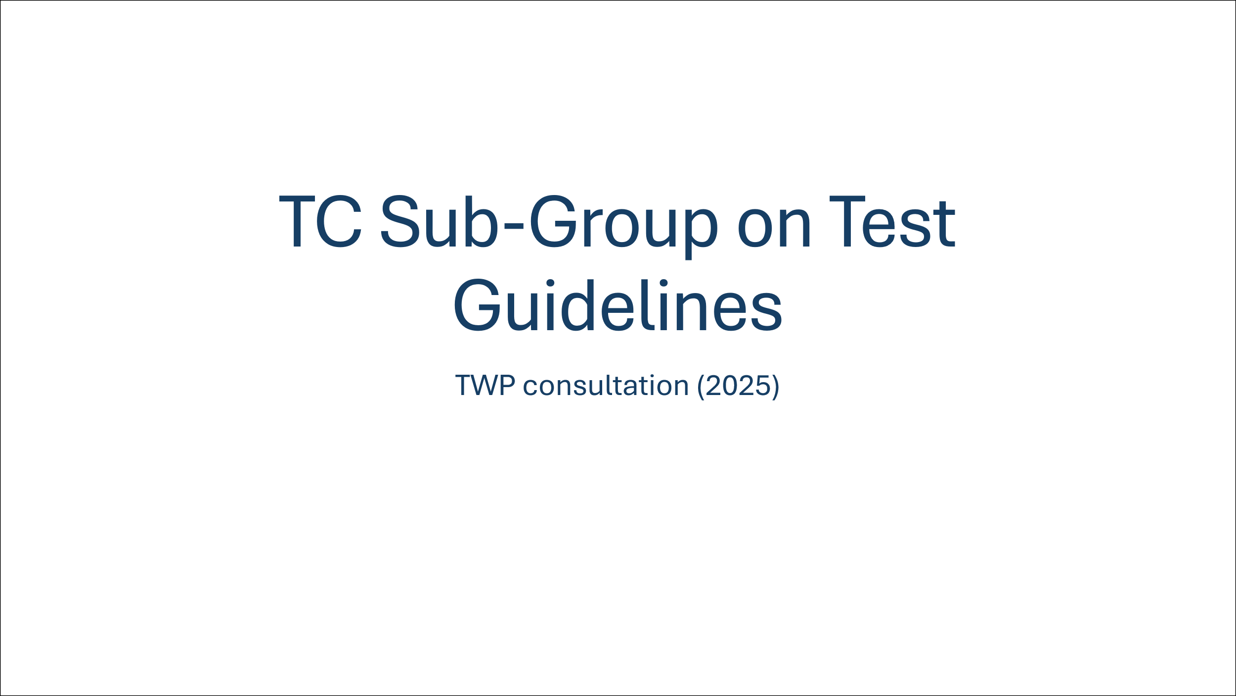

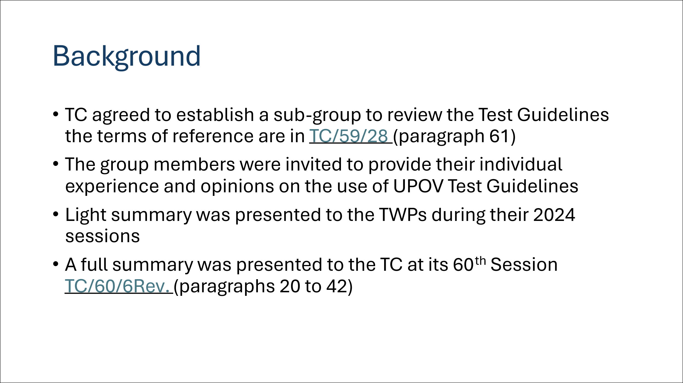

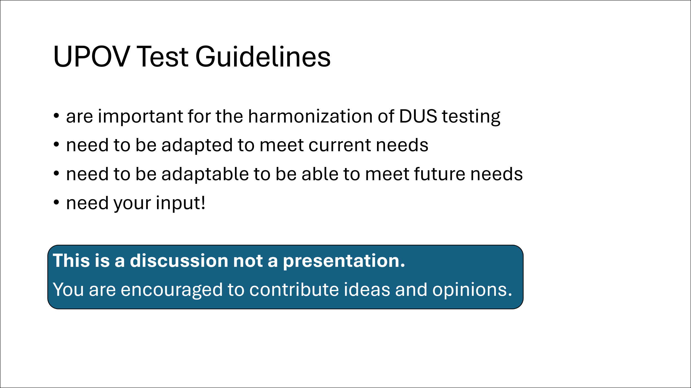

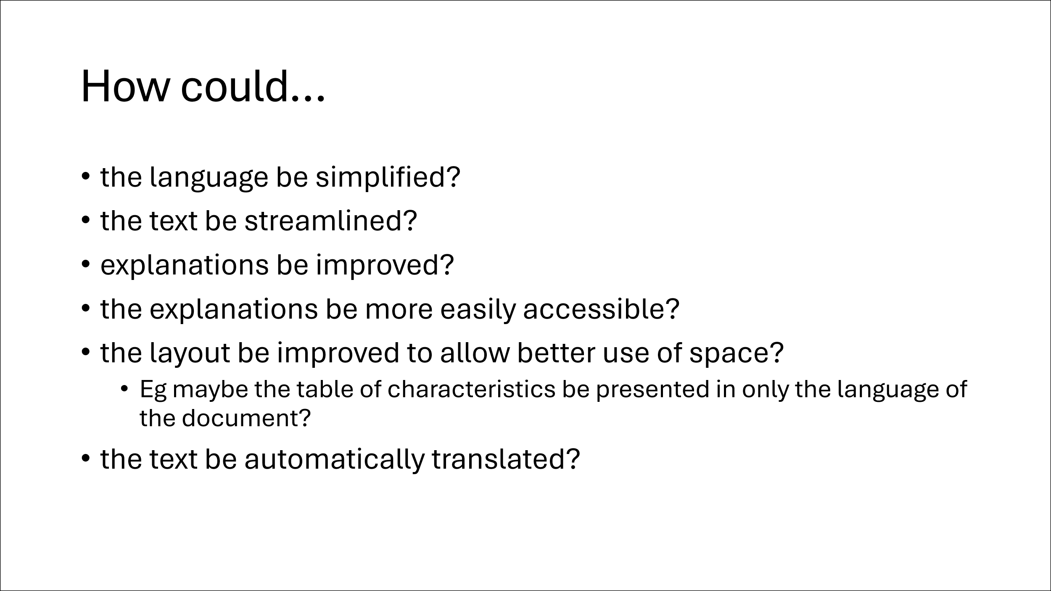

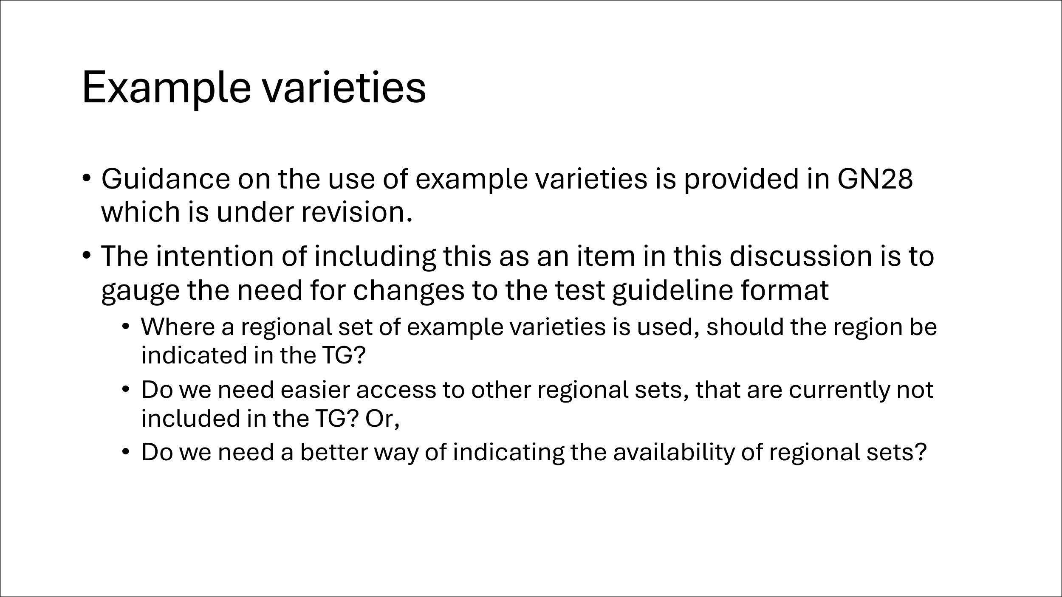

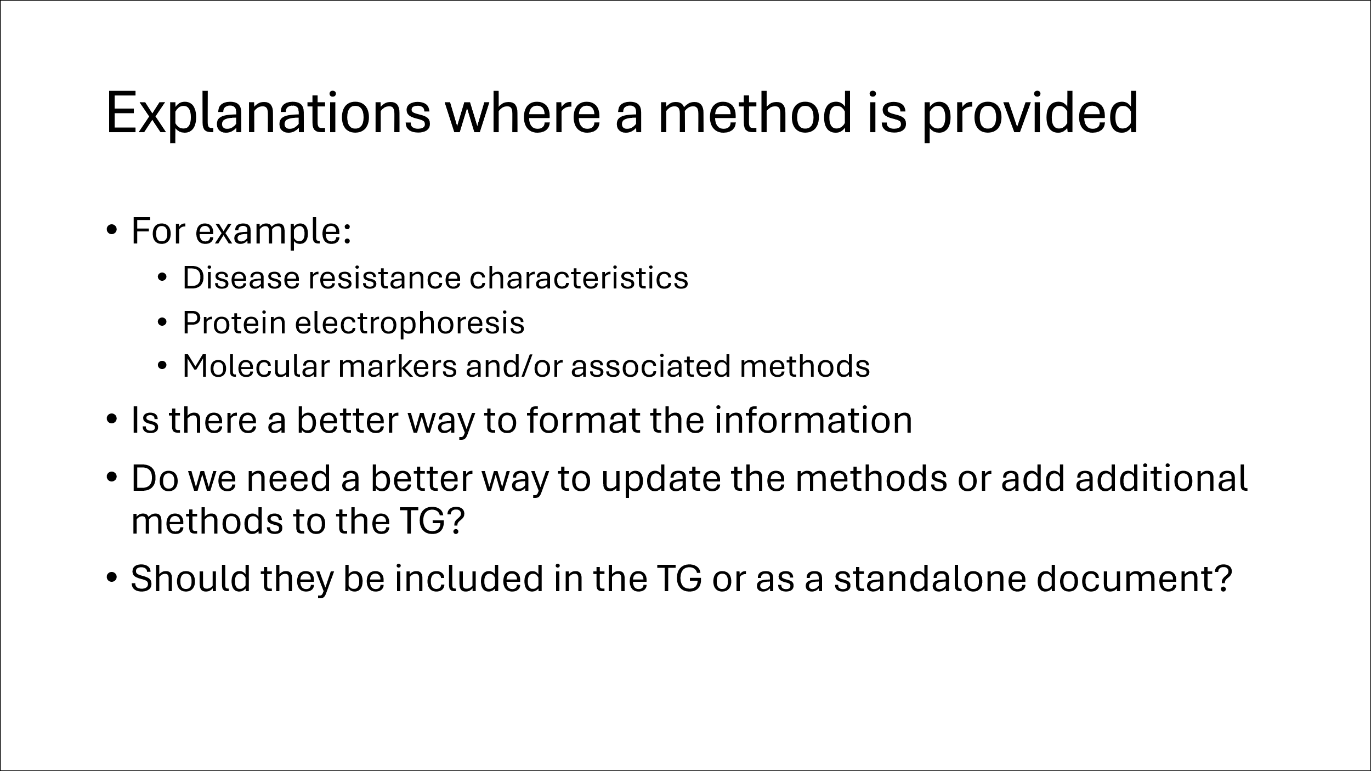

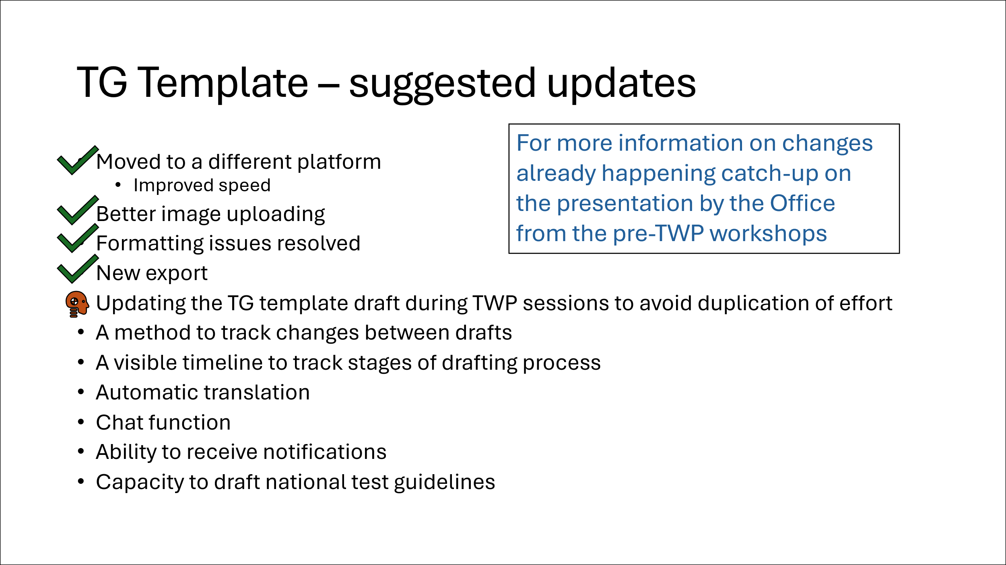

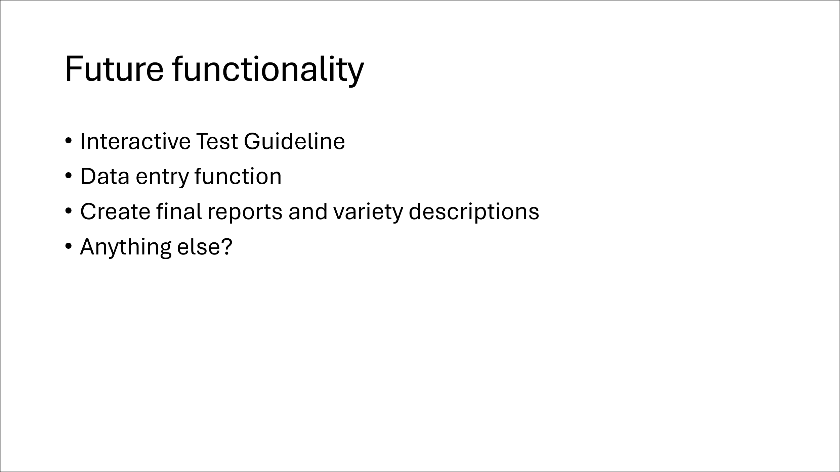

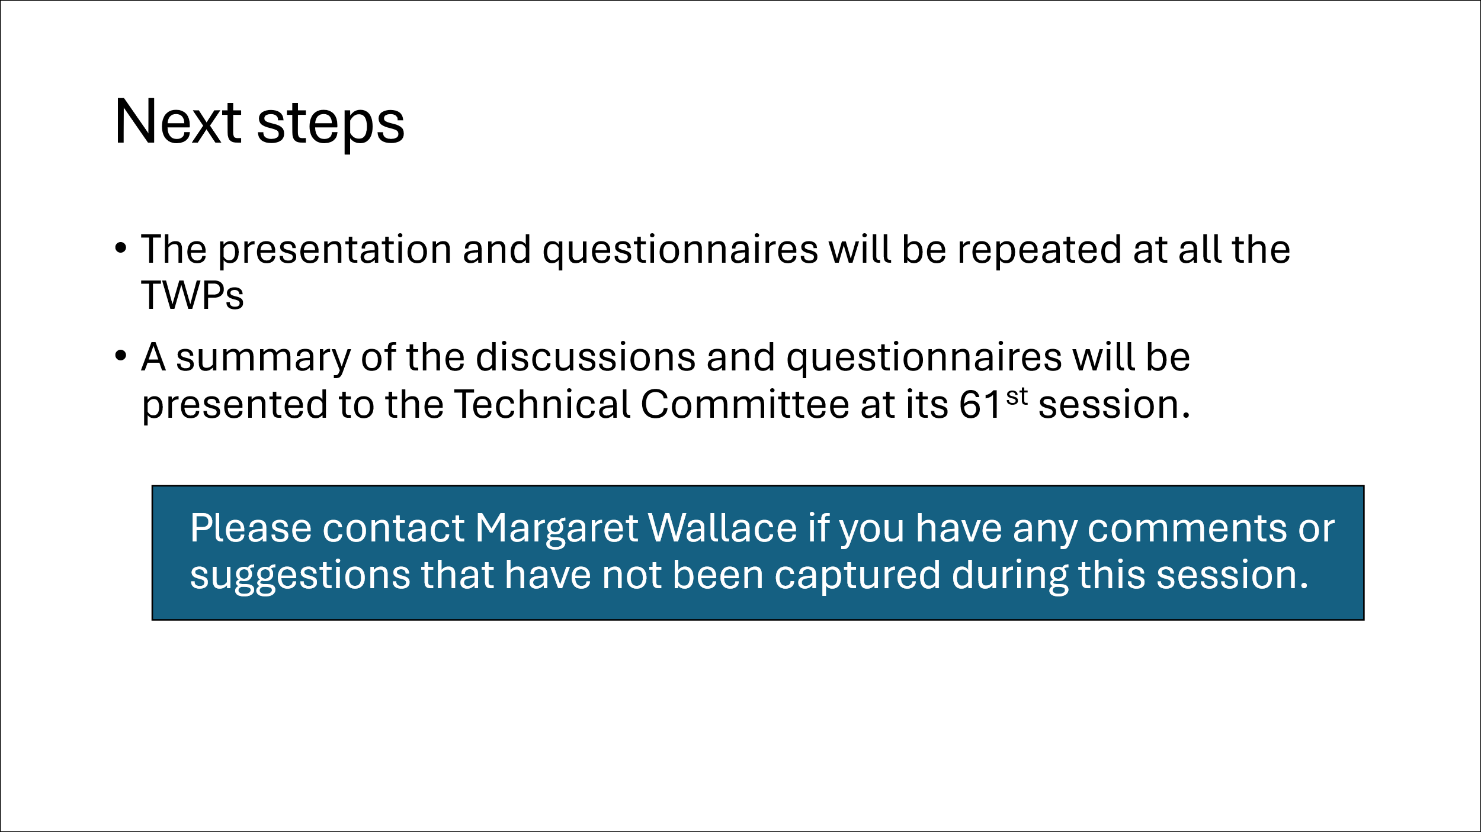

[Annex III follows]

TC SUB-GROUP ON TEST GUIDELINES:
SUMMARY OF DISCUSSION AT THE 57TH SESSION OF THE TWO
(Report by the leading expert, Ms. Margaret Wallace (United Kingdom))

The TWO discussed the presentation from the leading expert of the subgroup, Margaret Wallace (United Kingdom), a copy of which is provided in document TWP/9/3. The group also submitted responses to an online questionnaire.

A summary of the responses and discussion follows:

The group recognised the technical nature of the language used in the standard wording and agreed that it was important that any simplification of wording does not lose the important information.

The TWO agreed that there could be improvements made to the linking of UPOV Guidance documents.

Of the 36 responses to the questionnaire, 28 said that they do print the Test Guidelines. Of those who print, half said they only print part(s) of the document, with the table of characteristics (section 7) and associated explanations (section 8) being the most printed section of the Test Guidelines.

The TWO agreed that viewing the Test Guidelines on a screen (rather than on paper) caused some difficulty in viewing the table of characteristics and the explanations.

The summary of the group responses to the questionnaire indicated that illustrations, diagrams, or photographs was the preferred method of harmonising observations; followed by text explanations, then example varieties in the order of UPOV, National, and then Regional sets.

The questionnaire included questions related to the use of the UPOV Technical Questionnaires.

The group had mixed opinions on whether the TQ should remain part of the Test Guidelines (33%) or form a separate document (36%). The remaining responses were unsure and would have to check (31%).

The TWO had limited experience of the inclusion of descriptions of methods in a Test Guidelines but agreed that having a separate document may reduce ease of access, so careful consideration would be required.

Follow-up actions:

This summary will be collated with those from discussions at the 2025 sessions of the TWM, TWV, TWA, and TWF, along with other comments made during the discussions and presented to the Technical Committee for consideration at its sixty-first session.

TC SUB-GROUP ON TEST GUIDELINES
SUMMARY OF THE DISCUSSION AT THE 59th SESSION OF THE TWV
(Report by the leading expert, Ms. Margaret Wallace (United Kingdom))

The TWV discussed the presentation from the leading expert of the subgroup, Margaret Wallace (United Kingdom), a copy of which is provided in document TWP/9/3. The group also submitted responses to an online questionnaire.

Prior to the online survey, the group discussed the importance of example varieties. It was noted that regional sets of example varieties are important so that the characteristics are expressed appropriately in the growing conditions of that region. The TWV also recognized the significant role of illustrations in cases where example varieties were not readily available.

It was recognized that the TWV had the most experience with the development of disease resistance characteristics, therefore would be best placed to provide opinion on these including the associated explanations. The group agreed that it was essential that details of the methods are included in the Test Guidelines for the purposes of harmonization particularly in the exchange of reports. It was noted that the explanations for disease resistance characteristics included contact details of experts with experience in the assessment of the characteristics. It was agreed that there was scope to improve the presentation of the information to streamline the process, with three proposals made:

- Present the explanations in English only to avoid the cost of translation of technical material while developing further translation options.
- As far as possible use a standardized template to facilitate translation.
- Provide a link in the Test Guidelines to a document on the UPOV website that contains the explanation of the characteristic.

It was agreed that there is an opportunity to increase efficiency in the process for revision of Test Guidelines when including disease resistance characteristics. It is likely this process needs to be agreed first, so that the format of the Test Guidelines can be adapted appropriately.

Of the 29 responses to the questionnaire, 22 said that they do print the Test Guidelines. Of those who print, 10 said they only print part(s) of the document, with the table of characteristics (section 7) and associated explanations (section 8) being the most printed section of the Test Guidelines.

The summary of the group responses to the questionnaire indicated that illustrations, diagrams, or photographs was the preferred method of harmonizing observations; followed by text explanations, then example varieties in the order of regional sets, across the UPOV membership, and then national.

The questionnaire included questions related to the use of the UPOV Technical Questionnaires.

The group had mixed opinions on whether the TQ should remain part of the Test Guidelines (34%) or form a separate document (38%). The remaining responses were unsure and would have to check (28%).

The TWV did not agree on whether guidance on methods being contained in a separate document. They were in favor of having a structured template for guidance on techniques to ensure consistent presentation.

The group felt that links within the document could help usability, or to put the explanation of characteristics beside the characteristics.

Another suggestion was received to include the explanation from the TG in the technical questionnaire to help the applicant complete the form.

Follow-up actions

This summary of the discussion and the results of the online questionnaire will be collated with those from discussions at the 2025 sessions of the TWO, TWA, and TWF, along with other comments made during the discussions and presented to the Technical Committee for consideration at its sixty-first session.
TC SUB-GROUP ON TEST GUIDELINES
SUMMARY OF THE DISCUSSION AT THE 54TH SESSION OF THE TWA
(Report by the leading expert, Ms. Margaret Wallace (United Kingdom))

The TWA received a presentation from the leading expert of the subgroup, Margaret Wallace (United Kingdom), a copy of which is provided in document TWP/9/3. The group also submitted responses to an online questionnaire. There was limited time for a discussion so the opinions of the TWA are captured in the responses to the questionnaire only.

A summary of the responses follows:

The Group had mixed views on the complete revision of the standard wording.

Of the 33 responses to the questionnaire, 23 said that they do print the Test Guidelines. Of those who print, 17 stated that they print the entire document, and six said they only print part(s) of the document, with the table of characteristics (section 7) and associated explanations (section 8) being the most printed section of the Test Guidelines. One respondent indicated that they print the entire document except the TQ and Annex.

The summary of the group responses to the questionnaire indicated that illustrations, diagrams, or photographs was the preferred method of harmonising observations; followed by text explanations, then example varieties in the order of regional sets of example varieties, harmonised across the UPOV membership, and then National sets.

The questionnaire included questions related to the use of the UPOV Technical Questionnaires. 47% of the Group felt that the Technical Questionnaire could be a separate document from the Test Guideline, while 28% indicated the preference that it should remain part of the Test Guideline. The remaining responses were unsure and would have to check (25%).

There was a request to improve text regarding homogeneity which is an issue for many breeders.

The TWA Group mostly agreed that there should be a template for the description of methods included in the Test Guidelines. The group did not agree on whether the guidance should be contained in a document separate to the Test Guidelines.
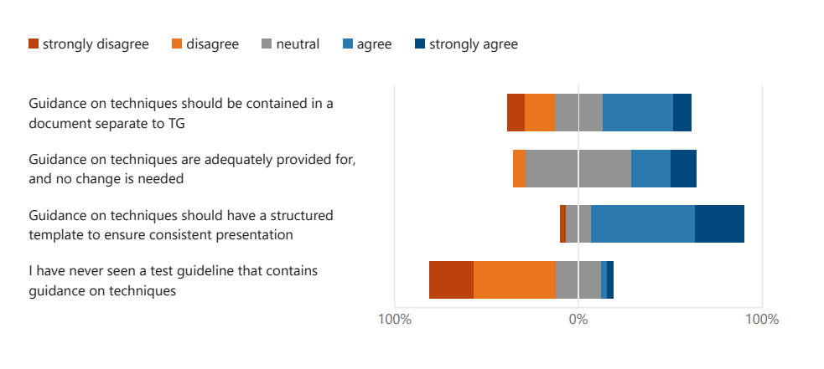
Follow-up actions

This summary will be collated with those from discussions at the 2025 sessions of the TWO, TWV, and TWF, along with other comments made during the discussions and presented to the Technical Committee for consideration at its sixty-first session.

TC SUB-GROUP ON TEST GUIDELINES
SUMMARY OF THE DISCUSSION AT THE 56TH SESSION OF THE TWF
(Report by the leading expert, Ms. Margaret Wallace (United Kingdom))

The TWF received a presentation from the leading expert of the subgroup, Margaret Wallace (United Kingdom), a copy of which is provided in document TWP/9/3. The group also submitted responses to an online questionnaire. There was limited time for discussion so the opinions of the TWF are captured in the responses to the questionnaire only.

A summary of the responses follows:

The Group had a mixed views on the complete revision of the standard wording. The average rating was 6.61, so slightly more for than against.

Of the 29 responses to the questionnaire, 22 said that they do print the Test Guidelines. Of those who print, 5 said they only print part(s) of the document, with the table of characteristics (section 7) and associated explanations (section 8) being the most printed section of the Test Guidelines.

The Group was split on the need for the four languages in the table of characteristics (16 “for” versus 13 “against”).

The summary of the group responses to the questionnaire indicated that illustrations, diagrams, or photographs was the preferred method of harmonising observations; followed by text explanations, then example varieties in the order of those agreed across the UPOV membership, then regional sets, and then National.

There was a positive response to the inclusion of video explanations.

The questionnaire included questions related to the use of the UPOV Technical Questionnaires.

The group had mixed opinions on whether the TQ should remain part of the Test Guideline (48%) or form a separate document (34%). The remaining responses were unsure and would have to check (17%).

The TWF did not agree on whether guidance on methods being contained in a separate document. They were in favour of having a structured template for guidance on techniques to ensure consistent presentation.

Some responded to indicate that links within the document could help usability, or to put the explanation of characteristics beside the characteristics.

Follow-up actions:

This summary of the discussion and the results of the online questionnaire will be collated with those from discussions at the 2025 sessions of the TWO, TWV, and TWA, along with other comments made during the discussions and presented to the Technical Committee for consideration at its sixty-first session.

[End of Annex III and of document]

Technical Committee, sixty-first session, held in Geneva on October 20 and 21, 2025. See document TC/61/8 “Report”, paragraphs 42 to 44
TWF, fifty-sixth session, held in Bursa, Türkiye, from June 23 to 26, 2025. See document TWF/56/7 “Report”, paragraphs 55 and 56
TWO, fifty-seventh session, held in Roelofarendsveen, Kingdom of the Netherlands, from March 31 to April 3, 2025. See document TWO/57/10 “Report”, paragraph 38.
TWV, fifty-ninth session, held via electronic means, from May 5 to 8, 2025. See document TWV/59/19 “Report”, paragraph 39.
TWA, fifty-fourth session, held Arusha, United Republic of Tanzania, from May 19 to 22, 2025. See document TWA/54/7 “Report”, paragraph 35.
TWF, fifty-sixth session, held Bursa, Türkiye, from June 23 to 26, 2025. See document TWF/56/7 “Report”, paragraph 45

