d |  |  |  | E  TG/162/5(proj.3)  ORIGINAL: English  DATE: 2026-04-03
INTERNATIONAL UNION FOR THE PROTECTION OF NEW VARIETIES OF PLANTS
Geneva
 |  | DRAFT

 | GARLIC  UPOV Code(s): ALLIU_SAT  Allium sativum L. | *

GUIDELINES
FOR THE CONDUCT OF TESTS
FOR DISTINCTNESS, UNIFORMITY AND STABILITY

prepared by an expert from France

to be considered by the

Technical Working Party for Vegetables at its sixtieth session,
to be held in Pacific Grove, California, United States of America from 2026-05-18 to 2026-05-21

Disclaimer: this document does not represent UPOV policies or guidance

Alternative Names:*

Botanical name | English | French | German | Spanish
Allium sativum L. | Garlic | Ail | Knoblauch | Ajo

The purpose of these guidelines (“Test Guidelines”) is to elaborate the principles contained in the General Introduction (document TG/1/3), and its associated TGP documents, into detailed practical guidance for the harmonized examination of distinctness, uniformity and stability (DUS) and, in particular, to identify appropriate characteristics for the examination of DUS and production of harmonized variety descriptions.

ASSOCIATED DOCUMENTS

These Test Guidelines should be read in conjunction with the General Introduction and its associated
TGP documents.

TABLE OF CONTENTS PAGE
1. Subject of these Test Guidelines 3
2. Material Required 3
3. Method of Examination 3
3.1 Number of Growing Cycles 3
3.2 Testing Place 3
3.3 Conditions for Conducting the Examination 3
3.4 Test Design 3
3.5 Additional Tests 4
4. Assessment of Distinctness, Uniformity and Stability 4
4.1 Distinctness 4
4.2 Uniformity 5
4.3 Stability 5
5. Grouping of Varieties and Organization of the Growing Trial 5
6. Introduction to the Table of Characteristics 6
6.1 Categories of Characteristics 6
6.2 States of Expression and Corresponding Notes 6
6.3 Types of Expression 6
6.4 Example Varieties 6
6.5 Legend 7
7. Table of Characteristics/Tableau des caracteres/Merkmalstabelle/Tabla de caracteres 8
8. Explanations on the Table of Characteristics 16
8.1 Explanations covering several characteristics 16
8.2 Explanations for individual characteristics 16
9. Literature 27
10. Technical Questionnaire 28

Subject of these Test Guidelines

These Test Guidelines apply to all varieties of Allium sativum L.

Material Required

2.1 The competent authorities decide on the quantity and quality of the plant material required for testing the variety and when and where it is to be delivered. Applicants submitting material from a State other than that in which the testing takes place must ensure that all customs formalities and phytosanitary requirements are complied with.

2.2 The material is to be supplied in the form of seed in the case of seed-propagated varieties, or in the form of bulbs free from virus in the case of vegetative propagated varieties.
.

2.3 The minimum quantity of plant material, to be supplied by the applicant, should be:

Seed-propagated varieties: 7,500 seeds, or
Vegetative propagated varieties: 60 bulbs

In the case of seed, the seed should meet the minimum requirements for germination, species and analytical purity, health and moisture content, specified by the competent authority.
In the case of bulbs, the plant material should at least meet the minimum requirements for sprouting capacity, moisture content and purity for marketing plant material in the country in which the application is made.
2.4 The plant material supplied should be visibly healthy, not lacking in vigor, nor affected by any important pest or disease.

2.5 The plant material should not have undergone any treatment which would affect the expression of the characteristics of the variety, unless the competent authorities allow or request such treatment. If it has been treated, full details of the treatment must be given.

Method of Examination

Number of Growing Cycles

3.1.1 The minimum duration of tests should normally be two independent growing cycles.

3.1.2 The two independent growing cycles should be in the form of two separate plantings.

3.1.3 The testing of a variety may be concluded when the competent authority can determine with certainty the outcome of the test.

Testing Place

Tests are normally conducted at one place. In the case of tests conducted at more than one place, guidance is provided in TGP/9 "Examining Distinctness".

Conditions for Conducting the Examination

The tests should be carried out under conditions ensuring satisfactory growth for the expression of the relevant characteristics of the variety and for the conduct of the examination.

Test Design

3.4.1 In the case of seed propagated varieties, each test should be designed to result in a total of at least 200 plants, which should be divided between at least 2 replicates.

3.4.2 In the case of vegetative propagated varieties, each test should be designed to result in a total of at least 100 plants, which should be divided between at least 2 replicates.

3.4.3 The design of the tests should be such that plants or parts of plants may be removed for measurement or counting without prejudice to the observations which must be made up to the end of the growing cycle.
3.4.4 The storage conditions of bulbs could have an impact on the expression of characteristics. It is recommended to perform observations on material propagated and stored in similar conditions. Separate plots for visual observation and for measuring can only be used if they have been subject to similar environmental conditions.

Additional Tests

Additional tests, for examining relevant characteristics, may be established.

Assessment of Distinctness, Uniformity and Stability

Distinctness

4.1.1 General Recommendations

It is of particular importance for users of these Test Guidelines to consult the General Introduction prior to making decisions regarding distinctness. However, the following points are provided for elaboration or emphasis in these Test Guidelines.

4.1.2 Consistent Differences

The differences observed between varieties may be so clear that more than one growing cycle is not necessary. In addition, in some circumstances, the influence of the environment is not such that more than a single growing cycle is required to provide assurance that the differences observed between varieties are sufficiently consistent. One means of ensuring that a difference in a characteristic, observed in a growing trial, is sufficiently consistent is to examine the characteristic in at least two independent growing cycles.

4.1.3 Clear Differences

Determining whether a difference between two varieties is clear depends on many factors, and should consider, in particular, the type of expression of the characteristic being examined, i.e. whether it is expressed in a qualitative, quantitative, or pseudo-qualitative manner. Therefore, it is important that users of these Test Guidelines are familiar with the recommendations contained in the General Introduction prior to making decisions regarding distinctness.

4.1.4 Number of Plants or Parts of Plants to be Examined

In the case of seed-propagated varieties, unless otherwise indicated, for the purposes of distinctness, all observations on single plants should be made on 60 plants or parts taken from each of 60 plants and any other observation made on all plants in the test, disregarding any off-type plants.

In the case of vegetative propagated varieties, unless otherwise indicated, for the purposes of distinctness, all observations on single plants should be made on 30 plants or parts taken from each of 30 plants and any other observation made on all plants in the test, disregarding any off-type plants.

4.1.5 Method of Observation

The recommended method of observing the characteristic for the purposes of distinctness is indicated by the following key in the Table of Characteristics (see document TGP/9 "Examining Distinctness", Section 4 "Observation of characteristics"):

MG: single measurement of a group of plants or parts of plants
MS: measurement of a number of individual plants or parts of plants
VG: visual assessment by a single observation of a group of plants or parts of plants
VS: visual assessment by observation of individual plants or parts of plants

Type of observation: visual (V) or measurement (M)

"Visual" observation (V) is an observation made on the basis of the expert's judgment. For the purposes of this document, "visual" observation refers to the sensory observations of the experts and, therefore, also includes smell, taste and touch. Visual observation includes observations where the expert uses reference points (e.g. diagrams, example varieties, side-by-side comparison) or non-linear charts (e.g. color charts). Measurement (M) is an objective observation against a calibrated, linear scale e.g. using a ruler, weighing scales, colorimeter, dates, counts, etc.

Type of record: for a group of plants (G) or for single, individual plants (S)

For the purposes of distinctness, observations may be recorded as a single record for a group of plants or parts of plants (G), or may be recorded as records for a number of single, individual plants or parts of plants (S). In most cases, "G" provides a single record per variety and it is not possible or necessary to apply statistical methods in a plant-by-plant analysis for the assessment of distinctness.

In cases where more than one method of observing the characteristic is indicated in the Table of Characteristics (e.g. VG/MG), guidance on selecting an appropriate method is provided in document TGP/9, Section 4.2.

Uniformity

4.2.1 It is of particular importance for users of these Test Guidelines to consult the General Introduction prior to making decisions regarding uniformity. However, the following points are provided for elaboration or emphasis in these Test Guidelines:

4.2.2 These Test Guidelines have been developed for the examination of vegetative propagated and seed-propagated varieties. For varieties with other types of propagation, the recommendations in the General Introduction and document TGP/13 "Guidance for new types and species" Section 4.5 "Testing Uniformity" should be followed.

4.2.3 The assessment of uniformity for cross-pollinated should be according to the recommendations for cross-pollinated varieties in the General Introduction.

4.2.4 The assessment of uniformity for hybrid varieties depends on the type of hybrid and should be according to the recommendations for hybrid varieties in the General Introduction.

4.2.5 For the assessment of uniformity of vegetative propagated varieties, a population standard of 1% and an acceptance probability of at least 95% should be applied. In the case of a sample size of 100 plants, 3 off-types are allowed.
4.2.6 For the assessment of uniformity of inbred lines varieties and hybrid varieties, a population standard of 2% and an acceptance probability of at least 95 % should be applied. In the case of a sample size of 200 plants, 7 off-types are allowed.

Stability

4.3.1 In practice, it is not usual to perform tests of stability that produce results as certain as those of the testing of distinctness and uniformity. However, experience has demonstrated that, for many types of variety, when a variety has been shown to be uniform, it can also be considered to be stable.

4.3.2 Where appropriate, or in cases of doubt, stability may be further examined by testing a new seed or plant stock to ensure that it exhibits the same characteristics as those shown by the initial material supplied.

Grouping of Varieties and Organization of the Growing Trial

5.1 The selection of varieties of common knowledge to be grown in the trial with the candidate varieties and the way in which these varieties are divided into groups to facilitate the assessment of distinctness are aided by the use of grouping characteristics.

5.2 Grouping characteristics are those in which the documented states of expression, even where produced at different locations, can be used, either individually or in combination with other such characteristics: (a) to select varieties of common knowledge that can be excluded from the growing trial used for examination of distinctness; and (b) to organize the growing trial so that similar varieties are grouped together.

5.3 The following have been agreed as useful grouping characteristics:

(a) Leaf blade: green color (characteristic 3)
(b) Leaf blade: waxiness (characteristic 4)
(c) Pseudostem: flowering stem (characteristic 11)
(d) Only for varieties with Pseudostem: flowering stem present: length (characteristic 13)
(e) Bulb: anthocyanin stripes on dry external scales (characteristic 23)
(f) Clove: ground color of scale (characteristic 30)
(g) Time of harvest maturity (characteristic 36)
(h) End of dormancy of clove in bulb (characteristic 37)

5.4 Guidance for the use of grouping characteristics, in the process of examining distinctness, is provided through the General Introduction and document TGP/9 "Examining Distinctness".

Introduction to the Table of Characteristics

Categories of Characteristics

6.1.1 Standard Test Guidelines Characteristics

Standard Test Guidelines characteristics are those which are approved by UPOV for examination of DUS and from which members of the Union can select those suitable for their particular circumstances.

6.1.2 Asterisked Characteristics

Asterisked characteristics (denoted by *) are those included in the Test Guidelines which are important for the international harmonization of variety descriptions and should always be examined for DUS and included in the variety description by all members of the Union, except when the state of expression of a preceding characteristic or regional environmental conditions render this inappropriate.

States of Expression and Corresponding Notes

6.2.1 States of expression are given for each characteristic to define the characteristic and to harmonize descriptions. Each state of expression is allocated a corresponding numerical note for ease of recording of data and for the production and exchange of the description.

6.2.2 All relevant states of expression are presented in the characteristic.

6.2.3 Further explanation of the presentation of states of expression and notes is provided in document TGP/7 "Development of Test Guidelines".

Types of Expression

An explanation of the types of expression of characteristics (qualitative, quantitative and pseudo-qualitative) is provided in the General Introduction.

Example Varieties

Where appropriate, example varieties are provided to clarify the states of expression of each characteristic.

Legend

 |  | English |  | français |  | deutsch | español | Example Varieties  Exemples  Beispielssorten  Variedades ejemplo | Note/  Nota
1 | 2 | 3 | 4 | 5 | 6 | 7
 |  | Name of characteristics in English |  | Nom du caractère en français |  | Name des Merkmals auf Deutsch | Nombre del carácter en español
 |  | states of expression |  | types d’expression |  | Ausprägungsstufen | tipos de expresión

1 Characteristic number

2 (*) sterisked characteristic – see Chapter 6.1.2

3 Type of expression
QL Qualitative characteristic – see Chapter 6.3
QN Quantitative characteristic – see Chapter 6.3
PQ Pseudo-qualitative characteristic – see Chapter 6.3

4 Method of observation (and type of plot, if applicable)
MG, MS, VG, VS – see Chapter 4.1.5

5 (+) See Explanations on the Table of Characteristics in Chapter 8.2

6 (a)-(c) See Explanations on the Table of Characteristics in Chapter 8.1

7 Not applicable

Table of Characteristics/Tableau des caracteres/Merkmalstabelle/Tabla de caracteres

 |  | English |  | français |  | deutsch | español | Example Varieties  Exemples  Beispielssorten  Variedades ejemplo | Note/  Nota
1. | (*) | QN | VG | (+) | (a)
 |  | Foliage: density
 |  | very sparse |  |  |  |  |  | Ti Rouge | 1
 |  | very sparse to sparse |  |  |  |  |  |  | 2
 |  | sparse |  |  |  |  |  | Vacoa | 3
 |  | sparse to medium |  |  |  |  |  |  | 4
 |  | medium |  |  |  |  |  | Printanor | 5
 |  | medium to dense |  |  |  |  |  |  | 6
 |  | dense |  |  |  |  |  | Germidour | 7
 |  | dense to very dense |  |  |  |  |  |  | 8
 |  | very dense |  |  |  |  |  |  | 9
2. | (*) | QN | VG | (+) | (a)
 |  | Foliage: attitude
 |  | erect |  |  |  |  |  | Jolimont, Vayo | 1
 |  | erect to semi-erect |  |  |  |  |  | Printanor | 2
 |  | semi-erect |  |  |  |  |  | Germidour | 3
3. | (*) | QN | VG |  | (a)
 |  | Leaf blade: green color
 |  | very light |  |  |  |  |  |  | 1
 |  | very light to light |  |  |  |  |  |  | 2
 |  | light |  |  |  |  |  | Primor | 3
 |  | light to medium |  |  |  |  |  |  | 4
 |  | medium |  |  |  |  |  | Messidrome | 5
 |  | medium to dark |  |  |  |  |  |  | 6
 |  | dark |  |  |  |  |  | Germidour | 7
 |  | dark to very dark |  |  |  |  |  | Valdour | 8
 |  | very dark |  |  |  |  |  |  | 9
4. | (*) | QN | VG |  | (a)
 |  | Leaf blade: waxiness
 |  | absent or very weak |  |  |  |  |  |  | 1
 |  | weak |  |  |  |  |  | Sprint | 2
 |  | medium |  |  |  |  |  | Messidrome | 3
 |  | strong |  |  |  |  |  | Germidour | 4
 |  | very strong |  |  |  |  |  | Gayant, Printanor | 5
5. | (*) | QN | MS/VG | (+) | (a)
 |  | Leaf blade: length
 |  | very short |  |  |  |  |  |  | 1
 |  | very short to short |  |  |  |  |  |  | 2
 |  | short |  |  |  |  |  | Vacoa | 3
 |  | short to medium |  |  |  |  |  |  | 4
 |  | medium |  |  |  |  |  | Gayant | 5
 |  | medium to long |  |  |  |  |  |  | 6
 |  | long |  |  |  |  |  | Sultop | 7
 |  | long to very long |  |  |  |  |  |  | 8
 |  | very long |  |  |  |  |  |  | 9
6. | (*) | QN | MS/VG | (+) | (a)
 |  | Leaf blade: width
 |  | very narrow |  |  |  |  |  |  | 1
 |  | very narrow to narrow |  |  |  |  |  |  | 2
 |  | narrow |  |  |  |  |  | Vacoa | 3
 |  | narrow to medium |  |  |  |  |  |  | 4
 |  | medium |  |  |  |  |  | Printanor | 5
 |  | medium to broad |  |  |  |  |  |  | 6
 |  | broad |  |  |  |  |  | Germidour | 7
 |  | broad to very broad |  |  |  |  |  |  | 8
 |  | very broad |  |  |  |  |  |  | 9
7. | (*) | QN | VG | (+) | (a)
 |  | Leaf blade: shape in cross section
 |  | strongly concave |  |  |  |  |  | Vacoa | 1
 |  | slightly concave |  |  |  |  |  | Precosem | 2
 |  | flat |  |  |  |  |  | Germidour | 3
8. |  | QN | VG | (+) | (a)
 |  | Pseudostem: anthocyanin coloration at base
 |  | absent or very weak |  |  |  |  |  | Printanor | 1
 |  | weak |  |  |  |  |  | Messidrome | 2
 |  | medium |  |  |  |  |  |  | 3
 |  | strong |  |  |  |  |  | Germidour | 4
 |  | very strong |  |  |  |  |  |  | 5
9. | (*) | QN | MS/VG | (+) | (a)
 |  | Pseudostem: width at base
 |  | very narrow |  |  |  |  |  |  | 1
 |  | very narrow to narrow |  |  |  |  |  |  | 2
 |  | narrow |  |  |  |  |  | Vacoa | 3
 |  | narrow to medium |  |  |  |  |  |  | 4
 |  | medium |  |  |  |  |  | Printanor | 5
 |  | medium to broad |  |  |  |  |  |  | 6
 |  | broad |  |  |  |  |  | Germidour | 7
 |  | broad to very broad |  |  |  |  |  |  | 8
 |  | very broad |  |  |  |  |  |  | 9
10. |  | QL | VG | (+) | (a)
 |  | Pseudostem: production of bulblets
 |  | absent |  |  |  |  |  | Rose de Lautrec | 1
 |  | present |  |  |  |  |  | Germidour | 9
11. | (*) | QL | VG |  | (b)
 |  | Pseudostem: flowering stem
 |  | absent |  |  |  |  |  | Germidour | 1
 |  | present |  |  |  |  |  | Rose de Lautrec | 9
12. |  | QL | VG | (+) | (b)
 |  | Only for varieties with Pseudostem: flowering stem present: curvature
 |  | absent |  |  |  |  |  | Sultop | 1
 |  | present |  |  |  |  |  | Iberose, Precosem | 9
13. | (*) | QN | MS/VG | (+) | (b)
 |  | Only for varieties with Pseudostem: flowering stem present: length
 |  | very short |  |  |  |  |  |  | 1
 |  | short |  |  |  |  |  | Rose de Lautrec | 2
 |  | medium |  |  |  |  |  | Precosem | 3
 |  | long |  |  |  |  |  | Sultop | 4
 |  | very long |  |  |  |  |  |  | 5
14. | (*) | QN | MS/VG |  | (c)
 |  | Bulb: size
 |  | very small |  |  |  |  |  |  | 1
 |  | very small to small |  |  |  |  |  |  | 2
 |  | small |  |  |  |  |  | Vacoa | 3
 |  | small to medium |  |  |  |  |  |  | 4
 |  | medium |  |  |  |  |  | Printanor | 5
 |  | medium to large |  |  |  |  |  |  | 6
 |  | large |  |  |  |  |  | Messidrome | 7
 |  | large to very large |  |  |  |  |  |  | 8
 |  | very large |  |  |  |  |  |  | 9
15. | (*) | QN | VG | (+) | (c)
 |  | Bulb: shape in longitudinal section
 |  | transverse narrow elliptic |  |  |  |  |  | Sprint | 1
 |  | transverse broad elliptic |  |  |  |  |  | Germidour | 2
 |  | circular |  |  |  |  |  |  | 3
16. |  | QN | MS/VG | (+) | (c)
 |  | Bulb: shape in cross section
 |  | elliptic |  |  |  |  |  | Ti Rouge | 1
 |  | circular |  |  |  |  |  | Sprint | 2
17. |  | QN | VG | (+) | (c)
 |  | Bulb: position of cloves at top of bulb
 |  | inserted |  |  |  |  |  | Sprint | 1
 |  | at same level |  |  |  |  |  | Corail | 2
 |  | exerted |  |  |  |  |  | Germidour | 3
18. | (*) | QN | VG | (+) | (c)
 |  | Bulb: position of root disc
 |  | recessed |  |  |  |  |  | Germidour | 1
 |  | at the same level |  |  |  |  |  | Rose de Lautrec | 2
 |  | protruded |  |  |  |  |  |  | 3
19. | (*) | QN | VG | (+) | (c)
 |  | Bulb: shape of base
 |  | depressed |  |  |  |  |  | Germidour | 1
 |  | flat |  |  |  |  |  | Printanor | 2
 |  | rounded |  |  |  |  |  |  | 3
20. | (*) | QN | VG | (+) | (c)
 |  | Bulb: compactness of cloves
 |  | very loose |  |  |  |  |  |  | 1
 |  | loose |  |  |  |  |  | Sprint | 2
 |  | medium |  |  |  |  |  | Germidour | 3
 |  | compact |  |  |  |  |  | Printanor | 4
 |  | very compact |  |  |  |  |  |  | 5
21. | (*) | QN | VG | (+) | (c)
 |  | Bulb: ground color of dry external scales
 |  | white |  |  |  |  |  | Aulxito, Printanor | 1
 |  | yellowish white |  |  |  |  |  | Jolimont, Vigor Supreme | 2
22. |  | QN | VG | (+) | (c)
 |  | Bulb: anthocyanin area on dry external scales
 |  | absent or very small |  |  |  |  |  | Jolimont, Messidrome | 1
 |  | small |  |  |  |  |  | Ti Rouge | 2
 |  | medium |  |  |  |  |  | Germidour | 3
 |  | large |  |  |  |  |  |  | 4
 |  | very large |  |  |  |  |  |  | 5
23. | (*) | QN | VG |  | (c)
 |  | Bulb: anthocyanin stripes on dry external scales
 |  | absent or weak |  |  |  |  |  | Aulxito, Printanor | 1
 |  | medium |  |  |  |  |  | Germidour | 2
 |  | strong |  |  |  |  |  |  | 3
24. |  | QN | VG | (+) | (c)
 |  | Bulb: skin adherence of dry external scales
 |  | very weak |  |  |  |  |  |  | 1
 |  | weak |  |  |  |  |  | Sprint | 2
 |  | medium |  |  |  |  |  | Messidrome | 3
 |  | strong |  |  |  |  |  | Gayant, Printanor | 4
 |  | very strong |  |  |  |  |  |  | 5
25. |  | QN | MS/VG |  | (c)
 |  | Bulb: thickness of dry external scales
 |  | very thin |  |  |  |  |  |  | 1
 |  | thin |  |  |  |  |  | Sprint | 2
 |  | medium |  |  |  |  |  | Gayant | 3
 |  | thick |  |  |  |  |  | Jolimont | 4
 |  | very thick |  |  |  |  |  |  | 5
26. | (*) | QN | MS/VG | (+) | (c)
 |  | Bulb: number of cloves
 |  | very few |  |  |  |  |  | Dangiai | 1
 |  | few |  |  |  |  |  | Nevasem | 2
 |  | medium |  |  |  |  |  | Printanor | 3
 |  | many |  |  |  |  |  | Plamegar | 4
 |  | very many |  |  |  |  |  |  | 5
27. | (*) | QL | VG | (+) | (c)
 |  | Bulb: distribution of cloves
 |  | radial |  |  |  |  |  | Rose de Lautrec, Sprint | 1
 |  | non-radial |  |  |  |  |  | Jolimont, Messidrome | 2
28. | (*) | QL | VG | (+) | (c)
 |  | Bulb: external cloves
 |  | absent |  |  |  |  |  | Sprint, Sultop | 1
 |  | present |  |  |  |  |  | Messidor | 9
29. | (*) | QN | MS/VG | (+) | (c)
 |  | Clove: size
 |  | very small |  |  |  |  |  |  | 1
 |  | veru small to small |  |  |  |  |  |  | 2
 |  | small |  |  |  |  |  | Rose de Lautrec | 3
 |  | small to medium |  |  |  |  |  |  | 4
 |  | medium |  |  |  |  |  | Printanor | 5
 |  | medium to large |  |  |  |  |  |  | 6
 |  | large |  |  |  |  |  | Germidour | 7
 |  | large to very large |  |  |  |  |  |  | 8
 |  | very large |  |  |  |  |  |  | 9
30. | (*) | PQ | VG | (+) | (c)
 |  | Clove: ground color of scale
 |  | white |  |  |  |  |  |  | 1
 |  | yellowish white |  |  |  |  |  | Messidrome | 2
 |  | pink |  |  |  |  |  | Printanor | 3
 |  | purple |  |  |  |  |  |  | 4
 |  | brown |  |  |  |  |  | Corail | 5
31. |  | QN | VG | (+) | (c)
 |  | Clove: intensity of ground color of scale
 |  | very weak |  |  |  |  |  |  | 1
 |  | weak |  |  |  |  |  |  | 2
 |  | medium |  |  |  |  |  |  | 3
 |  | strong |  |  |  |  |  |  | 4
 |  | very strong |  |  |  |  |  |  | 5
32. | (*) | PQ | VG | (+) | (c)
 |  | Clove: over color of scale
 |  | absent |  |  |  |  |  | Messidrome | 1
 |  | yellowish white |  |  |  |  |  |  | 2
 |  | pink |  |  |  |  |  | Iberose | 3
 |  | purple |  |  |  |  |  |  | 4
 |  | brown |  |  |  |  |  |  | 5
33. |  | QN | VG |  | (c)
 |  | Clove: intensity of over color of scale
 |  | very weak |  |  |  |  |  |  | 1
 |  | weak |  |  |  |  |  |  | 2
 |  | medium |  |  |  |  |  |  | 3
 |  | strong |  |  |  |  |  |  | 4
 |  | very strong |  |  |  |  |  |  | 5
34. | (*) | QN | VG |  | (c)
 |  | Clove: anthocyanin stripes on scale
 |  | absent or weak |  |  |  |  |  | Precosem | 1
 |  | medium |  |  |  |  |  | Pinkysem | 2
 |  | strong |  |  |  |  |  |  | 3
35. | (*) | QN | VG |  | (c)
 |  | Clove: color of flesh
 |  | white |  |  |  |  |  | Printanor | 1
 |  | yellowish |  |  |  |  |  | Germidour | 2
36. | (*) | QN | MG/VG | (+)
 |  | Time of harvest maturity
 |  | very early |  |  |  |  |  |  | 1
 |  | very early to early |  |  |  |  |  | Primor | 2
 |  | early |  |  |  |  |  | Sprint | 3
 |  | early to medium |  |  |  |  |  | Dario | 4
 |  | medium |  |  |  |  |  | Germidour, Messidrome | 5
 |  | medium to late |  |  |  |  |  | Iberose | 6
 |  | late |  |  |  |  |  | Printanor | 7
 |  | late to very late |  |  |  |  |  | Flavor | 8
 |  | late very late |  |  |  |  |  | Ail du Nord, Gayant | 9
37. | (*) | QN | MG/VG | (+)
 |  | End of dormancy of clove in bulb
 |  | very early |  |  |  |  |  |  | 1
 |  | very early to early |  |  |  |  |  |  | 2
 |  | early |  |  |  |  |  | Sprint | 3
 |  | early to medium |  |  |  |  |  | Messidrome | 4
 |  | medium |  |  |  |  |  | Rose de Lautrec | 5
 |  | medium to late |  |  |  |  |  |  | 6
 |  | late |  |  |  |  |  | Flavor | 7
 |  | late to very late |  |  |  |  |  |  | 8
 |  | very late |  |  |  |  |  | Ail du Nord, Gayant | 9

Explanations on the Table of Characteristics

Explanations covering several characteristics

Characteristics containing the following key in the Table of Characteristics should be examined as indicated below:

(a) Observation should be made before the natural fall over of foliage (physiological senescence).

(b) Observations should be made before the harvest, when the flowering stem is fully developed or the foliage fully developed in case of absence of flowering stem.

(c) Observation should be made on dried material harvested from the trial.

Explanations for individual characteristics

Ad. 1: Foliage: density
This characteristic results from a combination of several factors. It is primarily associated with the length of the internodes. Its visual assessment is also influenced by the width, the shape of the cross-section of the leaf blade and the attitude of the foliage.
Short internodes, combined with a large leaf blade, a flat cross-section and an more erect foliage, enhance the perception of foliage density.

Ad. 2: Foliage: attitude
Observations should be made on the middle third of the plant. It corresponds to the angle formed by the base of the leaf and an imaginary vertical axis.
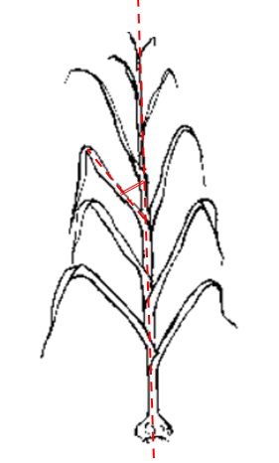 | 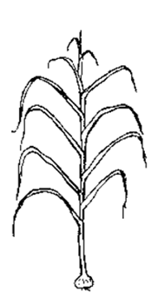 | 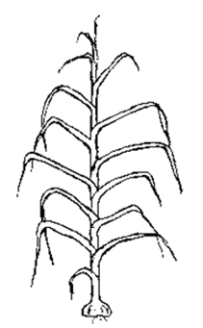
1 | 2 | 3
erect | erect to semi-erect | semi-erect

Ad. 5: Leaf blade: length
Observation should be made on the longest leaf blade.
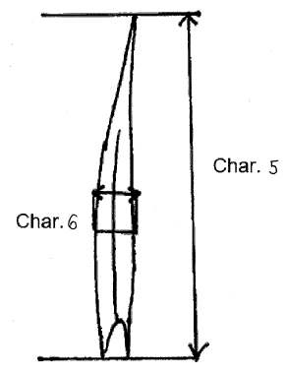

Ad. 6: Leaf blade: width
Cf. Ad. 5
Observation should be made at the widest part of the longest leaf blade.

Ad. 7: Leaf blade: shape in cross section

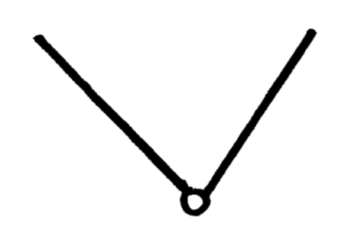 | 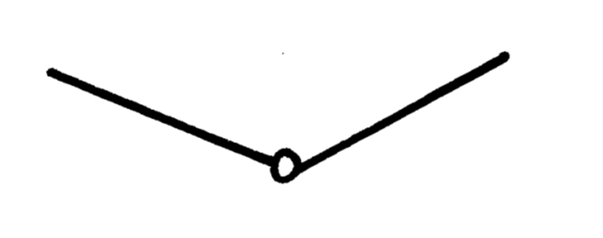 | 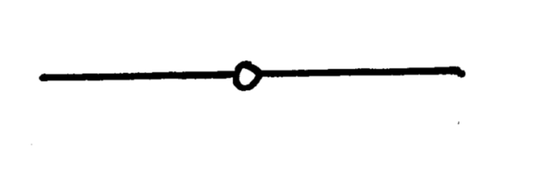
1 | 2 | 3
strongly concave | slightly concave | flat

Ad. 8: Pseudostem: anthocyanin coloration at base
Observations should be made at ground level.

Ad. 9: Pseudostem: width at base
Observations should be made at ground level.

Ad. 10: Pseudostem: production of bulblets
This characteristic can be influence by the genetic background and the influence of agroclimatic conditions. The ability to produce bulblets through the pseudostem has to be observed at a late stage of observation (a).
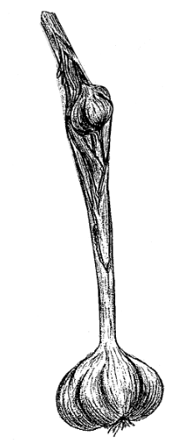 | 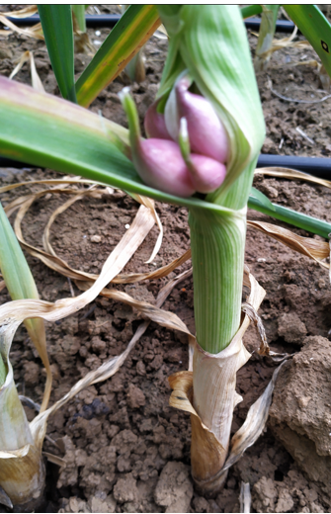

Ad. 12: Only for varieties with Pseudostem: flowering stem present: curvature

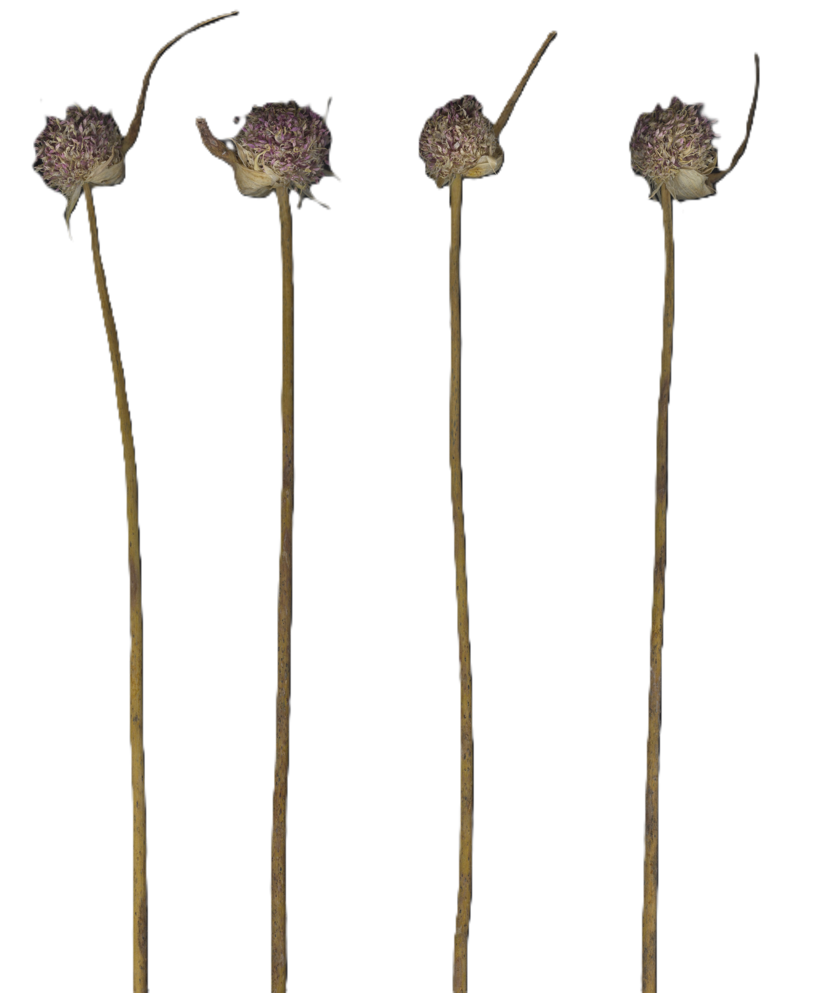 | 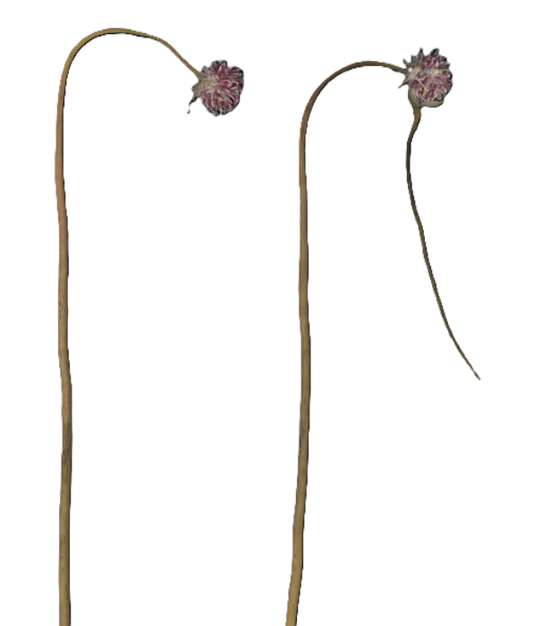
1 | 9
absent | present

Observation has to be performed just before the harvest.

Ad. 13: Only for varieties with Pseudostem: flowering stem present: length

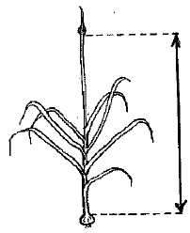
Observation has to be performed just before the harvest.

Ad. 15: Bulb: shape in longitudinal section

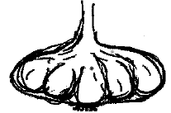 | 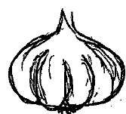 | 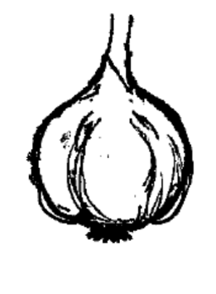
1 | 2 | 3
transverse narrow elliptic | transverse broad elliptic | circular

Ad. 16: Bulb: shape in cross section

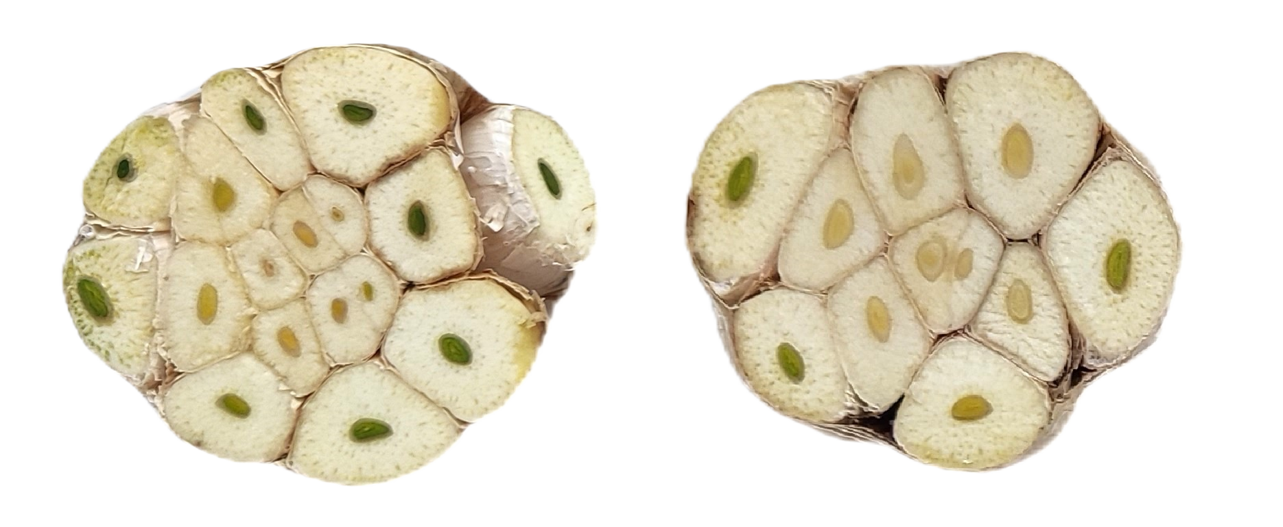 | 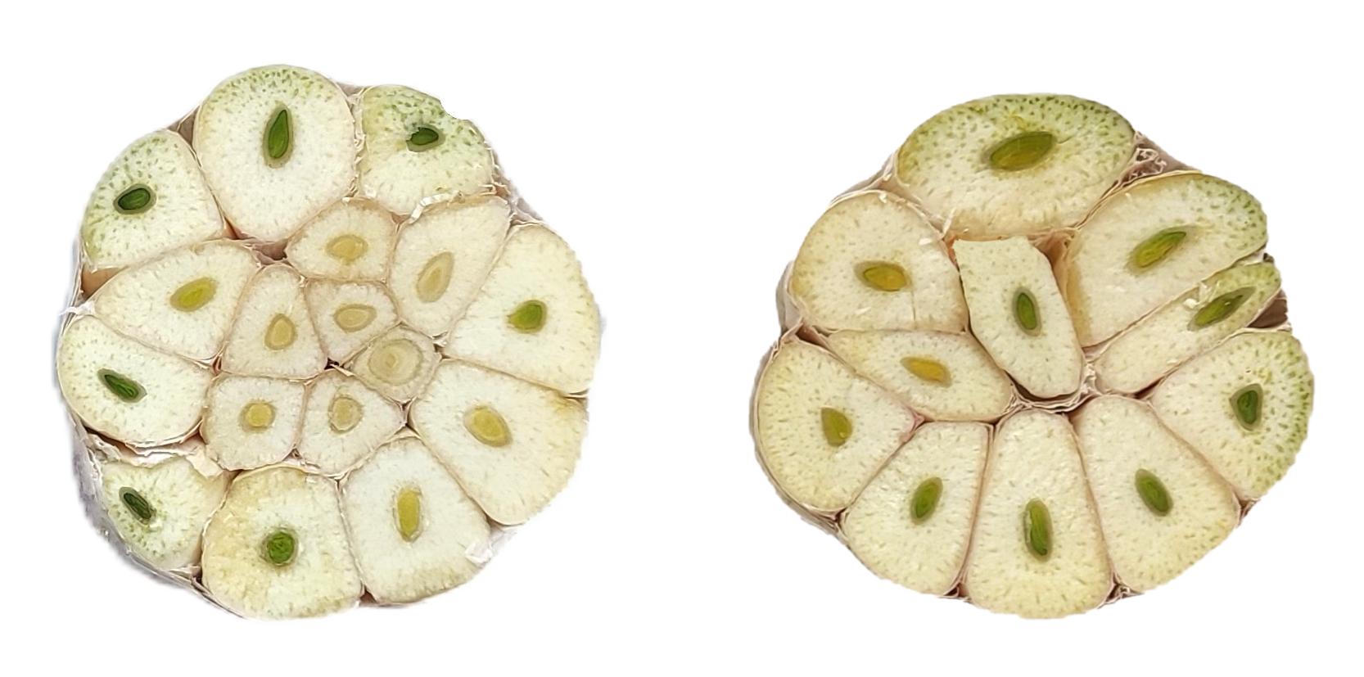
1 | 2
elliptic | circular

Ad. 17: Bulb: position of cloves at top of bulb

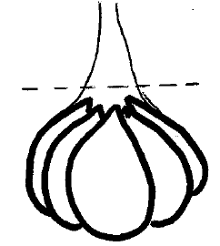 | 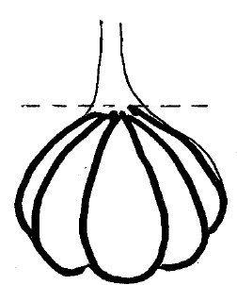 | 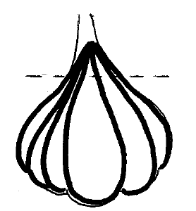
1 | 2 | 3
inserted | at same level | exerted

Ad. 18: Bulb: position of root disc

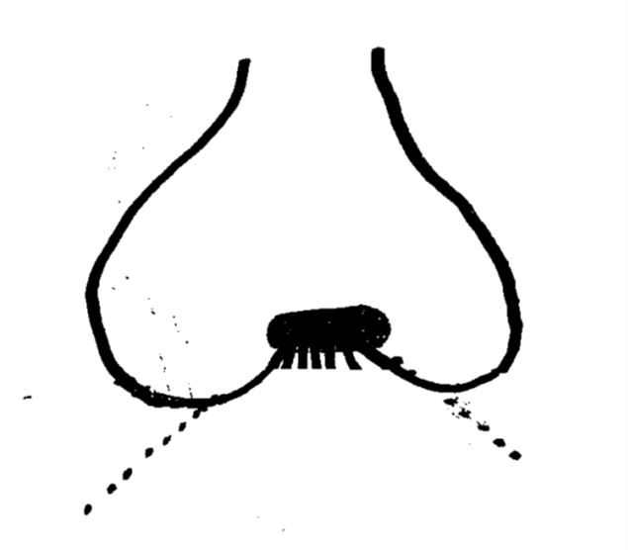 | 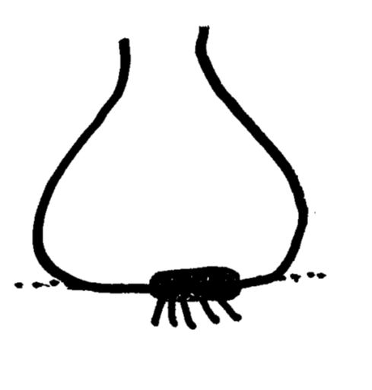 | 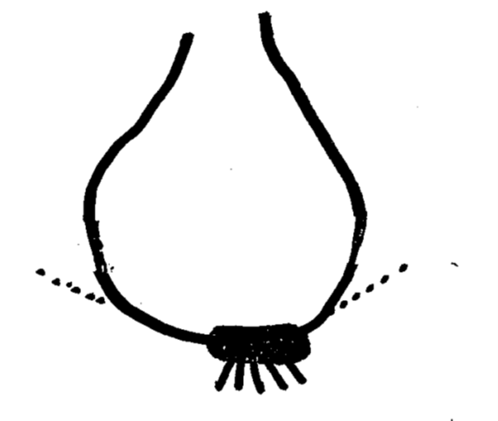
1 | 2 | 3
recessed | at the same level | protruded

Ad. 19: Bulb: shape of base

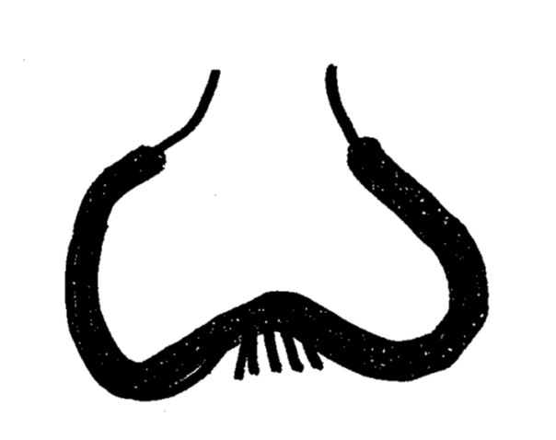 | 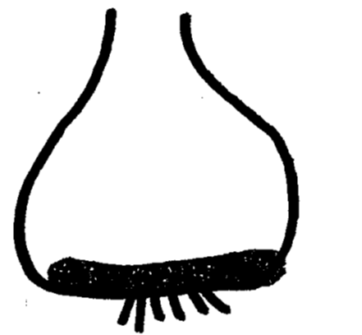 | 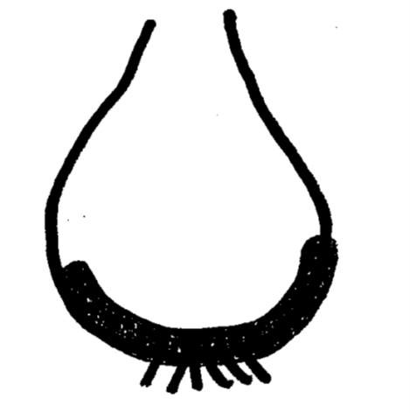
1 | 2 | 3
depressed | flat | rounded

Ad. 20: Bulb: compactness of cloves
It corresponds to the closeness of the cloves between them. Without space between cloves, the bulb is compact. The more space there is between cloves, the looser the bulb is.

Ad. 21: Bulb: ground color of dry external scales
The ground color is the first color to appear chronologically during the development of the bulb. Other colors may develop in time in the form of stripes, area.

Ad. 22: Bulb: anthocyanin area on dry external scales
Observations have to be done on the upper part of the bulb. This character is independent of the presence or absence of anthocyanin stripes.
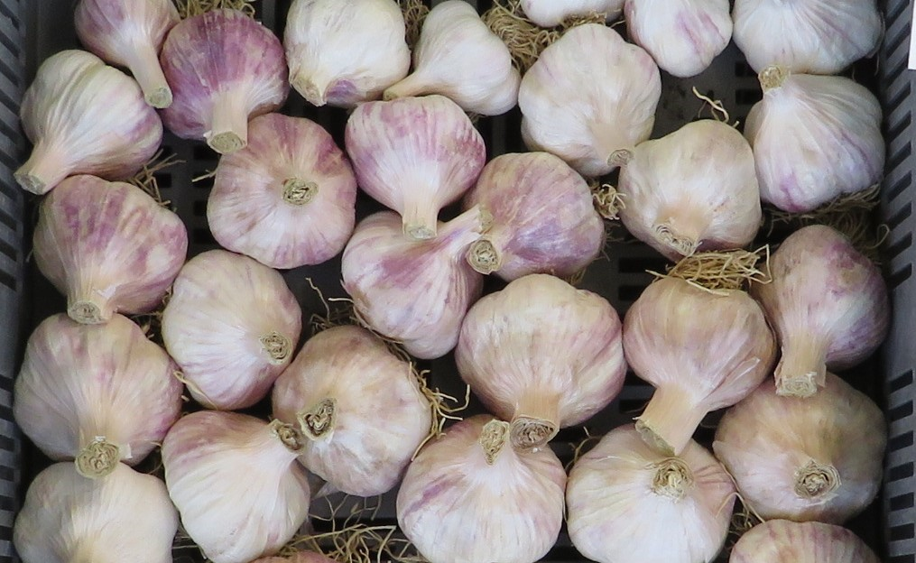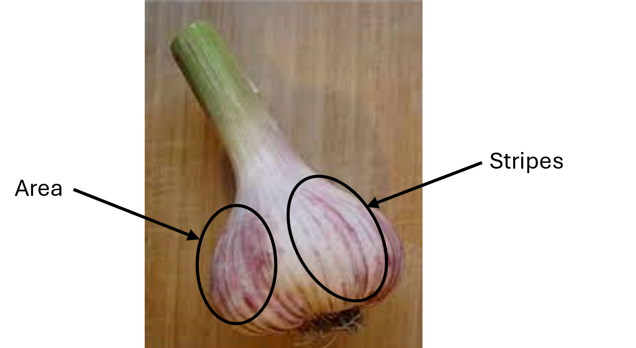

Ad. 24: Bulb: skin adherence of dry external scales
The dry external scales are more or less completely covering the cloves below. Regarding the level of adherence, the scales can loose a part of their integrity (cracks, rips...). The assessment of this characteristic combines a visual observation and also the touch to finalize the description.
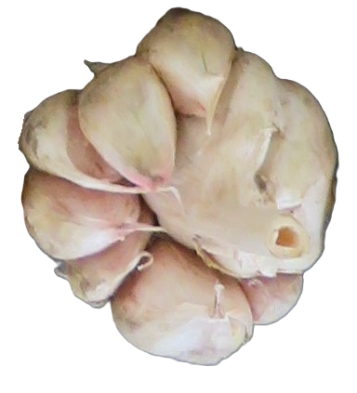 | 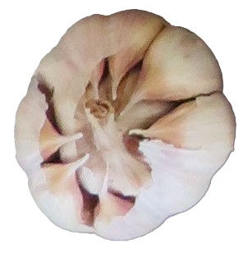 | 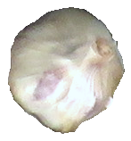 | 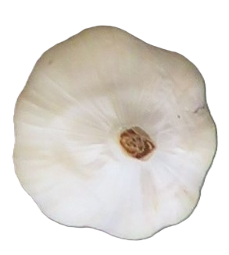
1 | 2 | 3 | 4 | 5
very weak | weak | medium | strong | very strong

Ad. 26: Bulb: number of cloves

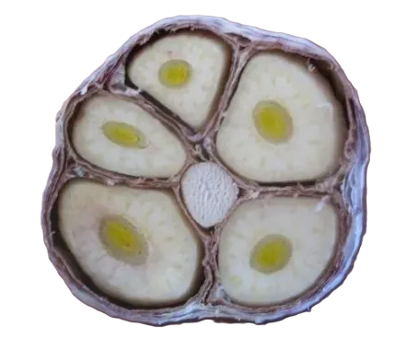 | 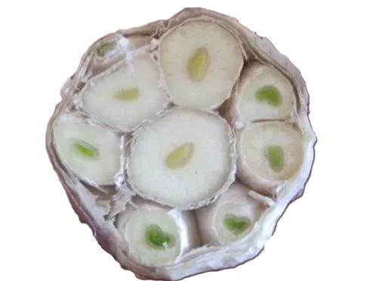 | 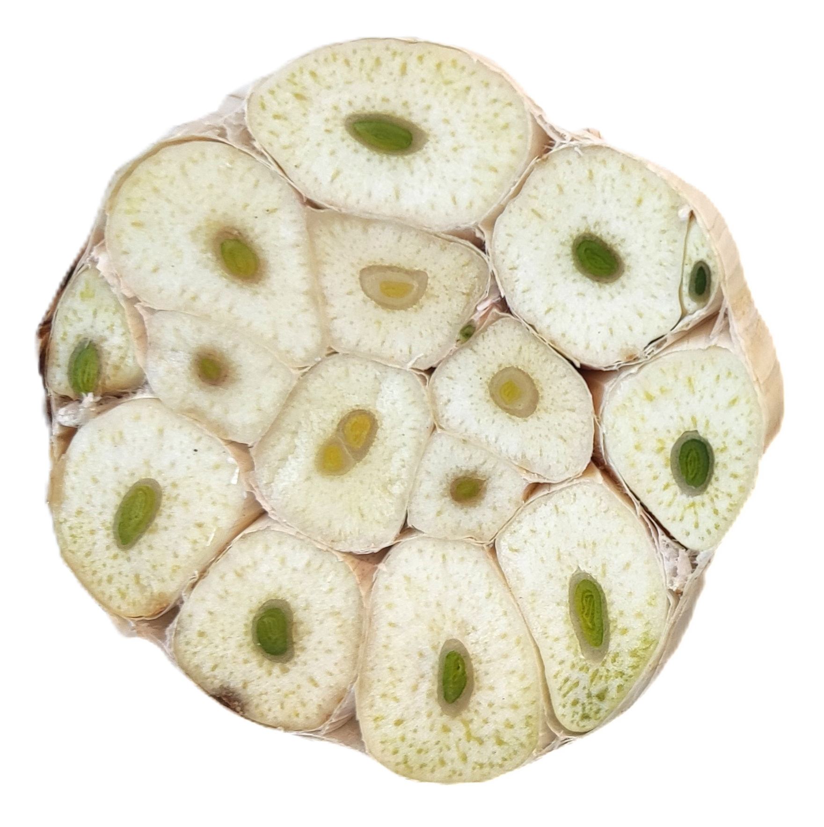 | 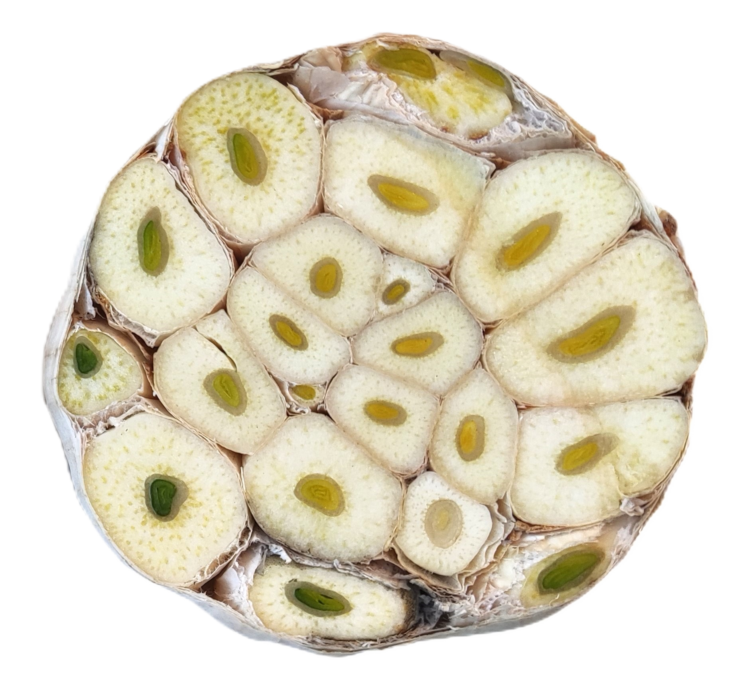
1 | 3 | 5 | 7 | 9
very few | few | medium | many | very many

Ad. 27: Bulb: distribution of cloves

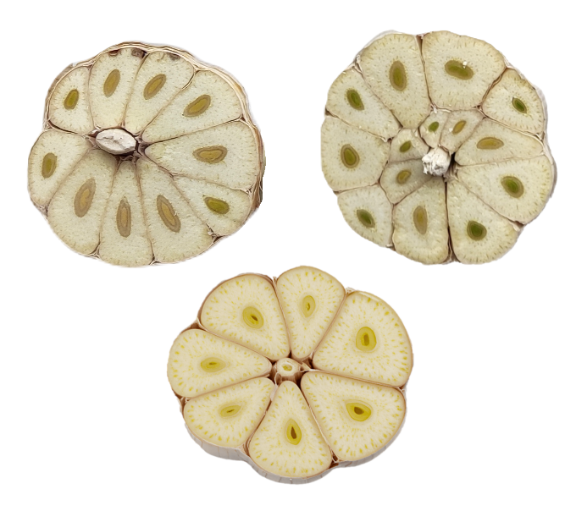 | 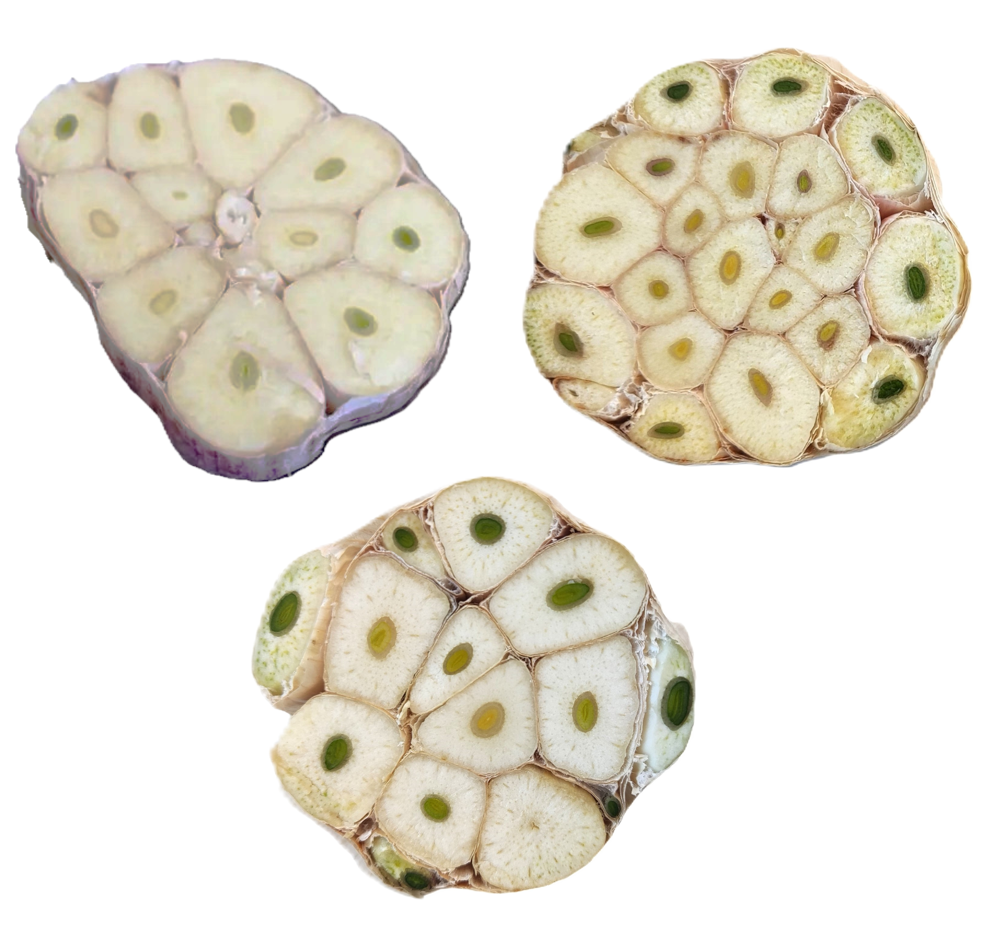
1 | 2
radial | non-radial
Please note that, even if it is often the case, the presence of a flower stem is not systematically linked to a radial distribution of cloves.

Ad. 28: Bulb: external cloves

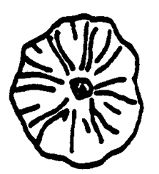 | 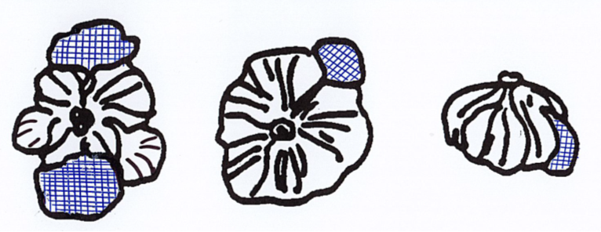
1 | 9
absent | present

Ad. 29: Clove: size
The selected cloves to multiply a vegetative propagated variety have to correspond to the average size of the variety. The smaller and the bigger ones have to be discarded.

Ad. 30: Clove: ground color of scale
TGP/14/6: SECTION 2: BOTANICAL TERMS
Subsection 3: Color: 3. Approaches to Describe Colors and Color Patterns
When an organ has two layers of tissue containing color pigmentation and one layer is covering the other, the colors of the two layers can be described as ground color and over color. The term ground color can be used in different ways:
(a) Ground color:
(i) The ground color is the first color to appear chronologically during the development of the
plant part. Other colors may develop in time in the form of spots, blotches, or a flush.
(ii) The ground color is the color which has a continuous dispersion across the surface of the plant part.
The ground color is not always the color occupying the largest surface area of the plant part concerned.
For certain organs having two layers of tissue containing color pigmentation, and one layer is covering
the other on the upper side of the organ it may be appropriate to determine the ground color by observing the main color of the lower side of the organ.
(b) Over color:
In the case of a plant part which has a ground color upon which a second color such as a flush develops over time, the flush is considered the over color. The over color is not always the color occupying the smallest surface area of the plant part concerned.
Eg. Same ground color and same over color, but in different proportions and intensity.
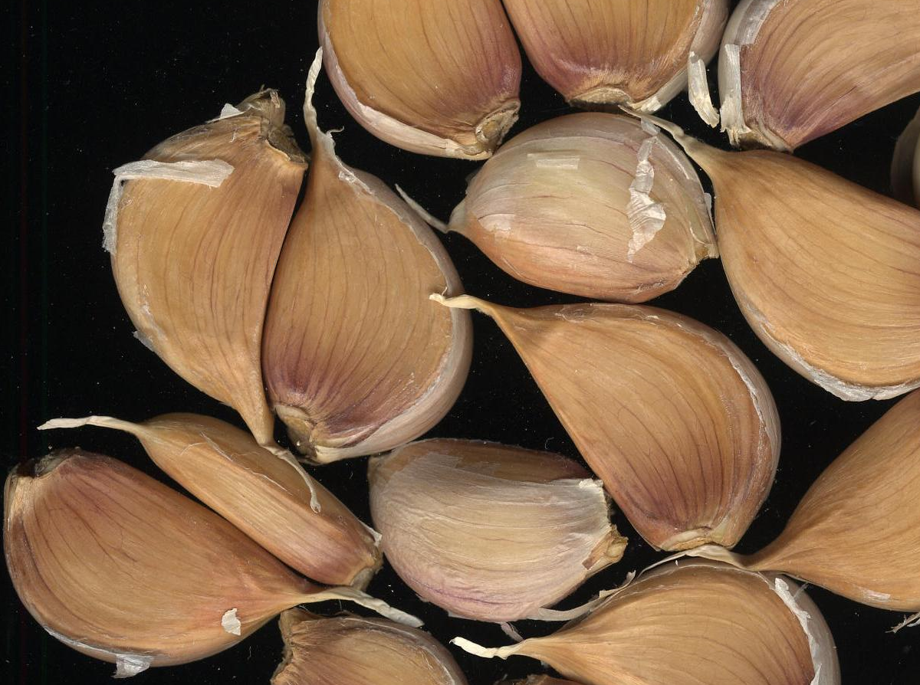 | 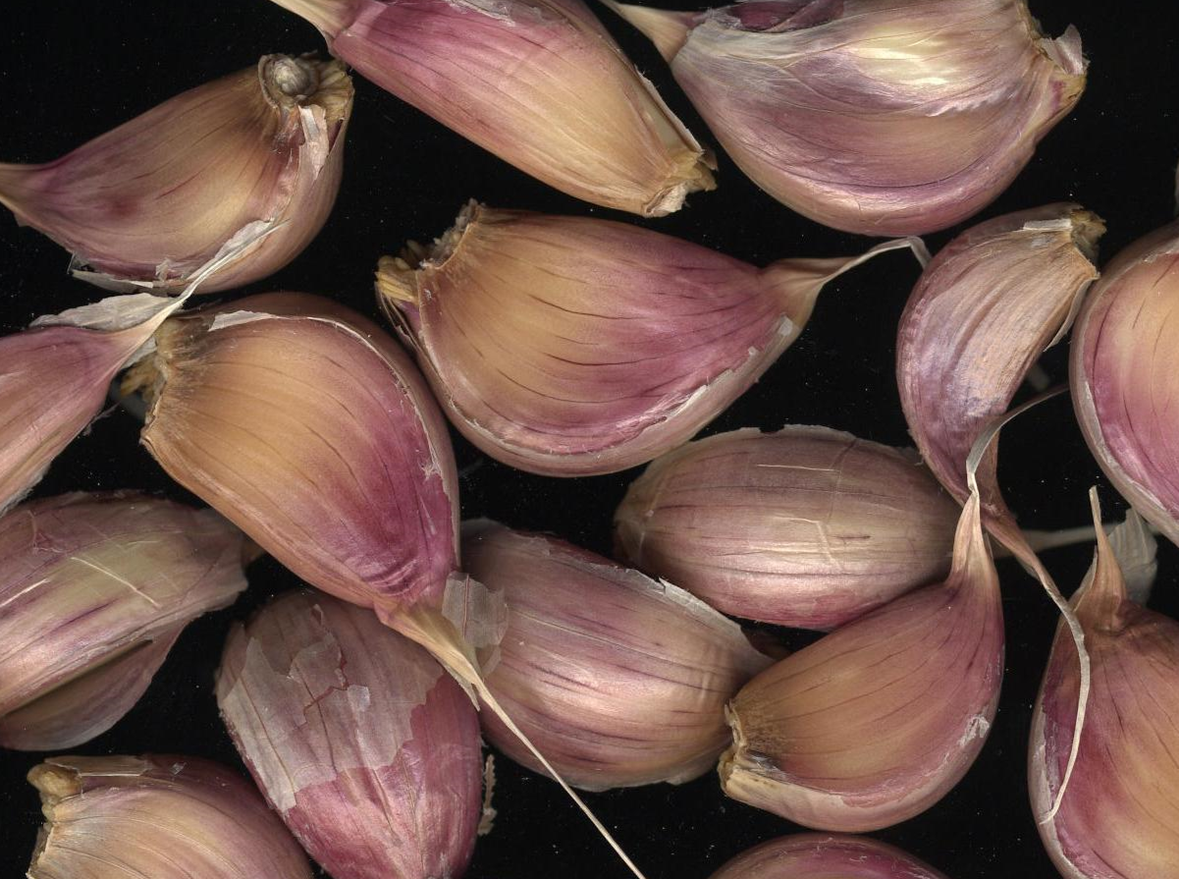

Ad. 31: Clove: intensity of ground color of scale
The varieties with a white scale are not concerned by this characteristic.

Ad. 32: Clove: over color of scale
Cf. Ad. 30: Clove: ground color of scale

Ad. 36: Time of harvest maturity
The time of harvest maturity is estimated (around 50%) thanks to the level of natural senescence of foliage (yellowing and drying of the leaves) in a healthy culture.
This approach has to be calibrated thanks to the expected earliness of each cultigroup. It can potentially be ensured by the observations of the cross section of few harvested bulbs. At the right stage, the cloves are clean, firm an well-defined.
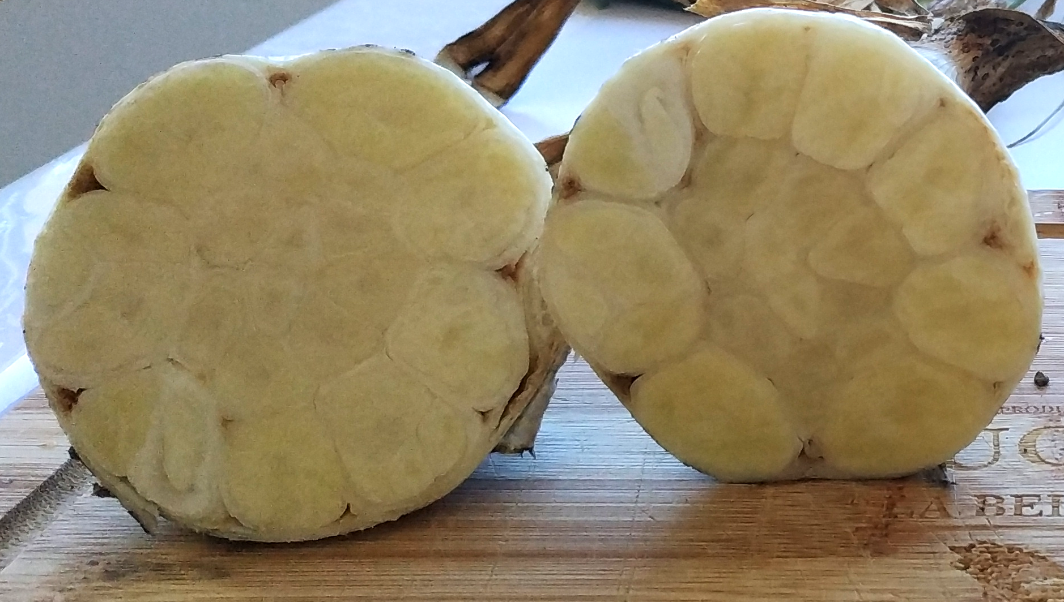
ready to harvest

Ad. 37: End of dormancy of clove in bulb

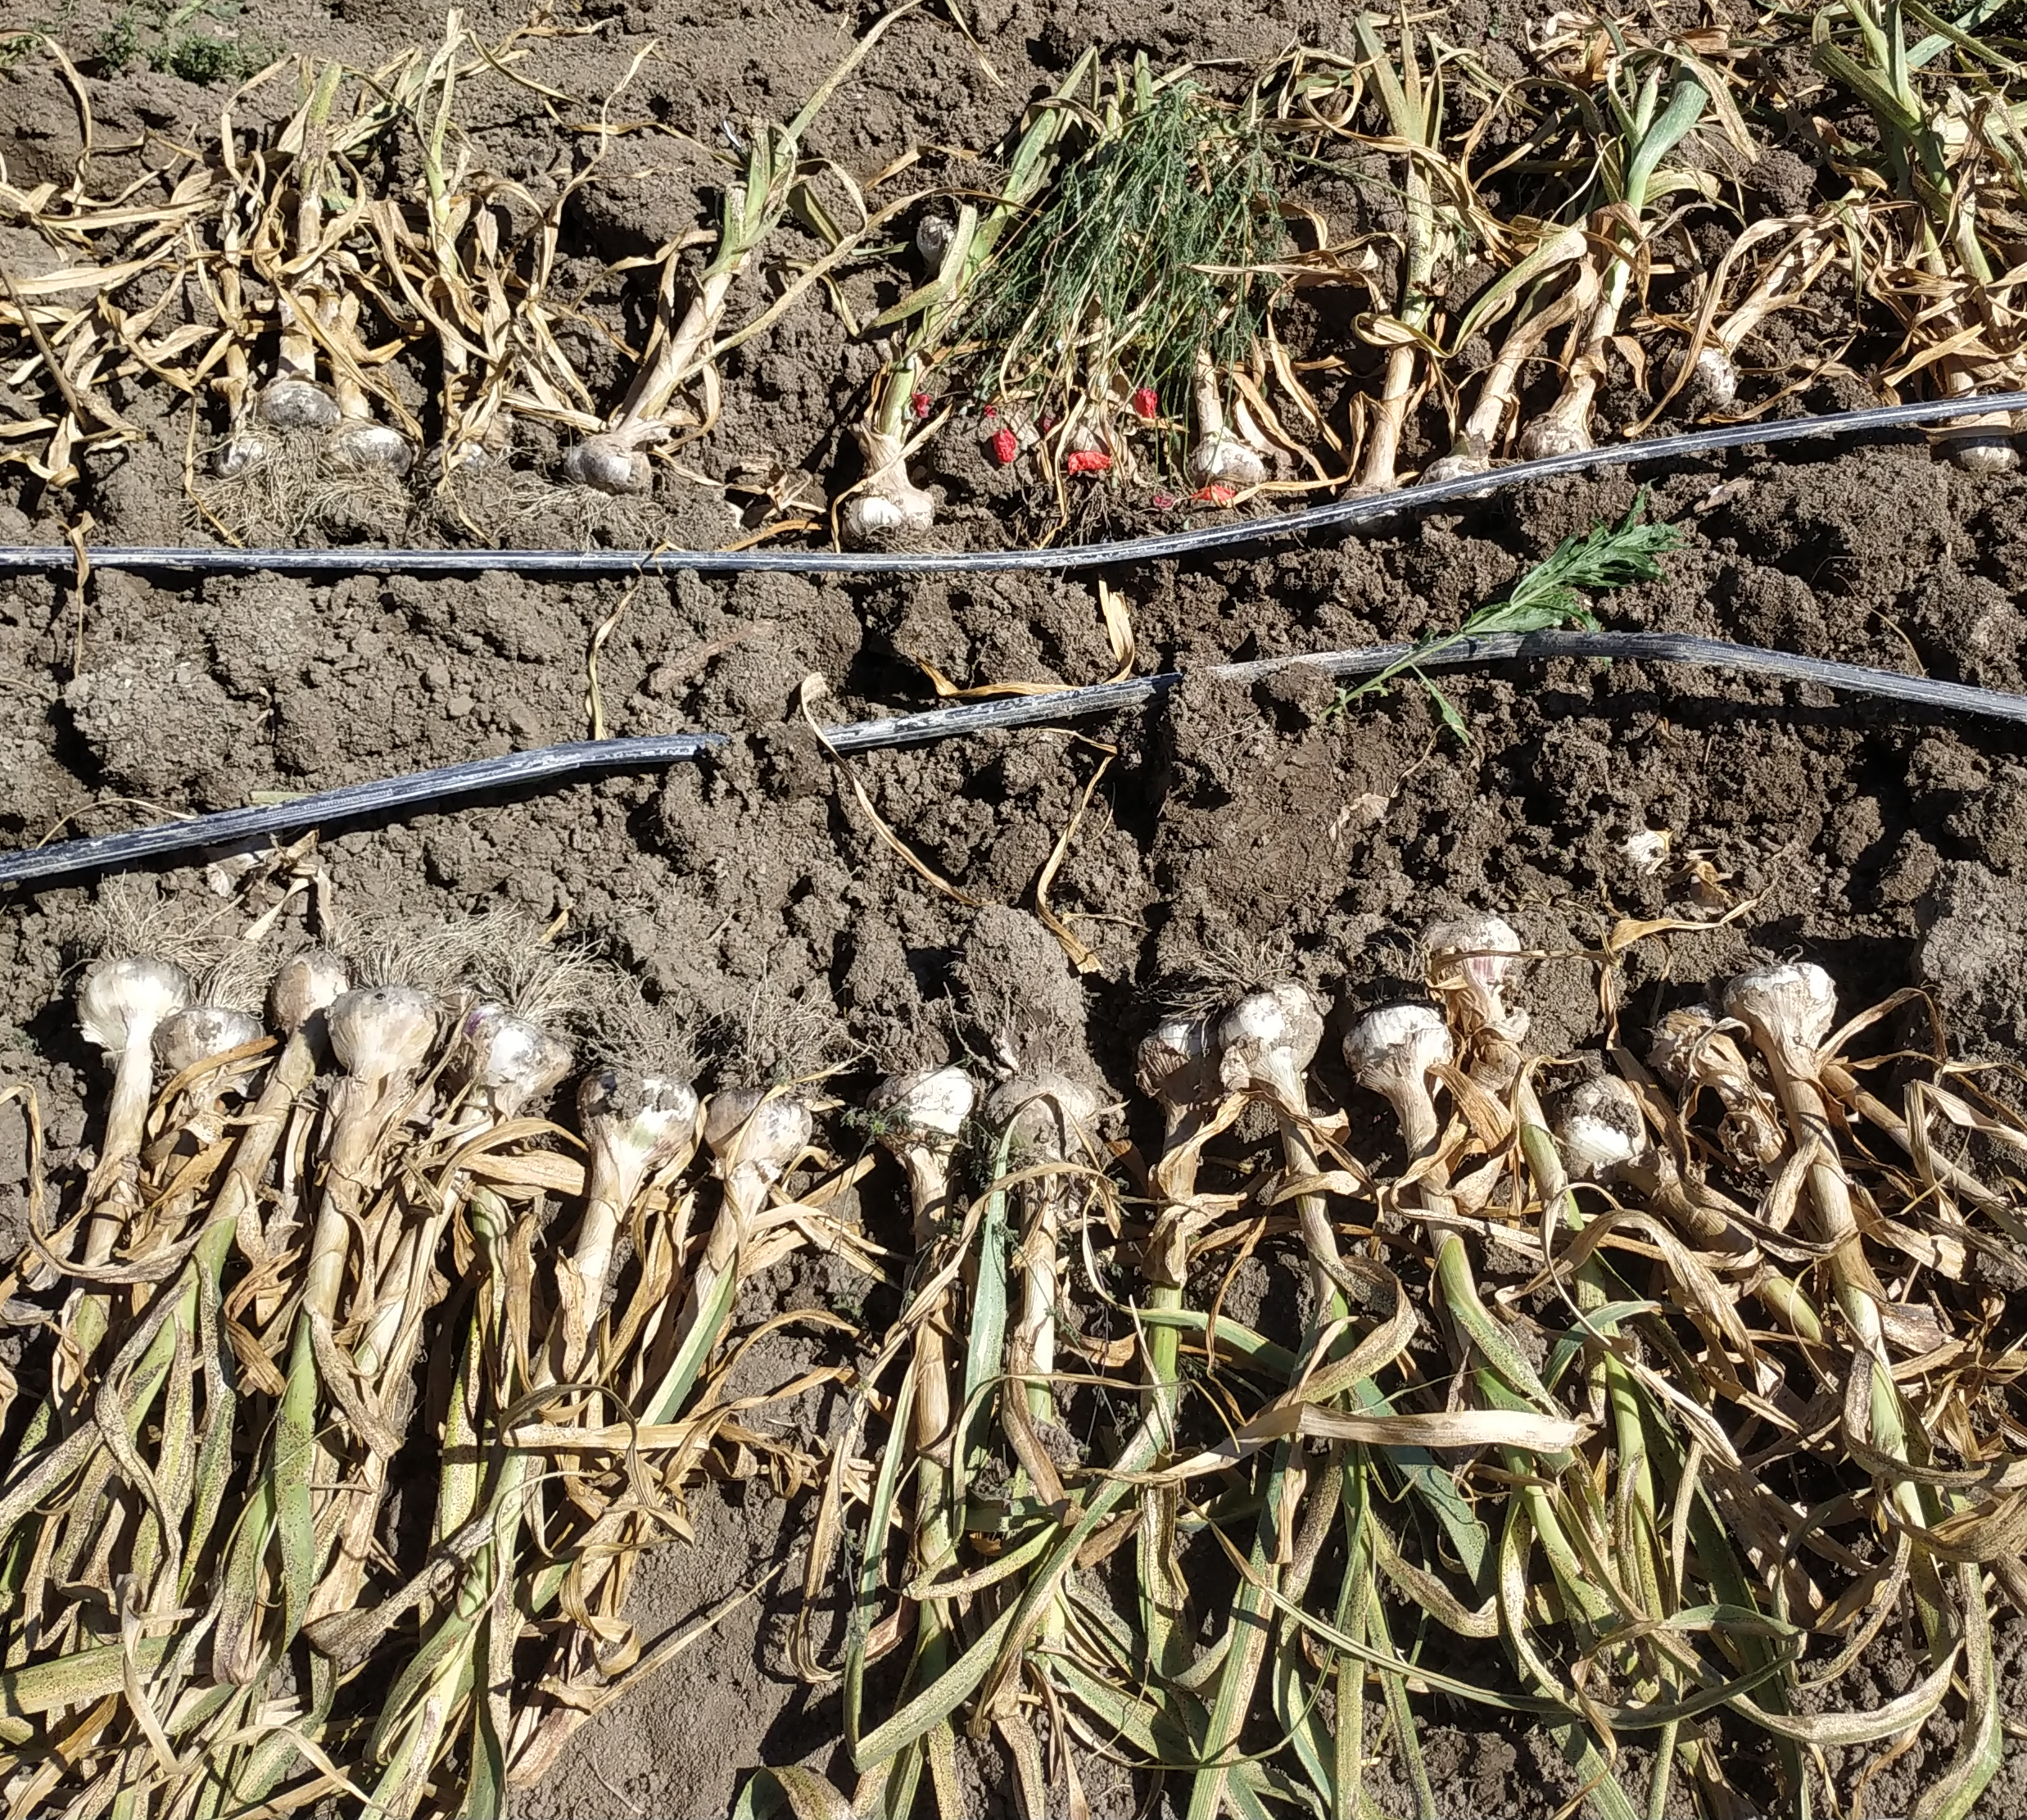 | 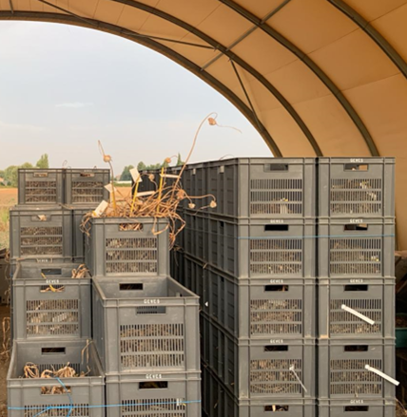 | 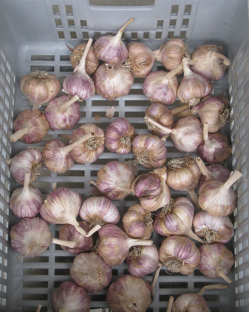
Harvest of plants, with a minimum of soil.  Beginning of the drying at open air, in the field (some hours). | Storage several weeks of the complete plants, in perforated boxes, placed in a ventilated room, to allow a complete drying at open air. | Cleaning of each plant: cutting of the roots and the pseudostem at around 5 cm of the base of the bulb.
The dried and prepared bulbs are stored in a ventilated room at an optimum temperature (20ºC to 25ºC), to avoid ambient excessive humidity, and a managed relative humidity, without being split into cloves.
The end of dormancy is assessed by observing the percentage of sprouted bulbs.
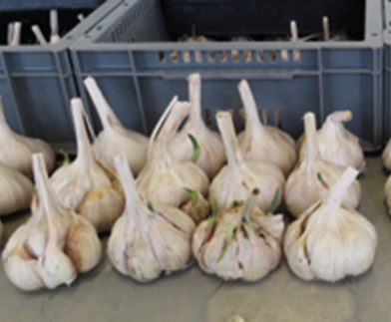

Literature

Brand, R., 1996, “L’Ail, une semence à part dans les Allium”, La Lettre des Ressources Génétiques Végétales, nº 9, octobre 1996, FR pp. 11 to 16.
Messiaen, C. M., Cohat, J., Leroux, J. P., Pichon, M., Beyries, A. 1993: “Vegetatively Propagated Edible Alliums”. Edition
INRA, FR, 222 pp.
Messiaen, C.M., “ La variabilité chez l’Ail”, La Lettre des Ressources Génétiques Végétales, nº 9, octobre 1996, FR, pp. 7 to 10.

Technical Questionnaire

TECHNICAL QUESTIONNAIRE | Page {x} of {y} | Reference Number:

Application date:
(not to be filled in by the applicant)
TECHNICAL QUESTIONNAIRE
to be completed in connection with an application for plant breeders' rights
1. Subject of the Technical Questionnaire

1.1 |  |  | Botanical name |  | Allium sativum L.
1.2 |  |  | Common name |  | Garlic
2. Applicant

 |  | Name
 |  | Address
 |  | Telephone No.
 |  | Fax No.
 |  | E-mail address
 |  | Breeder (if different from applicant)
3. Proposed denomination and breeder's reference

 | Proposed denomination (if available)
 | Breeder's reference

TECHNICAL QUESTIONNAIRE | Page {x} of {y} | Reference Number:

#4. Information on the breeding scheme and propagation of the variety

4.1 Breeding scheme

Variety resulting from:

4.1.1 Crossing

(a) controlled cross [ ]

(b) partially known cross [ ]

(c) unknown cross [ ]

4.1.2 Mutation
(please state parent varieties)

4.1.3 Discovery and development
(please state where and when discovered and how developed)

4.1.4 Other
(Please provide details)

TECHNICAL QUESTIONNAIRE | Page {x} of {y} | Reference Number:

4.2 Method of propagating the variety

4.2.1 Seed-propagated varieties

(a) Cross-pollination [ ]
(b) Hybrid [ ]
(c) Inbred line [ ]
(d) Other (Please provide details) [ ]

4.2.2 Vegetative propagation

(a) Division [ ]
(b) Other (state method) [ ]

4.2.3 Other
(Please provide details) [ ]

TECHNICAL QUESTIONNAIRE |  | Page {x} of {y} |  | Reference Number:
5. Characteristics of the variety to be indicated (the number in brackets refers to the corresponding characteristic in Test Guidelines; please mark the note which best corresponds).

 | Characteristics |  | Example Varieties |  | Note
5.1  (2) | Foliage: attitude
 | erect |  | Jolimont, Vayo |  | 1 [ ]
 | erect to semi-erect |  | Printanor |  | 2 [ ]
 | semi-erect |  | Germidour |  | 3 [ ]
5.2  (3) | Leaf blade: green color
 | very light |  |  |  | 1 [ ]
 | very light to light |  |  |  | 2 [ ]
 | light |  | Primor |  | 3 [ ]
 | light to medium |  |  |  | 4 [ ]
 | medium |  | Messidrome |  | 5 [ ]
 | medium to dark |  |  |  | 6 [ ]
 | dark |  | Germidour |  | 7 [ ]
 | dark to very dark |  | Valdour |  | 8 [ ]
 | very dark |  |  |  | 9 [ ]
5.3  (4) | Leaf blade: waxiness
 | absent or very weak |  |  |  | 1 [ ]
 | weak |  | Sprint |  | 2 [ ]
 | medium |  | Messidrome |  | 3 [ ]
 | strong |  | Germidour |  | 4 [ ]
 | very strong |  | Gayant, Printanor |  | 5 [ ]
5.4  (11) | Pseudostem: flowering stem
 | absent |  | Germidour |  | 1 [ ]
 | present |  | Rose de Lautrec |  | 9 [ ]

TECHNICAL QUESTIONNAIRE |  | Page {x} of {y} |  | Reference Number:
 | Characteristics |  | Example Varieties |  | Note
5.5  (13) | Only for varieties with Pseudostem: flowering stem present: length
 | very short |  |  |  | 1 [ ]
 | short |  | Rose de Lautrec |  | 2 [ ]
 | medium |  | Precosem |  | 3 [ ]
 | long |  | Sultop |  | 4 [ ]
 | very long |  |  |  | 5 [ ]
5.6  (14) | Bulb: size
 | very small |  |  |  | 1 [ ]
 | very small to small |  |  |  | 2 [ ]
 | small |  | Vacoa |  | 3 [ ]
 | small to medium |  |  |  | 4 [ ]
 | medium |  | Printanor |  | 5 [ ]
 | medium to large |  |  |  | 6 [ ]
 | large |  | Messidrome |  | 7 [ ]
 | large to very large |  |  |  | 8 [ ]
 | very large |  |  |  | 9 [ ]
5.7  (15) | Bulb: shape in longitudinal section
 | transverse narrow elliptic |  | Sprint |  | 1 [ ]
 | transverse broad elliptic |  | Germidour |  | 2 [ ]
 | circular |  |  |  | 3 [ ]
5.8  (21) | Bulb: ground color of dry external scales
 | white |  | Aulxito, Printanor |  | 1 [ ]
 | yellowish white |  | Jolimont, Vigor Supreme |  | 2 [ ]
5.9  (23) | Bulb: anthocyanin stripes on dry external scales
 | absent or weak |  | Aulxito, Printanor |  | 1 [ ]
 | medium |  | Germidour |  | 2 [ ]
 | strong |  |  |  | 3 [ ]
5.10  (28) | Bulb: external cloves
 | absent |  | Sprint, Sultop |  | 1 [ ]
 | present |  | Messidor |  | 9 [ ]

TECHNICAL QUESTIONNAIRE |  | Page {x} of {y} |  | Reference Number:
 | Characteristics |  | Example Varieties |  | Note
5.11  (29) | Clove: size
 | very small |  |  |  | 1 [ ]
 | veru small to small |  |  |  | 2 [ ]
 | small |  | Rose de Lautrec |  | 3 [ ]
 | small to medium |  |  |  | 4 [ ]
 | medium |  | Printanor |  | 5 [ ]
 | medium to large |  |  |  | 6 [ ]
 | large |  | Germidour |  | 7 [ ]
 | large to very large |  |  |  | 8 [ ]
 | very large |  |  |  | 9 [ ]
5.12  (30) | Clove: ground color of scale
 | white |  |  |  | 1 [ ]
 | yellowish white |  | Messidrome |  | 2 [ ]
 | pink |  | Printanor |  | 3 [ ]
 | purple |  |  |  | 4 [ ]
 | brown |  | Corail |  | 5 [ ]
5.13  (32) | Clove: over color of scale
 | absent |  | Messidrome |  | 1 [ ]
 | yellowish white |  |  |  | 2 [ ]
 | pink |  | Iberose |  | 3 [ ]
 | purple |  |  |  | 4 [ ]
 | brown |  |  |  | 5 [ ]
5.14  (35) | Clove: color of flesh
 | white |  | Printanor |  | 1 [ ]
 | yellowish |  | Germidour |  | 2 [ ]

TECHNICAL QUESTIONNAIRE |  | Page {x} of {y} |  | Reference Number:
 | Characteristics |  | Example Varieties |  | Note
5.15  (36) | Time of harvest maturity
 | very early |  |  |  | 1 [ ]
 | very early to early |  | Primor |  | 2 [ ]
 | early |  | Sprint |  | 3 [ ]
 | early to medium |  | Dario |  | 4 [ ]
 | medium |  | Germidour, Messidrome |  | 5 [ ]
 | medium to late |  | Iberose |  | 6 [ ]
 | late |  | Printanor |  | 7 [ ]
 | late to very late |  | Flavor |  | 8 [ ]
 | late very late |  | Ail du Nord, Gayant |  | 9 [ ]
5.16  (37) | End of dormancy of clove in bulb
 | very early |  |  |  | 1 [ ]
 | very early to early |  |  |  | 2 [ ]
 | early |  | Sprint |  | 3 [ ]
 | early to medium |  | Messidrome |  | 4 [ ]
 | medium |  | Rose de Lautrec |  | 5 [ ]
 | medium to late |  |  |  | 6 [ ]
 | late |  | Flavor |  | 7 [ ]
 | late to very late |  |  |  | 8 [ ]
 | very late |  | Ail du Nord, Gayant |  | 9 [ ]

TECHNICAL QUESTIONNAIRE |  | Page {x} of {y} |  | Reference Number:
6. Similar varieties and differences from these varieties

Please use the following table and box for comments to provide information on how your candidate variety differs from the variety (or varieties) which, to the best of your knowledge, is (or are) most similar. This information may help the examination authority to conduct its examination of distinctness in a more efficient way

Denomination(s) of variety(ies) similar to your candidate variety | Characteristic(s) in which your candidate variety differs from the similar variety(ies) |  | Describe the expression of the characteristic(s) for the similar variety(ies) |  | Describe the expression of the characteristic(s) for your candidate variety
Example
Comments

TECHNICAL QUESTIONNAIRE | Page {x} of {y} | Reference Number:
#7. Additional information which may help in the examination of the variety

7.1 In addition to the information provided in sections 5 and 6, are there any additional characteristics which may help to distinguish the variety?

Yes [ ] No [ ]

(If yes, please provide details)

7.2 Are there any special conditions for growing the variety or conducting the examination?

Yes [ ] No [ ]

(If yes, please provide details)

7.3 Other information

A representative color photograph of the variety displaying its main distinguishing feature(s), should accompany the Technical Questionnaire. The photograph will provide a visual illustration of the candidate variety which supplements the information provided in the Technical Questionnaire.

The key points to consider when taking a photograph of the candidate variety are:

• Indication of the date and geographic location
• Correct labeling (breeder's reference)
• Good quality printed photograph (minimum 10 cm x 15 cm) and/or sufficient resolution electronic format version (minimum 960 x 1280 pixels)

Further guidance on providing photographs with the Technical Questionnaire is available in document TGP/7 "Development of Test Guidelines", Guidance Note 35 (http://www.upov.int/tgp/en/).

The link provided may be deleted by members of the Union when developing authorities' own test guidelines.

7.* Representative color phtotograph requested
7.* Resistance to pests and diseases
Please specify:
7.* Special conditions for the examination of the variety
7.* Type
Long-day type Autumn [ ]
Short-day type Spring [ ]
7.* Other information

TECHNICAL QUESTIONNAIRE | Page {x} of {y} | Reference Number:
8. Authorization for release

(a) Does the variety require prior authorization for release under legislation concerning the protection of the environment, human and animal health?

Yes [ ] No [ ]

(b) Has such authorization been obtained?

Yes [ ] No [ ]

If the answer to (b) is yes, please attach a copy of the authorization.
9. Information on plant material to be examined or submitted for examination

9.1 The expression of a characteristic or several characteristics of a variety may be affected by factors, such as pests and disease, chemical treatment (e.g. growth retardants or pesticides), effects of tissue culture, different rootstocks, scions taken from different growth phases of a tree, etc.

9.2 The plant material should not have undergone any treatment which would affect the expression of the characteristics of the variety, unless the competent authorities allow or request such treatment. If the plant material has undergone such treatment, full details of the treatment must be given. In this respect, please indicate below, to the best of your knowledge, if the plant material to be examined has been subjected to:

(a) Microorganisms (e.g. virus, bacteria, phytoplasma) Yes [ ] No [ ]

(b) Chemical treatment (e.g. growth retardant, pesticide) Yes [ ] No [ ]

(c) Tissue culture Yes [ ] No [ ]

(d) Other factors Yes [ ] No [ ]

Please provide details for where you have indicated "yes".

____________________________________________________________

9.3 Has the plant material to be examined been tested for the presence of virus or other pathogens?

Yes [ ]

(please provide details as specified by the Authority)

No [ ]

9.4 The provided material (application and/or example variety) must be in good sanitary condition and free from virus, in particular from Onion yellow dwarf virus (OYDV) and Leek yellow stripe virus (LYSV).

10. I hereby declare that, to the best of my knowledge, the information provided in this form is correct:

Applicant's name
Signature |  | Date
 | [End of document]

