d |  |  |  | E  TG/130/5(proj.2)  ORIGINAL: English  DATE: 2026-04-03
INTERNATIONAL UNION FOR THE PROTECTION OF NEW VARIETIES OF PLANTS
Geneva
 |  | DRAFT

 | ASPARAGUS  UPOV Code(s): ASPAR_OFF  Asparagus officinalis L. | *

GUIDELINES
FOR THE CONDUCT OF TESTS
FOR DISTINCTNESS, UNIFORMITY AND STABILITY

prepared by an expert from the Netherlands (Kingdom of)

to be considered by the

Technical Working Party for Vegetables at its sixtieth session,
to be held in Pacific Grove, California, United States of America from 2026-05-18 to 2026-05-21

Disclaimer: this document does not represent UPOV policies or guidance

Alternative Names:*

Botanical name | English | French | German | Spanish
Asparagus officinalis L. | Asparagus | Asperge | Spargel | Espárrago

The purpose of these guidelines (“Test Guidelines”) is to elaborate the principles contained in the General Introduction (document TG/1/3), and its associated TGP documents, into detailed practical guidance for the harmonized examination of distinctness, uniformity and stability (DUS) and, in particular, to identify appropriate characteristics for the examination of DUS and production of harmonized variety descriptions.

ASSOCIATED DOCUMENTS

These Test Guidelines should be read in conjunction with the General Introduction and its associated
TGP documents.

TABLE OF CONTENTS PAGE
1. Subject of these Test Guidelines 3
2. Material Required 3
3. Method of Examination 3
3.1 Number of Growing Cycles 3
3.2 Testing Place 3
3.3 Conditions for Conducting the Examination 3
3.4 Test Design 3
3.5 Additional Tests 4
4. Assessment of Distinctness, Uniformity and Stability 4
4.1 Distinctness 4
4.2 Uniformity 5
4.3 Stability 5
5. Grouping of Varieties and Organization of the Growing Trial 5
6. Introduction to the Table of Characteristics 6
6.1 Categories of Characteristics 6
6.2 States of Expression and Corresponding Notes 6
6.3 Types of Expression 6
6.4 Example Varieties 6
6.5 Legend 7
7. Table of Characteristics/Tableau des caracteres/Merkmalstabelle/Tabla de caracteres 8
8. Explanations on the Table of Characteristics 12
8.1 Explanations covering several characteristics 12
8.2 Explanations for individual characteristics 12
9. Literature 18
10. Technical Questionnaire 19

Subject of these Test Guidelines

These Test Guidelines apply to all varieties of Asparagus officinalis L.

Material Required

2.1 The competent authorities decide on the quantity and quality of the plant material required for testing the variety and when and where it is to be delivered. Applicants submitting material from a State other than that in which the testing takes place must ensure that all customs formalities and phytosanitary requirements are complied with.

2.2 The material is to be supplied in the form of seeds or plants.

2.3 The minimum quantity of plant material, to be supplied by the applicant, should be:

Seed-propagated varieties: 600 seeds
Vegetatively propagated varieties: 30 plants

In the case of seed, the seed should meet the minimum requirements for germination, species and analytical purity, health and moisture content, specified by the competent authority.

2.4 The plant material supplied should be visibly healthy, not lacking in vigor, nor affected by any important pest or disease.

2.5 The plant material should not have undergone any treatment which would affect the expression of the characteristics of the variety, unless the competent authorities allow or request such treatment. If it has been treated, full details of the treatment must be given.

Method of Examination

Number of Growing Cycles

3.1.1 The minimum duration of tests should normally be two independent growing cycles.

3.1.2 The two independent growing cycles may be observed from a single planting, examined in two separate growing cycles.

3.1.3 The testing of a variety may be concluded when the competent authority can determine with certainty the outcome of the test.

Testing Place

Tests are normally conducted at one place. In the case of tests conducted at more than one place, guidance is provided in TGP/9 "Examining Distinctness".

Conditions for Conducting the Examination

3.3.1 The tests should be carried out under conditions ensuring satisfactory growth for the expression of the relevant characteristics of the variety and for the conduct of the examination.

3.3.2 The optimum stage of development for the assessment of each characteristic is indicated by a reference in the Table of Characteristics. The stages of development denoted by each reference are described in Chapter 8.

Test Design

3.4.1 In the case of seed-propagated varieties, each test should be designed to result in a total of at least 40 plants, which should be divided between at least 2 replicates.

3.4.2 In the case of vegetatively propagated varieties, each test should be designed to result in a total of at least 20 plants, which should be divided between at least 2 replicates.

3.4.3 The design of the tests should be such that plants or parts of plants may be removed for measurement or counting without prejudice to the observations which must be made up to the end of the growing cycle.

Additional Tests

Additional tests, for examining relevant characteristics, may be established.

Assessment of Distinctness, Uniformity and Stability

Distinctness

4.1.1 General Recommendations

It is of particular importance for users of these Test Guidelines to consult the General Introduction prior to making decisions regarding distinctness. However, the following points are provided for elaboration or emphasis in these Test Guidelines.

4.1.2 Consistent Differences

The differences observed between varieties may be so clear that more than one growing cycle is not necessary. In addition, in some circumstances, the influence of the environment is not such that more than a single growing cycle is required to provide assurance that the differences observed between varieties are sufficiently consistent. One means of ensuring that a difference in a characteristic, observed in a growing trial, is sufficiently consistent is to examine the characteristic in at least two independent growing cycles.

4.1.3 Clear Differences

Determining whether a difference between two varieties is clear depends on many factors, and should consider, in particular, the type of expression of the characteristic being examined, i.e. whether it is expressed in a qualitative, quantitative, or pseudo-qualitative manner. Therefore, it is important that users of these Test Guidelines are familiar with the recommendations contained in the General Introduction prior to making decisions regarding distinctness.

4.1.4 Number of Plants or Parts of Plants to be Examined

In the case of seed-propagated varieties, unless otherwise indicated, for the purposes of distinctness, all observations on single plants should be made on 40 plants or parts taken from each of 40 plants and any other observation made on all plants in the test, disregarding any off-type plants.

In the case of observations of parts taken from single plants, the number of parts to be taken from each of the plants should be 20.

In the case of vegetatively propagated varieties, unless otherwise indicated, for the purposes of distinctness, all observations on single plants should be made on 20 plants or parts taken from each of 20 plants and any other observation made on all plants in the test, disregarding any off-type plants.

In the case of observations of parts taken from single plants, the number of parts to be taken from each of the plants should be 10.

4.1.5 Method of Observation

The recommended method of observing the characteristic for the purposes of distinctness is indicated by the following key in the Table of Characteristics (see document TGP/9 "Examining Distinctness", Section 4 "Observation of characteristics"):

MG: single measurement of a group of plants or parts of plants
MS: measurement of a number of individual plants or parts of plants
VG: visual assessment by a single observation of a group of plants or parts of plants
VS: visual assessment by observation of individual plants or parts of plants

Type of observation: visual (V) or measurement (M)

"Visual" observation (V) is an observation made on the basis of the expert's judgment. For the purposes of this document, "visual" observation refers to the sensory observations of the experts and, therefore, also includes smell, taste and touch. Visual observation includes observations where the expert uses reference points (e.g. diagrams, example varieties, side-by-side comparison) or non-linear charts (e.g. color charts). Measurement (M) is an objective observation against a calibrated, linear scale e.g. using a ruler, weighing scales, colorimeter, dates, counts, etc.

Type of record: for a group of plants (G) or for single, individual plants (S)

For the purposes of distinctness, observations may be recorded as a single record for a group of plants or parts of plants (G), or may be recorded as records for a number of single, individual plants or parts of plants (S). In most cases, "G" provides a single record per variety and it is not possible or necessary to apply statistical methods in a plant-by-plant analysis for the assessment of distinctness.

In cases where more than one method of observing the characteristic is indicated in the Table of Characteristics (e.g. VG/MG), guidance on selecting an appropriate method is provided in document TGP/9, Section 4.2.

Uniformity

4.2.1 It is of particular importance for users of these Test Guidelines to consult the General Introduction prior to making decisions regarding uniformity. However, the following points are provided for elaboration or emphasis in these Test Guidelines:

4.2.2 These Test Guidelines have been developed for the examination of seed-propagated varieties and vegetatively propagated varieties. For varieties with other types of propagation, the recommendations in the General Introduction and document TGP/13 "Guidance for new types and species" Section 4.5 "Testing Uniformity" should be followed.

4.2.3 The assessment of uniformity for seed-propagated should be according to the recommendations for cross-pollinated varieties in the General Introduction.

4.2.4 For the assessment of uniformity of vegetatively propagated varieties and male F1 hybrids, a population standard of 1% and an acceptance probability of at least 95% should be applied. In the case of a sample size of 20 plants, 1 off-type is allowed. In the case of a sample of 40 plants, 2 off-types are allowed.

Stability

4.3.1 In practice, it is not usual to perform tests of stability that produce results as certain as those of the testing of distinctness and uniformity. However, experience has demonstrated that, for many types of variety, when a variety has been shown to be uniform, it can also be considered to be stable.

4.3.2 Where appropriate, or in cases of doubt, stability may be further examined by testing a new seed or plant stock to ensure that it exhibits the same characteristics as those shown by the initial material supplied.

Grouping of Varieties and Organization of the Growing Trial

5.1 The selection of varieties of common knowledge to be grown in the trial with the candidate varieties and the way in which these varieties are divided into groups to facilitate the assessment of distinctness are aided by the use of grouping characteristics.

5.2 Grouping characteristics are those in which the documented states of expression, even where produced at different locations, can be used, either individually or in combination with other such characteristics: (a) to select varieties of common knowledge that can be excluded from the growing trial used for examination of distinctness; and (b) to organize the growing trial so that similar varieties are grouped together.

5.3 The following have been agreed as useful grouping characteristics:

(a) Spear: anthocyanin coloration of apex (characteristic 2)
(b) Plant: intensity of green coloration of foliage (characteristic 11)
(c) Stem: length (characteristic 12)
(d) Type of flowering (characteristic 15)

5.4 Guidance for the use of grouping characteristics, in the process of examining distinctness, is provided through the General Introduction and document TGP/9 "Examining Distinctness".

Introduction to the Table of Characteristics

Categories of Characteristics

6.1.1 Standard Test Guidelines Characteristics

Standard Test Guidelines characteristics are those which are approved by UPOV for examination of DUS and from which members of the Union can select those suitable for their particular circumstances.

6.1.2 Asterisked Characteristics

Asterisked characteristics (denoted by *) are those included in the Test Guidelines which are important for the international harmonization of variety descriptions and should always be examined for DUS and included in the variety description by all members of the Union, except when the state of expression of a preceding characteristic or regional environmental conditions render this inappropriate.

States of Expression and Corresponding Notes

6.2.1 States of expression are given for each characteristic to define the characteristic and to harmonize descriptions. Each state of expression is allocated a corresponding numerical note for ease of recording of data and for the production and exchange of the description.

6.2.2 All relevant states of expression are presented in the characteristic.

6.2.3 Further explanation of the presentation of states of expression and notes is provided in document TGP/7 "Development of Test Guidelines".

Types of Expression

An explanation of the types of expression of characteristics (qualitative, quantitative and pseudo-qualitative) is provided in the General Introduction.

Example Varieties

Where appropriate, example varieties are provided to clarify the states of expression of each characteristic.

Legend

 |  | English |  | français |  | deutsch | español | Example Varieties  Exemples  Beispielssorten  Variedades ejemplo | Note/  Nota
1 | 2 | 3 | 4 | 5 | 6 | 7
 |  | Name of characteristics in English |  | Nom du caractère en français |  | Name des Merkmals auf Deutsch | Nombre del carácter en español
 |  | states of expression |  | types d’expression |  | Ausprägungsstufen | tipos de expresión

1 Characteristic number

2 (*) sterisked characteristic – see Chapter 6.1.2

3 Type of expression
QL Qualitative characteristic – see Chapter 6.3
QN Quantitative characteristic – see Chapter 6.3
PQ Pseudo-qualitative characteristic – see Chapter 6.3

4 Method of observation (and type of plot, if applicable)
MG, MS, VG, VS – see Chapter 4.1.5

5 (+) See Explanations on the Table of Characteristics in Chapter 8.2

6 (a)-(c) See Explanations on the Table of Characteristics in Chapter 8.1

7 Not applicable

Table of Characteristics/Tableau des caracteres/Merkmalstabelle/Tabla de caracteres

 |  | English |  | français |  | deutsch | español | Example Varieties  Exemples  Beispielssorten  Variedades ejemplo | Note/  Nota
1. | (*) | QN | MS | (+) | (a)
 |  | Time of emergence of spears
 |  | very early |  |  |  |  |  |  | 1
 |  | very early to early |  |  |  |  |  |  | 2
 |  | early |  |  |  |  |  | Gijnlim | 3
 |  | early to medium |  |  |  |  |  |  | 4
 |  | medium |  |  |  |  |  | Darbella, Herkolim | 5
 |  | medium to late |  |  |  |  |  |  | 6
 |  | late |  |  |  |  |  | Backlim | 7
 |  | late to very late |  |  |  |  |  |  | 8
 |  | very late |  |  |  |  |  |  | 9
2. | (*) | QL | VG | (+) | (a)
 |  | Spear: anthocyanin coloration of apex
 |  | absent |  |  |  |  |  | Xenolim | 1
 |  | present |  |  |  |  |  | Backlim | 9
3. |  | QN | VG | (+) | (a)
 |  | Only varieties with Spear: anthocyanin coloration of apex present Spear: anthocyanin coloration of apex
 |  | very weak |  |  |  |  |  |  | 1
 |  | weak |  |  |  |  |  | Robbems | 2
 |  | medium |  |  |  |  |  | Spartacus | 3
 |  | strong |  |  |  |  |  | Terralim | 4
 |  | very strong |  |  |  |  |  | Erasmus | 5
4. | (*) | QN | VG | (+) | (a)
 |  | Spear: shape of apex
 |  | acute |  |  |  |  |  | Dariana | 1
 |  | obtuse |  |  |  |  |  | Grolim | 2
 |  | rounded |  |  |  |  |  |  | 3
5. |  | QN | VG | (+) | (a)
 |  | Spear: opening of bracts
 |  | weak |  |  |  |  |  | UC 157 | 1
 |  | medium |  |  |  |  |  | Gijnlim | 2
 |  | strong |  |  |  |  |  |  | 3
6. | (*) | QN | MS/VG |  | (a)
 |  | Spear: size of first bracts at base of apex
 |  | very small |  |  |  |  |  |  | 1
 |  | small |  |  |  |  |  |  | 2
 |  | medium |  |  |  |  |  | Grolim, Herkolim | 3
 |  | large |  |  |  |  |  | Sanukinomezame Violeta | 4
 |  | very large |  |  |  |  |  |  | 5
7. |  | QL | VG | (+) | (b)
 |  | Spear: anthocyanin coloration of stem
 |  | absent |  |  |  |  |  | Spartacus | 1
 |  | present |  |  |  |  |  | Sanukinomezame Violeta | 9
8. |  | QN | VG |  | (b)
 |  | Only for varieties with Spear: anthocyanin coloration of stem: present Spear: anthocyanin coloration of stem
 |  | weak |  |  |  |  |  |  | 1
 |  | medium |  |  |  |  |  | Harumurasakil Efu | 2
 |  | strong |  |  |  |  |  | Sanukinomezame Violeta | 3
9. | (*) | QN | VG |  | (c)
 |  | Plant: number of stems
 |  | very few |  |  |  |  |  |  | 1
 |  | very few to few |  |  |  |  |  |  | 2
 |  | few |  |  |  |  |  | Atlas, Darbella | 3
 |  | few to medium |  |  |  |  |  |  | 4
 |  | medium |  |  |  |  |  | Avalim | 5
 |  | medium to many |  |  |  |  |  |  | 6
 |  | many |  |  |  |  |  | Amadeus | 7
 |  | many to very many |  |  |  |  |  |  | 8
 |  | very many |  |  |  |  |  |  | 9
10. |  | QN | VG | (+) | (c)
 |  | Plant: density of phylloclades
 |  | very sparse |  |  |  |  |  |  | 1
 |  | very sparse to sparse |  |  |  |  |  |  | 2
 |  | sparse |  |  |  |  |  | Magnus | 3
 |  | sparse to medium |  |  |  |  |  |  | 4
 |  | medium |  |  |  |  |  | Grolim | 5
 |  | medium to dense |  |  |  |  |  |  | 6
 |  | dense |  |  |  |  |  | Amadeus | 7
 |  | dense to very dense |  |  |  |  |  |  | 8
 |  | very dense |  |  |  |  |  |  | 9
11. | (*) | QN | VG |  | (c)
 |  | Plant: intensity of green coloration of foliage
 |  | very light |  |  |  |  |  |  | 1
 |  | very light to light |  |  |  |  |  |  | 2
 |  | light |  |  |  |  |  | Atlas | 3
 |  | light to medium |  |  |  |  |  |  | 4
 |  | medium |  |  |  |  |  | Vegalim | 5
 |  | medium to dark |  |  |  |  |  |  | 6
 |  | dark |  |  |  |  |  | Avalim, Grolim | 7
 |  | dark to very dark |  |  |  |  |  |  | 8
 |  | very dark |  |  |  |  |  |  | 9
12. | (*) | QN | MS/VG | (+) | (c)
 |  | Stem: length
 |  | very short |  |  |  |  |  |  | 1
 |  | very short to short |  |  |  |  |  |  | 2
 |  | short |  |  |  |  |  | Argenteuil | 3
 |  | short to medium |  |  |  |  |  |  | 4
 |  | medium |  |  |  |  |  | Vitalim | 5
 |  | medium to long |  |  |  |  |  |  | 6
 |  | long |  |  |  |  |  | Vegalim | 7
 |  | long to very long |  |  |  |  |  |  | 8
 |  | very long |  |  |  |  |  | Inkalim | 9
13. | (*) | QN | MS/VG | (+) | (c)
 |  | Stem: length up to first ramification
 |  | very short |  |  |  |  |  |  | 1
 |  | very short to short |  |  |  |  |  |  | 2
 |  | short |  |  |  |  |  | Argenteuil | 3
 |  | short to medium |  |  |  |  |  |  | 4
 |  | medium |  |  |  |  |  | Avalim, Gijnlim | 5
 |  | medium to long |  |  |  |  |  |  | 6
 |  | long |  |  |  |  |  | Thielim | 7
 |  | long to very long |  |  |  |  |  |  | 8
 |  | very long |  |  |  |  |  |  | 9
14. | (*) | QN | VG |  | (c)
 |  | Stem: diameter at ground level
 |  | very small |  |  |  |  |  |  | 1
 |  | very small to small |  |  |  |  |  |  | 2
 |  | small |  |  |  |  |  | Ercole | 3
 |  | small to medium |  |  |  |  |  |  | 4
 |  | medium |  |  |  |  |  | Gijnlim | 5
 |  | medium to large |  |  |  |  |  |  | 6
 |  | large |  |  |  |  |  | Darbella, Grolim | 7
 |  | large to very large |  |  |  |  |  |  | 8
 |  | very large |  |  |  |  |  |  | 9
15. | (*) | QL | VG | (+) | (c)
 |  | Type of flowering
 |  | only plants with male flowers without style rudiments |  |  |  |  |  | Cumulus | 1
 |  | plants with male flowers and plants with female flowers |  |  |  |  |  | Argenteuil | 2
 |  | only plants with male flowers with style rudiments |  |  |  |  |  | Backlim, Gijnlim | 3
 |  | only plants with female flowers |  |  |  |  |  | L324 | 4

Explanations on the Table of Characteristics

Explanations covering several characteristics

Characteristics containing the following key in the Table of Characteristics should be examined as indicated below:

(a) to be observed at emergence of spears.

(b) to be observed at harvest time

(c) to be observed on non harvested plants at the end of the growing season, when the plants and phylloclades are fully developed.

Explanations for individual characteristics

Ad. 1: Time of emergence of spears

The time of emergence of spears is when at least 30% of the plants have at least 1 spear emerged.

Ad. 2: Spear: anthocyanin coloration of apex

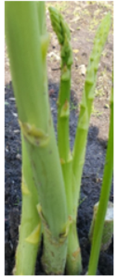 | 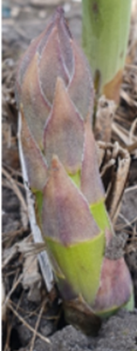
1 | 9
absent | present

Ad. 3: Only varieties with Spear: anthocyanin coloration of apex present Spear: anthocyanin coloration of apex

 | 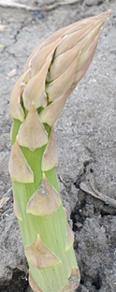 | 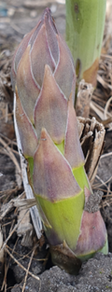 | 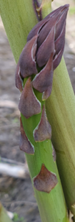 | 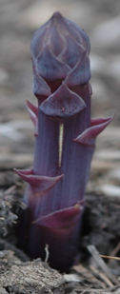
1 | 2 | 3 | 4 | 5
very weak | weak | medium | strong | very strong

Ad. 4: Spear: shape of apex

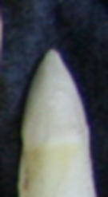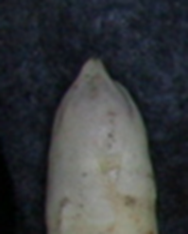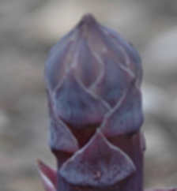
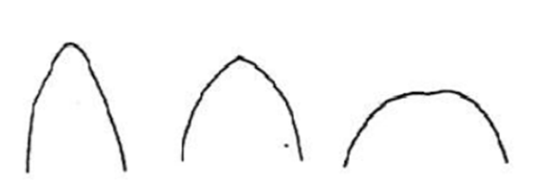

1 | 2 | 3
acute | obtuse | rounded

Ad. 5: Spear: opening of bracts
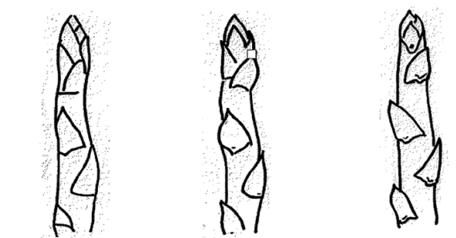
1 | 2 | 3
weak | medium | strong
To be observed when the spear is 5-10 cm above soil surface.

Ad. 7: Spear: anthocyanin coloration of stem

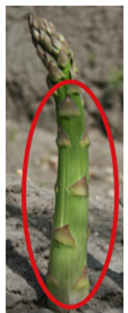 | 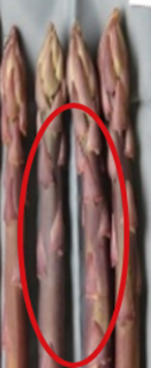
1 | 9
absent | present
Observations should be made on the spear from the ground to the apex, excluding the bracts.

Ad. 10: Plant: density of phylloclades
Observations should be made on the middle third of the plant.

Ad. 12: Stem: length

See Ad. 13.

Ad. 13: Stem: length up to first ramification

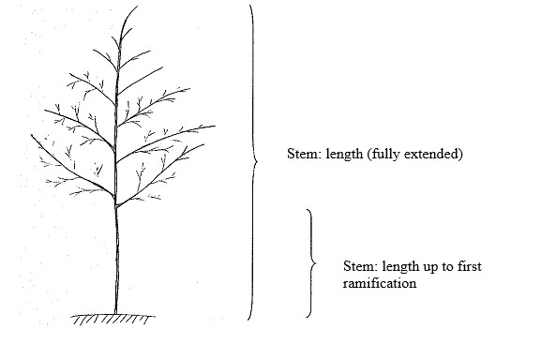

Ad. 15: Type of flowering
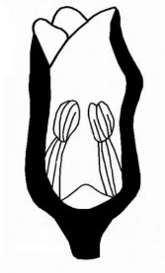 | 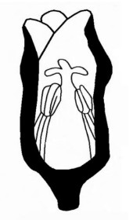 | 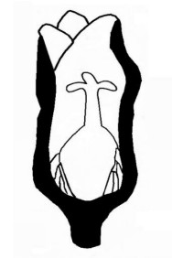
male flower | male flower | female flower
(without style rudiment) | (with style rudiment including androhermaphrodite)

Type of male flowers
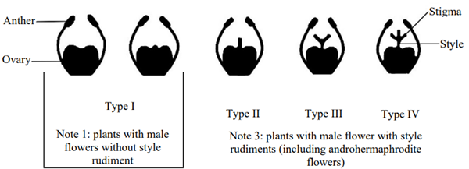
Type of male flowers: the flowers always have fully developed anthers; the style can be from absent to fully developed (Type I to IV), but the stigmas are always rudimentary or absent. Even when two of the three stigmas are present, the flower is consider to be male. The male flower will not produce seeds.
The androhermaphrodite flower (Type IV) has three stigmas and anthers which produce pollen. The flower has the possibility, when self-pollinated, to produce a berry with some seeds. These berries are always smaller and with less seeds than on female plants and in much smaller quantities.
Varieties with note 3 (plants with male flower with style rudiments) can also have plants with androhermaphrodite flowers. Within these varieties the ratio between male flowers with style rudiments (type II and III) and androhermaphrodite flowers (type IV) can vary, leading to a smaller or larger percentage of male plants with small berries.

Literature

Darbonne, 1982-1987: Information technique d’asperges, Soc. Darbonne, FR.
Franken, A.A., 1969 : Geslachtskenmerken en geslachtsovererving bij asperges, Thesis, Wageningen, Verslagen van Landbouwkundige Onderzoekingen, 728, 107 pp.
Hartmann, H.D., 1989: Spargel, Geisenheim, Ulmer Fachbuch Gemüsebau (ISBN 3-80001-5277-0).
Hegi, G., 1906-1931: Illustrierte Flora von Mittel Europa, II BND, pp. 260-265.
Huyskens, J.A. & Sneep, J., 1960: Handbuch der Pflanzenzüchtung, Band VI, Spargel, pp. 131-148.
Roux, L. & Roux, Y., 1981: Identification biochimique de clones et de lignées d’asperge (Asparagus officinalis L., Liliacees), Agronomie 1, pp. 541-548.
Roux, L. & Roux, Y., 1983: Identification biochimique de clones et de lignées d’asperge II. Caractères particuliers liés à l’état homozygote ou hétérozygote, Agronomie 3, pp. 57-66.
Roux, L. & Roux, Y., 1983: Identification biochimique de clones et de lignées d’asperge II. Caractérisation des hybrides de clones hétérozygotes, Agronomie 3, pp. 67-74.
Thévenin, L., 1967 : Les problèmes d’ámèlioration chez Asparagus officinalis L., I. Biologie et Amélioration, Ann. Amelior. Plantes 17, pp. 33-66.
Thévenin, L., 1968 : Les problèmes d’ámèlioration chez Asparagus officinalis L., II. Haploidie et Amélioration, Ann. Amelior. Plantes 18, pp. 327-365.
Thévenin, L. & Dore, C., 1976 : L’ámèlioration d’asperge (Asparagus officinalis L.) et son atout majeur, la culture invitro, Ann. Amelior. Plantes 26, pp. 655-674.

Technical Questionnaire

TECHNICAL QUESTIONNAIRE | Page {x} of {y} | Reference Number:

Application date:
(not to be filled in by the applicant)
TECHNICAL QUESTIONNAIRE
to be completed in connection with an application for plant breeders' rights
1. Subject of the Technical Questionnaire

1.1 |  |  | Botanical name |  | Asparagus officinalis L.
1.2 |  |  | Common name |  | Asparagus
2. Applicant

 |  | Name
 |  | Address
 |  | Telephone No.
 |  | Fax No.
 |  | E-mail address
 |  | Breeder (if different from applicant)
3. Proposed denomination and breeder's reference

 | Proposed denomination (if available)
 | Breeder's reference

TECHNICAL QUESTIONNAIRE | Page {x} of {y} | Reference Number:

#4. Information on the breeding scheme and propagation of the variety

4.1 Breeding scheme

Variety resulting from:

4.1.1 Crossing

(a) controlled cross [ ]

(b) partially known cross [ ]

(c) unknown cross [ ]

4.1.2 Mutation
(please state parent varieties)

4.1.3 Discovery and development
(please state where and when discovered and how developed)

4.1.4 Other
(Please provide details)

TECHNICAL QUESTIONNAIRE | Page {x} of {y} | Reference Number:

4.2 Method of propagating the variety

4.2.1 Seed-propagated varieties

(a) Self-pollination [ ]
(b) Cross-pollination [ ]
(c) Hybrid [ ]
(d) Inbred line [ ]
(e) Other (Please provide details) [ ]

4.2.2 Vegetative propagation

(a) Cuttings [ ]
(b) In vitro propagation [ ]
(c) Other (state method) [ ]

4.2.3 Other
(Please provide details) [ ]

TECHNICAL QUESTIONNAIRE |  | Page {x} of {y} |  | Reference Number:
5. Characteristics of the variety to be indicated (the number in brackets refers to the corresponding characteristic in Test Guidelines; please mark the note which best corresponds).

 | Characteristics |  | Example Varieties |  | Note
5.1  (2) | Spear: anthocyanin coloration of apex
 | absent |  | Xenolim |  | 1 [ ]
 | present |  | Backlim |  | 9 [ ]
5.2  (11) | Plant: intensity of green coloration of foliage
 | very light |  |  |  | 1 [ ]
 | very light to light |  |  |  | 2 [ ]
 | light |  | Atlas |  | 3 [ ]
 | light to medium |  |  |  | 4 [ ]
 | medium |  | Vegalim |  | 5 [ ]
 | medium to dark |  |  |  | 6 [ ]
 | dark |  | Avalim, Grolim |  | 7 [ ]
 | dark to very dark |  |  |  | 8 [ ]
 | very dark |  |  |  | 9 [ ]
5.3  (12) | Stem: length
 | very short |  |  |  | 1 [ ]
 | very short to short |  |  |  | 2 [ ]
 | short |  | Argenteuil |  | 3 [ ]
 | short to medium |  |  |  | 4 [ ]
 | medium |  | Vitalim |  | 5 [ ]
 | medium to long |  |  |  | 6 [ ]
 | long |  | Vegalim |  | 7 [ ]
 | long to very long |  |  |  | 8 [ ]
 | very long |  | Inkalim |  | 9 [ ]

TECHNICAL QUESTIONNAIRE |  | Page {x} of {y} |  | Reference Number:
 | Characteristics |  | Example Varieties |  | Note
5.4  (14) | Stem: diameter at ground level
 | very small |  |  |  | 1 [ ]
 | very small to small |  |  |  | 2 [ ]
 | small |  | Ercole |  | 3 [ ]
 | small to medium |  |  |  | 4 [ ]
 | medium |  | Gijnlim |  | 5 [ ]
 | medium to large |  |  |  | 6 [ ]
 | large |  | Darbella, Grolim |  | 7 [ ]
 | large to very large |  |  |  | 8 [ ]
 | very large |  |  |  | 9 [ ]
5.5  (15) | Type of flowering
 | only plants with male flowers without style rudiments |  | Cumulus |  | 1 [ ]
 | plants with male flowers and plants with female flowers |  | Argenteuil |  | 2 [ ]
 | only plants with male flowers with style rudiments |  | Backlim, Gijnlim |  | 3 [ ]
 | only plants with female flowers |  | L324 |  | 4 [ ]

TECHNICAL QUESTIONNAIRE |  | Page {x} of {y} |  | Reference Number:
6. Similar varieties and differences from these varieties

Please use the following table and box for comments to provide information on how your candidate variety differs from the variety (or varieties) which, to the best of your knowledge, is (or are) most similar. This information may help the examination authority to conduct its examination of distinctness in a more efficient way

Denomination(s) of variety(ies) similar to your candidate variety | Characteristic(s) in which your candidate variety differs from the similar variety(ies) |  | Describe the expression of the characteristic(s) for the similar variety(ies) |  | Describe the expression of the characteristic(s) for your candidate variety
Example | Stem: length |  | long |  | short
Comments

TECHNICAL QUESTIONNAIRE | Page {x} of {y} | Reference Number:
#7. Additional information which may help in the examination of the variety

7.1 In addition to the information provided in sections 5 and 6, are there any additional characteristics which may help to distinguish the variety?

Yes [ ] No [ ]

(If yes, please provide details)

7.2 Are there any special conditions for growing the variety or conducting the examination?

Yes [ ] No [ ]

(If yes, please provide details)

7.3 Other information

TECHNICAL QUESTIONNAIRE | Page {x} of {y} | Reference Number:
8. Authorization for release

(a) Does the variety require prior authorization for release under legislation concerning the protection of the environment, human and animal health?

Yes [ ] No [ ]

(b)Has such authorization been obtained?

Yes [ ] No [ ]

If the answer to (b) is yes, please attach a copy of the authorization.
9. Information on plant material to be examined or submitted for examination

9.1 The expression of a characteristic or several characteristics of a variety may be affected by factors, such as pests and disease, chemical treatment (e.g. growth retardants or pesticides), effects of tissue culture, different rootstocks, scions taken from different growth phases of a tree, etc.

9.2 The plant material should not have undergone any treatment which would affect the expression of the characteristics of the variety, unless the competent authorities allow or request such treatment. If the plant material has undergone such treatment, full details of the treatment must be given. In this respect, please indicate below, to the best of your knowledge, if the plant material to be examined has been subjected to:

(a) Microorganisms (e.g. virus, bacteria, phytoplasma) Yes [ ] No [ ]

(b) Chemical treatment (e.g. growth retardant, pesticide) Yes [ ] No [ ]

(c) Tissue culture Yes [ ] No [ ]

(d) Other factors Yes [ ] No [ ]

Please provide details for where you have indicated "yes".

____________________________________________________________

10. I hereby declare that, to the best of my knowledge, the information provided in this form is correct:

Applicant's name
Signature |  | Date
 | [End of document]

