d |  |  |  | E  TG/119/5(proj.1)  ORIGINAL: English  DATE: 2026-04-02
INTERNATIONAL UNION FOR THE PROTECTION OF NEW VARIETIES OF PLANTS
Geneva
 |  | DRAFT

 | VEGETABLE MARROW  UPOV Code(s): CUCUR_PEP  Cucurbita pepo L. | *

GUIDELINES
FOR THE CONDUCT OF TESTS
FOR DISTINCTNESS, UNIFORMITY AND STABILITY

prepared by an expert from Austria

to be considered by the

Technical Working Party for Vegetables at its sixtieth session,
to be held in Pacific Grove, California, United States of America from 2026-05-18 to 2026-05-21

Disclaimer: this document does not represent UPOV policies or guidance

Alternative Names:*

Botanical name | English | French | German | Spanish
Cucurbita pepo L. | Vegetable Marrow, Squash | Courgette | Zucchini | Calabacín

The purpose of these guidelines (“Test Guidelines”) is to elaborate the principles contained in the General Introduction (document TG/1/3), and its associated TGP documents, into detailed practical guidance for the harmonized examination of distinctness, uniformity and stability (DUS) and, in particular, to identify appropriate characteristics for the examination of DUS and production of harmonized variety descriptions.

ASSOCIATED DOCUMENTS

These Test Guidelines should be read in conjunction with the General Introduction and its associated
TGP documents.

TABLE OF CONTENTS PAGE
1. Subject of these Test Guidelines 3
2. Material Required 3
3. Method of Examination 3
3.1 Number of Growing Cycles 3
3.2 Testing Place 3
3.3 Conditions for Conducting the Examination 3
3.4 Test Design 3
3.5 Additional Tests 4
4. Assessment of Distinctness, Uniformity and Stability 4
4.1 Distinctness 4
4.2 Uniformity 5
4.3 Stability 5
5. Grouping of Varieties and Organization of the Growing Trial 5
6. Introduction to the Table of Characteristics 6
6.1 Categories of Characteristics 6
6.2 States of Expression and Corresponding Notes 6
6.3 Types of Expression 6
6.4 Example Varieties 6
6.5 Legend 7
7. Table of Characteristics/Tableau des caracteres/Merkmalstabelle/Tabla de caracteres 8
8. Explanations on the Table of Characteristics 27
8.1 Explanations covering several characteristics 29
8.2 Explanations for individual characteristics 29
9. Literature 40
10. Technical Questionnaire 41

Subject of these Test Guidelines

These Test Guidelines apply to all varieties of Cucurbita pepo L.

Material Required

2.1 The competent authorities decide on the quantity and quality of the plant material required for testing the variety and when and where it is to be delivered. Applicants submitting material from a State other than that in which the testing takes place must ensure that all customs formalities and phytosanitary requirements are complied with.

2.2 The material is to be supplied in the form of seeds.

2.3 The minimum quantity of plant material, to be supplied by the applicant, should be:

200g or 1000 seeds

The seed should meet the minimum requirements for germination, species and analytical purity, health and moisture content, specified by the competent authority. In cases where the seed is to be stored, the germination capacity should be as high as possible and should be, stated by the applicant.

2.4 The plant material supplied should be visibly healthy, not lacking in vigor, nor affected by any important pest or disease.

2.5 The plant material should not have undergone any treatment which would affect the expression of the characteristics of the variety, unless the competent authorities allow or request such treatment. If it has been treated, full details of the treatment must be given.

Method of Examination

Number of Growing Cycles

3.1.1 The minimum duration of tests should normally be two independent growing cycles.

3.1.2 The two independent growing cycles should be in the form of two separate plantings.

3.1.3 The testing of a variety may be concluded when the competent authority can determine with certainty the outcome of the test.

Testing Place

Tests are normally conducted at one place. In the case of tests conducted at more than one place, guidance is provided in TGP/9 "Examining Distinctness".

Conditions for Conducting the Examination

3.3.1 The tests should be carried out under conditions ensuring satisfactory growth for the expression of the relevant characteristics of the variety and for the conduct of the examination.

3.3.2 The optimum stage of development for the assessment of each characteristic is indicated by a reference in the Table of Characteristics. The stages of development denoted by each reference are described in Chapter 8.

Test Design

3.4.1 Each test should be designed to result in a total of at least 20 plants, which should be divided between at least 2 replicates.

3.4.2 The design of the tests should be such that plants or parts of plants may be removed for measurement or counting without prejudice to the observations which must be made up to the end of the growing cycle.

Additional Tests

Additional tests, for examining relevant characteristics, may be established.

Assessment of Distinctness, Uniformity and Stability

Distinctness

4.1.1 General Recommendations

It is of particular importance for users of these Test Guidelines to consult the General Introduction prior to making decisions regarding distinctness. However, the following points are provided for elaboration or emphasis in these Test Guidelines.

4.1.2 Consistent Differences

The differences observed between varieties may be so clear that more than one growing cycle is not necessary. In addition, in some circumstances, the influence of the environment is not such that more than a single growing cycle is required to provide assurance that the differences observed between varieties are sufficiently consistent. One means of ensuring that a difference in a characteristic, observed in a growing trial, is sufficiently consistent is to examine the characteristic in at least two independent growing cycles.

4.1.3 Clear Differences

Determining whether a difference between two varieties is clear depends on many factors, and should consider, in particular, the type of expression of the characteristic being examined, i.e. whether it is expressed in a qualitative, quantitative, or pseudo-qualitative manner. Therefore, it is important that users of these Test Guidelines are familiar with the recommendations contained in the General Introduction prior to making decisions regarding distinctness.

4.1.4 Number of Plants or Parts of Plants to be Examined

Unless otherwise indicated, for the purposes of distinctness, all observations on single plants should be made on 10 plants or parts taken from each of 10 plants and any other observations made on all plants in the test, disregarding any off-type plants.

In the case of observations of parts taken from single plants, the number of parts to be taken from each of the plants should be 1.
For testing the resistance to certain pathogens, unless otherwise indicated, the test should be performed on at least 20 plants.
4.1.5 Method of Observation

The recommended method of observing the characteristic for the purposes of distinctness is indicated by the following key in the Table of Characteristics (see document TGP/9 "Examining Distinctness", Section 4 "Observation of characteristics"):

MG: single measurement of a group of plants or parts of plants
MS: measurement of a number of individual plants or parts of plants
VG: visual assessment by a single observation of a group of plants or parts of plants
VS: visual assessment by observation of individual plants or parts of plants

Type of observation: visual (V) or measurement (M)

"Visual" observation (V) is an observation made on the basis of the expert's judgment. For the purposes of this document, "visual" observation refers to the sensory observations of the experts and, therefore, also includes smell, taste and touch. Visual observation includes observations where the expert uses reference points (e.g. diagrams, example varieties, side-by-side comparison) or non-linear charts (e.g. color charts). Measurement (M) is an objective observation against a calibrated, linear scale e.g. using a ruler, weighing scales, colorimeter, dates, counts, etc.

Type of record: for a group of plants (G) or for single, individual plants (S)

For the purposes of distinctness, observations may be recorded as a single record for a group of plants or parts of plants (G), or may be recorded as records for a number of single, individual plants or parts of plants (S). In most cases, "G" provides a single record per variety and it is not possible or necessary to apply statistical methods in a plant-by-plant analysis for the assessment of distinctness.

In cases where more than one method of observing the characteristic is indicated in the Table of Characteristics (e.g. VG/MG), guidance on selecting an appropriate method is provided in document TGP/9, Section 4.2.

Uniformity

4.2.1 It is of particular importance for users of these Test Guidelines to consult the General Introduction prior to making decisions regarding uniformity. However, the following points are provided for elaboration or emphasis in these Test Guidelines:

4.2.2 These Test Guidelines have been developed for the examination of seed-propagated varieties. For varieties with other types of propagation, the recommendations in the General Introduction and document TGP/13 "Guidance for new types and species" Section 4.5 "Testing Uniformity" should be followed.

4.2.3 The assessment of uniformity for open-pollinated varieties should be according to the recommendations for cross-pollinated varieties in the General Introduction.

4.2.4 The assessment of uniformity for hybrid varieties depends on the type of hybrid and should be according to the recommendations for hybrid varieties in the General Introduction.

4.2.5 For the assessment of uniformity of hybrid varieties and inbred lines, a population standard of 1% and an acceptance probability of at least 95% should be applied. In the case of a sample size of 20 plants, 1 off-type is allowed.
4.2.6 For the assessment of uniformity of open-pollinated varieties, a population standard of 2% and an acceptance probability of at least 95% should be applied. In the case of a sample size of 20 plants, 2 off-types are allowed.

Stability

4.3.1 In practice, it is not usual to perform tests of stability that produce results as certain as those of the testing of distinctness and uniformity. However, experience has demonstrated that, for many types of variety, when a variety has been shown to be uniform, it can also be considered to be stable.

4.3.2 Where appropriate, or in cases of doubt, stability may be further examined by testing a new seed stock to ensure that it exhibits the same characteristics as those shown by the initial material supplied.

Grouping of Varieties and Organization of the Growing Trial

5.1 The selection of varieties of common knowledge to be grown in the trial with the candidate varieties and the way in which these varieties are divided into groups to facilitate the assessment of distinctness are aided by the use of grouping characteristics.

5.2 Grouping characteristics are those in which the documented states of expression, even where produced at different locations, can be used, either individually or in combination with other such characteristics: (a) to select varieties of common knowledge that can be excluded from the growing trial used for examination of distinctness; and (b) to organize the growing trial so that similar varieties are grouped together.

5.3 The following have been agreed as useful grouping characteristics:

(a) Plant: growth habit (characteristic 4)
(b) Plant: degree of branching (characteristic 6)
(c) Leaf blade: relative area covered by silvery patches (characteristic 15)
(d) Fruit: general shape (characteristic 31)
(e) Fruit: main color of skin (excluding color of dots, patches, stripes and bands) (characteristic 56)

5.4 Guidance for the use of grouping characteristics, in the process of examining distinctness, is provided through the General Introduction and document TGP/9 "Examining Distinctness".

Introduction to the Table of Characteristics

Categories of Characteristics

6.1.1 Standard Test Guidelines Characteristics

Standard Test Guidelines characteristics are those which are approved by UPOV for examination of DUS and from which members of the Union can select those suitable for their particular circumstances.

6.1.2 Asterisked Characteristics

Asterisked characteristics (denoted by *) are those included in the Test Guidelines which are important for the international harmonization of variety descriptions and should always be examined for DUS and included in the variety description by all members of the Union, except when the state of expression of a preceding characteristic or regional environmental conditions render this inappropriate.

States of Expression and Corresponding Notes

6.2.1 States of expression are given for each characteristic to define the characteristic and to harmonize descriptions. Each state of expression is allocated a corresponding numerical note for ease of recording of data and for the production and exchange of the description.

6.2.2 All relevant states of expression are presented in the characteristic.

6.2.3 Further explanation of the presentation of states of expression and notes is provided in document TGP/7 "Development of Test Guidelines".

Types of Expression

An explanation of the types of expression of characteristics (qualitative, quantitative and pseudo-qualitative) is provided in the General Introduction.

Example Varieties

Where appropriate, example varieties are provided to clarify the states of expression of each characteristic.

Legend

 |  | English |  | français |  | deutsch | español | Example Varieties  Exemples  Beispielssorten  Variedades ejemplo | Note/  Nota
1 | 2 | 3 | 4 | 5 | 6 | 7
 |  | Name of characteristics in English |  | Nom du caractère en français |  | Name des Merkmals auf Deutsch | Nombre del carácter en español
 |  | states of expression |  | types d’expression |  | Ausprägungsstufen | tipos de expresión

1 Characteristic number

2 (*) sterisked characteristic – see Chapter 6.1.2

3 Type of expression
QL Qualitative characteristic – see Chapter 6.3
QN Quantitative characteristic – see Chapter 6.3
PQ Pseudo-qualitative characteristic – see Chapter 6.3

4 Method of observation (and type of plot, if applicable)
MG, MS, VG, VS – see Chapter 4.1.5

5 (+) See Explanations on the Table of Characteristics in Chapter 8.2

6 (a)-(h) See Explanations on the Table of Characteristics in Chapter 8.1

7 Not applicable

Table of Characteristics/Tableau des caracteres/Merkmalstabelle/Tabla de caracteres

 |  | English |  | français |  | deutsch | español | Example Varieties  Exemples  Beispielssorten  Variedades ejemplo | Note/  Nota
1. |  | PQ | VG | (+) | (a)
 |  | Seedling: shape of cotyledons
 |  | narrow elliptic |  |  |  |  |  | Bianchini | 1
 |  | medium elliptic |  |  |  |  |  | Cora, Tivoli | 2
 |  | broad elliptic |  |  |  |  |  | Cinderella, Goldi | 3
 |  | circular |  |  |  |  |  | Yellow Crookneck | 4
 |  | obovate |  |  |  |  |  |  | 5
2. |  | QN | VG |  | (a)
 |  | Seedling: intensity of green color of cotyledons
 |  | very light |  |  |  |  |  | Sunburst | 1
 |  | light |  |  |  |  |  | Bianchini | 3
 |  | medium |  |  |  |  |  | Cora | 5
 |  | dark |  |  |  |  |  | Lidia | 7
 |  | very dark |  |  |  |  |  | Saray | 9
3. |  | QN | VG | (+) | (a)
 |  | Seedling: cross section of cotyledons
 |  | concave |  |  |  |  |  |  | 1
 |  | straight |  |  |  |  |  | Sunburst | 2
 |  | convex |  |  |  |  |  | Bianchini,  Yellow Crookneck | 3
4. |  | QL | VG |  | (b)
 |  | Plant: growth habit
 |  | bush |  |  |  |  |  | Greyzini | 1
 |  | trailing |  |  |  |  |  | Becky, Cinderella, Everest,  Long Green Trailing, Twickers | 2
5. |  | QN | VG |  | (b)
 |  | Only varieties with Plant: growth habit: trailing: Plant: length of trail
 |  | short |  |  |  |  |  |  | 1
 |  | medium |  |  |  |  |  |  | 2
 |  | long |  |  |  |  |  |  | 3
6. |  | QN | VG |  | (b)
 |  | Plant: degree of branching
 |  | absent or very weak |  |  |  |  |  | Cora, Goldi | 1
 |  | weak |  |  |  |  |  | Karioka, Verdi | 3
 |  | medium |  |  |  |  |  | Goldrush, Tivoli | 5
 |  | strong |  |  |  |  |  | Blanche non coureuse 3, Jack O’Lantern,  Yellow Crookneck | 7
 |  | very strong |  |  |  |  |  | Patty Green Tint,  Sweet Dumpling | 9
7. |  | QN | VG |  | (c)
 |  | Only varieties with Plant: growth habit: bush: Plant: attitude of petiole (excluding lower external leaves)
 |  | erect |  |  |  |  |  | Blanche non coureuse 3, Yellow Crookneck | 1
 |  | erect to semi erect |  |  |  |  |  | Sardane | 2
 |  | semi erect |  |  |  |  |  | Arlesa | 3
 |  | semi erect to horizontal |  |  |  |  |  | Goldi | 4
 |  | horizontal |  |  |  |  |  | Ambassador | 5
8. |  | PQ | VG |  | (b)
 |  | Stem: color
 |  | completely green |  |  |  |  |  | Becky | 1
 |  | partly green and partly yellow |  |  |  |  |  | Autumn Gold | 2
9. |  | QN | VG |  | (b)
 |  | Stem: intensity of green color
 |  | very light |  |  |  |  |  | Maayan | 1
 |  | light |  |  |  |  |  | Bianchini | 3
 |  | medium |  |  |  |  |  | Cinderella | 5
 |  | dark |  |  |  |  |  | Greyzini | 7
 |  | very dark |  |  |  |  |  | Goldrush | 9
10. |  | QL | VG |  | (b)
 |  | Stem: mottling
 |  | absent |  |  |  |  |  | Cinderella | 1
 |  | present |  |  |  |  |  | Cora | 9
11. |  | QL | VG |  | (b)
 |  | Stem: tendrils
 |  | absent to rudimentary |  |  |  |  |  | Goldrush, Sylvana | 1
 |  | well developed |  |  |  |  |  | Baby Bear, Greyzini | 2
12. |  | QN | VG |  | (c)
 |  | Leaf blade: size
 |  | very small |  |  |  |  |  | Becky | 1
 |  | small |  |  |  |  |  | Small Sugar | 3
 |  | medium |  |  |  |  |  | Ambassador | 5
 |  | large |  |  |  |  |  | Kriti | 7
 |  | very large |  |  |  |  |  |  | 9
13. |  | QN | VG | (+) | (c)
 |  | Leaf blade: incisions
 |  | absent or very shallow |  |  |  |  |  | Scallopini | 1
 |  | shallow |  |  |  |  |  | Everest | 3
 |  | medium |  |  |  |  |  | Jackpot | 5
 |  | deep |  |  |  |  |  | Civac | 7
 |  | very deep |  |  |  |  |  | Isotta | 9
14. |  | QN | VG |  | (c)
 |  | Leaf blade: intensity of green color of upper surface
 |  | light |  |  |  |  |  | Ghazzi | 3
 |  | medium |  |  |  |  |  | Cora | 5
 |  | dark |  |  |  |  |  | Everest | 7
15. |  | QN | VG |  | (c)
 |  | Leaf blade: relative area covered by silvery patches
 |  | absent or very small |  |  |  |  |  | Albo, Black Forest, Scallopini | 1
 |  | small |  |  |  |  |  | Aziz | 3
 |  | medium |  |  |  |  |  | Ambassador | 5
 |  | large |  |  |  |  |  | Cora | 7
 |  | very large |  |  |  |  |  | Summerstar | 9
16. |  | QN | VG |  | (c)
 |  | Petiole: length
 |  | short |  |  |  |  |  | Jack be Little, Karioka | 3
 |  | medium |  |  |  |  |  | Goldi | 5
 |  | long |  |  |  |  |  | Autumn Gold, Baikal | 7
17. |  | QN | VG |  | (c)
 |  | Petiole: number of prickles
 |  | absent or very few |  |  |  |  |  | Kojac | 1
 |  | few |  |  |  |  |  | Opaline | 3
 |  | medium |  |  |  |  |  | Spidy | 5
 |  | many |  |  |  |  |  | White Bush Scallop | 7
 |  | very many |  |  |  |  |  | Yellow Summer Crookneck | 9
18. |  | QN | MG | (+)
 |  | Time of flowering of female flower
 |  | early |  |  |  |  |  |  | 3
 |  | medium |  |  |  |  |  |  | 5
 |  | late |  |  |  |  |  |  | 7
19. |  | QN | MG | (+)
 |  | Time of flowering of male flower
 |  | early |  |  |  |  |  |  | 3
 |  | medium |  |  |  |  |  |  | 5
 |  | late |  |  |  |  |  |  | 7
20. |  | PQ | VG |  | (d)
 |  | Female flower: ring at inner side of corolla
 |  | predominantly absent |  |  |  |  |  | Cinderella, Greyzini | 1
 |  | predominantly present |  |  |  |  |  | Aurore | 9
21. |  | PQ | VG |  | (d)
 |  | Only varieties with Female flower: ring at inner side of corolla: predominantly present: Female flower: color of ring at inner side of corolla
 |  | yellow |  |  |  |  |  | Diamant, Patro | 1
 |  | green |  |  |  |  |  | Aurore,  Early White Bush Scallop, President | 2
 |  | yellow and green |  |  |  |  |  | Pueblo | 3
22. |  | QN | VG |  | (d)
 |  | Only varieties with Female flower: green ring at inner side of corolla: Female flower: intensity of green color of ring at inner side of corolla
 |  | weak |  |  |  |  |  | Maya, Sardane | 3
 |  | medium |  |  |  |  |  | Samba, Senator | 5
 |  | strong |  |  |  |  |  | Aristocrat, Diamant | 7
23. |  | PQ | VG |  | (d)
 |  | Male flower: ring at inner side of corolla
 |  | predominantly absent |  |  |  |  |  | Bianchini | 1
 |  | predominantly present |  |  |  |  |  | Goldi | 9
24. |  | PQ | VG |  | (d)
 |  | Only varieties with Male flower: ring at inner side of corolla: predominantly present: Male flower: color of ring at inner side of corolla
 |  | yellow |  |  |  |  |  | Afrodite, Patro, Zyzo | 1
 |  | green |  |  |  |  |  | Austral, Belor, Goldi | 2
 |  | yellow and green |  |  |  |  |  | Alice, Carmina,  Green Gem, Ibis | 3
25. |  | QN | VG |  | (d)
 |  | Only varieties with Male flower: green ring at inner side of corolla: Male flower: intensity of green color of ring at inner side of corolla
 |  | weak |  |  |  |  |  | Cora | 3
 |  | medium |  |  |  |  |  | Verdi | 5
 |  | strong |  |  |  |  |  | Goldi | 7
26. |  | QN | VG |  | (e)
 |  | Only Zucchini type varieties: Young fruit: ratio length / maximum diameter
 |  | very small |  |  |  |  |  | Ghazzi | 1
 |  | small |  |  |  |  |  | Opal | 3
 |  | medium |  |  |  |  |  | Cora | 5
 |  | large |  |  |  |  |  | Carlotta | 7
 |  | very large |  |  |  |  |  | Spidy | 9
27. |  | PQ | VG | (+) | (e)
 |  | Only Zucchini and Rounded Zucchini type varieties: Young fruit: general shape
 |  | globular |  |  |  |  |  | De Nice à Fruit Rond | 1
 |  | pear shaped |  |  |  |  |  | Clarita | 2
 |  | tapered elliptical |  |  |  |  |  | Top Kapi | 3
 |  | elliptical |  |  |  |  |  | Table Dainty | 4
 |  | cylindrical |  |  |  |  |  | Ambassador, Ibis | 5
 |  | tapered cylindrical |  |  |  |  |  |  | 6
28. |  | PQ | VG |  | (e)
 |  | Young fruit: main color of skin (excluding color of dots, patches, stripes and bands)
 |  | white |  |  |  |  |  | White Bush Scallop | 1
 |  | cream |  |  |  |  |  | Tivoli | 2
 |  | yellow |  |  |  |  |  | Goldi | 3
 |  | orange |  |  |  |  |  |  | 4
 |  | green |  |  |  |  |  | Elite, Opal, Romano | 5
 |  | partly white and partly yellow |  |  |  |  |  |  | 6
 |  | partly white and partly green |  |  |  |  |  |  | 7
 |  | partly yellow and partly green |  |  |  |  |  | Sunburst, Zephyr | 8
29. |  | QN | VG |  | (e)
 |  | Only varieties with Young fruit: main color of skin: yellow: Young fruit: intensity of yellow color of skin (as for 28)
 |  | light |  |  |  |  |  |  | 3
 |  | medium |  |  |  |  |  |  | 5
 |  | dark |  |  |  |  |  |  | 7
30. |  | QN | VG |  | (e)
 |  | Only varieties with Young fruit: main color of skin: green: Young fruit: intensity of green color of skin (as for 28)
 |  | very light |  |  |  |  |  | Clarita, Goya,  Patty Green Tint | 1
 |  | light |  |  |  |  |  | Arlika | 3
 |  | medium |  |  |  |  |  | Baccara | 5
 |  | dark |  |  |  |  |  | Arlesa, Sandra, Zefira | 7
 |  | very dark |  |  |  |  |  | Carnaval, Corsair | 9
31. |  | PQ | VG | (+) | (f)
 |  | Fruit: general shape
 |  | disc shaped |  |  |  |  |  |  | 1
 |  | transverse elliptical |  |  |  |  |  |  | 2
 |  | transverse broad elliptical |  |  |  |  |  |  | 3
 |  | globular |  |  |  |  |  |  | 4
 |  | top shaped |  |  |  |  |  |  | 5
 |  | broad elliptical |  |  |  |  |  |  | 6
 |  | ovate |  |  |  |  |  |  | 7
 |  | elliptical |  |  |  |  |  |  | 8
 |  | cylindrical |  |  |  |  |  |  | 9
 |  | pear shaped |  |  |  |  |  |  | 10
 |  | bottle shaped |  |  |  |  |  |  | 11
 |  | club shaped |  |  |  |  |  |  | 12
32. |  | QN | VG |  | (f)
 |  | Only Scallop type varieties: Fruit: length
 |  | short |  |  |  |  |  | Bennings Green Tint | 3
 |  | medium |  |  |  |  |  | Sunburst | 5
 |  | long |  |  |  |  |  | Yellow Bush Scallop | 7
33. |  | QN | VG |  | (f)
 |  | Only Acorn type varieties: Fruit: length
 |  | short |  |  |  |  |  | Table Gold | 3
 |  | medium |  |  |  |  |  | Swan White Acorn | 5
 |  | long |  |  |  |  |  | Ebony Table Queen | 7
34. |  | QN | VG |  | (f)
 |  | Only Neck type varieties: Fruit: length
 |  | short |  |  |  |  |  | Wryneck | 3
 |  | medium |  |  |  |  |  | Yellow Summer Crookneck | 5
 |  | long |  |  |  |  |  | Sunbar | 7
35. |  | QN | VG |  | (f)
 |  | Only Zucchini type varieties: Fruit: length
 |  | very short |  |  |  |  |  | Jericho | 1
 |  | short |  |  |  |  |  | Jedida | 3
 |  | medium |  |  |  |  |  | Cora | 5
 |  | long |  |  |  |  |  | Carlotta | 7
 |  | very long |  |  |  |  |  | Altea | 9
36. |  | QN | VG |  | (f)
 |  | Only Scallop type varieties: Fruit: maximum diameter
 |  | small |  |  |  |  |  | Scallopini | 3
 |  | medium |  |  |  |  |  | Yellow Bush Scallop | 5
 |  | large |  |  |  |  |  | White Bush Scallop | 7
37. |  | QN | VG |  | (f)
 |  | Only Acorn type varieties: Fruit: maximum diameter
 |  | small |  |  |  |  |  | Table Gold | 3
 |  | medium |  |  |  |  |  | Table King | 5
 |  | large |  |  |  |  |  | Swan White Acorn | 7
38. |  | QN | VG |  | (f)
 |  | Only Zucchini type varieties: Fruit: maximum diameter
 |  | small |  |  |  |  |  | Goldi | 3
 |  | medium |  |  |  |  |  | Opal | 5
 |  | large |  |  |  |  |  | Jericho, Spidi | 7
39. |  | QN | VG |  | (f)
 |  | Only Scallop type varieties: Fruit: ratio length / maximum diameter
 |  | small |  |  |  |  |  | White Bush Scallop | 3
 |  | medium |  |  |  |  |  | Scallopini | 5
 |  | large |  |  |  |  |  | Sunburst | 7
40. |  | QN | VG |  | (f)
 |  | Only Acorn type varieties: Fruit: ratio length / maximum diameter
 |  | small |  |  |  |  |  | Heart of Gold | 3
 |  | medium |  |  |  |  |  | Table Gold | 5
 |  | large |  |  |  |  |  | Table King | 7
41. |  | QN | VG |  | (f)
 |  | Only Zucchini type varieties: Fruit: ratio length / maximum diameter
 |  | very small |  |  |  |  |  | Jericho | 1
 |  | small |  |  |  |  |  | Jedida | 3
 |  | medium |  |  |  |  |  | Cora | 5
 |  | large |  |  |  |  |  | Carlotta | 7
 |  | very large |  |  |  |  |  | Tarquinio | 9
42. |  | QN | VG |  | (f)
 |  | Only Pumpkin type varieties: Fruit: size
 |  | very small |  |  |  |  |  | Wee-B-Little | 1
 |  | small |  |  |  |  |  | Peek-a-Boo | 3
 |  | medium |  |  |  |  |  | Spirit | 5
 |  | large |  |  |  |  |  | Ghost Rider | 7
 |  | very large |  |  |  |  |  | Howden | 9
43. |  | QN | VG |  | (f)
 |  | Only Rondini type varieties: Fruit: size
 |  | small |  |  |  |  |  | Pomme d’Or | 3
 |  | medium |  |  |  |  |  | Rolet | 5
 |  | large |  |  |  |  |  | Little Gem | 7
44. |  | QN | VG |  | (f)
 |  | Only Oilpumpkin type varieties: Fruit: size
 |  | small |  |  |  |  |  |  | 3
 |  | medium |  |  |  |  |  |  | 5
 |  | large |  |  |  |  |  |  | 7
45. |  | QN | VG |  | (f)
 |  | Only Miniature Pumpkin type varieties: Fruit: peduncle end
 |  | straight |  |  |  |  |  | Sweetie Pie | 1
 |  | concave |  |  |  |  |  | Jack Be Little | 2
46. |  | QN | VG |  | (f)
 |  | Only Scallop type varieties: Fruit: protrusion of equatorial margin
 |  | weak |  |  |  |  |  | Scallopini | 3
 |  | medium |  |  |  |  |  | Sunburst | 5
 |  | strong |  |  |  |  |  | White Bush Scallop | 7
47. |  | QN | VG |  | (f)
 |  | Only Scallop type varieties: Fruit: position of equatorial margin
 |  | at the middle |  |  |  |  |  | Sunburst | 1
 |  | towards stem end |  |  |  |  |  | Golden Bush Scallop | 2
48. |  | QN | VG |  | (f)
 |  | Only Scallop type varieties: Fruit: peduncle end
 |  | straight |  |  |  |  |  | White Bush Scallop | 1
 |  | convex |  |  |  |  |  | Yellow Bush Scallop | 2
49. |  | QN | VG |  | (f)
 |  | Only Scallop type varieties: Fruit: blossom end
 |  | flat |  |  |  |  |  | Scallopini | 1
 |  | indented |  |  |  |  |  | Yellow Bush Scallop | 2
50. |  | QN | VG |  | (f)
 |  | Only Acorn type varieties: Fruit: position of maximum diameter
 |  | at the middle |  |  |  |  |  | Ebony Table Queen | 1
 |  | towards stem end |  |  |  |  |  | Swan White Acorn | 2
51. |  | QN | VG |  | (f)
 |  | Only Acorn type varieties: Fruit: peduncle end
 |  | concave |  |  |  |  |  | Swan White Acorn | 1
 |  | straight |  |  |  |  |  | Table King | 2
 |  | convex |  |  |  |  |  | Ebony Table Queen | 3
52. |  | QN | VG |  | (f)
 |  | Only Neck type varieties: Fruit: length of neck
 |  | short |  |  |  |  |  | Wryneck | 3
 |  | medium |  |  |  |  |  | Yellow Summer Crookneck | 5
 |  | long |  |  |  |  |  | Sundance | 7
53. |  | QN | VG |  | (f)
 |  | Only Neck type varieties: Fruit: diameter of neck in relation to maximum diameter
 |  | small |  |  |  |  |  | Sundance | 3
 |  | medium |  |  |  |  |  | Yellow Summer Crookneck | 5
 |  | large |  |  |  |  |  | Sunbar | 7
54. |  | QL | VG |  | (f)
 |  | Only Neck type varieties: Fruit: curving of neck
 |  | absent |  |  |  |  |  | Early Prolific Straightneck | 1
 |  | present |  |  |  |  |  | Yellow Summer Crookneck | 9
55. |  | QN | VG |  | (f)
 |  | Only Neck and Zucchini type varieties: Fruit: blossom end
 |  | rounded |  |  |  |  |  |  | 1
 |  | pointed |  |  |  |  |  |  | 2
56. |  | PQ | VG |  | (f)
 |  | Fruit: main color of skin (excluding color of dots, patches, stripes and bands)
 |  | white |  |  |  |  |  | Pâtisson blanc panaché de vert | 1
 |  | cream |  |  |  |  |  | Early White Bush Scallop, Little Boo | 2
 |  | yellow |  |  |  |  |  | Autumn Gold | 3
 |  | orange |  |  |  |  |  |  | 4
 |  | green |  |  |  |  |  | Ambassador, Baby Bear | 5
 |  | partly white and partly yellow |  |  |  |  |  |  | 6
 |  | partly white and partly green |  |  |  |  |  |  | 7
 |  | partly yellow and partly green |  |  |  |  |  | Sunburst, Zephyr | 8
57. |  | QN | VG |  | (f)
 |  | Only varieties with Fruit main color of skin: yellow: Fruit: intensity of yellow color of skin (as for 56)
 |  | light |  |  |  |  |  |  | 3
 |  | medium |  |  |  |  |  |  | 5
 |  | dark |  |  |  |  |  |  | 7
58. |  | QN | VG |  | (f)
 |  | Only varieties with Fruit: main color of skin: green: Fruit: intensity of green color of skin (as for 56)
 |  | very light |  |  |  |  |  |  | 1
 |  | light |  |  |  |  |  |  | 3
 |  | medium |  |  |  |  |  |  | 5
 |  | dark |  |  |  |  |  | Cora | 7
 |  | very dark |  |  |  |  |  | Baby Bear, Sardane | 9
59. |  | QN | VG |  | (f)
 |  | Only varieties with two main colors: Fruit: distribution of green color
 |  | green ring around blossom end |  |  |  |  |  | Sunburst | 1
 |  | from blossom end one third green |  |  |  |  |  | Zephyr | 2
 |  | from blossom end one half green |  |  |  |  |  |  | 3
60. |  | QN | VG | (+) | (f)
 |  | Fruit: depth of grooves
 |  | absent or very shallow |  |  |  |  |  | Spooktacular | 1
 |  | shallow |  |  |  |  |  | Connecticut Field | 3
 |  | medium |  |  |  |  |  | Delicata, Table Queen | 5
 |  | deep |  |  |  |  |  | Jack Be Little,  Swan White Acorn | 7
 |  | very deep |  |  |  |  |  | Heart of Gold,  Sweet Dumpling | 9
61. |  | QL | VG |  | (f)
 |  | Only varieties with Fruit: grooves: present: Fruit: stripes in grooves
 |  | absent |  |  |  |  |  | Baby Bear, Jack Be Little | 1
 |  | present |  |  |  |  |  | Delicata, Heart of Gold, Pâtisson jaune panaché de vert | 9
62. |  | PQ | VG |  | (f)
 |  | Only varieties with Fruit: stripes in grooves: present: Fruit: color of stripes in grooves
 |  | light green |  |  |  |  |  |  | 1
 |  | dark green |  |  |  |  |  | Sweet Dumpling | 2
 |  | yellow |  |  |  |  |  | Puccini | 3
 |  | orange |  |  |  |  |  |  | 4
63. |  | QN | VG |  | (f)
 |  | Fruit: protrusion of ribs
 |  | absent or very weak |  |  |  |  |  | Leda, Tivoli | 1
 |  | weak |  |  |  |  |  | Ambassador | 3
 |  | medium |  |  |  |  |  | Ibis, Opal | 5
 |  | strong |  |  |  |  |  | Spidi | 7
 |  | very strong |  |  |  |  |  | Mogango Enrugado Mineiro, Tonda Padana | 9
64. |  | QN | VG |  | (f)
 |  | Only varieties with Fruit: ribs: present: Fruit: color of ribs compared to main color of skin (as for 56)
 |  | lighter |  |  |  |  |  |  | 1
 |  | same |  |  |  |  |  | Grey Zucchini | 2
 |  | darker |  |  |  |  |  | De Nice à Fruit Rond, Orangetti | 3
65. |  | QN | VG |  | (f)
 |  | Fruit: size of main dots
 |  | absent or very small |  |  |  |  |  | Badger Cross, Sunburst | 1
 |  | small |  |  |  |  |  | Ambassador | 3
 |  | medium |  |  |  |  |  | Grey Zucchini | 5
 |  | large |  |  |  |  |  | Kingsize | 7
 |  | very large |  |  |  |  |  | Becky | 9
66. |  | QL | VG |  | (f)
 |  | Fruit: secondary green color (excluding dots)
 |  | absent |  |  |  |  |  | Grey Zucchini,  Small Sugar | 1
 |  | present |  |  |  |  |  | Beatrice, Greyzini,  Heart of Gold,  Tonda Padana, Zubi | 9
67. |  | QN | VG |  | (f)
 |  | Only varieties with Fruit: secondary green color: present: Fruit: intensity of secondary green color
 |  | very light |  |  |  |  |  |  | 1
 |  | light |  |  |  |  |  |  | 3
 |  | medium |  |  |  |  |  |  | 5
 |  | dark |  |  |  |  |  |  | 7
 |  | very dark |  |  |  |  |  | Heart of Gold | 9
68. |  | PQ | VG | (+) | (f)
 |  | Only varieties with Fruit: secondary green color: present: Fruit: distribution of secondary green color
 |  | sparse patches |  |  |  |  |  | Elite, Greyzini | 1
 |  | dense patches |  |  |  |  |  |  | 2
 |  | one colored stripes |  |  |  |  |  | Altea | 3
 |  | two colored stripes |  |  |  |  |  |  | 4
 |  | one colored bands covering the whole surface |  |  |  |  |  | Badger Cross, Twickers, Zubi | 5
 |  | two colored bands covering the whole surface |  |  |  |  |  | Beatrice | 6
69. |  | QN | VG |  | (f)
 |  | Fruit: number of warts on skin
 |  | absent or very few |  |  |  |  |  | Scallopini | 1
 |  | few |  |  |  |  |  |  | 3
 |  | medium |  |  |  |  |  | Patisson verruqueux panaché | 5
 |  | many |  |  |  |  |  | Yellow Summer Crookneck | 7
 |  | very many |  |  |  |  |  | Wryneck | 9
70. |  | QN | VG | (+) | (f)
 |  | Fruit: size of flower scar
 |  | very small |  |  |  |  |  | Jack be Little | 1
 |  | small |  |  |  |  |  | Goldi | 3
 |  | medium |  |  |  |  |  | Spidi | 5
 |  | large |  |  |  |  |  | Cinderella | 7
 |  | very large |  |  |  |  |  | Howden | 9
71. |  | QN | VG | (+) | (f)
 |  | Fruit: length of peduncle
 |  | very short |  |  |  |  |  | Arlesa | 1
 |  | short |  |  |  |  |  | Clarita | 3
 |  | medium |  |  |  |  |  | Cinderella | 5
 |  | long |  |  |  |  |  | Tivoli | 7
 |  | very long |  |  |  |  |  | Western Sunrise | 9
72. |  | PQ | VG |  | (f)
 |  | Fruit: color of peduncle
 |  | yellow |  |  |  |  |  |  | 1
 |  | green |  |  |  |  |  | Ambassador | 2
 |  | partly yellow and partly green |  |  |  |  |  | Autumn Gold | 3
73. |  | QN | VG |  | (f)
 |  | Only varieties with Fruit: color of peduncle: green: Fruit: intensity of green color of peduncle
 |  | light |  |  |  |  |  | Bianchini | 3
 |  | medium |  |  |  |  |  | Sunburst | 5
 |  | dark |  |  |  |  |  | Gold Rush | 7
74. |  | QL | VG |  | (f)
 |  | Fruit: mottling of peduncle
 |  | absent |  |  |  |  |  | Sunburst | 1
 |  | present |  |  |  |  |  | Elite | 9
75. |  | QN | MG | (+)
 |  | Time of maturity
 |  | early |  |  |  |  |  |  | 3
 |  | medium |  |  |  |  |  |  | 5
 |  | late |  |  |  |  |  |  | 7
76. |  | QN | MG | (+) | (g)
 |  | Number of ripe fruits per plant
 |  | few |  |  |  |  |  |  | 3
 |  | medium |  |  |  |  |  |  | 5
 |  | many |  |  |  |  |  |  | 7
77. |  | PQ | VG |  | (g)
 |  | Ripe fruit: main color of skin (excluding dots, patches, stripes and bands)
 |  | white |  |  |  |  |  | Pâtisson blanc panaché de vert | 1
 |  | whitish |  |  |  |  |  | White Bush Scallop | 2
 |  | cream |  |  |  |  |  | Bianchini, Opal | 3
 |  | yellow |  |  |  |  |  | Gold Rush | 4
 |  | orange |  |  |  |  |  | Autumn Gold | 5
 |  | green |  |  |  |  |  |  | 6
78. |  | QN | VG |  | (g)
 |  | Only varieties with Ripe fruit: main color of skin: yellow, orange and green: Ripe fruit: intensity of main color of skin
 |  | light |  |  |  |  |  |  | 3
 |  | medium |  |  |  |  |  |  | 5
 |  | dark |  |  |  |  |  |  | 7
79. |  | PQ | VG |  | (g)
 |  | Ripe fruit: secondary color of skin (as for 77)
 |  | whitish |  |  |  |  |  |  | 1
 |  | cream |  |  |  |  |  |  | 2
 |  | yellow |  |  |  |  |  |  | 3
 |  | orange |  |  |  |  |  |  | 4
 |  | green |  |  |  |  |  |  | 5
80. |  | QN | VG |  | (g)
 |  | Only varieties with Ripe fruit: main color of skin: white or cream: Ripe fruit: prominence of green hue (as for 77)
 |  | absent or very weak |  |  |  |  |  | Jedida | 1
 |  | weak |  |  |  |  |  | Eskenderany | 3
 |  | medium |  |  |  |  |  | Corona | 5
 |  | strong |  |  |  |  |  | Amalthee | 7
 |  | very strong |  |  |  |  |  |  | 9
81. |  | PQ | VG |  | (g)
 |  | Ripe fruit: color of flesh
 |  | cream |  |  |  |  |  | Elite | 1
 |  | yellow |  |  |  |  |  | Sunburst,  Vegetable Spaghetti | 2
 |  | orange |  |  |  |  |  | Autumn Gold | 3
82. |  | QL | VG |  | (g)
 |  | Ripe fruit: lignified rind
 |  | absent |  |  |  |  |  | Small Sugar,  Table Queen,  Vegetable Spaghetti | 1
 |  | present |  |  |  |  |  | Elite, Little Gem, Scallopini, Yellow Summer Crookneck | 9
83. |  | QL | VG |  | (g)
 |  | Ripe fruit: structure of flesh
 |  | not fibrous |  |  |  |  |  | Elite | 1
 |  | fibrous |  |  |  |  |  | Vegetable Spaghetti | 2
84. |  | QN | VG |  | (h)
 |  | Seed: size
 |  | very small |  |  |  |  |  | Jack be Little | 1
 |  | small |  |  |  |  |  | Delicata | 3
 |  | medium |  |  |  |  |  | Diamant | 5
 |  | large |  |  |  |  |  |  | 7
 |  | very large |  |  |  |  |  | Citrouille de Touraine | 9
85. |  | QN | VG |  | (h)
 |  | Seed: shape
 |  | narrow elliptic |  |  |  |  |  | Caserta | 3
 |  | medium elliptic |  |  |  |  |  | Elite | 5
 |  | broad elliptic |  |  |  |  |  | Baby Boo | 7
86. |  | QL | VG |  | (h)
 |  | Seed: hull
 |  | absent |  |  |  |  |  | Chapingo Uno | 1
 |  | present |  |  |  |  |  | Baby Bear, Elite | 9
87. |  | QL | VG |  | (h)
 |  | Only varieties with Seed: hull: present: Seed: appearance of hull
 |  | rudimentary |  |  |  |  |  | Baby Bear | 1
 |  | fully developed |  |  |  |  |  | Elite | 2
88. |  | PQ | VG |  | (h)
 |  | Only varieties with Seed: hull: present: Seed: color of hull
 |  | whitish |  |  |  |  |  | Table Queen | 1
 |  | cream |  |  |  |  |  | De Nice à Fruit Rond | 2
89. |  | PQ | VG | (+) | (h)
 |  | Only varieties with Seed: hull: absent: color of seeds
 |  | yellow green |  |  |  |  |  | GLB1607 | 1
 |  | light green |  |  |  |  |  | GL1348, GL81 | 2
 |  | medium green |  |  |  |  |  | GL Sonne, GL10424 | 3
 |  | dark green |  |  |  |  |  | GL211,  Gleisdorfer Diamant | 4
90. |  | QN | VG/VS | (+)
 |  | Resistance to Zucchini yellow mosaic virus (ZYMV)
 |  | absent or low |  |  |  |  |  | Cora | 1
 |  | medium |  |  |  |  |  | Mirza | 2
 |  | high |  |  |  |  |  | Mikonos | 3
91. |  | QL | VG/VS | (+)
 |  | Resistance to Watermelon mosaic virus (WMV)
 |  | absent |  |  |  |  |  | Cora | 1
 |  | present |  |  |  |  |  | Mikonos, Sofia, Syros | 9

Explanations on the Table of Characteristics

Fruit: type | Fruit: general shape (ch. 30) | Plant: length of trail (ch. 4) | Fruit: depth of grooves (ch. 59) | Fruit: protrusion of ribs (ch. 62) | Fruit: surface structure (ch. 68) | Ripe fruit: main color of skin (ch. 77) | Ripe fruit: color of flesh (ch. 81) | Ripe fruit: lignified rind (ch. 82) | Ripe fruit: structure of flesh (ch. 83) | Seed: hull (ch. 86) | Example varieties
Pumpkin | from flattened globular to elliptical globular |  | present | absent or very weak | smooth |  | orange | absent |  | present | Halloween, Little Boo, Small Sugar | 1
Miniature Pumpkin | transverse elliptical | long | present | absent or very weak | smooth |  | orange | absent |  | present | Jack Be Little | 2
Scallop | flattened disc shaped with equatorial margin | absent or very short or short | absent or very shallow | absent or very weak |  |  | cream | present |  | present | Patty Pan, Scallopini | 3
Acorn | top shaped with furrows | absent or very short |  |  |  |  | orange | absent |  | present | Table Queen | 4
Neck | bottle-shaped with pointed blossom end | absent or very short |  |  | warts | orange |  | present |  | present | Early Prolific Straightneck, Yellow Summer Crookneck | 5
Zucchini | from pear-shaped to elliptical to cylindrical to club-shaped |  |  |  |  |  | cream | present |  | present | Ambassador, Beiruti, Clarita, Elite, Ibis, Romano | 6
Rounded Zucchini | globular | absent or very short |  |  | smooth |  | cream | present |  | present | De Nice à fruit rond, Redondo | 7
Delicata | elliptical | long | present | absent or very weak | smooth |  |  |  |  | present | Delicata | 8
Spaghetti Squash | elliptical | long |  |  | smooth |  | yellow to orange | absent | fibrous | present | Pasta, Vegetable Spaghetti | 9
Rondini | globular | long |  | absent or very weak | smooth |  | yellow | present |  | present | Little Gem | 10
Oilpumpkin | from transverse elliptical to globular and from broad elliptical to elliptical |  |  |  | smooth to rough | cream to orange |  | absent |  | absent | GL Rudolf | 11
Other |  |  |  |  |  |  |  |  |  |  |  | 12

Explanations covering several characteristics

Characteristics containing the following key in the Table of Characteristics should be examined as indicated below:

(a) All observations on the seedling should be made when the cotyledons are fully developed and before the development of the first leaf.

(b) All observations regarding the growth type, branching and stem should be made when the first flower(s) are visible, but before the first young fruit is developed.

(c) All observations on the leaf blade and the petiole should be made on fully developed leaves on the main vine, preferably on the 5th to 8th leaf when already 12 to 15 leaves are fully developed.

(d) All observations on the flower should only be made on fully developed flowers on the main vain.

(e) All observations on the young fruit should be made when the fruit reached 10% of the final size and before the color changes, if applicable.

(f) All observations on fruits should be made when the first fruits are fully developed and before they change the color due to ripening.

(g) All observations on ripe fruits should be made on physiologically ripe fruits, when 90% of the peduncles are dry and the fruits have changed color, if applicable.

(h) All observations on the seed should be made on fully developed and dry seeds, harvested from the ripe fruits.

Explanations for individual characteristics

Ad. 1: Seedling: shape of cotyledons

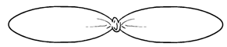 | 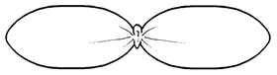 | 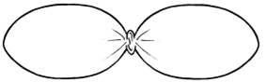
1 | 2 | 3
narrow elliptic | medium elliptic | broad elliptic

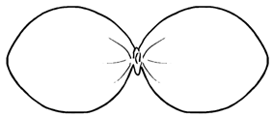 | 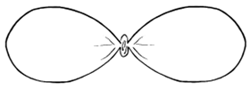
4 | 5
circular | obovate

Ad. 3: Seedling: cross section of cotyledons

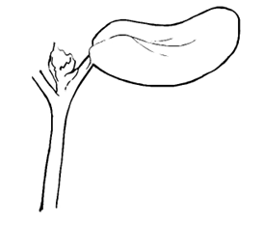 | 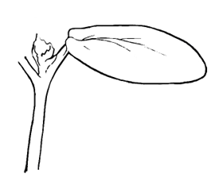 | 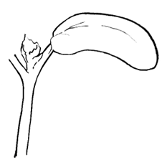
1 | 2 | 3
concave | straigt | convex

Ad. 13: Leaf blade: incisions

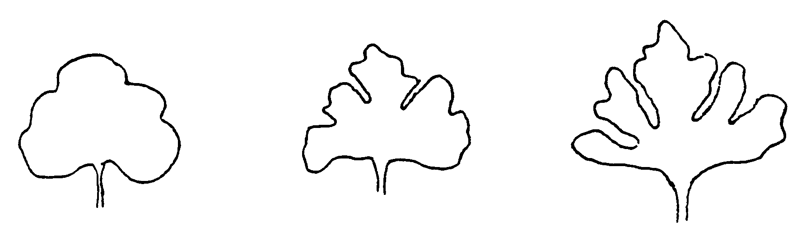
1 | 3 | 5
absent or very shallow | shallow | medium

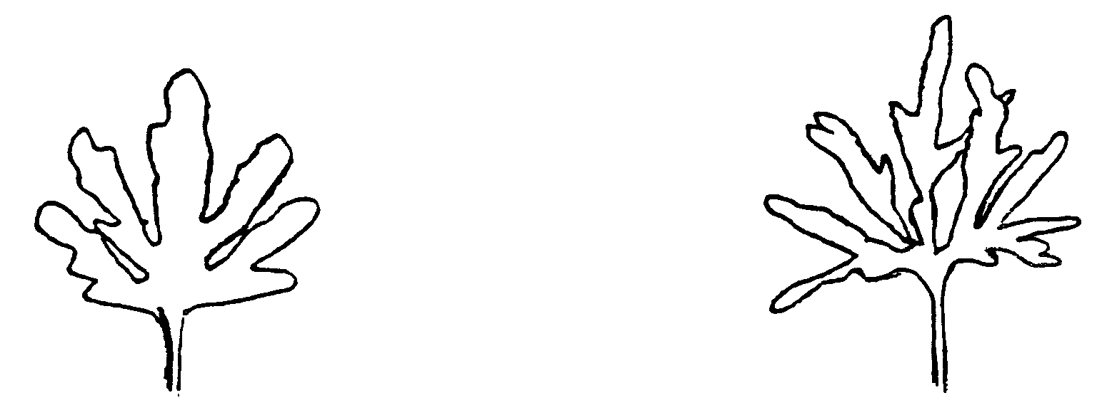
7 | 9
deep | very deep

Ad. 18: Time of flowering of female flower
The time of flowering of the female flower is when 10% of the plants have the first female flower open.

Ad. 19: Time of flowering of male flower
The time of flowering of the male flower is when 10% of the plants have the first male flower open.

Ad. 27: Only Zucchini and Rounded Zucchini type varieties: Young fruit: general shape

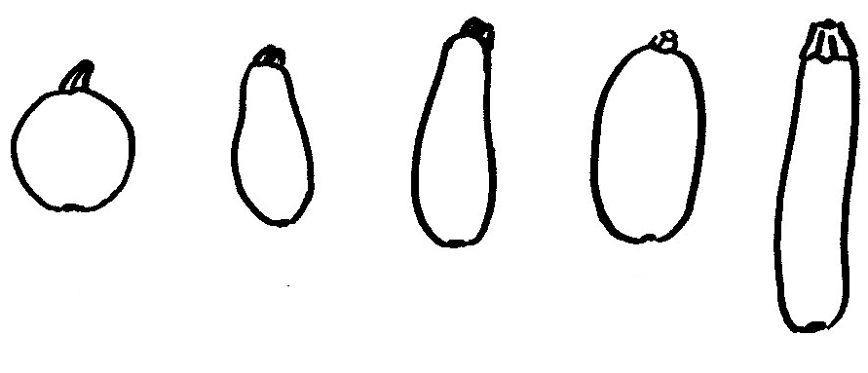 |  |  |  |  | 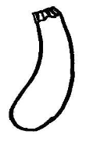
1 | 2 | 3 | 4 | 5 | 6
globular | pear shaped | tapered elliptical | elliptical | cylindrical | tapered cylindrical

Ad. 31: Fruit: general shape

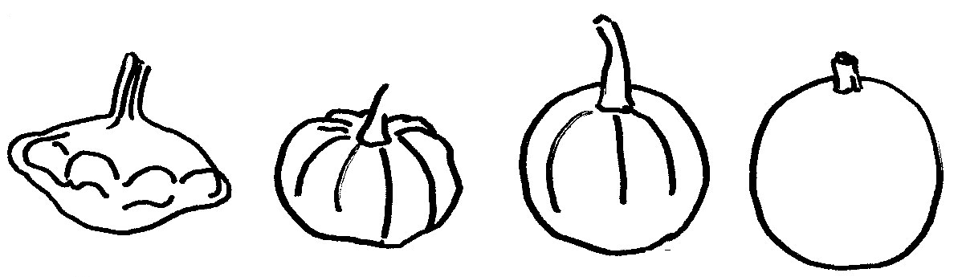
1 | 2 | 3 | 4
disc shaped | transverse elliptical | transverse broad elliptical | globular

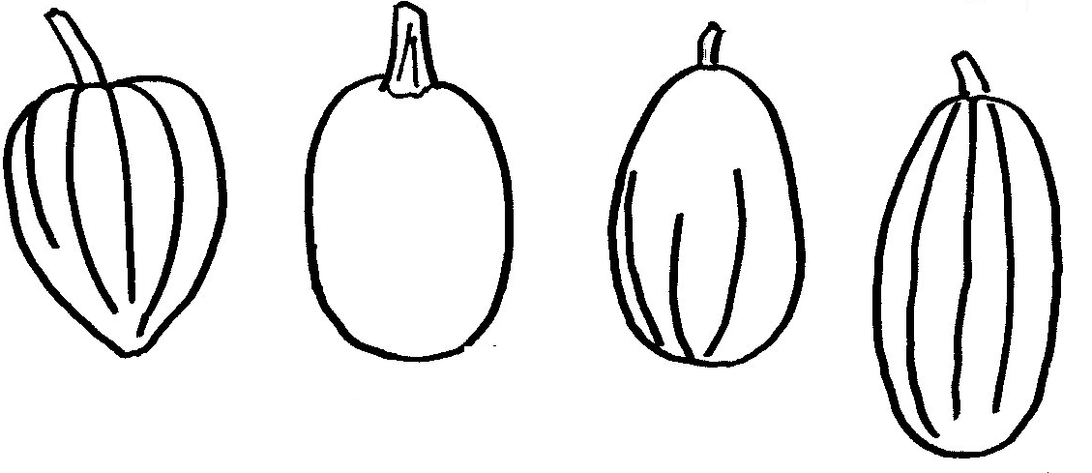
5 | 6 | 7 | 8
top shaped | broad elliptical | ovate | elliptical

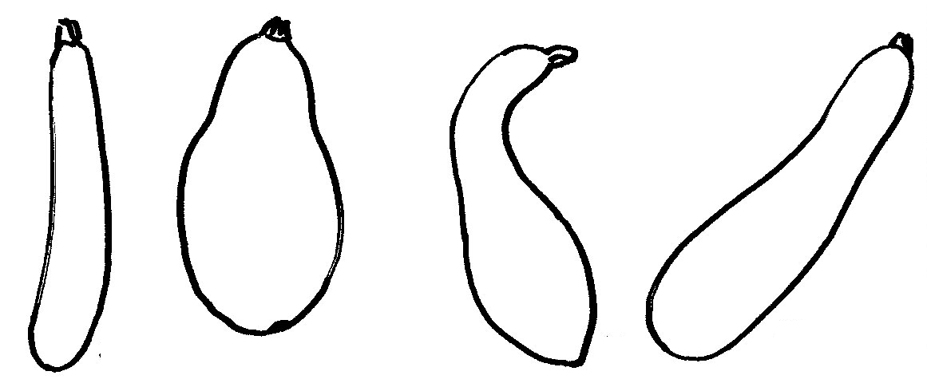
9 | 10 | 11 | 12
cylindrical | pear shaped | bottle shaped | club shaped

Ad. 60: Fruit: depth of grooves
Comparison of ribs and grooves
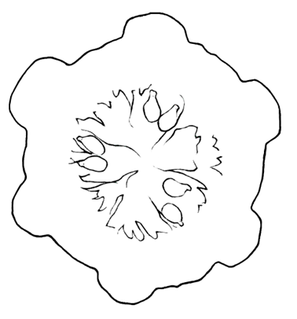 | 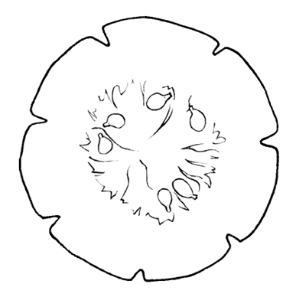
ribs | grooves

Ad. 68: Only varieties with Fruit: secondary green color: present: Fruit: distribution of secondary green color

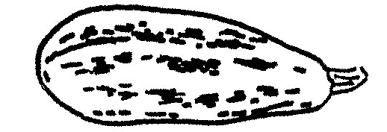 | 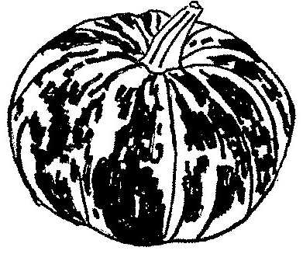
1  sparse patches | 2  dense patches

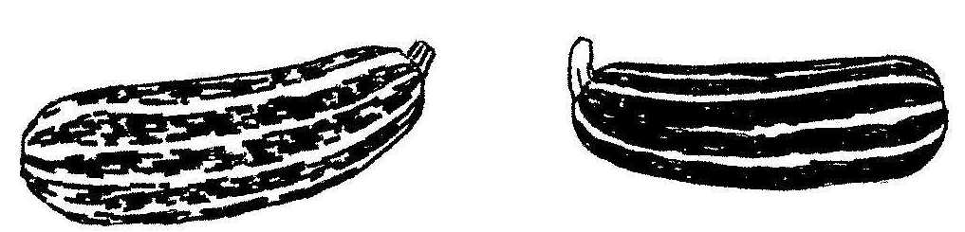

3  one colored stripes  4  two colored stripes | 5  one colored bands covering the whole surface  6  two colored bands covering the whole surface

Ad. 70: Fruit: size of flower scar

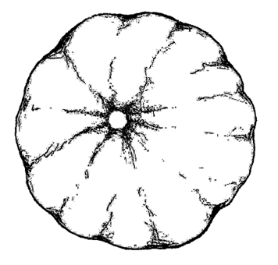 | 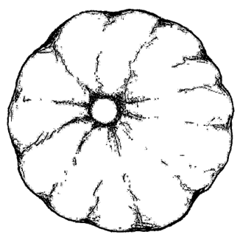 | 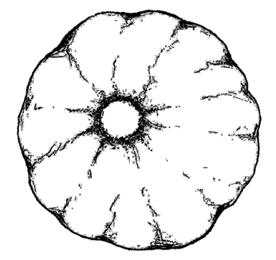
3 | 5 | 7
small | medium | large

Ad. 71: Fruit: length of peduncle

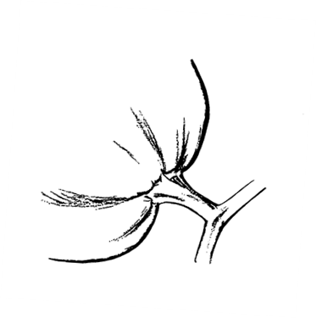 | 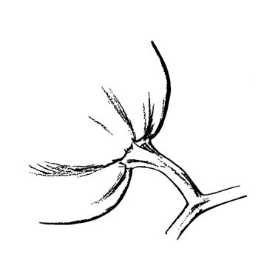 | 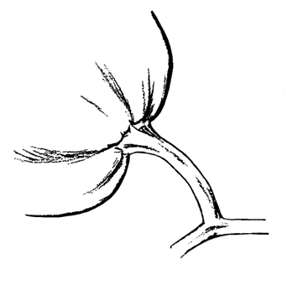
3 | 5 | 7
short | medium | long

Ad. 75: Time of maturity
Time of maturity is reached when 90% of the fruits have a dried peduncle and the leaves are dried up.

Ad. 76: Number of ripe fruits per plant
The plants per plot are counted. At the end of the vegetation period the fully developed, ripe fruits are counted.
With these two values the number of ripe fruits per plant is calculated:

Ad. 89: Only varieties with Seed: hull: absent: color of seeds

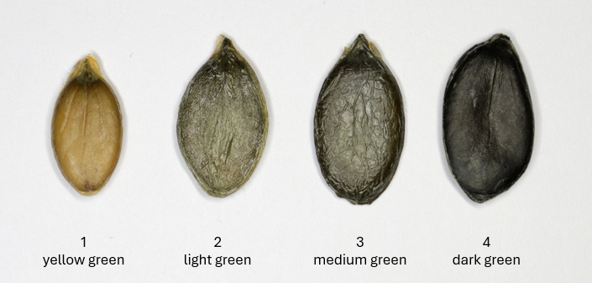

Ad. 90: Resistance to Zucchini yellow mosaic virus (ZYMV)

1. | Pathogen | Zucchini yellow mosaic virus (ZYMV)
2. | Quarantine status | No
3. | Host species | Cucurbita pepo L.
4. | Source of inoculum | GEVES (FR)[1]
5. | Isolate | e.g. strain E9  = MAT/REF/06-08-02-02
6. | Establishment isolate identity | -
7. | Establishment pathogenicity | Symptoms on susceptible squash variety
8. | Multiplication inoculum
8.1 | Multiplication medium | Living plant
8.2 | Multiplication variety | e.g. Cora
8.3 | Plant stage at inoculation | -
8.4 | Inoculation medium | -
8.5 | Inoculation method | -
8.6 | Harvest of inoculum | -
8.7 | Check of harvested inoculum | -
8.8 | Shelf life/viability inoculum | -
9. | Format of the test
9.1 | Number of plants per genotype | At least 20
9.2 | Number of replicates | At least 2 (e.g. 2x10 plants)
9.3 | Control varieties | To illustrate and define the UPOV states  - absent or low resistance (=susceptible): Cora  - medium resistance: Mirza (low threshold of medium resistance level):  - high resistance: Mikonos (low threshold of high resistance level)
9.4 | Test design | add non inoculated plants
9.5 | Test facility | Climatic room or greenhouse
9.6 | Temperature | e.g. 22°C or 24°C/18°C
9.7 | Light | 12h-16h
9.8 | Season
9.9 | Special measures | keep glasshouse free of aphids
10. | Inoculation
10.1 | Preparation inoculum | 1 g leaf with symptoms with 4 mL of PBS with carborundum (400 mg) and activated carbon (400 mg) or similar buffer, homogenize
10.2 | Quantification inoculum
10.3 | Plant stage at inoculation | First expanded leaf
10.4 | Inoculation method | Rubbing cotyledons with virus suspension  Optional: repeat the inoculation after 3 days
10.5 | First observation | 14 days post-inoculation
10.6 | Second observation | -
10.7 | Final observations | 21 days post-inoculation
11. | Observations
11.1 | Method | Visual observation
11.2 | Observation scale | Class 0: no symptom  Class 1: few small chlorotic patches  Class 2: many chlorotic patches  Class 3: large chlorotic areas (some patches on young leaves)  Class 4: mosaic and weak vein banding  Class 5: deformation and vein banding
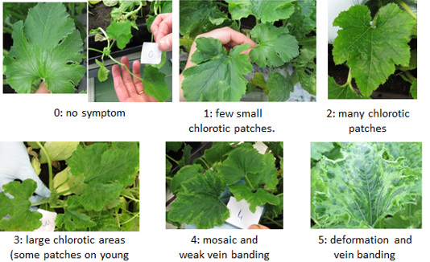
Courtesy of GEVES-SNES
11.3 | Validation of test | The high resistance control (Mikonos), the medium resistance control (Mirza) and the absent to low resistance (=susceptible) control (Cora) are necessary to validate the aggressiveness of test.  Results should be compared with results of controls, based on disease index (DI) and distribution of plants over the classes.
11.4 | Off-types | -
12. | Interpretation of data in terms of UPOV characteristic states | - Note 1: Most plants are in class 4 and/or 5 (absent or low resistance = susceptible)  - Note 2 Most plants are in class 2 and/or 3 (medium resistance)  - Note 3: Most plants are in class 0 and/or 1 (high resistance)  A variety with a lower resistance than Mirza (note 2) will be described note 1. A variety with a lower resistance than Mikonos (note 3), will be described note 2.  An additional statistical analysis can be used to finalize the pathologist’s raw observation to the assessment of uniformity, and relative position regarding the controls results.
Resistance to ZYMV:
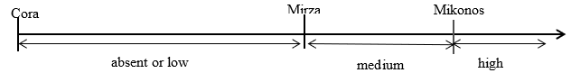
13. | Critical control points | Date of notation may be adapted depending on expression of symptoms on controls.  Environmental conditions can influence the expression of symptoms over time. In this case a second notation could be necessary.  Aphids may transmit ZYMV as well as other viruses that may contaminate the ZYMV strain. Test should be in aphid-free compartment.

[1] matref@geves.fr
Ad. 91: Resistance to Watermelon mosaic virus (WMV)

1. | Pathogen | Watermelon mosaic virus (WMV)
2. | Quarantine status | No
3. | Host species | Cucurbita pepo L.
4. | Source of inoculum | GEVES (FR)[1]
5. | Isolate | e.g., strain LL1A  = MAT/REF/06-09-01 2
6. | Establishment isolate identity | -
7. | Establishment pathogenicity | Symptoms on susceptible squash variety
8. | Multiplication inoculum
8.1 | Multiplication medium | Living plant
8.2 | Multiplication variety | e.g. Cora
8.3 | Plant stage at inoculation | -
8.4 | Inoculation medium | -
8.5 | Inoculation method | -
8.6 | Harvest of inoculum | -
8.7 | Check of harvested inoculum | -
8.8 | Shelf life/viability inoculum | -
9. | Format of the test
9.1 | Number of plants per genotype | At least 20
9.2 | Number of replicates | At least 2 (e.g. 2 x 10 plants)
9.3 | Control varieties | To illustrate UPOV notes:  - resistance absent: Cora  - resistance present: Sofia (minimum resistance level)  Mikonos, Syros have higher resistance than Sofia, but not resistant enough to illustrate a high resistance.
9.4 | Test design | add non inoculated plants
9.5 | Test facility | Climatic room or greenhouse
9.6 | Temperature | e.g., 22°C or 24°C/18°C
9.7 | Light | 12h-16h
9.8 | Season
9.9 | Special measures | Keep glasshouse free of aphids
10. | Inoculation
10.1 | Preparation inoculum | 1 g leaf with symptoms with 4mL of PBS with carborundum (400mg) and activated carbon (400mg) or similar buffer, homogenize
10.2 | Quantification inoculum | -
10.3 | Plant stage at inoculation | First expanded leave
10.4 | Inoculation method | Rubbing cotyledons with virus suspension  Optional: repeat the inoculation after 3 days
10.5 | First observation | 14 days post-inoculation
10.6 | Second observation | -
10.7 | Final observations | 21 days post-inoculation
11. | Observations
11.1 | Method | Visual observation
11.2 | Observation scale | Class 0: no symptom  Class 1: few small chlorotic patches  Class 2: many chlorotic patches  Class 3: large chlorotic areas (some patches on young leaves)  Class 4: mosaic, weak vein banding  Class 5: deformation and vein banding
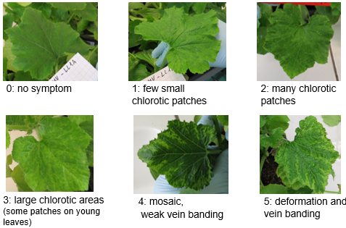
Courtesy of GEVES-SNES
11.3 | Validation of test | On three controls: Cora, Sofia, Mikonos or Syros  The presence of Syros or Mikonos (and not only Sofia) is necessary to validate the aggressiveness of the test.  Results should be compared with the results of controls, based on disease index (DI) and distribution of plants over the classes.
11.4 | Off-types | -
12. | Interpretation of data in terms of UPOV characteristic states | Note 1: Most plants are in class 4 and/or 5 (resistance absent or low to be considered)  Note 9: Most plants are in class 0, 1, 2 and/or 3 (resistance present -more or less intensely)  A variety with a lower level of resistance than Sofia (note 9), will be described as note 1  An additional statistical analysis can be used to finalize the pathologist’s raw observation to the assessment of uniformity, and relative position regarding the controls results.
13. | Critical control points | Date of notation may be adapted depending on expression of symptoms on controls.  Environmental conditions can influence the expression of symptoms over time. In this case a second notation could be necessary.  Aphids may transmit WMV as well as other viruses that may contaminate the WMV strain. Test should be in aphid-free compartment.

[1] matref@geves.fr

Literature

Decker, D.S., 1988, Origin(s), Evolution, and Systematics of Cucurbita pepo (Cucurbitaceae). Economic Botany, 42(1), S. 4-15.
Paris, H.S., 1986, A proposed subspecific classification for Cucurbita pepo, Phytologia 61 (3), S. 133-138.
Paris, H.S., 1998, Some Observations Concerning Diversity in the Subspecies and Horticultural Groups of Cucurbita pepo, Cucurbits Genetics Cooperative Report 21, S. 51-53.
Andres, T.C. 1995, Complexities in the infraspecific nomenclature of the Cucurbita pepo complex, Acta Horticulturae 413, S 65-91.
Tapley, W.T., Enzie, W.D., Eseltine, G.P. van, 1937, The Vegetables of New York, New York State Agricultural Experiment Station.
Paris, H.S., 1989, Historical Records, Origins and Development of the Edible Cultivar Groups of Cucurbita pepo (Cucurbitaceae), Economic Botany, 43(4), 1989, S. 423-443.
Paris, H.S., 1996, Summer Squash: History, Diversity, and Distribution, HorTechnology Jan./März 6/1.
Brancucci, Dr. Michel, Banziger, Erica, 2000, Das Grosse Buch vom Kürbis, Midena & Fona Verlag GmbH.
Phillips, Roger & Rix, Martyn, 1994, Groente, Het Spectrum B.
Naktuinbouw, 2010, Naktuinbouw calibration book for squash.

Technical Questionnaire

TECHNICAL QUESTIONNAIRE | Page {x} of {y} | Reference Number:

Application date:
(not to be filled in by the applicant)
TECHNICAL QUESTIONNAIRE
to be completed in connection with an application for plant breeders' rights

In the case of hybrid varieties which are the subject of an application for plant breeders' rights, and where the parent lines are to be submitted as a part of the examination of the hybrid variety, this Technical Questionnaire should be completed for each of the parent lines, in addition to being completed for the hybrid variety.
1. Subject of the Technical Questionnaire

1.1.1 |  |  | Botanical name |  | Cucurbita pepo L.
1.1.2 |  |  | Common name |  | VEGETABLE MARROW
1.2.1 |  |  | Botanical name |  | Cucurbita pepo L. var. styriaca Greb.
1.2.2 |  |  | Common name |  | OILPUMPKIN
2. Applicant

 |  | Name
 |  | Address
 |  | Telephone No.
 |  | Fax No.
 |  | E-mail address
 |  | Breeder (if different from applicant)
3. Proposed denomination and breeder's reference

 | Proposed denomination (if available)
 | Breeder's reference

TECHNICAL QUESTIONNAIRE | Page {x} of {y} | Reference Number:

#4. Information on the breeding scheme and propagation of the variety

4.1 Breeding scheme

Variety resulting from:

4.1.1 Crossing

(a) controlled cross [ ]

(please state parent varieties)

(…………………..……………..…) x (……………..…………………..…)

female parent male parent

(b) unknown cross [ ]

4.1.2 Mutation
(please state parent varieties)

4.1.3 Discovery and development
(please state where and when discovered and how developed)

4.1.4 Other
(Please provide details)

TECHNICAL QUESTIONNAIRE | Page {x} of {y} | Reference Number:

4.2 Method of propagating the variety

4.2.1 Seed-propagated varieties

(a) Cross-pollination [ ]
(i) Population [ ]
(ii) Synthetic variety [ ]
(b) Hybrid [ ]
(i) Single hybrid [ ]
(ii) Three-way hybrid [ ]
(iii) Double hybrid [ ]
(c) Inbred line [ ]
(e) Other (Please provide details) [ ]

4.2.2 Other
(Please provide details) [ ]

In the case of hybrid varieties the production scheme for the hybrid should be provided on a separate sheet. This should provide details of all the parent lines required for propagating the hybrid e.g.
Single Hybrid
(…………………..……………..…) x (……………..…………………..…)
female parent male parent

Three-Way Hybrid
(…………………..……………..…) x (……………..…………………..…)
female line male line

(…………………..……………..…) x (……………..…………………..…)
single hybrid used as female parent male parent
or
(…………………..……………..…) x (……………..…………………..…)
female parent single hybrid used as male parent

TECHNICAL QUESTIONNAIRE |  | Page {x} of {y} |  | Reference Number:
5. Characteristics of the variety to be indicated (the number in brackets refers to the corresponding characteristic in Test Guidelines; please mark the note which best corresponds).

 | Characteristics |  | Example Varieties |  | Note
5.1  (4) | Plant: growth habit
 | bush |  | Greyzini |  | 1 [ ]
 | trailing |  | Becky, Cinderella, Everest, Long Green Trailing, Twickers |  | 2 [ ]
5.2  (5) | Plant: length of trail
 | absent or very short (bush) |  | Greyzini |  | 1 [ ]
 | short |  |  |  | 2 [ ]
 | medium |  |  |  | 3 [ ]
 | long |  |  |  | 4 [ ]
5.3  (6) | Plant: degree of branching
 | absent or very weak |  | Goldi |  | 1 [ ]
 | very weak to weak |  |  |  | 2 [ ]
 | weak |  |  |  | 3 [ ]
 | weak to medium |  |  |  | 4 [ ]
 | medium |  |  |  | 5 [ ]
 | medium to strong |  |  |  | 6 [ ]
 | strong |  |  |  | 7 [ ]
 | strong to very strong |  |  |  | 8 [ ]
 | very strong |  |  |  | 9 [ ]
5.4  (8) | Stem: color
 | completely green |  | Becky |  | 1 [ ]
 | partly green and partly yellow |  | Autumn Gold |  | 2 [ ]
5.5  (9) | Stem: intensity of green color
 | very light |  | Maayan |  | 1 [ ]
 | very light to light |  |  |  | 2 [ ]
 | light |  | Bianchini |  | 3 [ ]
 | light to medium |  |  |  | 4 [ ]
 | medium |  | Cinderella |  | 5 [ ]
 | medium to dark |  |  |  | 6 [ ]
 | dark |  | Greyzini |  | 7 [ ]
 | dark to very dark |  |  |  | 8 [ ]
 | very dark |  | Goldrush |  | 9 [ ]

TECHNICAL QUESTIONNAIRE |  | Page {x} of {y} |  | Reference Number:
 | Characteristics |  | Example Varieties |  | Note
5.6  (13) | Leaf blade: incisions
 | absent or very shallow |  | Scallopini |  | 1 [ ]
 | very shallow to shallow |  |  |  | 2 [ ]
 | shallow |  | Everest |  | 3 [ ]
 | shallow to medium |  |  |  | 4 [ ]
 | medium |  | Jackpot |  | 5 [ ]
 | medium to deep |  |  |  | 6 [ ]
 | deep |  | Civac |  | 7 [ ]
 | deep to very deep |  |  |  | 8 [ ]
 | very deep |  | Isotta |  | 9 [ ]
5.7  (15) | Leaf blade: relative area covered by silvery patches
 | absent or very small |  | Albo, Black Forest, Scallopini |  | 1 [ ]
 | very small to small |  |  |  | 2 [ ]
 | small |  | Aziz |  | 3 [ ]
 | small to medium |  |  |  | 4 [ ]
 | medium |  | Ambassador |  | 5 [ ]
 | medium to large |  |  |  | 6 [ ]
 | large |  | Cora |  | 7 [ ]
 | large to very large |  |  |  | 8 [ ]
 | very large |  | Summerstar |  | 9 [ ]
5.8  (16) | Petiole: length
 | very short |  |  |  | 1 [ ]
 | very short to short |  |  |  | 2 [ ]
 | short |  | Jack be Little |  | 3 [ ]
 | short to medium |  |  |  | 4 [ ]
 | medium |  | Karioka |  | 5 [ ]
 | medium to long |  |  |  | 6 [ ]
 | long |  | Autumn Gold, Baikal |  | 7 [ ]
 | long to very long |  |  |  | 8 [ ]
 | very long |  |  |  | 9 [ ]

TECHNICAL QUESTIONNAIRE |  | Page {x} of {y} |  | Reference Number:
 | Characteristics |  | Example Varieties |  | Note
5.9  (27) | Only Zucchini and Rounded Zucchini type varieties: Young fruit: general shape
 | globular |  | De Nice à Fruit Rond |  | 1 [ ]
 | pear shaped |  | Clarita |  | 2 [ ]
 | tapered elliptical |  | Top Kapi |  | 3 [ ]
 | elliptical |  | Table Dainty |  | 4 [ ]
 | cylindrical |  | Ambassador, Ibis |  | 5 [ ]
 | tapered cylindrical |  |  |  | 6 [ ]
5.10  (28) | Young fruit: main color of skin (excluding color of dots, patches, stripes and bands)
 | white |  | Yellow Bush Scallop |  | 1 [ ]
 | cream |  | Tivoli |  | 2 [ ]
 | yellow |  | Goldi |  | 3 [ ]
 | green |  | Elite, Opal, Romano |  | 4 [ ]
 | partly white and partly yellow |  | Sunburst, Zephyr |  | 5 [ ]
 | partly white and partly green |  |  |  | 6 [ ]
 | partly yellow and partly green |  |  |  | 7 [ ]
5.11  (30) | Only varieties with green color of skin: Young fruit: intensity of green color of skin (as for 28)
 | very light |  | Clarita, Goya, Patty Green Tint |  | 1 [ ]
 | very light to light |  |  |  | 2 [ ]
 | light |  | Arlika |  | 3 [ ]
 | light to medium |  |  |  | 4 [ ]
 | medium |  | Baccara |  | 5 [ ]
 | medium to dark |  |  |  | 6 [ ]
 | dark |  | Arlesa, Sandra, Zefira |  | 7 [ ]
 | dark to very dark |  |  |  | 8 [ ]
 | very dark |  | Carnaval, Corsair |  | 9 [ ]

TECHNICAL QUESTIONNAIRE |  | Page {x} of {y} |  | Reference Number:
 | Characteristics |  | Example Varieties |  | Note
5.12  (31) | Fruit: general shape
 | disc shaped |  |  |  | 1 [ ]
 | transverse elliptical |  |  |  | 2 [ ]
 | transverse broad elliptical |  |  |  | 3 [ ]
 | globular |  |  |  | 4 [ ]
 | top shaped |  |  |  | 5 [ ]
 | broad elliptical |  |  |  | 6 [ ]
 | ovate |  |  |  | 7 [ ]
 | elliptical |  |  |  | 8 [ ]
 | cylindrical |  |  |  | 9 [ ]
 | pear shaped |  |  |  | 10 [ ]
 | bottle shaped |  |  |  | 11 [ ]
 | club shaped |  |  |  | 12 [ ]
5.13  (32) | Only Scallop type varieties: Fruit: length
 | very short |  |  |  | 1 [ ]
 | very short to short |  |  |  | 2 [ ]
 | short |  | Bennings Green Tint |  | 3 [ ]
 | short to medium |  |  |  | 4 [ ]
 | medium |  | Sunburst |  | 5 [ ]
 | medium to long |  |  |  | 6 [ ]
 | long |  | Yellow Bush Scallop |  | 7 [ ]
 | long to very long |  |  |  | 8 [ ]
 | very long |  |  |  | 9 [ ]

TECHNICAL QUESTIONNAIRE |  | Page {x} of {y} |  | Reference Number:
 | Characteristics |  | Example Varieties |  | Note
5.14  (33) | Only Acorn type varieties: Fruit: length
 | very short |  |  |  | 1 [ ]
 | very short to short |  |  |  | 2 [ ]
 | short |  | Table Gold |  | 3 [ ]
 | short to medium |  |  |  | 4 [ ]
 | medium |  | Swan White Acorn |  | 5 [ ]
 | medium to long |  |  |  | 6 [ ]
 | long |  | Ebony Table Queen |  | 7 [ ]
 | long to very long |  |  |  | 8 [ ]
 | very long |  |  |  | 9 [ ]
5.15  (34) | Only Neck type varieties: Fruit: length
 | very short |  |  |  | 1 [ ]
 | very short to short |  |  |  | 2 [ ]
 | short |  | Wryneck |  | 3 [ ]
 | short to medium |  |  |  | 4 [ ]
 | medium |  | Yellow Summer Crookneck |  | 5 [ ]
 | medium to long |  |  |  | 6 [ ]
 | long |  | Sunbar |  | 7 [ ]
 | long to very long |  |  |  | 8 [ ]
 | very long |  |  |  | 9 [ ]

TECHNICAL QUESTIONNAIRE |  | Page {x} of {y} |  | Reference Number:
 | Characteristics |  | Example Varieties |  | Note
5.16  (35) | Only Zucchini type varieties: Fruit: length
 | very short |  |  |  | 1 [ ]
 | very short to short |  |  |  | 2 [ ]
 | short |  | Jedida |  | 3 [ ]
 | short to medium |  |  |  | 4 [ ]
 | medium |  | Cora |  | 5 [ ]
 | medium to long |  |  |  | 6 [ ]
 | long |  | Carlotta |  | 7 [ ]
 | long to very long |  |  |  | 8 [ ]
 | very long |  |  |  | 9 [ ]
5.17  (36) | Only Scallop type varieties: Fruit: maximum diameter
 | very small |  |  |  | 1 [ ]
 | very small to small |  |  |  | 2 [ ]
 | small |  | Scallopini |  | 3 [ ]
 | small to medium |  |  |  | 4 [ ]
 | medium |  | Yellow Bush Scallop |  | 5 [ ]
 | medium to large |  |  |  | 6 [ ]
 | large |  | White Bush Scallop |  | 7 [ ]
 | large to very large |  |  |  | 8 [ ]
 | very large |  |  |  | 9 [ ]

TECHNICAL QUESTIONNAIRE |  | Page {x} of {y} |  | Reference Number:
 | Characteristics |  | Example Varieties |  | Note
5.18  (37) | Only Acorn type varieties: Fruit: maximum diameter
 | very small |  |  |  | 1 [ ]
 | very small to small |  |  |  | 2 [ ]
 | small |  | Table Gold |  | 3 [ ]
 | small to medium |  |  |  | 4 [ ]
 | medium |  | Table King |  | 5 [ ]
 | medium to large |  |  |  | 6 [ ]
 | large |  | Swan White Acorn |  | 7 [ ]
 | large to very large |  |  |  | 8 [ ]
 | very large |  |  |  | 9 [ ]
5.19  (38) | Only Zucchini type varieties: Fruit: maximum diameter
 | very small |  |  |  | 1 [ ]
 | very small to small |  |  |  | 2 [ ]
 | small |  | Goldi |  | 3 [ ]
 | small to medium |  |  |  | 4 [ ]
 | medium |  | Opal |  | 5 [ ]
 | medium to large |  |  |  | 6 [ ]
 | large |  | Jericho, Spidi |  | 7 [ ]
 | large to very large |  |  |  | 8 [ ]
 | very large |  |  |  | 9 [ ]
5.20  (42) | Only Pumpkin type varieties: Fruit: size
 | very small |  | Wee-B-Little |  | 1 [ ]
 | very small to small |  |  |  | 2 [ ]
 | small |  | Peek-a-Boo |  | 3 [ ]
 | small to medium |  |  |  | 4 [ ]
 | medium |  | Spirit |  | 5 [ ]
 | medium to large |  |  |  | 6 [ ]
 | large |  | Ghost Rider |  | 7 [ ]
 | large to very large |  |  |  | 8 [ ]
 | very large |  | Howden |  | 9 [ ]

TECHNICAL QUESTIONNAIRE |  | Page {x} of {y} |  | Reference Number:
 | Characteristics |  | Example Varieties |  | Note
5.21  (43) | Only Rondini type varieties: Fruit: size
 | very small |  |  |  | 1 [ ]
 | very small to small |  |  |  | 2 [ ]
 | small |  | Pomme d’Or |  | 3 [ ]
 | small to medium |  |  |  | 4 [ ]
 | medium |  | Rolet |  | 5 [ ]
 | medium to large |  |  |  | 6 [ ]
 | large |  | Little Gem |  | 7 [ ]
 | large to very large |  |  |  | 8 [ ]
 | very large |  |  |  | 9 [ ]
5.22  (56) | Fruit: main color of skin (excluding color of dots, patches, stripes and bands)
 | white |  | Pâtisson blanc panaché de vert |  | 1 [ ]
 | cream |  | Early White Bush Scallop, Little Boo |  | 2 [ ]
 | yellow |  | Autumn Gold |  | 3 [ ]
 | orange |  |  |  | 4 [ ]
 | green |  | Ambassador, Baby Bear |  | 5 [ ]
 | partly white and partly yellow |  | Sunburst, Zephyr |  | 6 [ ]
 | partly white and partly green |  |  |  | 7 [ ]
 | partly yellow and partly green |  |  |  | 8 [ ]
5.23  (57) | Only varieties with yellow color of skin: Fruit: intensity of yellow color of skin (as for 56)
 | very light |  |  |  | 1 [ ]
 | very light to light |  |  |  | 2 [ ]
 | light |  |  |  | 3 [ ]
 | light to medium |  |  |  | 4 [ ]
 | medium |  |  |  | 5 [ ]
 | medium to dark |  |  |  | 6 [ ]
 | dark |  |  |  | 7 [ ]
 | dark to very dark |  |  |  | 8 [ ]
 | very dark |  |  |  | 9 [ ]

TECHNICAL QUESTIONNAIRE |  | Page {x} of {y} |  | Reference Number:
 | Characteristics |  | Example Varieties |  | Note
5.24  (58) | Only varieties with green color of skin: Fruit: intensity of green color of skin (as for 56)
 | very light |  | Cora |  | 1 [ ]
 | very light to light |  |  |  | 2 [ ]
 | light |  | Baby Bear, Sardane |  | 3 [ ]
 | light to medium |  |  |  | 4 [ ]
 | medium |  |  |  | 5 [ ]
 | medium to dark |  |  |  | 6 [ ]
 | dark |  |  |  | 7 [ ]
 | dark to very dark |  |  |  | 8 [ ]
 | very dark |  |  |  | 9 [ ]
5.25  (60) | Only varieties with Fruit: grooves: present: Fruit: depth of grooves
 | absent or very shallow |  | Spooktacular |  | 1 [ ]
 | very shallow to shallow |  |  |  | 2 [ ]
 | shallow |  | Connecticut Field |  | 3 [ ]
 | shallow to medium |  |  |  | 4 [ ]
 | medium |  | Delicata, Table Queen |  | 5 [ ]
 | medium to deep |  |  |  | 6 [ ]
 | deep |  | Jack Be Little, Swan White Acorn |  | 7 [ ]
 | deep to very deep |  |  |  | 8 [ ]
 | very deep |  | Heart of Gold, Sweet Dumpling |  | 9 [ ]
5.26  (61) | Fruit: stripes in grooves
 | absent |  | Baby Bear, Jack Be Little |  | 1 [ ]
 | present |  | Delicata, Heart of Gold, Pâtisson jaune panaché de vert |  | 9 [ ]

TECHNICAL QUESTIONNAIRE |  | Page {x} of {y} |  | Reference Number:
 | Characteristics |  | Example Varieties |  | Note
5.27  (65) | Fruit: size of main dots
 | absent very small |  | Badger Cross |  | 1 [ ]
 | very small to small |  |  |  | 2 [ ]
 | small |  | Ambassador |  | 3 [ ]
 | small to medium |  |  |  | 4 [ ]
 | medium |  | Grey Zucchini |  | 5 [ ]
 | medium to large |  |  |  | 6 [ ]
 | large |  | Kingsize |  | 7 [ ]
 | large to very large |  |  |  | 8 [ ]
 | very large |  | Becky |  | 9 [ ]
5.28  (66) | Fruit: secondary green color (excluding dots)
 | absent |  | Grey Zucchini, Small Sugar |  | 1 [ ]
 | present |  | Beatrice, Greyzini, Heart of Gold, Tonda Padana, Zubi |  | 9 [ ]
5.29  (68) | Only varieties with secondary green color: present: Fruit: distribution of secondary green color
 | sparse patches |  | Elite, Greyzini |  | 1 [ ]
 | dense patches |  |  |  | 2 [ ]
 | one colored stripes |  | Altea |  | 3 [ ]
 | two colored stripes |  | Badger Cross, Twickers, Zubi |  | 4 [ ]
 | one colored bands covering the whole surface |  | Beatrice |  | 5 [ ]
 | two colored bands covering the whole surface |  |  |  | 6 [ ]
5.30  (77) | Ripe fruit: main color of skin (excluding dots, patches, stripes and bands)
 | white |  | Pâtisson blanc panaché de vert |  | 1 [ ]
 | whitish |  | White Bush Scallop |  | 2 [ ]
 | cream |  | Bianchini, Opal |  | 3 [ ]
 | yellow |  | Gold Rush |  | 4 [ ]
 | orange |  | Autumn Gold |  | 5 [ ]
 | green |  |  |  | 6 [ ]

TECHNICAL QUESTIONNAIRE |  | Page {x} of {y} |  | Reference Number:
 | Characteristics |  | Example Varieties |  | Note
5.31  (79) | Ripe fruit: secondary color of skin (as for 77)
 | whitish |  |  |  | 1 [ ]
 | cream |  |  |  | 2 [ ]
 | yellow |  |  |  | 3 [ ]
 | orange |  |  |  | 4 [ ]
 | green |  |  |  | 5 [ ]
5.32  (81) | Ripe fruit: color of flesh
 | cream |  | Elite |  | 1 [ ]
 | yellow |  | Sunburst, Vegetable Spaghetti |  | 2 [ ]
 | orange |  | Autumn Gold |  | 3 [ ]
5.33  (90) | Resistance to Zucchini yellow mosaic virus (ZYMV)
 | absent or low |  | Cora |  | 1 [ ]
 | medium |  | Mirza |  | 2 [ ]
 | high |  | Mikonos |  | 3 [ ]
5.34  (91) | Resistance to Watermelon mosaic virus (WMV)
 | absent |  | Cora |  | 1 [ ]
 | present |  | Mikonos, Sofia, Syros |  | 9 [ ]
5.35 | Types of varieties: Fruit: Type
 | Pumpkin |  | Halloween, Little Boo, Small Sugar |  | 1 [ ]
 | Miniature Pumpkin |  | Jack Be Little |  | 2 [ ]
 | Scallop |  | Patty Pan, Scallopini |  | 3 [ ]
 | Acorn |  | Table Queen |  | 4 [ ]
 | Neck |  | Early Prolific Straightneck, Yellow Summer Crookneck |  | 5 [ ]
 | Zucchini |  | Ambassador, Beiruti, Clarita, Elite, Ibis, Romano |  | 6 [ ]
 | Rounded Zucchini |  | De Nice à fruit rond, Redondo |  | 7 [ ]
 | Delicata |  | Delicata |  | 8 [ ]
 | Spaghetti Squash |  | Pasta, Vegetable Spaghetti |  | 9 [ ]
 | Rondini |  | Little Gem |  | 10 [ ]
 | Oilpumpkin |  | GL Rudolf |  | 11 [ ]
 | Other |  |  |  | 12 [ ]

TECHNICAL QUESTIONNAIRE |  | Page {x} of {y} |  | Reference Number:
6. Similar varieties and differences from these varieties

Please use the following table and box for comments to provide information on how your candidate variety differs from the variety (or varieties) which, to the best of your knowledge, is (or are) most similar. This information may help the examination authority to conduct its examination of distinctness in a more efficient way

Denomination(s) of variety(ies) similar to your candidate variety | Characteristic(s) in which your candidate variety differs from the similar variety(ies) |  | Describe the expression of the characteristic(s) for the similar variety(ies) |  | Describe the expression of the characteristic(s) for your candidate variety
Example | Fruit: general shape |  | transverse elliptical |  | club shaped
Comments

TECHNICAL QUESTIONNAIRE | Page {x} of {y} | Reference Number:
#7. Additional information which may help in the examination of the variety

7.1 In addition to the information provided in sections 5 and 6, are there any additional characteristics which may help to distinguish the variety?

Yes [ ] No [ ]

(If yes, please provide details)

7.2 Are there any special conditions for growing the variety or conducting the examination?

Yes [ ] No [ ]

(If yes, please provide details)

7.3 Other information

- Resistance to Pests and Diseases

TECHNICAL QUESTIONNAIRE | Page {x} of {y} | Reference Number:
8. Authorization for release

(a) Does the variety require prior authorization for release under legislation concerning the protection of the environment, human and animal health?

Yes [ ] No [ ]

(b)Has such authorization been obtained?

Yes [ ] No [ ]

If the answer to (b) is yes, please attach a copy of the authorization.
9. Information on plant material to be examined or submitted for examination

9.1 The expression of a characteristic or several characteristics of a variety may be affected by factors, such as pests and disease, chemical treatment (e.g. growth retardants or pesticides), effects of tissue culture, different rootstocks, scions taken from different growth phases of a tree, etc.

9.2 The plant material should not have undergone any treatment which would affect the expression of the characteristics of the variety, unless the competent authorities allow or request such treatment. If the plant material has undergone such treatment, full details of the treatment must be given. In this respect, please indicate below, to the best of your knowledge, if the plant material to be examined has been subjected to:

(a) Microorganisms (e.g. virus, bacteria, phytoplasma) Yes [ ] No [ ]

(b) Chemical treatment (e.g. growth retardant, pesticide) Yes [ ] No [ ]

(c) Tissue culture Yes [ ] No [ ]

(d) Other factors Yes [ ] No [ ]

Please provide details for where you have indicated "yes".

____________________________________________________________

10. I hereby declare that, to the best of my knowledge, the information provided in this form is correct:

Applicant's name
Signature |  | Date
 | [End of document]

