 | E
International Union for the Protection of New Varieties of Plants

Technical Working Party for Vegetables  Fifty-Ninth Session  Virtual meeting, May 5 to 8, 2025 | TWV/59/3  Original: English  Date: March 31, 2025
Partial revision of the Test Guidelines for TOMATO ROOTSTOCKS
Document prepared by an expert from the Netherlands (Kingdom of)
Disclaimer: this document does not represent UPOV policies or guidance
The purpose of this document is to present a proposal for a partial revision of the Test Guidelines for Tomato Rootstocks (document TG/294/1 Rev. 5).

The Technical Working Party for Vegetables (TWV), at its fifty-eighth session, agreed that the Test Guidelines for Tomato rootstocks be partially revised (see document TWV/58/11 “Report”, Annex II).

The following changes are proposed:

- Revision of characteristic 22 “Meloidogyne incognita (Mi)”: states of expression to read the same as in the Test Guidelines for Tomato
- Revision of explanation Ad. 22 “Meloidogyne incognita (Mi)”

The proposed changes are presented below in highlight and underline (insertion) and strikethrough (deletion).

Proposed revision of characteristic 22 “Meloidogyne incognita (Mi): states of expression to read the same as in the Test Guidelines for Tomato

Current wording

22.  (*)  (+) | VG | Resistance to Meloidogyne incognita (Mi) | Résistance à Meloidogyne incognita (Mi) | Resistenz gegen Meloidogyne incognita (Mi) | Resistencia a Meloidogyne incognita (Mi)
QN |  | susceptible | sensible | anfällig | susceptible | Bruce | 1
 |  | moderately resistant | moyennement résistant | mäßig resistent | moderadamente resistente |  | 2
 |  | highly resistant | hautement résistant | hoch resistent | muy resistente | Emperador | 3

Proposed new wording

22.  (*)  (+) | VG | Resistance to Meloidogyne incognita (Mi) | Résistance à Meloidogyne incognita (Mi) | Resistenz gegen Meloidogyne incognita (Mi) | Resistencia a Meloidogyne incognita (Mi)
QN |  | susceptible  absent or low | sensible  absente ou faible | anfällig  fehlend oder gering | susceptible  ausente o baja | Bruce | 1
 |  | moderately resistant  medium | moyennement resistant  moyenne | mäßig resistent  mittel | moderadamente resistente media |  | 2
 |  | highly resistant  high | hautement resistant  élevée | hoch resistent  hoch | muy resistente  alta | Emperador | 3

Revision of explanation Ad. 22 “Meloidogyne incognita (Mi): control varieties

Current wording

Ad. 22: Resistance to Meloidogyne incognita (Mi)
1. | Pathogen | Meloidogyne incognita
2. | Quarantine status | -
3. | Host species | Tomato - Solanum lycopersicum
4. | Source of inoculum | GEVES (FR) or INIA – CSIC (ES) or Naktuinbouw (NL)
5. | Isolate | non-resistance breaking
6. | Establishment isolate identity | use tomato standards
7 | Establishment pathogenicity | use susceptible rootstock or tomato standard
8. | Multiplication inoculum
8.1 | Multiplication medium | living plant
8.2 | Multiplication variety | susceptible variety, preferably resistant to powdery mildew
8.3 | Plant stage at inoculation | 2nd leaf stage
8.5 | Inoculation method | deposit of piece of inoculated roots in soil (around 5-10g near each plant, to adapt depending on the population aggressivity)
8.6 | Harvest of inoculum | 6 to 10 weeks after inoculation, root systems are cut with scissors into pieces of about 1 cm length
8.7 | Check of harvested inoculum | visual check for presence of root knots and ripe egg masses
8.8 | Shelf life/viability inoculum | 1 day
9. | Format of the test
9.1 | Number of plants per genotype | 30 plants  Remark: knowing that germination in rootstocks might be low and/or irregular it is recommended to sow more seeds to be sure to get at least 30 plants.  It is recommended to include in the test, 10 non-inoculated plants, to be able to identify a possible lack of germination or a delay in plant growth, due to the material.
9.2 | Number of replicates | at least 2, preferably 3 to allow statistical analysis
9.3 | Control varieties | Susceptible: Bruce and (Solanum lycopersicum) Casaque Rouge  Intermediate resistant: (Solanum lycopersicum)  Campeon, Tyonic  Highly resistant: Emperador
9.4 | Test design | 3 replicates of 10 plants in different trays by variety
9.5 | Test facility | greenhouse or climate room
9.6 | Temperature | 20-26°C, the temperature should be adapted, depending on the aggressiveness of the test, to obtain the expected response of the controls, but should not exceed 26°C. Higher temperatures will cause breakdown of resistance.
9.7 | Light | at least 12 h per day
10 | Inoculation
10.1 | Preparation inoculum | small pieces of diseased roots mixed with soil
10.2 | Quantification inoculum | Quantity of inoculum depends on aggressivness of test and growing conditions (e.g. between 30g to 60g of inoculated roots for 100 plants in a tray of 45*30 cm containing approximately 5.5 kg of substrate); galls should be homogeneously mixed with soil.
10.3 | Plant stage at inoculation | seed
10.4 | Inoculation method | Seeds are sown in non-inoculated soil and inoculation of soil and inoculation of soil is done after sowing when plantlets are at cotyledon stage.
10.7 | End of test | 28 to 45 days after inoculation depending on test conditions (temperature, season)
11. | Observations
11.1 | Method | root inspection per plant
11.2 | Observation scale
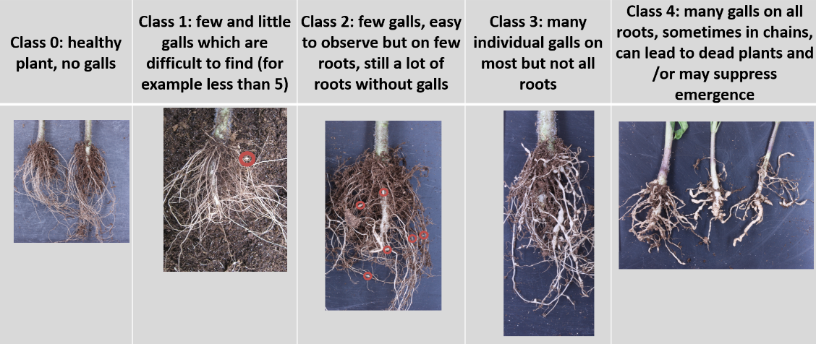

11.3 | Validation of test | Validation on controls. Expected reactions of controls:  Susceptible control: most plants at classes 3 and 4.  Highly resistant: most plants at classes 0 and 1.  Intermediate resistant: clearly different from other controls with majority of plants around class 2.
12. | Interpretation of data in terms of UPOV characteristic states | [1] Susceptible: variety very similar to susceptible control  [2] Intermediate resistant: variety very similar to intermediate resistant control  [3] Highly resistant: variety very similar to highly resistant control  If results are not clear, statistical analysis is advised.  If significantly different from the controls, a retest is advised to check if the result is stable.
13. | Critical control points | Avoid overwatering. This may result in rotting of roots.  In case of aggressive test, decrease the quantity of inoculum.

Proposed new wording

Ad. 22: Resistance to Meloidogyne incognita (Mi)
1. | Pathogen | Meloidogyne incognita
2. | Quarantine status | -
3. | Host species | Tomato - Solanum lycopersicum
4. | Source of inoculum | GEVES (FR) or INIA – CSIC (ES) or Naktuinbouw (NL)
5. | Isolate | non-resistance breaking
6. | Establishment isolate identity | use tomato standards
7 | Establishment pathogenicity | use susceptible rootstock or tomato standard
8. | Multiplication inoculum
8.1 | Multiplication medium | living plant
8.2 | Multiplication variety | susceptible variety, preferably resistant to powdery mildew
8.3 | Plant stage at inoculation | 2nd leaf stage
8.5 | Inoculation method | deposit of piece of inoculated roots in soil (around 5-10g near each plant, to adapt depending on the population aggressivity)
8.6 | Harvest of inoculum | 6 to 10 weeks after inoculation, root systems are cut with scissors into pieces of about 1 cm length
8.7 | Check of harvested inoculum | visual check for presence of root knots and ripe egg masses
8.8 | Shelf life/viability inoculum | 1 day
9. | Format of the test
9.1 | Number of plants per genotype | 30 plants  Remark: knowing that germination in rootstocks might be low and/or irregular it is recommended to sow more seeds to be sure to get at least 30 plants.  It is recommended to include in the test, 10 non-inoculated plants, to be able to identify a possible lack of germination or a delay in plant growth, due to the material.
9.2 | Number of replicates | at least 2, preferably 3 to allow statistical analysis
9.3 | Control varieties | ISF definitions:
 | Susceptible | Bruce and (Solanum lycopersicum) Casaque Rouge
 | Intermediate resistant | (Solanum lycopersicum) Campeon, Tyonic
 | Highly resistant | Emperador and (Solanum lycopersicum) Arletta, Anahu, Anahu x Casaque Rouge
9.4 | Test design | 3 replicates of 10 plants in different trays by variety
9.5 | Test facility | greenhouse or climate room
9.6 | Temperature | 20-26°C, the temperature should be adapted, depending on the aggressiveness of the test, to obtain the expected response of the controls, but should not exceed 26°C. Higher temperatures will cause breakdown of resistance.
9.7 | Light | at least 12 h per day
10 | Inoculation
10.1 | Preparation inoculum | small pieces of diseased roots mixed with soil
10.2 | Quantification inoculum | Quantity of inoculum depends on aggressivness of test and growing conditions (e.g. between 30g to 60g of inoculated roots for 100 plants in a tray of 45*30 cm containing approximately 5.5 kg of substrate); galls should be homogeneously mixed with soil.
10.3 | Plant stage at inoculation | seed
10.4 | Inoculation method | Seeds are sown in non-inoculated soil and inoculation of soil and inoculation of soil is done after sowing when plantlets are at cotyledon stage.
10.7 | End of test | 28 to 45 days after inoculation depending on test conditions (temperature, season)

11. | Observations
11.1 | Method | root inspection per plant
11.2 | Observation scale
11.3 | Validation of test | Validation on controls. Expected reactions of controls:  Susceptible control: most plants at classes 3 and 4.  Highly resistant: most plants at classes 0 and 1.  Intermediate resistant: clearly different from other controls with majority of plants around class 2.
12. | Interpretation of data in terms of UPOV characteristic states | [1] Susceptible absent or low: variety very similar to susceptible control.  [2] Intermediate resistant medium: variety very similar to intermediate resistant control.  [3] Highly resistant high: variety very similar to highly resistant control.  If results are not clear, statistical analysis is advised.  If significantly different from the controls, a retest is advised to check if the result is stable.
13. | Critical control points | Avoid overwatering. This may result in rotting of roots.  In case of aggressive test, decrease the quantity of inoculum.

[End of document]

held via electronic means, from April 22 to 25, 2024.
GEVES; matref@geves.fr
INIA; resistencias@inia.es
Naktuinbouw; resistentie@naktuinbouw.nl
GEVES; matref@geves.fr
INIA; resistencias@inia.es
Naktuinbouw; resistentie@naktuinbouw.nl
ISF, https://www.worldseed.org

