 | E
International Union for the Protection of New Varieties of Plants

Technical Working Party for Vegetables  Fifty-Ninth Session  Virtual meeting, May 5 to 8, 2025 | TWV/59/12  Original: English  Date: April 11, 2025
Matters to be resolved concerning Test Guidelines put forward for adoption by the Technical Committee: Cucumber, Gherkin
Document prepared by an expert from the Netherlands (Kingdom of)
Disclaimer: this document does not represent UPOV policies or guidance
The Enlarged Editorial Committee (TC-EDC), at their meetings held in January and March 2025, considered the partial revision of the Test Guidelines for Cucumber, Gherkin (document TC-EDC/JAN25/3) and agreed that a technical matter should be addressed by the TWV.

The following table presents the list of recommendations made by the TC-EDC on the partial revision of the Test Guidelines for Cucumber, Gherkin (Cucumis sativus L). The technical matter to be addressed by the TWF are indicated with “#” (hashtag).

#Char. 52 | To check whether to be presented as QN characteristic. The clear cut between absent and present which is typical for a QL characteristic is missing.  Leading Expert: provided new proposal for Ad. 52 to be discussed during the TWV/59 session, as presented in the Annex to this document
Ad. 52 | to add “6. Establishment isolate identity” to read “Resistant and susceptible controls”  Leading Expert: agreed. See Annex to this document

[Annex follows]

Proposed addition of new Characteristic 52 “Resistance to Cucumber green mottle mosaic virus (CGMMV)” at the end of the Table of Characteristics

 |  | English | français | Deutsch | español | Example Varieties  Exemples  Beispielssorten  Variedades ejemplo | Note/  Nota
52.  (+) | VS | Resistance to Cucumber green mottle mosaic virus (CGMMV) | Resistance au Cucumber green mottle mosaic virus (CGMMV) | Resistenz gegen Cucumber green mottle mosaic virus (CGMMV) | Resistencia a Cucumber green mottle mosaic virus (CGMMV)
QL |  | absent | absente | fehlend | ausente | Topspin | 1
 |  | present | présente | vorhanden | presente | Bonaire, Bluesbrother | 9

Proposed addition of an explanation Ad. 52 “Resistance to Cucumber green mottle mosaic virus (CGMMV)” in Chapter 8.2 “Explanations for individual characteristics”

Ad. 52: Resistance to Cucumber green mottle mosaic virus (CGMMV)

1. | Pathogen | Cucumber green mottle mosaic virus (CGMMV)
2. | Quarantine status | -
3. | Host species | Cucumis sativus L.
4. | Source of inoculum | Naktuinbouw (NL)
5. | Isolate | e.g. nt280  Other validated isolates may be used, as long as producing the same results on the differential set.
6. | Establishment isolate identity | Resistant and susceptible controls
7. | Establishment pathogenicity | Test on susceptible plants
8. | Multiplication inoculum
8.1 | Multiplication medium | Living plants
8.2 | Multiplication variety | Susceptible variety e.g. Topspin
8.3 | Plant stage at inoculation | Cotyledon or first leaf (ca. 7 days old)
8.4 | Inoculation medium | PBS 0,01 M
8.5 | Inoculation method | Rubbing cotyledons with abrasive added to buffer
8.6 | Harvest of inoculum | Soon after the symptoms appear (ca. 14 days after  inoculation), first true leaves
8.8 | Shelf life/viability inoculum | Fresh longer than 1 day, desiccated longer than 1 year
9. | Format of the test
9.1 | Number of plants per genotype | At least 20 plants
9.2 | Number of replicates | -
9.3 | Control varieties | Resistance absent: Topspin  Resistance present: Bonaire (minimum resistance level), Bluesbrother  Bluesbrother has higher resistance than Bonaire
9.5 | Test facility | Glasshouse or climate room
9.6 | Temperature | 24/22°C day/night
9.7 | Light | At least 12 hours
10. | Inoculation
10.1 | Preparation inoculum | 1 g leaf with symptoms with 10 ml 0,01 M PBS or similar buffer. Homogenize, add abrasive to buffer (1 g/30 ml)
10.3 | Plant stage at inoculation | Cotyledon (ca. 7 days old plant)
10.4 | Inoculation method | Gentle rubbing with abrasive added to buffer
10.5 | First observation | 2 weeks after inoculation
10.6 | Second observation | 3 weeks after inoculation
10.7 | Final observations | When Topspin has symptoms predominantly in class 5
11. | Observations
11.1 | Method | Visual
11.2 | Observation scale | Class 1) No virus symptoms  Class 2) Isolated yellow spots  Class 3) Mild, localized lesions  Class 4) Wide distribution of mosaic and mottling  Class 5) Strong mosaic, yellowing and distortion of leaf shape
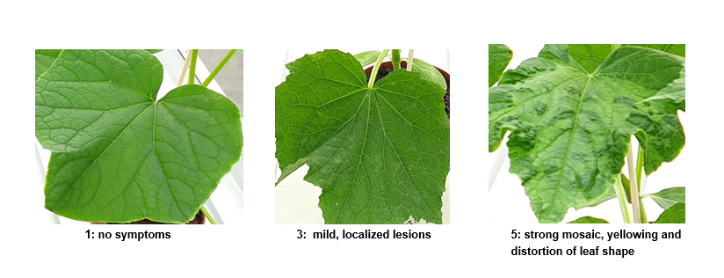

Class 1: no symptoms | Class 3: mild, localized lesions | Class 5: strong mosaic, yellowing and distortion of leaf shape

11.3 | Validation of test | Validation on controls. Expected response of controls:  Susceptible control:  -most plants in classes 4 and 5,  Resistant control:  -most plants in classes 1,2 and/or 3
12. | Interpretation of data in terms of UPOV characteristic states | [1] absent: distribution of plants in the classes comparable with the susceptible control  [9] present: distribution of plants in the classes comparable with the resistant controls  A variety with a lower level of resistance than Bonaire (note 9), will be described as note 1.  The decision on which side of a border line a variety is described is made on the basis of side by side comparison with the threshold variety Bonaire. Additionally, statistical analysis could be used to support the decision.
13. | Critical control points | • The first symptoms will appear relatively late, compared with other cucumber viruses. When symptoms appear before day 11 after inoculation, it may be another virus.  • CGMMV is contagious, and stable, also outside the plant. Avoid touching the plants. Use gloves. Do not combine CGMMV testing with other cucumber resistance tests in one compartment, if possible.  • Aphids may transmit CGMMV as well as other viruses that may contaminate the CGMMV strain. Test should be in aphid-free compartment.

[End of document]

resistentie@naktuinbouw.nl

