E
International Union for the Protection of New Varieties of Plants

Technical Working Party for Vegetables  Fifty-Eigth Session  Virtual meeting, April 22 to 25, 2024 | TWV/58/6  Original: English  Date: March 22, 2024
Partial revision of the Test Guidelines for Cucumber, Gherkin
Document prepared by an expert from the Netherlands
Disclaimer: this document does not represent UPOV policies or guidance
The purpose of this document is to present a proposal for a partial revision of the Test Guidelines for Cucumber, Gherkin (document TG/61/7 Rev. 2 Corr. 2).

The Technical Working Party for Vegetables (TWV), at its fifty-eighth session, agreed that the Test Guidelines for Cucumber, Gherkin (Cucumis sativus L.) be partially revised (see document TWV/57/26 Corr. “Report”, Annex II).

The following changes are proposed:

- Addition of new Characteristic 52 “Resistance to Cucumber green mottle mosaic virus (CGMMV)” at the end of the Table op Characteristics
- Addition of an explanation Ad. 52 “Resistance to Cucumber green mottle mosaic virus (CGMMV)” in Chapter 8.2 “Explanations for individual characteristics”

Proposed addition of new Characteristic 52 “Resistance to Cucumber green mottle mosaic virus (CGMMV)” at the end of the Table Of Characteristics

 |  | English | français | Deutsch | español | Example Varieties  Exemples  Beispielssorten  Variedades ejemplo | Note/  Nota
52.  (+) | VS | Resistance to Cucumber green mottle mosaic virus (CGMMV) | Resistance au Cucumber green mottle mosaic virus (CGMMV) | Resistenz gegen Cucumber green mottle mosaic virus (CGMMV) | Resistencia a Cucumber green mottle mosaic virus (CGMMV)
QL |  | absent | absente | fehlend | ausente | Topspin | 1
 |  | present | présente | vorhanden | presente | Bonaire, Bluesbrother | 9

Proposed addition of an explanation Ad. 52 “Resistance to Cucumber green mottle mosaic virus (CGMMV)” in Chapter 8.2 “Explanations for individual characteristics”

Ad. 52: Resistance to Cucumber green mottle mosaic virus (CGMMV)

1. | Pathogen | Cucumber green mottle mosaic virus (CGMMV)
2. | Quarantine status | -
3. | Host species | Cucumis sativus L.
4. | Source of inoculum | Naktuinbouw (NL)
5. | Isolate | e.g. nt280
7. | Establishment pathogenicity | Test on susceptible plants
8. | Multiplication inoculum
8.1 | Multiplication medium | Living plants
8.2 | Multiplication variety | Susceptible variety e.g. Topspin
8.3 | Plant stage at inoculation | Cotyledon or first leaf (ca. 7 days old)
8.4 | Inoculation medium | PBS 0,01 M
8.5 | Inoculation method | Rubbing cotyledons with abrasive added to buffer
8.6 | Harvest of inoculum | Soon after the symptoms appear (ca. 14 days after  inoculation), first true leaves
8.8 | Shelf life/viability inoculum | Fresh longer than 1 day, desiccated longer than 1 year
9. | Format of the test
9.1 | Number of plants per | At least 20
9.2 | Number of replicates | -
9.3 | Control varieties | Resistance absent: Topspin  Resistance present: Bonaire (minimum resistance level)  Bluesbrother has higher resistance than Bonaire
9.5 | Test facility | Glasshouse or climate room
9.6 | Temperature | 24/22°C d/n
9.7 | Light | At least 12 hours
10. | Inoculation
10.1 | Preparation inoculum | 1 g leaf with symptoms with 10 ml 0,01 M PBS or similar buffer. Homogenize, add abrasive to buffer (1 g/30 ml)
10.3 | Plant stage at inoculation | Cotyledon (ca. 7 days old plant)
10.4 | Inoculation method | Gentle rubbing with abrasive added to buffer
10.5 | First observation | 2 weeks after inoculation
10.6 | Second observation | 3 weeks after inoculation
10.7 | Final observations | When Topspin has symptoms predominantly in class 5
11. | Observations
11.1 | Method | Visual
11.2 | Observation scale | 1) No virus symptoms  2) Isolated yellow spots  3) Mild, localized lesions  4) Wide distribution of mosaic and mottling  5) Strong mosaic, yellowing and distortion of leaf shape
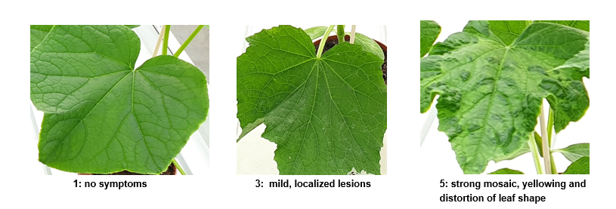
11.3 | Validation of test | On three controls: Topspin, Bonaire, Bluesbrothers, The presence of Bluesbrother (and not only Bonaire) is necessary to validate the aggressiveness of the test.
12. | Interpretation of data in terms of UPOV characteristic states | [1] Resistance absent: comparable with Topspin  [9] Resistance present: comparable with Bonaire and Bluesbrother  A variety with a lower level of resistance than Bonaire (note 9), will be described as note 1.
13. | Critical control points | • The first symptoms will appear relatively late, compared with other cucumber viruses. When symptoms appear before day 11 after inoculation, it may be another virus.  • CGMMV is contagious, and stable, also outside the plant. Avoid touching the plants. Use gloves. Do not combine CGMMV testing with other cucumber resistance tests in one compartment, if possible.  • Aphids may transmit CGMMV as well as other viruses that may contaminate the CGMMV strain. Test should be in aphid-free compartment.
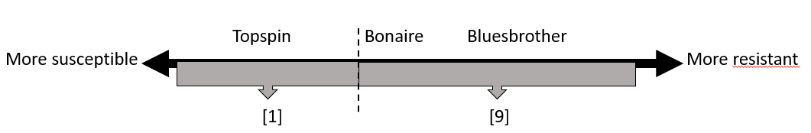

[End of document]

held in Antalya, Türkiye, from May 1 to 5, 2023, in hybrid format
resistentie@naktuinbouw.nl

