|  |  |
| --- | --- |
|  | E |
| International Union for the Protection of New Varieties of Plants |  |

|  |  |
| --- | --- |
| Technical Working Party for Vegetables  Fifty-Eighth Session Virtual meeting, April 22 to 25, 2024 | TWV/58/5  Original: English  Date: March 22, 2024 |

Partial revision of the Test Guidelines for Asparagus

Document prepared by an expert from Japan

Disclaimer: this document does not represent UPOV policies or guidance

The purpose of this document is to present a proposal for a partial revision of the Test Guidelines for Asparagus (document TG/130/4).

The Technical Working Party for Vegetables (TWV), at its fifty-seventh session[1], agreed that the Test Guidelines for Asparagus (*Asparagus officinalis* L.) be partially revised (see document TWV/57/26 Corr. “Report”, Annex II).

The following changes are proposed:

1. Revision of Characteristic 16 “Type of flowering”
2. Revision of Ad.16: Type of flowering

The proposed changes are presented below in highlight and underline (insertion) and ~~strikethrough~~ (deletion).

Revision of Characteristic 16 “Type of flowering”

*Current wording*

|  |  |  |  |  |  |  |  |
| --- | --- | --- | --- | --- | --- | --- | --- |
|  |  | English | français | deutsch | español | Example Varieties/ Exemples/ Beispielssorten/ Variedades ejemplo | Note/ Nota |
| 16.  (+) (*) | VG | Type of flowering | Type de floraison | Blühtyp | Tipo de floración |  |  |
| **QL** |  | plants with male flowers and plants with female flowers | plantes avec des fleurs mâles et plantes avec des fleurs femelles | Pflanzen mit männlichen Blüten und Pflanzen mit weiblichen Blüten | plantas con flores masculinas y plantas con flores femeninas | Andreas | 1 |
|  |  | plants with male and female flowers | plantes avec des fleurs mâles et des fleurs femelles | Pflanzen mit männlichen und weiblichen Blüten | plantas con flores masculinas y femeninas | Argenteuil, Desto | 2 |
|  |  | plants with androhermaphrodite flowers and plants with male flowers with style rudiments | plantes avec des fleurs androhermaphrodites et plantes avec des fleurs mâles avec rudiments de style | Pflanzen mit männlich-zwittrigen Blüten und Pflanzen mit männlichen Blüten mit Griffelrudimenten | plantas con flores hermafroditas masculinas y plantas con flores masculinas con estilo | Backlim, Gijnlim | 3 |

*Proposed new wording*

|  |  |  |  |  |  |  |  |
| --- | --- | --- | --- | --- | --- | --- | --- |
|  |  | English | français | deutsch | español | Example Varieties/ Exemples/ Beispielssorten/ Variedades ejemplo | Note/ Nota |
| 16.  (+) (*) | VG | Type of flowering | Type de floraison | Blühtyp | Tipo de floración |  |  |
| **QL** |  | only plants with male flowers without style rudiments 　~~and plants with female flowers~~ | seulement plantes avec des fleurs mâles sans rudiments de style ~~et plantes avec des fleurs femelles~~ | nur Pflanzen mit männlichen Blüten ohne Griffelrudimente ~~und Pflanzen mit weiblichen Blüten~~ | solo plantas con flores masculinas sin estilo ~~y plantas con flores femeninas~~ | ~~Andreas,~~ Cumulus | 1 |
|  |  | plants with male flowers and plants with female flowers | plantes avec des fleurs mâles et plantes avec des fleurs femelles | Pflanzen mit männlichen Blüten und Pflanzen mit weiblichen Blüten | plantas con flores masculinas y plantas con flores femeninas | Argenteuil, Desto | 2 |
|  |  | plants with ~~androhermaphrodite flowers and plants with~~ male flowers with style rudiments (including plants with androhermaphrodite flowers) | plantes avec ~~des fleurs androhermaphrodites et plantes avec~~ des fleurs mâles avec rudiments de style (plantes avec des fleurs androhermaphrodites comprises) | Pflanzen mit ~~männlich-zwittrigen Blüten und Pflanzen mit~~ männlichen Blüten mit Griffelrudimenten (einschließlich Pflanzen mit männlich-zwittrigen Blüten) | plantas con ~~flores hermafroditas masculinas y plantas con~~ flores masculinas con estilo (incluidas las plantes con flores hermafroditas masculinas) | Backlim, Gijnlim | 3 |
|  |  | only plants with female flowers | seulement des plantes avec des fleurs femelles | nur Pflanzen mit weiblichen Blüten | solo plantas con flores femeninas | L324 | 4 |

Changes agreed to characteristics in the table of characteristics would also be reflected in Chapter 10 “Technical Questionnaire”, Section 5 “Characteristics of the variety to be indicated”.

Revision of Ad.16: Type of flowering

*Current wording*

Ad. 16: Type of flowering



Type of male flowers: the flowers always have fully developed anthers; the style can be from absent to fully developed, but the stigmas are always rudimentary or absent. Even when two of the three stigmas are present, the flower is considered to be male. The male flower will not produce seeds.

The androhermaphrodite flower has three stigmas and anthers which produce pollen. The flower has the possibility, when self-pollinated, to produce a berry with some seeds.

*Proposed new wording*

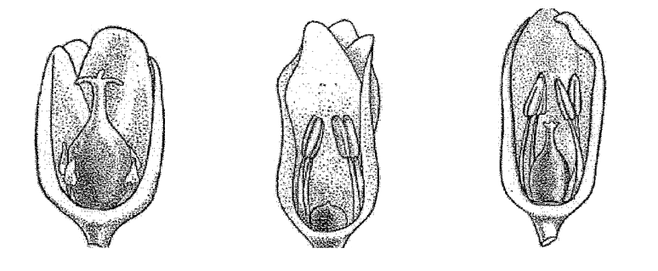

~~Female~~

~~androhermaphrodite~~

~~male~~

male flower

(with rudiment style including androhermaphrodite)

male flower

(without rudiment style)

Female flower

Type of male flowers

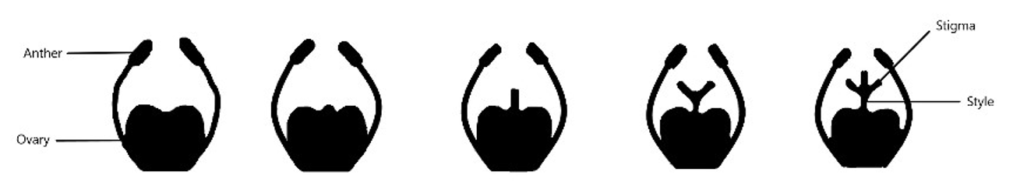

Stigma

Anther

Style

Ovary

Type I

Type IV

Type III

Type II

Note 3: plants with male flower with style rudiments (including androhermaphrodite flowers)

Note 1: plants with male flowers without style rudiment)

Type of male flowers: the flowers always have fully developed anthers; the style can be from absent to fully developed (Type I to IV), but the stigmas are always rudimentary or absent. Even when two of the three stigmas are present, the flower is considered to be male. The male flower will not produce seeds.

The androhermaphrodite flower (Type IV) has three stigmas and anthers which produce pollen. The flower has the possibility, when self-pollinated, to produce a berry with some seeds. These berries are always smaller and with less seeds than on female plants and in much smaller quantities.

Varieties with note 3 (plants with male flower with style rudiments) can also have plants with androhermaphrodite flowers. Within these varieties the ratio between male flowers with style rudiments (type II and III) and androhermaphrodite flowers (type IV) can vary, leading to a smaller or larger percentage of male plants with small berries.

[End of document]

1. held in Antalya, Türkiye, from May 1 to 5, 2023, in hybrid format