E
International Union for the Protection of New Varieties of Plants

Technical Working Party for Vegetables  Fifty-Eighth Session  Virtual meeting, April 22 to 25, 2024 | TWV/58/3  Original: English  Date: 15 April, 2024
Assessing distinctness in disease resistance characteristics
Document prepared by experts from France and the Netherlands, with the support of European Union, Japan and breeders’ organizations
Disclaimer: this document does not represent UPOV policies or guidance

Executive Summary

- There are certain quantitative (QN) disease resistance characteristics where it is not possible to describe different levels of resistance according to the current QN states of expression. These levels could be caused by few genes with overlapping levels of resistance and are influenced by testing conditions. The genetic background might not be completely known. In this case, only two levels of resistance can describe the distinctiveness: “absent or low” (1) on one side and “medium or high” (2) on the other side.

- Therefore, there is a need to introduce a new type of expression of characteristics, or at least to introduce amendments to the definition of the QN type of expression of characteristics.

Background

3. The TWV, at its fifty-seventh session (May 2023),

- Received a contribution from the experts from France (FR) and the Netherlands (Kingdom of) (NL) (TWV/57/10) to propose the base of a guidance explaining the particular features of disease resistance characteristics that require special treatment in relation to general UPOV guidance.
- The draft guidance would allow to establish distinctness for quantitative disease resistance characteristics based on a difference of one note between varieties.

- In its report, (see document TWV/57/26 CORR. “Report”, paragraphs 23 to 24), the purpose of additional discussion was defined.

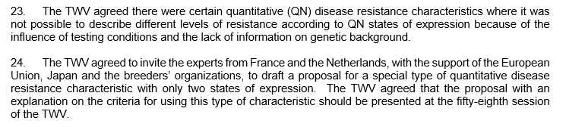

Proposal

- In the previous defined framework, the working group, led by NL and FR, studied the following table showing the similarities (in italic underlined) and differences (in bold) between the Quantitative (QN) characteristic definition and the proposed new characteristic definition, provisionally named Pseudo Quantitative (PQN) characteristic.
Pseudo-Quantitative Characteristics: PQN
are those which are quantitative, where the expression does not cover the full range of variation.

The expression can be recorded on a one-dimensional, continuous but nonlinear scale.

The range of expressions is divided in 2 states for the purpose of description, with notes 1 and 2, (e.g. Resistance to ….: absent or low (1), medium or high (2)). The division provides an uneven distribution across the scale.

The states of expression provide distinctness with only 1 note difference, in the case of a condensed scale.

The states of expression are, however, meaningful for DUS assessment.

Quantitative characteristics: QN
are those where the expression covers the full range of variation from one extreme to the other.

The expression can be recorded on a one-dimensional, continuous or discrete, linear scale.

The range of expressions is divided into a number of states for the purpose of description (e.g. length of stem: very short (1), short (3), medium (5), long (7), very long (9)¹. The division seeks to provide, as far as is practical, an even distribution across the scale.

The Test Guidelines do not specify the difference needed for distinctness².

The states of expression should, however, be meaningful for DUS assessment.

^{1, 2} Situation validated, but not yet updated in the definition of a Quantitative char.

¹ or with a condensed scale: absent or low (1), medium (2), high (3)

² The states of expression provide a sufficient distinctness with only 1 note difference, in the case of a condense scale.

- The QN and PQN characteristics are both potentially caused by different combinations of genes (from one gene to gene pyramiding) whose expression could also be influenced by genetic background.

- In the case of a PQN characteristic, the high resistance level is not identified yet or cannot be distinguished from the level medium resistant, regardless of the test circumstances. Thus, only two reliable notes are proposed.

- The PQN characteristic could, after a case-by-case study, replace the currently applied QL format (with its two levels of expression). The scale 1- absent or low / 2- medium or high would advantageously replace the scale 1- absent / 9- present, to avoid confusion with the scale dedicated to QL characteristic.

- To illustrate properly all the states of expression, the working group proposed a panel of examples(See Annex I).

- The distinctness in the framework of a QN or a PQN characteristic is based on the relevant choice of the threshold varieties which illustrate the cut-off point between 2 UPOV notes by their phenotype.

- Threshold varieties are special control varieties and must be used to explain the characteristic and define the cut-off points between states of expression. They have to be included in the test. The way to identify and validate a threshold control is detailed in Annex II.

- Previously adopted type of expression of disease resistance characteristics may need to be revised to confirm their type of expression, scale of notes and explanations on assessment. The TWV may wish to consider commissioning an inventory of disease resistance characteristics in Test Guidelines for future revision.

- In a preliminary test phase, FR Examination Office and breeders’ organizations have begun (March 2024) answering a survey covering all Test Guidelines regardless of the combination Species/Resistance. It has been fruitful to start comparing the proposal of the representatives of the applicants and the FR examination office proposal, to consider the genetic background and to identify some potential revisions of the type of the expression of characteristics.

- These criteria should be applied to all future Test Guidelines proposals. Experts currently developing or revising Test Guidelines should consider applying these criteria as far as possible. Discussions on applying these criteria to individual Test Guidelines could be organized before the TWV, as required.

- The TWV is invited to consider possible definition of a new type of expression in UPOV Test Guidelines (or alternatives), with a new note scale, as set out in paragraph 4 of this document.

[Annex I follows]

Proposed examples to illustrate the used scales

To illustrate the QL scale _______________________________________________________________

Example: “Resistance to disease ‘x’” with states of expression “absent”, note 1; “present” note 9.

e.g. - Tomato mosaic virus strain 0 (ToMV:0) in Tomato (TG/44/12(PROJ.4, char.59) - not yet adopted by the Technical Committee.

[…]
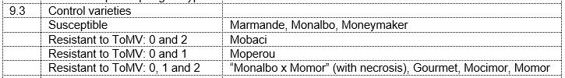
[…]
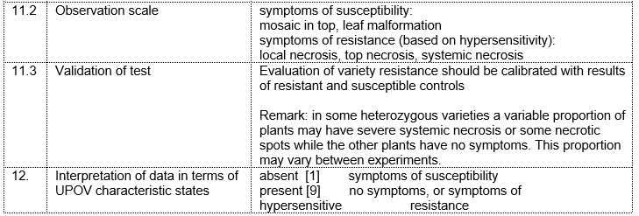

e.g. - Tomato spotted wilt virus (TSWV) in Pepper (TG/76/9(PROJ.6, char.62) - not yet adopted by the Technical Committee.

[…]
[…]
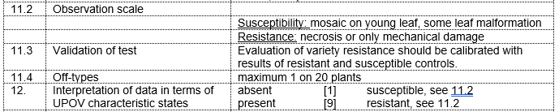

e.g. - Passalora fulva (Pf) in Tomato ( TG/44/12(PROJ.4, char.51) - not yet adopted by the Technical Committee.

[…]
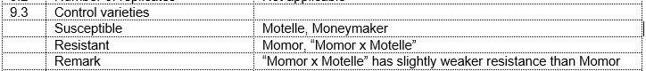
[…]
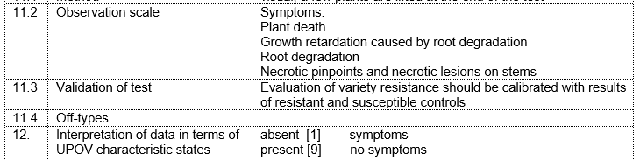

To illustrate the QN scale_______________________________________________________________

Example: “Resistance to disease ‘x’” with states of expression “absent or low”, note 1; “medium”, note 2; and “high”, note 3.

e.g. - Meloidogyne incognita (Mi) in Tomato ( TG/44/12(PROJ.4, char45) - not yet adopted by the Technical Committee.

[…]
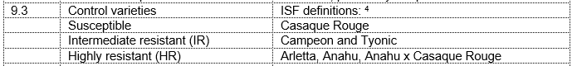
[…]
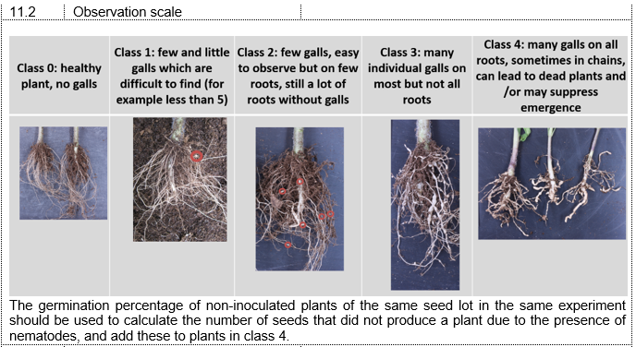
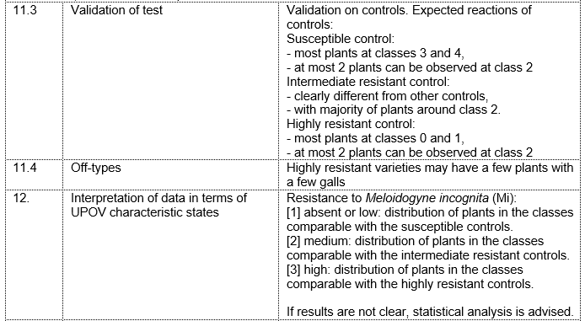

e.g. - Cucumber mosaic virus (CMV) in Cucumber (TG/61/7 Rev. 2 Corr. 2, char.45)

[…]
[…]
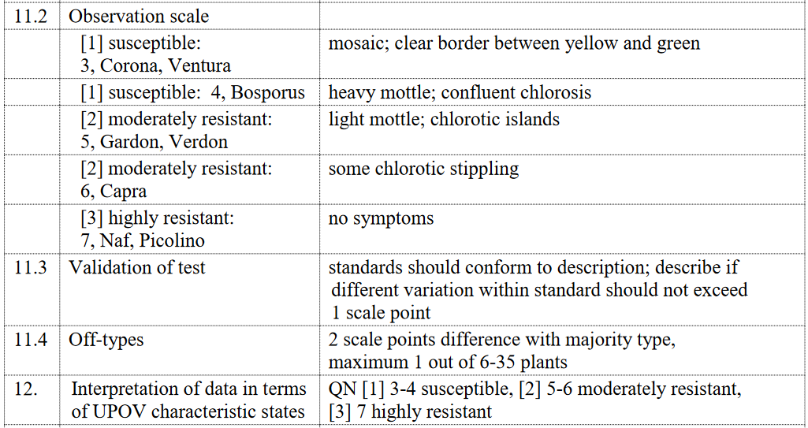

PQN (which are today identified under the type of expression QL) _________________________________

Example: “Resistance to disease ‘x’” with states of expression “absent or low”, note 1; “medium or high”, note 2.

e.g. - Cucumber green mottle mosaic virus (CGMMV) in Cucumber (2024 partial revision (TWV/58/6, char. 52)

[…]
[…]
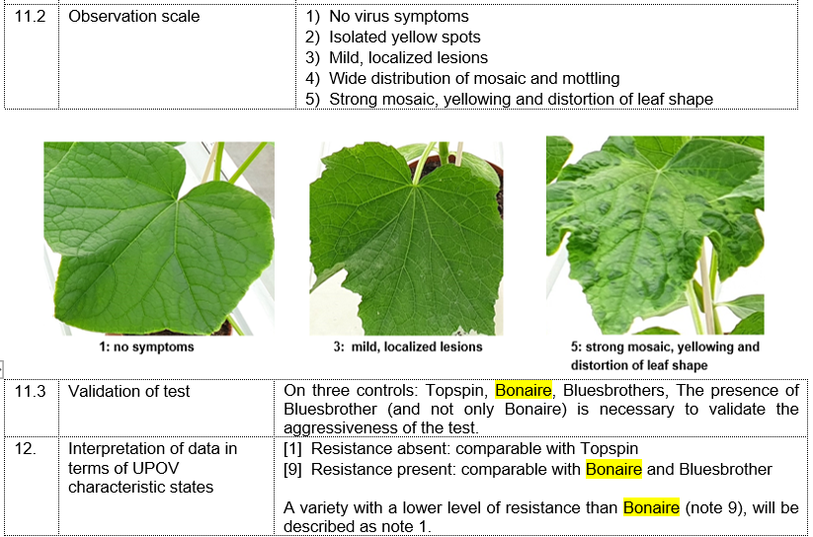

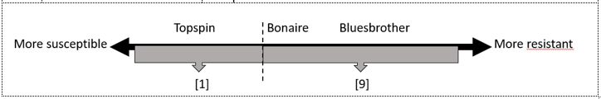

e.g. - Fusarium oxysporum melonis Race 2 (Fom: 2) in Melon, (TC/59/20, char. 69.3) - not yet adopted by the Technical Committee.

[…]
[…]
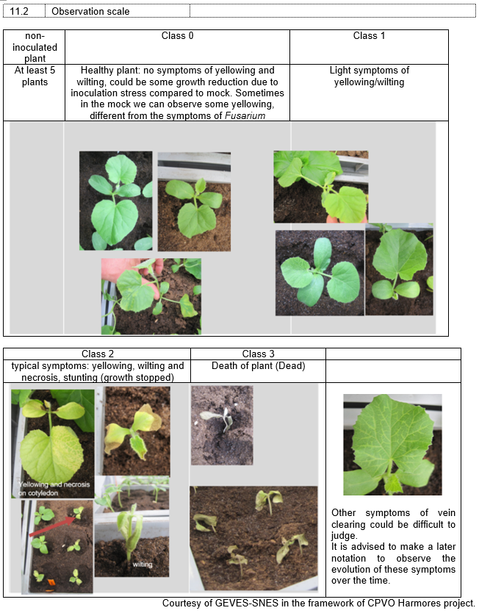
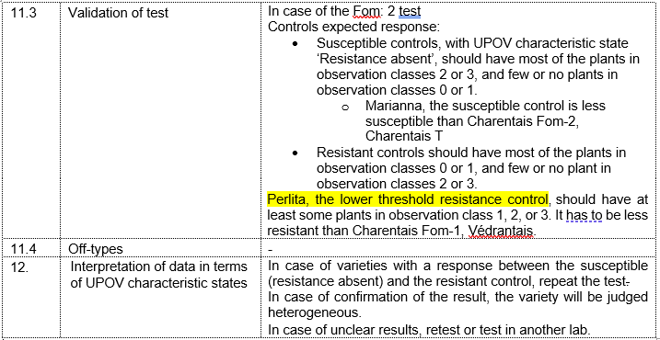

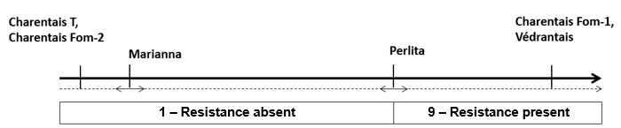

e.g. - Fusarium oxysporum f.sp lycopersici (Fol) , race 0 and 1, in Tomato (TG/44/12(PROJ.4, char. 83) - not yet adopted by the Technical Committee.

[…]
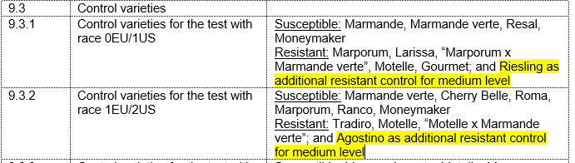
[…]
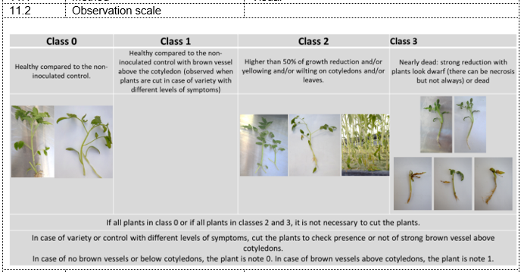

In some cases, information may not be available for certain levels of susceptibility / resistance, such as when there are no known varieties with high level of resistance to illustrate a particular QN characteristic.

e.g. - Watermelon mosaic virus (WMV) in Squash (TC/59/24, char. 83) - not yet validated by TC-EDC.

[…]
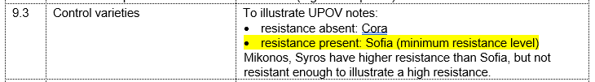
[…]
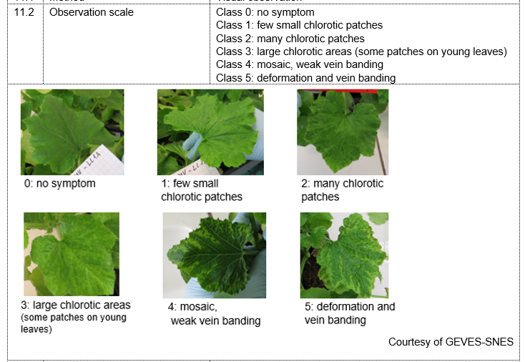
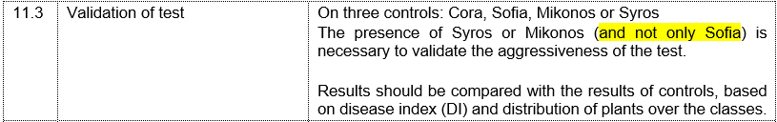
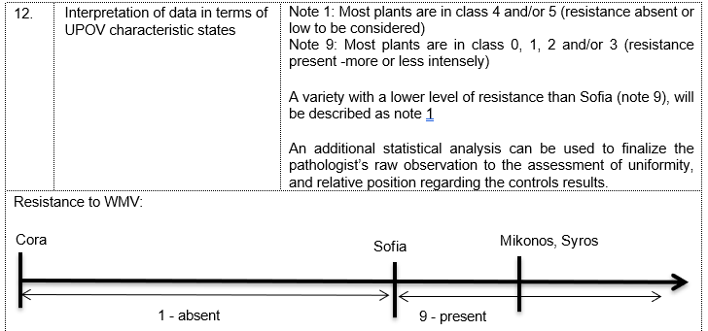

[Annex II follows]

How to identify and validate a threshold control?

Several steps have to be fulfilled before the validation of a threshold variety, such as:

- To identify the threshold control candidates amongst varieties with well identified resistance genetic and / or correlated with field observations.
- To be included in a panel of potential controls, in an international R&D project, involving interested examination offices regularly performing the test for DUS purpose, and disease resistance labs of applicants
- To regularly show the expected behavior, in the framework of a finalized and published disease resistance test protocol.
- To be maintained and available from by reliable initiatives (e.g: MATREF (FR), PLANTUM (NL), CPPSI (USA)…), identified in an international database such as HARMORESCOLL – EU
- The behavior of a threshold variety does not have an absolute value by itself, but it obtains a strategic value in a validated test, including the other required controls, to allow the validation of the test (aggressiveness, number of tested plants to allow potential statistical assistance, required season if required….)

[End of Annex II and of document]

