 |  | E
 |  | TG/162/5(proj.1)  ORIGINAL: English  DATE: 2024-03-09
INTERNATIONAL UNION FOR THE PROTECTION OF NEW VARIETIES OF PLANTS
 | Geneva
 | DRAFT
 | GARLIC  UPOV Code(s): ALLIU_SAT  Allium sativum L. | *
GUIDELINES
FOR THE CONDUCT OF TESTS
FOR DISTINCTNESS, UNIFORMITY AND STABILITY

prepared by experts from France
to be considered by the
Technical Working Party for Vegetables

at its fifty-eighth session, to be held virtually
from 2024-04-22 to 2024-05-25

Disclaimer: this document does not represent UPOV policies or guidance
Alternative names:*

Botanical name | English | French | German | Spanish
Allium sativum L. | Garlic | Ail | Knoblauch | Ajo

The purpose of these guidelines (“Test Guidelines”) is to elaborate the principles contained in the General Introduction (document TG/1/3), and its associated TGP documents, into detailed practical guidance for the harmonized examination of distinctness, uniformity and stability (DUS) and, in particular, to identify appropriate characteristics for the examination of DUS and production of harmonized variety descriptions.
ASSOCIATED DOCUMENTS
These Test Guidelines should be read in conjunction with the General Introduction and its associated TGP documents.

TABLE OF CONTENTS | PAGE
1. | SUBJECT OF THESE TEST GUIDELINES.......................................................................................................... | 3
2. | MATERIAL REQUIRED..................................................................................................................... | 3
3. | METHOD OF EXAMINATION............................................................................................................... | 3
3.1 | Number of Growing Cycles................................................................................................................. | 3
3.2 | Testing Place................................................................................................................... | 3
3.3 | Conditions for Conducting the Examination............................................................................................... | 3
3.4 | Test Design................................................................................................................. | 5
3.5 | Additional Tests................................................................................................................... | 5

4. | ASSESSMENT OF DISTINCTNESS, UNIFORMITY AND STABILITY................................................................. | 5
4.1 | Distinctness.......................................................................................................... | 5
4.2 | Uniformity............................................................................................................ | 6
4.3 | Stability............................................................................................................... | 7

5. | GROUPING OF VARIETIES AND ORGANIZATION OF THE GROWING TRIAL................................................ | 8
6. | INTRODUCTION TO THE TABLE OF CHARACTERISTICS................................................................................ | 8
6.1 | Categories of Characteristics...................................................................................................... | 8
6.2 | States of Expression and Corresponding Notes........................................................................................ | 8
6.3 | Types of Expression............................................................................................................ | 8
6.4 | Example Varieties.............................................................................................................. | 8
6.5 | Legend................................................................................................................. | 10

7. | TABLE OF CHARACTERISTICS/TABLEAU DES CARACTÈRES/MERKMALSTABELLE/TABLA DE CARACTERES.................................................................................................................. | 11
8. | EXPLANATIONS ON THE TABLE OF CHARACTERISTICS............................................................................... | 25
8.1 | Explanations covering several characteristics........................................................................................... | 25
8.2 | Explanations for individual characteristics................................................................................................. | 26

9. | LITERATURE................................................................................................................... | 32
10 | TECHNICAL QUESTIONNAIRE............................................................................................................ | 33

1. | Subject of these Test Guidelines
 | These Test Guidelines apply to all varieties of Allium sativum L.

2. | Material Required
2.1 | The competent authorities decide on the quantity and quality of the plant material required for testing the variety and when and where it is to be delivered. Applicants submitting material from a State other than that in which the testing takes place must ensure that all customs formalities and phytosanitary requirements are complied with.
2.2 | The material is to be supplied in the form of seed in the case of seed-propagated varieties, or in the form of bulbs in the case of vegetatively propagated varieties.
2.3 | The minimum quantity of plant material, to be supplied by the applicant, should be:
Seed-propagated varieties: 7,500 seeds, or
Vegetatively propagated varieties: 120 bulbs

 | In the case of seed, the seed should meet the minimum requirements for germination, species and analytical purity, health and moisture content, specified by the competent authority.
 | In the case of bulbs, the plant material should at least meet the minimum requirements for sprouting capacity, moisture content and purity for marketing plant material in the country in which the application is made. It must be in good sanitary condition and free from virus, in particular from Onion yellow dwarf virus (OYDV) and Leek yellow stripe virus (LYSV).
2.4 | The plant material supplied should be visibly healthy, not lacking in vigor, nor affected by any important pest or disease.
2.5 | The plant material should not have undergone any treatment which would affect the expression of the characteristics of the variety, unless the competent authorities allow or request such treatment. If it has been treated, full details of the treatment must be given.

3. | Method of Examination
3.1 | Number of Growing Cycles
3.1.1 | The minimum duration of tests should normally be two independent growing cycles.
3.1.2 | The two independent growing cycles should be in the form of two separate plantings.
3.1.3 | The testing of a variety may be concluded when the competent authority can determine with certainty the outcome of the test.
3.2 | Testing Place
 | Tests are normally conducted at one place. In the case of tests conducted at more than one place, guidance is provided in TGP/9 “Examining Distinctness”.
3.3 | Conditions for Conducting the Examination
 | The tests should be carried out under conditions ensuring satisfactory growth for the expression of the relevant characteristics of the variety and for the conduct of the examination.
3.4 | Test Design
3.4.1 | In the case of seed propagated varieties, each test should be designed to result in a total of at least 200 plants which should be divided between at least 2 replicates.
3.4.2 | In the case of vegetatively propagated varieties, each test should be designed to result in a total of at least 100 plants which should be divided between at least 2 replicates.

3.4.3 | The design of the tests should be such that plants or parts of plants may be removed for measurement or counting without prejudice to the observations which must be made up to the end of the growing cycle.
3.4.4 | Separate plots for visual observation and for measuring can only be used if they have been subject to similar environmental conditions.  Because of the effect of conditions of storage of bulbs on the expression of characteristics, comparison of varieties should be made only on material which has been propagated and stored under the same temperature and humidity conditions.
3.5 | Additional Tests
 | Additional tests, for examining relevant characteristics, may be established.

4. | Assessment of Distinctness, Uniformity and Stability
4.1 | Distinctness
4.1.1 | General Recommendations
 | It is of particular importance for users of these Test Guidelines to consult the General Introduction prior to making decisions regarding distinctness. However, the following points are provided for elaboration or emphasis in these Test Guidelines.
4.1.2 | Consistent Differences
 | The differences observed between varieties may be so clear that more than one growing cycle is not necessary. In addition, in some circumstances, the influence of the environment is not such that more than a single growing cycle is required to provide assurance that the differences observed between varieties are sufficiently consistent. One means of ensuring that a difference in a characteristic, observed in a growing trial, is sufficiently consistent is to examine the characteristic in at least two independent growing cycles.
4.1.3 | Clear Differences
 | Determining whether a difference between two varieties is clear depends on many factors, and should consider, in particular, the type of expression of the characteristic being examined, i.e. whether it is expressed in a qualitative, quantitative, or pseudo-qualitative manner. Therefore, it is important that users of these Test Guidelines are familiar with the recommendations contained in the General Introduction prior to making decisions regarding distinctness.
4.1.4 | Number of Plants or Parts of Plants to be Examined
In the case of seed-propagated varieties, unless otherwise indicated, for the purposes of distinctness, all observations on single plants should be made on 60 plants or parts taken from each of 60 plants and any other observation made on all plants in the test, disregarding any off-type plants.

In the case of vegetatively propagated varieties, unless otherwise indicated, for the purposes of distinctness, all observations on single plants should be made on 30 plants or parts taken from each of 30 plants and any other observation made on all plants in the test, disregarding any off-type plants.

4.1.5 | Method of Observation
 | The recommended method of observing the characteristic for the purposes of distinctness is indicated by the following key in the Table of Characteristics (see document TGP/9 “Examining Distinctness”, Section 4 “Observation of characteristics”):
MG: single measurement of a group of plants or parts of plants
MS: measurement of a number of individual plants or parts of plants
VG: visual assessment by a single observation of a group of plants or parts of plants
VS: visual assessment by observation of individual plants or parts of plants

 | Type of observation: visual (V) or measurement (M)
 | “Visual” observation (V) is an observation made on the basis of the expert’s judgment. For the purposes of this document, “visual” observation refers to the sensory observations of the experts and, therefore, also includes smell, taste and touch. Visual observation includes observations where the expert uses reference points (e.g. diagrams, example varieties, side-by-side comparison) or non-linear charts (e.g. color charts). Measurement (M) is an objective observation against a calibrated, linear scale e.g. using a ruler, weighing scales, colorimeter, dates, counts, etc.
 | Type of record: for a group of plants (G) or for single, individual plants (S)
 | For the purposes of distinctness, observations may be recorded as a single record for a group of plants or parts of plants (G), or may be recorded as records for a number of single, individual plants or parts of plants (S). In most cases, “G” provides a single record per variety and it is not possible or necessary to apply statistical methods in a plant-by-plant analysis for the assessment of distinctness.
 | In cases where more than one method of observing the characteristic is indicated in the Table of Characteristics (e.g. VG/MG), guidance on selecting an appropriate method is provided in document TGP/9, Section 4.2.
4.2 | Uniformity
4.2.1 | It is of particular importance for users of these Test Guidelines to consult the General Introduction prior to making decisions regarding uniformity. However, the following points are provided for elaboration or emphasis in these Test Guidelines:
4.2.2 | These Test Guidelines have been developed for the examination of vegetatively propagated and seed-propagated varieties. For varieties with other types of propagation, the recommendations in the General Introduction and document TGP/13 "Guidance for new types and species" Section 4.5 "Testing Uniformity" should be followed.
4.2.3 | The assessment of uniformity for hybrid varieties depends on the type of hybrid and should be according to the recommendations for hybrid varieties in the General Introduction.
4.2.4 | For the assessment of uniformity of hybrids or inbred lines, a population standard of 1% and an acceptance probability of at least 95% should be applied. In the case of a sample size of 200 plants, 5 off-types are allowed.
4.2.5 | For the assessment of uniformity of vegetatively propagated varieties, a population standard of 1% and an acceptance probability of at least 95% should be applied. In the case of a sample size of 100 plants, 3 off-types are allowed.
4.3 | Stability
4.3.1 | In practice, it is not usual to perform tests of stability that produce results as certain as those of the testing of distinctness and uniformity. However, experience has demonstrated that, for many types of variety, when a variety has been shown to be uniform, it can also be considered to be stable.
4.3.2 | Where appropriate, or in cases of doubt, stability may be further examined by testing a new seed or plant stock to ensure that it exhibits the same characteristics as those shown by the initial material supplied.

5. | Grouping of Varieties and Organization of the Growing Trial
5.1 | The selection of varieties of common knowledge to be grown in the trial with the candidate varieties and the way in which these varieties are divided into groups to facilitate the assessment of distinctness are aided by the use of grouping characteristics.
5.2 | Grouping characteristics are those in which the documented states of expression, even where produced at different locations, can be used, either individually or in combination with other such characteristics: (a) to select varieties of common knowledge that can be excluded from the growing trial used for examination of distinctness; and (b) to organize the growing trial so that similar varieties are grouped together.
5.3 | The following have been agreed as useful grouping characteristics:
(a) |  | Pseudostem: flowering stem (characteristic 10)
(b) |  | Clove: color of scale (characteristic 29)
(c) |  | Time of harvest maturity (characteristic 33)
(d) |  | End of dormancy of clove in bulb (characteristic 34)

5.4 | Guidance for the use of grouping characteristics, in the process of examining distinctness, is provided through the General Introduction and document TGP/9 “Examining Distinctness”.
6. |  | Introduction to the Table of Characteristics
6.1 |  | Categories of Characteristics
6.1.1 |  | Standard Test Guidelines Characteristics
 |  | Standard Test Guidelines characteristics are those which are approved by UPOV for examination of DUS and from which members of the Union can select those suitable for their particular circumstances.
6.1.2 |  | Asterisked Characteristics
 |  | Asterisked characteristics (denoted by *) are those included in the Test Guidelines which are important for the international harmonization of variety descriptions and should always be examined for DUS and included in the variety description by all members of the Union, except when the state of expression of a preceding characteristic or regional environmental conditions render this inappropriate.
6.2 |  | States of Expression and Corresponding Notes
6.2.1 |  | States of expression are given for each characteristic to define the characteristic and to harmonize descriptions. Each state of expression is allocated a corresponding numerical note for ease of recording of data and for the production and exchange of the description.
6.2.2 |  | All relevant states of expression are presented in the characteristic.
6.2.3 |  | Further explanation of the presentation of states of expression and notes is provided in document TGP/7 “Development of Test Guidelines”.
6.3 |  | Types of Expression
 |  | An explanation of the types of expression of characteristics (qualitative, quantitative and pseudo-qualitative) is provided in the General Introduction.

6.4 | Example Varieties
 | Where appropriate, example varieties are provided to clarify the states of expression of each characteristic.
6.5 | Legend
 |  | English |  | français |  | deutsch | español | Example Varieties  Exemples  Beispielssorten  Variedades ejemplo | Note/Nota
1 | 2 | 3 | 4 | 5 | 6 | 7
 |  | Name of characteristics in English |  | Nom du caractère en français |  | Name des Merkmals auf Deutsch | Nombre del carácter en español
 |  | states of expression |  | types d’expression |  | Ausprägungsstufen | tipos de expresión

1 | Characteristic number
2 | (*) | Asterisked characteristic | – see Chapter 6.1.2
3 | Type of expression
 | QL | Qualitative characteristic | – see Chapter 6.3
 | QN | Quantitative characteristic | – see Chapter 6.3
 | PQ | Pseudo-qualitative characteristic | – see Chapter 6.3
4 | Method of observation (and type of plot, if applicable)
 | MG, MS, VG, VS |  | – see Chapter 4.1.5
5 | (+) | See Explanations on the Table of Characteristics in Chapter 8.2
6 | (a)-(b) | See Explanations on the Table of Characteristics in Chapter 8.1
7 | Not applicable

7. | Table of Characteristics/Tableau des caractères/Merkmalstabelle/Tabla de caracteres

 |  | English |  | français |  | deutsch | español | Example Varieties  Exemples  Beispielssorten  Variedades ejemplo | Note/Nota
1. | (*) | QN | VG |  | (a)
 |  | Foliage: density
 |  | very loose |  |  |  |  |  | Ti Rouge | 1
 |  | very loose to loose |  |  |  |  |  |  | 2
 |  | loose |  |  |  |  |  | Vacoa | 3
 |  | loose to medium |  |  |  |  |  |  | 4
 |  | medium |  |  |  |  |  | Printanor | 5
 |  | medium to dense |  |  |  |  |  |  | 6
 |  | dense |  |  |  |  |  | Germidour | 7
 |  | dense to very dense |  |  |  |  |  |  | 8
 |  | very dense |  |  |  |  |  |  | 9
2. | (*) | QN | VG | (+) | (a)
 |  | Foliage: attitude
 |  | erect |  |  |  |  |  | Jolimont, Vayo | 1
 |  | erect to semi-erect |  |  |  |  |  | Printanor | 2
 |  | semi-erect |  |  |  |  |  |  | 3
3. | (*) | QN | VG |  | (a)
 |  | Leaf: green color
 |  | very light |  |  |  |  |  |  | 1
 |  | very light to light |  |  |  |  |  |  | 2
 |  | light |  |  |  |  |  | Primor | 3
 |  | light to medium |  |  |  |  |  |  | 4
 |  | medium |  |  |  |  |  | Messidrome | 5
 |  | medium to dark |  |  |  |  |  |  | 6
 |  | dark |  |  |  |  |  | Germidour | 7
 |  | dark to very dark |  |  |  |  |  | Valdour | 8
 |  | very dark |  |  |  |  |  |  | 9
4. |  | QN | VG |  | (a)
 |  | Leaf: waxiness
 |  | absent or very weak |  |  |  |  |  |  | 1
 |  | weak |  |  |  |  |  | Sprint | 2
 |  | medium |  |  |  |  |  | Messidrome | 3
 |  | strong |  |  |  |  |  | Germidour | 4
 |  | very strong |  |  |  |  |  | Gayant, Printanor | 5
5. | (*) | QN | MS/VG |  | (a)
 |  | Leaf: length (longest leaf)
 |  | very short |  |  |  |  |  |  | 1
 |  | very short to short |  |  |  |  |  |  | 2
 |  | short |  |  |  |  |  |  | 3
 |  | short to medium |  |  |  |  |  |  | 4
 |  | medium |  |  |  |  |  |  | 5
 |  | medium to long |  |  |  |  |  |  | 6
 |  | long |  |  |  |  |  | Sultop | 7
 |  | long to very long |  |  |  |  |  |  | 8
 |  | very long |  |  |  |  |  |  | 9
6. | (*) | QN | MS/VG |  | (a)
 |  | Leaf: width (as for 5)
 |  | very narrow |  |  |  |  |  |  | 1
 |  | very narrow to narrow |  |  |  |  |  |  | 2
 |  | narrow |  |  |  |  |  |  | 3
 |  | narrow to medium |  |  |  |  |  |  | 4
 |  | medium |  |  |  |  |  | Printanor | 5
 |  | medium to broad |  |  |  |  |  |  | 6
 |  | broad |  |  |  |  |  | Germidour | 7
 |  | broad to very broad |  |  |  |  |  |  | 8
 |  | very broad |  |  |  |  |  |  | 9
7. | (*) | QN | VG |  | (a)
 |  | Leaf: shape in cross section
 |  | strongly concave |  |  |  |  |  | Vacoa | 1
 |  | slightly concave |  |  |  |  |  |  | 2
 |  | flat |  |  |  |  |  | Germidour | 3
8. | (*) | QN | VG |  | (a)
 |  | Pseudostem: intensity of anthocyanin coloration at base
 |  | absent or very weak |  |  |  |  |  | Printanor | 1
 |  | very weak to weak |  |  |  |  |  |  | 2
 |  | weak |  |  |  |  |  | Messidrome | 3
 |  | weak to medium |  |  |  |  |  |  | 4
 |  | medium |  |  |  |  |  |  | 5
 |  | medium to strong |  |  |  |  |  |  | 6
 |  | strong |  |  |  |  |  | Germidour | 7
 |  | strong to very strong |  |  |  |  |  |  | 8
 |  | very strong |  |  |  |  |  |  | 9
9. | (*) | QN | MS/VG |  | (a)
 |  | Pseudostem: width of the base
 |  | very narrow |  |  |  |  |  |  | 1
 |  | very narrow to narrow |  |  |  |  |  |  | 2
 |  | narrow |  |  |  |  |  | Vacoa | 3
 |  | narrow to medium |  |  |  |  |  |  | 4
 |  | medium |  |  |  |  |  | Printanor | 5
 |  | medium to broad |  |  |  |  |  |  | 6
 |  | broad |  |  |  |  |  | Germidour | 7
 |  | broad to very broad |  |  |  |  |  |  | 8
 |  | very broad |  |  |  |  |  |  | 9
10 | (*) | QL | VG |  | (a)
 |  | Pseudostem: flowering stem
 |  | absent |  |  |  |  |  | Germidour | 1
 |  | present |  |  |  |  |  | Rose de Lautrec | 9
11 | (*) | QL | VG | (+) | (a)
 |  | Flowering stem: curvature
 |  | absent |  |  |  |  |  | Sultop | 1
 |  | present |  |  |  |  |  | Iberose | 9
12 | (*) | QN | MS/VG | (+) | (a)
 |  | Flowering stem: length
 |  | very short |  |  |  |  |  |  | 1
 |  | very short to short |  |  |  |  |  |  | 2
 |  | short |  |  |  |  |  | Rose de Lautrec | 3
 |  | short to medium |  |  |  |  |  |  | 4
 |  | medium |  |  |  |  |  |  | 5
 |  | medium to long |  |  |  |  |  |  | 6
 |  | long |  |  |  |  |  | Sultop | 7
 |  | long to very long |  |  |  |  |  |  | 8
 |  | very long |  |  |  |  |  |  | 9
13 | (*) | QL | VG | (+) | (a)
 |  | Flowering stem: emergence of bulblets through the pseudostem
 |  | absent |  |  |  |  |  | Rose de Lautrec | 1
 |  | present |  |  |  |  |  | Germidour | 9
14 | (*) | QN | MS/VG |  | (b)
 |  | Bulb: size
 |  | very small |  |  |  |  |  |  | 1
 |  | very small to small |  |  |  |  |  |  | 2
 |  | small |  |  |  |  |  | Vacoa | 3
 |  | small to medium |  |  |  |  |  |  | 4
 |  | medium |  |  |  |  |  | Printanor | 5
 |  | medium to large |  |  |  |  |  |  | 6
 |  | large |  |  |  |  |  | Messidrome | 7
 |  | large to very large |  |  |  |  |  |  | 8
 |  | very large |  |  |  |  |  |  | 9
15 | (*) | QN | VG | (+) | (b)
 |  | Bulb: shape in longitudinal section
 |  | transverse narrow elliptic |  |  |  |  |  | Sprint | 1
 |  | transverse broad elliptic |  |  |  |  |  | Germidour | 2
 |  | circular |  |  |  |  |  |  | 3
16 |  | QN | VG |  | (b)
 |  | Bulb: shape in cross section
 |  | elliptic |  |  |  |  |  |  | 1
 |  | circular |  |  |  |  |  | Sprint | 2
17 |  | QN | VG | (+) | (b)
 |  | Bulb: position of cloves at top of bulb
 |  | inserted |  |  |  |  |  | Sprint | 1
 |  | at same level |  |  |  |  |  | Corail | 2
 |  | exerted |  |  |  |  |  | Germidour | 3
18 | (*) | QN | VG |  | (b)
 |  | Bulb: position of root disc
 |  | depressed |  |  |  |  |  | Germidour | 1
 |  | flat |  |  |  |  |  | Rose de Lautrec | 2
 |  | raised |  |  |  |  |  |  | 3
19 | (*) | PQ | VG | (+) | (b)
 |  | Bulb: shape of base
 |  | recessed |  |  |  |  |  | Germidour | 1
 |  | flat |  |  |  |  |  | Printanor | 2
 |  | rounded |  |  |  |  |  |  | 3
20 |  | QN | VG |  | (b)
 |  | Bulb: compactness of cloves
 |  | very loose |  |  |  |  |  |  | 1
 |  | loose |  |  |  |  |  | Sprint | 2
 |  | medium |  |  |  |  |  | Germidour | 3
 |  | compact |  |  |  |  |  | Printanor | 4
 |  | very compact |  |  |  |  |  |  | 5
21 | (*) | PQ | VG |  | (b)
 |  | Bulb: ground color of dry external scales
 |  | white |  |  |  |  |  | Printanor | 1
 |  | yellowish white |  |  |  |  |  | Vigor Max, Vigor Supreme | 2
 |  | reddish white |  |  |  |  |  | Germidour | 3
22 | (*) | QL | VG |  | (b)
 |  | Bulb: anthocyanin stripes on dry external scales
 |  | absent |  |  |  |  |  | Aulxito, Printanor | 1
 |  | present |  |  |  |  |  | Germidour, Sprint | 9
23 |  | QN | VG |  | (b)
 |  | Bulb: skin adherence of dry external scales
 |  | very weak |  |  |  |  |  |  | 1
 |  | weak |  |  |  |  |  | Sprint | 2
 |  | medium |  |  |  |  |  | Messidrome | 3
 |  | strong |  |  |  |  |  | Gayant, Printanor | 4
 |  | very strong |  |  |  |  |  |  | 5
24 |  | QN | MS/VG |  | (b)
 |  | Bulb: thickness of dry external scales
 |  | very thin |  |  |  |  |  |  | 1
 |  | very thin to thin |  |  |  |  |  |  | 2
 |  | thin |  |  |  |  |  |  | 3
 |  | thin to medium |  |  |  |  |  |  | 4
 |  | medium |  |  |  |  |  |  | 5
 |  | medium to thick |  |  |  |  |  |  | 6
 |  | thick |  |  |  |  |  | Jolimont | 7
 |  | thick to very thick |  |  |  |  |  |  | 8
 |  | very thick |  |  |  |  |  |  | 9
25 | (*) | QN | MS/VG |  | (b)
 |  | Bulb: number of cloves
 |  | very few |  |  |  |  |  |  | 1
 |  | very few to few |  |  |  |  |  |  | 2
 |  | few |  |  |  |  |  |  | 3
 |  | few to medium |  |  |  |  |  |  | 4
 |  | medium |  |  |  |  |  | Printanor | 5
 |  | medium to many |  |  |  |  |  |  | 6
 |  | many |  |  |  |  |  |  | 7
 |  | many to very many |  |  |  |  |  |  | 8
 |  | very many |  |  |  |  |  |  | 9
26 | (*) | QL | VG | (+) | (b)
 |  | Bulb: distribution of cloves
 |  | radial |  |  |  |  |  | Rose de Lautrec, Sprint | 1
 |  | non-radial |  |  |  |  |  | Jolimont, Messidrome | 2
27 | (*) | QL | VG | (+) | (b)
 |  | Bulb: external cloves
 |  | absent |  |  |  |  |  | Sprint, Sultop | 1
 |  | present |  |  |  |  |  |  | 9
28 | (*) | QN | MS/VG | (+) | (b)
 |  | Clove: size
 |  | very small |  |  |  |  |  |  | 1
 |  | very small to small |  |  |  |  |  |  | 2
 |  | small |  |  |  |  |  | Rose de Lautrec | 3
 |  | small to medium |  |  |  |  |  |  | 4
 |  | medium |  |  |  |  |  | Printanor | 5
 |  | medium to large |  |  |  |  |  |  | 6
 |  | large |  |  |  |  |  | Germidour | 7
 |  | large to very large |  |  |  |  |  |  | 8
 |  | very large |  |  |  |  |  |  | 9
29 | (*) | PQ | VG |  | (b)
 |  | Clove: color of scale
 |  | white |  |  |  |  |  |  | 1
 |  | cream |  |  |  |  |  | Messidrome | 2
 |  | pink |  |  |  |  |  | Printanor | 3
 |  | purple |  |  |  |  |  | Sprint | 4
 |  | brown |  |  |  |  |  | Corail | 5
30 | (*) | QN | VG |  | (b)
 |  | Clove: intensity of color of scale (excluding white scale)
 |  | medium to strong
 |  | strong to very strong
 |  | very weak to weak
 |  | weak to medium
 |  | very weak |  |  |  |  |  |  | 1
 |  | weak |  |  |  |  |  | Printanor | 2
 |  | medium |  |  |  |  |  | Iberose, Sultop | 3
 |  | strong |  |  |  |  |  |  | 4
 |  | very strong |  |  |  |  |  |  | 5
31 | (*) | QL | VG |  | (b)
 |  | Clove: anthocyanin stripes on scale
 |  | absent |  |  |  |  |  |  | 1
 |  | present |  |  |  |  |  |  | 9
32 | (*) | QN | VG |  | (b)
 |  | Clove: color of flesh
 |  | white |  |  |  |  |  | Printanor | 1
 |  | yellowish |  |  |  |  |  | Germidour | 2
33 | (*) | QN | MS/VG
 |  | Time of harvest maturity
 |  | very early |  |  |  |  |  |  | 1
 |  | very early to early |  |  |  |  |  | Primor | 2
 |  | early |  |  |  |  |  | Sprint | 3
 |  | early to medium |  |  |  |  |  |  | 4
 |  | medium |  |  |  |  |  | Germidour, Messidrome | 5
 |  | medium to late |  |  |  |  |  |  | 6
 |  | late |  |  |  |  |  | Printanor | 7
 |  | late to very late |  |  |  |  |  |  | 8
 |  | late very late |  |  |  |  |  | Ail du Nord, Gayant | 9
34 | (*) | QN | MS/VG | (+)
 |  | End of dormancy of clove in bulb
 |  | very early |  |  |  |  |  |  | 1
 |  | very early to early |  |  |  |  |  |  | 2
 |  | early |  |  |  |  |  | Sprint | 3
 |  | early to medium |  |  |  |  |  |  | 4
 |  | medium |  |  |  |  |  | Rose de Lautrec | 5
 |  | medium to late |  |  |  |  |  |  | 6
 |  | late |  |  |  |  |  | Flavor | 7
 |  | late to very late |  |  |  |  |  |  | 8
 |  | very late |  |  |  |  |  | Ail du Nord, Gayant | 9

8. | Explanations on the Table of Characteristics
8.1 | Explanations covering several characteristics
 | Characteristics containing the following key in the Table of Characteristics should be examined as indicated below:
(a) | Observations on the leaf, foliage, pseudostem, and flowering stem should be made before the foliage fall over.
(b) | Observations on the bulbs and cloves should be made on dried material harvested from the trial.

8.2 | Explanations for individual characteristics
Ad. 2: Foliage: attitude

Observations should be made on the middle third of the plant.

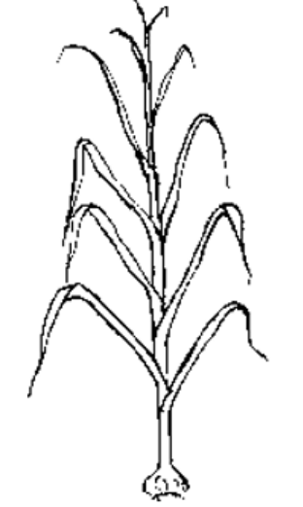 | 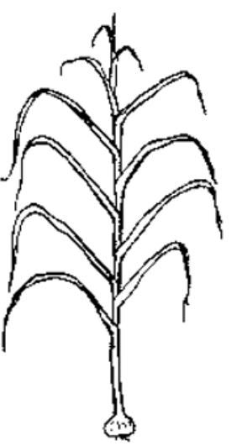 | 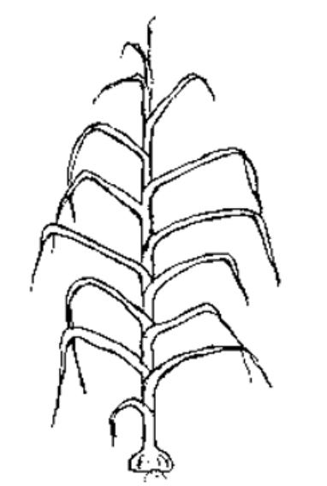
1 | 2 | 3
erect | erect to semi-erect | semi-erect

Ad. 11: Flowering stem: curvature

to include

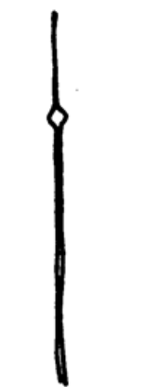 | 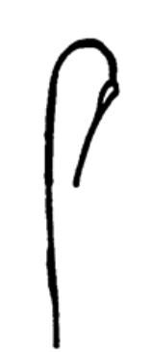
1 | 9
absent | present

Ad. 12: Flowering stem: length

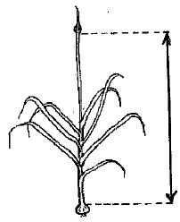

Ad. 13: Flowering stem: emergence of bulblets through the pseudostem

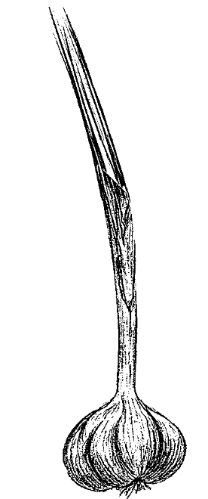 | 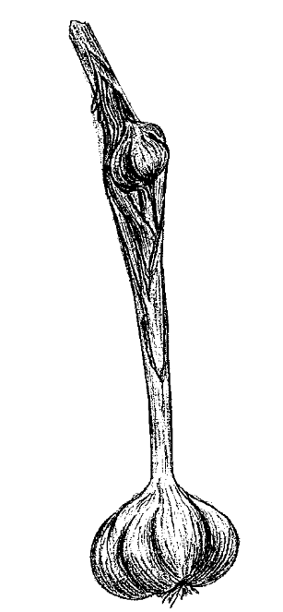
1 | 9
absent | present

Ad. 15: Bulb: shape in longitudinal section

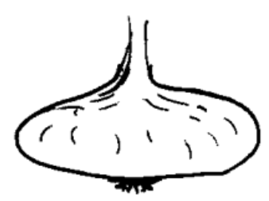 | 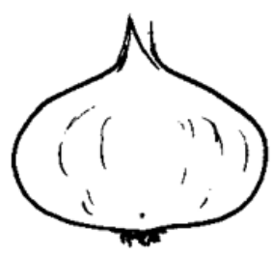 | 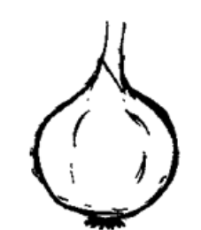
1 | 2 | 3
transverse narrow elliptic | transverse broad elliptic | circular

Ad. 17: Bulb: position of cloves at top of bulb

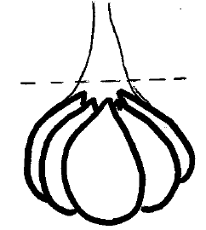 |  | 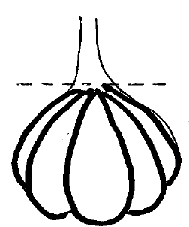 |  | 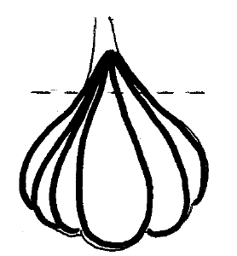
1 | 2 |  | 3
inserted | at the same level |  | exerted

Ad. 19: Bulb: shape of base

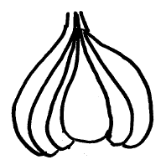 | 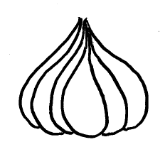 | 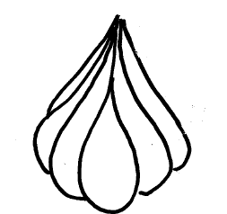
1 | 2 | 3
recessed | flat | rounded

Ad. 26: Bulb: distribution of cloves

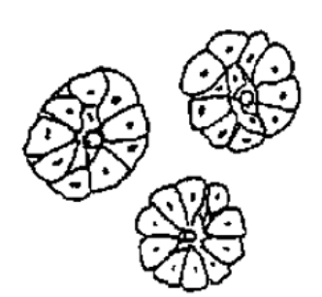 | 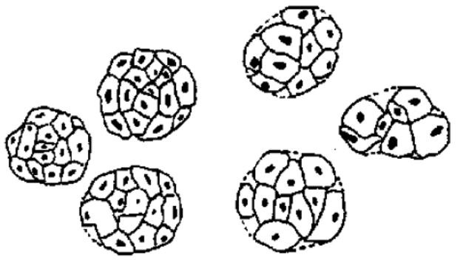
1 | 2
radial | non-radial

Ad. 27: Bulb: external cloves

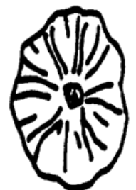 | 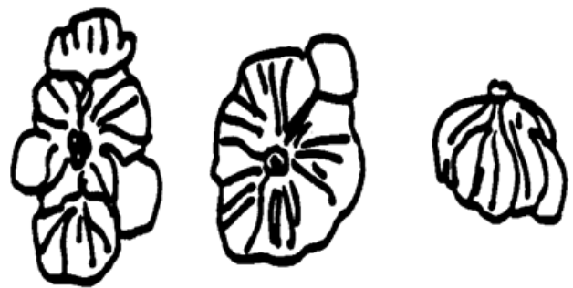
1 | 9
absent | present

Ad. 28: Clove: size

The selected cloves to multiply a vegetatively propagated variety have to correspond to the average size of the variety. The smaller and the bigger ones are discarded.

Ad. 34: End of dormancy of clove in bulb

After harvest, bulbs are stored in a ventilated room at an optimum temperature (20ºC to 25ºC), to avoid an excessive humidity, and a managed relative humidity, without being split into cloves.
The end of dormancy is evaluated by observing the percentage of sprouted bulbs.

9. | Literature

Brand, R., 1996, “L’Ail, une semence à part dans les Allium”, La Lettre des Ressources Génétiques Végétales, nº 9, octobre 1996, FR pp. 11 to 16.

Messiaen, C. M., Cohat, J., Leroux, J. P., Pichon, M., Beyries, A. 1993: “Vegetatively Propagated Edible Alliums”. Edition
INRA, FR, 222 pp.

Messiaen, C.M., “ La variabilité chez l’Ail”, La Lettre des Ressources Génétiques Végétales, nº 9, octobre 1996, FR, pp. 7 to 10.

10. | Technical Questionnaire

TECHNICAL QUESTIONNAIRE | Page {x} of {y} | Reference Number:

Application date:
(not to be filled in by the applicant)
TECHNICAL QUESTIONNAIRE
to be completed in connection with an application for plant breeders' rights

1. | Subject of the Technical Questionnaire
 | 1.1 | Botanical name | Allium sativum L.
 | 1.2 | Common name | Garlic

2. | Applicant
 | Name
 | Address
 | Telephone No.
 | Fax No.
 | E-mail address
 | Breeder (if different from
 | applicant)

3. | Proposed denomination and breeder's reference
 | Proposed denomination
 | (if available)
 | Breeder's reference

TECHNICAL QUESTIONNAIRE |  |  | Page {x} of {y} | Reference Number:
#4. | Information on the breeding scheme and propagation of the variety
 | 4.1 | Breeding scheme
 | Variety resulting from:
4.1.1 | Crossing
(a) | controlled cross | [ ]
(b) | partially known cross | [ ]
(c) | unknown cross | [ ]
4.1.2 | Mutation  (please state parent variety) | [ ]
4.1.3 | Discovery and development  (please state where and when discovered and how developed) | [ ]
4.1.4 | Other  (Please provide details) | [ ]

TECHNICAL QUESTIONNAIRE | Page {x} of {y} | Reference Number:

 | 4.2 | Method of propagating the variety
4.2.1 | Seed-propagated varieties
(a) | Cross-pollination | [ ]
(b) | Hybrid | [ ]
(c) | Inbred line | [ ]
(d) | Other (please provide details) | [ ]
4.2.2 | Vegetative propagation
(a) | Division | [ ]
(b) | Other (state method) | [ ]
4.2.3 | Other  (Please provide details) | [ ]

TECHNICAL QUESTIONNAIRE | Page {x} of {y} | Reference Number:

5. | Characteristics of the variety to be indicated (the number in brackets refers to the corresponding characteristic in Test Guidelines; please mark the note which best corresponds).

 | Characteristics | Example Varieties | Note
5.1  (2) | Foliage: attitude
 | erect | Jolimont, Vayo | 1 [ ]
 | erect to semi-erect | Printanor | 2 [ ]
 | semi-erect |  | 3 [ ]
5.2  (3) | Leaf: green color
 | very light |  | 1 [ ]
 | very light to light |  | 2 [ ]
 | light | Primor | 3 [ ]
 | light to medium |  | 4 [ ]
 | medium | Messidrome | 5 [ ]
 | medium to dark |  | 6 [ ]
 | dark | Germidour | 7 [ ]
 | dark to very dark | Valdour | 8 [ ]
 | very dark |  | 9 [ ]
5.3  (10) | Pseudostem: flowering stem
 | absent | Germidour | 1 [ ]
 | present | Rose de Lautrec | 9 [ ]
5.4  (14) | Bulb: size
 | very small |  | 1 [ ]
 | very small to small |  | 2 [ ]
 | small | Vacoa | 3 [ ]
 | small to medium |  | 4 [ ]
 | medium | Printanor | 5 [ ]
 | medium to large |  | 6 [ ]
 | large | Messidrome | 7 [ ]
 | large to very large |  | 8 [ ]
 | very large |  | 9 [ ]

 | Characteristics | Example Varieties | Note
5.5  (15) | Bulb: shape in longitudinal section
 | transverse narrow elliptic | Sprint | 1 [ ]
 | transverse broad elliptic | Germidour | 2 [ ]
 | circular |  | 3 [ ]
5.6  (21) | Bulb: ground color of dry external scales
 | white | Printanor | 1 [ ]
 | yellowish white | Vigor Max, Vigor Supreme | 2 [ ]
 | reddish white | Germidour | 3 [ ]
5.7  (27) | Bulb: external cloves
 | absent | Sprint, Sultop | 1 [ ]
 | present |  | 9 [ ]
5.8  (28) | Clove: size
 | very small |  | 1 [ ]
 | veru small to small |  | 2 [ ]
 | small | Rose de Lautrec | 3 [ ]
 | small to medium |  | 4 [ ]
 | medium | Printanor | 5 [ ]
 | medium to large |  | 6 [ ]
 | large | Germidour | 7 [ ]
 | large to very large |  | 8 [ ]
 | very large |  | 9 [ ]
5.9  (29) | Clove: color of scale
 | white |  | 1 [ ]
 | cream | Messidrome | 2 [ ]
 | pink | Printanor | 3 [ ]
 | purple | Sprint | 4 [ ]
 | brown | Corail | 5 [ ]
5.10  (32) | Clove: color of flesh
 | white | Printanor | 1 [ ]
 | yellowish | Germidour | 2 [ ]

 | Characteristics | Example Varieties | Note
5.11  (33) | Time of harvest maturity
 | very early |  | 1 [ ]
 | very early to early | Primor | 2 [ ]
 | early | Sprint | 3 [ ]
 | early to medium |  | 4 [ ]
 | medium | Germidour, Messidrome | 5 [ ]
 | medium to late |  | 6 [ ]
 | late | Printanor | 7 [ ]
 | late to very late |  | 8 [ ]
 | late very late | Ail du Nord, Gayant | 9 [ ]
5.12  (34) | End of dormancy of clove in bulb
 | very early |  | 1 [ ]
 | very early to early |  | 2 [ ]
 | early | Sprint | 3 [ ]
 | early to medium |  | 4 [ ]
 | medium | Rose de Lautrec | 5 [ ]
 | medium to late |  | 6 [ ]
 | late | Flavor | 7 [ ]
 | late to very late |  | 8 [ ]
 | very late | Ail du Nord, Gayant | 9 [ ]

TECHNICAL QUESTIONNAIRE | Page {x} of {y} | Reference Number:

6. | Similar varieties and differences from these varieties
Please use the following table and box for comments to provide information on how your candidate variety differs from the variety (or varieties) which, to the best of your knowledge, is (or are) most similar. This information may help the examination authority to conduct its examination of distinctness in a more efficient way.

Denomination(s) of variety(ies) similar to your candidate variety | Characteristic(s) in which your candidate variety differs from the similar variety(ies) | Describe the expression of the characteristic(s) for the similar variety(ies) | Describe the expression of the characteristic(s) for your candidate variety

Example

 | Comments:

TECHNICAL QUESTIONNAIRE | Page {x} of {y} | Reference Number:

#7. | Additional information which may help in the examination of the variety
7.1 | In addition to the information provided in sections 5 and 6, are there any additional characteristics which may help to distinguish the variety?
 | Yes | [ ] | No | [ ]
 | (If yes, please provide details)
7.2 | Are there any special conditions for growing the variety or conducting the examination?
 | Yes | [ ] | No | [ ]
 | (If yes, please provide details)
7.3 | Other information
A representative color photograph of the variety displaying its main distinguishing feature(s), should accompany the Technical Questionnaire. The photograph will provide a visual illustration of the candidate variety which supplements the information provided in the Technical Questionnaire.
The key points to consider when taking a photograph of the candidate variety are:
• Indication of the date and geographic location
• Correct labelling (breeder’s reference)
• Good quality printed photograph (minimum 10 cm x 15 cm) and/or sufficient resolution electronic format version (minimum 960 x 1280 pixels)”
Further guidance on providing photographs with the Technical Questionnaire is available in document TGP/7 "Development of Test Guidelines", Guidance Note 35 (http://www.upov.int/tgp/en/).
[The link provided may be deleted by members of the Union when developing authorities’ own test guidelines.]
7.* Representative color photograph requested

7.* Resistance to pests and diseases
Please specify:

7.* Special conditions for the examination of the variety

7.* Type
Long-day type Autumn [ ]
Short-day type Spring [ ]

7.* Other information

TECHNICAL QUESTIONNAIRE | Page {x} of {y} | Reference Number:

8. | Authorization for release
 | (a) | Does the variety require prior authorization for release under legislation concerning the protection of the environment, human and animal health?
 |  | Yes | [ ] | No | [ ]
 | (b) | Has such authorization been obtained?
 |  | Yes | [ ] | No | [ ]
 | If the answer to (b) is yes, please attach a copy of the authorization.

9. Information on plant material to be examined or submitted for examination

9.1 The expression of a characteristic or several characteristics of a variety may be affected by factors, such as pests and disease, chemical treatment (e.g. growth retardants or pesticides), effects of tissue culture, different rootstocks, scions taken from different growth phases of a tree, etc.
9.2 The plant material should not have undergone any treatment which would affect the expression of the characteristics of the variety, unless the competent authorities allow or request such treatment. If the plant material has undergone such treatment, full details of the treatment must be given. In this respect, please indicate below, to the best of your knowledge, if the plant material to be examined has been subjected to:

 | (a) | Microorganisms (e.g. virus, bacteria, phytoplasma) | Yes [ ] | No [ ]
 | (b) | Chemical treatment (e.g. growth retardant, pesticide) | Yes [ ] | No [ ]
 | (c) | Tissue culture | Yes [ ] | No [ ]
 | (d) | Other factors | Yes [ ] | No [ ]
 | Please provide details for where you have indicated “yes”.

9.3 Has the plant material to be examined been tested for the presence of virus or other pathogens?

 | Yes | [ ]
 | (please provide details as specified by the Authority)
 | No | [ ]

10. | I hereby declare that, to the best of my knowledge, the information provided in this form is correct:
 | Applicant’s name
 | Signature |  | Date

[End of document]

